Effect of organic inputs and microbial consortium on growth and yield parameters of radish (Raphanus sativus L.) cv Japanese white

Abstract
The present investigation was carried out to study the influence of organic inputs and microbial consortium on growth parameters of radish cv Japanese white. The experiment was carried out at experimental farm, Department of Horticulture, Jorhat during the year 2018-19 and 2019-20. Pooled data over two years revealed that T₈ (80:60:60kg NPK + 10t FYM ha1) recorded the yield of Radish 191.45q ha-1 which was followed by 169.73q ha⁻¹ under T₇(Enriched compost 5t ha).
The growth and yield attributing characters were significantly influenced by application of different nutrient sources. Highest plant height (32.84 cm), maximum number of leaves (16.31), maximum leaf length (24.91 cm), maximum leaf width (7.6 cm) and maximum leaf area index (3.42) was exhibited by treatment T₈ followed by 29.25 cm, 16.0, 22.73 cm, 7.35 cm and 3.35 respectively in T₇. Pooled data over two years revealed that the maximum root length (25.45cm), maximum root diameter (2.715cm), was found in treatment T₈. Among organic treatments, maximum root length (24.26 cm, highest total yield (25.41 t ha⁻¹) were found in the treatment T₇. All the growth and yield parameters were significantly poor in T₁:(Rock phosphate + Consortium).

Keywords: Organic, Vermicompost, Enriched Compost, Consortium, growth parameters

Introduction:
Radish (Raphanus sativus L.) under the family Cruciferae is a popular root vegetable grown all over the world. Its roots are consumed raw as salad or as cooked vegetable known for its unique pungent flavour. It is grown both as annual and biennial root crop depending upon type. Radish is grown for its tender roots which are eaten as raw as salad or cooked vegetable. It is good source of fibre, vitamin- C, folic acid and potassium, and a good source of riboflavin, vitamin B6, magnesium, copper, calcium and manganese. It is heavy feeder and exhaustive crop, also responds very well to the application of nutrients. The low production of radish may be due to several factors of which nutrition is utmost important. In the recent days, in order to increase the productivity and profitability, the use of chemical fertilizers, pesticides and other chemical inputs are increasing day by day resulting in environmental and ecological problems, which adversely affects the sustainability of agricultural system. Soil health is a key factor for sustaining agricultural productivity. Low and abundant use of chemical fertilizers coupled with continuous cropping results in deterioration of innate soil fertility and possesses a serious threat to soil biochemical properties. Soils of Assam have medium availability of phosphorous and potassium, low in nitrogen. Biofertilizers have been designated as the supplement sources of soil fertility as they improve nutrient supply through living organisms. Biofertilizers are produced by using selected beneficial and live microorganisms, which help to improve plant growth and productivity. Recently customized consortia of such biofertilizers are better adapted to local climatic conditions have also been developed and are available commercially. This consortium along with organic inputs are applied in soil which increases the nutrient use efficiency. Hence, there is need to popularize and standardize this eco-friendly and cost-effective organic manures and microbial consortium for vegetable crops. So, keeping the above factors in view, the present investigation was carried out.

Materials and methods:
The experiment was laid out in RBD with three replications. There were altogether 8 treatments, T1:(Rock phosphate + Consortium), T2:T1 +Compost (2.5 t ha⁻¹), T3: T1 +Compost (5t ha-1), T4 : T1+Vermicompost (2.5 t ha-1), T5: T1+Vermicompost (5 t ha⁻¹ ), T6 :T1 +Enriched compost (2.5t ha⁻¹), T7 : T1+ Enriched compost (5t ha⁻¹) and T8 : RDF (Recommended dose of fertilizer@50:50:100kg NPK ha-1) + FYM @10t ha⁻¹ .
The farm yard manure was applied @25 t ha⁻¹ as a basal dose during field preparation. For organic plots, Compost, Vermicompost and Enriched compost was applied according to the dosage mentioned in a particular treatment. Rock phosphate is applied as per recommended dose of phosphorus. For inorganic plots, Nitrogen, phosphorous and potassium were applied at 50:50:100 NPK Kgha⁻¹. For organic plots, microbial consortium was mixed with respective organic nutrients at a ratio of 1:100 and mixed properly and water was sprinkled and heaped. The heaps were covered by gunny bags. After 8-10 days, the mixture was applied in the plot per treatment. Thinning of plants was carried out at 15 – 20 DAS maintaining a distance of 10 cm between plants in a row.
Results and discussion:
Growth parameters:
Plant height(cm): The interpretation of pooled data at 60 DAS over two years revealed that highest plant height (32.84 cm) was observed under T₈ [RDF (50:50:100 kg ha⁻¹ NPK +10 t ha⁻¹ FYM)]. Among the organic treatments, the highest plant height (29.25 cm) was observed in T₇ (T₁ + Enriched compost 5 t ha⁻¹) which was followed by T₆ (28.85 cm). The lowest plant height (24.58 cm) was found in T₁ (Rock phosphate+ consortium).
Number of leaves: Similarly, maximum number of leaves (16.31 cm) was observed under T₈. Among the organic treatments, the highest leaf number (16.00) was observed in T₇ which was followed by T₆ (15.82). The lowest leaf number (11.89) was found in T₁(Rock phosphate+ consortium).
Leaf length: Likewise, the leaf length at 60 days of sowing was highest (24.91 cm) in the treatment T₈. Analysis of variance revealed that among organic treatments, the highest leaf length (22.73) at harvest was found in the treatment T₇ which was at par with T₆(21.64), which was further followed by T₅ (20.51). The lowest leaf length of 19.06 cm was found in the treatment T₁.
Leaf area index (LAI): Significantly the highest leaf area index of 3.42 was recorded in T₈ followed by 3.35 in T₇ (T1 + Enriched compost 5 t ha-1). Whereas T₁ (Rock phosphate +Consortium) recorded the lowest leaf area index of 2.70.
The treatment with recommended dose of fertilizers recorded the maximum values with respect to growth parameters due to availability and uptake of nutrients like nitrogen, phosphorus and potassium to the plants at earlier stages of plant growth. This increase in results was supported by the report of Sharma (1995) in tomato. The possible cause for better growth performance under organic sources might be due to the added organic nutrients which would have improved physical and chemical and biological properties of soil which helps in better utilization and absorption of nutrients by the plants ultimately leading to better plant growth and development. This might also be attributed due to growth promoting substances secreted by the biofertilizers which in turn might lead to the better root development, better transportation of water, uptake and absorption of nutrients. These findings were similar to the findings reported by Kanwar et al.(2002) in cauliflower, Chumyani et al. (2012) in tomato, Merentola et al(2012) in cabbage.

Table.1 Effect of organic fertilizer and microbial consortium on growth parameters of radish
(Pooled data over 2 years -20018-19, 2019-20)
Treatments | Plant height | No of  leaves | Leaf length | Leaf area index (LAI)
T1: Rock phosphate+Consortium | 24.58 | 11.89 | 19.06 | 2.70
T2 :T1 + Compost (2.5 t ha⁻¹) | 26.17 | 13.22 | 19.79 | 2.76
T3 : T1 + Compost (5 t ha⁻¹) | 26.42 | 13.69 | 20.97 | 2.80
T4:T1 +Vermicompost(2.5 t ha⁻¹) | 27.30 | 14.06 | 19.10 | 2.86
T5: T1 + Vermicompost (5 t ha ⁻¹) | 27.39 | 14.58 | 20.51 | 2.98
T6:T1+Enrichedcompost(2.5t ha⁻¹) | 28.85 | 15.82 | 21.64 | 3.08
T7: T1+ Enriched compost(5tha⁻¹) | 29.25 | 16.00 | 22.73 | 3.35
T8 : RDF* (50:50:100 kg ha-1 NPK +10 t ha⁻¹ FYM) | 32.84 | 16.31 | 24.91 | 3.42
S.Ed(±) | 1.12 | 0.09 | 0.13 | 0.02
CD (5%) | 2.40 | 0.20 | 0.28 | 0.04
*RDF: Recommended Dose of Fertilizer

Table.2 Effect of organic fertilizer and microbial consortium on yield parameters of radish
(Pooled data over 2 years -20018-19, 2019-20)
Treatments | Root length  (cm) | Root diameter (cm) | Total yield  (t ha⁻¹)
T1:Rock phosphate+Consortium | 18.14 | 1.98 | 4.39
T2 :T1 + Compost (2.5 t ha-1) | 18.64 | 2.08 | 5.23
T3 : T1 + Compost (5 t ha-1) | 20.36 | 2.16 | 5.34
T4:T1 +Vermicompost(2.5 t ha-1) | 19.63 | 2.30 | 5.69
T5: T1 + Vermicompost (5 t ha -1) | 21.53 | 2.46 | 6.17
T6:T1+Enriched compost (2.5t ha-1) | 21.91 | 2.48 | 6.32
T7: T1+ Enriched compost(5tha-1) | 24.26 | 2.55 | 6.58
T8 : RDF (50:50:100 kg ha-1 NPK +10 t ha-1 FYM) | 25,45 | 2.75 | 8.44
S.Ed(±) | 1.83 | 0.10 | 0.46
CD (5%) | 3.93 | 0.22 | 0.99

Yield parameters:
Root length(cm): Pooled data over two years exhibited the highest root length of 25.45 cm in T₈. Among organic treatments, T₇ was observed to have highest root length of 26.63cm, 21.88 cm and 24.26 cm during 2018-2019,2019-2020 and pooled data over two years respectively, which was followed by T₆ with root length of 21.91 cm. There was also significant difference among the treatments T₅ (21.53 cm) which was followed by T₄ (19.63 cm). The lowest root length was found in the treatment T₁ with root length of 18.14 cm.
Root diameter (cm): Root diameter was found to be significant among different treatments. Results depicted that the minimum root diameter of 1.99 cm was found in T₁. Among organic treatments, Root diameter was highest in T₇ 2.56 cm which was followed by T₆ (2.48 cm). Over all the root diameter was highest in T₈ with 2.71cm
Total yield (t ha-1) : Data presented in Table no 2 depicted that there was significant difference among the treatments. Out of the inorganic treatments, T₈ recorded highest total yield of 22.75 t ha⁻¹. Among the organic treatments, T₇ showed higher total yield of 18.34 t ha⁻ ¹ which was followed by T₆ (17.30 t ha-1). The lowest total yield was found in T₁ (7.34 t ha⁻¹)
This increase in root parameters might be due to higher photosynthetic rate from greater photosynthetic area and their movement towards root resulting in increase in root parameters. The present findings were in close conformity with the findings reported by Chaurasia et al ;2001 and Sharma and Singh (2003). The increase in root length and root diameter in organic treatment might be due to direct contribution of organic inputs with consortium in improving the fertility condition of the soil because of the increased microbial activity and better plant stand in the soil.
The yield improvement under T₈ was also found due to the long-term fertilizer application along with farm yard manure (Swaroop,1998). Yield improvement in organic treatments was due to improvement in the physical and biological properties of soil as a result of supply of additional nutrient through organics (Sharma et al,2005). Meanwhile, the beneficial effect of organic manure on yield might be due to an increase in organic matter content caused by the carbon dioxide generation during process of compost degradation. (Wilkinson,1979) and enhancement of the soil physical conditions, which helped the plant to have good root development by improving the aeration of the soil. (Arisha et al ;2003). Application of organic manure along with Consortium also known to have improvement of microbial population in soil which helps the soil to release various immobile nutrients and they also produce plant growth promoters which improve plant growth on photosynthesis activity (Levy and Taylor, 2003). These results were in consonance with Raja et al. (2006). From the study it was clearly observed that organic manures and microbial consortium had positive impact on growth and yield of radish. Among organic treatments, T₇ :T₁ +Enriched compost(5 t ha⁻¹) was found best.
References:
Arisha, H. M. E., Gad, A. A., & Younes, S. E. (2003). Response of some pepper cultivars to organic and mineral nitrogen fertilizers under sandy soil conditions. Zagazig J Agric. Res.30: 1875-1899.
Chaurasia, S. N. S., Prasad, R. N., Yadava, R. B., & Singh, D. K. (2012). Nutrient Management in Vegetable Crops for Sustainable Production. Green Agril, 281.
Chumyani, K. S., Singh, A. K., & Singh, V. B. (2012). Effect of integrated nutrient management on growth, yield and quality of tomato (Lycopersicon esculentum mill.). J. of Soil and Crops, 22, 5-9.
Levy, J. S., & Taylor, B. R. (2003). Effects of pulp mill solids and three composts on early growth of tomatoes. Biores Technol , 89(3), 297-305.
Merentola; Kanaujia, S. P., & Singh, V. B. (2012). Effect of integrated nutrient management on growth, yield and quality of cabbage (Brassica oleracea var.capitata). J. of Soils and Crops, 22(2), 233-239.
Raja, P., Uma, S., Gopal, H., & Govindarajan, K. (2006). Impact of bio inoculants consortium on rice root exudates, biological nitrogen fixation and plant growth. J. Biol. Sci.6: 815-823.
Sharma, R. P., Sharma, A., & Sharma, J. K. (2005). Productivity, nutrient uptake, soil fertility and economics as affected by chemical fertilizers and farmyard manure in broccoli (Brassica oleracea var italica) in an Entisol. Ind. J. of Agric.Sci., 75(9), 576-579.
Sharma, S. K., & Singh, H. (2003). Effect of Seed Rate and Fertilizer Doses on Growth, Yield and Seed Quality of Pea (Pisum sativum L.) cv. Arkel. Seed Res. New Delhi-, 31(1), 43-46.
Wilkinson, S. R. (1979). Plant nutrient and economic values of animal manures. J. of animal Sci.48(1), 121-133.

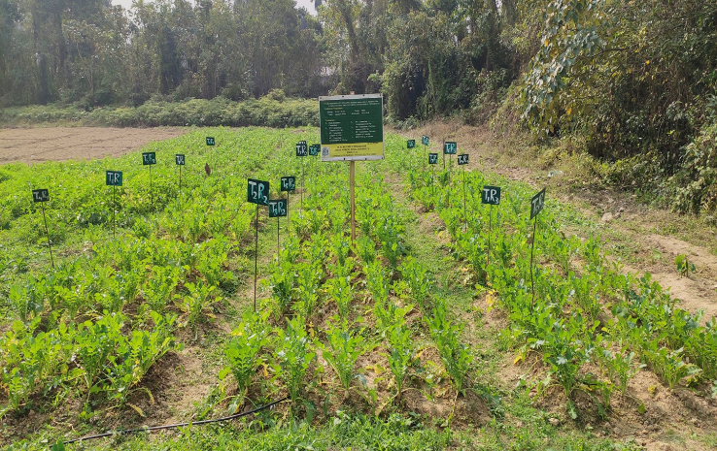
Fig1. Experimental plot

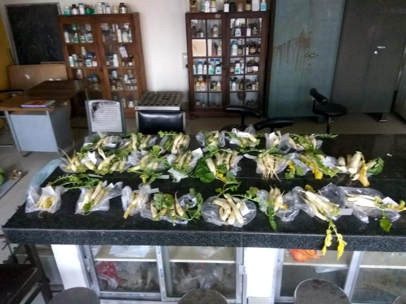
Fig 2. Harvested radish

