SKELETAL SURVEY IMAGING IN CLINICAL PRACTICE: CHALLENGES, INNOVATIONS, AND FUTURE PERSPECTIVES

ABSTRACT:-
The diagnosis of suspected non-accidental injury (NAI) and complex skeletal diseases is still based on skeletal Survey (SS) imaging, although it is becoming progressively difficult to use. This article is a review of the current state of SS practice with particular emphasis on the most important roles of standardized procedures and strict Quality Assurance (QA), which are crucial to ensuring great diagnostic yield. We discuss the game changers, such as the increased tissue characterization of CT that Dual-Energy CT (DECT) provides, and state-of-the-art, the ultra-high-resolution of new Photon-Counting Detector CT (PCD-CT). Also, the incorporation of Artificial Intelligence (AI) is transforming the sphere fast, and deep learning models provide high accuracy in diagnosing the fractures, and Large Language Models (LLMs) simplify the process of reporting radiology. Finally, the implementation of these technological advancement and maintenance of high levels of ethics, medico-legal, and radiation safety is important in order to optimize the patient outcome and shape the future of musculoskeletal radiology.
KEY WORDS:-
Skeletal Survey, Non-Accidental Injury (NAI), Photon-Counting Detector CT (PCD-CT), Artificial Intelligence (AI), Quality Assurance (QA), Follow-up Skeletal Survey (FUSS)
INTRODUCTION:
A skeletal survey imaging refers to a series of X-rays made of the entire skeleton to identify any abnormalities like fractures, bone diseases or tumors. It is extensively utilized in medicine to diagnose disorders such as suspected non-accidental injuries, detecting subtle or occult bone injuries, skeletal dysplasia as well as metastatic bone diseases that might not be apparent with the aid of single X-rays. The process is done at varying angles so that a thorough assessment of the bones is found. Altogether, skeletal survey is a basic diagnostic technique in musculoskeletal medicine.
Skeletal survey imaging is a visualist representation of the modern radiology of diagnosing. The basic investigation in suspected pediatric non-accidental injury is the plain radiography skeletal survey which is less costly, available in smooth, and offers easy to measure imaging services with a reasonably low effective dose of radiation comparable to a month of background radiation ^{[1]}.
Artificial intelligence has become a technological revolution in musculoskeletal imaging and has provided answers to the problem of growing volumes of imaging and shortages of fellowship-trained radiologists. The multimodal AI models are exhibiting impressive flexibility in musculoskeletal imaging that are helping in the complex tasks such as fracture atlas, bone age, osteoarthritis grade, and tumor detection. They have sensitivity values of 91.43 and specificity rate of 92.12 to detect fracture on plain radiograph. This accelerates scan speed and in turn increases diagnostic access to advanced imaging processes ^{[2]}.
Even with technological advancements, the skeletal survey imaging has been having significant challenges in the clinical practice. The nature of imaging procedures especially among children presents a very complex procedure which demands expert knowledge and strict compliance with high-technical standards to produce the best of the diagnosis effects ^{[3]}.
Another major breakthrough in skeletal imaging technology is the Dual-energy computed tomography. This novel modality shows excellent musculoskeletal modalities, especially in the examination of crystal arthropathy, bone marrow edema, soft tissue structures such as tendons and ligaments whereas virtual monoenergetic images of different energies improve the techniques of removing metal artifact ^{[4]}.
The structured reporting programs have become an important innovation in skeletal imaging practice, especially in such complicated cases like skeletal dysplasia. It has been proven that the accuracy rates range between 48% and 64% when a structured training intervention is implemented ^{[5]}.
The nature of complementary of the various imaging modalities is what still characterizes the best diagnostic approaches in skeletal imaging. Comparison of skeletal survey & bone scintigraphy on suspected child abuse cases show that 20% of injured children are only lesions seen on bone scan, whereas the metaphyseal causes of child abuse are largely invisible on the scintigraphy with just 35% showing increased uptake. This highlights the paramount essence of effective imaging regimens with the application of multiple modalities to obtain maximum diagnostic sensitivity (Fig-1) ^{[6]}.

Fig-1: Schematic Representation of Key Challenges, Innovations, and Future Horizons of Skeletal Imaging.
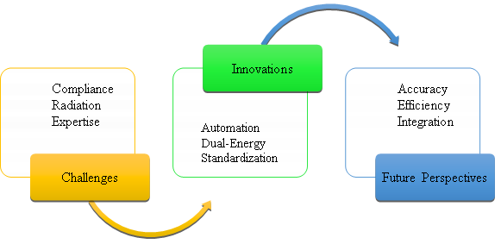
IMAGING PROTOCOLS:
The skeletal survey is a paramount element of the complete radiological survey of suspected child physical abuse that should not be compromised. Its diagnostics power is the direct product of the rigor of the imaging protocol implementation, which points at the need to standardize technical parameters.
- Required Radiographic Views
The complete skeletal survey is basically described as a combination of radiographic images of all body parts undertaken in different perspectives. Although certain institutional procedures can differ, the normal first examination usually consists of 20 to 30 images, which is usually mentioned as about 25 standard views ( Table 1). These angles are carefully selected 7and adjusted to ensure the most obvious and mild injuries are observed all over the skeleton^{[7,8,9]}.
REGION | VIEW | NO. OF IMAGES | REGION | VIEW | NO. OF IMAGES
Skull | Anteroposterior (AP) or Posteroanterior (PA) | 1 | Upper Limbs | Bilateral Forearms (AP) | 2
Skull | Lateral | 1 | Upper Limbs | Bilateral Hands (Posteroanterior - PA) | 2
Thorax | Anteroposterior (AP) | 1 | Lower Limbs | Bilateral Femora (AP) | 2
Thorax | Oblique Rib Views (Left and Right) | 2 | Lower Limbs | Bilateral Lower Legs (AP) | 2
Spine | Whole Lateral Spine | 1 | Lower Limbs | Bilateral Feet (Dorsoposterior - DP) | 2
Spine | Lateral Lumbosacral Spine | 1 | Joints (Specific Views) | Coned Lateral Knees (Left and Right) | 2
Pelvis | Anteroposterior (AP) | 1 | Joints (Specific Views) | Coned Anteroposterior (AP) Ankles | 2
Upper Limbs | Anteroposterior (AP) | 1 | Joints (Specific Views) | Coned Lateral Ankles (Left and Right) | 2
Table 1: Shows Standard Radiographic Views and total of 25 images taken during Initial Skeletal Survey.
- Parameters Of Image Quality & Technologies
The quality of the images is of utmost importance since one may end up with non-diagnostic studies and even lose key findings because of poor quality. The quality of diagnostic is attained by tight regard to technical standards, especially with regard to positioning, collimation, and exposure. The positioning should be accurate, with adequate centering and projection; e.g., special tools, such as immobilization. To decrease scattered radiations, it should be collimated close to the region of interest to bring about a better contrast of the image. The exposure parameters should be adjusted to obtain sufficient penetration and contrast resolution between the necessity to visualize subtle cortical and metaphyseal fractures. It is highly recommended that, institutions should operate the quality assurance program usually through an imaging checklist, to maintain high and consistent skeletal survey quality ^{[1,7,10]}.
- Radiation Dose Considerations & ALARA Principles
As pediatric patients are vulnerable, SS protocols focus on radiation dose issues. Although the diagnostic requirement of the SS on NAI testing is much more important than the comparative low radiation dose, an attempt to keep the ALARA (As Low As Reasonably Achievable) principle should be made in all possible cases. Advanced technological advances in high sensitivity digital detectors and high tube filters have helped in the important dose reduction approaches. To make sure that the SS is a high-yield diagnostic tool without undermining the long-term patient safety, the optimization of these protocols is a continuous natural process. The three major elements of the principle of ALARA implemented with regard to SS imaging with emphasis on a balance of diagnostic effectiveness and radiation safety^{[10,11]} (Fig-2).
Fig-2: Key Components of ALARA Principle

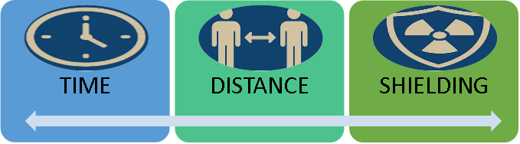
GUIDELINES COMPLIANCE AND THE REQUIREMENT OF QUALITY ASSURANCE PROGRAMS.
- Guideline & Necessity of Quality Assurance Programs.
Evidence-based NAI diagnosis requires adherence to professional SS regulations. Intensive QA measures and imaging checklists need to be used by institutions to standardize technique, positioning and series completeness. Such protocols ensure that the number of poor quality studies is minimized whereby maximum number of injuries are identified and used to guarantee diagnostic value against clinical and legal defense. The major QA measures, including imaging checklists, ensure that there are appropriate technique, positioning and completeness of the radiographic series, which reduces the risk of poor studies ^{[1,11]}.
- The Authority Of ACR Protocols
The best NAI imaging guidelines are offered by the American College of Radiology (ACR) and Society of Pediatric Radiology (SPR ) Practice Parameters. Standardizing the diagnosis and reducing the variability in practice are the two protocols that involve two-week-follow-up surveys that are obligatory. When these high-yield standards are followed patient safety is guaranteed and the skeletal survey results in court are maximally legally valid^{[1, 9,10]}.
CLINICAL APPLICATIONS:
- Core Application: Skeletal Survey For Suspected Non-Accidental Injury (NAI)
The skeletal survey has the greatest and most time sensitive use in assessment of suspected non-accidental injury. The second common occurrence in NAI after cutaneous lesions is fractures. The great sensitivity of the SS is essential to identify silent or undetected acute and healing venular injuries in the clinic that may be either invisible by physical examination or not present ^{[1,13]}.
Fracture Patterns Specific to Abuse: are key to the diagnosis of NAI, Some fractures are said to be highly absence of abuse, such as fractures of the anterior ribs, classic metaphyseal lesions (CMLs) or "bucket-handle/corner" fractures, and multiplanar skull fractures(Fig-3 & 4). Bony injuries identified among the cases of child abuse include rib fractures. These injuries need to be carefully and standardized identified which might require particular radiographic projections ^{[3,6,9]}.

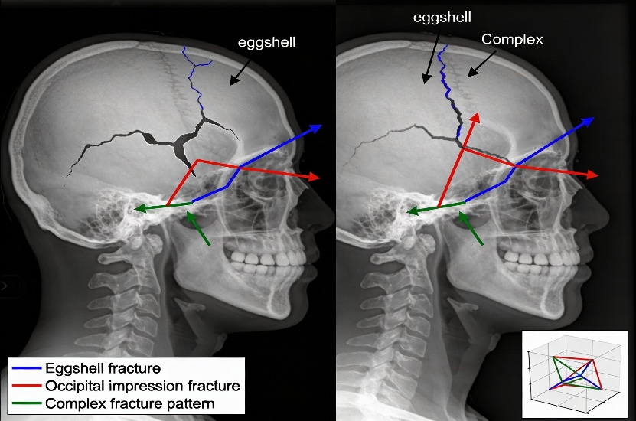
Fig. 3: X-ray illustration: Multiplanar skull fractures in child abuse (NAI)

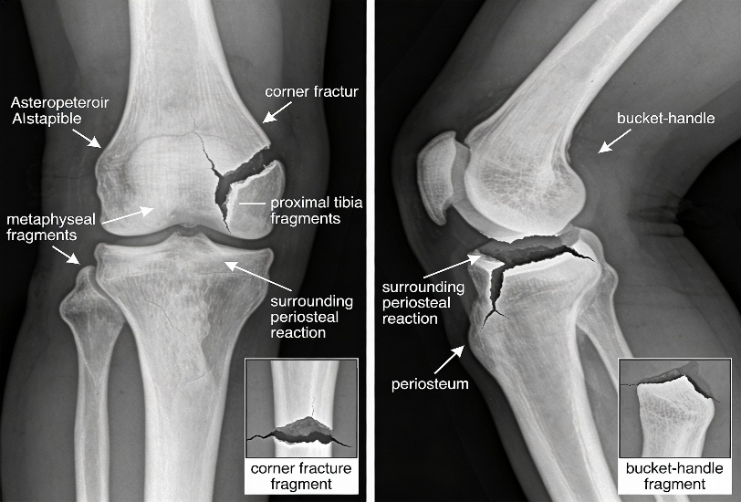
Fig. 4: Classic metaphyseal lesions (CML) and bucket-handle fractures in child abuse

Age-Specified Imaging Protocols: Not all imaging protocols should be identical and should vary according to the children in the range of ages. The ACR-SPR practice parameter has a guideline on the performance of the SS. In most instances, a skeletal survey can be suggested to all children under 24 months suspected of abuse. In children of old age (e.g., above 24 months) the necessity of an SS is conditioned in accordance with clinical signs, but full SS could still be justified in the event of physical abuse. Such age-specific intervention can be used to make sure that the resources are used properly and to reduce radiation in children who are not at risk^{[3,9,10,13,14]}.
Follow-up Skeletal Surveys (10–14 days post-initial): HC follow-up limited skeletal survey (FUSS) is already proven to be important. The FUSS is normally advisable after 10-14 days of the first investigation. Acute injuries, like swelling of the soft tissue or occult fracture, can only be seen as radiographically evident when periosteal new bone starts to develop, a process taking place during the 10-to-14-day period. One of the institutional issues is to enhance adherence to the FUSS^{[8,14]}.
Fig-5
A- MRI of Brain showing areas of injury (arrows)
B- CT Scan of Cervical Spine showing abnormality at the craniocervical junction (arrow)
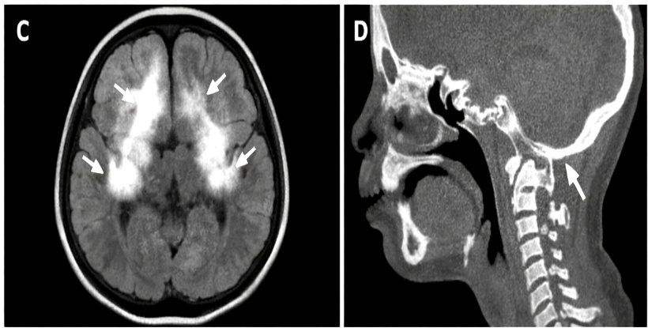
A
B
Complementary Imaging Modalities: Although the SS is used as the major screening tool, other imaging is usually used in conjunction. An adjunctive method that could be used in conjunction with the SS is bone scintigraphy (radioisotope bone scan). Magnetic Resonance Imaging (MRI) of the brain and whole spine (fig. 5-A) as well as Computer Tomography (CT), in particular as to the skull and spine (fig. 5-B) is often a part of the first workup of the suspected child abuse in order to assess soft tissue and central nervous system injuries ^{[3,6,9]}.
- Skeletal Dysplasia
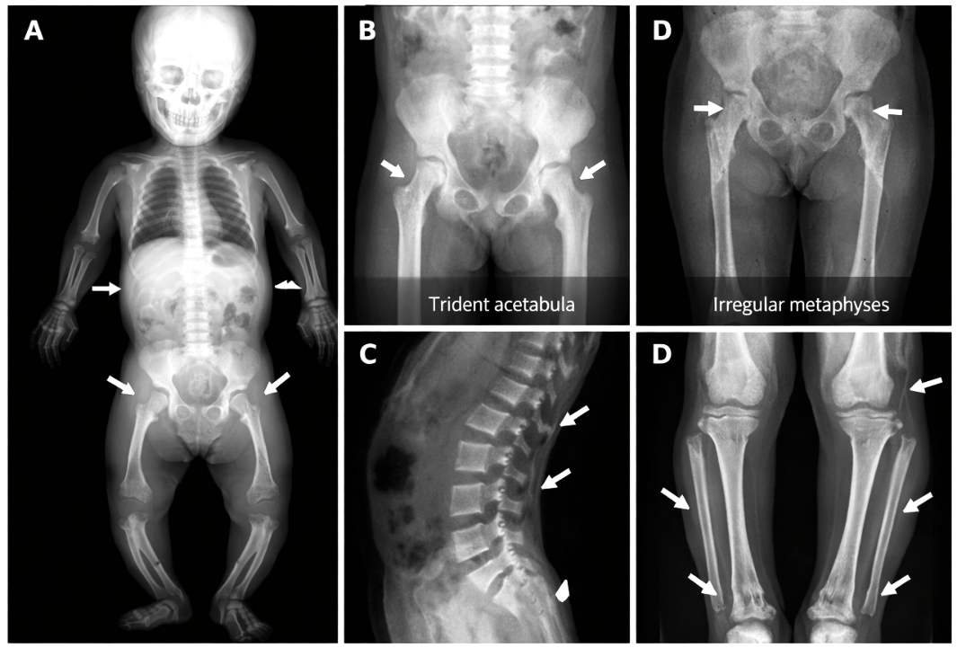
Skeletal dysplasia is an extensive and complicated group of genetic disorders and skeletal survey plays the crucial role in diagnosis and classification. The skeletal dysplasia states are complex in nature and therefore, a structured radiological reporting format helps in the interpretation of the SS. Standardized language in reporting contributes to less ambiguity, as well as enhancing uniformity and comparability amongst the reports of different institutions and particular providers. Standardized terminology plays a critical role in precise description of the findings, and this helps the geneticists and clinicians to shortlist the differential diagnoses in an effective manner. This is a gradual process that will help to achieve proper diagnosis in this multifaceted field. Radiologists have to distinguish true dysplasia and the mimickers as well, and a proper interpretation of SS findings also implies that the radiologist needs to consider some metabolic illnesses ^{[5]} (Fig. 6).
Fig 6: Imaging of Skeletal Dysplasia. (A) Full skeletal survey showing typical features of skeletal dysplasia (bowing of tong bones indicated by white arrows). (B) Pelvic X-rays showing trident acetabula (left arrows) and irregular metaphysis of the, arrows) of the femurs. (C) Lateral spine X-ray showing platyspondyly (flattened vertebral bodies, arrows). (D) X-rays of lower lags showing bowed tibiae and metaphyseal irregularity.

CHALLENGES IN IMPLEMENTATION & INTERPRETATION
- Technical Challenges
This is due to poor practices of imaging guidelines and the failure to have uniform practice across the institutions, which checks the consistent high quality of Skeletal Survey (SS) examinations. This is especially difficult when hospitals do not operate with specific personnel assigned to pediatric radiology, and who will find it difficult to provide the technical specificities that an ideal SS is going to demand. Such variability decreases the diagnostic yield. The essential parameters such as correct positioning and collimation are hard to sustain and motion artifact is regular, particularly because multiple images are required. Major and minor movements of the patient may also hide small fractures, which might lead to false-negative outcome. It has been demonstrated that the implementation of effective institutional policies, Quality Assurance (QA) programs, as well as imaging checklists and improved compliance and general imaging quality ^{[1,9].}
- Diagnostic Challenges
The SS diagnostic interpretation is associated with many challenges especially because of the detection sensitivity limit and limitations of the injuries dating. The skeletal survey may have a weakness in its sensitivity to identify some lesions. Indeed, in case of classic metaphyseal lesions (CMLs) which are very specific (abuse) some complementary methods such as bone scintigraphy do not find any in a major percentage of cases. In general, the comparison of SS and bone scintigraphy studies indicate that these two modalities are equally useful, but certain injuries are specific to one or the other, which directly leads to the necessity of their supplementary application ^{[3,6,13]}.
- Meeting The Challenges Of Following Up Skeletal Survey (FUSS) Compliance
One of the implementation issues is that there is a specific and repetitive implementation issue to ensure that the Follow-up Skeletal Survey (FUSS) is completed. The FUSS older, normally, 10-14 days following the primary study. The completion rates of the FUSS may not be good though; one report recorded a 40 percent average completion rate. The obstacles to completion of FUSS are multifactorial, which entail insufficient knowledge of the provider on the significance of the FUSS, no standardized order of the FUSS prior to hospital discharge, loss to follow-up, and parental refusal. The methods to the barriers identified to improve the FUSS completion rates have required interventions like provider education, protocolization of FUSS scheduling, and documentation standardization. Enhancement of FUSS completion is essential to reduce chances of suffering recurrent injury and to guarantee long-term safety of the child ^{[14].}
INNOVATIONS & TECHNOLOGICAL ADVANCEMENTS
- High Quality CT: Clinical Usefulness Of Dual-Energy CT (DECT) In Bone Characterization
Dual-Energy Computed Tomography (DECT) has the advantage of being a robust and an advanced new modality which is able to give new insight in the characterization of the tissues that cannot be done using a conventional single-energy CT. DECT allows material decomposition images to be generated by obtaining attenuation data at two sets of different energy spectra. This gives it distinctive quantitative data, including the ability to create virtual non-calcium images, which may preferentially delete the bone structures in order to see marrow or soft tissue lesions that would otherwise be obscured by the dense bone structures. Looking at musculoskeletal imaging, DECT has been demonstrated to be increasingly useful in crystal arthropathy including gout, and bone marrow edema, which was previously viewed as the prerogative of Magnetic Resonance Imaging (MRI). Radiologists should be well skilled in the technical complexity and other reconstruction algorithms of DECT so as to be able to maximize its potential use in both everyday clinical practice and studies ^{[4]}.
- Emerging Technology: Photon-Counting Detector CT (PCD-CT) To Ultra-High Resolution Imaging.
The Photon-Counting Detector CT (PCD-CT) which represents the next step in CT technology will add to the further improvement of musculoskeletal imaging. Contrary to conventional energy-integrating detectors, PCD-CT systems are counted devices, that is, they count single X-ray photons and measure their energy. This gives a more accurate spectral characterization than that of even DECT, generating really good signal to noise ratios and quality images. Benefits of PCD-CT are directly applicable to skeletal assessment because it is an ultra-high spatial resolution imaging of central bone structures, and large bone joints. This increase of cortical and trabecular resolution greatly improves the appearance of a variety of skeletal abnormality with better bone digitization and characterization. Moreover, PCD-CT technology demonstrates prospects in metal artifact reduction that is usually a problem in post-operative or orthopedic trauma radiography ^{[15]}.
- Patient Safety Focus: General Pediatric Radiation Dose Reduction Strategies In PED Skeletal Imaging.
The major initiative in musculoskeletal imaging in pediatrics is the increased focus on patient safety and radiation reduction. Optimized protocols coupled with high-sensitivity digital detectors and innovated tube filtering methods have resulted in significant radiation dose-reduction methods in both customary radiography and CT. The combination of the sophisticated techniques like iterative reconstruction algorithm assists in preserving the quality of diagnostic images but substantially reduces effective dose. It is obligatory that the ALARA (As Low As Reasonably Achievable) principle should continue to be adopted, especially when patients that are being examined are young and delicate enough (e.g., Skeletal Survey) ^{[10,11]}.
D. Evolution Of Modalities: Taking Whole-Body MRI To A Higher Level Of Evaluation Of The Skeleton.
Although the SS is still the gold standard of primary screening during NAI, the Whole-Body Magnetic Resonance Imaging (WB-MRI) has become a radiation free crucial tool especially in certain clinical scenarios. WB-MRI has shown superior diagnosis on some diseases bringing about its continually increasing features in non-invasive imaging. It is also useful specially in the overall examination of bone marrow infiltration and the prognosis of diseases such as multiple myeloma where it can tell the focal and diffuse bone marrow lesions. Improvements have been done in the application of quantitative Diffusion-Weighted Imaging (DWI) in measuring treatment response and dynamic intensity entropy transformation. Creation of CT-resembling MRI sequences further fills the gap between the two techniques such that the future development of MRI can carry on with the development of musculoskeletal assessment without the negative factor of radiation-free diagnosis^{[11,16]}.
QUALITY ASSURANCE & IMPROVEMENT
The diagnostic reliability of the skeletal survey (SS) is impossible to maintain without Systematic Quality Assurance (QA) programs especially in cases where high stakes NAI aur involved. The policies in the institution should be strict regarding the implementation of standards. One of the fundamental aspects of QA is that it involves the application of checklists and systematic operations to reduce technique, positioning, and completeness errors to reduce non-diagnostic or low quality studies. Some of the best QA practices include learning interventions, audit, and feedback. The data indicate that such programs increase compliance greatly; as an example, the level of SS compliance increased to 86 percent in high-risk groups after the implementation of QA (a baseline of 36 percent). This is an essential improvement to decrease false negatives and improve the overall level of quality as well as medico-legal defensibility of the examination ^{[1,14]}.
COMPARATIVE ANALYSIS: SKELETAL SURVEY VS. BONE SCINTIGRAPHY
FEATURE | SKELETAL SURVEY (SS) | BONE SCINTIGRAPHY (BS)
Modality Type | Anatomic/Morphologic (Bony structure) | Physiologic/Functional (Metabolic activity)
Primary Role | Gold Standard for initial screening/morphology. | Occult or acute injury Complementary Tool.
Strengths | Excellent for Classic Metaphyseal Lesions (CMLs) and fracture dating. | Very sensitive when it comes to acute, occult fractures (ribs, long bone shafts).
Weaknesses | Reduced sensitivity to fractures that are pure acute and subtle. | Low sensitivity to CMLs (around 35% of them detected) and skull fractures.
Radiation Type | Ionizing Radiation (X-rays). | Ionizing Radiation (Radiotracer).
Conclusion | Necessary for fracture pattern and dating; defines morphology. | Best for detecting physiological bone reaction; needs X-ray confirmation.
Table 2: Comparative Analysis of Skeletal Survey and Bone Scintigraphy in Skeletal Injury Detection
FUTURE PERSPECTIVES: THE INTEGRATION OF ARTIFICIAL INTELLIGENCE
FUTURE Prospects: The Implementation of Artificial Intelligence. The future of the musculoskeletal imaging domain is inherently connected to the incorporation of the Artificial Intelligence (AI) and deep learning that is likely to increase diagnostic effectiveness and accuracy and broaden the opportunities of non-invasive assessment ^{[16, 18]}.
- DUAL ROLE OF ARTIFICIAL INTELLIGENCE : EFFICIENT WORKFLOW AND DIAGNOSIS:
At the same time, AI in Workflow uses Generative AI and Large Language Models (LLM) to change reporting. These models simplify the diagnostic task by building in-depth reports and modeling complicated situations, which will free up time of radiologists to handle hard cases. Radiology will become a new revolution after the implementation of Artificial Intelligence (AI). With AI-Assisted Analysis, machine learning models, which include Convolutional Neural Networks (CNNs) are used in skeletal surveys and X-rays due to their high accuracy in detecting bone fracture. The AI-based Computer-Aided Diagnosis (CAD) systems can be more sensitive and specific than the conventional diagnostic methods. ^{[2,17,18]}
- Specialized AI Programs: Systemic Disease & Bone Age Quantitative Assessment
Use of AI is also applicable in very specialized fields of quantitative evaluation. Machine learning and radiomics are applied in the quantitative evaluation of bone marrow myeloma multiple (MM) infiltration and prognosis in systemic diseases. It usually includes the use of AI on radiation-free modalities, such as Whole-Body MRI, that includes quantitative Diffusion-Weighted Imaging (DWI) and dynamic intensity entropy transformation, to determine treatment reaction. Moreover, AI, specifically with the help of deep learning approaches, is becoming more frequently involved in bone age estimation through the use of a variety of medical imaging tools, as an avenue on the way to radiation-free and less subjective testing in the pediatric group ^{[19,20]}.
MEDICO-LEGAL & ETHICAL CONSIDERATIONS
Commonly used in the suspected Non-Accidental Injury (NAI), the Skeletal Survey (SS) has come under the focus of the medico-legal and ethical criticism concerning the protection of children and resulting lawsuits. False diagnoses cause serious repercussions in the court of law, which can only be avoided by thorough records including a chain of custody of the pictures. To ensure successful diagnosis, the multidisciplinary communication between the radiologists, pediatricians and social workers is mandatory. The ethical issues of the future include common data privacy and the responsible AS AI/machine learning systems implementation in the clinical practice^{[1,9,13,18]}.
DISCUSSION
The ACS-SPR protocols of standardization of Skeletal Survey are considered crucial to the maximization of legal validity in court. Although Jacques Bence confirm that Quality Assurance programs significantly enhance the institutional compliance, other authors such as Iram J. Ashraf assert that the tools such as provider education are still necessary to address the obstacles to the completion of the follow-up surveys. In my opinion, although the new technologies such as Photon-counting CT offer unprecedented levels of resolution, clinical success depends on the combination between such innovations and strict and standardized human methods, so as to make the use of such technologies completely safe to the child undergoing the procedure.
CONCLUSION
The skeletal survey (SS) is an essential component of capstone diagnostic radiology specifically in close-to-the-knife examination of possible non-accidental injury (NAI) and the thorny classification of skeletal dysplasias. As it has been proved all through this analysis, the utility of the SS directly depends on the strict compliance to the standardized protocols as well as the efficient Quality Assurance (QA) programs. The fact that technical issues, which include practice variability and low adherence rates to Follow-up Skeletal Survey (FUSS), persist despite institutional efforts and education supports the necessity of further institutional initiatives and educational interventions. Remarkable accounts of technological improvements are playing an active role in the future of skeletal imaging. New higher modalities such as Dual-Energy CT (DECT) and more recent Photon-Counting Detector CT (PCD-CT) are now being able to offer previously unseen tissue characterization and ultra-high resolution of the spatial resolution. At the same time, the incorporation of Artificial Intelligence (AI), through the adoption of Fracture Detection by means of Machine Learning models and shows and reporting simplification by means of Generative AI, is likely to increase the diagnostic confidence and efficiency. Such a transformation into a hybrid, multi-mod approach, which places safety and quantitative evaluation in the forefront, is essential to enhance patient outcomes and high medico-legal standard demanded in such a critical field.
FUTURE RECOMMENDATIONS:-
More attention should be focused on increased compliance with standardized Skeletal Survey (SS) and Follow-up Skeletal Survey (FUSS) procedures by including them in QA programs and checklists in the future. When assessing diagnostic accuracy and efficiency, institutions need to incorporate AI and novel modalities (such as PCD-CT and DECT). Lastly, it is crucial to maintain the attention to radiation safety (ALARA), as well as stringent medico-legal/ethical principles, in order to maximize patient services and transform the field of musculoskeletal radiology.

REFERENCES:
- Bence J, Kidd M, Pitcher RD. The impact of a quality assurance programmed on skeletal survey imaging for suspected non-accidental injury. Br J Radiol. 2025. https://doi.org/10.1093/bjr/tqaf184 .
- Oettl FC, Zsidai B, Oeding JF, Hirschmann MT, Feldt R, Fendrich D, et al. Artificial intelligence-assisted analysis of musculoskeletal imaging—a narrative review of the current state of machine learning models. Knee Surg Sports Traumatol Arthrosc. 2025;33:3032-3038. https://doi.org/10.1002/ksa.12702 .
- Colleran GC, Fossmark M, Rosendahl K, Argyropoulou M, Mankad K, Offiah AC. ESR Essentials: imaging of suspected child abuse—practice recommendations by the European Society of Paediatric Radiology. Eur Radiol. 2025;35:1868-1880. https://doi.org/10.1007/s00330-024-11052-4 .
- Albano D, Di Luca F, D'Angelo T, Booz C, Midiri F, Gitto S, et al. Dual-energy CT in musculoskeletal imaging: technical considerations and clinical applications. Radiol Med. 2024;129(7):1038-1047. https://doi.org/10.1007/s11547-024-01827-6 .
- Gupta A, Gupta N, Kabra M, Kaur T, Gabra P, Khan MA, et al. Impact of structured reporting of skeletal survey in skeletal dysplasia: a single institution experience. Indian J Radiol Imaging. 2023;33(2):144-149. https://doi.org/10.1055/s-0043-1762935 .
- Mandelstam SA, Cook D, Fitzgerald M, Ditchfield MR. Complementary use of radiological skeletal survey and bone scintigraphy in detection of bony injuries in suspected child abuse. Arch Dis Child. 2003;88(5):387-390 https://doi.org/10.1136/adc.88.5.387 .
- Phillips, K. L., Bastin, S. T., Davies-Payne, D., Browne, D., Bird, H. L., Craw, S., Duncan, D., Depree, P., Leigh, A., McLaughlin, A., Metcalfe, R., Murdoch, J., Pearce, K., Perry, D., Thomas, I., Thomson, G. D., Vogel, S., Wilson, F., & Teele, R. L. (2015). Radiographic skeletal survey for non-accidental injury: Systematic review and development of a national New Zealand protocol. Journal of Medical Imaging and Radiation Oncology, 59(1), 54–65. https://doi.org/10.1111/1754-9485.12271
- Manchester University NHS Foundation Trust. (2022). Skeletal survey examinations in children: Information for parents and carers (TIG 77/17). Manchester University NHS Foundation Trust. https://www.mft.nhs.uk/app/uploads/2023/02/TIG-77-17-Skeletal-Survey-Feb-2023.pdf
- Botash, A. S., & Ashraf, I. (2021). CHAMP practice recommendation: Skeletal survey. Child Abuse Medical Provider (CHAMP) Program. https://www.champprogram.com/pdf/skeletal-survey-march-2021.pdf
- American College of Radiology, & Society for Pediatric Radiology. (2021). ACR–SPR practice parameter for the performance and interpretation of skeletal surveys in children. American College of Radiology. https://www.acr.org/-/media/ACR/Files/Practice-Parameters/Skeletal-Survey.pdf
- Kraus, T., et al. (2025). Recent advances in pediatric musculoskeletal imaging. Journal of Children’s Orthopaedics, 19(2), 112–120. https://doi.org/10.1177/18632521251325122
- Wood, J. N., Fakeye, O., Feudtner, C., Mondestin, V., Localio, R., & Rubin, D. M. (2014). Development of guidelines for skeletal survey in young children with fractures. Pediatrics, 134(1), 45–53. https://doi.org/10.1542/peds.2013-3242
- Nguyen, A., & Hart, R. (2018). Imaging of non-accidental injury: What is clinical best practice? Journal of Medical Radiation Sciences, 65(2), 123–130. https://doi.org/10.1002/jmrs.269
- Ashraf, I. J., Ackley, D. F., Razawich, K., Botash, A., Schafer, M., & Pekarsky, A. (2022). Improving follow up skeletal survey completion in children with suspected nonaccidental trauma. Pediatric Quality & Safety, 7(4), e567. https://doi.org/10.1097/pq9.0000000000000567
- Baffour, F., et al. (2023). Photon-counting CT for musculoskeletal imaging: Technical principles and clinical applications. AJR. American Journal of Roentgenology, 220, 554–563. https://doi.org/10.2214/AJR.22.28418
- Hock, R. (2023). Advances in musculoskeletal radiology: A comprehensive review. OMICS Journal of Radiology, 12, 503. https://doi.org/10.4172/2167-7964.1000503
- Guermazi A, Omoumi P, Tordjman M, Fritz J, Kijowski R, Regnard N-E, et al. How AI may transform musculoskeletal imaging. Radiology. 2024;310(1):e230764. doi:10.1148/radiol.230764. https://doi.org/10.1148/radiol.230764
- Kutbi, M. (2024). Artificial intelligence-based applications for bone fracture detection using medical images: A systematic review. Diagnostics, 14(17), 1879. https://doi.org/10.3390/diagnostics14171879
- Anonymous. (2024). Quantitative assessment of multiple myeloma: Current imaging techniques and emerging roles of CT and MRI. American Journal of Nuclear Medicine and Molecular Imaging, 14(4), 208–229. https://doi.org/10.62347/NLLV9295
- Anonymous. (2025). Radiation-free and low-dose imaging strategies for skeletal assessment and bone age with artificial intelligence integration. Diagnostics, 15(2), 257. https://doi.org/10.3390/diagnostics15030257

