Original Research Article

Comparative Evaluation of the Color Stability of Monochromatic Versus Polychromatic Resins After Coffee Staining: An In Vitro Study

.
ABSTRACT

Aims: This in vitro study aimed to evaluate and compare the color stability and color match of a monochromatic versus a polychromatic composite resin after a coffee staining protocol..
Study design: This study employed an in vitro, randomized, and blinded comparative experimental design.
Place and Duration of Study: Department of Dentistry, State University of Western Paraná (UNIOESTE), between June 2024 and July 2025.
Methodology: Fifteen extracted human molars with standardized Class V cavities were restored with either a monochromatic resin (Omnichroma) or a polychromatic resin (Filtek Z350 XT, shade A3). The specimens were subjected to two staining cycles designed to simulate 10 months of coffee consumption. Two blinded clinicians visually assessed the color match at baseline (T1), after the first cycle (T2), and after the second cycle (T3).
Results: The polychromatic resin, Filtek Z350 XT, demonstrated a superior color match at baseline (P=.007), whereas the monochromatic resin, Omnichroma, performed significantly better after the first staining cycle (P=.004). At the final assessment (T3), both materials showed similar, though diminished, color compatibility (P=.784). Inter-rater reliability for the visual assessment was poor (Cohen's Kappa = 0.179), indicating significant subjectivity.
Conclusion: The monochromatic resin provided long-term aesthetic performance comparable to the conventional polychromatic resin. These findings confirm its viability as a clinical alternative and highlight the limitations of subjective visual assessment, suggesting a need for instrumental analysis in future studies.

Keywords: composite resins, coffee, humans, single-shade, color perception.

1. INTRODUCTION

The development of restorative materials that combine functionality with aesthetics is a primary focus of modern dentistry. Among these materials, composite resins are notable for their ability to effectively mimic the natural color of teeth [1, 2]. However, accurately reproducing the natural tooth shade remains a significant clinical challenge. The conventional approach involves a multi-shade system, most commonly based on the VITA Classical scale (VITA Zahnfabrik, Germany), which categorizes shades by hue (A-D) and chroma/value (1-4) [3]. This extensive range of options complicates ideal shade selection, potentially increasing inventory costs and clinical chair time [1].
To streamline this process, single-shade composite resins—also known as universal or monochromatic—have been introduced. These materials utilize a "blending effect," a phenomenon of color assimilation, to adapt to the surrounding enamel and dentin [2]. One such material, Omnichroma (Tokuyama Dental, Tokyo, Japan), employs structural color technology designed to match all 16 shades of the VITA scale. Although some studies report high chromatic adaptation potential, the overall effectiveness of single-shade systems remains under investigation, with other reports indicating limitations in their ability to match the full spectrum of tooth shades [4, 5].
Beyond the initial shade match, the long-term aesthetic durability of composite resins remains a critical clinical challenge. Color stability can be compromised by intrinsic material properties and extrinsic factors, such as diet and oral hygiene [1, 6, 7]. Chromogenic beverages like coffee are known to cause significant discoloration, potentially leading to the premature replacement of otherwise functional restorations and unnecessary loss of tooth structure [7, 8].
Although the color stability of conventional resins is well-documented, the performance of newer single-shade systems after prolonged exposure to staining agents is less understood.
Therefore, this study aimed to compare the color compatibility of a monochromatic (Omnichroma) and a polychromatic (Filtek Z350 XT) composite resin after being subjected to a coffee staining protocol. The null hypotheses tested were: (1) there is no difference in color compatibility between the two types of restorative materials, and (2) coffee staining does not affect the color compatibility between the restorations and the adjacent tooth structure.

2. material and methods

Study Design, Place and Duration of Study:
This in vitro, randomized, and blinded comparative study was carried out at the Department of Dentistry, State University of Western Paraná (UNIOESTE), Cascavel, Paraná, Brazil, between June 2024 and February 2025.

Ethical aspects
This in vitro study was approved by the Research Ethics Committee of the State University of Western Paraná, under protocol number 7,050,710. All teeth were collected after patients provided written informed consent.

Tooth selection and preparation
Fifteen sound human third molars, stored in a 0.1% thymol solution at 4°C for no more than 30 days, were selected for this study [9]. The teeth were cleaned with a pumice-water slurry, and their shade was visually confirmed as A3 using the VITA Classical scale. Specimens with discoloration, caries, or enamel defects were excluded. For teeth with incomplete root formation, the root apex was sealed with Filtek Z350 XT composite resin (3M ESPE, St. Paul, MN, USA) over a layer of Ambar Universal APS adhesive (FGM Dental Group, Joinville, SC, Brazil). The resin and adhesive layers were light-cured for 40 and 20 seconds, respectively, using a Valo LED device (Ultradent, South Jordan, UT, USA) at an intensity of 1,400 mW/cm².
On the smoothest buccal and lingual surfaces of each tooth, two standardized Class V cavities (4 mm wide x 2 mm high x 2 mm deep) were prepared 2 mm coronal to the cementoenamel junction (CEJ). The cavities were prepared using a water-cooled #1016 spherical diamond bur (KG Sorensen, Cotia, SP, Brazil). To ensure precision, the bur was replaced after every two preparations [9]. Cavity margins were prepared without a bevel [7]. One surface was marked on the root for identification (Figure 1).

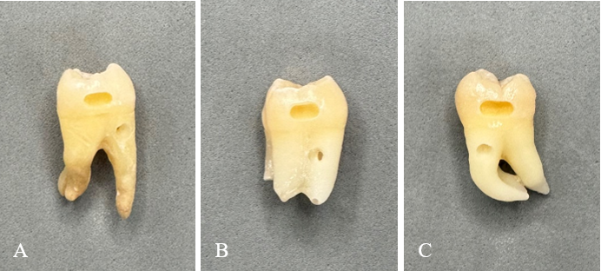
Figure 1: Specimen preparation. (A, B, C) Examples of extracted human third molars after the preparation of standardized Class V cavities (4 mm x 2 mm x 2 mm) on the buccal and lingual surfaces. The root of one cavity was marked for group identification.
Source: author

Tooth restoration and randomization
Cavities were randomly assigned to one of two groups: Group R1, restored with Filtek Z350 XT polychromatic resin (shade A3), and Group R2, restored with Omnichroma monochromatic resin. All restorations were performed by a single operator using a single-increment technique. Prior to restoration, a universal adhesive (Ambar Universal APS) was applied to all cavities with a microbrush following the manufacturer's instructions. The solvent was evaporated with a gentle air stream for five seconds, and the adhesive was light-cured for 20 seconds. For Group R1, Filtek Z350 XT (shade A3B) was applied and light-cured for 40 seconds. For Group R2, Omnichroma was applied and light-cured for 40 seconds. All materials used are detailed in Table 1.
Following restoration, the surfaces were finished and polished with a standardized sequence of abrasive discs (TDV, Pomerode, SC, Brazil) for 15 seconds each, using a low-speed micromotor at 4,000 rpm. The specimens were then stored in distilled water at 37°C for 48 hours, as described by Kwon et al. [10].

Table 1: Composition and manufacturer details of the materials used in the study.
Composite  resin | Manufacturer | Matrix | Charging system | Lot Nº
Omnichroma | Tokuyama Dental  (Tokyo, Japan) | UDMA, TEGDMA | SiO2, ZrO2, CF (68% in volume; 79% by weight; 0.2μm - 0,4 μm of  diameter) | 089E33
Filtek Z350 XT, A3 body | 3M ESPE,  St. Paul, MN, EUA | bis-GMA, UDMA,  TEGDMA, bis-EMA and PEGDMA | 20nm silica, non-agglomerated. Zirconia 4-11nm, non-agglomerated. Agglomerates of  20nm silica particles and 4-11nm zirconia. | 2303700361
Ambar Universal APS | FGM  Dental Group, SC, Brazil | Methacrylic monomers (65-75%), Monomer methacrylic phosphate (5-15%), Water (5-15%), Ethanol (2-7%), APS photoinitiator composition (< 5%), and Stabilizers (<1%) | Silicon dioxide (< 5%), Methacryloyl silane (<5%) and Aminosilane (<3%) | 190124
Bis-GMA: Bisphenol-A diglycidyl methacrylate; TEGDMA: Triethylene glycol dimethacrylate; UDMA: Urethane dimethacrylate; bis-EMA: Ethoxylated bisphenol A dimethacrylate; PEGDMA: Polyethylene glycol dimethacrylate.
Source: author

Staining Procedure
Specimens were subjected to a coffee staining protocol to simulate extrinsic discoloration [7, 11]. To ensure uniform crown exposure to the solution, the specimens were fixed vertically by the root on a utility wax plate. The initial color (T1) was visually recorded before staining. The staining solution was prepared by dissolving 3 g of soluble coffee powder (Nescafé 3 in 1, Nestlé, Vevey, Switzerland) in 150 mL of deionized water. The mixture was boiled for 10 minutes, filtered to remove impurities, and cooled before being transferred to individual vials [11]. The specimens were immersed in the solution, and the hermetically sealed jars were stored at 37°C.
The coffee solution was replaced daily during the five-day immersion period. This period was designed to simulate approximately five months of coffee consumption, based on an average daily intake of 3.2 cups, with each cup consumed over 15 minutes [7]. Two consecutive five-day cycles were carried out, totaling 10 days of immersion, corresponding to approximately 10 months of coffee consumption. After the first cycle, the specimens were removed from the solutions, rinsed, and kept in saline solution at 37°C for two days before color analysis (T2). The final evaluation (T3) was performed one week after the second staining cycle to allow for complete color stabilization [12]. The procedural steps are illustrated in Figure 2 [12].
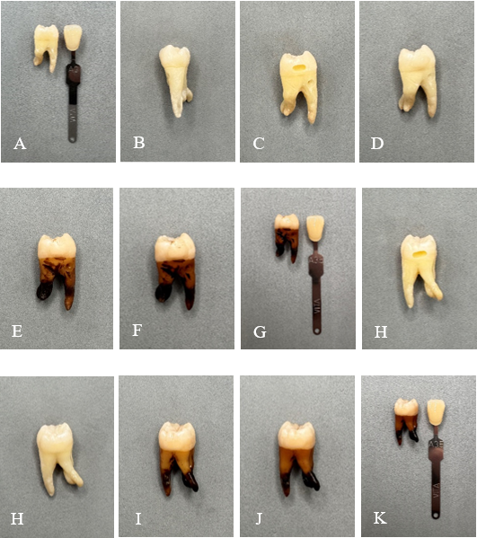
Figure 2: Chronological steps of the experimental protocol performed on a single tooth. (A) Initial tooth shade assessment (A3, VITA Classical). (B) Shade selection for the polychromatic resin (Filtek Z350 XT, A3). (C) Prepared Class V cavity. (D) Restoration with Filtek Z350 XT at baseline (T1). (E-F) Color compatibility assessment at T2 and T3, respectively. (G) Final tooth shade assessment at T3 (A3.5, VITA Classical). (H) Prepared Class V cavity on the opposite surface. (H) Restoration with Omnichroma resin at T1. (I-J) Color compatibility assessment at T2 and T3, respectively. (K) Final tooth shade assessment at T3 (A3.5, VITA Classical).
Source: author

Visual color assessment
Color assessment was performed at three time points: before staining (T1), two days after the first staining cycle (T2), and one week after the second staining cycle (T3), as shown in Figure 3. Two clinicians, blinded to the restorative material used, evaluated the shade under a D65 standard illuminant with a 0°/45° viewing geometry. The samples were positioned on neutral gray paper under adequate clinical lighting, at a 90º angle to the surface, simulating clinical conditions. Each observer had 25 seconds to classify the samples into one of three categories: (a) best match, (b) intermediate match, or (c) worst match [7]. To prevent visual fatigue, evaluators rested their eyes by focusing on a neutral blue background between assessments.
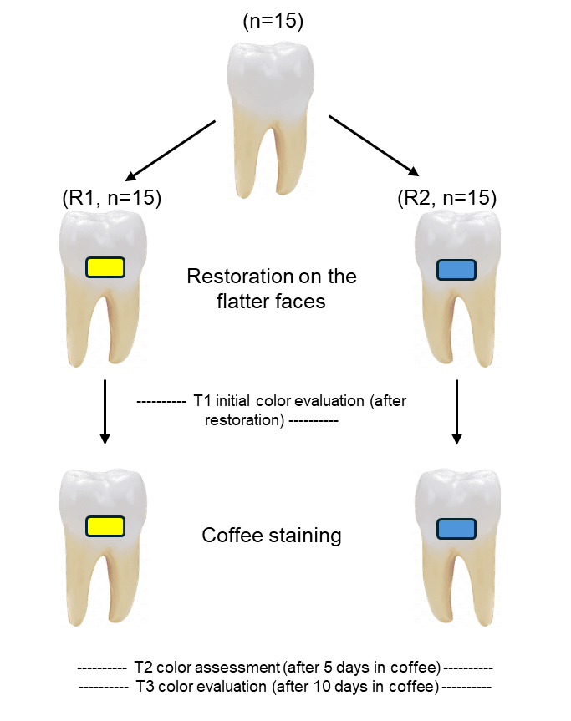
Figure 3: Flowchart of the study design. The diagram illustrates the randomization of the two restorative materials (Filtek Z350 XT and Omnichroma) into the prepared cavities, the sequence of coffee staining cycles, and the three time points for visual color assessment (T1, T2, and T3).
Source: author.

Statistical analysis
Data were analyzed using Jamovi software (Version 2.6.44). The Shapiro-Wilk test confirmed a non-normal distribution of data (P<.01). The Mann-Whitney U test was used for inter-group comparisons at each time point, while the Friedman test was used for intra-group comparisons over time. Statistical significance was set at P<.05. Inter-rater reliability was assessed using Cohen's Kappa coefficient.

3. results and discussion

Inter-rater Reliability
Inter-rater reliability for the visual assessment was evaluated using Cohen's Kappa coefficient. The analysis of 90 assessments yielded a Kappa value of 0.179, which indicates poor agreement between the two evaluators. The agreement was not statistically significant (P=.066).

Color compatibility and stability
The median color compatibility scores for both groups at all time points are presented in Table 2.
Table 2: Median and interquartile range (IQR) for color compatibility scores
Group | Median and interquartile range (IQR)
Group | T1 | T2 | T3
R1 – Z350 XT resin | 3.00 (IQR:0.00)^{Aa} | 2.00 (IQR:1.00)^{Ba} | 2.00 (IQR:1.00)^{Ba}
R2 – Omnichroma resin | 2.50 (IQR:1.00)^{Ab} | 3.00 (IQR:1.00)^{Ab} | 2.00 (IQR:1.00)^{Ba}
Rows with different capital letters indicate statistically significant intra-group differences over time (P<.05; Friedman test). Columns with different lowercase letters indicate statistically significant inter-group differences at each time point (P<.05; Mann-Whitney test).
Source: Author
Intra-group analysis using the Friedman test revealed significant changes in color compatibility over time for both the Z350 XT group (P<.001) and the Omnichroma group (P=.007). For Z350 XT, post-hoc analysis showed a significant decrease in compatibility from T1 to T2 (P<.001) and from T1 to T3 (P<.001). For Omnichroma, the compatibility score was significantly reduced between T2 and T3 (P=.002).
Inter-group comparisons with the Mann-Whitney test showed that Z350 XT had a significantly better initial color match (T1, P=.007), while Omnichroma was superior after the first staining cycle (T2, P=.004). No significant difference was observed between the groups at the final time point (T3, P=.784). These trends in color compatibility over time are illustrated in Graph 1.
Graph 1: Evolution of color compatibility scores for Z350 XT and Omnichroma resins over time.

The bars represent the distribution of scores assigned by the evaluators at each time point: 3 = best compatibility (green), 2 = intermediate compatibility (blue), and 1 = worst compatibility (orange)
Source: Author

This in vitro study demonstrated a dynamic shift in the color match of monochromatic and polychromatic composite resins after coffee staining, leading to the rejection of both null hypotheses. The aesthetic integration of composite resins is largely dependent on the blending effect (BE), a multifactorial phenomenon influenced by the material's composition, shade, and translucency [2, 5, 13]. The materials evaluated represent two distinct optical technologies: Omnichroma, which utilizes structural color from 260 nm SiO₂-ZrO₂ spheroidal nanoparticles [14, 15], and Filtek Z350 XT, which relies on conventional pigments to achieve its shade [16]. Our findings provide insight into how these different technologies respond to extrinsic staining, a significant challenge for the long-term aesthetic durability of restorations [1, 13, 17].
At baseline (T1), the polychromatic resin, Filtek Z350 XT, demonstrated superior color matching. This finding is consistent with expectations, as the polychromatic resin shade was specifically selected to match the A3 tooth structure. Furthermore, its composition includes Bis-GMA, which is associated with higher translucency, enhancing its initial blending capabilities compared to Omnichroma [18].
Conversely, after the first staining cycle (T2), Omnichroma exhibited significantly better color compatibility. This finding suggests a superior chromatic adaptation by the monochromatic resin. As the tooth structure darkened from coffee exposure, Omnichroma's structural color technology may have enabled superior chromatic adaptation to the new underlying shade compared to the fixed-pigment Z350 XT resin [7, 8, 11, 18, 19]. This adaptation could also be related to Omnichroma's lower surface roughness (Ra) after polishing compared to Z350 XT, which may influence how light reflects and interacts with the stained substrate [20].
However, following the second staining cycle (T3), this advantage was lost, and both materials showed similar and significantly reduced color compatibility. This aligns with previous studies confirming that prolonged exposure to chromogenic agents like coffee negatively impacts the color stability of all composite resins [8, 21]. Although the observed color changes might remain within a clinically acceptable range, the progressive discoloration underscores the potent staining capacity of coffee [22].
A critical finding of this study was the poor inter-rater reliability of the visual assessment (Cohen’s Kappa = 0.179). This highlights the inherent subjectivity and potential unreliability of the human eye in distinguishing subtle color differences between restorative materials with fundamentally different optical properties [13, 18, 23, 24]. While visual evaluation is clinically relevant for patient acceptance [18], our results strongly suggest that objective, instrumental methods such as spectrophotometry are necessary for accurately assessing the color stability of modern composite resins, as supported by other studies [13, 25].
This study has several limitations that should be acknowledged. As an in vitro investigation, it could not fully replicate the complex oral environment. The use of a single staining agent (coffee) and standardized cavities also limits the generalization of the findings to varied clinical scenarios. Given the subjective nature of the primary outcome measure, future in vivo studies incorporating instrumental analysis are essential to confirm these results and further evaluate the long-term performance of single-shade composite resins.

4. Conclusion

Within the limitations of this in vitro study, the monochromatic composite resin (Omnichroma) demonstrated comparable long-term color stability to the polychromatic resin (Filtek Z350 XT) after simulated coffee staining. Therefore, the single-shade composite tested represents a viable clinical alternative for Class V restorations, offering acceptable aesthetic outcomes while streamlining the restorative process by eliminating the shade-matching step. The results also strongly indicate that instrumental analysis should be prioritized over subjective visual assessment in future research evaluating the color properties of these materials.

Consent

All authors declare that written informed consent was obtained from the patients for the donation of extracted teeth used in this study. A copy of the written consent is available for review by the Editorial office/Chief Editor/Editorial Board members of this journal.

Ethical approval

All authors hereby declare that all experiments have been examined and approved by the Research Ethics Committee of the State University of Western Paraná (Protocol number: 7,050,710) and have therefore been performed in accordance with the ethical standards laid down in the 1964 Declaration of Helsinki.

References

1. El-Rashidy A. A., Abdelraouf R. M., & Habib N. A. (2022). Effect of two artificial aging protocols on color and gloss of single-shade versus multi-shade resin composites. BMC Oral Health, 22(1), 321. DOI: 10.1186/s12903-022-02351-7
2. Ismail E. H., & Paravina R. D. (2022). Color adjustment potential of resin composites: Optical illusion or physical reality, a comprehensive overview. Journal of Esthetic and Restorative Dentistry, 34(1), 42–54. DOI: 10.1111/jerd.12843
3. Chen F., Toida Y., Islam R., Alam A., Chowdhury, Abu Faem Mohammad Almas, & Yamauti M., et al. (2021). Evaluation of shade matching of a novel supra-nano filled esthetic resin composite employing structural color using simplified simulated clinical cavities. Journal of Esthetic and Restorative Dentistry, 33(6), 874–883. DOI: 10.1111/jerd.12671
4. Pereira Sanchez N., Powers J. M., & Paravina R. D. (2019). Instrumental and visual evaluation of the color adjustment potential of resin composites. Journal of Esthetic and Restorative Dentistry, 31(5), 465–470. DOI: 10.1111/jerd.12488
5. Iyer R. S., Babani V. R., Yaman P., & Dennison J. (2021). Color match using instrumental and visual methods for single, group, and multi-shade composite resins. Journal of Esthetic and Restorative Dentistry, 33(2), 394–400. DOI: 10.1111/jerd.12621
6. Alkhadim Y. K., Hulbah M. J., & Nassar H. M. (2020). Color Shift, Color Stability, and Post-Polishing Surface Roughness of Esthetic Resin Composites. Materials, 13(6), 1376. DOI: 10.3390/ma13061376
7. Cubukcu I., Gundogdu I., & Gul P. (2023). Color match analysis of single-shade and multi-shade composite resins using spectrophotometric and visual methods after bleaching. Dental Materials Journal, 42(6), 826–834. DOI: 10.4012/dmj.2023-115
8. Duzyol M., Duzyol E., & Çarıkçıoğlu B. (2024). Assessing one-shade composite resin color stability in response to everyday drinks. BMC Oral Health, 24(1), 821. DOI: 10.1186/s12903-024-04612-z
9. Forabosco E., Consolo U., Mazzitelli C., Kaleci S., Generali L., & Checchi V. (2023). Effect of bleaching on the color match of single-shade resin composites. J Oral Sci, 65(4), 232–236. DOI: 10.2334/josnusd.23-0159
10. Kwon S. R., Meharry M., Oyoyo U., & Li Y. (2015). Efficacy of do-it-yourself whitening as compared to conventional tooth whitening modalities: an in vitro study. Operative Dentistry, 40(1), E21-7. DOI: 10.2341/13-333-LR
11. Rohym S., Tawfeek H. E. M., & Kamh R. (2023). Effect of coffee on color stability and surface roughness of newly introduced single shade resin composite materials. BMC Oral Health, 23(1), 236. DOI: 10.1186/s12903-023-02942-y
12. Faus-Matoses V., Palau-Martínez I., Amengual-Lorenzo J., Faus-Matoses I., & Faus-Llácer V.-J. (2019). Bleaching in vital teeth: Combined treatment vs in-office treatment. Journal of Clinical and Experimental Dentistry, 11(8), e754-e758. DOI: 10.4317/jced.56079
13. Koi K., Amaya-Pajares S. P., Kawashima S., Arora G., FERRACANE J., & Watanabe H. (2024). The color-matching ability of single-shade universal composites in extracted human teeth. Journal of Esthetic and Restorative Dentistry, 37(2), 456-464. DOI: 10.1111/jerd.13291
14. Kobayashi S., Nakajima M., Furusawa K., Tichy A., Hosaka K., & Tagami J. (2021). Color adjustment potential of single-shade resin composite to various-shade human teeth: Effect of structural color phenomenon. Dental Materials Journal, 40(4), 1033–1040. DOI: 10.4012/dmj.2020-364
15. Sharma N., & Samant P. S. (2021). Omnichroma: the see‐it‐to‐believe‐it technology. EAS J Dent Oral Med, 3(3), 100. DOI: 10.36349/easjdom.2021.v03i03.008
16. Ebaya M. M., Ali A. I., El-Haliem H. A., & Mahmoud S. H. (2022). Color stability and surface roughness of ormocer- versus methacrylate-based single shade composite in anterior restoration. BMC Oral Health, 22(1), 430. DOI: 10.1186/s12903-022-02423-8
17. Abdelhamed B., Metwally A. A.-H., & Shalaby H. A. (2022). Rational durability of optical properties of chameleon effect of Omnichroma and Essentia composite thermocycled in black dark drinks (in vitro study). Bull Natl Res Cent, 46(1). DOI: 10.1186/s42269-022-00865-2
18. Da Cruz Silva E. T., Charamba Leal C. d. F., Miranda S. B., Evangelista Santos M., Saeger Meireles S., & Maciel de Andrade A. K., et al. (2023). Evaluation of Single-Shade Composite Resin Color Matching on Extracted Human Teeth. ScientificWorldJournal, 2023, 4376545. DOI: 10.1155/2023/4376545
19. Nagi S., & Lamiaa M. (2022). Color match clinical evaluation and patients’ acceptability for a single shade Universal resin composite in Class III and V anterior restorations. J Int Dent Med Res, 15
20. Qurany E., Al-Saudi K., Jamil W., & Zaghlool R. (2024). Evaluation of surface and interfacial roughness of nano resin composites using different polishing systems. Egyptian Dental Journal, 70(2), 1867–1878. DOI: 10.21608/edj.2024.256687.2834
21. Gürses M., Çobanoğlu N., & Abdulateef O. F. (2021). Comparative evaluation of the color stability of universal composites. Int Dent Res, 11(Suppl. 1), 234–237. DOI: 10.5577/intdentres.2021.vol11.suppl1.34
22. Hasanain F. A. (2022). Effect of Ageing, Staining and Polishing on the Colour Stability of a Single, a Group Shade and Nano Fill Dental Composite: An In-vitro Study. JCDR. DOI: 10.7860/JCDR/2022/57606.16627
23. Khayat W. F. (2024). In Vitro Comparison of Optical Properties Between Single-Shade and Conventional Composite Resin Restorations. Cureus, 16(4), e57664. DOI: 10.7759/cureus.57664
24. Petropoulou A., Dimitriadi M., Zinelis S., Antoniadou M., & Eliades G. (2024). Effect of Photoaging on the Structure, Optical Properties and Roughness of One-Shade Composite Restoratives. Journal of Functional Biomaterials, 15(9). DOI: 10.3390/jfb15090245
25. Zotti F., Ferrari F., Penazzo M., Lanzaretti G., & Zerman N. (2024). Chromatic Adaption of Two Universal Composites: Spectrophotometric Analysis. Materials, 17(20). DOI: 10.3390/ma17205103

