Original Research Article

Activity of Curcuma longa L. tincture against biofilms of Candida standard strains

.
ABSTRACT

Aims: To evaluate the fungistatic, fungicidal, and antibiofilm activity of C. longa L. tincture against Candida species.
Study design: Quantitative and mechanistic experimental design using dilution methods to determine the Minimum Inhibitory Concentration (MIC) and the Minimum Candidacidal Concentration (MCC), and specific assays for evaluating the inhibition of biofilm formation and the viability of biofilm-associated cells.
Place and Duration of Study: The microorganisms were maintained at the Laboratory of Microbiological Analysis in Health and Environment of the Institute of Tropical Pathology and Public Health at the Federal University of Goiás. The microbiological assays were conducted at the Bioassay Laboratory of the Center for Research and Graduate Studies at the State University of Goiás, and the phytochemical characterization analyses were performed at the Bioproducts and Synthesis Research Laboratory of the State University of Goiás, Anápolis-GO, Brazil, between August 2024 and September 2025.
Methodology: The extract was characterized for its curcuminoid profile by HPLC-DAD, and its concentration was determined by rotary evaporation and lyophilization. The MIC and MCC were determined by the broth microdilution method. The action on biofilms was investigated by determining the MBIC₅₀ (concentration that inhibits 50% of the biofilm biomass). Additionally, the viability of yeasts in the biofilm was quantified by CFU counting.
Results: We verified that all yeasts form biofilms and that the C. longa L. tincture showed fungistatic activity starting at 45.36 mg∙mL⁻¹ and was fungicidal between 90.72 and 362.88 mg∙mL⁻¹. The tincture reduced biofilm formation variably in the tested yeasts and in a dose-dependent manner with inhibitory concentrations starting at 1.77 mg∙mL⁻¹.
Conclusion: The Curcuma longa L. tincture is a promising herbal medicine, being notably more effective at preventing Candida biofilm formation than at eliminating yeasts in suspension, with its superior action attributed to the synergy among its compounds.

Keywords: Antifungal, natural products, turmeric, curcumin, microbial biofilm.

1. INTRODUCTION

Candida yeasts represent a significant challenge in healthcare. As opportunistic pathogens, they cause infections in vulnerable hosts and have demonstrated increasing resistance to multiple antifungal agents [1]. Biofilm formation is a crucial virulence characteristic for Candida, as it not only allows for persistent colonization and protection against the host immune system, but also confers intrinsic and acquired resistance to antifungals. This makes biofilm-associated infections extremely difficult to treat and a serious public health problem [2,3].
Microorganisms present in biofilms have the ability to resist antibiotic levels 10 to 1000 times higher compared to their planktonic form, mainly due to the EPS matrix [4]. Furthermore, microbial biofilms frequently trigger progressive infections that, in certain situations, can become chronic problems. Current treatment for implant-associated infections generally involves the administration of high-dose antibiotics, according to the severity of the infection; however, if symptoms persist, surgical replacement may be necessary [5].
The medicinal use of plants has been essential since the dawn of humanity and plays a fundamental role in healthcare, being a common practice in various cultures and traditions. Natural medicines are formed by plant secondary metabolites, which generally exhibit important pharmacological properties [6].
Curcuma longa L. is popularly known as turmeric, Indian saffron, curry, among other popular names, and has great applicability in cooking as a condiment and dye, due to its flavor and especially its golden-yellow color [7]. Furthermore, it is a medicinal plant highlighted by extensive scientific investigation of its therapeutic properties. It is characterized as a perennial herbaceous plant, native to South Asia, cultivated in various tropical regions [8].
The rhizome of C. longa L., the underground part of the plant, presents a color ranging from brownish-yellow to brownish-ochre. It is the main source of bioactive compounds, with curcumin being the most researched [9]. The main chemical compound of the curcuminoid class is curcumin, a multifunctional molecule with the ability to activate various signaling pathways and possessing anti-inflammatory, antimicrobial properties, and antitumor activity against some aggressive and recurrent types of cancer [10, 11]. Curcumin is a polyphenol of the curcuminoid class and represents 2-5% of the dry weight of turmeric, and standard commercial formulations generally contain curcumin (77%), demethoxycurcumin (18%), and bisdemethoxycurcumin (5%). It is highly soluble in ethanol, its efficacy varies according to the extraction method and temperature, but pure curcumin is not always more effective than whole turmeric extracts, which contain synergistic compounds (e.g., turmerones, volatile oils) [12]. The bioactive compounds present in turmeric, especially curcuminoids and essential oils, have the ability to inhibit biofilm formation. This action is due to the presence of substances such as curcumin, ar-turmerone, α-turmerone, and β-turmerone, which interfere with bacterial adhesion and reduce the cellular viability of microorganisms. These findings reinforce turmeric's potential as a natural and effective alternative in combating the formation of pathogenic biofilms [13].
Tincture of C. longa L. is prepared by extracting compounds from the rhizome using ethanol as a solvent. This process concentrates the plant's active principles, making the tincture a potent form of administration. Traditionally, turmeric tincture has been used to treat a variety of conditions, including digestive problems, inflammations, and wounds [14]. The ethanolic extract of C. longa L. exhibits significant antifungal activity against yeasts, notably inhibiting the growth of Candida albicans. This activity is primarily attributed to curcuminoids - curcumin, demethoxycurcumin, and bisdemethoxycurcumin - and volatile oils present in the extract, which act by damaging the fungal cell membrane [12].
In this context, considering the need for the development of new antimicrobial agents and/or technologies to address the challenges posed by fungal infections, we investigated the antifungal activity of C. longa L. tincture against Candida genus yeasts, with an emphasis on inhibiting biofilm formation. We also analyzed several protocol parameters, such as curcumin concentration, different Candida species, and the evaluation of activity against planktonic and biofilm-associated cells.

2. material and methods

2.1 Characterization of the evaluated product
The C. longa L. tincture (Curcuma longa Bio-Tincture - Turmeric 100 mL, manufacturer Livealoe, batch 008, valid until 06/11/2026) was evaluated. The tincture consists of a 1:2 hydroalcoholic extract of turmeric root, which, according to the manufacturer, was produced from plants organically grown in the Brazilian Cerrado (https://www.livealoe.com.br/curcuma-longa-bio-tintura-100-ml). The product is an extract of Curcuma longa L. rhizome at 1:2 in 35-45% v/v ethanol, with purified water q.s.p., meaning it is a liquid extract that preserves the botanical properties of the plant without artificial coloring or added pigments.
The mass and concentration of the Curcuma longa ethanolic extract were determined by rotoevaporation of the ethanolic solvent, followed by lyophilization. The mass was obtained by weighing the solid after lyophilization, and the concentration (mg∙mL⁻¹) was calculated as the ratio between the mass of solids and the volume of tincture used. This process allowed for precise quantification while preserving thermolabile compounds.
The chromatographic profile of compounds present in the Curcuma longa tincture was performed using high-performance liquid chromatography with a diode array detector (HPLC-DAD). A C18 reversed-phase column (Phenomenex, 4.6 mm x 25 cm, 0.25𝜇m) was used for separation, with gradient elution of acid formic 0.1% (A) and acetonitrile (B). The elution gradient started at 60:40 (solvent A:solvent B) and was maintained for 20 minutes. It then increased to 60% solvent A over the course of 2 minutes and was held at this composition for an additional 3 minutes. The flow rate was set at 1.0 mL/min and 5 𝜇L was injected. Identification was based on comparing retention times and absorption spectra of the peaks in the chromatograms, and the profile was compared with literature data. To verify the presence of curcuminoids, a synthesized curcumin was used as a standard and compared with the profile, and the corresponding peak was identified by retention time comparison.
For the microbiological assays, the tincture (1:2) was serially diluted in Brain Heart Infusion broth supplemented with 2% sucrose (BHIS) to obtain the concentration ranges for the tests. All procedures were performed aseptically.

2.2 Yeasts activation
Frozen stocks of yeasts from the microorganism collection of the Bioassay Laboratory at the Research and Postgraduate Center of UEG were reactivated on Sabouraud agar and incubated at 35.5 °C for 48 hours before the assays. The yeasts tested were Candida albicans ATCC 10231, Candida metapsilosis ATCC 96143, Candida dubliniensis ATCC MYA-646, Candida orthopsilosis ATCC 96141, and Candida parapsilosis ATCC 22019.

2.3 Candida spp. Biofilm Formation Assays
Biofilm formation was evaluated by determining the total biomass in flat-bottom polystyrene microplates stained with crystal violet [15] For total biomass determination, yeasts were reactivated, and after incubation, typical colonies were suspended in sterile physiological saline (SPS), and inoculum densities were adjusted to 0.5 McFarland standard. Subsequently, 500 μL of the yeast suspension was transferred to 4500 μL of BHI broth with 2% sucrose (BHIS). Then, 200 μL of the inocula were transferred to flat-bottom polystyrene microplates, which were incubated at 35.5 °C for 48 hours. After incubation, the microplates were processed by removing the growth, washing, fixing, staining the wells with crystal violet, and reading the OD_{620nm} in a microplate reader (Thermo Scientific, Multiskan). The results were organized as means and standard deviations.
Viable yeasts adhered to the biofilm were quantified in Eppendorf microtubes by preparing the inocula in the same manner as for the total biofilm biomass determination assays. Briefly, 100 µL of the adjusted inocula were transferred to microtubes with 900 µL of BHIS broth, which were incubated at 35.5 °C for 48 h. After incubation, the microtubes were processed aseptically for the detachment of biofilm-associated cells, by removing the overgrown broth and washing with 1 mL of SPS three times, sonication in an ultrasonic bath for 5 minutes at room temperature, vortexing for 30 seconds, dilution, and plating for colony counting and calculation of colony-forming units (CFU∙mL⁻¹).

2.4 Activity of C. longa L. Tincture against Yeasts
Yeasts were subjected to the broth microdilution test to determine the Minimum Inhibitory Concentration (MIC) and Minimum Candidacidal Concentration (MCC) of C. longa L. tincture, with adaptation of the method recommended by the Clinical and Laboratory Standard Institute (CLSI) for antimicrobial susceptibility testing [16].
The C. longa L. tincture was homogenized, and 750 μL were diluted in 750 μL of BHIS broth. From this dilution, 200 μL were transferred to wells in column 2 of a 96-well round-bottom microplate (manufactured by Olen, China), and then, 100 μL were serially diluted into wells in columns 3 to 9 containing 100 μL of BHIS broth, with a final discard of 100 μL from the wells in column 9.
Yeast suspensions were prepared by dissolving typical isolated colonies in 0.9% sterile physiological saline (SPS), and the inoculum density was adjusted to 0.5 McFarland standard. After adjustment, a 1:10 dilution was performed in BHIS broth by transferring 500 μL of the suspension to 4500 μL of BHIS broth, to obtain a final concentration of approximately 1.5 × 10⁵ CFU.mL⁻¹. The fungal suspension was prepared up to 15 minutes before inoculation. Subsequently, 20 μL of this suspension were inoculated into wells in columns 2 to 11, with columns 10 and 11 used as viability controls (broth + microorganism) and column 1 as an uninoculated control (broth only). After yeast inoculation, the C. longa L. tincture was tested at
concentrations ranging from 362.88 to 2.835 mg.mL⁻¹ (Figure 1).
Figure 1. Assay for evaluating the antifungal activity of C. longa tincture.
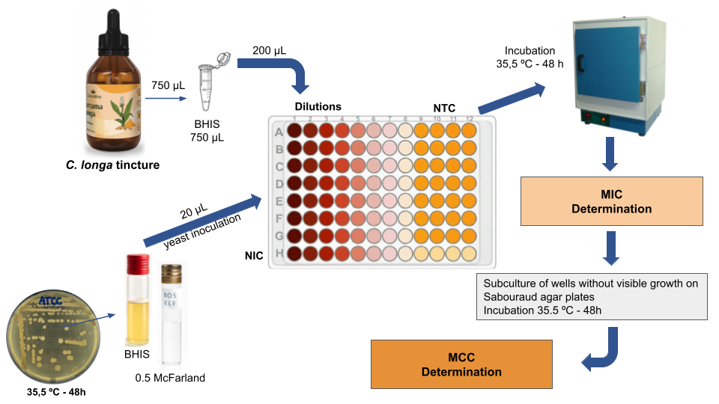
Captions: BHIS - Brain Heart Infusion with 20% sucrose, NTC - No treated control, NIC - No inoculated control, MIC - Minimal Inhibitory Concentration, MCC - Minimal Candicidal Concentration.

MIC was determined by visual reading of the lowest curcumin concentration capable of inhibiting yeast growth after incubation at 35.5 °C for 48 h, and MCC was defined as the lowest curcumin concentration capable of inhibiting the recovery of viable yeasts after transferring 100 µL of BHIS broth from wells without detectable turbidity to Sabouraud agar after incubation at 35.5 °C for 48 hours. All assays were performed in independent triplicates, and MIC and MCC values were obtained.

2.5 Activity of C. longa L. tincture on biofilm formation (MBIC₅₀)
The activity of the compounds against biofilm formation was performed in flat-bottomed microplates (Olen, China). The compounds and inocula were prepared as described for the MIC determination assay; however, 100 µL of the inocula were transferred to the microplate wells, and the concentrations tested ranged from 226.80 to 14.24 mg∙mL⁻¹ of the C. longa L. tincture.
The microplates were incubated in an oven at 35.5 °C for 48 hours, and after this period, processing was performed as previously described in the total biofilm biomass assay. The MBIC₅₀ was defined as the lowest concentration of the compounds capable of reducing the OD_{620nm} by at least 50% in relation to the untreated viability control. All assays were performed in independent triplicates, and the values allowed for the calculation of means and standard deviations (Figure 2).
Figure 2. Assay for evaluating the antibiofilm activity of C. longa L. tincture against yeasts.
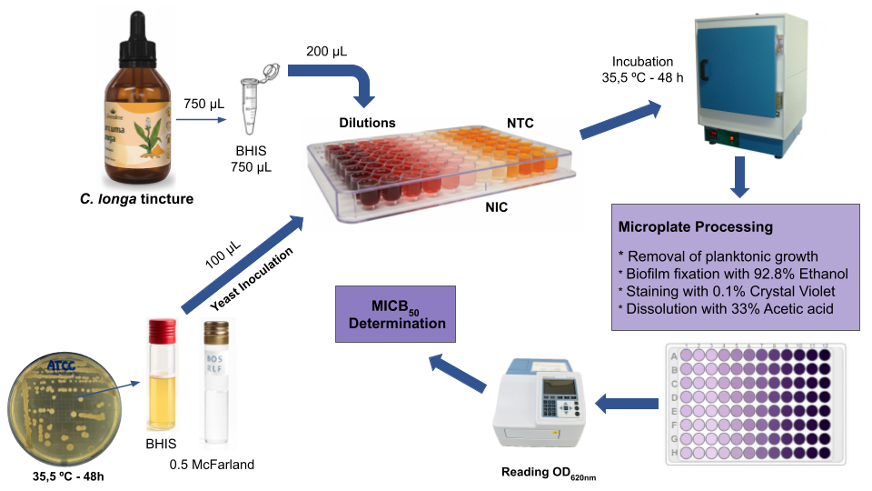Captions: BHIS - Brain Heart Infusion with 20% sucrose, NTC - No treated control, NIC - No inoculated control, OD_{620nm} - Optical density at 620 nm; MBIC₅₀ - Minimal Inhibitory Concentration of Biofilm.

3. results and discussion

3.1 Product characterization
Phytochemical investigations of turmeric have revealed that it contains curcuminoids and volatile oils as its main components [17, 18]. The yellow-orange coloration is attributed to three main pigments or curcuminoids: bisdemethoxycurcumin, demethoxycurcumin, and curcumin, which make up the majority of its composition. It also contains volatile compounds such as ar-turmerone, β-turmerone, and α-turmerone.
The HPLC analysis of the turmeric tincture revealed a chromatographic profile consistent with previously reported data in the literature (Figure 3). In the chromatogram recorded at 260 nm (Figure 3A), three major peaks corresponding to volatile compounds were detected, with retention times of 21.24, 24.74, and 24.83 minutes. Additionally, analysis at 415 nm (Figure 3B) showed the presence of curcuminoids, identified by their retention times of 8.75, 9.44, and 10.15 minutes. These results confirm the expected composition of the tincture, including both volatile and non-volatile phytochemicals.
To confirm the identity of the curcuminoids, a synthesized curcumin sample was analyzed as a reference standard and exhibited a retention time of 10.12 minutes (data not shown), closely matching the 10.15 min peak observed in the tincture sample. This result supports the identification of curcumin in the tincture and reinforces the reliability of the chromatographic method used.
Figure 3. HPLC chromatograms of the turmeric tincture analyzed at different wavelengths. Chromatogram recorded at (A) 260 nm (B) 415 nm.
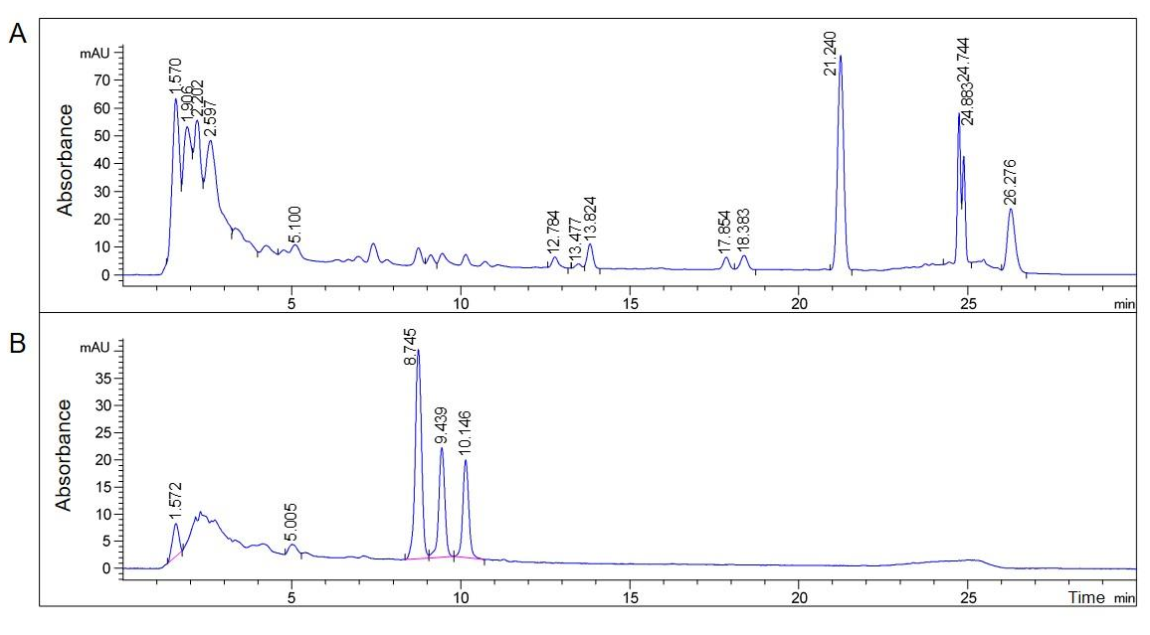
3.2 Biofilm formation by Candida spp.
The results of biofilm formation by Candida spp. yeasts were evaluated by measuring the optical density (OD_{620nm}) after crystal violet staining, as shown in Table 1. Viable yeast counts associated with biofilms ranged from 6.11 to 6.62 log10 CFU.mL⁻¹. The grown biofilms were classified as strong or moderate based on the intensity of the detected OD_{620nm}.
Table 1. Biofilm formation of Candida spp. yeasts.
Candida spp. | Biofilm formation
Candida spp. | OD_{620nm} |  | log₁₀ CFU.mL⁻¹ |  | Classification
Candida spp. | MEAN | ±SD | MEAN | ±SD | Classification
C. albicans ATCC 10231 | 0.399 | ±0.102 | 6.39 | ±5.88 | Strong
C. metapsilosis ATCC 96143 | 0.602 | ±0.175 | 6.11 | ±5.62 | Strong
C. dubliniensis ATCC MYA-646 | 0.404 | ±0.110 | 6.30 | ±5.15 | Strong
C. orthopsilosis ATCC 96141 | 0.288 | ±0.109 | 6.62 | ±5.72 | Moderate
C. parapsilosis ATCC 22019 | 0.310 | ±0.109 | 6.16 | ±5.68 | Moderate
Captions: OD_{620nm} - Optical Density at 620nm; Colony Forming Units per milliliter (CFU.mL⁻¹); ATCC - American Type Culture Collection.

The yeasts Candida albicans, Candida metapsilosis, and Candida dubliniensis exhibited the highest OD_{620nm} values, indicating a significant capacity for biofilm formation. Candida metapsilosis stood out with the highest reading (0.602±0.175), suggesting more intense adhesion and extracellular matrix production, while Candida orthopsilosis and Candida parapsilosis showed lower values (0.288±0.109 and 0.310±0.109, respectively) and were classified as moderate biofilm formers, which may reflect differences in virulence or polymeric matrix production among the species.
The results demonstrate variations in biofilm formation capacity among Candida species, which is relevant for the development of targeted antifungal strategies, especially considering biofilm-associated resistance. The "strong" classification for three of the five strains highlights the need for effective therapeutic approaches, such as the use of C. longa L., to inhibit or reduce this formation.

3.3 Anti-Candida activity of C. longa L. tincture
The Curcuma longa L. tincture demonstrated antifungal activity against Candida yeast (Table 2).
Table 2. Antifungal activity of C. longa L. tincture.
Yeasts | C. longa L. tincture  (mg.mL⁻¹)
Yeasts | MIC | MCC
Candida albicans ATCC 10231 | 90.72 | 362.88
Candida metapsilosis ATCC 96143 | 90.72 | 362.88
Candida dubliniensis ATCC MYA-646 | 45.36 | 90.72
Candida orthopsilosis ATCC 96141 | 90.72 | 362.88
Candida parapsilosis ATCC 22019 | 90.72 | 362.88
Captions: MIC - minimum inhibitory concentration; MCC - minimum candidacidal concentration.

All tested yeasts were inhibited by 90.72 mg.mL⁻¹ of the tincture, except Candida dubliniensis ATCC MYA-646, which was sensitive to 45.36 mg.mL⁻¹. Similarly, the C. longa L. tincture was fungicidal at 362.88 mg.mL⁻¹ for all yeasts and at 90.72 mg.mL⁻¹ for C. dubliniensis. Candida dubliniensis ATCC MYA-646 was sensitive to 45.36 mg∙mL⁻¹ of the tincture, while the others were inhibited by 90.72 mg.mL⁻¹ of the tincture. In the same way, the C. longa L. tincture was fungicidal at 362.88 mg.mL⁻¹ for all and at 90.72 mg.mL⁻¹ for C. dubliniensis.
Curcuma longa L. tincture is known for its antioxidant, anti-inflammatory, and anticancer properties, attributed to curcuminoids (primarily curcumin, demethoxycurcumin, and bisdemethoxycurcumin) and volatile oils like turmerone, atlantone, and zingiberene. Other constituents include sugars, proteins, and resins [8, 19, 20].
Proposed mechanisms for the antifungal activity are associated with its bioactive compounds, mainly curcumin, which interferes with the yeast cell membrane, inducing oxidative stress and cell wall damage, and with its volatile oils (turmerone, zingiberene) that act synergistically, disrupting biofilm organization and quorum sensing communication [13, 21].
Other authors found activity against C. albicans. Martins et al. (2023) [20] reported that C. longa L. extracts inhibited C. albicans with MICs between 0.05 and 0.2 mg.mL⁻¹, values lower than those detected in our study, and Tamfu et al. (2020) [7] highlighted that isolated curcumin has greater potency against C. albicans biofilms than against Gram-positive bacteria.
Curcumin (1,7-bis(4-hydroxy-3-methoxyphenyl)-1,6-heptadiene-3,5-dione) or diferuloylmethane) is one of the main curcuminoid constituents with biological activity. The volatile oils present in this species, such as turmerone, atlantone, and zingiberene, are volatile compounds that contribute to the aroma and have anti-inflammatory and antimicrobial properties, along with other compounds like sugars, proteins, resins, and other secondary metabolites [8, 19, 20, 23].
Curcumin effectively inhibited planktonic Candida strains (including C. albicans ATCC 90028, C. albicans JY, C. parapsilosis ATCC 22019, C. glabrata ATCC 90030, and C. dubliniensis ATCC MYA-646), but its action against mature biofilms was significantly reduced and strain-dependent, failing entirely against one clinical isolate. This is due to curcumin's mechanisms, such as cell membrane damage and oxidative stress, being more effective at preventing biofilm formation than eradicating established structures, whose extracellular matrix hinders compound penetration [24].
Additionally, curcumin has demonstrated several advantages over conventional antifungals. Unlike antifungals such as fluconazole, which face resistance in Candida spp., C. longa L. tincture can act through multiple mechanisms, hindering microbial adaptation [25], inhibiting quorum sensing [21], and exhibiting synergistic action against biofilms [13].
3.4 Antibiofilm activity of C. longa tincture
Figure 4 illustrates the inhibitory activity of C. longa L. tincture on biofilm formation by different Candida species. The results are presented in a line graph comparing biofilm biomass at different tincture concentrations.
Figure 4. Biofilm formation in the presence of different concentrations (mg.mL⁻¹) of C. longa tincture.
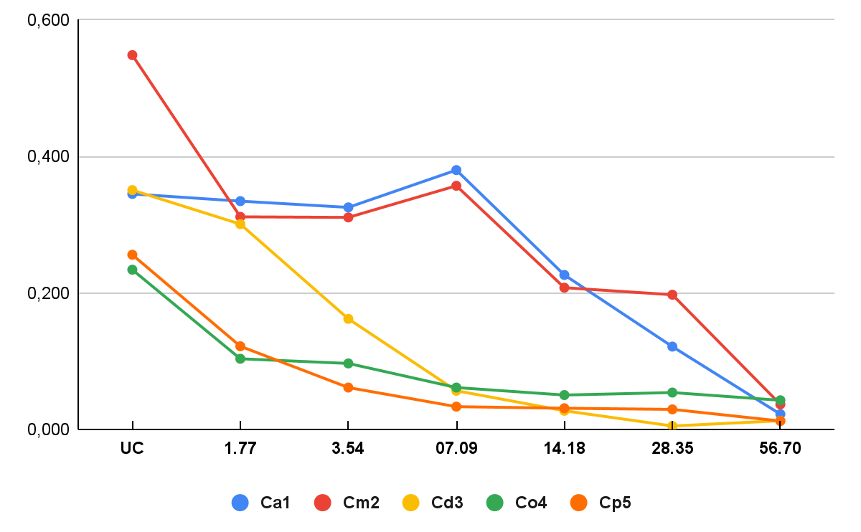
Captions: UC - untreated control; Ca1 - C. albicans ATCC 10231; Cm2 - C. metapsilosis ATCC 96143; Cd3 - C. dubliniensis ATCC MYA-646; Co4 - C. orthopsilosis ATCC 96141; Cp5 - C. parapsilosis ATCC 22019.
It is possible to observe that as the tincture concentration increases, the optical density decreases, indicating a reduction in biofilm formation. C. orthopsilosis and C. parapsilosis yeasts were the most sensitive, showing a sharp reduction even at low concentrations (1.77 mg.mL⁻¹). C. dubliniensis also exhibited strong inhibition (3.54 mg.mL⁻¹). Yeasts with less inhibition, C. albicans and C. metapsilosis, required higher concentrations (28.35 and 14.18 mg.mL⁻¹, respectively) for significant inhibition.
Thus, the tincture showed variable efficacy among species, and its activity was dose-dependent, being proportional to the tincture concentration. This demonstrates a connection with studies such as Packiavathy et al. (2014) [21], which show a similar effect for isolated curcumin and suggest that this effect may be related to differences in extracellular matrix (EPS) composition or adhesion protein expression.
In our study, it was verified that the C. longa L. tincture has significant inhibitory activity on Candida spp. biofilm formation (Table 3). C. orthopsilosis and C. parapsilosis were more sensitive with MBIC₅₀ = 1.77 mg.mL⁻¹, followed by C. dubliniensis with MBIC₅₀ = 3.54 mg.mL⁻¹. On the other hand, the most resistant yeasts were C. metapsilosis with MBIC₅₀ = 14.18 mg.mL⁻¹ and C. albicans with MBIC₅₀ = 28.35 mg.mL⁻¹ (Table 3).
Table 3. Inhibitory activity of Curcuma longa L. tincture on Candida biofilm formation.
Yeasts | C. longa L. tincture (mg∙mL⁻¹)
Yeasts | MIC | MBIC₅₀ |  | ratio  MIC/MBIC₅₀
Candida albicans ATCC 10231 | 90.72 |  | 28.35 | 3.20x
Candida metapsilosis ATCC 96143 | 90.72 |  | 14.18 | 6.40x
Candida dubliniensis ATCC MYA-646 | 45.36 |  | 3.54 | 12.80x
Candida orthopsilosis ATCC 96141 | 90.72 |  | 1.77 | 51.25x
Candida parapsilosis ATCC 22019 | 90.72 |  | 1.77 | 51.25x
Captions: MIC - minimum inhibitory concentration; MBIC₅₀ - Minimal Inhibitory Concentration of Biofilm.

The efficacy of C. longa L. tincture in inhibiting biofilm formation varied significantly among Candida species. The most sensitive yeasts were C. orthopsilosis and C. parapsilosis, where the tincture inhibited biofilm formation at very low concentrations (1.77 mg.mL⁻¹), with an MBIC₅₀ 51.25 times lower than the MIC. Therefore, C. longa L. tincture demonstrated a notable ability to inhibit biofilm formation in the tested yeasts, requiring a much lower concentration to prevent biofilm than to prevent planktonic growth, especially for C. orthopsilosis and C. parapsilosis.
Previous studies demonstrate that the effect against biofilms was observed with whole extracts of C. longa L., not just pure curcumin, which showed broader antibiofilm activity due to the synergy among compounds [13]. However, although free C. longa L. exhibits antibiofilm activity, its effectiveness may be limited in some circumstances due to issues of bioavailability and stability [7, 21].
Nonetheless, Zangirolami et al. (2022) [4] demonstrated that photoactivated curcumin reduces biofilms on catheters, suggesting that combined formulations, such as nanoparticles, can improve efficacy. Furthermore, the antibiofilm activity of curcumin in its isolated form is more potent against certain types of microorganisms, notably Gram-positive bacteria and yeasts like Candida albicans [7, 26].
The mechanisms of action of C. longa L. tincture against biofilms have been proposed in three groups: 1) Inhibition of cell adhesion - curcumin and other curcuminoids interfere with adhesion proteins (e.g., als3 in C. albicans), reducing yeast attachment to surfaces [21] 2) Degradation of the extracellular matrix (EPS) - volatile oils (turmerone, zingiberene) damage the polymeric matrix of the biofilm, facilitating the penetration of antifungal agents [13], and 3) Quorum sensing blockade - curcumin suppresses signaling molecules (e.g., farnesol in Candida), which are important for mature biofilm formation [7].
Comparative studies indicate that the ethanolic extract of C. longa L. exhibits superior performance compared to aqueous extracts, although mature Candida biofilms have shown resistance. These properties underpin the investigation into the use of C. longa L. extract in the development of antimicrobial formulations, such as mouthwashes for the treatment of oral candidiasis and natural preserving agentes [27]
Although biofilm inhibitory activity varies significantly with some experimental characteristics, such as the target microorganism, applied concentrations, and the presence of other techniques, our results demonstrated that C. longa L. is promising against Candida biofilms, especially for non-albicans species [20].

4. Conclusion

The hydroalcoholic tincture of Curcuma longa L. demonstrated antifungal and anti-biofilm activity against a panel of clinically relevant standard Candida strains. Our key findings show that the tincture exhibits fungistatic and fungicidal activity at concentrations ranging from 45.36 to 362.88 mg.mL⁻¹. We observed that the tincture was more effective in inhibiting biofilm formation, with values 51.25 times higher compared to its activity against planktonic cells for C. orthopsilosis and C. parapsilosis.
The difference between MIC and MBIC₅₀ values highlights the effective activity in the initial stages of biofilm development, likely through inhibition of cell adhesion and quorum sensing, rather than merely exerting a general cytotoxic effect. The superior performance of the whole tincture, compared to findings in the literature using pure curcumin, underscores the crucial role of synergistic interactions among curcuminoids, volatile oils, and other secondary metabolites present in the full-spectrum extract.
In conclusion, the Curcuma longa L. tincture may represent a promising phytotherapeutic for the management of biofilm-associated Candida yeast infections. Its effectiveness against non-albicans species, which are often less susceptible to conventional antifungals, indicates its potential in the context of antifungal treatments. Future research should validate our findings in animal models, verify synergy with conventional antifungal drugs, and guide the development of optimized delivery systems to improve the bioavailability and stability of its active compounds.

Consent
Not applicable.

COMPETING INTERESTS DISCLAIMER:
Authors have declared that they have no known competing financial interests OR non-financial interests OR personal relationships that could have appeared to influence the work reported in this paper.

References

- Farhan, M.S, Al-Kadmy, I.M.S., Aziz, S.N., Ahmad, M., Khit, I.A., Al-Shamari, A.A., et al. Review of virulence factors in Candida. J Res Appl Sci Biotechnol. 2024;3(2):75-82. doi:10.55544/jrasb.3.2.15.
- Branco, J., Miranda, I.M., Rodrigues, A.G. Candida parapsilosis virulence and antifungal resistance mechanisms: a comprehensive review of key determinants. J Fungi (Basel). 2023; 9(1):80. doi:10.3390/jof9010080.
- Ahamad, I., Arora, I., Nayik, G.A., Khan, M.A., Prakash, C., Althobaiti, N.A., et al. Antibiofilm activities of biogenic silver nanoparticles against Candida albicans. Front Microbiol. 2022; 12:741493. doi:10.3389/fmicb.2021.741493.
- Zangirolami, A.C., Oliveira, L.V., Oliveira, B.G.R.B., Oliveira, T.M.B.M., Dias, H.B., Bagnato, V.S., et al. Impact of light-activated curcumin and curcuminoids films for catheters decontamination. Colloids Surf B Biointerfaces. 2022;213:112386. doi:10.1016/j.colsurfb.2022.112386.
- Khatoon, Z., McTiernan, C.D., Suuronen, E.J., Mah, T.F., Alarcon, E.I. Bacterial biofilm formation on implantable devices and approaches to its treatment and prevention. Heliyon. 2018;4(12):e01067. doi:10.1016/j.heliyon.2018.e01067.
- Teanpaisan, R., Kawsud, P., Pahumunto, N., Puripattanavong, J. Screening for antibacterial and antibiofilm activity in Thai medicinal plant extracts against oral microorganisms. J Tradit Complement Med. 2017;7(2):172-7. doi:10.1016/j.jtcme.2016.06.007.
- Tamfu, A.N., Ceylan, O., Kucukaydin, S., Duru, M.E., Ozturk, M. HPLC-DAD phenolic profiles, antibiofilm, anti-quorum sensing and enzyme inhibitory potentials of Camellia sinensis (L.) O. Kuntze and Curcuma longa L. LWT. 2020;133:110150. doi:10.1016/j.lwt.2020.110150.
- Aggarwal, B.B., Harikumar, K.B. Potential therapeutic effects of curcumin, the anti-inflammatory agent, against neurodegenerative, cardiovascular, pulmonary, metabolic, autoimmune and neoplastic diseases. Int J Biochem Cell Biol. 2009; 41(1):40-59.
- Brasil. Ministério da Saúde. Informações Sistematizadas da Relação Nacional de Plantas Medicinais de Interesse ao SUS: Curcuma longa L., Zingiberaceae – Açafrão-da-terra [recurso eletrônico]. Brasília: Ministério da Saúde; 2020 [acesso em 23 out 2023]. 182 p. Disponível em: http://bvsms.saude.gov.br/bvs/publicacoes/informacoes_sistematizadas_relacao_curcuma_longa.pdf
- Barankevicz, G.B. Poder antioxidante da cúrcuma (Curcuma longa L.) nos parâmetros neuroquímicos em ratos induzidos à depressão [tese]. São Paulo: Universidade de São Paulo; 2015 [citado 2024 Out 27]. Disponível em: https://doi.org/10.11606/D.11.2015.tde-12032015-152200.
- Devassy, J.G., Nwachukwu, I.D., Jones, P.J.H. Curcumin and cancer: barriers to obtaining a health claim. Nutr Rev. 2015;73(3):155-65. doi:10.1093/nutrit/nuu064.
- Jyotirmayee, B., Mahalik, G. A review on selected pharmacological activities of Curcuma longa L. Int J Food Prop. 2022;25(1):1377-98. doi:10.1080/10942912.2022.2082464.
- Lahiri, D., Nag, M., Sarkar, T., Dutta, B., Ray, R.R. Phytocompounds of Curcuma longa extract are more effective against bacterial biofilm than pure curcumin only: An in-vitro and in-silico analysis. Kuwait J Sci. 2021;48(2). doi:10.48129/kjs.v48i2.8310.
- Araújo, C.A.C., Leon, L.L. Biological activities of Curcuma longa. Mem Inst Oswaldo Cruz. 2001;96(5):723-8. doi:10.1590/S0074-02762001000500026.
- Zayed, S.M., Aboulwafa, M.M., Hashem, A.M., Saleh, S,E. Biofilm formation by Streptococcus mutans and its inhibition by green tea extracts. AMB Express. 2021;11(1):73. doi:10.1186/s13568-021-01232-6.
- Clinical and Laboratory Standards Institute (CLSI). Performance standards for antimicrobial susceptibility testing: informational supplement. 28th ed. Wayne, PA: CLSI; 2018. (Document M100).
- Chao, I.C., Wang, C.M., Li, S.P., Lin, L.G., et al. Simultaneous quantification of three curcuminoids and three volatile components of Curcuma longa using pressurized liquid extraction and high-performance liquid chromatography, Molecules 2018, 23, 1568; doi:10.3390/molecules23071568.
- Sahu, P.K., Panda, J., Kumar, Y.V.V.V.J., Ranjitha, K. A robust RP-HPLC method for determination of turmeric adulteration. Journal of Liquid Chromatography & RelatedTechnologies, 2020, 1-7. https://doi.org/10.1080/10826076.2020.1722162
- Jurenka, J.S. Anti-inflammatory properties of curcumin, a major constituent of Curcuma longa: a review of preclinical and clinical research. Altern Med Rev. 2009;14(2):141-53.
- Prasad, S., Aggarwal, B.B. Turmeric, the Golden Spice: From Traditional Medicine to Modern Medicine. In: Benzie IFF, Wachtel-Galor S, editores. Herbal Medicine: Biomolecular and Clinical Aspects. 2nd ed. Boca Raton (FL): CRC Press/Taylor & Francis; 2011.
- Packiavathy, I.A.S.V., Akilandeswari, P., Musthafa, K.S., Pandian, S.K., Ravi, A.V. Inhibition of biofilm development of uropathogens by curcumin–an anti-quorum sensing agent from Curcuma longa. Food Chem. 2014;148:453-60. doi:10.1016/j.foodchem.2012.08.002.
- Martins, K.M.C., Silva Júnior, J.I.C., Silva, L.C.N., Silva, R.O., Monteiro, C.A., Farias, I.A.P., et al. Potencial antifúngico e antibiofilme do extrato de açafrão-da-terra (Curcuma longa L.) contra Candida spp. Rev Odontol UNESP. 2023;51(esp):e20230001. doi:10.1590/1807-2577.00123.
- Rathore, S., Mukim, M., Sharma, P., Devi, S., et al. Curcumin: A Review for Health Benefits. Int J Res Rev. 2020;7(1):310-6.
- Narayanan, V.S., Muddaiah, S., Shashidara, R., Sudheendra, U.S., Deepthi, N. Variable antifungal activity of curcumin against planktonic and biofilm phase of different Candida species. Indian J Dent Res. 2020;31(1):145-8.
- Dai, C., Lin, J., Li, H., Shen, Z., Wang, Y., Velkov, T., et al. The natural product curcumin as an antibacterial agent: Current achievements and problems. Antioxidants (Basel). 2022;11(3):459. doi:10.3390/antiox11030459.
- Lencova, S., Stibor, I., Hruskova, V., Svoboda, J., Efenberkova, M., Weiserova, M., et al. Bacterial biofilms on polyamide nanofibers: factors influencing biofilm formation and evaluation. ACS Appl Mater Interfaces. 2021;13(2):2277-88. doi:10.1021/acsami.0c19016.
- Jyotirmayee, B., Mahalik, G. A review on selected pharmacological activities of Curcuma longa L. Int J Food Prop. 2022;25(1):1377-98. doi:10.1080/10942912.2022.2082464.

