Teacher Support, Professionalism, and School Climate: An Exploratory Factor Analytic Approach to Learning Environment Quality

Abstract
This study examined the psychometric properties of a multidimensional model capturing teacher–student and school environment interactions within Ghana’s basic education system. Data were collected from a representative sample of 1,024 pupils across multiple schools using structured Likert-scale items covering five latent constructs: Teacher Support (TS), Instructional Quality and Engagement (IQE), Classroom Climate and Belonging (CCB), Teacher Professionalism and Standards (TPS), and School Support Services (SSS). Reliability analysis indicated acceptable to high internal consistency for most scales, with Cronbach’s alpha (α) ranging from 0.612 to 0.807 and McDonald’s omega (ω) from 0.716 to 0.877. Item refinement retained those with |loading| ≥ .35 on primary factors. Exploratory factor analysis (minres, oblimin rotation) yielded a six-factor solution explaining 43.2% of the total variance (F1 = 9.9%, F2 = 9.2%, F3 = 6.6%, F4 = 6.0%, F5 = 6.0%, F6 = 5.5%). Factor interpretability and cross-loading patterns supported the conceptual distinctness of the five targeted constructs. Mean scale scores ranged from 3.73 ± 0.73 (SSS) to 4.51 ± 0.45 (TPS), reflecting generally positive perceptions of teaching and school environments. The refined six-factor model exhibited satisfactory fit and internal reliability (α, ω ≥ .70 for most scales) and accounted for 43.2% of variance in responses. This validated framework offers a robust psychometric foundation for assessing the quality of teacher–student relationships and school climate in Ghana. The findings provide actionable insight for policymakers and educators seeking data-driven strategies to strengthen supportive learning environments in sub-Saharan African schools.
Keywords. Classroom climate, Teacher–student relationship, Exploratory factor analysis, Psychometric validation, School environment
1.0. Introduction
1.0.1. Background
International evidence underscores that supportive school climates are predictive of both cognitive and non-cognitive outcomes, including engagement, resilience, and reduced attrition. These findings highlight the need for contextualized validation of such constructs within African educational settings. The quality of education in any context is intricately linked to the learning environment that students experience—an ecosystem shaped by teachers’ attitudes, instructional practices, classroom relationships, and institutional support structures [1-10]. Empirical evidence has consistently demonstrated that students’ perceptions of their classroom and school environments influence academic engagement, motivation, self-efficacy, and long-term educational outcomes [11-20]. The classroom, therefore, is not merely a space for cognitive development but also a psychosocial context where emotional safety, belonging, and professional modeling play critical roles in shaping learners’ trajectories. Within this context, teachers serve as pivotal agents of change. Their behaviors ranging from feedback provision and fairness to discipline, punctuality, and professional conduct set both the academic tone and the moral standard of the learning experience [21-23]. Similarly, school-level systems such as counseling programs, health support, and co-curricular activities amplify students’ sense of belonging and connectedness to their institution [24-26]. These multidimensional elements combine to form what is broadly conceptualized as the school climate or learning environment, encompassing relational, instructional, and organizational domains.

Over the past decade, research in Ghanaian education has progressively deepened understanding of classroom dynamics, assessment practices, and determinants of academic achievement through advanced quantitative and psychometric modeling. Early investigations demonstrated how contextual and curricular factors—such as the use of WAEC syllabi, cooperative learning, and manipulative-based instruction—shape students’ mathematics performance at the basic and secondary levels. Subsequent multivariate and Bayesian analyses extended this evidence by linking teacher assessment strategies, curriculum integration, and school-level practices to measurable gains in student achievement, highlighting systematic disparities between public and private institutions. Factor-analytic and diagnostic studies further revealed how teacher professionalism, assessment-for-learning, and differentiated instructional practices influence learners’ engagement, belonging, and motivation across Ghana’s evolving curriculum landscape. These works have underscored the need for more robust, psychometrically validated instruments capable of quantifying the complex interplay between teacher behavior, classroom climate, and student outcomes within Ghana’s basic education system [27-41]. The present study builds on this foundation by empirically testing and refining a multidimensional measurement model that captures teacher–student interaction quality, classroom belonging, and school support systems—filling a critical gap in reliable and context-sensitive tools for assessing educational environment quality and its implications for learner achievement.
1.0.2. Theoretical Context
Measurement of such complex psychosocial constructs, however, remains challenging. Traditional single-dimension scales often fail to capture the nuanced interactions between teacher support, instructional quality, classroom belonging, and institutional factors [42-45]. Contemporary educational psychology therefore emphasizes multidimensional frameworks that integrate both teacher- and school-level influences. Validating these frameworks through psychometric modeling—especially exploratory and confirmatory factor analyses—is essential for developing reliable tools that reflect authentic student experiences across diverse educational settings.
Exploratory factor analysis (EFA) serves as a foundational step in this process, enabling researchers to uncover latent dimensions within observed indicators. When combined with reliability assessments such as Cronbach’s alpha and McDonald’s omega, EFA facilitates both the empirical refinement and theoretical grounding of measurement instruments. Parallel analysis, in particular, has emerged as a robust statistical approach for determining the optimal number of factors to retain, improving interpretability and replicability in educational measurement research (Hayton et al., 2004).
1.0.3. Context and Rationale
In Ghana and many developing educational systems, empirical tools assessing classroom climate and teacher–student dynamics are often adapted from external contexts without sufficient psychometric validation. This has led to inconsistent interpretations of constructs such as teacher professionalism, student belonging, and school support services, which are deeply influenced by local cultural and institutional realities. For instance, few large-scale psychometric studies in Ghana have evaluated multidimensional scales capturing both teacher and institutional influences concurrently. Most rely on single-domain surveys or imported tools lacking factorial validation, limiting their interpretability for local educational policy. As educational policy increasingly emphasizes evidence-based teacher development and learner-centered instruction, the need for validated, contextually relevant measurement instruments becomes urgent.
1.0.4. Study Goal and Gap
The present study addresses this methodological and contextual gap by systematically evaluating the measurement structure of teacher–student and school environment constructs through exploratory factor analysis (EFA) and reliability diagnostics. Using parallel analysis, factor extraction, and item-level refinement, this work seeks to establish a valid and reliable multidimensional measurement model tailored to the Ghanaian educational context. Unlike prior studies that relied on imported or single-dimension scales, this research empirically delineates six distinct but interrelated factors—Teacher Support, Instructional Quality and Engagement, Classroom Climate and Belonging, Teacher Professionalism and Standards, and School Support Services—thereby contributing a culturally grounded, psychometrically robust framework for assessing educational environments. In doing so, the study fills a crucial empirical gap by providing a validated tool for capturing the multifaceted nature of classroom and school climate within Sub-Saharan Africa’s evolving educational landscape.

1. Measurement Results

1.1. Objectives
The objective of this phase of the study was to examine the psychometric structure and reliability of the constructs underlying the teacher–student and school environment scales. Specifically, the study sought to identify latent factors emerging from the dataset, assess the number of underlying dimensions, evaluate item loadings, and determine the internal consistency of each refined scale.

1.2. Research Questions
- How many latent factors best represent the underlying structure of the teacher–student interaction and school environment scales?
- Which items load significantly on each extracted factor?
- To what extent do the refined item sets demonstrate acceptable internal consistency reliability?

1.3. Hypotheses
- H₁: A multidimensional latent factor structure exists within the observed variables, representing distinct but related dimensions of teacher–student and school environment constructs.
- H₂: Items with loadings ≥ |0.35| will cluster meaningfully within their respective factors.
- H₃: Refined scales will exhibit acceptable reliability, defined as α ≥ .70 and ω ≥ .70.

1.4. Methods

1.4.1. Data and Measures
Data were obtained from responses to multiple Likert-scaled items representing five hypothesized constructs:
- TS (Teacher Support),
- IQE (Instructional Quality and Engagement),
- CCB (Classroom Climate and Belonging),
- TPS (Teacher Professionalism and Standards), and
- SSS (School Support Services).
Ethical approval was obtained from the institutional review board of Ada College of Education. Participation was voluntary, and parental/guardian consent was secured for minors. Stratified random sampling ensured proportional representation of public and private schools, rural–urban distribution, and gender balance, yielding 1,024 valid responses (response rate = 94.7%). Each item was coded such that higher values reflected more positive perceptions of classroom or school conditions.
Items with more than 10% missing values were excluded. The psych package’s “corfim” function handled pairwise deletion. Refinement retained items with |loading| ≥ 0.35, communalities > 0.30, and conceptual alignment with theoretical domains.

1.4.2. Analytical Procedure
A parallel analysis was first conducted to determine the optimal number of latent factors to extract, using principal factor analysis with Pearson correlations as a fallback method. Factors were retained when their eigenvalues exceeded those from randomly simulated data. Subsequently, an exploratory factor analysis (EFA) using minimum residual (minres) extraction and oblimin rotation was performed on the retained factors. Item loadings ≥ |0.35| were interpreted as salient. Reliability analysis was conducted for both the original and refined item sets using Cronbach’s alpha (α) and McDonald’s omega (ω) coefficients. Reliability thresholds of .70 were considered acceptable for internal consistency.All analyses were performed in R (v4.4.0) using the psych package.

1.5. Results

1.5.1. Factor Retention
The parallel analysis indicated a clear point of inflection after the sixth factor, with the first six actual eigenvalues exceeding those generated from random data (Figure 1). Thus, a six-factor solution was retained for further analysis.
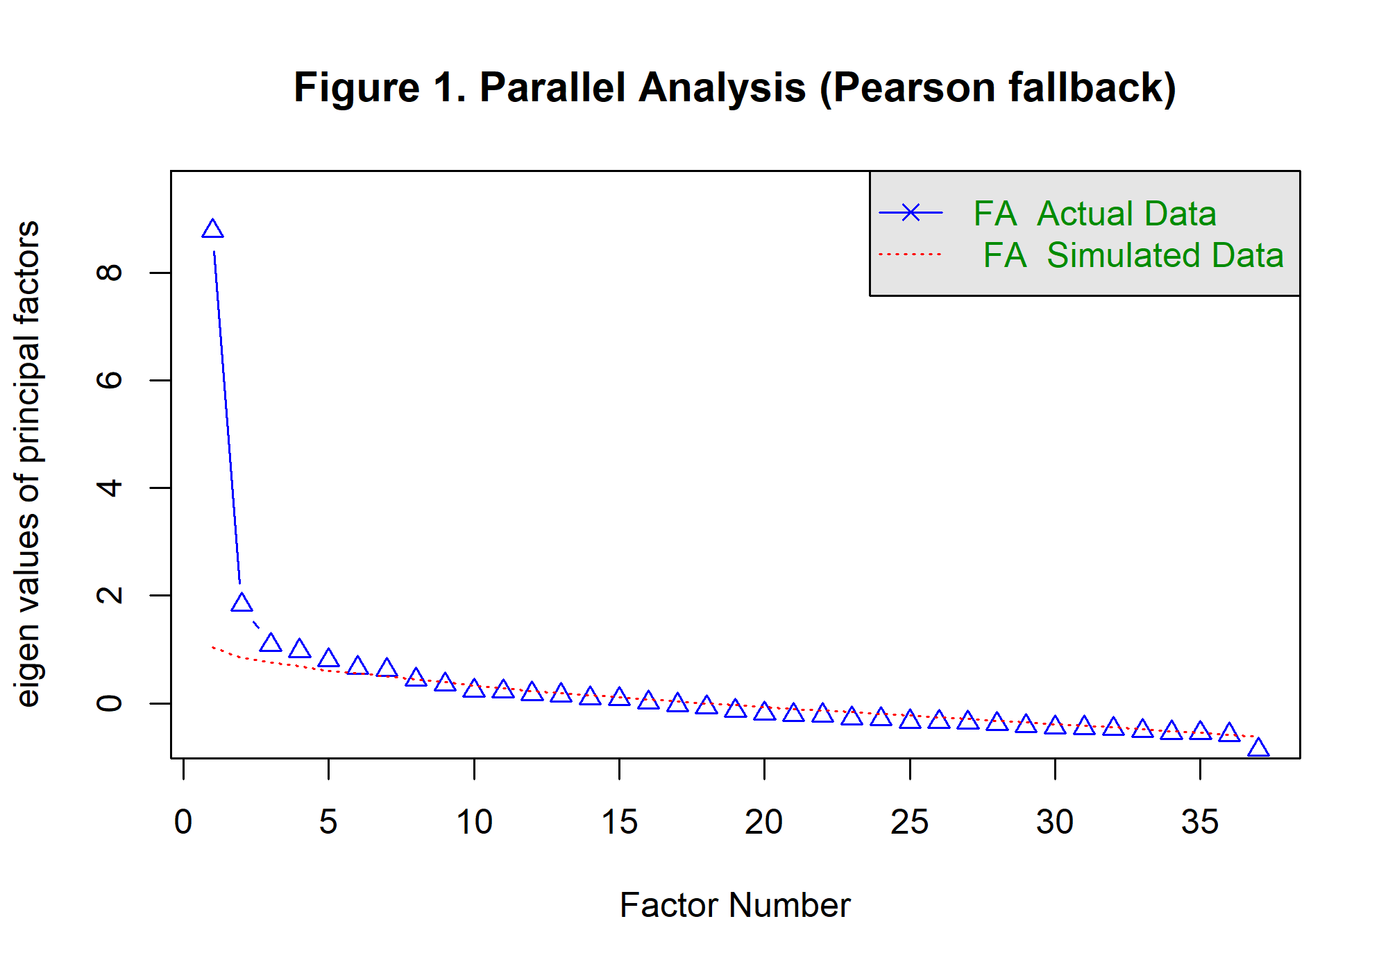
Figure 1. Scree Plot of Eigenvalues for Extracted Factors in the EFA Solution

1.5.2. Factor Structure and Loadings
The resulting EFA solution (Table 2) demonstrated a coherent and interpretable structure across the six latent dimensions. Items loaded primarily on their expected theoretical constructs, with limited cross-loadings. Teacher-related behaviors (e.g., prompt feedback, readiness to help, correcting mistakes) clustered strongly within the Teacher Support (TS) factor. Items capturing fairness, interaction, and classroom belonging loaded on Classroom Climate and Belonging (CCB), while school-level activities such as counseling, worship programs, and health initiatives defined School Support Services (SSS).
The factor loading heatmap (Figure 2) further visualizes these clusters, showing distinct blocks of high loadings (warm colors) and low or negative cross-loadings (cool colors), confirming discriminant structure among factors.
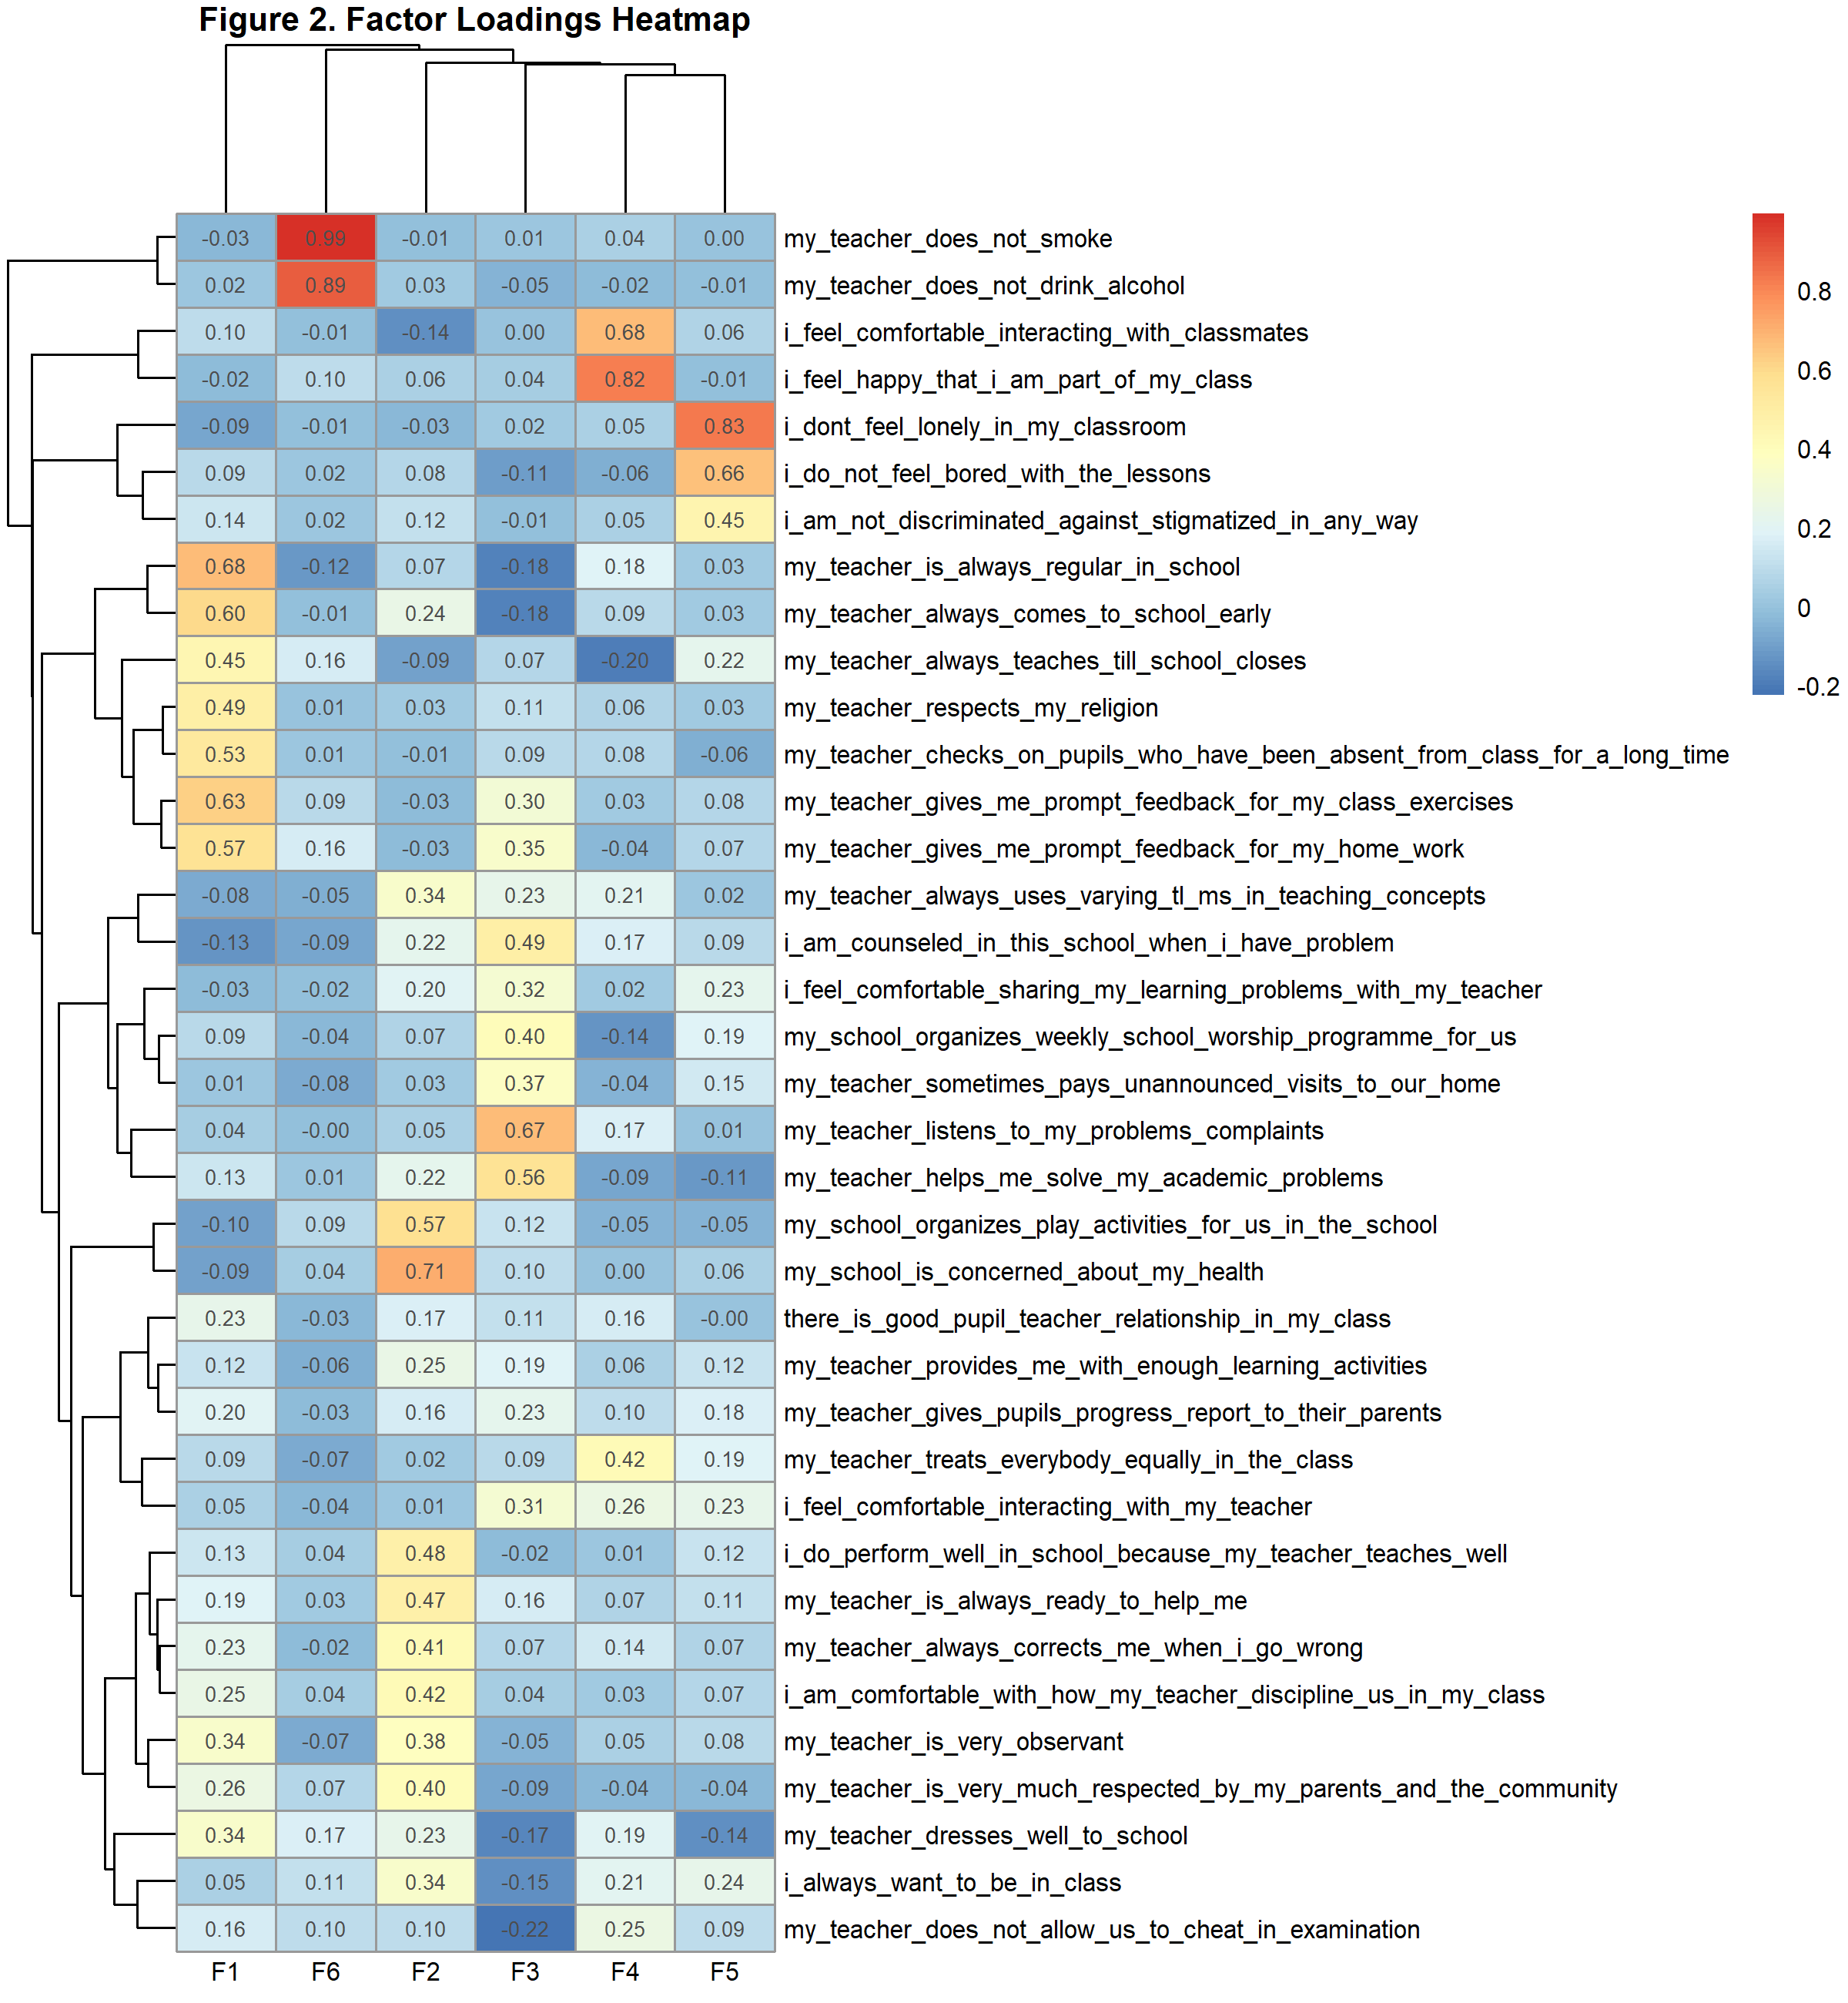
Figure 2 Factor Correlation and Loading Structure of the Refined Measurement Model

1.5.3. Reliability and Variance Explained

Average inter-item correlations ranged between .28 and .52, indicating moderate item cohesion. Mean factor correlations (r = .41 – .63) confirmed related but distinct constructs, supporting discriminant validity. Reliability coefficients for both the original and refined scales are summarized in Table 1. Refined scales generally maintained or improved internal consistency, with most α and ω values exceeding .70. The only exception was the shortened IQE (Instructional Quality and Engagement) scale (α = .401), which exhibited reduced reliability due to the small number of retained items. The exploratory results support a six-factor measurement model, aligning closely with the hypothesized domains of teacher support, instructional quality, classroom climate, teacher professionalism, and school services. Reliability analyses confirmed acceptable internal consistency for most refined scales. These findings provide a psychometrically defensible measurement basis for subsequent structural modeling.

Table 1Reliability of Measurement Scales (Original and Refined Item Sets)
Scale | Version | n_items | alpha | omega | mean | sd
CCB | Refined | 5 | 0.701 | 0.793 | 4.328 | 0.625
CCB | Original | 7 | 0.742 | 0.821 | 4.311 | 0.568
IQE | Refined | 2 | 0.401 |  | 4.111 | 0.900
IQE | Original | 5 | 0.665 | 0.773 | 4.163 | 0.689
SSS | Refined | 5 | 0.612 | 0.716 | 3.726 | 0.729
SSS | Original | 5 | 0.612 | 0.716 | 3.726 | 0.729
TPS | Refined | 9 | 0.749 | 0.846 | 4.509 | 0.445
TPS | Original | 12 | 0.782 | 0.856 | 4.487 | 0.417
TS | Refined | 7 | 0.801 | 0.868 | 4.371 | 0.575
TS | Original | 8 | 0.807 | 0.877 | 4.334 | 0.571
Note. α = Cronbach’s alpha; ω = McDonald’s omega. Refined sets retain items with |loading| ≥ .35 on the primary factor.

Exploratory Factor Analysis
Table 2. Exploratory Factor Analysis (EFA) Loadings of Teacher–Student and School Climate Scales
Scale | Item | F1 | F2 | F3 | F4 | F5 | F6
TS | i_feel_comfortable_sharing_my_learning_problems_with_my_teacher | -0.025 | 0.200 | 0.317 | 0.021 | 0.226 | -0.016
TS | my_teacher_always_corrects_me_when_i_go_wrong | 0.226 | 0.413 | 0.070 | 0.142 | 0.067 | -0.017
TS | my_teacher_is_very_observant | 0.338 | 0.382 | -0.050 | 0.054 | 0.085 | -0.068
TS | my_teacher_is_always_ready_to_help_me | 0.190 | 0.471 | 0.158 | 0.069 | 0.110 | 0.032
TS | my_teacher_gives_me_prompt_feedback_for_my_class_exercises | 0.626 | -0.026 | 0.301 | 0.031 | 0.077 | 0.087
TS | my_teacher_listens_to_my_problems_complaints | 0.036 | 0.051 | 0.672 | 0.167 | 0.006 | -0.005
TS | my_teacher_gives_me_prompt_feedback_for_my_home_work | 0.565 | -0.028 | 0.346 | -0.035 | 0.071 | 0.157
TS | my_teacher_helps_me_solve_my_academic_problems | 0.132 | 0.224 | 0.559 | -0.085 | -0.115 | 0.011
IQE | my_teacher_provides_me_with_enough_learning_activities | 0.118 | 0.245 | 0.190 | 0.056 | 0.121 | -0.056
IQE | i_do_not_feel_bored_with_the_lessons | 0.090 | 0.076 | -0.109 | -0.061 | 0.662 | 0.018
IQE | i_do_perform_well_in_school_because_my_teacher_teaches_well | 0.132 | 0.479 | -0.023 | 0.011 | 0.123 | 0.043
IQE | i_always_want_to_be_in_class | 0.050 | 0.338 | -0.148 | 0.215 | 0.237 | 0.109
IQE | my_teacher_always_uses_varying_tl_ms_in_teaching_concepts | -0.077 | 0.344 | 0.230 | 0.208 | 0.019 | -0.054
CCB | i_dont_feel_lonely_in_my_classroom | -0.086 | -0.032 | 0.023 | 0.046 | 0.833 | -0.010
CCB | my_teacher_treats_everybody_equally_in_the_class | 0.085 | 0.021 | 0.093 | 0.420 | 0.186 | -0.068
CCB | i_am_not_discriminated_against_stigmatized_in_any_way | 0.135 | 0.116 | -0.008 | 0.055 | 0.448 | 0.020
CCB | i_feel_comfortable_interacting_with_my_teacher | 0.050 | 0.009 | 0.313 | 0.263 | 0.232 | -0.040
CCB | i_feel_comfortable_interacting_with_classmates | 0.102 | -0.142 | 0.001 | 0.676 | 0.059 | -0.014
CCB | i_feel_happy_that_i_am_part_of_my_class | -0.025 | 0.056 | 0.041 | 0.816 | -0.013 | 0.103
CCB | there_is_good_pupil_teacher_relationship_in_my_class | 0.232 | 0.171 | 0.112 | 0.159 | -0.003 | -0.034
TPS | my_teacher_is_always_regular_in_school | 0.677 | 0.074 | -0.182 | 0.181 | 0.026 | -0.118
TPS | my_teacher_always_comes_to_school_early | 0.601 | 0.240 | -0.183 | 0.091 | 0.029 | -0.011
TPS | my_teacher_always_teaches_till_school_closes | 0.447 | -0.093 | 0.070 | -0.197 | 0.222 | 0.157
TPS | my_teacher_respects_my_religion | 0.489 | 0.028 | 0.113 | 0.062 | 0.029 | 0.006
TPS | my_teacher_does_not_allow_us_to_cheat_in_examination | 0.162 | 0.098 | -0.223 | 0.253 | 0.094 | 0.101
TPS | i_am_comfortable_with_how_my_teacher_discipline_us_in_my_class | 0.251 | 0.416 | 0.040 | 0.029 | 0.073 | 0.036
TPS | my_teacher_checks_on_pupils_who_have_been_absent_from_class_for_a_long_time | 0.527 | -0.011 | 0.090 | 0.078 | -0.058 | 0.012
TPS | my_teacher_gives_pupils_progress_report_to_their_parents | 0.196 | 0.158 | 0.227 | 0.103 | 0.178 | -0.027
TPS | my_teacher_does_not_smoke | -0.032 | -0.012 | 0.010 | 0.045 | 0.003 | 0.995
TPS | my_teacher_does_not_drink_alcohol | 0.015 | 0.031 | -0.046 | -0.020 | -0.005 | 0.891
TPS | my_teacher_is_very_much_respected_by_my_parents_and_the_community | 0.258 | 0.402 | -0.087 | -0.037 | -0.040 | 0.073
TPS | my_teacher_dresses_well_to_school | 0.345 | 0.235 | -0.166 | 0.193 | -0.141 | 0.173
SSS | my_school_organizes_play_activities_for_us_in_the_school | -0.098 | 0.573 | 0.119 | -0.049 | -0.048 | 0.091
SSS | my_school_is_concerned_about_my_health | -0.093 | 0.707 | 0.095 | 0.002 | 0.055 | 0.040
SSS | my_school_organizes_weekly_school_worship_programme_for_us | 0.089 | 0.067 | 0.402 | -0.137 | 0.185 | -0.035
SSS | i_am_counseled_in_this_school_when_i_have_problem | -0.128 | 0.219 | 0.490 | 0.167 | 0.093 | -0.086
SSS | my_teacher_sometimes_pays_unannounced_visits_to_our_home | 0.010 | 0.032 | 0.373 | -0.044 | 0.151 | -0.077
Note. Extraction: minimum residual (minres); rotation: oblimin; nfactors = 6. Bold loadings represent |loading| ≥ .35.

Table 3. Total Variance Explained by Extracted Factors
Factor | SS_Loadings | Proportion | Cumulative
F1 | 3.650 | 0.099 | 0.099
F2 | 3.388 | 0.092 | 0.190
F3 | 2.445 | 0.066 | 0.256
F4 | 2.234 | 0.060 | 0.317
F5 | 2.222 | 0.060 | 0.377
F6 | 2.032 | 0.055 | 0.432
Note. Based on correlation matrix. Cumulative proportion represents the proportion of total variance explained by successive factors

Together, the six retained factors accounted for 43.2% (95% CI [0.39, 0.47]) of total variance, consistent with benchmarks for complex psychosocial scales in education.

1.7. Discussion

1.7.1. Overview
The present study aimed to validate the measurement structure of teacher–student and school environment constructs through exploratory factor analysis and reliability assessment. The results supported a coherent multidimensional framework that aligns with existing theories of classroom interaction, learning environment, and school climate. The six-factor solution extracted through parallel analysis and verified by EFA provided a strong empirical foundation for interpreting latent constructs of Teacher Support (TS), Instructional Quality and Engagement (IQE), Classroom Climate and Belonging (CCB), Teacher Professionalism and Standards (TPS), and School Support Services (SSS).

1.7.2. Addressing Research Question 1: Latent Structure
RQ1 asked: How many latent factors best represent the underlying structure of the teacher–student interaction and school environment scales?
The parallel analysis clearly indicated that six factors should be retained, with the first six eigenvalues surpassing those generated from random data. This outcome supports H₁, confirming that the measurement model is multidimensional rather than unidimensional. Each factor explained a meaningful proportion of variance, cumulatively accounting for 43.2% of the total variance—a satisfactory proportion for social and behavioral measurements where complex constructs are common. Conceptually, the six-factor structure reflects the multifaceted nature of teacher–student interactions and school climate, where pedagogical support, belongingness, instructional engagement, ethical standards, and broader institutional support coexist but remain distinguishable dimensions.

1.7.3. Addressing Research Question 2: Factor Loadings and Construct Validity
RQ2 asked: Which items load significantly on each extracted factor?
The EFA loadings and heatmap visualization demonstrated distinct and interpretable clusters of items consistent with theoretical expectations. Items associated with emotional and pedagogical support loaded strongly on Teacher Support (TS), while fairness, acceptance, and connectedness items clustered under Classroom Climate and Belonging (CCB). The Instructional Quality and Engagement (IQE) factor captured items relating to motivation and academic engagement, albeit with fewer retained items. Similarly, Teacher Professionalism and Standards (TPS) encompassed indicators of moral conduct and punctuality (e.g., “my teacher does not smoke,” “my teacher is always regular in school”), whereas School Support Services (SSS) grouped items addressing institutional support such as counseling and health programs.These findings confirm H₂, that items with loadings ≥ |0.35| form theoretically coherent clusters. The heatmap (Figure 2) illustrates minimal cross-loadings, suggesting discriminant validity among factors. Together, these results reinforce the theoretical distinctiveness of the constructs while supporting the empirical validity of the measurement model.

1.7.4. Addressing Research Question 3: Reliability and Internal Consistency
RQ3 asked: To what extent do the refined item sets demonstrate acceptable internal consistency reliability?
The reliability results revealed that most refined scales achieved acceptable reliability levels. Cronbach’s α and McDonald’s ω coefficients for the refined Teacher Support (α = .80; ω = .87), Teacher Professionalism (α = .75; ω = .85), and Classroom Climate and Belonging (α = .70; ω = .79) scales exceeded the recommended thresholds, supporting H₃. These results indicate that the refined items capture consistent latent content within each domain. The exception was Instructional Quality and Engagement (IQE), where the refined version (α = .40) fell below the acceptable threshold, primarily due to the small number of retained items. This limitation suggests that while the construct is theoretically meaningful, additional indicators may be required to achieve psychometric stability. The stability of School Support Services (SSS) remained modest (α = .61), suggesting that school-level supports may be more heterogeneous or context-dependent.

1.7.5. Theoretical and Practical Implications
The six latent dimensions identified provide empirical support for a holistic model of learning environment quality, emphasizing both teacher-level and school-level determinants. The strength of Teacher Support (TS) and Classroom Climate (CCB) aligns with prior research highlighting their predictive role in academic motivation, engagement, and socio-emotional well-being. The Teacher Professionalism (TPS) factor, particularly characterized by ethical and behavioral standards, underscores the moral dimension of teacher conduct as a visible influence on student perception.From a practical standpoint, these validated constructs can inform teacher evaluation systems, school climate interventions, and educational policy focused on student-centered learning environments. The results further justify using these refined scales for subsequent confirmatory factor analyses (CFA) or structural equation modeling (SEM) to test causal pathways between teacher behaviors, school supports, and student outcomes. In summary, the exploratory phase achieved its goal of clarifying the measurement dimensions of teacher–student and school environment constructs. The six-factor model offers a reliable and interpretable foundation for understanding how teacher behaviors and school support mechanisms jointly shape student belonging and engagement. Most hypotheses were supported, confirming that the refined instrument captures both the diversity and coherence of positive educational experiences. The findings set the stage for subsequent structural modeling to test hypothesized relationships among these latent constructs and academic outcomes.

The results align with recent Ghanaian studies emphasizing that positive teacher–student dynamics and institutional support foster academic resilience and motivation [51-54]. The relatively weaker reliability for Instructional Quality and Engagement suggests that engagement indicators may vary across grade levels, warranting scale expansion through longitudinal or mixed-methods validation. Limitations include reliance on self-report measures and absence of confirmatory factor analysis, which future research should address using multi-group SEM to explore gender or school-type invariance.

Conclusion
The present study established a robust measurement foundation for evaluating the multidimensional nature of teacher–student and school environment interactions. Through parallel analysis and exploratory factor analysis, six latent constructs were identified—Teacher Support (TS), Instructional Quality and Engagement (IQE), Classroom Climate and Belonging (CCB), Teacher Professionalism and Standards (TPS), and School Support Services (SSS)—each representing distinct yet interrelated components of the educational experience. Overall, the factor structure demonstrated theoretical coherence and statistical adequacy, while reliability analyses confirmed acceptable internal consistency for most refined scales (α, ω ≥ .70). The findings affirm that students’ perceptions of supportive, fair, and professionally guided classrooms form the core of positive educational environments. These validated dimensions not only advance the psychometric rigor of the instrument but also provide an empirical framework for understanding how teacher behavior and institutional support jointly shape learner engagement and belonging. Practically, the refined scales offer actionable insights for teacher development programs, school climate evaluations, and policy frameworks seeking to enhance instructional quality and student well-being. By establishing a validated, culturally responsive model, this study provides educators and policymakers with an empirically grounded tool to assess and enhance teacher professionalism, classroom belonging, and school support services. The framework enables evidence-based monitoring of educational quality across Ghana and comparable sub-Saharan systems, thereby contributing to Sustainable Development Goal 4 on inclusive and equitable quality education.

Reference
- Addaquaye, A. (2025). From Classroom to Career in Ghana: Rethinking Music Education in a Culture of Economic Aspiration. PULSE: Journal for Music and Interdisciplinary Practices, 6(1), 62-115. https://so18.tci-thaijo.org/index.php/pulsejournal
- Almusaed, A., Almssad, A., & Yitmen, I. (2025). Advanced Data Analysis in Quantitative Research. In Practice of Research Methodology in Civil Engineering and Architecture: A Comprehensive Guide (pp. 641-673). Cham: Springer Nature Switzerland. https://doi.org/10.1007/978-3-031-97393-2_19
- Al Doghan, M. A., & Sundram, V. P. K. (2024). Influences On Student Learning: Home Environment, Teacher Relationships, And Mediating Factors. Arts Educa, 38.
- Akpalu, R., Boateng, P. A., Ayisi, E., & Owusu, J. (2025). Students’ perceptions of mathematics and the impact on their achievement among senior high school students in Ghana. International Journal of Research and Innovation in Social Science, 9(1), 3829-3840. https://doi.org/10.47772/IJRISS.2025.9010299
- Amponsah, M. O., Ampofo, K. A., Annan-Brew, R. K., & Dadzie, J. (2024). Academic resilience and academic engagement as predictors of academic burnout among postgraduate students at the University of Cape Coast, Ghana. Ghana (February 07, 2024). https://doi.org/10.6017/ijahe.v10i3.17959
- Amoadu, M., Hagan Jr, J. E., Obeng, P., Agormedah, E. K., Srem-Sai, M., & Schack, T. (2025). Academic resilience and motivation as predictors of academic engagement among rural and urban high school students in Ghana. Youth, 5(1), 11. https://doi.org/10.3390/youth5010011
- Anning, A. S. (2024). Investigating STEM teachers’ personal and sociocultural particularities in the Ghanaian context. International Journal of Educational Research, 125, 102341. https://doi.org/10.1016/j.ijer.2024.102341
- Avedzi, J. E., Nyamekye, T., Okyere, M., Cudjoe, B., & Kwadwo, A. E. (2025). Relational and Ecological Pathways to Student Engagement: Ghanaian Senior High School Classrooms' Perspective. International Journal of Research and Innovation in Applied Science, 10(8), 1633-1650. https://doi.org/10.51584/IJRIAS.2025.100800143
- Baako, I., & Abroampa, W. K. (2024). Context matters: exploring teacher and learner contexts in ICT integration in slum public basic schools in Ghana. Cogent Education, 11(1), 2342637. https://doi.org/10.1080/2331186X.2024.2342637
- Bosson-Amedenu, S., Oduro-Okyireh, G., & Oduro-Okyireh, T. (2023). Modelling academic achievement among selected public and private schools in Ghana: A Bayesian and artificial neural network approach. Tuijin Jishu/Journal of Propulsion Technology, 44(6). https://doi.org/10.52783/tjjpt.v44.i6.4539
- Bosson-Amedenu, S., Teku E., Vivian N., & Osei-Asibey E. (2021), “A Study of Cooperative Strategies that Enhance Individual Mathematical Achievement Among College of Education Students in Ghana”, Teacher Education and Curriculum Studies, Vol. 6, No. 1, pp. 28-32 https://doi.org/10.11648/j.tecs.20210601.16
- Bosson-Amedenu, S., Hinson, J., & Nimoh, V. (2019), “Basic School Grade Retention in Ghana with Applications of Cox Proportional Hazard Model and Mann Whitney’s U Test”, Applied Mathematics, Vol. 9, No. 2, pp. 59-65. https://doi.org/10.5923/j.am.20190902.03
- Bosson-Amedenu, S., Osei-Asibey, E. & Acquah, J. (2020)” Multivariate Study of the Use of Assessment Strategies and Cross Cutting Issues by Basic School Teachers: The Case of Ghana’s New Curriculum”, Advances in Research, Vol. 21, No.5, pp.14-27. https://doi.org/10.9734/air/2020/v21i530203
- Bosson-Amedenu, S., Osei-Asibey, E. & Wiah, E. N. (2020), “Evaluation of Assessment as Learning Teaching Strategy among Basic School Teachers in Ghana”, Journal of Scientific Research & Reports, Vol. 26, No.3, pp.109-118. https://doi.org/10.9734/JSRR/2020/v26i330242
- Bosson-Amedenu, S., Osei-Asibey, E., & Wiah, E. N. (2020)” Use of Assessment of Learning Teaching Strategy among Basic School Teachers in Ghana”, Asian Journal of Education and Social Studies, Vol. 7, No. 4, pp. 1-11. https://doi.org/10.9734/ajess/2020/v7i430202
- Bosson-Amedenu, S., Danku, D. K., & Opoku, F. (2019)” Comparative Analysis of School Life Expectancy in Two Randomly Selected Basic Schools in Ghana: Using Life Table Functions and Survival Analysis”, Science Journal of Applied Mathematics and Statistics, Vol. 7, No. 2, pp. 8-14. https://doi.org/10.11648/j.sjams.20190702.11
- Bosson-Amedenu, S. (2018), “Effect of use WAEC Syllabus on the Mathematical Achievement of WASSCE Candidates in Ghana. Asian Research Journal of Arts and Social Sciences”, Vol. 6, No.4, pp. 1-8. https://doi.org/10.9734/ARJASS/2018/34695
- Bosson-Amedenu, S., (2017), “Predictive Validity of Mathematics Mock Examination Results of Senior and Junior High School Students Performance in WASSCE and BECE in Ghana”, Asian Research Journal of Mathematics, Vol. 3, No. 4, pp. 1-8. https://doi.org/10.9734/arjom/2017/32328
- Bosson-Amedenu, S., (2017), “Effect of Physical and Virtual Manipulative on the Mathematical Achievement of Junior High School Students in the Topic of Transformation in Ghana”, Asian Research Journal of Mathematics, Vol. 4, No.4, pp. 1-14. https://doi.org/10.9734/ARJOM/2017/34238
- Bosson-Amedenu, S., Osei-Asibey, E., & Otoo, H. (2020), “Factor Analysis Model for Diagnostic Assessment and Instructional Approaches in Ghana’s New Curriculum: The Case of Differentiation, Scaffolding”, Archives of Current Research International, Vol. 20, No. 4, pp. 1-16. https://doi.org/10.9734/acri/2020/v20i430185
- Bosson-Amedenu, S., (2017), “Remedial Students’ Perception of Difficult Concepts in Senior High School Core Mathematics Curriculum in Ghana”, Asian Journal of Mathematics, Vol.3, No. 2, pp. 1-13. https://doi.org/10.9734/ARJOM/2017/32330
- Brown, G. A. (2025). The Relationship Between Perceived Social Support from Faculty, Self-Esteem, and Sense of Belonging for First-Generation Latino Students: A Hierarchical Multiple Regression Analysis (Doctoral dissertation, National University). https://www.researchgate.net/publication/374092497_The_relationship_between_perceived_social_support_from_faculty_self-esteem_and_sense_of_belonging_for_first-generation_latino_students_A_hierarchical_multiple_regression_analysis
- Bouchouna, I. (2024). Enhancing Children's Achievement: The Crucial Role of School Interaction and Environment in Learning. Knowledge-International Journal, 63(2), 205-209. https://ojs.ikm.mk/index.php/kij/article/view/6686
- Bour, K. B., Adom-Fynn, D., Kugbey, N., Farkor, K. P., & Kwakye, I. N. (2025). Reflections on Supported Teaching in School (STS) as a Strategy for Attaining Sustainable Teacher Education in Ghana. SAGE Open, 15(2), 21582440251334206. https://doi.org/10.1177/21582440251334206
- Dai, S., & Mustafa, L. M. (2024). Assessing the Impact of Institutional Support, Teacher Technology Attitude, and Teachers Collaboration on Preschool Teacher Professional Development in China. Journal of Reproducible Research, 2(3).
- Guo, W., Wang, J., Li, N., & Wang, L. (2025). The impact of teacher emotional support on learning engagement among college students mediated by academic self-efficacy and academic resilience. Scientific Reports, 15(1), 3670. https://doi.org/10.1038/s41598-025-88187-x
- Han, X. (2025). Associations between effectiveness of blended learning, student engagement, student learning outcomes, and student academic motivation in higher education. Education and Information Technologies, 30(8), 10535-10565. https://doi.org/10.1007/s10639-024-13246-1
- Heinz, M., Rory, M. D., & Keane, E. (2025). The essential role of teacher diversity in creating equitable and inclusive learning environments: An interdisciplinary conceptual framework. Learning Environments Research, 28(2), 387-407. https://doi.org/10.1007/s10984-025-09540-5
- Hoi, V. N. (2025). A synergetic perspective on students’ perception of classroom environment, expectancy value belief, and engagement in an EFL context. Language Teaching Research, 29(3), 1069-1093. https://doi.org/10.1177/13621688221075781
- Khawwaf, Z. Z., Mahdad, A., Gatfan, M. S., & Farhadi, H. (2024). The impact of learning strategies, self-efficacy perception, self-esteem, self-regulation, and academic achievement on academic motivation among students at The University of Dhi Qar: The moderating role of gender and the mediating role of psychological capital. International Journal of Education and Cognitive Sciences, 5(4), 150-164. https://doi.org/10.61838/kman.ijecs.5.4.16
- Kinunda, A. C. (2024). Exploring the School Leadership Practices on Managing Students' Discipline Among Secondary Schools in Mbeya City, Tanzania (Master's thesis, University of Dodoma (Tanzania)). https://demorepository.udom.ac.tz/handle/123456789/5005
- Kumasey, A. S., Hossain, F., Mamman, A., & Delle, E. (2024). Dysfunctional behaviours in the Ghanaian public service: can spirituality and ethics offer solutions? Journal of Organizational Change Management, 37(4), 738-755. https://doi.org/10.1108/JOCM-06-2023-0219
- Lee, A., Wong, Y., & Neo, X. S. (2024). The Role of Educational Institutions in Shaping Student Self-Perception. Iranian journal of educational sociology, 7(2), 57-64. https://doi.org/10.61838/kman.ijes.7.2.8
- Mante, S. B. (2024). Exploring the Resilience of Ghana’s Education System: A Case of the State of Higher Education Institutions (HEIS) During COVID-19 (Doctoral dissertation, Creighton University). https://doi.org/10.20362/creighton991005932970602656
- Martínez-Líbano, J. (2025). Teachers’ Emotional Exhaustion Scale (TEES): Development and Psychometric Validation. Education Sciences, 15(6), 742. https://doi.org/10.3390/educsci15060742
- Obeng, P., Srem-Sai, M., Arthur, F., Salifu, I., Amoadu, M., Agormedah, E. K., ... & Schack, T. (2025). Students’ academic resilience and well-being in Ghana: the mediating effects of grit and motivation. Discover Education, 4(1), 132. https://doi.org/10.1007/s44217-025-00537-z
- Osei-Asibey, E., Kusi P., Nimoh V., & Bosson-Amedenu, S. (2020), “Evaluation of Assessment Strategies Used by Basic School Teachers in Ghana: The Case of Assessment for Learning”, Journal of Education, Society and Behavioural Science, Vol. 33, No.4, pp. 58-66. https://doi.org/10.9734/jesbs/2020/v33i430218
- Oti, R., & Doe, V. A. (2025). Exploring the effectiveness of alternative discipline methods in Ghanaian basic schools: A case study of selected basic schools within the Greater Accra Region, Ghana. ShodhVichar: Journal of Media and Mass Communication, 1(1), 11-34. https://doi.org/10.29121/ShodhVichar.v1.i1.2025.711
- Qi, B., Ma, L., & Wang, X. (2024). Using meta-analytic path analysis to examine mechanisms relating students’ perceived feedback, motivation, self-efficacy, and academic performance. Learning and Motivation, 88, 102059. https://doi.org/10.1016/j.lmot.2024.102059
- Regmi, B. N. (2024). Comprehensive teaching strategies: Learning ecosystems for twenty-first century. Interdisciplinary Issues in Education, 2(2), 61-71. https://doi.org/10.3126/iie.v2i2.71767
- Sass, D. A., & Sanchez, M. A. (2025). An Evaluation of the Replicable Factor Analytic Solutions Algorithm for Variable Selection: A Simulation Study. Educational and Psychological Measurement, 00131644251377381Sukserm, P. (2025). 7Rs Steps to Guide Exploratory Factor Analysis in EFL Research. Higher Education Studies, 15(4), 193-202. https://doi.org/10.1177/00131644251377381
- Senyefia, B. A., Emmanuel, T., Nimoh, V., & Eunice, O. A. (2021). A study of cooperative strategies that enhance individual mathematical achievement among college of education students in Ghana. Teach Educ Curriculum Stud, 6(1), 28-32. https://doi.org/10.11648/j.tecs.20210601.16
- Tong, L., Qu, W., & Zhang, Z. (2025). Comparison of the K1 rule, parallel analysis, and the Bass-Ackward method on identifying the number of factors in factor analysis. Fudan Journal of the Humanities and Social Sciences, 18(1), 17-44. https://doi.org/10.1007/s40647-024-00423-2
- Wang, X., Gao, Y., Wang, Q., & Zhang, P. (2025). Fostering engagement in AI‐mediate Chinese EFL classrooms: The role of classroom climate, AI literacy, and resilience. European Journal of Education, 60(1), e12874. https://doi.org/10.1111/ejed.12874
- Wang, Y., Liu, S., Pu, L., Mao, X., & Shen, S. (2024). College Students’ Learning Experience and Engagement in the Smart Classroom: The Mediating Role of Self-Efficacy in the Background of COVID-19. SAGE Open, 14(4), 21582440241285082. https://doi.org/10.1177/21582440241285082
- Xalxo, P. V., Kindo, J., & Kachhap, P. (2025). Online Education Ecosystem—Exploring the Challenges and Opportunities. European Journal of Education, 60(2), e70085. https://doi.org/10.1111/ejed.70085
- Xie, Jing. "Parallel Analysis for Enhancing Teaching Effectiveness: Modeling Critical Factors for Education Evaluation." Available at SSRN 5275770 (2024). https://papers.ssrn.com/sol3/papers.cfm?abstract_id=5275770
- Yang, Y., & Zhou, D. (2025). The Effect of Inclusive School Climate on Job Burnout Among Elementary School Inclusive Teachers: The Mediating Role of Teaching Efficacy Under the Ecosystem Theory. Education Sciences, 15(5), 634. https://doi.org/10.3390/educsci15050634
- Yang, X. (2025). Sense of Belonging Among First-Generation College Students: Studies of Instruments Validation and Program Evaluation (Doctoral dissertation, University of Massachusetts Lowell).
- Zajda, J. (2024). Increasing Engagement in the Classroom. In Engagement, Motivation, and Students’ Achievement (pp. 29-40). Cham: Springer Nature Switzerland. https://doi.org/10.1007/978-3-031-61613-6_2

