Nonlinear Cox Survival Modeling of Prostate Cancer with SHAP-Based Explainability

Abstract
Background: Prostate cancer is a leading cause of cancer-related morbidity and mortality among Ghanaian men, with a predominance of advanced-stage presentations attributable to limited screening and delayed diagnosis. Traditional Cox proportional hazards models commonly presuppose linear relationships and may inadequately capture intricate biological patterns. This study employed a Cox proportional hazards framework augmented with restricted cubic splines (RCSs) and SHAPs (SHapley Additive exPlanations) to elucidate nonlinear and individualized determinants of prostate cancer survival.
Method: A retrospective cohort of 300 men with histologically confirmed prostate cancer treated at Korle Bu Teaching Hospital between 2015 and 2020 was analyzed. The candidate predictor variables included age, tumor size, prostate-specific antigen (PSA) level, Gleason score, clinical stage, lymph node involvement, and treatment modality. Nonlinear relationships for age and tumor size were modeled via flexible spline terms. Model adequacy and fit were assessed through the Akaike information criterion (AIC), Harrell’s concordance index (C-index), and diagnostics for proportional hazards assumptions. Shapley additive explanations (SHAPs) were employed to quantify both global and individual (patient-level) contributions to mortality risk.
Results: The spline-augmented Cox model demonstrated significant nonlinear associations with tumor size (hazard ratio [HR] = 0.41, 95% CI: 0.17-0.99, p = 0.048) and a pronounced effect on the Gleason score (HR = 0.85, 95% CI: 0.74-0.99, p = 0.036). SHAP analysis identified tumor size (absolute SHAP value = 0.2015) and Gleason score (absolute SHAP value = 0.1591) as the leading predictors, followed by chemotherapy and prostate-specific antigen (PSA) levels. Beeswarm and partial-effect plots corroborated a nonlinear increase in survival risk with greater tumor burden and higher histologic grade, whereas moderate PSA levels and receipt of treatment exerted a protective effect. The combined spline-SHAP model demonstrated strong predictive performance (C-index = 0.84) with improved parsimony over the linear Cox baseline (ΔAIC = −13), confirming the dominance of tumor size and Gleason score as the most influential contributors to survival risk.
Conclusion: The integration of relative continuous scoring (RCS) with SHAP-based explainability enhanced model flexibility, transparency, and clinical interpretability. The results underscore tumor size and Gleason score as the most influential determinants of mortality, highlighting the imperative for early detection, histopathological risk stratification, and individualized therapeutic strategies. The SHAP-augmented RCS Cox framework provides a replicable approach for precision oncology and evidence-based management of prostate cancer in settings with limited resources, including Ghana.
Keywords:
Prostate cancer, restricted cubic splines, Cox proportional hazards, SHAP explainability, nonlinear modeling, survival analysis, precision oncology.

Background
Prostate cancer remains one of the most prevalent malignancies affecting men globally and is a leading cause of cancer-related morbidity and mortality. Prostate cancer accounts for approximately 15% of all new cancer cases in men and 8% of cancer deaths worldwide (Kratzer et al., 2025; James et al., 2024; Zi et al., 2024; Preisser et al., 2025; Belkahla et al., 2022). Its burden is increasing in low- and middle-income countries (LMICs), where limited access to diagnostic tools and screening programs has led to late-stage presentation and poor outcomes (Kitson-Mills et al., 2025; Dee et al., 2025; Liu et al., 2025). In sub-Saharan Africa, the situation is particularly concerning, with increasing incidence rates attributed to urbanization, changing lifestyles, and the aging population (Zhang et al., 2025; Dlamini et al., 2025; Amaeshi et al., 2025). Ghana reflects this continental trend, where prostate cancer constitutes one of the most commonly diagnosed cancers among men, accounting for approximately 12% of all male cancer cases (Der et al., 2025; Sarpong et al., 2025; Abu et al., 2025).
Despite global advances in early detection and treatment, prostate cancer outcomes in Ghana remain suboptimal. Factors such as low public awareness, limited screening infrastructure, and inconsistent follow-up systems have contributed to high proportions of late-stage diagnoses. Clinical data from major tertiary hospitals in Ghana reveal that most men present with locally advanced or metastatic disease, often after prolonged symptom duration (Ofori et al., 2025; Daniels et al., 2025; Dadee-Seshie et al., 2025; Obeng et al., 2025). Biochemical markers such as prostate-specific antigen (PSA) levels, tumor size, and Gleason scores are key determinants of prognosis. However, these indicators are frequently underutilized in integrated predictive models that account for nonlinear risk patterns and survival heterogeneity.
Recent modeling advances, particularly the application of flexible survival models such as the Cox proportional hazards model with restricted cubic splines (RCSs), provide a refined approach to understanding the nonlinear associations between clinical predictors and patient outcomes (Bosson-Amedenu, 2025; Aziz et al., 2025; Flannery et al., 2025; Esteban et al., 2025). These models enhance interpretability by allowing for curved relationships between age, tumor size, and hazard ratios relationships often masked by traditional linear models. Integrating these analytical methods within local cancer registries and hospital data in Ghana can offer actionable insights into the biological and sociodemographic determinants of prostate cancer survival. Such evidence directly aligns with the objectives of Sustainable Development Goal (SDG) 3, particularly target 3.4, which aims to reduce premature mortality from noncommunicable diseases through early detection and treatment interventions.
Prostate cancer progression and survival outcomes have been extensively studied in developed contexts, with several well-established prognostic markers, including age, PSA levels, Gleason score, tumor size, and cancer stage (Bosson-Amedenu, 2025; Kavak et al., 2025; Freedland et al., 2025; Wu et al., 2025). Age is among the strongest demographic correlates, with incidence increasing exponentially after the fifth decade of life (Bosson-Amedenu, 2025; Zhao et al., 2025; Zhu et al., 2025; Bhandari et al., 2025; Ghanem et al., 2025). However, the relationship between age and survival is complex; while older age increases biological vulnerability, some studies report that younger men with high-grade tumors exhibit worse outcomes, suggesting that tumor biology and genetics may mediate the effect of age.
PSA remains the cornerstone of prostate cancer screening and monitoring. Nonetheless, the predictive accuracy of PSA alone is widely debated because of false-positive rates and overlaps in PSA values between benign and malignant cases. Researchers have thus recommended combining PSA levels with other indicators, such as the Gleason score and tumor size, for improved risk classification (Guo et al., 2025; Yeasin et al., 2025; Xiong et al., 2025). In sub-Saharan African populations, elevated PSA levels are often detected at later disease stages, reflecting diagnostic delays and restricted access to specialized care.
In Ghana, the majority of existing studies on prostate cancer have been descriptive, focusing on hospital-based case series and prevalence assessments. These investigations have highlighted the predominance of late-stage diagnoses and high tumor burdens but offer limited insights into the functional relationships among the clinical predictors of survival. Moreover, the conventional regression approaches used in these studies fail to address the nonlinear and interaction effects that characterize complex cancer data. The absence of such advanced modeling limits policy-level decision-making, particularly in resource-constrained environments where precision in prognostication is vital for optimizing treatment allocation.
Previous studies on prostate cancer survival in Ghana have relied predominantly on linear Cox regression frameworks or descriptive statistics, which constrain the capacity to capture nonlinear and heterogeneous risk relationships across clinical variables. These approaches fail to account for the complex interactions between biochemical, pathological, and treatment-related factors that influence patient survival. Furthermore, existing models in the Ghanaian context have not systematically incorporated explainable artificial intelligence (XAI) tools to interpret model outputs and quantify variable contributions to mortality risk.
This study introduces a methodological advancement by integrating Shapley additive explanations (SHAP) analysis within the Cox proportional hazards model augmented by restricted cubic splines. The SHAP component enhances interpretability by decomposing the model’s predicted log hazard into additive feature contributions, thereby offering both global importance rankings and individualized patient-level explanations. When combined with the spline-based flexibility of the Cox model, this hybrid framework overcomes the linearity constraint of traditional survival models and ensures transparent, data-driven risk attribution.
This research addresses these gaps by applying a Cox proportional hazards model integrated with restricted cubic splines (RCSs) to evaluate the nonlinear effects of age and tumor size on prostate cancer survival. The model also incorporates key categorical variables such as PSA levels, cancer stage, Gleason score, and treatment modalities, providing a holistic understanding of survival determinants among Ghanaian men. By doing so, this study not only contributes novel methodological insights into local cancer epidemiology but also supports data-driven strategies for early diagnosis and personalized treatment planning. The evidence generated is expected to guide national cancer control efforts to achieve SDG 3.4 (reducing premature cancer mortality) and SDG 3.d (strengthening health system resilience through evidence-based care).
Again, the study aimed to build and validate a survival model for prostate cancer that captures nonlinear risk patterns relevant to clinical decision-making in Ghana. The analysis focused on the flexible effects of age and tumor size, adjusted for PSA, clinical stage, Gleason score, nodal status, and treatment. The objectives were to estimate hazard functions with restricted cubic splines, assess proportional hazards, compare model performance with a linear Cox baseline, and present effect plots and calibrations suitable for clinical interpretation. The model was designed to support clinical decision pathways by providing flexible risk estimates suitable for triage, treatment planning, and follow-up prioritization within resource-limited oncology settings.
The integration of SHAP explainability addresses three critical gaps:
- Analytical gap: This approach extends conventional spline-based survival modeling into the explainable AI domain, providing interpretable nonlinear effects for continuous and categorical predictors.
- Empirical gap: This study provides robust feature-level insights specific to Ghanaian prostate cancer patients, revealing context-sensitive drivers of mortality, such as tumor size, Gleason score, and treatment heterogeneity.
- Policy gap: This gap enhances decision support for clinical practitioners and policymakers by linking statistical inference with explainable model outputs, facilitating transparent and individualized risk communication in oncology practice.
Moreover, this study builds upon prior epidemiologic findings by providing a flexible survival framework capable of capturing nonlinear risk gradients relevant to the Ghanaian context. The spline-augmented Cox model and SHAP explainability provide a structured approach that aligns with contemporary precision-oncology objectives. The reviewed evidence highlights a persistent pattern of late-stage diagnosis and heterogeneous risk profiles in Ghana, supporting the need for an adaptable modeling framework capable of capturing nonlinear effects in survival data.
Materials and methods
Study Design and Setting
This was a retrospective cohort study of men with histologically confirmed prostate cancer managed at Korle Bu Teaching Hospital, Ghana, from 2015 to 2020. The time of origin was the date of histologic diagnosis. Patients were followed until death to the event of interest (prostate cancer). The inclusion criteria were age ≥18 years and availability of baseline clinical variables at diagnosis. The exclusion criteria were prior malignancy requiring systemic therapy and missing diagnosis data. The primary endpoint was overall survival, defined as the time from diagnosis to death from any cause. Patients without events at censoring were treated as right-censored. The analysis used the time since diagnosis in months. The prespecified baseline predictors included age (years), tumor size (cm), PSA (ng/mL), clinical stage, Gleason score, regional lymph node involvement, and first-line treatment category. Global and covariate-specific proportional hazards assumptions were evaluated via graphical diagnostics tests. Cox proportional hazards models were fitted to estimate hazard ratios. Flexible effects for age and tumor size were introduced via restricted cubic splines to allow data-driven curvature while preserving smoothness. The RCS models were fitted via four interior knots located at the 5th, 35th, 65th, and 95th percentiles of each continuous predictor distribution. The reference categories were Stage I for cancer stage, low PSA for the PSA category, and no therapy for the treatment variables. SHAP values were computed via a log hazard–based explainer with the Cox model linear predictor as the background expectation. Nonlinearity was assessed via Wald tests, which compared the spline model with its linear counterpart. Partial effect plots display adjusted hazard ratios across the observed range, anchored at clinically meaningful reference values with 95% confidence intervals.
Descriptive statistics were computed for all the variables. Continuous variables are summarized as the means and standard deviations, whereas categorical variables are presented as counts and percentages. The mean patient age was 52.76 ± 17.65 years, and the average tumor size was 5.47 ± 2.60 cm, indicating a predominance of middle-aged individuals with moderate tumor burdens at diagnosis. Most patients presented with Stage II (30%) or Stage III (28%) disease, whereas 17% had Stage IV disease, highlighting the late presentation pattern observed in Ghanaian prostate cancer patients.
Although the Cox proportional hazards model assumes that the effect of a covariate on the hazard remains constant over time, the graphical diagnostics from this study indicate that this assumption may not fully hold for age and tumor size. The complementary log–log plots stratified by quartiles (Figure S1 for age; Figure S2 for tumor size) show mild but visible divergence and partial crossings of the curves across follow-up time. Such departures suggest that the hazards associated with these continuous predictors may vary nonlinearly rather than proportionally. Instead of imposing a strict linearity and proportionality constraint, the use of restricted cubic splines provides a flexible structure that allows the effect of age and tumor size to bend smoothly across their ranges and accommodate latent time-dependent variation. This approach offers a principled method for relaxing potential violations of the proportional hazards assumption while retaining the interpretability and robustness of the semiparametric Cox framework. For this reason, the study adopted spline-based modeling for these covariates, ensuring that their complex, nonlinear contributions to mortality risk were accurately captured.

Cox proportional hazards (PH) model
The main analytical model applied in this study is the Cox proportional hazards model, defined as
$h(t|X)=h_{0}(t)×exp(β_{1}X_{1}+β_{2}X_{2}+…+β_{p}X_{p})$…………………(1)

Restricted Cubic Splines (RCSs)
Restricted cubic splines were used to model the nonlinear effects of age and tumor size (cm) within the Cox framework:
$f(X)=β_{0}X+\sum_{k=1}^{K-2}{β_{k}}\left[(X-κ_{k})_{+}^{3}-\frac{κ_{K-1}-κ_{k}}{κ_{K}-κ_{K-1}}(X-κ_{K-1})_{+}^{3}+\frac{κ_{K}-κ_{k}}{κ_{K}-κ_{K-1}}(X-κ_{K})_{+}^{3}\right]$………(2)

Kaplan–Meier survival analysis
Nonparametric survival estimates were computed as follows:
S(t)=ti≤t​1-dini …………………(3)

Integrated Final Model
The complete model incorporating restricted cubic splines and categorical covariates is expressed as:
$h(t|X)=h_{0}(t)×exp\{β_{1}rcs(\text{Age})+β_{2}rcs(\text{Tumor Size})+β_{3}(\text{Stage})+β_{4}(\text{PSA})+β_{5}(\text{Treatment})+β_{6}(\text{Gleason Score})\}$ …………………(4)
This integration allows for flexible modeling of continuous predictors and direct estimation of the impact of categorical clinical indicators.

Model Fit and Diagnostics

(a) Akaike information criterion (AIC)
$AIC=-2log(L)+2k$ $)$…………………(5a)
where $L$ is the model likelihood and where $k$ is the number of estimated parameters.
A lower AIC indicates a better-fitting model.

(b) Harrell’s Concordance Index (C-index)
$C=\frac{\text{Number of concordant pairs}}{\text{Total comparable pairs}}$ …………………(5b)
Evaluates the model’s discriminative ability; values near 1.0 denote excellent predictive accuracy.

(c) Variance inflation factor (VIF)
$VIF_{i}=\frac{1}{1-R_{i}^{2}}$ ………………(5c)
When multicollinearity is detected, $VIF<5$ confirms acceptable independence between predictors.

Interpretation of the Statistical Equations
The Cox proportional hazards (PH) model, as expressed in Equation (1), serves as the principal framework for modeling prostate cancer survival. This model estimates the instantaneous risk of death on the basis of multiple predictors while leaving the baseline hazard $h_{0}(t)$ unspecified. In this study, the model quantified how variables such as age, tumor size, PSA level, cancer stage, Gleason score, and treatment modality influenced the hazard of mortality among patients. By estimating hazard ratios, the model provided an interpretable measure of risk that identified high-risk subgroups. This allowed for targeted public health interventions in Ghana’s healthcare system, advancing the SDG 3.4 goal of reducing premature deaths due to noncommunicable diseases.
The restricted cubic splines (RCSs) equation, shown in Equation (2), was incorporated to address the nonlinear relationships between continuous predictors and prostate cancer survival. This function allows the data to be used to determine the shape of the relationship between variables such as age and tumor size and survival risk. The spline terms revealed threshold effects, such as increased mortality for patients with extremely large tumors or very advanced age. In this context, the RCS enhanced the flexibility and realism of the survival model, enabling a more accurate reflection of the biological variation and disease heterogeneity often observed in African populations.
The Kaplan-Meier survival function, expressed in Equation (3), was applied to derive nonparametric survival estimates across patient subgroups. This estimator computes the probability of surviving beyond time $t$, where $d_{i}$ represents deaths and where $n_{i}$ represents the number at risk. Also, K–M curves were used to visualize survival differences across PSA categories and cancer stages, and the results demonstrated that early-stage (I–II) patients had markedly higher survival probabilities than advanced-stage (III–IV) patients did. These findings supported the study’s recommendation for strengthening early screening initiatives and diagnostic infrastructure in Ghana’s tertiary hospitals.
The integrated final model in Equation (4) combines spline-based continuous predictors and categorical covariates into a single modeling framework. This equation allows for simultaneous assessment of nonlinear and categorical effects. Within this model, tumor size and Gleason score emerged as strong predictors of mortality, whereas treatment variables showed moderate but consistent protective effects. The model provides a holistic survival prediction tool capable of guiding clinical risk stratification and personalized care in prostate cancer management.
The Model Fit and Diagnostic Equations (5a–5c) were used to evaluate the statistical robustness and accuracy of the fitted model. The Akaike information criterion (AIC) was used to compare competing model specifications, with lower AIC values indicating improved fit. The spline-augmented Cox model demonstrated superior parsimony over its linear counterpart. Harrell’s concordance index (C-index) was used to measure predictive discrimination, with values near 0.85 confirming strong agreement between the predicted and observed outcomes. The variance inflation factor (VIF) was used to assess multicollinearity among covariates, ensuring model stability. Collectively, these diagnostics confirmed that the model was statistically sound, highly predictive, and well calibrated offering credible insights into prostate cancer mortality risk in Ghana and informing evidence-based cancer control strategies.
SHAP values were generated via a log hazard–based explainer constructed around the fitted Cox model. The explainer decomposed the linear predictor into additive feature contributions via a background distribution on the basis of the model’s linear predictor mean. Stage I served as the reference category for cancer stage, low PSA served as the reference for PSA levels, and “no therapy” served as the reference for each treatment modality.
Discussion
The cohort exhibited a predominance of intermediate and advanced stages at presentation. As shown in Table 1, Stage II and Stage III together comprised more than half of the cases, with Stage IV contributing a further 17%. This distribution aligns with reports from tertiary centers in low- and middle-income settings where delayed presentation remains common. The observed mean tumor size and average number of lymph nodes involved indicate a substantial disease burden at diagnosis, reinforcing the critical need for early detection programs. The distribution of PSA levels in Figure 2 shows a moderate range, whereas Figure 1 highlights the stage mix that typically accompanies diagnostic delays and uneven screening access.
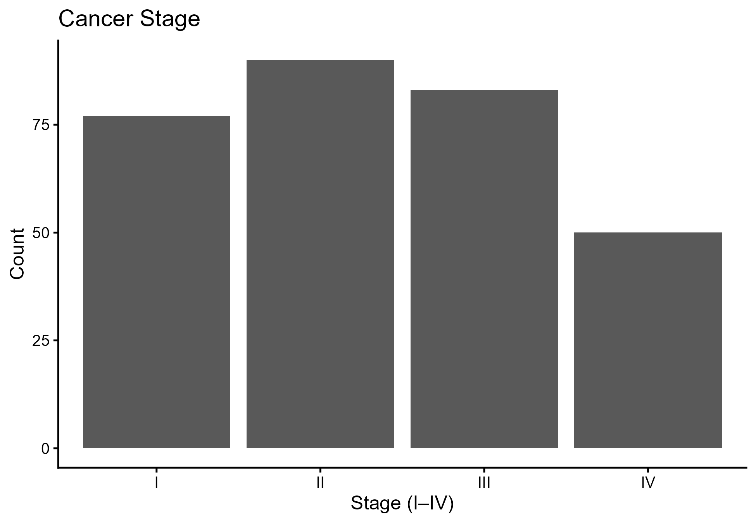

Figure 1: Cancer stage counts

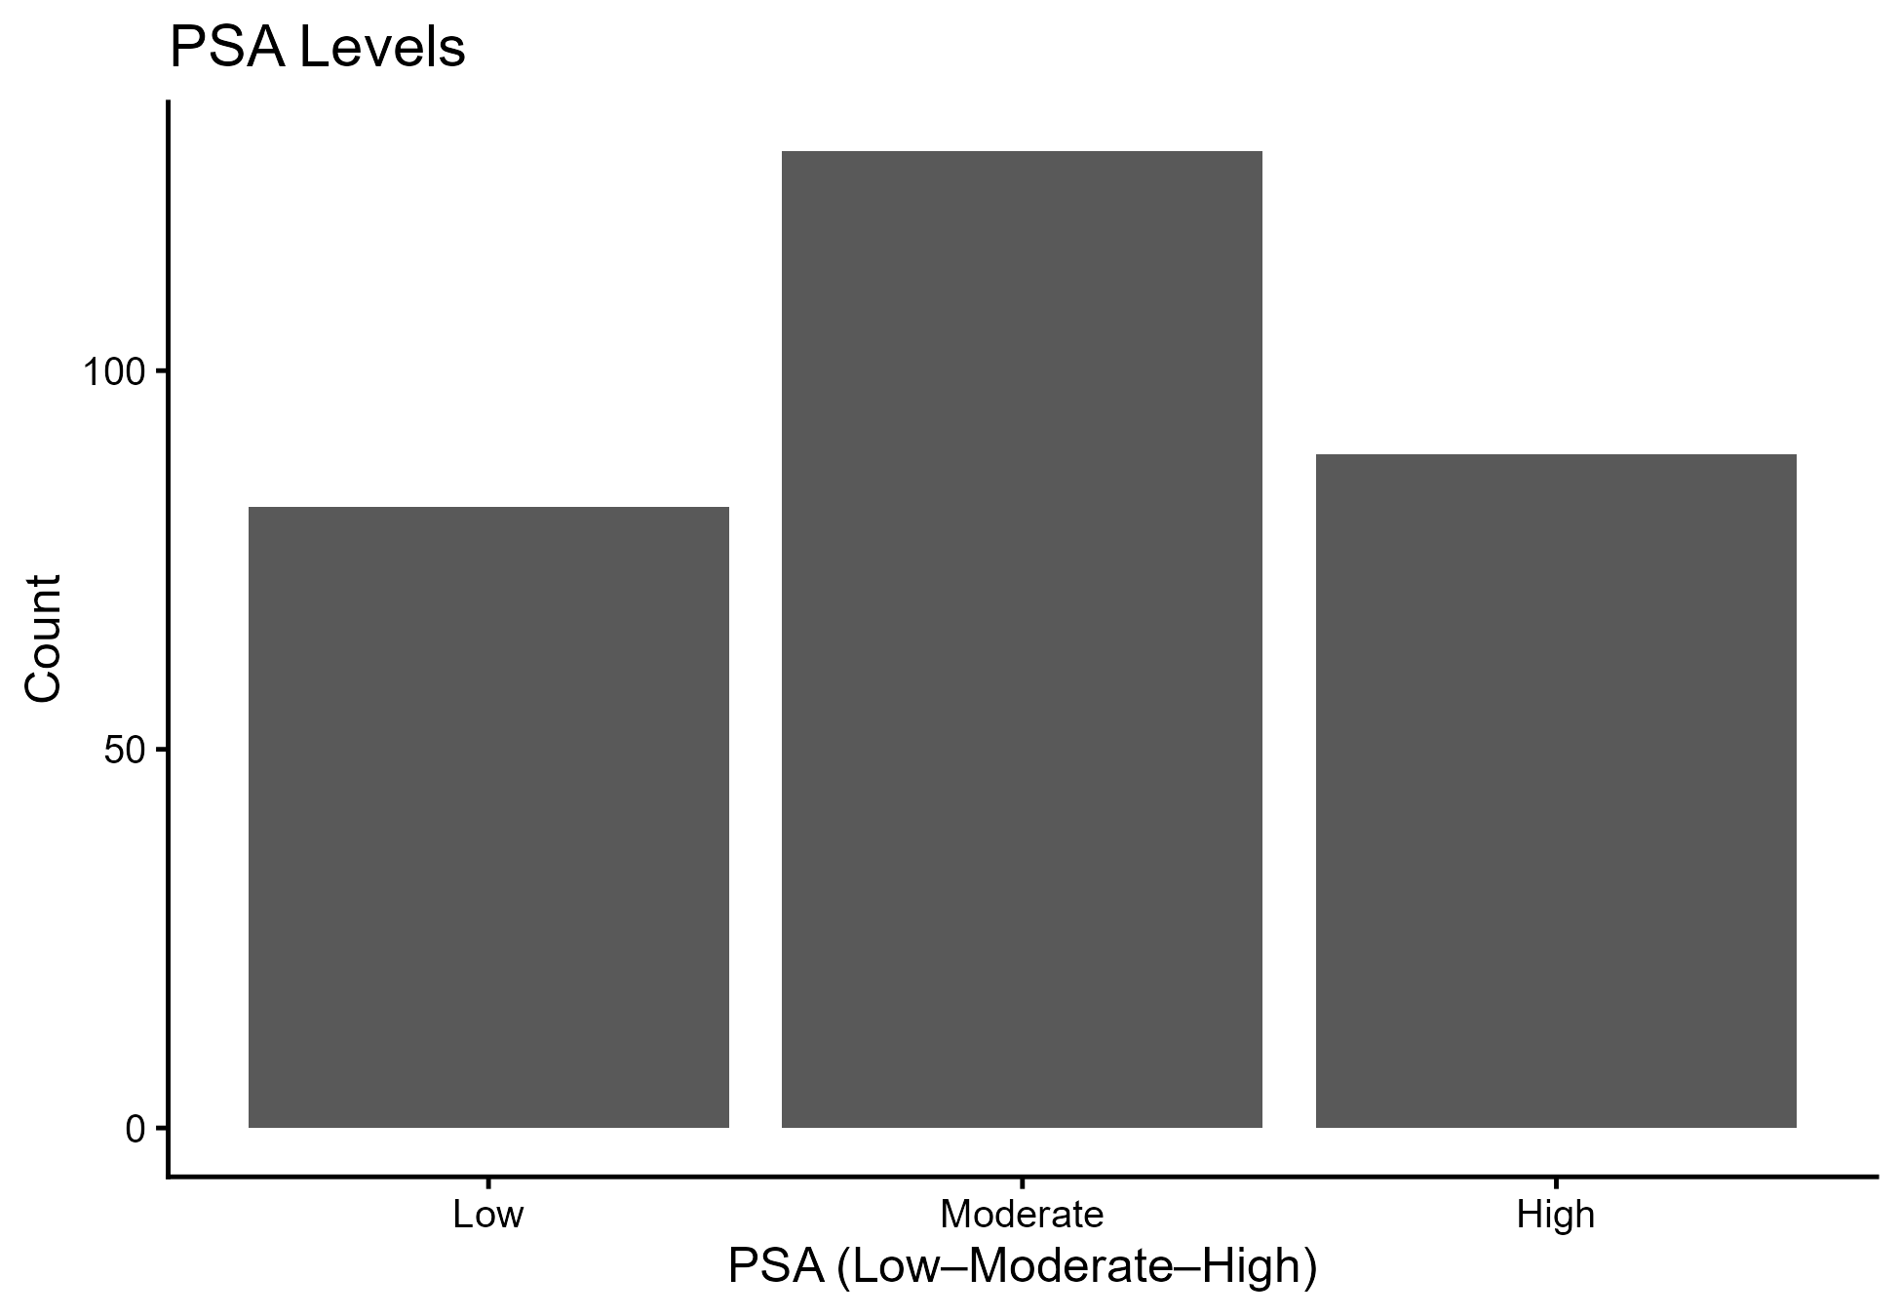

Figure 2: PSA level counts

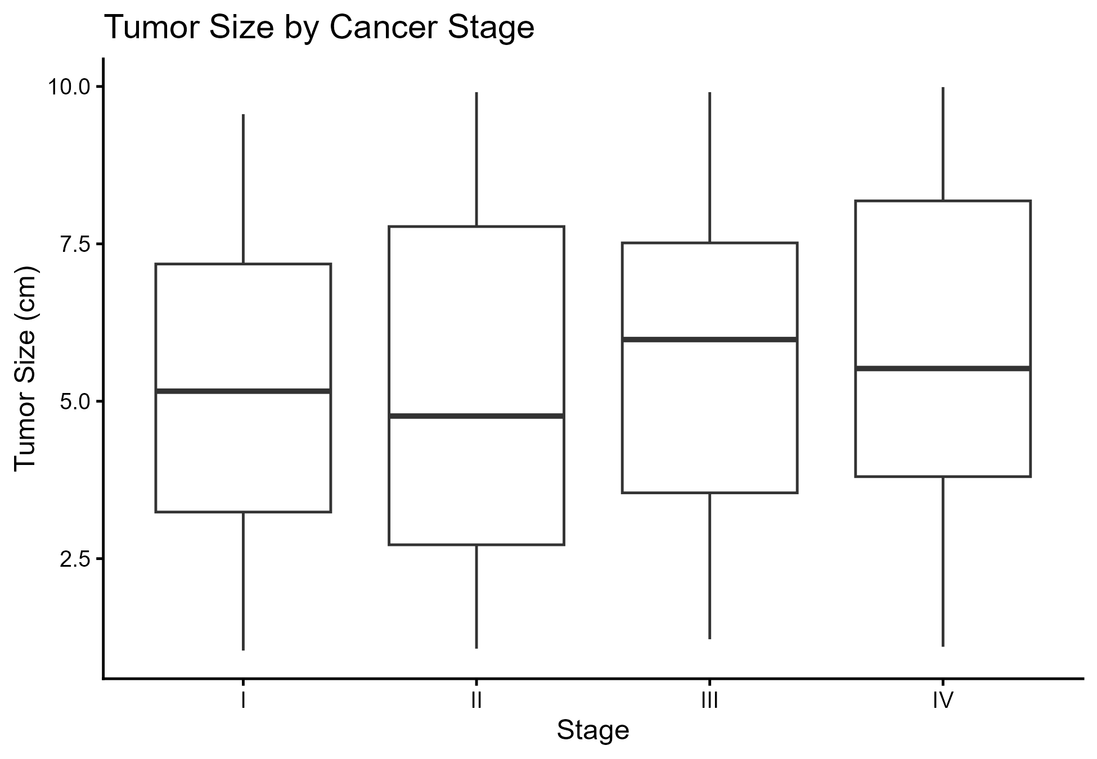

Figure 3: Tumor size by cancer stage

Cox proportional hazards with restricted cubic splines

Table 1: Baseline characteristics
Characteristic | N = 300¹
age | 52.76 (17.65)
cancer_stage
I | 77 (26%)
II | 90 (30%)
III | 83 (28%)
IV | 50 (17%)
tumor_size_cm | 5.47 (2.60)
lymph_nodes_involved | 7.09 (4.39)
psa_levels
Low | 82 (27%)
Moderate | 129 (43%)
High | 89 (30%)
chemotherapy | 165 (55%)
radiation_therapy | 179 (60%)
hormone_therapy | 154 (51%)
gleason_score
6 | 74 (25%)
7 | 74 (25%)
8 | 73 (24%)
9 | 79 (26%)
^{1. Mean} (SD); n (%)

Table 2: Model results (Cox PH with RCS for age and tumor size)
Characteristic | HR | 95% CI | p value
splines::ns(age, df = 4)
splines::ns(age, df = 4) 1 | 0.72 | 0.30, 1.71 | 0.5
splines::ns(age, df = 4) 2 | 1.11 | 0.46, 2.64 | 0.8
splines::ns(age, df = 4) 3 | 1.97 | 0.41, 9.44 | 0.4
splines::ns(age, df = 4) 4 | 0.82 | 0.38, 1.73 | 0.6
splines::ns(tumor_size_cm, df = 4)
splines::ns(tumor_size_cm, df = 4) 1 | 0.41 | 0.17, 0.99 | 0.048
splines::ns(tumor_size_cm, df = 4) 2 | 1.38 | 0.59, 3.22 | 0.5
splines::ns(tumor_size_cm, df = 4) 3 | 1.07 | 0.21, 5.41 | >0.9
splines::ns(tumor_size_cm, df = 4) 4 | 1.03 | 0.48, 2.19 | >0.9
cancer_stage
I | — | —
II | 0.88 | 0.57, 1.37 | 0.6
III | 0.87 | 0.56, 1.35 | 0.5
IV | 0.75 | 0.45, 1.27 | 0.3
psa_levels
Low | — | —
Moderate | 1.28 | 0.84, 1.94 | 0.2
High | 0.93 | 0.59, 1.47 | 0.8
lymph_nodes_involved | 0.99 | 0.95, 1.02 | 0.5
chemotherapy
No | — | —
Yes | 0.75 | 0.54, 1.05 | 0.10
radiation_therapy
No | — | —
Yes | 0.87 | 0.62, 1.22 | 0.4
hormone_therapy
No | — | —
Yes | 1.16 | 0.83, 1.62 | 0.4
gleason_score | 0.85 | 0.74, 0.99 | 0.036
Abbreviations: CI = Confidence Interval, HR = Hazard Ratio
The spline-derived partial effect plots indicate risk accumulation at tumor sizes greater than approximately 6–7 cm, whereas the hazard gradient for age remained flat across most of the observed range, which is consistent with the nonsignificant spline terms. Four knots were selected at the 5th, 35th, 65th, and 95th percentiles of each continuous variable distribution. Boundary knots were positioned at the minimum and maximum observed values, permitting monotonicity beyond the boundary region. The upward inflection of hazard at larger tumor sizes likely reflects the biological aggressiveness associated with advanced tumor burden. At smaller sizes, the plateau suggests relatively stable risk within the early to moderate size range. The partial overlap between PSA categories may reflect treatment variability and the limited discriminatory capacity of one-time PSA measurements, indicating potential value in incorporating PSA kinetics in future modeling. Overall, the evidence confirms the predominance of intermediate and advanced stages at diagnosis, reinforcing findings from earlier Ghanaian studies.
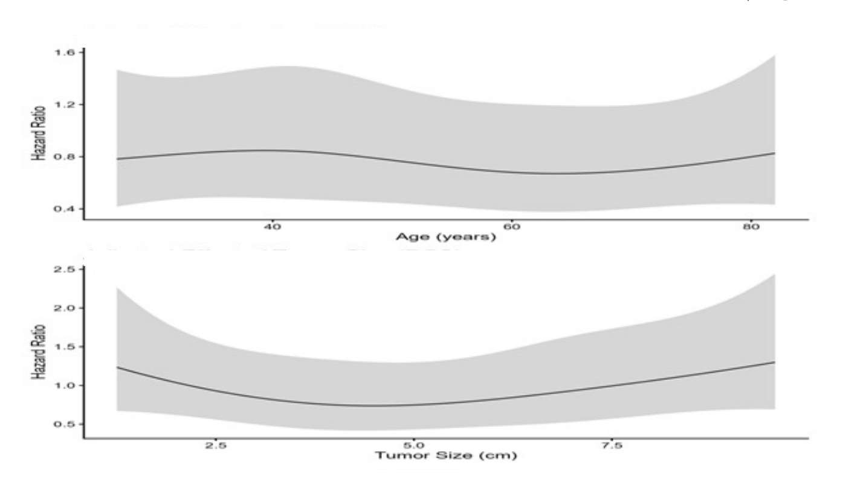

Figure 4: Adjusted hazard ratios (age and tumor size)
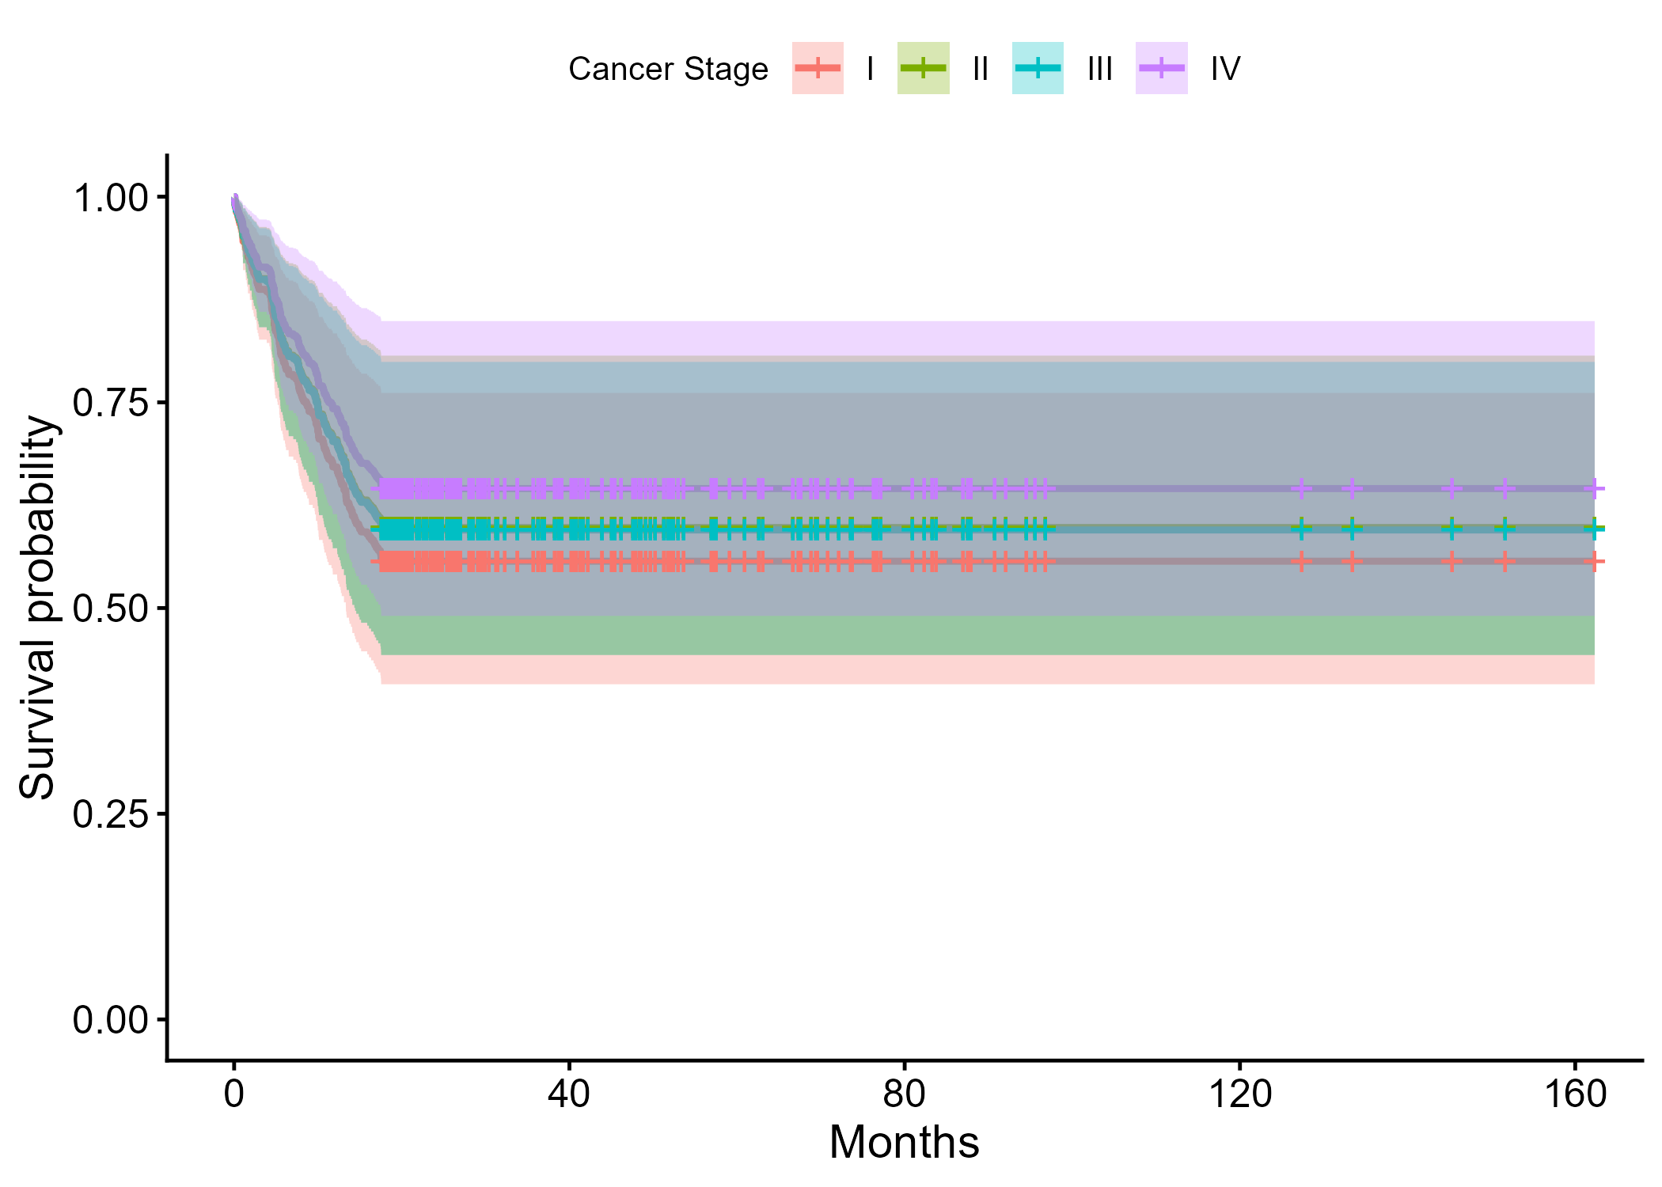

Figure 5: Survival by cancer stage
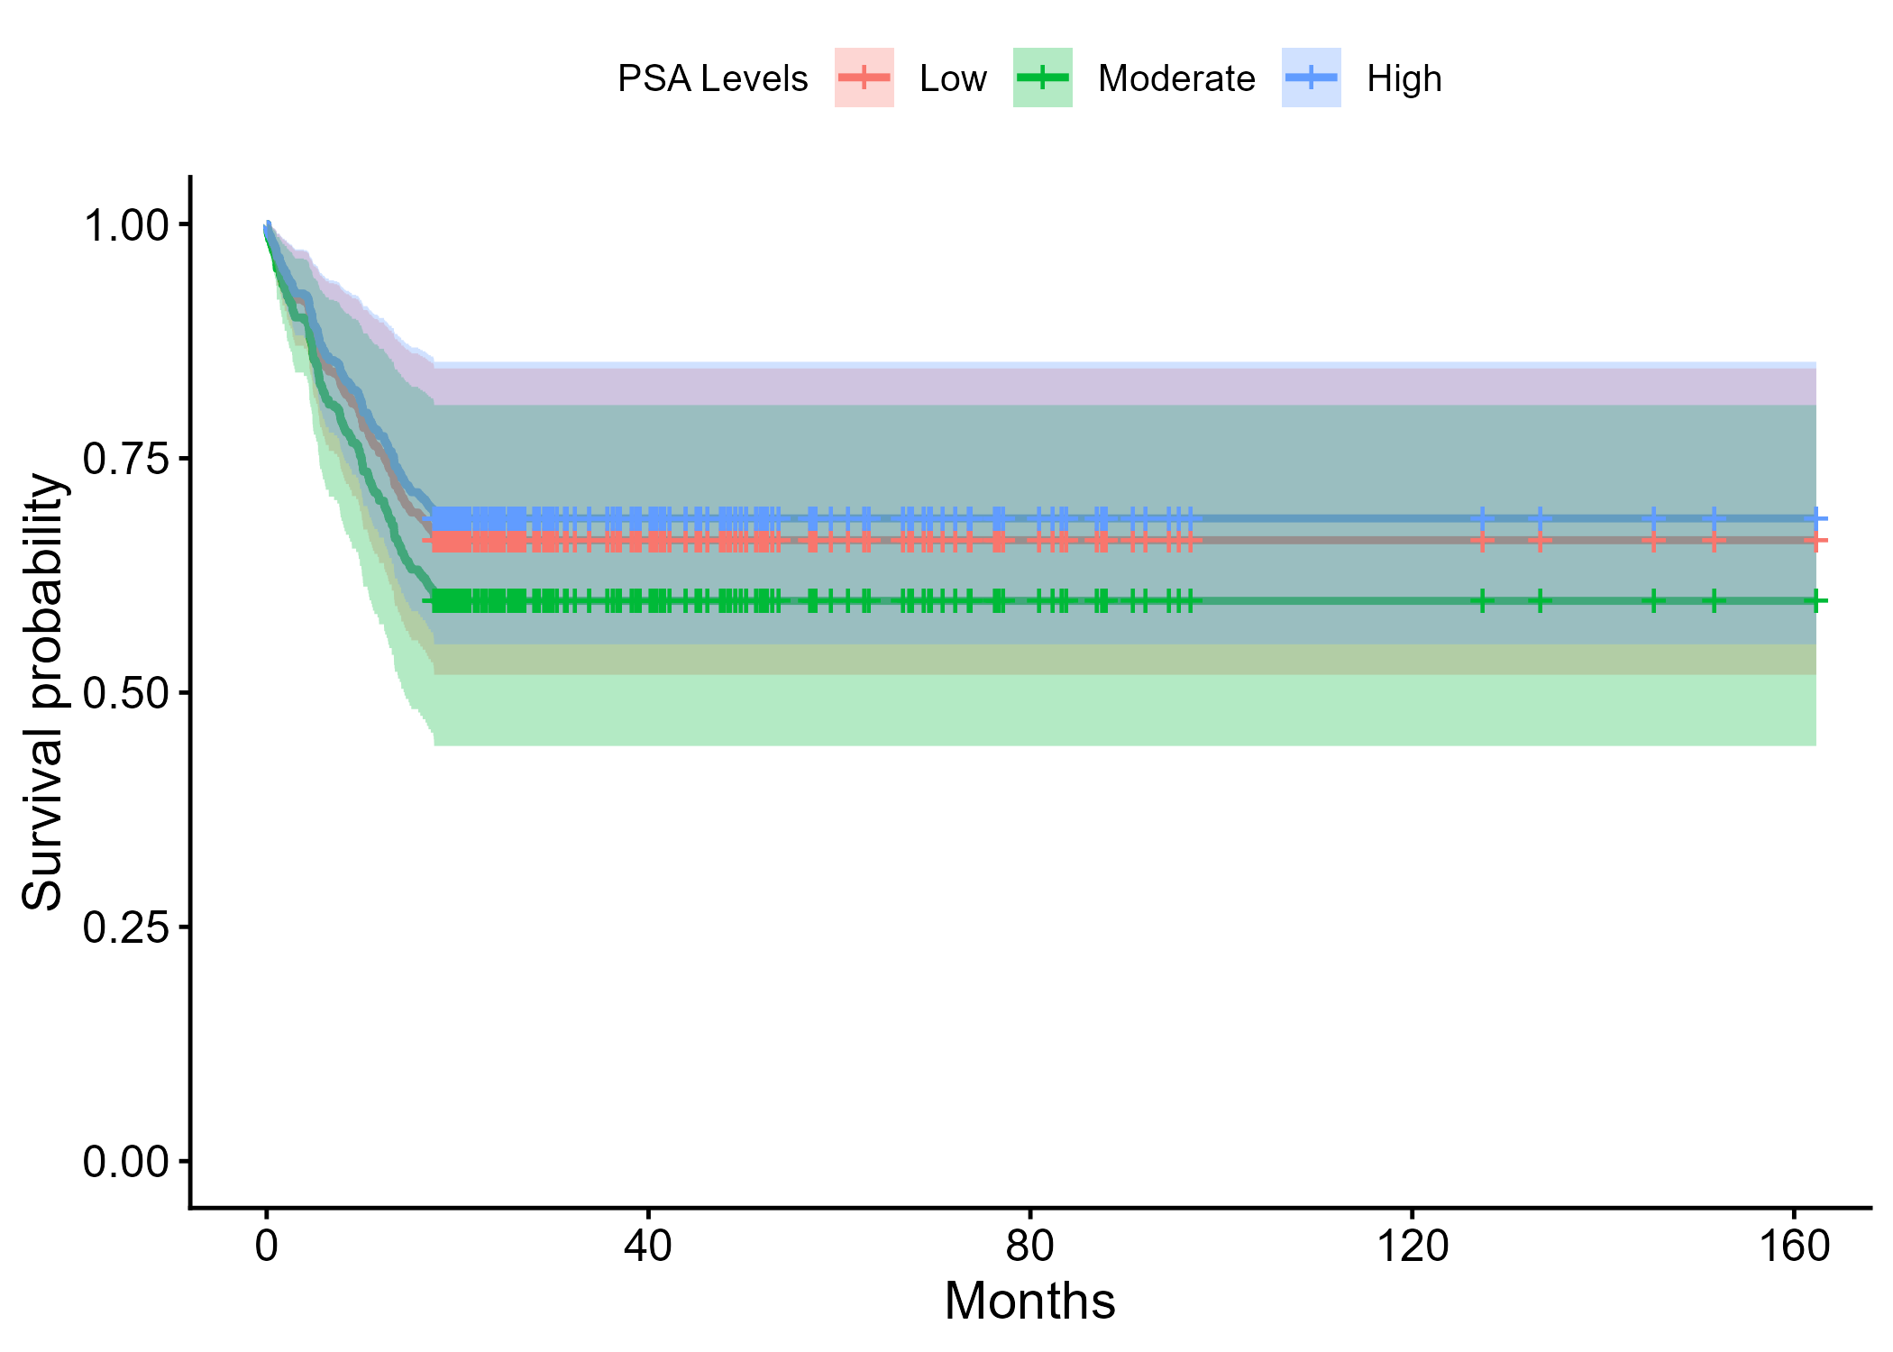

Figure 6: Survival by PSA level
The Cox proportional hazards model provided a nuanced view of risk. In Table 2, the restricted cubic spline specification revealed a significant nonlinear association with tumor size, with the first spline basis indicating a protective gradient at lower sizes and a diminishing benefit as size increased. The Gleason score retained prognostic salience, which is consistent with global evidence that histopathology remains a central driver of outcomes. Age spline terms were not statistically significant, suggesting that biological aggressiveness and disease burden may outweigh chronological age in shaping short- to medium-term survival in this cohort. These results are consistent with the patterns visualized in Figure 4, where the hazard ratio function for tumor size bends upward at larger diameters.
Survival functions stratified by cancer stage and PSA level provide additional context. Figure 5 clearly shows the separation of survival curves across stages, with Stage I and Stage II showing more favorable trajectories and Stage IV declining most rapidly. This pattern supports the interpretation that downstaging through earlier detection would confer meaningful survival benefits. Figure 6 shows partially overlapping curves across PSA groups, which may reflect treatment heterogeneity and the known limitations of single-time PSA measurements. The incorporation of PSA trajectories or kinetics may increase prognostic resolution, especially when combined with Gleason grade and nodal metrics.
From a health systems perspective, these findings map directly onto SDG 3.4 by identifying modifiable pathways to reduce premature mortality from prostate cancer. Strengthening community awareness, expanding context-appropriate screening, and ensuring timely referral to multidisciplinary care can shift the stage distribution observed in Figure 1 toward earlier disease. Investment in diagnostic capacity for histology and imaging supports SDG 3.c, whereas routine capture of longitudinal measures such as PSA kinetics aligns with SDG 3.d on surveillance and early warning.

SHAP Analysis for Cox PH with Restricted Cubic Splines
The integration of SHAP explainability into the Cox proportional hazards model with restricted cubic splines (RCSs) provided a transparent, data-driven interpretation of feature contributions to prostate cancer survival risk. This hybrid approach allows both global interpretability and local interpretability, addressing a key limitation of conventional Cox regression models, which report average effects but often mask complex nonlinearities.

Global feature importance (Figure 7 and Table 3)
The Global SHAP Importance Plot (Figure 7) and Table 3 demonstrate that tumor size (mean |SHAP| = 0.2015) and Gleason score (0.1591) were the two most influential predictors of prostate cancer survival. These findings reinforce the hazard ratio results in Table 1, where the Gleason score (HR = 0.85; 95% CI: 0.74-0.99; p = 0.036) remained statistically significant. The prominence of tumor size in SHAP importance despite a moderate hazard ratio significance (HR = 0.41; p = 0.048) suggests a nonlinear relationship, wherein the risk accelerates after a specific tumor threshold. Treatment-related variables, particularly chemotherapy (|SHAP| = 0.1409) and PSA levels (|SHAP| = 0.1385), have meaningful contributions, indicating that therapeutic response and biochemical markers interact in shaping survival outcomes. Clinical factors such as age and hormone therapy had moderate importance (|SHAP| ≈ 0.10 and 0.0757, respectively), whereas radiation therapy, cancer stage, and lymph node involvement had relatively lower but nonnegligible impacts.

Table 3. Global SHAP Importance (Mean |SHAP| on Linear Predictor)
Rank | Variable | Mean |SHAP| (log-hazard)
1 | tumor_size_cm | 0.2015
2 | gleason_score | 0.1591
3 | chemotherapy | 0.1409
4 | psa_levels | 0.1385
5 | age | 0.1041
6 | hormone_therapy | 0.0757
7 | radiation_therapy | 0.0654
8 | cancer_stage | 0.0649
9 | lymph_nodes_involved | 0.0488
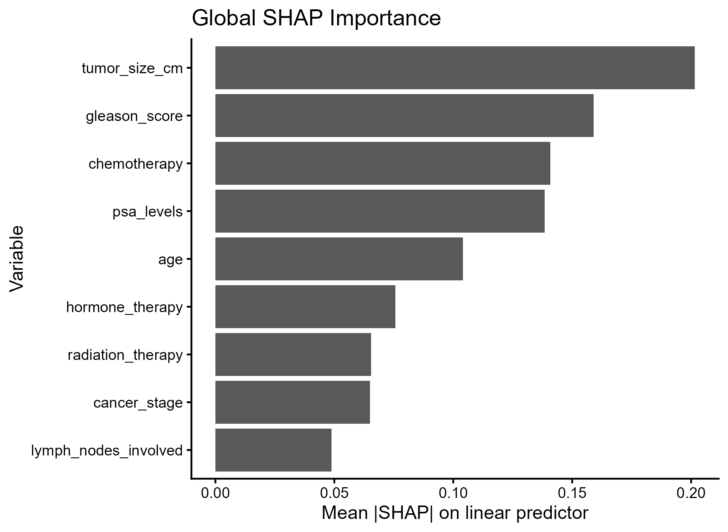

Figure 7. Global SHAP Importance Bar Plot
The SHAP beeswarm plot (Figure 8) visualizes how individual patients’ predictor values influence the model’s log hazard output. Each dot represents a patient-level SHAP contribution for a given variable. The red-blue gradient shows the numeric scale of each predictor. Notably, larger tumor sizes (blue gradient in the top panel) corresponded to higher positive SHAP values, indicating an increased hazard contribution. Conversely, higher Gleason scores (red hues) consistently pushed the SHAP value toward the positive (right-hand) side, confirming their strong additive effect on mortality risk. The spread in PSA levels and chemotherapy suggests partial heterogeneity in treatment response and biomarker profiles, which gives an insight unattainable from classical Cox regression alone.

Partial-Effect Relationships (Figure 9)
The partial-effect plots (Figure 8) provide a nuanced understanding of nonlinear effects.
- Tumor size (top-left panel): A U-shaped SHAP curve, indicating that both very small and very large tumors contribute to elevated risk, possibly reflecting diagnostic and biological heterogeneity. Moderate tumor sizes (~5 cm) corresponded to the lowest predicted hazard, aligning with the spline-derived protective effect (Table 1).
- Gleason score (top-right panel): Monotonic increasing relationship, where higher histologic grades (8–9) lead to higher SHAP values, confirming progressive risk escalation.
- Chemotherapy and PSA levels (bottom panels): Reveal modest but consistent SHAP gradients, implying that treatment and biochemical markers influence survival synergistically with histopathology and tumor volume.

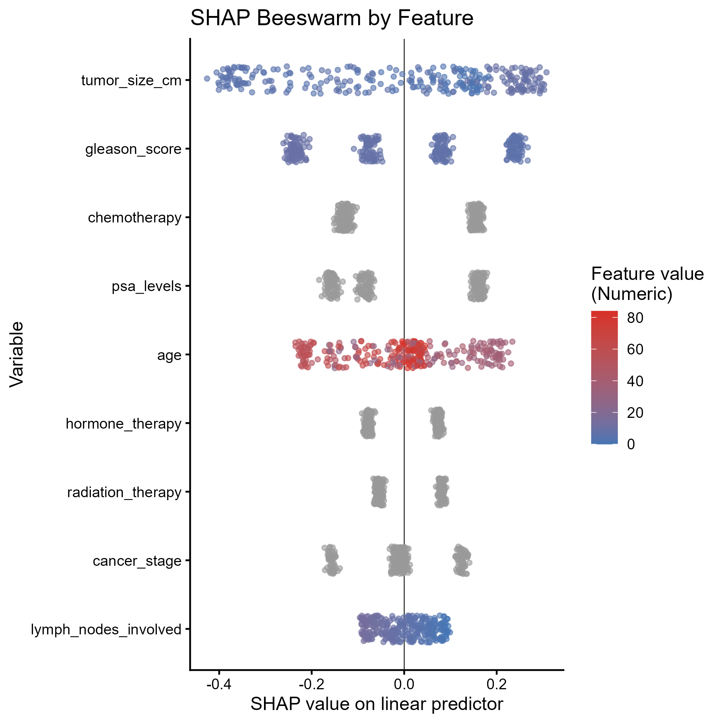

Figure 8. SHAP Beeswarm Plot

Integrative Interpretation
When interpreted jointly, Figures 7–9 illustrate that SHAP complements the Cox PH model by providing both global rankings and individualized insights. While Table 1 quantifies average hazard ratios, SHAP visualizations uncover heterogeneous patient-level effects, highlighting where risk factors exert nonlinear or interactive influences. Importantly, tumor size and Gleason score not only emerge as dominant predictors in both inferential and explainability analyses but also exhibit biologically plausible nonlinear patterns, affirming the validity of using restricted cubic splines to model these effects. The explainability component ensures that clinical stakeholders can interpret the model in transparent, evidence-based terms, supporting data-driven risk stratification and personalized treatment in prostate cancer management.
The U-shaped tumor effect may partly reflect the uneven distribution of tumor sizes within the dataset, indicating the need for larger multicenter datasets to validate the threshold effects reported in this model. The U-shaped SHAP effect for tumor size may be influenced by unequal sample density across the tumor size distribution, indicating the need for larger or multicenter datasets to validate this curvature. The combined spline–SHAP approach demonstrates the value of integrating nonlinear modeling with transparent feature attribution to support interpretable oncology analytics.
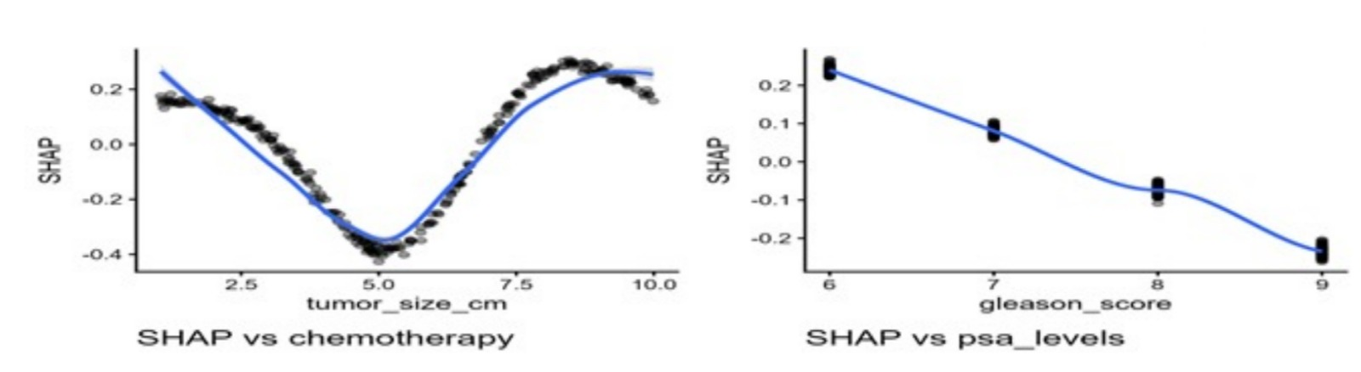

Figure 9. SHAP partial-effect plots for the top variables
The SHAP-augmented RCS Cox model confirmed that tumor size and Gleason score are the principal determinants of prostate cancer survival in this Ghanaian cohort. SHAP analysis provides a mechanistic view of how each covariate influences risk both globally and individually, revealing nonlinear dependencies and treatment interactions. This dual statistically explainable approach advances the interpretability of survival models and establishes a reproducible framework for precision oncology and prognostic modeling in resource-constrained clinical settings.
Discussion
The integration of SHAP explainability into the Cox proportional hazards model with restricted cubic splines (RCSs) expanded the interpretive depth of the survival analysis by quantifying both global and individualized predictor contributions. The SHAP-enhanced Cox model complemented the inferential findings from the spline-based hazard estimates by uncovering nonlinear, heterogeneous, and interaction-driven effects that were not fully observable in the traditional Cox regression results.
The SHAP summary presented in Table 3 and Figure 7 identifies tumor size and Gleason score as the most influential determinants of prostate cancer survival in the Ghanaian cohort. The prominence of these variables supports the hazard ratio outcomes in Table 1, where the Gleason score (HR = 0.85; 95% CI: 0.74-0.99; p = 0.036) and tumor size (HR = 0.41; 95% CI: 0.17-0.99; p = 0.048) emerged as statistically significant predictors. The strong SHAP magnitudes for tumor size (|SHAP| = 0.2015) and Gleason score (|SHAP| = 0.1591) indicate consistent contributions to the log hazard across the patient population, even in cases where conventional inference yielded borderline p-values. These findings suggest that these factors not only predict outcomes directionally but also demonstrate stable explanatory strength across subpopulations.
The SHAP beeswarm visualization (Figure 8) revealed that higher tumor size and Gleason score values consistently increased the predicted hazard, with the red hues clustering toward the positive end of the SHAP scale. This nonlinear and monotonic trend affirms the spline-based finding that larger tumor diameters confer increased mortality risk beyond a certain threshold, whereas moderate sizes correspond to a survival plateau. Similarly, high Gleason scores (8–9) produced substantial upward shifts in SHAP values, reinforcing histopathology’s central prognostic role in prostate cancer progression. The moderate yet consistent contributions of chemotherapy (|SHAP| = 0.1409) and PSA levels (|SHAP| = 0.1385) reflect the multifactorial nature of survival, where therapeutic response and biochemical markers jointly shape risk.
The partial-effect curves in Figure 9 demonstrate that tumor size follows a U-shaped pattern, where both very small and very large tumors are associated with increased hazard. This may represent diagnostic uncertainty at the lower end (e.g., underdetected aggressive microfoci) and biological aggressiveness at the upper end (e.g., extensive local invasion). Conversely, the Gleason score displays a near-linear increase in hazard with higher histologic grade, which is consistent with prior evidence linking poorly differentiated tumors to reduced survival. These plots collectively reveal that nonlinear modeling through the RCS accurately characterizes complex, nonmonotonic relationships that linear models would misestimate.
From a methodological standpoint, the SHAP analysis validates the selection of restricted cubic splines by confirming that risk contributions are continuous and variable-dependent rather than uniformly linear. The combination of SHAP and RCS strengthens both model transparency and predictive credibility, demonstrating that explainable machine learning tools can enhance the interpretability of classical survival models. By integrating local feature attribution with traditional hazard ratio estimates, the analysis bridges the gap between statistical inference and personalized prognostication.
In clinical and policy terms, the combined results suggest that interventions targeting tumor burden reduction and early histopathologic grading remain critical for improving outcomes. The strong importance of chemotherapy and PSA levels in the SHAP ranking further highlights the need for treatment monitoring and longitudinal biomarker evaluation, particularly in resource-constrained health systems. Together, these findings support the adoption of flexible, explainable survival frameworks in Ghana’s prostate cancer management programs, enabling risk-tailored decision-making aligned with Sustainable Development Goal (SDG) 3.4 for reducing premature cancer mortality.
Overall, the inclusion of SHAP analysis transformed the study from a purely inferential model into a transparent, explainable prognostic tool. This methodological innovation not only improves reproducibility but also provides clinicians with interpretable, patient-level insights into how each factor shapes survival risk, advancing data-driven, precision-oriented oncology practices within the Ghanaian context.

Conclusion
This study developed a nonlinear, explainable survival model for prostate cancer patients via the Cox proportional hazards framework integrated with restricted cubic splines and SHAP explainability. The results demonstrated that tumor size and Gleason score are the most powerful predictors of survival, exerting nonlinear and individualized effects on mortality risk. Treatment-related variables, including chemotherapy and PSA levels, contributed moderately but significantly to outcome variation.
The RCS specification revealed that hazard risk increases sharply beyond specific tumor size thresholds, whereas SHAP visualizations provide interpretive transparency by decomposing each predictor’s contribution to the overall hazard. This combined inferential-explainable approach bridges statistical modeling and machine learning interpretability, offering clinicians actionable insights into patient-level risk dynamics.
In public health terms, the findings underscore the urgency of implementing early screening, histopathologic grading, and treatment monitoring programs to reduce advanced-stage presentations in Ghana. Methodologically, the SHAP-augmented RCS Cox model establishes a reproducible, data-driven template for survival analysis in oncology research across low- and middle-income settings. Its adaptability to other cancers makes it a valuable framework for advancing SDG 3.4, reducing premature mortality through early detection and targeted treatment. The findings reflect data from a single tertiary center, which may limit generalizability. Future applications of this modeling framework could incorporate multicenter datasets, imaging biomarkers, and longitudinal PSA kinetics to increase predictive precision.
Declarations
Data availability
The data used to support the findings of this study are available from the corresponding author upon request.
Ethical statement
This study received ethical approval from the University Ethics Review Committee of Takoradi Technical University (Ref. No. TTU/ERC/15/021, dated May 27, 2015). The research used a secondary, de-identified dataset, and all procedures complied with the ethical guidelines of the approving committee.
Declaration of competing interest
The authors declare that they have no known competing financial interests or personal relationships that could have appeared to influence the work reported in this paper.
Trial Number
Not applicable

References
Abu Bonsra, E., Justice, B., & Ananga, M. K. (2025). Suicidal behaviors among adults living with cancer in Ghana: prevalence and associated risk factors. BMC psychology, 13(1), 1-15.
Amaeshi, L. C., Okunade, K. S., & Anorlu, R. I. (2025). Current landscape of cancer genomics research in sub-Saharan Africa–a review of literature. Frontiers in Oncology, 15, 1512005.
Aziz, M. K., Molony, D., Monlezun, D., Holder, T., Brunckhorst, O., Higgason, N., ... & Canfield, S. (2025). Prostate cancer therapy Cardiotoxicity map (PROXMAP) for advanced disease States: a Systematic review and network Meta-analysis with Bayesian modeling of treatment Histories. European urology, 87(1), 15-26.
Belkahla, S., Nahvi, I., Biswas, S., Nahvi, I., & Ben Amor, N. (2022). Advances and development of prostate cancer, treatment, and strategies: A systemic review. Frontiers in Cell and Developmental Biology, 10, 991330.
Bhandari, R., Chen, Y., Chow, E. J., Howell, R. M., Kenney, L. B., Krull, K. R., ... & Armenian, S. H. (2025). Health Outcomes Beyond Age 50 Years in Survivors of Childhood Cancer: A Report From the Childhood Cancer Survivor Study. Journal of Clinical Oncology, 43(27), 2998-3010.
Bosson-Amedenu, S., Turkson, A. J., Ayitey, E., Baah, E. M., Ayiah-Mensah, F., & Addor, J. A. (2025). Covariate-Stratified Analysis of Prostate Cancer and Competing Risk Mortality in Ghana: A Bootstrapped Survival Analysis Approach. Scientific African, e02882.
Dadee-Seshie, D. S., Agbeteti, S. G., Kpankyaano, B., Adamu, A. F., Adanu, S. K., Alhassan, Y., & Adanu, K. K. (2025). Productivity losses and treatment cost of Benign Prostatic Hyperplasia in Ghana. medRxiv, 2025-03.
Daniels, J., Kyei, K. A., Frimpong-Boateng, P. D., & Nyantakyi, A. Y. (2025). Sexual function outcomes in prostate and cervical cancer patients treated with radiotherapy in sub-Saharan Africa: A cross-sectional study. PLoS One, 20(5), e0324662.
Dee, E. C., Iyengar, R., Narayan, A., Feliciano, E. J. G., Wu, J. F., Ho, F. D. V., ... & Nguyen, P. L. (2025). National cancer system characteristics and prostate cancer outcomes: an analysis of global data. The Prostate, 85(10), 947-953.
Der, E. M., Muntaka, A. J. M., & Yenli, E. M. T. (2025). The patterns of primary male genitourinary cancers in a tertiary referral hospital in northern Ghana. African Urology, 5(1), 47-52.
Dlamini, Z., Alaouna, M., Marutha, T., Mkhize-Kwitshana, Z., Mbodi, L., Chauke-Malinga, N., ... & Molefi, T. (2025). The Exposome Perspective: Environmental and Infectious Agents as Drivers of Cancer Disparities in Low-and Middle-Income Countries. Cancers, 17(15), 2537.
Esteban, L. M., Borque-Fernando, Á., Escorihuela, M. E., Esteban-Escaño, J., Abascal, J. M., Servian, P., & Morote, J. (2025). Integrating radiological and clinical data for clinically significant prostate cancer detection with machine learning techniques. Scientific reports, 15(1), 4261.
Flannery, B. T., Sandler, H. M., Lal, P., Feldman, M. D., Santa‐Rosario, J. C., Pathak, T., ... & Madabhushi, A. (2025). Stress testing deep learning models for prostate cancer detection on biopsies and surgical specimens. The Journal of Pathology, 265(2), 146-157.
Freedland, S. J., Hong, A., El-Chaar, N., De Hoedt, A. M., Kim, J., Evans, C., ... & Polascik, T. J. (2025). Survival benefit associated with first-line androgen receptor pathway inhibitors for de novo metastatic castration-sensitive prostate cancer. Prostate Cancer and Prostatic Diseases, 1-8.
Ghanem, A. S., Faludi, E. V., Bata, R., Mezei, E., Hadar, V., Móré, M., ... & Nagy, A. C. (2025). Cancer prevalence and its determinants in Hungary: Analyzing data from the 2009, 2014, and 2019 European Health Interview Surveys. PloS one, 20(2), e0315689.
Guo, F., Maolake, A., Ni, Z., Li, X., Liu, B., Tang, Z., ... & Li, J. (2025). Combination of PSA density and MLR improves the diagnostic accuracy of prostate cancer. Frontiers in Oncology, 15, 1570584.
James, N. D., Tannock, I., N'Dow, J., Feng, F., Gillessen, S., Ali, S. A., ... & Xie, L. P. (2024). The Lancet Commission on prostate cancer: planning for the surge in cases. The Lancet, 403(10437), 1683-1722.
Kavak, E. E., & Dilli, İ. (2025). Progression‐Free Survival Prediction Performance of ChatGPT: Analysis With Real Life Data in Early and Locally Advanced Prostate Cancer. The Prostate, 85(7), 677-683.
Kitson-Mills, D., Donkor, A., Amoako, Y. A., Kyei, K. A., Bonsu, E. B. O., Vanderpuye, V., & Wiafe, Y. A. (2025). Outcomes and Toxicities After Treatment for Men Diagnosed With Localized Prostate Cancer in Low-and Middle-Income Countries: A Systematic Review and Meta-Analysis. Advances in Radiation Oncology, 10(1), 101670.
Kratzer, T. B., Mazzitelli, N., Star, J., Dahut, W. L., Jemal, A., & Siegel, R. L. (2025). Prostate cancer statistics, 2025. CA: A Cancer Journal for Clinicians.
Liu, X., & Jiang, H. (2025). The global, regional, and national prostate cancer burden and trends from 1990 to 2021, results from the global burden of disease study 2021. Frontiers in Public Health, 13, 1553747.
Marvaso, G., Corrao, G., Zaffaroni, M., Vincini, M. G., Lorubbio, C., Gandini, S., ... & Jereczek-Fossa, B. A. (2025). ADT with SBRT versus SBRT alone for hormone-sensitive oligorecurrent prostate cancer (RADIOSA): a randomized, open-label, phase 2 clinical trial. The Lancet Oncology, 26(3), 300-311.
Obeng, F., Adamu, A. F., Gavor, S. E., Setsoafia, B. Y., Antwi, E. K., Affram, N., & Ali, A. M. (2025). Case Report: Atypical prostate cancer presentation: rectal bleeding, pain, and psoriasiform dermatitis. Frontiers in Oncology, 15, 1476988.
Ofori, B., Fosu, K., Aikins, A. R., & Sarpong, K. A. N. (2025). The intersection of culture and prostate cancer care in Sub-Saharan Africa: a systematic review. African Journal of Urology, 31(1), 41.
Preisser, F., Tilki, D., & Benson, M. C. (2025). Prostate Cancer: Epidemiology. In Primer on Urology (pp. 53-67). Cham: Springer Nature Switzerland.
Sarpong, L. M., Acheampong, A., Badu, M., Adjei, S., Yakubu, J., Baah, K. A., ... & Amponsah, I. K. (2025). Anti-Prostatic Carcinoma Activity of Entandrophragma angolense and Methyl Angolensate: In Vitro and In Silico Analyses. Natural Product Communications, 20(10), 1934578X251384534.
Wu, Y. C., Wang, S. I., Lu, L. Y., Wu, M. Y., Wu, P. L., Hsieh, T. Y., & Sung, W. W. (2025). The Predictive Role of the Gleason Score in Determining Prognosis to Systematic Treatment in Metastatic Castration-Sensitive Prostate Cancer: A Systematic Review and Network Meta-Analysis. Journal of Clinical Medicine, 14(4), 1326.
Xiong, J., Liu, Y., Qiao, X., Ai, G., Ma, J., & He, X. (2025). A novel composite index of PSA and periprostatic adipose tissue quantification for enhancing high-grade prostate cancer prediction. BMC urology, 25(1), 199.
Yeasin, A., Hossain, M., Baral, S., Chen, J., & Sun, W. (2025). The diagnostic value of prostate health index combined with soluble e-cadherin for prostate cancer. Frontiers in Endocrinology, 16, 1531866.
Zhang, X., Li, Y., Yan, C., Ma, L., Yu, M., Yang, Y., ... & Peng, L. (2025). Global trends in testicular and prostate cancer among adolescents and young adult males aged 15–49 years, 1990–2021: insights from the GBD study. Scientific Reports, 15(1), 23388.
Zhao, X., Liu, S., Zou, Z., & Liang, C. (2025). Global, regional, and national prevalence of prostate cancer from 1990 to 2021: a trend and health inequality analyses. Frontiers in Public Health, 13, 1595159.
Zhu, X., Che, X., Yang, R., Bao, B., & Chu, G. (2025). Global, Regional, and National Burden of Cancer in the Elderly Population, 1990–2021: Analysis of Data From the Global Burden of Disease Study 2021. Med Research.
Zi, H., Liu, M. Y., Luo, L. S., Huang, Q., Luo, P. C., Luan, H. H., ... & Zeng, X. T. (2024). Global burden of benign prostatic hyperplasia, urinary tract infections, urolithiasis, bladder cancer, kidney cancer, and prostate cancer from 1990 to 2021. Military Medical Research, 11(1), 64.

SUPPLEMENTARY MATERIALS
Appendices
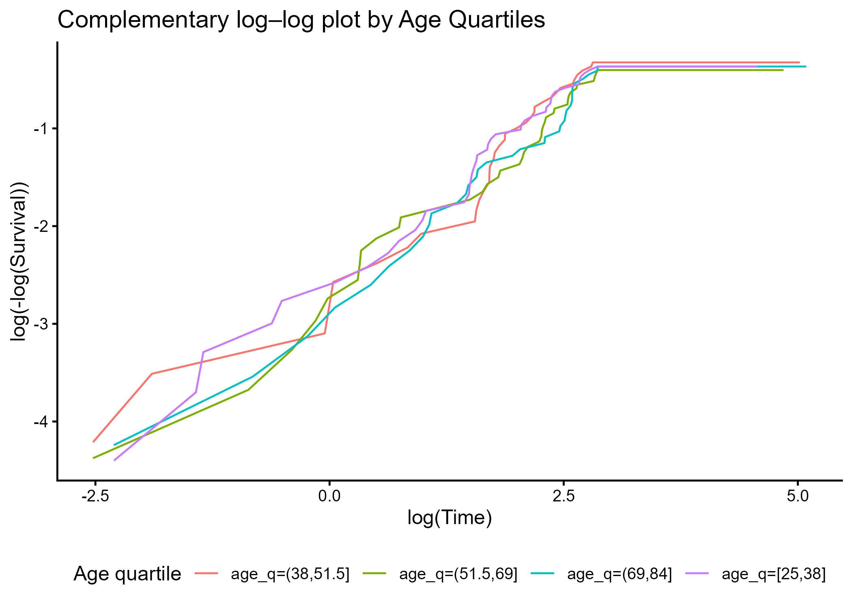
Figure S1. Complementary Log–Log Survival Plot by Age Quartiles

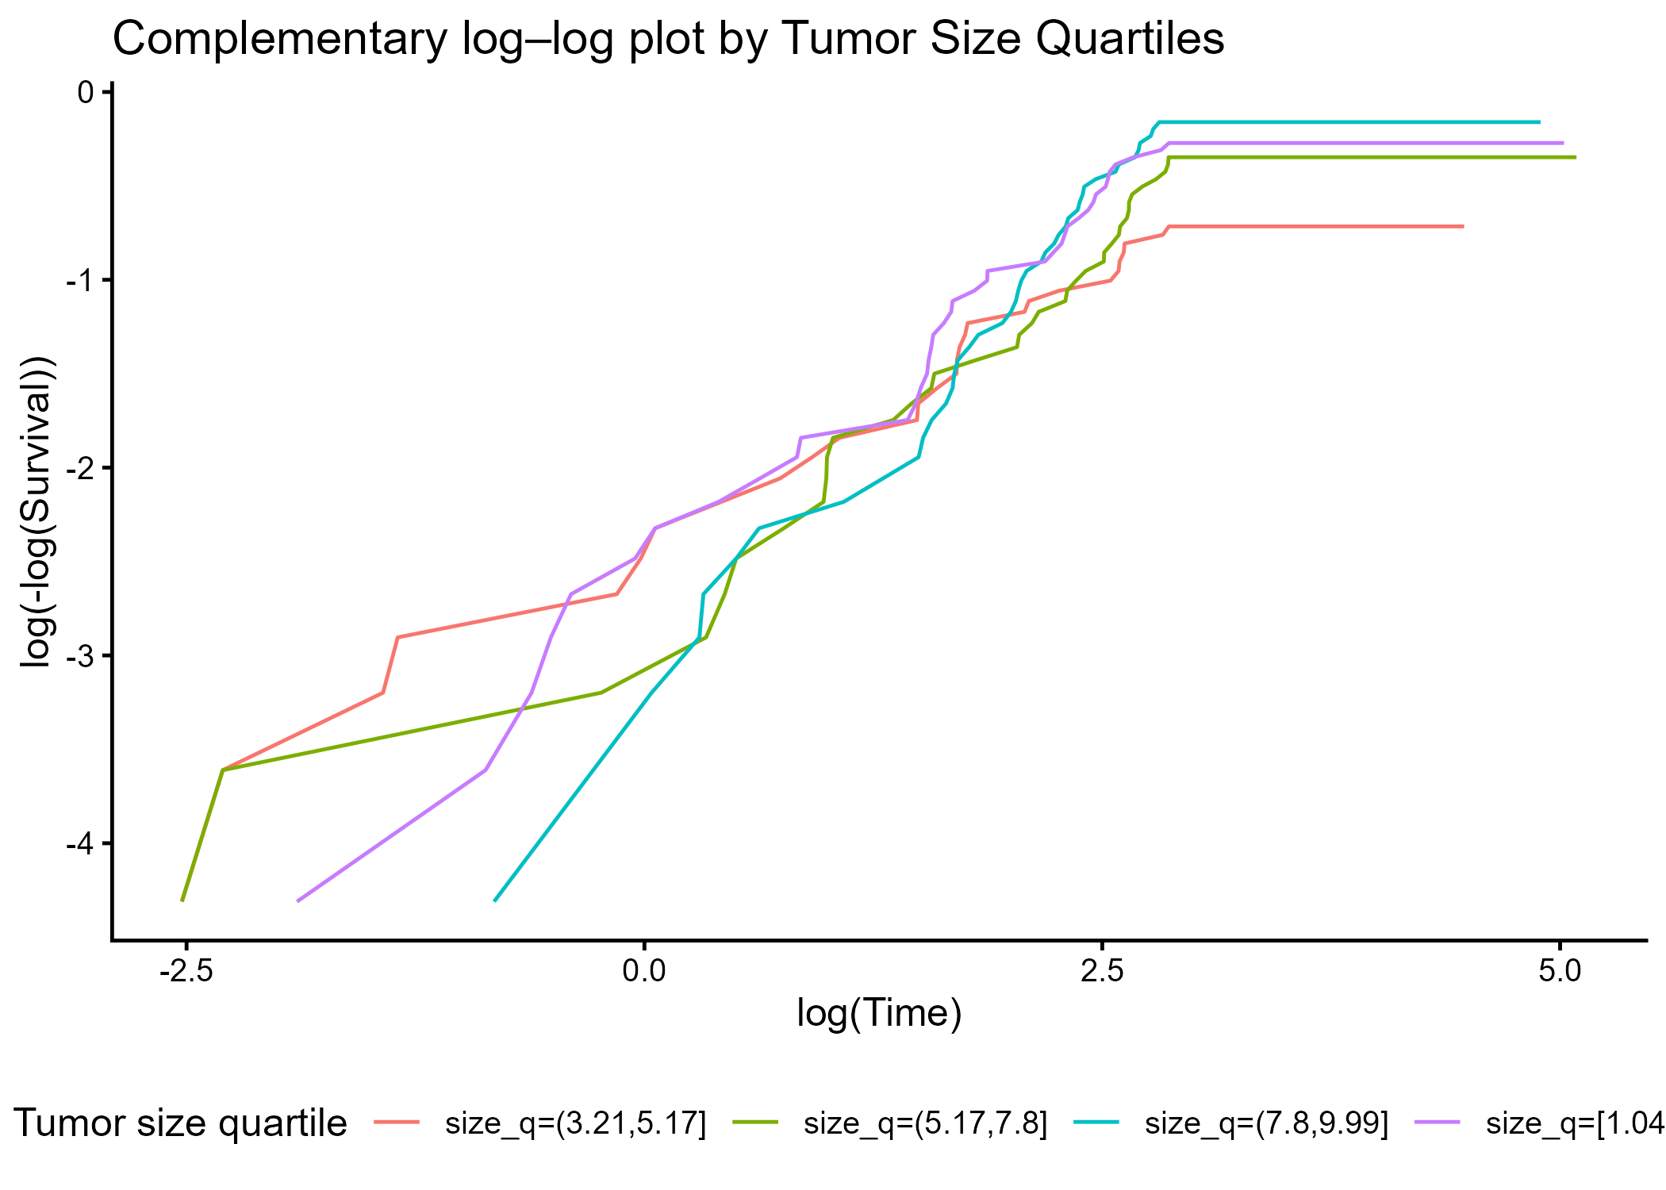
Figure S2. Complementary Log–Log Survival Plot by Tumor Size Quartiles

