Solubilization of Copper, Nickel and Zinc from electronics waste using Providencia and Pseudomonas species

Abstract
The role of microbes in solubilization of e-waste metals offers an eco-friendlier and cost-effective alternative to traditional metal recovery methods. Pseudomonas aeruginosa, Providencia. manganoxydans and Pseudomonas fluorescens isolated from soil obtained from an e-waste dump site in Owerri and water from coal mines in Enugu, were used to solubilize copper, nickel and zinc from printed circuit boards of discarded electronics devices. The solubilization assessment was carried out for 24 days with two particles sizes of the printed circuit boards (50 µm and 950 µm), single and mixed cultures of the organisms and three added nitrogen sources (NPK, organic manure and (NH4)2SO4). The result obtained showed that the three organisms can solubilize multiple metals simultaneously, the single cultures of P. manganoxydans and P. fluorescens performed better than the different mixed cultures of the organism based on the concentration of the metals in solution after the solubilization. The solubilization rate for the powered printed circuit boards particle size (ps) 50 µm were better when compared to the particle size (ps) 950 µm across the three isolates. At the end of the 24th day, cultures with NPK and (NH4)2SO4 as nitrogen sources performed better than those with organic manure. P. manganoxydans and P. fluorescens had a better metal solubilization concentration than P. aeruginosa. P. fluorescens with (NH4)2SO4 and particle size (ps) 50 µm showed a solubilization rate of 68% for copper, 67% for nickel and 64% for zinc, the metal solubilization rate of P. manganoxydans with (NH4)2SO4 was 86% for copper, 68% for nickel and 70% for zinc while the metal solubilization rate of P. aeruginosa with (NH4)2SO4 was 37% for copper, 62% for nickel and 32% for zinc. P. fluorescens with NPK and particle size (ps) 50 µm showed a solubilization rate of 72% for copper, 80% for nickel and 72% for zinc, the metal solubilization rate of P. manganoxydans with NPK was 70% for copper, 70% for nickel and 61% for zinc while the metal solubilization rate of P. aeruginosa with NPK was 31% for copper, 55% for nickel and 20% for zinc. P. fluorescens with organic manure and particle size (ps) 50 µm showed a solubilization rate of 15% for copper, 53% for nickel and 34% for zinc, the metal solubilization rate of P. manganoxydans with organic manure was 52% for copper, 47% for nickel and 47% for zinc while the metal solubilization rate of P. aeruginosa with organic manure was 14% for copper, 13% for nickel and 28% for zinc. Microbial solubilization presents a transformative approach to metal extraction, by offering a greener, cost-effective, and efficient alternative to conventional methods, it holds great promise for the future of metal resource recovery. Research development in microbial solubilization should include the use of genetically engineered microorganisms or novel microbial solubilization techniques to further enhance the efficiency and selectivity of the process. As such, microbial solubilization may continue to evolve as a cutting-edge method/technology for sustainable metal extraction.
INTRODUCTION
As the surge in global electronic waste continue to pose a threat to the environment and ecosystem, with discarded electronic devices or components that have reached the end of their useful life or are no longer wanted (Bas, Deveci & Yazici, 2013). E-waste becomes a global concern due to the rapid technological advancements and high consumption of electronic products. Items such as old smartphones, computers, televisions, printers, and refrigerators are littered in landfills or surfaces, where they metal components eventual find their way into the ecosystem, instigating havoc and posing health treats. It becomes imperative that we employ an eco-friendlier and cost-effective methods towards handling the overwhelming increase of these e-waste. In 2021, over 57 million metric tons of e-waste were produced globally, and this number is expected to increase due to high consumer demand for new electronics (Needhidasan, Samuel, & Chidambaram, 2014).
The role of microbial solubilization of metals is becoming increasingly important due to its numerous environmental, economic, and technological benefits. This technique offers an eco-friendlier alternative to traditional leaching methods, which often involve toxic chemicals like cyanide or sulfuric acid. It reduces the environmental impact, as it requires lower energy input and produces fewer harmful emissions. Although, it may take longer time than conventional methods, it is often more cost-effective, particularly when dealing with e-waste materials (Kudpeng, Bohu, Morris, Thiravetyan, & Kaksonen, 2020).
Electric and electronic products continue to revolutionize communication, entertainment, transportation, education and health care around the world. There is no sign that this revolution will abate soon. The development of electronic and electrical industries and the widespread use of electronic technologies result in the production of more and new electronic devices (Wang, Faraji, Ramsay, & Ghahreman, 2021). Developing countries in Africa and Asia receive a lot of electronic devices from developed countries which are close to the end of their useful lives. A lot of this ends up accumulating in landfills, where toxic metals leach out and enter groundwater and food chains, threatening human health and the environment (Hagelüken & Meskers, 2008). The composition of e-waste is very heterogeneous and includes a variety of hazardous and/or non-hazardous substances including polymers, glass fiber, flame retardants, and ferrous and non-ferrous metals, which, if improperly managed, can be toxic to humans and the environment (Kudpeng, Bohu, Morris, Thiravetyan, & Kaksonen, 2020).
Precious metals have a wide application in the manufacture of electronic appliances, serving as contact materials due to their high chemical stability and their good conducting properties. It’s a bitter irony that the e-waste mountains collecting in the world’s poorest places actually contain a fortune. Precious metals are found in your phone and computer, and each year US$21 billion worth of gold and silver are used to manufacture new electronic devices. E-waste is thought to contain 7% of the world’s gold, and could be used to manufacture new products if it could be solubilized and recycled safely (Dutta, Goel & Kumar, 2022). Until now, different processes such as mechanical, pyrometallurgical, and hydrometallurgical methods were tried to solubilize precious metals from E- waste (Arshadi, Yaghmaei, & Mousavi, 2019). The mechanical process had a low outcome and were used as a pre-treatment process. Other traditional methods produced atmospheric pollution and were not economically viable. In recent years’ researchers have tend towards biohydrometallurgy which is eco-friendlier. Bio-leaching is an essential field in the biohydrometallurgy, it is environmentally friendly at low cost and an efficient process (Arshadi, Yaghmaei, & Mousavi, 2019).
Microorganisms (bacteria & fungi) and metals interact in the bioleaching process. By oxidation and reduction reactions, insoluble metals are converted to soluble forms and transferred to the solution (Petter, Veit, & Bernardes, 2018). There are many parameters influencing bioleaching such as pH, temperature, pulp density, bacterial growth, particle size, among others. Cyanogenic Pseudomonas species are well-known bacteria involved in the bioleaching process and have been extensively used to solubilize basic metals from different solid wastes and ores (Hong & Valix, 2014). Their abilities to solubilize basic metals such as Cu, Zn, Pb, Ni, and Sn from E-waste have been proven (Petter, Veit, & Bernardes, 2018). These bacteria oxidize the elemental metals existing in the E-waste to form their ions within an indirect cyclic mechanism identified below. In the production cycle, ferric ions as the oxidizing agents mobilize metals having a lower potential-oxidation number than ferric ions (such as Cu, Ni, etc.) (Hong & Valix, 2014).
M + Fe₂(SO₄)₂→M²⁺ + 2Fe²⁺ + 3SO₄²⁻
2Fe₂SO₄ + H₂SO₄ + 50₂ → Fe₂(SO₄) + H₂O
There have been many studies on bioleaching from different authors, using different microorganisms with a combination of different types of E-waste (including mobile phone, computers, central processing units, fax machine, copy machine, and television) to recover the maximum amount of metals, this study focused on bioleaching process with improved efficiency using augmented nitrogen sources, mixed cultures of bioleaching organisms and varying particle sizes of the E-waste sample in metal solubilization.

MATERIALS AND METHOD
Sample collection
Soil samples were obtained from the waste metal dumpsite at the Nekede mechanic village Owerri falling between the geographical coordinates Lat. 5.454954⁰N and Long. 7.039687⁰E. A sterile spatula was used to obtain surface soil samples which were composited and transferred into a sterile bottle and was transported immediately to the laboratory for analysis. Water samples were obtained from the acid mine drainage water from Onyeama coal mine in Enugu, Enugu State (Geographical coordinates; Lat 6.4139⁰N Long 7.457409⁰E), using a sterile 1-liter bottle. The water sample was dipped in ice packs in an icebox and transported to the laboratory for analysis (Amiya, 2010). Discarded printed circuit boards were obtained from different electronics shop in Tetlow Owerri and Orlu international Market both in Imo state.

Preparation of Printed Circuit Board
Discarded PCBs obtained, were cleaned to remove dust and sand particles using iron brushes and crushed into two different particle sizes (Ps) using a plastic crushing machine and was sieved into Ps 50 µm and Ps 950 µm.
Isolation and Identification of Microorganisms
Pseudomonas species
Aliquots of the soil’s suspension in sterile distilled water were transferred into 20 ml test tubes containing nutrient broth in duplicate. This was followed by the incubation of the inoculated test tubes in an incubator at 28±2^{ᴼ}C for 24-48h. After incubation, the test tubes were observed for growth, indicated by the appearance of turbidity in the broth. Microorganisms were transferred from such turbid test tubes into a cetrimide agar (Oxoid UK) plate using a sterile wire loop and the plates incubated at 28±2°C for 24h in an incubator. Isolates from discrete colonies were purified by repeated sub-culturing and subsequently stored on a cetrimide agar slant in a refrigerator at 4^{ᴼ}C for subsequent identification and use.

Providencia manganoxydans
Metal solubilizing bacterial species from the coal mine water were isolated using the 9k medium, which is composed of solution A and B, prepared as stated below;
Solution A was prepared by mixing (NH₄)₂SO_{4,} 3 g; K₂HPO₄, 0.5 g; MgSO₄.7H₂O, 0.5 g; KCl, 0.1 g; Ca(NO₃)₂, 0.01 g and 700 ml of distilled water in a 1000 ml conical flask, and sterilized at 121°C for 15 mins at 15 psi.
Solution B was prepared by mixing 44.22 g of FeSO₄.7H₂0 and 300 ml of distilled water. This was swirled and filtered using a sterile filter paper.
Solution A and B were mixed after cooling, and its pH adjusted to 2.0 by adding conc. H₂SO₄ and carefully distributed into sterile screw cap bottles for storage (Ahmed et al., 2022).
The 9k medium was used for the isolation of metal solubilizing species from the coal mine drain. The coal mine drain sample (1 ml) was transferred into 20 ml test tubes containing 10 ml of the 9k medium in duplicate. The inoculated tubes were incubated at 28±2^{ᴼ}C for 24 - 48h in a shaker incubator (Ahmed et al., 2022). A loopful of culture from turbid test tubes indicating culture with with microbial growth were obtained using a sterile wire loop and inoculated on cysteine lactose electrolyte deficient (CLED) agar and nutrient agar plates for metal solubilizing bacterial isolation. Inoculated plates were incubated at 28±2^{ᴼ}C for 24 h in an incubator. Discrete colonies obtained from inoculated plates were purified by sub-culturing and subsequently stored on a nutrient agar slant in a refrigerator at 4^{ᴼ}C for subsequent identification and use.
Identification of microbial species
The microbiological, biochemical and molecular identification procedures were employed to identify isolated organisms.

Bioleaching Experiments

This was done to check the bioleaching of metals from PCBs of two particle sizes (Ps 50 µm and Ps 950 µm) by the isolated three microorganisms (Providencia manganoxydans, P. fluorescens and P. aeruginosa) utilizing three nitrogen sources ((NH₄)₂SO₄, NPK and organic manure) in different set ups.
The two steps bioleaching process was used in the bioleaching assay. Here, nutrient broths in respective flasks were inoculated with pure colonies of the respective organisms, these were incubated at 28±2^{ᴼ}C for 24 h. Thereafter, the PCB and respective nitrogen sources were added and this was incubated 28±2^{ᴼ}C in an incubator for 24 days (Dave, Sodha & Tipre, 2018).
Experiment 1: Effects of nitrogen source and particle size of PCB on metal solubilization by single microbial isolates
The treatments for studying the effects of nitrogen source and particle size of PCB on metal solubilization by single isolate are shown in Table 1 below
Table 1- Experimental protocol for studying effects of nitrogen source and particle size of PCB on solubilization of metals by single microbial isolates
SET UP | TREATMENT
1 | NPK+ Ps 950 µm + P. manganoxydans
2 | Organic manure + Ps 950 µm + P. manganoxydans
3 | (NH₄)₂SO₄ + Ps 950 µm + P. manganoxydans
4 | NPK + Ps 50 µm + P. manganoxydans
5 | Organic manure + Ps 50 µm + P. manganoxydans
6 | (NH₄)₂SO₄ + Ps 50 µm + P. manganoxydans
7 | NPK+ Ps 950 µm + P. aeruginosa
8 | Organic manure + Ps 950 µm + P. aeruginosa
9 | (NH₄)₂SO₄ + Ps 950 µm + P. aeruginosa
10 | NPK + Ps 50 µm + P. aeruginosa
11 | Organic manure + Ps 50 µm + P. aeruginosa
12 | (NH₄)₂SO₄ + Ps 50 µm + P. aeruginosa
13 | NPK+ Ps 950 µm + P. fluorescens
14 | Organic manure + Ps 950 µm + P. fluorescens
15 | (NH₄)₂SO₄ + Ps 950 µm + P. fluorescens
16 | NPK + Ps 50 µm + P. fluorescens
17 | Organic manure + Ps 50 µm + P. fluorescens
18 | (NH₄)₂SO₄ + Ps 50 µm + P. fluorescens
Six (6) controls
19 | NPK+ Ps 950 µm
20 | Organic manure + Ps 950 µm
21 | (NH₄)₂SO₄ + Ps 950 µm
22 | NPK + Ps 50 µm
23 | Organic manure + Ps 50 µm
24 | (NH₄)₂SO₄ + Ps 50 µm
Solubilization assay
One ml of the standardized microbial inoculum containing 1.5 x 10⁸ cfu/ml was introduced into 250 ml conical flask containing 100 ml of nutrient broth with an adjusted pH of 4.5 for P. manganoxydans, and a pH of 7 for the Pseudomonas species. This was incubated at 28±2^{ᴼ}C for 24 h in an incubator. Thereafter, five grams (5 g) of the respective nitrogen sources ((NH₄)₂SO₄, NPK and organic manure) and five grams (5 g) of the Ps 50 µm and Ps 950 µm were added as shown in table 1 above, and this was further incubated at 28±2^{ᴼ}C for 24 days in an incubator. Solubilization of metals were determined after obtaining the concentrations of metals using an Atomic Absorption Spectrophotometer, at days 0 and 24. This was recorded as percentage solubilization and was determined using the formula:
$\frac{Ac-Ab}{Ab}x100$ Equation 1.
Where; Ac= metal concentration on day 24 and Ab = metal concentration on day 0.
Experiment 2: Effects of nitrogen source and particle size of PCB on solubilization by mixed isolates
The treatments for studying the effects of nitrogen source, particle size of PCB on solubilisation by mixed cultures of bacterial isolates are shown in Table 2 below

Table 2 Experimental design for studying effects of nitrogen source and particle size of PCB on solubilization of metals by mixed bacterial culture
SET UP | TREATMENT
1 | NPK+ Ps 950 µm + P. manganoxydans + P. aeruginosa
2 | Organic manure + Ps 950 µm + P. manganoxydans + P. aeruginosa
3 | (NH₄)₂SO₄ + Ps 950 µm + P. manganoxydans + P. aeruginosa
4 | NPK + Ps 50 µm + P. manganoxydans + P. aeruginosa
5 | Organic manure + Ps 50 µm + P. manganoxydans + P. aeruginosa
6 | (NH₄)₂SO₄ + Ps 50 µm + P. manganoxydans + P. aeruginosa
7 | NPK+ Ps 950 µm + P. aeruginosa + P. fluorescens
8 | Organic manure + Ps 950 µm + P. aeruginosa + P. fluorescens
9 | (NH₄)₂SO₄ + Ps 950 µm + P. aeruginosa + P. fluorescens
10 | NPK + Ps 50 µm + P. aeruginosa + P. fluorescens
11 | Organic manure + Ps 50 µm + P. aeruginosa + P. fluorescens
12 | (NH₄)₂SO₄ + Ps 50 µm + P. aeruginosa + P. fluorescens
13 | NPK+ Ps 950 µm + P. fluorescens + P. manganoxydans
14 | Organic manure + Ps 950 µm + P. fluorescens + P. manganoxydans
15 | (NH₄)₂SO₄ + Ps 950 µm + P. fluorescens + P. manganoxydans
16 | NPK + Ps 50 µm + P. fluorescens + P. manganoxydans
17 | Organic manure + Ps 50 µm + P. fluorescens + P. manganoxydans
18 | (NH₄)₂SO₄ + Ps 50 µm + P. fluorescens + P. manganoxydans
19 | NPK+ Ps 950 µm + P. fluorescens + P. manganoxydans + P. aeruginosa
20 | Organic manure + Ps 950 µm + P. fluorescens + P. manganoxydans + P. aeruginosa
21 | (NH₄)₂SO₄ + Ps 950 µm + P. fluorescens + P. manganoxydans + P. aeruginosa
22 | NPK + Ps 50 µm + P. fluorescens + P. manganoxydans + P. aeruginosa
23 | Organic manure + Ps 50 µm + P. fluorescens + P. manganoxydans + P. aeruginosa
24 | (NH₄)₂SO₄ + Ps 50 µm + P. fluorescens + P. manganoxydans + P. aeruginosa
Set up for solubilization assay, six (6) controls were maintained. These are (25) NPK+ Ps 950 µm, (26) organic manure + Ps 950 µm, (27) (NH₄)₂SO₄ + Ps 950 µm, (28) NPK + Ps 50 µm, (29) Organic manure + Ps 50 µm, (30) (NH₄)₂SO₄ + Ps 50 µm.
Solubilization assay
A sterile pipette was used to obtain 0.5 ml of the standardized respective microbial inoculum containing 1.5 x 10⁸ cfu/ml and introduced into 250 ml conical flask containing 100 ml of nutrient broth with an adjusted pH, to form mixed isolates, which was incubated at 28±2^{ᴼ}C for 24 h in an incubator. Five grams (5 g) of the individual nitrogen sources ((NH₄)₂SO₄, NPK and organic manure) and five grams (5 g) of the respective PCB (Ps 50 µm and Ps 950 µm) were added and this was further incubated at 28±2^{ᴼ}C for 24 days. Solubilization of metals was determined after obtaining the concentrations of metals at days 0 and 24 using an Atomic Absorption Spectrophotometer. This was recorded as percentage solubilization and was determined using the formula in equation 1 in Experiment 2.

RESULT
The result of the agarose gel electrophoresis showing the amplified 16srRNA of the isolated test species are shown in Figure 1.

1 L 2 3
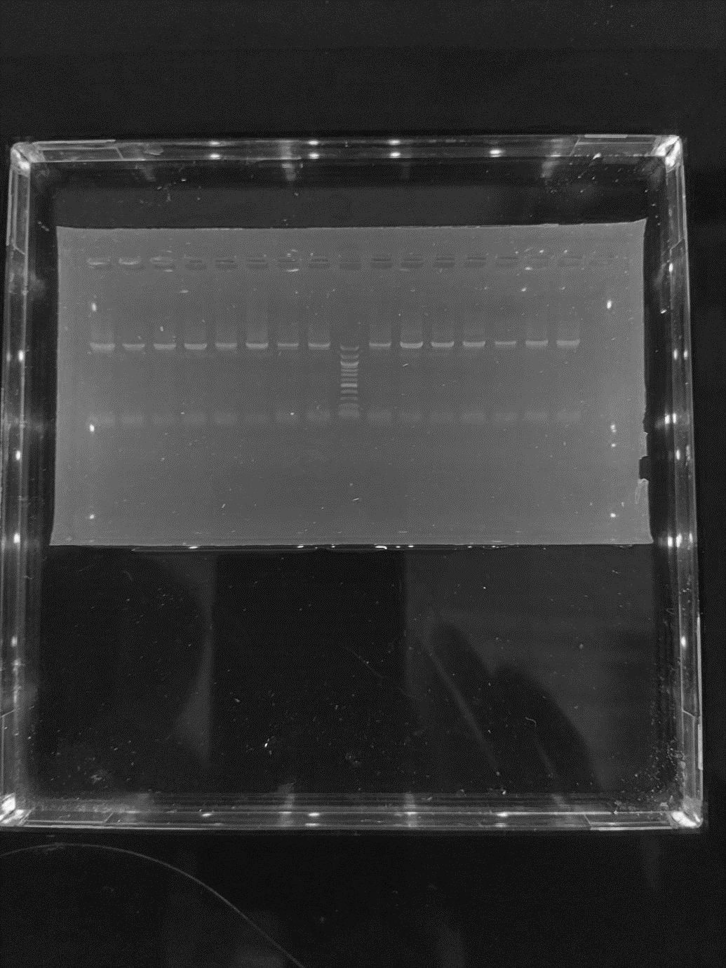
16SrRNA(1500bp)
500bp
Figure 1: Agarose gel electrophoresis showing the amplified 16srRNA of the test isolates
Lanes 1-3 represent the amplified 16srRNA at 1500bp while lane L represents the 100bp DNA ladder.
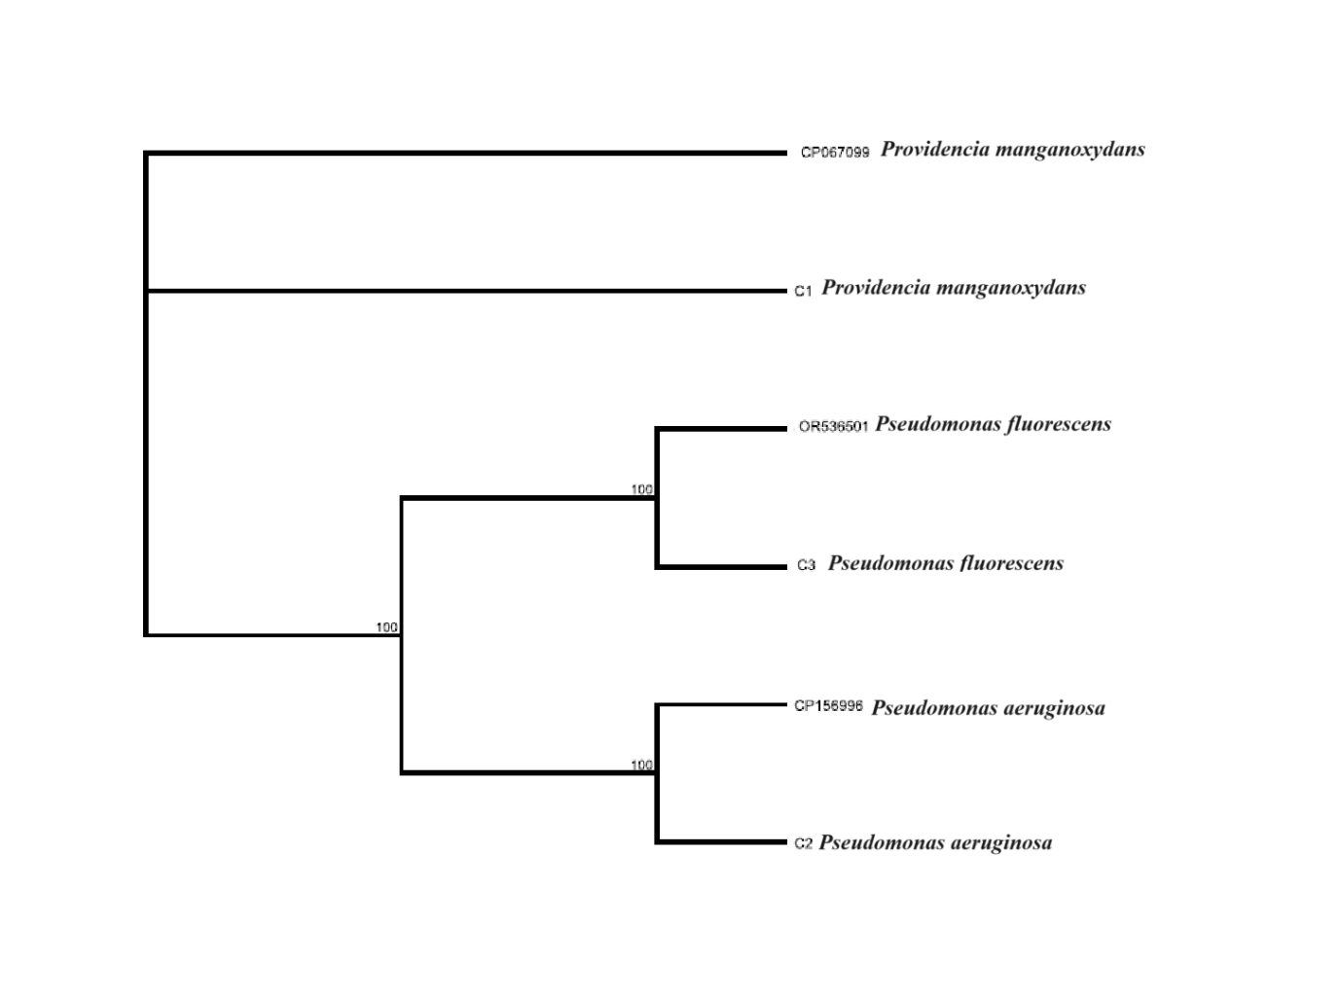
Fig. 2. Phylogenetic tree showing the evolutionary relationship between the bacterial isolates

Table 3: Solubilization of copper with (NH₄)₂SO₄
 | Ps 50 µm |  |  | Ps 950 µm
Organisms | DAY 0 (mg/l) | DAY 24 (mg/l) | % mean | DAY 0 (mg/l) | DAY 24 (mg/l) | %  mean
P. fluorescens + P. manganoxydans | 8.668 | 12.524 | 44% | 2.761 | 3.748 | 35%
P. aeruginosa + P. manganoxydans | 5.151 | 5.498 | 6% | 2.391 | 2.439 | 2%
P. manganoxydans | 3.482 | 6.511 | 86% | 1.994 | 3.197 | 60%
P. fluorescens | 14.108 | 23.781 | 68% | 3.722 | 5.351 | 43%
P. aeruginosa + P. manganoxydans + P. fluorescens | 12.452 | 16.245 | 30% | 3.491 | 4.089 | 17%
P. aeruginosa | 4.28 | 5.881 | 37% | 1.143 | 1.491 | 30%
P. aeruginosa + P. fluorescens | 4.647 | 7.665 | 64% | 1.219 | 1.759 | 44%
Control | 1.169 | 1.194 | 2% | 1.014 | 1.028 | 1%

Table 4: Solubilization of nickel with (NH₄)₂SO₄
 | Ps 50 µm |  |  | Ps 950 µm
Organisms | DAY 0 (mg/l) | DAY 24 (mg/l) | % | DAY 0 (mg/l) | DAY 24 (mg/l) | %
P. fluorescens + P. manganoxydans | 0.559 | 0.731 | 30% | 0.293 | 0.336 | 14%
P. aeruginosa + P. manganoxydans | 0.526 | 0.674 | 28% | 0.172 | 0.208 | 20%
P. manganoxydans | 0.494 | 0.831 | 68% | 0.115 | 0.187 | 62%
P. fluorescens | 0.756 | 1.268 | 67% | 0.577 | 0.880 | 52%
P. aeruginosa + P. manganoxydans + P. fluorescens | 0.624 | 0.866 | 38% | 0.211 | 0.275 | 30%
P. aeruginosa | 0.534 | 0.868 | 62% | 0.301 | 0.447 | 48%
P. aeruginosa + P. fluorescens | 0.696 | 0.991 | 42% | 0.243 | 0.332 | 36%
Control | 0.731 | 0.788 | 7% | 0.231 | 0.243 | 5%

Table 5: Solubilization of zinc with (NH₄)₂SO₄
 | Ps 50 µm |  |  | Ps 950 µm
Organisms | DAY 0 (mg/l) | DAY 24 (mg/l) | % | DAY 0 (mg/l) | DAY 24 (mg/l) | %
P. fluorescens + P. manganoxydans | 0.237 | 0.326 | 37% | 0.201 | 0.270 | 34%
P. aeruginosa + P. manganoxydans | 0.132 | 0.188 | 42% | 0.112 | 0.154 | 37%
P. manganoxydans | 0.121 | 0.206 | 70% | 0.101 | 0.162 | 60%
P. fluorescens | 0.326 | 0.537 | 64% | 0.162 | 0.238 | 46%
P. aeruginosa + P. manganoxydans + P. fluorescens | 0.343 | 0.453 | 32% | 0.141 | 0.182 | 29%
P. aeruginosa | 0.414 | 0.547 | 32% | 0.211 | 0.264 | 25%
P. aeruginosa + P. fluorescens | 0.223 | 0.354 | 58% | 0.153 | 0.217 | 41%
Control | 0.111 | 0.120 | 8% | 0.112 | 0.120 | 7%

Table 6: Solubilization of copper with NPK
 | Ps 50 µm |  |  | Ps 950 µm
Organisms | DAY 0 (mg/l) | DAY 24 (mg/l) | % | DAY 0 (mg/l) | DAY 24 (mg/l) | %
P. aeruginosa + P. fluorescens | 6.347 | 10.227 | 61% | 3.641 | 4.802 | 31%
P. aeruginosa | 11.743 | 15.428 | 31% | 2.773 | 3.151 | 13%
P. fluorescens | 7.85 | 13.569 | 72% | 4.981 | 7.483 | 50%
P. aeruginosa + P. manganoxydans | 7.864 | 8.858 | 12% | 2.914 | 2.997 | 3%
P. aeruginosa + P. manganoxydans + P. fluorescens | 16.102 | 17.898 | 10% | 4.621 | 4.999 | 8%
P. fluorescens + P. manganoxydans | 9.324 | 9.979 | 7% | 2.017 | 2.094 | 4%
P. manganoxydans | 2.081 | 3.538 | 70% | 3.610 | 5.422 | 5%
Control | 13.204 | 13.976 | 5% | 4.301 | 4.382 | 2%

Table 7: Solubilization of nickel with NPK
 | Ps 50 µm |  |  | Ps 950 µm
Organisms (NPK) | DAY 0 (mg/l) | DAY 24 (mg/l) | % | DAY 0 (mg/l) | DAY 24 (mg/l) | %
P. aeruginosa + P. fluorescens | 0.427 | 0.664 | 55% | 0.339 | 0.457 | 34%
P. aeruginosa | 0.398 | 0.617 | 55% | 0.171 | 0.217 | 26%
P. fluorescens | 0.435 | 0.786 | 80% | 0.382 | 0.595 | 55%
P. aeruginosa + P. manganoxydans | 0.505 | 0.581 | 15% | 0.269 | 0.354 | 31%
P. aeruginosa + P. manganoxydans + P. fluorescens | 0.545 | 0.653 | 19% | 0.174 | 0.196 | 12%
P. fluorescens + P. manganoxydans | 0.401 | 0.551 | 37% | 0.097 | 0.117 | 20%
P. manganoxydans | 0.605 | 1.034 | 70% | 0.273 | 0.388 | 42%
Control | 0.683 | 0.759 | 11% | 0.411 | 0.428 | 4%

Table 8: Solubilization of zinc with NPK
 | Ps 50 µm |  |  | Ps 950 µm
Organisms | DAY 0 (mg/l) | DAY 24 (mg/l) | % | DAY 0 (mg/l) | DAY 24 (mg/l) | %
P. aeruginosa + P. fluorescens | 0.131 | 0.171 | 30% | 0.125 | 0.158 | 26%
P. aeruginosa | 0.233 | 0.280 | 20% | 0.143 | 0.167 | 16%
P. fluorescens | 0.124 | 0.214 | 72% | 0.118 | 0.168 | 42%
P. aeruginosa + P. manganoxydans | 0.311 | 0.367 | 18% | 0.263 | 0.291 | 10%
P. aeruginosa + P. manganoxydans + P. fluorescens | 0.245 | 0.270 | 10% | 0.128 | 0.140 | 9%
P. fluorescens + P. manganoxydans | 0.116 | 0.149 | 28% | 0.113 | 0.137 | 21%
P. manganoxydans | 0.142 | 0.230 | 61% | 0.131 | 0.175 | 33%
Control | 0.122 | 0.129 | 5% | 0.109 | 0.116 | 6%

Table 9: Solubilization of copper with organic manure
 | Ps 50 µm |  |  | Ps 950 µm
Organisms | DAY 0 (mg/l) | DAY 24 (mg/l) | % | DAY 0 (mg/l) | DAY 24 (mg/l) | %
P. aeruginosa + P. manganoxydans + P. fluorescens | 4.705 | 5.590 | 18% | 2.671 | 2.807 | 5%
P. aeruginosa + P. fluorescens | 11.966 | 14.350 | 19% | 1.582 | 1.691 | 6%
P. aeruginosa | 11.287 | 12.894 | 14% | 3.401 | 3.486 | 2%
P. aeruginosa + P. manganoxydans | 8.853 | 11.500 | 29% | 2.173 | 2.550 | 17%
P. fluorescens + P. manganoxydans | 8.774 | 10.007 | 14% | 1.303 | 1.418 | 8%
P. fluorescens | 13.713 | 15.900 | 15% | 3.014 | 3.199 | 6%
P. manganoxydans | 5.332 | 8.122 | 52% | 1.521 | 2.249 | 47%
Control | 13.204 | 13.905 | 5% | 5.304 | 5.442 | 2%

Table 10: Solubilization of nickel with organic manure
 | Ps 50 µm |  |  | Ps 950 µm
Organisms | DAY 0 (mg/l) | DAY 24 (mg/l) | % | DAY 0 (mg/l) | DAY 24 (mg/l) | %
P. aeruginosa + P. manganoxydans + P. fluorescens | 0.45 | 0.53 | 17% | 0.211 | 0.240 | 12%
P. aeruginosa + P. fluorescens | 0.552 | 0.689 | 24% | 0.187 | 0.210 | 12%
P. aeruginosa | 0.536 | 0.608 | 13% | 0.359 | 0.377 | 5%
P. aeruginosa + P. manganoxydans | 0.505 | 0.587 | 16% | 0.125 | 0.149 | 19%
P. fluorescens + P. manganoxydans | 0.467 | 0.539 | 15% | 0.141 | 0.151 | 7%
P. fluorescens | 0.531 | 0.813 | 53% | 0.273 | 0.357 | 30%
P. manganoxydans | 0.459 | 0.677 | 47% | 0.162 | 0.194 | 19%
Control | 0.683 | 0.735 | 7% | 0.313 | 0.318 | 2%

Table 11: Solubilization of zinc with organic manure
 | Ps 50 µm |  |  | Ps 950 µm
Organisms | DAY 0 (mg/l) | DAY 24 (mg/l) | % | DAY 0 (mg/l) | DAY 24 (mg/l) | %
P. aeruginosa + P. manganoxydans + P. fluorescens | 0.121 | 0.137 | 13% | 0.117 | 0.128 | 9%
P. aeruginosa + P. fluorescens | 0.201 | 0.245 | 21% | 0.107 | 0.120 | 12%
P. aeruginosa | 0.125 | 0.160 | 28% | 0.111 | 0.133 | 19%
P. aeruginosa + P. manganoxydans | 0.201 | 0.253 | 25% | 0.204 | 0.248 | 21%
P. fluorescens + P. manganoxydans | 0.224 | 0.263 | 17% | 0.112 | 0.120 | 7%
P. fluorescens | 0.103 | 0.139 | 34% | 0.121 | 0.154 | 27%
P. manganoxydans | 0.109 | 0.161 | 47% | 0.134 | 0.187 | 39%
Control | 0.101 | 0.108 | 6% | 0.102 | 0.105 | 2%

DISCUSSION
The development of electronic and electrical industries and the widespread use of electronic technologies have resulted in the increased production of existing and novel electronic devices (Wu, Liu, Zhang, Xhu, & Tan, 2018). The rapid and improper disposal of electronic waste (e-waste) has become an issue of great concern, resulting in serious threats to the environment and public health. and many developing countries have embraced the benefits of e-technology but seem to overlook the environmental and health consequences of improper handling of the resultant e-waste and the possibility of harnessing valuable materials in the wastes for reuse. Microorganisms play a crucial role in the extraction of metals from e-waste, a technology known as bioleaching or metal solubilization (Nasiri et al., 2023).
The molecular identification using primers targeting the 16S rRNA of the isolated three bacteria, confirmed that the organisms were P. manganoxydans, P. fluorescens and P. aeruginosa as shown by the bands seen in the agarose gel electrophoresis and the phylogenetic tree; which represented the evolutionary relationship between the bacterial isolates. The phylogenetic tree for P. manganoxydans showed similarity with that reported by Li et al., (2022) for novel isolates obtained from heavy metal contaminated soils in China, the Pseudomonas fluorescens obtained from the study on bioleaching of gold from waste printed circuit boards in China by Li et al., (2020) and the Pseudomonas aeruginosa obtained from a study on the bioleaching of copper from its ore in Iran by Shabani et al., (2013).
The solubilization analysis of the PCB by the bacteria isolates based on the particle sizes (50 µm and 950 µm), showed that the percentage increase in metals obtained after solubilization assay for the Ps 50 µm were more when compared to those for the Ps 950 µm across all the assay set up after the 24 days of solubilization. This agrees with the findings of Rouchalova et al., (2020) on the effect of different particle sizes on bioleaching, with smaller particles having more bioleaching efficiencies when compared to bigger particles. It also had similar outcome with the study by Guven and Akinci, (2013), on the effect of particle size on metal bioleaching from bay sediments using fine (<45 μm), medium (45–300 μm), and coarse (300–2000 μm) size fractions of sediment samples contaminated with Cr, Cu, Pb, and Zn, who reported that the bioleaching efficiencies were more for lesser particle sizes when compared to bigger particle size particles. These similar outcomes could be attributed to the more surface area 50 μm particle size PCB in the medium, which may have increased the area of the PCB available for microbial activities by the test inoculum.
P. manganoxydans had a percentage solubilization outcome of 86%, 68% and 70% for copper, nickel and zinc in (NH₄)₂SO₄, 70%, 70% and 61% respectively for copper, nickel and zinc with NPK, and 52%, 47% and 47% for organic maure. This provides insight on the ability of P. manganoxydans to solubilize different metals and establishing its role as an efficient metal solubilization microbial species when placed in favourable environmental conditions. Although P. manganoxydans has been associated with the solubilization of Mn²⁺ from heavy metal contaminated soils (Li et al., 2022), no known report has been made of its solubilization of copper, nickel and zinc. This report presents as an added information on the properties and potentials of the bacteria.
P. fluorescens achieved 72%, 80% and 72% solubilization for copper, nickel and zinc respectively in NPK, 68%, 67%, 64% solubilization for copper, nickel and zinc in (NH₄)₂SO₄, at the end of the 24 days. The solubilization performance of the organism can be adjudged good across the 3 metals when compared to the 10% and 4% solubilization respectively for Cu and Zn reported by Potysz et al. (2016). This improved outcome can be attributed to the environmental conditions maintained throughout the assay, with an alkalinic pH for the organism in this study. Also, no additional nitrogen source was added to his assay and no varying particle size. These environmental conditions can be pivotal in solubilization efficiencies of a bacteria.
In this study, P. aeruginosa had the least solubilization rate across assays with varying nitrogen sources and particle sizes. This was also observed by Shabani et al. (2013) in a study on copper extraction from copper oxide ore using P. aeruginosa, Affirming the bioleaching potential of P. aeruginosa under ideal conditions but stressing the importance of selected strains for optimal result.
The percentage solubilization of test metals in setups with organic manure as the nitrogen source was the least when compared to solubilization obtained with other nitrogen sources employed in the assay across different particle sizes. This could be attributed to (NH₄)₂SO₄ and NPK being synthetic sources which are readily available sources of nitrogen, leading to quick uptake. While organic manures release nutrients gradually. Also, the test organisms may be spending more energy breaking down the organic molecules, this energy may be conserved with the use of (NH₄)₂SO₄ and NPK. However, the use of organic manure which is natural, will most likely promote a more balanced and sustainable nutrient cycle, throughout the duration of usage (Li et al., 2024). The (NH₄)₂SO₄ and NPK used will also be quick in depletion in cases of long term usage.
Conclusion
As the surge in global electronic waste continue to pose a threat to the environment and ecosystem, microbial solubilization presents a transformative approach to metal extraction that aligns with the growing global emphasis on sustainability and resource efficiency. By offering a greener, cost-effective, and efficient alternative to conventional methods, it holds great promise for the future of metal resource recovery.

References
Bas, A. D., Deveci, H., & Yazici, E. Y. (2013). Bioleaching of copper from low grade scrap TV circuit boards using mesophilic bacteria. Hydrometallurgy, 138, 65-70. https://doi.org/10.1016/j.hydromet.2013.06.015
Needhidasan, S., Samuel, M., & Chidambaram, R. (2014). Electronic Waste—An Emerging Threat to the Environment of Urban India. Journal of Environmental Health Science & Engineering, 12(1), 36. https://doi.org/10.1186/2052-336X-12-36
Kudpeng, K., Bohu, T., Morris, C., Thiravetyan, P., & Kaksonen, A. H. (2020). Bioleaching of gold from sulfidic gold ore concentrate and electronic waste by Roseovarius tolerans and Roseovarius mucosus. Microorganisms, 8(11), 1783. https://doi.org/10.3390/microorganisms8111783
Wang, J., Faraji, F., Ramsay, J., & Ghahreman, A. (2021). A review of biocyanidation as a sustainable route for gold recovery from primary and secondary low-grade resources. Journal of Cleaner Production. https://doi.org/10.1016/j.jclepro.2021.126457
Hagelüken, C. and Meskers, C. (2008). Mining our computers-opportunities and challenges to recover scarce and valuable metals from end-of-life electronic Electronic Goes Green, Berlin, Germany.
Dutta, D., Goel, S., & Kumar, S. (2022). Health risk assessment for exposure to heavy metals in soils in and around E-waste dumping site. Journal of Environmental Chemical Engineering, 10, 107269. https://doi.org/10.1016/j.jece.2022.107269
Arshadi, M., Nili, S., & Yaghmaei, S. (2019). Ni and Cu recovery by bioleaching from the printed circuit boards of mobile phones in non-conventional medium. Journal of Environmental Management. https://doi.org/10.1016/j.jenvman.2019.109502
Petter, P. M. H., Veit, H. M., & Bernardes, A. M. (2014). Evaluation of gold and silver leaching from printed circuit board of cellphones. Waste Management, 34(2), 475–482. https://doi.org/10.1016/j.wasman.2013.10.032
Hong, Y., & Valix, M. (2014). Bioleaching of electronic waste using acidophilic sulfur oxidising bacteria. Journal of Cleaner Production, 65, 465-472. https://doi.org/10.1016/j.jclepro.2013.08.043
Amiya, K. P. (2010). Isolation and Characterization of Thiobacillus ferrooxidans from Coal Acid Mine Drainage. International Journal of Applied Agricultural Research, 5(1), 73–85 http://www.ripublication.com/ijaar.htm
Ahmed, R. N., Alafara, A. B., Sani, A., Alamu, F. B., & Ajijolakewu, A. K. (2012). Bioleaching of Lead from Nigerian Anglesite Ore by Acidithiobacillus ferrooxidans. Journal of Applied Sciences Research, 8(12), 5591-5598.
Dave, S. R., Sodha, A. B., & Tipre, D. R. (2018). Microbial technology for metal recovery from e-waste printed circuit boards. Journal of Bacteriology and Mycology, 6(4), 241–247. https://doi.org/10.15406/jbmoa.2018.06.00212
Wu, W., Liu, X., Zhang, X., Zhu, M., & Tan, W. (2018). Bioleaching of copper from waste printed circuit boards by bacteria-free cultural supernatant of iron–sulfur-oxidizing bacteria. Bioresources and Bioprocessing, 5, 10. https://doi.org/10.1186/s40643-018-0196-6
Nasiri, T., Mokhtari, M., Teimouri, F., & Abouee, E. (2023). Remediation of metals and plastic from e-waste by iron mine indigenous acidophilic bacteria. Waste Management Resources, 41, 894–902. https://doi.org/10.1177/0734242X221126418
Li, Z., Liao, F., Ding, Z., Chen, S., & Li, D. (2022). Providencia manganoxydans sp. nov., a Mn(II)-oxidizing bacterium isolated from heavy metal contaminated soils in Hunan Province, China. International Journal of Systematic and Evolutionary Microbiology, 72(8), 005474. https://doi.org/10.1099/ijsem.0.005474
Li, D., Li, R., Ding, Z., Ruan, X., Luo, J., Chen, J., Zheng, J., & Tang, J. (2020). Discovery of a novel native bacterium of Providencia sp. with high biosorption and oxidation ability of manganese for bioleaching of heavy metal contaminated soils. Chemosphere, 241, 125039. https://doi.org/10.1016/j.chemosphere.2019.125039
Shabani, M. A., Irannajad, M., Azadmehr, A. R., & Meshkini, M. (2013). Bioleaching of copper oxide ore by Pseudomonas aeruginosa. International Journal of Minerals, Metallurgy and Materials, 20(12), 1130–1133. https://doi.org/10.1007/s12613-013-0845-x
Rouchalova, D., Rouchalova, K., Janakova, I., Cablik, V., & Janstova, S. (2020). Bioleaching of Iron, Copper, Lead, and Zinc from the Sludge Mining Sediment at Different Particle Sizes, pH, and Pulp Density Using Acidithiobacillus ferrooxidans. Minerals, 10(11), 1013 https://doi.org/10.3390/min10111013
Guven, D. E., & Akinci, G. (2013). Effect of sediment size on bioleaching of heavy metals from contaminated sediments of Izmir Inner Bay. Journal of Environmental Sciences, 25(9), 1784-1794. https://doi.org/10.1016/S1001-0742(12)60198-3
Potysz, A., Lens, P. N. L., van de Vossenberg, J., Rene, E. R., Grybos, M., Guibaud, G., Kierczak, J., & van Hullebusch, E. D. (2016). Comparison of Cu, Zn and Fe bioleaching from Cu-metallurgical slags in the presence of Pseudomonas fluorescens and Acidithiobacillus thiooxidans. Applied Geochemistry, 68, 39-52. https://doi.org/10.1016/j.apgeochem.2016.03.006
Li, P., Zhai, W., Guo, Q., Zou, X., Wang, Y., Gu, Y., Liu, X., Zhou, Z., Wang, P., & Liu, D. (2024). Effects of ammonium sulfate on the degradation and metabolism of dinotefuran in soil: Evidence from soil physicochemical properties and bacterial community structure. Science of The Total Environment, 954, 176674. https://doi.org/10.1016/j.scitotenv.2024.176674

