Characterization and Antibiotic Resistance Profile of Biofilm Forming Pseudomonas aeruginosa Isolated From Infected Wounds

ABSTRACT
Pseudomonas aeruginosa is a leading cause of chronic and hard-to-heal wound infections due to its strong ability to form biofilms and develop multidrug resistance. Biofilm-associated growth significantly limits antibiotic penetration and promotes persistent infection, making treatment challenging. This study aimed to determine the prevalence, biofilm-forming ability, and antimicrobial susceptibility patterns of P. aeruginosa isolated from infected wounds. A total of 248 wound swab samples were aseptically collected from in-patients and out-patients presenting with clinical evidence of wound infection in hospitals within Enugu metropolis. Samples were cultured on Blood agar and MacConkey agar plates and incubated aerobically at 37 °C for 24–48 hours and isolates were identified using standard microbiological and biochemical tests. Antibiotic susceptibility testing was performed using the Kirby–Bauer disk diffusion method following CLSI guidelines. Also, biofilm formation was detected using Congo Red Agar (CRA). A total of 248 wound swab samples were collected from patients with clinically diagnosed wound infections and analyzed. Out of these, 184 samples (74.2%) yielded significant bacterial growth, while 64 samples (25.8%) showed no bacterial growth after 24–48 hours of incubation. Among the positive cultures, Gram –negative bacteria were 61.4% and Pseudomonas aeruginosa had 56 isolates (30.4%) which were the predominant isolates. Out of the 248 samples that were analysed, 184 samples (74.2%) showed significant bacterial growth, and P. aeruginosa had 56 isolates (30.4%) which were the predominant isolates. Antimicrobial susceptibility testing of all P. aeruginosa isolates was performed using the Kirby–Bauer disk diffusion method. High resistance was observed against commonly used antibiotics: Cefotaxime (80.4%), Ceftazidime (75.0%), Ciprofloxacin (69.6%), Gentamicin (62.5%) and Ofloxacin (58.9%). Moderate susceptibility was observed with Piperacillin–tazobactam (59.0%), Imipenem (55.4%) and Meropenem (51.8%) while the highest susceptibility was seen in amikacin, with 64.3% sensitivity. All 56 P. aeruginosa isolates were screened for biofilm formation using the Congo Red Agar (CRA) method. It was observed that 24 isolates (42.9%) were strong biofilm formers, 18 (32.1%) were moderate/weak while 14 (25.0%) isolates did not form biofilms. The high prevalence of biofilm formation shows the organism’s inherent ability to establish persistent infection, particularly in chronic wound environments where biofilm facilitates adhension, protects bacteria from host defenses and significantly reduces antibiotic penetration which will lead to resistance. These findings emphasize the clinical relevance of biofilm formation as a key virulence mechanism contributing to antimicrobial resistance and treatment failure in Pseudomonas aeruginosa wound infections.

Keywords: Pseudomonas aeruginosa, biofilm formation, wound infection, antibiotic resistance.

- INTRODUCTION
A wound is defined as a physical injury to the skin or underlying tissues that disrupts normal anatomical structure and function. Wounds may result from surgical procedures, trauma, burns, pressure ulcers, or infections. They are broadly categorized into acute and chronic wounds, depending on the healing pattern. While acute wounds follow a predictable inflammatory and repair sequence, chronic wounds often persist due to underlying infections or impaired immune responses, thereby failing to heal within the expected timeframe (Bowler et al., 2001).
Infected wounds occur when microbial colonization surpasses a threshold and causes pathological changes in the wound bed. It is also the invasion of a wound by proliferating microorganisms to a level that invokes a local and/or systemic response in the host, the ultimate result being extensive local tissue damage and impeded wound healing. Wound infections progress from the state of contamination through colonisation to local infection and finally to systemic infections, in accordance with the enhancement in microbial load, virulence, and the degree of pathogenicity (Kebede et al. 2024). This may be characterized by symptoms such as pain, swelling, erythema, foul odor, delayed healing, and exudate formation. Infections in wounds are often caused by opportunistic or nosocomial pathogens that are capable of evading host immune responses and establishing persistent colonization (Gnanadhas et al., 2013). These infections are the major burden in clinical settings, leading to delayed healing, increased hospitalization, healthcare costs, and in severe cases, amputations or death. This is always seen in developing countries where poor hygiene, limited access to health care and indiscriminate use of antibiotics results in increased morbidity and mortality (Hong et al. 2025).
Pseudomonas aeruginosa is the most common microorganism isolated from chronic wounds, often found as biofilm producer,that acts as a barrier in wound healing and shows resistance to antimicrobial therapy (Wang et al. 2025; Tuon et al., 2022).. It is a Gram-negative and rod-shaped opportunistic pathogen that is a major causative microorganism in wound infections, delaying the wound healing process (Kashif et al. 2017, Sang et al., 2023). Its relevance in wound infections stems not only from its ubiquity but from a wide array of virulence factors that enable colonization of compromised tissues, immune evasion and persistence in hostile environments (Tuon et al., 2022). In severe cases, the infection can spread to deeper tissues or cause systemic infections such as sepsis, particularly in immunocompromised individuals (Bassetti et al., (2018).
Biofilm is actually a structured consortium of bacteria and extracellular matrix, which adheres to surfaces and is essential for interconnecting the bacteria and can be composed of polysaccharides, proteins, and extracellular DNA (eDNA) (Kashif et al. 2017). Within biofilm communities, the bacterial cells exhibit altered physiology including slower growth, reduced antimicrobial penetration and increased tolerance to host immune responses.
The biofilm of P. aeruginosa functions as a dynamic reservoir of resistance genes and virulence factors, serving as the core mechanism underlying persistent clinical infections ((Kashif et al. 2017). A critical barrier to effective treatment is biofilm formation, a quorum-sensing-mediated process that impedes antibiotic penetration and complicates intravenous therapy (Hong et al. 2025). In chronic wound environments, biofilm formations by P. aeruginosa have been shown to delay wound closure or healing, exacerbate inflammation and enhance resistance of the bacteria to both antibiotics and immune clearance (Rias et al., 2023) thereby leading to treatment failure despite the use of broad-spectrum antibiotics (Al-Judaibi et al., 2023). The organism can acquire further resistance determinants through horizontal gene transfer and mutation under antibiotic-selection pressure (Donlan, 2022).

- MATERIALS AND METHODS

2.1 Study Design

The study design that was used in this work was experimental research design.

2.2 Study Population

The study population used were 248 in-patients and out-patients presenting with clinical evidence of wound infection such as pus discharge, inflammation, or delayed healing in hospitals within Enugu metropolis.

2.3 Study Location

The study location was Enugu metropolis, Enugu State, Nigeria.

2.4 Determination of Sample Size

A total population of 650 in-patients and out-patients with clinical evidence of wound infection was identified as the study population. Using a confidence level of 95% and assuming maximum variability (p= 0.5), a sample size of 248 patients was determined.
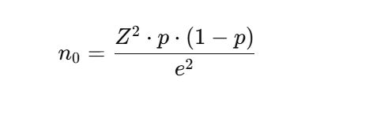
Where:
- Z is the Z-score (confidence level)
- p is the estimated proportion of the population
- e is the margin of error
(Adopted from Daniel, 1999)

2.5 Sample collection
A total of 248 wound swab samples were collected aseptically using sterile swab sticks moistened with sterile normal saline. Each sample was labeled and transported immediately to the microbiology laboratory for analysis.
2.6 Sample Inoculation and Identification of Isolates
Samples were inoculated onto Blood agar and MacConkey agar plates and incubated aerobically at 37 °C for 24–48 hours. Colonies showing characteristic P. aeruginosa morphology (greenish pigment, fruity odor, and β-hemolysis on blood agar) were subjected to Gram staining and a series of biochemical tests, including oxidase, catalase, citrate utilization, and triple sugar iron (TSI) tests (Forbes et al., 2017; Olajuyigbe and Afolayan, 2021).
2.7 Antibiotics susceptibility test
The antibiotic susceptibility profile of all confirmed P. aeruginosa isolates were determined using the Kirby–Bauer disk diffusion method on Mueller–Hinton agar (Oxoid Ltd. UK) following Clinical and Laboratory Standards Institute (CLSI) guidelines (CLSI, 2024). The antibiotics tested were: Cefotaxime (30 µg), Ceftazidime (30 µg), Ofloxacin (5 µg), Imipenem (10 µg), Meropenem (10 µg), Ciprofloxacin (5 µg), Gentamicin (10 µg), Amikacin (30 µg) and Piperacillin-tazobactam (100/10 µg). A 0.5 McFarland standard suspension of each isolate was swabbed evenly on Mueller–Hinton agar plates, and antibiotic discs were applied aseptically. Plates were incubated at 37 °C for 18–24 hours, and inhibition zone diameters were measured and interpreted according to CLSI performance standards (CLSI, 2024).

2.8 Biofilm formation test (Congo red agar method)
This method involved the use of special media, Brain Heart Infusion (BHI) agar with Sucrose and Congo red. BHI agar-52 g/L; sucrose-36 g/L; agar-10 g/L; congo red-0.8 g/L were used. Congo red was prepared as concentrated solution and autoclaved. It was added to the medium when agar was cooled to 55°C and they were poured into sterile petri dishes and inoculated with the isolates and incubated for 24–48 h at 37°C. Black colonies with dry crystalline morphology was considered positive for biofilm production while weak or nonbiofilm colonies appeared red in colour (Kala et al., 2020).
- RESULTS AND DISCUSSION
A total of 248 wound swab samples were collected from patients with clinically diagnosed wound infections and analyzed. Out of this 248 wound samples, 184 samples (74.2%) yielded significant bacterial growth, while 64 samples (25.8%) showed no bacterial growth after 24–48 hours of incubation. Among the positive cultures, Gram –negative bacteria were 61.4% and Pseudomonas aeruginosa had 56 isolates (30.4%) which were the predominant isolates (Table 1) (Figure 1).
Table 1: Result on the distribution of wound samples
Sample Number (n) Percentage (%)
Wound samples collected 248 100%
Positive cultures 184 74.2%
Negative cultures 64 25.8%
P. aeruginosa isolates from positive
cultures 56 30.4%

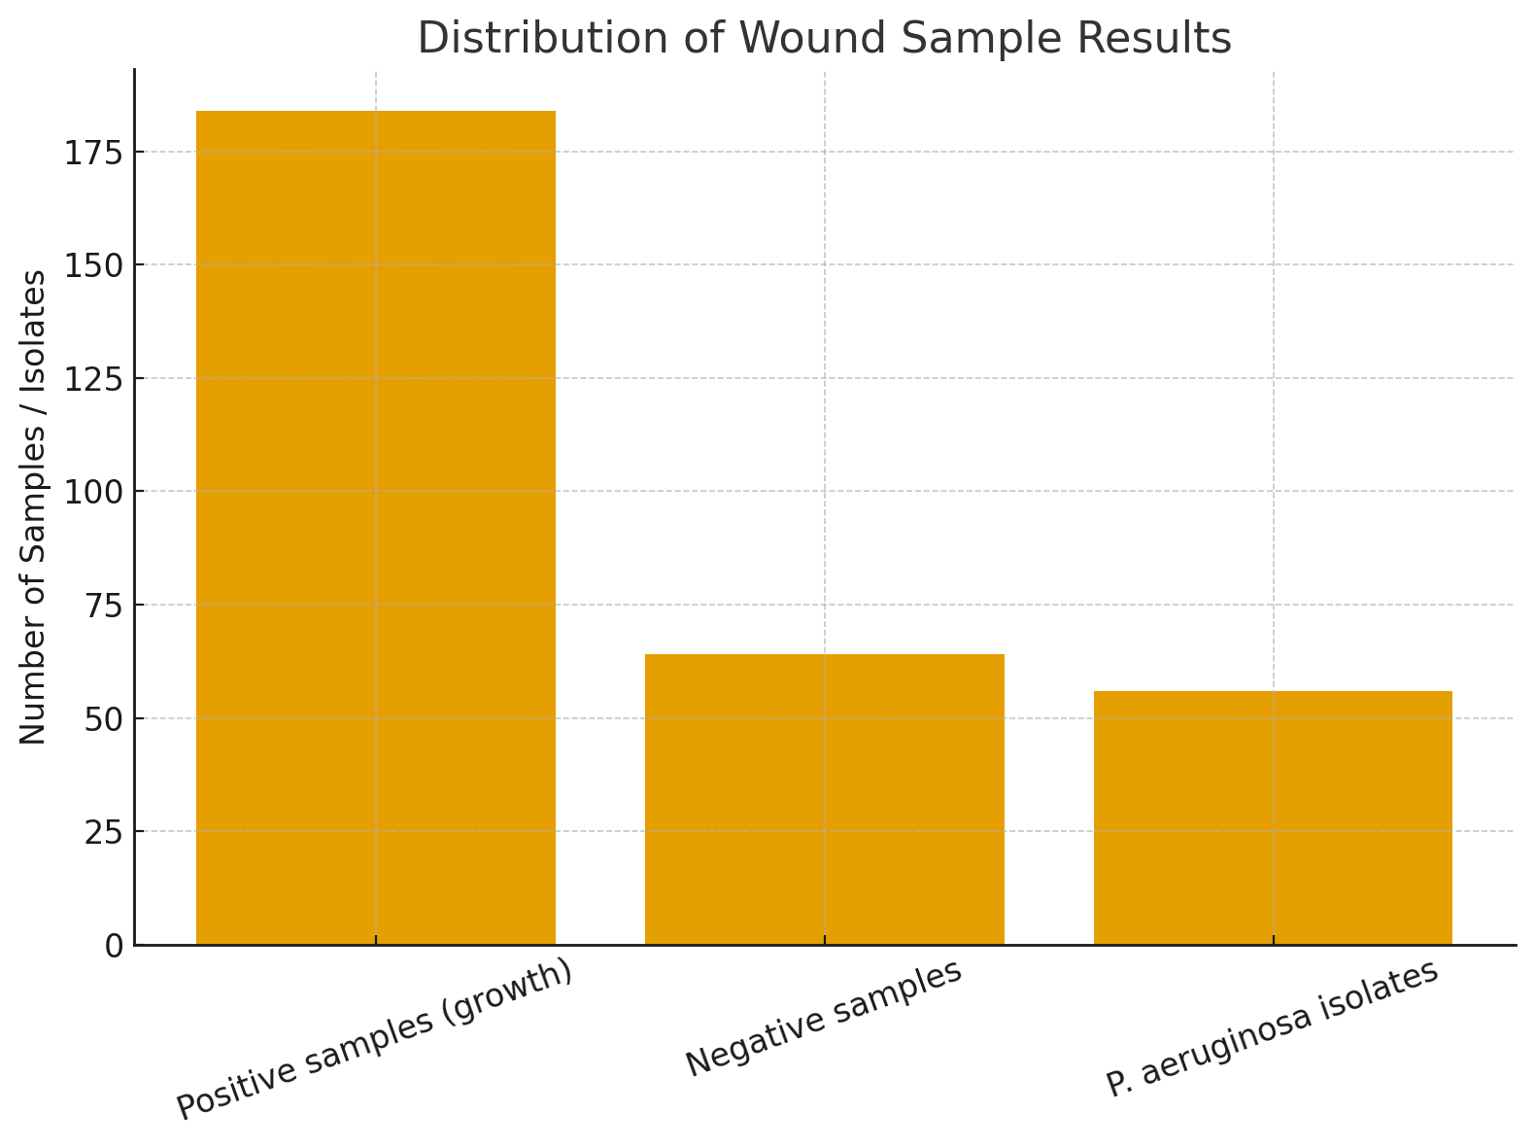
Figure 1: Result on the distribution of wound samples
Colonies of P. aeruginosa appeared large, flat, and with a characteristic blue-green pigment and a grape-like odor. The isolates were Gram-negative rods, oxidase positive, catalase positive, and motile. They produced beta-hemolysis on blood agar and were confirmed by standard biochemical tests (Table 2).

Table 2: Result on morphology and biochemical characteristics of Pseudomonas aeruginosa isolates
Test Result
Gram Staining Gram – negative rods
Motility Motile
Pigment production Bluish-green pigment on nutrient agar
Odour Characteristic fruity/grape-like smell
Catalase Positive
Oxidase Postive
Citrate utilization Positive
Urease Negative
Indole Negative

Antimicrobial susceptibility testing of all P. aeruginosa isolates was performed using the Kirby–Bauer disk diffusion method. High resistance was observed against commonly used antibiotics: Cefotaxime (80.4%), Ceftazidime (75.0%), Ciprofloxacin (69.6%), Gentamicin (62.5%) and Ofloxacin (58.9%). Moderate susceptibility was observed with Piperacillin–tazobactam (58.9%), Imipenem (55.4%) and Meropenem (51.8%) while the highest susceptbility was seen in amikacin, with 64.3% sensitivity (Table 3) (Figure 2).
Table 3: Result of Antibiotic susceptibility profile of Pseudomonas aeruginosa
Antibiotic Sensitive n (%) Resistant n (%)
Cefotaxime 11 (19.6%) 45 (80.4%)
Ceftazidime 14 (25.0%) 42 (75.0%)
Ciprofloxacin 17 (30.4%) 39 (69.6%)
Gentamicin 21 (37.5%) 35 (62.5%)
Ofloxacin 23 (41.1%) 33 (58.9%)
Amikacin 36 (64.3%) 20 (35.7%)
Piperacillin-Tazobactam 33 (58.9%) 23 (41.1%)
Imipenem 31 (55.4%) 25 (44.6%)
Meropenem 29 (51.8%) 27 (48.2%)

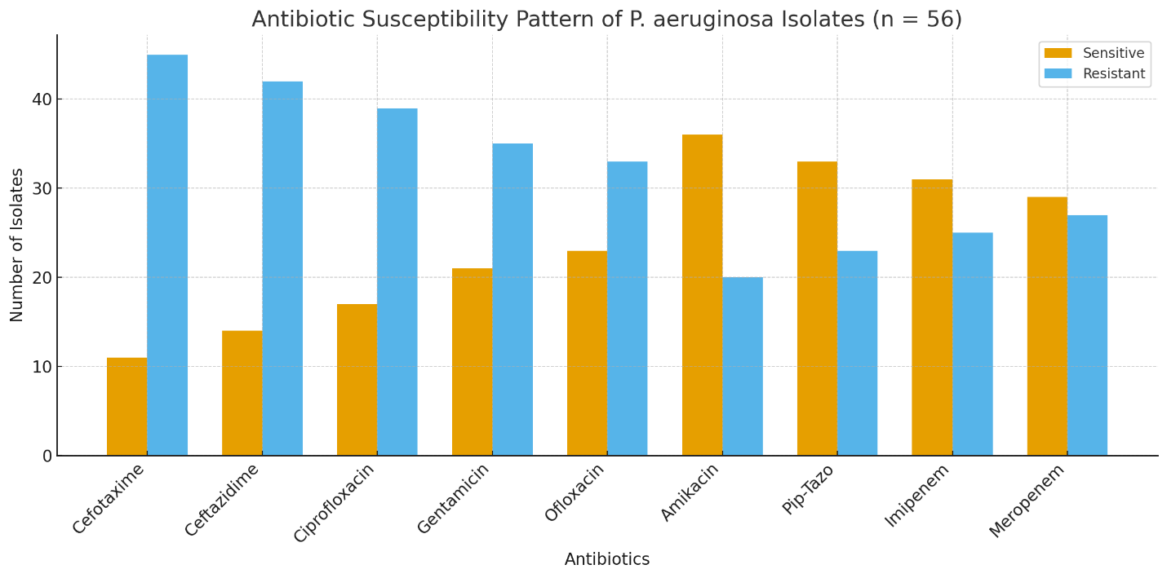
Figure 2: Result of Antibiotic susceptibility profile of Pseudomonas aeruginosa

All 56 P. aeruginosa isolates were screened for biofilm formation using the Congo Red Agar. Black colonies showed strong biofilm formation, dark red or dry red colonies indicated moderate/weak biofilm formation while smooth red colonies indicated non-biofilm formation. It was observed that 24 isolates (42.9%) were strong biofilm formers, 18 (32.1%) were moderate/weak while 14 (25.0%) isolates did not form biofilms (Table 4) (Figure 3).

Table 4: Result of biofilm formation of Pseudomonas aeruginosa
Biofilm Reaction No. of Isolates Percentage (%)
Strong biofilm formerd 24 42.9%
Moderate/weak biofilm formers 18 32.1%
Non-biofilm formers 14 25.0%
Total 56 100%

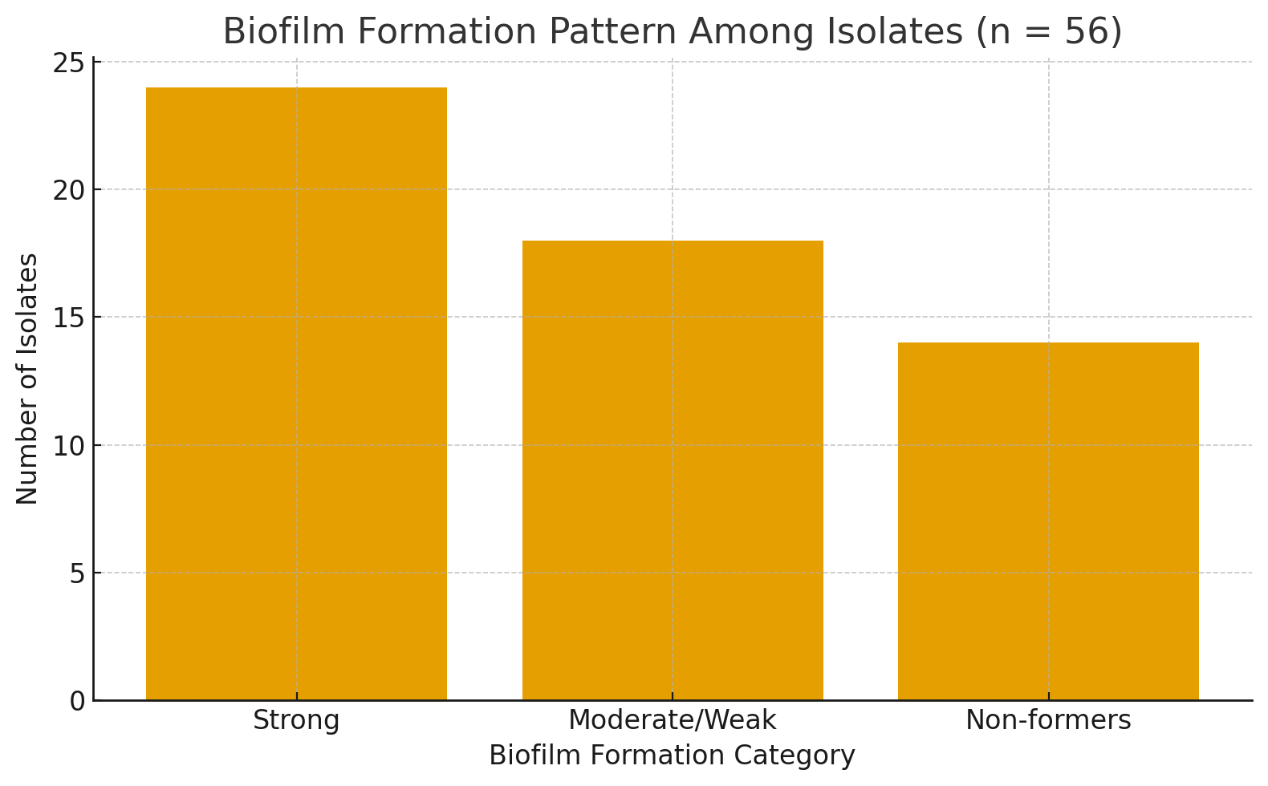
Figure 3: Result of biofilm formation of Pseudomonas aeruginosa

Wound infections continue to be a major public health concern, particularly in healthcare settings where delayed healing, prolonged hospitalization, and increased treatment costs are common outcomes. The present study investigated the occurrence, biofilm-forming ability, and antibiotic susceptibility pattern of Pseudomonas aeruginosa isolated from infected wounds. Out of 248 wound swab samples analyzed, 184 (74.2%) yielded significant bacterial growth, with P. aeruginosa being the predominant isolate (30.4%). This finding aligns with several previous studies reporting P. aeruginosa as one of the most frequent pathogens associated with wound and burn infections due to its remarkable adaptability and intrinsic resistance mechanisms (Lister et al., 2022; Ananda-Rajah et al., 2024).
It was observed that 42.9% of the isolates were strong biofilm formers while 32.1% were moderate or weak biofilm formers. This is in conformity with the work of Akinjogunla et al., 2023 and Olayinka et al., 2023 who observed high prevalence of biofilm formation among P. aeruginosa wound isolates. The high prevalence of biofilm formation shows the organism’s inherent ability to establish persistent infection, particularly in chronic wound environments where biofilm facilitates adhension, protects bacteria from host defenses and significantly reduces antibiotic penetration and resistance. Biofilm formation provides bacteria with a protective environment against host immune responses and antimicrobial agents, allowing the persistence of chronic infections (Hall and Mah, 2022). The extracellular polymeric substance (EPS) matrix of biofilms impedes antibiotic penetration and facilitates horizontal gene transfer, enhancing multidrug resistance (Donlan, 2022).
The Antibiotic Susceptibility Pattern revealed high resistance rates to cefotaxime (80.4%), ceftazidime (75.0%), and ciprofloxacin (69.6%), while the highest sensitivity was observed with piperacillin–tazobactam (58.9%) and imipenem (55.4%). These results are in agreement with the work of Mannmeet and Ashish, 2019 who also discovered that most of the isolates obtained from wound samples were multi-drug resistant and high sensitivity were seen in Amikacin and Imipenem. Also, Shirin et al., 2023 also observed that cefotaxime, ceftazidime were highly resistance.
The high resistance observed against third-generation cephalosporins may result from the widespread occurrence of extended-spectrum β-lactamases (ESBLs) and AmpC β-lactamases, which hydrolyze β-lactam antibiotics ( Livermore, 2024).
- CONCLUSION
This study shows that there was a high prevalence of biofilm-forming Pseudomonas aeruginosa among wound infections, with a significant proportion of isolates exhibiting multidrug resistance. The high prevalence of biofilm formation shows the organism’s inherent ability to establish persistent infection, particularly in chronic wound environments where biofilm facilitates adhension, protects bacteria from host defenses and significantly reduces antibiotic penetration which leads to resistance. Therefore, addressing biofilm-associated resistance is crucial for enhancing treatment outcomes and reducing the burden of chronic wound infections which may lead to high mortality among patients with infected wound.
ETHICAL APPROVAL
Ethical approval was gotten from the ethical committee of the Faculty of Biological Sciences of the University.

REFERENCES
Akinjogunla, O.J., Enabulele, I.O. & Mboto, C.I. (2023). Biofilm formation and multidrug resistance in Pseudomonas aeruginosa isolated from wound swabs. Ann Med Health Sci Res. 13(2):112-119.
Al- Judaibi, A., Al-Harbi, N., & Al-Ghamdi, A. (2023). Multidrug resistant Pseudomonas aeruginosa in wound infections: prevalence and impact on treatment outcome. J. Infect Public Health, 16(4): 527-534.
Ananda-Rajah, M.R., Grayson, M.L. & Johnson, P.D.R. (2024). Emerging patterns of Pseudomonas aeruginosa wound infections in clinical practice: A comprehensive review. Clin Microbiol Rev. 37(2):17-23.
Bassetti, M., Vena, A., Croxatto, A., Righi, E., & Guery, B. (2018). How to manage Pseudomonas aeruginosa infections. Drugs in Context. https://doi.org/10.7573/dic.212527
Bowler, P. G., Duerden, B. I., & Armstrong, D. G. (2001). Wound microbiology and associated approaches to wound management. Clinical Microbiology Reviews, 14(2), 244–269. https://doi.org/10.1128/CMR.14.2.244-269.2001
Clinical and Laboratory Standards Institute. (2024). Performance Standards for Antimicrobial Susceptibility Testing, 34th ed. CLSI supplement M100. Wayne, PA. https://clsi.org
Daniel, W.W (1999). Biostatistics: A Foundation for Analysis in the Health Sciences, 7th Edition pp.140-145.
Donlan, R. M. (2002). Biofilms: microbial life on surfaces. Emerging Infectious Diseases, 8(9), 881–890. https://doi.org/10.3201/eid0809.020063
Tille, P. M. (2015). Bailey & Scott's Diagnostic Microbiology (14th ed.). Elsevier. https://www.elsevier.com/books/bailey-and-scotts-diagnostic-microbiology/tille/978-0-323-35482-0
Gnanadhas, D. P., Marathe, S. A., & Chakravortty, D. (2013). Biopharmaceuticals for Wound Healing: Newer Approaches. Current Pharmaceutical Biotechnology, 14(2), 119–132. https://doi.org/10.2174/138920101402130904100909

Hall, C. W., & Mah, T.-F. (2017). Molecular mechanisms of biofilm-based antibiotic resistance and tolerance in pathogenic bacteria. FEMS Microbiology Reviews, 41(3), 276–301. https://doi.org/10.1093/femsre/fux010
Hong, X., Li, Z., Xia, W., Tan, Z., Hu, Y., Zhang, L., & Liu, G. (2025). Pseudomonas aeruginosa in wound infections: Genomic characterization and emergence of hypervirulent ST1965/ST3418 strains co-harbouring exoU and exoS. Journal of Global Antimicrobial Resistance, 43, 220-228. https://doi.org/10.1016/j.jgar.2025.05.007
Kala, H., Shenoy, V. P., Narasimhaswamy, N., & Chawla, K. (2020). Detection of Biofilm Production and Its Impact on Antibiotic Resistance Profile of Bacterial Isolates from Chronic Wound Infections. Journal of Global Infectious Diseases, 12(3), 129–134. https://doi.org/10.4103/jgid.jgid_150_19
Rahim, K., Saleha, S., Basit, A., Zhu, X., Ahmed, I., Huo, L., Zhang, P., Usman, B., Muneer, S., & Franco, O. L. (2017). Pseudomonas aeruginosa as a powerful biofilm producer and positive action of amikacin against isolates from chronic wounds. Jundishapur Journal of Microbiology, 10(10), e57564. https://doi.org/10.5812/jjm.57564
Kebede, K., Zerihun, Z., Mohammed, S., Amanuel, D., Aseer, M., Teshome, K., Alahmadi, R. M., Raman, G., & Akbar, I. (2024). Biofilm formation and antibiogram profile of bacteria from infected wounds in a general hospital in southern Ethiopia. Scientific Reports, 14(1), 26359. https://doi.org/10.1038/s41598-024-78283-9
Lister, P. D., Wolter, D. J., & Hanson, N. D. (2009). Antibacterial-Resistant Pseudomonas aeruginosa: Clinical Impact and Complex Regulation of Chromosomally Encoded Resistance Mechanisms. Clinical Microbiology Reviews, 22(4), 582–610. https://doi.org/10.1128/CMR.00040-09
Livermore, D.M. (2024). Mechanisms of β-lactam resistance in Gram-negative bacteria: Clinical relevance and evolving threats. J Antimicrob Chemother. 79(2):241-253.
Gill, M. K., & Khanna, A. (2019). Antibiogram of Pseudomonas aeruginosa Isolated from Infected wounds. IP International Journal of Medical Microbiology and Tropical Diseases. https://doi.org/10.18231/j.ijmmtd.2019.036
Olajuyigbe, O.O. & Afolayan, A..J. (2021). Isolation and characterization of Pseudomonas aeruginosa from wound infections in a tertiary hospital. Afr J Clin Exp Microbiol. 22(2):172-179.
Olayinka, A.T., Abiola-Owolabi, B. & Olasunkanmi A.O. (2023). Phenotypic detection of biofilm-producing Pseudomonas aeruginosa from wound infections in North-West Nigeria. Niger J Microbiol. 37(2):85-92.
Riaz, S., Latif, S., Quddus, S., Bukhari, N. T., Ali, K., Alveena, Asghar, S., & Shah, S. M. A. (2025). Role of biofilm-forming bacteria in chronic wound infections and their antibiotic resistance profiles. Journal of Medical & Health Sciences Review, 2(3). https://doi.org/10.62019/adzs3w86

Sang, P., Feng, C. H., Huang, R., Lee, Z. X., Moua, Y., Phung, O. J., & Lenhard, J. R. (2023). Relative Abundance and Detection of Pseudomonas aeruginosa from Chronic Wound Infections Globally. Microorganisms, 11(5), 1210. https://doi.org/10.3390/microorganisms11051210
Shirin, G., Kargar, M., Hadadi, H., Khademi, S., Khosravani, E., Gholami, S., Moradi, A., & Kafil, H. S. (2023). Molecular characterizations of antibiotic resistance, biofilm formation, and virulence determinants of Pseudomonas aeruginosa isolated from burn wound infection. Journal of Clinical Laboratory Analysis. https://doi.org/10.1002/jcla.24850
Tuon, F. F., Dantas, L. R., Suss, P. H., & Tasca Ribeiro, V. S. (2022). Pathogenesis of the Pseudomonas aeruginosa Biofilm: A Review. Pathogens, 11(3), 300. https://doi.org/10.3390/pathogens11030300
Wang, Y., Qian, X., Qiong, Y., Lin, Y., Jin, Z., Zhang, T., Hu, Y., Gao, B., Chen, X., Wang, T., & Xu, L. (2025). Impact of Pseudomonas aeruginosa biofilm formation by different sequence types on treating lower limb vascular infections. Current Research in Microbial Sciences, 8, 100379. https://doi.org/10.1016/j.crmicr.2025.100379

