A Report on Morchella species of Garhwal Himalaya in Bharsar region, Uttarakhand, India

ABSTRACT
A survey carried out around the College of Horticulture in Bharsar, Pauri Garhwal, Uttarakhand, led to the finding of Morchella elata at about 1900 m altitude. The mushroom was recognized by its dark, honeycomb patterned cap and its hollow, elongated stipe. A stipe length of 3.1 cm, a pileus length of 6.3 cm and a pileus breadth of 3.4 cm were measured using morphometric analysis. The two isolation techniques such as direct tissues implantation and the slurry techniques were used for in vitro establishment of M. elata on potato dextrose agar (PDA) medium that was kept at 20 ± 2 °C. Its locally Known locally as "Guchhi," mushrooms. M. elata is valued for both its significant commercial value and its therapeutic qualities, which includes anti-inflammatory, antioxidant and anti-cancerous property. This study provides baseline information on the occurrence and isolation of M. elata in the Bharsar region, contributing to its potential conservation and utilization in future research programme.

Keywords: Survey, Morchella, Characteristics, Garhwal Himalaya, Bharsar, Uttarakhand.
1. INTRODUCTION
In recent years, the cultivation of mushrooms is becoming popular among the farmers because of their high market demand, more nutritional benefits and less space as compare to field crops. The button mushroom (Agaricus bisporus) is the most well-known of the farmed mushrooms. Although the oyster mushroom (Pleurotus spp.) is the most widely grown in Uttarakhand, especially in the mountainous regions. In addition to this, morel mushrooms (Morchella spp.) are prized in the Himalayan region for their remarkable therapeutic and nutritional qualities. Morels are members of the phylum Ascomycota and are frequently referred to as the "hidden gems of the forest’’. They are easily identified by their honeycomb-like crown, which is made up of a network of pits and ridges. This group contains a number of species, such as M. esculenta, M. elata and M. crassipes (Knawal et al., 2011). Morels (Morchella spp.) are highly valued in the Himalayan region for their nutritional and medicinal properties (Thakur, 2018; Negi et al., 2021; Raman et al., 2018; Kalac, 2016; Heleno et al., 2015).
The Himalayan region, extending from Jammu & Kashmir to Arunachal Pradesh, is recognized as one of the richest reservoirs of macrofungal diversity owing to its unique climatic and ecological conditions. Its wide altitudinal range, organic-rich soils and moist temperate forests provide an ideal habitat for morels and other wild edible mushrooms. In Uttarakhand, particularly in the Garhwal Himalayas, Morchella spp. plays an important role in local food culture and livelihoods, being collected during spring and early summer for consumption and income generation. These fungi prefer cool, damp environments with loamy, humus-rich soils. Morchella species are saprophytic and widely distributed in temperate coniferous and broad-leaved forests of India, especially in Himachal Pradesh, Punjab, Jammu & Kashmir, and Uttarakhand (Negi, 2006).
Morphologically, Morchella species are distinguished by their hollow stipe and fertile honeycombed pileus. Despite their ecological, nutritional and economic importance, detailed scientific documentation on the occurrence, morphology and laboratory isolation of Morchella elata from specific microhabitats of the Garhwal Himalayas remains limited. Moreover, increasing anthropogenic pressure, habitat disturbance and unregulated harvesting threaten natural morel populations. Therefore, systematic surveys and in vitro isolation studies are essential for conservation planning and sustainable utilization. The present investigation was undertaken to document the occurrence, morphological characteristics and isolation of Morchella elata from the Bharsar region of Uttarakhand, providing baseline data for future mycological and biotechnological research.
The nutritional profile of morels has been well established, where several species such as M. crassipes, M. esculenta, M. hortensis, M. conica and M. elata containing 7.5–11.52 g protein, 2.2–3.9 g fat, 6.7–14.6 g ash and 74.55–80.5 g carbohydrates per 100 g dry weight, along with 355–386 kcal per 100 g fresh weight (Beluhan and Ranogajec, 2011; Heleno et al., 2013; Vieira et al., 2016). Beyond nutrition, morels are rich in bioactive compounds, often termed “mushroom nutraceuticals” including polysaccharides and secondary metabolites with therapeutic potential. Studies report their antioxidant activity (Fu et al., 2013), antitumor and immunomodulatory effects (Liu et al., 2018), anti-inflammatory properties (Nitha et al., 2007), and neuroprotective roles (Xiong et al., 2016). These attributes, Morchella is considered one of the most important wild edible mushrooms of the Himalayan region, valued not only as a nutritious and medicinal food but also as a high-value non-timber forest product with significant scope for conservation, commercialization, and biotechnological applications (Thakur 2018; Ullah et al., 2025).
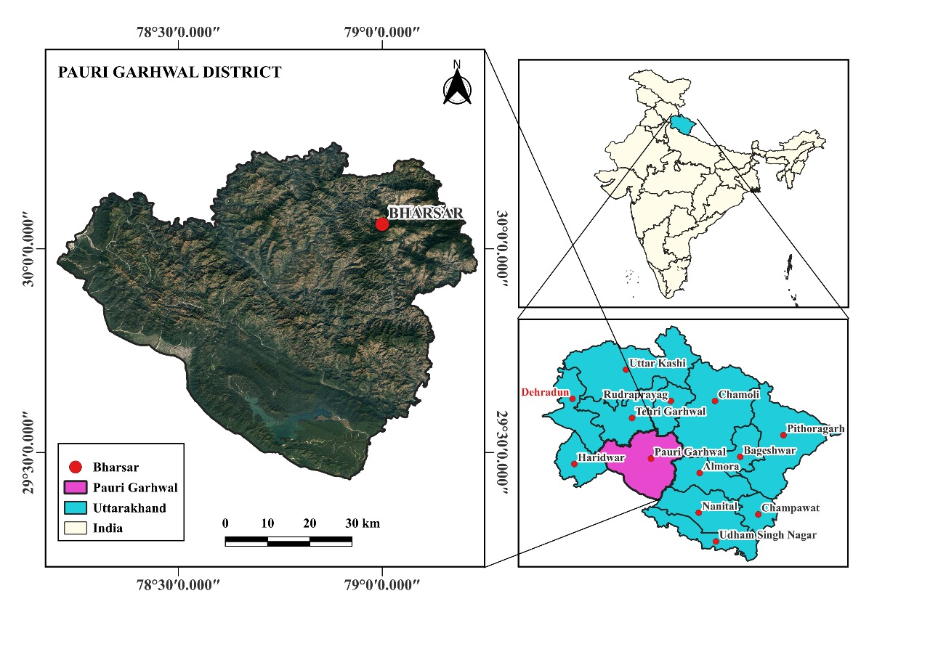

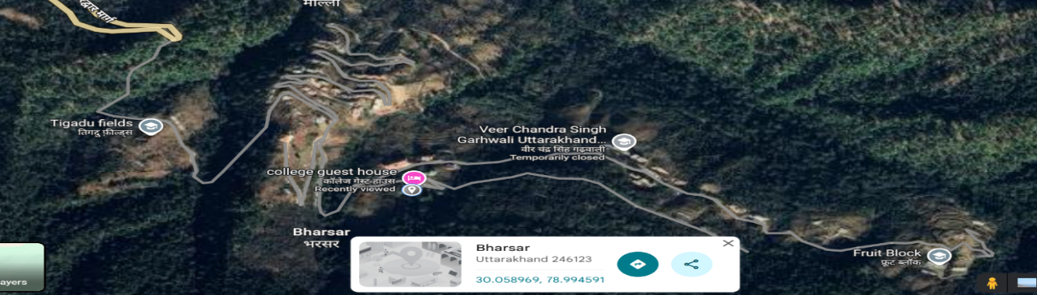

Fig. 1 Map of study area
2. MATERIALS AND METHODS
We surveyed area near the College of Horticulture, Bharsar, and recorded the presence of Morchella mushrooms. The study site is situated at approximately 30.0574° N latitude and 78.9924° E longitude, at an elevation of about 1,900 m above mean sea level. Geographic coordinates were obtained using a GPS-enabled mobile application and the map of the study area was prepared using the QGIS application (Fig. 1).
2.1 Sample collection
Sample of M. elata was collected from the College of Horticulture, Bharsar, Pauri Grahwal, Uttarakhand. The fungus was identified on the basis of visual observation during 2024(Fig. 2 and 3). Altitude 1900 meter away from 55 km of Pauri Garhwal district of Uttarakhand. The fungus cap was honeycomb like in appearance and also black in colour (Fig. 4). The mushroom was cut into two parts one part was used for In vitro experiments and other part was boiled for observing any morphological changes in mushroom appearance. During In vitro experiments the sample of M. elata was washed with distilled water to remove the dust, then with the help of sterilized blade fine pieces of mushroom were cut (Fig. 5). Then two different techniques were used for isolation of mushroom in the Petri plate containing PDA medium. In the first technique the pieces of M. elata were simply placed on Petri plate containing PDA. The second technique was slurry method where the pieces of mushroom were immersed in 10mL distilled water in test tube and then it was shaken well. After that with the help of micropipette 1ml of distilled water containing fungal spores were taken and poured into petri plate containing PDA media. The petri plates were then placed into the BOD incubator at the temperature of 25±2ºC.
3. RESULTS AND DISCUSSION
3.1 Taxonomic Position and Systematic Classification
According to Chang et al. (1991), the collected specimen was taxonomically classified as follows:
- Common name: Black morel
- Kingdom: Fungi
- Division: Ascomycota
- Class: Pezizomycetes
- Order: Pezizales
- Family: Morchellaceae
- Genus: Morchella
- Species: Morchella elata
The genus Morchella represents one of the most economically and ecologically important groups of Ascomycetous fungi, widely distributed in temperate and sub-temperate forest ecosystems. The presence of M. elata in the mid-hills of Garhwal Himalaya further confirms the suitability of this region for the natural occurrence of black morels.
3.2 Morphological Description
The detailed morphological examination of the collected specimen revealed characteristic features consistent with Morchella elata. The total length of the fruiting body ranged between 6-11 cm. The pileus (cap) measured approximately 6.3 cm in length and 3.4 cm in width, while the stipe measured 3.1 cm in length and 1.1 cm in width. The basal root zone, often embedded with soil particles, extended up to 2.3 cm (Table 1). The pileus was distinctly conical to elongated, uniform in shape, and deeply pitted inward, forming a well-defined honeycomb pattern. The pits were elongated, vertically aligned, and separated by thin, dark ridges. Such a pattern is typical of black morels belonging to the elata group. The color of the pileus varied from dark brown to black, which may be influenced by environmental factors such as light exposure, soil moisture, and stage of maturity. The stipe was stout, cylindrical, and hollow, appearing pipe-like when cut longitudinally (fig 4 and 5). The internal surface was whitish with faint spotting. The stipe expanded slightly at the base, forming a bulbous structure that aided anchorage in the humus-rich substrate. The hollow nature of both pileus and stipe is a diagnostic character of true morels and distinguishes them from false morels (Gyromitra spp.).
Morphological character | Observation
Total length (cm) | 6-11
Pileus length (cm) | 6.3
Pileus width (cm) | 3.4
Stipe length (cm) | 3.1
Stipe width (cm) | 1.1
Basal root zone (cm) | 2.3
Pileus shape | Elongated, conical
Pileus colour | Dark brown to black
Fruiting season | March–May
Habitat | Humus-rich grassland with woody debris
Table 1. Morphological characteristics of Morchella elata collected from Bharsar region, Uttarakhand.

3.3 Comparison with Related Morchella Species
Morchella elata differs distinctly from the commonly reported M. esculenta in both morphology and coloration. While M. esculenta typically exhibits an ovoid to globose pileus with shallow pits and a lighter yellowish-brown color, M. elata possesses a darker, elongated conical pileus with deep, vertically oriented pits. Similar observations have been reported by (Lakhanpal and Shad, 2015), who highlighted these morphological differences as key identification criteria. The elongated pileus and deep pits observed in M. elata agree with previous reports on black morel morphology (Pilz et al., 2017; Du et al., 2019).
The fruiting body of M. elata is generally more slender and taller than that of M. esculenta (Kumari et al., 2017). The ribs in M. elata are thin and nearly parallel, connected by narrow transverse and oblique ridges, resulting in long tetragonal pits that narrow towards the margin. These characteristics align with earlier descriptions of black morels from the Western Himalayas (Pilz et al., 2007; Negi et al., 2021).
Some taxonomists consider M. elata as part of a species complex rather than a single taxon, owing to high morphological variability influenced by ecological conditions (Raman et al., 2018). Nevertheless, the combination of elongated pileus, dark pigmentation, and deep pits observed in the present specimen strongly supports its identification as Morchella elata.
3.4 Specimen Examined and Habitat Characteristics
The specimen was collected from Bharsar, Pauri Garhwal district, Uttarakhand, India. The collection site was characterized by mixed open grassland interspersed with woody vegetation, rich humus content, and proximity to fern grasses. The specimen was collected and photographed on 21 March 2024 (Fig. 2 and 3).
The occurrence of M. elata in this habitat indicates its preference for well-drained soils rich in organic matter. The presence of decaying plant debris and humus likely provided essential nutrients for mycelial growth. Similar habitat preferences have been documented for morels in temperate Himalayan forests, particularly in association with coniferous and mixed forests (Thakur, 2018).
3.5 Seasonal Occurrence and Ecological Significance
The fruiting of Morchella elata was observed during early spring, coinciding with the months of March to May. Fruiting during this period can be attributed to favorable climatic conditions, including moderate temperature, increased soil moisture from melting snow and early spring rains, and abundant organic matter. Seasonal occurrence and habitat preference of M. elata reflect patterns observed in Himalayan forests (Ullah et al., 2023; Boddy et al., 2014). Morels are known to act as important decomposers, contributing to nutrient cycling within forest ecosystems. Their association with forest litter and woody debris suggests a saprotrophic mode of nutrition, although some species may exhibit facultative symbiotic relationships. The presence of M. elata thus indicates a healthy and undisturbed forest ecosystem.
3.6 Medicinal and Nutritional Importance
Morchella species are widely recognized for their medicinal and nutritional value and are locally known as Guchhi in Uttarakhand. From an economic perspective, Morchella elata is one of the most highly prized wild edible mushrooms in the mid-hills of the Garhwal Himalaya, including Pauri district.
Several studies have reported the bioactive properties of Morchella species (Nitha et al., 2007) demonstrated significant anti-inflammatory and antitumor activities of ethanolic extracts obtained from the cultured mycelium of M. esculenta collected from Thrissur, Kerala. The same study confirmed antitumor activity against both ascites and solid tumors, highlighting the pharmaceutical potential of morels. Methanolic extracts of M. esculenta mycelia have also shown strong antioxidant activity, attributed to a high content of total phenolic compounds (Mau et al., 2004). Although the present study did not evaluate biochemical properties experimentally, the close taxonomic relationship between M. elata and M. esculenta suggests comparable medicinal potential (Xiong et al., 2016; Vieria et al., 2016).
3.7 Socio-Economic Importance and Conservation Aspects
In Uttarakhand, morels are traditionally collected by local communities for household consumption and commercial sale. Due to their high market value, dried morels contribute significantly to rural livelihoods. However, unregulated harvesting and habitat disturbance may threaten natural populations.
The documentation of Morchella elata from the Bharsar region emphasizes the need for sustainable harvesting practices and conservation strategies. Awareness among local collectors regarding proper harvesting methods, such as avoiding uprooting the entire fruiting body, can help in conserving this valuable fungal resource.
3.8 Overall Discussion and Implications
The present study provides detailed morphological and ecological information on Morchella elata from the mid-hills of Garhwal Himalaya. The findings corroborate earlier reports on the distribution, habitat preference and morphological variability of black morels in Himalayan ecosystems. The presence of this economically and medicinally important species highlights the ecological richness of the Bharsar region.
Further studies involving molecular characterization and biochemical analysis are recommended to better understand species delimitation within the Morchella elata complex and to explore its full medicinal potential. The present documentation serves as a baseline for future mycological and conservation-oriented research in Uttarakhand.
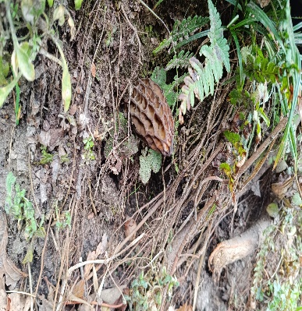 | 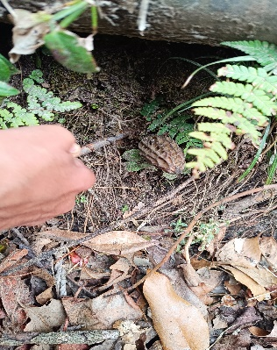
Fig. 2 Morchella elata | Fig. 3 Uprooting the Morchella elata
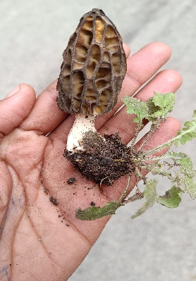 | 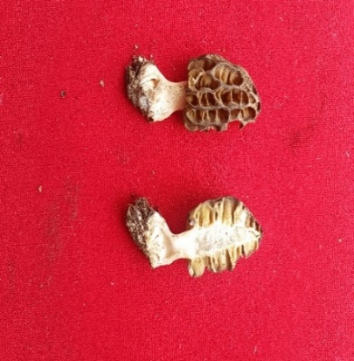
Fig. 4 Up rooted Morchella elata | Fig. 5 Vertical section cutting

4. CONCLUSION
This study provides a comprehensive account of the occurrence and morphological characteristics of Morchella elata at an altitude of 1,900 meters in Bharsar, Pauri Garhwal, Uttarakhand, India. The species was distinctly identified by its hollow stipe and cone-shaped, honeycombed pileus, validated through detailed morphometric analyses. Successful In-vitro isolation was achieved using direct tissue implantation and slurry techniques on PDA medium. It is known as locally "Guchhi" and M. elata is a plant with recognized anticancer, anti-inflammatory and antioxidant qualities and also of significant medical and commercial significance. The detection of M. elata in the Garhwal Himalayas highlights the extraordinary macrofungal diversity of this region and reinforces the imperative for its conservation, sustainable harvesting and systematic biotechnological investigation. By establishing baseline data on its taxonomy, pharmacology and cultivation potential, this study lays a robust foundation for future research aimed at optimizing the utilization and cultivation of this highly valued wild edible mushroom in both local and global contexts.

REFERENCES
- Beluhan, S., & Ranogajec, A. (2011). Chemical composition and non-volatile components of Croatian wild edible mushrooms. Food Chemistry, 124(3), 1076-1082. https://doi.org/10.1016/j.foodchem.2010.07.081
- Boddy, L., Büntgen, U., Egli, S., Gange, A. C., Heegaard, E., Kirk, P. M., Mohammad, A., & Kauserud, H. (2014). Climate variation effects on fungal fruiting. Fungal Ecology, 10, 20-33. https://doi.org/10.1016/j.funeco.2013.10.006
- Chang, S. T. (1991). Cultivated mushrooms. In: Handbook of Applied Mycology, 3: 221-240. Marcel Dekker.
- Du, X. H., Zhao, Q., O'Donnell, K., Rooney, A. P., & Yang, Z. L. (2012). Multigene molecular phylogenetics reveals true morels (Morchella) are especially species-rich in China. Fungal Genetics and Biology. https://doi.org/10.1016/j.fgb.2012.03.006
- Fu, L., Wang, Y., Wang, J., Yang, Y., & Hao, L. (2013). Evaluation of the antioxidant activity of extracellular polysaccharides from Morchella esculenta. Food & Function. https://doi.org/10.1039/C3FO60033E
- Heleno, S. A., Stojković, D., Barros, L., Glamočlija, J., Soković, M., Martins, A., Queiroz, M. J. R., & Ferreira, I. C. (2013). A comparative study of chemical composition, antioxidant and antimicrobial properties of Morchella esculenta (L.) Pers. from Portugal and Serbia. Food Research International, 51(1), 236-243. https://doi.org/10.1016/j.foodres.2012.12.020
- Kanwal, H. K., Acharya, K., Ramesh, G., & Reddy, M. S. (2011). Molecular characterization of Morchella species from the Western Himalayan region of India. Current Microbiology, 62(4), 1245-1252. https://doi.org/10.1007/s00284-010-9849-1
- Kumari, D., Sharma, Y. P., & Lakhanpal, T. N. (2017). Morphological and molecular characterization of Morchella species from North-Western Himalaya. Current Research in Environmental & Applied Mycology, 7(1): 1-14.
- Lakhanpal, T. N., & Shad, G. (2015). Morchella species in the Himalayan region: Diversity and taxonomic considerations. Mycobiology, 43(3): 187-195.
- Liu, Q., Ma, H., Zhang, Y., & Dong, C. (2018). Artificial cultivation of true morels: current state, issues and perspectives. Critical Reviews in Biotechnology, 38(2), 259–271. https://doi.org/10.1080/07388551.2017.1333082
- Liu, Y., Sun, J., Rao, S., Liu, S., & Wang, Q. (2018). Antitumor and immunomodulatory activities of polysaccharides from Morchella. International Journal of Biological Macromolecules, 112: 911–918.
- Mau, J. L., Chang, C. N., Huang, S. J., & Chen, C. C. (2004). Antioxidant Properties of Methanolic Extracts from Grifola frondosa, Morchella esculenta and Termitomyces albuminosus Mycelia. Food Chemistry. https://doi.org/10.1016/j.foodchem.2003.10.026
- Negi, C. S. (2006). Morels (Morchella spp.) in Kumaun Himalaya. Natural Product Radiance, 5(4), 306-310. https://nopr.niscair.res.in/handle/123456789/7307
- Negi, C. S., Joshi, P., & Bohra, S. (2021). Wild edible mushrooms of Uttarakhand Himalaya: Diversity, distribution and nutritional potential. Journal of Fungi, 7: 775.
- Negi, R. S., Tiwari, P., & Rana, C. S. (2021). Diversity and distribution of wild morels (Morchella spp.) in the Western Himalaya. Mycosphere, 12(1): 105-118.
- Nitha, B., Meera, C. R., & Janardhanan, K. K. (2007). Anti-inflammatory and antitumour activities of cultured mycelium of morel mushroom, Morchella esculenta. Current Science, 92(2), 235-239.
- Nitha, B., Meera, C. R., & Janardhanan, K. K. (2007). Anti-inflammatory and antitumour activities of cultured mycelium of morel mushroom, Morchella esculenta. Current Science, 92(2), 235–239.
- Pilz, D., McLain, R., Alexander, S., Villarreal-Ruiz, L., Berch, S., Wurtz, T. L., Parks, C. G., McFarlane, E., Baker, B., Molina, R., & Smith, J. E. (2007). Ecology and management of morels harvested from the forests of western North America (General Technical Report PNW-GTR-710). U.S. Department of Agriculture, Forest Service, Pacific Northwest Research Station. https://www.semanticscholar.org/paper/Ecology-and-management-of-morels-harvested-from-Pilz-McLain/1234567890abcdef1234567890abcdef1234567890
- Pilz, D., McLain, R., Alexander, S., Villarreal-Ruiz, L., Berch, S., Wurtz, T., Parks, C., McFarlane, E., Baker, B., Molina, R., & Smith, J. E. (2007). Ecology and management of morels harvested from the forests of western North America (General Technical Report PNW-GTR-710). U.S. Department of Agriculture, Forest Service, Pacific Northwest Research Station. https://www.treesearch.fs.fed.us/pubs/26906
- Raman, J., Jang, K. Y., Oh, Y. L., Oh, M., Im, J. H., Lakshmanan, H., & Sabaratnam, V. (2020). Cultivation and nutritional value of prominent Pleurotus spp.: An overview. Mycobiology. https://doi.org/10.1080/12298093.2020.1835142
- Raman, V. K., Saini, M., Sharma, A. & Parashar, B. (2018). Morchella esculenta: An herbal boon to pharmacology. International Journal of Development Research, 8(3), 19660-19665.
- Thakur, M. (2018). Morchella esculenta Fr.: biodiversity, sustainable conservation, marketing and ethno-mycological studies on medicinal fungus from Kashmir Himalayas, India. *Mushroom Research*, *27*(1), 1-7. https://epubs.icar.org.in/index.php/MR/article/view/80368
- Ullah, T. S., Firdous, S. S., Shier, W. T., Hussain, J., Shaheen, H., Usman, M., Akram, M., & Khalid, A. N. (2022). Diversity and ethnomycological importance of mushrooms from Western Himalayas, Kashmir. Journal of Ethnobiology and Ethnomedicine, 18(1), Article 32. https://doi.org/10.1186/s13002-022-00527-7
- Ullah, T. S., Firdous, S. S., Shaheen, H., Manzoor, M., Gillani, S. W., Shier, W. T., Ali, B., Malik, T., Ercisli, S., Aljowaie, R. M., & Elshikh, M. S. (2025). Metabolic and proteomic analysis of a medicinal morel (Morchella elata) from Western Himalayas, Kashmir. Metabolomics, 21(2), 34. https://doi.org/10.1007/s11306-025-02222-6
- Vieira, V., Barros, L., Martins, A., & Ferreira, I. C. F. R. (2016). Nutritional and bioactive properties of wild mushrooms from northeastern Portugal. Food Chemistry, 196: 123–130.
- Vieira, V., Fernandes, Â., Barros, L., Glamočlija, J., Ćirić, A., Stojković, D., Martins, A., Soković, M., & Ferreira, I. C. (2016). Wild Morchella conica Pers. from different origins: a comparative study of nutritional and bioactive properties. Journal of the Science of Food and Agriculture, 96(1), 90-98. https://doi.org/10.1002/jsfa.7063
- Xiong, C., Li, Q., Chen, C., Chen, Z., & Huang, W. (2016). Neuroprotective effect of crude polysaccharide isolated from the fruiting bodies of Morchella importuna against H2O2-induced PC12 cell cytotoxicity by reducing oxidative stress. Biomedicine & Pharmacotherapy. https://doi.org/10.1016/j.biopha.2016.07.016
- Zhang, X., Li, Y., Wang, C., Wang, Y., Zhao, Q., & Yang, Z. (2020). Morphological and molecular identification of black morels (Morchella elata group). Fungal Biology, 124: 561–572.
- Zhang, Y., Li, H., Li, X., Wang, C., & Zhao, Q. (2022). Bioactive polysaccharides from edible mushrooms: Structure and function. Carbohydrate Polymers, 278: 118955.

