Comparative Efficacy of Persea americana, Azadirachta indica Extracts and Synthetic antifungals Against Candida Species.

Abstract
There is an urgent need for new therapeutic options due to the rising incidence of antifungal resistance, especially among Candida species. Although medicinal plants such as Azadirachta indica (neem) and Persea americana (avocado) have long been used to treat infections, a thorough assessment of their relative effectiveness against modern clinical fungal isolates is necessary. Clinical Candida isolates were characterized using phenotypic and molecular techniques. Their susceptibility to fluconazole, ketoconazole, and amphotericin B was determined by agar well diffusion. Methanolic leaf extracts of P. americana and A. indica were prepared, and their phytochemical constituents identified using Gas Chromatography-Mass Spectrometry (GC-MS). The antifungal activity of the extracts was evaluated and compared to the conventional drugs using agar well diffusion and agar dilution methods to determine the Minimum Inhibitory Concentration (MIC) and Minimum Fungicidal Concentration (MFC). Molecular identification confirmed the isolates as Candida albicans, C. parapsilosis, and C. tropicalis. All isolates (100%) were resistant to fluconazole, while varying resistance pattern was observed for ketoconazole (44.4%) and amphotericin B (44.4%). GC-MS analysis revealed diverse bioactive compounds in both extracts, including fatty acids, terpenoids, and phenolics. P. americana extract showed broad-spectrum activity, inhibiting all isolates at 100 mg/ml, including those resistant to all synthetic drugs, with an MIC of 20 mg/ml and an MFC of 20-30 mg/ml. In contrast, A. indica extract showed minimal activity in diffusion assays, although it shared a similar MIC (20 mg/ml), and MFC (30 mg/ml) when subjected to dilution assays.
This study confirms high rates of antifungal resistance among clinical Candida isolates, with both plant extracts demonstrating inhibitory potential. Persea americana leaf extract showed better efficacy, comparable to amphotericin B and fluconazole. These findings validate its ethnomedicinal use and strongly advocate for its further development as a promising source of novel antifungal agents against drug-resistant candidiasis.

Introduction
Nigeria is rich in diverse medicinal plants that synthesize bioactive compounds with antimicrobial properties, offering alternatives to synthetic drugs confronted by rising costs, toxicity, and variable efficacy (Muhammadi et al., 2018; Gupta et al., 2016). Plant-derived extracts, particularly those rich in phenolic compounds and secondary metabolites, demonstrate significant antimicrobial activity and are increasingly studied for their safety and environmental compatibility (Bolouri et al., 2022; Chen et al., 2019; Proestos, 2020).
Persea americana (Avocado) and Azadirachta indica (neem) are prominent examples of plants whose leaves are traditionally used for treating infections. Persea americana exhibit antibacterial effects attributed to secondary metabolites like terpenoids (Ajayi et al., 2017). Similarly, Azadirachta indica contains bioactive compounds such as azadirachtin, recognized for antimicrobial, antifungal, and anti-inflammatory properties (Alzohairy, 2016; Saleem et al., 2018).
Fungal infections, particularly by Candida species, pose global health challenges due to rising antifungal resistance. Candida albicans and non-albicans species (e.g., C. glabrata, C. auris) account for severe infections, with mortality rates up to 50% in invasive cases (Du et al., 2020; Burduniuc, 2021; Perlin et al., 2017). Current antifungal therapies are limited by resistance, necessitating novel solutions (Pfaller et al., 2021). A major limitation of synthetic antifungal drugs is their declining efficacy due to the emergence of drug-resistant fungal strains. Resistance to antifungal medications has been increasing steadily over the years, especially in hospital and immunocompromised patient settings (Gupta, 2016). Fluconazole, an azole commonly used to treat Candida infections, is increasingly ineffective due to the development of resistance, particularly in Candida glabrata, Candida krusei, and Candida auris (WHO, 2021). Azole resistance in Candida species occurs due to mutations in genes that encode for the enzyme lanosterol demethylase, which is the target for azole drugs (Kohlert et al., 2017). Similarly, other classes of synthetic antifungal agents, including amphotericin B and echinocandins, have shown decreased effectiveness against resistant fungal strains (Vaou et al., 2021).
Another critical limitation of synthetic antifungal drugs is their toxicity and adverse side effects (Konnoth, 2019). While antifungal drugs are essential for treating severe fungal infections, many of these drugs come with a range of potential side effects that can be detrimental to patient health. For instance, azoles such as fluconazole and ketoconazole are associated with liver toxicity, gastrointestinal disturbances, and adverse effects on endocrine function (Gupta, 2016). Ketoconazole has been linked to hepatotoxicity, and its use is often limited due to these severe side effects (Kohli, 2020). Polyenes, including amphotericin B, are known for their nephrotoxicity, which can lead to kidney damage, electrolyte imbalances, and renal failure (Vaou et al., 2021).
Emergence and spread of resistance, particularly in multidrug-resistant Candida species as well as toxicity and other adverse effects exhibited by most of the currently employed synthetic antifungal agents gave room for plant-based alternatives. This study evaluates the antifungal potential of methanolic extracts of P. americana and A. indica leaves against clinical candida species.
Methods
Study Area
The study was was carried out in Awka metropolis, Anambra state, Southeast Nigeria. Awka is located at latitude 8.2069°N and longitude 7.0678°E (Figure 1) and has a population of 361,657 (Nigeria Population Commission, 2006). Awka is noted for her iron craft and wood carving although becoming the capital of Anambra State in 2001 brought about the influx of civil servants to the town.

Figure 1: Map of Awka metropolis

Fungal Isolates and Identification.
Nine clinical Candida isolates were obtained from a research repository. Phenotypic confirmation involved subculture on CHROMagar-Candida, observation of culture characteristics, and microscopic examination (Saud et al., 2020). Gram staining was performed using standard methods (Cheesbrough, 2010), and a germ tube test was conducted. For molecular identification, genomic DNA was extracted using a Zymo Research Fungal/Bacterial DNA Miniprep kit. The Internal Transcribed Spacer (ITS) region was amplified via PCR and sequenced. Sequences were analyzed using BioEdit and MEGA X software.
Plant Material and Extraction.
Fresh leaves of Persea americana (avocado) and Azadirachta indica (neem) were collected, authenticated, washed, and shade-dried. Dried leaves were pulverized, and 50 g of each powder was subjected to cold maceration with 500 mL of methanol for 72 hours. The filtrate was concentrated by surface evaporation technique to obtain the crude methanolic extract.
Phytochemical Analysis.
The bioactive constituents of the crude extracts were identified using Gas Chromatography-Mass Spectrometry (GC-MS).
Antifungal Susceptibility Testing.
Conventional Drugs: The susceptibility of isolates to fluconazole, ketoconazole, and amphotericin B was determined using the agar well diffusion method (Balouiri et al., 2016; CLSI, 2020). Zones of inhibition were measured after 24-hour incubation at 37°C.
Plant Extracts: The antifungal activity of the plant extracts was evaluated using the agar well diffusion method previously described by Ezeadila et al. (2025) at concentrations of 100, 50, 25, 12.5, and 6.25 mg/mL
Determination of MIC and MFC. The Minimum Inhibitory Concentration (MIC) and Minimum Fungicidal Concentration (MFC) of the plant extracts and conventional drugs were determined using the agar dilution method (CLSI, 2024; Mota et al., 2009). The MIC was defined as the lowest concentration showing no visible growth. For MFC determination, subcultures from plates showing no growth were made onto drug-free agar; the MFC was the lowest concentration yielding no growth upon subculture (Murugesh et al., 2019).
Statistical Analysis. Inhibition zone diameters were analyzed using one-way Analysis of Variance (ANOVA) with Tukey's post-hoc test (p < 0.05). Analyses were performed using SPSS version 26
Results and Discussion
Characterization of Candida Isolates
Phenotypic identification of the nine clinical Candida isolates suggested a predominance of C. albicans (5/9), with others identified as C. glabrata (2/9) and C. guilliermondii (1/9) based on germ tube tests and chromogenic agar profiles (Table 1).
However, molecular analysis of the Internal Transcribed Spacer (ITS) region provided definitive speciation, confirming the isolates as C. albicans, C. parapsilosis, and C. tropicalis (Table 2). This discrepancy highlights the limitations of phenotypic methods, which can misclassify closely related species due to overlapping biochemical profiles, a finding consistent with previous reports (Coignard et al., 2004). Accurate identification is crucial for guiding appropriate therapy, reinforcing the need for molecular confirmation in clinical settings.
Antifungal Susceptibility of Clinical Isolates
A high level of resistance to conventional antifungals was observed (Table 3). All nine isolates (100%) were resistant to fluconazole across all tested concentrations (100–0.04 µg/mL). This alarming rate of azole resistance reflects a concerning global and regional trend (Osaigbovo et al., 2024; Hussen et al., 2024) hence queries the continued use of fluconazole as first-line therapy. Susceptibility to ketoconazole and amphotericin B was varied. While ketoconazole inhibited five isolates, four were fully resistant. Similarly, amphotericin B was effective against only three isolates, with six showing complete resistance, indicating emerging resistance to this polyene drug as noted elsewhere (Ezeadila et al., 2020).
Bioactive Compounds in Plant Extracts
GC-MS analysis revealed distinct phytochemical profiles for the two plant extracts. The methanolic extract of A. indica (neem) was rich in limonoids and phenolics, with nimbin (18%), oleic acid (10%), and 2,4-di-tert-butylphenol (9%) as major constituents (Fig. 2). Also, the P. americana (avocado) extract was characterized by a high concentration of fatty acid esters, including hexadecanoic acid ethyl ester (5.5%) and linoleic acid ethyl ester (4.8%), alongside terpenoids like bisabolene (Fig. 3). These compounds are associated with diverse biological activities, including antimicrobial effects (Akoh et al., 2021; Mahmoud et al., 2021), providing a chemical basis for the observed antifungal activity.
Antifungal Activity of Plant Extracts
The agar well diffusion assay demonstrated different activities between the two extracts. P. americana extract exhibited broad-spectrum activity, with zones ranging from 11.5 to 30.5 mm at 100 mg/mL (Table 4). Essentially, it inhibited isolates resistant to all three synthetic drugs. In contrast, A. indica extract showed negligible activity in this assay, producing a single inhibition zone against isolate 57M at 100 mg/mL (Table 5). This disparity may be attributed to the poor diffusibility of neem's hydrophobic constituents (e.g., nimbin) through the aqueous agar matrix, a known limitation of the well diffusion method (Balouiri et al., 2016).
MIC and MFC of Plant Extracts
The agar dilution method, which circumvents diffusion limitations, revealed both extracts possessed intrinsic antifungal activity with a uniform MIC of 20 mg/mL against all isolates (Tables 6 & 8). However, a key difference emerged in their fungicidal potential. The MFC for P. americana ranged from 20-30 mg/mL (Table 7), indicating fungicidal action close to its MIC. For A. indica, the MFC was consistently higher at 30 mg/mL (Table 9), suggesting a more fungistatic profile. This confirms that while both extracts can inhibit growth, P. americana has a superior fungicidal potential with respect to Candida cells, a highly desirable trait for an antifungal agent.
MIC and MFC of Conventional Drugs
The agar dilution results for conventional drugs aligned with the diffusion data, confirming the resistance patterns (Tables 10, 12). Ketoconazole showed a primarily fungistatic effect, with MFCs >5 µg/mL for most susceptible isolates (Table 11). Amphotericin B, where effective, demonstrated fungicidal activity with MFCs equal to its MICs (Table 13), but 44% of isolates were fully resistant.
Comparative Antifungal Efficacy
A direct comparison of inhibition zones at standard test concentrations highlighted the therapeutic potential of P. americana (Fig. 4). Its crude extract outperformed fluconazole completely and showed comparable or broader activity than ketoconazole and amphotericin B against this resistant panel. Most importantly, it was active against isolates resistant to all three conventional drugs, demonstrating its value as a source of novel antifungal agents.
Discussion
The study confirms the critical role of molecular identification in correcting phenotypic misidentification of Candida species, which can directly impact treatment decisions. The high prevalence of multi-drug resistance, particularly to fluconazole, presents a serious public health challenge and the urgent need for alternative therapeutic strategies.
The superior performance of P. americana over A. indica in both diffusion and dilution assays positions it as a more promising candidate. The activity of the crude avocado extract against resistant clinical isolates is particularly significant. Its efficacy is likely due to a synergistic blend of membrane-disrupting fatty acid esters and other bioactive terpenoids (Mahmoud et al., 2021). The discrepancy between the strong MIC/MFC results and weak diffusion activity for neem is methodological, highlighting that its hydrophobic active principles (like nimbin) are potent but poorly diffusible in standard agar well assays.
Conclusion
In conclusion, while both plants have potentials, P. americana leaf extract demonstrates consistent, broad-spectrum, and fungicidal activity against multi-drug resistant Candida isolates. This provides a strong scientific basis for its ethnomedicinal use and justifies focused future research, including bioassay-guided fractionation to isolate and characterize its active principles for potential development into a standardized phytomedicine.

Tabe 1: Morphological, Biochemical Characteristics and molecular identity of Candida Isolates
Isolate code | Appearance on CLED Agar | Glucose | Maltose | Sucrose | Lactose | Fructose | Mannitol | Galactose | Arabinose | Mannose | Germ tube | Growth on Sabouraud’s Dextrose Agar (SDA) | Growth on ChromaticCandida Agar (CCA)/Isolate | Molecular Identification of Candida Isolate
100F | Small whitish and moist colonies | A+G | A | A+G | - | A+G | - | - | - | A+G | + | Moderately large, milkfish and moist | Light green colonies of C albicans | Candida parapsilosis
149F | Small whitish and moist | A | - | - | - | A | - | - | - | A+G | - | Moderately large, milkfish and moist | Light pink-coloured colonies of C guilliermondii | Candida albicans
103FB | Small whitish and moist | A | A | A | - | - | - | - | - | A | - | Moderately large, milkfish and moist | Whitish colony with metallic blue reverse | Candida albicans
103FC | Small whitish and moist | A+G | - | A | - | A | - | - | - | A+G | - | Moderately large, milkfish and moist | Cream coloured colonies of C glabrata | Candida tropicalis
57M | Small whitish and moist | A | A | A | - | A+G | - | - | A | A | - | Moderately large, milkfish and moist | Cream coloured colonies of C glabrata | Candida albicans
28F | Small whitish and moist | A+G | - | A+G | - | A+G | - | - | - | A+G | + | Moderately large, milkfish and moist | Light green colonies of C albicans | N/A
81F | Small whitish and moist | A+G | - | A+G | - | A+G | - | - | - | A+G | + | Moderately large, milkfish and moist | Light green colonies of C albicans | N/A
152M | Small whitish and moist | A+G | A | A+G | - | A+G | - | - | - | A+G | + | Moderately large, milkfish and moist | Light green colonies of C albicans | N/A
381M | Small whitish and moist | A+G | - | A+G | - | A+G | - | - | - | A+G | + | Moderately large, milkfish and moist | Light green colonies of C albicans | N/A

KEY: CLED = Cystine Lactose Electrolyte Deficient, A+G = Acid + gas, A = Acid, -= Negative, N/A = Not Applicable

Table 2. Molecular identification of selected isolates
Isolate Id | Molecular Identity | Pairwise Similarity (%) | NCBI accession Number
57M | Candida albicans | 97.93% | KP675468.1
100F | Candida parapsilosis | 99.18% | KP674488.1
103FC | Candida tropicalis | 98.78% | MW845752.1

Table 3: Susceptibility Pattern of Candida isolates to Fluconazole, Ketoconazole and Amphotericin B
 |  |  |  |  | Concentrations used (µg/ml
 |  |  |  | FLU |  |  |  |  |  | KET |  |  |  |  |  |  |  | AMB
S/N | ID No | Isolate | 100 | 50 | 25 | 12.5 | 6.25 | 3.125 |  | 1.56 | 0.78 | 0.39 | 0.195 | 0.097 | 0.048 |  | 12.5 | 6.25 | 3.12 | 1.56 | 0.781 | 0.39
1 | 28F | Candida albicans | R | R | R | R | R | R |  | 19 | 20 | 20 | 21 | 21 | 19 |  | 27 | 24 | 22 | 20 | 20 | 19
2 | 57M | Candida albicans | R | R | R | R | R | R |  | 18 | 16 | 16 | 14 | 12 | 11 |  | 30 | 28 | 29 | 27 | 26 | 24
3 | 81F | Candida albicans | R | R | R | R | R | R |  | R | R | R | R | R | R |  | 26 | 24 | 20 | 20 | 17 | 21
4 | 100F | Candida parapsilosis | R | R | R | R | R | R |  | 24 | 18 | 16 | 17 | 16 | 15 |  | R | R | R | R | R | R
5 | 103FB | Candida albicans | R | R | R | R | R | R |  | R | R | R | R | R | R |  | 37 | 33 | 35 | 35 | 36 | 35
6 | 103FC | Candida tropicalis | R | R | R | R | R | R |  | 44 | 40 | 40 | 41 | 40 | 24 |  | 30 | 28 | 26 | 30 | 26 | 24
7 | 149F | Candida albicans | R | R | R | R | R | R |  | 15 | 14 | 15 | 15 | 14 | 15 |  | R | R | R | R | R | R
8 | 152M | Candida albicans | R | R | R | R | R | R |  | R | R | R | R | R | R |  | R | R | R | R | R | R
9 | 381M | Candida albicans | R | R | R | R | R | R |  | R | R | R | R | R | R |  | R | R | R | R | R | R

KEY: FLU = Fluconazole, KET = Ketoconazole, AMB = Amphotericin B; R = Resistance. Zone of inhibition captured in millimeter.
µg/ml = microgram per millimeter.

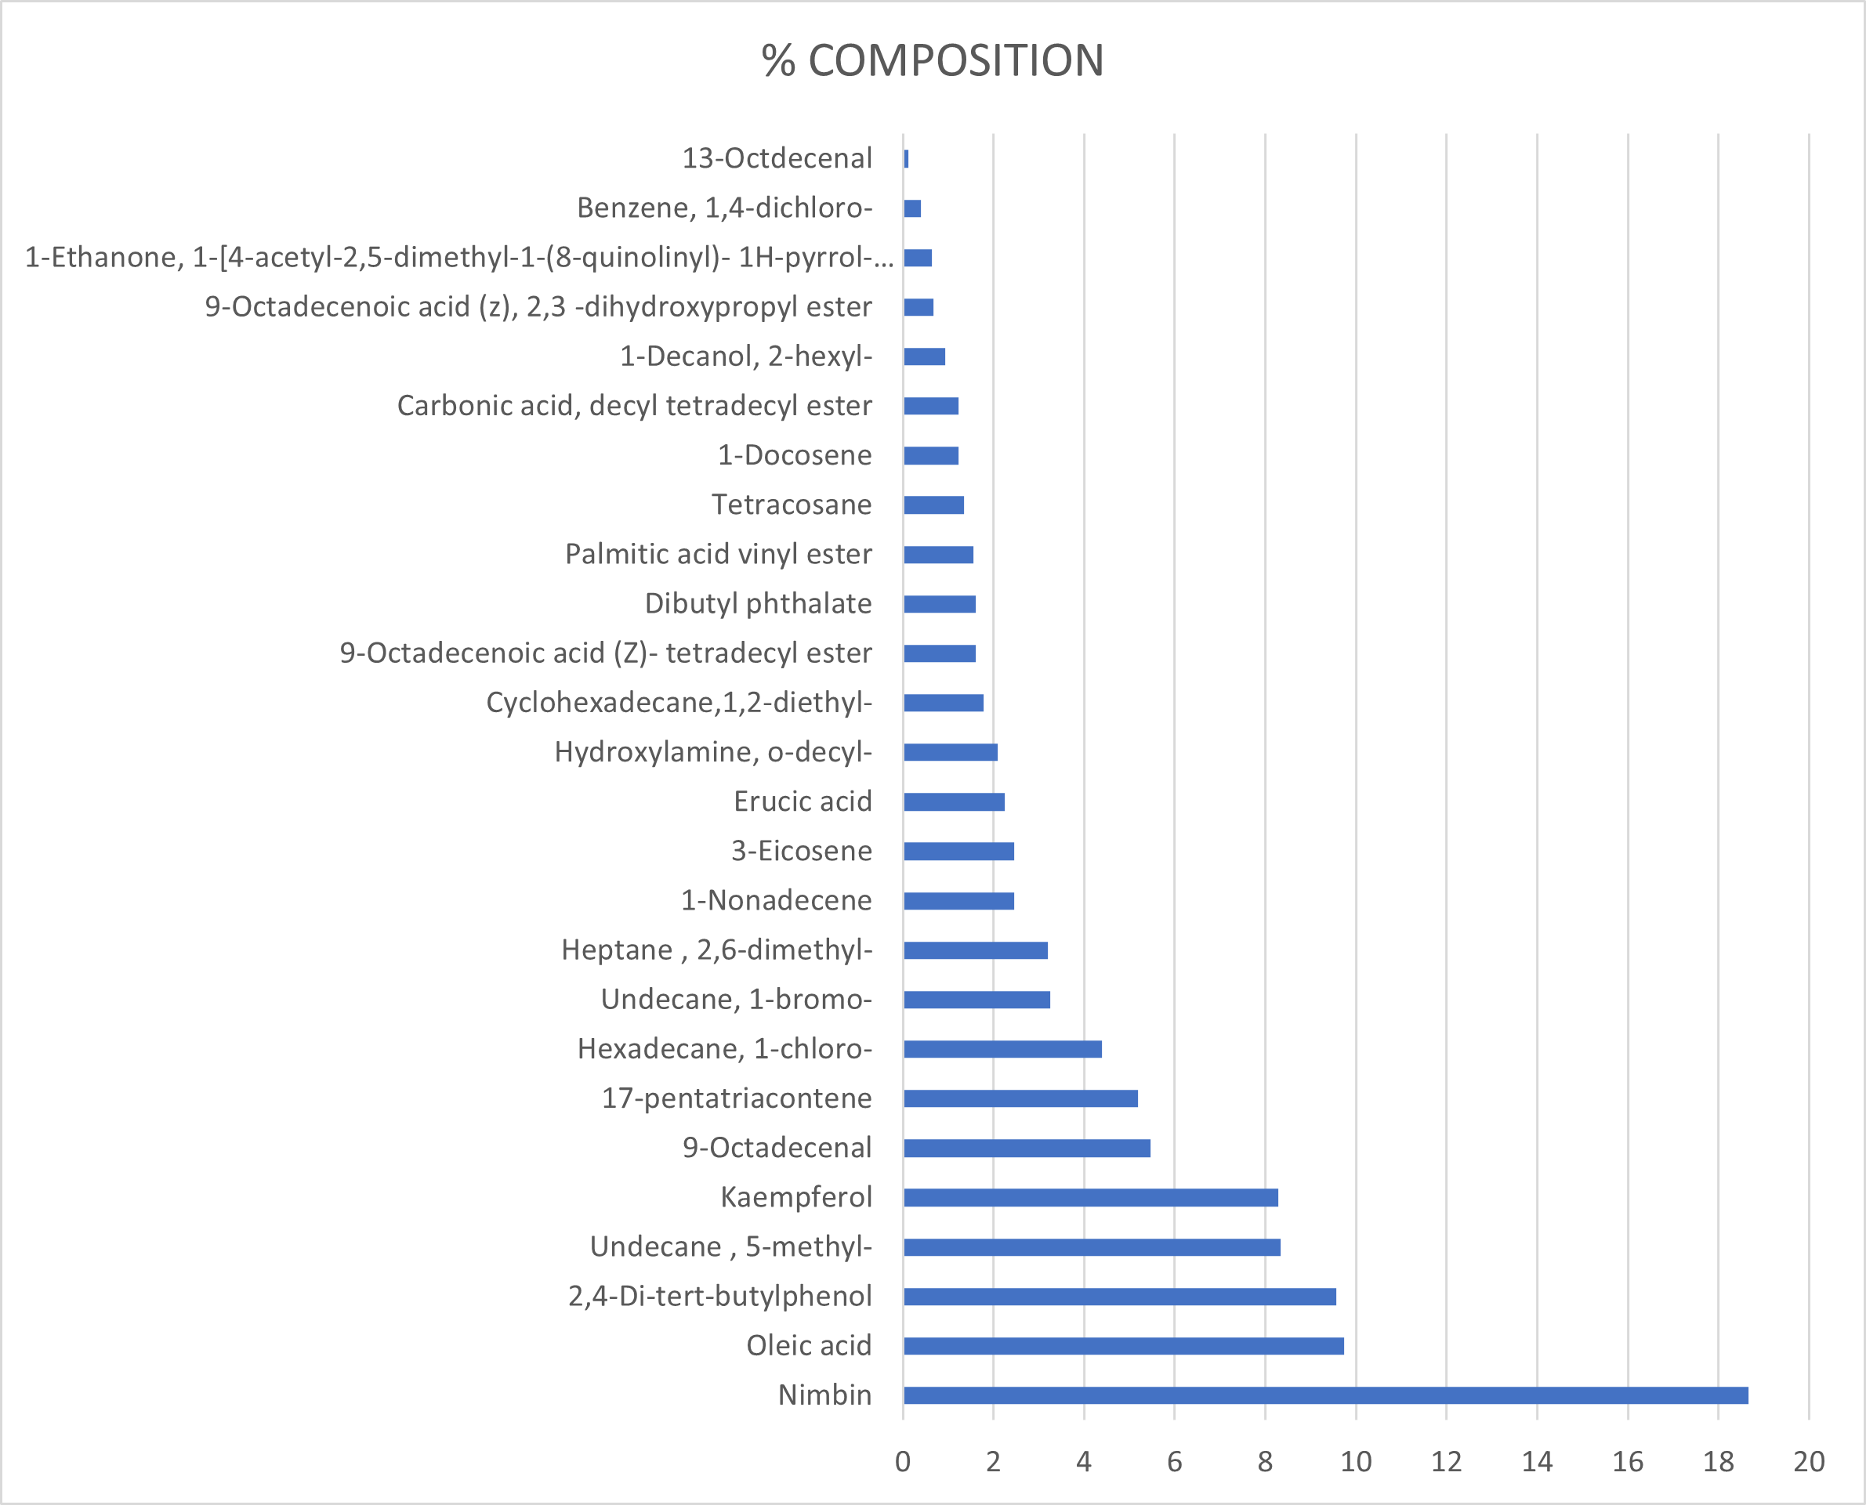

Fig. 2 Bioactive compound Composition (%) of Neem Plant (I. Indica)

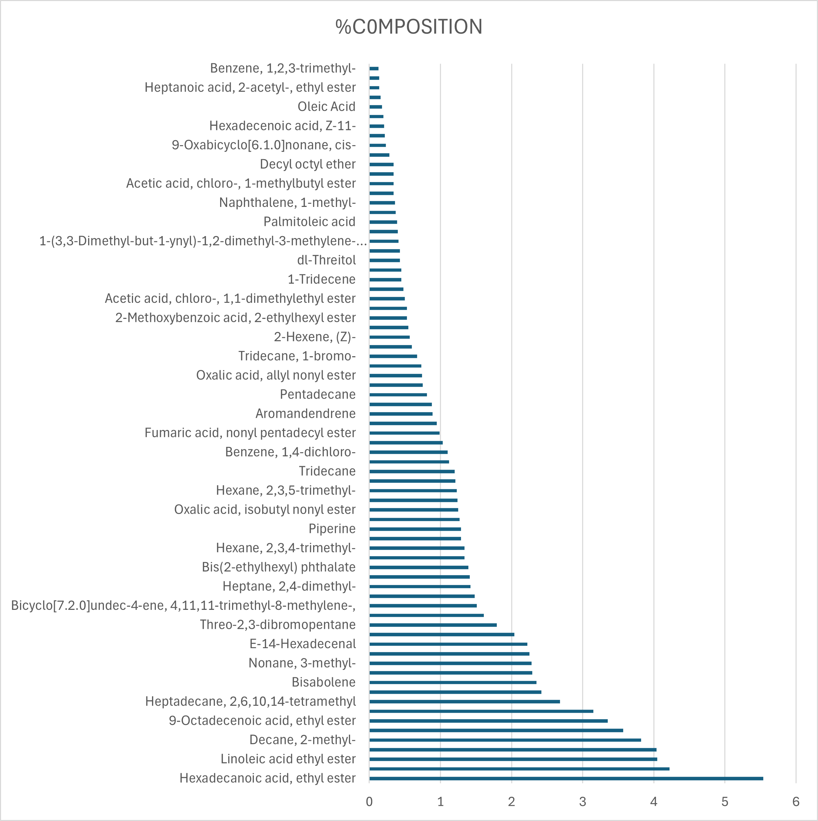

Fig. 3. Bioactive compound Composition (%) of Avacado Plant (P. americana)

Table 4: Inhibition zone diameter of P. americana against Candida Isolates
 |  | Concentration
ISOLATE | 100 mg/ml | 50 mg/ml | 25 mg/ml | 12.5 mg/ml | 6.25 mg/ml | DMSO
28f | 24.00±1.41ª | 16.00±1.41^{b} | 0.00±0^{c} | 0.00±0^{c} | 0.00±0^{c} | 0.00±0^{c}
57M | 27.50±3.54 ª | 20.00±0 ª | 19.50±2.12ª | 0.00±0 ^{b} | 0.00±0 ^{b} | 0.00±0 ^{b}
81F | 11.50±2.12 ª | 0.00±0^{b} | 0.00±0 ^{b} | 0.00±0 ^{b} | 0.00±0 ^{b} | 0.00±0 ^{b}
100F | 20.50±0.71 ª | 11.50±2.12^{b} | 0.00±0^{c} | 0.00±0^{c} | 0.00±0 ^{c} | 0.00±0 ^{c}
103FC | 30.50±0.71 ª | 0.00±0 ^{b} | 0.00±0^{b} | 0.00±0 ^{b} | 0.00±0 ^{b} | 0.00±0 ^{b}
103FB | 23.50±2.12 ª | 0.00±0 ^{b} | 0.00±0 ^{b} | 0.00±0 ^{b} | 0.00±0 ^{b} | 0.00±0 ^{b}
149F | 25.50±3.54 ª | 21.50±2.12ª | 0.00±0 ^{b} | 0.00±0 ^{b} | 0.00±0 ^{b} | 0.00±0 ^{b}
152M | 21.50±2.12 ª | 15.50±2.12ª | 0.00±0 ^{b} | 0.00±0 ^{b} | 0.00±0 ^{b} | 0.00±0 ^{b}
381M | 16.00±1.41 ª | 14.50±0.71ª | 0.00±0 ^{b} | 0.00±0 ^{b} | 0.00±0 ^{b} | 0.00±0 ^{b}

Values in the same row and subtable not sharing the same subscript are significantly different at p< 0.05 in the two-sided test of equality for column means.

Table 5: Inhibition zone diameter of Azadirachta indica against Candida Isolates
 |  | Concentration
ISOLATE | 100 mg/ml | 50 mg/ml | 25 mg/ml | 12.5 mg/ml | 6.25 mg/ml | DMSO
28F | 0.00±0.00ª | 0.00±0.00a | 0.00±0.00a | 0.00±0.00a | 0.00±0.00a | 0.00±0.00a
57M | 15.00±0.00ª | 0.00±0.00a | 0.00±0.00a | 0.00±0.00a | 0.00±0.00a | 0.00±0.00a
81F | 0.00±0.00ª | 0.00±0.00a | 0.00±0.00a | 0.00±0.00a | 0.00±0.00a | 0.00±0.00a
100F | 0.00±0.00ª | 0.00±0.00a | 0.00±0.00a | 0.00±0.00a | 0.00±0.00a | 0.00±0.00a
103FC | 0.00±0.00ª | 0.00±0.00a | 0.00±0.00a | 0.00±0.00a | 0.00±0.00a | 0.00±0.00a
103FB | 0.00±0.00ª | 0.00±0.00a | 0.00±0.00a | 0.00±0.00a | 0.00±0.00a | 0.00±0.00a
149F | 0.00±0.00ª | 0.00±0.00a | 0.00±0.00a | 0.00±0.00a | 0.00±0.00a | 0.00±0.00a
152M | 0.00±0.00ª | 0.00±0.00a | 0.00±0.00a | 0.00±0.00a | 0.00±0.00a | 0.00±0.00a
381M | 0.00±0.00ª | 0.00±0.00a | 0.00±0.00a | 0.00±0.00a | 0.00±0.00a | 0.00±0.00a

Values in the same row and subtable not sharing the same subscript are significantly different at p< 0.05 in the two-sided test of equality for column means.

Table 6. Determination of MIC of P. americana against Candida species using Agar dilution method.
 |  |  |  |  | Concentration (mg/ml)
ISOLATE | 100 | 90 | 80 | 70 | 60 | 50 | 40 | 30 | 20 | 10 | DMSO
28F | - | - | - | - | - | - | - | - | - | + | +
57M | - | - | - | - | - | - | - | - | - | + | +
81F | - | - | - | - | - | - | - | - | - | + | +
100F | - | - | - | - | - | - | - | - | - | + | +
103FC | - | - | - | - | - | - | - | - | - | + | +
103FB | - | - | - | - | - | - | - | - | - | + | +
149F | - | - | - | - | - | - | - | - | - | + | +
152M | - | - | - | - | - | - | - | - | - | + | +
381M | - | - | - | - | - | - | - | - | - | + | +

Key : - = No visible microbial growth
+ = Visible microbial growth

Table 7. Determination of MFC of P. americana against Candida species using Agar dilution method.
 |  |  |  |  | Concentration (mg/ml)
ISOLATE | 100 | 90 | 80 | 70 | 60 | 50 | 40 | 30 | 20 | 10 | DMSO
28f | - | - | - | - | - | - | - | - | - | + | +
57M | - | - | - | - | - | - | - | - | + | + | +
81F | - | - | - | - | - | - | - | - | - | + | +
100F | - | - | - | - | - | - | - | - | - | + | +
103FC | - | - | - | - | - | - | - | - | - | + | +
103FB | - | - | - | - | - | - | - | - | + | + | +
149F | - | - | - | - | - | - | - | - | + | + | +
152M | - | - | - | - | - | - | - | - | - | + | +
381M | - | - | - | - | - | - | - | - | + | + | +

Key: - = No visible microbial growth
+ = Visible microbial growth

Table 8. Determination of MIC of A. indica against Candida species using Agar dilution method.
 |  |  |  |  | Concentration (mg/ml)
ISOLATE | 100 | 90 | 80 | 70 | 60 | 50 | 40 | 30 | 20 | 10 | DMSO
28f | - | - | - | - | - | - | - | - | - | + | +
57M | - | - | - | - | - | - | - | - | - | + | +
81F | - | - | - | - | - | - | - | - | - | + | +
100F | - | - | - | - | - | - | - | - | - | + | +
103FC | - | - | - | - | - | - | - | - | - | + | +
103FB | - | - | - | - | - | - | - | - | - | + | +
149F | - | - | - | - | - | - | - | - | - | + | +
152M | - | - | - | - | - | - | - | - | - | + | +
381M | - | - | - | - | - | - | - | - | - | + | +

Key: - = No visible microbial growth
+ = Visible microbial growth

Table 9. Determination of MFC of A. indica against Candida species using Agar dilution method.
 |  |  |  |  | Concentration (mg/ml)
ISOLATE | 100 | 90 | 80 | 70 | 60 | 50 | 40 | 30 | 20 | 10 | DMSO
28f | - | - | - | - | - | - | - | - | + | + | +
57M | - | - | - | - | - | - | - | - | + | + | +
81F | - | - | - | - | - | - | - | - | + | + | +
100F | - | - | - | - | - | - | - | - | + | + | +
103FC | - | - | - | - | - | - | - | - | + | + | +
103FB | - | - | - | - | - | - | - | - | + | + | +
149F | - | - | - | - | - | - | - | - | + | + | +
152M | - | - | - | - | - | - | - | - | + | + | +
381M | - | - | - | - | - | - | - | - | + | + | +

Key: - = No visible microbial growth
+ = Visible microbial growth

Table 10. Minimum Inhibitory Concentration (MIC) of Commercially available Ketoconazole against Candida

 | Concentrations
ISOLATE | 5 µg/ml | 2.5 µg/ml | 1.25 µg/ml | 0.625 µg/ml | 0.315 µg/ml | DMSO
28F | - | + | + | + | + | +
57M | - | + | + | + | + | +
81F | + | + | + | + | + | +
100F | - | - | + | + | + | +
103FB | + | + | + | + | + | +
103FC | - | + | + | + | + | +
149F | - | - | + | + | + | +
152M | + | + | + | + | + | +
381M | + | + | + | + | + | +
Key: (+) = Presence of Growth (Resistant); (-) = Absence of Growth (Inhibited).

Table 11. Minimum Fungicidal Concentration (MFC) of Commercially available Ketoconazole against Candida.
 | Concentrations
ISOLATE | 5 µg/ml | 2.5 µg/ml | 1.25 µg/ml | 0.625 µg/ml | 0.315 µg/ml | DMSO
28F | - | + | + | + | + | +
57M | - | + | + | + | + | +
81F | + | + | + | + | + | +
100F | - | + | + | + | + | +
103FB | + | + | + | + | + | +
103FC | - | + | + | + | + | +
149F | - | + | + | + | + | +
152M | + | + | + | + | + | +
381M | + | + | + | + | + | +

Table 12: Minimum Inhibitory Concentration (MIC) of Amphotericin B against Candida Isolates by Agar Dilution
 | Concentrations (µg/ml)
ISOLATE | 25 | 12. | 6.25 | 3.125 | 1.56 | 0.78 | 0.39 | DMSO
28F | - | - | - | + | + | + | + | +
57M | - | - | - | + | + | + | + | +
81F | - | - | - | - | - | - | + | +
100F | + | + | + | + | + | + | + | +
103FB | - | - | - | - | + | + | + | +
103FC | - | - | - | + | + | + | + | +
149F | + | + | + | + | + | + | + | +
152M | + | + | + | + | + | + | + | +
381M | + | + | + | + | + | + | + | +
Key: (+) = Presence of Growth (Resistant); (-) = Absence of Growth (Inhibited).

Table 13: Minimum Fungicidal Concentration (MFC) of Amphotericin B against Candida Isolates by Agar Dilution.
 | Concentrations (µg/ml)
ISOLATE | 25 | 12.5 | 6.25 | 3.125 | 1.56 | 0.78 | 0.39 | DMSO
28F | - | - | - | + | + | + | + | +
57M | - | - | - | + | + | + | + | +
81F | - | - | - | - | - | + | + | +
100F | + | + | + | + | + | + | + | +
103FB | - | - | - | + | + | + | + | +
103FC | - | - | - | + | + | + | + | +
149F | + | + | + | + | + | + | + | +
152M | + | + | + | + | + | + | + | +
381M | + | + | + | + | + | + | + | +
Key: (+) = Presence of Growth (Resistant); (-) = Absence of Growth (Inhibited).

Figure 4: Comparative antifungal activity.

References
Ajayi, O. E., Awala, S. I., Olalekan, O. T., & Alabi, O. A. (2017). Evaluation of Antimicrobial Potency and Phytochemical Screening of Persea americana Leaf Extracts against Selected Bacterial and Fungal Isolates of Clinical Importance. Microbiology Research Journal International, 20(1), 1–11. https://doi.org/10.9734/MRJI/2017/24508
Akoh, O. U., Mac-Kalunta, O. M., Amadi, O. K., & Ekwerike, J. (2021). ANTIMICROBIAL SCREENING, VITAMIN ASSAY AND GCMS ANALYSIS OF CHLOROFORM EXTRACT OF Azadirachta Indica (NEEM) LEAVE. Journal of Chemical Society of Nigeria, 46(1). https://doi.org/10.46602/jcsn.v46i1.574
Akpomie, O. O., Ehwarieme, D. D., Enivweru, O., Ajise, J. E., Kovo, G. A., & Soumya, G. (2021). Antimicrobial activity of Persea americana seed extract. Nigerian Journal of Microbiology, 35(1), 5556–5567.
Alzohairy, M. A. (2016). Therapeutics Role of Azadirachta indica (Neem) and Their Active Constituents in Diseases Prevention and Treatment. Evidence-Based Complementary and Alternative Medicine. https://doi.org/10.1155/2016/7382506
Balouiri, M., Sadiki, M., & Ibnsouda, S. K. (2016). Methods for in vitro evaluating antimicrobial activity: A review. Journal of Pharmaceutical Analysis, 6(2), 71–79. https://doi.org/10.1016/j.jpha.2015.11.005
Bolouri, P., Salami, R., Kouhi, S., Kordi, M., M., Asgari Lajayer, B., Hadian, J., & Astatkie, T. (2022). Applications of Essential Oils and Plant Extracts in Different Industries. Molecules, 27(24), 8999. https://doi.org/10.3390/molecules27248999
Burduniuc, O. (2021). Antifungal susceptibility patterns and virulence factors of clinical Candida spp. isolates. Arta Medica, 79(2), 4–9. https://doi.org/10.5281/zenodo.5636857
Cheesbrough, M. (2006). District laboratory practice in tropical countries, part 2. Cambridge University Press. https://doi.org/10.1017/CBO9780511543470
Chen, C., Cai, N., Chen, J., & Wan, C. (2019). Clove essential oil as an alternative approach to control postharvest blue mold caused by Penicillium italicum in citrus fruit. Biomolecules, 9(5), 197. https://doi.org/10.3390/biom9050197
Clinical Laboratory Standards Institute. (2018). Methods for dilution antimicrobial susceptibility tests for bacteria that grow aerobically. 11th ed. CLSI standard M07. https://clsi.org/standards/products/microbiology/documents/m07/
Clinical and Laboratory Standards Institute. (2020). Performance standards for antifungal susceptibility testing of yeasts (2nd ed., M60). Clinical and Laboratory Standards Institute. https://www.clsi.org
CLSI. (2024). Methods for dilution antimicrobial susceptibility tests for bacteria that grow aerobically (12th ed.). CLSI standard M07. https://www.clsi.org/standards/products/microbiology/documents/m07/
Coignard, C., Hurst, S. F., Benjamin, L. E., Brandt, M. E., Warnock, D. W., & Morrison, C. J. (2004). Resolution of discrepant results for Candida species identification by using DNA probes. Journal of Clinical Microbiology, 42(2), 858–861. https://doi.org/10.1128/JCM.42.2.858-861.2004
Du, H., Bing, J., Hu, T., Ennis, C. L., Nobile, C. J., & Huang, G. (2020). Candida auris: Epidemiology, biology, antifungal resistance, and virulence. PLoS Pathogens, 16(10), e1008921. https://doi.org/10.1371/journal.ppat.1008921
Ezeadila, J. O., Uba, C. C., Udemezue, O. I., Ilo, P. C., Orji, C. C., & Anene, C. C. (2025). The Activity of Combination of Fluconazole with Ethanol Extracts of Some Medicinal Plants as Antifungals Against Some Clinical Candida species. International Journal of Pathogen Research, 14(6), 80-93. https://journalijpr.com/index.php/IJPR/article/view/412
Ezeadila, J. O., Okoli, I., & Oyeka, C. A. (2020). Antifungal Resistance Pattern of Candida Species Isolated from High Vaginal Swabs of Women Attending a Hospital in Enugu State, Nigeria. Journal of Advances in Microbiology, 20(9), 62–72. https://doi.org/10.9734/jamb/2020/v20i930281
Gupta, R., Dutta, T. K., Kundu, S. S., Chatterjee, A., Gautam, M., & Sarkar, S. (2016). Nutritional evaluation of tree leaves of Ayodhya Hills of Purulia District, West Bengal. Indian Journal of Animal Nutrition, 33(4), 404–410. https://epubs.icar.org.in/index.php/IJAN/article/view/78882
Gupta, S. (2016). Antifungal resistance: Mechanisms and clinical implications. Journal of Medical Mycology, 25(3), 115–123.
Hussen, I., Aliyo, A., Abbai, M. K., & Dedecha, W. (2024). Vaginal candidiasis prevalence, associated factors, and antifungal susceptibility patterns among pregnant women attending antenatal care at Bule Hora University Teaching Hospital, Southern Ethiopia. BMC Pregnancy and Childbirth, 24(1), 619. https://doi.org/10.1186/s12884-024-06844-x
Kohli, A. (2020). Ketoconazole-associated hepatotoxicity: A clinical review. Annals of Hepatology, 19(6), 547–552.
Konnoth, C. J. (2019). Drugs' other side-effects. Iowa Law Review, 105, 171. https://ilr.law.uiowa.edu/volume-105/drugs-other-side-effects/
Mahmoud, A. H., Samy, M. N., Wanas, A. S., & Kamel, M. S. (2021). Gas chromatography-mass spectrometry profiling and analgesic, anti-inflammatory, antipyretic, and antihyperglycemic potentials of Persea americana. Iranian Journal of Basic Medical Sciences, 24(5), 641-649. https://doi.org/10.22038/ijbms.2021.53390.12016
Mota, C. R. A., Miranda, K. C., Lemos, J. D. A., Costa, C. R., Souza, L. K. H., Passos, X. S., Meneses e Silva, H., & Silva, M. D. R. R. (2009). Comparison of in vitro activity of five antifungal agents against dermatophytes, using the agar dilution and broth microdilution methods. Revista da Sociedade Brasileira de Medicina Tropical, 42(3), 250–254. https://doi.org/10.1590/s0037-86822009000300003
Mohammadi, H., Ghorbanpour, M., & Brestič, M. (2018). Exogenous putrescine changes redox regulations and essential oil constituents in field-grown Thymus vulgaris L. under well-watered and drought stress conditions. Industrial Crops and Products. https://doi.org/10.1016/j.indcrop.2018.05.064
Murugesh, J., Annigeri, R. G., Mangala, G. K., Mythily, P. H., & Chandrakala, J. (2019). Evaluation of the antifungal efficacy of different concentrations of Curcuma longa on Candida albicans: An in vitro study. Journal of Oral and Maxillofacial Pathology, 23(2), 305. https://doi.org/10.4103/jomfp.JOMFP_200_18
Ombajo, L. A., Kanyua, A., Ngugi, R., Malcolm, C., Berkow, E., Gade, L., ... & Toda, M. (2024). Investigation and successful control of a Candida auris outbreak at a tertiary health care facility in Kenya. IJID Regions, 13, 100460. https://doi.org/10.1016/j.ijregi.2024.100460
Osaigbovo, I. I., Ekeng, B. E., Davies, A. A., Ebeigbe, E., Bongomin, F., Kanyua, A., Revathi, G., & Oladele, R. O. (2024). Candida auris: A systematic review of a globally emerging fungal pathogen in Africa. Open Forum Infectious Diseases, 11(6), ofad681. https://doi.org/10.1093/ofid/ofad681
Perlin, D. S., Rautemaa-Richardson, R., & Alastruey-Izquierdo, A. (2017). The global problem of antifungal resistance: Prevalence, mechanisms, and management. Lancet Infectious Diseases, 17(12), e383–e392. https://doi.org/10.1016/S1473-3099(17)30316-X
Pfaller, M. A., Diekema, D. J., & Turnidge, J. D. (2019). Twenty years of the SENTRY antifungal surveillance program: Results for Candida species from 1997–2016. Open Forum Infectious Diseases, 6(Suppl 1), S79–S94. https://doi.org/10.1093/ofid/ofy358
Proestos, C. (2020). The benefits of plant extracts for human health. Foods, 9(11), 1653. https://doi.org/10.3390/foods9111653
Saleem, S., Muhammad, G., Hussain, M. A., & Bukhari, S. N. A. (2018). A comprehensive review of phytochemical profile, bioactives for pharmaceuticals, and pharmacological attributes of Azadirachta indica. Phytotherapy Research, 32(7), 1241–1272. https://doi.org/10.1002/ptr.6076
Saud, B., Bajgain, P., Paudel, G., Shrestha, V., Bajracharya, D., Adhikari, S., Dhungana, G., & Awasthi, M. S. (2020). Fungal infection among diabetic and nondiabetic individuals in Nepal. Interdisciplinary Perspectives on Infectious Diseases. https://doi.org/10.1155/2020/7949868
Vaou, N., Stavropoulou, E., Voidarou, C., Tsigalou, C., & Bezirtzoglou, E. (2021). Towards Advances in Medicinal Plant Antimicrobial Activity: A Review Study on Challenges and Future Perspectives. Microorganisms, 9(10), 2041. https://doi.org/10.3390/microorganisms9102041
Whaley, S. G., Berkow, E. L., Rybak, J. M., Nishimoto, A. T., Barker, K. S., & Rogers, P. D. (2017). Azole antifungal resistance in Candida albicans and emerging non-albicans Candida species. Frontiers in Microbiology, 7, Article 2173. https://doi.org/10.3389/fmicb.2016.02173
World Health Organization. (2017). Global priority list of antibiotic-resistant bacteria to guide research, discovery, and development of new antibiotics. http://www.who.int/medicines/publications/WHO-PPL-Short_Summary_25Feb-ET_NM_WHO.pdf?ua=1

