The Impact of Mutations in the Pore-Forming Cytotoxins NheA and NheB of Bacillus cereus Isolated from four Traditional Fermented Beverages

Abstract
Bacillus cereus is commonly associated with foodborne illnesses but also plays a significant role in food and beverage fermentations. Mutations in the non-hemolytic enterotoxin (Nhe) genes, which encode the NheA, NheB, and NheC components, can have significant functional consequences. This study aims to determine whether hemolytic enterotoxin Hbl, non-hemolytic enterotoxin (NheA, NheB, and NheC), and CytK components contain mutations that could alter the 3D structure of these proteins. Using microbiological and molecular techniques, including 16S rRNA analysis, 300 isolates were identified as B. cereus, with 11% (34/300) confirmed through NCBI accession, demonstrating its ubiquity. Genotypic and phenotypic analyses revealed strains with enzymatic activities, suggesting potential benefits in fermentation processes. Strains were also tested for the presence of the Hbl, Nhe complex, and cytK genes using PCR and sequencing. A total of 170 PCR amplifications targeting the hblA, nheA, nheB, nheC, and cytK genes were performed on 34 randomly selected strains. Of these, 69% (116/170) of the genes were successfully amplified, while 31% (54/170) were not detected. In-silico analysis of the wild-type hblA, nheA, nheB, nheC, and cytK genes confirmed their relation to B. cereus. Seven mutations were detected in the NheA₆₀₋₂₂₀ region, including Q62N, Y64S, L82K, W96E, Y122D, D135N, and I213H. Four mutations were found in the NheA₂₇₀₋₃₈₀ peptide sequence: Q280N, I316V, D317E, and W330Y. In NheB, truncated tripeptides NheB_{∆VKQ} at position 34 and NheB_{∆SQD} at position 211 were identified. Additional NheB mutations included A213S, D154E, Y231L, G273V, and K283Y. No mutations were detected in the NheC or HblA proteins. Some key mutations significantly altered the predicted 3D structure of the NheA and NheB components. These conformational changes may explain the non-pathogenicity of B. cereus in traditional fermented foods and beverages, which are often consumed without sterilization treatment.
Introduction
Traditional fermented foods are a cornerstone of cultural heritage in the Republic of Congo, offering nutritional, economic, and social benefits [1-3]. Several fermented foods and fermented beverages have been documented. This is included Ntoba Mbodi (Fermented cassava leaves from Manihot esculenta), Bikédi (fermented cassava tubers), Foufou (flour made from fermented cassava tubers), Mokiki (Roasted paste made from fermented cassava tubers) [4-6], Poto-poto (fermented maize product from Zea mays ) [7-9], Ngayi-Ngayi (fermented leaves of Hibiscus sabdariffa) [10], Mbavu (fermented plantain wine from Musa paradisiaca) [11], Loungouila (fermented sugarcane wine from Saccharum officinarum), Nsamba (fermented wine from the palm sap of Elaeis guineensis) and Malala (fermented wine from grapefruits of Citrus maxima) [1].
These foods are typically produced through spontaneous fermentation, a process driven by diverse microbial communities [12, 13]. Among these microorganisms, Bacillus species, particularly B. cereus, are frequently encountered [10, 14-16]. While B. cereus is notorious for its role in foodborne illnesses [17-19], some strains exhibit functional properties that contribute to fermentation quality and flavor development [20]. Three secreted pore-forming cytotoxins Hbl, Nhe and CytK have been implicated as the causative agents of diarrhoeal disease [21]. The Nhe toxin is a tripartite system that forms pores in target cell membranes [22]. This dual nature underscores the importance of pore-forming cytotoxins in the understanding of role in fermented foods and beverages[3]. The population of the group belonging to B. cereus has significantly evolved from a genetic point of view [23].
Many studies have focused on the identification and characterization of B. cereus. The genetic diversity of resistance genes has also been demonstrated [24]. On the other hand, No study has focused on investigating mutations in hblA, nheA, nheB, nheC and cytK genes to attempt to explain the non-pathogenicity of B. cereus in fermented beverages and foods. We hypothesize that B. cereus isolated from fermented foods are not all the same and that each food may have its own B. cereus genetic fingerprints. This study aims also to assess the prevalence of B. cereus in four traditional fermented beverages from the Republic of Congo, evaluate its genetic diversity, explore its enzymatic activities, and finally explain why population cannot go through diarrhea diseases consuming freshly harvested beverages.
Materials and Methods

Sample Collection
Four traditional fermented beverages were selected for this study, including including Mbavu, Loungouila, Nsamba and Malala. Samples were collected from local markets and households across various regions of the Republic of Congo, specially Brazzaville, Bouenza (Madingou, Bokosongo, Loutété, Nkayi and Loudima) and Cuvette departement. The table below summarizes the number of samples by food type and by department. The samples were collected and then transported to the laboratories under aseptic conditions (Table 1).
Table 1: Number of Sample collected in this study
Fermented foods and beverages | Food and beverages charateristics | Regions of Sampling | Number of Samples
Mbavu (Mbavou) | Fermented plantain wine from Musa paradisiaca | Brazzaville (done in lab) | 14
Mbavu (Mbavou) | Fermented plantain wine from Musa paradisiaca | Loutété (Bouenza) | 10
Mbavu (Mbavou) | Fermented plantain wine from Musa paradisiaca | Madingou (Bouenza) | 14
Loungouila  or Lungwila | Fermented sugarcane wine from Saccharum officinarum | Madingou (Bouenza) | 10
Loungouila  or Lungwila | Fermented sugarcane wine from Saccharum officinarum | Nkayi (Bouenza) | 14
Loungouila  or Lungwila | Fermented sugarcane wine from Saccharum officinarum | Sibiti (Lekoumou) | 10
Nsamba | Fermented wine from the palm sap of Elaeis guineensis | Brazzaville | 14
Nsamba | Fermented wine from the palm sap of Elaeis guineensis | Madingou (Bouenza) | 14
Nsamba | Fermented wine from the palm sap of Elaeis guineensis | Nkayi (Bouenza) | 14
Nsamba | Fermented wine from the palm sap of Elaeis guineensis | Ouesso (Cuvette) | 14
Malala | Fermented wine from grapefruits of Citrus maxima | Madingou (Bouenza) | 8
Malala | Fermented wine from grapefruits of Citrus maxima | Nkayi (Bouenza) | 14
Malala | Fermented wine from grapefruits of Citrus maxima | Loutété (Bouenza) | 10
Malala | Fermented wine from grapefruits of Citrus maxima | Sibiti (Lekoumou) | 10
Total |  |  | 170

Isolation of Bacillus cereus
Samples from Mbavu (Mbavou), Loungouila, Nsamba, and Malala beverages were homogenised and distributed in sterile tubes. As previously described [25] successive dilutions were performed, and the bacterial suspensions were inoculated in a mossel agar medium (10.0 g of peptone, 1.0 g of meat extract, 10.0 g of mannitol, 10% of egg yolk, 0.01 g of polymyxin B sulphate, 0.025 g of phenol red, 10.0 g of sodium chloride, 14.0 g of agar and pH 7.2) to promote the growth of B. cereus. The plates were incubated at 37 ° C for 24 hours and the colony count was carried out in triplicate. The purification of the isolates was carried out rigorously by successive subcultures using Luria-Bertani (10 g of peptone, 5 g of yeast extract, 10 g of NaCl with 0.01 g of polymyxin B sulphate). The morphological characteristics of the colonies, such as shape, size, and colour, were recorded. Morphological characterization was performed using a light microscope (OPTIKA, Italy), and Gram-staining was performed with a solution of 3% potassium hydroxide (KOH). For future experiments, all purified isolated cultures were stored at -20 ° C in Luria-Bertani (LB) broth containing 20% glycerol (v / v). The colonies were selected since B. cereus does not ferment mannitol. The colonies remain pink or red (no pH change). B. cereus produces an enzyme, lecithinase, which hydrolyzes the lecithin present in egg yolk. This is manifested by an opaque precipitate (white/cream halo) around the colonies.
Phenotypic Characterization
Phenotypic analyses included testing for enzymatic activities (amylase, protease, and cellulase) have been done. The proteolytic, amylolytic, and cellulolytic activities of the solution had been tested to degrade casein in skim milk, cassava starch, and cellulose, on the one hand. On the other hand, the ability of, isolates to produce proteases, amylases, cellulases was based on their ability to degrade casein in skim milk, cassava starch, and cellulose as substrates. The methodology carried out had been previously described [26, 27]. In terms of proteolytic activities, an overnight culture of isolates was prepared in Luria broth (LB) with 0.01 g of polymyxin B sulphate at 37 ° C. The 10 ml of culture was then centrifuged at 12, 000 × g for 10 min and the supernatant was concentrated 10 times and 75 µL of each culture supernatant was transferred to a well containing 1% agarose and skim milk (10%). Regarding the amylolytic and cellulolytic activities, 1 g of starch and 0.5 g of cellulose were added separately in 100 ml of LB agar. The Petri dishes were incubated at 37 ° C for 24 h. Positive activity was revealed by the presence of a halo around the well. The diameters of the hydrolysed halo were measured. A Lugol solution (Merck, Germany) was used to reveal positive amylolytic and cellulolytic activities. The percentage of lysis for each isolated colony was evaluated using the following formula [% L = ((DT-DC)/DT)], where % L is the percentage of lysis, DT is the total diameter (colony and halo) and DC is the colony diameter. The average of the three measurements was determined.

Genomic DNA Extraction, Molecular Identification and Bioinformatics analysis
Isolates were subjected to genomic DNA extraction and purification. This experiment was carried out using the NucleoSpin Microbial DNA Kit (Macherey-NAGEL, Germany). We followed the methods of N’goma Mona et al. [25]. Briefly, isolates were cultured in 5 ml of LB broth for 24 hours at 37 ° C with shaking. DNA purity was assessed by the UV absorbance ratio (260/280 nm). 1 μL of template DNA with concentrations equalling 10–20 ng/μL. Universal 16S rRNA primers fD1 (5'-AGAGTTTGATCCTGGCTCAG -3') and rP2 (5'- ACGGCTACCTTGTTACGACTT -3') were used to amplify the 16S RNA gene (Eurogentec). 5 µl of each amplification product was mixed with 2 μl of loading buffer (BIOKE, The Netherlands). The mixtures were then electrophoresed on a 1% (w/v) agarose gel. The molecular weight marker used was the 10-kb 2-Log DNA sample (BIOKE, The Netherlands). PCR products were purified using the Gel Extraction Kit (Omega Biotek), the purified products were subjected to Sanger sequencing (3130xl Genetic Analyser, Applied Biosystems). The sequences obtained were aligned with Bio Numerics 7.5 software (Applied Maths, Belgium) and manually corrected to resolve the discrepancies between the sense and antisense strands. The sequences were compared with homologous sequences contained in sequence databases through the NCBI portal using the BLASTn programme (https://www.ncbi.nlm.nih.gov/).
To evaluate food safety risks, isolates were screened for the presence of key virulence genes, such as nhe (nheA, nheB, and nheC), hblA, and cytK, using PCR. A multiplex endpoint PCR assay was used to identify B. cereus enterotoxins: hemolysin BL (hblD) with Eurogentec primers (Table 2)
The phylogenic tree has been designed to facilitate the execution of phylogenetic workflows. The new generation phylogenetic services of NGPhylogeny.fr have been used to perform iTOL (interactive of live) [28].

Table 2: List of primers used in this study

Name | Sequences 5’ 3’
nheC-S | ATGCAGAAAAGATTTTATAAAAAGTG
nheC-AS | TTACTTCGCCACACCTTCATG
nheA-S | GTGAAAAAGACTTTAATTACAGGGTT
nheA-AS | TTAATGTACTTCAACGTTTGTAA
nheB-S | ATGACAAAAAAACCTTATAAAGTAATGGC
nheB-AS | TTAAGCTTTTTTCGTATCTACTACTTTAATATC
Cyt-S | ATGAAACGTTCTAAAACATATTTAAAATG
Cyt-As | TTATTTTTTCTCTACTAACTTTTTATTCTTCC
hblA-S | ATGATAAAAAAAATCCCTTACAAATTACTCG
Hbl-AS | CTATTTTTGTGGAGTAACAGTTTCCAC

Results

Prevalence of Bacillus cereus
Colonies suspected of belonging to the B. cereus group were isolated from all ten fermented foods, with the highest abundance observed in fermented cassava and maize products. The microbial load ranged from 10⁵ to 5.10⁵ CFU/g across food samples and 10² to 7.10² CFU/ml across food samples (Table 3).
Table 3: Number of isolates and CFU/mL
Fermented foods and beverages | Regions of Sampling | Number of isolates | CFU/ml
Mbavu (Mbavou) | Brazzaville (done in lab) | 20 | 7.10²
Mbavu (Mbavou) | Loutété (Bouenza) | 20 | 6.10²
Mbavu (Mbavou) | Madingou (Bouenza) | 25 | 3.10²
 | Bokosongo | 17 | 2.10²
Loungouila  or Lungwila | Madingou (Bouenza) | 20 | 5.10²
Loungouila  or Lungwila | Nkayi (Bouenza) | 21 | 6.10²
Loungouila  or Lungwila | Sibiti (Lekoumou) | 16 | 4.10²
Nsamba | Brazzaville | 19 | 5.10²
Nsamba | Madingou (Bouenza) | 17 | 8.10²
Nsamba | Nkayi (Bouenza) | 20 | 6.10²
Nsamba | Ouesso (Cuvette) | 20 | 5.10²
Malala | Madingou (Bouenza) | 26 | 4.10²
Malala | Nkayi (Bouenza) | 25 | 5.10²
Malala | Loutété (Bouenza) | 14 | 6.10²
Malala | Sibiti (Lekoumou) | 20 | 6.10²
Total |  | 300
.

Enzymatic Activities
300 isolates were screened for their abilities to produce hydrolases including amylase, proteases and cellulases. Most isolates exhibited significant enzymatic activity, particularly amylase and protease which are critical for carbohydrate and protein breakdown during fermentation in Louguila, Nsamba, Malala and Mbavu. Amylase activity was less common in Mbavu and Malala but present in strains isolated from palm wine and fermented cassava (Data no not shown).

Molecular Identification and Genetic diversity

To understand the non-pathogenicity of B. cereus strains, we investigate genetic diversity. 28 isolates were randomly chosen according to the fermented beverage and their origin. First, using the 16S RNA gene amplification of 34 isolates, the following table shows the accession numbers of the strains obtained (Table 4, 5, 6 and 7). All isolates were related to B. cereus species. Secondly PCR screening identified virulence genes in 11% of the isolates. The nhe (nheA, B and C) gene was the most prevalent, followed by hblA and cytK. Thirdly some isolates exhibited all five virulence factors simultaneously in nine strains including Bzv3 (PQ764102), Mad70 (PQ764136), Oue115 (PQ764140), Bzv124 (PQ764128), Oue149 (PQ764133), Mad203 (PQ764485), Mad204 PQ764486 and Nka219 (PQ764487) (Table 4, 5, 6 and 7). Sequencing was performed on strains that amplify and sequenced hblA, nhe and cytK genes. Mutations were detected

Table 4: Isolates from Loungouila with NCBI accession numbers and PCR screening
Loungouila  or Lungwila | Molecular identification |  |  | Amplifications of cytotoxins genes
Loungouila  or Lungwila | Isolates | Strains | Accession number | hblA | nheA | nheB | nheC | cytK
Loungouila  or Lungwila | Mad3 | B. cereus | PQ764102 | + | + | + | + | +
Loungouila  or Lungwila | Mad4 | B. cereus | PQ764103 | - | + | + | + | -
Loungouila  or Lungwila | Mad13 | B. cereus | PQ764104 | + | + | + | + | -
Loungouila  or Lungwila | Mad16 | B. cereus | PQ764105 | - | + | + | + | -
Loungouila  or Lungwila | Nka30 | B. cereus | PQ764106 | - | + | + | + | -
Loungouila  or Lungwila | Nka31 | B. cereus | PQ764107 | + | - | - | + | -
Loungouila  or Lungwila | Bok32 | B. cereus | PQ764145 | + | + | + | + | +
Loungouila  or Lungwila | Bok33 | B. cereus | PQ764146 | - | + | + | + | -
Loungouila  or Lungwila | Lou36 | B. cereus | PQ764147 | - | + | + | + | +
Loungouila  or Lungwila | Lou37 | B. cereus | PQ764148 | - | + | + | + | +
Loungouila  or Lungwila | Boua40 | B. cereus | PQ764149 | - | + | + | + | -
Loungouila  or Lungwila | Boua42 | B. cereus | PQ764150 | + | + | + | + | -

Table 5: Isolates from Nsamba with NCBI accession numbers
Nsamba | Molecular identification |  |  | Amplifications of Cytotoxins
Nsamba | Isolates | Strains | Accession numbers | hblA | nheA | nheB | nheC | cytK
Nsamba | Bzv45 | B. cereus | PQ764134 | - | + | + | + | -
Nsamba | Bzv46 | B. cereus | PQ764135 | + | + | + | + | -
Nsamba | Mad70 | B. cereus | PQ764136 | + | + | + | + | +
Nsamba | Mad71 | B. cereus | PQ764137 | - | + | + | + | -
Nsamba | Nka91 | B. cereus | PQ764138 | - | + | + | + | -
Nsamba | Nka92 | B. cereus | PQ764139 | - | + | + | + | -
Nsamba | Oue115 | B. cereus | PQ764140 | + | + | + | + | +
Nsamba | Oue116 | B. cereus | PQ764141 | + | + | + | + | -

Table 6: Isolates from Mbavu with NCBI accession numbers and PCR screening
Mbanvu | Molecular identification |  |  | Amplifications of Cytotoxins
Mbanvu | Isolates | Strains | Accession numbers | hblA | nheA | nheB | nheC | cytK1
Mbanvu | Bzv124 | B. cereus | PQ764128 | + | + | + | + | +
Mbanvu | Bzv125 | B. cereus | PQ764129 | - | + | + | + | -
Mbanvu | Mad134 | B. cereus | PQ764130 | - | + | + | + | -
Mbanvu | Mad135 | B. cereus | PQ764131 | - | + | + | + | -
Mbanvu | Oue148 | B. cereus | PQ764132 | - | + | + | + | -
Mbanvu | Oue149 | B. cereus | PQ764133 | + | + | + | + | +

Table 7: Isolates from Malala with accession numbers and PCR screening
Malala | Molecular identification |  |  | Amplifications of Cytotoxins
Malala | Isolates | Strains | Accession numbers | hblA | nheA | nheB | nheC | cytK
Malala | Bzv193 | B. cereus | PQ764483 | + | - | + | + | -
Malala | Bzv194 | B. cereus | PQ764484 | + | - | + | + | -
Malala | Mad203 | B. cereus | PQ764485 | + | + | + | + | +
Malala | Mad204 | B. cereus | PQ764486 | + | + | + | + | +
Malala | Nka219 | B. cereus | PQ764487 | + | + | + | + | +
Malala | Nka220 | B. cereus | PQ764488 | - | + | + | + | -
Malala | Oue236 | B. cereus | PQ764489 | - | + | + | + | -
Malala | Oue237 | B. cereus | PQ764490 | - | + | + | + | -
PCR screening identified virulence genes in 34 isolates (Table 4, 5, 6 and 7). The nhe (nheA, nheB and nheC) gene (31/34) was the most prevalent, followed by hblA (16/34) and cytK (11/34). 9/34 isolates exhibited the presence of all 4 virulence factors simultaneously (Table Table 4, 5, 6 and 7, yellow line). A total of 170 PCRs were performed on the amplification of the hblA, nheA, nheB, nheC and cytK genes. 69% of the genes could be amplified and 31% (54/170) of the genes could not be amplified and sequenced. The amplified genes were sequenced and aligned to the NCBI programs. 69% of the sequences including hblA, nheA, nheB, nheC and cytK genes were associated with 100% B. cereus (strains Mad3 (PQ764102), Bok32 (PQ764145), Mad70 (PQ764136), Oue115 (PQ764140), Bzv124 (PQ764128), Oue149 (PQ764133), Mad203 (PQ764485), Mad204 (PQ764486(, and Nka219 (PQ764487)).
To detect possible mutations, the 9 isolates that allowed the amplification of all 5 genes (hblA, nheA, B, C, and cyk) were sequenced and translated into protein sequences. The NheA₆₀₋₂₂₀ and NheA₂₇₀₋₃₈₀ were the most conserved regions with some bacteria toxins. Protein sequences were aligned with each other (Figure 1A). Seven mutations were detected from the wild-type NheA sequence (Nhewt). These were the substitution mutations including Q62N, Y64S, L82K, W96E, Y122D, D135N, and I213H. Only the NheA genes amplified in strains Mad203, Mad204, Mad70, and Nka219 could contain these mutations (Figure 1A). In terms of NheA₂₇₀₋₃₈₀, peptide sequences four had been aligned, mutations had been detected. Q280N, I316V, D317E, and W330Y specially in Mad203, Bok32, Mad204, Mad70, and Nka219 (Figure 1B ). The Q62N involves substitution of glutamine (Q) with asparagine (N). Both are polar residues, but asparagine has a shorter side chain. With Y64S replacement of tyrosine (Y), a bulky aromatic residue, with serine (S), a smaller polar residue. L82K, a substitution of leucine (L), a hydrophobic residue, with lysine (K), a positively charged residue. W96E, a replacement of tryptophan (W), a large aromatic residue, with glutamic acid (E), a negatively charged residue. Y122D, Substitution of tyrosine (Y) with aspartic acid (D). This replaces an aromatic hydroxyl group with a negatively charged carboxylic acid. D135N, a replacement of aspartic acid (D), a negatively charged residue, with asparagine (N), a neutral polar residue. I213H, a substitution of isoleucine (I), a hydrophobic residue, with histidine (H), which has an imidazole group capable of gaining or losing a proton at physiological pH (Figure 1A, B).

(A)
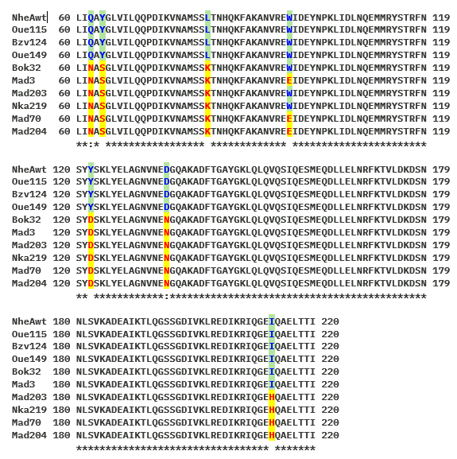

(B)
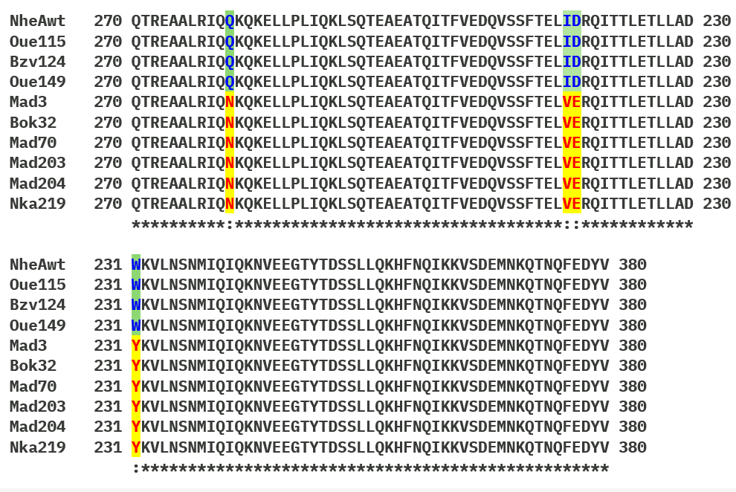
Figure 1: Sequence alignment of 9 strains that amplify simultaneous non-hemolytic enterotoxin A. The wild type of nheA, VIMSS645267 gene is from B. cereus ATCC 10987. A: Sequence alignment for NheA₆₀₋₂₂₀, B: Sequence alignment for NheA₂₇₀₋₃₈₀. NheAwt: sequence from microbesOnline data base (http://www.microbesonline.org ). Strains: Mad3 (PQ764102), Bok32 (PQ764145), Mad70 (PQ764136), Oue115 (PQ764140), Bzv124 (PQ764128), Oue149 (PQ764133), Mad203 (PQ764485), Mad204 (PQ764486(, and Nka219 (PQ764487)). Blue: wild type amino acids. Mutation detected in NheA₆₀₋₂₂₀ are showing in red color including Q62N, Y64S, L82K, W96E, Y122D, D135N, and I213H. mutation detected in NheA₂₇₀₋₃₈₀: Q280N, I316V, D317E, and W330Y.
To explain the toxicity or not of the selected strains, we predicted the three-dimensional structure using SwissModel of two groups. Group I included NheA_Mad3 and NheA_Bok32 (Figure B), and groups II included NheA-Mad70, NheA-Mad203, NheA-Mad204, and NheA-Nkay219 (Figure 2c). The results were compared with the crystallized structure of NheA (PDB: 4K1P, DOI: https://doi.org/10.2210/pdb4K1P/pdb) (Figure A). The mutations have strongly impacted the secondary structures of the proteins. Larger static coils are generated in both groups (Figure 2).
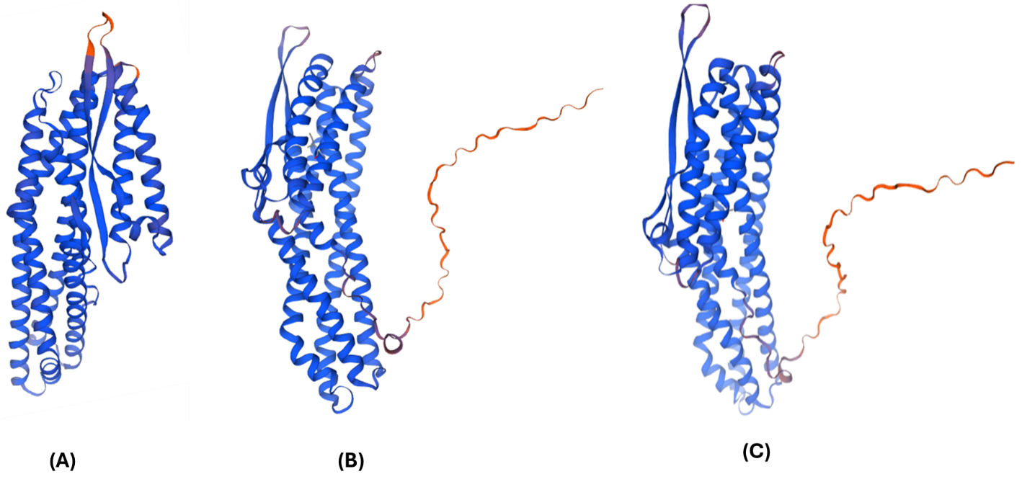
(C)
Figure 2: Comparison of the three-dimensional structures. (A) NheA (4K1P, DOI: https://doi.org/10.2210/pdb4K1P/pdb) de B. cereus protein and variants including (B) Group I included NheA_Mad3 and NheA_Bok32, and (C) groups II included NheA-Mad70, NheA-Mad203, NheA-Mad204, and NheA-Nkay219. (B) and (C) have been predicted in Swiss model (https://swissmodel.expasy.org ).
We have had no mutations in the case of the HblA, NheC and CytK protein. However, in the case of the NheB gene, the amplification and sequencing revealed two truncated regions of three amino acids each including NheB_{∆VKQ} at position 34 and NheB_{∆SQD} at position 211. This protein also contains a substitution mutation where alanine has been replaced by serine (A213S). This concerns the NheB mutation in the B. cereus Mad203 strain. However, the NheB protein obtained from the B. cereus Mad203 strain revealed that aspartic acid was replaced by glutamic acid at position 154 (D154E), tyrosine was replaced by leucine at position 231 (Y231L), glycine was replaced by valine at position 273 (G273V), and lysine was replaced by tyrosine at position 283 (K283Y) (Figure 3A). The prediction of the three structures using the Swiss-Model search engine showed that the conformation of the protein was altered in the N-terminal region, leading to the formation of a long, highly flexible static coil (Figure 3B).

(A)

(B)

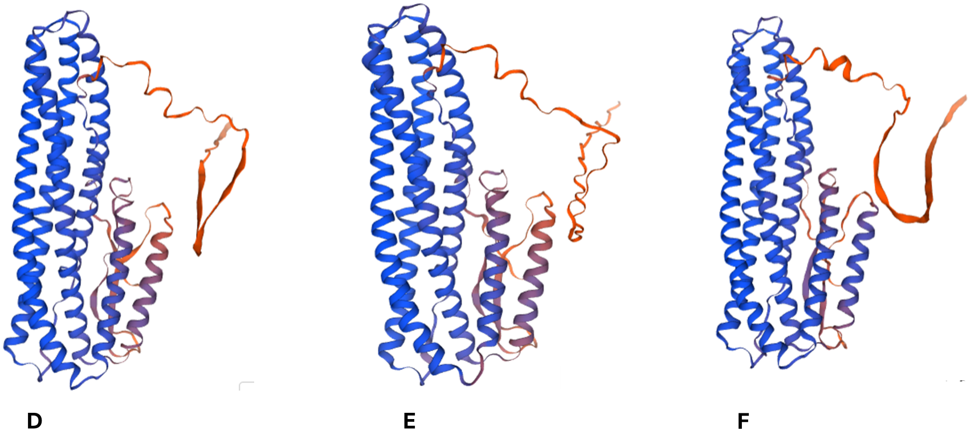

Figure 3: Prediction of the 3D structure of the NheB protein has been performed in Swiss-Model (https://swissmodel.expasy.org ). The NheB wild type sequence has been obtained from NCBI data base from B. cereus ATCC 10987, as well as for NheB from B. cereus Mad3 and Mad203 strains.

Discussion
In Republic of Congo, the incidence of B. cereus outbreaks is unknown, and there is little information about B. cereus occurrence in traditional fermented food. People consume traditional fermented beverages without really worrying about the drink poisoning aspects. The reliable existence of B. cereus in home fermented foods highlights its adaptability and prospective implication in fermentation procedures [20, 23, 29]. The finding mentioned above showed that B. cereus was able to secrete a cargo of hydrolases. Its enzymatic activities suggest a operational role in improving flavor and texture [30]. However, the detection of cytotoxins genes point out the need for rigorous examining to relieve food protection risks.
The prime identification of isolates was done by using 16S rRNA. Polymorphism refers to variations in the nucleotide sequences of the 16S rRNA gene among different strains of the same species or closely related species [31-34]. In B. cereus, these variations can include nucleotide substitutions with point mutations [31, 34], Insertions or deletions, and the presence of multiple slightly divergent copies of the 16S rRNA gene within the same genome [35]. The 16S rRNA gene is widely used in microbiology for bacterial identification and classification because it is highly conserved across all bacteria, with variable regions that allow species differentiation, and it contains hypervariable regions (V1 to V9) that are useful for distinguishing between closely related strains [36]. However, in B. cereus, the polymorphism of the 16S gene sometimes complicates precise identification [37], as it shares high sequence similarity with other species in the B. cereus sensu lato group including B. anthracis, B. mycoides and B. thuringiensis [37, 38]. Several factors can explain the polymorphism of the 16S rRNA gene includes multiple copies of the 16S rRNA gene meaning that the genome of B. cereus contains several copies of the 16S gene [36], which can evolve independently. These copies may accumulate mutations, resulting in intra-genomic variations [39, 40]. B. cereus is known to exchange genetic material with closely related species, which can introduce diversity into its genes, including the 16S rRNA gene. Adaptation to diverse environments may favor mutations in genes, even those as conserved as the 16S rRNA gene [41].
We do not claim to say that the B. cereus has been clearly identified because we know that the polymorphism can make it difficult to accurately identify B. cereus using 16S rRNA sequences, especially in studies relying on methods like Sanger sequencing [41]. We are also aware that the high similarity between the 16S sequences of B. cereus and related species (B. anthracis, B. thuringiensis, B. mycoides) can lead to ambiguous phylogenetic analyses [41]. The high genetic diversity observed among isolates suggests multiple sources of contamination, likely from raw materials, processing environments, and handlers. Further research is needed to elucidate the specific contributions of B. cereus to fermentation and strategies to manage pathogenic strains

To overcome these weaknesses, we improve 16S rRNA analysis in combination with cytotoxins HblA, Nhe (NheA, NheB, and NheC) and CytK genes in B. cereus isolated from 10 fermented foods genes. The predominance of Nhe components has already been demonstrated in several studies [42]. Separately, these proteins show no toxicity, but as a binary complex some activities more toxicity can be viewed [43]. In addition, none of the three components of hemolysin BL is hemolytic individually [44]. It is known that Nhe-induced cytotoxicity required a specific binding order of the individual components whereby the presence of NheC in the priming step as well as the presence of NheA in the round cultivation step is required [45].
By performing an in silico Predict Protein alignment (https://predictprotein.org ) with Protein Data Bank (PDB), we observed that NheA toxin structure [46] shares sequence homology between 21% and 31% with Vibrio cholarea toxins (PDB: 6W1W, 6DFP) [47], Cry6Aa2 from Bacillus thurengensis (PDB: 5GHE, 5KUC) [48], XaxA and XaxAB from Xenorhabdus nematophila [49], AhlB and AhlC from Aeromonas hydrophila (PDB: 6GRJ, 6GRK, 6R1J, and 6H2E) [50], and YaxA from Yersinia enterocolitica (PDB: 6EK7) [51]. The NheA₆₀₋₂₂₀ and Nhe₂₇₀₋₃₈₀ regions are the most conserved. No previous study has shown the importance of these extremely conserved regions. The percentage of amino acids including Q62, Y64, L82, W96, Y122, D135, I213, Q280, I316, D317, and W330 are highly conserved in the regions involving the toxin fonction. In this study, we did not perform site-directed mutagenesis in plasmids to thoroughly investigate the amino acid changes, i.e., the substitution mutations in the regions and the potential deletions we observed.
Generally, several studies focus on mutations related to the multidrug resistance of bacteria [52] excepting on B. anthracis which is the more related Bacillus species to B. cereus. haemolytic enterotoxin Hbl and the pleiotropic regulator PlcR have been determined [53]. We have highlighted mutations related to silent and missense substitutions. Q62N mutation might cause minor structural changes, especially if Q62 is involved in hydrogen bonding or located in a flexible loop. If Y64 contributes to hydrophobic interactions or stacking, this mutation may disrupt structural stability or ligand binding. L82 mutation introduces a charge in a typically hydrophobic environment, potentially destabilizing local folding or disrupting interactions with other residues. W96E is a drastic change that could disrupt hydrophobic cores or protein-protein interactions, especially if W96 is part of a binding site or core structure. W96 is present in α2 of NheA [46]. Y122 involves hydrogen bonding or stacking interactions, this change might cause significant disruption. This such replacement (D135N) could affect charge-based interactions, such as ionic bonds, or alter the local pH sensitivity of the protein. The pore in the fully assembled Nhe toxin (NheA, NheB and NheC) with an estimated diameter of 50 Å [54]. These mutations may affect the interaction of the pore components (NheA, NheB and NheC) [22, 55]. I213H could introduce pH-dependent effects or disrupt hydrophobic packing, potentially altering the stability or function of the region. Mutations that change the conformation, charge, or hydrophobicity of residues can disrupt secondary and tertiary structures, especially if the residues are in the protein core or interaction interfaces. Residues are part of active sites, binding pockets, or interaction surfaces, these mutations ma [56-58]y impair the protein's function or alter its specificity [56-58]. The impact of these mutations has been validated using computational modeling. Protein folding/unfolding is a complicated process that defies high-resolution characterization [59].
In this study, we showed that both Group I included NheA_Mad3 and NheA_Bok32, and groups II included mutated components NheA-Mad70, NheA-Mad203, NheA-Mad204, and NheA-Nkay219 form static coils. Static coils are regions that allow proteins to adopt different conformations [60], which is essential for functions involving the recognition of multiple molecular partners, transient interactions (weak and reversible bonds), and structural plasticity needed to adapt to variable environments [57].
This could explain why people consume freshly harvested fermented beverages. We note that we did not obtain mutations in the NheB and NheC genes. We do not claim to easily conclude with the results obtained. It is important to establish procedures that allow filtering the musts of fermented beverages.

Conclusion
B.cereus is a ubiquitous component of traditional fermented foods in the Republic of Congo, with dual roles as a potential contributor to fermentation quality and a food safety concern. This study provides a foundation for understanding its complex role in traditional food systems and emphasizes the importance of balancing benefits and risks in utilizing this versatile microorganism. Mutations causing truncated NheA and NheB are likely to severely impair the toxin’s ability to form functional pores, which are critical for its pathogenic activity. This highlights the importance of each component in the cooperative mechanism of Nhe-mediated toxicity. This work is a first in this area, as it has never been published elsewhere. The various mutations observed in this study could provide an interesting approach to understanding why certain B. cereus strains are not pathogenic, as evidenced by the increased consumption of fermented beverages in rural areas
Data Availability Statement
The data that support the findings of this study are available from the corresponding author upon reasonable request.

References
1. Kayath AC, Nguimbi E, Goma Tchimbakala J, Mamonékéné V, Lebonguy AA, Ahombo G: Towards the understanding of fermented food Biotechnology in Congo Brazzaville. Advance Journal of Food Science and Technology 2016, 12(11):593-602.
2. Diez-Ozaeta I, Astiazaran OJ: Fermented foods: An update on evidence-based health benefits and future perspectives. Food Res Int 2022, 156:111133.
3. kayath A, C., Mokemiabeka SN, Mayaya Dangui Nieko NP, Vouidibio Mbozo AB, Nguimbi E, Kéléké S, Kobawila SC, Louembé D: Evolution of Fermented Food Products in the Republic of Congo: A Meta-analytic Review. Journal of Advances in Microbiology 2024, 24(12).
4. Kobawila SC, Louembe D, Keleke S, Hounhouigan DJ, C. Gamba C: Reduction of the cyanide content during fermentation of cassava roots and leaves to produce bikedi and ntoba mbodi, two food products from Congo. . Afr J Biotechnol 2005, 4(7 ):689-696.
5. Louembé D, Kobawila SC, Bouanga Kalou G, Kéléké S: Etude microbiologique des feuilles fermentées de manioc: “Ntoba Mbodi”. Tropicultura 2003, 21(3):106-111.
6. Louembé D, Kobawila SC, Keléké S, Diakabana P, Nkoussou Moulassou B: Rouissage des tubercules de manioc à partir de “pied de cuve” à base de manioc roui. TROPICULTURA, 2002, 20(3):18-124.
7. Abriouel H, Ben Omar N, Lopez RL, Martinez-Canamero M, Keleke S, Galvez A: Culture-independent analysis of the microbial composition of the African traditional fermented foods poto poto and degue by using three different DNA extraction methods. Int J Food Microbiol 2006, 111(3):228-233.
8. Louembé D, Kéléké S, Kobawila C, Nzoussi JP: Variabilité et amélioration de la technologie traditionnelle de production de la pâte fermentée de maïs au Congo. . Tropicultura 2004, 22(4):211-218.
9. Louémbé D, Keléké S, Kobawila SC, Nzounzi JP: Bactéries lactiques de la pâte fermentée de maïs au Congo. Tropicultura, 2003, 21:3-9. .
10. Lembella Boumba AE, Lebonguy AA, Goma-Tchimbakala J, Nzaou SAE, Limingi Polo CP, Bokamba Moukala M: Bacterial Community Diversity of Fermented Pepper in Brazzaville Revealed by Illumina Miseq of 16S rRNA Gene. Food and Nutrition Sciences 2021, 12(1).
11. Kayath AC, Vouidibio Mbozo AB, Makaya Dangui NP, Kaya-Ongoto MD, Kinouani Kinavouidi DJ, Tsiba-Nkoli JAI, Nguimbi E: A Quick Biochemical Comparison between the Traditional Fermentation of Plantain Wine and Banana Wine Produced in Republic of Congo. Advance Journal of Food Science and Technology 2020, 18(1):15-21.
12. Kaya-Ongoto MD, Kayath CA, Nguimbi E, Lebonguy AA, Nzaou SAE, Elenga Wilson PS, Ahombo G: Genetic Clearness Novel Strategy of Group I Bacillus Species Isolated from Fermented Food and Beverages by Using Fibrinolytic Enzyme Gene Encoding a Serine-Like Enzyme. J Nucleic Acids 2019, 2019:5484896.
13. Kayath CA, Ibala Zamba A, Mokemiabeka SN, Opa-Iloy M, Elenga Wilson PS, Kaya-Ongoto MD, Mouellet Maboulou RJ, Nguimbi E: Synergic Involvements of Microorganisms in the Biomedical Increase of Polyphenols and Flavonoids during the Fermentation of Ginger Juice. Int J Microbiol 2020, 2020:8417693.
14. Kaya-Ongoto MD, Kayath AC, Awah-Lekaka Niebi NJ, Nguimbi E: Molecular identification of biofilm-producing Bacillus species and yeasts isolated from food sources andtheir interaction with Lysinibacillus louembei strain African Journal of Microbiology Research 2023, 17(12):291-305.
15. Limingui Polo CP, Lebonguy AA, Lembella Boumba AE, Nzaou SAE, Bokamba Moukala M, Goma-Tchimbakala J, Diatewa M: Bacterial Community Diversity of a Congolese Traditional Fermented Food, “Pandé”, Revealed by Illumina MiseqTM Sequencing of 16S rRNA Gene. Open Journal of Applied Sciences 2022, 12 (3).
16. Vouidibio Mbozo AB, Kobawila C, Anyogu A, Awamaria B, Louembe D, Sutherland JP, Ouoba LI: Investigation of the diversity and safety of the predominant Bacillus pumilus sensu lato and other Bacillus species involved in the alkaline fermentation of cassava leaves for the production of Ntoba Mbodi. 2017, 82:154-162.
17. Ehling-Schulz M, Fricker M, Scherer S: Bacillus cereus, the causative agent of an emetic type of food-borne illness. Mol Nutr Food Res 2004, 48(7):479-487.
18. Enosi Tuipulotu D, Mathur A, Ngo C, Man SM: Bacillus cereus: Epidemiology, Virulence Factors, and Host-Pathogen Interactions. Trends Microbiol 2021, 29(5):458-471.
19. Nishikawa T, Okamoto Y, Tanabe T, Kodama Y, Shinkoda Y, Kawano Y: Critical illness polyneuropathy after Bacillus cereus sepsis in acute lymphoblastic leukemia. Intern Med 2009, 48(13):1175-1177.
20. Abriouel H, Ben Omar N, Lucas Lopez R, Martinez Canamero M, Ortega E, Galvez A: Differentiation and characterization by molecular techniques of Bacillus cereus group isolates from poto poto and degue, two traditional cereal-based fermented foods of Burkina Faso and Republic of Congo. J Food Prot 2007, 70(5):1165-1173.
21. Fagerlund A, Lindback T, Granum PE: Bacillus cereus cytotoxins Hbl, Nhe and CytK are secreted via the Sec translocation pathway. BMC Microbiol 2010, 10:304.
22. Heilkenbrinker U, Dietrich R, Didier A, Zhu K, Lindback T, Granum PE, Martlbauer E: Complex formation between NheB and NheC is necessary to induce cytotoxic activity by the three-component Bacillus cereus Nhe enterotoxin. PLoS One 2013, 8(4):e63104.
23. Priest FG, Barker M, Baillie LW, Holmes EC, Maiden MC: Population structure and evolution of the Bacillus cereus group. J Bacteriol 2004, 186(23):7959-7970.
24. Lee N, Sun JM, Kwon KY, Kim HJ, Koo M, Chun HS: Genetic diversity, antimicrobial resistance, and toxigenic profiles of Bacillus cereus strains isolated from Sunsik. J Food Prot 2012, 75(2):225-230.
25. N’goma-Mona ND, Kayath CA, Mokemiabeka NM, Okouakoua FY: A Meta-Advance of Bacillus-Mediated Biosurfactant Augmentation in the Chikwangue Composition. Advances in Microbiology 2025, 15(2).
26. Elenga-Wilson PS, Kayath CA, Mokemiabeka NS, Nzaou SAE, Nguimbi E, Ahombo G: Profiling of Indigenous Biosurfactant-Producing Bacillus Isolates in the Bioremediation of Soil Contaminated by Petroleum Products and Olive Oil. Int J Microbiol 2021, 2021:9565930.
27. Okouakoua YF, Kayath AC, Mokemiabeka SN, Moukala DCR, Kaya-Ongoto MD, Nguimbi E: Involvement of the Bacillus SecYEG Pathway in Biosurfactant Production and Biofilm Formation. Int J Microbiol 2024, 2024:6627190.
28. Lemoine F, Correia D, Lefort V, Doppelt-Azeroual O, Mareuil F, Cohen-Boulakia S, Gascuel O: NGPhylogeny.fr: new generation phylogenetic services for non-specialists. Nucleic Acids Res 2019, 47(W1):W260-W265.
29. Shin H, Bandara N, Shin E, Ryu S, Kim KP: Prevalence of Bacillus cereus bacteriophages in fermented foods and characterization of phage JBP901. Res Microbiol 2011, 162(8):791-797.
30. Navaneethan Y, Effarizah ME: Post-Cooking Growth and Survival of Bacillus cereus Spores in Rice and Their Enzymatic Activities Leading to Food Spoilage Potential. Foods 2023, 12(3).
31. Brumlik MJ, Bielawska-Drozd A, Zakowska D, Liang X, Spalletta RA, Patra G, Delvecchio VG: Genetic diversity among Bacillus anthracis, Bacillus cereus and Bacillus thuringiensis strains using repetitive element polymorphism-PCR. Pol J Microbiol 2004, 53(4):215-225.
32. Mc LJ, Salmon JE, Ahmed S, Brazier JS, Brett MM, George RC, Hood J: Amplified fragment length polymorphism (AFLP) analysis of Clostridium novyi, C. perfringens and Bacillus cereus isolated from injecting drug users during 2000. Journal of medical microbiology 2002, 51(11):990-1000.
33. Ticknor LO, Kolsto AB, Hill KK, Keim P, Laker MT, Tonks M, Jackson PJ: Fluorescent Amplified Fragment Length Polymorphism Analysis of Norwegian Bacillus cereus and Bacillus thuringiensis Soil Isolates. Appl Environ Microbiol 2001, 67(10):4863-4873.
34. Ripabelli G, McLauchlin J, Mithani V, Threlfall EJ: Epidemiological typing of Bacillus cereus by amplified fragment length polymorphism. Lett Appl Microbiol 2000, 30(5):358-363.
35. Tsen HY, Chen ML, Hsieh YM, Sheu SJ, Chen YL: Bacillus cereus group strains, their hemolysin BL activity, and their detection in foods using a 16S RNA and hemolysin BL gene-targeted multiplex polymerase chain reaction system. J Food Prot 2000, 63(11):1496-1502.
36. Sanschagrin S, Yergeau E: Next-generation sequencing of 16S ribosomal RNA gene amplicons. J Vis Exp 2014(90).
37. Ehling-Schulz M, Lereclus D, Koehler TM: The Bacillus cereus Group: Bacillus Species with Pathogenic Potential. Microbiol Spectr 2019, 7(3).
38. Trunet C, Cauquil A, Hymery N, Koullen L, Postollec F, Coroller L: Are Bacillus thuringiensis strains like any other Bacillus cereus strains? Phenotypic-based tools to locate Bacillus thuringiensis in the diversity of the Bacillus cereus sensu lato group. Res Microbiol 2023, 174(6):104077.
39. Zarske M, Werckenthin C, Golz JC, Stingl K: The point mutation A1387G in the 16S rRNA gene confers aminoglycoside resistance in Campylobacter jejuni and Campylobacter coli. Antimicrob Agents Chemother 2024, 68(11):e0083324.
40. Park HE, Kim S, Shim S, Park HT, Park WB, Im YB, Yoo HS: 16S and 23S rRNA Gene Mutation Independent Multidrug Resistance of Non-Tuberculous Mycobacteria Isolated from South Korean Soil. Microorganisms 2020, 8(8).
41. Patino-Navarrete R, Sanchis V: Evolutionary processes and environmental factors underlying the genetic diversity and lifestyles of Bacillus cereus group bacteria. Res Microbiol 2017, 168(4):309-318.
42. Kim SA, Park HJ, Cho TJ, Rhee MS: Toxic potential of Bacillus cereus isolated from fermented alcoholic beverages. Food Res Int 2020, 137:109361.
43. Lindback T, Fagerlund A, Rodland MS, Granum PE: Characterization of the Bacillus cereus Nhe enterotoxin. Microbiology (Reading) 2004, 150(Pt 12):3959-3967.
44. Heinrichs JH, Beecher DJ, MacMillan JD, Zilinskas BA: Molecular cloning and characterization of the hblA gene encoding the B component of hemolysin BL from Bacillus cereus. J Bacteriol 1993, 175(21):6760-6766.
45. Lindback T, Hardy SP, Dietrich R, Sodring M, Didier A, Moravek M, Fagerlund A, Bock S, Nielsen C, Casteel M et al: Cytotoxicity of the Bacillus cereus Nhe enterotoxin requires specific binding order of its three exoprotein components. Infect Immun 2010, 78(9):3813-3821.
46. Ganash M, Phung D, Sedelnikova SE, Lindback T, Granum PE, Artymiuk PJ: Structure of the NheA component of the Nhe toxin from Bacillus cereus: implications for function. PLoS One 2013, 8(9):e74748.
47. Herrera A, Kim Y, Chen J, Jedrzejczak R, Shukla S, Maltseva N, Joachimiak G, Welk L, Wiersum G, Jaroszewski L et al: A Genomic Island of Vibrio cholerae Encodes a Three-Component Cytotoxin with Monomer and Protomer Forms Structurally Similar to Alpha-Pore-Forming Toxins. J Bacteriol 2022, 204(5):e0055521.
48. Yu Z, Luo H, Xiong J, Zhou Q, Xia L, Sun M, Li L, Yu Z: Bacillus thuringiensis Cry6A exhibits nematicidal activity to Caenorhabditis elegans bre mutants and synergistic activity with Cry5B to C. elegans. Lett Appl Microbiol 2014, 58(6):511-519.
49. Schubert E, Vetter IR, Prumbaum D, Penczek PA, Raunser S: Membrane insertion of alpha-xenorhabdolysin in near-atomic detail. Elife 2018, 7.
50. Wilson JS, Churchill-Angus AM, Davies SP, Sedelnikova SE, Tzokov SB, Rafferty JB, Bullough PA, Bisson C, Baker PJ: (Identification and structural analysis of the tripartite alpha-pore forming toxin of Aeromonas hydrophila). Nat Commun 2019, 10(1):2900.
51. Brauning B, Bertosin E, Praetorius F, Ihling C, Schatt A, Adler A, Richter K, Sinz A, Dietz H, Groll M: Structure and mechanism of the two-component alpha-helical pore-forming toxin YaxAB. Nat Commun 2018, 9(1):1806.
52. Bartoszewicz M, Czyzewska U: Comparison of the antibiotic resistance between genetically diverse and toxigenic Bacillus cereus sensu lato from milk, pepper and natural habitats. J Appl Microbiol 2021, 130(2):370-381.
53. Gierczynski R, Zasada AA, Kaluzewski S, Jagielski M: [Molecular characterisation of the haemolytic isolates of Bacillus anthracis originated in Poland]. Med Dosw Mikrobiol 2006, 58(4):339-346.
54. Haug TM, Sand SL, Sand O, Phung D, Granum PE, Hardy SP: Formation of very large conductance channels by Bacillus cereus Nhe in Vero and GH(4) cells identifies NheA + B as the inherent pore-forming structure. J Membr Biol 2010, 237(1):1-11.
55. Rocha EP, Danchin A: An analysis of determinants of amino acids substitution rates in bacterial proteins. Mol Biol Evol 2004, 21(1):108-116.
56. Habchi J, Tompa P, Longhi S, Uversky VN: Introducing protein intrinsic disorder. Chem Rev 2014, 114(13):6561-6588.
57. Gao M, Han Y, Zeng Y, Su Z, Huang Y: Introducing intrinsic disorder reduces electrostatic steering in protein-protein interactions. Biophys J 2021, 120(15):2998-3007.
58. Zhao Z, Peng Z, Yang J: Improving Sequence-Based Prediction of Protein-Peptide Binding Residues by Introducing Intrinsic Disorder and a Consensus Method. J Chem Inf Model 2018, 58(7):1459-1468.
59. Ferina J, Daggett V: Visualizing Protein Folding and Unfolding. J Mol Biol 2019, 431(8):1540-1564.
60. Babu MM: Intrinsically disordered proteins. Mol Biosyst 2012, 8(1):21.

