Biochar and NPK fertilization: impacts on the growth, yield and soil properties of maize (Zea mays L.) in Yamoussoukro (sol-Y).

Abstract
This study evaluates the effect of the separate application of biochar and NPK on the growth, yield and quality of maize (Zea mays L.) grains grown in the soil of Yamoussoukro. In the greenhouse, three doses of biochar (2%, 5%, 10%) were tested, while in the field, treatments consisted of biochar alone (2 t/ha) and NPK alone (250 kg/ha). The parameters measured included stem height and diameter, number of leaves, yield, and 1000-grain weight. In the greenhouse, the 5% dose of biochar promoted the best growth, with an average height of 179.33 cm, a stem diameter of 8.93 mm and 7.67 leaves, while the 2% and 10% doses and the control showed lower values. In the field, the biochar application produced a yield of 3.94 t/ha and a 1000-grain weight of 315.63 g, while the NPK application yielded 4.06 t/ha and a weight of 316.5 g. These values ​​are statistically similar and significantly higher than the control (1.33 t/ha and 246 g). These results indicate that biochar, even when applied alone, can improve maize growth, yield, and grain quality in a manner comparable to NPK. The study highlights the potential of biochar as a sustainable soil amendment in Yamoussoukro, capable of supporting maize productivity while improving soil fertility.
Keywords: Maize, Biochar, NPK, Yamoussoukro soil, Growth, Yield, Grain weight
Introduction
Agriculture in tropical zones faces many challenges, among which soil degradation is a major obstacle to crop productivity (Appiah et al., 2025). Low organic matter content, poor physical structure, and nutrient loss significantly limit plant growth and yield. In this context, biochar, a carbonaceous material produced by the pyrolysis of biomass, appears to be a promising solution for restoring soil fertility while improving the sustainability of agricultural systems.
Biochar can improve soil physicochemical properties through increased cation exchange capacity, improved water and nutrient retention, and organic carbon stabilization (Hou et al., 2025). While many studies have evaluated the combined effects of biochar and mineral fertilizers, few have examined their separate application, which is essential for understanding the individual impact of each treatment on plants and soil.
Previous studies show that adding biochar in combination with nitrogen fertilizers can improve nitrogen use efficiency, nitrogen retention in the soil, and enzyme activity (Li et al., 2023). For example, in a study on black soils in China, Li et al. (2023) observed a significant increase in maize yield when biochar was applied with nitrogen. Furthermore, the study by Sun et al. (2023) indicates that biochar combined with nitrogen fertilizer stimulates the activity of soil enzymes such as urease, thereby improving soil health and productivity.
However, some tropical studies suggest that a single application of biochar can also have positive effects over several crop cycles. For example, research in Ghana showed that a single application of biochar, even without being mixed with an NPK fertilizer, could improve certain soil parameters (pH, cation exchange capacity, nitrogen content, organic carbon content) while influencing yields over three growing seasons (Frimpong et al., 2021). Furthermore, the study by Mohamed et al. (2024) on maize and wheat cropping systems in arid soils showed that biochar increases productivity and nitrogen retention, although the performance of pure NPK is sometimes superior depending on the conditions.
Furthermore, the effects of biochar on maize growth can be highly dependent on the application method. For example, a recent study indicates that a single application of biochar improves yield and water and fertilizer efficiency under various irrigation conditions, even without additional mineral fertilizer (Yang et al., 2022).
Despite these promising results, specific studies are lacking in highly degraded soil contexts such as those of Yamoussoukro (Côte d'Ivoire), where soil, climate, and agronomic characteristics can differ considerably from those of other tropical regions studied. Understanding how biochar applied alone in greenhouses and how separate applications of biochar alone or NPK alone in fields affect maize growth, yield, and soil properties in this context is essential for proposing sustainable agronomic practices adapted to local conditions.
The objective of this study was to evaluate the differentiated effects of biochar in the greenhouse and field treatments (biochar alone, NPK alone) on maize (Zea mays L.) growth, yield, and soil fertility in Yamoussoukro. It was hypothesized that amendment with biochar and NPK would (1) improve nutrient availability in the soil, (2) influence plant growth characteristics, and (3) increase maize yield, both under greenhouse and open field conditions.

- Material and methods
1.1 Biochar
Biochar made from cassava peels was used in this study. It was obtained by slow pyrolysis in a conventional oven at a temperature of 400 ± 10 °C for three hours. Its physicochemical properties are presented in Table I (Hamissou et al., 2023).
Table I : Physicochemical properties of biochar (Hamissou et al., 2023)
Parameters | Values
pH | 10
Electrical conductivity (EC) | 4.69 us/cm
Salinity (TDS) | 2.4 mg/L
Ash content (TC) | 11.28 %
Moisture content (TH) | 6 %
Dry matter (DM) | 94 %
Bulk density (Da) | 1.54
Total nitrogen (NT) | 1.14 %
Total organic carbon (TOC) | 50.76 %
Total inorganic carbon (TIC) | 28.23 %
Carbon/nitrogen ratio (C/N) | 68.51
Oxygen/carbon ratio (O/C) | 0.23
Hydrogen/carbon ratio (H/Corg) | 0.03
Specific surface area | 341.11 (m2/g)
Total pore volume | 0.8 (cm3/g)
Average pore diameter | 1.44 (nm)

1 .2 Physical and chemical characteristics of soil-Y before testing
Table II presents the particle size distribution and chemical characteristics of the Yamoussoukro soil (Y-soil) (Hamissou et al., 2025). The particle size fractions are expressed as percentages of clay, fine and coarse silt, and fine and coarse sand. The chemical parameters include pH, carbon (C), total nitrogen (Nt), organic matter (OM), C/Nt ratio, available phosphorus (P), cation exchange capacity (CEC), and the main exchangeable cations (Ca²⁺, Mg²⁺, K⁺, and Na⁺).
Table II. Physical and chemical parameters of soil prior to crop establishment (Hamissou et al., 2025)
Parameters | Values
Clay | (2±0.64) %
Fine silt | (1±0.94) %
Coarse silt | (26.15±0.12) %
Fine sand | (2.4±0.94) %
Coarse sand | (67.91±0.05) %
pH-water | 6.9±0,00
C | (0.2±0.03) %
Nt | (0.04±0.03) %
MO | (0.34±0.02) %
C/Nt | 5±0.28
P.ass | (25±0.43) Cmol/kg
CEC | (4.56±0.23) Cmol/kg
Ca²⁺ | (0.55±1.03) Cmol/kg
Mg²⁺ | (0.49±0.13) Cmol/kg
K⁺ | (0.06±1.03) Cmol/kg
Na+ | (0.11±0.34) Cmol/kg

1 .3 Seeds
The selected corn variety (EV8728-SR) is distinguished by its early maturity and semi-dent yellow kernels. With an average growth cycle of around 70 days, it is a strategic choice for farmers in Côte d'Ivoire. This variety was specifically chosen for its remarkable adaptability to the country's different agroecological zones, making it the predominant choice among local farmers.
1 .4 Soil sampling
Soils from the experimental field of the École Supérieure d'Agronomie (ESA) of INP-HB Nord (located at 6°88'75'‘ latitude and 5°22'84’' longitude) were sampled in June 2021 using a stainless steel hand auger, in the top 30 cm of soil, according to a five-point randomization scheme: in the center and at the four corners of the field. These points were chosen in order to sample composite subsamples over an area of 0.5 ha, which were then mixed to obtain a 1 kg composite sample for various laboratory analyses. Subsequently, 200 kg of this agricultural soil was carefully collected, placed in plastic bags, and transported for agronomic testing in a greenhouse.
2. Physicochemical analysis of soil after greenhouse testing
2 .1 Determination of soil chemical properties
The pH was measured by electrometry using a pH meter according to Pansu et al. (Pansu et al., 2003). Exchangeable bases (Ca²⁺, Mg²⁺, K⁺, Na⁺) and cation exchange capacity (CEC) were measured on a KCl suspension (Pansu et al., 2003) after mechanical agitation of 5 g of the sample. Total organic carbon was measured using a wet method at a temperature of 120°C (Walkley and Black, 1934). Organic matter (OM) was calculated using the following equation (Bivoko et al., 2013):
$$MO=carbon x 1.72$$
Total nitrogen was determined using the Kjeldahl method (Bremner, 1960). The C/N ratio was derived from the carbon and total nitrogen values. Assimilable phosphorus (assimilable P) was extracted in sodium bicarbonate at pH 8.5 using the Olsen method (Olsen, 1952).
2.2 Determination of soil physical properties
Soil particle size distribution was determined using the Robinson pipette method (Anderson and Ingram, 1994). The proportions of particle classes were defined according to French standard NF X31 107 (Baize, 2018) and textures were determined using the USDA (United States Department of Agriculture) texture triangle according to Soil Survey Staff (Staff, 1998).
2.3 Soil quality assessment standards
The interpretation of soil analysis results is based on the criteria set out in Table III, which provides a specific framework for assessing soil composition and quality.
Table III: Soil quality assessment standards
Doucet's reference threshold values (Doucet, 2006) following the approach of Ballot et al (Baillie, 2009)
Parameters | C |  | Nt | C/Nt |  | P.ass |  | Ca²⁺ | Mg²⁺ |  | K⁺ | Na⁺ | CEC
Threshold value |  | 1.6-  2.5 | 1.2-  2.2 |  | 11 à 15 | 3 à 8 | 5 à 8 |  |  | 1.5-  3.0 | 0.15-  0.25 | 0.3-  0.7 | 10≤CEC≤2 0

2.4 Assessment of soil fertility levels
The fertility of the soils studied was assessed according to the criteria for classifying fertility classes as reported by Amonmide et al (Amonmide et al., 2019), (Table VI).
Table IV: Criteria for assessing soil fertility classes
Fertility level
 | Very high | High | Medium | Low | Very low
Characteristic | Degree 0 | Degree 1 | Degree 2 | Degree 3 | Degree 4
MO (%) | > 2 | 2-1.5 | 1.5-1 | 1-0.5 | < 0.5
Nt (%) | > 0.08 | 0.08-0.06 | 0.06-0.04 | 0.045-0.03 | < 0.03
P.ass (cmol/kg) | > 20 | 20-15 | 15 à 10 | 10 à 5 | < 5
K+ (cmol/kg) | > 0.4 | 0.4-0.3 | 0.3-0.2 | 0.2-0.1 | < 0.1
CEC (cmol/kg) | > 25 | 25-15 | 15 à 10 | 10 à 5 | < 5
pH | 5.5-6.5  6.5-8.2 | 5.5-6.0  6.5-7.8 | 5.5-5.3  7.8-8.3 | 5.3-5.2  8.3-8.5 | <5.2  >8.5

2.5 Agronomic testing site
In order to properly evaluate the agronomic performance of the biochar produced, two experiments were carefully conducted. The first took place from late June to early September 2022 in the INP-HB Nord agricultural greenhouse, located at latitude 6°88'82'‘ and longitude 5°22'63’'. The objective of this phase was to determine the optimal dose of biochar to improve tomato growth and yield without the use of NPK. The second agronomic trial, conducted on the agricultural plot of the École Supérieure d'Agronomie (ESA) of INP-HB Nord, from early August to late November 2023, at a latitude of 6°88'75'‘ and a longitude of 5°22'84’', was carried out with separate plots for biochar and NPK in order to evaluate the impact of each fertilizer separately. Both experiments were rigorously planned to ensure reliable and relevant data on the impact of biochar and NPK on the agronomic parameters studied. Figure 1 shows the location of the two sites where the agronomic trials were conducted.
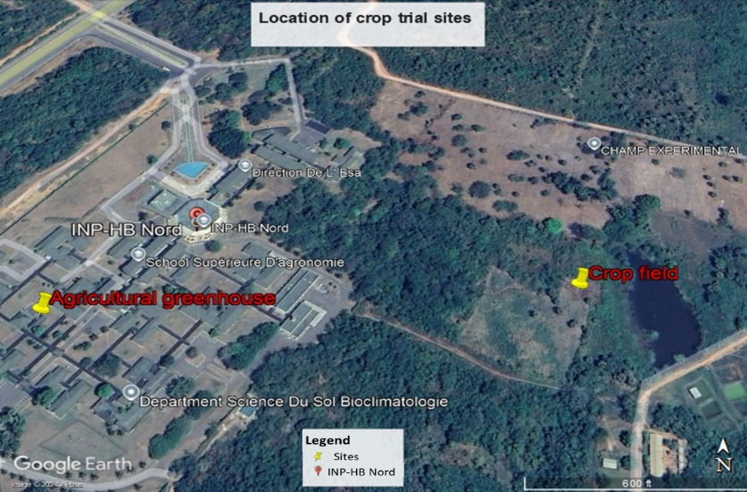
Figure 1 : Location of the two agronomic trial sites (Hamissou et al., 2025)

2.6 Greenhouse experimental setup
The experimental setup used to study greenhouse vegetable production in pots (Figure 2) is based on a completely randomized block design comprising four distinct treatments, each replicated three times to ensure the reliability of the results. In this experimental setup, each pot contains 3 kg of soil, with biochar percentages varying according to the treatments: 2%, 5%, and 10%. Pots without biochar are used as controls. These pots, composed solely of soil without added biochar, allow the effect of biochar to be compared to a conventional crop without amendment. A layer of gravel is placed at the bottom of the pot to ensure good drainage, allowing excess water to drain away and preventing soil saturation, which prevents root asphyxiation. Aeration holes in the bottom of the pot also facilitate the drainage of excess water, reducing the risk of root rot due to stagnant water, while promoting aeration of the root system for optimal plant growth.
The treatments evaluated include:
T0: control treatment without biochar;
T1: consisting of 3 kg of soil enriched with 60 g of biochar (2%),
T2: consisting of 3 kg of soil with 150 g of biochar incorporated (5%),
T3: consisting of 3 kg of soil mixed with 300 g of biochar (10%).
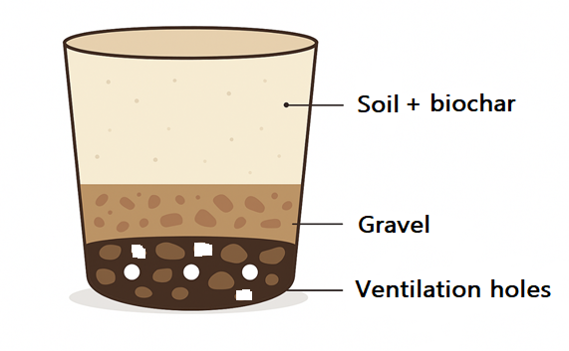
Figure 2 : Diagram of pots used for growing corn
2.7 Field experimental setup
The trial focused on corn production. The experimental design adopted for this trial was completely randomized Fisher blocks, comprising three distinct treatments, each repeated three times (Figure 3). This resulted in nine plots for the two trials. Each block consisted of three plots, each measuring 6 m x 4 m, spaced 1 m apart, with a distance of 2 m between blocks. The treatments applied were as follows
T0: control plot without biochar addition;
T1: 2 tons per hectare of biochar;
T2: 250 kg of NPK (12-22-22) per hectare.
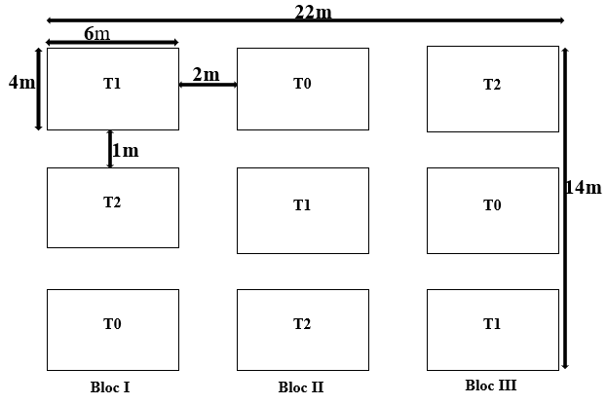
Figure 3: Field trial design for tomatoes
2.8 Evaluation of agromorphological parameters
To determine the effect of biochar and NPK fertilizer (12-22-22) on vegetable crops, measurements were taken over the three months of the experiment on morphological characteristics.
- Plant height was measured from the collar to the top of the main plant using a tape measure.
- The number of visible leaves on each plant was estimated.
- The diameter of the stems at the collar was measured using a FISHTEC electronic caliper.
- The yield (in t.ha-1) of corn kernels from each experimental device was determined per plot after threshing.

2.9 Method for determining the weight of 1,000 corn kernels
Thousand kernel weight (TKW) is a key indicator of corn yield quality, reflecting grain size and density (Hojka, 2010). In this study, it was determined in accordance with the recommendations of the AFNOR NF V03-702 standard (AFNOR NF V03-702, 1981) and the methods reported by Nielsen et al. (Nielsen et al., 2018) and Outéndé (Outéndé, 2016). At physiological maturity, a representative sample of grains was taken from each batch or treatment. Damaged, broken, or malformed grains were removed so that only healthy, homogeneous grains remained. Then, exactly 1,000 grains were counted and weighed using a precision balance (±0.01 g). The operation was repeated on three subsamples to reduce experimental error and obtain a representative average (Nielsen et al., 2018). All grains were used at a standardized moisture content of approximately 13%.

2.10 Statistical data analysis
The collected data were entered into an Excel 2013 spreadsheet and then subjected to a one-way analysis of variance (ANOVA) using Minitab 18 software. Histograms were created using Origin Pro 2024 software.
The ANOVA was performed on the means of the measured parameters (stem size, collar diameter, number of leaves, and yield). However, prior to analysis, the data were subjected to a normality test (Shapiro et al., 1968) and a test of homogeneity of variance (Brown and Forsythe, 1974). The hypothesis tested by ANOVA is that there is no difference between treatments, H0: T1=T2=.................................=Tn. ANOVA is significant when the probability level is lower than the theoretical probability level at risk (α = 5%). When a significant difference is observed between treatments, ANOVA is supplemented by Fisher's test. This test identifies the treatment(s) whose effect differs significantly and compares the treatment means at the 5% significance level.
2. Results and discussion
3.1 Results of greenhouse and field trials on corn cultivation
Figure 4 shows two images (A and B) illustrating different stages of growth of corn plants grown in pots in a greenhouse and amended with biochar produced from cassava root peelings. Image A shows the plants at the beginning of their vegetative period. They are small, with relatively small leaves and a few developed stems. Image B shows the same plants at a more advanced stage of their vegetative period after the application of biochar. The plants are significantly larger, with thicker stems and more leaves, which are also larger. The difference between images A and B illustrates the progression of maize vegetative growth, potentially positively influenced by soil amendment with biochar from cassava peelings.
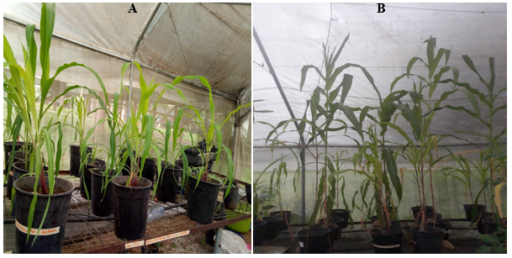
Figure 4. Appearance of corn plants in pots under greenhouse conditions (A = Beginning of the vegetative period; B = During the vegetative growth period)

Figure 5 illustrates the growth stage of corn plants grown in open fields, amended with biochar produced from cassava root peels, as well as with NPK chemical fertilizer (12-22-22) and controls without amendment. The figure shows the plants at an advanced stage of their vegetative phase, after application of biochar and chemical fertilizer. Significantly greater growth is observed in the treated plants, with thicker stems and more and larger leaves. This image suggests an improvement in the vegetative growth of the corn, potentially linked to the soil amendment with biochar and chemical fertilizer.

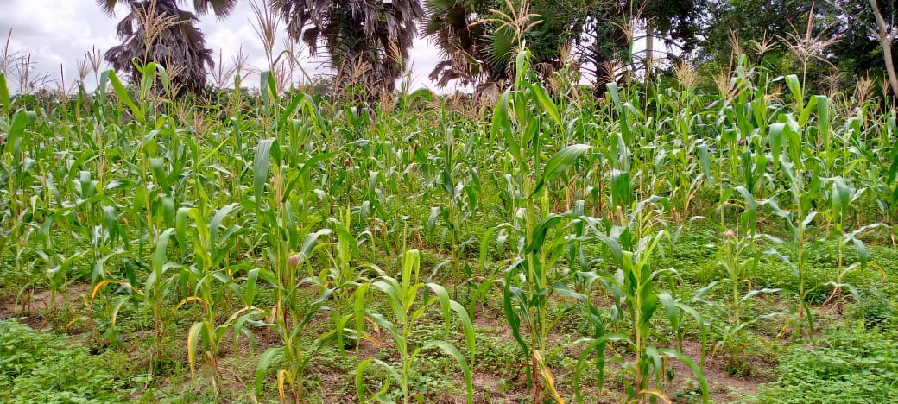
Figure 5. Corn plants in the field
3.1 Assessment of soil fertility levels-Y prior to testing
The soil-Y has a low fertility level (Table V). The pH-water is high, which may be favorable for nutrient availability (Hamissou et al., 2025). However, the total nitrogen (Nt) content is low, which limits fertility in terms of this essential element. The carbon/nitrogen ratio (C/Nt) is also low, indicating a low capacity for organic matter decomposition. Organic matter (OM) is very low, which affects soil structure and its ability to retain water and nutrients. In addition, the availability of assimilable phosphorus (P.ass) and cation exchange capacity (CEC) are very low, which limits the absorption of nutrients by plants. Furthermore, the low concentration of potassium (K+) is another factor limiting the fertility of this soil (Hamissou et al., 2025).
Table V: Soil fertility level of the study
Features | pH-eau | C/Nt | Nt | MO | P.ass | CEC | K⁺
Units |  |  | (%) |  | cmol/kg
Soil-Y | High | Low | Low | Very low | Very low | Very low | Very low

3.2 Effects of biochar on corn growth parameters
Table VI presents the results of the experiment on corn growth based on different doses of biochar added to the soil. The growth parameters measured were corn stalk height, corn stalk diameter, and number of corn stalk leaves. The analyses show that the soil responds differently to the addition of biochar. This variability can be attributed to the unique properties of each soil type, such as texture, structure, fertility, and pH, which influence the interaction between biochar and soil (Cissé, 2022).
Table VI. Variation in corn growth parameters under biochar amendments in a greenhouse on the studied soil
Soil type | Treatment | Average corn stalk height (cm) | Average corn stalk diameter (mm) | Average number of corn stalk leaves
Soil-Y | 2 % biochar | 63.00 ± 2.64^{b} | 4.67 ± 1.27^{b} | 7 .00 ± 1.00^{ab}
Soil-Y | 5 % biochar | 179.33 ± 1.16ª | 8.93 ± 2.25ª | 7.67 ± 0.58ª
Soil-Y | 10 %  biochar | 44 ± 3.61^{c} | 3.60 ± 0.26^{b} | 5.33 ± 1.52^{b}
Soil-Y | Control | 50.33 ± 4.93^{c} | 4.60 ± 0.90^{b} | 7.67 ± 1.53ª
Values followed by the same letter in each column are not statistically different at the α <0.05 threshold according to Fischer's test.
The results presented in the table above highlight significant differences for each of the growth parameters. Treatment with 5% biochar produced the best results for all corn growth parameters.
At 5% biochar, the average stalk height was 179.33 cm. The 2% treatment produced stalks of 63 cm, while the control produced stalks of 50.33 cm. The 10% treatment showed a sharp decrease in stem height (44 cm). Stem diameter followed a similar trend, with a maximum of 8.93 mm at 5%, compared to 4.67 mm at 2% and 3.6 mm at 10%. The number of leaves was relatively stable at 5% and 7.67 leaves for the control, while the 2% treatment produced 7 leaves and the 10% treatment produced the lowest number of leaves (5.33).
These results reveal a significant increase in the height and diameter of corn stalks compared to other doses and controls. These observations are similar to those of Cissé (2022), who demonstrated the positive impact of biochar on corn growth. However, at 10% biochar, a drastic reduction in these parameters was observed in all soil types. This could be explained by a non-linear response and possible toxicity at high doses. Studies such as that by Muthaura et al. (2017) have shown that moderate application of amendments can improve corn growth, while excessive doses can reduce growth by negatively affecting plant metabolism. The work of Bitew and Workie (2017) highlights the importance of soil nutrient balance for optimal crop growth, which could explain the variations in results depending on soil type and biochar dose.
3.3 Effects of biochar on corn grain yield in greenhouses
During greenhouse corn trials, no grain yield was observed. This lack of production can be explained by climatic conditions that are unfavorable for food crops in this type of environment. Corn is a light-demanding plant; a lack of natural light or insufficient artificial lighting can slow its growth. In addition, corn pollination, which is mainly wind-pollinated, is limited in greenhouses due to poor air circulation. As a result, pollen from male flowers (panicles) does not effectively reach the silks of female flowers, compromising ear formation (Kabongo, 2018; Nielsen, 2018).
3.4 Impact of biochar on the physicochemical parameters of greenhouse soil
Soils amended with 5% biochar were characterized in order to determine the impact of biochar on physicochemical parameters and compare them with control soils. Tables VII and VIII present the results of the physicochemical parameters of soils with 5% biochar and control soils after the greenhouse pot trial with corn.
Table VII. Physical characteristics of soils after the greenhouse corn cultivation trial
Treatment |  | Clay (%) |  | Fine limon (%) |  | Coarse limon (%) |  | Fine sand (%) |  | Coarse sand (%)
Soil-Y | Control |  | 2 ± 0.77 |  | 1 ± 0.77 |  | 26.15 ± 1.07 | 2.6 ± 0,02 | 67.91 ± 1.08
Soil-Y | 5 %  Biochar |  | 8.5 ± 0.45 |  | 14 ± 0.07 |  | 4.1 ± 0.08 | 22.6 ± 0.00 | 48.93 ± 0.03

Table VIII. Chemical characteristics of soils after the greenhouse corn cultivation trial
Parameters |  |  | pH-eau | C | Nt | MO | C/Nt | P.ass | CEC | Ca²⁺ | Mg²⁺ | K⁺ | Na⁺
 | Treatement |  | - | (%) |  |  | - | (cmol(+)/kg)
Soil-Y |  | Control | 6.8  ± 0.13 | 0.22  ± 0.10 | 0.04  ± 0.07 | 0.37  ± 0.10 | 5.5  ± 1.96 | 4,03  ± 0,30 | 4.56  ± 1.06 | 0.55  ± 0.07 | 0.49  ± 1.07 | 0.06  ± 1.07 | 0.11  ± 1.06
 |  | 5 % biochar | 6.2  ± 0.10 | 1.09  ± 0.00 | 0.08  ± 0.19 | 1.87  ± 0.00 | 14  ± 0.01 | 8.55  ± 0.08 | 5.2  ± 0.05 | 2.74  ± 0.08 | 1.05  ± 0.97 | 0.11  ± 2.17 | 0.12  ± 0.00

The addition of 5% biochar led to a significant increase in the proportion of clay (from 2% to 8.5%) and fine silt (from 1% to 14%), accompanied by a decrease in coarse sand (from 67.91% to 48.93%). These improvements can be explained by the presence of biochar, which has the ability to modify soil structure, improve water retention, and make nutrient resources more available (Table VII).
From a chemical perspective, adding 5% biochar slightly increased the pH of all soils, making them slightly more acidic, which is favorable for nutrient availability. The levels of carbon, organic matter, total nitrogen, available phosphorus, and cation exchange capacity (CEC) increased significantly with the addition of 5% biochar to all soils. Ca²⁺, Mg²⁺, and K⁺ contents also increased with the addition of 5% biochar in all soils, but no increase in Na⁺ content was observed. The increase in these soil nutrients could be explained by the addition of biochar, which is a matrix capable of improving soil fertility and structure (Glaser et al., 2002). There was also a drastic decrease in the C/Nt ratio after the addition of 5% biochar, which is close to the optimal range (10-20), which is beneficial for the crop. This could be explained by the increase in chemical parameters (carbon, total nitrogen) after the addition of 5% biochar. This result is consistent with those found by Lehmann and Joseph (2015a), who explain that the C/Nt ratio is a very important parameter for measuring soil microorganism activity and the degree of nutrient mineralization.
3.5 Effects of biochar and NPK on corn growth
Table IX shows the effect of different doses of biochar and NPK fertilizer (12-22-22) on corn growth, with the following parameters: average height, average diameter, and average number of leaves measured.
Table IX. Variation in corn growth parameters under biochar and NPK (12-22-22) amendments in open fields on Yamoussoukro soil (Sol-Y).
Doses | Average corn height (cm) |  |  | Average corn diameter (mm) | Average number of corn leaves
2 t/ha of Biochar |  |  | 232 .17±0.76^{b} | 28.37±0.35^{b} | 13.33±0.58^{ab}
250 Kg/ha of NPK (12-22-22) |  | 240.17±0.76ª |  | 29.27±0.35ª | 14.33±0.58ª
Control |  |  | 99.67±0.58^{c} | 11.93±0.21^{c} | 10.67±1.53^{b}
Values followed by the same letter in each column are not statistically different at the α <0.05 threshold according to Fischer's test. 2 t/ha of Biochar
The analyses show a significant difference at all dosage levels and for each parameter. Treatment with NPK chemical fertilizer (12-22-22) at a dosage of 250 kg/ha produced the best results, with an average height of 240.17 cm, an average stem diameter of 29.27 mm, and an average number of leaves of 14.33. Biochar applied at a rate of 2 t/ha also promoted growth, with an average height of 232.17 cm, an average diameter of 28.37 mm, and an average number of leaves of 13.33. In contrast, the untreated control showed significantly lower values, with an average height of 99.67 cm, an average diameter of 11.93 mm, and an average number of leaves of 10.67.
These results show that the application of NPK (250 kg/ha) promotes the highest corn growth (240.17 cm), closely followed by biochar at 2 t/ha (232.17 cm), while the control without fertilization produced the shortest plants (99.67 cm). The differences in height are significant, indicating that both NPK and biochar stimulate corn height growth, with statistically higher efficacy for NPK, due to the rapid availability of nutrients in chemical fertilizers compared to organic amendments such as biochar (Du et al., 2021). Stem diameter followed a similar trend, with the largest diameter for the NPK treatment (29.27 mm), followed by biochar (28.37 mm), and the control showing the smallest diameter (11.93 mm). These differences are significant and confirm the advantage of NPK in promoting more robust stem growth thanks to its rapidly assimilable nutrients (Pahalvi et al., 2021). In terms of leaf number, the NPK treatment produced the highest number (14.33), followed by biochar (13.33), while the control had the lowest number (10.67). Although the differences are less pronounced, they remain significant, suggesting that chemical fertilizers promote better leaf production. In addition, biochar improves water retention, soil structure, and nutrient availability, thereby contributing to plant growth (Bagheri et al., 2023; Du et al., 2021).
3.6 Impact of biochar and NPK on corn yield in the field
Figure 6 shows the effect of different doses of biochar amendment and NPK fertilizer on corn yield.
The corn yield with the application of 2 tons of biochar per hectare is around 3.94 t/ha. This value is statistically similar to the yield obtained with the application of NPK and significantly higher than the control. This result is higher than that obtained by Cissé (2022). The latter found a corn yield of 3.441 t/ha after treating 2.5 tons of biochar per hectare. Treatment with 250 kg/ha of NPK yielded a slightly higher yield (4.06 t/ha) than the yield obtained with biochar, but statistically the difference is not significant. The corn yield obtained by the control is 1.33 t/ha, which is significantly lower than the yields obtained with the other two treatments. This confirms that biochar could be a viable alternative or complement to chemical fertilizers, particularly in the context of sustainability and long-term soil management (Agegnehu et al., 2016; Jeffery et al., 2011).
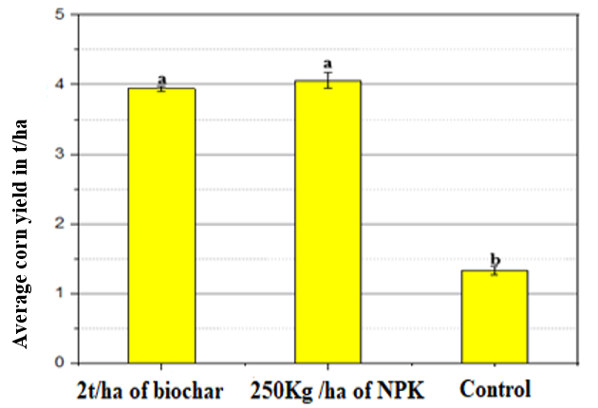

Figure 6. Variation in corn yield depending on treatment

3.7 Weight of 1000 grains depending on treatment
The weight of 1,000 grains is a very important parameter for characterizing grain quality. Indeed, a high grain yield does not always mean a good yield in terms of quality. The more organic matter the plant accumulates in its grains, the higher the weight of 1,000 grains, and vice versa (Outéndé, 2016). Figure 7 shows the average weight of 1,000 corn grains according to treatment.
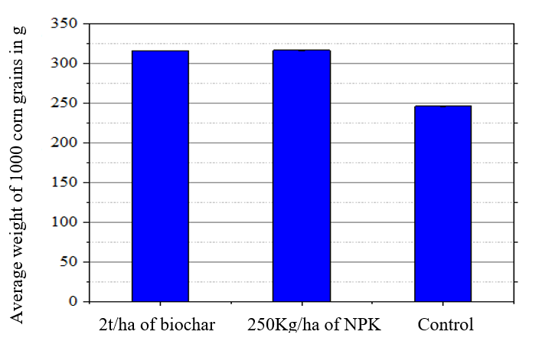
Figure 7. Average weight of 1,000 corn kernels according to treatment
The weight of 1,000 corn kernels with the application of 2 tons per hectare of biochar is 315.63 g, showing a significant increase compared to the control. This indicates an improvement in grain quality. With the application of 250 kg/ha of NPK (12-22-22), the weight of 1,000 grains is 316.5 g, slightly higher than that obtained with biochar, although the difference between the two treatments is not significant. The average weight of grains from the control plot was 246 g, significantly lower than that obtained with the biochar and NPK treatments. This difference highlights the positive impact of these amendments on grain quality. The differences between the biochar and NPK treatments in terms of grain weight were minimal and not significant, confirming that both treatments are effective in improving grain quality. These results confirm the observations made on corn yield. As a sustainable amendment, biochar may be of particular interest for sustainable agricultural practices, as it improves not only grain quality but also long-term soil health (Jeffery et al., 2011).

Conclusion
The study highlights the diverse effects of biochar applied at different concentrations on corn growth and soil properties. For corn grown in greenhouses, a concentration of 5% biochar proves to be optimal, promoting growth in height, stem diameter, and number of leaves, while improving soil properties. However, higher concentrations (10%) tend to hinder corn growth, potentially due to toxicity or inadequate use of resources by the plant. In addition, the application of 250 kg/h of NPK stands out as the best option for corn growth in open fields, slightly surpassing the effectiveness of biochar at 2 t/h. Fertilization treatments, whether biochar or NPK, significantly improve corn yield compared to the untreated control. Although NPK appears to be slightly more effective in terms of grain weight, the difference is not statistically significant. These results highlight the importance of amendments in increasing agricultural productivity, with biochar offering additional benefits in terms of sustainability and soil health, in line with recent literature. These results confirm the importance of amendments for tomato cultivation, in line with existing literature.
References
AFNOR NF V03-702, 1981. Methods for determining the weight of 1,000 grains.
Agegnehu, G., Bass, A.M., Nelson, P.N., Bird, M.I., 2016. Benefits of biochar, compost and biochar–compost for soil quality, maize yield and greenhouse gas emissions in a tropical agricultural soil. Science of The Total Environment 543, 295–306. https://doi.org/10.1016/j.scitotenv.2015.11.054
Amonmide, I., Dagbenonbakin, G., Agbangba, E., Akponikpe, I., 2019. Contribution to the assessment of soil fertility levels in cotton-based cropping systems in Benin. International Journal of Biological and Chemical Sciences 13, 1846. https://doi.org/10.4314/ijbcs.v13i3.52
Anderson, J.M., Ingram, J.S.I., 1994. Tropical Soil Biology and Fertility: A Handbook of Methods. Soil Science 157, 265. https://doi.org/10.1097/00010694-199404000-00012
Appiah, E., Essilfie, M.E., Asiedu, E.K., Owusu, S.E., 2025. Effect of Biochar, NPK, and Poultry Manure on Yield Productivity of Maize under Rainfed Conditions. Journal of Scientific Research and Reports 31, 1080–1105. https://doi.org/10.9734/jsrr/2025/v31i63199
Bagheri Novair, S., Cheraghi, M., Faramarzi, F., Asgari Lajayer, B., Senapathi, V., Astatkie, T., Price, G.W., 2023. Reviewing the role of biochar in paddy soils: An agricultural and environmental perspective. Ecotoxicology and Environmental Safety 263, 115228. https://doi.org/10.1016/j.ecoenv.2023.115228
Baillie, I., 2009. Amazonian Dark Earths: Wim Sombroek&#39;s Vision - by Woods, W.I., Teixeira, W.G., Lehmann, J., Steiner, C., WinklerPrins, A.M.G.A. &amp; Rebellato, L. (editors). European Journal of Soil Science 60, 1126–1127. https://doi.org/10.1111/j.1365-2389.2009.01179.x
Baize, D., 2018. Guide des analyses en pédologie 1–328. https://www.quae.com/produit/1643/9782759228379/guide-des-analyses-en-pedologie
Bitew, Y., Workie, M., 2017. Impact of Crop Production Inputs on Soil Health: A Review. Asian Journal of Plant Sciences 16, 109–131. https://doi.org/10.3923/ajps.2017.109.131
Bivoko, D.R.R., Ahonzo-Niamke, S.L., Zeze, A., 2013. Impact des proprietes physicochimiques des sols de culture du manioc sur l’abondance et la diversite des communautes de champignons mycorhiziens à arbuscules dans la zone agroecologique d’azaguie, Sud-Est de la Côte D’Ivoire. Agronomie Africaine 25, 251–264. https://www.ajol.info/index.php/aga/article/view/100655
Bremner, J.M., 1960. Determination of nitrogen in soil by the Kjeldahl method. The Journal of Agricultural Science 55, 11–33. https://doi.org/10.1017/S0021859600021572
Brown, M.B., Forsythe, A.B., 1974. The Small Sample Behavior of Some Statistics Which Test the Equality of Several Means. Technometrics 16, 129–132. https://doi.org/10.2307/1267501
Cissé, D., 2022. Effects of biochar-based amendments on agro-pedological parameters in a cotton-corn rotation in western Burkina Faso. ULiège - University of Liège, Gembloux, Belgium. https://orbi.uliege.be/handle/2268/266942
Doucet, R., 2006. Le climat et les sols agricoles - Editions Berger Inc. [WWW Document]. URL https://www.editionsberger.com/fr/agriculture/le-climat-et-les-sols-agricoles (accessed 4.15.24). https://www.editionsberger.com/fr/agriculture/le-climat-et-les-sols-agricoles
Du, Q.-J., Xiao, H.-J., Li, J.-Q., Zhang, J.-X., Zhou, L.-Y., Wang, J.-Q., 2021. Effects of different fertilization rates on growth, yield, quality and partial factor productivity of tomato under non-pressure gravity irrigation. PLoS One 16, e0247578. https://doi.org/10.1371/journal.pone.0247578
Frimpong, K.A., Phares, C.A., Boateng, I., Abban-Baidoo, E., Apuri, L., 2021. One-time application of biochar influenced crop yield across three cropping cycles on tropical sandy loam soil in Ghana. Heliyon 7, e06267. https://doi.org/10.1016/j.heliyon.2021.e06267
Glaser, B., Lehmann, J., Zech, W., 2002. Ameliorating physical and chemical properties of highly weathered soils in the tropics with charcoal - a review. Biology and Fertility of Soils 35, 219–230. https://doi.org/10.1007/s00374-002-0466-4
Hamissou, I.G., Konan, A.T.S., Marius, K., Garba Labo, M.N., Mahamane Nassirou, A.K., Brou, Y., Benjamin, Y., 2025. Impact of Biochar and NPK Fertilization on Tomato (Solanum lycopersicum L.) Growth, Yield and Soil Properties in Degraded Tropical Soils. Annual Research & Review in Biology 40, 136–150. https://doi.org/10.9734/arrb/2025/v40i102328
Hamissou, I.G.M., Appiah, K.E.K., Sylvie, K.A.T., Ousmaila, S.M., Casimir, B.Y., Benjamin, Y. kouassi, 2023. Valorization of cassava peelings into biochar: Physical and chemical characterizations of biochar prepared for agricultural purposes. Scientific African 20, https://doi.org/10.1016/j.sciaf.2023.e01737
Hou, L., Wang, Y., Wang, Z., Gao, R., Zhou, X., Yang, S., Luo, X., Jiang, Z., Liu, Z., 2025. Effects of Biochar on Soil Quality in a Maize Soybean Rotation on Mollisols. Agronomy 15, 1226. https://doi.org/10.3390/agronomy15051226
Jeffery, S., Verheijen, F.G.A., van der Velde, M., Bastos, A.C., 2011. A quantitative review of the effects of biochar application to soils on crop productivity using meta-analysis. Agriculture, Ecosystems & Environment 144, 175–187. https://doi.org/10.1016/j.agee.2011.08.015
Kabongo, J.P.T., 2018. Evaluation of the sensitivity to water stress of corn (Zea mays L.) cultivated in the savannah of southwestern DR Congo, case study of Mvuazi. National Pedagogical University, Kinshasa 1.
Lehmann, J., Joseph, S., 2015. Biochar for Environmental Management: Science, Technology and Implementation. Routledge. https://doi.org/10.4324/9780203762264
Li, C., Zhao, C., Zhao, X., Wang, Y., Lv, X., Zhu, X., Song, X., 2023. Beneficial Effects of Biochar Application with Nitrogen Fertilizer on Soil Nitrogen Retention, Absorption and Utilization in Maize Production. Agronomy 13, 113. https://doi.org/10.3390/agronomy13010113
Mohamed, I., El-habbak, A.K., Abbas, M.H., Scopa, A., Drosos, M., AbdelRahman, M.A.E., Bassouny, M.A., 2024. Rice straw biochar and NPK minerals for sustainable crop production in arid soils: a case study on maize-wheat cropping system. CABI Agriculture and Bioscience 5, 91. https://doi.org/10.1186/s43170-024-00289-0
Muthaura, C., Mucheru-Muna, M., Zingore, S., Kihara, J., Muthamia, J., 2017. AND YIELD PARAMETERS OF MAIZE (Zea mays), CASE OF 12. http://www.arpnjournals.com/jabs/volume_12_no_1_jan_2017.htm
Nielsen, S., Joseph, S., Ye, J., Chia, C., Munroe, P., Zwieten, L. van, Thomas, T., 2018. Crop-season and residual effects of sequentially applied mineral enhanced biochar and N fertiliser on crop yield, soil chemistry and microbial communities. Agriculture, Ecosystems & Environment 255, 52–61. https://doi.org/10.1016/j.agee.2017.12.020
Olsen, S.B., 1952. Measurement of Surface Phosphate on Hydroxylapatite and Phosphate Rock with Radiophosphorus. J. Phys. Chem. 56, 630–632. https://doi.org/10.1021/j150497a016
Outéndé TOUNDOU, 2016. Evaluation of the chemical and agronomic characteristics of five waste composts and study of their effects on soil chemical properties, physiology, and yield of corn (Zea mays L. Var. Ikenne) and tomato (Lycopersicum esculentum L. Var. Tropimech) under two water regimes in Togo. https://aurore.unilim.fr/ori-oai-search/notice/view/2016LIMO0020
Pahalvi, H., Majeed, L., Rashid, S., Nisar, B., Kamili, A., 2021. Chemical Fertilizers and Their Impact on Soil Health. pp. https://link.springer.com/chapter/10.1007/978-3-030-61010-4_1
Pansu, M., Gautheyrou, J., Aventurier, A., Feller, C., Bottner, P., 2003. L’analyse du sol : minéralogique, organique et minérale.
R.L. (Bob) Nielsen, 2018. Effects of Severe Stress During Grain Filling in Corn [WWW Document]. URL https://www.documentation.ird.fr/hor/fdi:010030120
Shapiro, S.S., Wilk, M.B., Chen, H.J., 1968. A Comparative Study of Various Tests for Normality. Journal of the American Statistical Association 63, 1343–1372. https://www.tandfonline.com/doi/abs/10.1080/01621459.1968.10480932
Staff, S.S., 1998. Keys to Soil Taxonomy, United States Department of Agriculture. Natural Resources Conservation Service, Washington, DC.
Sun, J., Lu, X., Wang, S., Tian, C., Chen, G., Luo, N., Zhang, Q., Li, X., 2023. Biochar Blended with Nitrogen Fertilizer Promotes Maize Yield by Altering Soil Enzyme Activities and Organic Carbon Content in Black Soil. Int J Environ Res Public Health 20, 4939. https://www.mdpi.com/1660-4601/20/6/4939
Walkley et Black, P., 1934. Walkley-Black Method Soil Organic Matter Application and Principle.
Yang, W., Feng, G., Jia, Y., Yang, Y., Gao, X., Gao, L., Qu, Z., 2022. Impact of single biochar application on maize growth and water-fertilizer productivity under different irrigation regimes. Front Plant Sci 13, 1006827. https://www.frontiersin.org/articles/10.3389/fpls.2022.1006827/full

