Evaluating Genetic Variation and Multi-Trait Selection in Soybean Genotypes for Enhanced Yield

ABSTRACT:
Aims: Present investigation was conducted to evaluate 42 soybean genotypes along with two commercial check varieties (JS 335 and Basara) for grain yield and attributing traits to identify best lines for yield and yield attributing trait, understanding of nature and magnitude of variability among the advanced lines and to know the association among the traits under study
Study design: Randomized block design with 3 replications
Place and Duration of Study: Present study was conducted at research farm of Agricultural Research Station, Adilabad, PJTAU, Telangana, India for two seasons, kharif, 2023 and kharif, 2024.
Methodology: 42 genotypes were evaluated agaist two checks and the data was recorded on days to 50% flowering, plant height (cm), days to maturity, number of branches per plant, number of pods per plant, number of clusters per plant, 100 seed weight (g) on five randomly selected plants on each genotype in all the three replicates using standard procedure(IBPGR 1984). Grain yield was recorded in kg on plot basis for each genotype in all replications. Then converted to kg /ha using conversion factor. The broad-sense heritability (h2BS), selection differential (SD), selection differential percentage (SD %) and selection gain in percentage (SG %) were calculated as per standard formula.
Results: The genotype ADSb 146 (3023 kg/ha) produced the highest mean grain yield followed by ADSb 109 (2748 kg/ha) ADSb 45 (2613 kg/ha) and ADSb 94 (2478 kg/ha) compared to the best check variety JS 335 (2338 kg/ha) across the seasons. The MGIDI was calculated to identify best genotypes when considering all measured traits. Based on MGIDI index, Basara, JS 335, ADSb 150 and ADSb 124 genotypes were selected as the best genotypes in both seasons. Through correlation, it was found that across the two seasons, days to 50% flowering, days to maturity, number of pods per plant and number of clusters per plant was significantly and positively correlated with grain yield.
Discussion: ADSb 146, ADSb 109, ADSb 45 and ADSb 94 were found superior for yield across the seasons. Based on MGIDI index, Basara, JS 335, ADSb 150 and ADSb 124 genotypes were selected as the best genotypes. These genotypes were valuable resources for the direct release as varieties or for large-scale testing under AICRP trials.

Key words: Soybean; MGIDI; correlation; cluster analysis
- INTRODUCTION:
Soybean (Glycine max (L.) Merr.) is one of the important leguminous crops in the world, as it provides more than one-quarter of the world’s protein for human and animal consumption (Graham and Vance 2003). Globally, approximately 362 million metric tonnes of soybean is produced per year. Further, in India soybean is grown across an area of 11.90 m ha with production of 11.8 million metric tonnes (SOPA 2021). However, in India its productivity (~1.0 t/ha) is far below the world average (2.5 t/ha). Among various factors, pest and diseases are the most important ones responsible for low productivity in some of the major soybean growing countries including India (Maranna et al.2021). Currently India imports total edible oil worth USD 12.35 billion and soybean oil worth USD 2.4 billion (DGCIS 2020). Therefore, to reduce the edible oil imports, soybean breeders need to breed high yielding and disease resistant cultivars to make soybean cultivation sustainable in India. Worldwide soybean yield potential is restricted by the narrow genetic variation in G. max, hindering the potential for breeding soybean varieties with high environmental stress tolerance and resistance traits. Soybean possesses a narrow genetic base and in fact the varieties developed and released for cultivation can be traced back to only a few genotypes (Delannay et al. 1983; Gizlice et al. 1994; Bisen et al. 2015; Kumawat et al. 2015). Narrowing of soybean’s genetic base has been brought about by domestication and plant breeding processes. However, it has helped in achieving tremendous gains in yield potential, largely through hybridization between elite soybean cultures across the world (Thorne and Fehr 1970). Several means and methods are available to broaden the narrow genetic base, such as use of exotic germplasm in varietal development, use of wild species accessions for transfer of useful genes into the elite and adapted genetic background, and development of the breeding population by involving multi-parents.
Precise estimation of genotypic values is critical for selection and recommendation of any genotype. Breeders often target multiple traits during the selection process, in addition to the yield performance. Multi-trait-based selections are often carried out using a linear-selection index: Smith-Hazel (SH) index 26. However, the multi-collinearity effect and irrational allocation of weightage coefficients to the traits under study, renders the SH index ineffective in achieving the desired genetic gain 27. A recent multivariate selection index, MGIDI that negates these drawbacks was found to outperform the SH index 28.
To overcome the limitations of previously reported selection indices, the multivariate selection index genotype–ideotype distance index (MGIDI) (Olivoto and Nardino. 2020) has been developed, which accounts for the multi-collinearity and considers all the traits favourably. It provides a unique selection process that facilitates the fine tuning of stability and mean performance by considering multiple traits based on positive or negative selection differential required for a particular trait.
Multivariate analysis tools such as principal component analysis (PCA) and linear discriminant analysis have been extensively used in filed experiments (Ekka et al., 2021;Urun et al., 2021). These analyses were successfully employed to establish a relationship between traits but ranking of treatments based on single trait values remains a challenge. Multivariate approaches are needed to provide strategic treatment ranking considering value on multiple traits. To overcome limitations, multi-trait genotype-ideotype distance index (MGIDI) has been proposed (Olivoto & Nardino, 2021) and has been successfully used to select superior genotypes (Aboughadareh et al., 2021; Caballero et al., 2022; Farhad et al., 2022; Leon et al., 2021; Olivoto & Nardino, 2021; Uddin et al., 2021).
With this background the current investigation was performed with the following objectives – (i) development and evaluation of advanced breeding lines for yield and yield attributing trait ii) understanding of nature and magnitude of variability among the advanced lines iii) To know the association among the traits under study
2. MATERIALS AND METHODS
2.1 EXPERIMENTAL SITE
The experiments were conducted over two seasons at Agricultural Research Station, Adilabad, PJTAU during kharif, 2023 and kharif, 2024. The handling of plant material used in the present investigation was carried out in accordance with relevant guidelines and regulations.

2.2 EXPERIMENTAL DETAILS
Evaluation of advanced breeding lines for grain yield and attributing traits. 42 soybean genotypes along with two commercial check varieties (JS 335 and Basara) (Table 2) were grown in three replicates with 5 rows of 3 metres length for each genotype. The 42 were evaluated for two seasons, kharif, 2023 and kharif, 2024 (June–October) at research farm of Agricultural Research Station, Adilabad, PJTAU, Telangana, India to select the best genotypes. The data on days to 50% flowering, plant height (cm), days to maturity, number of branches per plant, number of pods per plant, number of clusters per plant, 100 seed weight (g) were recorded on five randomly selected plants on each genotype in all the three replicates using standard procedure(IBPGR 1984). Grain yield was recorded in kg on plot basis for each genotype in all replications. Then converted to kg /ha using conversion factor. The broad-sense heritability (h²_{BS),} selection differential (SD), selection differential percentage (SD %) and selection gain in percentage (SG %) were calculated as per standard formula (Olivoto and Nardino, 2020).
The details have been given below:
1. h² _{BS} = ( V_{gen}) / (V_{gen} +V_{res}),
Where V_{gen} = genotypic variance, V_{res} = residual variance.
2. SD=Xs−Xo where,
Xs =mean of the selected genotypes, Xo = mean of the original population.
3. (SD %) = (Xs –Xo) ×100

4. (SG %) = [(Xs –Xo) × h²_{BS} / Xo] ×100

2.3 DATA ANALYSIS
For the comparison of 44 genotypes including advanced breeding lines and check varieties, Analysis of Variance (ANOVA) was performed for each year of evaluation. All the analyses have were carried out using R software version 4.2.1 (R Core Team 2022). MGIDI index were calculated using R package ‘metan’ (Olivoto and Lucio, 2020). Correlation analysis has been carried out using R package “Performance-Analytics” (Peterson & Carl, 2018).
3. RESULTS AND DISCUSSION
In the present investigation, quantitative data of 44 soybean genotypes were subjected to ANOVA for 8 characters which are presented in Table 1. The mean sum of square was observed significant for all the characters studied indicating that there is sufficient variation among the treatments.
For grain yield, advance lines performed better than the best checks for both the years (Table 2). For instance, genotype ADSb 146 (3023 kg/ha) produced the highest mean grain yield followed by ADSb 109 (2748 kg/ha) ADSb 45 (2613 kg/ha) and ADSb 94 (2478 kg/ha) compared to the best check variety JS 335 (2338 kg/ha) across the seasons (Table 2). Similarly, 100-seed weight was the highest in the entry ADSb 149 (15.3 g) and ADSb 146 (15. 3 g) followed by ADSb 151 (15.2 g), ADSb 154 (15.2 g), whereas the best check variety, JS 335 recorded 12.7 g for 100-seed weight. The details of year-wise performance and variability of the 44 genotypes are presented in Table 2. and Fig. 1.
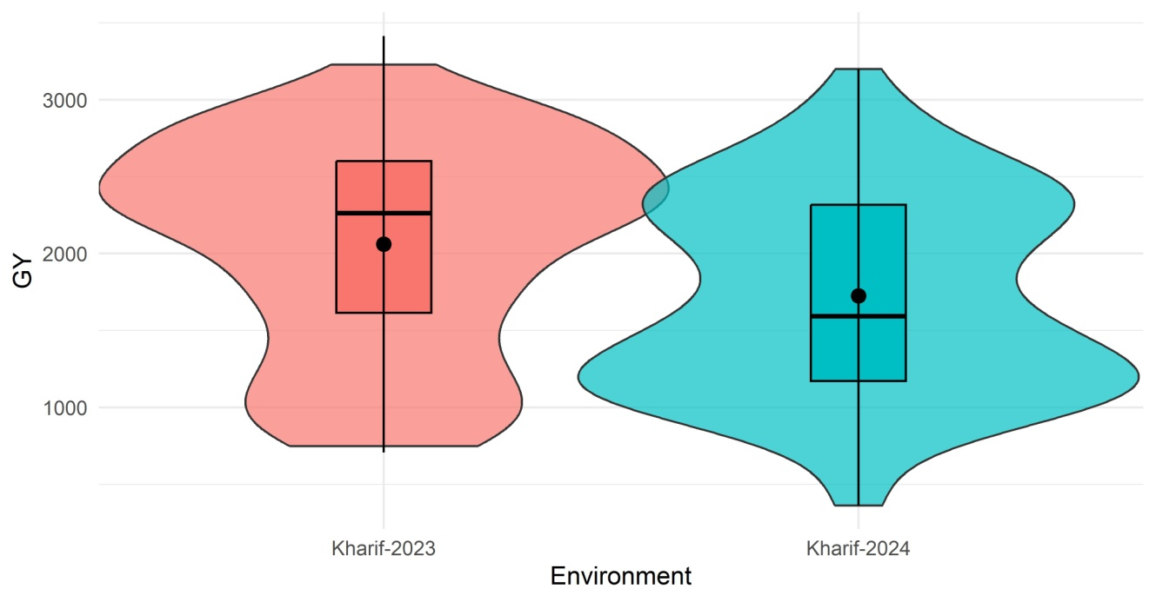

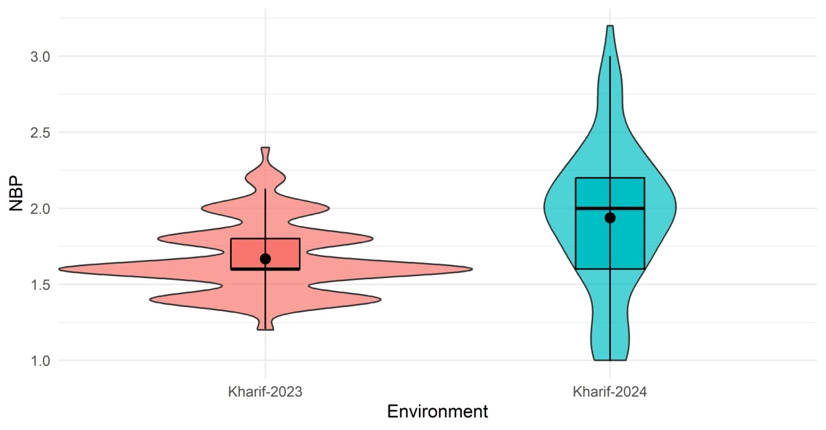

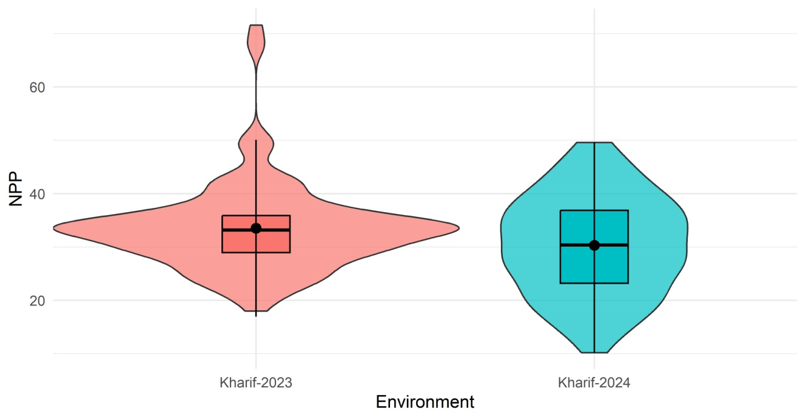

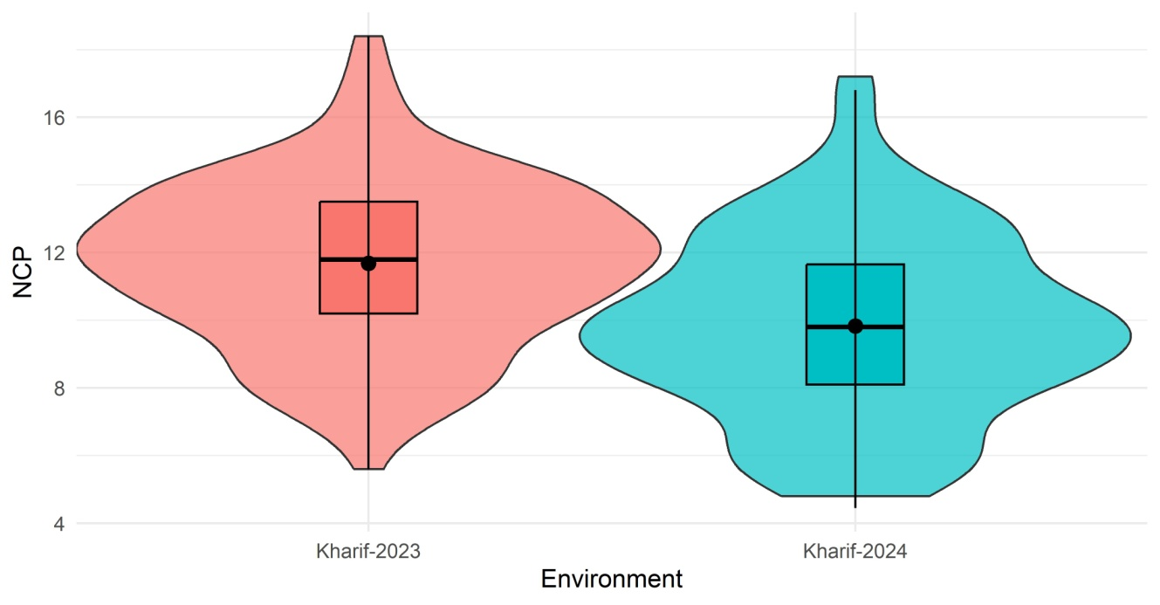

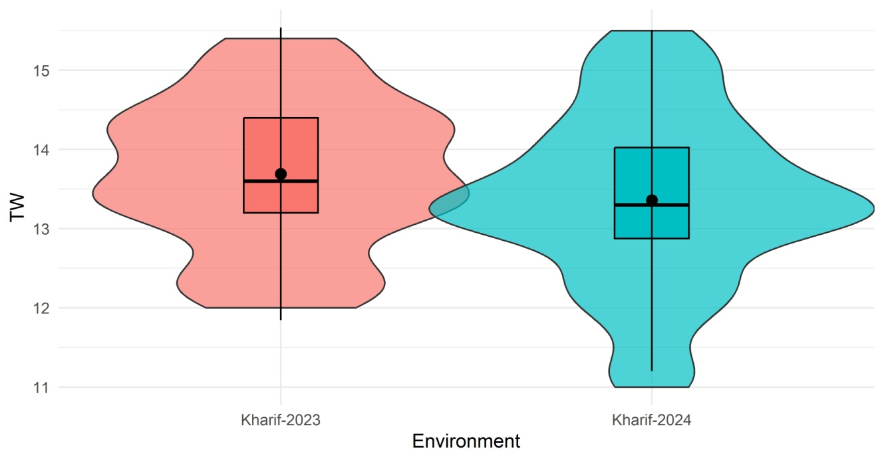

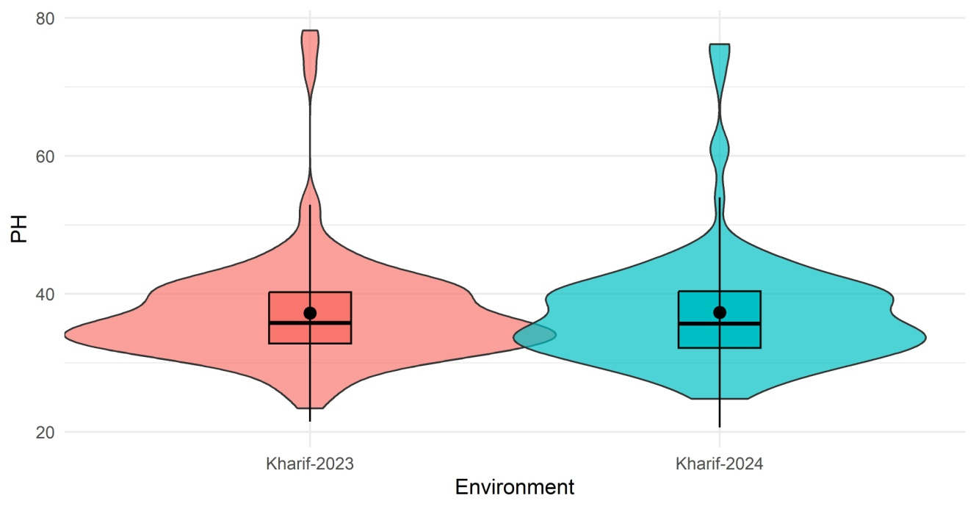

Fig. 1. Depiction of variability parameters in 42 advanced breeding lines and check varieties by violin plots

3.1 MEAN, SELECTION DIFFERENTIAL AND GENETIC GAIN

Overall mean of the genotypes was higher for grain yield (2061 kg/ha) for the 2023 season than in 2024 (1726 kg/ha). Similarly, means for other traits like number of pods per plant, number of cluster per plant and 100-seed weight were also higher in 2023 than 2024. Selection differential was also found to be higher for the traits like grain yield, number of cluster per plant, number of branches per pant and plant height in 2024 season than in 2023. Whereas selection gain was higher in 2024 for Selection of genotypes based on MGIDI all traits, except number of pods per plant and 100-seed weight. The heritability was found to be high for all the traits for both years (Table 3).
The MGIDI index was applied within each crop season to select genotypes that perform well in specific conditions; Based on the genetic gain, Basara, JS 335, ADSb 150 and ADSb 124 were selected in both thus exploiting narrow adaptations. The multi-trait genotype–ideotype distance index (MGIDI) was calculated to identify best genotypes when considering all measured traits. The broad-sense heritability (h²) ranged from 0.72–0.99 and 0.90–0.99 for the 2023 and 2024 seasons, respectively. Very high values of heritability were estimated for all traits under consideration, suggesting a strong likelihood of genetic gains. The genotypes selected using the MGIDI index were Basara, JS 335, ADSb 150, ADSb 154, ADSb 43, ADSb 124 and ADSb 58 for 2023 season (Fig. 2) Basara, JS 335, ADSb 107, ADSb 150, ADSb 152, ADSb 124 and ADSb 07 for 2024 season (Fig. 3). Further, Basara, JS 335, ADSb 150 and ADSb 124 genotypes were selected as the best genotype in both seasons.
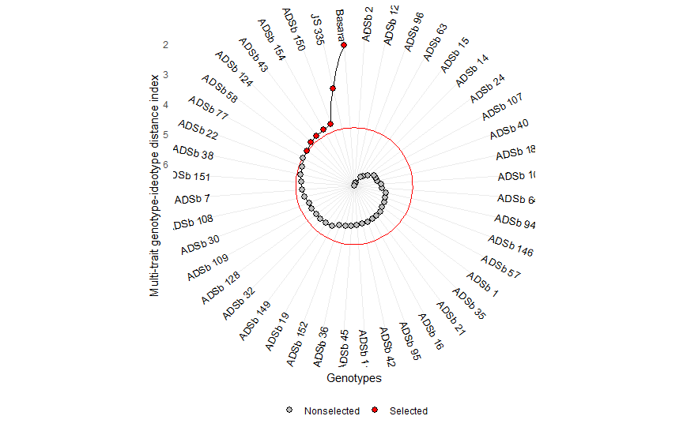
Fig.2. MGIDI index analysis for the 44 genotypes under study for selection of ideal genotypes during 2023
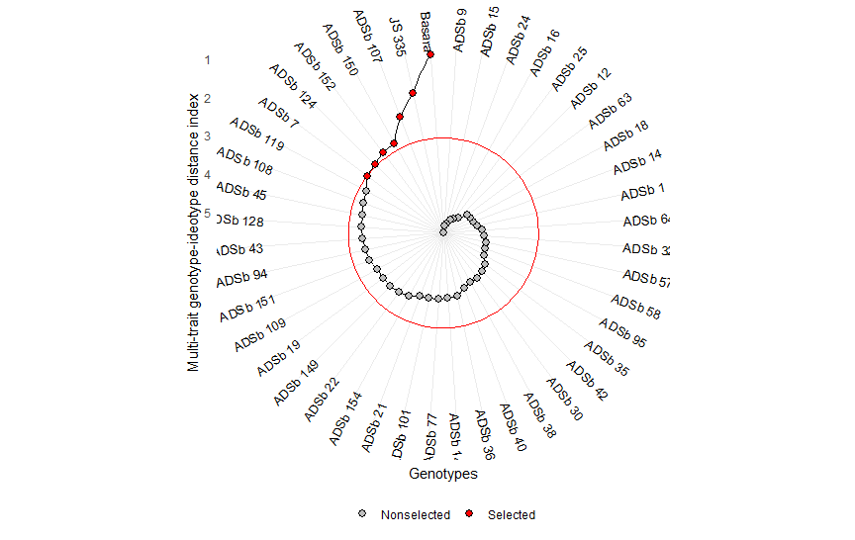
Fig.3. MGIDI index analysis for the 44 genotypes under study for selection of ideal genotypes during 2024
3.2 CORRELATION ANALYSIS
For correlation analysis, Grain yield was considered as dependent parameter and other parameters, namely, days to 50% flowering, days to maturity, Plant height, number of pods per plant, number of clusters per plant, number of branches per plant, and 100-seed weight were counted as independent parameters. Through correlation, it was found that across the two seasons days to 50% flowering, days to maturity, number of pods per plant and number of clusters per plant were significantly and positively correlated with grain yield. The details of association among the yield and attributing traits are presented in Figures 4.
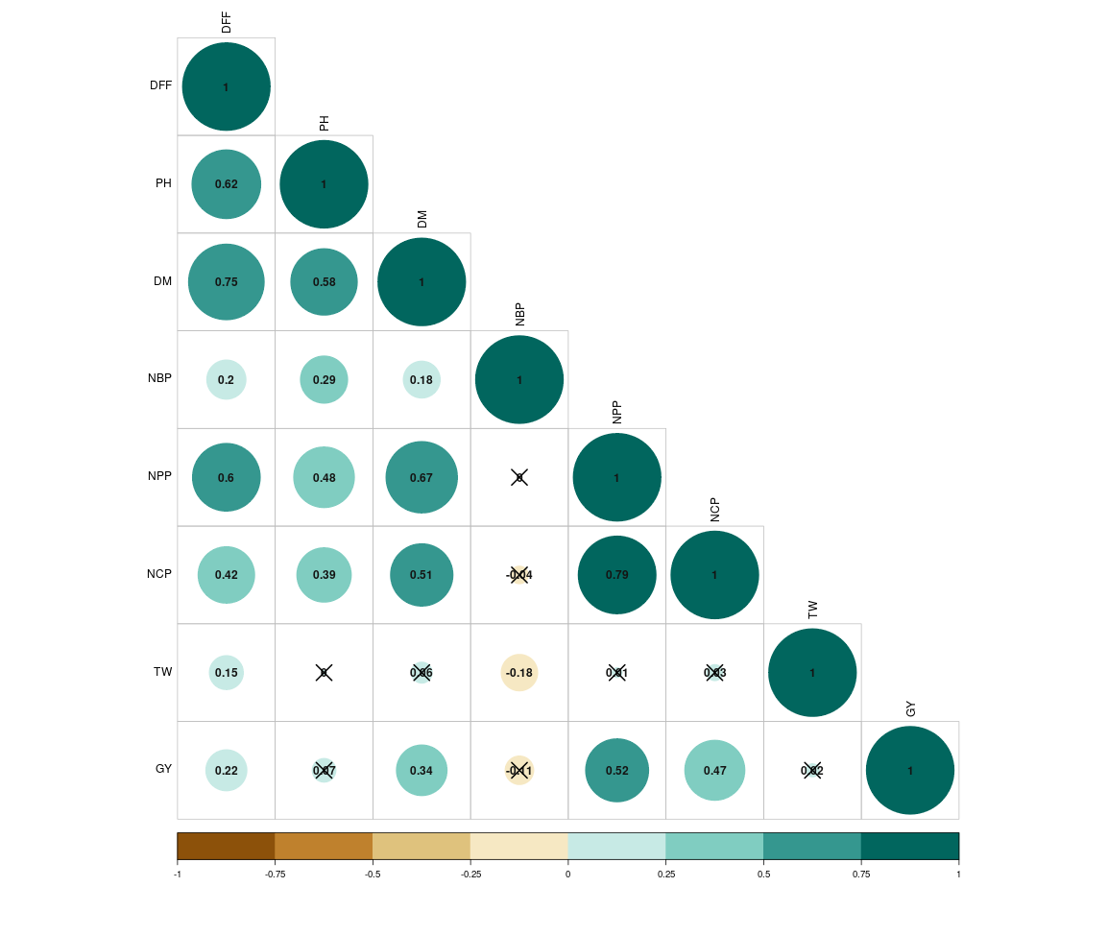
Fig.4. Association among the yield and attributing traits
Utility of MGIDI index in selecting ideal genotypes based on multiple traits has been demonstrated for yield attributing traits in soybean (Maranna et al., 2023; Maranna et al., 2021). The current study reports several genotypes superior based on MGIDI over two seasons. The current study made an attempt to dissect the performance of genotypes for yield and yield component traits in small field trial. Evaluation of genotypes in larger plot sizes is helpful in realized estimate of actual performance by reducing the error. Therefore, the superior genotypes identified from this study will be evaluated further in larger plots to check for their superiority over the best check varieties. Noteworthy to mention here that ADSb 109 ADSb 45 and ADSb 94 selected as superior over the best check variety and being evaluated under initial varietal trials (IVT) of All India Co-ordinated Research Project (AICRP) on soybean for its release as variety across the soybean growing areas in India. In the current study, the significant positive correlation of Grain yield was noticed with days to 50% flowering, days to maturity, number of pods per plant and number of clusters per plant as reported previously (Shivakumar et al., 2011; Maranna et al., 2021). The association indicated that direct positive selection for these traits helps in improvement of grain yield in soybean.

4. CONCLUSION
The study identified ideal genotypes performing over two seasons. ADSb 146, ADSb 109, ADSb 45 and ADSb 94 were found superior for yield across the seasons. Based on MGIDI index, Basara, JS 335, ADSb 150 and ADSb 124 genotypes were selected as the best genotypes. These genotypes were valuable resources for the direct release as varieties or for large-scale testing under AICRP trials.

REFERENCES

Aboughadareh, A., Sanjani, S., Chamanabad, N. H., Mehrvar, M. R., Asadi, A., & Amini, A. (2021). Identification of salt-tolerant barley genotypes using multiple-traits index and yield performance at the early growth and maturity stages. Bulletin of the National Research Centre, 45(1), Article 117. https://doi.org/10.1186/s42269-021-00576-0
Bisen, A., Khare, D., Nair, P., & Tripathi, N. (2015). SSR analysis of 38 genotypes of soybean (Glycine Max (L.) Merr.) genetic diversity in India. Physiology and Molecular Biology of Plants, 21, 109–115. https://doi.org/10.1007/s12298-014-0269-8
Osuna-Caballero, S., Rispail, N., Barilli, E., & Rubiales, D. (2022). Identification and characterization of novel sources of resistance to rust caused by Uromyces pisi in Pisum spp. Plants, 11(17), 2268 https://doi.org/10.3390/plants11172268
Delannay, X., Rodgers, D.M., & Palmer, R.G. (1983). Relative genetic contributions among ancestral lines to North American soybean cultivars. Crop Science, 23, 944–949. https://doi.org/10.2135/cropsci1983.0011183x002300050031x
DGCIS. (2020). Collection, compilation and dissemination of India’s Trade Statistics and Commercial Information. http://www.dgciskol.gov.in/
Ekka, A., Tirkey, A., & Kujur, N. (2021). Cluster and principal component analysis (PCA) in ashwagandha [Withania somnifera (L.) Dunal] for root traits. International Journal of Chemical Studies. https://doi.org/10.22271/chemi.2021.v9.i1ap.11687
Farhad, M., Tripathi, S. B., Singh, R. P., Joshi, A. K., Bhati, P. K., Vishwakarma, M. K., Mondal, S., Malik, A. A., & Kumar, U. (2022). Multi-trait selection of bread wheat ideotypes for adaptation to early sown condition. Crop Science, 62(1), 67–82. https://doi.org/10.1002/csc2.20628
Graham, P. H., & Vance, C. P. (2003). Legumes: importance and constraints to greater use. Plant Physiology. https://doi.org/10.1104/pp.017004
International Board for Plant Genetic Resources. (1984). Descriptors for soyabean. IBPGR Secretariat. https://hdl.handle.net/10568/72944
Leon, R., Rosero, A., García, J. L., Morelo, J., Orozco, A., Silva, G., de la Ossa, V., Correa, E., Cordero, C., Villalba, L., Belalcazar, J., & Ceballos, H. (2021). Multi-trait selection indices for identifying new cassava varieties adapted to the Caribbean region of Colombia. Agronomy, 11(9), 1694. https://doi.org/10.3390/Agronomy11091694
Maranna, S., Kumawat, G., Nataraj, V., Gill, B. S., Nargund, R., Sharma,A., Rajput, L. S., Ratnaparkhe, M. B., & Gupta, S. (2023). Development of improved genotypes for extra early maturity, higher yield and Mungbean Yellow Mosaic India Virus (MYMIV) resistance in soybean (Glycine max L.). Crop and Pasture Science, 74(12), 1165–1179. https://doi.org/10.1071/CP22339
Maranna, S., Nataraj, V., Kumawat, G., Chandra, S., Rajesh, V., Ramteke, R., Patel, R. M., Ratnaparkhe, M. B., Husain, S. M., Gupta, S., & Khandekar, N. (2021). Breeding for higher yield, early maturity, and wider adaptability and waterlogging tolerance in soybean (Glycine max L.): A case study. Scientific Reports https://doi.org/10.1038/s41598-021-02064-x
Olivoto, T., & Lúcio, A. D. (2020). metan: An R package for multi‐environment trial analysis. Methods in Ecology and Evolution, 11, 783–789. https://doi.org/10.1111/2041-210X.13384
Olivoto, T., & Nardino, M. (2021). MGIDI: toward an effective multivariate selection in biological experiments. Bioinformatics, 37(10), 1383–1389. https://doi.org/10.1093/bioinformatics/btaa981
Olivoto, T., & Nardino, M. (2021). MGIDI: Toward an effective multivariate selection in biological experiments. Bioinformatics, 37(10), 1383–1389. https://doi.org/10.1093/bioinformatics/btaa981
Peterson, B. G., & Carl, P. (2018). PerformanceAnalytics: Econometric tools for performance and risk analysis (R package version 1.5.2). CRAN. https://doi.org/10.32614/CRAN.package.PerformanceAnalytics
R Core Team. (2022). R: A language and environment for statistical computing. R Foundation for Statistical Computing, Vienna, Austria. https://www.R-project.org
Shivakumar, M., Basavaraja, G. T., Salimath, P. M., Patil, P. V., & Talukdar, A. (2011). Identification of rust resistant lines and their genetic variability and character association studies in soybean [Glycine max (L.) Merr.]. Indian Journal of Genetics and Plant Breeding, 71(3), 235–240. https://doi.org/10.31742/ISGPB.71.3.235
SOPA (2021) Statistics at Glance in India and World. The Soybean Processor Association of India (SOPA) Available at https://www. sopa.org/
Thorne, J. C., & Fehr, W. R. (1970). Exotic germplasm for yield improvement in 2-way and 3-way soybean crosses. Crop Science, 10, 677–678. https://doi.org/10.2135/cropsci1970.0011183x001000060022x
Uddin, M. S., Billah, M., Afroz, R., Rahman, S., Jahan, N., Hossain, M. G., Bagum, S. A., Uddin, M. S., Khaldun, A. B. M., Azam, M. G., Hossain, N., Akanda, M. A. L., Alhomrani, M., Gaber, A., & Hossain, A. (2021). Evaluation of 130 Eggplant (Solanum melongena L.) Genotypes for Future Breeding Program Based on Qualitative and Quantitative Traits, and Various Genetic Parameters. Horticulturae, 7(10), 376. https://doi.org/10.3390/horticulturae7100376
Urün, I., Attar, S. H., Sönmez, D. A., Gündeşli, M. A., Ercişli, S., Kafkas, N. E., Bandić, L. M., & Duralija, B. (2021). Comparison of polyphenol, sugar, organic acid, volatile compounds, and antioxidant capacity of commercially grown strawberry cultivars in Turkey. Plants, 10(8), 1654. https://doi.org/10.3390/plants10081654

Table 1: Analysis of Variation (ANOVA) for quantitative traits across two seasons (2023 & 2024)
Source of variation | df | MSS
Source of variation | df | DFF |  | DM |  | PH |  | NBP |  | NPP |  | NCP |  | TW |  | GY
Source of variation | df | 2023 | 2024 | 2023 | 2024 | 2023 | 2024 | 2023 | 2024 | 2023 | 2024 | 2023 | 2024 | 2023 | 2024 | 2023 | 2024
Treatment | 43 | 29.97* | 29.82* | 171.4* | 226.3 * | 171.2* | 197.8* | 0.09* | 0.55* | 186.8* | 235.8* | 14.5* | 20.9* | 2.53* | 3.42* | 1317610.5* | 1200100.3*
Replication | 2 | 2.09 | 0.69 | 5.69 | 0.71 | 37.17 | 14.95 | 0.49 | 0.26 | 17.09 | 0.08 | 0.60 | 0.16 | 0.21 | 0.05 | 84674.82 | 43815.01
Error | 86 | 0.25 | 0.88 | 1.64 | 0.98 | 7.63 | 6.49 | 0.02 | 0.05 | 10.65 | 13.02 | 1.71 | 0.56 | 0.03 | 0.04 | 37326.56 | 34242.15
CV  (at 5%) | - | 1.51 | 2.81 | 1.41 | 1.10 | 7.40 | 6.83 | 9.44 | 12.00 | 9.74 | 11.90 | 11.21 | 7.65 | 1.29 | 1.64 | 9.37 | 10.72

Where, DFF= Days to 50% flowering, DM= Days to maturity, PH = Plant height (cm), NBP= Number of branches per plant,
NPP= Number of pods per plant, NCP= Number of clusters per plant, TW = Test weight (g), GY=Grain yield (kg/ha)

Table 2. Genotypic means for advanced breeding lines evaluated across two seasons

Genotypes | DFF |  | DM |  | PH |  | NBP |  | NPP |  | NCP |  | TW |  | GY
Genotypes | 2023 | 2024 | 2023 | 2024 | 2023 | 2024 | 2023 | 2024 | 2023 | 2024 | 2023 | 2024 | 2023 | 2024 | 2023 | 2024
ADSb 1 | 30 | 32 | 82 | 79 | 35.9 | 35.8 | 1.5 | 1.1 | 31.6 | 29.5 | 11.4 | 9.9 | 12.4 | 13.0 | 1983 | 1825
ADSb 7 | 32 | 33 | 89 | 90 | 37.2 | 41.9 | 1.9 | 2.3 | 34.0 | 35.1 | 11.4 | 11.9 | 15.2 | 15.0 | 1615 | 1970
ADSb 12 | 30 | 30 | 82 | 79 | 29.8 | 25.9 | 1.5 | 1.4 | 24.5 | 25.7 | 8.0 | 9.4 | 13.4 | 13.2 | 2328 | 1346
ADSb 14 | 31 | 30 | 87 | 81 | 29.9 | 30.3 | 1.7 | 1.4 | 30.1 | 23.6 | 9.5 | 9.5 | 12.4 | 12.5 | 2711 | 1170
ADSb 15 | 30 | 30 | 86 | 85 | 29.5 | 28.2 | 1.5 | 1.0 | 30.6 | 26.9 | 8.8 | 8.0 | 13.3 | 13.2 | 2346 | 1694
ADSb 16 | 33 | 32 | 83 | 81 | 30.9 | 30.7 | 1.8 | 2.5 | 32.1 | 11.7 | 11.7 | 5.1 | 12.9 | 12.7 | 2099 | 405
ADSb 18 | 31 | 32 | 91 | 85 | 35.5 | 32.2 | 1.7 | 1.1 | 27.3 | 25.0 | 8.6 | 9.6 | 12.4 | 12.1 | 1785 | 1459
ADSb 19 | 32 | 32 | 87 | 89 | 31.9 | 32.6 | 1.5 | 2.3 | 35.9 | 32.5 | 13.6 | 10.6 | 13.3 | 12.6 | 1820 | 1128
ADSb 21 | 31 | 30 | 89 | 85 | 38.2 | 36.5 | 1.6 | 1.8 | 31.3 | 29.9 | 11.5 | 9.8 | 13.9 | 13.0 | 2615 | 2227
ADSb 22 | 31 | 30 | 89 | 88 | 33.2 | 32.6 | 1.7 | 1.9 | 34.9 | 41.5 | 14.8 | 13.5 | 14.3 | 13.7 | 2437 | 2452
ADSb 24 | 30 | 30 | 84 | 79 | 31.7 | 32.2 | 1.5 | 1.1 | 28.2 | 24.7 | 10.3 | 8.0 | 14.4 | 14.5 | 2168 | 1491
ADSb 25 | 31 | 29 | 84 | 82 | 33.1 | 33.1 | 1.5 | 1.6 | 21.1 | 17.9 | 8.0 | 6.0 | 14.3 | 14.1 | 2296 | 1304
ADSb 30 | 32 | 31 | 81 | 82 | 39.1 | 38.5 | 1.9 | 2.1 | 30.0 | 18.5 | 10.3 | 9.8 | 14.5 | 14.0 | 1867 | 1175
ADSb 32 | 33 | 34 | 91 | 89 | 34.2 | 33.2 | 1.9 | 2.1 | 34.1 | 20.8 | 11.4 | 7.5 | 13.5 | 13.3 | 2296 | 1047
ADSb 35 | 30 | 30 | 87 | 85 | 36.4 | 34.8 | 1.5 | 1.8 | 29.7 | 30.3 | 14.4 | 8.8 | 13.4 | 13.2 | 2765 | 1116
ADSb 36 | 31 | 30 | 91 | 88 | 30.5 | 30.5 | 1.6 | 1.6 | 36.3 | 35.9 | 11.5 | 11.6 | 12.2 | 12.1 | 1264 | 2563
ADSb 38 | 32 | 32 | 83 | 79 | 40.5 | 37.5 | 2.0 | 2.3 | 25.9 | 25.5 | 13.1 | 6.9 | 14.2 | 13.6 | 943 | 1114
ADSb 40 | 33 | 33 | 91 | 92 | 41.0 | 42.3 | 1.5 | 1.6 | 31.9 | 29.6 | 8.2 | 8.9 | 13.5 | 13.3 | 2899 | 1252
ADSb 42 | 32 | 32 | 91 | 88 | 35.2 | 37.3 | 1.7 | 2.3 | 29.8 | 20.2 | 10.6 | 8.2 | 13.3 | 13.2 | 1736 | 1017
ADSb 43 | 34 | 34 | 97 | 106 | 34.9 | 33.9 | 1.6 | 2.1 | 39.5 | 41.6 | 14.6 | 12.5 | 14.3 | 14.5 | 1244 | 2669
ADSb 45 | 33 | 34 | 90 | 88 | 32.9 | 36.1 | 1.5 | 1.9 | 39.3 | 42.0 | 14.4 | 12.8 | 13.5 | 13.5 | 2889 | 2336
ADSb 57 | 32 | 33 | 91 | 89 | 44.2 | 44.1 | 1.5 | 2.1 | 29.1 | 19.1 | 10.7 | 5.6 | 14.8 | 14.5 | 830 | 1044
ADSb 58 | 33 | 33 | 86 | 83 | 40.5 | 41.3 | 1.7 | 2.0 | 34.0 | 20.8 | 12.7 | 6.2 | 14.0 | 13.5 | 1926 | 988
ADSb 63 | 31 | 31 | 87 | 85 | 33.4 | 30.7 | 1.7 | 1.7 | 22.7 | 21.8 | 6.5 | 6.2 | 14.2 | 13.1 | 923 | 1551
ADSb 64 | 33 | 33 | 85 | 81 | 34.6 | 33.3 | 1.5 | 2.4 | 32.3 | 20.0 | 12.5 | 5.8 | 14.4 | 13.9 | 2452 | 1094
ADSb 77 | 33 | 34 | 89 | 88 | 40.9 | 37.9 | 1.8 | 2.3 | 30.7 | 27.7 | 13.1 | 8.2 | 13.5 | 13.1 | 2378 | 1210
ADSb 94 | 33 | 34 | 92 | 89 | 34.1 | 33.9 | 1.6 | 1.9 | 30.9 | 32.5 | 13.1 | 8.8 | 12.2 | 11.1 | 2513 | 2442
ADSb 95 | 30 | 30 | 86 | 83 | 30.4 | 30.0 | 1.6 | 1.7 | 34.3 | 29.2 | 13.6 | 10.7 | 13.3 | 13.1 | 2370 | 1173
ADSb 96 | 34 | 34 | 87 | 86 | 30.4 | 29.5 | 1.4 | 1.4 | 23.3 | 17.7 | 9.8 | 6.2 | 14.1 | 14.5 | 1728 | 963
ADSb 101 | 33 | 32 | 90 | 85 | 37.9 | 37.9 | 1.9 | 2.5 | 25.2 | 20.0 | 9.3 | 8.9 | 12.1 | 11.3 | 963 | 1197
ADSb 107 | 33 | 32 | 91 | 87 | 33.3 | 35.4 | 1.7 | 2.5 | 29.8 | 41.9 | 10.7 | 12.6 | 12.3 | 11.1 | 2602 | 2222
ADSb 108 | 32 | 33 | 96 | 95 | 41.5 | 43.1 | 1.7 | 2.1 | 33.5 | 29.9 | 11.1 | 9.9 | 14.5 | 13.8 | 2607 | 2220
ADSb 109 | 38 | 39 | 83 | 91 | 34.7 | 35.0 | 1.8 | 2.0 | 36.1 | 36.5 | 12.4 | 11.4 | 14.5 | 14.1 | 2990 | 2506
ADSb 119 | 34 | 33 | 107 | 105 | 31.2 | 33.0 | 1.7 | 2.0 | 36.2 | 45.0 | 12.3 | 13.4 | 13.6 | 13.2 | 2807 | 2558
ADSb 124 | 33 | 32 | 90 | 88 | 41.6 | 42.1 | 1.7 | 2.3 | 34.7 | 34.7 | 12.9 | 9.8 | 13.5 | 13.2 | 2397 | 2067
ADSb 128 | 33 | 33 | 85 | 85 | 37.2 | 38.2 | 1.7 | 2.2 | 33.1 | 31.7 | 10.6 | 10.3 | 13.5 | 13.3 | 948 | 1578
ADSb 146 | 38 | 39 | 97 | 105 | 42.1 | 41.9 | 1.3 | 1.6 | 46.2 | 47.6 | 13.5 | 13.5 | 15.3 | 15.2 | 3020 | 3025
ADSb 149 | 34 | 35 | 87 | 86 | 39.5 | 40.6 | 1.7 | 2.0 | 34.4 | 32.9 | 11.3 | 12.3 | 15.2 | 15.3 | 2753 | 1518
ADSb 150 | 39 | 40 | 100 | 104 | 40.3 | 41.6 | 1.6 | 2.0 | 40.3 | 40.3 | 13.3 | 14.3 | 14.3 | 13.7 | 825 | 2437
ADSb 151 | 38 | 39 | 101 | 102 | 41.9 | 42.3 | 1.5 | 2.0 | 40.3 | 38.7 | 12.6 | 10.0 | 15.2 | 15.1 | 1069 | 2234
ADSb 152 | 38 | 39 | 103 | 101 | 36.8 | 38.4 | 1.7 | 2.0 | 34.8 | 39.9 | 10.8 | 11.4 | 13.4 | 11.9 | 2397 | 2306
ADSb 154 | 38 | 39 | 105 | 103 | 42.5 | 42.7 | 1.7 | 1.9 | 35.5 | 36.3 | 13.4 | 9.8 | 15.1 | 15.2 | 1328 | 2634
Basara (C ) | 44 | 40 | 113 | 110 | 75.3 | 74.5 | 1.5 | 2.3 | 69.1 | 45.1 | 17.7 | 16.8 | 12.2 | 11.9 | 2316 | 1955
JS 335 (C ) | 41 | 38 | 108 | 108 | 51.5 | 58.7 | 2.3 | 3.0 | 50.1 | 36.3 | 13.9 | 12.2 | 12.9 | 12.4 | 2432 | 2244

Where, DFF= Days to 50% flowering, DM= Days to maturity, PH = Plant height (cm), NBP= Number of branches per plant,
NPP= Number of pods per plant, NCP= Number of clusters per plant, TW = Test weight (g), GY=Grain yield (kg/ha)

Table 3. Estimates of selection differential, selection gain, and heritability based on MGIDI for six quantitative traits evaluated for 2023 and 2024 seasons

Characters | Year | Xo | Xs | SD | SD % | h² | SG | SG%
Plant Height (cm) | 2023 | 37.2 | 46.2 | 9.02 | 24.2 | 0.95 | 8.62 | 23.2
Plant Height (cm) | 2024 | 37.3 | 47.2 | 9.86 | 26.4 | 0.96 | 9.53 | 25.5
Number of branches per plant | 2023 | 1.6 | 1.7 | 0.04 | 2.8 | 0.72 | 0.03 | 2.03
Number of branches per plant | 2024 | 1.9 | 2.3 | 0.37 | 19.3 | 0.90 | 0.33 | 17.4
Number of clusters per plant | 2023 | 11.7 | 13.8 | 2.11 | 18.1 | 0.88 | 1.86 | 16.0
Number of clusters per plant | 2024 | 9.8 | 12.6 | 2.82 | 28.6 | 0.97 | 2.74 | 27.9
Number of pods per plant | 2023 | 33.5 | 42.8 | 9.25 | 27.6 | 0.94 | 8.72 | 26.0
Number of pods per plant | 2024 | 30.3 | 38.6 | 8.24 | 27.2 | 0.94 | 7.79 | 25.7
Test weight (g) | 2023 | 13.7 | 13.8 | 0.06 | 0.5 | 0.98 | 0.06 | 0.5
Test weight (g) | 2024 | 13.4 | 12.7 | -0.61 | -4.6 | 0.98 | -0.60 | -4.5
Grain yield (kg/ha) | 2023 | 2061.0 | 1789.0 | -272.0 | -13.2 | 0.97 | -264.0 | -12.8
Grain yield (kg/ha) | 2024 | 1726.0 | 2159.0 | 433.0 | 25.1 | 97.1 | 421.0 | 24.4

Xo= overall mean of genotypes; Xs= mean of the selected genotypes; SD= selection differential; SG= selection gain or impact; h²= heritability.

