CHARACTER ASSOCIATION STUDIES FOR GRAIN YIELD AND ITS COMPONENTS INCLUDING KERNEL ZINC IN MAIZE HYBRIDS

Abstract:
Maize plays an important role in global food and nutritional security. Exploring trait associations with grain yield and kernel zinc concentration supports breeding strategies aimed at combining productivity with improved micronutrient content. A total of 55 hybrids including checks were evaluated in two locations and two replications to understand the relationship among grain yield, and its components including kernel zinc using correlation and path analysis coefficient. Significant genetic variation was observed for all traits, with heritability estimates ranging from moderate to moderately high (0.35–0.60), indicating substantial scope for selection. Grain yield (YD) exhibited strong and significant positive correlations with number of ears per plot (NE), number of plants per plot (NP), plant height (PH) and ear height (EH). Path analysis revealed that NE exerted the largest direct effect on grain yield, whereas NP, PH and EH influenced yield primarily through indirect pathways, highlighting their importance as selection criteria in yield improvement. Kernel zinc concentration showed no significant correlation with grain yield (r = –0.062) and had negligible direct effects (–0.0218), demonstrating that zinc accumulation is essentially independent of yield and its component traits. These findings confirm that zinc biofortification in maize can be pursued without compromising grain yield potential, enabling simultaneous improvement of both productivity and nutritional quality.
Key words: Grain yield, Kernel zinc, XRF, Correlation, Path analysis
Introduction
Maize (Zea mays L.) is often referred to as the “Queen of Cereals” due to its remarkable production potential and versatility. Beyond its role in human consumption, maize is a major component of poultry and livestock feed and serves as an important raw material for the starch, oil, biofuel and processed food industries. Given its wide utility and dependence in developing regions, maize is an excellent candidate for zinc biofortification, which can help address zinc deficiency in populations relying predominantly on maize. Zn is considered essential for living organisms because it is an important component of 300 enzymes.
In parallel with yield improvement, increasing the micronutrient density of maize grain, especially zinc (Zn) has emerged as a priority to address widespread dietary Zn deficiency. The first step towards improving a crop for desired traits is to assess genetic diversity. Information on the relationship between kernel zinc content and agronomic traits is essential to determine whether zinc can be enhanced without compromising yield. Enhancing grain yield has been a long-standing objective in maize breeding because yield is a complex quantitative trait governed by multiple agronomic components. Identifying the traits that exert the strongest influence on yield is therefore critical for designing effective selection strategies. Correlation analysis provides insight into the degree of association among traits, while path coefficient analysis partitions these correlations into direct and indirect effects, enabling a clearer understanding of the causal structure underlying yield formation.
Although several studies have investigated trait to yield relationships in maize, limited information exists on how agronomic traits and kernel zinc content interact within the same genetic background. Integrating zinc with yield-related traits in correlation and path analyses provides a comprehensive framework for evaluating whether zinc accumulation influences productivity directly or indirectly.
The present study evaluates 55 maize hybrids along with checks across environments to (i) quantify genetic variability for grain yield, its component traits and kernel zinc content (ii) assess the relationships among these traits using correlation analysis and (iii) identify the direct and indirect contributions of individual traits to grain yield using path coefficient analysis. By explicitly examining zinc alongside key agronomic attributes, this study aims to determine whether zinc biofortification can be advanced without compromising grain yield.
Material and methods
A total of 55 maize hybrids, crossed from parents of Mexico and Asian origin, were evaluated for correlation analysis across two environments in 2 reps. Field trials were evaluated at CIMMYT (Asia), ICRISAT Campus, Hyderabad, Telangana, located at 17°53′ N latitude, 78°27′ E longitude, and 545 m above mean sea level during Kharif 2024. The second season trial was conducted during early Rabi 2024 at the Orchard Block of the Agricultural College Farm, Bapatla, Andhra Pradesh, situated at 15°55′ N latitude, 80°30′ E longitude, and 5.49 m above mean sea level. At both locations, the experiment was laid out using an alpha-lattice design in 11 blocks with block size of five i.e., each block consists of eight lines to improve precision and account for field heterogeneity. Each genotype was planted in a single 2-meter row with a spacing of 60 cm × 20 cm. All the cultural practices such as fertilizer management, weeding, inter cultivation, irrigation and plant protection measures were followed as per the recommendations.
Observations on various pre and post-harvest parameters were recorded on five plants selected at random from each entry in each replication. Details of the different parameters studied were as follows. Data were recorded on Days to 50% Anthesis, Days to 50% Silking, plant height, ear height, ear length, number of plants per plot, number of ears per plot, grain yield and kernel zinc content. The combined dataset from both replications and locations was used to estimate phenotypic correlations among traits using alpha-lattice–adjusted means, with particular emphasis on understanding the relationship between grain yield and kernel zinc content.
Determination of Kernel zinc content
Zinc content were quantified using an Oxford Instruments X-Supreme 8000 spectrometer equipped with a Rhodium (Rh) X‐ray tube and a high‐resolution silicon drift detector. Measurements were conducted using sample cups prepared following the procedures described by Paltridge et al. (2012) and Guild and Stangoulis (2016), with a 4 μm Poly-4 XRF film sealing one end of each cup. All cups were thoroughly cleaned and prepared prior to analysis to minimize cross-contamination. Approximately 20 g of sample was used for each measurement to ensure that the material met the infinite thickness requirement for EDXRF analysis (Paltridge et al. 2012). Calibration was performed using the maize flour 2016 method, standardized for zinc quantification in maize flour in HarvestPlus at ICRISAT. These calibration standards were obtained from CIMMYT–Mexico. Measurements were repeated in duplicates and mean Zn content were expressed in parts per million (ppm) on a dry weight basis.
Statistical Analysis
The linear mixed models were implemented using the lmer from package lme4 of R, employing the restricted maximum likelihood (REML) method to calculate BLUPs and estimate the variance components. For calculating the BLUPs and broad-sense heritability, all effects are considered random. A mixed linear model was fitted to partition the total phenotypic variance into its components due to genotype, genotype × environment interaction and residual effects using REML algorithm in META-R v6.0 (CIMMYT, Mexico).
The significance of the genotype variance (σ_{G}² ​) was determined through a likelihood ratio test (LRT) comparing the restricted log-likelihoods of a full model (with genotype effect included) and a reduced model (excluding the genotype term). The resulting p-values indicated whether the observed genetic variance differed significantly from zero. Significant p-values (P < 0.05) implied the presence of substantial genetic variability among genotypes across environments.
Results and Discussion
Analysis of variance components demonstrated marked genetic variability across all traits for 55 hybrids including checks. Significant genotypic variances for plant height, ear height, ear length, number of plants per plot, number of ears per plot, zinc content and grain yield confirm the availability of substantial genetic diversity for improvement (Table 1). Heritability estimates were moderate to moderately high (0.35-0.60), indicating that selection can effectively capture genetic gains. The mean grain yield across environments was 3.06 t ha⁻¹, with BLUP-adjusted values ranging from 2.0 to 4.5 t ha⁻¹; only 14% of genotypes exceeded this mean, reflecting clear opportunities for yield enhancement. Grain yield exhibited a significant genotypic variance (0.60**) and moderate heritability (H² = 0.59), reinforcing the scope for selecting high-performing and stable genotypes.
Table 1: Variance components and descriptive statistics for grain yield and its components along with kernel zinc
Statistic | DA | DS | PH | EH | EL | NP | NE | Zn | YD
Heritability | 0.35 | 0.35 | 0.58 | 0.44 | 0.45 | 0.49 | 0.55 | 0.6 | 0.59
Genotype Variance | 1.11 | 1.13 | 79.07** | 29.41* | 0.69* | 2.3* | 2.45* | 2.21** | 0.6**
GenxLoc Variance | 1.44 | 1.28 | 47.82 | 31.87 | 0.44 | 2.66 | 1.21 | 0.91 | 0.39
Residual Variance | 5.51 | 5.97 | 137.96 | 85.74 | 2.47 | 4.24 | 5.64 | 3.98 | 0.9
Grand Mean | 57.11 | 58.72 | 182.04 | 81.9 | 16.56 | 8.53 | 7.81 | 18.97 | 3.06
Minimum | 56.3 | 57.9 | 167.8 | 74.0 | 15.3 | 6.0 | 5.5 | 16.4 | 2.0
maximum | 59.4 | 61.1 | 195.5 | 88.5 | 18.0 | 10.6 | 11.2 | 22.1 | 4.5
CV | 4.11 | 4.16 | 6.45 | 11.31 | 9.5 | 24.15 | 30.43 | 10.52 | 31.07
Kernel zinc content showed a high and significant genotypic variance (2.21**) and a heritability of 0.60, consistent with earlier reports by Šimić et al. (2011) and Baxter et al. (2013). With BLUP values ranging from 16.4 to 22.1 ppm and 50% of genotypes surpassing the overall mean, the population exhibits strong potential for zinc biofortification. Comparable levels of variability in kernel zinc content have been reported earlier, with Goswami et al. (2014) recording a range of 10.6–21.3 ppm, while higher ranges have been documented in other studies, such as Mallikarjuna et al. (2014) and Pandey et al. (2015). These observations collectively confirm that considerable genetic variation exists for kernel zinc content across diverse maize genetic backgrounds.
Correlation studies
The correlation analysis revealed several significant associations among the measured traits. Days to 50% Anthesis and Days to 50% Silking were highly and positively correlated (r = 0.994***), indicating strong synchrony between male and female flowering. Plant height showed a strong positive correlation with ear height (r = 0.677***), suggesting that taller plants tended to produce higher ear placement. Ear height also exhibited significant positive associations with number of plants (r = 0.39**), number of ears (r = 0.402**) and grain yield (r = 0.476***). These results are consistent with the findings of Dhanapati K. (2023), who likewise reported strong positive correlations between grain yield and plant height and ear height. Grain yield was strongly and positively correlated with number of ears per plot (r = 0.886***) and number of plants per plot (r = 0.802***), confirming their direct contribution to productivity.
Negative significant correlations were observed between flowering traits (DT, DS) and zinc content (r = -0.321* and -0.320* respectively), suggesting that early flowering genotypes tended to accumulate more zinc. Of all the agronomic parameters, only number of Days to 50% Silking and Days to 50% Anthesis had significant negative correlations with kernel zn content. This implied that none of the agronomic traits could be used as an indirect selection criterion for Zn content. This finding is consistent with Akinwale et al. (2016), who also reported a significant negative association between Days to 50% Silking and kernel zinc content.
Zinc content showed no significant association with grain yield, indicating that yield improvement may not adversely affect kernel zinc levels. This also implies that content of Zn in the maize grain and grain yield were not under the same genetic control as grain yield. Consistent with our findings, several studies have similarly reported weak or negligible relationships between these traits. Vyn and Tollenaar (1998) demonstrated that historical yield gains in maize hybrids were not accompanied by consistent changes in grain mineral content, including Zn. Likewise, Brkić et al. (2003), Menkir (2008), Šimić et al. (2009) and Lung’aho et al. (2011) found no meaningful associations between grain yield and kernel Zn content. Long et al. (2004), Chakraborti et al. (2011) and Pixley et al. (2011) also reported an absence of significant relationships across diverse germplasm and environments. Akinwale et al. (2016) confirmed this trend with a negligible correlation (r = 0.01), while Baxter et al. (2013) observed only a weak negative association between kernel weight and Zn content. Collectively, the evidence demonstrates that grain yield and kernel Zn are largely independent traits, indicating strong potential to improve kernel Zn content without compromising yield performance. The estimates of correlation coefficients among grain yield and its component traits are presented in Table 2, while Fig. 1 illustrates the correlation heatmap of grain yield, its components along with kernel zinc content.
Table 2: Estimates of correlation coefficients among grain yield and its components
 | DA | DS | PH | EH | EL | NP | NE | YD | Zn
DA | 1 | 0.994*** | -0.009 | 0.162 | -0.104 | -0.165 | -0.313* | -0.161 | -0.321*
DS | 0.994*** | 1 | 0.008 | 0.182 | -0.123 | -0.179 | -0.33* | -0.168 | -0.32*
PH | -0.009 | 0.008 | 1 | 0.677*** | 0.254 | 0.265 | 0.303* | 0.35** | 0.016
EH | 0.162 | 0.182 | 0.677*** | 1 | 0.212 | 0.39** | 0.402** | 0.476*** | 0.095
EL | -0.104 | -0.123 | 0.254 | 0.212 | 1 | 0.078 | 0.127 | 0.179 | -0.115
NP | -0.165 | -0.179 | 0.265 | 0.39** | 0.078 | 1 | 0.884*** | 0.802*** | 0.03
NE | -0.313* | -0.33* | 0.303* | 0.402** | 0.127 | 0.884*** | 1 | 0.886*** | -0.004
YD | -0.161 | -0.168 | 0.35** | 0.476*** | 0.179 | 0.802*** | 0.886*** | 1 | -0.062
Zn | -0.321* | -0.32* | 0.016 | 0.095 | -0.115 | 0.03 | -0.004 | -0.062 | 1
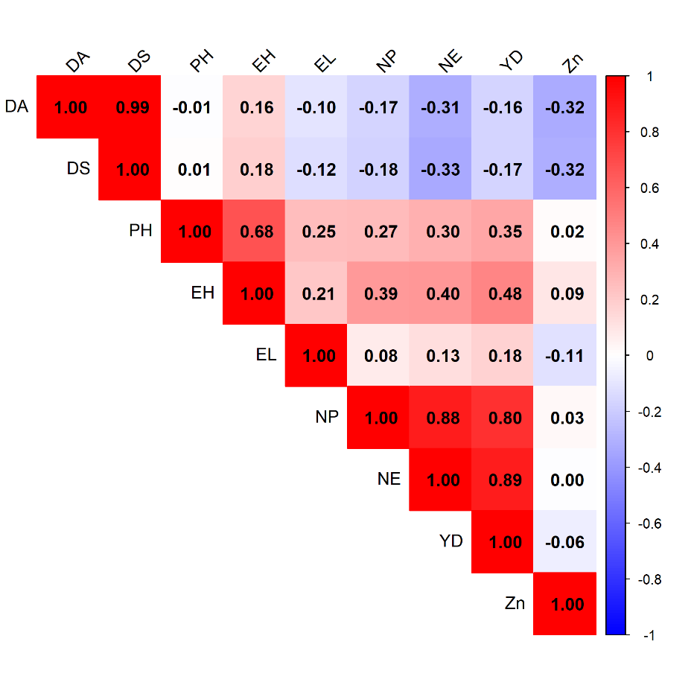
Fig 1: Correlation heatmap of Grain yield and its components along with kernel zinc
Path analysis
Path analysis revealed that the traits contributing most strongly to grain yield were those with high direct effects combined with strong correlations. The number of ears (0.8770), showed the highest direct effect on grain yield and this was consistent with its very strong positive correlation with yield (r = 0.886***). This indicates that NE is the primary determinant of grain yield in this population, contributing largely through its direct influence. In contrast, number of plants (NP) displayed a strong correlation with yield (r = 0.802***), but its direct effect was very low (0.0248). This suggests that the association between NP and grain yield is largely indirect, operating mainly through the strong indirect contribution of NE (0.7756) to NP, which ultimately drives the yield response. Plant height (PH) had a very low direct effect (0.0030), yet showed a significant positive correlation with yield (r = 0.35**). This difference clearly indicates that PH affects grain yield indirectly, mainly through its positive indirect (0.2656) contributions through number of ears (NE). Ear height (EH) had a low direct effect (0.0632) but a stronger correlation with yield (r = 0.476***), showing that its influence on yield is also mostly indirect, especially through NE. The residual effect (0.42) implies that the traits included in the model explained 58% of the variation in grain yield. The estimates of direct and indirect effects of component traits on grain yield are presented in Table 3, while Fig. 2 illustrates the path diagram depicting these direct and indirect effects on grain yield.
Table 3: Estimates of direct and indirect effects of component traits on grain yield
 | DA | DS | PH | EH | EL | NP | NE | Zn | YD
DA | -0.6888 | 0.7966 | 0.0000 | 0.0103 | -0.0079 | -0.0041 | -0.2744 | 0.0070 | -0.161
DS | -0.6844 | 0.8017 | 0.0000 | 0.0115 | -0.0093 | -0.0044 | -0.2896 | 0.0070 | -0.168
PH | 0.0061 | 0.0067 | 0.0030 | 0.0428 | 0.0192 | 0.0066 | 0.2656 | -0.0004 | 0.35**
EH | -0.1118 | 0.1460 | 0.0020 | 0.0632 | 0.0160 | 0.0097 | 0.3529 | -0.0021 | 0.476***
EL | 0.0717 | -0.0983 | 0.0008 | 0.0134 | 0.0757 | 0.0019 | 0.1115 | 0.0025 | 0.179
NP | 0.1139 | -0.1434 | 0.0008 | 0.0247 | 0.0059 | 0.0248 | 0.7756 | -0.0007 | 0.802***
NE | 0.2155 | -0.2648 | 0.0009 | 0.0254 | 0.0096 | 0.0219 | 0.8770 | 0.0001 | 0.886***
Zn | 0.2208 | -0.2562 | 0.0000 | 0.0060 | -0.0087 | 0.0007 | -0.0033 | -0.0218 | -0.062
Direct effects on main diagonal (bold), Residual effects: 0.42
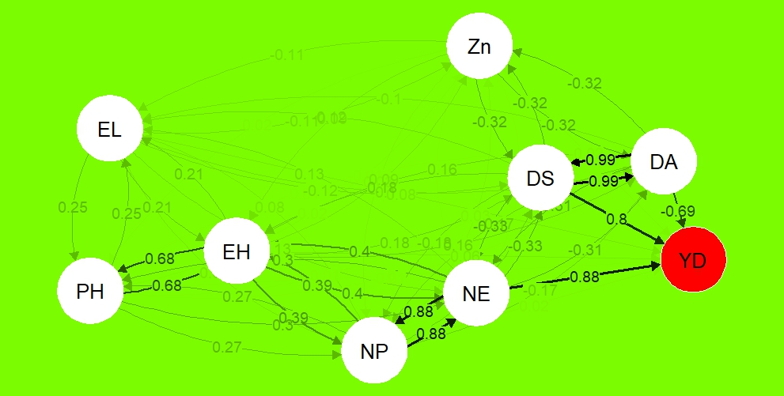
Fig 2: Path diagram depicting direct and indirect effects on grain yield
Conclusions:
Both kernel zinc and grain yield showed a high significant genotypic variance along with the heritability of 60%, indicating strong genetic control and substantial genetic variability within the population. Grain yield had significant and strong correlation with number of ears per plot (NE), number of plants per plot (NP), plant height (PH) and ear height (EH). Among these, number of ears per plot exerted the strongest direct effect on yield, whereas NP, PH and EH contributed primarily through indirect pathways. Kernel zinc showed no significant association with grain yield, confirming that zinc biofortification can be advanced without compromising yield potential.
References :
- Akinwale, R. O., & Adewopo, O. A. (2016). Grain iron and zinc concentrations and their relationship with selected agronomic traits in early and extra-early maize. Journal of Crop Improvement, 30(6), 641–656. https://doi.org/10.1080/15427528.2016.1211577
- Baxter, I. R., Gustin, J. L., Settles, A. M., & Hoekenga, O. A. (2013). Ionomic characterization of maize kernels in the intermated B73 × Mo17 population. *Crop Science*, *53*, 208–220. https://doi.org/10.2135/cropsci2012.02.0135
- Brkic I, Simic D, Zdunic C, Jambrovic A, Ledencan T, Kovacevic V and Kadar I. 2003. Combining abilities of corn-belt inbred lines of maize for mineral content in grain. Maydica. 48: 293–297.
- Chakraborti, M., Prasanna, B. M., Hossain, F., & Singh, A. M. (2011). Evaluation of single cross Quality Protein Maize (QPM) hybrids for kernel iron and zinc concentrations. INDIAN JOURNAL OF GENETICS AND PLANT BREEDING, 71(04), 312–319. http://www.indianjournals.com/ijor.aspx?target=ijor:ijgpb&volume=71&issue=4&article=003
- Dhanapati, K. (2023). Genetic analysis of grain yield and turcicum leaf blight resistance in maize (Zea mays L.) (Doctoral dissertation, Acharya N G Ranga Agricultural University) https://krishikosh.egranth.ac.in/handle/1/95000
- Goswami, R., Kumar, J., Hossain, F., Thirunavukkarasu, N., Manjaiah, K.M., Agrawal, P. K., Gupta, H. S. 2014. Analyses of the genetic variability for kernel-iron and kernel-zinc in maize genotypes. In B. M. Prasanna et al. (Eds.), 12th Asian maize conference and expert consultation on maize for food, feed and nutritional security, book of abstracts (p. 116). 30 October - 01 November, Bangkok, Thailand.
- Long, J. K., Bänziger, M., & Smith, M. E. (2004). Diallel analysis of grain iron and zinc density in Southern African-adapted maize inbreds. Crop Science, 44(6), 2019–2026. https://doi.org/10.2135/cropsci2004.2019
- Lung'aho, M. G., Mwaniki, A. M., Szalma, S. J., Hart, J. J., Rutzke, M. A., Kochian, L. V., Glahn, R. P., & Hoekenga, O. A. (2011). Genetic and physiological analysis of iron biofortification in maize kernels. PLoS ONE, 6(6), e20429. https://doi.org/10.1371/journal.pone.0020429
- Mallikarjuna, M. G., Nepolean, T., Hossain, F., Manjaiah, K. M., Singh, A. M., & Gupta, H. S. (2014). Genetic variability and correlation of kernel micronutrients among exotic quality protein maize inbreds and their utility in breeding programme. Indian Journal of Genetics and Plant Breeding, 74, 166–173. https://doi.org/10.5958/0975-6906.2014.00152.7
- Menkir, A. (2008). Genetic variation for grain mineral content in tropical-adapted maize inbred lines. Food Chemistry. https://doi.org/10.1016/j.foodchem.2008.02.025
- Pandey, N., Hossain, F., Kumar, K., Vishwakarma, A. K., Muthusamy, V., Manjaiah, K. M., Agrawal, P. K., Guleria, S. K., Reddy, S. S., Thirunavukkarasu, N., & Gupta, H. S. (2015). Microsatellite marker-based genetic diversity among quality protein maize (QPM) inbreds differing for kernel iron and zinc. Molecular Plant Breeding, 6(3), 1-10. https://doi.org/10.5376/mpb.2015.06.0003
- Pixley, K. V., Palacios-Rojas, N., & Glahn, R. P. (2011). The usefulness of iron bioavailability as a target trait for breeding maize (Zea mays L.) with enhanced nutritional value. Field Crops Research, 123, 153–160. https://doi.org/10.1016/j.fcr.2011.05.011
- Simić, D., Mladenović Drinić, S., Zdunić, Z., Jambrović, A., Ledencan, T., Brkić, J., Brkić, A., & Brkić, I. (2012). Quantitative Trait Loci for Biofortification Traits in Maize Grain. Journal of Heredity. https://doi.org/10.1093/jhered/esr122
- Vyn, T. J., & Tollenaar, M. (1998). Changes in chemical and physical quality parameters of maize grain during three decades of yield improvement. Field Crops Research, 59, 135–140. https://doi.org/10.1016/S0378-4290(98)00114-2
- Guild, G. E., & Stangoulis, J. C. R. (2016). Non-matrix Matched Glass Disk Calibration Standards Improve XRF Micronutrient Analysis of Wheat Grain across Five Laboratories in India. Frontiers in Plant Science, 7, 784. https://doi.org/10.3389/fpls.2016.00784
- Paltridge, N. G., Palmer, L. J., Milham, P. J., Guild, G. E., & Stangoulis, J. C. R. (2012). Energy-dispersive X-ray fluorescence analysis of zinc and iron concentration in rice and pearl millet grain. Plant and Soil, 361, 251–260. https://doi.org/10.1007/s11104-011-1104-4

