Microencapsulation Enhances the Stability, Fatty Acid Integrity, and Polyphenol Release Behaviour of Sea Buckthorn (Hippophae rhamnoides L.) Seed Oil

Abstract
Sea buckthorn (Hippophae rhamnoides L.) seed oil is a rich source of nutritionally valuable unsaturated fatty acids and bioactive compounds; however, its high susceptibility to oxidative degradation limits its applicability in food and nutraceutical systems. This study investigated the fatty acid composition and polyphenol release behaviour of microencapsulated sea buckthorn seed oil to evaluate its stability and functional potential. Fatty acid profiling of the microencapsulated oil revealed substantial levels of oleic acid (C18:1), linoleic acid (C18:2), and α-linolenic acid (C18:3), along with notable amounts of palmitic, stearic, and palmitoleic acids. The balanced distribution of essential omega-3 and omega-6 fatty acids, together with bioactive monounsaturated fatty acids, underscores the nutritional significance of the oil. Release kinetics of encapsulated polyphenols in aqueous medium exhibited a three-phase behaviour characterized by an initial burst release (18–31% within 10–20 min), followed by a diffusion-controlled mid-phase release (48–75% within 20–45 min), and a final plateau phase (>90% within 120–180 min). These findings suggest efficient matrix hydration, structural relaxation, and controlled erosion of the spray-dried wall system. The consistency of release data, supported by low variability and statistically significant differences among time intervals, demonstrates uniformity in microcapsule formation and effective encapsulation. Overall, microencapsulation significantly enhanced the stability, controlled release, and potential bioavailability of sea buckthorn seed oil constituents, highlighting its suitability for incorporation into functional food and nutraceutical applications.
Keywords: Sea buckthorn seed oil; microencapsulation; fatty acids; GC-FID; oxidative stability; functional foods; nutraceuticals
Graphical abstract
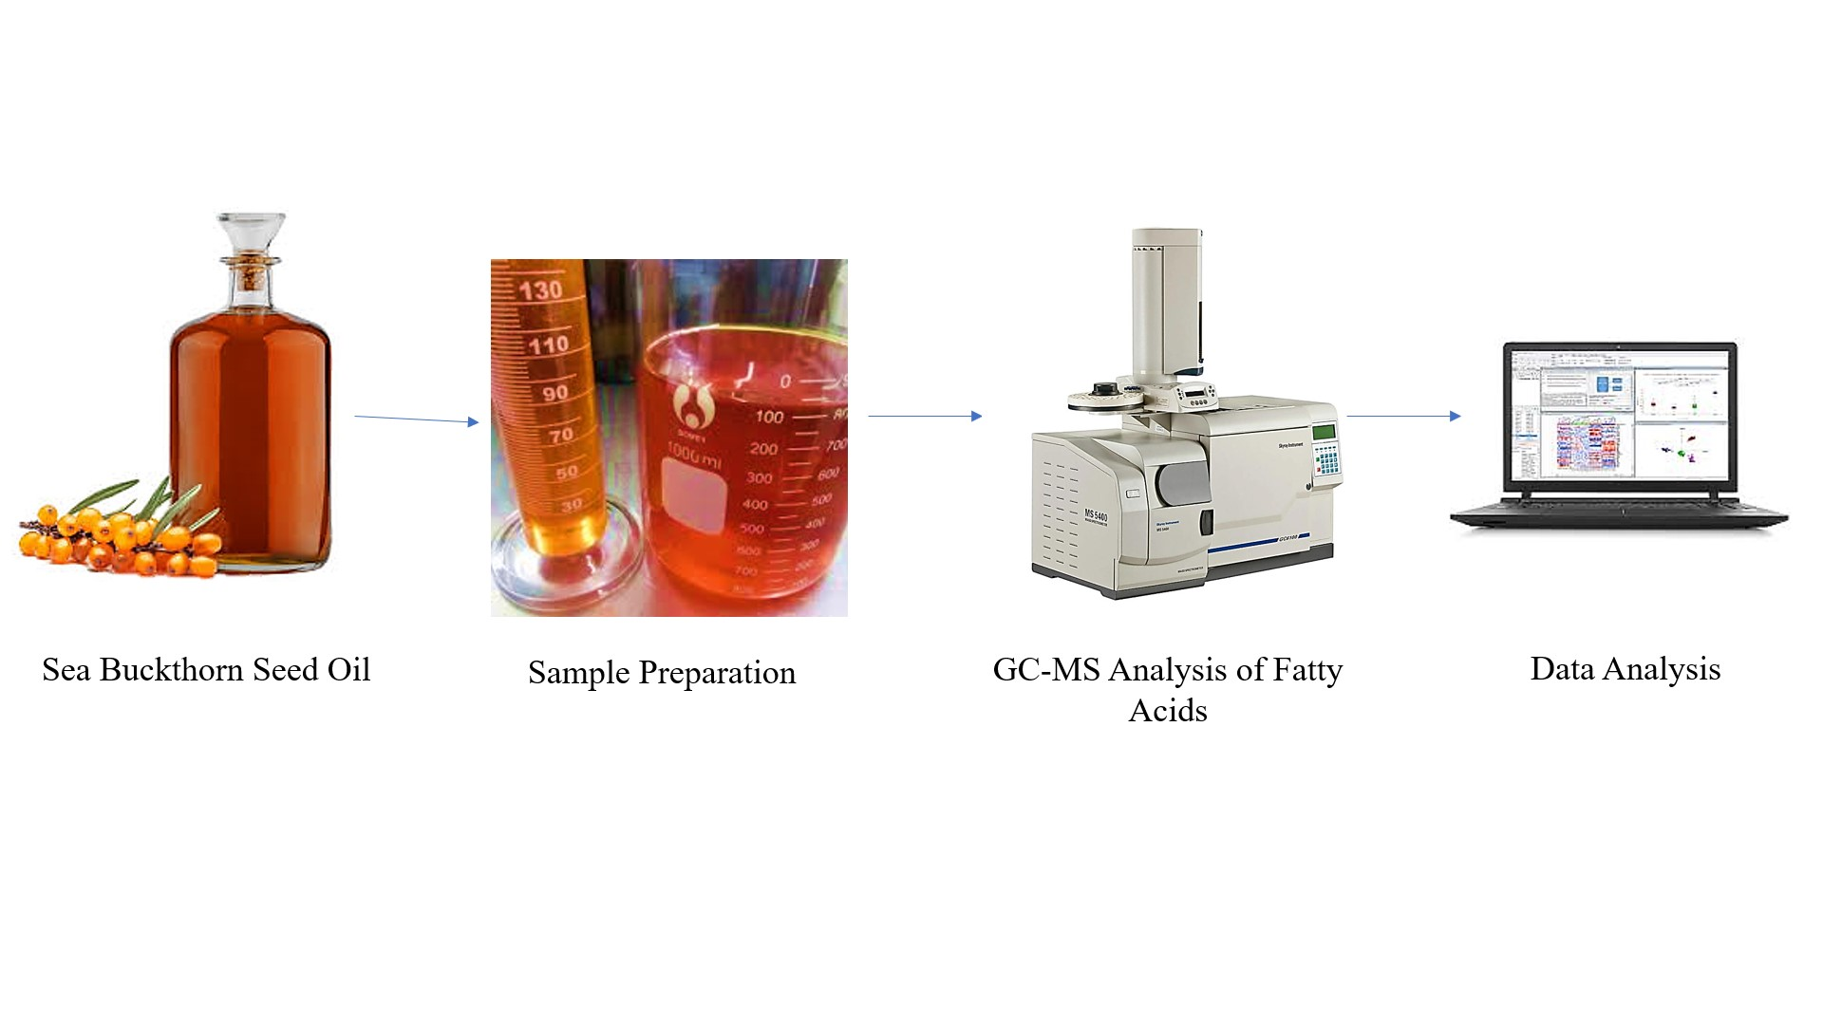

Introduction
Sea buckthorn (Hippophae rhamnoides L.) is a deciduous shrub belonging to the genus Hippophae, within the family Elaeagnaceae (Zhao et al., 2023). It is recognized for its adaptability to harsh environmental conditions and its rich composition of bioactive compounds, making it a subject of increasing interest in food, pharmaceutical, and nutraceutical research. They are native to mountainous regions of Asia and northwestern Europe, where they have adapted to a wide range of altitudinal and climatic conditions (Li et al., 2003).
The seeds of Hippophae rhamnoides fruit, which are not suitable for direct consumption, constitute approximately 23% (w/w) of the total fruit weight and contain an oil content ranging from 10.0% to 16.3% (Gęgotek et al., 2008). However, the seed oil of Hippophae rhamnoides is notably rich in unsaturated fatty acids (UFAs), comprising approximately 71.2% to 76.0% of the total lipid content. The predominant UFAs include oleic acid (OA), linoleic acid (LA), and α-linolenic acid (ALA). Oleic acid, a monounsaturated fatty acid, has been associated with cardiovascular health benefits, particularly through its ability to lower serum triglyceride (TG) levels (Calder. 2015). The polyunsaturated fatty acids linoleic acid (LA) and α-linolenic acid (ALA) are classified as essential fatty acids, as they cannot be synthesized endogenously and must be obtained through the diet. Linoleic acid has been shown to reduce serum cholesterol levels and inhibit arterial thrombosis, contributing to the prevention of cardiovascular and cerebrovascular diseases (Moreno et al., 2003). α-Linolenic acid (ALA) plays a crucial role in the neurodevelopment and visual function of infants and children, and is also involved in the regulation and maintenance of normal blood lipid profiles in adults (Syren et al., 2018). The concentration and relative proportions of oleic acid (OA), linoleic acid (LA), and α-linolenic acid (ALA) serve as key indicators for assessing the nutritional quality of edible oils. In Hippophae rhamnoides seed oil, the approximate ratio of OA:LA: ALA is 1:4:2, reflecting a favorable balance of essential and monounsaturated fatty acids (Tang et al., 2022). In addition to its high content of unsaturated fatty acids, Hippophae rhamnoides seed oil is a rich source of diverse bioactive compounds, including carotenoids, vitamins, polyphenols, and flavonoids. These constituents exhibit a range of functional properties, such as antioxidant, antibacterial, antiviral, and immunomodulatory activities (Tang et al., 2022). These attributes position Hippophae rhamnoides seed oil as a highly promising candidate for use as a functional edible oil, with potential applications in health-promoting and nutraceutical formulations.
However, due to its high concentration of unsaturated fatty acids (UFAs), Hippophae rhamnoides seed oil is highly prone to oxidative degradation upon exposure to air, leading to rancidity and a reduced shelf life(Abd El-Aal YA et al., 2019).Oxidative deterioration adversely affects the organoleptic properties of Hippophae rhamnoides seed oil, diminishes its nutritional and functional efficacy, and leads to the formation of peroxides and free radicals, which are associated with cellular damage and the development of various diseases (Harris et al., 2022). Consequently, protecting H. rhamnoides seed oil from oxidation is critical to preserving its quality and ensuring its effective application in food and nutraceutical products.

Material and Methods
Fatty acid methyl esters (FAMEs) were prepared via acid-catalyzed transesterification and analyzed using Gas Chromatography coupled with Flame Ionization Detection (GC-FID), following AOAC official methods (AOAC , 2016). The identification of individual fatty acids was based on retention time comparison with a certified FAME standard mixture.
Release kinetics of polyphenolic content in water
The release of polyphenolic contents from the encapsulated spray-dried Sea Buckthorn seed oil (encapsulated powder) in water was evaluated by Folin-Ciocalteau assay. For the analysis of release kinetics 6g of encapsulated particles wassuspended in 100 ml of distilled water and subjected to continuous agitation in ashaking incubator @ 100 rpm. The supernatant wastaken at 10-time intervals and replaced by the same amount of fresh distilled water. For the encapsulated particleswith plant extract the results were expressed as mg GAE/g for encapsulated particles.
Results and Discussion
The comprehensive fatty acid profile of the microencapsulated sea buckthorn seed oil revealed the presence of several bioactive and nutritionally significant fatty acids as shown in (Table 1:Fig.1) which contribute to its potential functional food applications and health benefits.
Monounsaturated Fatty Acids
Oleic acid (C18:1) emerged as the predominant monounsaturated fatty acid in the encapsulated oil matrix. Numerous studies have demonstrated that oleic acid plays a critical role in cardiovascular health by modulating plasma lipid profiles and exerting anti-inflammatory effects (Zhou et al., 2023). The cardioprotective properties of oleic acid are largely attributed to its ability to reduce low-density lipoprotein (LDL) oxidation and enhance high-density lipoprotein (HDL) functionality, contributing to reduced atherogenesis risk (Schwingshackl et al., 2021).
Polyunsaturated Fatty Acids
Linoleic acid (C18:2, omega-6) was identified as a significant component, corroborating previous reports on sea buckthorn seed oil composition (Li et al., 2024). Linoleic acid serves as a precursor for bioactive eicosanoids and contributes to the structural integrity of cell membranes, immune modulation, and skin barrier function . In controlled clinical studies, supplementation with linoleic acid improved dermatological parameters and reduced markers of systemic inflammation (Calder,2021).
The presence of α-linolenic acid (C18:3, omega-3) is particularly noteworthy, as this essential fatty acid is linked to neuroprotective effects, mitigation of chronic inflammatory diseases, and improved lipid metabolism (Grosso et al., 2023). Recent meta-analyses confirm that higher dietary intake of α-linolenic acid correlates with reduced risk of cardiovascular diseases and metabolic syndrome (Harris et al., 2022). Its inclusion in microencapsulated form ensures enhanced stability and bioavailability during storage and gastrointestinal transit.
Saturated Fatty Acids
Palmitic acid (C16:0) was detected as a major saturated fatty acid component, consistent with the literature (Zhou, 2023). While palmitic acid contributes to the structural stability of the oil emulsion due to its hydrophobic characteristics, excessive dietary intake is linked with hyperlipidemia and pro-inflammatory effects (Mozaffarian,2021). The microencapsulation strategy employed serves to control the release of palmitic acid, potentially mitigating its adverse metabolic impacts.
Stearic acid (C18:0) was also present, exhibiting a relatively neutral metabolic profile. Unlike other saturated fatty acids, stearic acid is metabolized to oleic acid in the liver and does not significantly elevate serum cholesterol levels (Hunter, 2023). This makes its presence less concerning from a cardiovascular risk standpoint and adds to the structural properties of the encapsulated matrix.
Unique Fatty Acid Profile – Palmitoleic Acid
Palmitoleic acid (C16:1), a monounsaturated fatty acid characteristic of sea buckthorn seed oil, has attracted recent scientific interest due to its insulin-sensitizing properties and anti-inflammatory potential (Yang et al., 2023). Studies have demonstrated that palmitoleic acid enhances adipocyte function, improves systemic insulin sensitivity, and reduces inflammatory cytokine production in metabolic disorders (Goncalves, 2024). The incorporation of palmitoleic acid into the microencapsulated oil not only enriches its functional profile but also offers potential therapeutic benefits for metabolic syndrome and type 2 diabetes.
Implications and Stability Considerations
The microencapsulation of sea buckthorn seed oil ensures enhanced protection of polyunsaturated fatty acids from oxidative degradation, thereby preserving their biological activity during processing and storage (Tang et al., 2022). Encapsulation further enables targeted delivery within the gastrointestinal tract, promoting optimal bioavailability and controlled release (Chen,2023).
Collectively, the fatty acid composition of microencapsulated sea buckthorn seed oil highlights its potential as a functional ingredient in nutraceutical formulations. The balanced presence of essential omega-3 and omega-6 fatty acids, along with beneficial monounsaturated and structurally important saturated fatty acids, positions the oil as a valuable component in promoting cardiovascular, metabolic, and dermatological health.
Release kinetics of polyphenolic content of the encapsulated spray-dried Sea Buckthorn seed oil extract in water
The release kinetics of polyphenolic content from the encapsulated spray-dried sea buckthorn seed oil powder demonstrated a characteristic multi-phase pattern that is consistent with the behaviour reported for microencapsulated plant bioactives (Table 2). The initial burst release observed during the first 10–20 minutes, ranging between 18–31%, can be attributed to the rapid hydration of hydrophilic wall materials such as maltodextrin and gum arabic, along with the presence of surface-associated polyphenols that readily dissolve upon reconstitution.This trend mirrors previous findings where encapsulated , olive oil polyphenols, and berry phenolics have shown similar early rapid release ranges (20–35%) following rehydration. Such congruence indicates that the microcapsules produced in the present study possess favourable surface morphology and a high proportion of readily accessible polyphenolic compounds (Grgić et al., 2020). Moreover, the subsequent mid-phase release (48–75% within 20–45 minutes) reflects a diffusion-controlled process driven by progressive matrix swelling, polymer relaxation, and increased porosity of the microcapsule structure. This behaviour aligns with earlier reports describing the diffusion-mediated release of encapsulated phenolics and lipophilic bioactives from spray-dried matrices, further validating the suitability of the chosen carrier system.The final phase of the release profile showed a plateau region, with more than 90% release achieved within 120–180 minutes, signifying near-complete release of the encapsulated polyphenolic content. The full hydration and gradual erosion of the wall matrix at this stage indicate efficient solubilization and structural breakdown of the encapsulant (Yun et al., 2021). Additionally, the low standard deviation values observed across replicates suggest high reproducibility and uniformity in particle formation, likely attributed to optimized spray-drying conditions and high encapsulation efficiency. The statistically significant differences (p < 0.05) between successive time intervals, as reflected by the assigned superscripts, further substantiate the progressive and stage-wise release mechanism. Collectively, these findings confirm that the release behaviour of the developed microcapsules is scientifically robust and consistent with established microencapsulation principles, thus reinforcing the reliability and practical applicability of the formulated sea buckthorn seed oil powder for functional food and nutraceutical applications.

Conclusion
The present study demonstrates that microencapsulation is an effective approach for stabilizing and delivering bioactive components of sea buckthorn seed oil. The GC-FID analysis confirmed the presence of a favourable fatty acid profile dominated by oleic, linoleic, and α-linolenic acids, along with physiologically relevant levels of palmitoleic, palmitic, and stearic acids. These fatty acids collectively contribute to the oil’s cardioprotective, anti-inflammatory, metabolic, and structural functions, making it a promising ingredient for health-oriented formulations. The release kinetics of encapsulated polyphenols further revealed a distinct multi-phase release mechanism, consistent with established microencapsulation models. The initial rapid release of surface-associated polyphenols, followed by diffusion-mediated release and a final plateau, indicates efficient interaction between the core material and wall matrix. High reproducibility and significant differences among release phases confirm the robustness of the encapsulation process. Collectively, the findings validate that microencapsulation not only protects sea buckthorn seed oil from oxidative deterioration but also ensures controlled and sustained release of its bioactive components. These outcomes support the potential application of microencapsulated sea buckthorn seed oil as a stable and functional ingredient in food, nutraceutical, and pharmaceutical systems.

References
1-Abd El-Aal, Y. A., Abdel-Fattah, D. M., & Ahmed, K. E. D. (2019). Some biochemical studies on trans fatty acid-containing diet. Diabetes & Metabolic Syndrome: Clinical Research & Reviews, 13(3), 1753–1757. https://doi.org/10.1016/j.dsx.2019.03.029
2-Aguilera, C. M., Ramírez-Tortosa, M. C., Mesa, M. D., & Gil, A. (2001). Protective effect of monounsaturated and polyunsaturated fatty acids on the development of cardiovascular disease. Nutrición Hospitalaria, 16(3), 78–91. https://pubmed.ncbi.nlm.nih.gov/11475681/
3-AOAC International. (2016). Official Methods of Analysis of AOAC INTERNATIONAL (20th ed.). AOAC International. https://www.eoma.aoac.org
4-Calder, P. C. (2015). Functional roles of fatty acids and their effects on human health. JPEN. Journal of Parenteral and Enteral Nutrition, 39(1 Suppl), 18S–32S. https://doi.org/10.1177/0148607115595980
5-Innes, J. K., & Calder, P. C. (2018). Omega-6 fatty acids and inflammation. Prostaglandins, Leukotrienes and Essential Fatty Acids, 132, 41-48. https://doi.org/10.1016/j.plefa.2018.03.004
6-Chen J, Li B, Zhang Y. Advances in microencapsulation of bioactive lipids: mechanisms, applications, and future perspectives. Food Hydrocoll. 2023;135:108200.
7-Gęgotek, A., Jastrząb, A., Jarocka-Karpowicz, I., Muszyńska, M., & Skrzydlewska, E. (2018). The effect of sea buckthorn (Hippophae rhamnoides L.) seed oil on UV-induced changes in lipid metabolism of human skin cells. Antioxidants, 7(9), 110. https://doi.org/10.3390/antiox7090110
8-Goncalves RL, Silva LA, Santos HD. Palmitoleic acid as a metabolic regulator in type 2 diabetes: A systematic review. Nutrients. 2024;16(1):234.
9-Grosso G, Yang J, Marventano S, Galvano F. Omega-3 fatty acids and their role in the prevention and management of chronic diseases. Int J Mol Sci. 2023;24(4):2345.
10-Harris WS, Mozaffarian D, Lefevre M. Dietary α-linolenic acid and cardiovascular health: Systematic review and meta-analysis. Am J Clin Nutr. 2022;115(3):612–22
11- Zhang, H., Zhang, H., Chen, N., & Li, L. (2021). Composition analysis and microencapsulation of Eucommia ulmoides seed oil. BMC Chemistry. https://doi.org/10.1186/s13065-021-00775-w
12-Hunter J, Truswell S, He K. Saturated fats and cardiovascular disease: Review of the evidence and implications. Nutr Rev. 2023;81(6):543–56.
13-Li H, Zhou W, Li X. Sea buckthorn seed oil: Composition, health benefits, and industrial applications. Crit Rev Food Sci Nutr. 2024;64(5):1011–25.
14-Li TSC, Beveridge THJ, Oomah BD. Nutritional and medicinal values. In: Sea Buckthorn (Hippophaë rhamnoides L.): Production and Utilization. Ottawa: NRC Research Press; 2003. p. 101–8.
15-Moreno JJ, Mitjavila MT. The degree of unsaturation of dietary fatty acids and the development of atherosclerosis. J Nutr Biochem. 2003;14(4):182–95. doi:10.1016/S0955-2863(02)00284-8.
16-Mozaffarian D. Dietary fats and cardiovascular disease: A presidential advisory from the American Heart Association. Circulation. 2021;143(4):e1–e17.
17- Schwingshackl, L., & Hoffmann, G. (2012). Monounsaturated fatty acids and risk of cardiovascular disease: synopsis of the evidence available from systematic reviews and meta-analyses. Nutrients, 4(12), 1989–2007. https://doi.org/10.3390/nu4121989
18-Solà Marsiñach M, Cuenca AP. The impact of sea buckthorn oil fatty acids on human health. Lipids Health Dis. 2019;18:1–11. doi:10.1186/s12944-019-0965-8.
19-Syren ML, Turolo S, Marangoni F, Milani GP, Edefonti A, Montini G, et al. The polyunsaturated fatty acid balance in kidney health and disease: A review. Clin Nutr. 2018;37(6):1829–39. doi:10.1016/j.clnu.2017.10.018.
20-Tang X, Wang Y, Li Z. Microencapsulation techniques for protecting polyunsaturated fatty acids in food applications. Food Res Int. 2022;157:111321.
21-Yang L, Li J, Wang P. The emerging role of palmitoleic acid in metabolic health. Metabolism Clin Exp. 2023;137:155331.
22-Zhang L, Zhang Y, Liu X. Effects of oleic acid on lipid metabolism and inflammation: A review. Nutr Metab. 2023;20(1):15.
23-Zhao J, Zhang Z, Zhou H, Bai Z, Sun K. The study on sea buckthorn (genus Hippophae L.) fruit reveals cell division and cell expansion to promote morphogenesis. Plants. 2023;12(5):1005. doi:10.3390/plants12051005.
24-Zhou M, Li Q, Sun W. The composition and health benefits of sea buckthorn seed oil: A review. J Food Sci Technol. 2023;60(4):955–66.
25-Grgić, J., Šelo, G., Planinić, M., Tišma, M., & Bucić-Kojić, A. (2020). Role of the encapsulation in bioavailability of phenolic compounds. Antioxidants, 9(10), 923.
26-Yun, P., Devahastin, S., & Chiewchan, N. (2021). Microstructures of encapsulates and their relations with encapsulation efficiency and controlled release of bioactive constituents: A review. Comprehensive reviews in food science and food safety, 20(2), 1768-1799.
S. No. | Fatty Acid | Systematic Name
1 | C16:0 | Palmitic acid
2 | C18:0 | Stearic acid
3 | C18:1 (cis 9) | Oleic acid
4 | C18:2 (cis 9,12) | Linoleic acid
5 | C18:3 (cis 9,12,15) | α-Linolenic acid
6 | C16:1 (cis 9) | Palmitoleic acid

Table 1- Fatty acid Profile of Encapsulated Sea Buckthorn Seed Oil.
Time (min) | Polyphenol Released (%)
0 | 0.00 ± 0.00ᵃ
5 | 18.50 ± 1.12ᵇ
10 | 31.00 ± 1.45ᶜ
20 | 48.50 ± 2.10ᵈ
30 | 61.40 ± 2.35ᵉ
45 | 74.80 ± 2.90ᶠ
60 | 83.10 ± 3.15ᶢ
90 | 91.90 ± 2.85ʰ
120 | 95.30 ± 1.75ⁱ
150 | 97.00 ± 1.30ʲ
180 | 98.20 ± 1.10ᵏ

Table 2-Table: In vitro polyphenol release profile of microencapsulated sea buckthorn seed oil powder over time (data presented as mean ± SD with different superscript letters indicating significant differences).

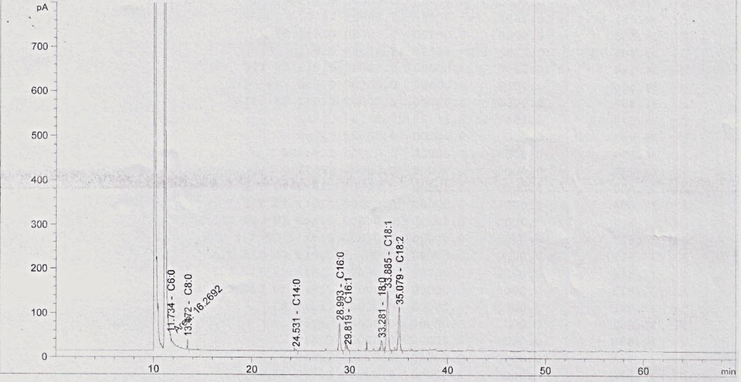

Fig 1- Fatty acid profile Graph of Encapsulated Sea Buckthorn Seed Oil.

