SURVEY FOR STATUS OF PURPLE BLOTCH OF GARLIC IN THE MAJOR GARLIC GROWING DISTRICTS OF KARNATAKA

ABSTRACT: An intensive roving survey was undertaken during Kharif/rabi 2021-2h2 and 2022-23 in major garlic growing regions viz., Chitradurga, Mysore, Chamarajanagar, Bidar, Kalaburagi, Vijayapura, Bagalkote, Gadag, Belagavi and Haveri districts of Karnataka. Totally 20 villages of 7 taluks and three districts were surveyed during Kharif 2021-22. Maximum mean per cent disease severity was observed in Chitradurga district (23.77 %) whereas, minimum mean per cent disease severity was noticed in Mysuru district (13.03 %). Totally 75 villages of 22 taluks and seven districts were surveyed during rabi 2021-22. Maximum mean per cent disease severity was observed in Belagavi district (42.95 %) whereas, minimum mean per cent disease severity was noticed in Gadag district (19.64 %). Totally 20 villages of 7 taluks and three districts were surveyed during Kharif 2022-23. Maximum mean per cent disease severity was observed in Chitradurga district (24.24 %) whereas, minimum mean per cent disease severity was noticed in Mysuru district (13.15 %). Totally 75 villages of 22 taluks and seven districts were surveyed during rabi 2022-23. Maximum mean per cent disease severity was observed in Belagavi district (42.12 %) whereas, minimum mean per cent disease severity was noticed in Gadag district (25.03 %).
Key Words: Disease severity, Garlic, Per cent disease index, Purple blotch, Roving survey

INTRODUCTION

Garlic (Allium sativum L.) is an important Spice crop cultivated all over the country during rabi season except in Ooty hills of Tamil Nadu where it is grown during rainy season. India is the second major producer of Garlic having 2.01 lakh ha. area, 1058 lakh mt production and 5.27 t/ha productivity next after China. India exported 22665.99 mt. Garlic amounting Rs. 3957.75 lakh during 2018-19 (Anon., 2025).It is widely used in flavouring of food, preparation of chutneys, pickles, curry powder, tomato ketch-up etc. Besides nutritive values, it is included in Indian system of medicines (Ayurvedic, Unani and Siddha) as a carminative and gastric stimulant to help digestion and absorption of food (Sankaracharya, 1974). It is rich source of carbohydrates, proteins, phosphorus and volatile oil. Garlic crop is affected by various diseases of which, purple blotch caused by Alternaria porri(Ellis) Cif. is a major constraint and causes severe yield loss
( Mishra et al., 2009). The purple blotch called by other names like Alternaria blight, Alternaria blotch and purple leaf spot. Complete damage to the leaf tissues is observed at the time of bulb maturity. Since the leaves are the only photosynthetic organ, this foliar pathogen directly influences the bulb yield. Significant reduction in bulb yield (25-60 %) due to drying of leaves has been observed in garlic (Bisht and Agarwal, 1993). In earlier studies, Pradnyarani and Kulkarni (2014b), Priya et al. (2016), Kodate (2020) and Vijaykumar et al. (2021) were conducted roving survey for purple blotch of onion and garlic. Hence, in the present studies, an intensive roving survey was conducted during both Kharif (August to September) and rabi (December to February) seasons of 2021-22 and 2022-23 in farmers fields in major garlic growing districts of Karnataka.
MATERIALS AND METHODS
a. Survey for the severity of purple blotch of Garlic in the major garlic growing districts of Karnataka.
An intensive roving survey was undertaken during Kharif/rabi 2021-22 and 2022-23 in major garlic growing districts viz., Chitradurga, Mysore, Chamarajanagar, Bidar, Kalaburagi, Vijayapura, Bagalkote, Gadag, Belagavi and Haveri of Karnataka in three to four months old crop to know the severity of purple blotch disease on garlic. In each taluka two to three villages were surveyed comprising two to three fields in each village. In each field ten plants were selected randomly and disease severity was assessed by using 0 to 5 scoring scale (Sharma, 1986) described below.
List 1 : Description of disease scoring scale (0 to 5)
Scale | Severity
0 | No disease symptoms
1 | A few spots towards the tip covering 1 to 10 per cent leaf area
2 | Several dark purplish brown patches covering 11 to 20 per cent leaf area
3 | Several patches with a paler outer zone covering 21 to 40 per cent leaf area
4 | Leaf streaks covering 41 to 75 per cent leaf area and breaking of the leaves from the centre.
5 | Leaf streaks covering more than 76 percent leaf area, followed by complete drying and breaking of the leaves from the centre.
The Per cent Disease Index (PDI) was calculated by using the formula proposed by Wheeler (1969).
Per cent disease index (PDI) = | Sum of the individual disease ratings
Per cent disease index (PDI) = | Number of leaves/plants scored x Maximum disease grade | ×100
During the survey, data on garlic cultivars, soil type, irrigation system, cultural practices carried out by farmers for garlic cultivation, stage and approximate age of the crop was collected. During survey the infected samples were collected and the proper labelling was carried out and stored properly for further studies. During survey information on latitude and longitude of the sampling point was collected by using Geographical Positioning System (GPS).
List 2 : Details of different garlic growing districts and taluks surveyed for the severity of garlic purple blotch in Karnataka
Sl. No. | Districts | Taluks | Villages
1 | Chitradurga | Chitradurga | Belagatta, Chikkagondanahalli, Kunabevu and Kalladevarapura
1 | Chitradurga | Hiriyur | Babbur, Aimangala and Yeraballi
1 | Chitradurga | Challakere | Bangigere and Ramajogihally
2 | Mysuru | Mysuru | Badipalya, Naganahalli and Yelaval
2 | Mysuru | Nanjanagudu | Sinduvalli and Uppanahalli
3 | Chamarajanagara | Chamarajanagara | Badanaguppe, Uttavalli and Yediyuru
3 | Chamarajanagara | Kollegala | Alahalli, Bastipura and Timmarajapura
4 | Bidar | Bidar | Anadhur,Astur, Chitta, Goranahalli and Kolar(K)
4 | Bidar | Aurad | Allapur, Diggi, Ekamba, Kamalnagar and Kherada (B)
4 | Bidar | Bhalki | Anandawadi, Halbarga, Khanapura, Maroor&Yekalaspur
4 | Bidar | Humnabad | Kanakatte, Hudagi, Kallur and Talamadagi
5 | Kalaburagi | Afzalpur | Badadal, Ballurgi and Hanooru
5 | Kalaburagi | Alanda | Kazoori, Kunisangavi and Narisirawadi
5 | Kalaburagi | Kamalapur | Kamalapura and Kinnisadak
6 | Vijayapura | Indi | Gornal, Ingalagi and Teggihalli
6 | Vijayapura | Devarahipparagi | Anemadu, Devarahipparagi and Kadarapur
6 | Vijayapura | Sindagi | Chikka Sindagi, Gubbewadi and Kannolli
7 | Bagalkote | Bagalkote | Ingalagi, Honnakatti, Keroor and Shiroor
7 | Bagalkote | Badami | Anantagiri and Katarki
7 | Bagalkote | Bilagi | Galagali, Kolar and Teggi
8 | Gadag | Gadag | Hulakoti, Nagavi and Shirol
8 | Gadag | Nargund | Chikkanaragund, Muganur and Siddapur
8 | Gadag | Rona | Arahunasi, Hosalli, Savadi and Talihal
9 | Belagavi | Gokak | Arabhavi, Ghataprabha and Kurbett
9 | Belagavi | Yergatti | Govinakoppa, Tavalageri and Yergatti
9 | Belagavi | Savadatti | Hadagali, Hirekumbi, Savadatti and Yedranvi
10 | Haveri | Haveri | Devihosuru, Devagiri, Kallapur and Naganooru
10 | Haveri | Byadagi | Bannahatti, Kadaramandalagi and Motebennuru
10 | Haveri | Ranebennuru | Devaragondanahatti, Honnatti, Kamadod and Veerapura
b .Collection of diseased samples for isolation of the pathogen
During the survey, garlic leaves showing typical purple blotch symptoms were collected from major garlic growing districts of Karnataka. The samples were collected separately in polythene bags or brown paper covers with proper labelling and brought to the laboratory and isolated the pathogen by following standard procedures.
c. Isolation and purification of the pathogen
The purple blotch infected leaf samples were collected from different areas of Karnataka where garlic was grown extensively and the pathogen (Alternaria porri) was isolated from each sample separately by following the tissue isolation technique and isolates were designated. The infected leaves, along with healthy portions, were cut into small bits and surface sterilized with one per cent sodium hypochlorite solution for 60 seconds and washed three times in sterile distilled water before transferring them to a Petri plate containing Potato Dextrose Agar (PDA) medium. The plates were incubated at room temperature (28±1°C) and observed periodically for fungal growth. The colonies that developed from the tissue bits were transferred to PDA slants. The single spore method (Johnson and Booth, 1983) or hyphal tip technique (Pathak, 1972) were used to obtain pure cultures of all isolates, which were preserved for further research.
d. Single spore isolation
Ten ml of clear, filtered water agar of two per cent strength was poured into a sterile plate and allowed to cool. Dilute spore suspension of A. porri (10-15 spores/ml) was prepared in sterile distilled water and spread uniformly on water agar. Such plates were incubated at 28±1°C for six hours and observed for individually germinated spores under a microscope. Such spores were then marked with ink on the glass surface of the plate. These marked agar areas were cut and transferred to Potato Dextrose Agar (PDA) slants with the help of a cork borer under aseptic conditions and incubated at a temperature of 28±1 °C. The growth obtained in slant was studied with respect to morphological characteristics to identify A. porri. The single spore culture of all the isolates was multiplied and such pure cultures were further used in all the experiments.
e. Maintenance of isolates of Alternaria porri
The fungal cultures of A. porri isolates were subcultured on potato dextrose agar slants and kept at 28±1 °C for 15 days and subsequently renewed every 30 days. Such isolates were stored in a refrigerator at 5 °C until further use.
f. Proving the pathogenicity
Artificial inoculation of the fungus (Bidar isolate) was carried out to prove the pathogenicity. The garlic cloves (Cultivar Rajalli gadde) were sown and seedlings were raised in pots and inoculated with fungal mycelial bit and spore suspension (2×10⁶ spores/ml) by spraying on the foliage and the inoculated seedlings were covered with polythene bags to create high relative humidity and incubated in a glasshouse for expression of symptoms.
RESULTS AND DISCUSSION
a. Survey for the severity of purple blotch of garlic in major garlic growing districts of Karnataka
An intensive roving survey was conducted during both Kharif (August to September) and rabi (December to February) seasons of 2021-22 and 2022-23 in farmers fields in major garlic growing districts of Karnataka as furnished in material and methods to determine the severity of purple blotch disease on garlic. In each taluka two to four villages were surveyed, comprising two to four fields in each village. In each field, ten plants were selected diagonally and disease severity was assessed by using 0 to 5 point scoring scale (Sharma, 1986) (Figure 1,2,3 and 4).
b. Severity of purple blotch during Kharif 2021-22
Totally 20 villages of 7 taluks and three districts were surveyed during Kharif 2021-22. Maximum mean per cent disease severity was observed in Chitradurga district (23.77 %) whereas, minimum mean per cent disease severity was noticed in Mysuru district (13.03 %) (Fiure 3). In Chitradurga district, three taluks were surveyed viz., Chitradurga, Hiriyur and Challakere. In Chitradurga taluka, the higher severity of purple blotch (28.00 %) was recorded in Kalladevarapura village followed by Chikkagondanahalli village with a severity of 27.33 per cent. However, the least severity (14.80 %) was recorded in Belagatta village. Similarly in Hiriyur taluka, the maximum severity (26.00 %) was recorded in Aimangala village and least severity (15.33 %) was recorded in Yeraballi village. In Challakere taluka, the maximum severity (28.40 %) was recorded in Bangigere and least severity (24.66 %) was recorded in Ramajogihally. Among the taluks surveyed in Chitradurga district, the maximum mean disease severity (26.53 %) was recorded in Challakere taluka followed by Chitradurga taluka (23.83 %). In Mysuru district, two taluks were surveyed, viz., Mysuru and Nanjanagudu. In Mysuru taluka, the highest severity of purple blotch (15.33 %) was recorded in Yelaval. The least severity (10.66 %) was recorded in Badipalya village. Similarly in Nanjanagudu taluka, the highest severity of purple blotch (16.80 %) was recorded in Sinduvalli village and least severity (10.00 %) was recorded in Uppanahalli village. Among the taluks surveyed in Mysuru district, the maximum mean disease severity (13.40 %) was recorded in Nanjanagudu taluka followed by Mysuru taluka (12.66 %). In Chamarajanagara district, two taluks were surveyed, viz., Chamarajanagara and Kollegala. In Chamarajanagara taluka, the highest severity of purple blotch (16.80 %) was recorded in Yediyuru village and least severity (12.00 %) was recorded in Uttavalli village. Similarly in Kollegala taluka, the highest severity of purple blotch (17.20 %) was recorded in Bastipura village and least severity (11.33 %) was recorded in Timmarajapura village. Among the taluks surveyed in Chamarajanagara district, the maximum mean disease severity (15.06 %) was recorded in Kollegala taluka followed by Chamarajanagara taluka (14.04 %).
c. Severity of purple blotch during rabi 2021-22
Totally 75 villages of 22 taluks and seven districts were surveyed during rabi 2021-22. Maximum mean per cent disease severity was observed in Belagavi district (42.95 %) whereas, minimum mean per cent disease severity was noticed in Gadag district (19.64 %) (Figure 3). In Bidar district, four taluks were surveyed viz., Bidar, Aurad, Bhalki and Humnabad. In Bidar taluka, the maximum severity (48.00 %) was recorded in Kolar(K) followed by Chitta with the severity of 47.20 per cent. The least severity (12.66 %) was recorded in Astur village. Similarly in Aurad taluka, the maximum severity of purple blotch (47.33 %) was recorded in Diggi village followed by Allapur village with severity of 42.66 per cent. The least severity (11.33 %) was recorded in Kherada (B) village.In Bhalki taluka, the maximum severity (34.00 %) was recorded in Halbarga followed by Anandawadi with the severity of 31.33 per cent. The least severity (16.66 %) was observed in Maroor. In Humnabad taluka, the maximum severity (49.33 %) was recorded in Talamadagi followed by Kanakatte with the severity of 42.80 per cent. The least severity (14.00 %) was observed in Kallur. Among the taluks surveyed in Bidar district, the maximum mean disease severity (38.98 %) was recorded in Bidar taluka and the least mean disease severity was recorded in Bhalki taluka (27.17 %). In Kalaburagi district, three taluks were surveyed, viz., Afzalpur, Alanda and Kamalapur. In Afzalpur taluka, the highest severity of purple blotch (37.60 %) was recorded in Badadal village and least severity (15.33 %) was recorded in Hanooru village. Similarly in Alanda taluka, the highest severity of purple blotch (38.40 %) was recorded in Kazoori village and least severity (26.00 %) was recorded in Narisirawadi village. In Kamalapur taluka, the maximum severity (28.66 %) was recorded in Kamalapur and least severity (24.00 %) was observed in Kinnisadak. Among the taluks surveyed in Kalaburagi district, the maximum mean disease severity (33.35 %) was recorded in Alanda taluka followed by Afzalpur taluka (28.31 %). In Vijayapura district, three taluks were surveyed, viz., Indi, Devarahipparagi and Sindagi. In Indi taluka, the highest severity of purple blotch (31.33 %) was recorded in Gornal village and least severity (20.66 %) was recorded in Teggihalli village. Similarly in Devarahipparagi taluka, the highest severity of purple blotch (42.00 %) was recorded in Anemadu village and least severity (19.20 %) was recorded in Kadarapur village. In Sindagi taluka, the maximum severity (29.33 %) was recorded in Kannolli and least severity (12.66 %) was observed in Chikkasindagi. Among the taluks surveyed in Vijayapura district, the maximum mean disease severity (30.17 %) was recorded in Devarahipparagi taluka followed by Indi taluka (26.93 %). In Bagalkote district, three taluks were surveyed, viz., Bagalkote, Badami and Bilagi. In Bagalkote taluka, the highest severity of purple blotch (49.33 %) was recorded in Shiroor village and least severity (24.40 %) was recorded in Keroor village. Similarly in Badami taluka, the highest severity of purple blotch (33.33 %) was recorded in Anantagiri village and least severity (28.00 %) was recorded in Katarki village. In Bilagi taluka, the maximum severity (49.33 %) was recorded in Galagali and least severity (32.50 %) was observed in Teggi. Among the taluks surveyed in Bagalkote district, the maximum mean disease severity (42.16%) was recorded in Bilagi taluka followed by Bagalkote taluka (40.79 %). In Gadag district, three taluks were surveyed, viz., Gadag, Nargund and Rona. In Gadag taluka, the highest severity of purple blotch (19.33 %) was recorded in Nagavi village and least severity (13.60 %) was recorded in Shirol village. Similarly in Nargund taluka, the highest severity of purple blotch (24.40 %) was recorded in Siddapur village and least severity (14.80 %) was recorded in Muganur village. In Rona taluka, the maximum severity (25.20 %) was recorded in Talihal followed by Savadi village with the severity of 23.20 per cent. The least severity (16.00 %) was recorded in Arahunasi village. Among the taluks surveyed in Gadag district, the maximum mean disease severity (21.26%) was recorded in Rona taluka followed by Nargund taluka (20.62%). In Belagavi district, three taluks were surveyed, viz., Gokak, Yergatti and Savadatti. In Gokak taluka, the highest severity of purple blotch (52.66 %) was recorded in Arabhavi village and least severity (39.33 %) was recorded in Kurbett village. Similarly in Yergatti taluka, the highest severity of purple blotch (49.33 %) was recorded in Govinakoppa village and least severity (34.00 %) was recorded in Tavalageri village. In Savadatti taluka, the maximum severity (42.00 %) was recorded in Hadagali followed by Hirekumbi village with the severity of 40.66 per cent. The least severity (31.33 %) was recorded in Savadatti. Among the taluks surveyed in Belagavi district, the maximum mean disease severity (46.93%) was recorded in Gokak taluka followed by Yergatti taluka (43.64%). In Haveri district, three taluks were surveyed, viz., Haveri, Byadagi and Ranebennuru. In Haveri taluka, the maximum severity (37.20 %) was recorded in Devihosuru followed by Kallapur village with the severity of 32.66 per cent. The least severity (28.80 %) was recorded in Naganooru village. Similarly in Byadagi taluka, the highest severity of purple blotch (44.66 %) was recorded in Bannahatti village and least severity (25.20 %) was recorded in Motebennuru village. In Ranebennuru taluka, the maximum severity (51.33 %) was recorded in Veerapura village followed by Kamadod village with the severity of 48.00 per cent. The least severity (21.60 %) was recorded in Honnatti village. Among the taluks surveyed in Haveri district, the maximum mean disease severity (41.89%) was recorded in Ranebennuru taluka followed by Byadagi taluka (33.15%).
d. Severity of purple blotch during Kharif 2022-23
Totally 20 villages of 7 taluks and three districts were surveyed during Kharif 2022-23. Maximum mean per cent disease severity was observed in Chitradurga district (24.24 %) whereas, minimum mean per cent disease severity was noticed in Mysuru district (13.15 %) (Figure 4). In Chitradurga district, three taluks were surveyed viz., Chitradurga, Hiriyur and Challakere. In Chitradurga taluka, the maximum severity of purple blotch (32.66 %) was recorded in Kunabevu village followed by Jaalikatte village with a severity of 29.33 per cent. However, the least severity (15.20 %) was recorded in Kirubanakallu. Similarly in Hiriyur taluka, the maximum severity (27.33 %) was recorded in Sakkara village and least severity (14.80 %) was recorded in Hariyabbe village. In Challakere taluka, the maximum severity (27.33 %) was recorded in Ghatparthi and least severity (20.40 %) was recorded in Channaganahalli village. Among the taluks surveyed in Chitradurga district, the maximum mean disease severity (26.42 %) was recorded in Chitradurgataluka followed by Challakere taluka (23.86%). In Mysuru district, two taluks were surveyed, viz., Mysuru and Nanjanagudu. In Mysuru taluka, the highest severity of purple blotch (16.80 %) was recorded in Anagalli village. The least severity (9.33 %) was recorded in Baradanapura village. Similarly in Nanjanagudu taluka, the highest severity of purple blotch (17.20 %) was recorded in Uppanahalli village and least severity (10.00 %) was recorded in Karlapura village. Among the taluks surveyed in Mysuru district, the maximum mean disease severity (13.60 %) was recorded in Nanjanagudu taluka followed by Mysuru taluka (12.71 %). In Chamarajanagara district, two taluks were surveyed, viz., Chamarajanagara and Kollegala. In Chamarajanagara taluka, the highest severity of purple blotch (17.60 %) was recorded in Ramasamudra village and least severity (10.00 %) was recorded in Kamaravadi village. Similarly in Kollegala taluka, the highest severity of purple blotch (17.50 %) was recorded in Hanur village and least severity (12.00 %) was recorded in Mullur village. Among the taluks surveyed in Chamarajanagara district, the maximum mean disease severity (15.38 %) was recorded in Kollegala taluka followed by Chamarajanagara taluka (13.64 %).
e. Severity of purple blotch during rabi 2022-23
Totally 75 villages of 22 taluks and seven districts were surveyed during rabi 2022-23. Maximum mean per cent disease severity was observed in Belagavidistrict (42.12 %) whereas, minimum mean per cent disease severity was noticed in Gadag district (25.03 %) (Table 1and 2; Figure 4). In Bidar district, four taluks were surveyed viz., Bidar, Aurad, Bhalki and Humnabad. In Bidar taluka, the maximum severity (51.33 %) was recorded in Gadgi followed by Kolar(K)with the severity of 48.66 per cent. The least severity (16.50 %) was recorded in Nandagonva village. Similarly in Aurad taluka, the higher severity of purple blotch (48.66 %) was recorded in Narayanpur village followed by Narasimpur village with severity of 42.66 per cent. The least severity (10.00 %) was recorded in Ekamba village. In Bhalki taluka, the maximum severity (52.66 %) was recorded in Anandawadi followed by Bhatambra with the severity of 47.33 per cent. The least severity (16.00 %) was observed in Jirgyal. In Humnabad taluka, the maximum severity (50.66 %) was recorded in Talamadagi followed by Tadola with the severity of 41.33 per cent. The least severity (12.00 %) was observed in Islampur. Among the taluks surveyed in Bidar district, the maximum mean disease severity (38.95 %) was recorded in Bidar taluka and the least mean disease severity was recorded in Aurad taluka (34.29 %). In Kalaburagi district, three taluks were surveyed, viz., Afzalpur, Alanda and Kamalapur. In Afzalpur taluka, the highest severity of purple blotch (38.66 %) was recorded in Shirwad village and least severity (20.40 %) was recorded in Gour B village. Similarly in Alanda taluka, the highest severity of purple blotch (44.66 %) was recorded in Telekuni village and least severity (30.00 %) was recorded in Kinnisultan village. In Kamalapur taluka, the maximum severity (27.33 %) was recorded in Rajanhal and least severity (20.00 %) was observed in Devalatanda. Among the taluks surveyed in Kalaburagi district, the maximum mean disease severity (37.33 %) was recorded in Alanda taluka followed by Afzalpur taluka (30.35 %). In Vijayapura district, three taluks were surveyed, viz., Indi, Devarahipparagi and Sindagi. In Indi taluka, the highest severity of purple blotch (37.33 %) was recorded in Mavinalli village and least severity (14.80 %) was recorded in Alur village. Similarly in Devarahipparagi taluka, the highest severity of purple blotch (48.66 %) was recorded in Bommanjogi village and least severity (37.33 %) was recorded in Shantinagar village. In Sindagi taluka, the maximum severity (38.40 %) was recorded in Benkotgi and least severity (20.00 %) was observed in Rampur. Among the taluks surveyed in Vijayapura district, the maximum mean disease severity (42.88 %) was recorded in Devarahipparagi taluka followed by Sindagi taluka (29.91 %). In Bagalkote district, three taluks were surveyed, viz., Bagalkote, Badami and Bilagi. In Bagalkote taluka, the highest severity of purple blotch (51.33 %) was recorded in Sigikeri village and least severity (28.66 %) was recorded in Keroor village. Similarly in Badami taluka, the highest severity of purple blotch (30.66 %) was recorded inYaragoppa village and least severity (28.80 %) was recorded in Mallapura village. In Bilagi taluka, the maximum severity (52.00 %) was recorded in Mannikeri and least severity (34.80 %) was observed in Honnihal village. Among the taluks surveyed in Bagalkote district, the maximum mean disease severity (44.48%) was recorded in Bilagi taluka followed by Bagalkote taluka (42.67 %). In Gadag district, three taluks were surveyed, viz., Gadag, Nargund and Rona. In Gadag taluka, the highest severity of purple blotch (25.33 %) was recorded in Shagoti village and least severity (18.00 %) was recorded in Shirol village. Similarly in Nargund taluka, the highest severity of purple blotch (31.33 %) was recorded in Kurlageri village and least severity (24.00 %) was recorded in Muganur village. In Rona taluka, the maximum severity (32.66 %) was recorded in Abbigeri followed by Savadi village with the severity of 29.33 per cent. The least severity (16.00 %) was recorded in Kurahatti village. Among the taluks surveyed in Gadag district, the maximum mean disease severity (26.71%) was recorded in Nargund taluka followed by Rona taluka (25.79%). In Belagavi district, three taluks were surveyed, viz., Gokak, Yergatti and Savadatti. In Gokak taluka, the highest severity of purple blotch (51.33 %) was recorded in Kulluru Tota village and least severity (40.66 %) was recorded in Arabhavi village.Similarly in Yergatti taluka, the highest severity of purple blotch (52.66 %) was recorded in Madamageri village and least severity (44.00 %) was recorded in Toranagatti village. In Savadatti taluka, the maximum severity (42.66 %) was recorded in Yedranvi followed byYakkeri village with the severity of 34.66 per cent. The least severity (28.66 %) was recorded in Ugarola village. Among the taluks surveyed in Belagavi district, the maximum mean disease severity (47.98%) was recorded in Yergatti taluka followed by Gokak taluka (44.53%). In Haveri district, three taluks were surveyed, viz., Haveri, Byadagi and Ranebennuru. In Haveri taluka, the maximum severity (35.50 %) was recorded in Kabbur followed by Kodihalli village with the severity of 31.20 per cent. The least severity (24.00 %) was recorded in Naganooru village. Similarly in Byadagi taluka, the highest severity of purple blotch (40.66 %) was recorded in Hedigonda village and least severity (20.50 %) was recorded in Motebennuru village. In Ranebennuru taluka, the maximum severity (49.33 %) was recorded in Devaragondanahatti village followed by Kummur village with the severity of 46.80 per cent. The least severity (20.00 %) was recorded in Kamadod village. Among the taluks surveyed in Haveri district, the maximum mean disease severity (38.69%) was recorded in Ranebennuru taluka followed by Byadagi taluka (30.83%).
The survey results revealed that purple blotch was more during the year 2022-23 than 2021-22 and the disease varied from location to location, season to season and year to year. Such variation is attributed to various environmental factors like temperature, relative humidity, pattern of rainfall and even it could also be attributed to existence of variability in pathogen and cropping pattern. Among the different districts surveyed for purple blotch during Kharif and rabi 2021-22 and 2022-23, Belagavi district recorded the highest severity of 42.95 and 42.12 per cent respectively. The least disease severity was recorded in Gadag district (19.64 and 25.03 per cent) during Kharif and rabi 2021-22 and 2022-23, respectively. Pradnyarani and Kulkarni (2014b) reported the highest per cent disease index of purple blotch in fields of Sangreshkoppa village (46.00 %) in Belgaum district and Priya et al. (2016) reported highest per cent disease index of purple blotch was noticed in Ilkal village of Bagalkote. Such variations in the disease severity was also observed by Kodate (2020) who reported that, highest severity of purple blotch of onion in Dharwad district (43.74 %) followed by Belagavi district (37.17 %) and the least severity in Gadag district (33.19 %) which clearly indicated that, the disease development and severity depends on factors like stage of the crop, cultural practices adopted and type cultivars grown. Apart from these, it also depends on congenial climatic conditions prevailing in that area for the disease development.

REFERENCES
Anonymous , (2025). NHB .Database. 2024.
Bisht, I. S., & Agarwal, R. C. (1993). Susceptibility to purple blotch (Alternaria porri) in garlic (Allium sativum). Annals of Applied Biology, 122(1), 31–38. https://doi.org/10.1111/j.1744-7348.1993.tb04011.x
Johnston, A., & Booth, C. (1983). Plant pathologist's pocketbook. Oxford and IBH Pub. Co. Calcutta.
Kodate, V., 2020, Studies on purple blotch of onion caused by Alternaria porri (Ellis) Cif. and its management through organics. M. Sc. (Agri.) Thesis, Univ. Agric. Sci. Dharwad, Karnataka (India).
Mishra, R. K.,Verma, A., Singh, S. and Gupta, R. P., 2009, Screening of garlic lines against purple blotch and stemphylium blight.Pest Manag. Horti. Eco.,15(2): 138-140.
Pathak, V. N., 1972. Essentials of Plant Pathology. Prakesh Publishers Jaipur, India, p. 448.
Pradnyarani, P. N. and Kulkarni, M. S., 2014b, Roving survey and in vitro identification of the fungus Alternaria porri causing purple blotch of onion in different growing areas of northern Karnataka. Trends Biosci., 7(10); 885-888.
Priya, R. U., Sataraddi, A. and Darshan, S., 2016, Survey for purple blotch of onion (Alternaria porri (Ellis) Cif.) in northern parts of Karnataka. Int. J. Agri. Environ. Biotechnol., 9(3): 367.
Sankaracharya, N. B. (1974). Symposium on spice industry in India,AFST, Central Food Technological
Institute, Mysore. pp. 24-36.
Sharma, S. R., 1986, Effect of fungicidal sprays on purple blotch and bulb yield of onion. Indian Phytopath., 39: 78-82.
Vijaykumar, K. N. (2022). Variability and integrated management of purple blotch of garlic of garlic (allium sativum l.) caused by alternaria porri (ellis) ciferri. (Ph.D. (Agri.) Thesis). University of Agricultural Sciences, Dharwad. https://shodhganga.inflibnet.ac.in/handle/10603/400000
Wheeler, B. E. J. (1969). An introduction to plant diseases. John Wiley and Sons Ltd. https://books.google.com/books/about/An_Introduction_to_Plant_Diseases.html?id=2_4bAAAAYAAJ

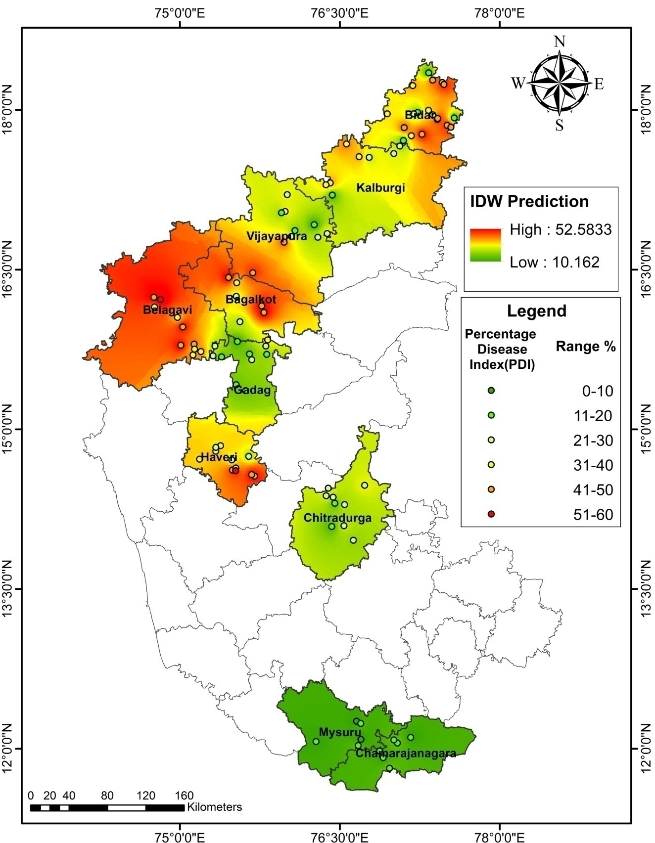
Fig. 1. Location map of selected districts of Karnataka monitored for purple blotch of garlic during Kharif and rabi 2021-22

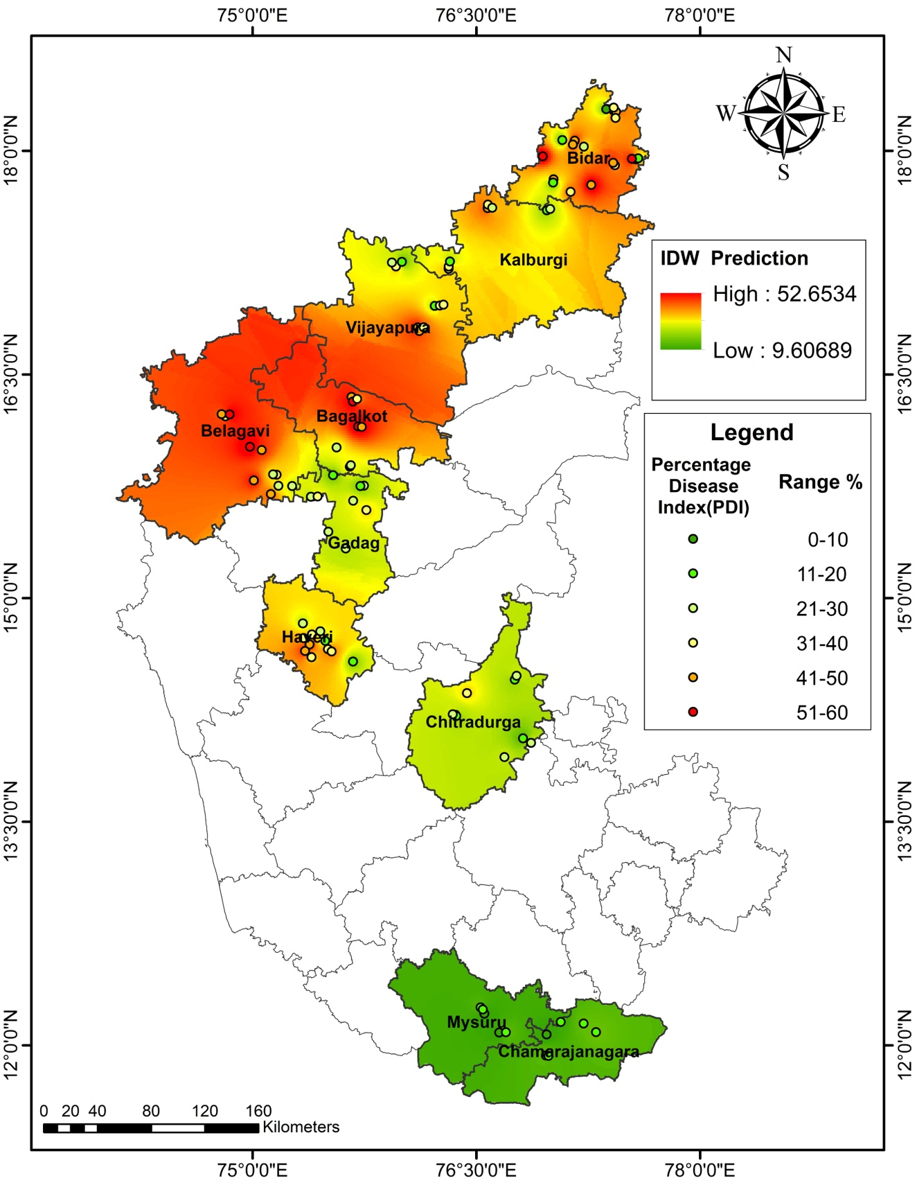
Fig. 2. Location map of selected districts of Karnataka monitored for purple blotch of garlic during Kharif and rabi 2022-23

District Mean
Taluku Mean
Fig. 3. Mean disease severity of purple blotch of garlic in different taluks and districts of Karnataka during Kharif and rabi 2021-22
Taluku Mean
District Mean
Fig. 4. Mean disease severity of purple blotch of garlic in different taluks and districts of Karnataka during Kharif and rabi 2022-23

