Chlorpyrifos degradation, antioxidant and biocontrol potential under pesticide stress by Leptolyngbya sp. isolated from Paddy field

Abstract
Aims: The present study focusses on exploring the potential of cyanobacteria in the bioremediation of organophosphorus (OP) compounds, also assessing the plant growth-promoting characteristics.
Study Design: The study was conducted in three phases to evaluate the potential of selected cyanobacterial strains for bioremediation of organophosphorus (OP) compounds and their plant growth-promoting (PGP) properties.
Place and Duration of study: The work was carried out in Department of Microbiology, S.K.Porwal College of Arts, Science and Commerce, Kamptee for one and a half year.
Methodology: Selected cyanobacterial isolates (Leptolyngbya) were cultured in BG-11 medium and exposed to organophosphorus (OP) compounds (chlorpyrifos) to assess degradation potential. Plant growth-promoting traits (IAA production, phosphate solubilization, and siderophore activity) were quantified using standard biochemical assays.
Results: The results demonstrated that blue-green algae (BGA) exerted simultaneous positive effects on both rice cultivation and soil properties. The Leptolyngbya sp. showed superior performance compared to the control, significantly improving plant growth and enhancing key soil parameters. The present study highlights the potential of cyanobacterial inoculants as effective tools for improving soil fertility and increasing rice yields. Further refinement of inoculant production techniques and extensive field-level evaluations are essential to maximize their effectiveness under sustainable agricultural systems.
Keywords: Cyanobacteria, Bioremediation, Organophosphorus degradation, Plant Growth-Promoting Rhizobacteria (PGPR)
INTRODUCTION
Organophosphorus (OP) compounds are extensively used as pesticides and industrial chemicals; however, their persistence and the formation of toxic breakdown products have led to severe environmental contamination (Kumar et al., 2018). Presently, the entry of OP residues has marked his presence in soil and water poses serious ecological and human health risks, thereby demanding the need of urgent attention towards the issue (Ibrahim et al., 2014). Parallel to pesticide overuse, the excessive application of chemical fertilizers has also resulted in multiple environmental problems, including greenhouse gas emissions, ozone layer depletion, acidification of water bodies, and soil degradation ( Santini et al., 2021). Prolonged use of synthetic fertilizers can adversely alter the physiochemical properties of the soil (Vijayan et al., 2020). These adverse consequences highlight the urgent need for eco-friendly alternatives.
The present conventional methods are not allied with sustainable approach due to its cost, energy input and secondary waste generation. Bioremediation is an eco-friendly and cost-effective strategy for degradation of organic pollutants such as hydrocarbons, pesticides, dyes, and industrial effluents (Vijayan et al., 2020). It employs microorganisms, plants, or microbial enzymes to transform toxic compounds into less harmful or inert products. The mechanism underlying bioremediation is through metabolic processes like oxidation, reduction, and hydrolysis, pollutants are mineralized into carbon dioxide, water, and biomass. This approach offers sustainable restoration of contaminated environments while minimizing secondary pollution compared to conventional physicochemical methods. Cyanobacteria can play a significant role in the bioremediation of polluted environments due to their metabolic versatility, resilience, and ability to thrive under diverse conditions (Santini et al., 2021; Ibrahim et al., 2014). They are able to degrade and transform a widespread range of organic contaminants, including pesticides, hydrocarbons, and phenolic compounds, through enzymatic pathways.
Cyanobacteria as biofertilizers i.e. microbial inoculants can act as an amendment to soil along with remediation action. Cyanobacteria not only provide essential nutrients to plants but also maintain soil structure and promote fertility in engaging nutrient recycling particularly carbon and nitrogen (Santini et al., 2021; Giesy et al., 2014). Among these, species with Plant Growth-Promoting attributes play a particularly significant role. PGPR enhance root development and overall plant growth through the secretion of plant growth regulators, such as indole acetic acid (IAA). Additionally, they improve nutrient availability and soil sustainability via mechanisms such as hydrogen cyanide (HCN) production, siderophore secretion, phosphate solubilization, and ammonia production (Kumar et al., 2018; Prasanna et al., 2016). This hormonal secretion can directly promote plant growth. The present research is focused on elucidating the organophosphorus degradation capability of cyanobacteria and plant growth promoting attributes of isolated cyanobacteria through a set of biochemical assays. The objective is directed towards enhancing knowledge and application of PGPR-mediated mechanisms for improving plant growth and maintaining soil fertility.
MATERIALS AND METHODS
MICROBIAL ANALYSIS OF SOIL AND WATER SAMPLES
Soil and water samples containing natural algal mats were collected from rice fields of Bhandara district and Nagpur district borderline area of Vidarbh region in Maharashtra state, India, using sterile containers. Samples were transported to the laboratory under cool and aseptic conditions for immediate processing.
For enrichment, 1–2 g of soil or 5 mL of water sample was inoculated into 250 mL Erlenmeyer flasks containing 100 mL of sterilized BG-11 medium. Cultures were incubated at 25 ± 2 °C under continuous fluorescent illumination (1500–2000 Lux) with continuous maintaining the 14:10 h light:dark photoperiod (Vijayan et al., 2020). Serial dilution and streak plate methods were employed to isolate unialgal colonies on BG-11 agar plates. After 7–14 days of incubation, distinct cyanobacterial colonies or filaments were picked using sterile glass capillaries/needles and transferred into fresh BG-11 liquid medium. This purification step was repeated until unialgal cultures were obtained, confirmed by microscopic observation. To reduce bacterial contamination, repeated washing with sterile distilled water was performed (Roque et al., 2023; Chittapun & Charoenrat, 2015).
Isolated strains were identified to the genus level based on morphological characteristics such as cell shape, filament structure, and pigmentation, using standard taxonomic keys. Pure cyanobacterial isolates were maintained on BG-11 agar slants and in liquid BG-11 medium under continuous illumination (1500–2000 lux) at 28 ± 2 °C. Cultures were sub-cultured every 4 weeks to ensure viability. For long-term storage, isolates were preserved at –80 °C in BG-11 medium supplemented with 10% glycerol (Roque et al., 2023; Scientific Reports, 2022; Tharindi et al., 2019).
SELECTION OF CHLORPYRIFOS-TOLERANT CYANOBACTERIA AND CHLORPYRIFOS DEGRADATION
The organophosphorus pesticide, chlorpyrifos, a commercially available formulation with the chemical name O, O-diethyl O-(3,5,6-trichloro-2-pyridinyl)-phosphorothioate. The initial inoculum was approximately 2 mg per 100 mL of culture medium for the screening of the cyanobacterial tolerant. For experiment, Chlorpyrifos was added to the medium at different concentrations ranging from 5, 10, 15, and 20 mg L⁻¹ for the biodegradation study. Similar dose-dependent ranges have been examined in earlier studies with cyanobacteria (Tang et al., 2024; Singh & Khattar, 2011).
The culture flasks were maintained under continuous illumination using daylight fluorescent tubes, providing an average light intensity of 1500-2000 Lux, which was kept constant throughout the experiment. The jars were incubated at 28-30°C under continuous shaking at 80 rpm. Samples were collected at five-day intervals up to 20 days for estimation of growth in terms of algal cell count. After five days, 10 mL of algal culture was withdrawn, and chlorpyrifos degradation was assessed spectrophotometrically, based on its characteristic absorbance peak at 290 nm. The algal strain was also employed to determine chlorpyrifos residues in the culture medium.
For the preparation of phosphorus-limited cultures, exponentially growing algal cells were inoculated into jars containing medium with 1/10th of the original phosphorus concentration. These phosphorus-limited cells were then cultured in media both without and with different concentrations of chlorpyrifos. After 20 days, samples were collected to estimate cell count and phosphorus content in the algal cells. The total phosphorus content in algal biomass was measured spectrophotometrically at 720 nm.
IDENTIFICATION OF CYANOBACTERIA
Genomic DNA was extracted from exponentially growing cyanobacterial cultures (15–20 days old). Approximately 50-100 mg of wet biomass was harvested by centrifugation at 10,000 rpm for 10 min. DNA extraction was performed using the CTAB method with modifications, or with a commercial bacterial DNA extraction kit. Assessment of the quality and quantity of DNA were completed by agarose gel electrophoresis (1%) and spectrophotometric measurement at 260/280 nm.
The 16S rRNA gene was targeted for molecular characterization. PCR amplification was carried out using universal cyanobacterial primers:
Forward: CYA359F (GGGGAATYTTCCGCAATGGG)
Reverse: CYA781R (GACTACWGGGGTATCTAATCCCWTT)
A partial nucleotide sequence of 421 bp obtained by amplification and sequencing of the 16S rRNA gene fragment showed that the selected cyanobacterial strain NGP3 was identified as Leptolyngbya species. The nucleotide sequence has been deposited in the NCBI GenBank database with accession number PP463919.1.
SCREENING OF PLANT GROWTH-PROMOTING CYANOBACTERIA FOR PLANT GROWTH-PROMOTING ACTIVITIES
INDOLE ACETIC ACID PRODUCTION
IAA production was estimated colorimetrically using Salkowski’s reagent. Bacterial isolates were grown in Luria–Bertani (LB) broth supplemented with L-tryptophan (0.5 mg/mL) and incubated at 28 °C for 48–72 h with shaking (120 rpm). Cultures were centrifuged at 10,000 rpm for 10 min, and 1 mL of supernatant was mixed with 2 mL of Salkowski’s reagent (1 mL of 0.5 M FeCl₃ in 50 mL of 35% perchloric acid). Development of a pink to red color after 30 min of incubation in the dark indicated IAA production. Absorbance was measured at 530 nm using a spectrophotometer (Waday et al., 2022).
PHOSPHATE SOLUBILISATION
Phosphate solubilization ability was tested using Pikovskaya’s agar medium containing tricalcium phosphate [Ca₃(PO₄)₂] as the insoluble phosphate source. Bacterial isolates were streaked onto Pikovskaya’s agar plates and incubated at 28–30°C for 5–7 days. Phosphate solubilization was indicated by the formation of a clear halo zone around the bacterial colonies. The Solubilization Index (SI) was calculated by measuring the ratio of the total halo zone diameter to the colony diameter (Waday et al., 2022).
SIDEROPHORE PRODUCTION
Siderophore production was assessed using the Chrome Azurol S (CAS) agar plate assay. PGPR isolates were spot-inoculated onto CAS agar plates and incubated at 28–30 °C for 3–5 days. The development of an orange halo around colonies indicated siderophore secretion. The diameter of the halo zone was recorded as a measure of siderophore production (Oo et al.,2020).
HYDROGEN CYANIDE PRODUCTION
The method of analysing HCN produced by PGPR was qualitative, and the reaction of the PGPR and picric acid with sodium hydroxide was employed to demonstrate HCN. Different strains of PGPR were stabbed onto nutrient agar than were incubated for 24-48 hours at the suitable temperature. These plates were later incubated and overlayed with filter paper soaked in picric acid solution (5% w/v) and then sealed with Incubation: Further incubation for 24-48 hours was carried a lid after. Out at RT. Observation: With a reaction between HCN and picric acid under alkaline conditions, the presence of red colour on the filter paper would show the HCN (Waday et al., 2022).
DETERMINATION OF ANTIOXIDANT ENZYME ACTIVITIES
In the present study, DPPH radical scavenging assay method was employed to determine antioxidant activity. The antioxidant potential, DPPH radical scavenging assay, various concentrations of organic fractions (25-125 µgml⁻¹) were combined with 1.0 ml of 0.135 mM DPPH in methanol, brought up to a final volume of 2.0 ml and stored in the dark for 30 minutes. The mixture's absorbance was measured using a spectrophotometer at 517 nm. Ascorbic acid was employed as a positive control. The radical scavenging activity was assessed by the percentage inhibition of absorbance, which was estimated using the following formula:
Inhibition of absorbance (%) = {(𝑁1−𝑁2)/ 𝑁1} 𝑥100
Where N1 and N2 are the absorbance of control and sample groups (Anas et. Al., 2016).
SEED GERMINATION OF RICE
Seed germination experiments were conducted using three Petri dishes, designated as A and B. Rice seeds were placed in each Petri dish and soaked with water. In Petri dish B, 0.25 g of wet cyanobacterial inoculum (Leptolyngbya sp.) was added at a rate corresponding to 500 seeds. Petri dish A served as the control, in which no cyanobacterial inoculum was added. After three weeks of incubation, the seedling height and root length were measured to estimate the effect of cyanobacterial inoculation on rice seed germination and early growth.
POT CULTURE ASSAY
Pot culture experiments were conducted using three pots, designated as A and B. Six rice seedlings, each measuring 2.5–6.5 cm in height, were transplanted from Petri dishes A and B into pots A and B, respectively. For inoculation, 1 gm of wet Leptolyngbya sp. inoculum was added to the soil of pot B at the same intervals. Pot A served as the uninoculated control. After three weeks of growth, plant parameters including shoot height, root length, fresh weight, and dry weight of leaves, stems, and roots were measured. In addition, soil physicochemical properties such as moisture content, bulk density, particle density, and porosity were also recorded.
RESULTS
MICROBIOLOGICAL ANALYSIS OF SOIL AND WATER SAMPLES
Soil is a fertile and dynamic ecosystem with a wide spread of microorganisms, with a special and essential role played by cyanobacteria. Cyanobacteria are autotrophic prokaryotes that can also be found in various soil environments and play a major role in nutrient cycling, particularly fixation of N₂, and solubilization of phosphorus (Singh et al., 2020; Singh et al., 2011). Not only do they improve the fertility of soil, but they also aid in the growth of plants and improve the structure of soil through the formation of biofilms and exopolysaccharide matrices surrounding the plant ecosystems. The microbiological examination of soil with emphasis on cyanobacteria is crucial in order to assess abundance, diversity, and functional potential of cyanobacteria, which are important to determine the ecological role and possible educational use in the sustainable agriculture and bioremediation of such pollutants like organophosphorus pesticides (Bioresources and Bioprocessing, 2022; Giesy et al., 2014).
The selective BG-11 medium was effective for the isolation of the cyanobacterial strains from water samples. After 20 days of incubation, distinct colonies were formed with typical morphological characteristics including filamentous shape, sheath and pigmentation between bluish-green to dark green.
CHLORPYRIFOS TOLERANCE
Cyanobacterial isolates exposed to different concentrations of chlorpyrifos (5, 10, 15, and 20 mg L⁻¹) demonstrated variable tolerance levels. At lower concentrations (5–10 mg L⁻¹), growth (measured as optical density at 750 nm and chlorophyll-a content) was only slightly reduced compared to the untreated control, indicating an adaptive capacity of the isolates. However, at 15 mg L⁻¹, moderate inhibition of growth was observed, with a significant reduction in biomass accumulation and pigment content. At the highest concentration (20 mg L⁻¹), most isolates exhibited pronounced growth inhibition, cell bleaching, and reduced viability, although a few strains continued to survive, suggesting inherent tolerance mechanisms.
IDENTIFICATION OF ISOLATED SPECIES
Molecular characterization through 16S rRNA gene amplification and sequencing validated the identity of the isolates as Leptolyngbya sp. which were assigned to genera Leptolyngbya (Pham et al., 2025).
A
B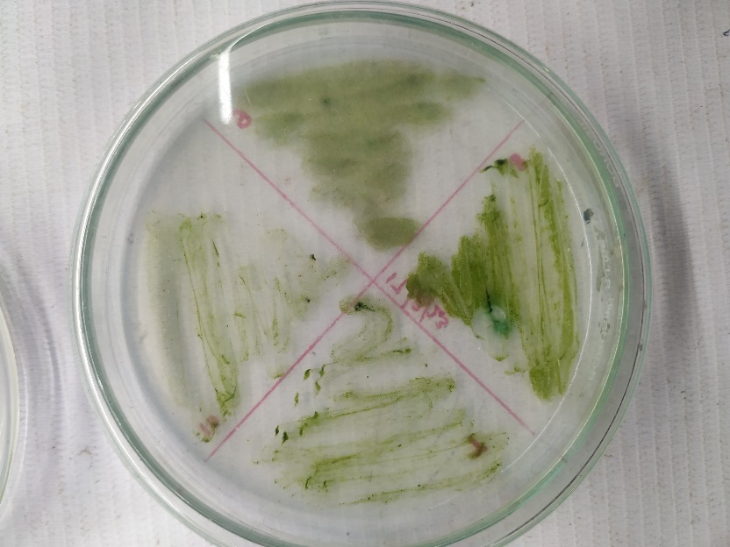 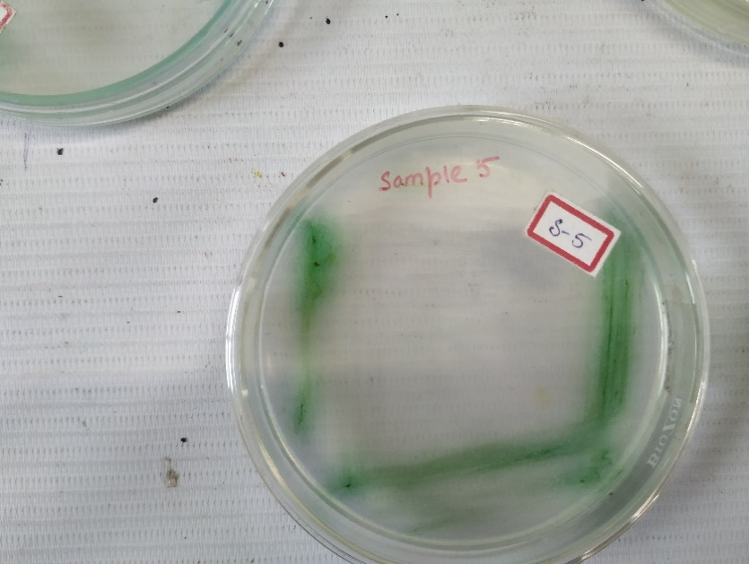 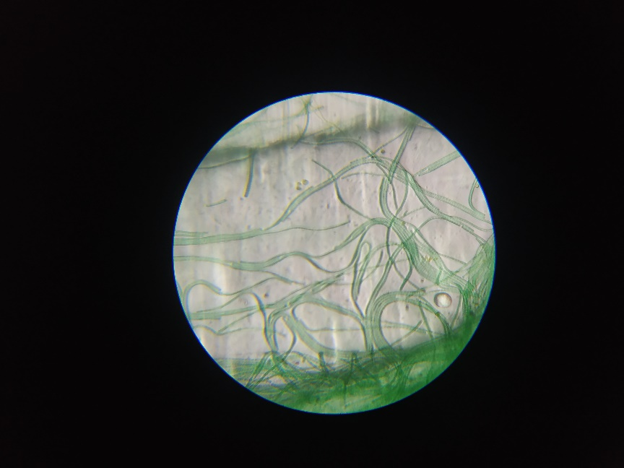

C
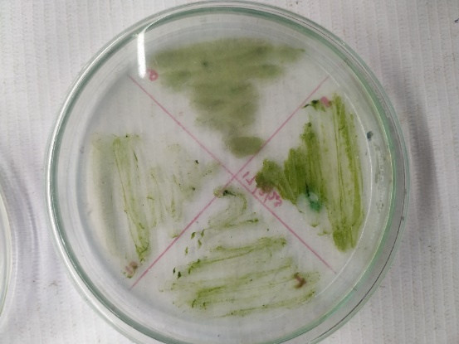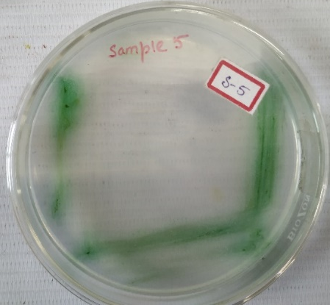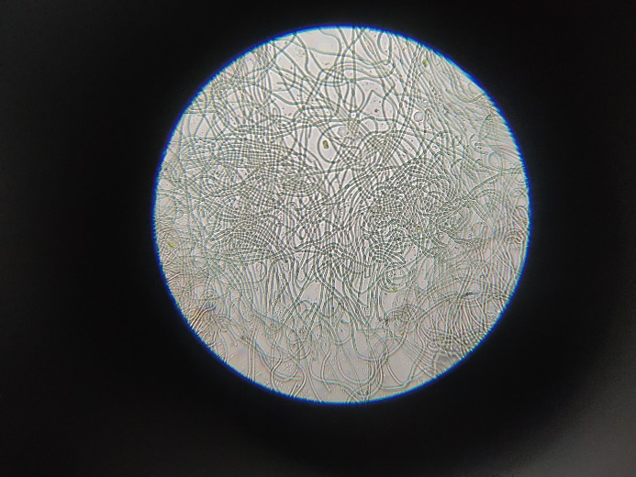
Figure 1: Isolation and Screening of Leptolyngbya sps. from paddy field. A) Isolation of cyanobacteria from paddy field. B) Growth on 20 ppm Chlorpyrifos spiked media. C) Microscopic examination at 100x objective of Leptolyngbya sp.
Scientific classification
Domain | Bacteria
Kingdom | Bacteria
Phylum | Cyanobacteriota
Class | Cyanophyceae
Order | Synechococcales
Family | Leptolyngbyaceae
GENUS | LEPTOLYNGBYA
Species | Leptolyngbya sp.
Table 1: Scientific Classification of Leptolyngbya sp.
CHLORPYRIFOS DEGRADATION
The cyanobacterial isolates exhibited a significant ability to degrade chlorpyrifos under laboratory conditions. Inoculated cultures showed a gradual reduction in pesticide concentration compared to the uninoculated control. Within 20 days of incubation, more than 85% degradation of chlorpyrifos was observed in treated samples, while only minimal degradation occurred in the control.
Cyanobacterium Leptolyngbya sp. demonstrated the highest degradation efficiency, achieving near-complete breakdown of the pesticide within the experimental period. Growth analysis revealed that the cyanobacterial biomass increased in pesticide-amended media, indicating a possible utilization of chlorpyrifos and/or its hydrolytic products as nutrient sources.

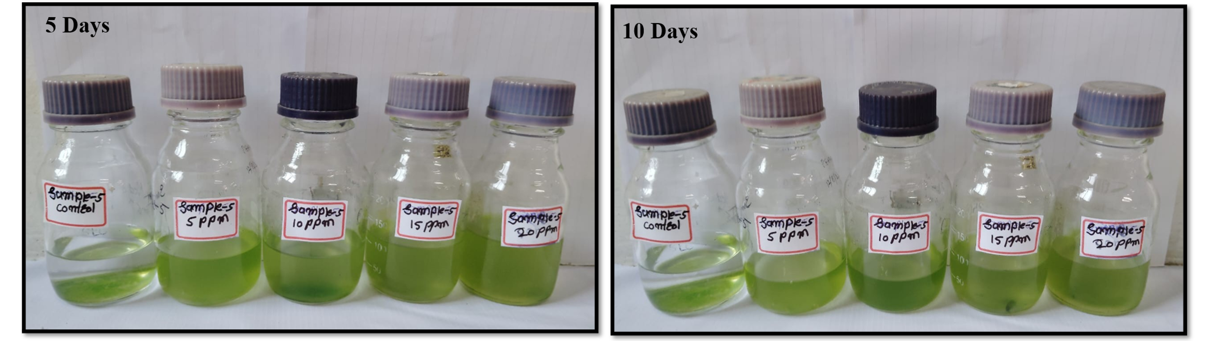
Figure 2: Degradation of chlorpyrifos uptill 10 days

Figure 3: Graphical representation of chlorpyrifos degradation by Leptolyngbya sp.

SCREENING OF PGPR FOR PLANT GROWTH-PROMOTING ACTIVITIES
INDOLE ACETIC ACID PRODUCTION
Cyanobacterial isolates tested in this study exposed positive results for indole-3-acetic acid production (IAA). Upon addition of Salkowski reagent, the culture supernatants developed a distinct pink to reddish coloration, confirming the presence of indolic compounds. Absorbance measurements at 530 nm indicated measurable concentrations of IAA in all isolates, with values ranging from 5 to 8 µg mL⁻¹ (mean ± SD), as determined from the standard calibration curve of authentic IAA. All this analysis confirmed that cyanobacteria isolates was lacel with attributes of plant growth promotion.
PHOSPHATE SOLUBILIZATION
The isolated cyanobacterial strains were screened for their ability to solubilize inorganic phosphate on Pikovskaya’s agar medium. The finding of clear zones around bacterial aggregates based on the fact that PGPR strains capable of solubilizing insoluble phosphorus resulted in phosphate solubilization. The amount of phosphate solubilization is quantified by measuring the diameter of the clear zones or by calculating the level of soluble phosphate in the agar using spectrophotometric methods. The identified isolate showed a clear halo zone around the colonies, indicating phosphate solubilization activity, although with varying efficiencies.
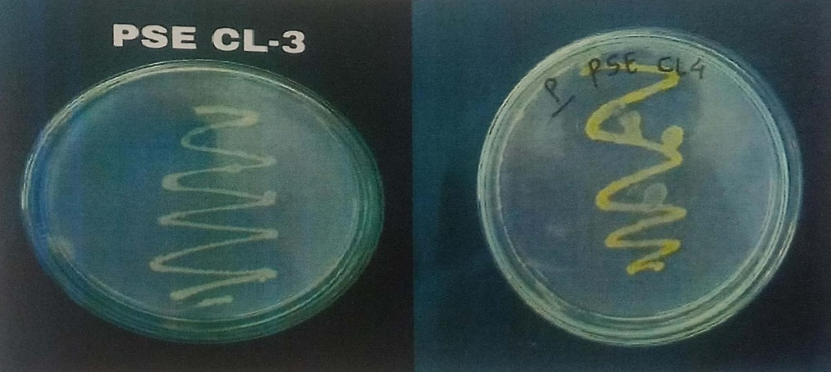
Figure 4: Phosphate solubilization test

SIDEROPHORE PRODUCTION
The production of siderophores by the PGPR was seen using the Chrome Azurol S agar (CAS) plates. Formation of the orange ring around plate colonies was proof of siderophore production, which forms a complex with iron and the CAS dye.
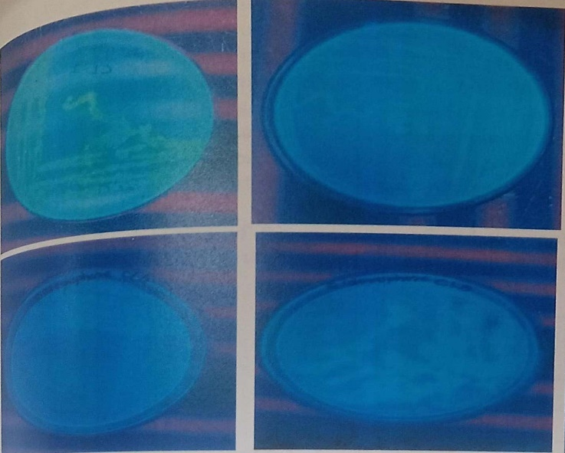
Figure 5: fluorescence green colour colony on CAS media indicate positive siderophore production

HCN PRODUCTION
The present method analysed qualitative HCN production by PGPR and the reaction of the PGPR and picric acid with sodium hydroxide was employed to demonstrate HCN. The isolate was stabbed onto nutrient agar than were incubated for 24-48 hours at the suitable temperature. The result was authenticated when the characteristic red coloration was localized on a filter paper inserted on top of the gel. The present study confirmed the ability of the tested isolates to produce hydrogen cyanide (HCN), as evidenced by the positive reaction in the qualitative assay. The production of HCN by cyanobacteria is an important physiological trait, as it may contribute to their ecological competitiveness, biocontrol potential against phytopathogens, and interaction with surrounding microbial communities. While excessive accumulation of HCN can be detrimental to plants and soil biota, its controlled release is often associated with growth-promoting and protective functions in the rhizosphere. The positive results obtained in this study suggest that cyanobacterial strains with HCN-producing ability could be explored further for their dual role in plant growth promotion and natural biocontrol application.
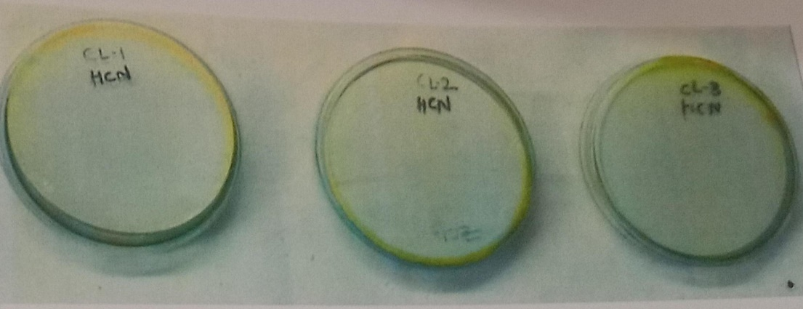
Figure 6: Hydrogen Cyanide (HCN) Production Test

Determination of antioxidants
The purple colour of the DPPH solution gradually changed to yellow upon addition of the methanol fraction, indicating reduction of DPPH radicals. Increase in sample concentration showed progressive decrease in absorbance at 517 nm. The methanol fraction displayed a dose-dependent scavenging activity, similar in trend to the standard antioxidant (Ascorbic acid). At higher concentrations, the reaction mixture became visibly lighter, confirming increased free radical scavenging. The methanol fraction exhibited significant DPPH radical scavenging activity, which increased with concentration. The fraction achieved a maximum of approximately 60–65% inhibition at 100 µg/mL. The methanol fraction showed good antioxidant activity in the DPPH assay, demonstrating its ability to effectively neutralize free radicals in a dose-dependent manner (Anas et. Al., 2016).

Figure 7: Antioxidants properties of methanol fraction of the samples expressed as their ability to scavenge DPPH (%RSA: % Radical Scavenging Activity)
EFFECT OF CYANOBACTERIA ON SEED GERMINATION
Cyanobacteria, functioning as natural biofertilizers and phytohormone producers, play a vital role in enhancing seed germination and early seedling establishment by improving nutrient accessibility and stimulating root and shoot development. In the present study, seeds treated with Leptolyngbya sp. exhibited the earliest germination, which was observed after 2 days, with seedlings attaining an average shoot height of 5.5 cm and root length of 3.0 cm within 12 days. In contrast, the control (untreated seeds) showed delayed germination, beginning only after 5 days, with seedlings achieving an average shoot height of 2.5 cm and root length of 1.5 cm after 20 days. These results clearly demonstrate the positive influence of cyanobacterial inoculation on accelerating germination, promoting seedling growth, and enhancing early root-shoot development compared to untreated controls.
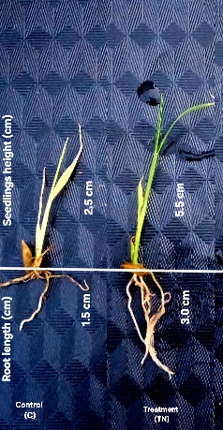
Figure 8: Effect of cyanobacteria on seed germination as Control (C) and treatment with Leptolyngbya sp. (TN)

Sample/Parameter | Control | Treatment  (TN)
Seedlings height (cm) | 2.5 | 5.5
Root length (cm) | 1.5 | 3.0
Period of germination times | 20 | 12
Germination rate (%) | 46 | 91
Table 2: Effect of Leptolyngbya sp. on germination of rice seeds
EFFECT OF CYANOBACTERIA ON RICE PLANT GROWTH (POT ASSAY)
The data demonstrate that cyanobacterial inoculation enhanced rice growth and soil moisture compared to the uninoculated control. Treatment with cyanobacteria resulted in significant increases in plant height, root length, and the biomass of shoots and roots. Specifically, plant height increased by 77% in TN, while root length improved by 62%. Fresh and dry weights of shoots and roots also showed substantial enhancement, indicating improved overall plant vigor.
Soil moisture content increased from 24.1% in the control to 31% in TN, indicating improved soil water retention under cyanobacterial treatment. Overall, both cyanobacterial treatments promoted growth and physiological development. TN showed higher efficacy in certain parameters in most traits, underscoring the potential of cyanobacteria as effective biofertilizers for sustainable rice cultivation.

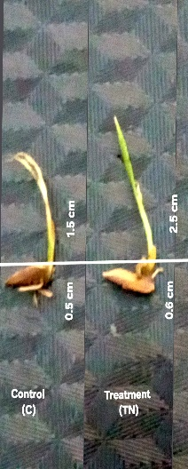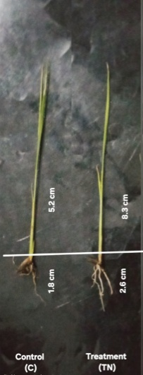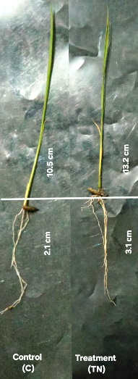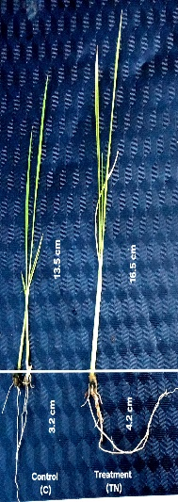
A
B
C
D
Figure 9: Effect of Leptolyngbya sp. on the growth of shoot and root length of Rice plant on A) 5th day B) 10th day C)15th day D) 20th day as Control (C), Treatment with Leptolyngbya sp. (TN). (All the images are representative of average triplicate results)

Sample | Control | Treatment  (TN) | Ratio control/TN%)
Plant height (cm) | 13.5 | 17.5 | 77
Root length (cm) | 3.2 | 5.1 | 62
Weight of fresh shoot(g) | 0.16 | 0.25 | 64
Weight of dry shoot (g) | 0.05 | 0.11 | 45
Weight of fresh root (g) | 0.24 | 0.42 | 57
Weight of dry root (g) | 0.065 | 0.16 | 40
Moisture  (%) | 24.1 | 32.0 | 75
Table 3. Effects of Leptolyngbya sp. on rice plant as Control (C) and treatment with Leptolyngbya sp. (TN).

Sample | Control | Treatment (TN) | % of increase or decrease by TN compared to control
Plant height(cm) | 13.5 | 16.5 | 40
Root length (cm) | 3.2 | 4.2 | 49
Weight of fresh shoot (g) | 0.16 | 0.20 | 42
Weight of dry shoot (g) | 0.05 | 0.10 | 97
Weight of fresh root (g) | 0.24 | 0.40 | 70
Weight of dry root (g) | 0.065 | 0.14 | 112
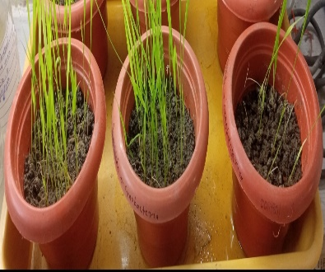
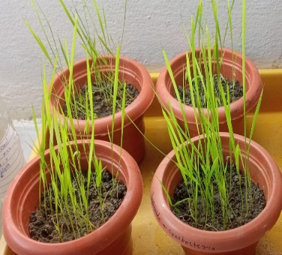
Table 4. Comparative study of the effects of Leptolyngbya sp. inoculant on rice plant and soil as Control (C) and treatment with Leptolyngbya sp. (TN).
A
B

Figure 10. Pot assay after three weeks A) Control pot (without cyanobacteria), B) Treatment pot (TN) with Leptolyngbya sp.

DISCUSSION
In this study, cyanobacteria (Blue-Green Algae, BGA) were isolated, identified, and mass-multiplied for use as inoculum in a pot experiment with rice. Soil pH, moisture, and cyanobacterial population were monitored across four seasons. The highest values for pH (6.8), soil moisture (43%), and cyanobacterial population (12–20 CFU/50 mL on A and B media) were recorded in spring, while the lowest values (pH 6.2, moisture 34%, 4–5 CFU/50 mL) were observed in winter (Pham et al.,2025).
Rice seeds treated with Leptolyngbya sp. exhibited faster germination compared to the control. Pot culture results demonstrated significant improvements in plant growth parameters: plant height increased by 40%, root length by 49%, fresh leaf and stem weight by 40%, fresh root weight by 49%, dry leaf and stem weight by 20%, dry root weight by 112%, and soil moisture by 75%. Statistical analysis revealed significant differences (P < 0.05) between BGA-treated pots and the control, highlighting the efficacy of cyanobacterial inoculation in promoting rice growth and improving soil conditions (Subhashini & Kaushik, 2013).
Leptolyngbya sp. have emerged as versatile microorganisms capable of performing dual roles in sustainable agriculture: bioremediation of environmental pollutants and biofertilization of crops (Prasanna et al., 2016; Singh et al., 2016). In the context of organophosphorus (OP) compound contamination, the isolated cyanobacteria were found to be tolerant and was found to degrade OP residues, thereby reducing their persistence in soil and water (Tang et at., 2024; El-Sayed et al.,2022). The isolates demonstrated growth in media supplemented with chlorpyrifos, indicating their inherent tolerance to pesticide stress (Tang et al., 2024; Singh & Khattar, 2011). This resilience may be attributed to their adaptive enzymatic systems and metabolic plasticity, which allow them to utilize xenobiotic compounds as alternative carbon or phosphorus sources under limited nutrient conditions (Kumar et al., 2018; Ibrahim et al., 2014). Their enzymatic treatments, including phosphotriesterases and hydrolases, facilitates the breakdown of complex organophosphates into less toxic compounds, mitigating their ecological and human health risks in the environment (Ibrahim et al., 2014; Singh & Khattar, 2011). The present study demonstrates that Leptolyngbya sp. inoculation can enhance OP degradation, confirming their potential as eco-friendly bioremediation agents (Kumar et al., 2018).
Beyond pollutant degradation, Leptolyngbya sp. also contribute to the plant growth promotion through several PGPR traits. The production of phytohormones such as indole acetic acid (IAA), siderophore secretion, phosphate solubilization, hydrogen cyanide (HCN) production, and ammonia release improves nutrient availability, root development, and overall plant potency (Santini et al.,2021; Singh et al., 2016; Prasanna et al.,2013). In rice and other crop systems, these traits lead to increased germination rates, higher biomass accretion, and improved root-shoot enhancements, which were observed in the current study. The dual benefits of cyanobacteria—reducing OP toxicity while enhancing soil fertility—make them suitable candidates for integrated sustainable agriculture practices (Roque et al., 2023; Pattanaik & Singh, 2020; Singh et al., 2016; Ansari et al., 2015; Prasanna et al., 2013).
Moreover, Leptolyngbya sp. contribute to soil health by fixing atmospheric nitrogen, improving moisture retention, and subsidiary microbial diversity (Tharindi et al., 2019; Chittapun & Charoenrat, 2015). Their resilience under diverse environmental conditions allows their application across diverse agro-ecosystems. The synergistic effect of OP degradation and PGPR activity suggests that cyanobacteria could serve as both bio-remediators and biofertilizers, thereby reducing dependency on chemical fertilizers and mitigating pesticide-induced soil toxicity (El-Sayed et al., 2022).
Leptolyngbya sp. offer a promising, eco-friendly strategy for simultaneously addressing soil contamination by organophosphorus compounds and enhancing the crop productivity through biofertilization. Future studies should focus on strain optimization, field-level validation and integration with other microbial consortia to maximize their efficiency in real-world agricultural systems (Rana et al., 2020).
The Leptolyngbya sp. demonstrated growth in media supplemented with chlorpyrifos, signifying their inherent tolerance to pesticide stress. This resilience may be attributed to their adaptive enzymatic systems and metabolic plasticity, which allow them to utilize xenobiotic compounds as alternative carbon or phosphorus sources under inadequate nutrient conditions (Kumar et al., 2018; Ibrahim et al., 2014).
CONCLUSION
In the present study, Leptolyngbya sp. isolated from rice field showed that BGA have positive effects simultaneously on rice plant and soil properties. Sao et al., (2015) reported similar results in their study. Leptolyngbya sp. inoculants exhibited better performance over control and in relation to improving rice growth and positive changes of soil properties. Chemical fertilizers widely used throughout most of agricultural causes huge ecological and environmental problems. Biofertilizers, organic fertilizers and other microbial products can overcome these problems because of they are viable components of a healthy and pleasant ecosystem. Cyanobacterial can play a crucial role in enhancing and repairing of soil fertility as biofertilizers and augment the growth and yield of crops particularly rice. In today’s world, considerable progress has been made in the development of cyanobacteria-based biofertilizers technology although Bangladesh stands behind regarding this issue. It was demonstrated that this technology can be a powerful means of enriching the soil fertility and increasing rice crop yields. However, the technology needs to be improved further for better exploitation under sustainable agricultural systems. Efficient high quality inoculants production and extensive field studies should be given priority in this regard.
REFERENCES:
- Anas, A., Vinothkumar, S., Gupta, S., Jasmin, C., Joseph, V., Parameswaran, P. S., & Nair, S. (2016). Evaluation of antioxidant and cytotoxic properties of cyanobacteria, Limnothrix sp. and Leptolyngbya sp. from Arabian Sea. Journal of Microbiology Biotechnology and Food Sciences, 6(3), 956-960. https://doi.org/10.15414/jmbfs.2016/17.6.3.956-960
- Ansari, M. F., Tipre, D. R., & Dave, S. R. (2015). Exploring the multi-trait plant growth promotion capability of commercial liquid biofertilizers isolates. International Journal of Life Sciences, 9(3), 24-37. https://doi.org/10.3126/ijls.v9i3.12463
- Mali, H., Shah, C., Patel, D. H., Trivedi, U., & Subramanian, R. B. (2022). Degradation insight of organophosphate pesticide chlorpyrifos through novel intermediate 2,6-dihydroxypyridine by Arthrobacter sp. HM01. Bioresources and Bioprocessing, 9(1), 31. https://doi.org/10.1186/s40643-022-00515-5
- Chittapun, S., & Charoenrat, T. (2015). Isolation and growth of N₂-fixing cyanobacteria from organic agricultural areas in Sanamchaikate, Chachoeng-Sao Province, Thailand. Thammasat International Journal of Science and Technology, 20(2), 28-37. https://he02.tci-thaijo.org/index.php/TIJSAT/article/view/39000
- Touliabah, H. E.-S., El-Sheekh, M. M., Ismail, M. M., & El-Kassas, H. (2022). A review of microalgae- and cyanobacteria-based biodegradation of organic pollutants. Molecules, 27(3), 1141. https://doi.org/10.3390/molecules27031141
- Giesy, J. P., Solomon, K. R., & Mackay, D. (2014). Evaluation of evidence that the organophosphorus insecticide chlorpyrifos is a potential persistent organic pollutant (POP) or persistent, bioaccumulative, and toxic (PBT). Environmental Sciences Europe, 26(1), 29. https://doi.org/10.1186/s12302-014-0029-y
- Ibrahim, W. M., Karam, M. A., El-Shahat, R. M., & Adway, A. A. (2014). Biodegradation and utilization of organophosphorus pesticide malathion by cyanobacteria. BioMed Research International. https://doi.org/10.1155/2014/392682
- Kumar, S., Kaushik, G., Dar, M. A., Nimesh, S., López-Chuken, U. J., & Villarreal-Chiu, J. F. (2018). Microbial degradation of organophosphate pesticides: A review. Pedosphere, 28(2), 190–208. https://doi.org/10.1016/S1002-0160(18)60017-7
- Oo, K. T., Win, T. T., Khai, A. A., & Fu, P. C. (2020). Isolation, screening and molecular characterization of multifunctional plant growth promoting rhizobacteria for a sustainable agriculture. American Journal of Plant Sciences, 11(6), 773-792. https://doi.org/10.4236/ajps.2020.116055
- Pattnaik, S., & Singh, L. (2020). Cyanobacteria Bioactive Compound, their Production and Extraction with Pharmaceutical Applications – A Review. International Journal of Current Microbiology and Applied Sciences. https://doi.org/10.20546/ijcmas.2020.906.402
- Pham, H. T. L., Ngo, T. T., Tran, T. V., Duong, T. A., Tran, L. D., Tran, A. T. T., Nguyen, V. T. H., & Nguyen, S. V. (2025). Classification of Nostoc-like cyanobacteria isolated from paddy soil into Aliinostoc, Aulosira, and Desmonostoc. Frontiers in Microbiology, 16, 1581725. https://doi.org/10.3389/fmicb.2025.1581725
- Prasanna, R., Joshi, M., Rana, A., Shivay, Y. S., & Nain, L. (2013). Cyanobacteria as potential options for improving productivity and sustainability of rice–wheat cropping systems. Soil Biology and Biochemistry, 65, 29–36. https://doi.org/10.1016/j.soilbio.2013.05.001
- Prasanna, R., Kumar, A., Singh, R. N., & Singh, P. K. (2016). Cyanobacteria as potential options for environmental sustainability—Promises and challenges. Indian Journal of Microbiology. https://doi.org/10.1007/s12088-016-0585-2
- Rana, A., Joshi, M., Prasanna, R., Shivay, Y. S., & Nain, L. (2020). Bioinoculants from cyanobacteria and PGPR: A potential biotechnological option for enhancing sustainable agriculture. Indian Journal of Microbiology, 60(1), 25–34. https://doi.org/10.1007/s12088-019-00825-5
- Roque, J., Brito, Â., Rocha, M., Pissarra, J., Nunes, T., Bessa, M., Vieira, J. P., & Tamagnini, P. (2023). Isolation and characterization of soil cyanobacteria and microalgae and evaluation of their potential as plant biostimulants. Plant and Soil. https://doi.org/10.1007/s11104-023-06217-x
- Santini, G., Biondi, N., Rodolfi, L., & Tredici, M. R. (2021). Plant biostimulants from cyanobacteria: An emerging strategy to improve yields and sustainability in agriculture. Plants, 10(4), 643. https://doi.org/10.3390/plants10040643
- Sao, S., & Samuel, K. (2015). Study of Cyanobacteria as biofertilizer from the rice field. World Journal of Pharmaceutical Research, 4(3), 1696-1706. https://www.wjpr.net/download/article/1425090923.pdf
- Singh, V. K., Singh, S. K., Singh, P. K., Verma, H., Pandey, K. D., Singh, P. K., & Kumar, A. (2020). Impact of pesticides applications on the growth and function of cyanobacteria. In P. K. Singh, A. Kumar, V. K. Singh, & A. K. Shrivistava (Eds.), Advances in Cyanobacterial Biology (pp. 151-162). Academic Press. https://doi.org/10.1016/B978-0-12-819311-2.00010-3
- Scientific Reports. (2022). Characterization of cyanobacterial isolates from freshwater and Egyptian lakes. Scientific Reports, 12, 13678. https://doi.org/10.1038/s41598-022-13678-2
- Singh, D. P., & Khattar, J. I. S. (2011). Chlorpyrifos degradation by the cyanobacterium Synechocystis sp. strain PUPCCC-64: tolerance and biodegradation studies. Environmental Monitoring and Assessment. https://doi.org/10.1007/s10661-011-2107-1
- Singh, J. S., Kumar, A., Rai, A. N., & Singh, D. P. (2016). Cyanobacteria: A Precious Bio-resource in Agriculture, Ecosystem, and Environmental Sustainability. Frontiers in Microbiology, 7, 529. https://doi.org/10.3389/fmicb.2016.00529
- Subhashini, D. V., & Kaushik, B. D. (2013). Cyanobacterial biofertilizers for rice crops. Current Science, 105(4), 507–508.
- Tang, S., Li, Y., Zhu, Z., Wang, Y., Peng, Y., Zhang, J., Nong, P., Pan, S., Fan, Y., & Zhu, Y. (2024). Biotransformation of Chlorpyrifos Shewanella oneidensis MR-1 in the Presence of Goethite: Experimental Optimization and Degradation Products. Toxics, 12(6), 402. https://doi.org/10.3390/toxics12060402
- Tharindi, P. W. M., Balasooriya, W. K., Suganthan, B., & Vivehananthan, K. (2016). Isolation and Identification of Culturable Cyanobacteria from Paddy Soils of the Intermediate Zone of Sri Lanka. Proceedings of the 15th Agricultural Research Symposium. https://www.researchgate.net/publication/337300000_Isolation_and_Identification_of_Culturable_Cyanobacteria_from_Paddy_Soils_of_the_Intermediate_Zone_of_Sri_Lanka
- Vijayan, N. P., Ali, S. H., Madathilkovilakathu, H., & Abdulhameed, S. (2020). Chlorpyrifos-degrading cyanobacterium – Coleofasciculus chthonoplastes isolated from paddy field. International Journal of Environmental Studies, 77(2), 307–317. https://doi.org/10.1080/00207233.2020.1739391
- Waday, Y. A., Girma Aklilu, E., Bultum, M. S., Ramayya Ancha, V., & Beyene, D. (2022). Isolation and Characterization of Plant Growth-Promoting Rhizobacteria from Coffee Plantation Soils and Its Influence on Maize Growth. Applied and Environmental Soil Science, 2022, 5115875. https://doi.org/10.1155/2022/5115875

