Genetic diversity assessment of off-season jackfruit (Artocarpus heterophyllus Lam.)

ABSTRACT
The study aims at assessing the genetic diversity of 30 off-season jackfruit (Artocarpus heterophyllus Lam.) accessions from Northern districts of Kerala (Kannur, Kozhikode, and Malappuram) using SSR and ISSR markers Genetic diversity in the accessions was analysed using 20 SSR and 10 ISSR markers. All 10 ISSR primers were polymorphic, with (Polymorphism Information Content) PIC value in the range of 0-0.5, whereas only 16 SSR primers were found to be polymorphic, with PIC value in the range of 0-0.80. The dendrogram representation classified the population into 2 major clusters and 4 subclusters, with maximum proximity between accessions KNR 3 and KNR 7. The Principal Co-ordinate Analysis (PCoA) showed distinct populations in 2 districts. Furthermore, 2 major clusters and 4 subclusters, with admixture was observed in the population structure analysis. Overall, the analysis indicates moderate levels of genetic differentiation and common ancestry, possibly due to limited genetic mixing and less seed dispersal rates in the close geographic locations the accessions were selected from.

KEYWORDS: Genetic diversity, molecular markers, jackfruit, SSR, ISSR

- INTRODUCTION

Jackfruit, scientifically Artocarpus heterophyllus is a crop native to the rainforests of India (Kavya and Shyamalamma, 2020). It is a monoecious species with thick white latex in all parts of the plant. India stands second in jackfruit production worldwide with cultivation spread across states like Assam, Tripura, Bihar, Uttar Pradesh, the foothills of the Himalayas and South Indian States of Kerala, Tamil Nadu and Karnataka (Uikey et al., 2020)
Molecular marker-based approach can be used for germplasm evaluation, and analysing population structure. Molecular characterization in using the SSR (Simple Sequence Repeat) and ISSR (Inter Simple Sequence Repeat) markers will help in identifying the specific locations of desirable alleles and sites at which polymorphism occurs (Xu et al., 2024). This can be further analyzed to understand the genetic diversity in a given population. (Nakintu et al., 2020). Moreover, population analysis of the hugely vast and varied population could be conducted for further studies and research based on crop domestication, conservation of plant genetic resources and gene pool utilization, as mentioned by Palupi et al. (2019). SSR and ISSR markers are effective in accessing genetic diversity among cultivars because they show high degrees of polymorphism to reveal differences at molecular level. The ISSR microsatellite markers are widely used in identification of plant species due to its high reproducibility (Gupta et al. (2011).
There is remarkable genetic diversity in jackfruit, possibly due to cross pollination and seed propagation (Kavya et al., 2019). Significant variability exists among the jackfruit trees and conducting in-situ evaluations of these germplasms for molecular characterization would be valuable in identifying new genotypes suitable for commercial cultivation. The evaluation of germplasm serves as a fundamental tool in identifying superior genotypes.

Identification and characterization of off-season bearing jackfruit types will enhance the availability of the fruit during “no jackfruit” days and farmers will get chances to earn more because, the off- season yield fetches a higher price in the market. However, there are a few studies
conducted in off season jackfruit in Kerala, as compared to other tropical
fruits. Minimal studies are conducted on the development of molecular markers in jackfruit (Kavya et al., 2019). Hence, the objective of present study is to explore the genetic diversity of off-season jackfruit in Northern districts of Kerala using SSR and ISSR markers.

- MATERIALS AND METHODS

  - Collection of Plant Materials
30 Jackfruit accessions were collected from 3 districts; Kannur, Kozhikode and Malappuram in North Kerala. The plants were collected using sterile dissection blades, cleaned using tissue paper and then enclosed in polybags to minimize polyphenol contamination (Ojwang, 2020). The samples are then maintained at -80℃ in College of Agriculture, Vellayani for future use. The locations of the collected accessions are given in Table 1.

Table 1. Location of 30 Jackfruit accessions collected
Sl. No. | Accessions | Location (District) | Latitude | Longitude
1 | KNR1 | Kannur | 11° 54' 23.65 N | 75° 22' 29.23E
2 | KNR2 | Kannur | 11° 54' 35.08 N | 75° 22' 26.97 E
3 | KNR3 | Kannur | 11° 54' 25.48 N | 75° 22' 34.77 E
4 | KNR4 | Kannur | 11° 54' 26.10 N | 75° 22' 35.68 E
5 | KNR5 | Kannur | 11° 54' 29.63 N | 75° 22' 24.31 E
6 | KNR6 | Kannur | 11° 54' 29.64 N | 75° 22' 24.24 E
7 | KNR7 | Kannur | 11° 54' 33.51 N | 75° 22' 24.39 E
8 | KZK1 | Kozhikode | 11° 18' 50.34 N | 75° 50' 32.97 E
9 | KZK2 | Kozhikode | 11° 18' 47.99 N | 75° 50' 31.50 E
10 | KZK3 | Kozhikode | 11° 18' 24.35 N | 75° 52' 33.82 E
11 | KZK4 | Kozhikode | 11° 18' 30.62 N | 75° 52' 4.31 E
12 | KZK5 | Kozhikode | 11° 16' 10.43 N | 75° 49' 0.52 E
13 | KZK6 | Kozhikode | 11° 16' 22.88 N | 75° 49' 6.46 E
14 | KZK7 | Kozhikode | 11° 16' 22.83 N | 75° 49' 1.65 E
15 | KZK8 | Kozhikode | 11° 16' 6.26 N | 75° 48' 55.18 E
16 | KZK9 | Kozhikode | 11° 16' 37.61 N | 75° 48' 30.09 E
17 | KZK10 | Kozhikode | 11° 16' 16.05 N | 75° 49' 16.26 E
18 | KZK11 | Kozhikode | 11° 16' 20.56 N | 75° 49' 7.41 E
19 | MPM1 | Malappuram | 11° 13' 50.68 N | 75° 58' 27.91 E
20 | MPM2 | Malappuram | 10° 56' 39.32 N | 76° 2' 23.70 E
21 | MPM3 | Malappuram | 11° 15' 12.02 N | 75° 58' 42.86 E
22 | MPM4 | Malappuram | 11° 14' 18.16 N | 75° 59' 1.30 E
23 | MPM5 | Malappuram | 11° 14' 7.91 N | 75° 57' 34.2 E
24 | MPM6 | Malappuram | 11° 16' 24.87 N | 76° 6' 58.91 E
25 | MPM7 | Malappuram | 10° 52' 1.48 N | 76° 20' 17.04 E
26 | MPM8 | Malappuram | 11° 13' 10.90 N | 75° 59' 35.16 E
27 | MPM9 | Malappuram | 11° 15' 53.62 N | 76° 9' 1.04 E
28 | MPM10 | Malappuram | 11° 15' 18.32 N | 76° 10' 2.56 E
29 | MPM11 | Malappuram | 11° 16' 26.98 N | 76° 9' 8.10 E
30 | MPM12 | Malappuram | 11° 15' 43.44 N | 76° 0' 21.78 E

  - DNA Extraction

DNA isolation of sample is done using the modified CTAB method to minimize chances of polyphenol contamination (Aboul-Maaty and Oraby 2019). The freshly collected plant samples are crushed in liquid nitrogen, to which preheated Cetyl Trimethyl Ammonium Bromide CTAB extraction buffer along with β mercaptoethanol and PVP is added. The crushed mixture transferred to centrifuge tube and is kept in a water bath at 65℃ for 45 minutes. The tubes are then centrifuged at 10000 rpm for 10 minutes. The supernatant is collected and purified using chloroform-isoamyl alcohol mixture in 24:1 ratio and centrifuged at 12000 rpm for 10 minutes. The resulting supernatant is precipitated using chilled isopropanol and kept overnight in -20℃, followed by centrifugation at 10000rpm for 15 minutes, to precipitate the DNA as pellets. The pellets are purified by washing twice in 70% ethanol and air drying. The pellets are then dissolved in TE buffer and stored in -20℃ (Porebski et al., 1997).

  - Quantification and gel documentation of DNA
Quantification of the isolated DNA is done using Nano Drop spectrophotometry to quantify the measure of nucleotide bases at 260/280nm wavelength by determining the ratio of absorbance. Samples with purity range between 1.8-2 is considered as good quantity and free of impurities (Doe et al., 2019).
Agarose gel documentation is used to visualize the extracted DNA and confirming the presence of bands, wherein, the DNA fragments are separated based on their size. Since DNA fragments are negatively charged, under the influence of electricity, DNA fragments move to the positive charged electrode, based on the molecular size; the lightest fragments move farthest from the negative end, thus separating the different sized DNA fragments.
The samples were observed in 3% agarose gel, prepared by melting 3.6g agarose in 120mL TAE buffer. Combs are placed to create wells in the gel after gel hardening, the combs are removed and samples are loaded. The isolated DNA sample is mixed with 6x Gel loading dye (1µL dye and 5µL DNA sample). The gel is run for about 1 hour to separate the bands.

  - Polymerase Chain Reaction
The 30 DNA samples were amplified using Polymerase Chain Reaction (PCR) using 20 SSR primers (Table 2) and 10 ISSR primers (Table 3). Reaction mixture (10 µL) for SSR primer was prepared using 5 µL PCR master mix, 0.5 µL forward primer, 0.5 µL reverse primer, 1 µL DNA extract and 3 µL nuclease-free water. Reaction mixture for ISSR markers included 5 µL PCR master mix, 2 µL primer, 2 µL DNA extract and 1 µL nuclease-free water. The SSR markers were selected from previously reported works of Singh et al. (2021), and ISSR primers from Aswini et al. (2018). The details of PCR reaction conditions for SSR and ISSR markers are given in Table 4.

Table 2. ISSR primers deployed for molecular diversity analysis of jackfruit accessions
Primer Name | Sequence
UBC 807 | AGAGAGAGAGAGAGAGT
UBC 809 | AGAGAGAGAGAGAGAGG
UBC 812 | GAGAGAGAGAGAGAGAA
UBC 834 | AGAGAGAGAGAGAGAGYT
UBC 840 | GAGAGAGAGAGAGAGAYT
UBC 841 | GAGAGAGAGAGAGAGATYC
UBC 855 | ACACACACACACACACYT
UBC 858 | TGTGTGTGTGTGTGTGRT
UBC 866 | CTCCTCCTCCTCCTCCTC
TC 10G | TCTCTCTCTCTCTCTCTCTCG

Table 3. SSR primers deployed for molecular diversity analysis of jackfruit accessions

Primer name | Forward primer | Reverse primer
JFSSR 4 | ACAAGAGACTCAAGCCTCAA | TCTTTGACTGCAATGAAGC
JFSSR 8 | CAACCCAAGAAGTAGTATCCA | GAGAAGGACGGAGATTCTTT
JFSSR 12 | TGGATCTTGGTGTCGGTCT | TACCACTCCGTACAGTGGAAA
JFSSR 13 | ACTCAGTTATTGAGCCTTCCT | CAAAGAGACGTGTGATGTTG
JFSSR 15 | CTCCCTGGGAAAGGAATA | CTTAACGATTTGCATTAGGG
JFSSR 18 | CACTAGTGAAACCTTCTGTGG | CTGTTCAGCAGGCAATAACT
JFSSR 19 | GAGTTTATTTCTTGCCCTTG | CTCATCATTTCGCTTTAACC
JFSSR 20 | AAATACCCAGCTCGCAGT | CACCAACAAACTCTTCCTTTC
JFSSR 25 | GTTATCAGAATATCGACAGCAG | GTGTTATTGCAGCTCACAAG
JFSSR 28 | GCCACTAGAAACTCCAAACTT | GGGAATGGGTATGAGTATGAG
JFSSR 32 | CAATCTCCCACTTGTTTGT | CTGTTATATCTTCGGGAAGTG
JFSSR 35 | AAGCGATCAAAGGTGACAT | CTCTCCTCCTTCTTCTTCATC
JFSSR 39 | AATGGCAACTTAGCAAGGTA | ATACGATGTCCCAGAAGTCAT
JFSSR 44 | CAAACCAACACTTATCACTCC | CCATCTTCAAAGTCCGTTC
JFSSR 45 | TTCTCTCACAAACACCCAAA | CCATCTTCAAAGTCCGTTC
JFSSR 47 | GAGAAGCAACCCAATTAAGA | GTGTTCGTGGAACGTAGTG
JFSSR 48 | ACCAAGTCACACATGATTACC | GTGTTCGTGGAACGTAGTG
JFSSR 52 | ACCAAGTCACACATGATTACC | ACAGTGTAGGCACTGTTTCTG
JFSSR 64 | CAGAATACGATGACAAGATGG | CTTCTTCATCGGTAAAGTGC
JFSSR 76 | TCGAAGCAGACAATCAGAAT | AGAGGAGAAGGGACTGAATTT

Table 4. PCR reaction conditions utilized in the molecular diversity analysis

 | SSR Markers (35 cycles) |  | ISSR Markers (35 cycles)
Profile | Temperature | Duration | Temperature | Duration
Lid temperature | 98 ℃ | - | 98 ℃ | -
Initial denaturation | 94 ℃ | 5 min | 94 ℃ | 2 min
Denaturation | 94 ℃ | 45s | 94 ℃ | 30s
Annealing | 45-60 ℃ | 30s | 48-62 ℃ | 45s
Extension | 72 ℃ | 30s | 72 ℃ | 2 min
Final extension | 72 ℃ | 7 min | 72 ℃ | 10 min
Infinite hold | 4 ℃ | - | 4 ℃ | -

  - Agarose gel electrophoresis analysis of PCR product

The PCR product can be viewed and analysed using agarose gel electrophoresis. The reaction mix after PCR is loaded in agarose gel containing a suitable fluorescent dye and 80mV current is passed through the gel using a gel electrophoresis unit. The amplified DNA fragments absorb ethidium bromide, a fluorescent dye, which is illuminated under the presence of UV radiation in a Gel documentation machine. The size of the bands are measured by comparing with a 100bp DNA ladder. The resulting image is used for analyzing the extend of amplification and the number of polymorphic bands. By counting the number of polymorphic bands.

  - Genetic diversity analysis

The presence and absence of bands can be recorded to calculate Polymorphism Information Content (PIC) value, heterozygosity, Marker Index and other parameters like dendrogram, genetic distance, PCoA and population structure analysis. PCR amplified image can be used PIC value can be calculated by counting the frequency of amplified alleles and null alleles. The PIC value can be used to understand the ability of a marker to identify polymorphism in a selected population. The PIC value can be calculated for SSR markers and ISSR markers using the following equation:

PIC value for SSR marker: 2fi(1-fi)

fi: Frequency of amplified allele.
(1-fi): Frequency of null allele (band absent) of marker i.

PIC value for ISSR marker: 1- Σpi²
pi: Frequency of i^{th} allele.

- Results
Genetic diversity analysis of 30 jackfruit accessions collected from 3 Northern districts in Kerala; Kannur, Kozhikode and Malappuram were done using 20 SSR and 10 ISSR primers.
A total of 7 accessions were collected from Kannur, 11 from Kozhikode and 12 from Malappuram district.

DNA was extracted from the 30 accessions using the modified CTAB method described by Doyle and Doyle (1990) (Plate 1). Quantification and quality analysis of extracted DNA was computed using spectrophotometer. The readings obtained are used to analyze the purity and concentration of the isolated DNA at A260/ A280. The purity values were in the range of 1.78 to 2.03, thus confirming that the isolated DNA samples are pure and free of protein or RNA contamination. The samples had ample concentration, ranging from 277 ng/µL to 685 ng/µL (Table 5). Furthermore, the bands observed in Plate 1 shows concentrated and intact samples without shearing. The samples are subjected to molecular characterization using 20 SSR primers reported by Singh et al. (2021), and 10 ISSR primers reported by Aswini et al. (2018). The annealing temperatures of each primer was standardized by running gradient PCR, ranging at a temperature of 45-60℃ for SSR primers and 48-62℃ for ISSR primers. All 10 ISSR markers were found to be polymorphic, with highest PIC value in primer UBC 809 (Table 6). 16 out of 20 SSR markers were polymorphic, while 4 SSR markers had only one band in all the 30 samples. The highest PIC value was found in primer JFSSR 47 (Table 7).

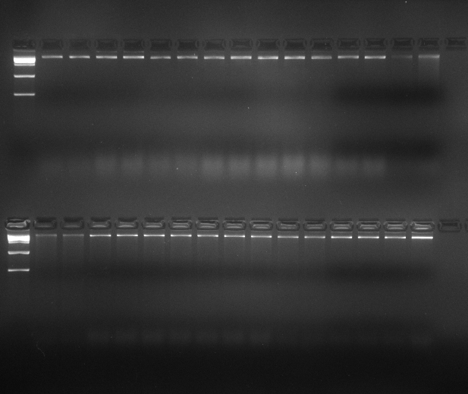
MM 16 17 18 19 20 21 22 23 24 25 26 27 28 29 30
MM 1 2 3 4 5 6 7 8 9 10 11 12 13 14 15
Plate 1: Gel profile of 30 jackfruit DNA samples

Table 5. Quality and quantity of DNA isolated from jackfruit genotypes by Nano Drop Spectrophotometer
S. No. | Accession | Purity | Concentration (ng/µl) | S. No. | Accession | Purity | Concentration (ng/µl)
1 | KNR 1 | 1.87 | 375 | 16 | KZK 9 | 1.87 | 349
2 | KNR 2 | 2.03 | 439 | 17 | KZK 10 | 1.86 | 284
3 | KNR 3 | 1.98 | 358.4 | 18 | KZK 11 | 1.83 | 359
4 | KNR 4 | 1.65 | 295 | 19 | KZK 12 | 1.75 | 354
5 | KNR 5 | 1.92 | 330 | 20 | MPM 1 | 1.92 | 598
6 | KNR 6 | 1.87 | 457 | 21 | MPM 2 | 1.67 | 512
7 | KNR 7 | 1.88 | 685 | 22 | MPM 3 | 2.06 | 359.7
8 | KZK 1 | 1.95 | 397 | 23 | MPM 4 | 1.92 | 283.4
9 | KZK 2 | 2.04 | 479 | 24 | MPM 5 | 1.68 | 372
10 | KZK 3 | 1.78 | 387 | 25 | MPM 6 | 1.85 | 476.5
11 | KZK 4 | 1.83 | 317.6 | 26 | MPM 7 | 1.93 | 357
12 | KZK 5 | 1.92 | 283 | 27 | MPM 8 | 1.87 | 265
13 | KZK 6 | 1.60 | 277 | 28 | MPM 9 | 1.52 | 249.3
14 | KZK 7 | 1.95 | 483 | 29 | MPM 10 | 2.14 | 355
15 | KZK 8 | 1.88 | 547.2 | 30 | MPM 11 | 1.93 | 305.4

Table 6. Details of amplification with selected primers for ISSR assay in jackfruit.

ISSR Primers | Total no. of amplicons | No. of Polymorphic Loci | Polymorphism (%) | PIC Value
UBC 807 | 8 | 6 | 75 | 0.23
UBC 809 | 8 | 6 | 75 | 0.29
UBC 812 | 8 | 7 | 87.5 | 0.18
UBC 834 | 8 | 6 | 75 | 0.30
UBC 840 | 5 | 4 | 80 | 0.04
UBC 841 | 7 | 5 | 71.4 | 0.22
UBC 855 | 7 | 6 | 85.7 | 0.16
UBC 858 | 6 | 3 | 50 | 0.15
UBC 866 | 4 | 2 | 50 | 0.02
TC 10 G | 7 | 5 | 71.4 | 0.24

Table 7. Details of amplification with selected primers for SSR assay in jackfruit.

SSR Primers | Total no. of amplicons | No. of Polymorphic Loci | Polymorphism (%) | PIC value
JFSSR 4 | 4 | 3 | 75 | 0.20
JFSSR 8 | 2 | 1 | 50 | 0.11
JFSSR 12 | 3 | 2 | 66.67 | 0.08
JFSSR 13 | 1 | 0 | 0 | 0.00
JFSSR 15 | 3 | 1 | 33.34 | 0.18
JFSSR 18 | 1 | 0 | 0 | 0.00
JFSSR 19 | 1 | 0 | 0 | 0.00
JFSSR 20 | 3 | 2 | 66.67 | 0.30
JFSSR 25 | 2 | 1 | 50 | 0.12
JFSSR 28 | 1 | 0 | 0 | 0.00
JFSSR 32 | 2 | 1 | 50 | 0.12
JFSSR 35 | 4 | 3 | 75 | 0.12
JFSSR 39 | 2 | 1 | 50 | 0.47
JFSSR 44 | 2 | 1 | 50 | 0.33
JFSSR 45 | 2 | 1 | 50 | 0.39
JFSSR 47 | 2 | 1 | 50 | 0.46
JFSSR 48 | 3 | 2 | 66.67 | 0.12
JFSSR 52 | 2 | 1 | 50 | 0.02
JFSSR 64 | 2 | 1 | 50 | 0.13
JFSSR 76 | 3 | 2 | 66.67 | 0.11

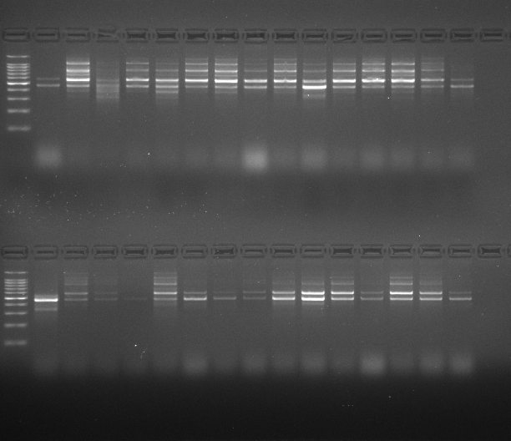
MM 1 2 3 4 5 6 7 8 9 10 11 12 13 14 15
MM 16 17 18 19 20 21 22 23 24 25 26 27 28 29 30
Plate 2. PCR amplification of jackfruit accessions using ISSR primer UBC 809.

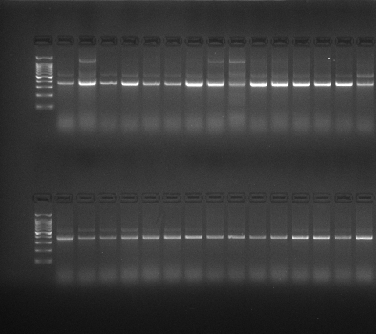
MM 16 17 18 19 20 21 22 23 24 25 26 27 28 29 30
MM 1 2 3 4 5 6 7 8 9 10 11 12 13 14 15
Plate 3. PCR amplification of 30 jackfruit accessions using SSR primers JFSSR 47

Further analysis of the presence and absence of bands was done in the NTSYS software using the UPGMA method (Rohlf, 2005), where dendrogram representation of the data was obtained by calculating the genetic distance between the accessions used for the study. As given in the dendrogram, (Fig. 1.) the genetic diversity and relationship between the 30 jackfruit accessions classifies the given population into two major clusters; Cluster I and Cluster II. Cluster I contains only one accession, KNR 1, whereas Cluster II which contains the remaining 29 accessions is further divided into two subcluster, subcluster IIA and subcluster II B, which contains 13 and 16 accessions respectively. Dendrogram represents the combined data of SSR and ISSR markers based on similarity matrix (Sujarit et al., 2019). Here, the dendrogram is given along a coefficient ranging from 0.67 to 0.95. A different clustering method was also performed using the STRUCTURE 2.3.4. for population structure analysis. The genetic structure of the 30 accessions in 163 different loci obtained from 30 primers were analyzed using the software, with 10,000 iterations and 1,00,000 repetitions. The results revealed that, the data probability was maximum at ΔK = 6, suggesting that there are 6 populations which are genetically different from each other (Fig. 2.) with varied levels of admixture in them.

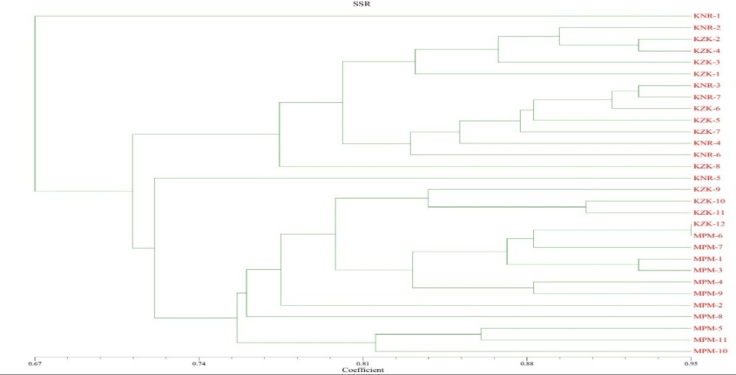
Fig. 1. Dendrogram showing genetic diversity of 30 jackfruit accessions

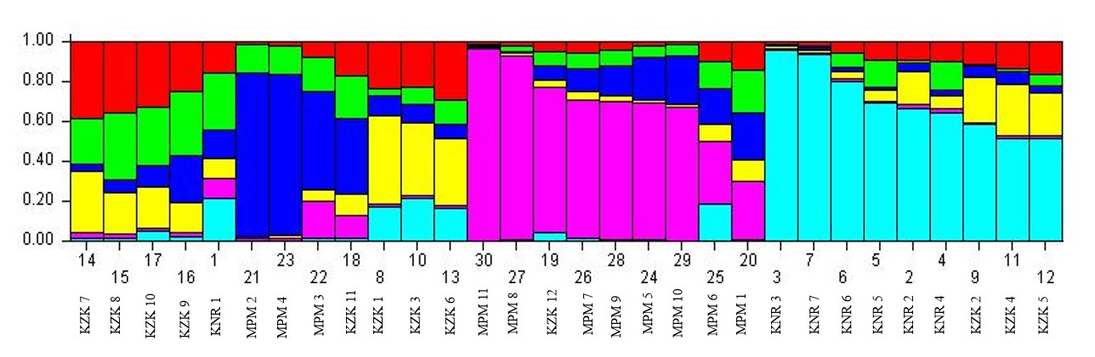
Fig.2. Population structure analysis of 30 jackfruit accessions

- Discussion

Thirty primers were used for the molecular characterization of thirty accessions collected from 3 districts in Northern Kerala; KNR 1 (Pallikunnu, Kannur), KNR 2 (Pallikunnu, Kannur), KNR 3 (Kottali, Kannur), KNR 4 (Kottali, Kannur), KNR 5 (Pallikunnu, Kannur), KNR 6 (Pallikunnu, Kannur), KNR 7 (Podikund, Kannur), KZK 1(Kunnamangalam, Kozhikode), KZK 2 (Kunnamangalam, Kozhikode), KZK 3 (Kunnamangalam, Kozhikode), KZK 4 (Kunnamangalam, Kozhikode ), KZK 5 (Chevayur, Kozhikode), KZK 6 (Chevayur, Kozhikode), KZK 7 (Chevayur, Kozhikode), KZK 8 (Chevayur, Kozhikode), KZK 9 (Chevayur, Kozhikode), KZK 10 (Chevayur, Kozhikode), KZK 11 (Chevayur, Kozhikode), KZK 12 (Chevarambalam, Kozhikode), MPM 1 (Palliserry, Malappuram), MPM 2 (Kadampuzha, Malappuram), MPM 3 (Cheekkode, Malappuram), MPM 4 (Vazhakkad, Malappuram), MPM 5 (Vazhzkkad, Malappuram), MPM 6 (Vettilappara, Malappuram), MPM 7 (Kinaradappan, Malappuram), MPM 8 (Vettilappara, Malappuram), MPM 9 (Vettilappara, Malappuram), MPM 10 (Kinaradappan, Malappuram), MPM 11 (Kinaradappan, Malappuram).

PIC value and polymorphism percentage refers to the ability of a marker to identify specificity in individuals in a given population (Kumar et al., 2015). For ISSR primers, PIC value between the range of 0-0.5 is considered to be highly informative and useful for studies, whereas for SSR primers, PIC values greater than 0.5 are considered to be highly informative, and values lower than 0.25 is considered to be less informative. In this context, it was observed that all of the tested ISSR markers were found to be highly polymorphic, as concluded from the high Marker index (2.37) and average PIC value between 0-0.5. Highest PIC value was recorded in primer UC 807. Number of amplicons were recorded as 7-8 in most samples and the average polymorphism percentage was found to 65.3%. Thus, the ISSR markers utilized for the study can be successfully used for further characterization. SSR markers on the other hand showed mild polymorphism, with average PIC value of 0.28 and average polymorphism percentage of 45%. Only 16 out of the 20 primers were found to be polymorphic, with highest PIC value observed in JFSSR 47. These markers are less likely to provide a comprehensive understanding of genetic diversity, and produced 1-2 amplicons in most samples. Low PIC value indicates less specificity between the individuals, possibly be due to the geographically close genetic population used for the study. Therefore, only 26 out of the 30 analyzed primers were found to be polymorphic.

However, upon merging the results obtained in ISSR and SSR amplification, the result as observed in dendrogram showed significant variability between one particular accession; KNR 1 and all the other accessions. Dendrogram representation is generated using genetic linkage and genetic distance between the samples, using similarity matrix. Thus, samples forming a cluster at coefficient 0.95 implies that, there is 95% similarity between the samples. Thus, from the given dendrogram (Fig.1.), it can be observed that, there is 67% similarity between the two major clusters. Cluster I contains only accession KNR 1 and Cluster II consists of 29 accessions. And more than 88% similarity between samples KZK 2 & KZK 4, MPM 1& MPM 3 and KNR 3 & KNR 7. The clustering pattern in dendrogram revealed close genetic linkage and common ancestry between accessions collected from same district. This information can be used to contribute to future breeding programs after analyzing the relationship between different genetic groups. Further analysis of population structure using the structure harvester software revealed significant difference in the population admixture of this particular accession KNR 1 when compared with others. A total of 6 populations could be observed from the diagrammatic representation (Fig. 2.), each indicated in different colors; pink, cyan blue, red, green, blue and yellow. These colors correspond to genetically distinct groups or ancestral populations, with varying degrees of admixture among them. The 2 major clusters are represented in pink and cyan color and the 4 subclusters are represented in blue, green, yellow and red colors. The population structure confirms the ancestry and the genetic linkage obtained in the dendrogram. All accessions taken from Kannur alone formed a significant population with minimal admixture, marked in cyan blue. These observations are consistent with the findings from dendrogram.
The high genetic similarity between the accessions could be due to various factors like proximity in geographic location of all the accessions, low seed dispersal rates, restricted mixing of genetic materials within populations. Furthermore, random genetic drift in small and isolated populations may result in allele fixation, thereby diminishing genetic diversity over time in the isolated population considered for the study (Allendorf et al., 2013)

- Conclusion
The results of the study shed light upon the genetic diversity of 30 jackfruit accessions using 30 primers; 10 ISSR and 20 SSR. It could be concluded that, accession KNR 1 is defined as a genetically diverse jackfruit ecotype as observed from the results in dendrogram. Connecting this information with the previously studied morphological characters of the accessions (Arathi, 2023) it was observed that, KNR 1 had lowest glycemic index when compared with other accessions. This information is useful for selective breeding programs. Moreover, there was a clear distinctiveness in the accessions collected from each of the three districts; accessions from Kannur and Kozhikode formed distinct clusters, with minimal population admixture. Accessions from Malappuram formed a separate cluster, with moderate levels of admixture within the population.

- References

- Allendorf, F. W., Luikart, G., & Aitken, S. A. (2013). Conservation and the genetics of populations (2nd ed.). Wiley-Blackwell. https://www.wiley.com/en-us/Conservation+and+the+Genetics+of+Populations,+2nd+Edition-p-9780470671450
- Aswini, A., Mathew, K. L., & Abidha, P. S. (2018). Molecular characterization of jackfruit (Artocarpus heterophyllus L.) accessions using ISSR markers. International Journal of Tropical Agriculture, 36(2), 301-310.
- Balan, A. 2023. Characterization of off-season bearing jackfruit (Artocarpus heterophyllus Lam.). M.Sc.(Ag) thesis, Kerala Agricultural University, Vellayani,
- Doe, J., Smith, A. & Lee, R. 2019. Quantification and purity assessment of genomic DNA using NanoDrop spectrophotometry. Journal of Molecular Biology Techniques, 12(3): 45–52.
- Gupta, M., Chyi, Y. S., Romero-Severson, J., & Owen, J. L. (1994). Amplification of DNA markers from evolutionarily diverse genomes using single primers of simple-sequence repeats. Theoretical and Applied Genetics, 89(7-8), 998-1006. https://doi.org/10.1007/BF00224530
- Gayatri, G., Kavya, K. K., & Shyamalamma, S. (2020). Characterization of Selected Jackfruit Germplasm Accessions for Fruit Shape Through Morphological and Marker Based Assay. Indian Journal of Agricultural Research. https://doi.org/10.18805/IJARe.A-5427
- Kavya, K., Shyamalamma, S., & Gayatri, S. (2019). Morphological and molecular genetic diversity analysis using SSR markers in Jackfruit (Artocarpus heterophyllus Lam.) genotypes for pulp colour. Indian Journal of Agricultural Research, 53(1), 8-16. https://doi.org/10.18805/IJARe.A-5066
- Kumar, S., Chauhan, R. S. & Bhatia, C. R. 2015. Genetic diversity analysis of Indian coffee genotypes using RAPD and ISSR markers. Molecular Biology Reports, 42: 507–517
- Nakintu, J., Albrecht, C., Kagoro-Rugunda, G., Olet, E. A., Lejju, J. B., Müller, C. M., Gemeinholzer, B., & Andama, M. (2020). Exploring the genetic diversity of jackfruit (Artocarpus heterophyllus Lam.) grown in Uganda based on SSR markers. *Genet. Resour. Crop Evol.*, *67*(3), 605–619. https://doi.org/10.1007/s10722-019-00830-5
- Ojwang, R. (2020). *Nutritional, phytochemical, antioxidant and genetic characterization of jackfruits (Artocarpus heterophyllus) found in selected regions of Kenya and Uganda* [Doctoral dissertation, University of Nairobi]. https://erepository.uonbi.ac.ke/handle/11295/112000
- Palupi, D., Rahayu, S. S. B., & Daryono, B. S. (2019). Genetic diversity in jackfruit (Artocarpus heterophyllus Lam.) based on molecular characters in Indonesia. *SABRAO Journal of Breeding and Genetics*, *51*(1), 57-67. https://doi.org/10.54910/sabrao2019.51.1.4
- Porebski, S., Bailey, L. G., & Baum, B. R. (1997). Modification of a CTAB DNA extraction protocol for plants containing high polysaccharide and polyphenol components. Plant Molecular Biology Reporter, 15, 8-15. https://doi.org/10.1007/BF02772108
- Rohlf, F.J. (2005). NTSYS-pc Numerical Taxonomy and Multivariate Analysis System. Version 2.2. Exeter software, New York.
- Singh, D. K., Pandey, A., Choudhary, S. B., Kumar, S., Tribhuvan, K., Mishra, D. C., Bhati, J., Kumar, M., Tomar, J. B., Bishnoi, S. K., Mallick, M. A., Bhadana, V. P., Sharma, T. R., Pattanayak, A., & Singh, B. K. (2021). Development of genic-SSR markers and their application in revealing genetic diversity and population structure in an Eastern and North-Eastern Indian collection of Jack (Artocarpus heterophyllus Lam.). *Ecological Indicators*, *131*, 108143. https://doi.org/10.1016/j.ecolind.2021.108143
- Sujarit, P., Srisawat, P., Piwat, S. & Suwannarach, N. 2019. Genetic diversity analysis of Thai sugarcane clones using combined SSR and ISSR markers. Sugar Tech, 21: 373–381.
- Kalamkar, R. B., Ahire, M. C., Ghadge, P. A., Dhenge, S. A., & Anarase, M. S. (2020). Drone and its applications in agriculture. International Journal of Current Microbiology and Applied Sciences, 9(6), 3022–3026. https://doi.org/10.20546/ijcmas.2020.906.363
- Xu, J., Wang, Y., Wu, K., & Chen, J. (2024). Identification and characterization of functionally relevant SSR markers in natural Dalbergia odorifera populations. BMC Plant Biology. https://doi.org/10.1186/s12870-024-05019-2

