Variation in soil nutrients in the different land use types of the upper catchment area of Narmada River Amarkantak in Central India

Abstract
This study was carried out on the variation in soil nutrients in the different land use types of the upper catchment area of Narmada River Amarkantak in Central India. The soil sample was collected from different soil depths viz; 0-20 cm and 20-40 cm with the help of a soil auger. Soil samples of the same depth in a given sampling quadrate were thoroughly mixed and a composite sample was obtained. All 60 soil samples (6 land use types x 5 quadrates x 2 depths) were collected and dried in shade and subjected to physico-chemical analysis. The results revealed that the average pH ranged from 5.75±0.15 to 6.79±0.58, average EC values ranged from 0.13±0.03 to 0.31±0.08 dS m⁻¹ statistically significant in different land use types. The average nitrogen ranged from 115.83±22.74 to 523.75±161.54 kg ha⁻¹. The average nitrogen was highest measured in dense mixed forest and lowest was in open land. The average potassium content varied from 240.97±31.20 to 474.56±90.69 kg ha⁻¹. The highest potassium was observed in dense mixed forests and the lowest was in open land. The average phosphorus contents were lies from 6.77±1.50 to 23.03±9.42 kg ha⁻¹. The maximum average P was measured in dense mixed forest and the minimum was in open land. The average SOC and SOM varied from 0.58±0.35 to 2.38±0.70% and 0.99±0.61 to 4.11±1.21%, respectively. The highest SOC and SOM were recorded in mixed forest and the lowest was recorded in open land. The highly positive correlation was observed between nitrogen to phosphorus, potassium, soil organic carbon and soil organic matter with R² value was 0.96, 0.96, 0.91 and 0.91, respectively. The phosphorus was showing highly positive correlation with nitrogen, potassium, soil organic carbon and soil organic matter with R² value was 0.96, 0.94, 0.93 and 0.93, respectively. The soil organic carbon and soil organic matter was statistically positive correlation was performed of nitrogen, phosphorus and potassium with R² value 0.91, 0.93 and 0.92, respectively. The electrical conductivity was negatively correlation of nitrogen, phosphorus, potassium, soil organic carbon and soil organic matter with R² value -0.39, -0.32, -0.34, -0.17 and -0.17, respectively. The present study indicated that the soil nutrient (NPK) contents were statistically significant relation to different land use types. The soil nutrient was highest in forest vegetation as compared to agricultural land, rangeland, and open land due to the forest area’s large no. of plant vegetation are present and higher litter decomposition rate.
Keywords: Soil nutrient; Land use; Land cover; Dense mixed forest; Sal mixed forest; Mixed forest etc.
Introduction
The Land use land cover (LULC) is the common term to describe natural or manmade feature on earth, where land use describes how a piece of a land is managed or used by humans and land cover is the observed physical and biological cover of the land such as vegetation or man-made features (Brady and Weil 2008). To meet demand of food and timber, the growing population has drastically changed the land use pattern in tropical forests (Lambin et al. 2001). Over the last decade there has been increasing interest in the impact of differential LULC on tree diversity and other ecosystem properties. This rapidly accelerating change in the LULC is associated with a wide variety of issues, including declining biodiversity (Darkoh 2003), global climate change and food security, and land degradation as it applies to soils, vegetation and water. Regulation function of tropical soil is receiving much interest by the scientific communities as it is an important part of the biosphere and has a higher potential to store carbon compared to vegetation and atmosphere (Bellamy et al. 2005). Since, about 14% of the world soil carbon is located in the soils of tropical forests (IPCC 2000). It has been estimated at approximately 3.3 times the size of the atmospheric pool and 4.5 times the size of the biotic pool (Lal 2004a, b). The soil Carbon (C) pool mainly comprises Soil Organic Carbon (SOC) estimated at 1550 Pg (1 petagram = 10¹⁵ g = 1 billion ton) and Soil Inorganic Carbon (SIC) of approx. 750 Pg, occurred up to 1m depth (Batjes 1996). In fact, two-thirds of the carbon in terrestrial ecosystems comes from SOC (Eswaran et al. 1993). It has been estimated that an increase in SOC by 0.01% could lead to the C sequestration equivalent to annual increase of atmospheric Carbon-dioxide Carbon (Lal et al. 1998). The land-use changes in the tropics are estimated to contribute about 23% to human-induced CO₂ emissions (Houghton 2003). Rapid and unprecedented changes in land uses for increasing demand of food, water, energy and space to meet the demands of increasing population has drawn the keen interest of many ecologists (Verburg et al. 2012). Land use land cover (LULC) change causes perturbation of the ecosystem and can influence the C stocks and fluxes. Since the 19th century, around 60% of the C in the world’s soils and vegetation has been lost owing to land use change (Houghton 1995).
The conversion of land use from forest to plantation or agriculture leads to emission of carbon due to biomass loss (Houghton 2005). Further, out of total C stored in an ecosystem, 89% loses are due to loss of living biomass and it is one of the important indicators of ecosystem services (Houghton 2005). An accurate estimation of SOC and the effects of LULC on C balance in the ecosystem are important to global climate change studies and to terrestrial carbon cycle research (Li 1998). Estimation of SOC stock in forest soil is important as approximately 70% of the C stored within the forest ecosystem is stored within forest soil (Dixon et al. 1994; Six et al. 2002). According to IPCC (2000) the major cause for the increase in C in the atmosphere (90% of net release) is change in LULC in the tropics. The magnitude of decline in soil C depends on the soil depth used for C estimations and time scale for land use change (IPCC 2000). For example, agriculture, through conversion of forests and grassland during past 140 years, has led to a net release of about 121 Gt C, of which about 60% has been emitted in tropics and remaining 40% in middle and high latitudes (IPCC 2000). The annual flux of C from LULC changes to the atmosphere was estimated at 2.2 (±0.6) Pg C/yr in the 1990s (Houghton 2003). C gains by rehabilitation of eroded and decertified soils have been estimated to be of the order of 0.1 to 0.4 t C/ha/yr (Sampson, R.N. and Scholes, 2000).
The role of land use in carbon sequestration and how to increase carbon sink potentials of soils has attracted considerable scientific attention in recent years (Kumar and Nair 2011; Arnhold et al. 2015; Fu et al. 2010). It is well known fact the soil historically played the roles of both source and sink of carbon (Torbert et al. 1997). Specifically, it has been well demonstrated that the SOC stock of the ecosystem was significantly affected by the land use/cover change, especially in farm activities (Wu et al. 2003; Gelaw et al. 2014) deforestation (Kucuker et al. 2015; Fujisaki et al. 2015) and afforestation (Barcena et al. 2014; Omonode and Vyn, 2006). The majority of this research has mainly concentrated on Soil Organic Carbon (SOC) variations in the horizon and vertical layers of soil under various land uses. The SOC stocks of forest lands were higher than cropland in humid tropics or drought loess regions (Fujisaki et al. 2015; Zhang et al. 2013).
Soil is the largest terrestrial pool of organic carbon (IPCC 2007). Soil organic carbon pool may greatly change responses to a host of potential environmental and anthropogenic driving factors (Stockmann et al. 2013). In addition, SOC and total nitrogen are supply nutrients for plant growth and improving the physical structure of the soil. It indicated that SOC and total nitrogen concentration enhancing the crop yield and reducing carbon emissions. Due that studies on nutrient composition of different land-use is essential to understand. This will be helpful in development of site specific nutrient management practice. The mineral nutrient elements play essential roles such as constituent of cell structures and cell metabolites, in cell osmotic relations and turgor-related processes, energy transfer reactions, enzyme-catalysed reactions and plant reproduction (Pandey, 2018). The present study focuses on assessment of soil nutrients in the different land use types of the upper catchment area of Narmada River Amarkantak in Central India.
Materials and Methods
Study Area
The study was conducted in different land use types of the upper catchment area of the Narmada River Amarkantak in Central India. The location map of the study area is 22º39’0” N to 22º44’0” N latitude and 81º40’0” E to 81º47’0” E longitude. The average altitude of site was 1048 m from mean sea level. In study area three different seasons i.e., summer season from April to June, rainy season from July to October and winter months from November to February. The climate type is sub-humid tropical monsoon. The average annual temperature ranged from 16.1 °C to 31 °C, with April and May being the hottest months and December and January being the coldest of the year, with minimum temperatures falling to 5 °C. Between 1350 and 1600 mm of rain occur per year in study area. This region's soils were primarily lateritic, alluvial, and black cotton types that were made of granite, gneisses, and basalt. The biosphere reserve is a habitat to an unusual diversity of flora and fauna because of its diverse climatic, topographic, and edaphic factors. The location map and DEM was represented in Figure 1 and 2.
Soil sampling
The soil samples were collected by laying out five quadrat randomly in each selected land use types of the upper catchment area of the Narmada River Amarkantak. The soil sample was collected from two soil depths i.e., 0-20 cm and 20-40 cm with the help of a soil auger. The composite soil sample was prepared for analysis. Total 60 soil samples (6 land use types x 5 quadrates x 2 depths) were collected and dried in shade and used for analysis of physico-chemical analysis of different land use
Analysis of physico-chemical properties
The physical properties i.e. pH and EC were measured by multi-parameter kits of each soil samples on lab. The soil nutrient properties i.e. available nitrogen, available phosphorus and available potassium. The available nitrogen was determined by the Micro-Kjeldahl method (Jackson 1967). The available phosphorous was determined by using a spectrophotometer method (Olsen et al. 1954) And the available potassium was determined by using flame-photometer method (Jackson 1967). The organic carbon in the soil was determined by Walkley and Black method (1934). The soil organic matter was calculated by using “van Bemmelen factor” to convert the organic carbon into organic matter (Organic carbon value was multiply by 1.724). The satellite image was prepared by ArcGIS 10.4 Software. The data was analysed BlueSky Statistics Software.
Results and Discussion
Importance of soil nutrients
Soil nutrients are essential to a plant’s growth and reproductive cycle. The nitrogen is the element which is mostly absorbed in soil under normal conditions by plants growing. Among the 3 main primary nutrients plants need nitrogen in the largest quantity. Nitrogen has various roles in plant body including: quick growth of plant body, increasing quality and sizes of leaf, increase in the development of seed and fruit; it also has vital role in the formation of amino acids that are structural blocks of enzymes and proteins, also involved in many biochemical processes as a catalyzing agent. Moreover, for the growth of plants nitrogen is the most important nutrient and its role in resistance against many diseases (Huber and Watson 1974).
A very important macronutrient that involved in most growth processes is phosphorus. In the growth of plant including proteins, nucleic acids, phospholipids, phosphates of sugar, enzymes and compounds with energy-rich phosphate, phosphorus is a vital component of most organic compounds, for example adenosine triphosphate (ATP) (Balkwill et al. 1988). In other words, plants need phosphorus for the energy development (ATP), nucleic acids and sugars. Deficiency of phosphorus will be occurring during the early growing season in the cool soils. In the young plants deficiency symptoms of phosphorus are usually more visible, (Brady and Weil 2008). When phosphorus is applied for fungal diseases and control seedlings it has been shown to be most beneficial (Omar, 1997).
The potassium is a vital nutrient that is mostly intake by plants in higher amounts than any other nutrient excluding nitrogen. In the plants potassium is utilized in enzymes activation, formation of protein, photosynthesis, and transport of sugar.
Results of physico-chemical properties of soil of upper the catchment area of Narmada River Amarkantak were presented in the Table 1 and Figure3.
Soil pH and Electrical conductivity
The results revealed that the pH was ranged from 5.85±0.11 to 7.20±0.28 at 0-20 cm soil depth and 5.64±0.34 to 6.38±0.35 at 20-40 cm soil depth, statistically significant from all the different land use types. The mean value of pH was varied from 5.75±0.15 to 6.79±0.58. The result shows that the highest soil pH was recorded in rangeland land use (7.20±0.28) followed by agriculture land (7.16±0.16), sal mixed forest (6.40±0.28), mixed forest (6.28±0.60) and dense mixed forest (6.15±0.26). The lowest soil pH was recorded in open land (5.85±0.11) at 0-20cm depths. A similar pattern of results was recorded in 20-40cm depths in all land use types. The mean value of pH maximum was recorded in rangeland and the minimum was open land (Table 1 & Figure 3).
Soil electrical conductivity (dS m⁻¹) was statistically significant (p value <.001) and values was observed between 0.16±0.01 to 0.37±0.06 dS m⁻¹ at 0-20 cm depths and 0.11±0.02 to 0.26 dS m⁻¹ at 20-40 cm depths in different land use types. The mean value of electrical conductivity (EC) was varied from 0.13±0.03 to 0.31±0.08 dS m⁻¹. Among the different land use the maximum EC (dS m⁻¹) was observed in range land (0.37±0.06) followed by agricultural land (0.30±0.05), open land (0.30±0.04), mixed forest (0.28±0.04) and dense mixed forest (0.19±0.03) while the minimum EC was observed in sal mixed forest (0.16±0.01). Among the different land use at 20-40cm soil depth, the maximum EC was recorded in agricultural land (0.26±0.03 dS m⁻¹), followed by rangeland (0.26±0.02 dS m⁻¹) followed by mixed forest (0.21±0.03 dS m⁻¹) and lowest value was recorded on sal mixed forest (0.11±0.02 dS m⁻¹). The mean value of EC was measured higher on rangeland (0.31±0.08 dS m⁻¹) followed by agricultural land (0.28± 0.03 dS m⁻¹), open land (0.25± 0.07 dS m⁻¹), mixed forest (0.24± 0.05 dS m⁻¹) and dense mixed forest (0.16±0.04 dS m⁻¹), it was lower value measured on sal mixed forest (0.13±0.03 dS m⁻¹) in different land use types (Table 1 & Figure 4).
Soil nutrients of different land use types of the upper catchment area of the Narmada River Amarkantak
Soil is a complex mixture of minerals, organic matter, water, and air, and it provides a crucial medium for plant growth. Various nutrients are essential for plants to thrive, and these can be categorized into two main groups: macronutrients (Nitrogen (N), Phosphorus (P), Potassium (K), Calcium (Ca), Magnesium (Mg) and Sulfur (S)) and micronutrients (Iron (Fe), Manganese (Mn), Zinc (Zn), Copper (Cu), Molybdenum (Mo), Boron (B), Chlorine (Cl)). These nutrients are crucial for plant growth, and their availability in the soil directly influences the health and productivity of plants.
Macronutrients are indispensable for the basic structure and function of plants. They are involved in key biochemical processes that sustain plant life, from photosynthesis to the formation of essential biomolecules. A deficiency or imbalance of macronutrients can lead to stunted growth, poor yield, and increased susceptibility to diseases. Therefore, proper soil fertility management and balanced fertilization are essential for ensuring the availability of these macronutrients to plants. In present study nitrogen, phosphorus and potassium were analyzed to understand the nutrient status of soil in different land use types of the upper catchment area of the Narmada River Amarkantak.
Available Nitrogen
Nitrogen is a crucial macronutrient for plants, and its importance lies in its involvement in various essential physiological processes such as protein synthesis, chlorophyll formation, leaf growth and development, enzyme activation, nucleic acid synthesis, energy transfer, root development and over all plant vigor. Higher amount of nitrogen also create a negative impact on ecosystems. Thus, sustainable and responsible nitrogen management practice are essential to meet the need of plants with environmental consideration.
The results of available nitrogen (kg ha⁻¹) in soil are depicted in Table 2 and Figure 5. The registered available nitrogen value in different land use (p value <.001), soil depths (p value <.001) and interaction (p value <.001) were statistically significant. The nitrogen (kg ha⁻¹) varied from 131.91±3.29 to 637.97±6.49 kg ha⁻¹ at 0-20 cm depth and 99.75±2.58 to 409.52±17.61 kg ha⁻¹ at 20-40 cm depth statistically significant in all land use types. The recorded mean value of nitrogen ranged from 115.83±22.74 to 523.75±161.54 kg ha⁻¹. Among the different land use type at 0-20 cm soil depth the maximum soil nitrogen was recorded in dense mixed forest (637.97±6.49 kg ha⁻¹) followed by sal mixed forest (605.93±8.64 kg ha⁻¹), mixed forest (515.97±7.50 kg ha⁻¹), rangeland (301.04±13.19 kg ha⁻¹) and agriculture land (288.69±10.08 kg ha⁻¹) while the minimum was recorded in open land (131.91±3.29 kg ha⁻¹). A similar pattern of available nitrogen result was noted between different land use type at 20-40 cm soil depths of upper catchment of Narmada River. The average available nitrogen (kg ha⁻¹) contents map represented different land use types of the upper catchment area of the Narmada River in Figure 11.
Available Phosphorus
The importance of phosphorus is essential constituent of nucleic acids, lipoprotein membranes of cell and many coenzymes responsible for energy transfer reactions in cell metabolism, necessary for development of roots, ripening of fruits and seeds and influences utilization of nitrogen.
The results of available phosphorus (kg ha⁻¹) in soil are depicted in Table 2 and Figure 6. The registered available phosphorus value in different land use (p value <.001), soil depths (p value <.001) and interaction (p value <.001) were statistically significant. The results on available phosphorus (kg ha⁻¹) in soil ranged from 7.83±1.38 to 29.69±1.39 kg ha⁻¹ at 0-20 cm depth and 5.71±0.23 to 17.98±1.55 kg ha⁻¹ at 20-40 cm depth statistically significant from different land use types. The mean value of available phosphorus lies from 6.77±1.50 to 23.03±9.42 kg ha⁻¹ statistically significant in different land use types. The maximum average available phosphorus (kg ha⁻¹) in soil was recorded in dense mixed forest, mixed forest, sal mixed forest, agricultural land, and rangeland in 23.03±9.42, 21.99±5.67, 20.98±4.80, 12.89±3.38 and 10.18±2.39 kg ha⁻¹, respectively. The minimum average available phosphorus was recorded in open land (6.77±1.50kg ha⁻¹). The average available phosphorus (kg ha⁻¹) contents map represented different land use types of the upper catchment area of the Narmada River in Figure 12.
Available Potassium
The importance of potassium is necessary for carbohydrate and protein synthesis and accelerator of enzyme system.
The results of available potassium (kg ha⁻¹) in soil are depicted in Table 2 and Figure 7. The registered available potassium value in different land use (p value <.001), soil depths (p value <.001) and interaction (p value <.001) were statistically significant. The results on available potassium (kg ha⁻¹) in soil ranged from 263.03±6.13 to 538.69±5.77 kg ha⁻¹ at 0-20 cm depth and 218.91±3.37 to 411.83±3.43 kg ha⁻¹ at 20-40 cm depth statistically significant from different land use types. The mean value of available potassium varied from 240.97±31.20 to 474.56±90.69 kg ha⁻¹ statistically significant in different land use types. The highest average K (kg ha⁻¹) in soil was recorded at 474.56±90.69, 466.28±40.68, 449.94±53.89, 312.89±49.62 and 300.99±77.80 in dense mixed forest, mixed forest, sal mixed forest, agricultural land, and rangeland, respectively while the lowest average available potassium was recorded in open land (240.97±31.20 kg ha⁻¹). The average available potassium (kg ha⁻¹) contents map represented different land use types of the upper catchment area of the Narmada River in Figure 13.
Soil organic carbon (SOC) and Soil organic matter (SOM)
Soil organic carbon (SOC) refers to the carbon component of organic matter in the soil. Organic matter in the soil is derived from the decomposition of plant and animal residues, microbial biomass, and other once-living organisms. It is a key component of soil that influences various soil properties and plays a crucial role in soil fertility, structure, and overall ecosystem health. Soil organic carbon acts as a reservoir for essential nutrients, including nitrogen, phosphorus, and sulfur. The decomposition of organic matter releases these nutrients, making them available for plant uptake. This helps to maintain nutrient cycling in the ecosystem. Organic matter improves soil structure by promoting the formation of aggregates. These aggregates create pore spaces in the soil, improving water infiltration, drainage, and root penetration. Soil with good structure resists erosion and compaction. Soil organic carbon is a key component of the global carbon cycle. Soils can act as a sink or source of carbon dioxide, depending on management practices. Increasing soil organic carbon through sustainable land management practices can contribute to carbon sequestration, helping mitigate climate change.
The data presented in the Table 3 showed the soil organic and organic matter recorded in the different land uses. Data indicated that both parameters were statistically significant in different land use, soil depths and interaction. Based on data revealed that the status of SOC (%) ranged from 0.83±0.06 to 2.88±0.10% at 0-20 cm depth and 0.33±0.02 to 1.88±0.11% at 20-40 cm depth and the recorded mean value was 0.58±0.35 to 2.38±0.70%. The average SOC was recorded as the maximum of mixed forest (2.38±0.70%) followed by sal mixed forest (2.21±0.59%), dense mixed forest (1.88±0.72%), agricultural land (1.43±0.64%) and rangeland (1.12±0.41%) while the minimum average SOC was measured in open land (0.58±0.35%) in different land use types of the upper catchment area of Narmada River. A similar pattern of results was observed in soil organic matter of soil (Table 3 & Figure 8 and 9). The figure 14 showing the average soil organic carbon in different land use types of the upper catchment area of the Narmada River.
Correlation between different physico-chemical parameters of soil in the upper catchment area of the Narmada River Amarkantak
The highly positive correlation was observed between nitrogen to phosphorus, potassium, soil organic carbon and soil organic matter with R² value was 0.96, 0.96, 0.91 and 0.91, respectively. The phosphorus was showing highly positive correlation with nitrogen, potassium, soil organic carbon and soil organic matter with R² value was 0.96, 0.94, 0.93 and 0.93, respectively. The soil organic carbon and soil organic matter was statistically positive correlation was performed of nitrogen, phosphorus and potassium with R² value 0.91, 0.93 and 0.92, respectively. The electrical conductivity was negatively correlation of nitrogen, phosphorus, potassium, soil organic carbon and soil organic matter with R² value -0.39, -0.32, -0.34, -0.17 and -0.17, respectively (Table 4 & Figure 10).
Species composition of upper catchment area of the Narmada River Amarkantak
The composition of species in different land use types of upper catchment area of the Narmada River in central India was recorded and top storey were Shorea robusta, Anogeissus latifolia, Boswellia serrata, Buchanania lanzan, Careya arborea, Casia fistula, Cleistanthus collinus, Diospyros melanoxylon, Lagerstroemia parviflora, Phyllanthus emblica, Pterocarpus marsupium, Schleichera oleiosa, Terminalia bellirica, Terminalia chebula, Terminalia tomentosa and Syzygium cumini etc., In middle storey the recorded species were Phoenix sylvestris, Abrus precatorius, Jatropha curcas, Lantana camara, Randia dumetorum, Vitex negundo, Ziziphus xylopyrus, Lawsonia inermis, Annona squamosa, Carissa carandas, Ziziphus mauritiana, Woodfordia floribunda and Ziziphus oenophlia etc., and the lower storey was present in different species like Eclipta alba, Iphigenia indica, Scoparia dulcis, Smithia conferta, Blainvillea acmella, Aeschynomene americana, Phyllanthus niruri, Asparagus racemosus, Chlorophytum borivilianum, Sida acuta, Curculigo orchioides, Achyranthes aspera, Curcuma angustifolia, Costusspecios, Curcuma amada, Ocimum gratissimum, Rauvolfia serpentina and Withania somnifera etc., (Thakur et al., 2021; Lal et al., 2022b; Lal, 2022, Lal et al., 2024a) (Table 4).
Discussion
In addition to altering biodiversity, changes in net fluxes of carbon dioxide and other biogeochemical cycles are caused by past and present land use patterns. Carbon dioxide (CO₂) and other greenhouse gases have increased significantly in the atmosphere over the past century as a result of human activities such as the burning of fossil fuels, deforestation, grassland conversion, and other land-use changes (Galloway et al. 2014). The majority of experts suggested that global warming caused by anthropogenic activities and its leads to abrupt rise in atmospheric CO₂. The majority of experts concur that climate change is inevitable if the current trend persists (Galloway et al. 2014).
In the present study, the average pH and EC (dS m⁻¹) values ranged from 5.75 to 6.79 and 0.13 to 0.31, respectively in different land use types. The mean N, P, and K content of soil varied from 115.83 to 523.75 kg ha⁻¹, 6.77 to 23.03 kg ha⁻¹ and 240.97 to 474.56 kg ha⁻¹, respectively in different land use types. The present study nutrients contents (N, P, K) were highest recorded on dense mixed forest, sal mixed forest and mixed forest due to maximum vegetation higher amount of litter fall on soil surface and forms thick layer higher humus formation. In this forest area litter decomposition rate was higher in this land use types thus nutrient are regularly added in this land use types. In open land use lowest amount of nutrient was recorded due to lowest density of vegetation was founded and less amount of litter fall in this land thus lower amount of nutrients were release. It will lead to lower productivity and degradation of soil. In case of agricultural land use nutrients content was lower as compare to dense mixed forest, sal mixed forest and mixed forest might be due to regular crop harvesting of crops and lower amount of adding additional nutrients in form of organic manure. In this land use nutrient also losses due to leaching. In range land use regular decomposition of herbs and grasses leaves adding nutrient contents in the soil. Among all the land use the organic carbon was highest measured in mixed forest due to in mixed forest higher amount of litter fall, higher litter decomposition rate and higher humus formation than organic carbon was added in soil of mixed forest. In case of open land organic carbon was very less due to vegetation was absent, lowest litter fall and decomposition rate of litter. The standing state of nutrients in different sites differed considerably on account of variations in different land use and nutrient concentration. Similar work has been done by different workers in a dry and moist tropical forest in central India (Thakur et al. 2018; Samal et al. 2022; Thakur et al. 2022; Lal et al. 2022a, b; Thakrey et al. 2022; Lal 2022, Tirkey et al., 2022a, b; Lal and Naugraiya 2022a, b, c; Patel et al. 2024; Mexudhan et al. 2024a, b; Lal and Patil 2024; Lal et al. 2024b). Studied that in the different agroforestry systems in the Amarkantak region results revealed that the N was lies from 400-420 kg ha⁻¹, P was varied from 7.5-22.5 kg ha⁻¹ and K was ranged from 187-255 kg ha⁻¹ at 0-20 cm soil depths (Thakur et al. 2018). Samal et al. (2022) have reported the N was ranged from 150.52-213.24 kg ha⁻¹, P was varied from 8.06-16.12 kg ha⁻¹ and K was lies from 146.16-270.36 kg ha⁻¹ at 0-10cm soil depths of M. parvifolia and H. cordifolia plantations in central India. Thakrey et al. (2022) have reported the soil properties of tropical dry deciduous forests in Chhattisgarh, India. The available N in the soil of undisturbed forests (UF) and disturbed forests (DF) was 43.9 and 43 kg ha⁻¹. Available P for the soil of UF was 4.70 kg ha⁻¹ and for DF 3.14 kg ha⁻¹ and available K was 291.85 kg ha⁻¹ in UF and 225.04 kg ha⁻¹ DF. The study was conducted on the physico-chemical properties of soil at AABR in central a similar type of results was found (Lal 2022). Jhariya and Singh (2021) studied the Bhoramdeo Wildlife Sanctuary of Chhattisgarh the total soil carbon stock (0–20 cm soil depth) was highest in no fire zone (69.51 t ha⁻¹) followed by medium (66.55 t ha⁻¹) or low fire severity (53.69 t ha⁻¹). The total soil nitrogen stock across the sites varied from 2.60 and 4.08 t ha⁻¹.
Conclusion
Land plays an important role in different nutrient cycles. The global cycles of greenhouse gases (the major GHGs are carbon dioxide (CO₂), methane (CH₄) and nitrous oxide (N₂O)) are also significantly affected by type of land and land use pattern. Greenhouse gas emissions or removal from the atmosphere can be caused by land use activities. The growth and development of vegetation is also control by land. In present study figure out that the important soil nutrient i.e. available nitrogen, available phosphorus, available potassium and soil organic carbon were higher in the forest land use (dense mixed forest and sal mixed forest) compared to agricultural, rangeland and open land. It indicates that the effective management of forest land helps in soil nutrient conservation as well as act as solution for mitigates climate change.
References
Arnhold, S., Otieno, D., Onyango, J., Koellner, T., Huwe, B., & Tenhunen, J. (2015). Soil properties along a gradient from hillslopes to the savanna plains in the Lambwe Valley, Kenya. Soil and Tillage Research, 154, 75-83. https://doi.org/10.1016/j.still.2015.06.021
Bárcena, T. G., Kiær, L. P., Vesterdal, L., Stefánsdóttir, H. M., Gundersen, P., & Sigurdsson, B. D. (2014). Soil carbon stock change following afforestation in Northern Europe: a meta‐analysis. Global Change Biology, 20(8), 2393-2405. https://doi.org/10.1111/gcb.12576
Bárcena, T. G., Kiær, L. P., Vesterdal, L., Stefánsdóttir, H. M., Gundersen, P., & Sigurdsson, B. D. (2014). Soil carbon stock change following afforestation in Northern Europe: a meta‐analysis. Global Change Biology, 20(8), 2393-2405. https://doi.org/10.1111/gcb.12576
Batjes, N. H. (1996). Total carbon and nitrogen in the soils of the world. European Journal of Soil Science, 47, 151-163. https://doi.org/10.1111/j.1365-2389.1996.tb01386.x
Bellamy, P. H., Loveland, P. J., Bradley, R. I., Lark, R. M., & Kirk, G. J. D. (2005). Carbon losses from all soils across England and Wales 1978–2003. Nature, 437, 245-248. https://doi.org/10.1038/nature04038

Brady, N. C. & Weil, R. R. (2008). The nature and properties of soils. Pearson Education, Inc., Upper Saddle River, New Jersey 07458. 13, 662-710.
Brady, N.C. & Weil, R.R. (2008). The Nature and Properties of Soils. Pearson Education, New Jersey, 975 p.
Cambardella, C. A., & Elliott, E. T. (1994). Carbon and nitrogen dynamics of soil organic matter fractions from cultivated grassland soils. Soil Science Society of America Journal, 58(1), 123-130. https://doi.org/10.2136/sssaj1994.03615995005800010017x
Darkoh, M. B. K. (2003). Regional perspectives on agriculture and biodiversity in the drylands of Africa. Journal of Arid Environments, 54(2), 261–279 https://doi.org/10.1006/jare.2002.1089
Davidson, E. A., & Janssens, I. A. (2006). Temperature sensitivity of soil carbon decomposition and feedbacks to climate change. Nature, 440(7081), 165-173. https://doi.org/10.1038/nature04514
Dixon, R. K., Brown, K. R. A., Houghton, R. A., Solomon, A. M., Trexler, M. C., & Wisniewski, J. (1994). Carbon Pools and Flux of Global Forest Ecosystems. Science. https://doi.org/10.1126/science.263.5144.18
Eswaran, H., Berg, E., & Van Den Reich, P. (1993). Organic Carbon in Soils of the World. Soil Science Society of America Journal, 57, 192-194. https://doi.org/10.2136/sssaj1993.03615995005700010034x
Finzi, A. C., Van Breemen, N., & Canham, C. D. (1998). Canopy tree–soil interactions within temperate forests: species effects on soil carbon and nitrogen. Ecological applications, 8(2), 440-446. https://doi.org/10.2307/2641083
Fu, X., Shao, M., Wei, X., & Horton, R. (2010). Soil organic carbon and total nitrogen as affected by vegetation types in Northern Loess Plateau of China. Geoderma, 155, 31-35. https://doi.org/10.1016/j.geoderma.2009.11.020
Fujisaki, K., Perrin, A. S., Desjardins, T., Bernoux, M., Balbino, L. C., & Brossard, M. (2015). From forest to cropland and pasture systems: a critical review of soil organic carbon stocks changes in Amazonia. Global Change Biology, 21(7), 2773-2786. https://doi.org/10.1111/gcb.12906
Galloway, J. N., Schlesinger, W. H., Clark, C. M., Grimm, N. B., Jackson, R. B., Law, B. E., Thornton, P. E., Townsend, A. R., & Martin, R. (2014). Chapter 15: Biogeochemical Cycles. In J. M. Melillo, T. C. Richmond, & G. W. Yohe (Eds.), Climate Change Impacts in the United States: The Third National Climate Assessment (pp. 350-368). U.S. Global Change Research Program. https://doi.org/10.7930/J0X63JT0
Gelaw, A. M., Singh, B. R., & Lal, R. (2014). Soil organic carbon and total nitrogen stocks under different land uses in a semi-arid watershed in Tigray, Northern Ethiopia. *Agriculture, Ecosystems & Environment*, *188*, 256-263. https://doi.org/10.1016/j.agee.2014.02.035
Houghton, R. A. (1995). Changes in the storage of terrestrial carbon since 1850. In R. Lal, J. Kimble, E. Levine, & B. A. Stewart (Eds.), *Soils and global change*. Lewis Publishers. https://www.routledge.com/Soils-and-Global-Change/Kimble-Levine-Stewart/p/book/9781566701181
Houghton, R. A. (2003). Revised estimates of the annual net flux of carbon to the atmosphere from changes in land use and land management 1850–2000. Tellus B: Chemical and Physical Meteorology, 55B, 378–390. https://doi.org/10.3402/tellusb.v55i2.16764
Houghton, R.A. (2005). Aboveground Forest Biomass and the Global Carbon Balance. Global Change Biology. https://doi.org/10.1111/j.1365-2486.2005.00955.x
Huber, D. M., & Watson, R. D. (1974). Nitrogen form and plant disease. Annual Review of Phytopathology, 12(1), 139-165. https://doi.org/10.1146/annurev.py.12.090174.001035
Intergovernmental Panel on Climate Change. (2007). Climate Change 2007: The Physical Science Basis. Contribution of Working Group I to the Fourth Assessment Report of the Intergovernmental Panel on Climate Change (S. Solomon, D. Qin, M. Manning, Z. Chen, M. Marquis, K.B. Averyt, M. Tignor, & H.L. Miller, Eds.). Cambridge University Press. https://www.ipcc.ch/report/ar4/wg1/
IPCC. (2000). Land Use, Land-Use Change, and Forestry. Cambridge University Press. https://www.ipcc.ch/report/land-use-land-use-change-and-forestry/
Jackson, M.L. (1967). Soil Chemical Analysis, Prentice Hall of India Pvt. Ltd., New Delhi.
Tirkey, J., Lal, J., Naugraiya, M.N. & Mexudhan. (2022a). Effect of Spacing on Growth and Yield Performance of Turmeric (Curcuma longa L.) in Vertisols of Chhattisgarh. Environment and Ecology, 40 (4D), 2835-2841
Tirkey, J., Naugraiya, M. N., & Lal, J. (2022). Yield performance of Turmeric (Curcuma longa) under Eucalyptus tereticornis based Agroforestry System in Plains of Chhattisgarh. International Journal of Current Microbiology and Applied Sciences. https://doi.org/10.20546/ijcmas.2022.1101.046
Jhariya, M. K., & Singh, L. (2021). Effect of fire severity on soil properties in a seasonally dry forest ecosystem of Central India. International Journal of Environmental Science and Technology, 18(12), 3967-3978. https://doi.org/10.1007/s13762-020-03062-8
Lal, J., & Naugraiya, M. N. (2022). Effect of Spacing on Growth and Yield Performance of Zingiber officinale Rosc. in Vertisols of Chhattisgarh. Eco. Env. & Cons., 28, S401-S406. https://doi.org/10.53550/EEC.2022.v28i03s.057
Lal, J., & Naugraiya, M. N. (2022). Growth Performance of Ginger Under Bamboo (Dendrocalamus strictus) Based Agroforestry System in Chhattisgarh. *Eco. Env. & Cons.*, *28*, S344-S349. https://doi.org/10.53550/EEC.2022.v28i03s.050
Lal, J., & Naugraiya, M. N. (2022). Yield of Zingiber officinale under Dendrocalamus strictus based Agroforestry System in plains of Chhattisgarh. International Journal of Current Microbiology and Applied Sciences. https://doi.org/10.20546/ijcmas.2022.1101.021
Kong, A. Y. Y., Six, J., Bryant, D. C., Denison, R. F., & van Kessel, C. (2005). The relationship between carbon input, aggregation, and soil organic carbon stabilization in sustainable cropping systems. Soil Science Society of America Journal, 69(4), 1078-1085. https://doi.org/10.2136/SSSAJ2004.0215
Kucuker, M. A., Guney, M., Oral, H. V., Copty, N. K., & Onay, T. T. (2015). Impact of deforestation on soil carbon stock and its spatial distribution in the Western Black Sea Region of Turkey. Journal of Environmental Management, 147, 227-235. https://doi.org/10.1016/j.jenvman.2014.08.017
Kumar, B. M., & Nair, P. K. R. (Eds.). (2011). Carbon sequestration potential of agroforestry systems: Opportunities and challenges. Springer. https://doi.org/10.1007/978-94-007-1630-8
Lal, J., Naugraiya, M.N., Anchal, N.K., Tirkey, J., & Patel, D.K. (2022). Growth performance, biomass, carbon storage and carbon dioxide release abatement of bamboo plantation in Chhattisgarh plains of India. Current Science. https://doi.org/10.18520/cs/v123/i4/596-600
Lal, J. (2022). Impact of Land Cover Change on Carbon Budget in Selected Forest of Central India of Achanakmaar Amarkantak Biosphere Reserve using Current Land Cover Schemes. Ph.D. Thesis, Indira Gandhi Krishi Vishwavidyalaya, Raipur, India.
Lal, J., & Patil, G. (2024). Adopted agroforestry practices in various agroclimatic zones of Chhattisgarh: A Review study. Indian Journal of Agroforestry, 26(2). https://epubs.icar.org.in/index.php/IJA/article/view/151028
Lal, J., Singh, L., & Thakur, T. K. (2024). Vegetation composition of Achanakmaar Amarkantak biosphere reserve and its ecosystem services. In Biodiversity and Bioeconomy (pp. 243-262). Elsevier. https://doi.org/10.1016/B978-0-323-95482-2.00011-0
Lal, J., Thakur, T. K., Toppo, S., Mexudhan, Tirkey, J., & Singh, L. (2022). Structure, composition and diversity of tree vegetation of buffer zone of Achanakmaar Amarkantak Biosphere Reserve in Central India. RASSA Journal of Science for Society, 4(2and3), 89-96. https://doi.org/10.5958/2583-3715.2022.00014.4
Lal, J., Tirkey, J., Mexudhan, Patel, D. K., Painkra, D. S., Toppo, P., & Singh, L. (2024). Species Diversity of Ex-situ Conservation of Medicinal and Aromatic Plants (MAPs) of Herbal Garden in I.G.K.V. Campus, Raipur, Chhattisgarh, India. Plant Archives, 24(1), 525-535. https://doi.org/10.51470/PLANTARCHIVES.2024.v24.no.1.071
Lal, R. (2004). Soil Carbon Sequestration to Mitigate Climate Change. Geoderma, 123, 1-22. https://doi.org/10.1016/j.geoderma.2004.01.032
Lal, R. (2004). Soil Carbon Sequestration Impacts on Global Climate Change and Food Security. Science, 304, 1623-1627. https://doi.org/10.1126/science.1097396
Lal, R., Kimble, J. M., Follett, R., & Stewart, B. A. (1998). Soil processes and the carbon cycle. CRC Press. https://doi.org/10.1201/9780203739273
Lambin, E. F., Turner, B. L., Geist, H. J., Agbola, S. B., Angelsen, A., Bruce, J. W., Coomes, O. T., Dirzo, R., Fischer, G., Folke, C., George, P. S., Homewood, K., Imbernon, J., Leemans, R., Li, X., Moran, E. F., Mortimore, M., Ramakrishnan, P. S., Richards, J. F., Skånes, H., Steffen, W., Stone, G. D., Svedin, U., Veldkamp, T. A., Vogel, C., & Xu, J. (2001). The causes of land-use and land-cover change: Moving beyond the myths. Global Environmental Change, 11(4), 261–269. https://doi.org/10.1016/S0959-3780(01)00007-3
Li, L.H. (1998). Effects of Land-Use Change on Soil Carbon Storage in Grassland Ecosystems. Acta Phytoecol Sin, 22, 300-302.
Mexudhan, J., Lal, J., & Patil, G. (2024). Assessment of Tree Species Diversity, Biomass, C and N Storage in Two Sites of Dry Tropical Forest of Chhattisgarh, India. International Journal of Economic Plants, 11(2), 180-187. https://doi.org/10.23910/2/2024.5263
Mexudhan, J., Lal, J., & Singh, L. (2024). Assessing Carbon Stocks and Ecosystem Functioning in Char (Buchanania Lanzan) Forests of Central India. International Journal of Environment and Climate Change, 14(10), 649-665. https://doi.org/10.9734/ijecc/2024/v14i104514
Olsen, S. R., Cole, C. V., Watanabe, F. S., & Dean, L. A. (1954). Estimation of available phosphorus in soils by extraction with sodium bicarbonate. U.S. Department of Agriculture Circular, 939.
Omar, S. A. (1998). The role of rock-phosphate-solubilizing fungi and vesicular–arbuscular-mycorrhiza (VAM) in growth of wheat plants fertilized with rock phosphate. World Journal of Microbiology and Biotechnology, 14(2), 211-218. https://doi.org/10.1023/A:1008830129262
Omonode, R. A., & Vyn, T. J. (2006). Vertical distribution of soil organic carbon and nitrogen under warm-season native grasses relative to croplands in west-central Indiana, USA. Agriculture, Ecosystems & Environment, 117(2-3), 159-170. https://doi.org/10.1016/j.agee.2006.03.031
Pandey, N. (2018). Role of Plant Nutrients in Plant Growth and Physiology. In M. Hasanuzzaman, M. Fujita, H. Oku, K. Nahar, & B. Hawrylak-Nowak (Eds.), Plant Nutrients and Abiotic Stress Tolerance (pp. 51-93). Springer. https://doi.org/10.1007/978-981-10-9044-8_2
Patel, D. K., Lal, J., & Thakur, T. K. (2024). A Spatio-temporal analysis of land use land cover changes of dry tropical forest ecosystem of Chhattisgarh, India. Biodiversity International Journal. https://doi.org/10.15406/bij.2024.07.00212
Sakin, E. (2012). Organic carbon organic matter and bulk density relationships in arid-semi arid soils in Southeast Anatolia region. African Journal of Biotechnology, 11(6), 1373-1377. https://doi.org/10.5897/AJB11.2297
Samal, B., Singh, L., & Jhariya, M.K. (2022). Carbon storage, mitigation and sequestration potential of Haldina cordifolia and Mitragyna parvifolia in tropical dry deciduous environment of Chhattisgarh, India. Ecological Engineering, 175, 106490. https://doi.org/10.1016/j.ecoleng.2021.106490
Sampson, R. N., & Scholes, R. J. (2000). Additional Human-Induced Activities—Article 3.4. In R. T. Watson et al. (Eds.), Land Use, Land-Use Change, and Forestry (pp. 183-281). Cambridge University Press. https://www.ipcc.ch/report/land-use-land-use-change-and-forestry/
Schroth, G., D’Angelo, S.A., Teixeira, W.G., Haag, D., & Lieberei, R. (2002). Conversion of secondary forest into agroforestry and monoculture plantations in Amazonia: consequences for biomass, litter and soil carbon stocks after 7 years. Forest Ecology and Management, 163(1-3), 131-150. https://doi.org/10.1016/s0378-1127(01)00537-0
Six, J., Conant, R. T., Paul, E. A., & Paustian, K. (2002). Stabilization Mechanisms of Soil Organic Matter: Implications for C-Saturation of Soils. Plant and Soil. https://doi.org/10.1023/A:1016125726789
Stockmann, U., Adams, M. A., Crawford, J. W., Field, D. J., Henakaarchchi, N., Jenkins, M., Minasny, B., McBratney, A. B., De Remy De Courcelles, V., Singh, K., Wheeler, I., Abbott, L., Angers, D. A., Baldock, J., Bird, M., Brookes, P. C., Chenu, C., Jastrow, J. D., Lal, R., ... Zimmermann, M. (2013). The knowns, known unknowns and unknowns of sequestration of soil organic carbon. Agriculture, Ecosystems & Environment, 164, 80-99. https://doi.org/10.1016/j.agee.2012.10.001
Thakrey, M., Singh, L., Jhariya, M.K., Tomar, A., Singh, A.K., & Toppo, S. (2022). Impact of disturbance on biomass, carbon, and nitrogen storage in vegetation and on soil properties of tropical dry deciduous forest in Chhattisgarh, India. Land Degradation & Development. https://doi.org/10.1002/ldr.4263
Thakur, T. K., Dutta, J., Upadhyay, P., Patel, D. K., Thakur, A., Kumar, M., & Kumar, A. (2022). Assessment of land degradation and restoration in coal mines of central India: A time series analysis. Ecological Engineering, 175, 106493. https://doi.org/10.1016/j.ecoleng.2021.106493

Thakur, T.K., Gautam, B., Kumar, Y. & Thakur, A. (2018). Carbon Sequestration and Nutrient Storage in Soil under Different Agroforestry systems of Madhya Pradesh, India. Asian Resonance, 7(3), 139-145
Thakur, T. K., Patel, D. K., Dutta, J., Kumar, A., Kaushik, S., Bijalwan, A., Fnais, M. S., Abdelrahman, K., & Ansari, M. J. (2021). Assessment of decadal land use dynamics of upper catchment area of Narmada River, the lifeline of Central India. Journal of King Saud University-Science, 33(2), 101322. https://doi.org/10.1016/j.jksus.2020.101322
Torbert, H. A., Rogers, H. H., Prior, S. A., Schlesinger, W. H., & Runion, G. B. (1997). Effects of elevated atmospheric CO2 in agro‐ecosystems on soil carbon storage. Global Change Biology, 3(6), 513-521. https://doi.org/10.1046/j.1365-2486.1997.d01-173.x
Verburg, P. H., Neumann, K., & Nol, L. (2011). Challenges in Using Land Use and Land Cover Data for Global Change Studies. Global Change Biology. https://doi.org/10.1111/j.1365-2486.2010.02307.x
Walkley, A. J., & Black, I. A. (1934). An examination of the Degtjareff method for determining soil organic matter, and a proposed modification of the chromic acid titration method. *Soil Science*, *37*(1), 29–38. https://doi.org/10.1097/00010694-193401000-00003
Wu, H., Guo, Z., & Peng, C. (2003). Land use induced changes of organic carbon storage in soils of China. Global Change Biology, 9(3), 305-315. https://doi.org/10.1046/j.1365-2486.2003.00590.x

Table 1 Physical properties of soil of upper catchment area of Narmada River Amarkantak in Central India
LULC types | pH |  |  | EC (dS m⁻¹)
LULC types | Depths (cm) |  |  | Depths (cm)
LULC types | 0-20 | 20-40 | Mean | 0-20 | 20-40 | Mean
Dense Mixed Forest | 6.15±0.26ª | 5.80±0.30ª | 5.97±0.32ª | 0.19±0.03^{abc} | 0.14±0.02ª | 0.16±0.04ª
Sal Mixed Forest | 6.40±0.34^{ab} | 5.67±0.37ª | 6.04±0.51ª | 0.16±0.01^{ab} | 0.11±0.02ª | 0.13±0.03ª
Mixed Forest | 6.28±0.60^{ab} | 5.67±0.22ª | 5.98±0.52ª | 0.28±0.04^{cde} | 0.21±0.03^{abcd} | 0.24±0.05^{b}
Open land | 5.85±0.11ª | 5.64±0.34ª | 5.75±0.25ª | 0.30±0.04de | 0.20±0.02^{abc} | 0.25±0.06^{b}
Rangeland | 7.20±0.28^{b} | 6.38±0.35^{ab} | 6.79±0.53^{b} | 0.37±0.06e | 0.26±0.02^{cd} | 0.31±0.07^{c}
Agriculture Land | 7.16±0.16^{b} | 6.06±0.25ª | 6.61±0.63^{b} | 0.30±0.05de | 0.26±0.03^{bcd} | 0.28±0.05^{bc}
Mean | 6.51±0.59^{b} | 5.87±0.38ª |  | 0.26±0.08^{b} | 0.19±0.06ª
 | F value | Pr(>F) |  | F value | Pr(>F)
LULC types | 9.94 | <.001*** |  | 24.68 | <.001***
Soil depths | 34.94 | <.001*** |  | 38.16 | <.001***
Soil depths x LULC types | 1.52 | 0.22 |  | 1.07 | 0.40
Note. Signif. codes: 0 '***' 0.001 '**' 0.01 '*' 0.05 '.' 0.1 ' ' 1
Letters (a–e) indicates the level of significance (P<0.05) for soil pH and EC
Table 2 NPK (kg ha⁻¹) of soil of upper catchment area of Narmada River Amarkantak in Central India
LULC types | Nitrogen (kg ha⁻¹) |  |  | Phosphorus (kg ha⁻¹) |  |  | Potassium (kg ha⁻¹)
LULC types | Depths (cm) |  |  | Depths (cm) |  |  | Depths (cm)
LULC types | 0-20 | 20-40 | Mean | 0-20 | 20-40 | Mean | 0-20 | 20-40 | Mean
Dense Mixed Forest | 637.97±6.49^{h} | 409.52±17.61e | 523.75±125.69e | 29.69±1.39^{f} | 16.37±2.83^{d} | 23.03±7.56^{d} | 538.69±5.77^{g} | 410.43±61.54de | 474.56±80.39^{c}
Sal Mixed Forest | 605.93±8.64^{g} | 399.03±11.10e | 502.48±113.67^{d} | 24.37±1.89e | 17.58±1.53^{d} | 20.98±4.02^{d} | 488.05±9.06^{fg} | 411.83±3.43de | 449.94±42.19^{c}
Mixed Forest | 515.97±7.50^{f} | 390.50±5.39e | 453.23±68.97^{c} | 26.00±0.62^{ef} | 17.98±1.55^{d} | 21.99±4.51^{d} | 495.04±4.67^{fg} | 437.51±7.06^{ef} | 466.28±31.96^{c}
Open land | 131.91±3.29^{b} | 99.75±2.58ª | 115.83±17.81ª | 7.83±1.38^{ab} | 5.71±0.23ª | 6.77±1.46ª | 263.03±6.13^{ab} | 218.91±3.37ª | 240.97±24.57ª
Rangeland | 301.04±13.19^{d} | 206.75±7.87^{c} | 253.90±52.55^{b} | 11.87±1.41^{bc} | 8.48±0.61^{ab} | 10.18±2.09^{b} | 356.00±10.60^{cd} | 245.98±10.28^{ab} | 300.99±60.98^{b}
Agriculture Land | 288.69±10.08^{d} | 230.25±5.56^{c} | 259.47±32.83^{b} | 15.28±1.05^{cd} | 10.49±0.74^{b} | 12.89±2.74^{c} | 347.98±15.52^{c} | 277.80±11.12^{b} | 312.89±40.29^{b}
Mean | 413.58±190.54^{b} | 289.30±121.27ª |  | 19.17±8.28^{b} | 12.77±5.07ª |  | 414.80±101.57^{b} | 333.75±93.46ª
 | F value | Pr(>F) |  | F value | Pr(>F) |  | F value | Pr(>F)
LULC types | 1923.20 | <.001*** |  | 139.87 | <.001*** |  | 159.55 | <.001***
Soil depths | 1634.04 | <.001*** |  | 180.00 | <.001*** |  | 153.67 | <.001***
Soil depths x LULC types | 110.72 | <.001*** |  | 11.80 | <.001*** |  | 4.00 | 0.0088 **
Note. Signif. codes: 0 '***' 0.001 '**' 0.01 '*' 0.05 '.' 0.1 ' ' 1
Letters (a–h) indicates the level of significance (P<0.05) for soil nitrogen, phosphorus and potassium

Table 3Soil organic carbon (SOC %) and soil organic matter (SOM %) of soil of the upper catchment area of Narmada River Amarkantak in Central India
LULC | SOC (%) |  |  | SOM (%)
LULC | Depths (cm) |  |  | Depths (cm)
LULC | 0-20 | 20-40 | Mean | 0-20 | 20-40 | Mean
Dense Mixed Forest | 2.39±0.07e | 1.37±0.07^{c} | 1.88±0.56^{d} | 4.13±0.12e | 2.36±0.12^{c} | 3.25±0.97^{d}
Sal Mixed Forest | 2.63±0.03^{ef} | 1.79±0.22^{d} | 2.21±0.48e | 4.53±0.05^{ef} | 3.09±0.37^{d} | 3.81±0.82e
Mixed Forest | 2.88±0.10^{f} | 1.88±0.11^{d} | 2.38±0.55^{f} | 4.97±0.18^{f} | 3.25±0.18^{d} | 4.11±0.96^{f}
Open land | 0.83±0.06^{b} | 0.33±0.02ª | 0.58±0.28ª | 1.42±0.10^{b} | 0.56±0.04ª | 0.99±0.48ª
Rangeland | 1.41±0.05^{c} | 0.83±0.06^{b} | 1.12±0.32^{b} | 2.43±0.09^{c} | 1.43±0.10^{b} | 1.93±0.55^{b}
Agriculture Land | 1.88±0.10^{d} | 0.97±0.05^{b} | 1.43±0.50^{c} | 3.24±0.17^{d} | 1.68±0.09^{b} | 2.46±0.86^{c}
Mean | 2.00±0.74^{b} | 1.20±0.57ª |  | 3.45±1.27^{b} | 2.06±0.98ª
 | F value | Pr(>F) |  | F value | Pr(>F)
LULC types | 339.94 | <.001*** |  | 342.07 | <.001***
Soil depths | 698.54 | <.001*** |  | 702.75 | <.001***
Soil depths x LULC types | 8.62 | <.001*** |  | 8.59 | <.001***
Note. Signif. codes: 0 '***' 0.001 '**' 0.01 '*' 0.05 '.' 0.1 ' ' 1
Letters (a–f) indicates the level of significance (P<0.05) for SOC (%) and SOM (%)
Table 4 Correlation between pH, EC, N, P, K, SOC and SOC of soil in the upper catchment area of Narmada River Amarkantak in Central India
 | pH | EC | N | P | K | SOC | SOM
pH | 1
EC | 0.52 | 1
N | 0.07 | -0.39 | 1
P | 0.06 | -0.32 | 0.96 | 1
K | 0.02 | -0.34 | 0.96 | 0.94 | 1
SOC | 0.21 | -0.17 | 0.91 | 0.93 | 0.92 | 1
SOM | 0.21 | -0.17 | 0.91 | 0.93 | 0.92 | 1.00 | 1

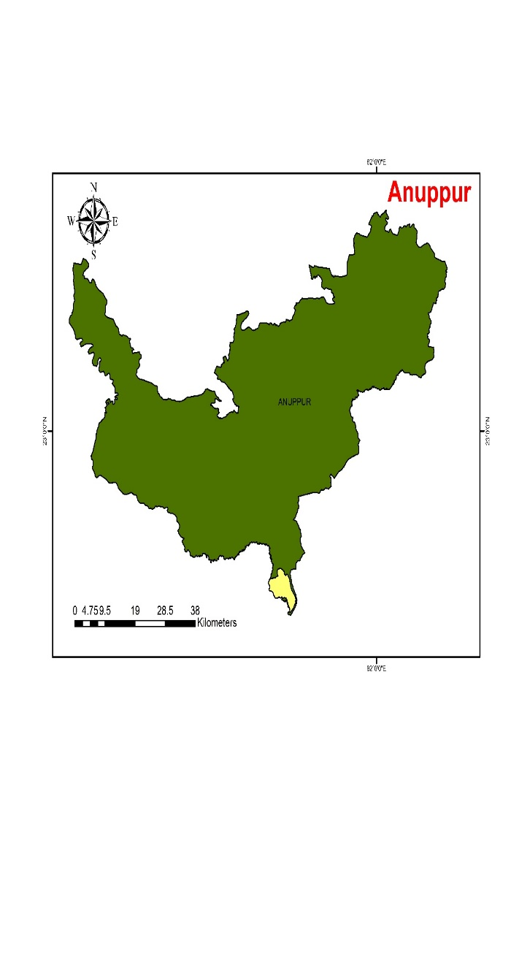
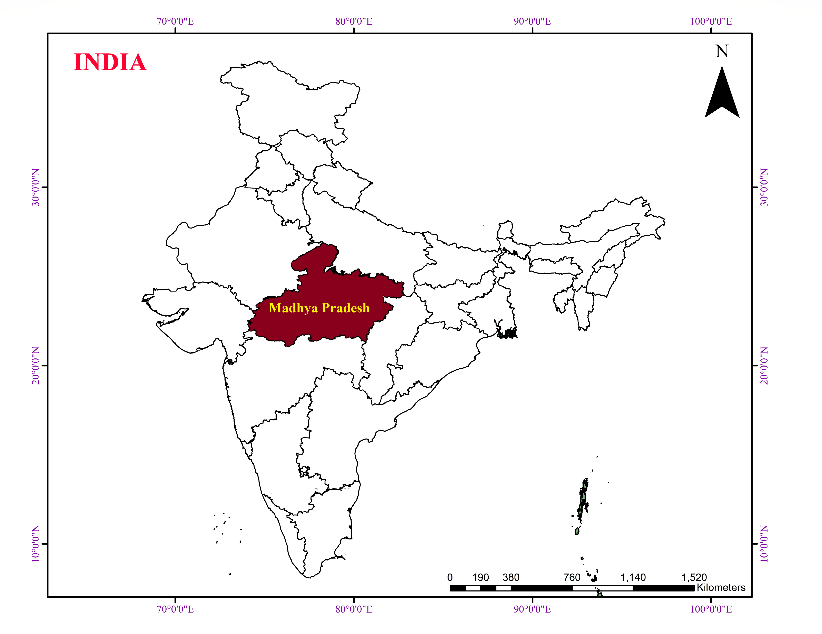
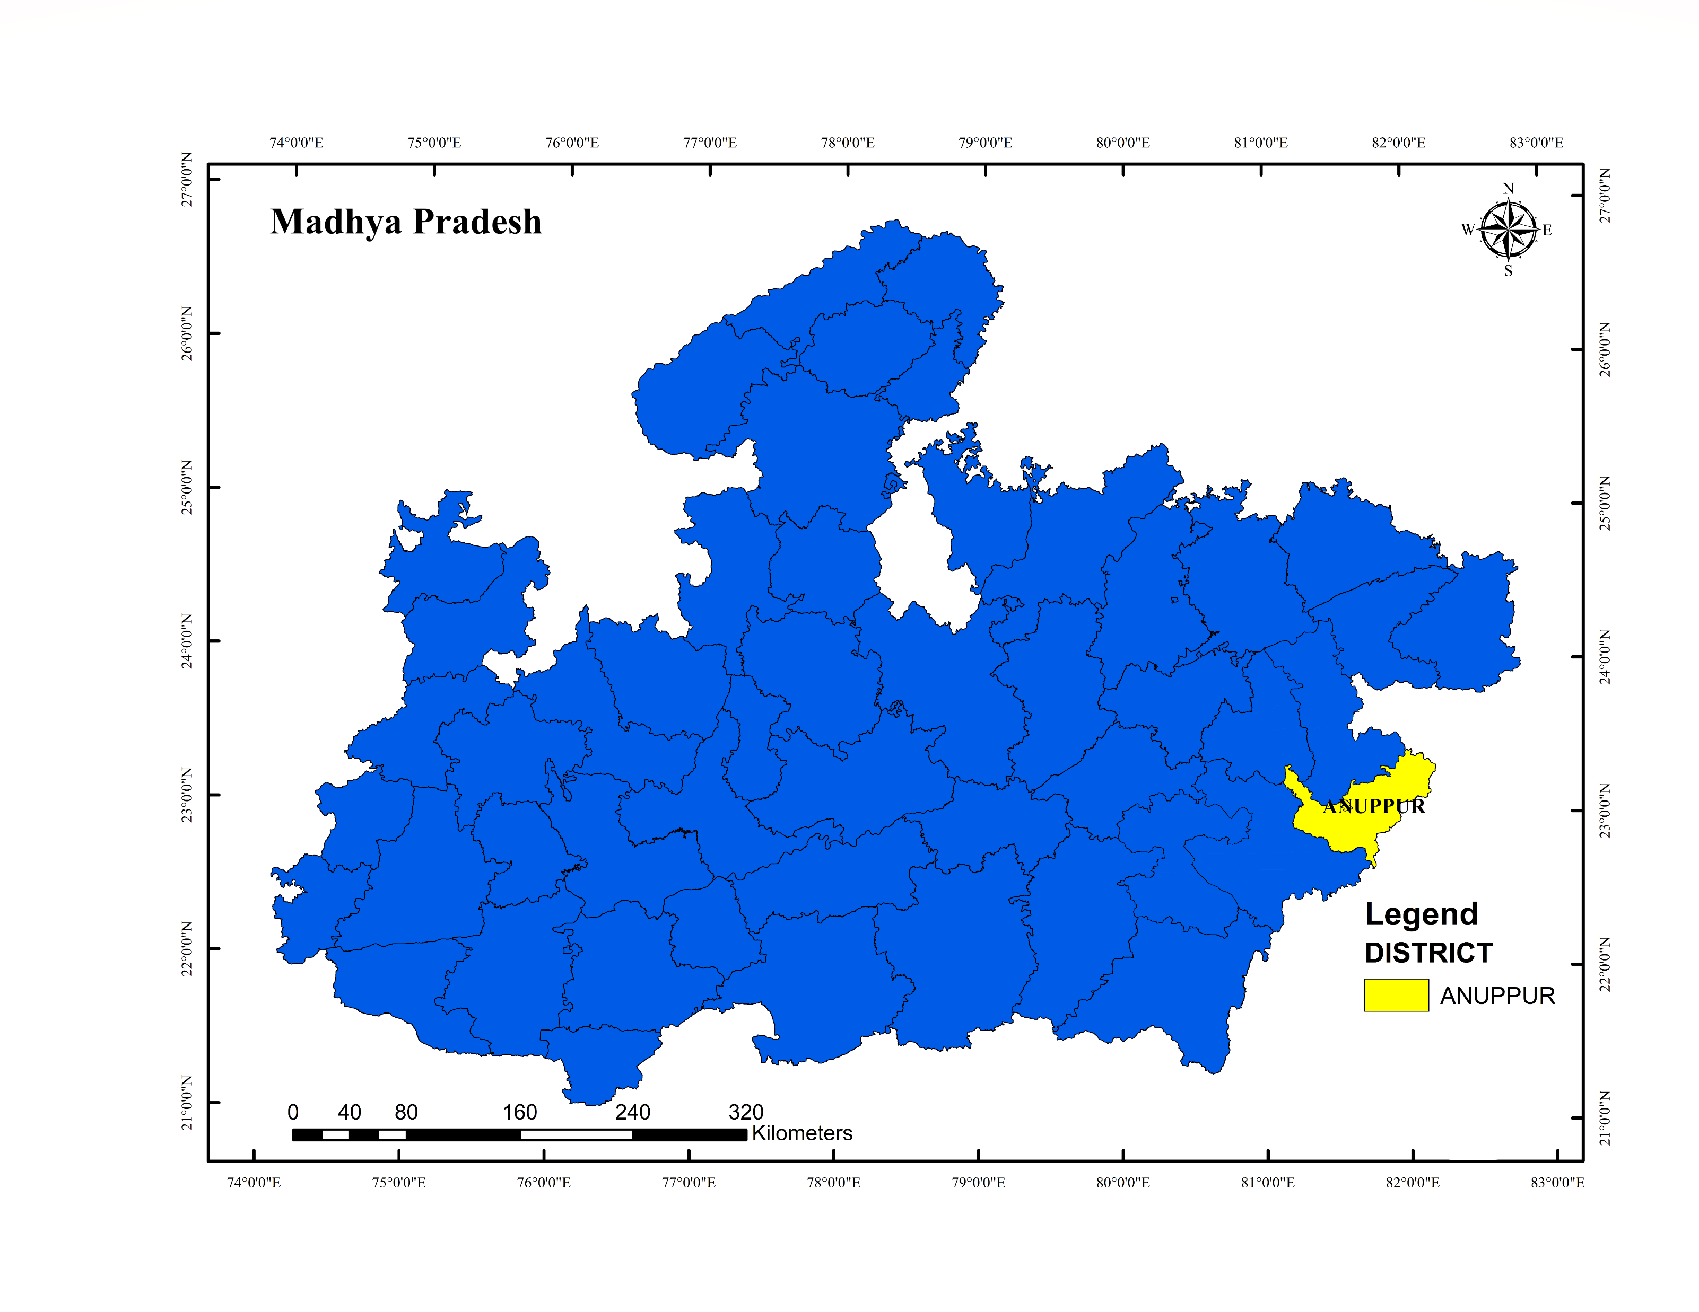

Figure 1 Map of the study area
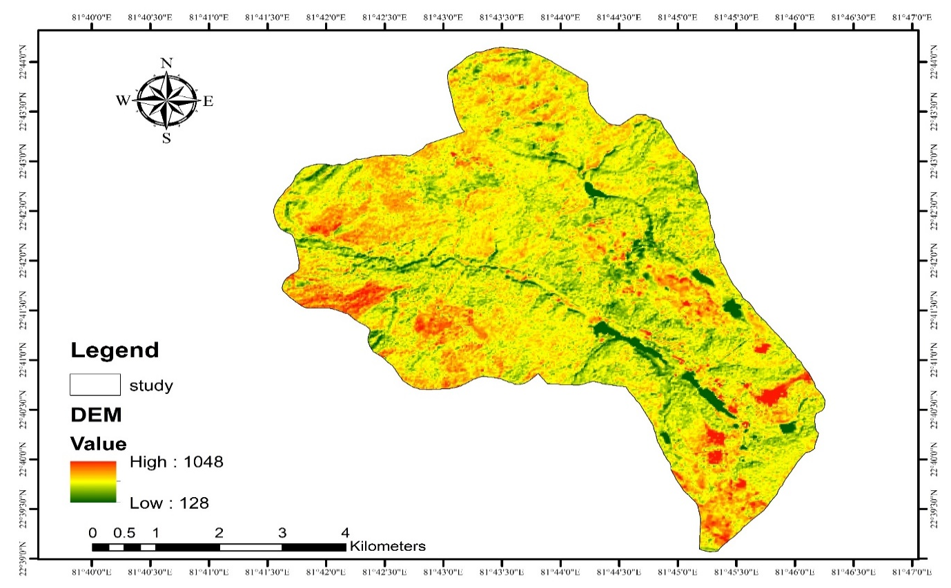Figure 2 Digital elevation model of the study area
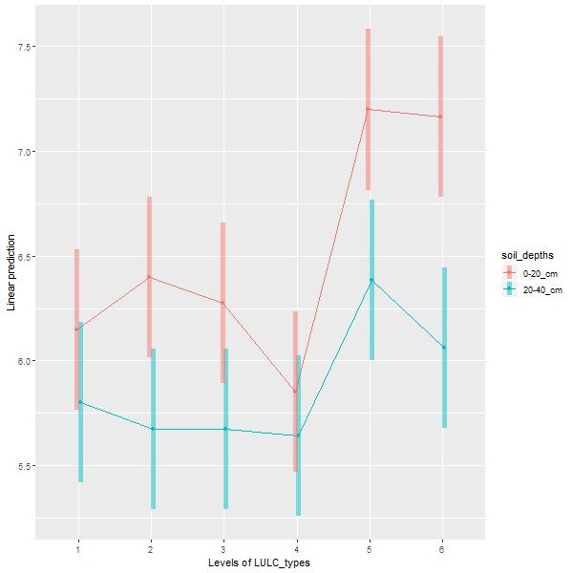
Figure 3 Soil pH of different soil depths and land use land cover typesinthe upper catchment area of the Narmada RiverAmarkantak (1 = Dense Mixed Forest, 2 = Sal Mixed Forest, 3 = Mixed Forest, 4 = Open land, 5 = Range land, 6 = Agriculture land)
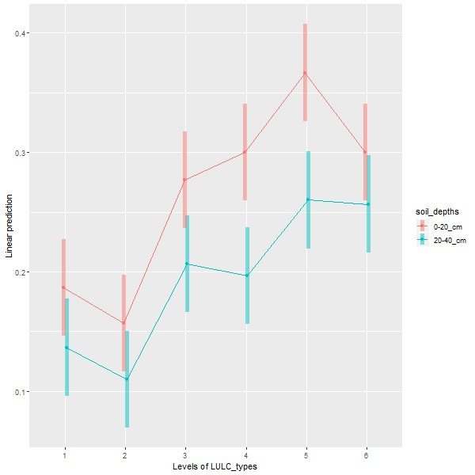
Figure 4 Soil EC (dS m⁻¹) of different soil depths and land use land cover typesin the upper catchment area of the Narmada River Amarkantak (1 = Dense Mixed Forest, 2 = Sal Mixed Forest, 3 = Mixed Forest, 4 = Open land, 5 = Range land, 6 = Agriculture land)
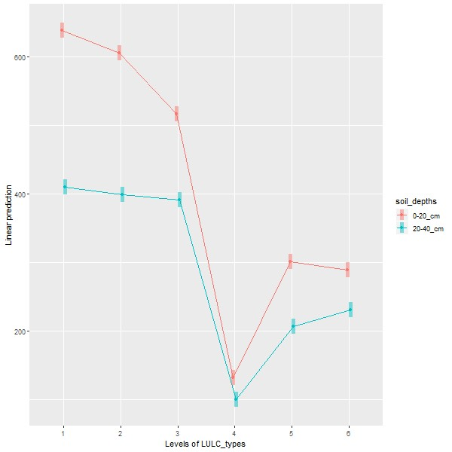
Figure 5 Nitrogen (kg ha⁻¹) of different soil depths and land use land cover typesin the upper catchment area of the Narmada River Amarkantak (1 = Dense Mixed Forest, 2 = Sal Mixed Forest, 3 = Mixed Forest, 4 = Open land, 5 = Range land, 6 = Agriculture land)
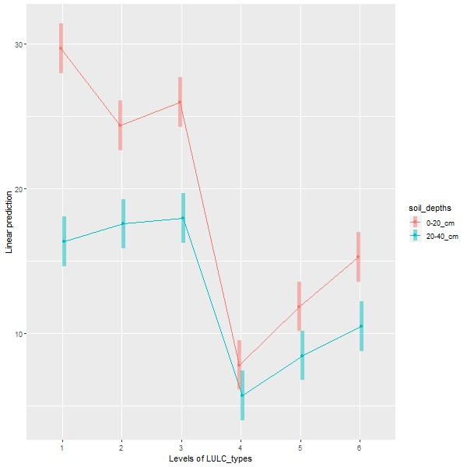
Figure 6 Phosphorus (kg ha⁻¹) of different soil depths and land use land cover typesin the upper catchment area of the Narmada River Amarkantak (1 = Dense Mixed Forest, 2 = Sal Mixed Forest, 3 = Mixed Forest, 4 = Open land, 5 = Range land, 6 = Agriculture land)
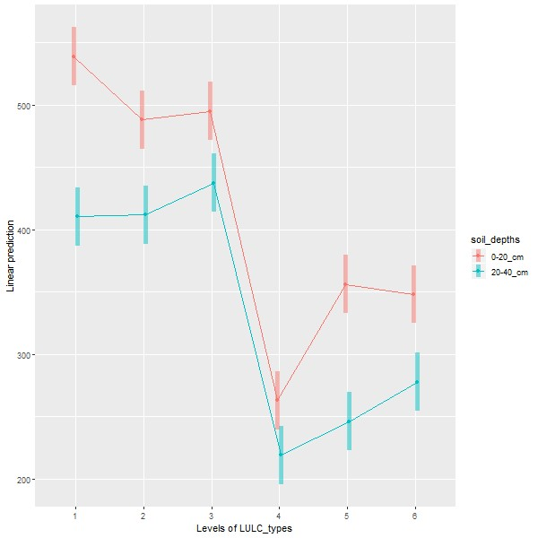
Figure 7 Potassium (kg ha⁻¹) of different soil depths and land use land cover typesin the upper catchment area of the Narmada River Amarkantak (1 = Dense Mixed Forest, 2 = Sal Mixed Forest, 3 = Mixed Forest, 4 = Open land, 5 = Range land, 6 = Agriculture land)
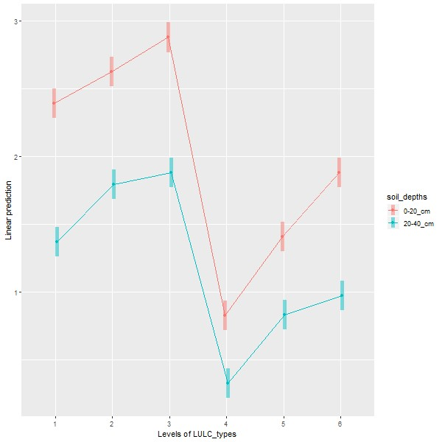
Figure 8 SOC (%) of different soil depths and land use land cover typesin the upper catchment area of the Narmada River Amarkantak (1 = Dense Mixed Forest, 2 = Sal Mixed Forest, 3 = Mixed Forest, 4 = Open land, 5 = Range land, 6 = Agriculture land)

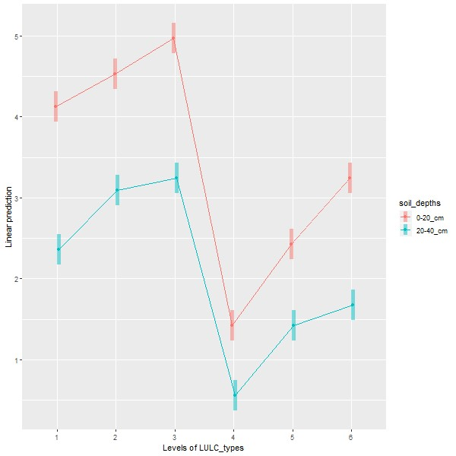
Figure 9 SOM (%) of different soil depths and land use land cover typesin the upper catchment area of the Narmada River Amarkantak (1 = Dense Mixed Forest, 2 = Sal Mixed Forest, 3 = Mixed Forest, 4 = Open land, 5 = Range land, 6 = Agriculture land)
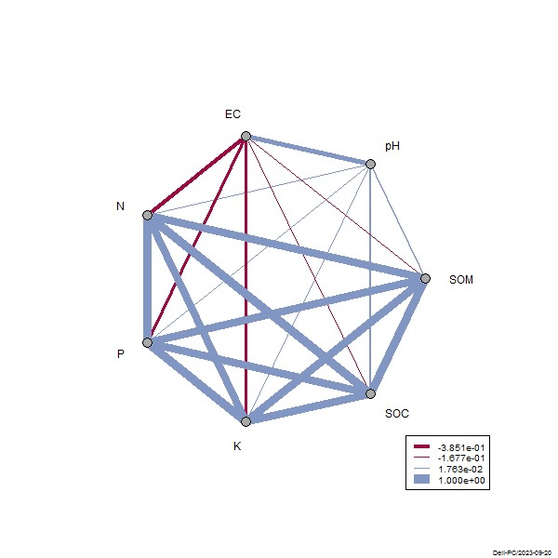
Figure 10Correlation between pH, EC, N, P, K, SOC and SOC of soil in the upper catchment area of Narmada River Amarkantak in Central India
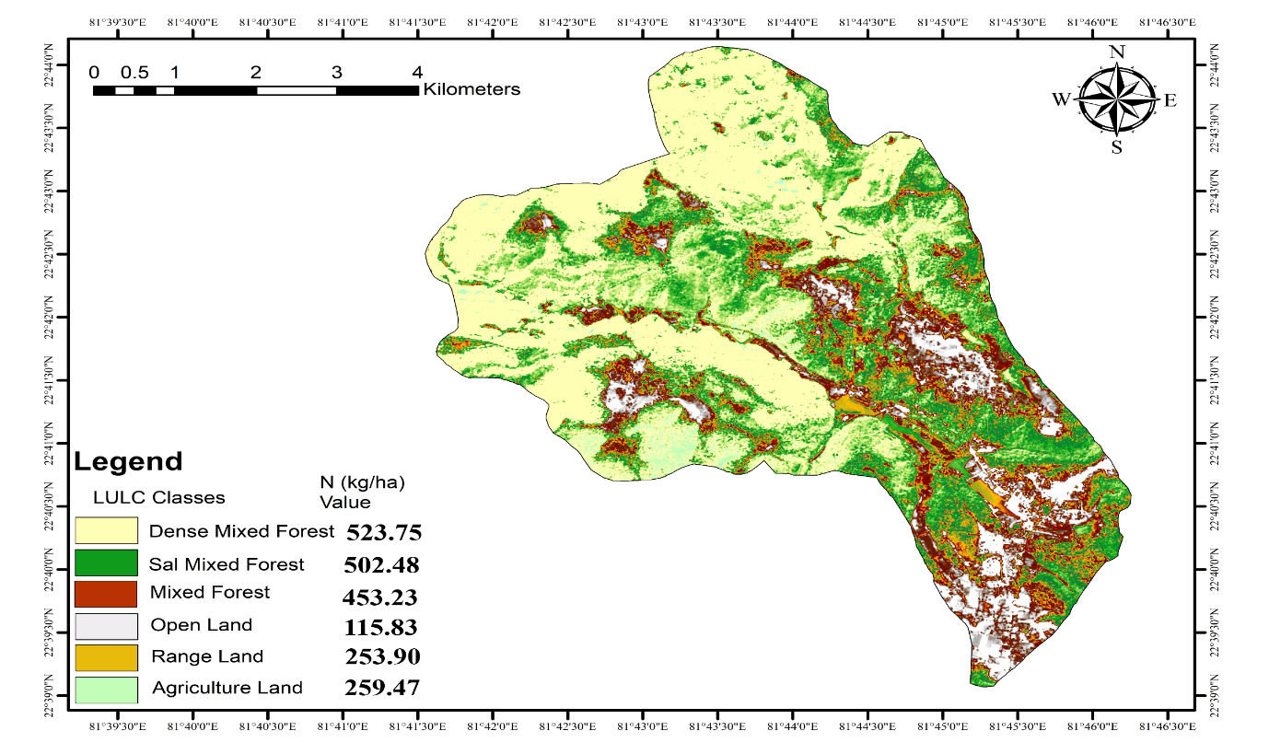
Figure 11 Nitrogen (kg ha⁻¹) contents of different LULC of the upper catchment of Narmada River Amarkantakin Central India
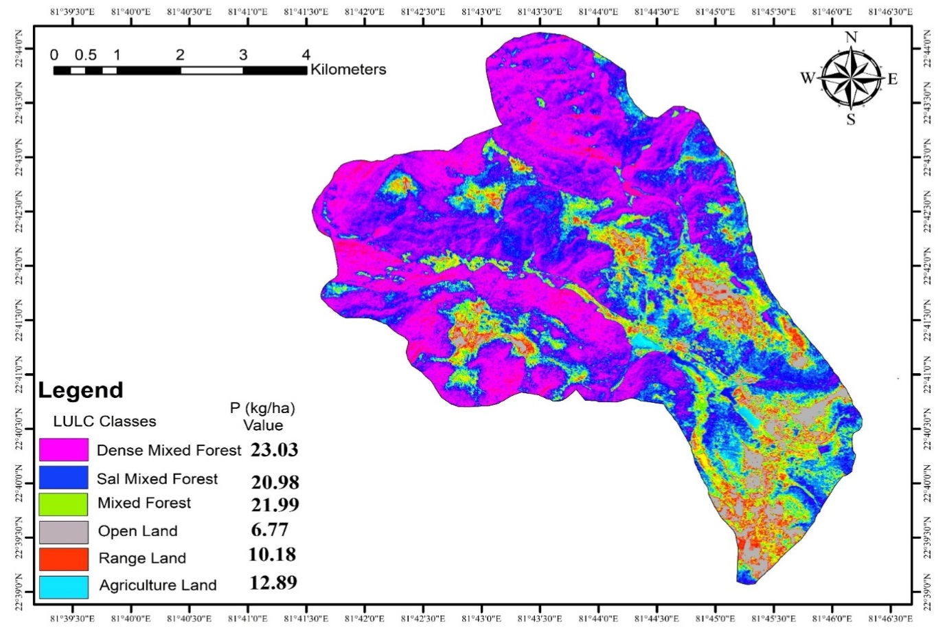
Figure 12 Phosphorus (kg ha⁻¹) contents of different LULCof the upper catchment of Narmada RiverAmarkantakin Central India

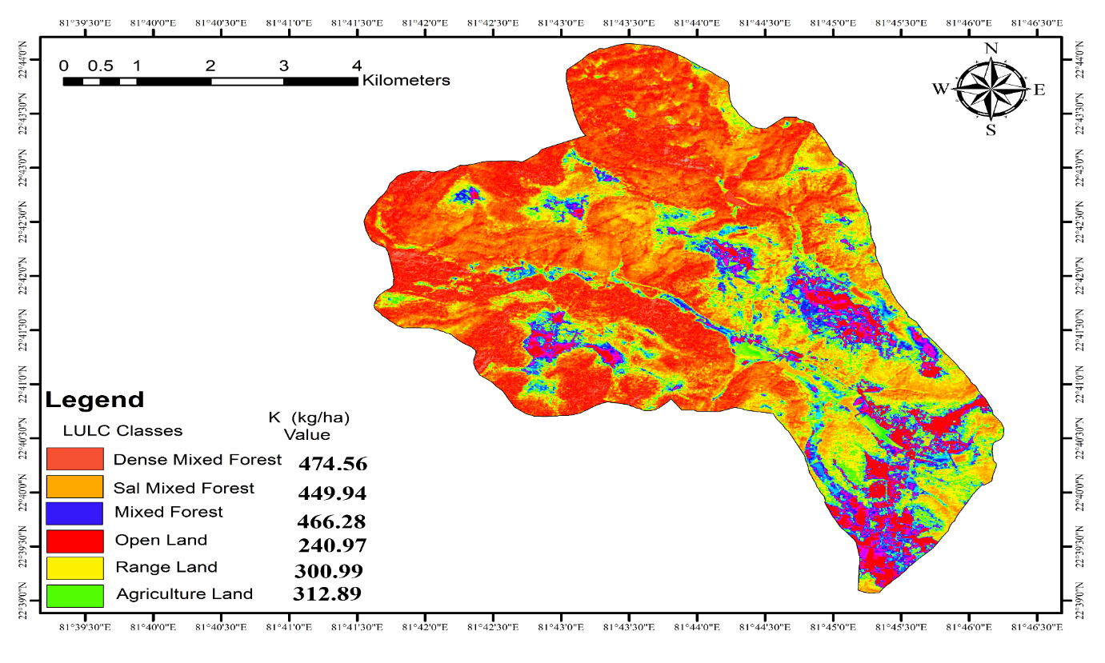
Figure 13Potassium (kg ha⁻¹) contents of different LULCof the upper catchment of Narmada RiverAmarkantakin Central India
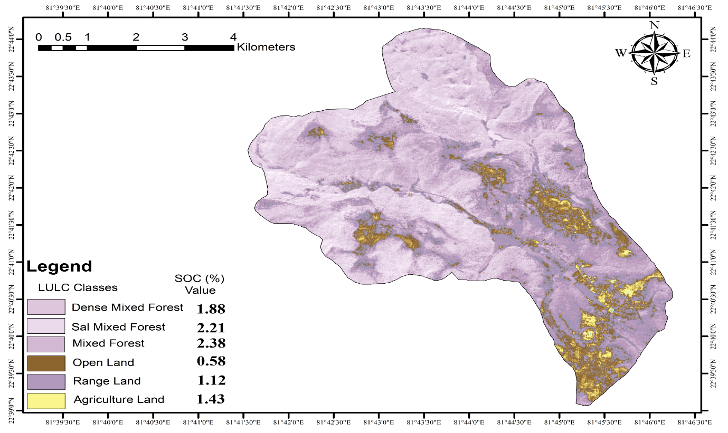
Figure 14 Soil organic carbon (%) of different LULCof the upper catchment of the Narmada RiverAmarkantakin Central India

Table 5. Species composition of top, middle and lower storey vegetation of upper catchment area of Narmada River Amarkantak in Central India and their uses (Thakur et al. 2021; Lal et al., 2022b; Lal, 2022)
S. No. | Common name | Scientific name | Family | Parts used | Uses
Top Storey
1. | Sal | Shorea robusta | Dipterocarpaceae | Stem, leaves | House construction, Furniture, Fuel wood, Tooth brush, oil, Cup and plate making
2. | Dhawda | Anogeissus latifolia | Combretaceae | Stem, Resin | House construction, Fuel wood, Agriculture implements
3. | Mohline | Bauhinia purpurea | Caesalpiniaceae | Leaf, Flower | Cup and plate making, Medicinal
4. | Bel | Aegle marmelos | Rutaceae | Fruit, Leaf | Edible, Medicinal, Religious
5. | Semal | Bombax ceiba | Malvaceae | Fruit, Flower | Medicine, Edible
6. | Salai | Boswellia serrata | Burseraceae | Resin | Medicine
7. | Char | Buchanania lanzan | Anacardiaceae | Fruit seed | Edible
8. | Palas | Butea monosperma | Fabaceae | Leaf | Cup and plate making
9. | Kumbhi | Careya arborea | Lecythidaceae | Bark | Fish poisoning
10. | Amaltash | Casia fistula | Caesalpinaceae | Fruit | Medicinal
 | Bhirra | Chloroxylon swietenia | Rutaceae | Stem, Bark | House Construction, Agricultural implements, Fuel wood
11. | Karra | Cleistanthus collinus | Euphorbiaceae | Stem | Furniture
12. | Shisham | Dalbergia sissoo | Leguminosae | Stem Leaf | House Construction, Agricultural Implements, Fuel Wood, Medicinal
13. | Gulmohar | Delonix regia | Leguminosae | Stem | Fuel wood
14. | Korkot | Dillenia pentagyna | Dilleniaceae | Root | Medicinal
 | Tendu | Diospyros melanoxylon | Ebenaceae | Fruit, leaves | Edible, Bidi making
15. | Bargad | Ficus benghalensis | Moraceae | Fruit | Edible
16. | Peepal | Ficus religiosa | Moraceae | Whole tree Fruit Leaf Religious Edible Fodder
17. | Kekat | Garuga pinnata | Burseraceae | Stem | Agricultural implements
18. | Lendia | Lagerstroemia parviflora | Lythraceae | Stem | Firewood, Boundary wall making
19. | Mahua | Madhuca indica | Sapotaceae | Flower, Fruit, Leaf | Edible after cooking Liquor preparation Oil Religious
20. | Aam | Mangifera indica | Anacardiaaceae | Fruit, Seed | Edible, medicinal
21. | Amla | Phyllanthus emblica | Euphorbiaceae | Fruit, Leaf | Edible and medicinal Cultural and medicinal
22. | Karanj | Pongamia pinnata | Fabaceae | Fruit | Oil extraction
23. | Bija | Pterocarpus marsupium | Fabaceae | Stem | House construction Furniture
24. | Kusum | Schleichera oleosa | Sapindaceae | Fruit, seed | Edible, oil extraction
25. | Bhelwa | Semicarpus anacardium | Anacardiaceae | Fruit | Edible, Medicinal
26. | Kullu | Sterculia urens | Sterculiaceae | Resin, Bark | Medicinal
27. | Jamun | Syzygium cumini | Myrtaceae | Stem, Fruit, Leaf | Cultural, Edible, medicinal
28. | Teak | Tectona grandis | Lamiaceae | Stem Leaf | House construction, Furniture, Dona making
29. | Arjun | Terminalia arjuna | Combretaceae | Stem | Firewood, House construction
30. | Beheda | Terminalia bellirica | Combretaceae | Fruit | Medicinal (Digestive)
31. | Harra | Terminalia chebula | Combretaceae | Fruit | Medicinal (Digestive)
32. | Saja | Terminalia tomentosa | Combretaceae | Stem | House construction, Fuel wood, Used during marriage
33. | Kala Umbar | Ficus hispida | Moraceae | Fruits | Fruits, vegetable
34. | Alu Bukhara | Flacourtia indica | Salicaceae | Fruit | Fruit- raw or cooked
35. | Kasihi | Bridelia retusa | Phyllanthaceae | Fruit, Bark, Flowers | Ripe fruit pulp, edible
Middle Storey
1. | Wild khajur | Phoenix sylvestris | Arecaceae | Fruit | Ripe fruits edible
2. | Neem | Azadirachta indica | Meliaceae | Fruit, seed | Oil extraction, medicinal
3. | Ghughch | Abrus precatorius | Fabaceae | Leaves | Mouth freshener
4. | Bans | Bambusa bamboo | Poaceae | Seeds | mix into flour
5. | Ratan jot | Jatropha curcas | Euphorbiaceae | Seed, Whole plant | Biofuel, Substitute of candle Bio-fencing
6. | Lantana | Lantana camara | Verbenaceae | Ripen fruits, Whole plant | Edible Bio-fencing
7. | Mainhar | Randia dumetorum | Rubiaceae | Leaf, Root | Vegetable Medicinal
8. | Arandi | Ricinis communis | Euphorbiaceae | Seed | Oil
9. | Nirgundi | Vitex nigundo | Verbenaceae | Leaf | Medicinal
10. | Ber | Ziziphus xilopyrus | Rhamnaceae | Fruit | Edible
11. | Aak | Calotropis gagentia | Musaceae | Leaf & flower | Offer to God
12. | Mehandi | Lawsonia irnemis | Lythraceae | Leaf | Dye
13. | Sitaphal | Annona squamosa | Annonaceae | Fruit | Ripe fruits edible
14. | Karonda | Carissa carandas | Apocynaceae | Fruit | Ripe fruits eaten & pickled
15. | Chota ber | Ziziphus mauritiana | Rhamnaceae | Fruit | Ripe fruits edible
16. | Dhavai | Woodfordia floribunda | Lytharaceae | Flowers | Flowers are eaten as food
17. | Makora | Ziziphus oenophlia | Rhamnaceae | Fruits | edible
Lower Storey
1. | Bhrangraj | Eclipta alba | Asteraceae | Oil | Medicinal
2. | Grass lily | Iphigenia indica | Poaceae | Leaves | Fodder
3. | Meethi buti | Scoparia dulcis | Plantaginaceae | Leaves, Seeds | Medicinal
4. | Naichi bhaji | Smithia conferta | Fabaceae | Leaves | Vegetable
5. | Kanghi | Blainvillea acmella | Asteraceae | Leaves | Medicinal
6. | Soli | Aeschynomene americana | Leguminosae | Seeds/grains | Grain edible
7. | Dudhali | Sopubia delphinifolia | Scrophulariaceae | Leaves, Seeds | Medicinal
8. | Akarkara | Spilanthes paniculata | Asteraceae | Inflorescences | Medicinal
9. | Bhui amla | Phyllanthus niruri | Euphorbiaceae | Whole plants | Medicinal
10. | Doodhi | Euphorbia heterophylla | Euphorbiaceae | Leaves | Medicinal
11. | Pulpuli grass | Arthraxon hispidus | Poaceae | Leaves | Fodder
12. | Satawar | Asparagus racemosus | Liliaceae | Roots/Tubers | Medicinal
13. | Haddi mushli | Chlorophytum borivilianum | Asparangaceae | Tubers | Medicinal
14. | Ghughunia | Crotalaria retusa | Leguminosae | Leaves | Food
15. | Pihrichara | Mecardonia procumbens | Scrophulariaceae | Leaves | Fodder
16. | Satparni | Desmodium gangeticum | Fabaceae | Leaves | Medicinal
17. | Kharatti | Sida acuta | Malvaceae | Leaves | Medicinal
18. | Sitab | Ruta graveolens | Rutaceae | Leaves | Medicinal
19. | Mameera | Thalictrum foliolosum | Rananculaceae | Leaves | Medicinal
20. | Bathua bhaaji | Chenopodium album | Chenopodiaceae | Leaves | Vegetable
21. | Pattharchoor | Plectranthus mollis | Lamiaceae | Roots/Tubers | Medicinal
22. | Bariyari | Sida cordata | Malvaceae | Leaves | Medicinal
23. | Hirankhuri | Emilia sonchifolia | Asteraceae | Fruits | Medicinal
24. | Badranjboya | Nepeta cataria | Lamiaceae | Seeds | Medicinal
25. | Varahi kand | Dioscorea bulbifera | Dioscoreaceae | Tuber | Medicinal
26. | Kali mushli | Curculigo orchioides | Agavaceae | Roots | Medicinal
27. | Tinpaniya | Oxalis corniculata | Oxalidaceae | Leaves | Medicinal & Vegetable
28. | Maskani | Evolvulus nummularius | Convolvulaceae | Leaves | Medicinal
29. | Chanchu | Corchorus fascicularis | Tiliaceae | Leaves | Food
30. | Kena | Commelina diffusa | Commelinaceae | Roots/tubers | Medicinal
31. | Kharmor | Rungia pectinata | Acanthaceae | Leaves/shoots | Medicinal
32. | Ghueen | Fimbristylis littoralis | Cyperceae | Roots/leaves | Medicinal
33. | Nagar motha | Cyperus gracilis | Poaceae | Leaves, roots | Fodder and Commercial products
34. | Bufalo grass | Paspalum conjugatum | Poaceae | Leaves | Fodder
35. | Baigasikiyab | Digitaria divaricatissima | Poaceae | Leaves | Fodder
36. | Janglimarua | Eleusine indica | Poaceae | Leaves | Fodder
37. | Dokar bel | Vitis carnosa | Vitaceae | Leaves/Fruits | Medicinal
38. | Chhuimui | Mimosa pudica | Fabaceae | Leaves | Medicinal
39. | Nuniya bhaji | Portulaca oleracea | Portulacaceae | Leaves | Vegetable
40. | Kanthkari | Solanum xanthocarpum | Solanaceae | Leaves | Medicinal
41. | Junglisama | Echinochloa colona | Poaceae | Seeds grains | Grain edible
42. | Amti | Solanum nodiflorum | Solanaceae | Fruits | Vegetable
43. | Chirchita | Achyranthes aspera | Amaranthaceae | Seeds, leaves | Medicinal
44. | Ghooma | Leucas aspera | Lamiaceae | Leaves | Vegetable
45. | Kaniya kanda | Dioscorea oppositifolia | Dioscoreaceae | Tubers | Medicinal
46. | Chench | Corchorus trilocularis | Tiliaceae | Leaves | Vegetable
47. | Chanahur | Marsdenia tenacissima | Asclepiadaceae | Leaves | Vegetable
48. | Van rai | Blumeopsis flava | Asteraceae | Seeds, Leaves | Medicinal,vegetable
49. | Tikhur | Curcuma angustifolia | Zingiberaceae | Tuber | Medicinal
50. | Mandukparni | Centella asiatica | Apiaceae | Leaves | Medicinal
51. | Ghuia | Colocasia esculenta | Araceae | Leaves, Rhizomes | Vegetable
52. | Kev kand | Costusspecios | Zingiberaceae | Tuber | Medicinal
53. | Amahaldi | Curcuma amada | Zingiberaceae | Tuber | Medicinal
54. | Jungli dhania | Eryngium foetidum | Apiaceae | Leaves, Seeds | Vegetable
55. | Bisakhpara | Boerhavia procumbens | Nyctaginaceae | Leaves | Vegetable
56. | Badi dudhi | Euphorbia hirta | Euphorbiaceae | Leaves | Medicinal
57. | Chhoti dudhi | Euphorbia macrophylla | Euphorbiaceae | Leaves | Medicinal
58. | Bara | Flemingia chappar | Fabaceae | Shoots | Lac
59. | Kalihari | Gloriosa superba | Colchicaceae | Climbers, Flower | Medicinal
60. | Jungle kevanch | Mucuna pruriens | Papilionaceae | Seeds | Medicinal
61. | Janglipyaj | Urginea indica | Liliaceae | Tuber | Medicinal
62. | Chirula | Aerva lanata | Amaranthaceae | Leaves | Medicinal
63. | Garundi | Alternanthera sessilis | Amaranthaceae | Leaves | Medicinal
64. | Jangli Tulsi | Ocimum gratissimum | Lamiaceae | Seeds, Leaves, Inflorescences | Medicinal
65. | Chirpoti | Physalis minima | Solanaceae | Fruits | Fruit edible
66. | Sarpgandha | Rauvolfia serpentina | Apocynaceae | Seeds | Medicinal
67. | Brahmi | Bacopa monnieri | Plantaginaceae | Whole plants | Medicinal
68. | Aswagandha | Withania somnifera | Solanaceae | Suckers, leaves | Medicinal
69. | Chirayta | Swertia alba | Gentianaceae | Whole plants | Medicinal
70. | Chaulai | Amaranthus spinosus | Amaranthaceae | Leaves | Vegetable
71. | Buch | Acorus calamus | Acoraceae | Rhizomes | Oil extraction, Medicinal
72. | Mandukparni | Centella asiatica | Plantaginaceae | Whole plants | Medicinal

