Genetic Variability Assessment in the F₂ Population of rice cross Uma × Nagina-22

ABSTRACT:
Genetic variability and its inherited components are crucial for identifying suitable breeding material and developing superior varieties. The present study was carried out at the College of Agriculture, Vellayani, Thiruvananthapuram, Kerala in the F₂ population of the Uma × Nagina 22 cross. The frequency distribution analysis revealed positive skewness with leptokurtic distribution for number of tillers, productive tillers, days to flowering, days to maturity, total chlorophyll content and seed length/breadth ratio. While panicle length, total grains per panicle, hundred seed weight, and proline content displayed negative skewness with platykurtic distribution. The PCV was higher than the GCV for all characters under study. High GCV and PCV were observed for the number of tillers, total number of grains per panicle, yield per plant, total chlorophyll content, proline content, protein content, and seed length/breadth ratio. The traits viz. plant height, days to flowering, panicle length, days to maturity, total number of grains per panicle, 100 seed weight, yield per plant, total chlorophyll content, proline content, protein content and seed length/breadth ratio exhibited high heritability coupled with high GAM. The presence of wide genetic variability, high heritability, and significant genetic advancement for many characters indicates an enormous potential for both direct and indirect selection to improve these traits.

Keywords: GCV, PCV, GAM, Heritability, Skewness, Kurtosis
INTRODUCTION
Rice (Oryza sativa) is one of the world's most important staple crops, feeding more than half of the world's population, primarily in Asia, Africa, and parts of Latin America (Bin Rahman and Zhang, 2023). Rice originated roughly 9,000 years ago in China's Yangtze River region and has evolved into a vital agricultural staple, adapting to a wide range of environments from flooded lowlands to upland terraces (Liu et al., 2017). Global rice production is expected to reach a record of 540.93 million tonnes in 2025, with India and China accounting for more than half of the total (USDA, 2025). Rice production is vital to the survival of billions of people around the world due to its unequalled importance in food security, cultural heritage, and economic stability. Continuous progress in the field of breeding, agronomy, and physiology aims to improve rice production, stress tolerance, and nutritional quality in the face of climate change and increasing demand. This underscores rice's vital role in global agriculture and human nutrition.
This crop has a lot of potential, therefore there is room to improve it and develop varieties that are tailored to particular agro-ecological circumstances. Any crop development program must begin with a thorough grasp of the degree of genetic variability for various traits. The basis of genetic improvement in any crop is the establishment and efficient use of diversity through suitable breeding techniques. In general, early segregating generations exhibit more variability than later ones. Designing an efficient breeding program requires evaluating genetic variation and the extent to which desired traits are inherited. Thus, the expected genetic gain from selection can be ascertained by assessing variability across various characters and dividing total variance into heritable and non-heritable components (Robinson and Comstock, 1949).
The success of any crop improvement programme largely relies on the degree of genetic variability available in the base population. In self-pollinated crops such as rice, identifying and selecting superior segregants from a heterogeneous population at early generations is crucial. Considering this, the present investigation was undertaken to assess the genetic variability for yield and its contributing traits in the F₂ population derived from the cross Uma × Nagina 22.
MATERIALS AND METHODS
The study was carried out at the College of Agriculture, Vellayani, Thiruvananthapuram, Kerala, from June to November 2025. The experimental material comprised an F₂ population developed from a cross between two parents - ‘Uma,’ a popular high-yielding rice variety released by KAU, Kerala, and Nagina 22 (N22), a heat and drought-tolerant genotype from ICAR–National Rice Research Institute (ICAR–NRRI), Cuttack, Odisha. The F₂ population derived from selfing the F₁, along with the parents Uma and N22, was grown in an unreplicated trial to evaluate yield and its related traits under heat and drought stress. Each F₂ plant was individually tagged, and data were recorded for thirteen quantitative traits: days to first flowering, plant height (cm), total number of tillers, number of productive tillers, days to maturity, panicle length(cm), total number of grains per panicle, seed size (length/breadth ratio), 100 seed weight (g), seed yield per plant (g plant⁻¹), total chlorophyll level (mg/g FW), proline content (μmol/g FW) and protein content (µg/µL).
Statistical analyses were carried out to estimate parameters such as mean, phenotypic variance (V_{p}), genotypic variance (V_{g}), and environmental variance (V_{e}), along with phenotypic and genotypic coefficients of variation (PCV and GCV), following the procedure of Panse and Sukhatme (1961). Broad-sense heritability was calculated using the formula proposed by Lush (1940), while the genetic advance as a percentage of the mean (GAM) was determined as per the method of Johnson et al. (1955). The third- and fourth-degree statistics viz., skewness and kurtosis, respectively, were computed according to Snedecor and Cochran (1974) to assess the distribution pattern of nine quantitative traits in the F₂ population derived from the cross Uma × N22. The statistical computations were performed using Microsoft Excel and SPSS software (Version 16).
RESULTS AND DISCUSSIONS
The nature of gene action and the number of genes governing characters can be understood through the study of frequency distributions, as well as third- and fourth-degree statistics, such as coefficients of skewness and Kurtosis (Robson, 1956). In general, a trait's skewed distribution indicates that it is impacted by environmental factors and controlled by non-additive gene action, particularly epistasis (Sheshaiah et al., 2018; Khandappagol et al., 2019). In the study for all characters, the F₂ population showed a significant degree of variation. Frequency distributions for yield and its attributing traits in the F2 population of cross Uma x N22 is shown in the Fig. 1. The table 1 displays the mean performance, range, skewness, and kurtosis of the F₂ segregating generations of the cross Uma × N22 for yield and the yield contributing attributes.
The number of tillers (1.52, 2.94), productive tillers (1.44, 2.40), days to flowering (0.25, 0.19), days to maturity (0.38, 0.04), total chlorophyll content (1.45, 1.47) and seed length/breadth ratio (0.71, 1.70) displayed positive skewness with leptokurtic distribution. The days to flowering, tiller number, panicle number and filled spikelets in F₇ segregants of Pusa-1176 × BPT-5204 displayed positive skewness and leptokurtic kurtosis, suggesting complementary epistasis and involvement of a few effective genes in governing these traits and this indicates high potential for effective early-generation selection (Kumari et al., 2024). While F₂ populations derived from AD 16019 × ADT 43 and AD 16019 × WGL 14377 showed positive skewness with a leptokurtic distribution for days to flowering, number of grains/panicles, seed length/breadth ratio, suggesting non-additive complementary interactions favouring selection for higher values (Lilly et al., 2018).
Plant height (-0.56, 0.93) recorded negative skewness with leptokurtic distribution. In multiple crossings and generations, plant height generally showed negative skewness, a characteristic associated with polygenic inheritance and duplicate epistasis under leptokurtic distributions. This indicates substantial genetic variability with the trait values clustered unevenly around the mean (Prasanna et al., 2024). ​On the other hand, panicle length (-0.12, -0.69), total grains per panicle (-0.08, -1.04), hundred seed weight (-0.61, -0.14), and proline content (-0.39, -0.25) displayed negative skewness with platykurtic distribution. Traits with negative skewness frequently signal a limited prospect for future improvement by direct selection, as most individuals already cluster at elevated values for the trait. While positive skewness with platykurtic distribution was recorded in yield per plant (0.49, -0.50) and protein content (0.47, -0.06). Lilly et al. (2018) reported that grain yield and 1000-grain weight showed positive skewness and platykurtic distributions in rice F₂ populations, indicating promising opportunities for effective trait improvement through selection.
Positive skewness indicates that the trait is influenced by complementing epistatic interactions. In such instances, selection progresses slowly under modest selection pressure but swiftly under stronger selection. In contrast, negative skewness which represents duplicate epistasis, enables faster improvement even with mild selection, and very rapid improvements as selection intensity increases. Similarly, kurtosis aids in the interpretation of population variation: platykurtic distributions represent larger variation, whereas leptokurtic distributions imply narrower variation. As a result, a platykurtic pattern is advantageous for selection due to the greater range of trait variation in the population (Subalakhshmi et al., 2024). ​
Evaluation of genetic variability in a population is crucial for the development of superior cultivars. Crop improvement slows in the absence of adequate genetic variability, limiting adaptation to new challenges such as climate change and pests. The study demonstrated that the genotypic variance is less than the phenotypic variance for all traits. The Fig. 2 presents the PCV and GCV levels for all traits. The traits like number of tillers (30.20, 20.59), total number of grains per panicle (39.58, 38.93), yield per plant (54.87, 50.55), total chlorophyll content (81.68, 79.01), proline content (28.23, 25.82), protein content (29.21, 28.87), and seed length/breadth ratio (23.96, 23.89) showed high PCV and GCV. Plant height (14.25, 12.28), days to flowering (17.15, 16.51), panicle length (14.52, 12.51), days to maturity (12.1, 11.86) and 100 seed weight (14.84, 12.73) exhibited moderate levels of PCV and GCV, respectively. But productive tillers exhibited high PCV (32.69) and moderate GCV (18.28). The PCV was higher than GCV for all characters, suggesting some environmental influence; however, the small difference between them indicates it is negligible. For efficient selection and crop improvement, traits with high GCV are very helpful. The results were in line with Naik et al. (2020) and Roy and Shil (2020).
Heritability measures how well traits are passed down from parents to offsprings (Falconer, 1964) and is useful in identifying superior genotypes among varied populations. It also serves as a measure of the reliability of phenotype as a guide to breeding value and the usefulness of field experiments. In this study, the number of tillers (46.47%) and productive tillers (31.27%) displayed moderate heritability. While remaining all characters, namely plant height (74.29%), days to flowering (92.69%), panicle length (74.21%), days to maturity (96.06%), total number of grains per panicle (96.76%), 100 seed weight (73.58%), yield per plant (84.86%), total chlorophyll content (93.56%), proline content (83.63%), protein content (97.70%) and seed length/breadth ratio (99.37%) showed high heritability. The results were in agreement with those of Ojah et al. (2019), Akshay et al. (2022), Chaudhary et al. (2023) and Anusha et al. (2024).
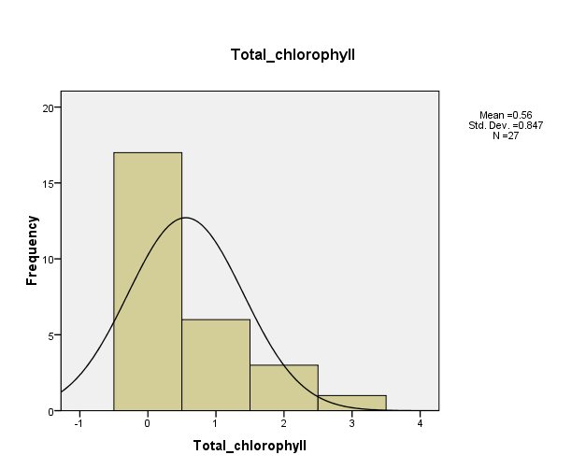
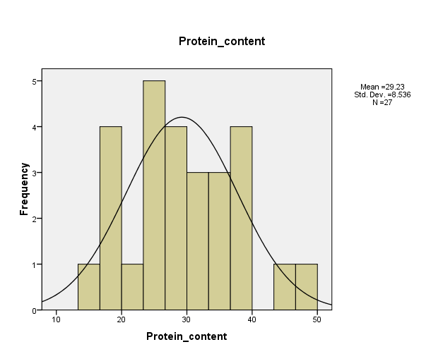
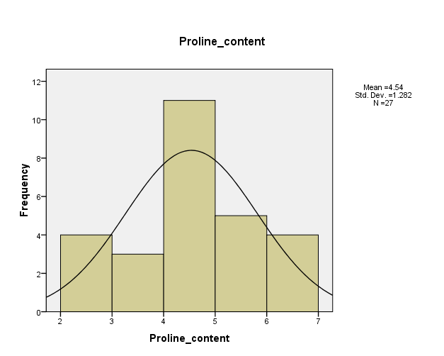
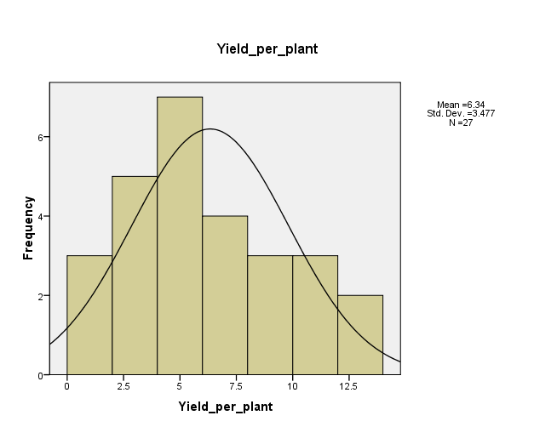
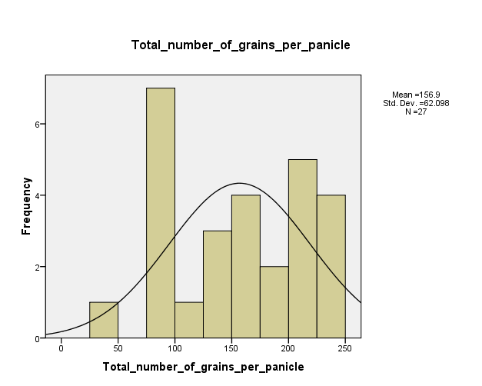
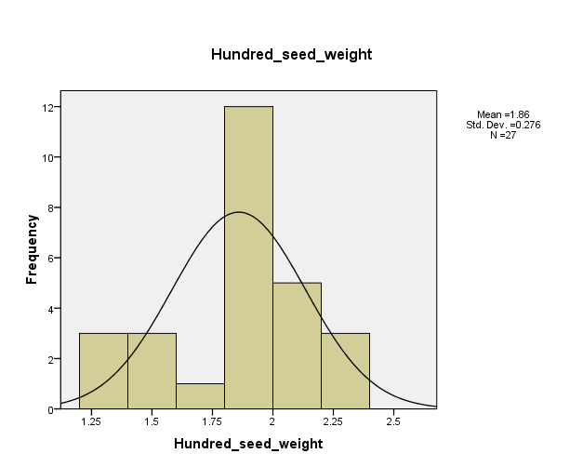
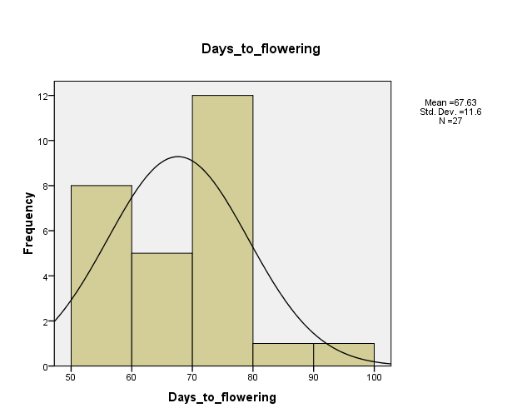
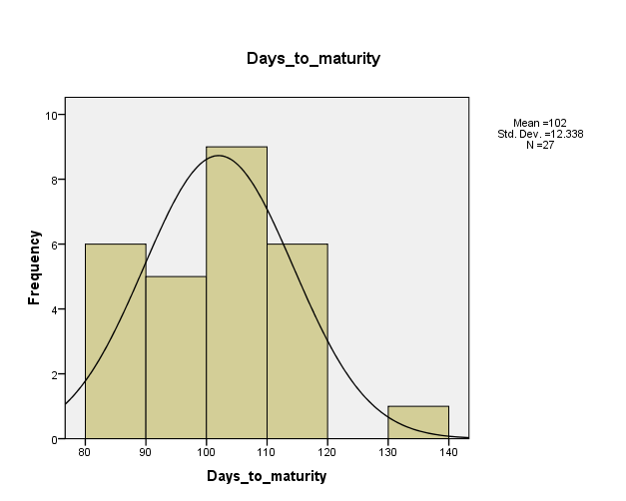
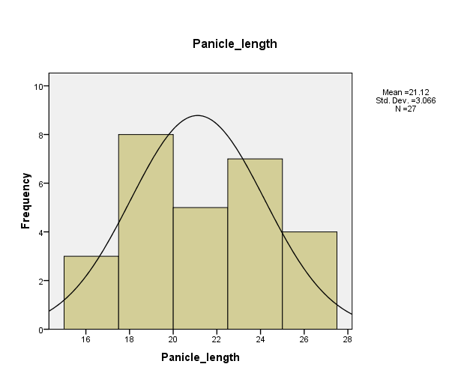
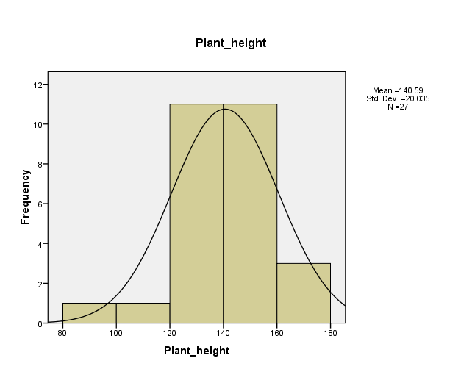
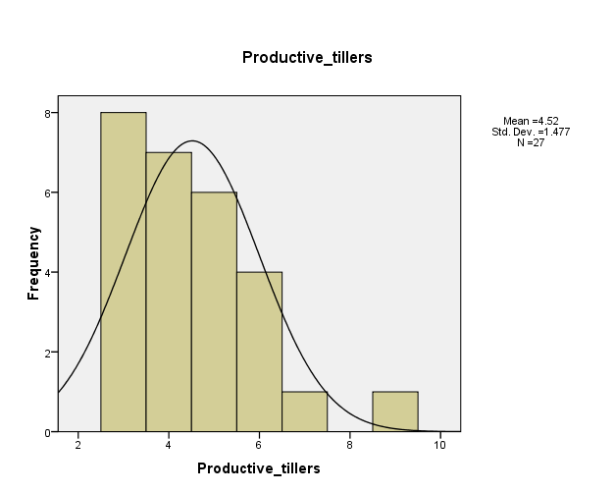
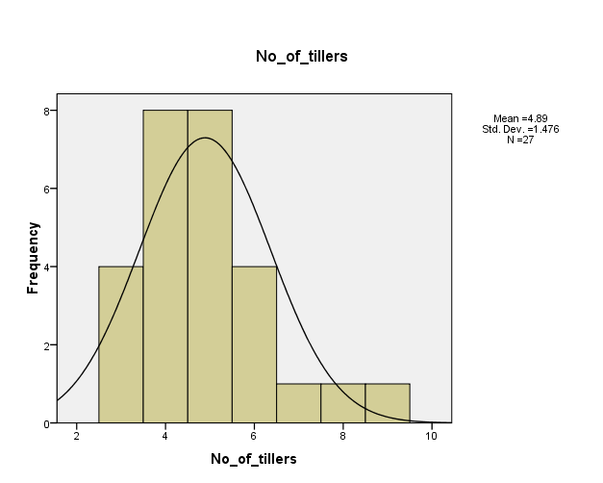
Genetic advance as percentage of mean (GAM) is an important selection criterion in plant breeding that quantifies the estimated genetic gain from one selection cycle as a percentage of the population mean, offering an approximate estimate of possible improvement in comparison to current performance. In the study, GAM was high for all traits viz. plant height (21.81), number of tillers (28.91), productive tillers (21.06), days to flowering (32.75), panicle length (22.19), days to maturity (23.94), total number of grains per panicle (78.89), 100 seed weight (22.49), yield per plant (95.92), total chlorophyll content (157.42), proline content (48.64), protein content (58.78) and seed length/breadth ratio (49.06). Fig. 3 illustrates the genetic advance as a percentage of the mean for all traits. The characters like plant height, days to flowering, panicle length, days to maturity, total number of grains per panicle, 100 seed weight, yield per plant, total chlorophyll content, proline content, protein content and seed length/breadth ratio exhibited high heritability coupled with high GAM. This indicates the presence of additive gene effects and selection is effective for these traits. These results are similar to the findings of Kumari and Parmar (2020), Soundharya et al. (2024) and Akhil et al. (2025).
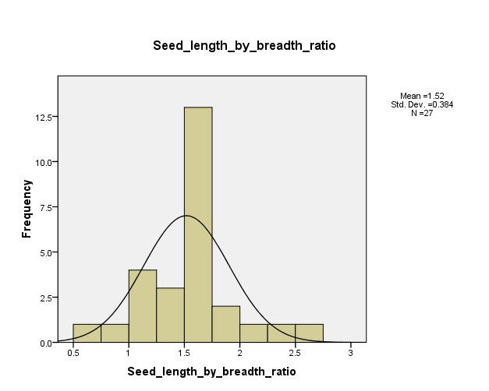

Fig. 1. Frequency distributions for yield and its attributing traits in the F₂ population of cross Uma x N22

Sl. No. | Characters | Mean | Range |  | V_{p} | V_{g} | PCV% | GCV% | h2bs% | GA | GAM% | Skewness | Kurtosis
Sl. No. | Characters | Mean | Minimum | Maximum
1 | Plant height | 140.59 | 86.20 | 176.60 | 401.40 | 298.19 | 14.25 | 12.28 | 74.29 | 30.66 | 21.81 | -0.56 | 0.93
2 | No. Of tillers | 4.89 | 3.00 | 9.00 | 2.18 | 1.01 | 30.20 | 20.59 | 46.47 | 1.41 | 28.91 | 1.52 | 2.94
3 | Productive tillers | 4.52 | 3.00 | 9.00 | 2.18 | 0.68 | 32.69 | 18.28 | 31.27 | 0.95 | 21.06 | 1.44 | 2.40
4 | Days to flowering | 67.63 | 51.00 | 99.00 | 134.55 | 124.72 | 17.15 | 16.51 | 92.69 | 22.15 | 32.75 | 0.25 | 0.19
5 | Panicle length | 21.12 | 15.13 | 26.50 | 9.40 | 6.98 | 14.52 | 12.51 | 74.21 | 4.69 | 22.19 | -0.12 | -0.69
6 | Days to maturity | 102.00 | 82.00 | 133.00 | 152.23 | 146.23 | 12.10 | 11.86 | 96.06 | 24.41 | 23.94 | 0.38 | 0.04
7 | Total number of grains per panicle | 156.90 | 30.67 | 247.67 | 3856.18 | 3731.37 | 39.58 | 38.93 | 96.76 | 123.78 | 78.89 | -0.08 | -1.04
8 | 100 seed weight | 1.86 | 1.22 | 2.28 | 0.08 | 0.06 | 14.84 | 12.73 | 73.58 | 0.42 | 22.49 | -0.61 | -0.14
9 | Yield per plant | 6.34 | 1.15 | 13.42 | 12.09 | 10.26 | 54.87 | 50.55 | 84.86 | 6.08 | 95.92 | 0.49 | -0.50
10 | Total chlorophyll content | 1.05 | 0.24 | 3.06 | 0.73 | 0.68 | 81.68 | 79.01 | 93.56 | 1.65 | 157.42 | 1.45 | 1.47
11 | Proline content | 4.54 | 2.00 | 6.62 | 1.64 | 1.37 | 28.23 | 25.82 | 83.63 | 2.21 | 48.64 | -0.39 | -0.25
12 | Protein content | 29.23 | 14.51 | 48.99 | 72.87 | 71.19 | 29.21 | 28.87 | 97.70 | 17.18 | 58.78 | 0.47 | -0.06
13 | Seed length/breadth ratio | 1.57 | 0.79 | 2.50 | 0.14 | 0.14 | 23.96 | 23.89 | 99.37 | 0.77 | 49.06 | 0.71 | 1.70
Table 1: Genetic parameter estimates and frequency distributions for yield and component traits in the F₂ population from the Uma × N22 cross

Fig. 2. PCV and GCV for yield and its attributing traits in the F₂ population of cross Uma × N22.

Fig. 3. Heritability and GAM for yield and its attributing traits in the F₂ population of cross Uma × N22.
CONCLUSION
The characters, namely number of tillers, total number of grains per panicle, yield per plant, total chlorophyll content, proline content, protein content, and seed length/breadth ratio, recorded high genetic variability. The plant height, days to flowering, panicle length, days to maturity, total number of grains per panicle, 100 seed weight, yield per plant, total chlorophyll content, proline content, protein content and seed length/breadth ratio also displayed high heritability along with substantial genetic advance as a percentage of the mean, indicating strong potential for improvement through selection. Most yield-related traits showed positive skewness across populations, with leptokurtic curves indicating complementary gene action and strong early-generation selection potential, whereas plant height and grain traits like panicle length, total number of grains per panicle and 100 seed weight showed negative skewness, which was linked to duplicate epistasis and broad genetic variability.
Competing interests
Authors have declared that no competing interests exist.
REFERENCES
- Akhil, D., Siddi, S., Chimmilli, S. R., & Mangrauthia, S. K. (2025). Investigations on variability, heritability and genetic advance in short and medium slender grain rice (Oryza sativa L.) genotypes. International Journal of Advanced Biochemistry Research, 9(8), 195-204. https://doi.org/10.33545/26174693.2025.v9.i8Sc.5120
- Akshay, M., Chandra, B. S., Devi, K. R., & Hari, Y. (2022). Genetic variability studies for yield and its attributes, quality and nutritional traits in rice (Oryza sativa L.). The Pharma Innovation Journal, 11(5), 167-172. https://www.thepharmajournal.com/archives/2022/vol11issue5/PartC/11-5-10-790.pdf
- Anusha, K., Srinivas, B., Hari, Y., Shankar, V. G., OmPrakash, S., & Kumar, R. S. (2024). Genetic Variability Studies for Yield and Yield Attributing Traits in Rice (Oryza sativa L.) Genotypes. Journal of Experimental Agriculture International, 46(8), 700-709. https://doi.org/10.9734/jeai/2024/v46i82753
- Bin Rahman, A. R., & Zhang, J. (2023). Trends in rice research: 2030 and beyond. Food and Energy Security, 12(2), e390. https://doi.org/10.1002/fes3.390
- Chaudhary, B. K., Verma, O. P., Singh, P. K., Patel, A., & Riju. (2023). Assessment of genetic variability, heritability and genetic advance of rice genotypes (Oryza sativa L.). International Journal of Plant & Soil Science. https://doi.org/10.9734/ijpss/2023/v35i193681
- Falconer, D. S. (1964). Introduction to Quantitative Genetics. Oliver and Boyd.
- Sheshaiah, B. M., Dushyantha Kumar, B. M., Gangaprasad, S., Gowda, T. H., Hosagoudar, G. N., & Shashidhar, H. E. (2018). Studies on variability and frequency distribution of yield and yield related traits in F2 population of rice (Oryza sativa L.). International Journal of Current Microbiology and Applied Sciences, 7(9), 2048-2052. https://doi.org/10.20546/ijcmas.2018.709.249
- Johnson, H. W., Robinson, H. F., & Comstock, R. E. (1955). Genotypic and Phenotypic Correlations in Soybeans and Their Implications in Selection. Agronomy Journal, 47, 477-483. https://doi.org/10.2134/agronj1955.00021962004700100008x
- Khandappagol, M., Rajanna, M. P., & Savita, S. K. (2019). Variability and frequency distribution studies in F2 population of two crosses involving traditional varieties of rice (Oryza sativa L.). Journal of Pharmacognosy and Phytochemistry, 8(1), 1630-1634. https://doi.org/10.58297/KLCF6831
- Lilly, M. S., Sassikumar, D., & Suresh, R. (2018). Variability and heritability analysis for yield and grain quality attributes in F2 intervarietal populations of rice. International Journal of Current Microbiology and Applied Sciences, 7(07), 4329-4338. https://doi.org/10.20546/ijcmas.2018.707.504
- Liu, T., Liu, Y., Sun, Q., Zong, Y., Finlayson, B., & Chen, Z. (2017). Early Holocene groundwater table fluctuations in relation to rice domestication in the middle Yangtze River basin, China. Quaternary Science Reviews, 155, 79-85. https://doi.org/10.1016/j.quascirev.2016.11.015
- Naik, M. V. K., Pillai, M. A., & Saravanan, S. (2020). Genetic variability studies in F1 rice (Oryza sativa L.) hybrids for yield and quality traits. The Journal of Phytopharmacology, 9(6), 453-458. https://doi.org/10.31254/phyto.2020.9613
- Kumari, N., & Parmar, M. B. (2020). Heritability and genetic advance analysis in rice (Oryza sativa L.) genotypes under aerobic condition. International Journal of Current Microbiology and Applied Sciences, 9(3), 1196-1204. https://doi.org/10.20546/ijcmas.2020.903.140
- Ojah, H., Talukdar, P., Sarma, D., & Goswami, R. (2019). Genetic variability for yield and yield contributing traits of rice under aerobic condition in Assam, India. Int. J. Curr. Microbiol. App. Sci, 8(7), 1530-1537. https://doi.org/10.20546/ijcmas.2019.807.182
- Panse, V. G. and Sukhatme, P. V. (1961). “Statistical Methods for Agricultural Workers,” 2nd ed. Indian Council of Agricultural Research, New Delhi.
- Prasanna, G. S. S., Joshi, J. L., & Muraleedharan, A. (2024). Utilizing Genetic Traits Distributions to Enhance Rice Breeding Programs: A Study of Skewness and Kurtosis in Segregating Generations. Journal of Experimental Agriculture International, 46(9), 741-760. https://doi.org/10.9734/jeai/2024/v46i92871
- Robson, D. S. (1956). Applications of the k4 statistic to genetic variance component analyses. Biometrics, 12(4), 433-444. https://doi.org/10.2307/3001682
- Roy, S. C., & Shil, P. (2020). Assessment of genetic heritability in rice breeding lines based on morphological traits and caryopsis ultrastructure. Scientific reports, 10(1), 7830. https://doi.org/10.1038/s41598-020-63976-8
- Snedecor, G. W., & Cochran, W. G. (1989). Statistical methods. Iowa State University Press. https://www.wiley.com/en-kr/Statistical+Methods%2C+8th+Edition-p-9780813815619
- Soundharya, B., Edukondalu, B., Narender, G., & Dinesh, A. (2024). Genetic Variability, Heritability and Genetic Advance for Yield and Yield Related Traits in Rice (Oryza Sativa L.). Journal of Advances in Biology & Biotechnology.
- Subalakhshmi, V. K. I. S., Rajeswari, S., Premalatha, N., Boopathi, N. M., & Thirukumaran, K. (2024). Analysis of skewness and kurtosis in F2 generation of four crosses in American cotton (Gossypium hirsutum L.). Emergent Life Sciences Research, 10, 52-57. https://doi.org/10.31783/ELSR.2024.1025257
- United States Department of Agriculture. (2025). Production - Rice. Washington, DC: USDA. https://www.fas.usda.gov/data/production/commodity/0422110

