Comprehensive Molecular Detection and Characterization of Cucumber Mosaic Virus Infecting Bhut Jolokia (Capsicum chinense Jacq.) in Assam, India

Abstract
Bhut Jolokia (Capsicum chinense), a high-value chili pepper indigenous to Northeast India, faces significant yield constraints due to viral diseases. Extensive field surveys conducted during 2020-2021 in the major Bhut Jolokia growing districts of Assam (Jorhat, Golaghat, Lakhimpur, and Dhemaji) revealed a high incidence of virus-like symptoms, including mosaic, mottling, leaf distortion, and stunting. Serological detection using Double Antibody Sandwich Enzyme-Linked Immunosorbent Assay (DAS-ELISA) confirmed the widespread presence of Cucumber mosaic virus (CMV), with disease incidence ranging from 30% to 80%. Molecular analysis further validated these findings. Reverse Transcription-Polymerase Chain Reaction (RT-PCR) using specific primers amplified fragments of the replicase (1052 bp) and coat protein (1130 bp) genes. Nucleotide sequencing of these amplicons revealed 98-100% identity among the Assam isolates. Phylogenetic analysis based on both genes unequivocally clustered the Assam CMV isolates within the subgroup IA, showing closest homology with other Indian isolates from chili. This study provides conclusive evidence of CMV as a predominant viral pathogen infecting Bhut Jolokia in Assam and offers essential genetic information for developing effective management strategies.
Keywords: Capsicum chinense, CMV, Phylogeny, RT-PCR, DAS-ELISA, Virus detection, Subgroup IA
Introduction:
Capsicum chinense Jacq., commonly known as Bhut Jolokia, is a critically important agricultural commodity in Northeast India, renowned for its exceptional pungency and high capsaicin content. Its economic value in both domestic and international markets is substantial. However, the productivity of this crop is severely hampered by a complex of pests and diseases, with viral infections being the most devastating (Talukdar et al., 2015). Among these, the Cucumber mosaic virus (CMV), a member of the genus Cucumovirus (family Bromoviridae), is one of the most economically significant plant pathogens worldwide due to its extensive host range, encompassing over 800 plant species (Palukaitis et al., 1992).
In India, mosaic disease in chili has been attributed to several viruses, including CMV, Tobacco mosaic virus (TMV), Potato virus Y (PVY), and Chilli veinal mottle virus (ChiVMV) (Jagadeeswar, 2004). CMV is particularly prevalent in vegetable crops across Northeast India and is efficiently transmitted by more than 60 species of aphids in a non-persistent manner, facilitating its rapid spread in the field (Palukaitis et al., 1992). Symptoms of CMV infection in Bhut Jolokia are diverse and often include chlorosis, severe mosaic, mottling, leaf filiformity (shoestring), and stunted growth, leading to significant fruit yield and quality losses (Borah et al., 2019, Routhu et al., 2022).
Initial diagnosis based on symptomatology can be misleading, as symptoms often overlap with those caused by other viruses or nutrient deficiencies. Therefore, reliable detection methods are crucial for accurate diagnosis and management. Serological techniques like DAS-ELISA are widely used for initial screening, but molecular methods such as RT-PCR offer higher sensitivity and specificity, especially for viruses present at low titers (Katoch et al., 2003). Genetic characterization and phylogenetic analysis of viral genes, particularly the replicase and coat protein, are essential for understanding the genetic diversity and evolutionary relationships of virus populations, which informs the development of resistant varieties and control measures.
Although CMV has been reported from Assam, a comprehensive molecular characterization of the virus infecting Bhut Jolokia in this region was lacking. This study was undertaken to (i) survey the incidence of CMV in major Bhut Jolokia growing districts of Assam, (ii) confirm CMV presence using serological and molecular tools, and (iii) genetically characterize the local CMV isolates through sequencing and phylogenetic analysis to determine their taxonomic subgroup.
Materials and Methods:
Field Survey and Sample Collection
A roving survey was conducted during 2020-2021 across Bhut Jolokia fields in four districts of Assam: Jorhat, Golaghat, Lakhimpur, and Dhemaji. Plants exhibiting characteristic viral symptoms such as mosaic, chlorosis, mottling, and leaf distortion were documented and leaf samples were collected. Disease incidence was calculated as the percentage of symptomatic plants relative to the total plants observed in each location.
Serological Detection by DAS-ELISA
Collected leaf samples were tested for CMV using DAS-ELISA following the protocol of Hobbs et al. (1987). Briefly, polystyrene microtiter plates were coated with CMV-specific IgG (1:200 dilution, obtained from USDA-ARS, Corvallis, USA). Leaf samples were homogenized in extraction buffer, added to the wells, and incubated. After washing, an alkaline phosphatase-conjugated antibody was added. The reaction was developed using p-nitrophenyl phosphate substrate, and the optical density (OD) was measured at 405 nm using an ELISA reader (BioRad). Samples were considered positive if their OD values were at least twice that of the healthy control.
Molecular Detection and Characterization
RNA Isolation
Total RNA was extracted from symptomatic leaf tissues using two methods: the standard TRIzol reagent protocol (Chomczynski and Sacchi, 1987) and a commercial NucleoSpin® RNA Plant kit (Macherey-Nagel). The concentration and purity of the extracted RNA were assessed using a spectrophotometer (Eppendorf), and RNA integrity was confirmed by 1.0% agarose gel electrophoresis.
cDNA Synthesis and PCR Amplification
First-strand cDNA was synthesized from 100 ng of total RNA using the PrimeScript™ 1st strand cDNA Synthesis Kit (TaKaRa) with oligo(dT) primers. Gene-specific primers were designed for the replicase and coat protein (CP) genes of CMV using Primer3 software after aligning multiple CMV sequences from the NCBI database (Table 1).
Table 1: List of primers used for RT-PCR amplification.
Gene Target | Primer Name | Sequence (5' → 3') | Amplicon Size (bp)
Replicase | GK Rep 4F | TGTAAAAACTACCCTTTGA | 1052 bp
Replicase | GK Rep 4R | AATGTCGAATGAGTTCGGTC | 1052 bp
Coat Protein | GK CMV F | GAGTTCTTCCGCGTCCCGCT | 1130 bp
Coat Protein | GK CMV R | AAACCTAGGAGATGGTTTCA | 1130 bp
Semi-quantitative PCR was performed using EmeraldAmp® MAX PCR Master Mix. The thermal cycling conditions included an initial denaturation at 94°C for 2 min, followed by 35 cycles of 94°C for 30 s, 55-57°C for 45 s, 72°C for 45 s, and a final extension at 72°C for 8 min. The amplified products were separated on a 1.2% agarose gel, visualized under UV light, and purified using a NucleoSpin Gel and PCR clean-up kit (Macherey-Nagel).
Cloning, Sequencing, and Phylogenetic Analysis
The purified PCR products were cloned into the pTZ57R/T vector and transformed into E. coli DH5α competent cells. Positive recombinant clones were identified by colony PCR and restriction digestion. Plasmid DNA from selected clones was sequenced commercially. The obtained nucleotide sequences were analyzed using the BLASTN algorithm. Multiple sequence alignments were performed with ClustalW, and phylogenetic trees were constructed using the Maximum Likelihood method in MEGA X software based on the Tamura-Nei model. The sequences were deposited in the NCBI GenBank under accession numbers OQ435160.1-OQ435160.4 (Replicase) and OQ435161.1-OQ435161.4 (Coat Protein).
Results
Disease Incidence and Symptomatology
The field survey revealed a high prevalence of viral diseases in Bhut Jolokia across Assam. The highest disease incidence (80%) was recorded in the Golaghat district, followed by Jorhat and Lakhimpur (40-60%), and the lowest (30%) in Dhemaji (Table 2). A wide range of symptoms was observed, including chlorotic yellow spots, severe mosaic, mottling, leaf puckering, filiformity (shoestring), and stunted growth (Figure 1).
Table 2: Disease incidence and serological detection of CMV in surveyed locations of Assam.
District | Pockets | OD Values @405nm (X-fold over healthy) | Disease Incidence (%)
Jorhat | Borbheta | 0.90-2.00 (1.4-3.1) | 60
Jorhat | Kasogoral | 0.90-2.00 (1.4-3.1) | 50
Golaghat | Misamora | 0.78-2.40 (1.2-3.7) | 80
Golaghat | Buralikson | 0.78-2.40 (1.2-3.7) | 70
Lakhimpur | Lakhimpur | 0.50-1.32 (0.7-2.1) | 60
Dhemaji | Gopak | 0.50-1.32 (0.7-2.1) | 30
OD of healthy control: 0.71

Serological and Molecular Detection
DAS-ELISA confirmed the presence of CMV in symptomatic samples, with OD values of infected plants being 2-3 times higher than those of healthy controls (Table 2). The virus titer was highest in samples from Golaghat.
RT-PCR using gene-specific primers successfully amplified fragments of the expected sizes—1052 bp for the replicase gene (Figure 2) and 1130 bp for the coat protein gene (Figure 3)—from all ELISA-positive samples, confirming CMV infection. No amplification was observed in healthy control plants.
Genetic Characterization and Phylogenetic Analysis
Nucleotide sequence analysis of the replicase and coat protein genes from the four Assam isolates showed 98-100% identity among themselves. BLAST analysis of the replicase gene (OQ435160) revealed the highest homology (99%) with a CMV isolate from chili in Tamil Nadu (ON156440.1). The coat protein gene (OQ435161) shared maximum identity (99%) with a Bhut Jolokia isolate from Assam (MW267939.1).
The replicase open reading frame (ORF) was 1052 bases long, encoding a predicted protein of 349 amino acids. The coat protein ORF was 816 bases long, encoding 217 amino acids.
Phylogenetic trees constructed from both gene sequences consistently placed all the Assam CMV isolates within a well-supported clade of subgroup IA strains (Figure 4 & 5). They clustered closely with other CMV isolates from India, distinctly separating from subgroup IB and II isolates.
Discussion
This study provides a comprehensive report on the molecular characterization of Cucumber mosaic virus infecting the economically important Bhut Jolokia crop in Assam. The high disease incidence (up to 80%) recorded in our survey aligns with previous reports of CMV being a major constraint in chili cultivation across India (Biswas et al., 2005; Narute et al., 2008; Borah et al., 2019). The variation in incidence among districts could be attributed to differences in vector population dynamics, cultural practices, and environmental conditions.
The combination of DAS-ELISA and RT-PCR proved to be a robust strategy for reliable detection. While DAS-ELISA is excellent for large-scale screening, RT-PCR provided definitive, genome-based confirmation, essential for characterizing the pathogen. The successful amplification of both the replicase and coat protein genes confirms the specificity of the designed primers for the Assam isolates.
The high nucleotide and amino acid sequence identity among the Assam isolates suggest a genetically homogeneous CMV population infecting Bhut Jolokia in this region. The phylogenetic analysis is a key finding of this work, as it clearly classifies the Assam isolates within the CMV subgroup IA. This subgroup has a worldwide distribution and is often associated with severe disease phenotypes (Roossinck, 2002). The close genetic relationship with other Indian CMV isolates indicates a common lineage and possibly a regional movement of the virus through infected planting material or aphid vectors. This finding is consistent with Borah et al. (2019), who also reported subgroup IA CMV isolates from Bhut Jolokia in Assam. In contrast, studies on CMV from other hosts like banana and coleus in Southern India have reported the prevalence of subgroup IB (Nagendran et al., 2018; Pavitra et al., 2019), highlighting potential host-specific or geographic patterns in CMV strain distribution within India.

Conclusion
In conclusion, our results unequivocally identify Cucumber mosaic virus as a widespread and significant pathogen of Bhut Jolokia in Assam. The virus is present at high incidence levels and is genetically characterized as belonging to the subgroup IA. The genetic homogeneity of the isolates is a positive sign for the potential development of uniform management strategies, such as RNAi-based approaches or the deployment of single, broad-spectrum resistance genes. The genetic data and specific primers developed in this study provide a foundation for future surveillance, breeding for resistance, and epidemiological studies aimed at mitigating the impact of CMV on Bhut Jolokia cultivation in Northeast India.

Data Availability- The nucleotide sequences generated during this study are available in the NCBI GenBank repository under accession numbers OQ435160.1-OQ435160.4 and OQ435161.1-OQ435161.4.
.

References
Biswas, K.K., Pun, K.B., Pant, R.P. and Ahlawat, Y.S. (2005). Mosaic disease in chilli (Capsicum annuum) cv Kalimpong Local in Darjeeling hills of West Bengal and its management. Indian Phytopathology, 58: 456-461. https://epubs.icar.org.in/index.php/IPPJ/article/view/17532
Borah, M.; Gowtham Kumar .R. and Sundaresha Siddappa. (2019). Molecular Detection and Phylogenetic Analysis of Cucumber Mosaic Virus Infecting Bhut Jolokia (Capsicum chinense Jacq.) of Assam. International Journal of Economic Plants 2019, 6(3):126-129. https://doi.org/10.23910/IJEP/2019.6.3.0320
Chomczynski, P., & Sacchi, N. (1987). Single-step method of RNA isolation by acid guanidinium thiocyanate-phenol-chloroform extraction. Analytical biochemistry, 162(1), 156-159. https://doi.org/10.1006/abio.1987.9999
Hobbs, H., Reddy, D., Rajeshwari, R., & Reddy, A. (1987). Use of direct antigen coating and protein a coating ELISA procedures. Plant Dis, 71(8), 747-749. https://doi.org/10.1094/PD-71-0747
Jagadeeshwar. (2004) Identification and management of naturally occurring viruses on chilli (Capsicum annuum L.) in Northern Telangana Zone of Andhra Pradesh. Ph.D Thesis submitted to the Acharya N.G. Ranga Agricultural University, Rajendranagar, Hyderabad. http://krishikosh.egranth.ac.in/handle/1/5810017675
Katoch, M.; Abdin, M. Z.; Ram, R. and Zaidi, A. A. (2003). An overview of diagnostics for viruses infecting gladiolus. Crop Protection, 22(1), 153-156. https://doi.org/10.1016/S0261-2194(02)00139-4
Nagendran, K.; Priyanka, R.; Aravintharaj, R.; Balaji, C. G.; Prashant, S.; Basavaraj, B., and Karthikeyan, G. (2018). Characterization of Cucumber mosaic virus infecting snake gourd and bottle gourd in India. Physiological and Molecular Plant Pathology, 103, 102-106. https://doi.org/10.1016/j.pmpp.2018.05.010
Narute, I. K.; Sawane, D. M. and Deshmukh, G. P. (2008). Incidence, survey and symptomatoloy of chilli mosaic virus grown under polyhouse condition in western Maharashtra. Journal of Plant Disease Sciences, 3(2), 206-209.
Palukaitis, P.; Roossinck, M. J.; Dietzgen, R. G. and Francki, R. I. (1992). Cucumber mosaic virus. Advances in virus research, 41, 281-348. https://doi.org/10.1016/s0065-3527(08)60039-1
Pavithra, B. S.; Govin, K.; Renuka, H. M.; Krishnareddy, M.; Jalali, S.; Samuel, D. K., and Himabindu, K. (2019). Characterization of cucumber mosaic virus infecting coleus (Plectranthus barbatus) in Karnataka. VirusDisease, 30, 403-412. https://doi.org/10.1007/s13337-019-00536-3
Roossinck, M. J. (2002). Evolutionary history of Cucumber mosaic virus deduced by phylogenetic analyses. Journal of virology, 76(7), 3382-3387. https://doi.org/10.1128/jvi.76.7.3382-3387.2002
Routhu, G. K., Borah, M., Siddappa, S., & Nath, P. D. (2022). Exogenous application of coat protein-specific dsRNA inhibits cognate cucumber mosaic virus (CMV) of ghost pepper. Journal of Plant Diseases and Protection, 129(2), 293-300. https://doi.org/10.1007/s41348-021-00558-4
Talukdar. J.; Saikia, A.K. and Borah, P. (2015). Survey and detection of the diseases of Bhut Jolokia (Capsicum chinense Jacq.) in Assam Journal Crop and Weed, 11(Special Issue):186-192. https://www.cropandweed.com/pdf/volume-11-special-issue/36.pdf

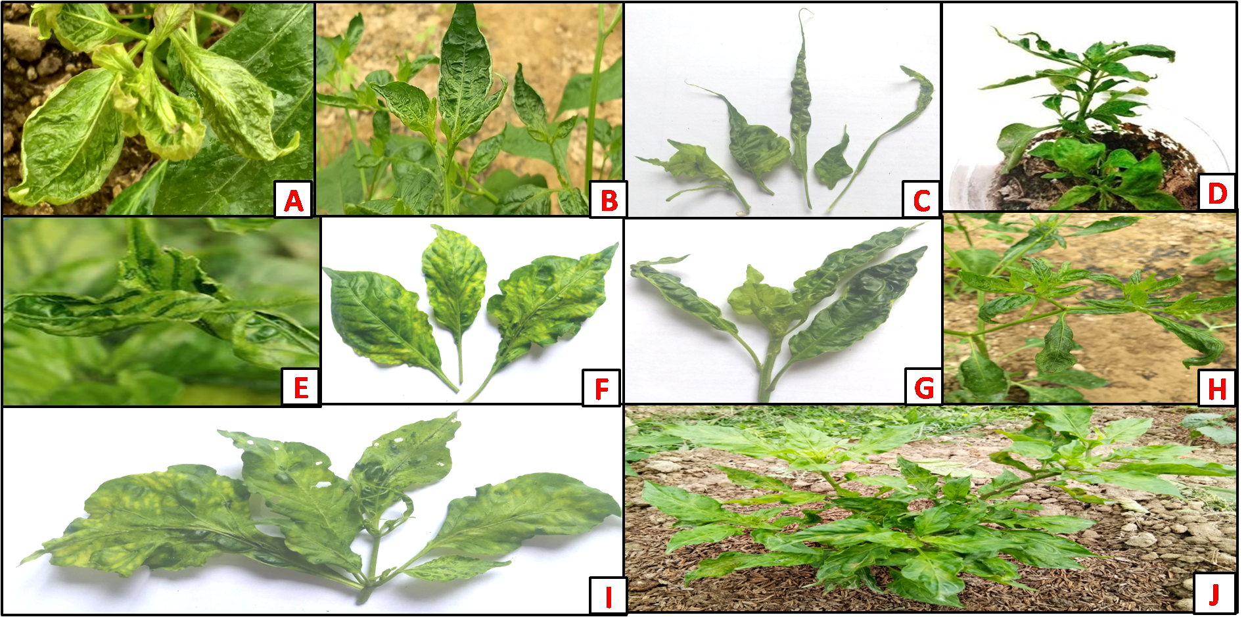
Figure 1: Symptoms observed during survey (a) Curling of leaves, (b) Crinkling of leaves, (c) Filiform leaves, (d) Stunted growth, (e) Vein banding on leaf, (f and g) Mosaic and mottling on leaf (h) Mosaic with puckering of leaf, (i) Green island symptoms and (j) Mosaic with stunted growth.

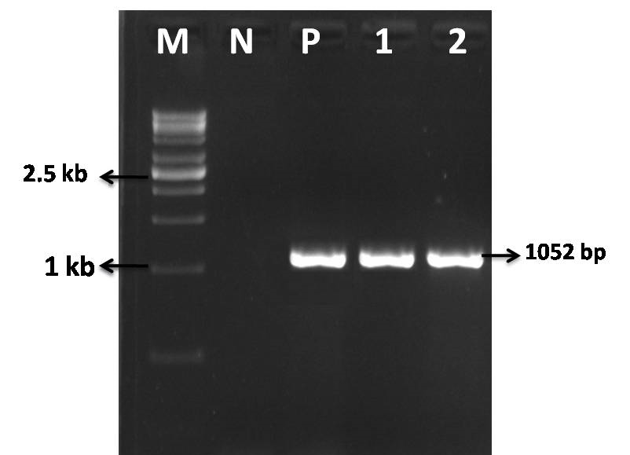
Figure 2: Agarose gel electrophoresis showing amplification of replicase gene with 1052 bp. M- 1kb ladder, N- healthy sample, P-positive sample, 1 & 2- isolates
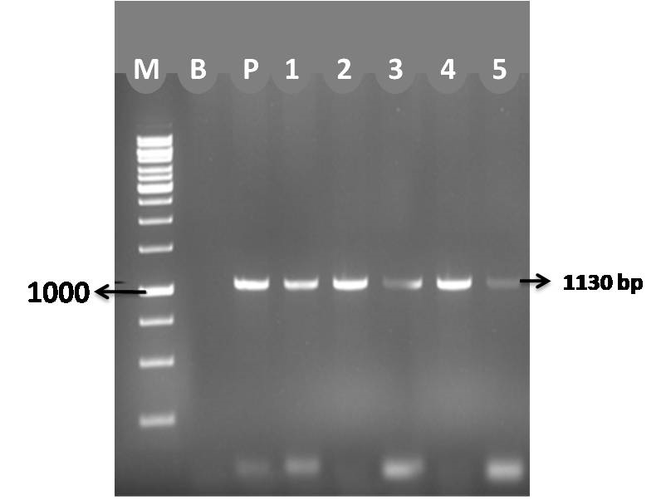
Figure 3: Agarose gel electrophoresis showing amplification of coat protein gene with 1130 bp. M- 1kb ladder, N- healthy sample, p-positive sample, l to 5 -isolates

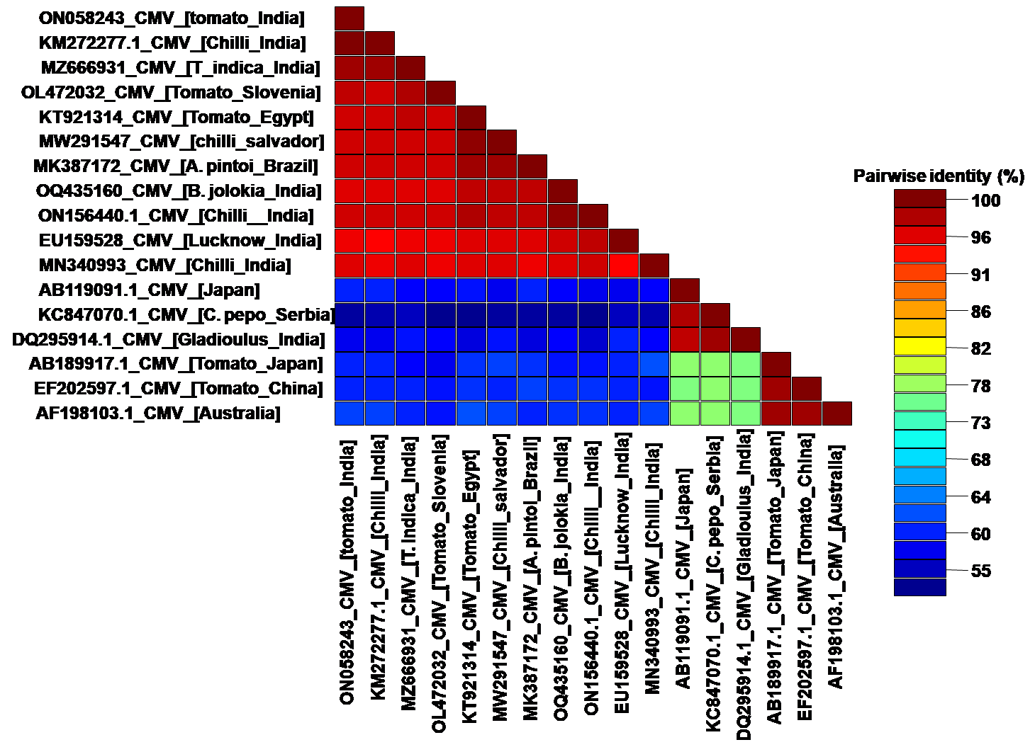
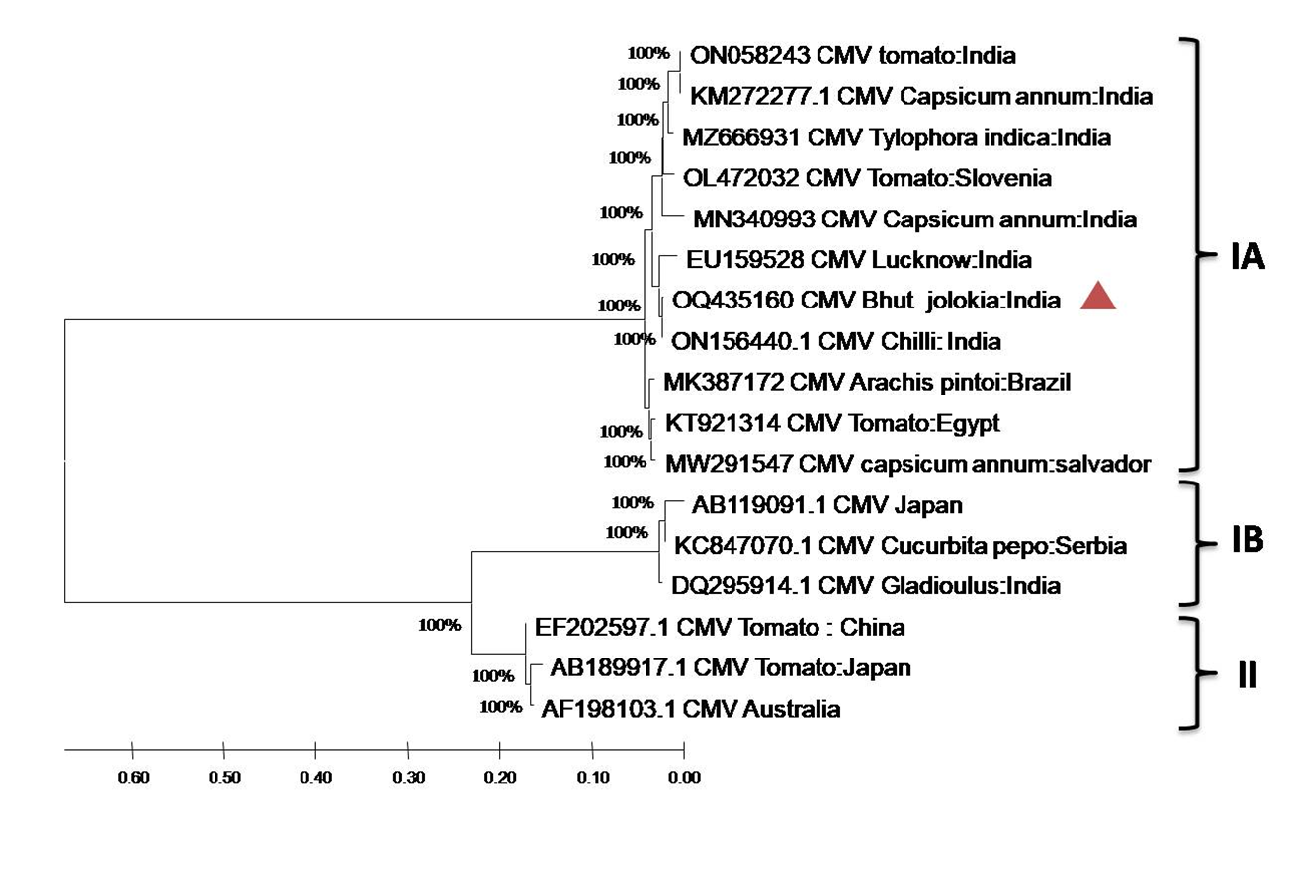
Figure 4: phylogenetic analysis using maximum likelihood parameter (1000 bootstrap) and pairwise nucleotide identity (per cent) of CMV isolates of Assam based on replicase fragment in MEGA X software.
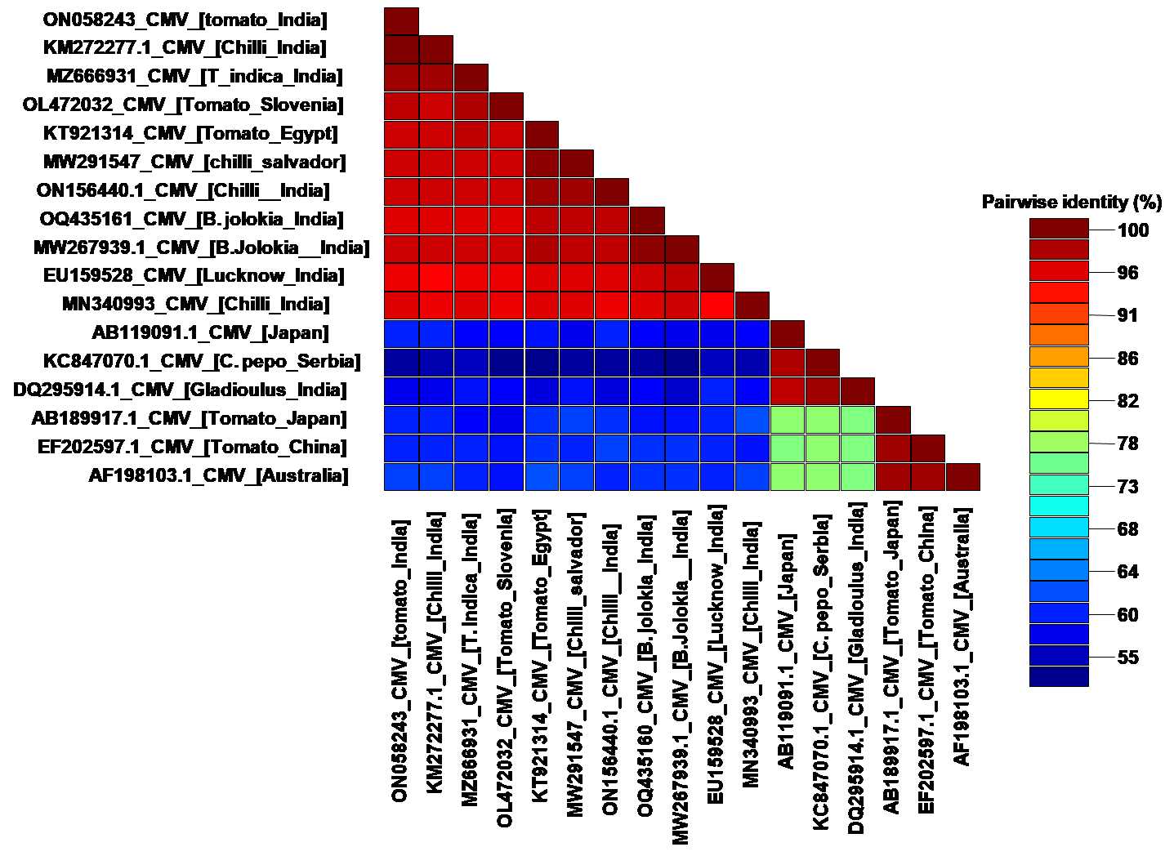
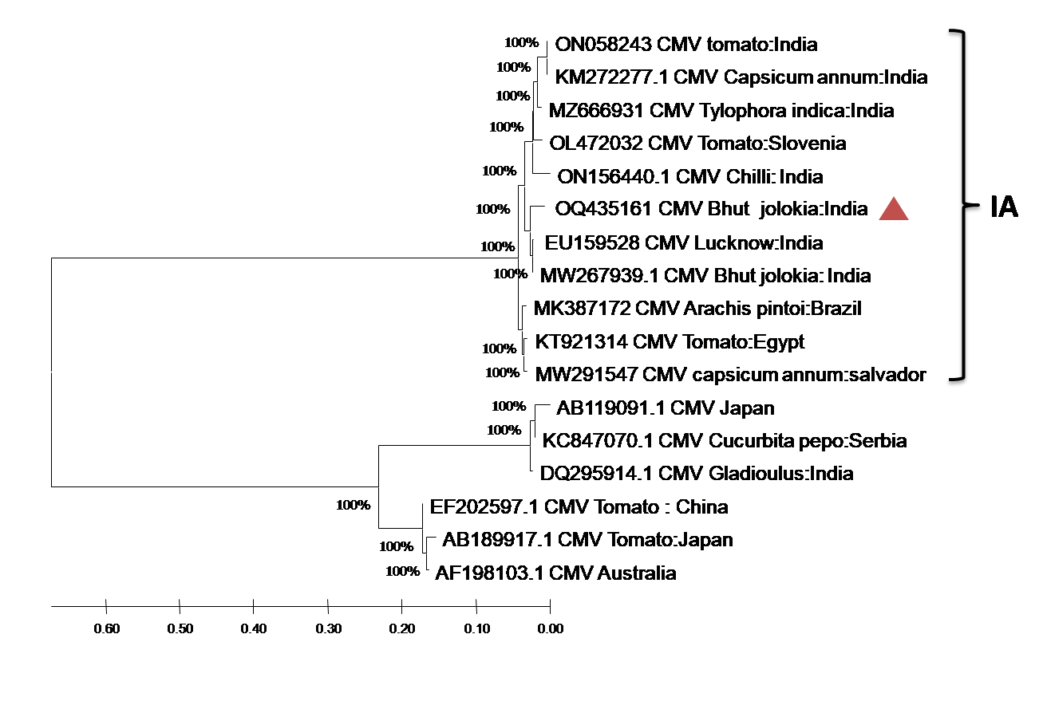
Figure 5: Phylogenetic analysis using maximum likelihood parameter (1000 bootstrap) and pairwise nucleotide identity (per cent) of CMV isolates of Assam based on coat protein fragment in MEGA X software

