Original Research Article
Occurrence and Characterization of Fungal Wilt of Salad Cucumber in Southern Kerala

ABSTRACT
The present study investigated the occurrence, symptomatology, pathogenicity and characterization of the fungal pathogen associated with wilt of salad cucumber in selected agro-ecological units (AEU 8 and AEU 9) of Kerala. Survey conducted in Thiruvananthapuram, Kollam and Pathanamthitta districts revealed that the disease was most prevalent during flowering and fruit bearing stages. Typical symptoms included yellowing and wilting of foliage, starting from the lower leaves and progressing upwards, ultimately leading to the complete drying of the vines. The location Anchal recorded the highest disease incidence and severity of 81.00% and 55.67% respectively. The pathogen isolated from infected tissues fulfilled Koch’s postulates. Among the isolates, the isolate I₃ from Kakkamoola was the most virulent producing symptoms within seven days of artificial inoculation. Cultural and morphological characterization revealed considerable variability among isolates. Mycelial growth among the isolates varied from cottony and fluffy to floccose, fibrous or sparse, with colony colours ranging from white to pale brown, lilac and pinkish red. Most isolates exhibited circular, radial growth with concentric or zonate rings, while a few showed uniform spreading or feathery margins. Pigmentation of the medium differed markedly, producing light salmon to reddish-pink or yellowish-brown hues, whereas some isolates showed no pigmentation. All the isolates produced macroconidia, microconidia, and chlamydospores. Macroconidia were fusiform to falcate shaped, with 2–4 septa, and microconidia were mostly oval shaped. Chlamydospores were globose and thick walled, with some having rough walls, produced terminally or intercalary in the mycelium, either singly or in pairs. Molecular identification of the most virulent isolate using ITS primers confirmed the identity of the pathogen as Fusarium incarnatum with 99.8% homology.
Keywords: Fungal wilt, Fusarium, salad cucmber, yellowing, wilting, stem splitting

1. INTRODUCTION
Salad cucumber (Cucumis sativus L.) belonging to the family Cucurbitaceae is a commercially cultivated vegetable crop known for its medicinal and therapeutic properties since ancient times. It is one of the oldest known cultivated vegetable crops, having been grown for approximately 5,000 years (Wehner and Guner, 2004). Cucumber is cultivated both in open fields and in protected environments, and is widely consumed fresh in salads owing to its refreshing, cooling effects and antioxidant properties (Mukherjee et al., 2013).
One of the major constraints in cucumber cultivation is the reduction in yield caused by phytopathogens, which deteriorate both the quality and quantity of the produce. Cucumber plants are adversely affected by many fungal pathogens and Fusarium is one among them. Fusarium oxysporum f. sp. cucumerinum is the fungus responsible for wilt disease in cucumbers, which is a significant concern in greenhouse production due to its economic impact and the resulting yield losses (Mohamed, 2011). The disease is prevalent in many countries worldwide, with yield losses ranging from 40% to 70% (Sharma and Shukla, 2021). Fusarium wilt was first reported from Florida in 1955 on commercial field-grown cucumber crops (Owen, 1955) while on greenhouse cucumbers, the disease was reported for the first time from North Carolina in 1979 (Jenkins and Wehner, 1983). In India, the disease was first reported from Jammu and Kashmir in 2012 (Pagoch and Raina, 2012). The pathogen is soil-borne and can survive in the soil for many years. The disease can affect plants at any stage of growth. Infection at the early stages can lead to pre or post-emergent damping-off, while older plants may experience yellowing, stunting, or wilting. If wilting occurs, the plant may die within three to five days and a white mycelium mat may form on the external plant surfaces (Pscheidt and Ocamb, 2016).
The present study was undertaken to study the symptoms, occurrence, severity, pathogenicity and to characterize the pathogen inciting fungal wilt of salad cucumber.
2. MATERIALS AND METHODS
2.1 Survey and collection of fungal wilt infected salad cucumber samples
Survey was conducted in two agro-ecological units of Kerala, namely Southern laterites (AEU 8) and South central laterites (AEU 9), encompassing the districts of Thiruvananthapuram, Kollam and Pathanamthitta and fungal wilt infected salad cucumber samples were collected.

Observations on nature of symptoms, number of plants infected, crop variety/hybrid, stage of the crop, disease incidence and disease severity were recorded from each field.

The percentage disease incidence (DI) was recorded as :

Percentage disease incidence (%) = Number of plants infected × 100

Total number of plants

Percent disease index (PDI) of the fungal wilt infected cucumber plants were assessed with a 0 - 5 disease rating scale as described by Liu et al. (1995).

0 : Plants with no symptoms

1 : Plants with < 25 % of leaves with yellowing, wilting and drying symptoms

2 : Plants with 26 to 50 % of leaves with yellowing, wilting and drying symptoms

3 : Plants with 51 to 75 % of leaves with yellowing, wilting and drying symptoms

4 : Plants with 76 to 100 % of leaves with yellowing, wilting and drying symptoms

5 : Plants with complete death

Percentage disease intensity (PDI) was calculated by using the formula given by Chattopadhyay and Sen (1996).

Percent disease intensity = Sum total of the score × 100

Total number of the plants assessed Maximum grade

2.2. Isolation of the pathogen, pathogenicity testing and virulence testing of the isolates

The roots and stems of infected salad cucumber plants were thoroughly washed under running tap water to remove adhering soil particles. The cleaned tissues were cut into small bits using a sterilized blade. These bits were then surface sterilized with 0.1% aqueous mercuric chloride (HgCl₂) solution for 30 seconds, followed by three successive rinses with sterile distilled water, each lasting one minute. The sterilized tissue bits were aseptically transferred into sterile Petri dishes containing solidified Potato Dextrose Agar (PDA) medium and incubated at room temperature (28 ± 2°C) to promote fungal growth. Emerging fungal colonies were subsequently sub-cultured onto PDA slants for further purification and maintenance following the procedure described by Aneja (2003).
The pathogenicity of different isolates, obtained from infected plants, was confirmed by fulfilling Koch’s postulates through artificial inoculation in healthy salad cucumber plants. Each fungal isolate was mass multiplied on sand – oat meal mixture following the protocol of Lewis and Papavizas (1984). Oat meal was mixed with sand in the ratio 1:9, and the mixture was moistened with sufficient water enough to support fungal growth. The mixture was taken in conical flasks and autoclaved at 1.05 kg/cm² pressure for two hours. After sterilization, actively growing mycelial discs of the pathogen was aseptically transferred into the flasks. The inoculated flasks were then incubated at room temperature (28 ± 2°C) for 10 days to allow fungal growth. The mass multiplied pathogen inoculum was subsequently applied to the root zone of the plants and thoroughly incorporated into the soil. Uninoculated control plants were also maintained. The ability of each isolate to induce wilt symptoms along with the number of days taken for symptom initiation, was recorded. Based on the time of symptom expression after inoculation, the isolates were rated for virulence.
2.3. Cultural characterization of the isolates
The cultural characteristics of different isolates were studied by growing the pathogen individually on PDA medium. For this, the medium was poured into sterile Petri plates and after solidification, a 5 mm mycelial disc of the pathogen was inoculated at the centre of each plate. The plates were then incubated at room temperature (28 ± 2°C). Observations on nature and colour of mycelium, pattern of growth and pigmentation of media were recorded.
2.4. Morphological characterization of the isolates

The morphological characteristics of the isolates were studied by slide culture technique as described by Riddell (1950). The slides were observed under a compound light microscope (LEICA DM750) at 400X magnification after staining with lactophenol cotton blue. The morphological characters including width of mycelium (µm), conidial characters (size and shape of conidia) and chlamydospore formation were studied using Leica LAS EZ (version 3.4.0) imaging software.
2.5. Molecular identification of the most virulent isolate

The most virulent isolate of the pathogen was characterized at the molecular level using ITS primers.

2.5.1. DNA isolation

About 100 mg of tissue or mycelium was homogenized in liquid nitrogen, and the resulting powder was transferred to a microcentrifuge tube. Four hundred microlitres of buffer PL1 was added, vortexed for 1 minute, followed by the addition of 10 µl RNase A and gentle mixing. The mixture was incubated at 65°C for 10 minutes and the lysate was then transferred to a Nucleospin filter and centrifuged at 11000 × g for 2 minutes. The filtrate was collected and mixed with 450 µl buffer PC, after which the solution was loaded onto a Nucleospin Plant II column and centrifuged for 1 minute. The column was sequentially washed with 400 µl of buffer PW1 and 700 µl of buffer PW2, each followed by centrifugation at 11000 × g and discarding of the flow-through. An additional 200 µl PW2 was added and centrifuged to dry the silica membrane. The column was transferred to a fresh 1.7 ml tube, and DNA was eluted with 50 µl buffer PE after incubation at 65°C for 5 minutes, followed by centrifugation at 11000 × g for 2 minutes and the eluted DNA was stored at 4°C.
The quality of isolated DNA was assessed by agarose gel electrophoresis. One microlitre of 6X gel-loading buffer was mixed with 5 µl of DNA and loaded onto a 0.8% agarose gel prepared in 0.5X TBE (Tris-Borate-EDTA) buffer containing 0.5 µg/ml ethidium bromide. Electrophoresis was performed in 0.5X TBE at 75 V until the dye front reached the bottom of the gel. Bands were visualized using a UV transilluminator (Genei), and images were captured with a Bio-Rad gel documentation system.
2.5.2. PCR Amplification
The PCR reaction mixture consisted of 1 μL of DNA template, 5 μL of 2X AmpliTaq mix, 4 μL of double-distilled water (D/W), 0.25 μL of forward primer and 0.25 μL of reverse primer. Primers known as ITS-1F and (forward) and ITS-4R (reverse) were specifically created to target the Internal Transcribed Spacer (ITS) region of the DNA. The thermal cycling conditions for the PCR reaction consisted of an initial denaturation step at 95°C for 5 minutes followed by 40 cycles of denaturation at 95°C for 30 seconds, annealing at 58°C for 30 seconds, and extension at 72°C for 30 seconds. After the completion of the cycles, a final extension was carried out at 72°C for 5 minutes, and the reaction was then held at 4°C indefinitely. PCR products were analyzed on 1.2% agarose gel prepared in 0.5X TBE with 0.5 µg/ml ethidium bromide. One microlitre of 6X loading dye was mixed with 4 µl PCR product and loaded onto the gel. Electrophoresis was performed at 75 V for 1–2 hours in 0.5X TBE until the dye front migrated close to the bottom of the gel. A 2-log DNA ladder (NEB) was used as the molecular marker. Gels were visualized using a UV transilluminator (Genei), and images were captured with a Bio-Rad gel documentation system.
ExoSAP-IT enzyme, containing Exonuclease I and Shrimp Alkaline Phosphatase, was used to remove residual primers and dNTPs from PCR products. Five microlitres of PCR product was treated with 0.5 µl ExoSAP-IT, incubated at 37°C for 15 minutes, and heated at 85°C for 5 minutes to inactivate the enzymes.Then the sequencing reaction was carried out in a PCR thermal cycler using the BigDye Terminator v3.1 Cycle sequencing Kit. The Sequencing PCR mix consisted of 6.6 μL of double-distilled water (D/W), 1.9 μL of 5X sequencing buffer, 0.3 μL each of forward and reverse primers, 0.2 μL of sequencing mix, and 1 μL of ExoSAP-treated PCR product. The sequencing PCR was performed with an initial denaturation at 96°C for 2 minutes, followed by 30 cycles of denaturation at 96°C for 30 seconds, annealing at 50°C for 40 seconds, and extension at 60°C for 4 minutes. Then the reaction was held at 4°C to preserve the amplified products. Fifty microliters of a precipitation mix containing distilled water (D/W), 125mM EDTA, 3M sodium acetate was added to each well containing the sequencing PCR product. After vortexing and incubating for 30 minutes, the plate was centrifuged at 3700 rpm for 30 minutes.The pellet was washed twice with 70% ethanol, air-dried, and resuspended in 10 µl HIDI formamide. The purified product was then sequenced using an ABI 3500 DNA Analyzer.
2.5.3. Phylogentic analysis
The ITS-rDNA region of the pathogen isolate was identified using a Basic Local Alignment Search Tool (BLAST) similarity search in the NCBI database. A phylogenetic tree was constructed using MEGA 11 software employing the Neighbour-Joining (NJ) method with 1,000 bootstrap replications to assess the reliability of the clades (Kumar et al., 2018).
3. RESULTS AND DISCUSSION
3.1 Survey and collection of fungal wilt infected salad cucumber samples

A survey was conducted in two agro-ecological units of Kerala, namely Southern laterites (AEU 8) and South central laterites (AEU 9), during 2024-2025 covering the districts of Thiruvananthapuram, Kollam and Pathanamthitta for the collection of fungal wilt infected salad cucumber samples. A total of 15 locations were surveyed, and samples were collected from 10 locations. Samples were collected from Palappooru, Vellayani, Kakkamoola, Pallichal and Nedumangad in Thiruvananthapuram district, Anchal, Arackal, Neduvathoor and Ezhukone in Kollam district and Anandapally in Pathanamthitta district.

The stage of the crop, the varieties grown and symptoms of infection from each location, were studied (Table 1). The symptoms were mostly observed in the flowering and fruit bearing stage and also in the harvesting stage. The most prominent symptom was the characteristic yellowing and wilting of the foliage, starting from the lower leaves and progressing upward, eventually leading to the complete drying of the vines (Figure 1a). In several locations, cracking and splitting of the basal stem (Figure 1b) were observed, along with occasional swelling at the collar region. In advanced stages of infection, shredding of the basal stem was also there. Pink-coloured roots was observed in the sample collected from Anchal. The symptoms observed were in accordance with symptoms described by Vakalounakis (1993), Al-Tuwaijri (2015) and Din et al. (2020). In contrast, vascular discolouration was not observed in samples collected from any of the surveyed locations.
Table 1. Stage of crop, variety and symptoms of infection from surveyed areas
Sample No. | Location | Stage of crop | Variety | Symptoms
S1 | Palappooru | Flowering stage | Local variety | Stem cracking, yellowing, wilting and complete drying of the plant
S2 | Vellayani | Fruit bearing stage | Snow white | Yellowing, wilting and drying
S3 | Kakkamoola | Fruit bearing stage | Local variety | Basal stem splitting and swelling, yellowing, wilting and complete drying of the plant
S4 | Pallichal | Fruit bearing stage | Local variety | Yellowing, wilting and complete drying of the plant
S5 | Nedumangad | Flowering stage | Snow white | Cracking of stem at the basal portion, yellowing and wilting
S6 | Anchal | Fruit bearing stage | Snow white | Basal stem splitting and swelling, pinkish coloration on the roots, wilting, complete drying of the plant
S7 | Arackal | Harvesting stage | Snow white | Shredding of basal portion of stem, yellowing, wilting and complete drying of the plant
S8 | Neduvathoor | Flowering stage | NS 415 | Yellowing and wilting and drying
S9 | Ezhukone | Fruit bearing stage | Multistar | Basal stem splitting, yellowing, wilting and complete drying
S10 | Anandapally | Fruit bearing stage | Local variety | Basal stem splitting, slight stem shredding, yellowing and wilting
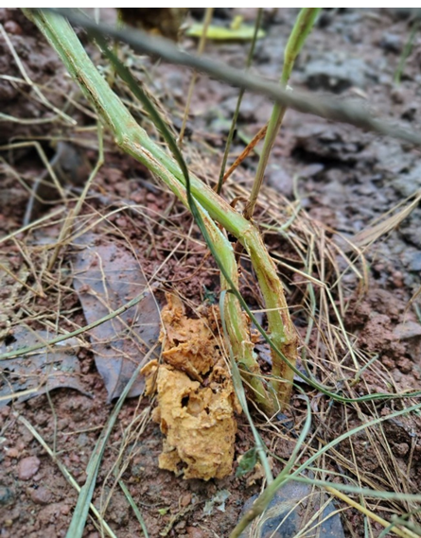
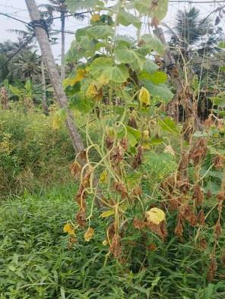

a)
b)

Fig. 1. (a) Yellowing, wilting and drying symptoms; (b) Stem splitting symptoms

The incidence and severity of wilt disease varied considerably among the surveyed locations (Table 2). The disease incidence ranged from 18.33% to 81.00% and severity ranged from 9.33% - 56.67%. The highest disease incidence (81.00%) was recorded at Anchal in Kollam district, followed by Pallichal (73.33%) and Kakkamoola (65.67%) in Thiruvananthapuram district. The lowest incidence (18.33%) was observed at Anandapally in Pathanamthitta district. Similarly, the highest disease severity was recorded at Anchal (56.67%), followed by Pallichal (49.67%) and Arackal (38.67%). The least severity (9.33%) was noted at Anandapally. Such spatial variations in disease intensity and disease severity could be attributed due to the differences in soil type, cropping pattern and the climatic conditions favouring pathogen proliferation. Sharma et al. (2022) reported similar variability in wilt incidence, and noted that higher disease levels in certain areas may result from the buildup of soil-borne inoculum associated with the monoculture of susceptible cultivars. Such variability in wilt incidence was also reported by Hussein et al. (2024).

Table 2. Disease incidence and disease severity of fungal wilt infection in the surveyed areas
Location | Disease incidence (%) | Disease severity (%)
Palappooru | 25.33 | 13.33
Vellayani | 45.67 | 28.00
Kakkamoola | 65.67 | 40.33
Pallichal | 73.33 | 49.67
Nedumangad | 44.67 | 24.33
Anchal | 81.00 | 56.67
Arackal | 61.67 | 38.67
Neduvathoor | 35.00 | 18.67
Ezhukone | 34.67 | 20.67
Anandapally | 18.33 | 9.33

3.2. Isolation of the pathogen, pathogenicity testing and virulence testing of the isolates

The pathogen causing fungal wilt of salad cucumber was isolated from the diseased specimens collected from the surveyed locations. A total of 10 fungal isolates were obtained and the isolates were designated as I₁, I₂, I₃, I₄, I₅, I₆, I₇, I₈, I₉ and I₁₀.
The Koch’s postulates of all the isolates were proved on plants artificially inoculated with mass-multiplied inoculum of the pathogen and comparative virulence was assessed. Following artificial inoculation, the isolates induced symptoms such as foliar yellowing (Figure 2a), splitting of the basal stem (Figure 2b), stem shredding (Figure 2c), and complete wilting of the plant (Figure 2d). The results are in agreement with Parasiya (2008) and Sharma et al. (2022) who reported soil inoculation by mass multiplication was the best method for proving pathogenicity of Fusarium oxysporum. Contrary to this, Rani et al. (2008) and Nirmaladevi and Srinivas (2012) observed root dip inoculation method was better for proving pathogenicity of F. oxysporum.
The isolates differed markedly in their ability to induce symptoms. Among the isolates, the isolate I₃ from Kakkamoola was the most virulent, inducing wilt symptoms within 7 days of artificial inoculation and exhibited all the characteristic symptoms. The isolates I₂, I₄, I₆, I₇, I₈ and I₉ induced symptoms within 8-10 days, and the isolates I₅ and I₁₀ induced symptoms within 11-12 days. Stem shredding and complete wilting was not observed in case of isolates I₅ and I₁₀. The isolate I₁ from Palappoor failed to induce any visible symptoms and was therefore considered avirulent. Similar variations in pathogenicity and virulence of Fusarium oxysporum f. sp. lycopersici were reported by Nirmaladevi (2016).
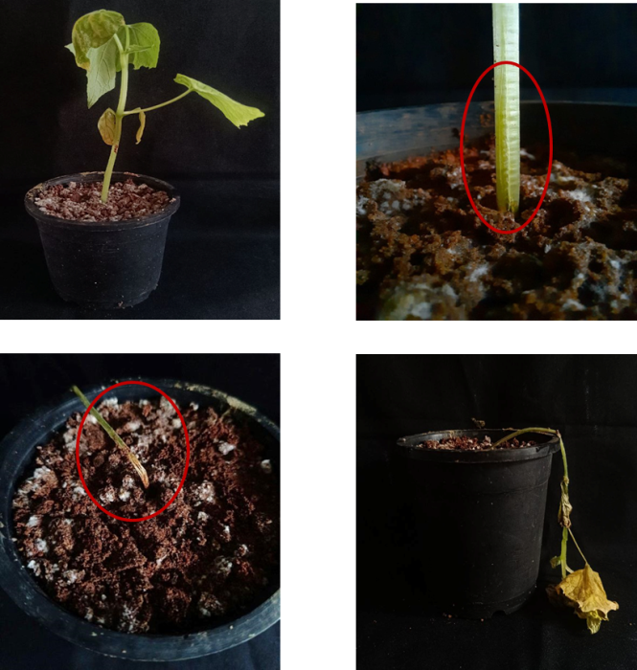

b)
a)

d)
c)

Fig. 2. (a) Initiation of foliar yellowing; (b) Splitting of basal stem; (c) Shredding of stem; (d) Complete wilting of the plant

3.3. Cultural characterization of the isolates

The cultural characteristics of all the ten isolates were observed by growing the isolates in PDA medium (Table 3). The isolates exhibited distinct cultural variations when grown in PDA medium (Figure 3).

The nature of mycelial growth varied among isolates, ranging from cottony and fluffy (I₃, I₁₀), cottony and fibrous (I₁, I₅, I₈), to cottony and floccose (I₂, I₄). Isolates I₆ and I₉ produced sparse or thin mycelium, while I₇ formed dense aerial mycelia, indicating differences in vegetative growth vigor among the isolates. Most of the isolates produced white to creamy white coloured colonies (I₁, I₂, I₃, I₅, I₈, I₁₀), while others exhibited dull white (I₉), grayish-white to lilac (I₄), pale brown (I₇, I₉), or creamy white with pinkish-red centres (I₆). The pattern of colony growth also differed among isolates. The isolates I₂, I₃ and I₇ developed concentric and zonate colonies, often with a dense central region and lighter outer zones, while I₄ and I₅ exhibited uniform radial spreading colonies. I₈ also exhibited zones of varying density. The isolates I₁, I₉ and I₁₀ exhibited radial spreading pattern; however I₉ developed distinct concentric rings while I₁₀ developed faint concentric rings. In contrast, I₆ displayed an appressed mycelial growth pattern with a pinkish ring. The pigmentation of the medium ranged from hues of light salmon (I₂, I₃), pale pink to purple (I₄), reddish pink (I₆), to yellowish brown (I₇), while isolates I₁, I₅, I₈, I₉ and I₁₀ did not produce any visible pigmentation. Based on these cultural characteristics, the pathogen was identified as belonging to the genus Fusarium. The cultural characteristics observed were in agreement with earlier reports (Owen, 1955; Burgess et al., 1994; Hussein, 2016; Sharma, 2019).
Table 3. Cultural characters of the pathogen isolates obtained from collected samples
Isolate | Nature of mycelia | Colony colour | Pattern of growth | Pigmentation of media
I₁ | Cottony and fibrous | White | Dense central growth and circular, radial colony pattern | No pigmentation
I₂ | Cottony to floccose | White with a pale brown centre | Concentric ring pattern radiating from the center with central region appeared dense and slightly raised | Light salmon
I₃ | Cottony and fluffy | White | Concentric and zonate colony with central dense zone and lighter outer zone | Light salmon
I₄ | Cottony to floccose | Grayish white to lilac | Spreads uniformly from the centre in a circular manner with feathery margins | Pale pink to purple
I₅ | Cottony | Creamy white | Aerial mycelial growth with a uniform radial spreading pattern | No pigmentation
I₆ | Sparse | Creamy white with pinkish red | Appressed mycelial growth with a concentric pinkish ring | Reddish pink
I₇ | Cottony and dense | Pale brown | Aerial mycelial growth with a concentric ring pattern radiating outward from the centre | Yellowish brown
I₈ | Cottony and fibrous | White | Circular with concentric zonation or zones of varying density and smooth margins | No pigmentation
I₉ | Cottony and sparse | Dull white | Symmetrical growth in a perfectly circular pattern with Distinct concentric rings | Dull white
I₁₀ | Cottony | White | Uniform radial spreading pattern with faint concentric rings | No pigmentation
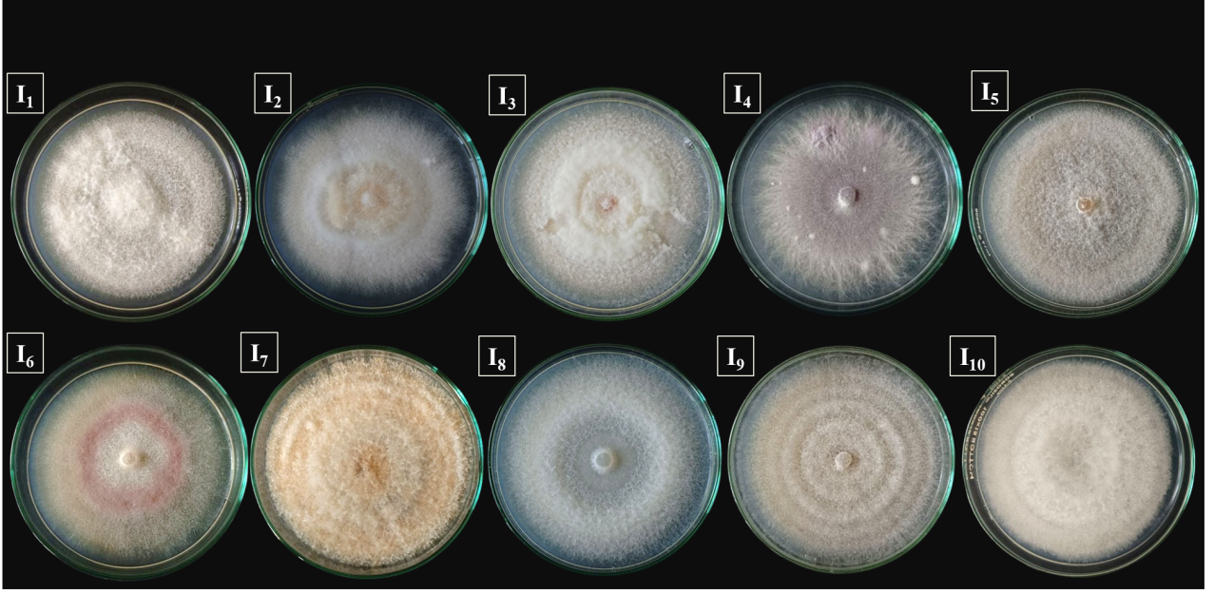

Fig.3. Cultural characters of the fungal isolates grown in PDA media

3.4. Morphological characterization of the isolates

Microscopic examination of the ten pathogen isolates revealed distinct variations in the conidial morphology, septation and chlamydospore formation (Table 4). The width of mycelium ranged from 1.52 to 2.31 μm, with hyphae that were hyaline, septate, and extensively branched. The isolate I₈ showed the highest hyphal width (2.31 μm) followed by I₃ (2.28 μm), I₁₀ (2.14 μm) and I₂ (2.11 μm).

All the ten isolates produced macroconidia, microconidia and chlamydospores. The macroconidia of all the isolates were hyaline, multicellular, slightly curved, and pointed at both ends, showing the characteristic falcate to fusiform shape (Figure 4a). The size of macroconidia ranged from 19.8 to 22.9 μm in length and 2.9 to 3.6 μm in width, bearing 2–4 septa. The isolates I₁, I₃, I₄, I₅, I₆, I₇, I₈ and I₉ predominantly produced fusiform macroconidia which are straight to slightly curved, while I₂ and I₁₀ formed falcate macroconidia which are distinctly curved like a sickle. The microconidia were mostly oval-shaped, single-celled or occasionally with a single septum, measuring 6.6–7.7 × 2.6–3.4 μm (Figure 4b). Isolate I₅ was exceptional in producing pear-shaped microconidia, while I₁₀ produced kidney-shaped conidia. Chlamydospores were formed by all isolates, either terminally or intercalary, singly or in chains, and were globose with smooth to roughened thick walls (Figure 4c). The isolates I₃, I₅, I₈, and I₉ exhibited rough walled chlamydospores while the remaining isolates produced smooth walled chlamydospores. Based on morphological characterization as well as the comparison with the standard keys described by Booth (1971), the fungal isolates were tentatively identified as Fusarium oxysporum, F. solani and F. incarnatum. The morphological characteristics observed were in agreement with the findings of earlier workers (Hussein, 2016; Din et al., 2020; Hussein, 2024).

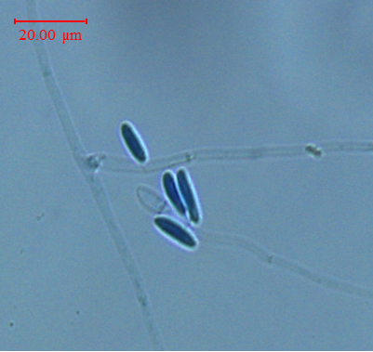
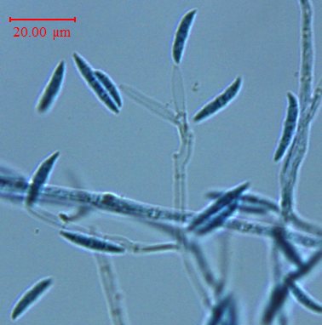
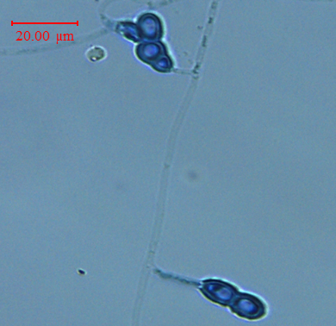
c)
b)
a)

Fig. 4. (a) Macroconidia; (b) Microconidia and (c) Chlamydospores of the most virulent isolate

Table 4. Morphological characters of the pathogen isolates
Isolate | Width of mycelium (µm) | Macroconidia |  |  | Microconidia |  |  | Chlamydospore
Isolate | Width of mycelium (µm) | Shape | Size (µm) | No. of septa | Shape | Size (µm) | No. of septa | Shape | Position
I₁ | 1.78 | Fusiform | 22.9 × 3.6 | 2-4 | Oval | 7.7 × 3.3 | 0-1 | Globose | Terminal
I₂ | 2.11 | Falcate | 20.8 × 3.1 | 2-3 | Oval | 6.8 × 3.1 | 0 | Globose | Terminal or intercalary
I₃ | 2.28 | Fusiform | 22.4 × 3.4 | 2-4 | Oval | 7.5 × 3.4 | 0 | Globose, rough walled | Terminal or intercalary
I₄ | 1.52 | Fusiform | 21.3 × 3.5 | 2-4 | Oval | 7.2 × 2.6 | 0-1 | Globose | Terminal or intercalary
I₅ | 1.59 | Fusiform | 20.8 × 2.9 | 3-4 | Pear | 6.6 × 2.8 | 0-1 | Globose, rough walled | Terminal or intercalary
I₆ | 1.86 | Fusiform | 19.8 × 3.6 | 1-3 | Oval | 6.9 × 3.1 | 0-1 | Globose | Terminal or intercalary
I₇ | 1.59 | Fusiform | 20.2 × 3.1 | 2-4 | Oval | 6.8 × 3.2 | 0 | Globose | Terminal or intercalary
I₈ | 2.31 | Fusiform | 20.6 × 3.2 | 3-4 | Oval | 7.3 × 3.3 | 0-1 | Globose, rough walled | Terminal
I₉ | 1.86 | Fusiform | 20.8 × 3.3 | 3-4 | Oval | 6.9 × 3.2 | 0 | Globose, rough walled | Terminal or intercalary
I₁₀ | 2.14 | Falcate | 21.2 × 3.1 | 2-4 | Kidney | 6.8 × 3.4 | 0 | Globose | Terminal or intercalary

3.5. Molecular identification of the pathogen

The ITS region amplified with ITS primers ITS-1F (TCCGTAGGTGAACCTGCGG) and ITS-4R (TCCTCCGCTTATTGATATGC) generated an amplicon with a size of 522 bp (Figure 5).The amplified region was sequenced by Sanger dideoxy sequencing in NCBI. The BLAST analysis revealed 99.8% homology with Fusarium incarnatum, confirming the identity of the most virulent isolate I₃ as F. incarnatum. To our knowledge, this was the first report of Fusarium incarnatum associated with fungal wilt of salad cucumber in India. The sequences were then submitted to NCBI database under the GenBank accession number PV945896. The phylogenetic tree constructed using the Neighbor-Joining method in MEGA 11 grouped the test isolate with F. equiseti isolates and F. incarnatum isolates, indicating close genetic relatedness among these species. The tree was rooted with Colletotrichum gloeosporioides as an outgroup strain (Figure 6). Sequence analysis of ITS region to differentiate Fusarium at the species level and to determine their phylogenetic relationships has also been undertaken by earlier researchers (Lee et al., 2000, Shahnazi et al., 2012, Sreeja, 2014).
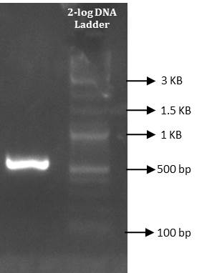

Fig. 5. Electrophoresis gel image of amplified DNA of Fusarium incarnatum amplified using universal primers ITS 1 and ITS 4

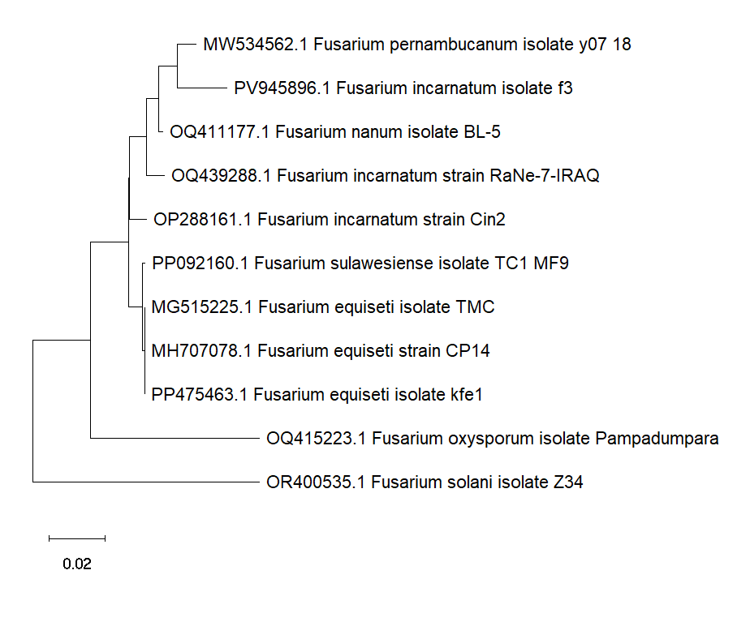

Fig. 6. Phylogenetic tree showing the evolutionary relationship of Fusarium incarnatum using Neighbourhood Joining method in MEGA 11

4. CONCLUSION
The present investigation provides a comprehensive account of the occurrence, severity, and etiology of fungal wilt of salad cucumber in the Southern Kerala. Field survey revealed that the incidence and intensity varied considerably across fields and districts. The characteristic symptoms like progressive foliar yellowing and wilting, basal stem splitting, and complete vine drying were consistently associated with the disease across locations. Molecular characterization using ITS sequencing confirmed the identity of the most virulent isolate as Fusarium incarnatum. Together, the cultural, morphological, and molecular findings indicate that wilt of salad cucumber in southern Kerala is caused by a complex of Fusarium species- F. incarnatum, F. oxysporum, and F. solani. The considerable variability in pathogenicity, cultural traits, and morphological features among the isolates underscores the need for location-specific and species-targeted disease management strategies. The identification of highly virulent strains provides a foundation for developing effective diagnostic tools, resistance screening programmes, and integrated disease management approaches for sustainable cultivation of salad cucumber in Kerala.
DISCLAIMER (ARTIFICIAL INTELLIGENCE)
Author(s) hereby declare that during the editing of the review article, the author(s) used CHATGPT AI tool in order to improve the readability and language of the manuscript. After using this tool/service, the author(s) reviewed and edited the content as needed and takes full responsibility for the content of the published article.

REFERENCES
Wehner, T.C., & Guner, N. (2004). Growth stage, flowering pattern, yield and harvest date prediction of four types of cucumber tested at 10 planting dates. In: McCreight, J.D., and Ryder, E.J. (eds.), Proceedings of the XXVI International Horticultural Congress – Advances in Vegetable Breeding. CIDA, USA, 637, 223–229.
Mukherjee, P.K., Nema, N.K., Maity, N., & Sarkar, B.K. (2013). Phytochemical and therapeutic potential of cucumber. Fitoterapia, 84, 227-236. https://doi.org/10.1016/j.fitote.2012.10.003
Mohamed, G.A.A. (2011). Induction Resistance of Cucumber Plants (Cucumis sativus L.) against Fusarium Wilt Disease under Protected Houses Conditions. PhD Thesis, Kazakh National Agrarian University, 151 p.
Sharma, D., & Shukla, A. (2021). Fusarium wilt of cucumber-A Review. International Journal of Economic Plants, 8(4), 193-200.
Owen, J.H. (1955). Fusarium wilt of cucumber. Phytopathology, 45, 435-439.
Jenkins, S.F., & Wehner, T.C. (1983). Occurrence of Fusarium oxysporum f. sp. cucumerinum on greenhouse grown Cucumis sativus seed stocks in North Carolina. Plant Disease, 67(9), 1024-1025.
Pagoch, K., & Raina, P.K. (2012). Occurrence, pathogenicity and characterization of Fusarium species inciting wilt in cucumber. Journal of Mycology and Plant Pathology, 42(2), 218-221.
Pscheidt, J.W., & Ocamb, C.M. (2016). Pacific northwest plant disease management handbook. Oregon: Oregon State Extension Service, 848p.
Liu, L., Kloepper, J.W., & Tuzun, S. (1995). Induction of systemic resistance in Cucumber against Fusarium wilt by plant growth-promoting rhizobacteria. Phytopathology, 85(6), 695-698.
Chattopadhyay, C., & Sen, B. (1996). Integrated management of Fusarium wilt of muskmelon caused by Fusarium oxysporum. Indian Journal of Mycology and Plant Pathology, 26(2), 162-170.
Aneja, K.R. (2003). Experiments in Microbiology, Plant Pathology and Biotechnology (4th Ed.). New Age International (P) Ltd. Publishers, New Delhi, 607p.
Lewis, J.A., & Papavizas, G.C. (1984). A new approach to stimulate population proliferation of Trichoderma species and other potential biocontrol fungi introduced into natural soils. Phytopathology, 74(10), 1240-1243.
Riddell, R.W. (1950). Permanent Stained Mycological Preparations Obtained by Slide Culture. Mycologia, 42(2), 265-270.
Kumar, S., Stecher, G., Li, M., Knyaz, C., & Tamura, K. (2018). MEGA X: Molecular Evolutionary Genetics Analysis across computing platforms. Molecular Biology and Evolution, 35(6), 1547-1549. https://.org/10.1093/molbev/msy096
Vakalounakis, D.J. (1993). Inheritance and genetic linkage of Fusarium wilt (Fusarium oxysporum f. sp. cucumerinum race 1) and scab (Cladosporium cucumerinum) resistance genes in cucumber (Cucumis sativus). Annals of Applied Biology, 123(2), 359–365.
Al-Tuwaijri, M.M. (2015). Studies on Fusarium wilt disease of cucumber. Journal of Applied Pharmaceutical Science, 5(2), 110–119. https://doi.org/10.7324/JAPS.2015.50216
Din, H.M., Rashed, O., & Ahmad, K. (2020). Prevalence of Fusarium wilt disease of cucumber (Cucumis sativus L.) in Peninsular Malaysia caused by Fusarium oxysporum and F. solani. Tropical Life Sciences Research, 31(3), 29-45. https://doi.org/10.21315/tlsr2020.31.3.3
Sharma, D., Shukla, A., & Gupta, M. (2022). Wilt in cucumber – an emerging disease in mid hills of Himachal Pradesh. Journal of Krishi Vigyan, 11(1), 401–405.
Hussein, A.N., Al-Janabi, H.J.K., Al-Janabi, J.K.A., & Al-Shujairi, A.R.S. (2024). Identification and characterization of species of Fusarium infecting cucumber in greenhouse conditions. Journal of Applied and Natural Science, 16(1), 209-220. https://doi.org/10.31018/jans.v16i1.5297
Parasiya B N (2008). Investigations on wilt disease of cucumber (Cucumis sativus L.) caused by Fusarium solani under South Gujarat conditions. M.Sc. Thesis. Department of Plant Pathology, Navsari Agricultural University, Gujarat, 62p.
Rani, G.S.D., Naik, M.K., Patil, M.B., & Patil, M.G. (2008). Screening of chilli genotypes against Fusarium wilt caused by Fusarium solani (Mart.) Sacc. Vegetable Science, 35(1), 49-54.
Nirmaladevi, D., & Srinivas, C. (2012). Cultural, morphological and pathogenicity variation in Fusarium oxysporum f. sp. lycopersici causing wilt of tomato. Batman University Journal of Life Sciences, 2(1), 1-16.
Nirmaladevi, D., Venkataramana, M., Srivastava, R.K., Uppalapati, S.R., Gupta, V.K., Yli-Mattila, T., Clement Tsui, K.M., Srinivas, C., Niranjana, S.R., & Chandra, N.S. (2016). Molecular phylogeny, pathogenicity and toxigenicity of Fusarium oxysporum f. sp. lycopersici. Scientific reports, 6(1), 21367.
Burgess, L.W., Summerall, B.A., Bullock, S., Gott, K.P., & Blackhouse, D. (1994). Laboratory Manual for Fusarium Research (3rd edn). Department of Crop Sciences, University of Sydney, Sydney, NSW.
Hussein, S.N. (2016). Molecular identification and integrated management of the Fusarium f. sp. cucumerinum the causal agent of Fusarium wilt disease of Cucumis sativus L. in Iraq. Journal of Experimental Biology and Agricultural Sciences, 4(4), 389-397. http://dx.doi.org/10.18006/2016.4(4).389.397
Sharma, D. (2019). Studies on Fusarium wilt of cucumber (Cucumis sativus L.). M.Sc. thesis, Dr. Yashwant Singh Parmar University of Horticulture and Forestry Solan (nauni), Himachal Pradesh, 89p.
Booth, C. (1971). The Genus Fusarium. Commonwealth Mycological Institute, Kew, England, 237p.

