SYNTHESIS, SPECTROSCOPIC CHARACTERIZATION, PXRD STRUCTURE AND THERMAL STUDY OFBIS(SALICYLALDIMINATO)Cl₂Fe(III)COMPLEX

Abstract
A novel Bis(salicylaldiminato)Cl₂Fe(III) complex was synthesized by reacting N-salicylideneaniline Schiff base and FeCl₃.6H₂O in methanolic solution. The complex was characterized by FT-IR, UV-Vis spectroscopy, DSC study and Mass spectrometry. The crystal structure was solved by powder X-ray diffraction (PXRD) method. The PXRD analysis shows a slightly distorted octahedral complex crystalizes inmono clinic crystal system with cell parameters:a = 15.565 , b = 7.027, c = 12.181andβ = 108.79⁰ and space group P121.Magnetic susceptibility measurement (µ_{eff} value 5.38 BM) suggests paramagnetic character of the complex.The mass spectra analysis confirms the formation of the complex and Differential Scanning Calorimetry (DSC) characterizes thermal phase transitions (e.g. melting point &dissociation).The UV-Vis spectroscopy shows characteristic Ligand to Metal charge transfer band at 570nm and FT-IR showsbands at 584and482cm⁻¹assigned forFe-N and Fe-O bonds, respectively.
Keywords: N-salicylideneaniline ligand, PXRD structure, DSC, LMCT band.

Graphical abstract :

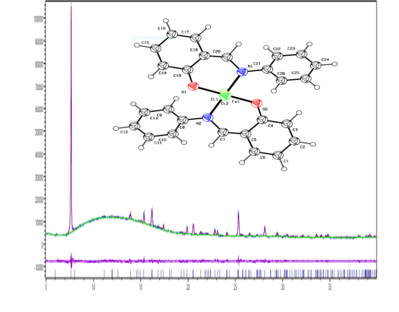

INTRODUCTION
Schiff base ligands have been extensively studied for their versatile applications in different fields of coordination chemistry, organic synthesis, analytical chemistry, refining of metals, metallurgy, electroplating and photography[1–4]. Additionally, their ability to form stable complexes with transition metal makes them useful for the development of new materials and devices. Schiff bases also play an essential role in biological systems with important applications. They shows antifungal,antiviral activity, anticancer, antibacterial as well as their use as antiparasitic agents with other biological performances[5–9]. The coordination complexes of N,O-chelating Schiff base ligands have been reported for their antibacterial, antifungal, anticancer and herbicidal activities[10–14].As the N,O-chelating Schiff base ligands can stabilize transition metals with different oxidation states by complexation, they are also effective in catalytic transformations[15]. The Fe and Ni complexes of bi-dentate N,O-ligands showed high catalytic activity for ethylene oligomerization and polymerization[16].
The advantages for using N-salicylidene aniline metal complexes are commercially available precursors in low cost, facile syntheses, wide range of biological[17] and catalytic activities[18], structural rigidity[19] and electronic properties[20]. The Fe,Co and Cr complexes are typically formed by reacting their salts with the N-salicylidene aniline ligand in aqueous solution. Beside biological activity they also have been found to be responsible for the oxidation of L-cysteine[21].Ming-Dong Zhou and his coworkershave demonstrated that N-salicylideneaniline derived Schiff base complexes of methyltrioxorhenium(VII) showed catalytic performance[14].KoheiJohmoto have investigated the photochromism control of salicylideneaniline derivatives by acid–base co-crystallization[19].Conjugated N-salicylideneaniline (anil) functionalized pyrrole and 2,5-dithienylpyrrole-based polymers were reported to show Electrochromic properties[20]. Electrodeposition of salicylidene aniline and its corrosion behavior were also investigated recently. ZailelahZainoldin and his coworkers discovered passive thin film coating through electrodeposition of salicylideneaniline[22].
In this study a newoctahedral Bis(salicylaldiminato)Cl₂Fe(III) complex (C1) was synthesized by complexation ofN-salicylidene aniline with FeCl₃.6H₂O in methanol. To the best of our knowledge, the synthesis and properties of this complex are not yet explored.The optical properties were investigated using FT-IR and UV-Vis spectroscopy. The PXRD and mass spectra were used to determine the structure of the complex. In addition, computational analysis was performed to optimize the structure.
EXPERIMENTAL
Materials and methods
All the reagents and chemicals were purchased from Sigma-Aldrich. The FT-IR spectrum was recorded with IR Prestige-21, Shimadzu, Japan in the region 400-4000 cm⁻¹usingKBrpellet.The UV-Vis spectrum was collected in Specord 205(Analytic Jena, Germany) spectrophotometerusing methanol at 25°C from the range 190-900 nm. ForN-salicylidene aniline¹H-NMR and ¹³C spectra were recorded in CDCl₃ on Bruker Ascend 400 MHz NMR spectrometer. Magnetic susceptibility was determined by using MK-1 magnetic susceptibility balance (Sherwood Scientific Ltd, England).Mass spectra for C1was obtained from Brukermicro-TOF Mass Spectrometer in APCI method. Differential scanning calorimetrey (DSC) analyses were performed on a Shimadzu DSC-60 at the range of 50-300°Cwith a rate of 10 K min⁻¹ under nitrogen flow. The molecular structure of C1 was optimized using Gaussian 09 rev. D1 software [23].
P-XRD data for N-salicylidene aniline ligand HL1 and its Fe complex C1 were recordedin GNR Expolrer Powder X-Ray Diffractometer operated at 40 kV and 30 mA using silicon zero background sample holder and Cu target (CuK_{α} radiation, λ = 1.5406 Å).
Synthesis of Ligand and Complex

Synthesis ofN-salicylidene aniline ligand,HL1:

The synthetic procedure of theN-salicylideneaniline ligand was followed according to the Schiff base condensation procedure[24]shown in Scheme-1.An ethanolic solution of 2- hydroxybenzaldehyde (1.22 g, 10 mmolin 15 mL) and aniline (0.96g, 10.3mmol in 10 mL) were mixed together and four drops of conc. HCl acidwere added to the reaction mixture.Then the mixture was refluxed for three hours and reaction progress was checked using TLC. After neutralization by NaHCO₃andcooled using crashed ice, the crude product was filtered throughfilter paper. Needle shaped yellow crystal was found after recrystallization of crude yellow solid powder in ethanol.Yield: 81.6%;mp:41ºC.
Synthesis of Bis(salicylaldiminato)Cl₂Fe(III) complex, C1:
For the preparation of our new complex C1we followed literature[25] (shown in Scheme 1)in which two separatemethanolic solutions of FeCl₃.6H₂O (0.270g, 1mmol in 4mL) and ligand HL1 (0.158g, 0.8 mmol in 4mL) were mixed together at room temperature followed by adding 6-8 drops of glacial acetic acid. A deep brown precipitate was formed initially and the reaction mixture was stirred for 24 hours. The solvent was discarded by filtration and product preserved in a desiccator. Further purification of the complex was perform edusing column chromatography with chloroform:methanol(4:1)system in silica gel.
However, several crystallization attempts failed to grow single crystals suitable for single crystal X-Ray diffraction experiment. For this reason the powder X-Ray diffraction data was used to determine the structural geometry of the complex.
Scheme 1.Synthetic route for the formation of Bis(salicylaldiminato)Cl₂Fe(III) complex,C1

PXRD Structure Solution for complex C1

For X-Ray crystal structure determination of C1, several crystallization attempts failed to grow single crystals suitable for single crystal X-Ray diffraction experiment. For this reason, the powder X-Ray diffraction data was used to determine the structure of the complex following previous communications[26–34].

The powder X-Ray diffraction data was collected for C1 over the angular range from 5-40⁰ 2θ with step size 0.02⁰and integration time 3 sec per step. The Expo2014 software[35] was used to determine the unit cell symmetry, structure solution process and refinement.
The background of the PXRD pattern of C1 was modeled using Chebyshev function with 15 coefficient. The diffractogram was indexed with 32 selected peaks using N-Treor09[36] module in Expo2014 software. The best unit cell was selected based on figure of merit (M20) and visual inspection of experimental peak positions between two monoclinic solutions suggested by the software. The best solution was a monoclinic cell with cell parameters: a = 15.5231 Å, b = 7.0119 Å, c = 12.1264 Å, β = 108.84⁰ and cell volume 1249.22 Å³. The number of formula unit was determined comparing unit cell volume (1249Å³), content volume (1191.4Å³), calculated density (1.383 g/cm³) and considering 18Å³ volume for non-hydrogen atoms. The space group was determined considering figure of merit based on occurrence frequency in CSD database and careful checking of systemic absences.
The structure solution step was performed in simulated annealing method using Gaussian optimized structures as input fragment. Several attempts were made for getting suitable structural input including solvent molecules (C1, C1.CH₃OH, C1.2CH₃OH and C1.2CH₃OH.H₂O) based on mass data. Total 15 parameters were refined during each structure solution process. The Fe atom was considered as center of rotation and anti-bump was selected for C, N and O atoms. The cost functions were calculated based on intensity and total 20 structural models were generated. Among 20 trial solutions the best one was selected based on visual packing and minimum cost function consideration.
The best structural model was refined using Rietveld refinement method incorporated in Expo2014 software. Automatic profile refinement was performed using Pearson VII peak shape function and non-structural parameters was refined with Le Bail method. The best result was found with input fragment C1 only. The difference plot shows good agreement with calculated and experimental pattern (Figure 1).
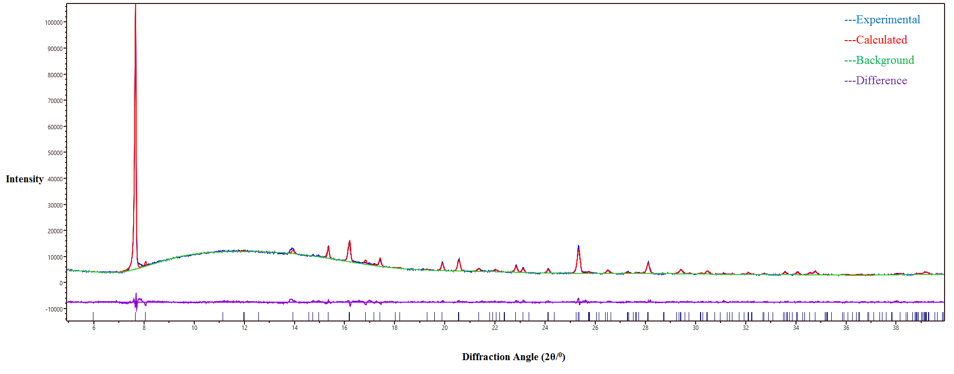
Figure 1. PXRD patterns for complexC1 (experimental, calculated, background and difference plot) after final Rietveld refinement.
The refined CIF was checked using EnCIFER software and validation was done from IUCr website using PLATON (check.def file’s version of 13/12/2023).

RESULTS AND DISCUSSION
Vibrational Spectra Study
The FT-IR spectra of the ligand and complex are presented in Figure S1 and S2, respectively(see SI). Interestingly, N-salicylideneaniline ligand (HL1)did not show broad hydroxyl (-OH) absorptionpeak around 3400 cm⁻¹ rather it showsa weak cis-keto (N-H) peak at 3226 cm⁻¹ and (-OH) peak at 2954 cm⁻¹similar to enol-imine type compounds[37].As deprotonation of phenolic hydrogen leads to complexation, the above peaks disappeared in complex C1.A weak broad peak at 3410cm⁻¹ may be due to hygroscopic nature of the complex.
The phenylC-H stretching in ligand (HL1) observed at 3076, 3053 and 3024 cm⁻¹ whereas values observed at 3059 and 3018 cm⁻¹in C1 complex[38]. The C-N stretching appearedat1398cm⁻¹and 1379cm⁻¹for HL1 and C1 respectively[39]. The imine C=Nstretching appeared at 1614 cm⁻¹and 1637cm⁻¹in ligand and complex, respectively[40]. The increase of wavenumber (decrease of frequency) in complex is due to coordination of lone pair electrons of nitrogen atom with central Fe atom results decreasing double bond character of C=N bond. Inligand HL1 and complexC1 the bands in the region of 1186 and 1145cm⁻¹arises for C-O. In both cases the aromatic C=C appeared in the region of 1606-1450 cm⁻¹. Two different bands with medium intensity at 584cm⁻¹and 482cm⁻¹in complex were assigned for Fe-N and Fe-O stretching respectively which are not present in the ligand[41, 42].
UV-Visible spectroscopy Study
UV-Vis data for ligand (HL1) and complex (C1)were collected in different concentration in methanol. The spectra of C1showed characteristic Ligand to Metal Charge Transfer (LMCT) band at 570nm[43] (see inset, Figure 2).The absorption bands at 252 nm for benzenoid π-π̽ transitions and at 321nm was assigned to conjugated imine π-π̽ transition for the aldimine residue of Fe(III) complex[49,51].C1 complex exhibited two intense absorption bands in the ranges 335–383 nm and 493–541 nm, which were assigned to phenolate (pπ) → Fe(III) (dσ*) and phenolate(pπ) → Fe(III) (dπ*) LMCT transitions,respectively[43].

Figure 2. UV-Vis spectrum of ligand HL1 and Complex C1, the LMCT band is showed in inset.

¹H NMR and ¹³C NMR Study
¹H NMR study (in CDCl₃) confirms the structure of the ligand HL1(See SI, Figure S3-S4). A peak at 13.18 ppm was observed for the hydroxyl group (-OH) of N-salicylidene aniline. We get a singlet at 8.91 ppm for imine hydrogen. A multiplate at the range 7.41-7.48 ppm was observed for five protons of aniline ring. A triplate at 7.35 ppm was assigned for H- 4. A doublet for one proton (H-3) and a multiplate for two proton (H-5,6) were at 7.61 and 6.99 ppm, respectively. ¹³C NMR spectra (See SI, Figure S5) analysis shows peaks for C-2 at 163.79ppm, C-7 at 161.21ppm, C-1at 148.57ppm, C-3 at 133.14 ppm, C-6 at 132.88 ppm, C- 4,5 at 129.44 ppm, C-1/ at 126.92 ppm, C-2/,3/,6/ at 121.27 ppm, C-5/ at 119.07 ppm , C-4/ at 116.78 ppm. But due to paramagnetic property of the complex C1 it did not show any splitting pattern in ¹H NMR Study.

Mass Data analysis
Mass spectrum of C1 in APCI method confirms the peak atm/z518 (M^{+.}), 448.1 ([M-Cl]⁺) and287 ([M-SL1]⁺)(Figure 3).Due to¹³C isotope a peak appeared at m/z 288 ([¹³C₁₃H₁₀ClFeNO]⁺).A peak at m/z 883.8may be for tetramer [C₃₉H₃₀Cl₂Fe₄N₃O₃]⁺ ion species. We get the mass spectra of ligand from previous literature[45].
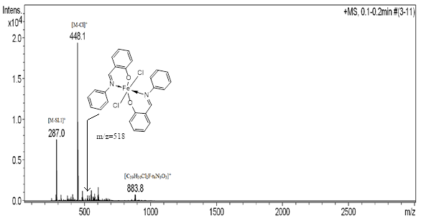
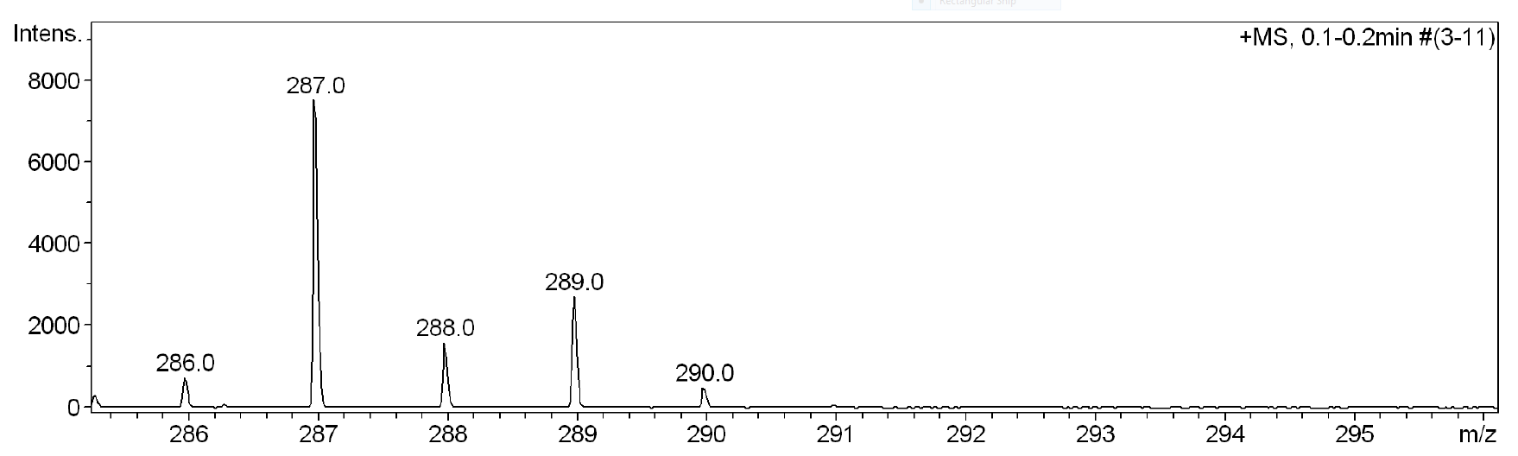
Figure 3. The Mass spectra of Bis(salicylaldiminato)Cl₂Fe(III) complex, C1 (APCI method) (see SI Figure S6 for expanded view)
Computational Study& Magnetic Susceptibility Measurement
Forstructural optimization of the complex the energy minima was calculated to ground state using semi empirical method with basis set PM6 as charge neutral complex in gas phase Nuclear repulsion energy is 1855.22Hartrees.
Magnetic susceptibility measurement shows paramagnetic property of C1 with µ_{eff} = 5.38 BM using Evans method[46, 47].
Powder X-ray diffraction Analysis
The Powder X-ray diffraction (PXRD) patterns (Figure4) confirm the crystalline nature of the ligand N-salicylideneaniline,HL1and metal complex Bis(salicylaldiminato)Cl₂Fe(III),C1. The different PXRD patterns of ligand and complex confirm their different crystal structures(Figure 4).The ligand crystallizes in orthorhombic crystal system with a = 5.794Å, b = 13.017Å, c = 13.617Å and space group Pbc2₁[48].The complexC1 crystalizes inmono clinic crystal system with cell parameters: a = 15.565 Å, b = 7.027 Å, c = 12.181 Åand β = 108.79⁰ and space group P121. (see Table 1)

Figure 4. Powder X-ray diffraction (PXRD) patterns ofHL1 and C1
Table 1. Crystal data for complex C1.
Formula | C₂₆H₂₀Cl₂FeN₂O₂
Temperature (K) | 296
Crystal system | Monoclinic
Wavelength (Å) | 1.540560
a (Å) | 15.565
b (Å) | 7.027
c (Å) | 12.181
α (º) | 90.00
β (º) | 108.79
γ (º) | 90.00
Volume (Å3) | 1261.22
No. of formula unit (Z) | 2
No of counts | 3501
2θ interval (º) | 5.004−40.004
No. of Reflections | 144
No. of background points | 15
Space Group | P 1 21
R_{p} | 2.237
R_{wp} | 3.257
Goodness of fit | 0.687

In the crystal packing of complex C1there are two molecules per unit cell. It crystallizes in monoclinic symmetry with space groupP121.Thecoordination geometry of the central iron atom is octahedral in which the axial positions are occupied by two chlorine atoms and equatorial positions are occupied by two oxygen and two nitrogen atoms. Thus itforms N,O-chelate complex where the ligands are in trans-position relative to each other. A comparison of bond lengths and bond angles in optimized structure and PXRD structure of C1are listed in Table 2.The bond lengths and bond angles in Optimized and PXRD structures slightly varied slightly may be due to optimization in gas phase but crystals in solid state.
The Fe1-Cl1/Fe1-Cl2 bond lengths are 1.843 Å, Fe1-O1/Fe1-O2 bond lengths are 1.928 Å and Fe1-N1/Fe1-N2 bond lengths are 1.979 Å which are comparable with those for the known complexes with coordinated N,O-chelate complexes [32-33]. The bond angles O1FeN1 (100.46˚), O2FeN2 (100.46˚), N1FeO2 (79.54˚) and N2FeO1 (79.54˚) suggest a slightly distorted octahedral geometry of the central Fe atom. The iron atom, two O atoms and two N atoms and two aromatic (salicylidene) rings lie in a single horizontal plane whereas two chlorine atoms lie almost perpendicular to this plane. The dihedral angels betweenthe horizontal plane and aromatic rings attached with N1 and N2 are 43.74˚ and 42.98˚ respectively(Figure 5).
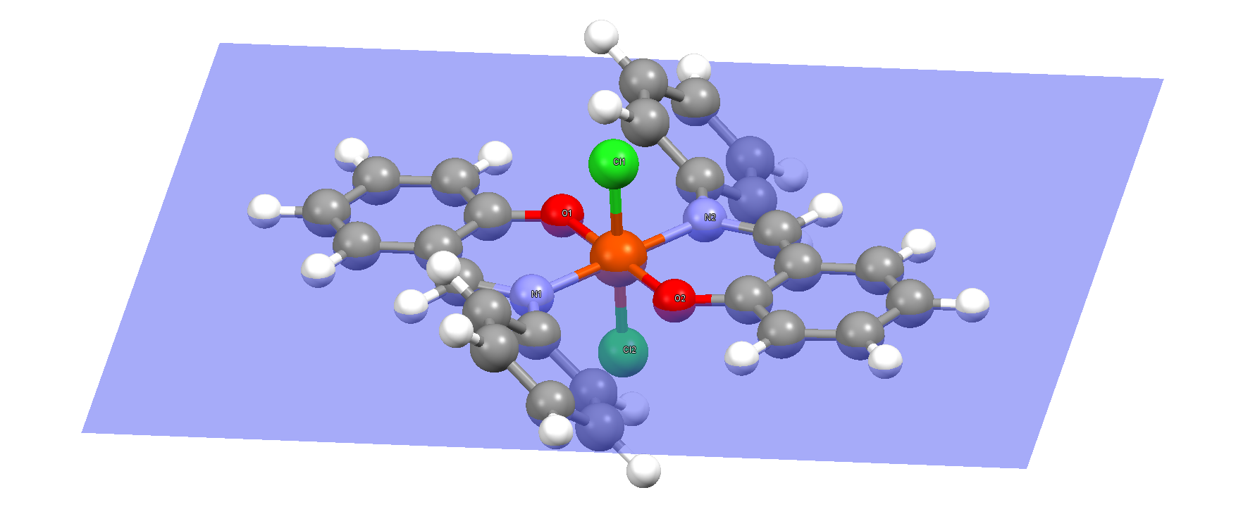
Figure 5. Distorted octahedral geometry of the central Fe atom in complex C1
A few short contacts are observed in the crystal packing of complex C1. The short intermolecular contacts between the hydrogen atoms (1.96Å, 1.94Å, 1.84Å, 1.85Å, 1.84Åand 0.87Å) of two HL1 ligand’s aromatic rings is due to intermolecular bonding between hydrogen atoms during crystal packing. Two long C-H bonds were observed for C7-H5 at 1.19 Å and C20-H15 at 1.19 Å which are also within considerable range.
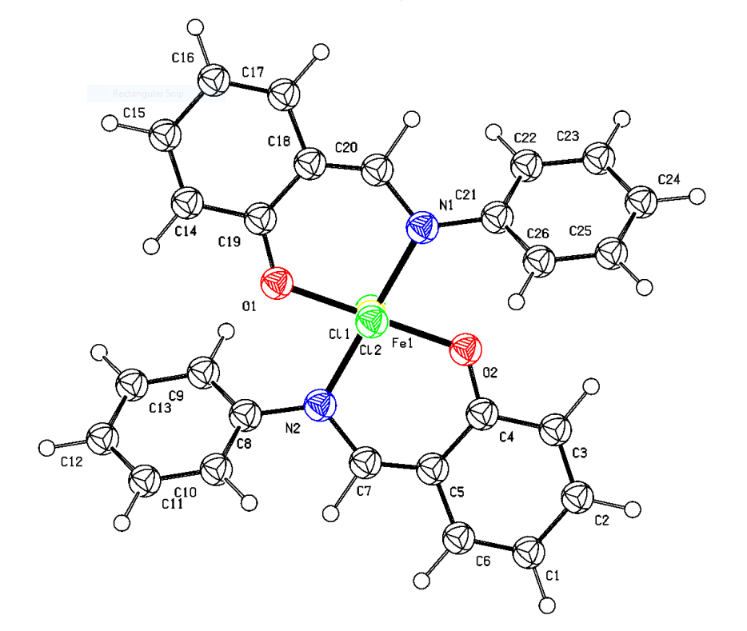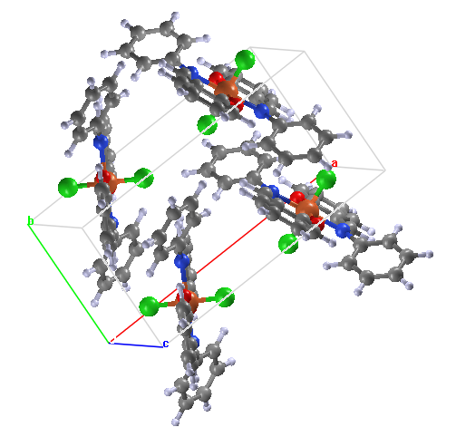
Figure 6.(a) Molecular structure and (b) Crystal packing of Complex C1
Table 2. Comparison of bond properties in Optimized structure and PXRD structure of C1 (Selected bond lengths and bond angle)
Bond Lengths & Angles |  | Optimized Structure | PXRD Structure
Bond Lengths  (Å) | Fe1-Cl1/ Fe1-Cl2 | 1.841 | 1.843
Bond Lengths  (Å) | Fe1-O1/ Fe1-O2 | 1.927 | 1.928
Bond Lengths  (Å) | Fe1-N1/ Fe1-N2 | 1.979 | 1.979
Bond Lengths  (Å) | N1-C20/N2-C7 | 1.450 | 1.412
Bond Lengths  (Å) | O1-C19 / O2-C4 | 1.286 | 1.285
Bond Angle  (⁰) | Cl1 Fe1 Cl2 | 179.99 | 180.00
Bond Angle  (⁰) | O1 Fe1 Cl1 | 90.00 | 90.00
Bond Angle  (⁰) | O1 Fe1 Cl2 | 89.99 | 90.00
Bond Angle  (⁰) | N1 Fe1 Cl1 | 90.01 | 89.98
Bond Angle  (⁰) | N1 Fe1 Cl2 | 89.99 | 90.02
Bond Angle  (⁰) | N2 Fe Cl1 | 89.44 | 90.02
Bond Angle  (⁰) | N1 Fe1 O1 | 79.53 | 100.46
Bond Angle  (⁰) | O2 Fe N2 | 79.35 | 100.46
Bond Angle  (⁰) | N2 Fe O1 | 100.86 | 79.54
Bond Angle  (⁰) | O2 Fe1 N1 | 79.529 | 79.54
Bond Angle  (⁰) | O2 Fe1 Cl1 | 90.00 | 90.00
Bond Angle  (⁰) | O2 Fe1 Cl2 | 89.99 | 90.00
Bond Angle  (⁰) | N2 Fe Cl2 | 90.85 | 89.98

Differential Scanning Calorimetry (DSC) analysis
In differential scanning calorimetryex periment endothermic and exothermic peaks were observed during the 1st heating. An endothermic peak was observed around 229°C, indicating melting of the complex, the exothermic peak at around 252°C refers to irreversible dissociation as 1st cooling and 2nd heating experiments have no peak(Figure 7).

Figure7.Differential Scanning Calorimetry (DSC) analysis for complex C1

CONCLUSION
In summary, a new octahedralFe(III) transition metal complex structure bearingN-salicylideneaniline ligand was synthesized, characterized and solvedby PXRD, Mass spectrometry, FT-IR, UV-Vis spectroscopy, DSC analysis. The magnetic susceptibility analysis shows paramagnetic property of the complex. Mass spectra analysis confirms that twobi-dentedN-salicylideneanilineligand and two chlorine atom coordinated with one iron atom through N, O -chelation. The PXRD data shows that slightly distortedoctahedral bis(salicylaldiminato)Cl₂Fe(III) complex crystalizes in monoclinic crystal system.

REFERENCES
1. More, M. S., Joshi, P. G., Mishra, Y. K., & Khanna, P. K. (2019). Metal complexes driven from Schiff bases and semicarbazones for biomedical and allied applications: a review. Materials Today Chemistry https://doi.org/10.1016/j.mtchem.2019.100195
2. Canpolat, E., & Kaya, M. (2005). Studies on Mononuclear Chelates Derived from Substituted Schiff Base Ligands (Part 4): Synthesis and Characterization of a New 5-Hydroxysalicyliden-P-Aminoacetophenoneoxime and Its Complexes with Co(II), Ni(II), Cu(II) and Zn(II). Turkish Journal of Chemistry https://journals.tubitak.gov.tr/chem/vol29/iss4/9
3. Pfeiffer, P., Breith, E., Lübbe, E., & Tsumaki, T. (1933). Tricyclische orthokondensierte Nebenvalenzringe. Justus Liebigs Annalen der Chemie, 503(1), 84–130. https://doi.org/10.1002/jlac.19335030106
4. Jarrahpour, A. A., Jalbout, A. F., Rezaei, S., & Trzaskowski, B. (2006). Synthesis and Physical Characterization of 2-((E)-1-(3-((E)-1-(2-hydroxyphenyl)ethylideneamino)-2-methylphenylimino)ethyl)phenol. Molbank. https://doi.org/10.3390/M455
5. Fonkui, T. Y., Ikhile, M. I., Ndinteh, D. T., & Njobeh, P. B. (2018). Microbial activity of some heterocyclic Schiff bases and metal complexes: A review. Tropical Journal of Pharmaceutical Research, 17(12), 2507–2518. https://doi.org/10.4314/tjpr.v17i12.29
6. Bajema, E. A., Roberts, K. F., & Meade, T. J. (2019). Cobalt-Schiff Base Complexes: Preclinical Research and Potential Therapeutic Uses. In Metal Ions in Life Sciences (Vol. 19, pp. 267–301). De Gruyter Open Ltd. https://doi.org/10.1515/9783110527872-017
7. Kaushik, S., Paliwal, S. K., Iyer, M. R., & Patil, V. M. (2023). Promising Schiff bases in antiviral drug design and discovery. Medicinal Chemistry Research, 32, 1063–1076. https://doi.org/10.1007/s00044-023-03068-0
8. Mohammadi, K., Azad, S. S., & Amoozegar, A. (2015). New tetradentate Schiff bases of 2-amino-3,5-dibromobenzaldehyde with aliphatic diamines and their metal complexes: Synthesis, characterization and thermal stability. Spectrochimica Acta Part A: Molecular and Biomolecular Spectroscopy, 146, 221–227. https://doi.org/10.1016/j.saa.2015.02.069
9. Ceramella, J., Iacopetta, D., Catalano, A., Cirillo, F., Lappano, R., & Sinicropi, M. S. (2022). A Review on the Antimicrobial Activity of Schiff Bases: Data Collection and Recent Studies. *Antibiotics*, *11*(2), 191. https://doi.org/10.3390/antibiotics11020191
10. More, M. S., Joshi, P. G., Mishra, Y. K., & Khanna, P. K. (2019). Metal complexes driven from Schiff bases and semicarbazones for biomedical and allied applications: a review. Materials Today Chemistry, 14, 100195. https://doi.org/10.1016/j.mtchem.2019.100195
11. Cavallini, D., De Marco, C., Duprè, S., & Rotilio, G. (1969). The copper catalyzed oxidation of cysteine to cystine. Archives of Biochemistry and Biophysics, 130(1), 354–361. https://doi.org/10.1016/0003-9861(69)90044-7
12. Evans, D. F., & James, T. A. (1979). Variable-temperature magnetic-susceptibility measurements of spin equilibria for iron(III) dithiocarbamates in solution. J. Chem. Soc. Dalton Trans. https://doi.org/10.1039/DT9790000723
13. Odabaşoǧlu, M., Arslan, F., Ölmez, H., & Büyükgüngör, O. (2007). Synthesis, crystal structures and spectral characterization of trans-bisaquabis(o-vanillinato)copper(II), cis-aquabis(o-vanillinato)copper(II) and aqua[bis(o-vanillinato)-1,2-ethylenediimin]copper(II). Dyes and Pigments, 75, 507–515. https://doi.org/10.1016/J.DYEPIG.2006.06.033
14. Zhou MD, Yu Y, Canape A, et al (2009) (N-Salicylidene)aniline Derived Schiff Base Complexes of Methyltrioxorhenium(VII): Ligand Influence and Catalytic Performance. Chem – An Asian J 4:411–418. https://doi.org/10.1002/ASIA.200800358
15. Adão, P., Maurya, M. R., Kumar, U., Avecilla, F., Henriques, R., Kusnetsov, M. L., Costa Pessoa, J., & Correia, I. (2009). Vanadium-salen and -salan complexes: Characterization and application in oxygen-transfer reactions. Pure and Applied Chemistry, 81(7), 1279–1296. https://doi.org/10.1351/PAC-CON-08-09-07
16. Speiser, F., Braunstein, P., & Saussine, L. (2004). Dinuclear nickel complexes with bidentate N,O ligands: Synthesis, structure, and catalytic oligomerization of ethylene. Inorganic Chemistry, 43(14), 4234–4240. https://doi.org/10.1021/ic049921r
17. Hameed, A., Al-Rashida, M., Uroos, M., Ali, S. A., Ali, M., Khan, S. A., Khan, S. U., & Choudhary, M. I. (2017). Schiff bases in medicinal chemistry: a patent review (2010-2015). Expert Opinion on Therapeutic Patents, 27(1), 63–79. https://doi.org/10.1080/13543776.2017.1252752
18. Liu, X., Manzur, C., Novoa, N., Celedón, S., Carrillo, D., & Hamon, J.-R. (2018). Multidentate unsymmetrically-substituted Schiff bases and their metal complexes: Synthesis, functional materials properties, and applications to catalysis. Coordination Chemistry Reviews, 357, 144–172. https://doi.org/10.1016/j.ccr.2017.11.030
19. Johmoto, K., Sekine, A., & Uekusa, H. (2012). Photochromism Control of Salicylideneaniline Derivatives by Acid–Base Co-Crystallization. Crystal Growth & Design, 12, 4779–4786. https://doi.org/10.1021/cg300454q
20. Ortiz-Sánchez, J. M., Gelabert, R., Moreno, M., & Lluch, J. M. (2008). Electronic-structure and quantum dynamical study of the photochromism of the aromatic Schiff base salicylideneaniline. Journal of Chemical Physics, 129(21), 214308. https://doi.org/10.1063/1.3032215
21. Abu-Surrah, A. S., Abdel-Halim, H. M., & Al-Qaisi, F. M. (2008). Synthesis of cobalt(III), iron(III), and chromium(III) complexes with salicylaldiminato ligands: Evaluation of the complexes as catalysts for oxidation of L-cysteine. Zeitschrift für Naturforschung B, 63(7), 848–852. https://doi.org/10.1515/znb-2008-0707
22. Zainoldin, Z., Harun, M. K., Bahron, H., & Kassim, K. (2012). Electrodeposition of Salicylideneaniline and its Corrosion Behavior. Advanced Materials Research, 554-556, 385–389. https://doi.org/10.4028/www.scientific.net/AMR.554-556.385
23. Frisch, M. J., Trucks, G. W., Schlegel, H. B., Scuseria, G. E., Robb, M. A., Cheeseman, J. R., Scalmani, G., Barone, V., Mennucci, B., Petersson, G. A., Nakatsuji, H., Caricato, M., Li, X., Hratchian, H. P., Izmaylov, A. F., Bloino, J., Zheng, G., Sonnenberg, J. L., Hada, M., Ehara, M., Toyota, K., Fukuda, R., Hasegawa, J., Ishida, M., Nakajima, T., Honda, Y., Kitao, O., Nakai, H., Vreven, T., Montgomery, J. A. Jr., Peralta, J. E., Ogliaro, F., Bearpark, M., Heyd, J. J., Brothers, E., Kudin, K. N., Staroverov, V. N., Kobayashi, R., Normand, J., Raghavachari, K., Rendell, A., Burant, J. C., Iyengar, S. S., Tomasi, J., Cossi, M., Rega, N., Millam, J. M., Klene, M., Knox, J. E., Cross, J. B., Bakken, V., Adamo, C., Jaramillo, J., Gomperts, R., Stratmann, R. E., Yazyev, O., Austin, A. J., Cammi, R., Pomelli, C., Ochterski, J. W., Martin, R. L., Morokuma, K., Zakrzewski, V. G., Voth, G. A., Salvador, P., Dannenberg, J. J., Dapprich, S., Daniels, A. D., Farkas, Ö., Foresman, J. B., Ortiz, J. V., Cioslowski, J., & Fox, D. J. (2009). Gaussian 09. Gaussian, Inc. https://gaussian.com/g09citation/
24. Furniss BS, Hannaford a J, Smith PWG, Tatchell a R (1989) Vogel’s TEXTBOOK OF PRACTICAL ORGANIC CHEMISTRY 5th ED Revised - Brian S. Furniss.pdf. J Polym Sci Part A Polym Chem 29:1223–1223
25. Abu-Surrah, A. S., Abdel-Halim, H. M., & Al-Qaisi, F. A. A. M. (2008). Synthesis of Cobalt(III), Iron(III), and Chromium(III) Complexes with Salicylaldiminato Ligands: Evaluation of the Complexes as Catalysts for Oxidation of L-Cysteine. Zeitschrift für Naturforschung B, 63, 848–852. https://doi.org/10.1515/znb-2008-0707
26. Haque I, Siam Abdullah M, Khairul Islam M, Enamullah M (2023) Synthesis, PXRD structure, spectroscopy, cyclic voltammogram, thermal analysis and DFT/TD-DFT calculations of bis[salicylaldehydato-κO,O’]nickel(II). Inorganica Chim Acta 550:121430. https://doi.org/10.1016/J.ICA.2023.121430
27. Enamullah, M., Al-moktadir Zaman, M., Bindu, M. M., Woschko, D., Islam, M. K., & Janiak, C. (2021). Pseudotetrahedral high-spin manganese(II)-complexes with (S or R)-N-1-(Ar)ethyl-salicylaldimine: Chiroptical property, chirality induction at-metal, paramagnetism, redox-potential, PXRD structures and DFT/TDDFT. Journal of Molecular Structure. https://doi.org/10.1016/j.molstruc.2021.130455
28. Enamullah, M., Joy, B. A., & Islam, M. K. (2019). Syntheses, spectroscopy, electrochemistry, EPR, PXRD-structure and DFT/TD-DFT of bis[2-oxo-1-naphthaldehydato-κO,O’]copper(II). Journal of Molecular Structure, 1175, 56–64. https://doi.org/10.1016/j.molstruc.2018.07.068
29. Ghosh, S., Pramanik, S., & Mukherjee, A. K. (2019). Structure analysis of a phenylpyrazole carboxylic acid derivative crystallizing with three molecules in the asymmetric unit (Z′ = 3) using X-ray powder diffraction. Powder Diffraction. https://doi.org/10.1017/S0885715619000289
30. Pramanik, S., Dey, T., & Mukherjee, A. K. (2019). Five benzoic acid derivatives: Crystallographic study using X-ray powder diffraction, electronic structure and molecular electrostatic potential calculation. Journal of Molecular Structure, 1175, 185–194. https://doi.org/10.1016/j.molstruc.2018.07.090
31. Das, U., Dey, T., Chatterjee, P., & Mukherjee, A. K. (2017). Structure determination from X-ray powder diffraction, DFT calculation, and Hirshfeld surface analysis of two fused bicyclic and tricyclic compounds. Powder Diffraction, 32(2), 86–92. https://doi.org/10.1017/S0885715617000173
32. Dey, T., Chatterjee, P., Bhattacharya, A., Pal, S., & Mukherjee, A. K. (2016). Three Nimesulide Derivatives: Synthesis, Ab Initio Structure Determination from Powder X-ray Diffraction, and Quantitative Analysis of Molecular Surface Electrostatic Potential. Crystal Growth & Design. https://doi.org/10.1021/acs.cgd.5b01547
33. Das, U., Naskar, J., & Mukherjee, A. K. (2015). Conformational analysis of an acyclic tetrapeptide: ab-initio structure determination from X-ray powder diffraction, Hirshfeld surface analysis and electronic structure. Journal of Peptide Science, 21(12), 845–852. https://doi.org/10.1002/psc.2825
34. Dey, T., Ghosh, S., Ghosh, S., & Mukherjee, A. K. (2015). 5-Arylidene derivatives of Meldrum’s acid: Synthesis, structural characterization using single crystal and powder crystal X-ray diffraction, and electronic properties. Journal of Molecular Structure, 1092, 51–62. https://doi.org/10.1016/j.molstruc.2015.03.002
35. Altomare, A., Cuocci, C., Giacovazzo, C., Moliterni, A., Rizzi, R., Corriero, N., & Falcicchio, A. (2013). EXPO2013: a kit of tools for phasing crystal structures from powder data. Journal of Applied Crystallography, 46, 1231–1235. https://doi.org/10.1107/S0021889813013113
36. Altomare, A., Campi, G., Cuocci, C., Eriksson, L., Giacovazzo, C., Moliterni, A., Rizzi, R., & Werner, P.-E. (2009). Advances in powder diffraction pattern indexing: N-TREOR09. Journal of Applied Crystallography, 42(5), 768–775. https://doi.org/10.1107/S0021889809025503
37. Fujiwara, T., Harada, J., & Ogawa, K. (2004). Solid-State Thermochromism Studied by Variable-Temperature Diffuse Reflectance Spectroscopy. A New Perspective on the Chromism of Salicylideneanilines. J. Phys. Chem. B, 108(13), 4035–4038. https://doi.org/10.1021/JP037438G
38. Coates, J. (2006). Interpretation of Infrared Spectra, A Practical Approach. In Encyclopedia of Analytical Chemistry. https://doi.org/10.1002/9780470027318.A5606
39. Turbeville, W., & Dutta, P. K. (1990). Spectroscopic studies of the photochromic molecule N-(2-hydroxybenzylidene)aniline and its photoproduct. The Journal of Physical Chemistry. https://doi.org/10.1021/J100373A033
40. Silverstein, R. M., Webster, F. X., Kiemle, D. J., & Bryce, D. L. (2014). *Spectrometric identification of organic compounds*. Wiley. https://www.wiley.com/en-us/Spectrometric+Identification+of+Organic+Compounds,+8th+Edition-p-9780470616376
41. Brisdon, A. K. (1998). Inorganic spectroscopic methods. Oxford University Press. https://global.oup.com/academic/product/inorganic-spectroscopic-methods-9780198559498
42. Sharma PK, Dubey SN (1994) Synthesis and structural studies of iron ( II ) complexes with N-salicylidene- and N-(2-hydroxyl-1-naphthylidene)amino acids. Indian J Chem 33:1113–1115
43. Mayilmurugan, R., Sankaralingam, M., Suresh, E., & Palaniandavar, M. (2010). Novel square pyramidal iron(III) complexes of linear tetradentate bis(phenolate) ligands as structural and reactive models for intradiol-cleaving 3,4-PCD enzymes: Quinone formation vs. intradiol cleavage. Dalton Transactions, 39, 9611–9625. https://doi.org/10.1039/C0DT00171F
44. Casella, L., & Gullotti, M. (1981). Coordination modes of histidine. 2. Stereochemistry of the reaction between histidine derivatives and pyridoxal analogues. Conformational properties of zinc(II) complexes of histidine Schiff bases. *Journal of the American Chemical Society*, *103*(21), 6338–6347. https://doi.org/10.1021/ja00411a013
45. Hashem MA, Tuli SK, Mahmud TB (2019) Synthesis of Bis (n-salicylidene-n-phenyl aminato) Palladium (II) complex to prepare a number of biphenyl compounds. Bangladesh J Sci Ind Res 54:223–230. https://doi.org/10.3329/BJSIR.V54I3.42674
46. Evans, D. F., & James, T. A. (1979). Variable-temperature magnetic-susceptibility measurements of spin equilibria for iron(III) dithiocarbamates in solution. Journal of the Chemical Society, Dalton Transactions. https://doi.org/10.1039/DT9790000723
47. Evans, D. F. (1959). The determination of the paramagnetic susceptibility of substances in solution by nuclear magnetic resonance. Journal of the Chemical Society (Resumed). https://doi.org/10.1039/JR9590002003
48. Arod F, Pattison P, Schenk KJ, Chapuis G (2007) Polymorphism in N-salicylideneaniline reconsidered. Cryst Growth Des 7:1679–1685. https://doi.org/10.1021/CG060389N/SUPPL_FILE/CG060389NSI20070227_041141.PDF

Supporting Information

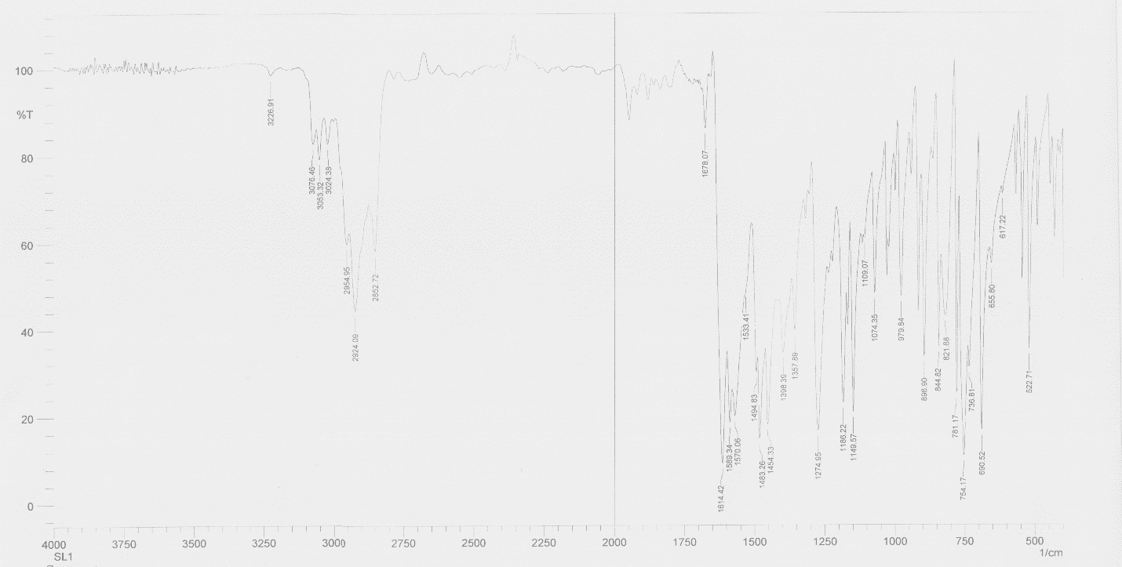
Figure S1.FT-IR spectra of ligand HL1
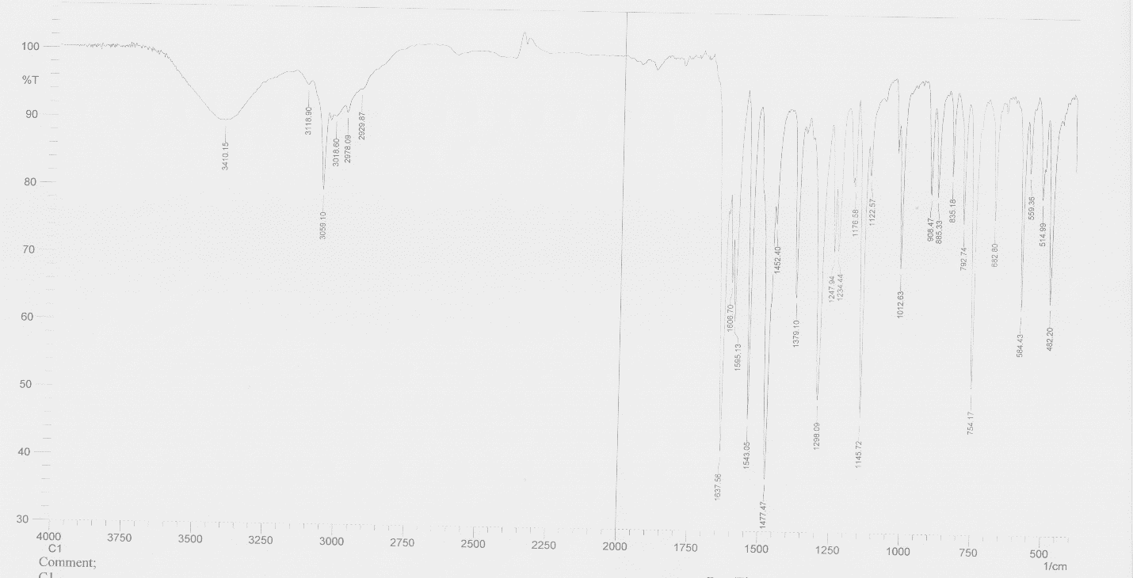
Figure S2. FT-IR spectra of Complex C1

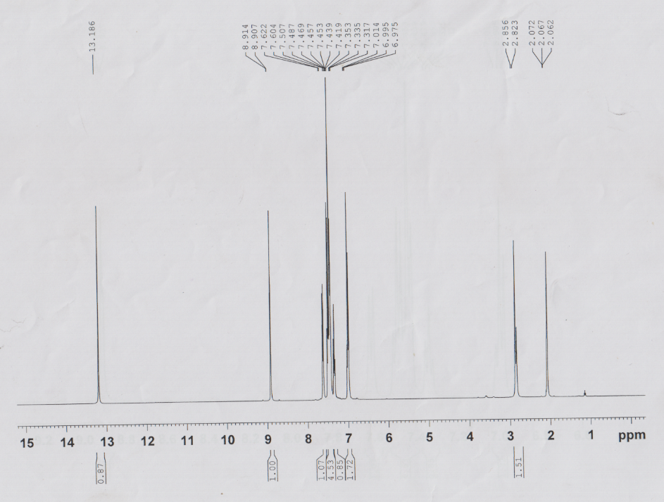
Figure S3. ¹H NMR (400 MHz) spectra of HL1
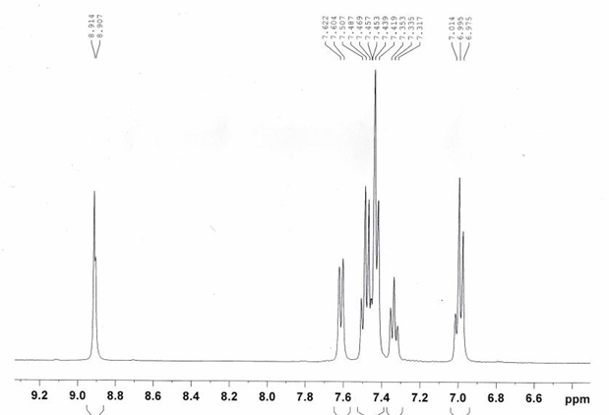
Figure S4. ¹H NMR (400 MHz) spectra of HL1 (expended)

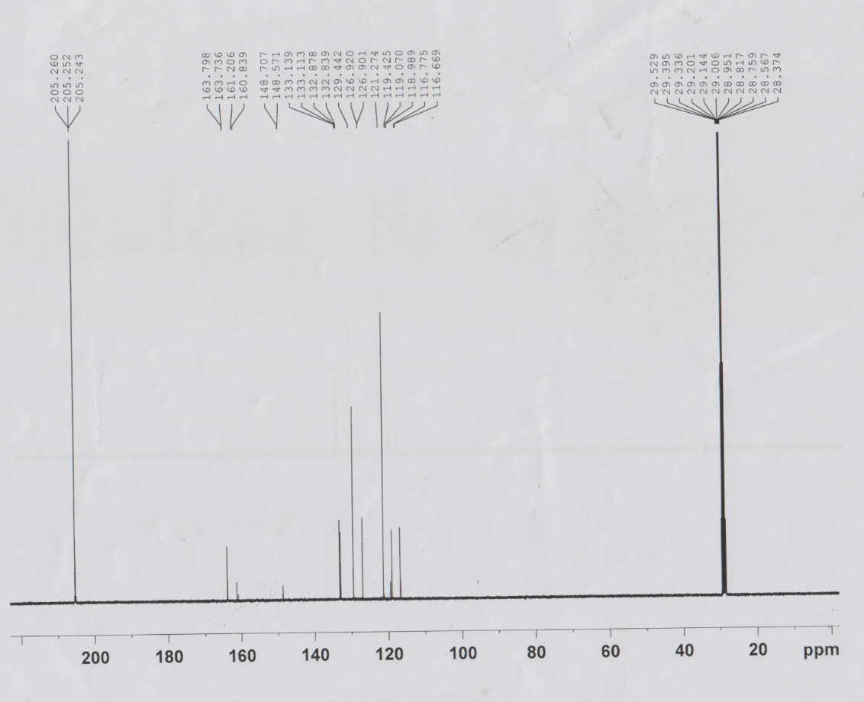
Figure S5. ¹³C NMR (400 MHz) spectra of HL1

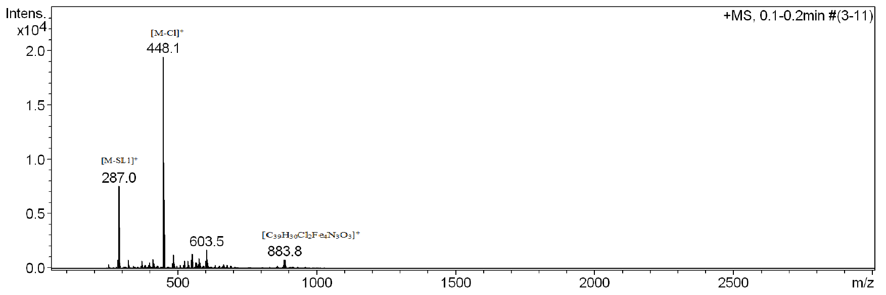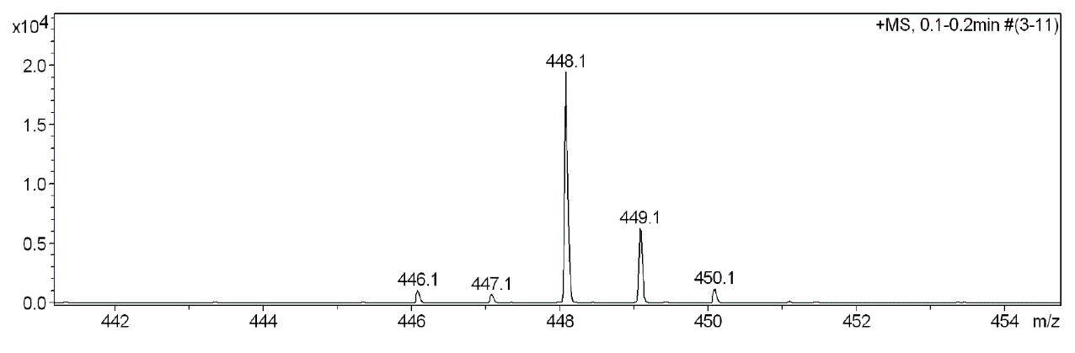
Figure S6. The Mass spectra of Bis(salicylaldiminato)Cl₂Fe(III) complex, C1 (APCI method)

