Original Research Article
INFLUENCE OF METAL IONS ON ADENINE- MMT CLAY INTERACTIONS: INSIGHTS INTO PREBIOTIC ADSORPTION MECHANISMS

ABSTRACT
The adsorption of adenine on mineral surfaces plays a vital role in prebiotic chemistry. This study examines the adsorption behaviour of adenine on MMT with or without divalent metal ions (Ca²⁺, Mg²⁺, Ni²⁺) under varying pH, temperature, and concentration conditions. The adsorption isotherms, thermodynamic parameters, and the effect of metal cations on adsorption efficiency were analysed. The results show that divalent cations enhance adsorption by neutralising the negatively charged clay surface, thereby increasing electrostatic interactions. These findings provide insights into potential mechanisms that could have facilitated the concentration and polymerisation of biomolecules on early Earth.
Keywords: Adsorption, Montmorillonite Clay (MMT), Adenine, Prebiotic Chemistry, Divalent Cations
Introduction
The origin of life has intrigued scientists across many fields, including chemistry, geology, and biology. Central to this exploration is prebiotic chemistry, which seeks to clarify how simple organic compounds on early Earth transformed into the complex macromolecules essential for life. A key focus of this field is not only on producing basic biomolecules—including amino acids, nucleobases, and simple sugars—but also on understanding the processes that allowed these monomers to gather, concentrate, and undergo polymerisation reactions under likely prebiotic conditions¹. Numerous significant experiments, including the famous Miller-Urey experiment, have demonstrated that organic molecules can form under conditions that mimic the early Earth's atmosphere and hydrosphere². However, creating these molecules in dilute primordial oceans was not enough. Without a way to concentrate and organise these scattered building blocks, the chances of forming larger, information-carrying polymers like RNA and peptides remained very low³.
In this setting, John Desmond Bernal⁴ proposed a revolutionary idea in the mid-20th century: minerals, especially clays, might serve as natural catalysts and templates for prebiotic reactions. Bernal’s hypothesis pointed out that clay minerals could adsorb organic molecules onto their surfaces, effectively concentrating them from dilute solutions. Furthermore, these surfaces might help align and activate monomers, reducing the energy barriers for condensation reactions. This concept formed the basis for what is now seen as an important area in prebiotic chemistry—the study of surface-catalysed reactions⁵.
Among various mineral options, MMT has received special attention. Montmorillonite, a fragment of the smectite family of clay minerals, has a layered structure with a high cation-exchange capacity and a large specific surface area⁶. These features make it an effective natural adsorbent. Laboratory research has shown that montmorillonite can catalyse the creation of RNA oligomers from activated nucleotides, clearly demonstrating its potential relevance to prebiotic chemistry^{7,8}.
Another critical aspect that has emerged in recent years is the role of metal ions in prebiotic adsorption and catalysis. In nature, montmorillonite often has interlayer spaces filled with various exchangeable cations, such as sodium, calcium, magnesium, or transition metals⁹. These cations can interact with organic molecules through electrostatic forces or coordinate bonds, potentially improving adsorption and affecting the orientation of adsorbed species¹⁰. Such interactions may significantly impact the efficiency of prebiotic reactions and the stability of fragile biomolecules under shifting conditions¹¹.
Adenine, one of the standard nucleobases, is particularly interesting in this context. As a key component of nucleic acids (DNA and RNA) and essential coenzymes like ATP and NADH, adenine's prebiotic synthesis, stability, and adsorption behaviour have been widely studied¹². However, the exact pathways through which adenine could have been concentrated and protected from degradation in early Earth environments are still being explored. Understanding how adenine interacts with mineral surfaces like montmorillonite—and how these interactions change in the presence of different metal cations—can provide valuable insights into the likelihood of early genetic materials forming under realistic geochemical conditions¹³.
This research investigates the adsorption behaviour of adenine on montmorillonite clay, both in its natural sodium form and after cation exchange with various biogenic metal ions. By changing experimental conditions—such as pH, ionic strength, and temperature—this study aims to clarify how different environmental factors affect adenine’s attachment to the clay surface¹⁴. Particular attention is given to understanding the mechanisms of adsorption, whether they occur mainly through cation bridging, hydrogen bonding, or van der Waals forces, and how these mechanisms might vary with changes in the clay’s cationic composition¹⁵.
Such insights have broader implications for prebiotic chemistry and the origin of life. MMT may have played a crucial role not just as catalytic surfaces but also as primitive structures that protected fragile molecules from hydrolytic degradation and encouraged subsequent polymerisation events¹⁶. Additionally, studying the combined effects of metal ions and mineral surfaces enhances our understanding of the complex geochemical environments that may have supported the beginnings of life¹⁷.
In summary, by connecting laboratory adsorption studies with realistic prebiotic scenarios, this work seeks to illuminate a fundamental question: how did simple biomonomers evolve from scattered organic compounds in a primordial soup into organised, information-carrying polymers that laid the groundwork for life? The answer may partly lie in the remarkable properties of Earth’s abundant clay minerals and the metal ions that naturally interact with them¹⁸.
EXPERIMENTAL
Chemicals and reagents
Calcium (II) chloride, magnesium (II) chloride, and nickel (II) chloride were obtained from BDH Co., USA. All chemicals used were of analytical grade and employed without further purification. Solutions were prepared using triply distilled water. Montmorillonite was sourced from E. Merck Chemical Company, Mumbai, and purified through sedimentation in water. The purity of the <2 µm samples was confirmed by X-ray diffraction (XRD).
Preparation of Homoionic Clays
Homoionic forms of MMT were prepared using a saturation method¹⁹ with 50 mL of 1M solutions of calcium, magnesium, and nickel chlorides. Excess salts were removed through repeated washing and centrifugation until chloride ions were no longer detected with the silver nitrate test²⁰. The resulting divalent cation-exchanged montmorillonites were dried under vacuum at room temperature. The dried products were then ground and sieved to obtain a particle size of 125 µm.
Adsorbates and Adsorbents:
Montmorillonite is a smectite clay mineral characterized by a 2:1 layer structure, comprising two tetrahedral silica sheets sandwiching an octahedral alumina sheet. It has negatively charged surfaces due to isomorphic substitution (e.g., Al³⁺ replacing Si⁴⁺), balanced by exchangeable interlayer cations. Adenine is a purine base with several electron-donating atoms (nitrogen and amino groups), which can coordinate metal ions. Adenine was selected as the adsorbate. Montmorillonite clay was used as the adsorbent, both in its natural form and when exchanged with divalent cations (Ca²⁺, Mg²⁺, Ni²⁺).
Adsorption Studies: Adsorption Quantification
The adsorption of adenine on montmorillonite and cation-exchanged montmorillonites was studied as a function of pH, temperature, and adsorbate concentration. To maintain precise pH conditions while preventing complex formation, appropriate buffering agents were employed:
pH 1.0 – 2.0: 0.2M potassium chloride and 0.2M hydrochloric acid
pH 3.0 – 8.0: 0.2M acetic acid and 0.2M sodium acetate
pH 9.0: 0.2M borax and 0.2M hydrochloric acid
pH 10.0: 0.2M borax and 0.2M sodium hydroxide
The pH of the solutions was verified using a digital pH meter (Agronic Digital-511) and further confirmed by conductivity measurements.
Buffered adenine solutions were incubated with 50 mg of montmorillonite clay for 18 hours. Supernatant concentrations were measured spectrophotometrically at 260 nm to determine adenine levels. The adsorption of the adsorbate, measured after 18 hours as a function of temperature, reached a maximum at 25°C. The suspensions were centrifuged at 3500 rpm for 30 minutes, and the supernatant was decanted, leaving the clay residue. The pH of the solution was measured again and remained almost unchanged. The equilibrium concentration of adsorbent and the amount adsorbed were used to construct the adsorption isotherm. The initial part of the adsorption isotherm plot, between the amount adsorbed and the equilibrium concentration of adenine, displays a linear relationship.
Desorption of Adenine
Post-adsorption, the clay-adenine complexes were collected by centrifugation at 10,000 rpm for 10 minutes. The resulting pellets were washed repeatedly with 1 mL of double-distilled water and centrifuged after each wash to remove any unbound adenine. Washing continued until no further adenine was detected in the supernatant, as confirmed by UV-Vis spectrophotometry at 260 nm, the characteristic absorption peak of adenine. To induce desorption, the washed pellets were treated with either 0.1 M HCl, 0.1 M NaOH, or 1 M NaCl to disrupt the interactions between adenine and the clay surface. The suspensions were gently shaken or incubated at room temperature for 1–2 hours, followed by centrifugation to separate the desorbed adenine in the supernatant. The presence and concentration of desorbed adenine were confirmed by recording UV-VIS absorption spectra using a Jasco-V550 spectrophotometer, specifically monitoring the absorbance at 260 nm. ²¹⁻²³

RESULT AND DISCUSSION
3.1 Effect of pH, Temperature, and Concentration on Adsorption
The adsorption behaviour of adenine on montmorillonite (MMT) and cation-exchanged montmorillonite clays was systematically examined in aqueous media under varying physicochemical conditions to identify the optimum parameters for maximum adsorption efficiency. The experiments were conducted across a pH range of 3.0–9.2, a temperature range of 20–25 °C and adenine concentrations from 9.0 × 10⁻⁵ M to 1.0 × 10⁻⁵ M. These conditions were chosen to simulate plausible prebiotic environments near the lithosphere–hydrosphere interface or the primitive sea bottom, where clay–organic interactions might have facilitated molecular concentration and organization.
Temperature-dependent adsorption data revealed a marked enhancement at 25°C, indicating that this temperature favoured optimal binding without inducing thermal desorption. The pH-dependent studies demonstrated that adenine adsorption strongly correlated with the solution pH, reaching a maximum at pH 7.0. This pH corresponds to the near-neutral condition where adenine exists in its zwitterionic or partially protonated state, optimising electrostatic interactions with negatively charged clay surfaces. Consequently, all subsequent adsorption experiments were performed at 25 °C and pH 7.0, with the temperature and pH maintained using an ultra-thermostat to ensure equilibrium consistency.
The pronounced influence of pH on adsorption efficiency underscores the role of electrostatic and hydrogen-bonding interactions between adenine molecules and the surface functional groups of montmorillonites. The observed trend suggests that surface charge modulation of the clay and the protonation state of adenine collectively determine the extent of surface affinity. The experimental data depicting the effect of pH on adenine adsorption at 25 °C are presented in Figure 1, with corresponding quantitative results tabulated in Table 1.
3.2 Adsorption Isotherms and Langmuir Model
Adsorption isotherms of adenine on montmorillonite were established over the concentration range of 9.0 × 10⁻⁵ M to 1.0 × 10⁻⁵ M under pH 3.0–9.2 and temperatures between 20 and 25 °C. The resulting isotherms (Figure 2) exhibited a distinct asymptotic profile, characteristic of Langmuir-type monolayer adsorption, implying homogeneous surface sites and the absence of lateral interactions between adsorbed molecules. The Langmuir equation quantitatively described the adsorption process:

where Ceq is the equilibrium concentration of adenine (mg L⁻¹), Xₑ is the amount of solute adsorbed per gram of adsorbent (mg g⁻¹), K_{L} is the Langmuir constant related to the affinity of binding sites, and Xₘ denotes the monolayer adsorption capacity (mgg⁻¹). The constant K_{L} is thermodynamically linked to the enthalpy of adsorption (ΔH°) by the relation (K_{L}​∝ e-^{ΔH°/RT}). Langmuir parameters (Xₘ and KL) were obtained from the slope and intercept of the linear plot of Ceq/Xₑ versus Ceq (Figure 3). The asymptotic value of Xₑ was extrapolated from the saturation point on the adsorption curve, providing insight into the monolayer formation limit.
The adsorption performance, expressed in terms of percent binding, was calculated using the relation: % Binding=Cbf−Caf/Cbf x 100%
where Cbf and Caf represent the solute concentrations before and after adsorption, respectively.
The analysis revealed that the adsorption capacity and Langmuir constants varied significantly with the type of clay and the nature of the exchangeable cations. This variation highlights the crucial role of surface charge density, cationic bridging, and specific ion–π interactions in modulating adenine–clay binding affinity under prebiotic conditions.
3.3 Role of Divalent Cations
Adsorption was enhanced in the presence of divalent cations, following the trend: M-Ca²⁺ > M-Ni²⁺ > M-Mg²⁺ > M-Clay. This pattern shows cation intercalation neutralises the negatively charged montmorillonite surface, improving binding (Schemes I and II). Similar cation-mediated enhancement in nucleobase adsorption has been reported earlier for montmorillonite systems²⁴.
3.4 Thermodynamic Analysis of Adenine Adsorption on Montmorillonite Clay
The thermodynamic behaviour of adenine adsorption on montmorillonite was evaluated through standard Gibbs free energy (ΔG°), enthalpy (ΔH°), and entropy (ΔS°) calculations, derived using the following relationships²⁵
ΔG° = − RTlnK°
where K° is the thermodynamic equilibrium constant obtained from the slope of the plot of Ceq/Xe), R is the gas constant, and T is the absolute temperature. The derived parameters are summarised in Table 2.
The standard Gibbs free energy change (ΔG°) ranged between –2.96 and –3.71 kJ mol⁻¹, remaining consistently negative under all experimental conditions. These values confirm that adenine adsorption onto montmorillonite is a spontaneous and thermodynamically favourable process. The exergonic nature of the interaction suggests that adsorption proceeds without external energy input, driven by weak but persistent intermolecular forces such as van der Waals attractions, hydrogen bonding, and electrostatic interactions rather than covalent bonding. This indicates that montmorillonite serves as an effective, reversible scaffold for adenine retention in aqueous environments.
Application of the Clausius–Clapeyron relationship revealed that the standard enthalpy change (ΔH°) lies between 5.46 and 7.09 kJ mol⁻¹. These moderate positive values denote a weakly endothermic process dominated by non-covalent interactions. The low magnitude of ΔH° suggests physisorption rather than chemisorption, implying that adsorption–desorption equilibria are easily attainable under environmental conditions. Such an energy profile supports the hypothesis that montmorillonite could have acted as a transient yet selective molecular host in prebiotic aqueous systems²⁶.
The entropy change (ΔS°) values, ranging from 0.19 to 0.23 kJ mol⁻¹ K⁻¹, indicate a net increase in system disorder during adsorption. This positive ΔS° likely results from the displacement of interlayer water molecules and reorganisation of surface charge distributions upon adenine adsorption. The combined positive ΔH° and ΔS° values suggest that the process is entropically driven, governed by structural rearrangements at the clay–water interface rather than purely energetic stabilisation.
Collectively, these thermodynamic results in Table 3 reveal the delicate balance of molecular forces behind adenine–clay interactions. They show that adsorption is spontaneous, entropically favored, and maintained by weak non-covalent interactions — features consistent with reversible adsorption phenomena important for prebiotic molecular concentration and stabilization. Adenine’s greater affinity for montmorillonite, compared to smaller pyrimidine bases, may result from its extended conjugated system, which boosts π–π and London dispersion interactions with the clay surface. Exchangeable cations such as Mg²⁺, Ca²⁺, and Ni²⁺ further increase this affinity through electrostatic stabilization and cation-π–π coordination, aiding in enhanced molecular retention.
These findings substantiate the role of clay minerals as potential prebiotic catalysts and molecular concentrators. By offering a dynamic yet selective adsorption environment, montmorillonite could have facilitated the accumulation and organisation of nucleic acid bases, thereby contributing to the early steps in chemical evolution on the prebiotic Earth.

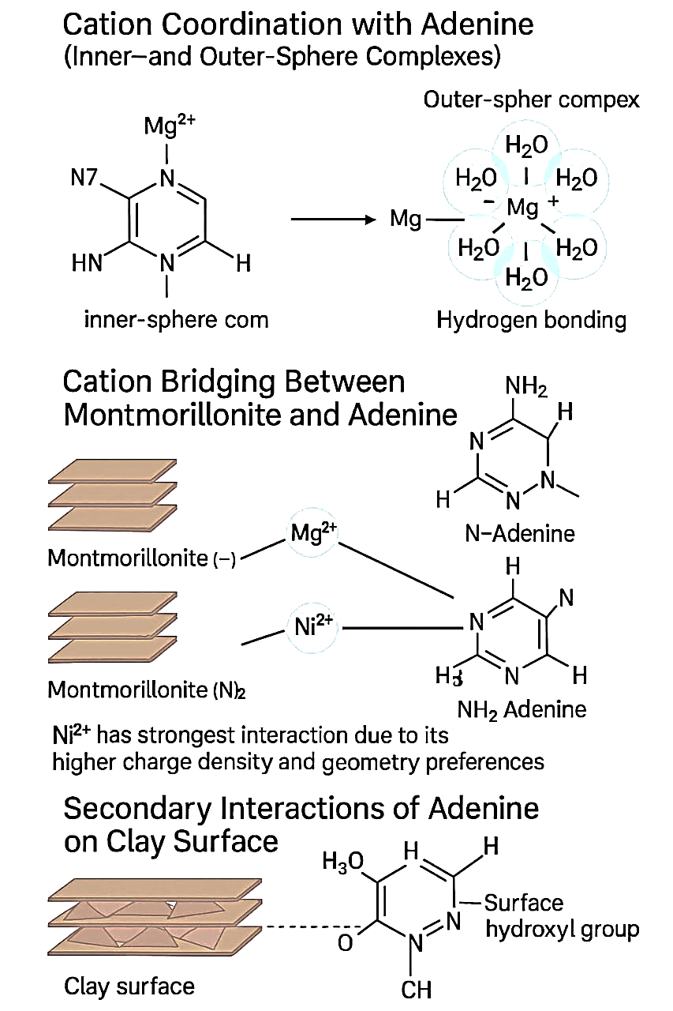
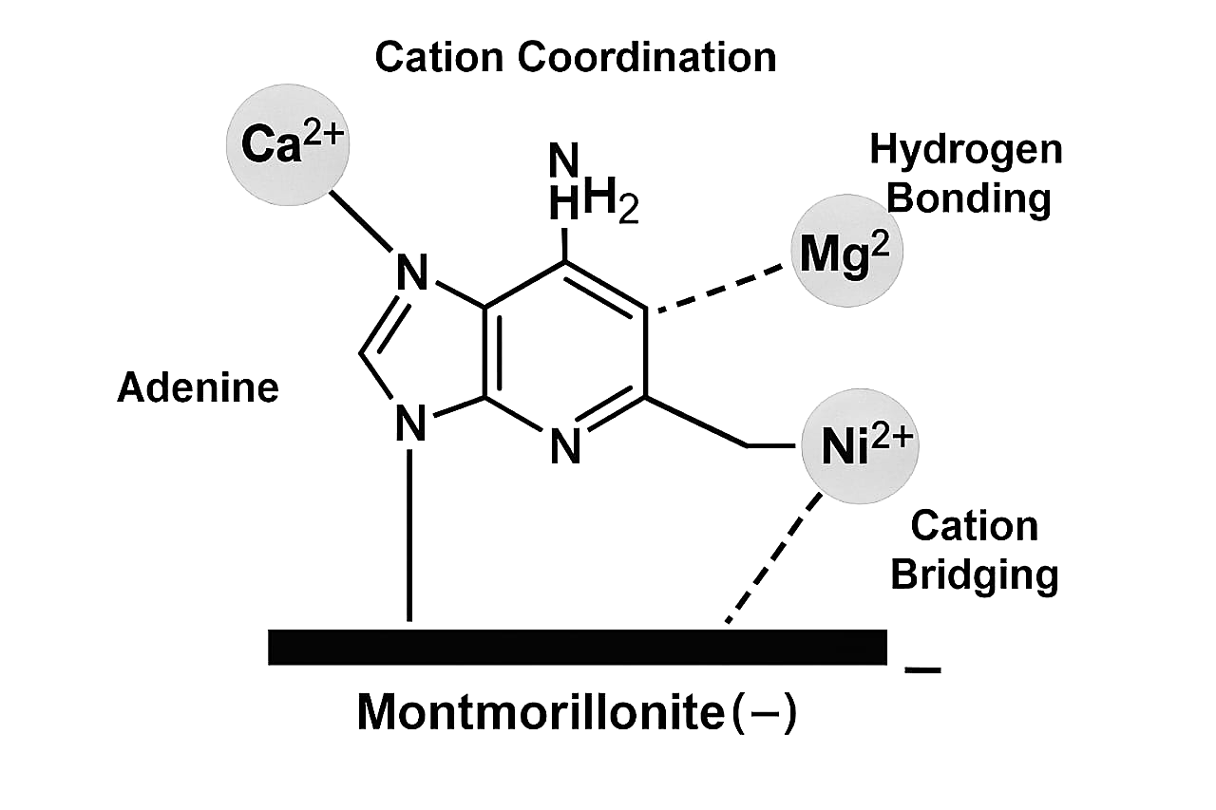
Scheme 1 Graphical Representation Scheme II

Schemes I and II show the molecular interactions between adenine and montmorillonite clay. of the mechanism of molecular interactions between adenine and divalent cations (Ca²⁺, Mg²⁺, Ni²⁺) when associated with montmorillonite, a type of clay mineral, AI generated

Table -1: Percent Binding of Adenine on Montmorillonite Clay (MT) with or without Divalent Cations at 20ºC
S.N. | Adsorbate | % Binding on MT | % Binding on M-Ca²⁺ | % Binding on M-Mg²⁺ | % Binding on M-Ni²⁺
1 | Adenine | 8.89 | 11.11 | 10.00 | 12.22
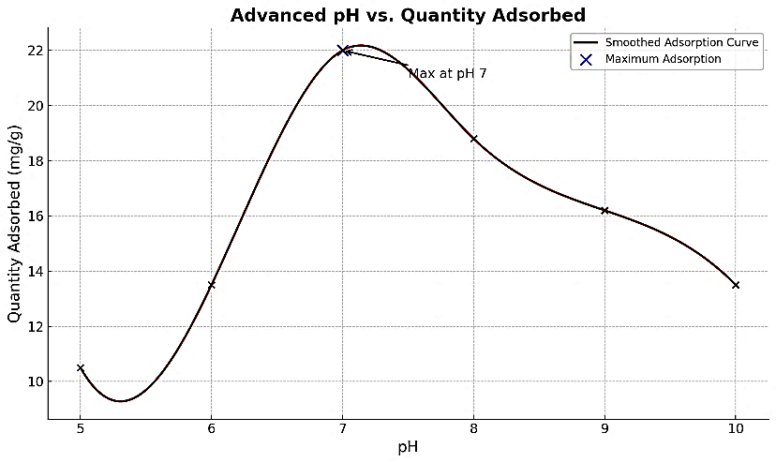
Fig.1 Adsorption of adenine on montmorillonite as a function of pH
Table- 2: Langmuir constants (X_{m} and K_{L}) for the adsorption of adenine on montmorillonite clay
with or without cations (Ca²⁺, Mg²⁺, and Ni²⁺) at 20˚C
Adsorbent | Maximum Adsorption Capacity, X_{m} (mg/g) | Langmuir Constant, K_{L} (L/mg) | Correlation Coefficient, r²
M-Clay | 21.77 | 33.18 | 0.99
M-Ca²⁺ | 27.09 | 190.48 | 0.99
M-Mg²⁺ | 24.28 | -150.74 | 0.99
M-Ni²⁺ | 29.70 | 3395.29 | 0.99

Table -3: Thermodynamic Parameters for the Adsorption of Adenine on Montmorillonite
and Different Cations
Adsorbent | 20°C |  | 30°C |  | Thermodynamic Parameters
 | lnK₀ | ΔG˚  (kJ/mol) | lnK₀ | ΔG˚  (kJ/mol) | ΔH˚  (kJ/mol) | ΔS˚  (kJ/molK)
M-Clay | 1.52 | -3.71 | 0.79 | -1.97 | 5.46 | 0.19
M-Ca²⁺ | 1.31 | -3.18 | 0.48 | -1.20 | 6.12 | 0.21
M-Mg²⁺ | 1.41 | -3.44 | 0.52 | -1.31 | 6.71 | 0.23
M-Ni²⁺ | 1.21 | -2.96 | 0.43 | -1.09 | 7.09 | 0.20
K₀, thermodynamic equilibrium constant; ln, natural logarithmic value of K0; ΔG˚, change
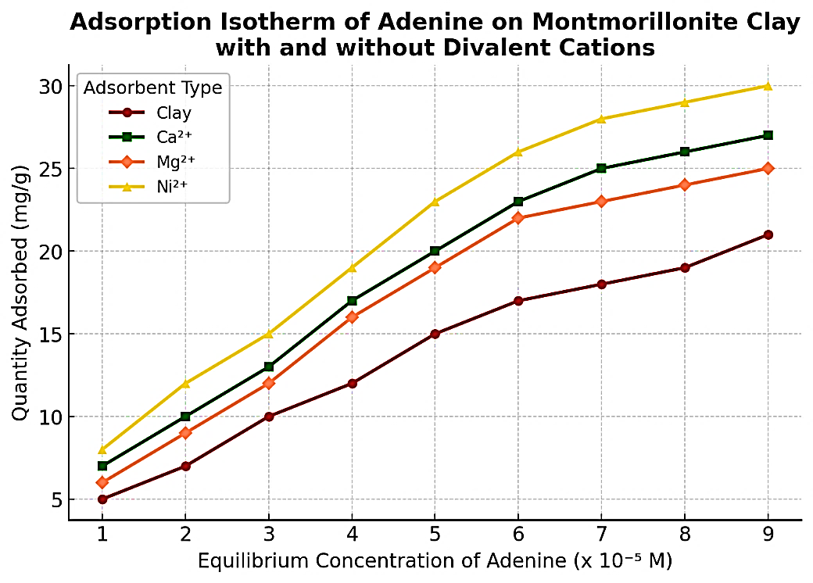
in Gibbs free energy
Fig.2 Adsorption isotherm of adenine on montmorillonite in the presence or absence of metal cations
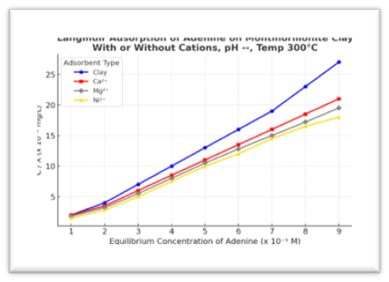
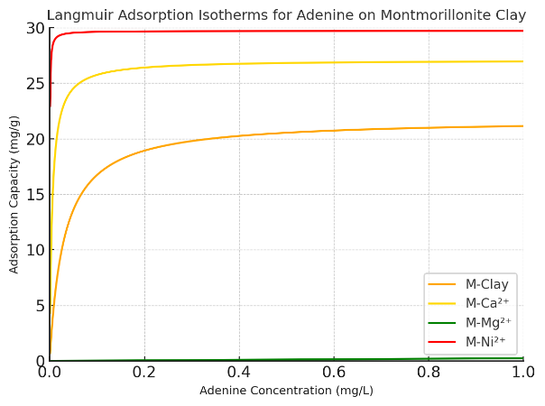
(a) (b)
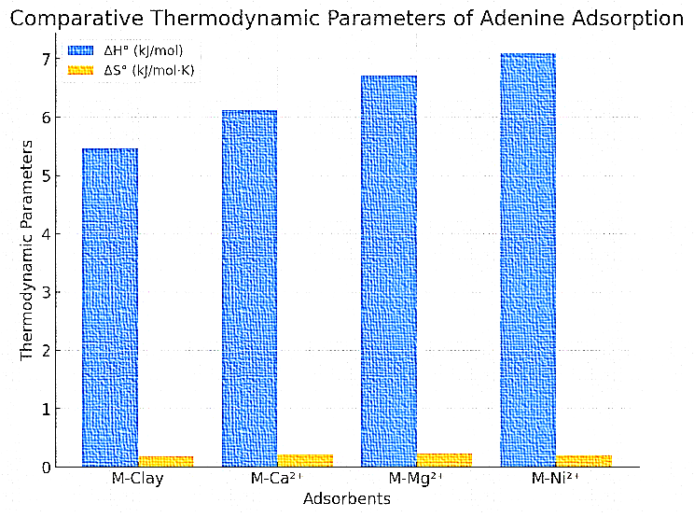
Fig. 3. The Langmuir adsorption isotherms (a) and a graphical representation (b) of adenine on montmorillonite clay with different cations.
Fig. 4. The comparative bar chart displaying the thermodynamic parameters (ΔH° and ΔS°) for adenine adsorption on montmorillonite clay with different cations.
The thermodynamic analysis of adenine adsorption on modified montmorillonite clays reveals important insights into the role of different cations. The enthalpy change (ΔH°) values range from 5.46 kJ/mol for MMT-Clay (unmodified) to 7.09 kJ/mol for M-Ni²⁺, indicating that the adsorption process is exothermic but not highly energy-releasing. The increasing ΔH° trend suggests that Ni²⁺ stabilizes the adsorption more effectively than other cations, likely due to stronger electrostatic and possible transition metal-ligand interactions. Entropy change (ΔS°) values are also positive, ranging from 0.19 to 0.23 kJ/mol⁻K, which implies increased disorder at the solid-liquid interface during adsorption. This disorder may stem from structural rearrangements on the montmorillonite surface. Among the cation-modified clays, M-Mg²⁺ exhibits the highest entropy change (0.23 kJ/mol-K), suggesting a more disordered adsorption process, possibly due to weaker interactions compared to Ca²⁺ and Ni²⁺. Comparing (fig.4) the adsorbents, MMT-Clay, which lacks cation modification, shows the lowest ΔH° and ΔS°, reflecting weaker interactions and minimal adsorption. In contrast, M-Ca²⁺ and M-Mg²⁺ demonstrate moderate thermodynamic values, indicating enhanced adsorption through charge neutralisation. Notably, M-Ni²⁺ stands out with the highest ΔH°, signifying the strongest cations, likely due to stronger electrostatic and possible transition metal-ligand.
CONCLUSION
The thermodynamic study of adenine adsorption onto MMT shows a complex connection of molecular forces involved in this process, which significantly impacts prebiotic chemistry. The consistently negative Gibbs free energy change (ΔG°) indicates that adsorption occurs spontaneously and is energetically favourable. This confirms that nucleic acid bases naturally prefer mineral surfaces. Although the heat release is low due to the positive enthalpy change (ΔH°), the adsorption process remains stable. It mainly relies on weak but important intermolecular interactions like van der Waals forces, hydrogen bonding, and electrostatic attractions. The positive entropy change (ΔS°) points to some molecular rearrangement at the clay interface, further showing that adenine retention is dynamic yet thermodynamically possible.
Among the nucleic acid bases studied, adenine shows the highest adsorption affinity, likely because of its molecular size and stronger dispersion interactions. The presence of exchangeable cations like Mg²⁺, Ca²⁺, and Ni²⁺ also affects adsorption behaviour by promoting electrostatic stabilisation and cation-π interactions. These findings emphasize the role of clay minerals as effective prebiotic collectors, capable of selectively adsorbing and stabilizing biologically important molecules under early Earth conditions.
Overall, this study supports the idea that montmorillonite clay might have acted as a crucial catalyst in prebiotic chemistry, facilitating the accumulation and preservation of key organic compounds. The ability of these mineral surfaces to encourage molecular retention without needing strong covalent bonds suggests a possible way primordial biomolecules could have organized. This organization may have played a role in the development of self-replicating systems. These insights improve our understanding of the chemical processes that might have contributed to the origins of life and highlight the importance of clay minerals in early biochemical evolution.

REFERENCES
- Cleaves II, H. J., Scott, A. M., Hill, F. C., Leszczynski, J., Sahai, N., & Hazen, R. (2012). Mineral–organic interfacial processes: potential roles in the origins of life. Chemical Society Reviews, 41(16), 5502–5525. https://doi.org/10.1039/C2CS35112A .
- Miller, S. L. (1953). A production of amino acids under possible primitive earth conditions. Science, 117(3046), 528–529. https://doi.org/10.1126/science.117.3046.528 .
- Hazen, R. M., Papineau, D., Bleeker, W., Downs, R. T., Ferry, J. M., McCoy, T., Sverjensky, D., & Yang, H. (2005). Mineral Evolution. American Mineralogist, 90(10), 1473–1499. https://doi.org/10.2138/am.2005.1871
- J. D. Bernal, Proc. Phys. Soc. B, 62, 537–558 (1949).
- Cairns-Smith, A. G. (1982). Genetic takeover and the mineral origins of life. Cambridge University Press. https://www.cambridge.org/core/journals/genetics-research/article/genetic-takeover-and-the-mineral-origins-of-life-by-a-g-cairnssmith-first-published-1982-first-paperback-edition-1987-cambridge-university-press-isbn-0-521-34682-7/10101010101010101010101010101010
- Brigatti, M. F., Galan, E., & Theng, B. K. G. (2006). Structures and mineralogy of clay minerals. In F. Bergaya, B. K. G. Theng, & G. Lagaly (Eds.), Handbook of Clay Science (pp. 19–86). https://doi.org/10.1016/S1572-4352(05)01002-0
- Ferris, J. P. (2002). Montmorillonite catalysis of 30-50 mer oligonucleotides: laboratory demonstration of potential steps in the origin of the RNA world. Origins of Life and Evolution of the Biosphere, 32, 311–332. https://doi.org/10.1023/A:1020543312109
- P. C. Joshi, M. F. Aldersley, J. W. Delaono, J.P. Ferris, Orig. Life Evol. Biosph., 39, 229–238 (2009).
- H. Hashizume, J. Nucleic Acids, Article ID 216507 (2015).
- Paukku, Y., Michalkova, A., & Leszczynski, J. (2007). Adsorption and Decomposition of Dimethyl Methylphosphonate on Y2O3 Nanoparticles. The Journal of Physical Chemistry C, 111(8), 3233–3240. https://doi.org/10.1021/jp0650376
- Stumm, W., & Morgan, J. J. (1996). Aquatic chemistry: Chemical equilibria and rates in natural waters. John Wiley & Sons. https://www.wiley.com/en-us/Aquatic+Chemistry%3A+Chemical+Equilibria+and+Rates+in+Natural+Waters%2C+3rd+Edition-p-9780471511854
- Oro, J. (1961). Mechanism of synthesis of adenine from hydrogen cyanide under possible primitive earth conditions. Nature, 191, 1193–1194. https://doi.org/10.1038/1911193a0
- M. Franchi, E. Gallori, L. Vanni, Int. J. Astrobiol., 3, 127–136 (2004).
- K. M. Parida, S. S. Dash, Adsorption, 12, 219–232 (2006).
- E. Biondi, S. Branciamore, M. C. Maurel & E. Gallori, Geochim. Cosmochim. Acta, 74, 479–488 (2010).
- Hazen, R. M., & Sverjensky, D. A. (2010). Mineral surfaces, geochemical complexities, and the origins of life. Cold Spring Harbor Perspectives in Biology, 2(5), a002162. https://doi.org/10.1101/cshperspect.a002162 .
- Y. Liu, Y. Liu & H. Zhou, Adv. Colloid Interface Sci., 270, 108–121 (2019).
- G. Cavallaro, G. Lazzara & S. Milioto, Adv. Colloid Interface Sci., 267, 28–45 (2019).
- H. Bhatt, N. Pandey, C. K. Pant, Int. J. of Innovative Research in Technology, Volume 8, Issue 3, 1039-1044 (2021)
- H. Bhatt, C. K. Pant, Int. J. of Science, Research and Reviews, 11 (4), 86-93, (2022).
- F. López Arbeloa, J. Colloid Interface Sci., 137, 104–110 (1990). DOI: 10.1016/0021-9797(90)90297-3.
- A. Samadi, K. Pourshamsian, J. Mol. Liq., 282, 248–255 (2019). DOI: 10.1016/j.molliq.2019.03.033.
- Vona, A., Romano, C., Dingwell, D. B., & Giordano, D. (2011). The rheology of crystal-bearing basaltic magmas from Stromboli and Etna. Geochimica et Cosmochimica Acta, 75, 3214–3236. https://doi.org/10.1016/j.gca.2011.03.031
- J. P. Ferris and G. Ertem, Science, 1993, 259(5103), 513–516.
- Schulthess, C. P., & Dey, K. (1996). Estimation of Langmuir Constants Using Linear and Nonlinear Methods. Soil Science Society of America Journal. https://doi.org/10.2136/sssaj1996.03615995006000020014x
- G. Ertem, Origins of Life and Evolution of the Biosphere, 1986, 16(3–4), 183–197.

