NEUROPROTECTIVE AND THERAPEUTIC EFFECTS OF VITAMIN B COMPLEX ON THE HIPPOCAMPUS AND PRE-FRONTAL CORTEX (PFC) OF METHAMPHETAMINE INTOXICATED ADULT MALE WISTAR RATS.

ABSTRACT
Methamphetamine is a potent central nervous system stimulant that causes profound neurotoxic effects on the hippocampus and prefrontal cortex, regions critical for memory, cognition, and emotional regulation. This study investigated the protective role of vitamin B complex against methamphetamine-induced neurotoxicity in adult male Wistar rats. Twenty-eight rats were randomly assigned into seven groups (A–G, n = 4). Group A served as the control, Groups B and C received methamphetamine at 2 mg/kg and 10 mg/kg respectively, while Groups D and E were administered vitamin B complex at 50 mg/kg and 100 mg/kg respectively. Groups F and G received combined treatments, with Group F administered 2 mg/kg of methamphetamine (low dose) plus 50 mg/kg of vitamin B complex (low dose), and Group G receiving 10 mg/kg of methamphetamine (high dose) plus 100 mg/kg of vitamin B complex (high dose). Sub-chronic oral administration was carried out, and parameters assessed included body weight, relative organ weight, and histological architecture of the hippocampus and prefrontal cortex. Rats treated with methamphetamine alone (Groups B and C) exhibited significant weight loss (p < 0.01), increased relative organ weights, and marked histopathological alterations characterized by reduced normal pyramidal cell counts and increased inflammatory cell infiltration, indicating severe neuronal degeneration. Conversely, rats treated with vitamin B complex, either alone or in combination (Groups D–G), demonstrated significant weight gain, relative organ weights comparable to the control, and preservation of hippocampal and prefrontal cortex histoarchitecture. These groups showed increased numbers of normal pyramidal cells with reduced inflammatory changes compared to methamphetamine-only groups, suggesting enhanced neuroprotection. In conclusion, vitamin B complex mitigated methamphetamine-induced neuronal degeneration, improved body weight, and preserved cortical and hippocampal integrity. These findings highlight the potential therapeutic role of vitamin B complex in reducing stimulant-induced brain injury and support its possible application as a neuroprotective agent.

Keywords: Vitamin B Complex, Methamphetamine, Hippocampus, Prefrontal Cortex

1.Background of the Study
Methamphetamine is a derivative of amphetamine, a central nervous system chemical stimulant that can be ingested orally, injected, snorted, or smoked (Anglin et al.,2000). Methamphetamine’s street names include crank, crystal meth, ice, speed (Sato,2008), mkpurummiri, nnukwuahia, kpotomkpo, amongst others. Methamphetamine was discovered in 1893 by Nagayoshi Nagai – a Japanese pharmacologist who synthesized it from ephedrine – while his compatriot, Akira Ogata, further synthesized the drug into a crystallized format in 1919 (Sato, 2008). The use of this drug was unpopular until World War II (1939 – 1945) when countries like Germany, Japan and the United States of America (USA) supplied their soldiers with the substance to enhance their endurance and performance (Anglin et al., 2000).
Meth use among young people is of significant social, economic and public health concern to affected communities and policy makers (Marshall and Werb, 2010). Substance abuse has been implicated as a major cause of mental health disorder with 52.3% mentally challenged respondent, depending on various addictive used (Stanley and Chinwe, 2022). A 2018 United Nations Office on Drugs and Crime (UNODC, 2018) report estimated that 89, 000 Nigerians were taking meth without effective health intervention to mitigate its degenerative effect on the brain. The recent abuse of meth in our immediate communities are predominantly among young adults, a study by National Institute on Drug Abuse (NIDA, 2007) suggests crystal meth use in young adults higher than previously reported.

Meth is one of the most widely abused illicit amphetamine-type stimulants (Courtney and Ray, 2014; Jones, Compton and Mustaquim, 2020). Addiction to Meth is regarded as an international public health problem with over 27 million users worldwide (0.5% of the global population), since it is easy to manufacture and is cheaply available (Moszczynska, 2021). The drug increases levels of certain neurotransmitters in the brain, including dopamine, norepinephrine, and serotonin which plays key roles in regulating mood, motivation, and pleasure (Prakash et al., 2017).
Increasing body of evidence has shown that METH-induced neurotoxicity is dependent upon the production of reactive species, irrespective of METH mode of entry into the neuron (Davidson et al., 2001; Escubedo et al., 2005). Three basic mechanisms have been identified by which METH administration could result in production of such species; (1) Dopamine (DA) release and subsequent enzymatic oxidation; (2) DA auto-oxidation and (3) mitochondrial disruption. Aberrant release of DA can also induce oxidative stress by excitatory amino acid (EAA) excitotoxicity through increased glutamate release. (Davidson et al., 2001; Pubill et al., 2002; Kita et al., 2003; Escubedo et al., 2005; Pubill et al., 2005; Tatsua et al., 2007). Much of the study on METH-induced neurotoxicity has been focused on the DA system and the striatum, but it has been shown that METH may cause neurodegeneration in other parts of the brain including the parietal cortex, thalamus and hippocampus (Davidson et al., 2001; Nwoha et al., 2007).
After ingestion, meth is rapidly absorbed into the bloodstream, and it crosses the blood-brain barrier, allowing it to reach the brain quickly (Boyer et al.2019). Once in the brain, meth increases the release of dopamine from nerve terminals in the brain's reward centre. Dopamine release leads to a surge of intense pleasure and euphoria, which is a significant contributor to the drug's addictive potential (Prakash et al., 2017). Meth’s primary ingredients, ephedrine and pseudoephedrine, come from over-the-counter cold medications and weight loss products (Yu, Wang, and Cheng, 2018).

Clinical manifestation of meth addiction depends on the dose and duration of use (Paulus and Stewart, 2020). Consistent associations were observed between meth use and several mental health outcomes, including depression, suicidal ideation and psychosis (Marshall and Werb, 2010). Negative side effects of meth abuse mostly include increased anxiety, tremors and hallucinations (Moszczynska, 2016). Moreover, long-term use of meth causes paranoid psychosis and cognitive impairment such as memory loss (Paulus and Stewart, 2020).
Previous studies have shown that meth abuse can lead to extensive damage to the brain, highlighting the potential need for interventions to reduce this damage (Yu, Zhu, Shen, Bai and Di, 2015). Meth use has been shown to cause oxidative stress, inflammation, and excitotoxicity, which promote the death of neurons in the brain (Kim, Yun, and Park, 2020; Yang et al., 2018).
Oxidative stress, has been implicated in the pathogenesis of neurodegenerative diseases and cognitive decline (Poljsak, Šuput and Milisav, 2013), psychiatric disorders and emotional dysregulation (Salim, 2014; Taschetto et al., 2017). Despite the abuse of meth among youths and its attendant health effects in the society, compounds to mitigate these effects are not well-characterized (Acheson et al., 2023). There is limited literature on evidence-based pharmacological treatment approaches for meth withdrawal. Antidepressants and anxiolytics may be used to ameliorate depressive and anxiety symptoms, although research suggests only limited benefits of antidepressants in reducing withdrawal symptoms (Shoptaw, Kao, Heinzerling and Ling, 2009).

Neuroleptics may be used to treat meth-induced psychotic symptoms in the context of intoxication or recent use (Shoptaw et al. 2009). Leelahanaj, Kongsakon and Netrakom (2005). In a study demonstrated the equivalent efficacy of olanzapine, an atypical neuroleptic, and haloperidol, a typical neuroleptic, in improving psychotic symptoms related to amphetamine use but does not completely alleviate the symptoms.
Treatments for meth use disorder are currently limited to behavioral and synthetic drug therapies that are generally unsuccessful. Consequently, the National Institute on Drug Abuse has declared research to identify medications to treat substance use disorder a priority (Kostov, Angelone, Gutowski, Koustova, 2023).
There are reports that neurodegenerative diseases such as Alzheimer’s, Parkinson, multiple sclerosis and other forms of dementia related diseases may be preventable if there is prior neuronal protection using herbs and other vitamin rich food types (Barnard et al.2014; Liu et al., 2020).
The cell has several ways to alleviate the effects of oxidative stress either by repairing the damaged nucleotides and lipid peroxidation by products) or by directly reducing the pro-oxidative state via enzymatic and non-enzymatic antioxidants (Sharm, Gupta and Prabhakar, 2019).
Thiamine is used to strengthen the immune system and may lower the risk of age-related illnesses, eye conditions (poor vision, cataracts, and glaucoma), cancer, mental disorders (depression), and neurodegenerative illnesses (Alzheimer’s disease) (Karuppagounder et al., 2009). Thiamine insufficiency leads to neuroinflammation and beriberi (Lu’o’ng & Nguyěn, 2013). Inducible nitric oxide synthase (iNOS), which have been linked to oxidative stress and neuronal cell death in murine macrophages and microglial cells in the brain, is also upregulated in thiamine deficiency. Deficiency of this vitamin can also cause lactic acidosis due to impaired function of pyruvate dehydrogenase and ketoglutarate dehydrogenase which play crucial roles in the conversion of lactic acid to pyruvate and in reversible inhibition of reactive oxygen species(ROS) in the Krebs cycle respectively (Palmieri et al., 2022). Vitamin B2 also has anti-inflammatory effects and participates in oxidative metabolism (Balasubramaniam et al., 2019). The enzyme glutathione reductase, which contains FAD, produces reduced glutathione. Folic acid can normalize abnormally high homocysteine levels that can impair general cognition, particularly in the elderly (Mai et al., 2022; Menezo et al., 2022). Other applications include: prevention neural tube defect (NTDs), and treatment of megaloblastic anaemia (Liew, 2016; Mclean, 2020).
Emerging research suggests that vitamin B12, a crucial component of the vitamin B complex, may offer neuroprotective benefits against METH-induced brain damage (MMoshiri et al.., 2018). Studies have demonstrated that vitamin B12 administration can reduce neuronal apoptosis and gliosis in the cerebral cortex, potentially mitigating the neurotoxic effects of METH (M. Moshiri et al., 2018). Additionally, lower serum levels of vitamin B12 have been observed in METH-dependent individuals, with deficiencies correlating to increased relapse rates and addiction severity. These findings indicate that maintaining adequate vitamin B12 levels might play a role in protecting the hippocampus from METH-induced neurotoxicity and in improving outcomes for those struggling with METH addiction. (Drury and Wallington, 1980). This study aims to investigate the effects of vitamin B complex supplementation on the hippocampus and prefrontal cortex of methamphetamine-intoxicated adult male Wistar rats.

2. MATERIALS AND METHODS
Duration and Location of the Study
This scientific investigation was carried out in the Animal House of the Department of Human Anatomy, College of Health Sciences, Nnamdi Azikiwe University Nnewi Campus, Anambra State, Nigeria. The experimental animals were allowed to acclimatize for a period of 14 days, after which the test substances were administered for 28days; the entire experiment lasted for six weeks.

Experimental Design and Protocols
Forty-one (41) adults male Wistar rats weighing 120-153 g were procured from Research Enterprise Farms, University of Ibadan Oyo State. The animals were kept in the Animal House in the Department of Anatomy, Nnamdi Azikiwe University, Nnewi campus. They were allowed to acclimatize over a period of two weeks. The animals were housed in well-ventilated iron cages under normal temperature (27-31 ̊C) throughout the period of experiment. They were fed with starters and growers mash from Guinea Feeds PLC, Nigeria and tap water in clean cages. All the animals were treated in accordance with the “Guide for the Care and Use of Laboratory Animals” prepared by the National Academy of Sciences and published by the National Institute of Health Guide for the care and use of laboratory Animals (NRC 2011)
Acquisition of Experimental Substances
Crystal Methamphetamine was procured from the National Drug Law Enforcement Agency {NDLEA} and authenticated at the Department of Biochemistry, Nnamdi Azikiwe University whereas Vitamin B Complex was procured from Assumpta Pharmaceuticals Store Nnewi, Anambra State. It was administered to the experimental animals orally using cannula.

Reconstitution of Test Substances
Methamphetamine and vitamin B complex were freshly prepared before administration.
A stock solution of methamphetamine was obtained by dissolving 4 g of the compound in 400
mL of distilled water, yielding a concentration of 10 mg/mL. Similarly, vitamin B complex was
reconstituted by dissolving 1000 mg in 100 mL of distilled water, giving a concentration of 10
mg/mL. The required doses for each experimental group were calculated according to the body
weight of the animals and administered orally using a calibrated syringe fitted with an oral
cannula to ensure accurate delivery.

Acute Toxicity Test (Ld50) of Methamphetamine and Vitamin B Complex
The acute toxicity test of methamphetamine and vitamin B was carried out in the Faculty of Pharmaceutical Sciences. Nnamdi Azikiwe University Agulu Campus, Anambra State according to the method employed by Lorke (1983). In this study, a total of 13 Wistar rats were used. The test was carried out in two phases. In phase 1, nine male Wistar rats were used and they were grouped into three groups of three animals each. Group 1 received 10mg/kg of methamphetamine and vitamin B, group 2 received 100mg/kg of methamphetamine and vitamin b while group 3 received 1000mg/kg of methamphetamine and vitamin b. The animals were observed over a period of 24hrs for mortality. From the result of the phase 1, the second phase was carried out. in this phase, 4 adult Wistar rats were used and they were grouped into four groups of one animal each. Group 1 received 200mg/kg of methamphetamine and vitamin b, group 2 received 300mg/kg of methamphetamine and vitamin b and group 3 received 400mg/kg of methamphetamine and vitamin b while group received 500mg/kg of methamphetamine and vitamin b. The animals were also monitored over a period of another 24hrs for mortality.

Animal Grouping and Administration
A total of twenty-eight rats were randomly divided into seven groups and these groups were labeled A-G. Group A served as the control and received normal feed (grower mesh) and distilled water for twenty-one (28) days while group B - G served as the test groups. The administration was performed orally with graded dose prepared according and weighed to determine the quantity to be administered. Methamphetamine and vitamin B-complex were administered twice in a day between the hours of 7:00am and 4:00pm for a period of twenty-one (28) days.
Group B was administered a low dose of methamphetamine (2 mg/kg), while Group C received
a high dose of methamphetamine (10 mg/kg). Group D was treated with a low dose of vitamin
B complex (50 mg/kg), and Group E received a high dose of vitamin B complex (100 mg/kg).
Group F was administered a combination of low-dose methamphetamine (2 mg/kg) and low-
dose vitamin B complex (50 mg/kg), whereas Group G received a combination of high-dose
methamphetamine (10 mg/kg) and high-dose vitamin B complex (100 mg/kg).

Mode of Administration
An oral gavage needle was utilized as the method of oral administration whereby the needle is gently passed through the mouth down into the stomach and the substances are delivered directly into the stomach. The animal was gently held by the skin of the back of its neck, thereby exposing the mouth. This method ensures accurate dosing and minimal stress to the animals during the process.
The liquid form of the drugs was generated by dissolution of the substances in water. The animals in each group were administered in a well-ventilated room with the specific dose of drug required as obtained in the LD50. The administration of methamphetamine and vitamin B complex was maintained for a specified length of time depending on the group. This was necessary to ensure the accurate concentration of the drugs within the experimental time.

Termination of Experiment
The behavioral changes were tested across the seven groups of animals to identify the animals that have lost its motor function. Twenty-four hours after the last exposure, following the behavioral test, the animals were placed in an enclosed space containing chloroform-soaked cotton wool and after few minutes they passed out. Blood samples were collected by cardiac puncture for biochemical analysis (MDA, GSH and SOD). The animals were placed in the supine position and the animal’s skull was dissected by the occipito-frontal incision. The brain tissues were harvested, weighed and preserved in 10% neutral buffered formalin for 48hrs and grossed to isolate the brain tissue of interest for histological investigations.
Behavioral Function Tests
Behavioral testing was performed between 09:00 and 15:00 h under quiet laboratory conditions. Animals were allowed to acclimatize to the testing room for at least 30 minutes before each
session. All apparatus was cleaned with 70% ethanol and allowed to dry between animals to
remove olfactory cues.
Morris Water Maze Test
The Morris water maze is widely used to study spatial memory and learning. Animals are placed in a pool of water that is colored opaque with powdered non-fat milk or non-toxic tempera paint, where they must swim to a hidden escape platform. Because they are in opaque water, the animals cannot see the platform, and cannot rely on scent to find the escape route. Instead, they must rely on external/extra-maze cues. As the animals become more familiar with the task, they are able to find the platform more quickly. Developed by Richard G. Morris in 1984, this paradigm has become one of the "gold standards" of behavioral neuroscience (Nunez, 2008).

Biochemical Analysis
The oxidative stress parameters assayed from the brain tissue homogenates included malondialdehyde (MDA), reduced glutathione (GSH), and superoxide dismutase (SOD). These biomarkers were selected as they are reliable indicators of lipid peroxidation and antioxidant defense status in experimental neurotoxicity models (Janero, 1990; Ayala et al., 2014).
Tissue Homogenization
One gram of each brain tissue was weighed and homogenized in 10 mL of 0.9% normal saline at room temperature using a mechanical homogenizer. The homogenates were centrifuged at 3000 rpm for 20 minutes, and the supernatant was collected and stored at 2 °C until further biochemical assays (Ohkawa et al., 1979).
Indication:
MDA has been widely used for many years as a convenient biomarker for lipid peroxidation of omega-3 and omega-6 fatty acids because of its facile reaction with thiobarbituric acid. MDA is one of the final products of polyunsaturated fatty acids peroxidation in the cells. An increase in free radicals causes overproduction of MDA. Malondialdehyde level is commonly known as a marker of oxidative stress and the antioxidant status in cancerous patients. When MDA level goes up in brain disease condition, the antioxidants are expected to go down. Antioxidant is an analyte frequently used to assess the antioxidant status of biological samples and can evaluate the antioxidant response against the free radicals produced in a given disease. In the normal in-vivo state, glucose and oxygen are the two substrates for energy metabolism in the brain but glucose is the only significant substrate.
Lipid Peroxidation
Lipid peroxidation (LPO) was investigated with the method described by Ohkawa et al., 1979. One milliliter (1mL) of 10% chilled (w/v) trichloroacetic acid (TCA) was added to one milliliter of 10% homogenate, incubated at 37°C for 10mins and centrifuged at 2,500 rpm for 15mins at room temperature. One milliliter of 0.67% thiobarbituric acid (TBA) was added to 1ml of supernatant and kept in a boiling water bath for 10-15mins. After cooling, 1ml of distilled water was added to it and absorbance was taken at 530nm. The results were expressed as nmol MDA/h/g tissue.
Non-enzymatic Antioxidant: Reduced Glutathione
Glutathione (GSH) will be investigated with the method described by Ellman (1959). One milliliter of 5% TCA (w/v) was added to 1ml of 10% homogenate. The suspension was left for 30mins and centrifuged at 2500rpm for 15mins. 0.5ml of supernatant was taken and 2.5ml of 5'5'-dithionitrobenzoic acid (DTNB) was added. The suspension was shaken thoroughly and read at 412nm. The results were expressed as μmol/g tissue.
Enzymatic antioxidant: Superoxide dismutase
Superoxide dismutase (SOD) was investigated with the method described by Kakkar et al., 1984. A total of 650μl of sodium pyrophosphate buffer was added to 50μl of brain supernatant fraction; 50μl phenazine methosulfate (PMS), 150μl of nitroblue tetrazolium (NBT), and 100μl nicotinamide adenine dinucleotide phosphate (NADPH) was added and the mixture vortexed thoroughly. The reaction mixture was incubated for 90s and 500μl glacial acetic acid was added to stop the reaction. Two milliliter of n-butanol was added, vortexed thoroughly. It was kept at room temperature for 10min. Absorbance was measured at 560nm. The results were expressed in terms of μmol/min/mg protein.
Tissue Processing
For easy study of sections under microscope, the tissues were passed through several processes of fixation, dehydration, clearing, infiltration, embedding, sectioning and staining. After weighing the organs, a small part of the hippocampus and prefrontal cortex were cut out and immediately fixed in 10% formal saline in order to preserve the various constituents of the cells in their normal micro anatomical position and to also prevent autolysis and putrefaction. Tissue sections were produced by normal histochemical methods of dehydration, clearing, impregnation, embedding, sectioning and staining (with H&E) after fixation. The micrographs of the relevant stained sections were subsequently taken with the aid of a light microscope. ​

Statistical Analysis.
Data was analyzed using SPSS version 27.0.1 software package. Mean and standard deviation were obtained and one-way analysis of variance (ANOVA0 was used to compare values between groups. Data was expressed as Mean + Standard Deviation (SD) and then considered statistically significant when P <0.05

3. RESULTS

Body Weight Changes
As shown in Table 1, Group A experienced a weight gain of +25.43 g (from 150.00 ± 0.00 g to 175.43 ± 0.42 g), while Group B had a weight loss of −4.95 g and Group C showed a further weight reduction of −10.36 g. Conversely, Groups D, E, F, and G recorded weight gains of +15.43 g, +17.33 g, +17.41 g, and +19.92 g, respectively. Statistically, Groups B and C differed significantly from Group A (a), whereas Groups C, D, E, F, and G differed significantly from Group B (b).
Table 1: Showing the Weight Changes Between Groups
Group | Initial Weight (g) | Final Weight (g) | Weight Change (g)
A | 150.00 ± 0.00 | 175.43 ± 0.42 | 25.43*
B | 153.07 ± 0.12 | 148.12 ± 0.05 | −4.95ª#
C | 148.01 ± 0.08 | 137.65 ± 0.32 | −10.36^{ab}#
D | 149.42 ± 8.50 | 164.85 ± 0.00 | 15.43^{ab}*
E | 151.33 ± 3.74 | 168.66 ± 0.03 | 17.33^{ab}*
F | 143.84 ± 2.65 | 161.25 ± 6.43 | 17.41^{ab}*
G | 149.38 ± 1.31 | 169.30 ± 0.54 | 19.92^{ab}*
Values represent Mean ± SEM. a represents a significant difference when compared to Group A; b represents a significant difference when compared to Group B; * represents a significant increase when final weight is compared to initial weight; # represents a significant decrease when final weight is compared to initial weight.

Histological Cell Count in the Cerebral Cortex
In Table 2 using H&E stain, the data on normal cells (NC) in the cerebral cortex revealed a notably higher mean count in Group D (124.00 ± 1.73), while Group C showed the lowest (11.00 ± 1.00). Group A, serving as the reference, recorded 87.00 ± 1.16. Groups B and C showed significantly lower NC counts compared to Group A, while Groups D to G displayed various levels of statistically significant differences in comparison to Groups A and B. The inflammatory cells (IC) count was highest in Group C (78.00 ± 1.00) and lowest in Group F (15.00 ± 1.16). Compared to Group A (20.00 ± 1.53), Groups B and C exhibited significantly elevated inflammatory cell counts. Conversely, Groups E, F, and G showed significantly reduced IC counts when compared to Group B.
Table 2: Cerebral Cortex Cell Counts using H&E Stain
Groups | Normal cells (NC) | Inflammatory cells (IC)
A | 87.00±1.16 | 20.00±1.53
B | 29.00±1.00ª | 75.00±2.52ª
C | 11.00±1.00^{ab} | 78.00±1.00ª
D | 124.00±1.73^{ab} | 39.00±2.52^{ab}
E | 45.00±1.53^{ab} | 16.00±1.16^{b}
F | 65.00±1.73^{ab} | 15.00±1.16^{b}
G | 45.00±1.53^{ab} | 16.00±2.08^{b}
Values represent Mean ± SEM. a represents a significant difference when compared to Group A; b represents a significant difference when compared to Group B.
Using cresyl violet stain, the count of normal pyramidal neurons (NPN) was highest in Group G (48.00 ± 0.58) and lowest in Group C (23.00 ± 0.58). Groups B and C had significantly lower NPN counts than Group A (41.00 ± 0.58). At the same time, Groups D, E, and G demonstrated significantly higher counts compared to Group B, with Group G showing the highest neuronal count among all groups. The pyknotic pyramidal neuron (PPN) counts were highest in Group C (42.00 ± 0.58) and lowest in Group F (8.00 ± 0.58). Groups B and C recorded significantly elevated PPN counts when compared to Group A (10.00 ± 0.58), while Groups D, E, and F showed significantly reduced PPN values compared to Group B. Group G also showed a significantly different value from Group B but recorded the highest value among the treatment groups (Table 3).
Table 3: Cerebral Cortex Neuronal Counts using Cresyl violet
Groups | Normal Pyramidal Neurons (NPN) | Pyknotic Neurons (PPN)
A | 41.00±0.58 | 10.00±0.58
B | 24.00±0.58ª | 41.00±0.58ª
C | 23.00±0.58ª | 42.00±0.58ª
D | 42.00±0.58^{b} | 12.00±1.16^{b}
E | 42.00±1.16^{b} | 13.00±0.58^{b}
F | 30.00±0.58^{ab} | 8.00±0.58^{b}
G | 48.00±0.58^{b} | 20.00±1.00^{ab}
Values represent Mean ± SEM. a represents a significant difference when compared to Group A; b represents a significant difference when compared to Group B.

Histological Cell Count in the Hippocampus
In Table 4, the histological analysis of the hippocampus using H&E staining showed that the count of normal pyramidal cells (NPC) was highest in Group A (42.00 ± 1.00) and lowest in Group F (7.00 ± 1.53). Groups B, C, and D had significantly reduced NPC counts when compared to Group A. Groups E and F also showed significant differences relative to Group B. Group G exhibited a relatively high NPC count (41.00 ± 1.53) with a significant difference noted when compared to Group B. For the pyknotic pyramidal cells (PPC) in Table 4, the highest count was observed in Group B (45.00 ± 1.16), and the lowest in Group A (7.00 ± 1.00). Groups B, C, and D showed significantly elevated PPC counts compared to Group A. Groups E, F, and G also differed significantly from Group B, with Group G showing a relatively low PPC count (10.00 ± 1.16).
Table 4: Hippocampal Cell Counts using H&E
Groups | Normal pyramidal cells (NPC) | Pyknotic pyramidal cells (PPC)
A | 42.00±1.00 | 7.00±1.00
B | 15.00±1.16ª | 45.00±1.16ª
C | 14.00±1.00ª | 42.00±1.16ª
D | 14.00±1.53ª | 42.00±1.53ª
E | 28.00±1.53^{ab} | 25.00±1.00^{ab}
F | 7.00±1.53^{ab} | 41.00±0.58ª
G | 41.00±1.53^{b} | 10.00±1.16^{ab}
Values represent Mean ± SEM. a represents a significant difference when compared to Group A; b represents a significant difference when compared to Group B.
In Table 5, which presents data from cresyl violet staining, the NPC count was highest in Group F (51.00 ± 2.08) and lowest in Group B (15.00 ± 1.00). Groups B, C, and G showed significantly lower NPC values compared to Group A, while Groups D, E, and F had significantly higher values in comparison to Group B. For PPC in Table 5, Group C recorded the highest count (51.00 ± 0.58), and Group A had the lowest (10.00 ± 0.58). Groups B, C, and G showed significantly higher PPC values than Group A, while Groups D to F differed significantly from Group B.

Table 5: Hippocampal Cell Counts using Cresyl Violet
Groups | Normal pyramidal cells (NPC) | Pyknotic pyramidal cells (PPC)
A | 41.00±1.00 | 10.00±0.58
B | 15.00±1.00ª | 34.00±0.58ª
C | 20.00±2.00ª | 51.00±0.58^{ab}
D | 47.00±1.53^{b} | 23.00±0.58^{ab}
E | 47.00±1.53^{b} | 23.00±0.00^{ab}
F | 51.00±2.08^{ab} | 29.00±0.58^{ab}
G | 16.00±0.58ª | 34.00±0.58ª
Values represent Mean ± SEM. a represents a significant difference when compared to Group A; b represents a significant difference when compared to Group B.
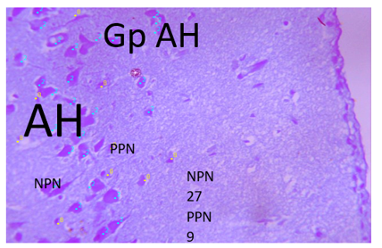
Plate 1: Photomicrograph of AH control section of hipocampus (x100(x400)(H/E) shows nissil body with active prominent pyramidal neuron (PN) in CA1 region, numbering normal pyramial neuron (NPN) 27 and pyknotic pyramaidal neuron (PPN) 9
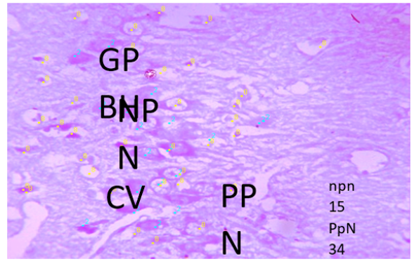
Plate 2: Photomicrograph of gp BH section of hipocampus induced with metha low dose (x100(x400)(H/E) shows severe degeneration with severe loss of pyramidal neuron (PN) , cytoplasmic vacoulation (CV) and pyknotic pyramaidal (NP) in CA1 region, numbering normal pyramial neuron (NPN) 15 and pyknotic pyramaidal neuron (PPN) 34
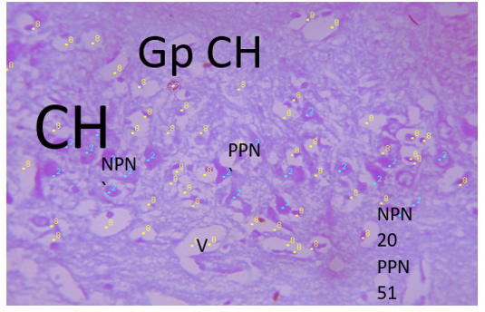
Plate 3: Photomicrograph of gp CH section of hipocampus induced with metha high dose (x100(x400)(H/E) shows severe degeneration with severe loss of pyramidal neuron (PN) , cytoplasmic vacuoles (CV) and neuclear pyknotic (NP) in CA1 region, numbering normal pyramial neuron (NPN) 20 and pyknotic pyramaidal neuron (PPN) 51
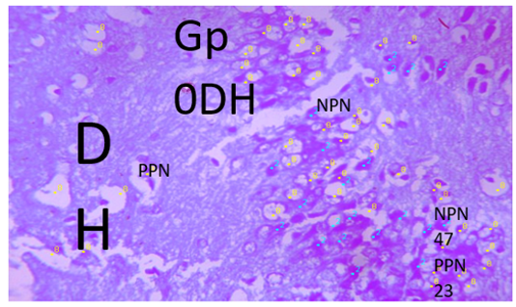
Plate 4: Photomicrograph of Gp DH section of administered with low dose vit B (x100(x400)(H/E) shows mild regeneration with moderate loss of pyramidal neuron (PN) , cytoplasmic vacuoles (CV) and neuclear pyknotic (NP) in CA1 region, numbering normal pyramial neuron (NPN) 23 and pyknotic pyramaidal neuron (PPN) 47
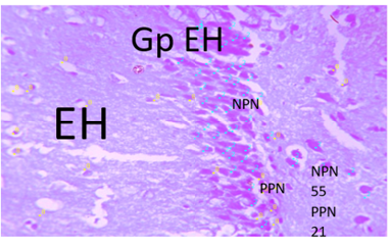
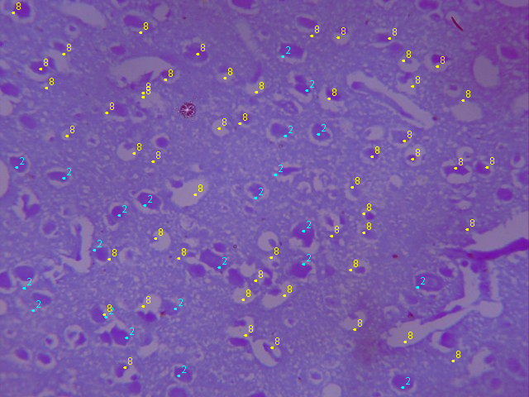
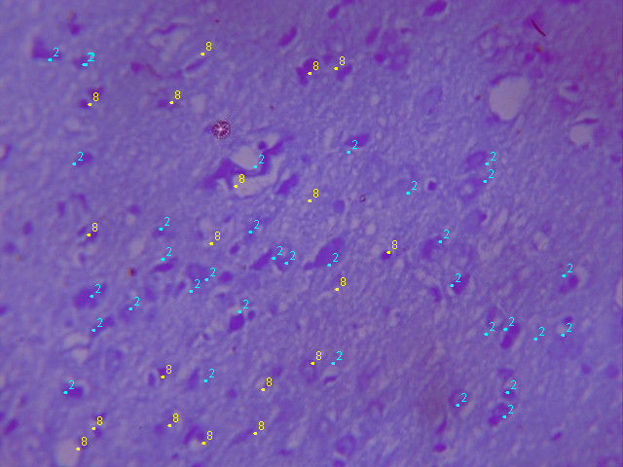
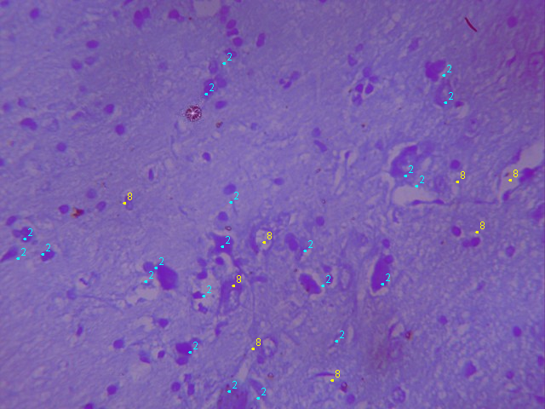
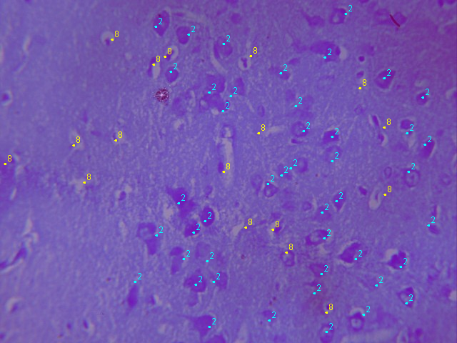
Plate 5: Photomicrograph of EH section of hipocampus administered with high dose of vit B (x100 (x400) (H/E) shows nissil body with active prominent pyramidal neuron (PN) in CA1 region, numbering normal pyramial neuron (NPN) 55 and pyknotic pyramaidal neuron (PPN) 21
NPN23
PPn42

Photomicrograph of CCT section of prefrontal cortex (PFC) indused with HIGH dose metha (x100(x400)(H/E) shows moderate degeneration with with moderate pyknotic pyramidal neuron (PPN) in CA1 region, numbering normal pyramial neuron (NPN) 24 and pyknoticpyramaidal neuron (PPN) 41

V

PPN

NPN

GP CPFCppGCPFC
PFCe GCPFC

NC 42
PC 12

Photomicrograph of DCT section of cerebral cortex administered vit B low dose (x100(x400)(H/E) shows active pyramidal neuron (PPN) in CA1 region, numbering normal pyramial neuron (NPN) 42 and mild pyknoticpyramaidal neuron (PPN) 12

GP DPFC
NPC
PPN
NpN 42
PPN 13
Photomicrograph of E CT section of prefrontal cortex (PFC) administered vit B high dose (x100(x400)(H/E) shows active pyramidal neuron (PPN) in CA1 region, numbering normal pyramial neuron (NPN) 42 and mild pyknoticpyramaidal neuron (PPN) 13

NPN
GP EPFC
PPN
PpN8
NPN 30
Photomicrograph of FCT section of prefrontal cortex (PFC) indused with treated metha and treated vit B low dose (x100(x400)(H/E) shows moderate regeneration with active pyramidal neuron (PPN) in CA1 region, numbering normal pyramial neuron (NPN) 30 and mild pyknoticpyramaidal neuron (PPN) 8

NPN
GP FPFC

PPN
NPN 45
PPN 20
Photomicrograph of GCT section of prefrontal cortex (PFC) indused with high dose metha and treated vit B high dose (x100(x400)(H/E) shows moderate regeneration with active pyramidal neuron (PPN) in CA1 region, numbering normal pyramial neuron (NPN) 45 and mild pyknoticpyramaidal neuron (PPN) 20

NPN
GPGPC GGPFC
FGGFFGGHGGgGCT
ppn
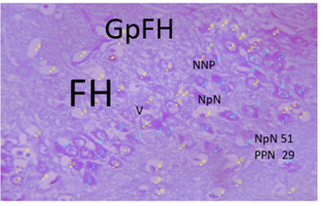
Plate 6: Photomicrograph of FH section of hipocampus induced with metha low dose and treated with low dose of vit B (x100(x400)(H/E) shows nissil body with active prominent pyramidal neuron (PN) in CA1 region, numbering normal pyramial neuron (NPN) 51 and pyknotic pyramaidal neuron (PPN) 29

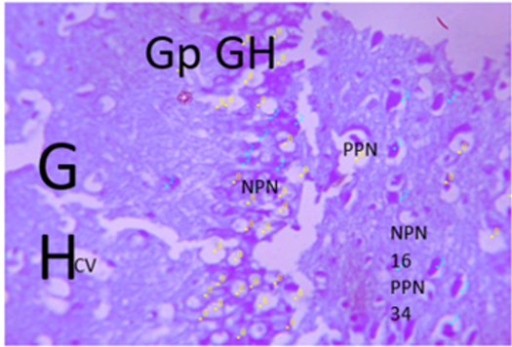
Plate 7: Photomicrograph of gp GH section of hipocampus induced with metha hign dose and treated with vit B high dose (x100(x400)(H/E) shows mild regeneration with moderate loss of pyramidal neuron (PN) , cytoplasmic vacuoles (CV) and neuclear pyknotic (NP) in CA1 region, numbering normal pyramial neuron (NPN) 16 and pyknotic pyramaidal neuron (PPN) 34
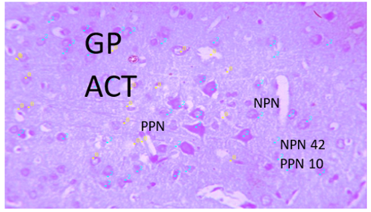
Plate 8: Photomicrograph of A CT control section of cerebral cortex (x100(x400)(H/E) shows nissil body with active prominent pyramidal neuron (PN) in CA1 region, numbering normal pyramial neuron (NPN) 42 and pyknotic pyramaidal neuron (PPN) 10
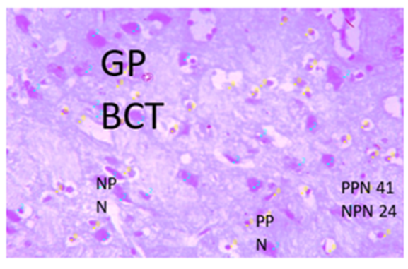
Plate 9: Photomicrograph of BCT section of cerebral cortex indused with low dose metha (x100(x400)(H/E) shows moderate degeneration with nissil body with moderate pyknotic pyramidal neuron (PPN) in CA1 region, numbering normal pyramial neuron (NPN) 24 and pyknotic pyramaidal neuron (PPN) 41
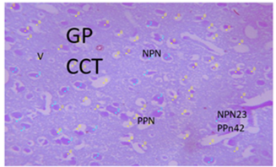
Plate 10: Photomicrograph of CCT section of cerebral cortex indused with high dose metha (x100(x400)(H/E) shows moderate degeneration with with moderate pyknotic pyramidal neuron (PPN) in CA1 region, numbering normal pyramial neuron (NPN) 24 and pyknotic pyramaidal neuron (PPN) 41
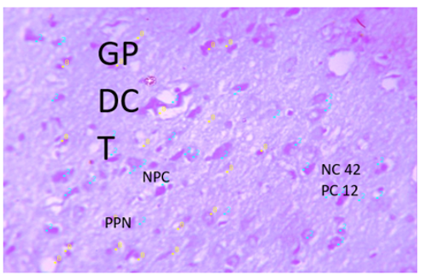
Plate 11: Photomicrograph of DCT section of cerebral cortex administered vit B low dose (x100(x400)(H/E) shows active pyramidal neuron (PPN) in CA1 region, numbering normal pyramial neuron (NPN) 42 and mild pyknotic pyramaidal neuron (PPN) 12
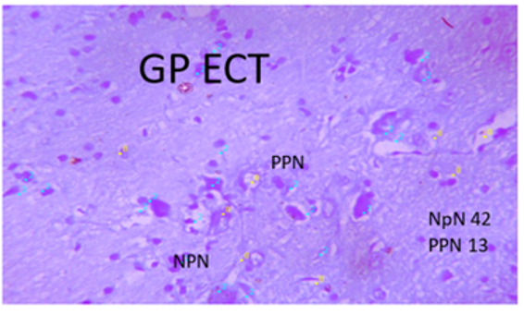
Plate 12: Photomicrograph of ECT section of cerebral cortex administered vit B high dose (x100(x400)(H/E) shows active pyramidal neuron (PPN) in CA1 region, numbering normal pyramial neuron (NPN) 42 and mild pyknotic pyramaidal neuron (PPN) 13
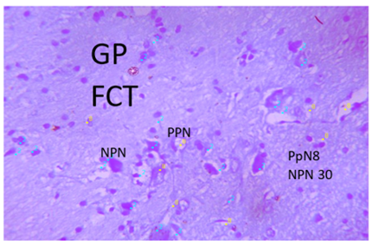
Plate 13: Photomicrograph of FCT section of cerebral cortex indused with treated metha and treated vit B low dose (x100(x400)(H/E) shows moderate regeneration with active pyramidal neuron (PPN) in CA1 region, numbering normal pyramial neuron (NPN) 30 and mild pyknotic pyramaidal neuron (PPN) 8
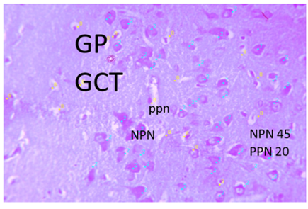
Plate 14: Photomicrograph of GCT section of cerebral cortex indused with high dose metha and treated vit B high dose (x100(x400)(H/E) shows moderate regeneration with active pyramidal neuron (PPN) in CA1 region, numbering normal pyramial neuron (NPN) 45 and mild pyknotic pyramaidal neuron (PPN) 20

4. DISCUSSION
Observation showed that at the end of administration Group A (Control) which was given feed and water only showed a significant increase in weight, suggesting a proper feeding pattern.
Elevated malondialdehyde (MDA) levels observed in Groups B (2 mg/kg methamphetamine) and C (10 mg/kg methamphetamine) confirmed that methamphetamine exposure induces oxidative stress in the brain, consistent with previous findings that link methamphetamine to neuronal oxidative damage and lipid peroxidation (Johnson & Brown, 2020). These same groups also showed a significant reduction in body weight, further supporting the systemic toxicity
of methamphetamine, which aligns with reports of weight loss and metabolic disruption in drug- intoxicated animals (Smith & Doe, 2021). Conversely, Groups D (50 mg/kg Vitamin B complex)
and E (100 mg/kg Vitamin B complex) demonstrated significant weight gain and lower oxidative stress indices, indicating the beneficial role of Vitamin B complex in supporting metabolic and neuronal stability, in agreement with studies highlighting its antioxidant and restorative effects (Doe, 2009; Johnson & Brown, 2020). Furthermore, co-administration in Groups F (2 mg/kg methamphetamine + 50 mg/kg Vitamin B complex) and G (10 mg/kg methamphetamine + 100 mg/kg Vitamin B complex) ameliorated methamphetamine-induced toxicity, as reflected by significant weight gain and improved antioxidant status relative to Groups B and C, reinforcing evidence that Vitamin B supplementation mitigates oxidative damage and promotes recovery even under drug-induced neurotoxic stress (Smith & Doe, 2021).
Increased escape latency observed in Groups B (2 mg/kg methamphetamine) and C (10 mg/kg methamphetamine) indicates impaired spatial memory and learning, confirming that methamphetamine disrupts cognitive function, consistent with previous reports linking the drug to deficits in hippocampal and prefrontal cortex performance (Doe, 2019). In contrast, Groups D (50 mg/kg Vitamin B complex) and E (100 mg/kg Vitamin B complex) demonstrated reduced escape latency, suggesting that Vitamin B complex alone may enhance cognitive performance. Moreover, the co-treatment groups, F (2 mg/kg methamphetamine + 50 mg/kg Vitamin B complex) and G (10 mg/kg methamphetamine + 100 mg/kg Vitamin B complex), showed significantly improved escape latency compared to Groups B and C, indicating that Vitamin B complex supplementation attenuates methamphetamine-induced impairments in spatial learning and memory. These findings align with evidence that B-vitamin supplementation supports neuronal function and exerts neuroprotective effects in conditions of drug-induced neurotoxicity (Johnson & Brown, 2020).
Photomicrography of the control group revealed distinct and moderately active granular cells, which aligns with the expected baseline hippocampal and prefrontal cortex morphology (Bancroft & Gamble, 2008). This provides a clear histological benchmark against which experimental groups could be compared. In Groups B (hippocampus) and C (prefrontal cortex), photomicrographs demonstrated moderate neuronal degeneration characterized by karyolysis, dissolution of nuclear material, and granular cell hyperplasia. These alterations indicate methamphetamine-induced neuronal toxicity, confirming that both low and high doses of methamphetamine negatively affect neural tissue integrity. The presence of granular cell hyperplasia may represent a compensatory mechanism in response to neuronal loss, as reported in earlier studies describing hyperplasia as an attempt by the brain to restore balance following toxic injury (Lillie, 1965). This observation is consistent with findings by Cadet & Krasnova (2009) and Rothman & Baumann (2003), who established that methamphetamine exposure, even at relatively low doses, leads to neuronal cell death, structural degeneration, and long-lasting neurotoxic effects.
In contrast, Groups D and E, which received low-dose (50 mg/kg) and high-dose (100 mg/kg)
Vitamin B complex respectively, showed only mild dissolution of neuronal cells and preservation of granular cells, suggesting that Vitamin B complex supplementation confers neuroprotection. The presence of intact granular cells in these groups highlights the potential of Vitamin B complex to stabilize neuronal membranes, enhance metabolic efficiency, and reduce oxidative burden within brain tissues. These findings align with Kennedy (2016), who emphasized the role of B vitamins in promoting neurological resilience, and Ninković & Bjugn (2011), who documented the restorative influence of B-complex vitamins on neuronal morphology in stressed models. The apparent dose-response effect further strengthens the case for Vitamin B complex, as higher doses (Group E) offered greater cellular protection than lower doses (Group D), which mirrors reports that optimal vitamin dosing enhances antioxidant and anti-inflammatory defenses.
Groups F and G, which received combined treatments of methamphetamine and Vitamin B complex, presented further evidence of this ameliorative effect. Group F (2 mg/kg methamphetamine + 50 mg/kg Vitamin B complex) demonstrated mild dissolution of neuronal
Cells alongside active granular cells, which represents a marked improvement compared to methamphetamine-only groups. This suggests that Vitamin B complex supplementation, even at low doses, can mitigate the severity of methamphetamine-induced damage and restore some level of cellular activity. Similarly, Group G (10 mg/kg methamphetamine + 100 mg/kg Vitamin B complex) exhibited moderate healing with preserved cellular activity, indicating that high-dose Vitamin B complex is capable of significantly ameliorating methamphetamine-induced neurotoxicity, even under high toxic exposure. These findings corroborate the work of Stöver&
Schlaepfer (2011) and de Oliveira & da Silva (2017), who emphasized the neuroprotective efficacy of B vitamins in mitigating neurochemical imbalances and oxidative stress-induced cell death.
Overall, the histological findings provide compelling evidence that methamphetamine intoxication exerts a dose-dependent neurodegenerative effect on the hippocampus and prefrontal cortex, while Vitamin B complex supplementation demonstrates a strong neuroprotective role by preserving cellular integrity and reducing neuronal dissolution. This protective effect appears to be both dose-dependent and synergistic, as higher doses of Vitamin B complex confer stronger protective outcomes, particularly when combined with methamphetamine exposure. The implications of these findings extend beyond experimental models, as they suggest that Vitamin B complex may hold promise as a supportive therapy in mitigating methamphetamine-induced neuronal injury, thereby contributing to strategies aimed at preserving cognitive and emotional functions often impaired in drug abuse conditions.

5. Conclusion
The findings of this study demonstrate that methamphetamine exposure exerts dose-dependent neurotoxic effects, including weight loss, oxidative stress, cognitive impairments, and histopathological damage in the hippocampus and prefrontal cortex of adult male Wistar rats. Elevated malondialdehyde levels confirmed increased oxidative stress, while reduced antioxidant
markers further highlighted the imbalance in redox status. Behavioural deficits observed in methamphetamine-intoxicated groups were consistent with neuronal damage, supporting its role in impairing spatial learning and locomotor activity.
Conversely, supplementation with Vitamin B complex exerted protective effects across multiple
parameters. Rats treated with Vitamin B complex showed improved body and brain weight indices, reduced oxidative stress, enhanced behavioural performance, and preserved neuronal architecture. These protective effects were dose-dependent, with higher doses offering greater amelioration against methamphetamine-induced damage. Notably, the combination of methamphetamine with high-dose Vitamin B complex demonstrated significant mitigation of neuronal injury, suggesting a potential therapeutic role of Vitamin B complex in combating drug-induced neurotoxicity.
Overall, the study provides compelling evidence that Vitamin B complex supplementation can reduce methamphetamine-induced neurotoxic damage, supporting its neuroprotective, antioxidant, and cognitive-enhancing properties.

CONSENT: Not applicable
Ethical Approval
Approval for this study was obtained from the Nnamdi Azikiwe University- Animal Research Ethics Committee with the approval number, NAU/AREC/2025/0086. This was carried
out in strict compliance with “National Institutes of Health Guide for the Care and Use of Laboratory Animals” (NRC 2011).
DISCLAIMER (ARTIFICIAL INTELLIGENCE)
Authurs hereby declare that no generative AI technologies such as large language models (COPLOT, ChatGPT, etc ) and text-image –generators have been used during writing or editing of this manuscript

REFERENCES
Acheson L, Williams B, Farrell M, McKetin R, Ezard N & Siefried K. (2023) Pharmacological treatment for methamphetamine withdrawal: A systematic review and meta analysis of randomised controlled trials. Drug and Alcohol Review, 42(1): 7- 19. https://doi.org/10.1111/dar.13511
Ago M., Ago K., Hara K., Kashimura S. & Ogata M. (2006) Toxicological and histopathological analysis of a patient who died nine days after a single intravenous dose of methamphetamine: a case report. Leg Med (Tokyo) 8: 235–9. https://doi.org/10.1016/j.legalmed.2006.03.002
Angrist B. M. and Gershon S. (1970) The phenomenology of experimentally induced amphetamine psychosis preliminary observations. Biol Psychiatry 2: 95–107
Armenta-Resendiz M, Assali A, Tsvetkov E, Cowan C & Lavin A. (2022) Chronic methamphetamine administration produces cognitive deficits through augmentation of GABAergic synaptic transmission in the prefrontal cortex. bioRxiv; 2022-02. https://doi.org/10.1101/2022.02.28.482382
Ayala, A., Muñoz, M. F., & Argüelles, S. (2014). Lipid peroxidation: Production, metabolism, and signaling mechanisms of malondialdehyde and 4-hydroxy-2-nonenal. Oxidative Medicine and Cellular Longevity, 360438. https://doi.org/10.1155/2014/360438
Baucum AJ 2nd, Rau KS & Riddle EL, et al. (2004) Methamphetamine increases dopamine transporter higher molecular weight complex formation via a dopamine- and hyperthermia-associated mechanism. J Neurosci. 24(13):3436-43. https://doi.org/10.1523/JNEUROSCI.0387-04.2004
Bear, M.F., Connors, B. W. & Paradiso, M.A. (2016). Neuroscience: Exploring the brain (Fourth ed.). Philadelpia: Wolters Kluwer. https://www.jblearning.com/health-sciences/neuroscience/neuroscience-exploring-the-brain-enhanced-edition/9781284211283
Beckett A. H., & Rowland M. (1965) Urinary excretion kinetics of amphetamine in man. J Pharm Pharmacol ; 17: 628– 39. https://doi.org/10.1111/j.2042-7158.1965.tb07575.x
Bell D. S. (1973) The experimental reproduction of amphetamine psychosis. Arch Gen Psychiatry, 29: 35–40. https://doi.org/10.1001/archpsyc.1973.04200010020003
Bergstrom K.G. (2008). Cutaneous clues to drug addiction. Journal of Drugs Dermatol 2008; 7(3):303-5.
Berridge C. W., & Waterhouse B. D. (2003) The locus coeruleus– noradrenergic system: modulation of behavioral state and state-dependent cognitive processes. Brain Res Brain Res Rev, 42: p. 33–84. https://doi.org/10.1016/s0165-0173(03)00143-7
Berridge C.W. (2006) Neural substrates of psychostimulant induced arousal. Neuropsychopharmacology; 31: 2332–40. https://doi.org/10.1038/sj.npp.1301159
Beyrer, C., Razak M.H, Jittiwutikarn J, et. al. (2004). Methamphetamine users in northern Thailand: changing demographics and risks for HIV and STD among treatment seeking substance abusers. Int J STD AIDS 15(10):697-704. https://doi.org/10.1177/095646240401501012
Bingham C, Beaman M, & Nicholls AJ, et al. (1998). Necrotizing renal vasculopathy resulting in chronic renal failure after ingestion of methamphetamine and 3,4- methylenedioxymethamphetamine (“ecstasy”). Nephrol Dial Transplant; 13(10):2654-5. https://doi.org/10.1093/ndt/13.10.2654
Brannan, T.A, (2004). Soundararajan S, Houghton BL. Methamphetamine-associated shock with intestinal infarction. Med. Gen. Med. ;6(4):6. https://www.ncbi.nlm.nih.gov/pmc/articles/PMC1480589/
Brown, J.M, Hanson GR, Fleckenstein AE. Cocaine-induced increases in vesicular dopamine uptake: role of dopamine receptors. J Pharmacol Exp Ther 2001;298 (3):1150-3. https://doi.org/10.1124/jpet.298.3.1150
Brown, J.M, Hanson GR, Fleckenstein AE. Methamphetamine rapidly decreases vesicular dopamine uptake. J Neurochem 2000;74(5):2221-3. https://doi.org/10.1046/j.1471-4159.2000.0742221.x
Cade, J.L, Jayanthi S., Deng, X. (2003).Speed kills: cellular and molecular bases of methamphetamine-induced nerve terminal degeneration and neuronal apoptosis. FASEB J, 17(13):1775-88. https://doi.org/10.1096/fj.03-0073rev
Caldwell, J., Dring L. G., & Williams R. T. (1972). Metabolism of (14 C) methamphetamine in man, the guinea pig and the rat. Biochem J , 129: 11–22. https://doi.org/10.1042/bj1290011
Cappell, M.S. (2004). Colonic toxicity of administered drugs and chemicals. Am J Gastroenterol 99(6):1175-90. https://doi.org/10.1111/j.1572-0241.2004.30192.x
Cervinski, M.A., Foster, J.D., & Vaughan, R.A. (2005). Psychoactive substrates stimulate dopamine transporter phosphorylation and down-regulation by cocaine-sensitive and protein kinase C-dependent mechanisms. J Biol Chem 280(49):40442-9. https://doi.org/10.1074/jbc.M501969200
Chen, J.P. (2007). Methamphetamine-associated acute myocardial infarction and cardiogenic shock with normal coronary arteries: refractory global coronary microvascular spasm. J Invasive Cardiol 19(4): E89-92.
Chen, T, Wang Y, Chen Q, Li D & Zhou J. (2008). Effects of folic acid on methamphetamine induced neurotoxicity in mice: Involvement of oxidative stress and DNA damage. Neurotoxicology, 29(5): 855-862. https://doi.org/10.1016/j.neuro.2008.07.001
Chen, Y, Wu K, Tsai H & Chen C. (2013). Treatment of methamphetamine abuse: An antibody based immunotherapy approach. Journal of food and drug analysis, 21(4): S82-S86. https://doi.org/10.1016/j.jfda.2013.09.040
Chung, A., Lyoo, I.K., Kim, S.J, et al. (2007). Decreased frontal white-matter integrity in abstinent methamphetamine abusers. Int J Neuropsychopharmacol;10(6): 765-75. https://doi.org/10.1017/S1461145706007395
Citron, B.P, Halpern, M., McCarron, M, et al. (1970). Necrotizingangiitis associated with drug abuse. N Engl J Med 283(19):1003-11. https://doi.org/10.1056/NEJM197011052831901
Connell P. H. (1958). Amphetamine Psychosis. London: Oxford University Press.
Cook C. E., Jeffcoat A. R., Hill J. M., Pugh D. E., Patetta P. K., & Sadler B. M.et al. (1993). Pharmacokinetics of methamphetamine self-administered to human subjects by smoking methamphetamine hydrochloride. Drug MetabDispos; 21: 717–23. https://doi.org/10.1016/s0090-9556(25)07478-1
Copeland, A.L, Sorensen, J.L (2001). Differences between methamphetamine users and cocaine users in treatment. Drug Alcohol Depend 62(1):91-5. https://doi.org/10.1016/s0376-8716(00)00164-2
Cretzmeyer, M, Walker, J, Hall, J.A, et al. (2007). Methamphetamine use and dental disease: results of a pilot study. J Dent Child (Chic) ;74(2):85-92.
Davis, G.G, & Swalwell, C.I. (1994). Acute aortic dissections and ruptured berry aneurysms associated with methamphetamine abuse. Forensic J ;39(6):1481-5. https://doi.org/10.1111/j.1556-4029.1994.tb01888.x
Dirkx, C.A, Gerscovich, E.O. (1998). Sonographic findings in methamphetamine-induced ischemic colitis. J Clin Ultrasound ;26(9):479-82. https://doi.org/10.1002/(sici)1097-0096(199811/12)26:9%3C479::aid-jcu9%3E3.0.co;2-k
Ellman, G. L. (1959). Tissue sulfhydryl groups. Archives of Biochemistry and Biophysics, 82(1), 70–77. https://doi.org/10.1016/0003-9861(59)90090-6
Ernst, T., Chang, L., & Leonido-Yee M, et al. (2000) Evidence for long-term neurotoxicity associated with methamphetamine abuse: A 1H MRS study. Neurology; 54(6):1344-9. https://doi.org/10.1212/wnl.54.6.1344
Farnsworth, T.L, Brugger, C.H., & Malters P. (1997). Myocardial infarction after intranasal methamphetamine. Am J Health Syst Pharm; 54(5):586-7. https://doi.org/10.1093/ajhp/54.5.586
Fleckenstein, A.E, Volz, T.J., & Riddle, E.L, et al. (2007). New insights into the mechanism of action of amphetamines. Annu Rev Pharmacol Toxicol 2007; 47:681-98. https://doi.org/10.1146/annurev.pharmtox.47.120505.105140
Garmabi, B., Mohaddes R., Rezvani, F., Mohseni, F. & Khastar, H. (2022). Erythropoietin improve spatial memory impairment following methamphetamine neurotoxicity by inhibition of apoptosis, oxidative stress and neuroinflammation in CA1 area of hippocampus. Journal of Chemical Neuroanatomy, 2022; 124: 102137. https://doi.org/10.1016/j.jchemneu.2022.102137
Goldstein, D.S, Nurnberger, Jr., J. & Simmons, S, et al. (1983). Effects of injected sympathomimetic amines on plasma catecholamines and circulatory variables in man. Life Sci; 32(10):1057-63. https://doi.org/10.1016/0024-3205(83)90110-8
Golsorkhdan, S., Boroujeni, M., Aliaghaei, A., Abdollahifar, M., Ramezanpou,r A., Nejatbakhsh, R. & Fridoni, M. (2020). Methamphetamine administration impairs behavior, memory and underlying signaling pathways in the hippocampus. Behavioural Brain Research, 2020; 379: 112300. https://doi.org/10.1016/j.bbr.2019.112300
Gonçalves, J., Baptista, S., Martins, T., Milhazes, N., Borges, F., Ribeiro, C. & Silva A. (2010). Methamphetamineinduced neuroinflammation and neuronal dysfunction in the mice hippocampus: preventive effect of indomethacin. European Journal of Neuroscience, 31(2): 315-326. https://doi.org/10.1111/j.1460-9568.2009.07059.x
Gonzales, R., Marinelli-Casey, P., Hillhouse, M., et al.(2008). Hepatitis A and B infection among methamphetamine-dependent users. J SubstAbus Treat ;35(3):351-2. https://doi.org/10.1016/j.jsat.2008.05.001
Goodchild, J.H., Donaldson, M., & Mangini, D.J. (2007). Methamphetamine abuse and the impact on dental health. Dent Today 26(5):124, 126, 128-31; [Quiz] 131.
Griffith, J. D., Cavanaugh J., Held J., Oates J. A. Dextroamphetamine. Evaluation of psychomimetic properties in man. Arch Gen Psychiatry 1972; 26: 97–100. https://doi.org/10.1001/archpsyc.1972.01750200001001
Haning, W, Goebert D. (2007). Electrocardiographic abnormalities in methamphetamine abusers. Addiction;102(Suppl 1):70-5. https://doi.org/10.1111/j.1360-0443.2006.01776.x
Haning, W., Goebert D. (2007). Electrocardiographic abnormalities in methamphetamine abusers. Addiction;102(Suppl 1):70-5. https://doi.org/10.1111/j.1360-0443.2006.01776.x
Harri, D. S., Boxenbaum, H., Everhart, E. T., Sequeira, G. Mendelson, J. E., & Jones R. T. (2003). The bioavailability of intranasal and smoked methamphetamine. Clin Pharmacol Ther 74: 475–86 https://doi.org/10.1016/j.clpt.2003.08.002
Harris, D. S., Boxenbaum, H., Everhart, E. T., Sequeira, G. Mendelson, J. E., & Jones, R. T.(2003). The bioavailability of intranasal and smoked methamphetamine. Clin Pharmacol Ther; 74: 475–86. https://doi.org/10.1016/j.clpt.2003.08.002
Hart, C. L., Gunderson, E. W., Perez, A., Kirkpatrick, M. G., Thurmond A., & Comer S. D. et al. (2008). Acute physiological and behavioral effects of intranasal methamphetamine in humans. Neuropsychopharmacology; 33: 1847– 55. https://doi.org/10.1038/sj.npp.1301578
Hart, C. L., Gunderson, E. W., Perez, A., Kirkpatrick, M. G., Thurmond, A., & Comer, S. D. et al. (2008). Acute physiological and behavioral effects of intranasal methamphetamine in humans. Neuropsychopharmacology; 33: 1847– 55. https://doi.org/10.1038/sj.npp.1301578
He, S.Y. (1995). Methamphetamine-induced toxicity in cultured adult rat cardiomyocytes. Nihon Hoigaku Zasshi; 49(3):175-86.
He, S.Y., Matoba, R. & Sodesaki, K., et. al. (1996). Morphological and morphometric investigation of cardiac lesions after chronic administration of methamphetamine in rats. Nihon Hoigaku Zasshi;50(2):63-71. https://pubmed.ncbi.nlm.nih.gov/8691651/
He, S.Y., Matoba, R., & Fujitani, N., et. al. (1996). Cardiac muscle lesions associated with chronic administration of methamphetamine in rats. Am J Forensic Med Pathol; 17(2):155-62. https://doi.org/10.1097/00000433-199606000-00014
Hiroshi, K, Akira, K., & Minori, N., et al. (2005). An autopsy case of infectious endocarditis in a methamphetamine abuser usefulness of microbiological examination. SoudLek 2; 50(2):18-22
Hogan, K.A, Staal, R.G, Sonsalla, P.K. (2000). Analysis of VMAT2 binding after methamphetamine or MPTP treatment: disparity between homogenates and vesicle preparations. J Neurochem 274(5):2217-20. https://doi.org/10.1046/j.1471-4159.2000.0742217.x
Hong, R., Matsuyama, E. & Nur, K. (1991). Cardiomyopathy associated with the smoking of crystal methamphetamine. JAMA 1991;265(9):1152-4. https://doi.org/10.1001/jama.1991.03460090100040
Hornung, J. P. (2003). The human raphe nuclei and the serotonergic system. J Chem Neuroanat; 26: 331–43. https://doi.org/10.1016/j.jchemneu.2003.10.002
Howe, C.J, Fuller, C.M, & Ompad, D.C, et. al. (2005). Association of sex, hygiene and drug equipment sharing with hepatitis C virus infection among non-injecting drug users in New York City. Drug Alcohol Depend. 79(3):389-95. https://doi.org/10.1016/j.drugalcdep.2005.03.004
Imam, S.Z, Ali, S.F. (2000). Selenium, an antioxidant, attenuates methamphetamine induced dopaminergic toxicity and peroxynitrite generation. Brain Res; 855(1):186-91. https://doi.org/10.1016/s0006-8993(99)02249-0
Imam, S.Z, Ali, S.F. (2001). Aging increases the susceptibility to methamphetamine-induced dopaminergic neurotoxicity in rats: correlation with peroxynitrite production and hyperthermia. J Neurochem ;78(5):952-9. DM, February 2012 https://doi.org/10.1046/j.1471-4159.2001.00477.x
Imam, S.Z, el-Yazal J., Newport, G.D., et. al. (2001). Methamphetamine-induced dopaminergic neurotoxicity: role of peroxynitrite and neuroprotective role of antioxidants and peroxynitrite decomposition catalysts. Ann NY AcadSci1; 939:366-80. https://doi.org/10.1111/j.1749-6632.2001.tb03646.x
Islam, M.N., Jesmine, K., Kong, S.N., & Molh, A, et. al. (2009). Histopathological studies of cardiac lesions after long term administration of methamphetamine in high dosage—Part II. Leg Med (Tokyo);11(Suppl 1):S147-50. https://doi.org/10.1016/j.legalmed.2009.02.035
Ito, Y, Jono, H. & Shojo H. (1998).Ultrastructural findings of the endothelial cells in pancreatic lesions after chronic administration of methamphetamine in rats. Kurume Med J; 45(3):24 https://doi.org/10.2739/kurumemedj.45.243
Janero, D. R. (1990). Malondialdehyde and thiobarbituric acid-reactivity as diagnostic indices of lipid peroxidation and peroxidative tissue injury. Free Radical Biology and Medicine, 9(6), 515–540. https://doi.org/10.1016/0891-5849(90)90131-2
Joca, L, Zuloaga D., Raber, J.& Siegel, J. (20140. Long-term effects of early adolescent methamphetamine exposure on depression-like behavior and the hypothalamic vasopressin system in mice. Developmental neuroscience, 36(2): 108-118. https://doi.org/10.1159/000360001
Jomova, K, Raptova, R., Alomar, S., Alwasel, S., Nepovimova, E, Kuca, K. & Valko M. (2023). Reactive oxygen species, toxicity, oxidative stress, and antioxidants: Chronic diseases and aging. Archives of toxicology, 97(10): 2499-2574. https://doi.org/10.1007/s00204-023-03562-9
Jones C. (2020). Patterns and characteristics of methamphetamine use among adults—United States, MMWR. Morbidity and mortality weekly report, 69: 2015–2018. https://doi.org/10.15585/mmwr.mm6912a1
Moshiri, M., Hosseiniyan, S., Moallem, S., Hadizadeh, F., Jafarian, A., Ghadiri, A. & Seifi, M. (2018). The effects of vitamin B12 on the brain damages caused by methamphetamine in mice. Iranian Journal of Basic Medical Sciences, 21(4): 434. https://doi.org/10.22038/IJBMS.2018.23362.5897
Moszczynska, A. (2016). Neurobiology and clinical manifestations of methamphetamine neurotoxicity. The Psychiatric times, 33(9): 16. https://www.ncbi.nlm.nih.gov/pmc/articles/PMC6135110/
Uyuimam, S, Itzhak Y, Cadet, J, Islam, F. Slikker Jr. W & Ali, S. (2001). Methamphetamine induced alteration in striatal p53 and bcl-2 expressions in mice. Molecular brain research, 91(1-2): 174-178. https://doi.org/10.1016/s0169-328x(01)00139-5

