Identification of barriers and facilitators to compliance to Mass Drug Administration for Soil-Transmitted Helminthiasis among adolescent girls and women of reproductive age in Bukavu, DRC, 2024: Implementation research
Original Research Article

.
.

ABSTRACT

Soil-transmitted helminthiasis (STH) is a neglected tropical disease requiring mass drug administration (MDA) for effective control. Depiste years of MDA implementation the prevalence of STH is still high in Bukavu. This study aims to identify barriers and facilitators to MDA compliance among adolescent girls and women of reproductive age (WRA) in Bukavu, where sociocultural, economic, and educational factors may hinder its adoption.
We conducted a cross-sectional study using a mixed-methods approach in the Kadutu Health Zone, Bukavu (DRC), from September 2024 to March 2025. The quantitative component determined the proportion of WRA adhering to MDA, analyzing their sociodemographic characteristics and health education background. The qualitative component provided an in-depth understanding of barriers and facilitators to compliance through key informant interviews (KII) and focus group discussions (FGD).
A total of 487 WRA (175 adolescent girls and 312 adult women) were included in the quantitative study. Additionally, 13 key informant interviews and 2 FGD were conducted for the qualitative study. Quantitative data were analyzed using R 4.4.1, applying descriptive, bivariate, and multivariate analyses. Qualitative data was processed using thematic coding in NVivo, followed by narrative analysis.
Among those surveyed, 64.89% of participants adhered to MDA, while 10.88% refused. Key factors influencing compliance included age (p = 0.005), education level (p = 0.040), prior MDA experience (p= 0.000), and quality of instructions received (p = 0.001). Qualitative analysis identified several barriers, including poor awareness, misconceptions about side effects, limited autonomy, and reluctance among inexperienced beneficiaries.
Strengthening health education and engaging community and religious leaders could improve MDA compliance. Tailored communication strategies and better motivation for community drug distributors may enhance program effectiveness.

Keywords: Soil-Transmitted Helminthiasis, Compliance, Adolescent, Women's, Factors, DRC.

INTRODUCTION
Soil-transmitted helminthiasis (STH) is a parasitic infection caused by nematodes that are transmitted through the soil (Nundu et al., 2014). It is classified as a neglected tropical disease (NTD). World Health Organization (WHO), recommends the mass drug administration (MDA) as pillar strategy for STH elimination through the anthelmintic administration, an essential approach for its elimination as a public health problem (WHO, 2018). MDA targets children of 1 to 14 years and women of 15 to 49 years. It is recommended annual or biannual deworming through a single dose of 400 mg of albendazole (ALB) or 500 mg of mebendazole for all at-risk individuals in areas where STH prevalence exceeds 20%. Women of child-bearing age are treated with the same medicines through antenatal care (Kalenga et al., 2003).
The success of MDA relies on compliance, meaning the extent to which the population perceives and follows the medication guidelines (individual factors). Programmatic factors, such as service quality, influence compliance to MDA, as demonstrated in fidelity dimension analyses (Kulandaipalayam, 2023; WHO, 2018).
The biological characteristics of adolescent girls and women of reproductive age (WRA) expose them to greater vulnerability to STH-related morbidity. These individuals experience blood loss during menstruation, which is exacerbated by helminth infections, leading to an increased risk of iron-deficiency anemia. This condition contributes to maternal and infant mortality and low birth weight in newborns (WHO, 2018, 2021).
More than 500 million WRA living in endemic areas require anthelmintic treatment to prevent STH (WHO, 2021). These infections affect nearly a quarter of the global population, with an estimated burden of 39 million Disability-Adjusted Life Years (DALYs) for Ancylostoma duodenale, Ascaris lumbricoides, and Trichuris trichiura, surpassing that of malaria (35.7 million DALYs)(anafrimed, 2009). In 2018, it was estimated that 49 countries required consecutive MDA rounds with at least 75% coverage. WHO also recommends an impact assessment after five years of chemoprevention to adjust treatment frequency based on the results obtained (Ntumba & Akilimali, 2024; WHO, 2023a).
In Democratic Republic of Congo (DRC), according to the 2021 report of the National Program for the Control of Neglected Tropical Diseases (PNLMTN), 291 Health Zones (HZs) have prevalence rates above the intervention threshold, with 93 HZs under treatment, though with numerous implementation irregularities (PNLMTN_CTP, 2022). Impact survey results on STH after five years are not yet available. However, before chemoprevention was launched in 2015 in two pilot provinces, prevalence rates ranged from 68.8% to 80% (Kabore et al., 2017). In comparison, a 2022 impact survey in Rwanda, a neighboring country, revealed prevalence rates between 20% and 50%, indicating more effective control (WHO, 2023b).è
Although the national coverage rate in the DRC is high (80%), the persistence of STH suggests adherence issues. WRA are likely less adherent to MDA than children due to multiple factors. They may not perceive themselves as at risk or may prioritize other responsibilities over their health. Additionally, misconceptions and erroneous beliefs may reinforce their reluctance (KAMARIZA, 2015; Lynch, 2022). In contrast, children are supervised by parents or schools, which enhances compliance (J-PAL, 2022).
In the DRC, the fight against STH is integrated with the lymphatic filariasis (LF) elimination program through an integrated strategy. This approach consists of administering anthelmintics to all at-risk groups, except pregnant women. During MDA, special attention is required for WRA, ensuring they are not pregnant. If their gestational status or gestational age is uncertain, it is recommended not to administer the medication.
In South Kivu, the provincial health division coordinates efforts to control NTDs, including STH, for which few studies have been conducted. In Kadutu Health Zone, albendazole coverage reached 81% in 2022 within the community, but the compliance rate was not reported (ZS Kadutu, 2022). Compliance in MDA is crucial, as poor adherence threatens the success of STH control efforts (Akinsolu & Abodunrin, 2023; Nath et al., 2019). The deployment of MDA in Kadutu encounters several obstacles. The lack of awareness limits the understanding of the treatment's benefits, while mistrust and misconceptions, particularly the belief that albendazole is an abortifacient, contribute to beneficiary reluctance.
Encouraging beneficiary populations to accept and adhere to STH-related interventions requires a participatory and culturally adapted approach to maximize effectiveness. Furthermore, gender dynamics and their interaction with other social variables must be considered, as they influence health inequalities and adherence to interventions (WHO, 2020). Although MDA interventions are widely accepted by policymakers, certain social groups may resist participation.
This study is justified by the need to explore and understand the socio-cultural, behavioral, and educational factors influencing MDA compliance among WRA, to adapt the strategy and improve its effectiveness. In 2018, the WHO guideline development group and external experts called for further research on the use of chemoprevention for STH. They emphasized the need to explore adherence-related factors such as values, attitudes, and preferences of WRA, highlighting the importance of health education in improving MDA compliance rates (WHO, 2018). This study aims to explore the barriers and facilitators related to STH MDA in WRA with the goal to adapt MDA strategies to better meet the specific needs of WRA and enhance its impact.

material and methods

Study setting and design
This study is a cross-sectional study carried out from September 2024 to March 2025. Data was collected between December 2024 and January 2025. It adopted a mixed-methods approach, combining quantitative and qualitative methods to explore the barriers and facilitators to compliance to MDA for STH among adolescent girls and WRA in Bukavu. It was conducted in the Kadutu Health Zone (HZ) in Bukavu, DRC. The HZ consists of 13 health areas and 79 avenues, of which 30 were selected as clusters during sampling.
Despite the presence of qualified healthcare personnel, Kadutu faces significant environmental challenges that facilitate the transmission of STH. The deployment of MDA in Kadutu encounters several obstacles. The lack of awareness limits the understanding of the treatment's benefits, while mistrust and misconceptions, particularly the belief that albendazole is an abortifacient, contribute to beneficiary reluctance.

Theoretical model and conceptual framework
A combination of the Consolidate Framework of Implementation Research (CFIR) and the Health Compliance Model (HCM) enabled us to identify the key elements to explore in this study. By integrating both frameworks, this study develops a holistic approach to understand how different implementation factors influence treatment compliance among beneficiaries (Figure 1). This approach allowed for a comprehensive analysis of the contextual, organizational, and individual dimensions affecting MDA compliance.
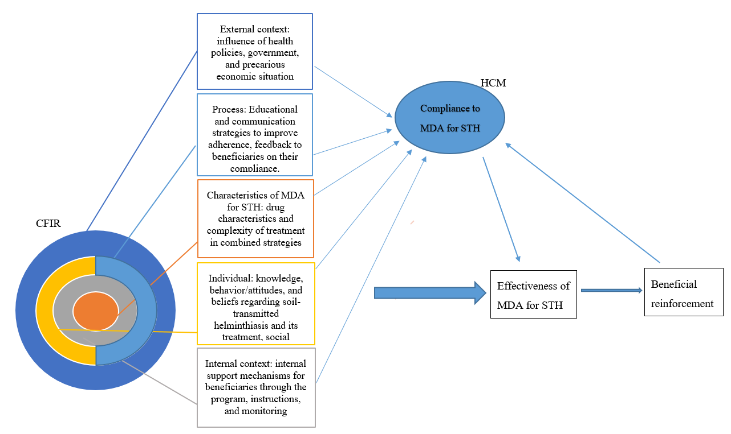
Figure 1: Conceptual framework of MDA/STH compliance considering contextual dimensions of implementation research based on CFIR.

Conceptual framework explanation (Figure 1)
- Intervention characteristics: Complexity of treatment (co-administration of LF/STH drugs), dosage, taste, color, packaging, quality of instructions, perceived benefits (health improvement, symptom reduction), and physical drawbacks (side effects).
- External context: Influence of health policies, government support, financial benefits, and economic factors.
- Internal context: Quality of interaction between beneficiaries and the program, particularly through community drug distributors (clarity of communication, understanding of instructions).
- Individual characteristics: Social and family support, decision-making autonomy, perceived social benefits (recognition by others), beliefs about illness and treatment efficacy, perceived health status, cost perception, satisfaction, fear of side effects, barriers to MDA, and socio-demographic factors.
- Implementation process: Strategies for education and communication to improve adherence, post-MDA follow-up, and beneficiary feedback on treatment adoption.
Intersectional gender perspective:
This study acknowledges that women of reproductive age (WRA) in Bukavu are not a homogeneous group. Their experiences are shaped by multiple identity factors, including socio-economic status, education, religion, social roles, and family dynamics in decision-making. Understanding how these factors intersect is crucial to assessing MDA compliance at both subgroup and population levels.

Study population
The study included adolescents (aged 15 and above) and adult women (up to 49 years old) residing in the Kadutu Health Zone, as well as key informants such as the health zone supervisor, community leaders, and drug distributors. Participation was voluntary, requiring informed consent and assent for minors. Exclusion criteria included individuals unable to respond due to severe cognitive impairments or those unavailable during the survey period for personal or professional reasons.

Quantitative component
The women of reproductive age (WRA) in Kadutu HZ, aged 15 to 49 years, constitute the target population of this study. They represent 21% of the total population, approximately 90,295 individuals in 2023. Participants were selected based on inclusion criteria respecting diversity for perfect sampling.

Sampling and sample size
The study employed a two-stage cluster sampling method. Thirty avenues were randomly selected from the 13 health areas of Kadutu. Household selection followed a route method, where a pen was tossed in a zigzag manner to indicate the direction for selecting additional households. Each identified household had to include at least one WRA meeting the inclusion criteria.
The sample size was calculated using Epi-Info 7.2.5, incorporating a 95% confidence level, a 5% margin of error, and a design effect of 1.8. The initial calculation yielded 390 participants, but a 10% adjustment was made to account for potential data gaps, increasing the required sample size to 429 participants. Ultimately, 487 WRA were included in the study, ensuring sufficient statistical power.

Data collection and analysis
Data was collected using a structured questionnaire administered via KoboCollect.
The variables studied included: demographic characteristics (age, marital status, education level, socioeconomic status and profession), access to health education, knowledge of MDA and STH, MDA schedule awareness, prior MDA experience, quality of instructions received, need for further learning on MDA/STH, and compliance.
Quantitative data were analyzed using R 4.4.1, with descriptive, bivariate, and multivariate analyses to identify factors associated with compliance.

Qualitative component
To gain deeper insights into participants' perceptions and experiences, individual interviews (KII) and focus group discussions (FGD) were conducted. 13 key informant interviews (KII) targeting 6 community leaders, the health zone supervisor and 6 community health workers (CHWs); then 2 FGDs with 12 participants (the first with 6 adolescent girls and the second with 6 adult women). The FGD participants were purposively selected, ensuring socio-demographic diversity and varied experiences with MDA for STH.

Qualitative themes
The qualitative analysis focused on several key themes, including:
Cultural values and perceptions: Social and family support, decision-making autonomy, perceptions of albendazole and MDA.
Individual preferences: Mode of treatment administration, distribution sites, health education strategies.
Attitudes toward MDA: Perception of benefits and drawbacks, barriers to adherence (fear of side effects, social pressures, acceptability among community distributors).
Interviews and FGDs were recorded, transcribed, and analyzed using NVivo, employing an inductive and deductive thematic analysis approach.

Data collection and analysis
Qualitative data were recorded, transcribed, and thematically analyzed using NVivo, enabling an in-depth exploration of cultural, social, and logistical barriers to MDA compliance. The triangulation of methods, data sources, results, and theoretical triangulation provided a comprehensive understanding.

Ethical considerations and funding
The study was approved by the Ethics Committee of the Official University of Bukavu (UOB) (N° UOB/CEM/021/2024) and received authorization from local health authorities. Informed consent was obtained from participants after a detailed explanation of the study’s objectives and procedures. To ensure confidentiality, data were anonymized and securely stored. All procedures were carried out in accordance with the relevant guidelines and regulations. The study was funded by Tropical Diseases Research/ World Health Organization – University of Sciences, Techniques and Technologies of Bamako (TDR/WHO-USTTB), ensuring its independence and impartiality.

results

Quantitative study

Descriptive statistics

Socio-demographic characteristics
The study included sample of 487 women of reproductive age (WRA). Socio-demographic characteristics indicated that most participants were adult women, single, and had a secondary level of education. The dominant occupational group was students. Economically, most participants were in a low or middle economic status (Table 1).
The mean age of participants was 25.14 years (95% CI: 24.35 – 25.93), with a standard deviation of 8.84 years and a median of 23 years.
Adolescents (15–19 years) were 175 participants and represented 35.93% (95% CI: 31.67 – 40.37). Adult women (20–49 years) were 312 participants and corresponded with 64.07% (95% CI: 59.63 – 68.33)

Table 1: Distribution of WRA based on sociodemographic characteristics
Category | Count | Percentage (%) | 95% CI
Age Group
<20 years | 175 | 35.93 | 31.67 – 40.37
20 – 49 years | 312 | 64.07 | 59.63 – 68.33
Marital Status
Single | 299 | 61.40 | 56.91 – 65.74
Married | 172 | 35.32 | 31.07 – 39.75
Divorced | 6 | 1.23 | 0.45 – 2.66
Widowed | 10 | 2.05 | 0.99 – 3.74
Occupation
Civil Servant | 19 | 3.90 | 2.36 – 6.03
Student/Pupil | 198 | 40.66 | 36.26 – 45.17
Trader | 76 | 15.61 | 12.50 – 19.14
Housewife | 106 | 21.77 | 18.18 – 25.70
Unemployed | 36 | 7.39 | 5.23 – 10.09
Others | 52 | 10.68 | 8.08 – 13.77
Education Level
No formal education | 25 | 5.13 | 3.35 – 7.49
Primary | 46 | 9.45 | 7.00 – 12.40
Secondary | 300 | 61.60 | 57.12 – 65.94
University | 116 | 23.82 | 20.10 – 27.86
Economic Status
Low | 151 | 31.01 | 26.92 – 35.32
Medium | 174 | 35.73 | 31.47 – 40.16
High | 38 | 7.80 | 5.58 – 10.55
Abstention | 124 | 25.46 | 21.65 – 29.58

Over one-quarter of participants had lived in their current location for less than two years, indicating recent mobility, while the tree -quarter had been residents for at least two years, suggesting a relatively stable population (Table 2).
A minority of participants rated their living conditions as poor, identifying them as a potentially vulnerable group. Among the participants, 64.48% (95% CI: 60.05 – 68.73) described their living conditions as average.
Catholics formed the largest religious group with 52.36% (95% CI: 47.82 – 56.87) of the surveyed, Protestants represented 32.03% (95% CI: 27.91 – 36.38) and Muslims constituted only 2.46% (95% CI: 1.28 – 4.26).

Table 2: Distribution of WRA based on sociodemographic characteristics
Category | Count | Percentage (%) | 95% CI
Residential status
Less than 2 years | 130 | 26.69 | 22.81 – 30.86
2 years and more | 357 | 73.31 | 69.14 – 77.19
Living conditions
Poor | 50 | 10.27 | 7.72 – 13.31
Average | 314 | 64.48 | 60.05 – 68.73
Good | 123 | 25.26 | 21.46 – 29.36
Ethnicity
Bangubangu | 9 | 1.85 | 0.85 – 3.48
Bembe | 14 | 2.87 | 1.58 – 4.78
Fulero | 6 | 1.23 | 0.45 – 2.67
Havu | 30 | 6.16 | 4.19 – 8.68
Kongo | 6 | 1.23 | 0.50 – 2.66
Lega | 91 | 18.69 | 15.32 – 22.44
Luba | 3 | 0.62 | 0.13 – 1.79
Nande | 13 | 2.67 | 1.43 – 4.52
Nyintu | 2 | 0.41 | 0.05 – 1.48
Shi | 294 | 60.36 | 55.87 – 64.74
Tembo | 14 | 2.87 | 1.58 – 4.78
Tutsi | 5 | 1.03 | 0.33 – 2.38
Religion
Catholic | 255 | 52.36 | 47.82 – 56.87
Protestant | 156 | 32.03 | 27.91 – 36.38
Muslim | 12 | 2.46 | 1.28 – 4.26
Others | 64 | 13.14 | 10.27 – 16.47

Health education and awareness
Among the participants, 67.35% (95% CI: 62.99 – 71.50) were aware of MDA and STH, indicating, 32.65% (95% CI: 28.50 – 37.01) lacked knowledge.
Sensitization campaigns were the main source of information, cited by 40.66% (95% CI: 36.26 – 45.17) of participants. Only 9.65% (95% CI: 7.18 – 12.63) learned about MDA in school. As source of information, health professionals and media, with respectively (9.24% and 7.19%), played in the information. In 32.65% (NA) lacked access to any information source.
As experience with MDA, 69.82% (95% CI: 65.52 – 73.86) had previously participated in an MDA campaign and 30.18% (95% CI: 26.14 – 34.48) had never participated.
For the number of MDA treatments received, 15.20% (95% CI: 12.12 – 18.70) participated in only one MDA round, 54.83% (95% CI: 50.28 – 59.31) received multiple MDA treatments and 29.98% (NA) had never participated.
For the knowledge of MDA schedule, 48.67% (95% CI: 44.14 – 53.20) understood that MDA is administered semi-annually, but this awareness needs reinforcement. Participants in 41.07% (95% CI: 36.66 – 45.58) were unaware of the MDA schedule.
For quality of instructions received during MDA, 10.88% (95% CI: 8.26 – 13.99) rated the instructions as very good, 20.74% (95% CI: 17.22 – 24.62) found the instructions good and 25.05% (95% CI: 21.26 – 29.15) perceived the instructions as poor.
For the willingness to learn, 78.03% (95% CI: 74.08 – 81.63) expressed interest in learning more about MDA and STH.

The proportion of MDA adherent among WRA was 64.89% (95% CI: 60.46 – 69.13), while 10.88% (95% CI: 8.26 – 13.99) were non-adherent. Additionally, 24.23% (95% CI: 20.49 – 28.29) had never participated in MDA, indicating a coverage gap.

Analytical statistics
For age and compliance, the median age of non-adherent participants was 19 years, compared to 23 years among adherents. Adult women (20-49 years) were 42% more likely (OR = 0.42; 95% CI: 0.23 – 0.76, p = 0.005) to adhere compared to adolescents (<20 years).
Assesing the key factors influencing compliance
Educated participants were nearly 3 times more likely (OR = 2.98; 95% CI: 1.08 – 8.21, p = 0.040) to adhere. Those with low economic status were 53% less likely (OR = 0.47; 95% CI: 0.26 – 0.87, p = 0.018) to adhere. Those with experience were 40 times more likely (OR = 39.41; 95% CI: 15.66 – 99.20, p < 0.001) to adhere.
Two logistic regression models were analyzed, confirming that prior MDA experience, education, and knowledge of MDA schedule significantly influenced compliance (Table 3).

Model 1 includes binary variables: age group, binary education level, binary economic status, information on MDA and STH, prior experience with MDA, and binary knowledge of MDA schedule. Model 2 includes: age group, education level, economic status, information on MDA and STH, prior experience with MDA, and binary knowledge of the MDA schedule.
For both models, moderate collinearity is observed (1 < VIF < 5). AIC was respectively 214.34 and 220.66. Hosmer-Lemeshow test also was respectively 0.75 and 0.93, indicating a good fit to the data.
Model 1 indicate that non-educated participants are 24% less likely to adhere to MDA compared to educated ones (p = 0.041). Women aged 20–49 are 2.36 times more likely to adhere to MDA compared to those under 20 (p = 0.041). Participants informed beforehand are 4.08 times more likely to adhere to MDA (p = 0.0009). And participants with prior experience are 24.72 times more likely to adhere compared to those without (p < 0.001).
Model 2 indicated that university-educated participants are 6.40 times more likely to adhere to MDA than non-educated ones (p = 0.026). Informed participants are 3.45 times more likely to adhere to MDA (p = 0.004). Participants with prior experience are 31 times more likely to adhere (p < 0.001).

Table 3: Summary of the Results of Models mod.1 and mod.2
Variables | OR [95% CI] /mod.1 | p /mod.1 | OR [95% CI] /mod.2 | p /mod.2
Intercept | - | 4.51e-05 *** | - | 0.99
Education Level
Non-educated*
Primary | - | - | 2.25 [0.43 – 11.73] | 0.35
Secondary | - | - | 3.48 [0.84 – 14.46] | 0.09
University | - | - | 6.40 [1.23 – 33.17] | 0.03 *
Educated | 0.24 [0.06 – 0.94] | 0.041 * | - | -
Age Group
< 20years*
20–49years | 2.36 [1.04 – 5.37] | 0.041 * | 2.11 [0.89 – 4.99] | 0.09
Economic Status
High*
Low | - | - | 1.28 [0.27 – 6.02] | 0.76
Medium | - | - | 0.97 [0.21 – 4.50] | 0.97
Absent | - | - | 0.95 [0.17 – 5.41] | 0.95
High vs Low* | 1.16 [0.50 – 2.69] | 0.73 | - | -
TDM Information
no*
yes | 4.08 [1.82 – 9.13] | 0.0009 *** | 3.45 [1.49 – 8.00] | 0.004 **
Prior TDM Experience
no*
yes | 24.69 [6.47 – 94.16] | 1.16e-09 *** | 31.08 [10.20 – 94.66] | 2.54e-09 ***

*: Statistically significant at the 0.05 level (p ≤ 0.05).
**: Highly significant at the 0.01 level (p ≤ 0.01).
***: Very highly significant at the 0.001 level (p ≤ 0.001)

Qualitative study

Identification of main themes
The qualitative analysis of individual in-depth interviews (IDI) and focus group discussions (FGD) allowed for the identification of several key themes, categorized into three major areas including cultural values and perceptions, preferences and attitudes and barriers to MDA compliance
Additionally, other emerging sub-themes were identified, including the influence of education level, the role of religious and educational leaders, resource and infrastructure limitations, mistrust, and doubts.

Narrative analysis
The qualitative findings from the FGDs and IDIs highlight multiple factors influencing compliance to MDA/STH.

Cultural values and perceptions
Cultural values, beliefs, and perceptions played a crucial role in the acceptance or rejection of MDA, significantly impacting compliance.
Family and social support can facilitate better adherence and higher participation rates. Some participants emphasized strong family support, especially when community health workers (CHWs) took the time to explain the importance of treatment.
"The population appreciates mass treatment… Even men and older adults are now asking for it." (Interview with a community health worker).
Conversely, some women reported negative influences from their communities, fueled by mistrust, misinformation, and fear.
"Sometimes, when they distributed the drugs, the community said that if you take them, you might get sick."(FGD)
Decision-making autonomy varies across age groups. While adult women generally have the freedom to make health decisions, adolescent girls and married women often need approval from parents or spouses, which can hinder compliance especially if key authority figures hold negative views on MDA.
"Adult women can freely make decisions, while minors have to wait for their parents’ permission". (Interview with a community leader).
The level of discussion about MDA within families and communities varies significantly. Some women reported never discussing it, while others highlighted the importance of sharing health information. The lack of dialogue can hinder awareness and reinforce misinformation.
"Personally, I never talk about it with my family or friends."(FGD)
Overall, the MDA campaign was perceived as an important public health initiative with good community acceptance.
"The treatment is well-received because it addresses a real health problem… there is a high demand for deworming medication."(Interview with the health zone supervisor)
Most respondents acknowledged its positive impact, particularly in reducing parasitic infections.
"Those distributing the drugs are doing excellent work, and they are welcomed by the community." (Interview with a community leader)
However, community involvement remains essential to strengthening this positive perception. Some misconceptions persist, particularly the belief that albendazole is an abortifacient, which negatively affects adherence among women of reproductive age.
"There are rumors that albendazole can cause miscarriages, and some young girls even use it to induce abortion." (Interview with a community health worker).
Mistrust regarding the origin and free distribution of the medication also emerged, with some questioning why the drugs are free while other medical treatments require payment.
"Some fear that the treatment might cause sterility or be part of a hidden family planning program." (FGD)
Others suggested that the government should also provide food assistance alongside the deworming medication.
"Don’t just bring us deworming drugs… We have many other health problems. Bring us food as well, so we don’t have to take medicine on an empty stomach." (FGD)
Past experiences with MDA strongly influenced participants' current acceptance or reluctance. Some women who had previously taken albendazole reported health improvements, while others mentioned unpleasant side effects, affecting their future willingness to adhere.
"Since they started distributing these medicines, some diseases have started to disappear." (FGD)

Participant preferences
Preferences regarding drug administration and distribution methods play a direct role in acceptance and adherence.
Taste, color, and texture significantly influence acceptance. Bitter or dark-colored pills are often rejected, while those with fruity flavors and lighter colors are better accepted.
"It’s better if the medicine isn’t bitter… That’s why Albendazole is accepted."(FGD)
Packaging concerns were also raised, as some participants disliked the way CHWs handled bulk medications. "Please bring blister-packed tablets instead of loose pills in bottles. Sometimes, the way they handle them is unappealing."(FGD)
Inadequate instructions were commonly reported. Rushed CHWs often failed to properly explain the medication's use and effects. "There are no clear instructions. We need more guidance." (FGD)
Distribution location preferences varied. Some preferred home delivery to ensure the entire family received treatment, while others suggested public distribution in schools, markets, or churches to increase coverage.
"We prefer that the medicine is brought to where we are." (FGD)
Concerns about CHW qualifications were expressed. Some were perceived as unreliable, leading to calls for better training and selection. "Some CHWs are not really suited for this job." (FDG)
Post-administration follow-up was almost nonexistent. Many participants were unaware of any monitoring visits.
"I didn’t even know that there were supposed to be follow-up visits after taking the medicine." (FGD)
Preferred communication channels included radio, visual aids (posters, videos), and social media. "The radio is the best way to communicate." (FGD)

Attitudes toward MDA and barriers to compliance
Participants' attitudes toward MDA were influenced by expected benefits, perceived side effects, and structural or cultural barriers.
Perceived benefits included reduced parasitic infections, improved overall health and lower medical costs
"Since they started distributing these medicines, some diseases have disappeared. Children no longer vomit worms…" (FGD)
The side effects perceived were a major deterrent, with some participants reporting nausea, vomitingnand abdominal pain
"It causes nausea, vomiting, and stomach pain."(FGD)
It is reported that refusal to take MDA was influenced by rumors, subjective experiences of side effects, religious objections, community misinformation, food insecurity, conspiracy theories about the program’s true purpose, and distrust of CHWs (Omedo et al., 2012).
Despite this, most participants trusted the program, particularly because health professionals themselves take the medication." I trust it because even doctors and nurses use it." (FGD)
However, a small minority remained skeptical.

Several key barriers to adherence were identified including:
Poor sensitization: "Some CHWs don’t give clear explanations." (FGD)
Fear of side effects: "I felt dizzy after taking the medicine." (FGD)
Limited accessibility: "We don’t have enough stock to cover everyone." (Interview with a CHW)
Reluctance among beneficiaries: "I only take medicine when I’m sick." (FGD)

discussion
The mixed-method approach used in this study allows for a triangulation of quantitative and qualitative results, providing a deeper understanding of MDA compliance for soil-transmitted helminthiasis (STH). The findings indicate that 64.89% of WRA adhered to MDA, while 10.88% did not, and 24.23% had never participated in an MDA campaign.
These results suggest that the actual coverage rate is lower than reported and that community drug distributors (CDDs) do not always ensure direct drug intake during delivery, contrary to MDA guidelines.

Sociodemographic profile and MDA compliance
The quantitative analysis reveals that adult woman (20–49 years old) are significantly more compliant than adolescents (15–19 years old). A similar trend was identified in the case-control study by Kulandaipalayam N. et al., where women aged 25–34 years showed the highest compliance(Kulandaipalayam, 2023).
Adult women were 42% more likely to adhere to MDA. This pattern is confirmed by qualitative findings, where adolescents often require parental consent before taking medication, limiting their decision-making autonomy.
"Adult women can freely make health decisions, while minors must wait for parental permission."
Additionally, educated women were nearly three times more likely to comply with MDA. This is supported by previous research highlighting the crucial role of education in treatment adherence (KAMARIZA, 2015; WHO, 2018). Similar findings were reported in rural Burundi, by Kamariza M. that helminthiasis persisted in 72% of illiterate individuals (KAMARIZA, 2015).
Economic status also influences MDA compliance. Women with a low economic status were 53% less likely to comply. This correlation may be linked to low education levels, misconceptions about treatment, and poor understanding of MDA objectives.
According to Cosse & Pascaline, women from low-income backgrounds often experience social and economic oppression, which limits their autonomy and access to healthcare (Cosse, 2005).
"Why do we take medicine when we're not sick? They should bring us food instead": said a woman in FGD.

Health education and compliance
The quantitative findings show that 67.35% of participants were aware of MDA and STH, primarily through awareness campaigns (40.66%). However, 32.65% of women were uninformed, which represents a major barrier to compliance.
Qualitative analysis highlights poor interpersonal communication regarding MDA, limiting knowledge dissemination.
"I personally never talk about it with my family or friends."
Furthermore, the quality of information received was rated as inadequate by some participants and more than 10% found the instructions excellent, 20.74% considered them good, 25.05% found them poor.
According to Mitchell E. et al., in their review on MDA acceptability in Asia, knowledge about treatment benefits was often inconsistent (Mitchell et al., 2022).
The study also reveals that up to 48% of participants knew the MDA schedule, while 41% did not. This lack of communication could negatively impact compliance.
Like our findings, a study by Campillo et al. found that although biannual albendazole administration is recommended, individual adherence remains highly variable, with an observance rate of 52% (Campillo et al., 2021)

Previous experience and trust in the program
The quantitative findings indicated that women who had previously participated in MDA were 40 times more likely to comply. This increased trust was also reflected in the qualitative findings.
"Since they started distributing these medicines, some diseases have disappeared."
In a study conducted in Kenya, Legge H. et al. found that participants recognized a decline in helminth infections, reinforcing engagement with MDA programs (Legge et al., 2020).

Perceived side effects
Perceived side effects were a major barrier to compliance. The qualitative analysis revealed that some women experienced nausea, vomiting, and abdominal pain, leading to reluctance in taking the medication.
"It causes nausea, vomiting, and stomach pain."
Similarly, Kulandaipalayam N. et al. found that 11% of MDA-compliant women reported side effects in their case-control study (Kulandaipalayam, 2023).

Misconceptions about medication
A key barrier identified was the misconception that albendazole induces abortion. This belief led some women to refuse treatment.
"There are rumors that albendazole can cause miscarriages."
Even when scientific explanations were provided, some participants remained skeptical, fearing infertility or a hidden family planning agenda.
A study by Legge H. et al. in Kenya reported similar rumors affecting MDA acceptability (Legge et al., 2020).

Strategies for improvement
The quantitative findings reveal that community workshops were the preferred learning method with up to 28% positive responses, followed by visual aids and social media.
The qualitative findings reinforce the importance of radio as an effective communication tool.
"The radio is the best way to communicate."
However, some participants emphasized the need for better training of community distributors.
"Some community health workers are not well-suited for this job."
According to Legge H. et al. the appearance and credibility of drug distributors influence community trust.

Structural and organizational barriers
Barriers to MDA compliance are not only individual but also structural and organizational.
Limited drug availability: "We don’t have enough stock to cover everyone" (Drug distributor).
Lack of post-administration follow-up: “I didn’t even know there were supposed to be follow-up visits after taking the medicine" (FGD).

Barriers and facilitators identified by this study.
Table 4: Summary of Facilitators and Barriers to TDM/GH compliance.
Categories | Facilitators | Barriers
Sociodemographic Profile | - Adulthood. | - Decision-making autonomy among minors.
Education Level | - Having attended school. | - Not having attended school.
Economic Status | - A middle or high economic status. | - Precarious economic situation.
Previous MDA Experience | - Having taken at least one MDA before. | - Never having experienced MDA.
Awareness and Information | - Being sensitized and informed. | - Lack of information about MDA.
Communication Channels | - Awareness campaigns, radio (best communication channel). | - Lack of awareness through school education, indicating limited integration into educational programs.
Quality of Instructions | - Clear instructions increase adherence. | - Poor instructions negatively impact adherence.
Perception of the Drug | - Trust in the health program. | - Misconceptions, particularly associating ALB with an abortifacient, create reluctance to take the drug.
Perceived Benefits of MDA | - Reduction of parasitic diseases and health improvement. | - Perceived side effects (nausea, vomiting, abdominal pain) hinder participation.
Drug Distribution Location | - Preference for home distribution and public places (schools, churches, markets). | - In the absence of beneficiaries during distribution, they do not take the medicines left behind.
MDA Schedule | - Knowledge of the MDA schedule. | - Ignorance of the MDA schedule.
Accessibility and Logistics | - Availability of drugs in well-served areas. | - Stock shortages: not enough medication for everyone.

Conclusion

This study explored various factors that facilitate or hinder MDA compliance among women of reproductive age (WRA). The findings indicate that 64.89% [60.46 – 69.13] of WRA adhere to MDA, 10.88% [8.26 – 13.99] do not comply, and 24.23% [20.49 – 28.29] have never participated in MDA. The key factors influencing compliance include age, education level, prior MDA experience, and the quality of instructions received. Qualitative analysis highlights social, logistical, and perceptual barriers that limit adherence, such as poor awareness, misconceptions, fear of side effects, limited autonomy, and reluctance among inexperienced beneficiaries. Omedo M. and col. found that refusal to take MDA was influenced by rumors, subjective experiences of side effects, religious objections, community misinformation, food insecurity, conspiracy theories about the program’s true purpose, and distrust of CHWs (Omedo and col., 2012).
These findings highlight the need to improve distribution strategies and follow-up measures to enhance MDA compliance. Improving MDA/STH compliance requires a concerted effort from all stakeholders, including health authorities, community drug distributors, beneficiaries, and local leaders. Key strategies to enhance compliance include strengthening communication and awareness campaigns, improving the training and support of community drug distributors, ensuring efficient and inclusive drug distribution, and addressing cultural and structural barriers. By implementing these measures, the national neglected tropical diseases (NTD) control program can enhance compliance rates and, consequently, improve the impact of MDA/STH on community health.

COMPETING INTERESTS DISCLAIMER:
Authors have declared that they have no known competing financial interests OR non-financial interests OR personal relationships that could have appeared to influence the work reported in this paper.

References

- Akinsolu, F. T., & Abodunrin, O. R. (2023). Community perception of school-based mass drug administration program for soil-transmitted helminths and schistosomiasis in Ogun State, Nigeria. PLOS Neglected Tropical Diseases, 17(7), e0011213. https://doi.org/10.1371/journal.pntd.0011213
- 2. anafrimed. (2009, September 24). Estimation of the prevalence of soil-transmitted helminths in Kinshasa (Meta-analysis of 185 studies)—Annales africaines de médecine. https://anafrimed.net/estimation-de-la-prevalence-des-geo-helminthes-a-kinshasa-meta-analyse-de-185-etudes/, https://anafrimed.net/estimation-de-la-prevalence-des-geo-helminthes-a-kinshasa-meta-analyse-de-185-etudes/
- 3. Campillo, J. T., Awaca-Uvon, N. P., Tambwe, J.-P., Kuyangisa-Simuna, G., Vlaminck, J., Weil, G. J., Boussinesq, M., Chesnais, C. B., & Pion, S. D. S. (2021). A strong effect of individual compliance with mass drug administration for lymphatic filariasis on sustained clearance of soil-transmitted helminth infections. Parasites & Vectors, 14(1), 310. https://doi.org/10.1186/s13071-021-04814-2
- 4. Cosse, P. (2005). Towards the development of women’s economic autonomy: A group experience. Social Service, 42(2), 163–182. https://doi.org/10.7202/706623ar
- 5. J-PAL. (2022). Deworming to improve school attendance. The Abdul Latif Jameel Poverty Action Lab (J-PAL). https://www.povertyactionlab.org/publication/roll-call-getting-children-school
- 6. Kabore, A., Ibikounle, M., Tougoue, J. J., Mupoyi, S., Ndombe, M., Shannon, S., Ottesen, E. A., Mukunda, F., & Awaca, N. (2017). Initiating NTD programs targeting schistosomiasis and soil-transmitted helminthiasis in two provinces of the Democratic Republic of the Congo: Establishment of baseline prevalence for mass drug administration. Acta Tropica, 166, 177–185. https://doi.org/10.1016/j.actatropica.2016.11.023
- 7. Kalenga, M. K., Nyembo, M. K., Nshimba, M., & Foidart, J. M. (2003). [Anemia associated with malaria and intestinal helminthiasis in Lubumbashi]. Public Health (Vandoeuvre-Les-Nancy, France), 15(4), 413–421.
- 8. Kamariza, M. (2015). Study of factors contributing to the persistence of soil-transmitted helminthiasis in rural areas: Case of Kirundo Province. National Institute of Public Health.
- 9. Kulandaipalayam, S. (2023). Perceptions Associated with Noncompliance to Community-Wide Mass Drug Administration for Soil-Transmitted Helminths. 4(109), 830–834. https://doi.org/10.4269/ajtmh.23-0176
- 10. Legge, H., Kepha, S., Prochazka, M., Halliday, K., Pullan, R., Gwayi-Chore, M.-C., & Njomo, D. (2020). Implement and recipient perspectives of community-wide mass drug administration for soil-transmitted helminths in Kwale County, Kenya. PLoS Neglected Tropical Diseases, 14(4), e0008258. https://doi.org/10.1371/journal.pntd.0008258
- 11. Lynch, S. (2022, September). Compliance with medication—Drugs. MSD Manuals for the general public. https://www.msdmanuals.com/fr/accueil/medications/factors-which-influence-the-response-to-medications/compliance-with-medication-treatment
- 12. Mitchell, E., Kelly-Hanku, A., Krentel, A., Romani, L., Robinson, L. J., Vaz Nery, S., Kaldor, J., Steer, A. C., & Bell, S. (2022). Community perceptions and acceptability of mass drug administration for the control of neglected tropical diseases in Asia-Pacific countries: A systematic scoping review of qualitative research. PLOS Neglected Tropical Diseases, 16(3), e0010215. https://doi.org/10.1371/journal.pntd.0010215

13. Nath, T. C., Padmawati, R. S., & Murhandarwati, E. H. (2019). Barriers and gaps in utilization and coverage of mass drug administration program against soil-transmitted helminth infection in Bangladesh: An implementation research. Journal of Infection and Public Health, 12(2), 205–212. https://doi.org/10.1016/j.ph
14. War, P., & Achilles, P. Z. (2024). Evaluation of Mass Drug Administration Coverage for Lymphatic Filariasis in the Lukonga Health Zone in 2022. https://doi.org/10.20944/preprints2
15. Nundu, S., Aloni, M.-N., Linsuke, S.-W.-L., Ekila, M.-B., Situakibanza, H.-T., Polman, K., & Lutumba, P.-T. (2014). Prevalence of geohelminthiases in children in Kinshasa. Archives of Pediatrics, 21(6), 579–583. https://doi.org/10.1016/j.arcped.2014.03.003
16. Omedo, M. O., Matey, E. J., Awiti, A., Ogutu, M., Alaii, J., Karanja, D. M. S., Montgomery, S. P., Secor, W. E., & Mwinzi, P. N. M. (2012). Community Health Workers’ Experiences and Perspectives on Mass Drug Administration for Schistosomiasis Control in Western Kenya: The SCORE Project. The American Society of Tropical Medicine and Hygiene, 87(6), 1065–1072. https://doi.org/10.4269/ajtmh.2012.12-0435
17. PNLMTN_CTP. (2022, March). Report 2021.
18. WHO. (2018). Guidelines: Chemoprevention to combat geohelminthiases in at-risk population groups. World Health Organization. https://iris.who.int/external/10665/276044
19. WHO. (2020). Incorporating Intersectional Gender Analysis into Research on Infectious Diseases of Poverty. World Health Organization.
20. WHO. (2021). Deparasitization of adolescents and women of procreative age: A guidance note. https://www.eliminateschisto.org/sites/gsa/files/content/attachments/2023-03-01/9789240042599-fre.pdf
21. WHO. (2022). Neglected tropical diseases: Progress towards recovery from COVID-19 – 2022 update. Weekly Epidemiological Record, 38, 465–480.
22. WHO. (2023a, October 13). Weekly epidemiological survey-Global program for the elimination of lymphatic filariasis: Status report, 2022. No 41.
23. WHO. (2023b, December 22). Weekly Epidemiological Survey-Schistosomiasis and Geohelminthiases: Status Report, 2022. No 51.
24. ZS Kadutu. (2022). Annual Health Zone Report.
APPENDIX

- SURVEY QUESTIONNAIRE
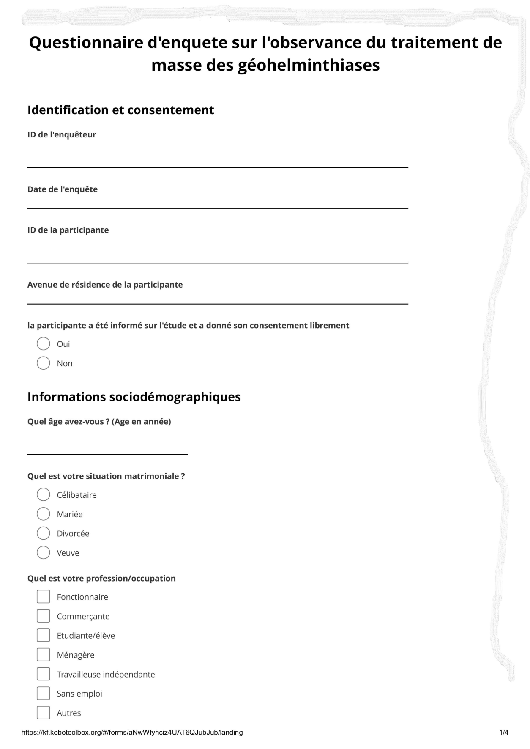
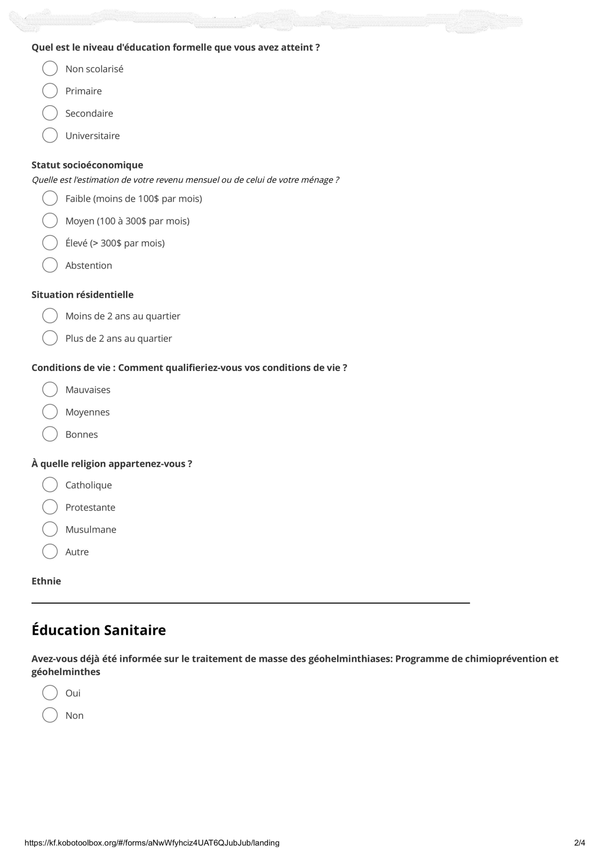
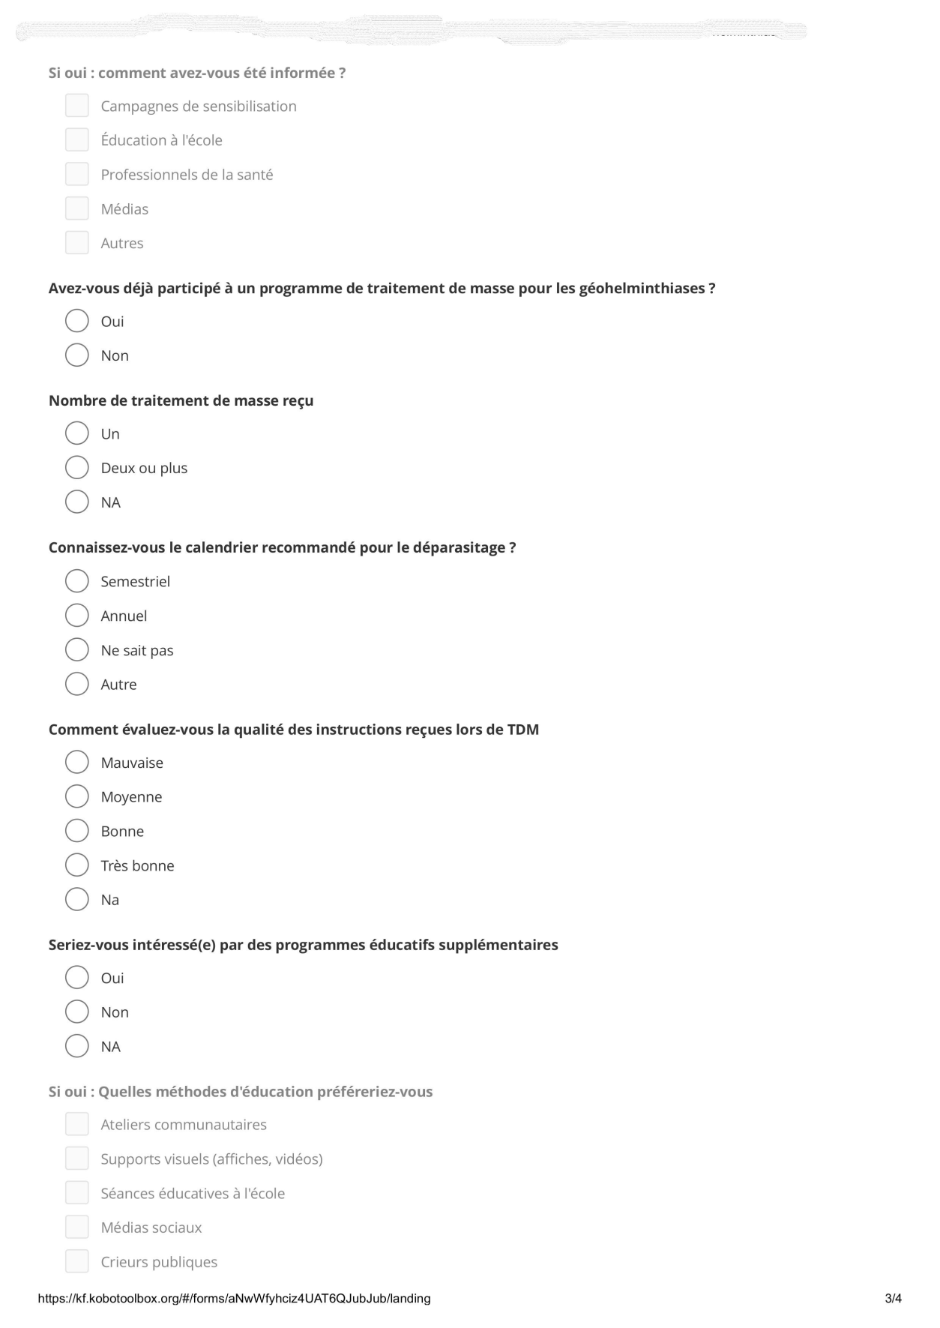
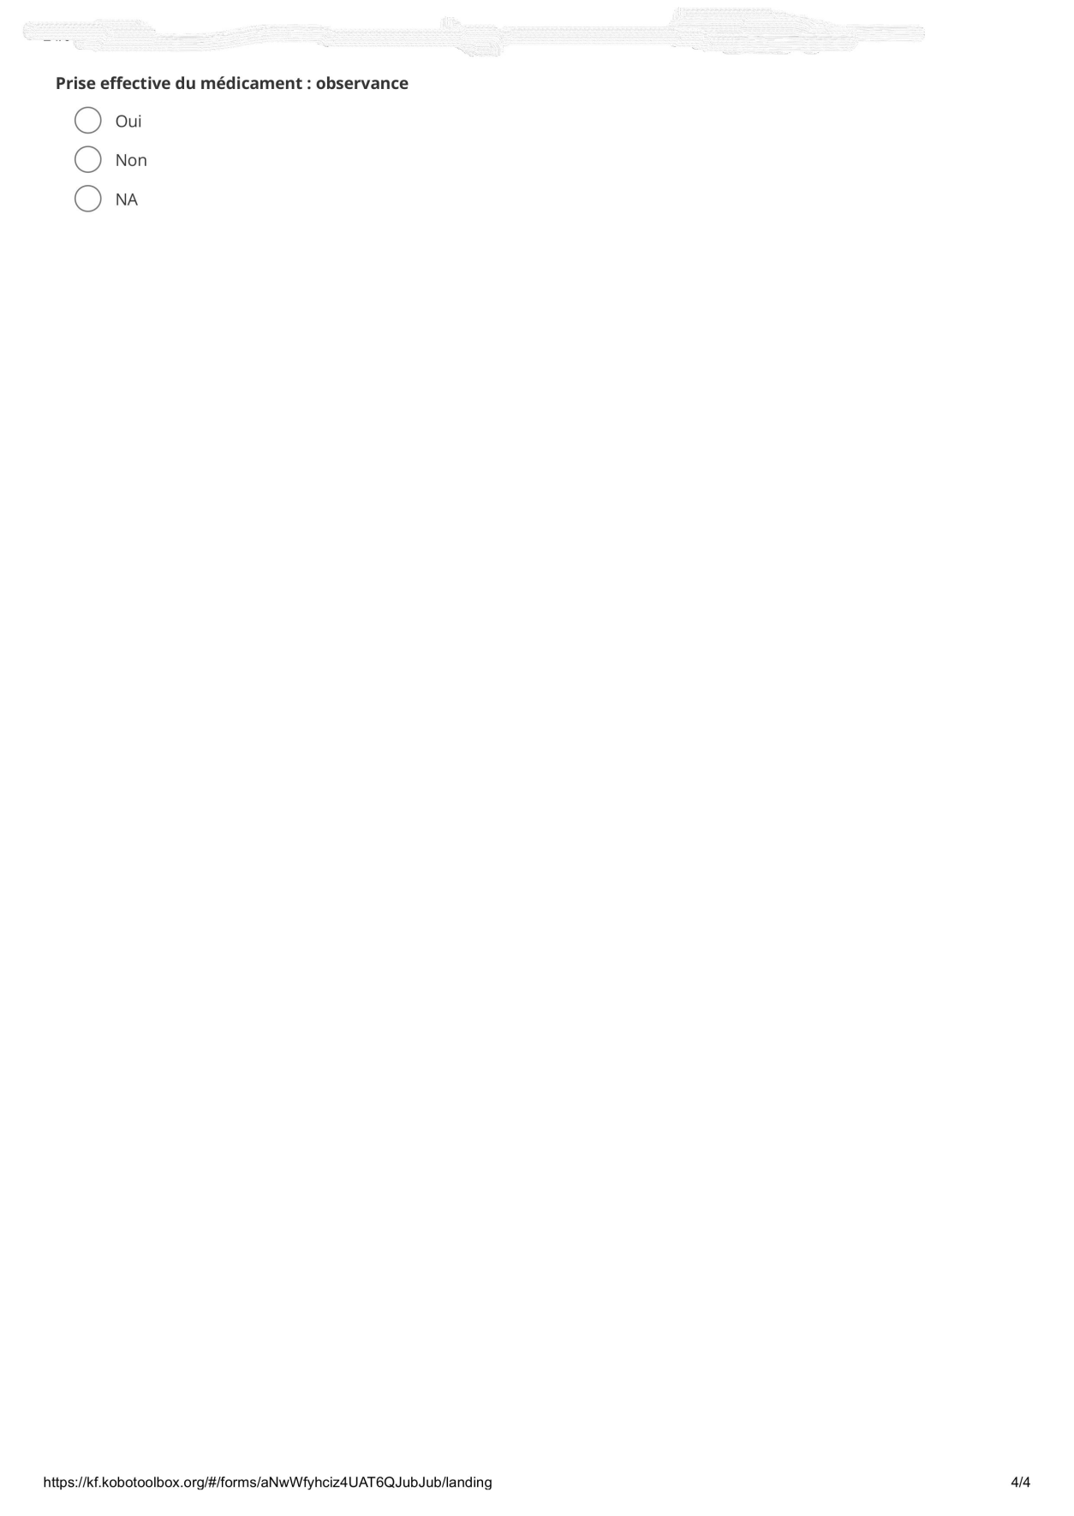
- Interview guide
