Case report

Primary Intraosseous Squamous Cell Carcinoma of the Mandible: Diagnostic and Therapeutic Insights from a Rare Case

Abstract
Primary intraosseous squamous cell carcinoma (PIOSCC) of the mandible is malignant epithelial neoplasm arising within the jawbone, without any initial connection to the oral mucosa. It represents a rare variant of odontogenic carcinoma and accounts for less than 2% of all oral malignancies. Due to its clinical and radiographic resemblance to other odontogenic tumors and inflammatory lesions, it often presents a diagnostic challenge. We report a case of PIOSCC in a 30-year-old male presenting with swelling and restricted mouth opening in the left posterior mandibular region. Comprehensive clinical, radiographic, and histopathologic examinations led to the diagnosis of primary intraosseous carcinoma. The patient underwent hemimandibulectomy, and the lesion was histopathologically confirmed. This article discusses the clinical presentation, radiological features of PIOSCC, along with a review of the literature emphasizing the diagnostic challenges and therapeutic strategies for this rare malignancy.

Keywords
Primary intraosseous carcinoma, squamous cell carcinoma, mandible, odontogenic carcinoma, jaw tumor, intraosseous malignancy

Introduction
Primary intraosseous squamous cell carcinoma (PIOSCC), also referred to as primary intraosseous carcinoma (PIOC), is a malignant epithelial tumor that arises within the jawbones, without initial connection to the oral mucosal surface. It is believed to originate from the remnants of odontogenic epithelium, such as the rests of Malassez or from epithelial linings of odontogenic cysts. Loos first described such a lesion in 1913, and later World Health Organization (WHO) termed them as PIOSCC [1]. The WHO 2017 classification categorizes PIOSCC into three main types: (1) solid type carcinoma arising de novo, (2) carcinoma arising from odontogenic cysts, and (3) carcinoma associated with other odontogenic tumors [2].
Clinically, PIOSCC manifests as a painful swelling, tooth mobility, or paresthesia, predominantly in the posterior mandible [3]. Radiographically, it presents as an ill-defined osteolytic lesion, which may mimic chronic osteomyelitis, odontogenic cysts, or ameloblastoma [4]. The rarity and overlapping features often lead to delayed diagnosis or misclassification. Early recognition and differentiation from other intraosseous pathologies are crucial for effective management and favorable prognosis.
This report presents a case of PIOSCC in a young male patient with clinical and radiographic findings initially suggestive of ameloblastoma. Through detailed evaluation, the lesion was identified as primary intraosseous in nature. The case underscores the significance of a multidisciplinary approach involving clinical, radiologic, and histopathologic correlation.

Case Report
A 30-year-old male presented with a complaint of swelling in the left lower jaw region for approximately ten days. The swelling was gradually progressive, associated with mild pain and difficulty in mouth opening. There was no history of trauma or systemic illness. The patient reported a chronic habit of chewing tobacco and kharra 3–4 times daily for the past ten years. His medical and family histories were non-contributory.
Extraoral inspection revealed a diffuse swelling over the left posterior mandibular region extending from the corner of the mouth to the angle of the mandible and from line joining corner of mouth and tragus of ear to 1cm below the lower border of mandible. (Figure 1) The overlying skin was normal in color and texture. On palpation, the swelling was firm, slightly tender, and non-fluctuant. Mouth opening was restricted to 15 mm.
Intraoral examination revealed a non- scrapable white patch on the left buccal mucosa extending from the corner of the mouth to the retromolar region (Figure 2). Mild erythema was noted in the left retromolar trigone, covered with whitish slough. There was generalized staining and calculus deposition on teeth. No cervical lymphadenopathy was palpable.
Orthopantomogram (OPG) revealed an ill-defined radiolucent lesion involving the left mandibular posterior region of mandible showing ragged borders. Internal structure was completely radiolucent. (Figure 3) Cone-beam computed tomography (CBCT) confirmed an osteolytic lesion in mandibular posterior region of jaw with complete destruction of buccal and lingual cortical plates. (Figure 4) Differential diagnoses included squamous cell carcinoma, ameloblastoma, and osteogenic sarcoma.
An incisional biopsy taken from the buccal mucosa demonstrated hyperkeratotic squamous epithelium with chronic inflammatory infiltrate, suggestive of leukoplakia. A CECT of the same region was performed with revealed a large heterogenous mass of size 5*4*4cm in the right angle of mandible. Extensive destruction of the mandibular body, angle and ramus was noted. The features were suggestive of malignant jaw tumor.
The patient underwent left hemimandibulectomy (Figure 5) under general anesthesia. Gross examination of the resected specimen showed an ill-defined, firm, greyish-white mass occupying the mandibular body and ramus (Figure 6). Histopathologic examination confirmed islands of dysplastic squamous epithelium infiltrating the medullary bone, with keratin pearls and hyperchromatic nuclei. The surrounding connective tissue exhibited chronic inflammatory infiltration. Lymph nodes were negative for metastasis. So, the final diagnosis primary intraosseous squamous cell carcinoma was given.
Postoperatively, the patient was referred for adjuvant radiotherapy due to the lesion’s size and potential local aggressiveness. At present the patient is kept under follow-up to check the for recurrence.
Discussion
Primary intraosseous squamous cell carcinoma (PIOSCC) represents an extremely rare odontogenic malignancy, accounting for less than 1-2% of all oral cancers. PIOC is thought to develop through malignant changes in odontogenic epithelial remnants, including the epithelial rests of Malassez, dental lamina, and dental follicle.
The diagnosis of primary intraosseous carcinoma (PIOC) is established on three principal criteria’s: (i) the absence of ulceration in the oral mucosa overlying the lesion, (ii) histopathological confirmation of squamous cell carcinoma (SCC), and (iii) exclusion of any other primary tumor through chest radiography at the time of diagnosis and during a minimum follow-up period of six months [5].
The most widely accepted classification of primary intraosseous carcinoma (PIOC) was proposed by Waldron and Mustoe [6,7]. According to this classification, Type 1 refers to PIOC arising from an odontogenic cyst. Type 2A denotes malignant ameloblastoma, while Type 2B represents ameloblastic carcinoma that may develop de novo or originate from a pre-existing ameloblastoma or odontogenic cyst. Type 3 corresponds to PIOC arising de novo, which is further subdivided into keratinizing and non-keratinizing variants and Type 4 designates intraosseous mucoepidermoid carcinoma
In the present case, no cystic or pre-existing tumor component was detected, suggesting a de novo origin. Such cases are particularly rare and often aggressive. Multiple case reports have been published by Sharma V et al. [8], Tamgadge S et al. [9], and Grisar K et al. [10] of PIOC arising from an odontogenic cyst. In most of the case reports, it was reported to develop from a keratocystic odontogenic tumor.
Hijioka et al. [11] reported a case in which squamous cell carcinoma (SCC) developed at the site of a pre-existing ameloblastoma. A few reports have documented metachronous occurrences of ameloblastoma and SCC without clear histologic evidence of their coexistence. In contrast, Hamakawa et al. [12] described cases showing both lesions within the same specimen. As the chronological sequence of tumor development remained uncertain, they suggested that the two neoplasms likely arose synchronously rather than one evolving from the other.
PIOC occurs mainly in older adults, most often during the sixth and seventh decades of life, and shows a strong male predilection (3:1). The posterior mandible represents the most frequent site of occurrence. A systematic review of 257 cases of PIOSCC was conducted by De Morais EF et al. [13] to study the clinicopathological characteristics and biological behavior. Most cases showed a male predilection (69.3%) and a preference for the mandible (7:1), with the posterior region being the most commonly affected site. The mean age at diagnosis was 57.3 years In a review of published cases, Thomas et al. conducted a pooled analysis of global literature and reported a mean age at diagnosis of 52.3 years, with patients ranging from 4 to 81 years of age. The study noted a male predominance with a male-to-female ratio of 2.5:1, and identified the posterior region of the mandible as the most frequently affected site. In our case, PIOSCC was observed in a 30-year-old male patient in the mandibular posterior region.
Oh et al. [14] reviewed 12 reported cases of PIOC in patients under 20 years and noted that, unlike the typical presentation in older adult males, pediatric cases showed a slight female predominance with a frequent occurrence in the mandible. Clinically, most patients presented with swelling, and radiographically many lesions appeared well-defined and unilocular, often leading to an initial misdiagnosis as odontogenic cysts. Interestingly, features such as tooth displacement and root resorption, usually associated with benign jaw lesions, were also observed in these cases.
In its initial phase, primary intraosseous squamous cell carcinoma (PIOSCC) typically presents without noticeable symptoms, but as the disease progresses, patients may experience swelling, pain, restricted mouth opening, or sensory disturbances such as paresthesia. In our case, the patient reported pain and swelling in the mandibular posterior region.
Radiographically, PIOSCC presents as an ill-defined radiolucency with irregular margins and cortical bone destruction. In a radiographic analysis of 24 cases of primary intraosseous squamous cell carcinoma (PIOSCC), Kaffe et al. [15] reported that most lesions (87%) exhibited a radiolucent appearance, whereas a smaller proportion (13%) displayed a mixed radiolucent-radiopaque pattern. None of the examined lesions exhibited corticated margins. More than half (56.5%) demonstrated well-defined but noncorticated borders, while the remaining 43.5% presented with ill-defined or diffuse margins. A unilocular configuration was predominant (61%), although a multilocular pattern was also occasionally identified. Because of its variable radiological features, PIOC may mimic benign odontogenic cysts or tumors; therefore, it should be included in the differential diagnosis of radiolucent jaw lesions. In our case, the lesion was radiolucent with ill-defined borders.
Treatment of PIOSCC primarily involves surgical resection with wide margins. In cases with nodal involvement or large lesions, neck dissection and adjuvant radiotherapy are recommended. Chemotherapy is reserved for advanced or recurrent cases. Survival rates range from 30% to 40%, depending on tumor differentiation, nodal status, and treatment adequacy.

The prognosis of PIOSCC largely depends on the stage at diagnosis and adequacy of surgical margins. Early-stage tumors with complete resection generally show better outcomes. Regular follow-up is essential due to the risk of local recurrence or delayed metastasis.

Conclusion

Primary intraosseous squamous cell carcinoma poses significant diagnostic challenges due to its similarity to benign jaw lesions. A multidisciplinary approach incorporating clinical, radiologic, and histopathologic evaluation is vital for accurate diagnosis. Surgical resection with adequate margins remains the mainstay of treatment, with radiotherapy & chemotherapy serving as an adjunct in advanced cases. Early diagnosis and long-term follow-up are crucial for improving prognosis and minimizing recurrence.

References
1. Thakur, A., Tupkari, J. V., Joy, T., & Gogri, A. A. (2017). Primary intraosseous squamous cell carcinoma - A rare odontogenic malignancy. Journal of Oral and Maxillofacial Pathology, 21(2), 320. https://doi.org/10.4103/jomfp.JOMFP_25_16
2. Elzay, R. P. (1982). Primary intraosseous carcinoma of the jaws. Review and update of odontogenic carcinomas. Oral Surgery, Oral Medicine, and Oral Pathology, 54(3), 299-303. https://doi.org/10.1016/0030-4220(82)90099-8.
3. Belinda, J. (2022). Primary intraosseous carcinoma of the jaws – A review. International Journal of Periodontal Rehabilitation. https://www.mmpubl.com/2022/ijperior/primary-intraosseous-carcinoma-of-the-jaws-a-review
4. Nandimath, K., Naikmasur, V. G., & Babshet, M. (2011). Primary Intraosseous Carcinoma of Mandible: A Case Report. Dental Research Journal (Isfahan), 8(2), 102-107. https://drj.mui.ac.ir/index.php/drj/article/view/102
5. AL-Harbawee, A., Mair, M., Rajaram, K., Baker, A., & Da Forno, P. (2021). Primary intraosseous squamous cell carcinoma: A rare malignancy of the mandible. Advances in Oral and Maxillofacial Surgery. https://doi.org/10.1016/j.adoms.2021.100063
6. De Morais, E. F., Carlan, L. M., de Farias Morais, H. G., Pinheiro, J. C., Martins, H. D., Barboza, C. A., & de Almeida Freitas, R. (2021). Primary intraosseous squamous cell carcinoma involving the jaw bones: A systematic review and update. Head and Neck Pathology, 15(2), 608-616. https://doi.org/10.1007/s12105-020-01234-z
7. Deshmukh, R., Deo, P., Chavan, S., & Halli, R. (2017). Primary intraosseous carcinoma of the mandible. Clinical Cancer Investigation Journal, 6(4), 203-206. https://doi.org/10.4103/ccij.ccij_41_17
8. Sharma, V., Dhaliwal, H., & Yadav, S. (2020). Primary Intraosseous Carcinoma Arising in a Mandibular Keratocystic Odontogenic Tumor: A Case Report. Journal of Mahatma Gandhi University of Medical Sciences and Technology, 5(3), 96-99. https://doi.org/10.5005/jp-journals-10057-0126
9. Tamgadge, S., Tamgadge, A., Modak, N., & Bhalerao, S. (2013). Primary intraosseous squamous cell carcinoma arising from an odontogenic keratocyst: a case report and literature review. Ecancermedicalscience, 7, 316. https://doi.org/10.3332/ecancer.2013.316
10. Grisar, K., Schol, M., Hauben, E., Schoenaers, J., & Politis, C. (2016). Primary intraosseous squamous cell carcinoma of the mandible arising from an infected odontogenic cyst: A case report and review of the literature. Oncology Letters, 12(6), 5327-5331. https://doi.org/10.3892/ol.2016.5378
11. Hijioka, H., Nishihara, K., Suzuki, H., Ishida, T., Kume, K., Yoshimura, T., Shima, K., Semba, I., & Nakamura, N. (2015). Primary intraosseous squamous cell carcinoma arising from ameloblastoma of the mandible: A case report. *Journal of Oral and Maxillofacial Surgery, Medicine, and Pathology*, *27*(5), 693–697. https://doi.org/10.1016/j.ajoms.2015.02.004
12. Hamakawa, H., Kayahara, H., Sumida, T., & Tanioka, H. (2000). Mandibular intraosseous carcinoma coexisting with ameloblastoma. Journal of Oral and Maxillofacial Surgery, 58(4), 430-433. https://doi.org/10.1016/s0278-2391(00)90929-7
13. Thomas, G., Pandey, M., Mathew, A., Abraham, E. K., Francis, A., Somanathan, T., Iype, M., Sebastian, P., & Nair, M. K. (2001). Primary intraosseous carcinoma of the jaw: Pooled analysis of world literature and report of two new cases. International Journal of Oral and Maxillofacial Surgery, 30(4), 349–355. https://doi.org/10.1054/ijom.2001.0069.
14. Oh, H. J., Shin, D. W., Yoon, H. J., Myoung, H., & Kim, S. M. (2022). Primary intraosseous carcinoma in the pediatric and adolescent mandible: analysis of reported cases and a new case report. World Journal of Surgical Oncology, 20(1), 25. https://doi.org/10.1186/s12957-021-02465-2

15. Kaffe, I., Ardekian, L., Peled, M., Machtey, E., & Laufer, D. (1998). Radiological features of primary intra-osseous carcinoma of the jaws. Analysis of the literature and report of a new case. Dentomaxillofacial Radiology, 27(4), 209-214. https://doi.org/10.1038/sj/dmfr/4600351

FIGURES

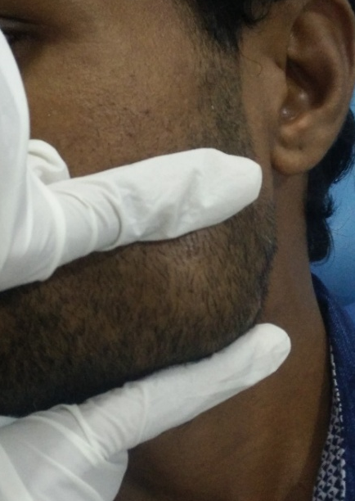
Figure 1: Extraoral swelling showing extent of the lesion

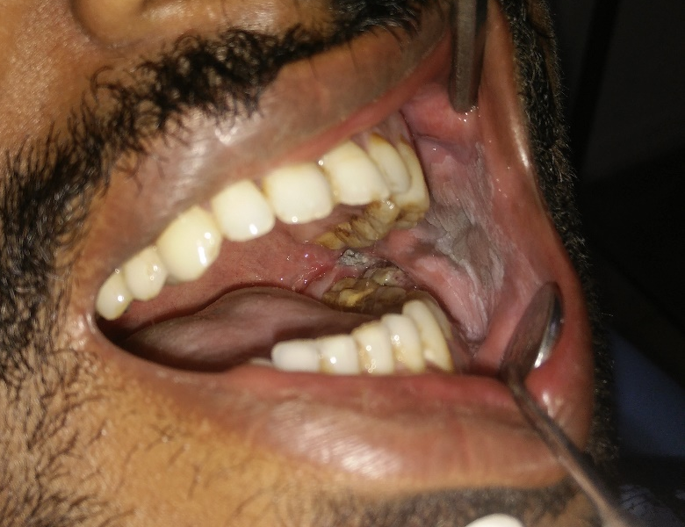
Figure 2: Intraoral examination revealing a white non- scrapable patch on the buccal mucosa
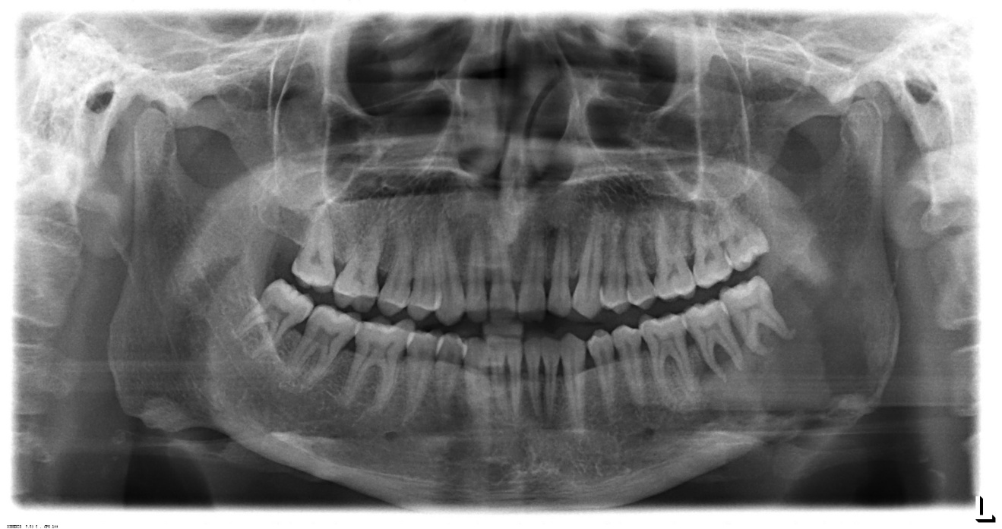
Figure 3: Orthopantomogram (OPG) showing ill-defined radiolucent lesion (black arrows) suggestive of cortical destruction in mandibular posterior region

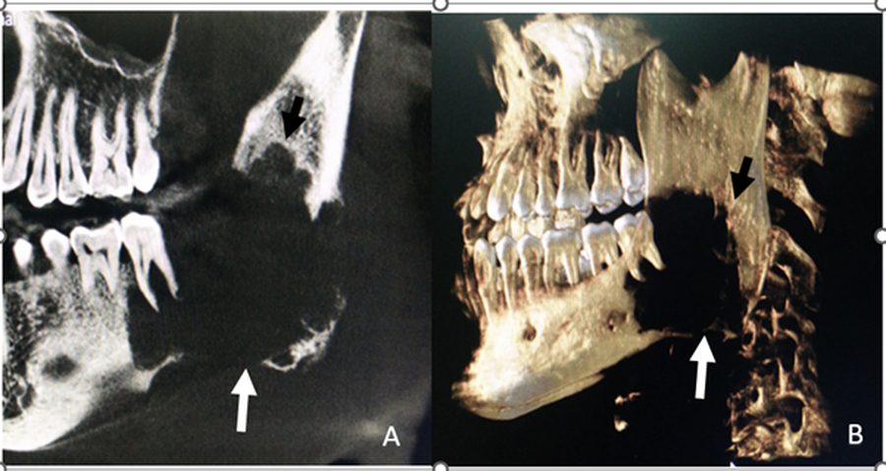

Figure 4: Cone-beam computed tomography (CBCT) images showing an extensive osteolytic lesion in the posterior region of mandible
(A) Sagittal section reveals an ill-defined radiolucent area with irregular borders (Black arrow) and marked destruction of lower border of mandible (White arrow). (B) Three-dimensional reconstructed view of the same lesion showing irregular borders (Black arrow) and involvement of lower border of mandible (White arrow)

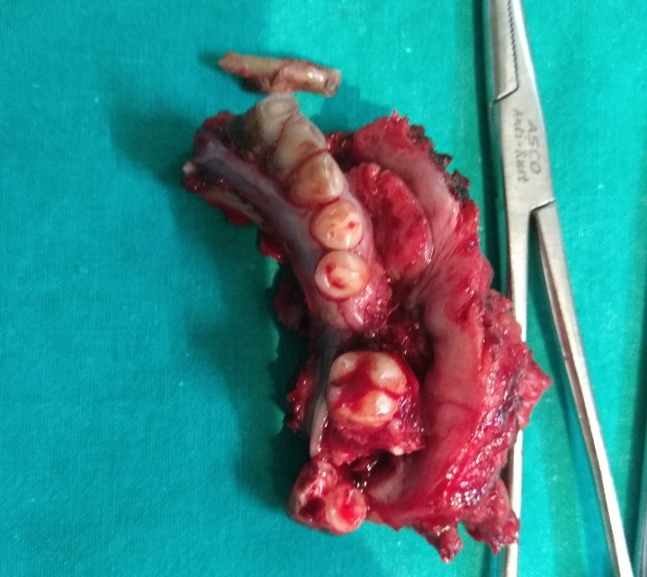
Figure 5: Gross specimen showing resected mandible and site of primary intraosseous carcinoma

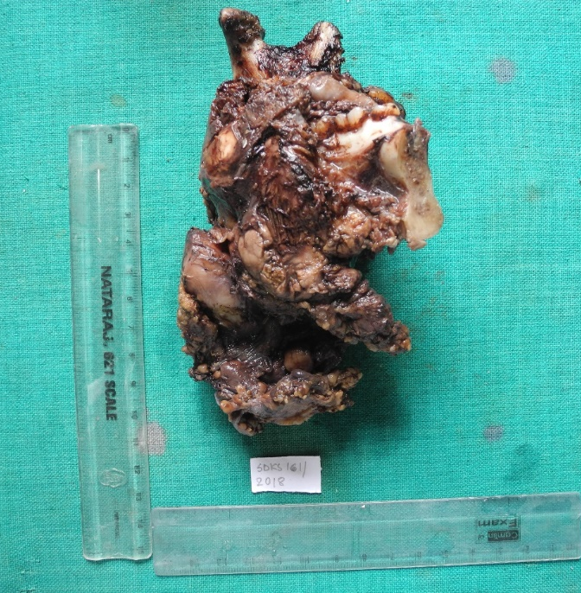
Figure 6: Hemimandibulectomy specimen with irregular mass involving the posterior region of mandible

