Digital Shade Selection in Dentistry: A Comprehensive Review

Abstract:
Achieving a harmonious shade match between restorative materials and natural dentition is one of the most demanding tasks in aesthetic dentistry [1]. The perceived color of a tooth is a result of complex optical interactions involving enamel translucency, dentin chroma, and light scattering [2]. Visual shade matching using traditional shade guides has long been the standard practice, yet it remains subjective and prone to error due to environmental lighting, observer variability, and fatigue [3].
The Introduction of digital shade selection systems, including spectrophotometers, colorimeters, and intraoral scanners, has significantly improved the objectivity and reproducibility of color determination [4]. These devices measure color numerically using standardized models such as Munsell, CIELAB, CIE color space, and RGB, providing a universal communication platform between clinician and laboratory [5,6].
This review consolidates current evidence on aesthetic restorative materials, ideal light sources for clinical color assessment, and instrumental shade-matching technologies. It further explores color coding systems, differentiates conventional from digital shade selection, and discusses potential errors and management strategies [7]. Emphasis is placed on the need for calibrated lighting, understanding of color metrics, and integration of digital workflows for achieving predictable and patient-centered aesthetic outcomes [8,9].
Keywords: Digital Shade Selection,​Aesthetic Dentistry,​Spectrophotometers,Colorimeters,​CIELAB,​CIE color space,​Munsell

Introduction:
The pursuit of aesthetic excellence in dentistry has evolved from simple shade estimation to scientifically measured color communication [10]. Color matching plays a vital role in restorative dentistry because even slight mismatches can compromise the visual integrity of restorations. Tooth color depends on hue (color family), chroma (intensity), and value (lightness), influenced by light scattering and absorption through enamel and dentin layers ( Fig.1).
Traditional methods rely on visual shade guides such as VITA Classical or VITA 3D-Master, which provide sets of porcelain or composite tabs arranged according to hue and chroma. Despite being cost-effective and widely available, these systems are inherently subjective—affected by individual color perception, ambient illumination, and psychological adaptation [12,13].
Studies have shown that even experienced clinicians may disagree on tooth shade in up to 30–60% of cases when using visual methods [14]. Consequently, digital shade-matching instruments have been introduced to overcome human bias, providing objective numerical data under controlled light conditions [15]. Devices such as spectrophotometers and colorimeters quantify color in standardized color spaces, improving repeatability and communication between the dental office and laboratory [16].
This review aims to offer a detailed analysis of digital shade selection systems, exploring the role of light, instrumentation, material optics, and color science in aesthetic restorative dentistry [17,18].

HISTORY AND EVOLUTION OF SHADE SELECTION IN DENTISTRY
The concept of shade selection in dentistry has evolved significantly over the past century. Earlier, dentists relied solely on visual judgment, using natural daylight and their personal perception to determine the closest shade for restorations. Before commercial shade guides were introduced, shade selection was largely empirical and inconsistent, resulting in significant variations in aesthetic outcomes among different clinicians.
The first major milestone occurred in the early 1900s with the introduction of porcelain shade tabs, which attempted to standardize natural tooth color into systematic categories. These early shade guides were rudimentary, offering only limited choices. The breakthrough came with the introduction of the VITA Classical shade guide, which classified shades into the A–D system based on hue and chroma. This system quickly became the global standard and is still widely used today.

By the 1990s and early 2000s, advances in color science and optics led to more structured systems such as the VITA 3D-Master, which arranged shades according to value, chroma, and hue in a more logical progression. This allowed clinicians to differentiate shades more accurately and understand subtle transitions.
The digital revolution in dentistry led to the development of spectrophotometers, colorimeters, and intraoral scanners, which transformed shade selection from an artistic skill into a scientific, repeatable procedure. Today, with the addition of AI-based diagnostics, cloud communication, and 3D color mapping, shade selection has become faster, more predictable, and more accurate than ever before.

Optical Properties of Natural Teeth
Natural teeth exhibit unique optical behaviors that make them challenging to reproduce artificially. Understanding these behaviors is key to selecting the most appropriate restorative materials and achieving an excellent shade match.
- Translucency
Enamel is a highly translucent material. Light penetrates enamel, scatters within dentin, and is partially reflected back. This interaction—known as subsurface scattering—creates the natural vitality of teeth. Restorative materials must mimic this phenomenon to avoid an artificial or opaque appearance.
- Opalescence
Enamel displays a blue-white appearance in reflected light and a warm orange glow when light passes through it. This dual property, called opalescence, contributes to the natural brightness of anterior teeth.
- Fluorescence
Under ultraviolet (UV) light, dentin emits a visible light that enhances tooth brightness. Some ceramics and composites incorporate fluorescence to maintain natural vitality, particularly in social settings where UV lighting is common.
- Metamerism
Metamerism occurs when two colors match under one light source but differ under another. It is a frequent cause of patient dissatisfaction and is strongly influenced by the spectral distribution of light used during shade selection. Digital shade devices help minimize metamerism by using standardized illumination.
COLOR SCIENCE FUNDAMENTALS IN DENTISTRY
Human color perception is a complex process involving the interaction of visible light with an object and the interpretation of that light by the eye and brain. The visible spectrum ranges from 400–700 nm, where violet has the shortest wavelength and red the longest. Tooth color perception mainly involves wavelengths between 500–650 nm because tooth shades fall within the yellow-red region of the spectrum.

The retina contains two types of photoreceptors:
Rods – responsible for low-light vision, not involved in color perception.
Cones – responsible for color vision and divided into S-cones (blue), M-cones (green), and L-cones (red).
The brain combines signals from these cones to interpret complex shades of teeth. Any imbalance in cone activity (e.g., slight color blindness, operator fatigue, lighting differences) can easily distort shade interpretation. Because human perception is not always linear, digital color models such as CIELAB were developed to represent colors in a uniform and reproducible way.
Aesthetic Restoration Types and Materials:
Aesthetic restoration materials must reproduce natural tooth characteristics such as translucency, fluorescence, and opalescence [1]. The optical behavior of restorative materials determines how light interacts within the restoration, influencing its final perceived color [2]. The three primary categories are composite resins, ceramics, and hybrid ceramics.
- Composite Resins:
Composite resins consist of a resin matrix and inorganic fillers, which together determine mechanical strength, color stability, and optical behavior [3]. Polymerization alters translucency and can shift the final shade slightly; thus, selecting the correct shade before curing is critical . Modern nanohybrid and nanofilled composites exhibit improved polishability and optical blending (“chameleon effect”) [4].

Composite resins are widely used for anterior restorations due to their ease of manipulation, cost-effectiveness, and aesthetic versatility.

Composition
Resin matrix (Bis-GMA, UDMA)
Inorganic filler particles (glass, silica, zirconia)
Coupling agents
Initiator systems

Factors influencing composite shade:
- Polymerization shrinkage
- Degree of conversion
- Composite thickness
- Surface polish and texture
- Light source used during curing

Clinical Implications
Thin composite layers adopt underlying tooth color, improving the “chameleon effect.”
Polymerization shrinkage can influence shade perception.
Surface polish alters value—well-polished composites appear brighter.

- Ceramic Materials
Ceramics provide superior color stability, translucency, and fluorescence compared to resin-based materials [5]. Feldspathic porcelains offer exceptional aesthetics but limited strength, while lithium disilicate combines high translucency with improved fracture resistance [6]. Zirconia, traditionally opaque, has evolved into translucent multi-layered zirconia systems that mimic dentin and enamel structures more naturally
[7].
Layering and Staining
Ceramic restorations often involve multiple layers (enamel + dentin) to replicate natural tooth optics. External staining techniques enhance characterization, but over-firing can alter shade.

- Hybrid Ceramics and CAD/CAM Blocks:
Hybrid ceramics, composed of resin-ceramic matrices, are now popular in CAD/CAM workflows for single-visit restorations [8]. These materials combine ceramic translucency with the resilience of resin composites, and their shades can be digitally matched and milled accurately [9]. The final color depends on the material’s thickness, cement shade, and underlying tooth color .

Ideal Light Source in the Clinic:
Lighting conditions significantly affect perceived color. The ideal light source for shade selection should replicate natural daylight, characterized by a color temperature of 5500 K and a Color Rendering Index (CRI) above 90 [11].
Natural daylight, especially from the north sky, is considered the gold standard. However, clinical environments often lack consistent daylight exposure. Therefore, daylightbalanced LED operatory lights (5000–5500 K) are recommended for accurate shade matching [12].
The illumination intensity at the patient’s mouth level should range between 1500–3000 lux, avoiding shadows and glare [13]. Standardized lighting booths or LED lamps .with consistent spectral distribution minimize metamerism—the phenomenon where colors appear different under varying light sources [14].
For consistent color evaluation, clinicians should document the light source type and temperature used during shade selection, ensuring reproducibility during laboratory fabrication [15].
Figure 5 - Light source - LED

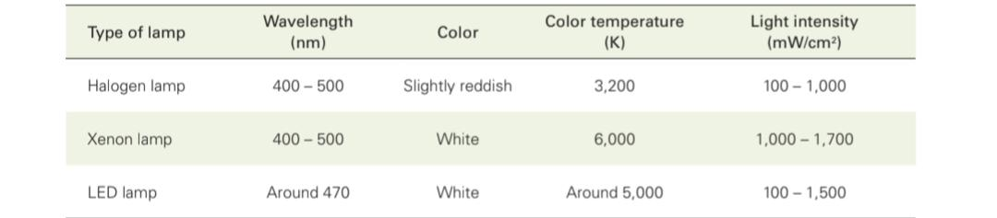
Common Light Sources and Their Characteristics:

Why Lighting Matters
Different light sources emit different spectral distributions:
Tungsten bulbs: Yellowish light; distort value.
Fluorescent lights: Green-blue shift; affect chroma.
LEDs: Most consistent if calibrated; some cheaper LEDs distort blue wavelengths.
The clinician must standardize lighting conditions and document the source used for shade selection to ensure accurate communication with the laboratory.

How to Measure Light
Light can be quantified in terms of illuminance, color temperature, and spectral distribution [19]. Illuminance (lux) is measured using a lux meter , assessing the light intensity reaching the tooth surface. Color temperature (Kelvin) is measured with a colorimeter or spectroradiometer, determining whether the light is warm or cool. Spectral

distribution indicates the wavelengths present in a light source and can be analyzed with a spectrophotometer [20].
For clinical consistency, light should be measured at the patient’s mouth level under operating conditions. Some modern dental lights include built-in sensors to monitor color temperature and maintain a stable CRI. Regular calibration ensures uniform conditions for every shade-matching procedure [12].

FACTORS AFFECTING TOOTH COLOR

Tooth color is influenced by several internal and external factors:

1. Age

Older patients have darker teeth due to secondary dentin deposition, reduced enamel thickness, and accumulation of stains.

2. Diet
Chromogenic foods such as tea, coffee, beetroot, turmeric, and red wine cause extrinsic staining.

3. Medications
Tetracycline, minocycline, and fluorosis create intrinsic discolorations.

4. Trauma
Pulpal hemorrhage, calcific metamorphosis, and non-vitality lead to darkening.

5. Tooth structure
Greater enamel thickness increases translucency, while thicker dentin increases chroma.

Understanding these factors helps clinicians choose appropriate materials and techniques.
Instrumental Methods: Spectrophotometers and Colorimeters
Instrumental methods enhance precision by quantifying color in numeric terms rather than relying on visual perception [13].
Spectrophotometers
These devices measure the intensity of reflected light at multiple wavelengths to compute color values within a defined color space, usually CIELAB [14]. They provide highly accurate, repeatable results and detect even subtle variations invisible to the naked eye [15]. Examples include VITA Easyshade, Shadepilot, and Crystaleye systems (Fig.2).
Colorimeters
Colorimeters use filtered sensors that correspond to the RGB spectrum to estimate color differences [16]. Although slightly less precise than spectrophotometers, they are affordable, compact, and suitable for clinical use (Fig.3).
Both devices output numerical values (L*, a*, b*) for standardized communication with laboratories. Digital shade-matching systems integrated with CAD/CAM and intraoral scanners further reduce operator variability [18].
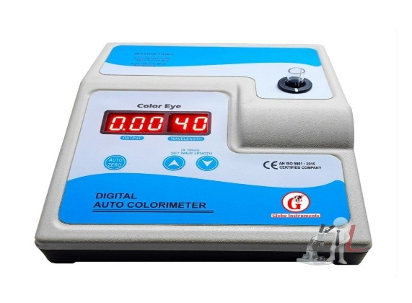
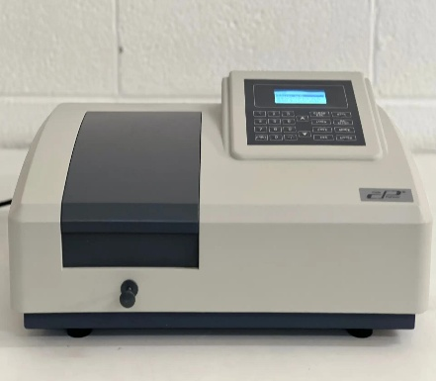
Fig.2- COLORIMETER
Fig.1- Spectrophotometer

Types of Shade Guide
Shade guides serve as reference systems for both conventional and digital shade selection [19].
Common types include:
VITA Classical (A1–D4): Organized by hue and chroma, still widely used in clinical practice.
VITA 3D-Master: Arranged systematically by lightness, chroma, and hue, allowing more precise differentiation.
Chromascop (Ivoclar Vivadent): Based on five hues with gradations in chroma.
Digital shade guides : Are evolved to include optical scanning capabilities, displaying numeric color data in real time and minimizing subjective interpretation .

Color Coding Systems
Munsell Color System
The Munsell System (Fig.3), developed by Albert Munsell, defines color through three parameters—hue, value, and chroma—organized in a three-dimensional space [3]. Each color is represented as “Hue–Value/Chroma” (e.g., 5Y 8/10). Though useful for visual teaching, it lacks spectral precision and is less frequently used in digital color measurement [4].

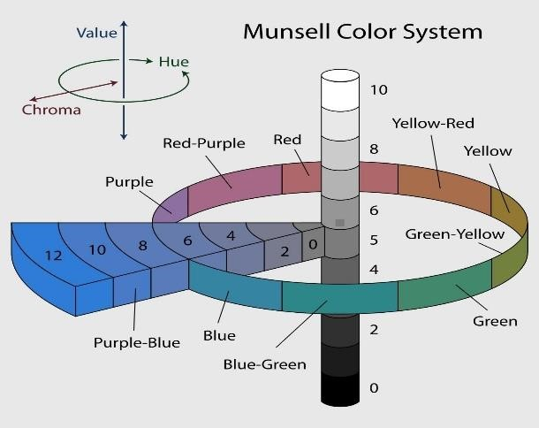
Fig.3- MUNSELL COLOR SYSTEM

CIELAB Color System
The CIELAB (L, a, b*)** model, established by the International Commission on Illumination (CIE), is the most widely accepted for dental applications (Fig.4).
L* denotes lightness (0 = black, 100 = white)
A* denotes red–green axis
B* denotes yellow–blue axis
Color differences are quantified as:
ΔE = √[(ΔL)² + (Δa)² + (Δb)²]
Values of ΔE < 2.7 are typically imperceptible to the human eye [6].
CIE Colour Space and RGB Model
The CIE color space represents all perceivable colors, serving as the foundation for color science. The RGB model is used in digital imaging, where color is produced through additive mixing of red, green, and blue light [7]. While RGB is device-dependent, CIELAB is preferred for its perceptual uniformity and universal compatibility [8].
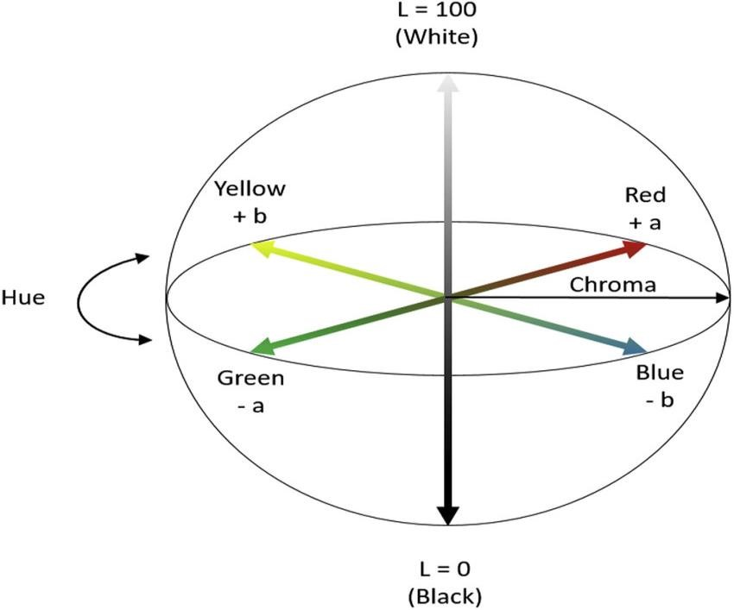
Fig.4-CIELAB COLOR SYSTEM

RGB Model
Used in digital imaging. Device-dependent and less reliable for clinical documentation.
The RGB (Red–Green–Blue) color model is an additive color system used primarily in electronic displays, digital cameras, intraoral scanners, and shade-matching mobile applications. In this model, colors are produced by combining varying intensities of red, green, and blue light, the three primary colors of the visible spectrum. When all three components are present at full intensity (R=255, G=255, B=255), the resultant color is white. Conversely, the absence of all three components (0,0,0) results in black.

Although the RGB model forms the basis of digital imaging, it is considered device-dependent, meaning the same RGB values may appear differently on different screens due to variations in brightness, calibration, contrast, and color profiles of devices. This is one of the biggest limitations when using conventional photography or smartphone apps for shade communication in dentistry.
- Principle of RGB Model
The RGB model uses an additive color mixing principle, where:
Adding more light increases the brightness of the resulting color.
Combining two primary colors produces secondary colors:
Red + Green = Yellow
Green + Blue = Cyan
Blue + Red = Magenta
These combinations are important in digital tooth imaging when analyzing color gradients, gingival shade transitions, or characterization areas (e.g., incisal translucency).
- Role of RGB in Digital Dental Photography
Digital dental photographs are captured using sensors that interpret light through RGB filters. The pixel values are translated into an RGB color map, which visually represents tooth color and surface characteristics.
Advantages:
High-resolution information about surface texture
Useful for documentation and communication
Helps visualize areas like translucency and opalescence
Low-cost, easily accessible (smartphone/DSLR cameras)
Limitations:
Highly dependent on the device’s camera sensor
Sensitive to:
Exposure
White balance
Ambient light
Image compression
Screen calibration
RGB does not correspond directly to human color perception as uniformly as CIELAB

Conventional and Digital Shade Selection: Comparison

Feature | Conventional (Visual) | Digital (Instrumental)
Principle | Subjective visual comparison | Objective electronic measurement (spectral data)
Accuracy | Variable, operator-dependent, ~50-70% | High, repeatable, ~90%+
Objectivity | Low (highly subjective) | High (objective data)
Influence of Light | High (prone to metamerism) | Low to None (uses its own standardized light source)
Operator Factors | High (influenced by eye fatigue, color vision, experience) | Low (minimal influence from operator)
Learning Curve | Deceptively high (to achieve true proficiency) | Low to moderate (for proper device handling)
Cost | Low (for shade guide) | High (initial investment for the device)
Data Output | Simple code (e.g., "A2" or "2M2") | $L^*a^*b^*$ values, spectral data, digital shade map, shade match
Communication | Written lab prescription, potential for ambiguity | Digital file transfer, precise shade map, photos
Process Speed | Fast (can be a quick glance) | Fast (measurement takes seconds)

Digital systems have shown accuracy levels above 90%, compared to 60–70% for conventional visual methods [9].

Article “Shade Selection: Blending of Conventional and Digital Methods
- An Updated Review” explains the difference :
Major challenges in cosmetic dentistry are to accomplish appropriate and satisfactory reproduction of natural shade of teeth. The procedure of choosing a shade can be performed using visual method or by an instrument.The kind of shade guide, individual ability to choose shades and conditions the choice is made under, all hay inluence on reliability and accuracy of the procedure. Therefore, it is necssary to introduce instrumental color determination in everyday work .They include RGB devices, colorimeters, spectrophotometers. The impact of the color science can be seen on various restorative materials ranging from ceramics to maxillofacial prosthetic materials. Good communication between the dental team of all these details is paramount to a successful aesthetic result (Fig.5,6).

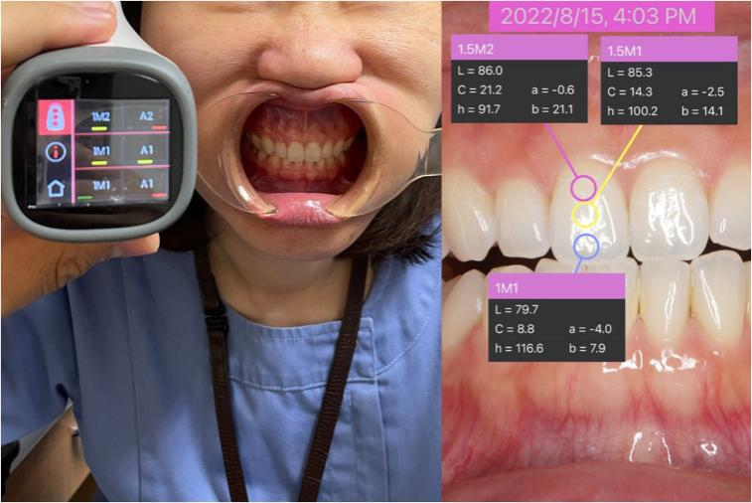
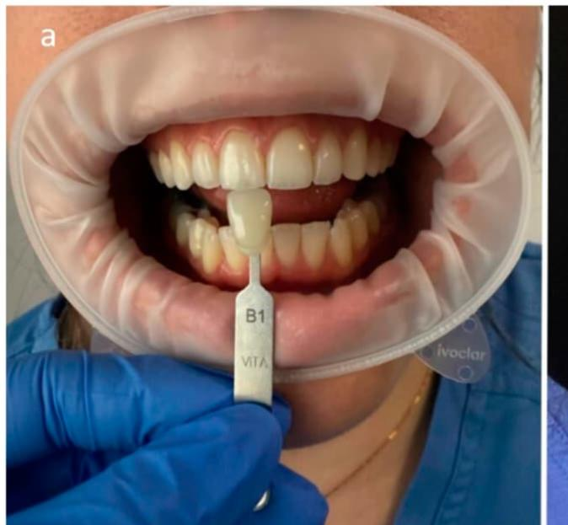
Fig .6- Digital shade selection
Fig.5-Conventional shade selection

Errors in Shade Matching and Management

Common errors include:
- Lighting inconsistency: metameric effect from varied light sources.
- Tooth dehydration: increases value, leading to lighter appearance.
- Improper shade guide storage: discoloration and contamination affect accuracy.
- Operator fatigue or color vision deficiency: can distort perception.
- Viewing angle and background color: influence visual adaptation [10].

Management strategies involve:
- Using neutral gray backgrounds.
- Allowing tooth rehydration before selection.
- Maintaining daylight-equivalent lighting.
- Calibrating devices regularly.
- Taking multiple readings at different angles to average results [11,12].

Advances in Digital Dental Technology
- Artificial Intelligence (AI) in Shade Analysis
AI integrated into intraoral scanners can:
Predict the closest shade
Analyze translucency and value gradients
Suggest multi-layering strategies for ceramics
- Machine Learning in Laboratory Workflow
Labs increasingly use AI to adjust ceramic layering and staining protocols to match digital shade data.
- Cloud-Based Shade Communication
Clinics can transmit high-resolution images, shade maps, and digital prescriptions instantly to the lab.
CLINICAL CASE EXAMPLES

Case 1: Composite Restoration Shade Mismatch
A 22-year-old patient received a composite restoration that appeared too white. The mismatch occurred because the tooth was dehydrated during selection. After rehydration, the correct shade was selected using a spectrophotometer, and layering with translucent enamel shades achieved a natural result.

Case 2: Zirconia Crown with Insufficient Translucency
A zirconia crown on tooth 11 appeared opaque. The issue was traced to using an older generation zirconia block. A multilayer high-translucency zirconia block was selected, and the final restoration blended much better.

Case 3: AI-Assisted Shade Selection for Veneers
AI scanning detected different chroma levels in the cervical and incisal thirds. A multi-layered ceramic veneer was fabricated using custom translucency mapping, leading to excellent aesthetic integration.

Clinical Protocol for Accurate Shade Selection (Step-by-Step)
- Schedule shade selection in the morning when eyes are fresh.
- Remove bright lipstick, makeup, or colorful clothing distracting from true color perception.
- Use neutral gray drapes or bibs around the patient.
- Ensure consistent lighting (5000–5500 K LED).
- Clean and hydrate teeth before selecting shade.
- Use both visual and digital methods for highest accuracy.
- Compare shades quickly (within 5 seconds) to avoid visual fatigue.
- Record digital values (L, a, b*)** for documentation.
- Send images, measurements, and device outputs to the lab with notes on translucency and surface characterization.

Conclusion
Digital shade selection has revolutionized the field of aesthetic dentistry by enabling objective, reproducible, and quantifiable color determination [13]. Integration with CAD/CAM and digital imaging has enhanced laboratory communication, improving patient satisfaction and treatment predictability [14].
However, clinical success still depends on the operator’s understanding of light behavior, material optics, and color theory. Combining digital precision with clinical artistry ensures restorations that blend seamlessly with natural dentition, achieving both function and aesthetics [15–20].
Shade selection is a multifactorial process that requires a balance of scientific precision and artistic judgement. Digital technologies have significantly enhanced the reliability and objectivity of shade matching by providing quantifiable data and minimizing subjectivity. Nevertheless, the clinician’s knowledge of color science, material optics, and proper clinical techniques continues to play a critical role.
A hybrid approach—combining visual assessment, instrumental measurements, optimal lighting, digital photography, and communication with the laboratory—remains the gold standard for achieving restorations that are both functional and aesthetically harmonious. As digital dentistry continues to evolve, the integration of AI, enhanced imaging systems, and cloud-based workflows promises to further refine and personalize the shade-selection process.
References
- Tabatabaian F, Namdari M, Mahshid M, Vora SR, Mirabbasi S. Accuracy and precision of intraoral scanners for shade matching: a systematic review. J Prosthet Dent. 2024;132(4):714–725. Doi:10.1016/j.prosdent.2022.08.034. Available from: https://www.sciencedirect.com/science/article/pii/S1882761624000164

- Floriani F, Jurado CA, Abuhammoud S, Vargas M, Fischer NG, Rojas-Rueda S, Lopes GC. A comparative study of shade-matching reproducibility using an intraoral scanner and a spectrophotometer. Dent J. 2024;12(3):62. Doi:10.3390/dj12030062. Available from: https://www.mdpi.com/2304-6767/12/3/62

- Şahin N, Ural Ç. Comparison of different digital shade selection methodologies in terms of accuracy. J Adv Prosthodont. 2024;16(1):38–47. Doi:10.4047/jap.2024.16.1.38. Available from: https://jap.or.kr/DOIx.php?id=10.4047/jap.2024.16.1.38

- Nayak VM, Sulaya K, Venkatesh SB. Current trends in digital shade matching: a scoping review. Jpn Dent Sci Rev. 2024;60:211–219. Doi:10.1016/j.jdsr.2024.10.001. Available from: https://www.sciencedirect.com/science/article/pii/S1882761624000164

- Rashid F, Farook TH, Dudley J. Digital shade matching in dentistry: a systematic review. Dent J. 2023;11(11):250. Doi:10.3390/dj11110250. Available from: https://www.mdpi.com/2304-6767/11/11/250

- Yoon HI, Bae JW, Park JM, Chun YS, Kim MA, Kim M. A study on possibility of clinical application for color measurements of shade guides using an intraoral digital scanner. J Prosthodont. 2018;27(7):670-675. doi:10.1111/jopr.12559. Available from: https://doi.org/10.1111/jopr.12559

- Li Q, Wang YN. Comparison of shade matching by visual observation and an intraoral dental colorimeter. J Oral Rehabil. 2007;34(11):848-854. doi:10.1111/j.1365-2842.2006.01678.x. Available from: https://doi.org/10.1111/j.1365-2842.2006.01678.x

- Olms C, Setz JM. The repeatability of digital shade measurement — a clinical study. Clin Oral Investig. 2013;17:1161–1166. PubMed PMID: 22828935. Available from: https://pubmed.ncbi.nlm.nih.gov/22828935/

- Borse S, Chaware SH. Tooth shade analysis and selection in prosthodontics: a systematic review and meta-analysis. J Indian Prosthodont Soc. 2020;20(2):131-140. doi:10.4103/jips.jips_399_19. Available from: https://pubmed.ncbi.nlm.nih.gov/32655217

- Hardan L, Bourgi R, Cuevas-Suarez CE, Lukomska-Szymanska M, Monjaras-Avila AJ, Zarow M, et al. Novel trends in dental color match using different shade selection methods: a systematic review and meta-analysis. Materials. 2022;15(2):468. Available from: https://share.google/0skvdleL2LJrgD9Mh

- Lund TW, Schwabacher WB, Goodkind RJ. Spectrophotometric study of the relationship between body porcelain color and applied metallic oxide pigments. J Prosthet Dent. 1985;53(6):790-796. doi:10.1016/0022-3913(85)90158-1. Available from: https://doi.org/10.1016/0022-3913(85)90158-1

- Joiner A. Tooth colour: a review of the literature. J Dent. 2004;32(Suppl):3-12. Doi:10.1016/j.jdent.2003.10.013. Available from: https://doi.org/10.1016/j.jdent.2003.10.013

- Sproull RC. Color matching in dentistry. Part II. Practical applications of the organization of color. J Prosthet Dent. 1973;29(5):556-566. doi:10.1016/0022-3913(73)90036-X. Available from: https://doi.org/10.1016/0022-3913(73)90036-X

- Sikri VK. Color implications in dentistry. J Conserv Dent. 2010;13(4):249-255. doi:10.4103/0972-0707.73381. Available from: https://doi.org/10.4103/0972-0707.73381

- J Oral Rehabil 2007. Title TBD. J Oral Rehabil. 2007;34 doi:10.1111/j.1365-2842.2007.01729.x. Available from: https://doi.org/10.1111/j.1365-2842.2007.01729.x

- Oi-Hong Tung, Yu-Lin Lai, Yi-Ching Ho, I-Chiang Chou, Shyh-Yuan Lee. Development of digital shade guides for color assessment using a digital camera with ring flashes. Clin Oral Investig. 2011;15:49–56. doi:10.1007/s00784-009-0366-1. Available from: https://link.springer.com/article/10.1007/s00784-009-0366-1

- Farhad Tabatabaian, Elaheh Beyabanaki, Parisa Alirezaei, Saied Epakchi. Visual and digital tooth shade selection methods, related effective factors and conditions, and their accuracy and precision: a literature review. J Esthet Restor Dent. 2021;33(8):1084-1104. doi:10.1111/jerd.12816. Available from: https://doi.org/10.1111/jerd.12816

- Goodkind RJ, Keenan KM, Schwabacher WB. A comparison of Chromascan and spectrophotometric color measurements of 100 natural teeth. J Prosthet Dent. 1985;53. Doi:10.1016/0022-3913(85)90077-0. Available from: https://doi.org/10.1016/0022-3913(85)90077-0

- Tam WK, Lee HJ. Dental shade matching using a digital camera. J Dent. 2012;40(11):956–963. Available from: https://www.sciencedirect.com/science/article/abs/pii/S0300571212001492

- Miyajiwala JS, Kheur MG, Patankar AH, Lakha TA. Comparison of photographic and conventional methods for tooth shade selection: a clinical evaluation. J Indian Prosthodont Soc. 2017;17(3):273–281. Available from: https://www.semanticscholar.org/paper/Comparison-of-photographic-and-conventional-methods-Miyajiwala-Kheur/2913ec5f7f16e6a3b97bf30775436e5922e8d2c4

- Tabatabaian F, Beyabanaki E, Alirezaei P, Epakchi S. Visual and digital tooth shade selection methods, related effective factors and conditions, and their accuracy and precision: a literature review. J Esthet Restor Dent. 2021;33(8):1084–1104. Available from: https://www.bohrium.com/paper-details/visual-and-digital-tooth-shade-selection-methods-related-effective-factors-and-conditions-and-their-accuracy-and-precision-a-literature-review/811833672335360000-5769

- Siddique SN, Khan FR, Babar P. Comparison of tooth shade matching using visual and digital camera methods. Pak Oral Dent J. 2019;39(2):184–188. Available from: https://podj.com.pk/index.php/podj/article/view/397

- Lee ST, Lee JH, Shin SY. Evaluation of shade guide using digital shade analysis system. J Korean Acad Prosthodont. 2009;:[1–11]. Available from: https://pesquisa.bvsalud.org/portal/resource/e/wpr-122874

- Alnusayri MO, Sghaireen MG, Mathew M, Alzarea B, Bandela V. Shade selection in esthetic dentistry: a review. Cureus. 2022;14(3):e23331. Available from: https://www.cureus.com/articles/90547-shade-selection-in-esthetic-dentistry-a-review#!/

- Sajini SI, Yousef MK, Azab A, Hamooh J, Abdel‑Maksoud HB. Comparative analysis of visual, light‑corrected, and digital shade selection protocols for natural teeth using VITA Classical and VITA 3D‑Master tooth guides. Ain Shams Dent J. 2025;37:10. Available from: https://ajdsm.journals.ekb.eg/article_228454.html

- Fayed AM, Mohamad HA, Othman HI. A comparison between visual shade matching and digital shade analysis system using K-NN algorithm. Al-Azhar J Dent Sci. 2022;25(2):133–141. Available from: https://ajdsm.journals.ekb.eg/article_228454.html

- Maksoud HBA, Sajini SI, Eid BM, Alhssaini SN, Alanazi YH. Comparison between visual shade selection and instrumental shade determination using intraoral scanner and digital spectrophotometer. J Complement Med Res. 2023;14(2):85–89. Available from: https://www.jocmr.com/index.php/JOCMR/article/view/228454

- Preethi Suganya S, Manimaran P, Saisadan D, Dhinesh Kumar C, Abirami D, Monnica V. Spectrophotometric evaluation of shade selection with digital and visual methods. J Pharm Bioallied Sci. 2020;12(5):319–324. Doi:10.4103/jpbs.jpbs_95_20. Available from: https://www.jpbsonline.org/article.asp?issn=0975-7406;year=2020;volume=12;issue=5;spage=319;epage=324;aulast=Preethi

- Binhuraib H, Aloqayli S, Alkhalifah S, Aljohani A, Alotaibi R, Almalki R, et al. Digital shade matching techniques in fixed prosthodontics. J Healthc Sci. 2024;4(1):Article ID JOHS2023000809. Doi:10.52533/JOHS.2024.40104. Available from: http://dx.doi.org/10.52533/JOHS.2024.40104

- Shetty R, Dewan H, Gamit KT, Khan AO, Othman A, Avinash B, et al. Shade match accuracy of AI‑based digital smile design vs conventional methods: a comparative study. Int J Dent Sci Res. 2025;21(9):62–70. Doi:10.58240/1829006X-2025.21.9-62. Available from: https://stomatology-mfsjournal.com/wp-content/uploads/2025/09/SHADE-MATCH-ACCURACY-OF-AI-BASED-DIGITAL-SMILE-DESIGN-VS-CONVENTIONAL-METHODS-A-COMPARATIVE-STUDY-3-1.pdf

- Paharia R, Suman S, Singh G, Paliwal P, Pandey A. Recent advances in shade selection in dentistry. J Dent Sci Res. 2025. Available from: https://www.ncbi.nlm.nih.gov/pmc/articles/PMC12244686/

- Vijayan A, Shibu SK. Colour matching in dentistry. J Biosci Bioeng. 2024. Available from: https://journalwebsite.com/article-link

- Tam WK, Lee HJ. Accurate shade image matching by using a smartphone camera. J Prosthet Res. 2017;61(4):447–454. Available from: https://doi.org/10.1016/j.jpor.2016.07.004

- Johnston WM. Color measurement in dentistry. J Dent. 2009;37 Suppl 1:e2–e6. Available from: https://doi.org/10.1016/j.jdent.2009.03

- Johnston WM, Reisbick MH. Color and translucency changes during and after curing of esthetic restorative materials. Dent Mater. 1997;13(2):89–97. Available from: https://doi.org/10.1016/S0109-5641(97)80017-6

- Mondal S, Arunachalam S, Gontu S, Mesa J. Shade Guide in Prosthodontics: a review. University Journal of Dental Sciences. 2023;9(4):-. Available from: https://www.ujds.in/index.php/ujds/article/view/1039

- Pawar PG, Bhoyar A, Sathe S. Development, evaluation, and comparison of an indigenous ‘APDS’ AI-based digital application for effective shade selection of silicone maxillofacial prosthesis: protocol for a cross-sectional study. J Clin Diagn Res. 2023;17(5):ZK05–ZK08. Available from: https://www.jcdr.net/articles/PDF/17991/61326_CE[Ra1]_F(IS)_PF1(HB_SS_KM)_PFA(HB_KM)_PN(KM).pdf

- Shajahan PA, Raghavan R, Kunjumon N. The Perfect Match: Recent Advances in Shade Matching. Int J Dent Med Sci Res. 2019;3(3):9–14. Available from: https://www.ijdmsr.com/wp-content/uploads/2019/03/B330914.pdf

- PMC10098283. Open-access prosthodontic article on optical/color evaluation for shade matching. Available from: https://www.ncbi.nlm.nih.gov/pmc/articles/PMC10098283/

- Lee JH, Kim HK. Tooth shade matching accuracy using digital methods. J Prosthet Dent. 2010;103(1):20–28. Doi:10.1016/S0022-3913(10)60020-0. Available from: https://www.sciencedirect.com/science/article/pii/S0022391310600200
- Author Unknown. In vivo tooth color measurement study. J Prosthet Dent. 2003;89:??–??. doi:10.1016/S0300571203001751. Available from: https://www.sciencedirect.com/science/article/pii/S0300571203001751

- Jánosi KM, Cerghizan D, Budușan LV, Crăciun AE, Baloș MD, Hănțoiu LG, Mureșan I, Albu AI. Study regarding tooth shade matching using digital dental photography. J Clin Med. 2021;10(19):4405. Available from: https://www.rjor.ro/wp-content/uploads/2023/01/STUDY-REGARDING-TOOTH-SHADE-MATCHING-USING-DIGITAL-DENTAL-PHOTOGRAPHY.pdf

- Mostafa MZA. Shade selection of composite in esthetic dentistry [thesis]. Baghdad: College of Dentistry, University of Baghdad. Available from: https://codental.uobaghdad.edu.iq/wp-content/uploads/sites/14/2023/12/Momen-Zain-Al-Abideen

- Rangel Todorov, Bozhidar Yordanov, Todor Peev, Stefan Zlatev. Shade guides used in the dental practice. J IMAB. 2020 Apr–Jun;26(2):3168-3173. doi:10.5272/jimab.2020262.3168. Available from: https://doi.org/10.5272/jimab.2020262.3168

- Md Sofiqul Islam, Teeb Sadeq Thahab, Abdullah Talib Alhayally, Vivek Padmanabhan, Smriti Aryal A C, Muhammed Mustahsen Rahman. The influence of different factors on shade-taking accuracy using digital shade guide. The Open Dentistry Journal. 2024 Jul 26; Research Article. doi:10.2174/0118742106315626240722093623. Available from: https://doi.org/10.2174/0118742106315626240722093623

- Richard J. Goodkind, William B. Schwabacher.Use of a fiber-optic colorimeter for in vivo color measurements of 2830 anterior teeth. Journal of Prosthetic Dentistry. 1987 Nov;58(5):535-542.doi: 10.1016/0022-3913(87)90380-5.Available from: https://doi.org/10.1016/0022-3913(87)90380-5
47.VINCENT O. KOKICH Jr, H. ASUMAN KIYAK, PETER A. SHAPIRO.Comparing the perception of dentists and lay people to altered dental esthetics. Journal of Esthetic and Restorative Dentistry. 2007;11(6):311-324.doi: 10.1111/j.1708-8240.1999.tb00414.x.Available from: https://doi.org/10.1111/j.1708-8240.1999.tb00414.x
49. Ivona Posavec, Vladimir Prpić, Dubravka Knezović Zlatarić. Influence of light conditions and light sources on clinical measurement of natural teeth color using VITA Easyshade Advance 4.0 spectrophotometer: pilot study. Acta Stomatologica Croatica. 2016;50(4):337-347. Available from: https://doi.org/10.15644/asc50/4/7
50. Paharia Ruchi, Suman Srinjal, Singh Garima, Paliwal Pragyan, Pandey Ananya. Recent Advances in Shade Selection in Dentistry. Journal of Pharmacy and Bioallied Sciences. 2025;17(Suppl 2):S1057-S1059. Available from: https://doi.org/10.4103/jpbs.jpbs_2007_24

