Original Research Article

Study the genetic diversity, correlation and variability of the Linseed (Linum usitatissimum L.) genotype

ABSTRACT

In 45 linseed genotypes for sixteen quantitative features, the genetic advancement, heritability, genetic variability, correlation coefficient and genetic divergence analysis were evaluated in the current study. Moderate GCV along with For Test weight, capsule size, seed size, number of primary branches/plant, number of secondary branches/plant, and test weight, high heritability combined with high genetic advance as a percentage of mean was noted. Indicated that most likely the heritability might be due to additive gene effect and selection may be effective in segregating generation for improvement of these traits. Grain yield showed positive significance association with all 16 quantitative characters. Genotype EC-12082 (4.59 g) had maximum grain yield per plant followed by EC-1411CK, EC-990020, EC-10077. When choosing linseed, these traits ought to be prioritized in order to increase yield. According to Mahalanobis D2 analysis five different clusters were created from these genotypes with cluster I as largest cluster having 34 genotypes and rest of the clusters with solitary genotypes. Cluster-I exhibited the highest intra-cluster distance of 13.17 indicating significant variability and diversity within this cluster and the largest inter-cluster IV and III 148.01 followed by cluster-II and cluster- IV 118.46, cluster-IV and cluster-I 104.58. The study found significant genetic variability in 45 linseed genotypes, with traits like number of branches and seed size showing high heritability, suggesting effective selection for yield improvement and Cluster I having the highest intra-cluster variability and significant inter-cluster differences, highlighting its potential for targeted selection.
Keywords: Linseed, Genetic variability, correlation, Significance, Diversity

1. Introduction

An annual self-pollinating crop, linseed belongs to the Linaceae family (Linum usitatissimum L: 2n=30). It is believed that the genus Linum first appeared in the Middle East or India before spreading to Asia, Europe, and ultimately the New World (Soto-Cerda et al., 2013). It is a great vegetarian source of Alpha-Linolenic Acid (ALA), an Omega 3 essential fatty acid, and has twice as much of it than fish oil. Due to their anti-inflammatory qualities, these important fatty acids can help prevent a range of chronic illnesses, including diabetes, arthritis, and heart disease (S. Sarkar and A. Sarkar, 2017). Linseed, also known as flax, is cultivated in temperate regions globally and is typically planted in India between October's final week and November's first week. For optimal seed germination, temperatures of 25–30°C are preferred, while seed production thrives at 15–20°C. When grown for fiber, the crop requires cooler temperatures (10–19°C) and high humidity levels (76%), and it is sensitive to frost (Singh and Manibhushan, 2018). Because of its high linolenic acid concentration (45–60%), which gives it drying and hardening qualities, the oil is mostly utilized in industrial processes including the manufacturing of printing inks, paints, varnishes, and soaps (Wakjira 2007).
It is necessary to first evaluate the variability of yield and its component aspects in order to plan an appropriate breeding strategy for genetic improvement. Genetic metrics such as the genotypic coefficient of variation (GCV) and phenotypic coefficient of variation (PCV) can be used to determine the level of diversity in the germplasm. In order to forecast the outcome of selecting the optimal genotypes for yield and the attributes that contribute to it, heritability in conjunction with high genetic advancement would be a more beneficial tool. It assists in figuring out how the environment affects how a character's genotype and dependability are expressed (Nimit Kumar et al; 2015).
Crop diversity allows plant breeders to select suitable parents and analyse the kind and quantity of genetic variation present in the germplasm to produce new and improved cultivars with desired features. (Govindaraj et al., 2015).

Rao (1952) and Murty and Anunachalam (1966) provide Mahalanobis D2 multivariate analysis of quantitative traits-based statistics as a powerful technique. The possibility of successfully choosing desired plant types through efficient breeding and selection processes increases with population variability and diversity. Breeders can find viable candidates with desired qualities by knowing the degree of variability and variation in the genotypes. This enables them generate superior crop varieties that better satisfy the needs of consumers and agriculture. The complex characteristics of seed yield are influenced by both hereditary and environmental factors. India typically produces less linseed than other nations; therefore, breaking through the current yield barrier and creating high-yielding cultivars would be necessary to increase production. The scope of irrigated linseed is greater than that of rainfed linseed. So, variability of different type of genotype on the basis of yield parameter helps to select the suitable quality of genotype in Prayagraj region.

2.MATERIALS AND METHODS
The experiment was carried out in the experimental farm of the Department of Genetics and Plant Breeding, Naini Agricultural Institute, Sam Higginbottom University of Agriculture, Technology, and Sciences, Prayagraj (Uttar Pradesh). During the Rabi season of 2023–2024, 43 linseed genotypes and two common check varieties, NEELAM and SHEKHAR, were evaluated using a Randomized Block Design with three replications. The distance between plants is 10 cm, while the distance between rows is 30 cm. Every genotype was cultivated in a single 1.5-meter line. The crop was effectively grown by applying all necessary and advised agronomic techniques. In order to reduce border impacts, five competitive random plants were chosen from each plot and tagged to exclude border plants. Five randomly chosen plants from each plot had their data averaged according to certain characters, and this data was then subjected to a number of statistical tests. Plant height, number of primary and secondary branches, number of capsules per plant, size of capsules, number of seeds per capsule, size of seeds, 1000 seed weight (gm), seed yield per plant (gm), biological yield (gm), number of seeds per plot (gm), number of seeds per ha (Kg), harvest index, and days to first flowering, days to 50% flowering, and days to maturity are the 16 characters for which data was made.
2.1. Statistical analysis
The recorded data was subjected to an analysis of variance (Panse and Sukhatme, 1985). The variability parameters were determined using the recommendations made by Johnson et al. (1955); Burton and De Vane (1953). Genetic divergence using $D^{2}$ Statistics (Mahalanobis, 1928).

3.RESULTS AND DISCUSSION
"Study on genetic Variability, Correlation and Diversity in Linseed (Linum usitatissimum L.) Genotype" is the title of the investigation. The results of this study supported the findings from the analysis of variance for pooled data, which indicated that there is a large variation in the genotypes for every character under investigation. Significant mean squares owing to seed yield and attributed attributes demonstrated the existence of considerable diversity in the material tested for the improvements of various traits, as shown by Table 1, which also showed that there is a considerable variety among the germplasm. There is a great degree of variability among the genotypes, as evidenced by the analysis of variance for 16 characters, which revealed very significant differences among 45 genotypes for all the traits analysed.
Table 1 shows the characteristics under study, including heritability, genetic advancement, genotypic and phenotypic coefficients of variation (PCV and GCV), expressed as a percentage of mean. Variability is a crucial factor to take into account in every crop improvement program. The assessment of genotypic and phenotypic variation, heritability (h2), phenotypic coefficient of variation (PCV), genotypic advance, and genetic gain for various quantitative variables are used to measure it. For every character (Table 1), the phenotypic coefficient of variation was greater than the genotypic coefficient of variation, suggesting that the environment influences genetic expression. Similar result reported by Mohapatra et al (2017).These parameters earn attention in selection for enhancement in concerned traits. Both genetic and environmental variation contribute to the observable phenotypic variability. It varies depending on the surroundings. The genotypic variance, ranged from 0.27 to 1079.04. The genotypic variance was highest for Seed yield per ha (Kg) (1079.04) followed by Days to maturity (47.96), Capsules per plant (12.53) and Days to 50% flowering (7.04). The phenotypic variance, ranged from 0.39 to 3661.7. The Seed yield per ha recorded maximum phenotypic variance (1079.04) followed by Days to maturity (52.77), Capsules per plant (40.91) and Days to first flowering (12.12). For the 16 traits under study, the general estimates of heritability varied from 16.66 (seed yield per plot) to 90.886 (days to maturity). elevated heritability (common sense) (≥60%) was recorded for Days to maturity (90.886), Number of primary branches (79.73), Number of secondary branches (77.155), Test weight (72.421), Capsule size (70.123), Seed size (68.895) and Days to 50% flowering (63.64). Moderate heritability (broad sense) (30-60 %) was observed for Seeds per capsule (35.89) and Capsules per plant (30.61) Low heritability (broad sense (≤30) was observed Seed yield per ha (29.468), Plant height (25.967), Harvest Index (21.029), Days to first flowering (21.027), Biological yield (20.957), Seed yield (20.928) and seed yield per plot (16.66) This suggests that non-cumulative gene action governs the features and that environmental factors have a greater influence. These findings were reported by Alaka et al. (2020) and Sharma et al. (2017). Genetic advancement as a percentage of mean ranged from 25.65 (number of major branches) to 1.35 (harvest index). Test weight (25.39), seed size (20.32), and number of primary branches (25.65) all showed high genetic advance as a percentage of mean (≥20). For capsule size (19.80), number of secondary branches (19.53), and days to maturity (12.28), a moderate genetic improvement was noted as a percentage mean (10–20). The remaining characteristics all displayed modest genetic advancement as a percentage of mean (≤10).

Table 2 The results of the genotypic correlation coefficient analysis demonstrated a significant and positive correlation between the amount of grain produced by each plant and the following variables: primary branches (0.544**), secondary branches (0.659**), capsules per plant (0.801**), seeds per capsule (0.437**), biological yield (0.842**), test weight (0.352**), capsule size (0.282**), seed size (0.268*), seed yield per plot (0.458**), seed yield per hectare (0.479**), and Harvest Index (0.221*).
The exploration of genetic diversity in the available crop materials holds significant promise for enhancing crop improvement efforts, particularly concerning the characters of interest. A crucial aspect of this endeavour is the accurate estimation of genetic distance. One effective statistical tool for assessing genetic divergence is the Mahalanobis is D² Rao's (1952) description of statistics. The Ward method (1963) was utilized to determine the clustering. The formula suggested by Rao (1952) was used to measure the intra- and inter-cluster distances (D2 value). Compute the cluster's average performance for each character as well. It offers insightful information about the varied makeup of the population being studied. The study's conclusions, which are shown below, provide insight into the degree of genetic variety and can be an invaluable manual for upcoming breeding and selection initiatives.
The cluster pattern of 45 different linseed genotypes has been provided in Table 3 based on the performance of several traits. According to Mahalanobis D2 analysis all the 45 genotypes linseed were divided into five groups. This suggested that there was no correlation between genetic diversity and geographic distribution. Of them, cluster I had the most genotypes thirty-four while cluster III had seven, cluster II and cluster V had one, and cluster IV had two. Some previous researchers have discovered different clustering patterns in linseed (Pali and Mehta, 2017 and Patial et al., 2019 and Kasana et al. 2018). The genotypes in all five clusters had the greatest values for seed yield per hectare, days to maturity, and capsule per plant, according to Table 5's mean value for each cluster.
Breeders' unidirectional selection pressure during the development program of the promising genotypes may have contributed to the divergence among genotypes within the same group or to different genotypes within the same cluster with different origins (Raina et al. 2015). Cluster distance was divided into two categories: intra-cluster and inter-cluster distances. Table 4 displays the intra- and inter-cluster distances. Intra-cluster distance was highest in Cluster I (13.17), followed by clusters III and IV (11.26 and 7.94), with nil intra-cluster distances for the remaining clusters. The inter-cluster distance between cluster IV and cluster III was the largest at 148.01, followed by cluster IV and cluster I (104.58), cluster III and cluster V (54.88), and cluster V and cluster IV (53.71). The closest distance between clusters was found to be 15.46 between clusters II and III, then 19.09 between clusters I and V, 19.26 between clusters I and II, 31.377 between clusters I and III, and 31.99 between clusters I and III. Kumar and Kumar also reported similar results (2021). Clusters II and III have a close association based on the minimum inter-cluster distance, but clusters III and IV contain genotypes that are less closely related based on the maximum inter-cluster distance. Desirable segregates are probably produced by crossings between the number of clusters separated by a high inter-cluster distance. Pali and Mehta (2017) added that in order to further improve flax seed output and its constituent parts, crossing clusters with high mean values and high inter-cluster distances may aid in the accumulation of desired features.
Table 5 displays the cluster means for 16 characteristics across 45 linseed genotypes. Maximum days to 50% flowering (82.67), plant height (73.47 cm), days to first flowering (73.01), number of primary branches (8.97), number of secondary branches (29.36), number of capsules per plant (95.87), number of seeds per capsule (9.84), seed yield (4.60 gm), biological yield (10.58 g), test weight (5.61 gm), size of capsule (9.59 mm), seed size (5.84 mm), seed yield per plot (91.93 gm), seed yield per ha (1021.48 kg), Harvest Index (44.70), and number of days to maturity (118.33 days) were all recorded by Cluster IV. The variety observed in the germplasm is further supported by a significant degree of variation within cluster averages for numerous metrics. Similar findings were reported by Patial et al. (2019), Kaur et al. (2018), Kumar et al. (2018), and Nizar and Mulani (2015).

Figure 1 displays the various characters' contributions to the overall divergence. Seed size (14 percent), followed by seed yield per ha (14 percent), harvest index (13 percent), seed yield per plot (11 percent), number of primary branches (9 percent), days to maturity (8 percent), test weight (8%), capsule size (7%), days to 50% flowering (7%), number of secondary branches (3 percent), seeds per capsule (3%), seed yield (2%), capsules per plant (1 percent), plant height (0.40 percent), days to first flowering (0.10 percent), and biological yield (0.10 percent) were the factors that contributed the most to divergence, with their corresponding times ranked first. Similar results were previously published by Kumar and Kumar (2021) and Nizar and Mulani (2015).

CONCLUSION

In the current investigation, notable differences were noted for every character. The current study's findings indicate that EC-12082 (4.59 g) had the highest recorded seed yield per plant, while EC-1411CK, EC-990020, and EC-10077 had the highest grain yield per plant. Additionally, EC-12082, EC-41665, and EC-990020 had the highest harvest index. Moderate PCV and GCV were observed for test weight, number of main branches, seed size, and capsule size. Days to 50% flowering, Plant height, Days to first flowering, primary branches, secondary branches, Capsules per plant, Number of seeds per capsule, Biological yield, Test weight, Capsule size, Seed size, Seed yield per plot, Seed yield per ha, and Harvest Index were all positively correlated with grain yield. According to Genetic divergence analysis cluster IV and III have highest inter-Cluster distance. Lastly, the contribution of Seed size (14%) and Seed yield per hectare (14%) is highest for genetic divergence.

COMPETING INTERESTS DISCLAIMER:
Authors have declared that they have no known competing financial interests OR non-financial interests OR personal relationships that could have appeared to influence the work reported in this paper.

REFERENCES:

Sarkar, S., & Sarkar, A. (2017). Improving growth and productivity of linseed (Linum usitatissimum) using mulches under different levels of irrigation. Journal of Crop and Weed.
Burton, G. W., & Devane, E. H. (1953). Estimating heritability in tall fescue (Festuca arundinacea) from replicated clonal material. Agronomy Journal, 45, 478-481. https://doi.org/10.2134/agronj1953.00021962004500100005x
Govindaraj, M., Vetriventhan, M., & Srinivasan, M. (2015). Importance of genetic diversity assessment in crop plants and its recent advances: An overview of its analytical perspectives. Genetics Research International, 2015, Article ID 431487. https://doi.org/10.1155/2015/431487
Johnson, H. W., Robinson, H. F., & Comstock, R. E. (1955). Estimates of genetic and environmental variability in soybeans. Agronomy Journal, 47, 314-318. https://doi.org/10.2134/agronj1955.00021962004700070009x
Kasana, R. K., Singh, P. K., Tomar, A., Mohan, S., & Kumar, S. (2018). Genetic diversity (D2) analysis in linseed (Linum usitatissimum L.). Journal of Pharmacognosy and Phytochemistry, 7(3), 2148-2152. https://www.jpp.com/journal/vol-7-issue-3-2018
Kaur, V., Kumar, S., Yadav, R., Wankhede, D.P., Aravind, J., Radhamani, J., Rana, J.C., & Kumar, A. (2018). Analysis of genetic diversity in Indian and exotic linseed germplasm and identification of trait specific superior accessions. Journal of Environmental Biology, 39(5), 702-709. https://doi.org/10.22438/jeb/39/5/MRN-849
Kumar, S., Sharma, A., Purushottam, & Chauhan, M.P. (2018). Diversity Analysis in Linseed (Linum usitatissimum L.). *International Journal of Current Microbiology and Applied Sciences*, *7*(2), 790-794. https://doi.org/10.20546/ijcmas.2018.702.100
Kumar, N., & Kumar, V. (2021). Assessment of genetic diversity in linseed germplasm using morphological traits. Electronic Journal of Plant Breeding. https://doi.org/10.37992/2021.1201.010
Kumar, N., Paul, S and Patial, R. (2015). Assessment of genetic variability, heritability and genetic advance for seed yield and its attributes in linseed (Linum usitatissimum L.). Plant Archives. 15(2): 863-867.

Mahalanobis PC. (1936). On the generalized distance in statistics. Proceedings of Indian National Science, 12:4955.
Meshram RP, Bhakre RL, Jayade VS, Gawande M. (2008). Evaluation of genetic divergence for choice of parents in linseed (Linum usitatissimum L.) breeding, Annals of Plant Physiology, 22(2): 249-251.
Murty BR, Arunachalam V. (1966). Nature of divergence in relation to breeding system in some crop plants. Indian J. of Genet. and Plant Breed., 26:188-198.
Nizar, M. A., & Mulani, R. M. (2015). Genetic diversity in indigenous and exotic linseed germplasm (Linum usitatissimum L.). Electronic Journal of Plant Breeding, 6(3), 848-854. https://www.ejplantbreeding.org/index.php/EJPB/article/view/249
Panse, V. G. and P. V. Sukhatme (1985). Statistical Methods for Agricultural Workers. ICAR Publication, New Delhi.
Pali, V., & Mehta, N. (2016). Genetic diversity assessment of flax (Linum usitatissimum L.) germplasm using molecular and morphological markers. Electronic Journal of Plant Breeding, 7(4), 986-995. https://doi.org/10.5958/0975-928X.2016.00135.6
Patial, R., Paul, S., Sharma, D., Sood, V. K., & Kumar, N. (2019). Morphological characterization and genetic diversity of linseed (Linum usitatissimum L.). Journal of Oilseeds Research, 36(1), 8-16. https://doi.org/10.56739/jor.v36i1.126048
Mohapatra, P. P., Bhoi, S., Maity, T. K., Majhi, A., & Tarafdar, J. (2017). Genetic variability, heritability and genetic advance studies in onion (Allium cepa L.). J. Crop and Weed, 13(3), 32-34. https://doi.org/10.1079/PW_2017_0005
Rao, C. R. (1952). Advanced Statistical Methods in Biometric Research. John Wiley & Sons. https://books.google.com/books/about/Advanced_Statistical_Methods_in_Biometri.html?id=2_4RAAAAIAAJ
Raina, D., Dhillon, W. S., Gill, P. P. S., & Singh, N. P. (2015). Assessment of genetic divergence using Mahalanobis D2 and principal component analysis of qualitative and quantitative characters in pomegranate genotypes under sub-tropics. Indian Journal of Horticulture, 72(4), 451-456. https://doi.org/10.5958/0974-0112.2016.00001.3
Savita, S. G., Kenchanagoudar, P. V., Parameshwarappa, K. G., & Rudranaik, V. (2011). Correlation and path coefficient analysis for yield and yield related components in linseed (Linum Usitatissimum L.) germplasm. Karnataka Journal of Agricultural Sciences, 24(3), 382-386.
Singh, S. K., Manibhushan, M., & Kumar, A. (2018). Organic linseed (Tisi) farming: a step towards doubling farmers’ income. Indian Farming, 68(1), 55-58. https://epubs.icar.org.in/index.php/IndFarm/article/view/80463
Soto-Cerda, B. J., Diederichsen, A., Ragupathy, R., & Cloutier, S. (2013). Genetic characterization of a core collection of flax (Linum usitatissimum L.) suitable for association mapping studies and evidence of divergent selection between fiber and linseed types. BMC Plant Biology, 13, 78. https://doi.org/10.1186/1471-2229-13-78
Adugna, W. (2007). Linseed (Linum usitatissimum L.). In H. A. M. van der Vossen & G. S. Mkamilo (Eds.), Vegetable oils and fats, Plant Resources of Tropical Africa (pp. 108-115). PROTA Foundation. https://www.prota4u.info/

Table 1 Estimation of genetic parameters for 16 quantitative characters in linseed.

SI. No. | Genetic Parameters | Grand mean | Range | GCV | PCV | Heritability (%) | GA | GAM
1 | Days to 50% flowering | 77 | 71-83 | 3.42 | 4.29 | 63.641 | 4.36 | 5.62
2 | Days to maturity | 110 | 92-118 | 6.25 | 6.56 | 90.886 | 13.60 | 12.28
3 | Plant height (cm) | 67.41 | 62.52-75.97 | 2.37 | 4.66 | 25.967 | 1.68 | 2.49
4 | Days to first flowering | 69 | 64-75 | 2.28 | 4.98 | 21.027 | 1.51 | 2.16
5 | Primary branches | 5.7 | 4.74-9.2 | 13.94 | 15.62 | 79.733 | 1.46 | 25.65
6 | Secondary branches | 20.4 | 17.07-31.37 | 10.79 | 12.29 | 77.155 | 3.98 | 19.53
7 | Capsules per plant | 79.59 | 73.73-97.27 | 4.45 | 8.04 | 30.619 | 4.03 | 5.07
8 | Seeds per capsule | 8.39 | 6.73-9.87 | 4.65 | 7.76 | 35.894 | 0.48 | 5.74
9 | Seed yield (g) | 3.82 | 3.6-4.61 | 3.45 | 7.55 | 20.928 | 0.12 | 3.25
10 | Biological yield (g) | 9.01 | 8.49-10.88 | 3.34 | 7.30 | 20.957 | 0.28 | 3.15
11 | Test weight (g) | 3.85 | 3.07-5.7 | 14.48 | 17.02 | 72.421 | 0.98 | 25.39
12 | Capsule size(mm) | 7.24 | 6-9.84 | 11.48 | 13.71 | 70.123 | 1.43 | 19.80
13 | Seed size(mm) | 4.34 | 3.34-6 | 11.89 | 14.32 | 68.895 | 0.88 | 20.32
14 | Seed yield per plot (gm) | 76.3 | 72-92.1 | 3.18 | 7.80 | 16.66 | 2.04 | 2.68
15 | Seed yield per ha (Kg) | 847.47 | 800-1023.7 | 3.88 | 7.14 | 29.468 | 3.73 | 4.33
16 | Harvest Index (%) | 42.54 | 40.57-44.74 | 1.43 | 3.12 | 21.029 | 0.57 | 1.35

Note: GCV- Genetic Co-efficient of Variance; PCV- Phenotypic Co-efficient of Variance; GA- Genetic Advance; GAM- Genetic Advance Mean

Table. 2. Correlation coefficient between yield and its attributing traits in 45 linseed genotypes at genotypic level.

 | Days to 50% flowering | Days to maturity | Plant  height (cm) | Days to first flowering | Primary branches | Secondary branches | Capusles per plant | Seeds per capsule | Biological yield (g) | Test weight (g) | Capsule size (mm) | Seed size  (mm) | Seed yield  per plot (gm) | Seed yield  Per hectare (Kg) | Harvest Index (%) | Seed yield (g)
Days to 50%  Flowering | 1 | 0.1051 | 0.0856 | 0.727** | 0.271* | 0.316** | 0.335** | 0.278* | 0.315** | 0.239* | 0.1295 | 0.1058 | 0.285** | 0.325** | 0.0417 | 0.339**
Days to  Maturity |  | 1 | 0.0715 | 0.0518 | 0.170* | 0.1472 | 0.0747 | 0.211* | 0.0688 | -0.1091 | 0.1425 | 0.182* | 0.1173 | 0.1294 | 0.149 | 0.1212
Plant height  (cm) |  |  | 1 | 0.0209 | 0.349** | 0.390** | 0.298** | 0.1671 | 0.347** | 0.173* | 0.254* | 0.198* | 0.275* | 0.341** | -0.0969 | 0.238*
Days to first  Flowering |  |  |  | 1 | 0.1662 | 0.1619 | 0.190* | 0.1534 | 0.198* | 0.1179 | 0.0894 | 0.0718 | 0.222* | 0.181* | 0.0063 | 0.200*
Primary  Branches |  |  |  |  | 1 | 0.748** | 0.519** | 0.456** | 0.497** | 0.454** | 0.424** | 0.425** | 0.508** | 0.538** | 0.276* | 0.544**
Secondary  Branches |  |  |  |  |  | 1 | 0.660** | 0.425** | 0.636** | 0.494** | 0.414** | 0.436** | 0.544** | 0.621** | 0.335** | 0.659**
Capsules per  Plant |  |  |  |  |  |  | 1 | 0.442** | 0.793** | 0.339** | 0.223* | 0.212* | 0.484** | 0.493** | 0.1072 | 0.801**
Seeds per  Capsule |  |  |  |  |  |  |  | 1 | 0.404** | 0.264* | 0.307** | 0.324** | 0.393** | 0.382** | 0.255* | 0.437**
Biological  yield (g) |  |  |  |  |  |  |  |  | 1 | 0.326** | 0.225* | 0.1654 | 0.473** | 0.480** | 0.0428 | 0.842**
Test weight  (g) |  |  |  |  |  |  |  |  |  | 1 | 0.283** | 0.332** | 0.341** | 0.359** | 0.269* | 0.352**
Capsule  size(mm) |  |  |  |  |  |  |  |  |  |  | 1 | 0.474** | 0.299** | 0.369** | 0.286** | 0.282**
Seed size(mm) |  |  |  |  |  |  |  |  |  |  |  | 1 | 0.331** | 0.341** | 0.349** | 0.268*
Seed yield per  plot (gm) |  |  |  |  |  |  |  |  |  |  |  |  | 1 | 0.482** | 0.274* | 0.458**
Seed yield per  Hectare (Kg) |  |  |  |  |  |  |  |  |  |  |  |  |  | 1 | 0.231* | 0.479**
Harvest Index  (%) |  |  |  |  |  |  |  |  |  |  |  |  |  |  | 1 | 0.221*
Seed yield (g) |  |  |  |  |  |  |  |  |  |  |  |  |  |  |  | 1

Note: *Significant at 5% level, **Significant at 1% level
Table 3. Clustering pattern among 45 genotypes of linseed for various yield and yield related traits.
Cluster Group | Number  of Genotypes | List of Genotypes
Cluster-I | 34 | A-181(175)(SGB-13), A-195(178)(SGB-14), NP-RR-191, A-196(179)(SGB-15), A-199(181)(SGB-16), A-76(115)(SGB-12), NP-RR-328, A-70(110)(SGB-9), EC-41528, NP-RR-10, A-72(112)(SGB-11), A-202B(183)(SGB-17), EC-589, A-238(196)(SGB-20), A-24-1-2(86)(SGB-4) and A-362(203)(SGB-21), EC-990020, EC-10077, A-370(209)(SGB-22), NP-RR-207, A-203B(184)(SGB-18), NP-23K, A-491(51)(SGB-24), SGB-1(DEEGAL), A-60-(100)(SGB-8), A-39(80)(SGB-5), A-51(SGB-7), NP-22,A-40(89)(SGB-6), NEELAM(FILLER), A-203(185)(SGB-19), EC-41665, EC-1411CK and IC-1 5866
Cluster-II | 1 | A-71(111) (SGB-10)
Cluster-III | 7 | EC-1 04265, A-4-1-(74) (SGB-2), EC-571, EC-5328, A-12-1-12(80) (SGB-3), EC-990017 and A-459(265) (SGB-23)
Cluster-IV | 2 | EC-12082 and SHEKHAR(NC)
Cluster-V | 1 | NEELAM(C)

Table 4. Cluster distances among five clusters in forty-five genotypes of Linseed.
Cluster Distances
Clusters | Cluster 1 | Cluster 2 | Cluster 3 | Cluster 4 | Cluster 5
Cluster 1 | 13.17 | 19.26 | 31.99 | 104.58 | 19.09
Cluster 2 | 19.26 | 0.00 | 15.46 | 118.46 | 31.37
Cluster 3 | 31.99 | 15.46 | 11.26 | 148.01 | 54.88
Cluster 4 | 104.58 | 118.46 | 148.01 | 7.94 | 53.71
Cluster 5 | 19.09 | 31.37 | 54.88 | 53.71 | 0.00

Table 5. Cluster means among five clusters in forty-five genotypes of Linseed.
 | Days to 50% flowering | Days to maturity | Plant height (cm) | Days to first flowering | Primary branches | Secondary branches | Capusles per plant | Seeds per capsule
Cluster 1 | 77.13 | 113.13 | 67.10 | 69.64 | 5.55 | 19.91 | 78.45 | 8.33
Cluster 2 | 81.00 | 107.00 | 67.17 | 72.34 | 5.34 | 20.67 | 78.47 | 8.20
Cluster 3 | 77.00 | 97.76 | 67.00 | 69.77 | 5.45 | 19.78 | 79.79 | 8.25
Cluster 4 | 82.67 | 115.17 | 73.47 | 73.01 | 8.97 | 29.36 | 95.87 | 9.84
Cluster 5 | 80.67 | 118.33 | 69.17 | 72.67 | 6.34 | 23.27 | 85.27 | 8.67

 | Seed yield (g) | Biological yield (g) | Test weight (g) | Capsule size(mm) | Seed size(mm) | Seed yield per plot (gm) | Seed yield per ha (Kg) | Harvest Index (%)
Cluster 1 | 3.77 | 8.90 | 3.75 | 7.13 | 4.31 | 75.33 | 836.95 | 42.51
Cluster 2 | 3.90 | 9.14 | 3.81 | 6.01 | 3.34 | 77.86 | 865.18 | 42.84
Cluster 3 | 3.77 | 8.96 | 3.86 | 7.16 | 4.15 | 75.24 | 835.98 | 42.14
Cluster 4 | 4.60 | 10.58 | 5.61 | 9.59 | 5.84 | 91.93 | 1021.48 | 44.70
Cluster 5 | 4.15 | 9.94 | 3.74 | 8.00 | 4.50 | 82.80 | 920.00 | 41.64

Fig 1. Percent contribution of various traits among forty-five genotypes of Linseed
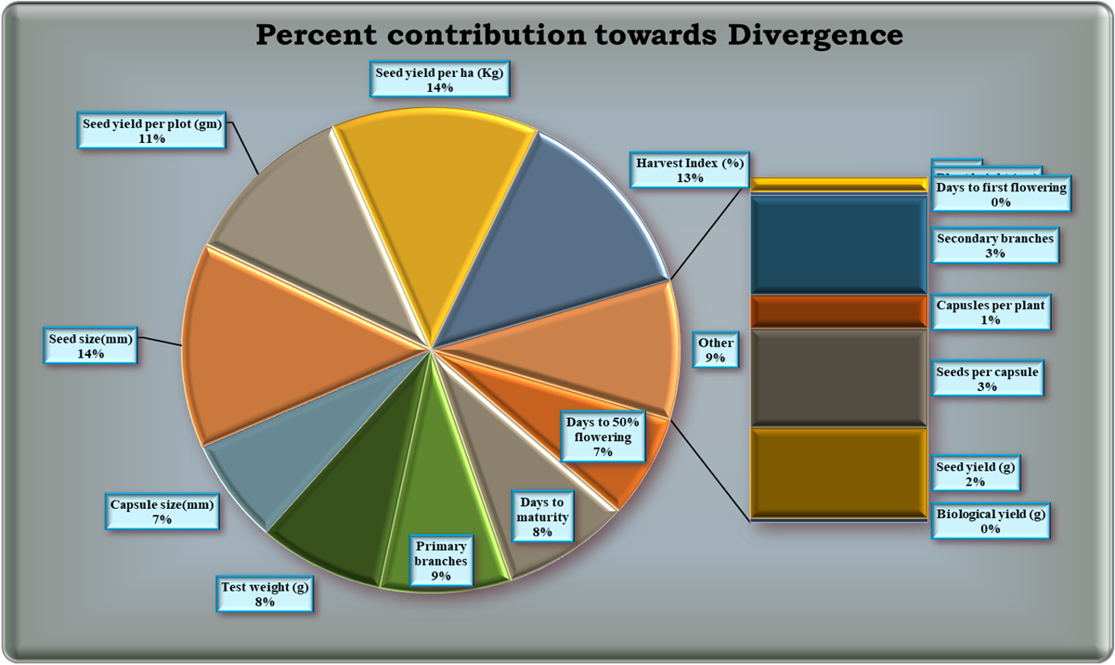

Fig 2 Shows image of five best genotype for quantitative characters

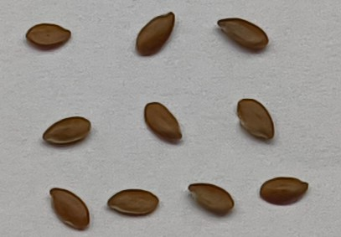
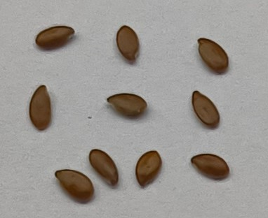
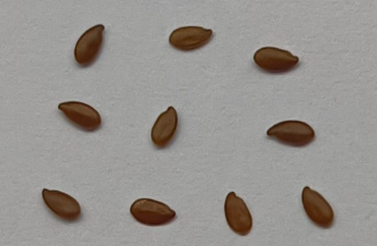
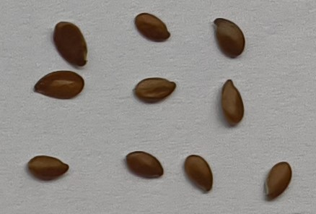
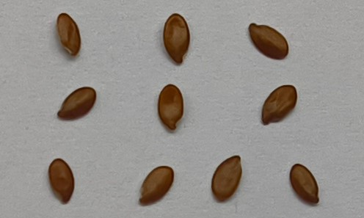
EC-990020
EC-1411CK
EC-12082
EC-41665
EC-10077

