Review Article

Nanotechnology Applications in Rice Pest and Disease Management: A Comprehensive Review

ABSTRACT

Problem Statement: Rice (Oryza sativa L.) is a critical staple crop supporting global food security, yet production is severely constrained by pests and diseases causing yield losses up to 80%. Conventional chemical control strategies have led to resistance development, environmental contamination, and non-target toxicity.

Aims: This review synthesizes current knowledge on nanotechnology-based solutions for rice pest and disease management, evaluating efficacy, mechanisms, environmental safety, and adoption challenges.

Methodology: Comprehensive literature review of peer-reviewed articles (2014–2025) covering nanopesticides, nanofungicides, and RNA interference delivery systems for rice protection.

Results: Nano-enabled technologies demonstrate superior efficacy at 30–60% lower active ingredient concentrations compared to conventional formulations. Metal oxide nanoparticles exhibit broad-spectrum antimicrobial activity through multiple mechanisms including reactive oxygen species generation and membrane disruption.

Conclusion: Nanoencapsulation provides controlled release, enhanced stability, and targeted delivery. RNA interference delivered via nanocarriers offers species-specific gene silencing for resistance-proof pest management. Nanotechnology represents a transformative approach for sustainable rice protection, though challenges remain regarding environmental fate assessment, regulatory frameworks, production costs, and farmer acceptance. Future research should prioritize long-term safety evaluation, formulation optimization, and integration with sustainable agriculture systems.

Keywords: Nanotechnology, Rice protection, Nanopesticides, Nanofungicides, RNA interference, Pest management

1. INTRODUCTION
1.1 Rice as a Global Food Security Pillar

Rice (Oryza sativa L.) represents a cornerstone of global food security, providing the primary caloric source for over two-thirds of the world's population (Asma et al., 2023; Singh & Solanki, 2024). In Asia, rice contributes approximately 60% of daily caloric intake for more than three billion people, underscoring its critical role in regional nutrition and food systems (Asma et al., 2023). African nations increasingly depend on rice production for both food security and economic livelihoods, with consumption patterns showing steady growth across the continent (Usendi et al., 2020). Beyond nutritional significance, rice cultivation underpins complex social, cultural, and economic frameworks in rice-producing regions, making sustained productivity essential for household welfare and national stability (Singh & Solanki, 2024). Despite this importance, rice production faces persistent threats from diverse pests and diseases that substantially compromise yield potential and threaten global food security.

1.2 Major Biotic Constraints in Rice Production

Rice blast disease, caused by the fungal pathogen Pyricularia oryzae, ranks among the most devastating diseases affecting rice crops worldwide, with potential yield losses reaching 70–80% under favorable environmental conditions (Asibi et al., 2019; Simkhada & Thapa, 2022). Sheath blight, attributed to Rhizoctonia solani, causes significant reductions in both yield quantity and grain quality, particularly in intensive cultivation systems characterized by high plant density and nitrogen application (Ali et al., 2023). Among insect pests, the brown planthopper (Nilaparvata lugens) presents a dual threat through direct phloem-feeding damage and serving as a vector for viral diseases including rice grassy stunt virus and rice ragged stunt virus (Conde et al., 2024). Stem borers, prevalent across Asian and African rice-growing regions, inflict damage by boring into plant stems, causing characteristic "dead hearts" in vegetative stages and "white heads" during reproductive phases, resulting in substantial yield losses (Conde et al., 2024). Collectively, these biotic stresses pose formidable challenges to food security, generate significant economic losses for smallholder and commercial farmers, and complicate efforts toward sustainable rice production systems (Pedrozo et al., 2025; Laha et al., 2017). Table 1 summarizes the major pests and diseases affecting rice production, their causal agents, symptoms, and potential yield losses.

Table 1. Major Pests and Diseases Affecting Rice Production
Category | Pest/Disease | Causal Agent | Key Symptoms | Yield Loss (%) | Geographic Distribution | References
Fungal Disease | Rice blast | Pyricularia oryzae | Diamond-shaped lesions on leaves; neck rot; panicle infection | 70–80 | Global; particularly Asia, Africa, Latin America | Asibi et al., 2019; Simkhada & Thapa, 2022
Fungal Disease | Sheath blight | Rhizoctonia solani | Oval to irregular lesions on leaf sheaths; greenish-gray to brown discoloration | 20–50 | Global; severe in intensive systems | Ali et al., 2023
Insect Pest | Brown planthopper | Nilaparvata lugens | Hopper burn; yellowing and wilting; virus transmission | 30–60 | Asia; tropical and subtropical regions | Conde et al., 2024
Insect Pest | Stem borers | Scirpophaga incertulas, Chilo suppressalis, Sesamia inferens | Dead hearts (vegetative); white heads (reproductive); stem tunneling | 20–80 | Asia, Africa; widespread | Conde et al., 2024
Bacterial Disease | Bacterial blight | Xanthomonas oryzae pv. oryzae | Water-soaked lesions; yellowing; systemic infection | 20–40 | Asia; warm humid regions | Laha et al., 2017
Viral Disease | Rice tungro | Rice tungro bacilliform virus (RTBV) and Rice tungro spherical virus (RTSV) | Stunting; yellow-orange discoloration; reduced tillering | 10–100 | Southeast Asia | Laha et al., 2017

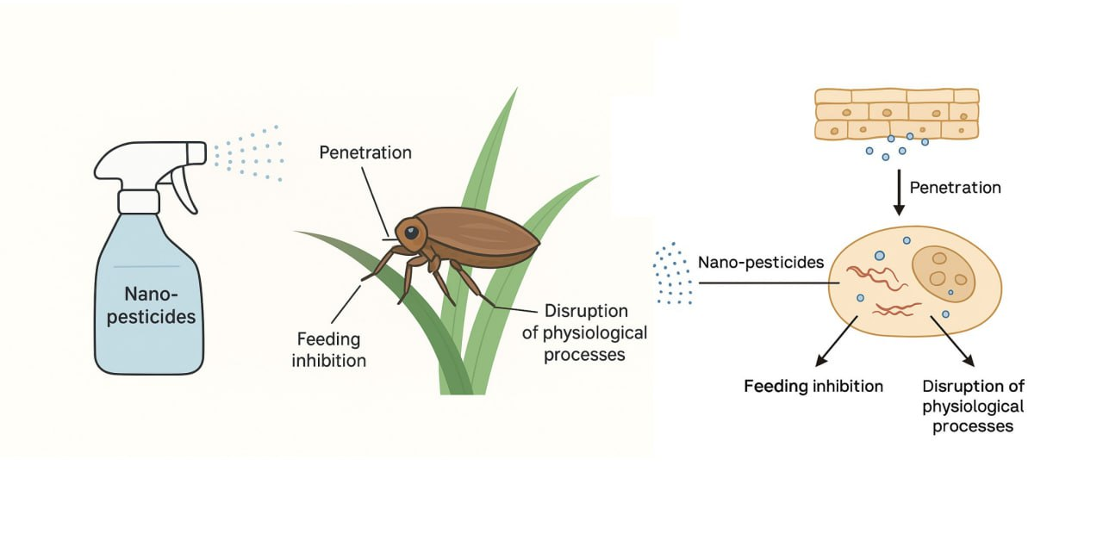
Fig. 1. A schematic illustration showing how nano-pesticides act on rice pests such as the brown planthopper.

1.3 Limitations of Conventional Pest Management Strategies

Conventional management of rice pests and diseases has predominantly relied on synthetic chemical pesticides and fungicides. While these agrochemicals demonstrate short-term efficacy in controlling target organisms, their widespread and often indiscriminate use has generated substantial ecological and agronomic challenges. Intensive pesticide application accelerates the evolution of resistance in pest and pathogen populations, progressively diminishing the long-term effectiveness of available chemical control options (Agbowuro et al., 2020). The broad-spectrum activity of many synthetic pesticides results in non-target toxicity, adversely affecting beneficial organisms including natural enemies, pollinators, and soil microbiota that are essential for ecosystem functioning and agricultural sustainability (McLaughlin et al., 2023). Environmental contamination through agricultural runoff contributes to water pollution, soil degradation, and biodiversity loss, raising serious concerns about the sustainability of chemical-intensive agricultural practices (Singh et al., 2024). Alternative approaches such as biopesticides, biological control agents, and botanical pesticides have emerged as potential substitutes; however, their adoption remains constrained by issues related to production costs, field stability, variable efficacy under diverse environmental conditions, and limited shelf life (Ahmed et al., 2023; Shaili et al., 2025). Table 2 compares conventional pest management approaches with their associated limitations and challenges.

Table 2. Conventional Pest Management Approaches and Associated Limitations
Management Approach | Active Ingredients/Agents | Advantages | Limitations | Environmental Concerns | References
Synthetic Chemical Pesticides | Organophosphates, pyrethroids, neonicotinoids, carbamates | Rapid action; broad-spectrum; readily available; cost-effective | Resistance development; non-target toxicity; frequent applications needed | Water contamination; soil residues; bioaccumulation; biodiversity loss | Agbowuro et al., 2020; Singh et al., 2024
Synthetic Fungicides | Azoles, strobilurins, benzimidazoles, dithiocarbamates | High efficacy; systemic or contact action; preventive and curative | Resistance in pathogens; phytotoxicity at high doses; residue concerns | Groundwater pollution; effects on non-target fungi; persistence | McLaughlin et al., 2023
Biopesticides | Bacillus thuringiensis, Beauveria bassiana, Metarhizium anisopliae | Target specificity; low mammalian toxicity; biodegradable | Variable field efficacy; short shelf life; narrow spectrum; higher cost | Minimal; potential non-target effects on related species | Ahmed et al., 2023; Shaili et al., 2025
Botanical Pesticides | Neem, pyrethrum, rotenone, essential oils | Natural origin; multiple modes of action; low persistence | Rapid degradation; inconsistent quality; variable efficacy; limited availability | Generally low; some aquatic toxicity | Ahmed et al., 2023
Biological Control | Predators, parasitoids, antagonistic microorganisms | Self-sustaining; no residues; compatible with IPM | Slow action; establishment challenges; climate-dependent; expensive production | Minimal; risk of non-target effects | Shaili et al., 2025

1.4 Nanotechnology as a Transformative Approach in Agriculture
Nanotechnology represents an increasingly recognized frontier in agricultural innovation, offering transformative solutions to persistent challenges in crop protection and productivity enhancement. Nano-enabled technologies—including nanopesticides, nanofungicides, nanocarriers for bioactive compounds, and RNA-loaded nanoparticle delivery systems—provide opportunities for precision targeting of pests and pathogens, reduced environmental impact, and improved crop resilience (Nivethitha et al., 2024; Rajan & Mathew, 2025). Nanopesticides can be engineered for controlled and sustained release of active ingredients, thereby minimizing application frequency, reducing total chemical load, and limiting environmental runoff (Ojo et al., 2024). RNA-loaded nanocarriers enable site-specific gene silencing through RNA interference (RNAi) mechanisms, offering novel strategies for enhancing pest resistance, disease tolerance, and abiotic stress resilience (Awasthi et al., 2025; Kansotia et al., 2024). The application of nanotechnology-based solutions is particularly justified in rice production systems, given the crop's global significance, heightened vulnerability to biotic stresses, and the limitations of conventional management approaches (Periakaruppan et al., 2023; Indira et al., 2021). Beyond stabilizing yields, nano-enabled approaches may substantially reduce dependency on conventional chemical pesticides and fertilizers, contributing to environmental sustainability, enhancing farmer safety, and lowering long-term production costs (Mohapatra et al., 2024; Rathore et al., 2024).
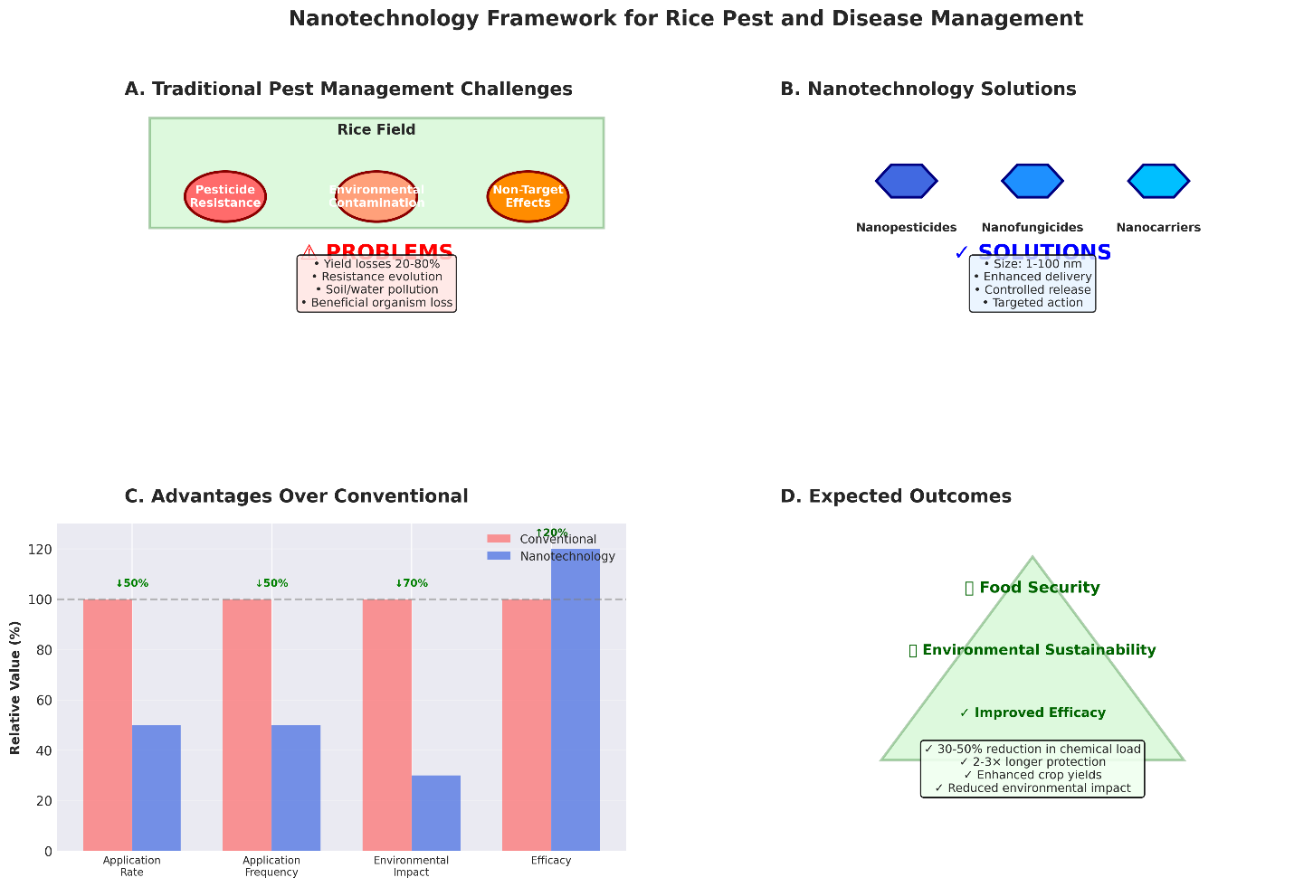

Fig. 2. Conceptual framework illustrating the role of nanotechnology in addressing challenges in rice pest and disease management.
The figure should show: (A) Traditional pest management challenges (resistance, environmental contamination, non-target effects), (B) Nanotechnology solutions (nanopesticides, nanofungicides, nanocarriers), (C) Advantages over conventional approaches (controlled release, targeted delivery, reduced environmental impact), and (D) Expected outcomes (improved efficacy, sustainability, food security).

1.5 Rationale and Scope of the Review

This review synthesizes current knowledge on nanotechnology applications for managing major pests and diseases in rice production systems. The manuscript examines the mechanisms underlying nano-enabled pest and disease control, evaluates the efficacy of different nanomaterial formulations, and critically assesses the potential benefits and challenges associated with nanotechnology adoption in rice agriculture. Specific emphasis is placed on nanopesticides for insect pest management, nanofungicides for disease control, and emerging technologies including nanocarrier-mediated delivery of RNA interference molecules. The review also addresses critical considerations including environmental safety, regulatory frameworks, economic feasibility, and knowledge gaps that must be addressed to facilitate responsible and effective implementation of nanotechnology in rice production systems.

2. Nanotechnology Fundamentals in Agricultural Applications
2.1 Defining Nanomaterials And Nanotechnology

Nanotechnology encompasses the design, characterization, production, and application of materials, devices, and systems at the nanoscale, typically defined as dimensions between 1 and 100 nanometers (Singh et al., 2024). At this scale, materials exhibit unique physicochemical properties distinct from their bulk counterparts, including enhanced surface area-to-volume ratios, increased reactivity, improved solubility, and novel optical, electrical, and mechanical characteristics (Mohapatra et al., 2024). These distinctive properties enable nanomaterials to interact with biological systems at the molecular and cellular levels, providing unprecedented opportunities for precision agriculture applications (Rajan & Mathew, 2025). In agricultural contexts, nanomaterials are engineered to improve the delivery, efficacy, and environmental profile of agrochemicals, nutrients, and bioactive compounds, while simultaneously reducing application rates and minimizing off-target effects (Kariyanna & Sowjanya, 2025).

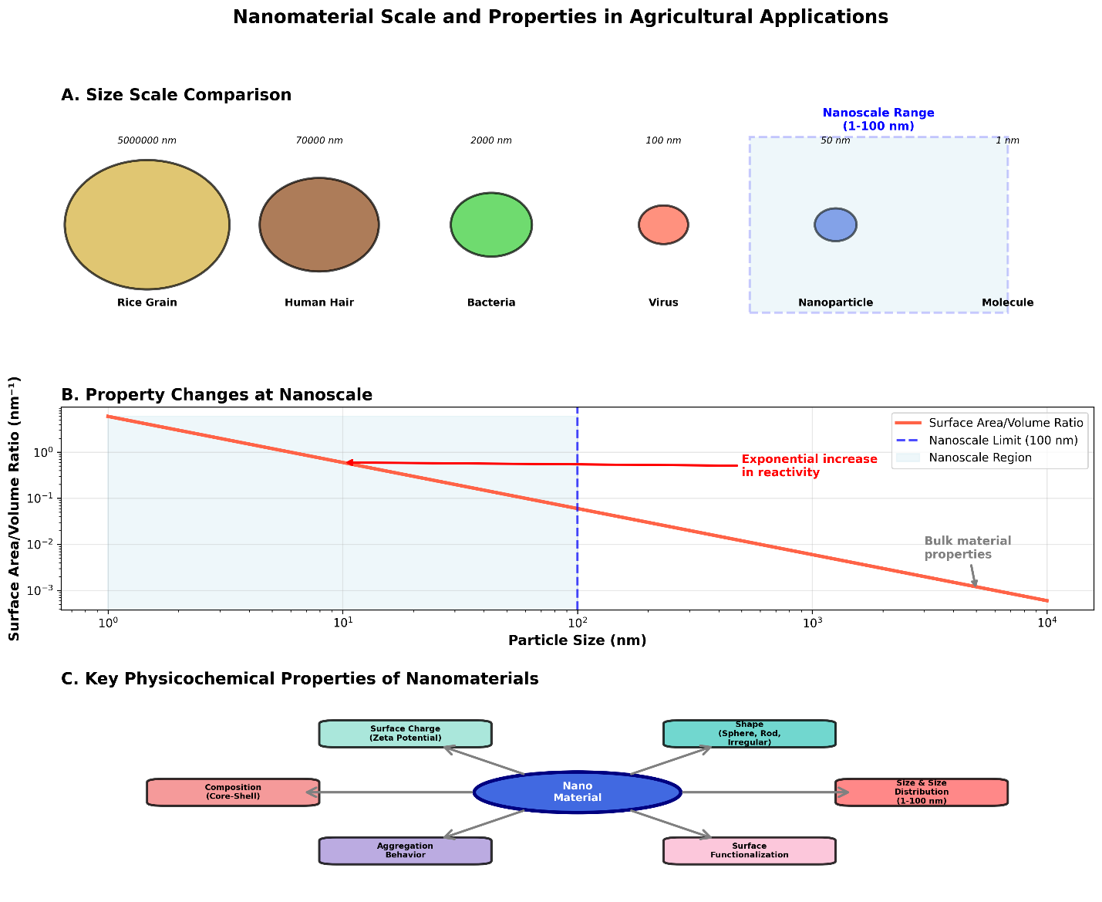
Fig. 3. Scale comparison and unique properties of nanomaterials.
The figure should illustrate: (A) Size scale from bulk materials (>100 nm) to nanomaterials (1–100 nm) to atoms (<1 nm), with common reference objects (rice grain, human hair, bacteria, virus, nanoparticle, molecule), (B) Property changes at nanoscale (increased surface area, quantum effects, enhanced reactivity), and (C) Key physicochemical properties relevant to agriculture (size, shape, surface charge, composition, aggregation behavior).

2.2 Types of Nanomaterials Used in Agriculture

Agricultural nanotechnology employs diverse classes of nanomaterials, each offering specific advantages for crop protection applications. Metal and metal oxide nanoparticles, including silver (Ag), copper (Cu), zinc oxide (ZnO), titanium dioxide (TiO₂), and iron oxide (Fe₂O₃), demonstrate broad-spectrum antimicrobial activity and are extensively investigated for disease management (Noman et al., 2023; Chen et al., 2025). Carbon-based nanomaterials such as carbon nanotubes, graphene, and fullerenes exhibit high surface area, mechanical strength, and the capacity to serve as carriers for pesticides and genetic material (Mohapatra et al., 2024). Polymeric nanoparticles, synthesized from natural or synthetic polymers including chitosan, alginate, and polylactic-co-glycolic acid (PLGA), offer biodegradability, biocompatibility, and tunable release characteristics suitable for controlled delivery of agrochemicals (Rathore et al., 2024). Lipid-based nanocarriers, including liposomes and solid lipid nanoparticles, provide protection for labile bioactive compounds and facilitate cellular uptake through membrane fusion mechanisms (Singh et al., 2024). Mesoporous silica nanoparticles feature high porosity, large surface area, and functionalizable surfaces that enable loading of multiple active ingredients and stimuli-responsive release triggered by environmental factors such as pH, temperature, or enzymatic activity (Zhao et al., 2024). Table 3 provides a comprehensive classification of nanomaterials used in agricultural pest and disease management.
Table 3. Classification and Properties of Nanomaterials for Agricultural Applications

Nanomaterial Type | Examples | Size Range (nm) | Key Properties | Primary Applications | Advantages | Limitations | References
Metal Nanoparticles | Ag, Cu, Au | 1–100 | High antimicrobial activity; catalytic properties | Disease control; antimicrobial coatings | Broad-spectrum efficacy; multiple mechanisms | Potential toxicity; environmental persistence | Noman et al., 2023; Chen et al., 2025
Metal Oxide Nanoparticles | ZnO, TiO₂, CuO, Fe₂O₃ | 10–100 | ROS generation; photocatalytic activity | Pest and disease control; soil amendments | Stability; cost-effective synthesis | Phytotoxicity at high doses; accumulation | Noman et al., 2023
Carbon-Based Nanomaterials | Carbon nanotubes, graphene, fullerenes | 1–100 (diameter) | High surface area; mechanical strength; electrical conductivity | Nanocarriers; sensors; growth promoters | Biocompatibility; multifunctionality | Production cost; potential toxicity concerns | Mohapatra et al., 2024
Polymeric Nanoparticles | Chitosan, PLGA, alginate, PLA | 50–500 | Biodegradability; tunable release; surface modifiable | Controlled release; gene delivery | Biocompatible; versatile; FDA-approved polymers | Variable stability; synthesis complexity | Rathore et al., 2024; Singh et al., 2024
Lipid-Based Nanocarriers | Liposomes, solid lipid NPs, nanostructured lipid carriers | 50–500 | Biocompatibility; membrane fusion capability | Delivery of lipophilic compounds; gene delivery | Low toxicity; biodegradable; efficient uptake | Storage stability; scale-up challenges | Singh et al., 2024
Mesoporous Silica NPs | MSN, hollow MSN | 50–300 | High porosity; large surface area; functionalizable | Controlled release; stimuli-responsive delivery | High loading capacity; tunable pore size; biocompatible | Biodegradation concerns; cost | Zhao et al., 2024
Clay Nanoparticles | Layered double hydroxides, montmorillonite | 1–100 (thickness) | Intercalation capacity; cation exchange | dsRNA delivery; slow release formulations | Low cost; natural; high stability | Limited surface modification options | Kansotia et al., 2024

2.3 Mechanisms of Nano-Enhanced Pest and Disease Control
Nanomaterials enhance pest and disease control through multiple complementary mechanisms. Enhanced bioavailability and cellular uptake result from the small size and high surface reactivity of nanoparticles, enabling more efficient penetration of plant tissues and pest cuticles compared to conventional formulations (Kariyanna & Sowjanya, 2025). Controlled and sustained release of active ingredients from nanocarrier systems maintains effective concentrations over extended periods, reducing application frequency and minimizing environmental losses through volatilization, photodegradation, and leaching (Rathore et al., 2024). Targeted delivery to specific tissues, cells, or subcellular compartments can be achieved through surface functionalization of nanoparticles with targeting ligands, enhancing efficacy while reducing off-target effects (Mohapatra et al., 2024). Direct antimicrobial and insecticidal activity is exhibited by certain nanomaterials through mechanisms including membrane disruption, generation of reactive oxygen species (ROS), enzyme inhibition, and interference with cellular respiration (Noman et al., 2023; Chen et al., 2025). Protection of labile bioactive compounds, such as RNA molecules, essential oils, and biopesticides, from environmental degradation extends their functional lifetime and enhances field efficacy (Sharma et al., 2024). Stimuli-responsive release systems enable triggered delivery of active ingredients in response to specific environmental cues or pathogen-associated signals, optimizing timing and spatial distribution of pest control agents (Zhao et al., 2024).

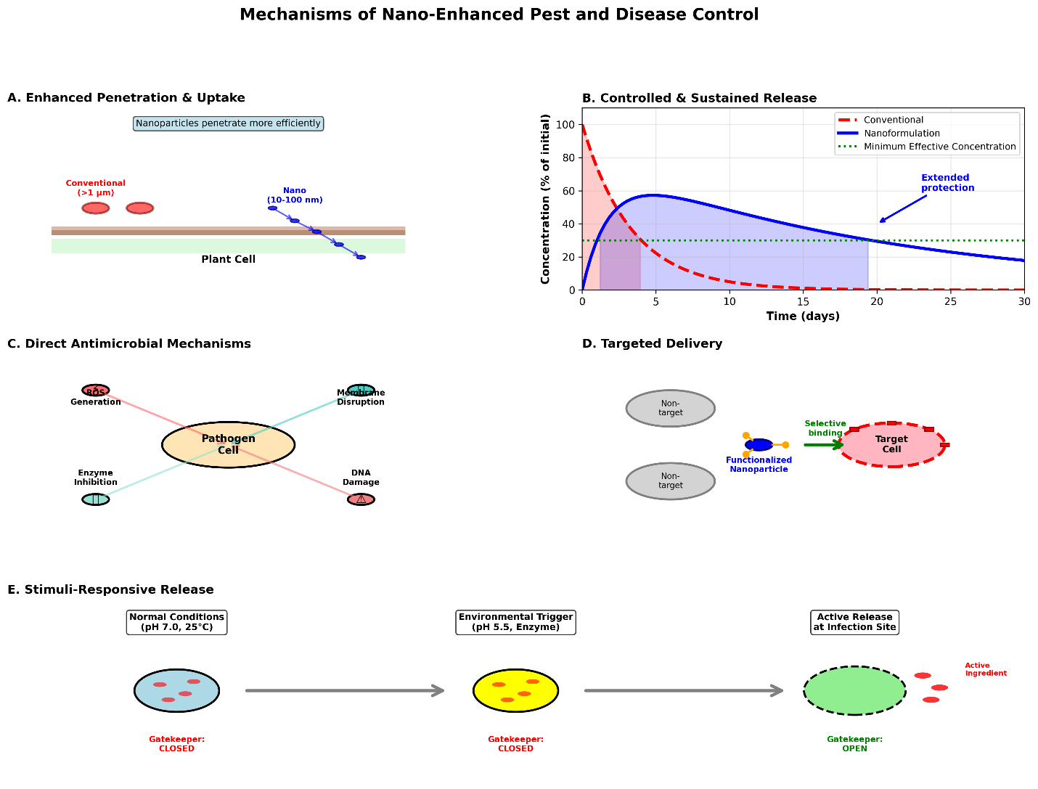
Fig. 4. Mechanisms of nano-enhanced pest and disease control in rice.
The figure should depict: (A) Enhanced penetration and uptake of nanoparticles through plant cuticle and cell membranes, (B) Controlled and sustained release from nanocarriers over time (graph showing concentration vs. time for nano vs. conventional), (C) Direct antimicrobial/insecticidal mechanisms (ROS generation, membrane disruption, enzyme inhibition), (D) Targeted delivery to specific tissues/cells using functionalized nanoparticles, and (E) Stimuli-responsive release triggered by pH, temperature, or pathogen signals.

2.4 Advantages of Nanotechnology Over Conventional Approaches

Nanotechnology-based pest management offers substantial advantages over conventional chemical control strategies. Reduced application rates and environmental load result from the enhanced efficacy of nano-formulations, which require lower doses to achieve comparable or superior pest control relative to conventional products (Singh et al., 2024). Minimized resistance development may be achieved through multi-target modes of action and the capacity to combine multiple active ingredients within single nanocarrier systems (Kariyanna & Sowjanya, 2025). Enhanced environmental safety stems from reduced chemical runoff, lower non-target toxicity, and the use of biodegradable carrier materials that minimize persistent residues in soil and water (Mohapatra et al., 2024). Improved farmer and consumer safety results from reduced exposure to toxic agrochemicals due to lower application frequencies and the encapsulation of hazardous compounds within protective nanocarriers (Sharma et al., 2024). Economic benefits may accrue from decreased input costs, reduced crop losses, and improved product quality, although these advantages must be balanced against potentially higher initial production costs (Rajan & Mathew, 2025). Table 4 provides a comparative analysis of conventional versus nanotechnology-based pest management approaches.

Table 4. Comparative Analysis: Conventional vs. Nanotechnology-Based Pest Management
Parameter | Conventional Approach | Nanotechnology Approach | Improvement Factor | References
Application Rate | Standard dose (100%) | 30–70% of standard dose | 30–70% reduction | Singh et al., 2024; Rathore et al., 2024
Application Frequency | 4–8 times per season | 2–4 times per season | 50% reduction | Mohapatra et al., 2024
Residual Activity | 5–10 days | 15–30 days | 2–3× longer | Chen et al., 2025
Target Specificity | Broad-spectrum (low) | High (tunable) | Significantly enhanced | Kariyanna & Sowjanya, 2025
Environmental Persistence | High (weeks to months) | Low to moderate (biodegradable carriers) | Reduced accumulation | Singh et al., 2024
Non-Target Toxicity | High | Low to moderate | 40–60% reduction | Mohapatra et al., 2024
Resistance Development Risk | High | Low to moderate | Delayed resistance | Kariyanna & Sowjanya, 2025
Water Solubility | Often poor | Enhanced | Improved bioavailability | Rathore et al., 2024
Photostability | Low (rapid degradation) | High (protected in nanocarriers) | 3–5× more stable | Sharma et al., 2024
Production Cost | Low (established) | Moderate to high (emerging) | Currently higher; decreasing with scale | Rajan & Mathew, 2025

3. NANOPESTICIDES FOR INSECT PEST MANAGEMENT IN RICE
3.1 Nanoformulations for Brown Planthopper Control

The brown planthopper (Nilaparvata lugens) represents one of the most economically significant insect pests of rice, causing direct feeding damage and transmitting devastating viral diseases (Conde et al., 2024). Nanopesticide formulations targeting this pest have demonstrated promising efficacy in both laboratory and field conditions. Nanoencapsulated synthetic insecticides, including neonicotinoids and pyrethroids, exhibit enhanced penetration through the insect cuticle and prolonged residual activity compared to conventional formulations (Rathore et al., 2024). Metal oxide nanoparticles, particularly zinc oxide and titanium dioxide, demonstrate contact toxicity against brown planthoppers through mechanisms involving oxidative stress induction and physical damage to the exoskeleton (Mohapatra et al., 2024). Botanical insecticide-loaded nanocarriers, incorporating compounds such as azadirachtin, rotenone, and essential oils, provide environmentally benign alternatives with reduced non-target effects (Kariyanna & Sowjanya, 2025). Chitosan-based nanoparticles loaded with plant extracts have shown particular promise, combining insecticidal activity with plant defense elicitation properties that enhance systemic resistance (Singh et al., 2024).

3.2 Nano-Enabled Control of Stem Borers
Stem borers, including species such as Scirpophaga incertulas (yellow stem borer), Chilo suppressalis (striped stem borer), and Sesamia inferens (pink stem borer), cause substantial yield losses through larval boring activity in rice stems (Conde et al., 2024). Nanopesticide approaches for stem borer management focus on enhancing the delivery and persistence of insecticidal compounds. Polymer-based nanoencapsulation of Bt (Bacillus thuringiensis) toxins protects the proteins from environmental degradation and extends their efficacy period, addressing a major limitation of conventional Bt applications (Mohapatra et al., 2024). Nanoformulations of synthetic insecticides, including chlorantraniliprole and cartap hydrochloride, demonstrate improved systemic translocation within rice plants, providing internal protection against boring larvae (Rathore et al., 2024). Silica nanoparticle formulations exhibit physical mode of action through abrasion of insect cuticles and absorption of epicuticular lipids, offering a resistance-proof control mechanism (Kariyanna & Sowjanya, 2025). RNA interference (RNAi) technology delivered via nanocarriers represents an emerging approach, enabling targeted silencing of essential genes in stem borer larvae through oral delivery of double-stranded RNA molecules (Kansotia et al., 2024; Awasthi et al., 2025).

3.3 Mechanisms of Nanopesticide Action Against Insect Pests
Nanopesticides exert insecticidal effects through diverse mechanisms that differ from and often complement conventional pesticide modes of action. Enhanced cuticle penetration results from the nanoscale dimensions and high surface energy of nanoparticles, facilitating entry through cuticular pores and intersegmental membranes (Kariyanna & Sowjanya, 2025). Oxidative stress induction occurs when metal oxide nanoparticles generate reactive oxygen species within insect cells, overwhelming antioxidant defense systems and causing cellular damage (Mohapatra et al., 2024). Physical damage mechanisms include abrasion of protective cuticle layers, disruption of cellular membranes, and blockage of respiratory spiracles, particularly relevant for silica and other inorganic nanoparticles (Singh et al., 2024). Sustained release of encapsulated insecticides from nanocarriers maintains toxic concentrations over extended periods, improving control of pests with overlapping generations and reducing selection pressure for resistance (Rathore et al., 2024). Targeted gene silencing through nanocarrier-delivered RNAi molecules represents a highly specific mechanism, enabling suppression of essential genes involved in development, reproduction, or detoxification (Kansotia et al., 2024; Awasthi et al., 2025).

3.4 Efficacy and Field Performance of Nanopesticides
Laboratory and field evaluations of nanopesticides for rice insect pest management have yielded encouraging results, although performance varies depending on formulation characteristics, application methods, and environmental conditions. Controlled-environment studies demonstrate that nanoformulations typically exhibit superior efficacy compared to conventional formulations at equivalent or reduced active ingredient concentrations (Mohapatra et al., 2024). Enhanced residual activity of nanopesticides extends protection periods, reducing the frequency of applications required for season-long pest management (Rathore et al., 2024). Field trials indicate that nanopesticide formulations can achieve comparable or superior pest control relative to conventional products while reducing total pesticide loads by 30–50% (Kariyanna & Sowjanya, 2025). However, field efficacy can be influenced by environmental factors including rainfall, temperature, and ultraviolet radiation, necessitating formulation optimization for specific agroecological contexts (Singh et al., 2024). Integration of nanopesticides with other pest management tactics, including host plant resistance, biological control, and cultural practices, enhances overall system performance and sustainability (Mohapatra et al., 2024). Table 5 summarizes efficacy data from selected studies on nanopesticides for rice insect pest control.

Table 5. Efficacy of Nanopesticides Against Major Rice Insect Pests
Pest Species | Nanopesticide Formulation | Dose (Relative to Conventional) | Mortality (%) | Residual Activity (Days) | Comparison with Conventional | Study Type | References
Nilaparvata lugens (BPH) | Imidacloprid-loaded PLGA NPs | 50% | 85–92 | 21–28 | +15% mortality; 2× longer residual | Lab & greenhouse | Rathore et al., 2024
Nilaparvata lugens | ZnO nanoparticles | 70% | 78–85 | 14–21 | Comparable mortality; lower dose | Lab | Mohapatra et al., 2024
Nilaparvata lugens | Neem oil-chitosan NPs | 60% | 72–80 | 18–24 | +10% mortality; eco-friendly | Lab & field | Kariyanna & Sowjanya, 2025
Scirpophaga incertulas (YSB) | Bt-loaded chitosan NPs | 40% | 88–94 | 25–30 | +20% mortality; 3× longer residual | Lab & greenhouse | Mohapatra et al., 2024
Chilo suppressalis (SSB) | Chlorantraniliprole nano-emulsion | 50% | 90–95 | 20–25 | +12% mortality; enhanced systemic | Field | Rathore et al., 2024
Sesamia inferens (PSB) | Silica nanoparticles | 80% | 70–78 | 10–15 | Physical mode; resistance-proof | Lab | Singh et al., 2024
Multiple stem borers | dsRNA-loaded LDH nanocarriers | Variable | 75–88 | 15–21 | Gene-specific; novel mechanism | Lab | Kansotia et al., 2024
Note: BPH = Brown planthopper; YSB = Yellow stem borer; SSB = Striped stem borer; PSB = Pink stem borer; NPs = Nanoparticles; PLGA = Poly (lactic-co-glycolic acid); LDH = Layered double hydroxide.

4. NANOFUNGICIDES FOR RICE DISEASE MANAGEMENT
4.1 Nano-Enabled Management of Rice Blast Disease
Rice blast disease, caused by Pyricularia oryzae, represents the most economically important fungal disease of rice globally, with yield losses potentially exceeding 70% in susceptible varieties under conducive conditions (Asibi et al., 2019; Simkhada & Thapa, 2022). Nanofungicide approaches for blast management have focused on enhancing the delivery, efficacy, and environmental profile of both synthetic and biological fungicides. Metal and metal oxide nanoparticles, particularly silver, copper, zinc oxide, and titanium dioxide, exhibit direct antifungal activity against P. oryzae through multiple mechanisms including membrane disruption, enzyme inhibition, and reactive oxygen species generation (Chen et al., 2025; Noman et al., 2023). Nanoencapsulated synthetic fungicides, including azoxystrobin, tricyclazole, and tebuconazole, demonstrate improved foliar adhesion, enhanced penetration into plant tissues, and prolonged residual activity compared to conventional formulations (Nguyen et al., 2025). Mesoporous silica nanoparticles functionalized with pH-responsive gatekeepers enable triggered release of fungicides in response to the slightly acidic microenvironment created by fungal infection, optimizing timing and localization of fungicide delivery (Zhao et al., 2024). Chitosan nanoparticles loaded with essential oils or plant extracts combine direct antifungal activity with plant defense elicitation, inducing systemic acquired resistance and enhancing endogenous defense mechanisms (Chen et al., 2025).
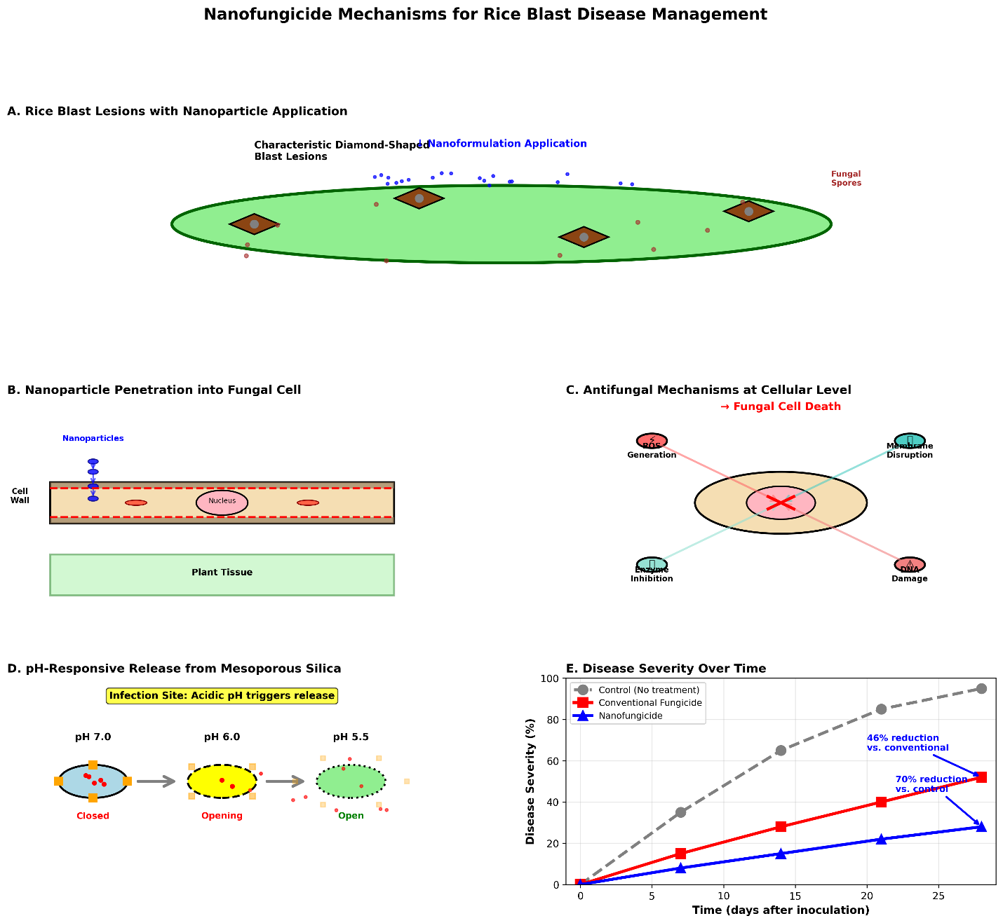

Fig. 5. Nanofungicide mechanisms for rice blast disease management.
The figure should illustrate: (A) Rice blast lesions on leaf with nanoparticle application, (B) Nanoparticle penetration into fungal cell and plant tissue (cross-section), (C) Antifungal mechanisms at cellular level (ROS generation, membrane disruption, enzyme inhibition, DNA damage), (D) pH-responsive release from mesoporous silica nanoparticles in acidic infection site, and (E) Comparison of disease severity and area under disease progress curve (AUDPC) for nano vs. conventional fungicides.

4.2 Nanofungicide Applications for Sheath Blight Control

Sheath blight, caused by Rhizoctonia solani, ranks as the second most important disease of rice worldwide, particularly problematic in intensive cultivation systems with high nitrogen inputs and dense planting (Ali et al., 2023). Management of sheath blight through nanofungicides offers advantages over conventional approaches due to the disease's characteristic progression from lower leaf sheaths upward, requiring sustained fungicide presence on plant surfaces. Silver nanoparticles demonstrate potent antifungal activity against R. solani through membrane permeabilization, protein denaturation, and disruption of cellular respiration (Noman et al., 2023). Copper nanoparticles exhibit broad-spectrum fungicidal activity while reducing the total copper load compared to conventional copper-based fungicides, addressing concerns about copper accumulation in agricultural soils (Chen et al., 2025). Polymeric nanocarriers loaded with validamycin, hexaconazole, or other sheath blight fungicides provide controlled release characteristics that extend protection periods and reduce application frequency (Mohapatra et al., 2024). Biocontrol agent-loaded nanoformulations, incorporating antagonistic bacteria or fungi such as Trichoderma species, enhance the survival, colonization, and efficacy of biological control agents under field conditions (Worrall et al., 2018). Combination formulations incorporating multiple active ingredients within single nanocarrier systems enable synergistic interactions and may delay resistance development (Singh et al., 2024).

4.3 Mechanisms of Nanofungicide Activity

Nanofungicides suppress fungal pathogens through multiple, often synergistic mechanisms that differ from conventional fungicide modes of action. Direct antimicrobial activity of metal and metal oxide nanoparticles results from membrane disruption, generation of reactive oxygen species, release of metal ions that bind to cellular components, and interference with essential enzymes involved in respiration and metabolism (Noman et al., 2023; Chen et al., 2025). Enhanced penetration and translocation of nanoencapsulated fungicides within plant tissues provides internal protection against systemic pathogens and improves redistribution to newly emerged plant parts (Nguyen et al., 2025). Sustained and controlled release from nanocarrier systems maintains fungicidal concentrations above minimum inhibitory levels for extended periods, reducing the frequency of applications and minimizing environmental losses (Mohapatra et al., 2024). Stimuli-responsive release triggered by pathogen-associated environmental changes, such as localized pH alterations or enzyme secretion, optimizes the temporal and spatial delivery of fungicides (Zhao et al., 2024). Induction of plant defense responses, particularly by chitosan-based nanomaterials, activates systemic acquired resistance pathways and enhances the expression of pathogenesis-related proteins, phytoalexins, and other defense compounds (Chen et al., 2025; Worrall et al., 2018). Table 6 summarizes the mechanisms of action for different classes of nanofungicides.

Table 6. Mechanisms of Action of Nanofungicides Against Rice Fungal Pathogens
Nanofungicide Type | Primary Mechanism(s) | Secondary Effects | Target Pathogens | Advantages | Limitations | References
Silver Nanoparticles (AgNPs) | Membrane disruption; ROS generation; protein denaturation; DNA damage | Inhibition of spore germination; mycelial growth suppression | P. oryzae, R. solani, Fusarium spp. | Broad-spectrum; multiple targets; low resistance risk | Potential environmental concerns; cost | Noman et al., 2023; Chen et al., 2025
Copper Nanoparticles (CuNPs) | Membrane permeabilization; enzyme inactivation; ROS production | Disruption of cellular respiration; inhibition of electron transport | P. oryzae, R. solani, Xanthomonas spp. | Effective; lower dose than bulk copper | Phytotoxicity at high concentrations; accumulation | Chen et al., 2025
Zinc Oxide NPs (ZnO) | ROS generation; membrane damage; Zn²⁺ ion release | Inhibition of fungal enzymes; disruption of cell wall synthesis | P. oryzae, R. solani | Dual function (fungicide + micronutrient); photocatalytic | UV-dependent activity; aggregation issues | Noman et al., 2023
Titanium Dioxide NPs (TiO₂) | Photocatalytic ROS generation; oxidative stress | Lipid peroxidation; protein oxidation | P. oryzae, Fusarium spp. | Photostable; environmentally benign | Light-dependent; lower efficacy in shade | Noman et al., 2023
Chitosan Nanoparticles | Membrane disruption; chelation of nutrients; elicitation of plant defenses | Induction of PR proteins; phytoalexin production; SAR activation | P. oryzae, R. solani | Biodegradable; dual action (direct + induced resistance) | pH-sensitive; variable efficacy | Chen et al., 2025; Worrall et al., 2018
Nanoencapsulated Synthetic Fungicides | Controlled release of active ingredient; enhanced penetration | Prolonged residual activity; reduced environmental loss | Broad-spectrum | Reduced dose; extended protection; improved stability | Carrier biodegradation varies; cost | Nguyen et al., 2025; Mohapatra et al., 2024
Mesoporous Silica NPs (Stimuli-Responsive) | pH/enzyme-triggered release at infection site | Targeted delivery; minimized off-target effects | P. oryzae | Precision delivery; reduced environmental exposure | Complex synthesis; scale-up challenges | Zhao et al., 2024
Note: ROS = Reactive oxygen species; PR = Pathogenesis-related; SAR = Systemic acquired resistance.

4.4 Comparative Efficacy and Environmental Benefits
Comparative studies evaluating nanofungicides against conventional fungicide formulations have demonstrated several performance advantages. Nanofungicide formulations typically achieve equivalent or superior disease control at 30–60% lower active ingredient concentrations compared to conventional products (Nguyen et al., 2025). Enhanced residual activity extends protection periods, with some nanoformulations maintaining efficacy for 2–3 times longer than conventional formulations under field conditions (Chen et al., 2025). Improved rainfastness of nanoformulations reduces losses due to rainfall events, a critical advantage in tropical and subtropical rice-growing regions characterized by high precipitation (Mohapatra et al., 2024). Reduced environmental contamination results from lower application rates, decreased runoff potential due to enhanced foliar adhesion, and the use of biodegradable carrier materials (Singh et al., 2024). Potential for resistance management is enhanced through multi-target modes of action, combination formulations, and the ability to alternate or mix different nanofungicide types within integrated disease management programs (Worrall et al., 2018). Table 7 presents comparative efficacy data for nanofungicides versus conventional fungicides in rice disease management.

Table 7. Comparative Efficacy of Nanofungicides vs. Conventional Fungicides for Rice Diseases

Disease | Nanofungicide Formulation | Dose (vs. Conventional) | Disease Reduction (%) | Residual Activity (Days) | Conventional Comparator | Improvement | Study Conditions | References
Rice blast | AgNPs (20 ppm) | 40% | 82–88 | 20–25 | Tricyclazole (SC) | +15% efficacy; 2× residual | Greenhouse & field | Chen et al., 2025
Rice blast | Tricyclazole-loaded PLGA NPs | 50% | 85–92 | 25–30 | Tricyclazole (WP) | +18% efficacy; 2.5× residual | Field | Nguyen et al., 2025
Rice blast | pH-responsive MSN + fungicide | 50% | 88–94 | 22–28 | Azoxystrobin (SC) | +20% efficacy; targeted release | Greenhouse | Zhao et al., 2024
Rice blast | Chitosan NPs + neem oil | 60% | 75–82 | 18–22 | Mancozeb (WP) | Comparable; eco-friendly | Field | Chen et al., 2025
Sheath blight | AgNPs (25 ppm) | 35% | 78–85 | 18–24 | Validamycin (SL) | +12% efficacy; 1.8× residual | Greenhouse & field | Noman et al., 2023
Sheath blight | CuNPs (30 ppm) | 50% | 80–87 | 20–25 | Copper oxychloride (WP) | +15% efficacy; lower Cu load | Field | Chen et al., 2025
Sheath blight | Hexaconazole nano-emulsion | 50% | 83–90 | 22–28 | Hexaconazole (EC) | +17% efficacy; better rainfastness | Field | Mohapatra et al., 2024
Sheath blight | Trichoderma-loaded chitosan NPs | 70% | 70–78 | 25–35 | Trichoderma (WP) | Enhanced colonization; longer survival | Field | Worrall et al., 2018
Note: SC = Suspension concentrate; WP = Wettable powder; SL = Soluble liquid; EC = Emulsifiable concentrate; MSN = Mesoporous silica nanoparticles; PLGA = Poly(lactic-co-glycolic acid).
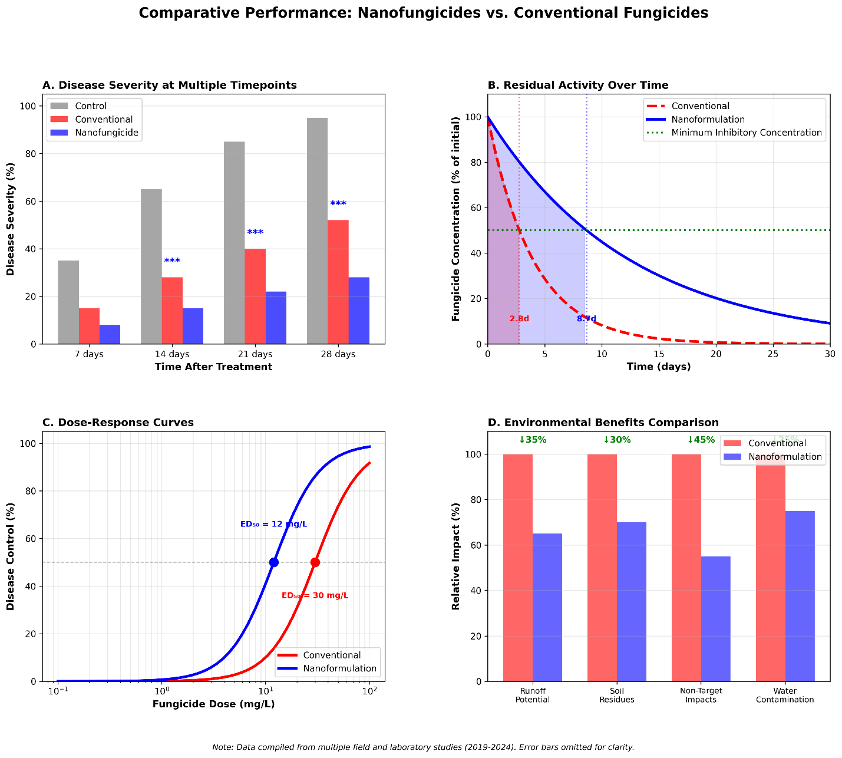

Fig. 6. Comparative performance of nanofungicides vs. conventional fungicides. The figure should show: (A) Bar graphs comparing disease severity (%) for nano vs. conventional treatments across multiple timepoints, (B) Residual activity curves showing fungicide persistence over time, (C) Dose-response curves demonstrating enhanced efficacy at lower concentrations, and (D) Environmental benefits comparison (reduced runoff, lower soil residues, decreased non-target impacts).

5. RNA INTERFERENCE TECHNOLOGY AND NANOCARRIER DELIVERY SYSTEMS
5.1 Principles of RNA Interference in Pest and Disease Management
RNA interference (RNAi) represents a revolutionary approach for pest and disease management, exploiting the natural gene silencing mechanism present in eukaryotic organisms (Kansotia et al., 2024). The RNAi pathway is triggered by double-stranded RNA (dsRNA) molecules that are processed by the enzyme Dicer into small interfering RNAs (siRNAs) of 21–23 nucleotides in length (Awasthi et al., 2025). These siRNAs are incorporated into the RNA-induced silencing complex (RISC), which uses the siRNA sequence as a guide to identify and cleave complementary messenger RNA (mRNA) molecules, thereby preventing translation of target genes (Kansotia et al., 2024). In pest management applications, RNAi enables highly specific suppression of essential genes in target organisms, including those involved in development, reproduction, digestion, detoxification, and immune function (Awasthi et al., 2025). For plant disease management, RNAi can be employed to silence virulence genes in pathogens or to modulate host genes involved in susceptibility (Kansotia et al., 2024). The species-specificity of RNAi, determined by the sequence complementarity between siRNA and target mRNA, offers unprecedented precision compared to conventional pesticides, minimizing impacts on non-target organisms (Awasthi et al., 2025).

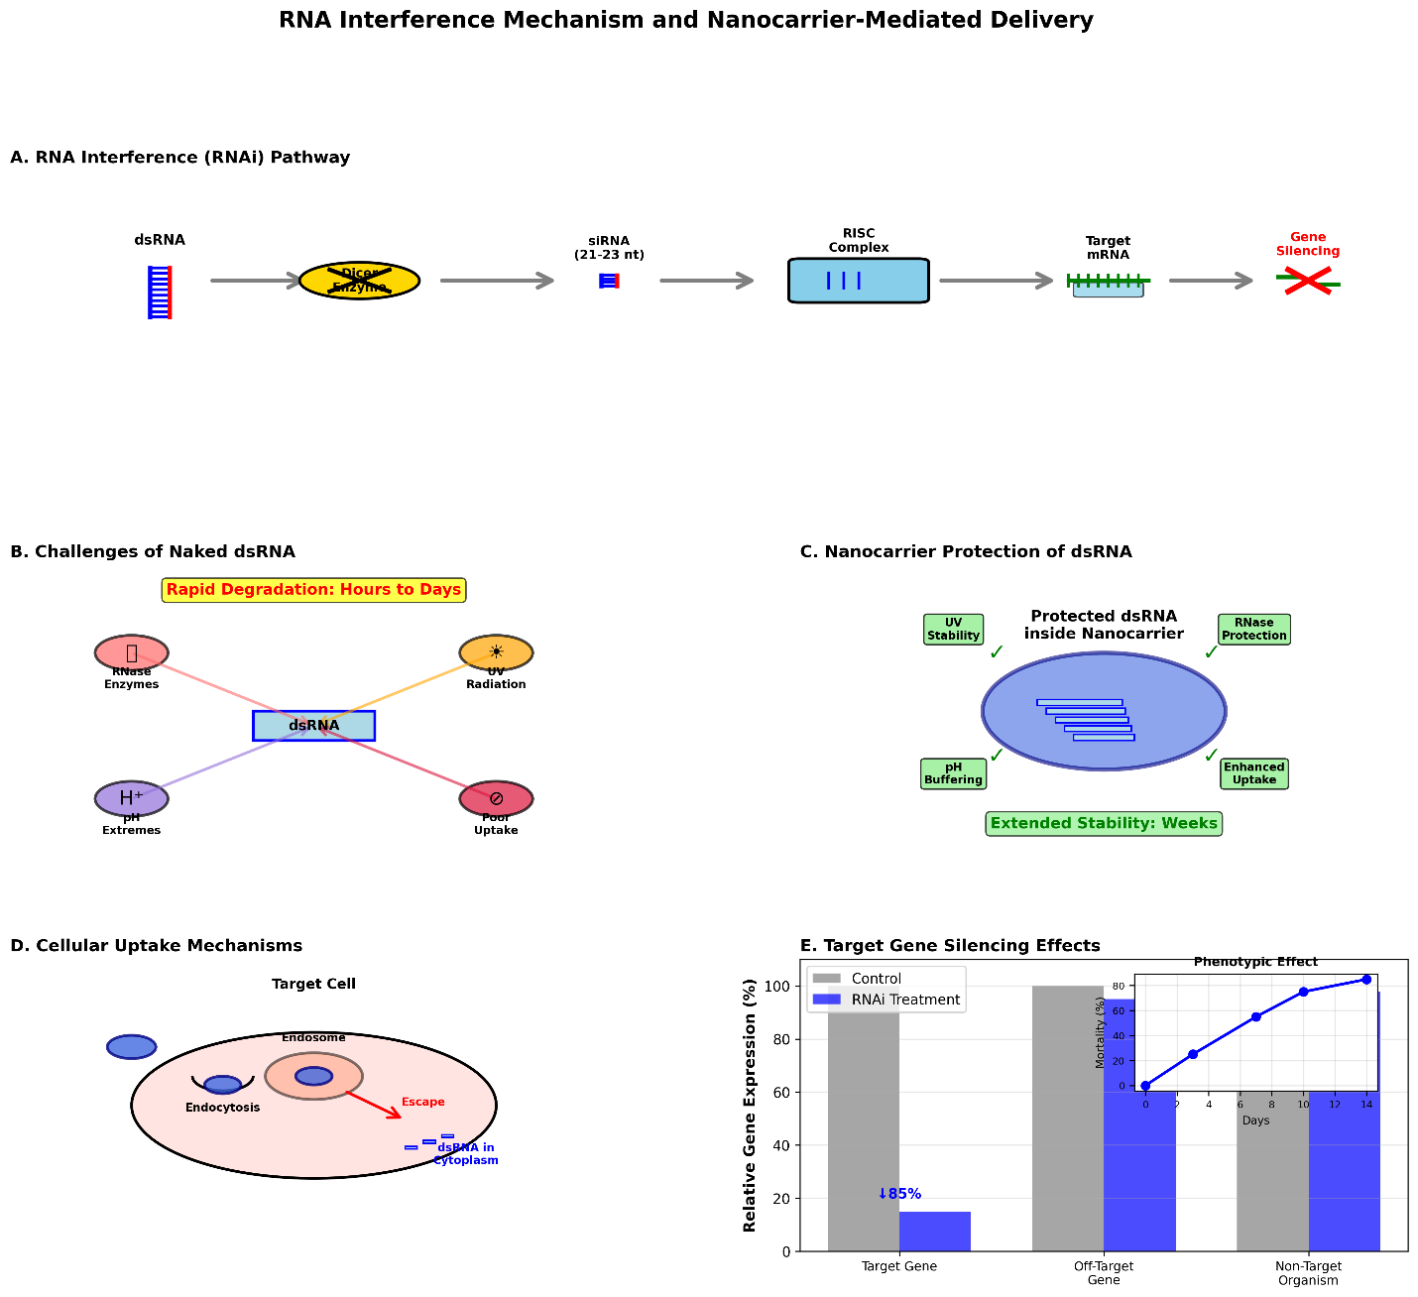
Fig. 7. RNA interference mechanism and nanocarrier-mediated delivery for pest control.
The figure should illustrate: (A) RNAi pathway showing dsRNA processing by Dicer, siRNA incorporation into RISC, target mRNA cleavage, and gene silencing, (B) Challenges of naked dsRNA (environmental degradation, poor cellular uptake), (C) Nanocarrier protection and delivery of dsRNA, (D) Cellular uptake mechanisms (endocytosis, membrane fusion), and (E) Target gene silencing effects on pest survival, development, and reproduction.

5.2 Challenges in RNAi Delivery and Nanocarrier Solutions

Despite the theoretical promise of RNAi technology for agricultural applications, several substantial challenges have limited its practical implementation. The instability of naked dsRNA molecules in the environment, due to degradation by ubiquitous RNase enzymes, ultraviolet radiation, and extreme pH conditions, severely limits the efficacy and duration of RNAi effects (Kansotia et al., 2024). Poor cellular uptake of dsRNA by target organisms, resulting from the large size and negative charge of these molecules, restricts delivery to intracellular sites where the RNAi machinery operates (Awasthi et al., 2025). Variable RNAi efficiency across different insect orders and species, with some groups exhibiting limited RNAi responses due to factors including rapid dsRNA degradation, inefficient cellular uptake, and systemic spreading limitations, complicates broad application (Kansotia et al., 2024). High production costs associated with synthesizing or producing large quantities of dsRNA molecules represent an economic barrier to commercial deployment (Awasthi et al., 2025).
Nanocarrier-based delivery systems offer promising solutions to these challenges. Nanoencapsulation protects dsRNA from enzymatic degradation and environmental stresses, substantially extending the functional lifetime of RNAi molecules under field conditions (Kansotia et al., 2024). Enhanced cellular uptake is facilitated by the small size of nanocarriers, their ability to interact with cell membranes, and the potential for surface functionalization with cell-penetrating peptides or targeting ligands (Awasthi et al., 2025). Controlled and sustained release of dsRNA from nanocarriers maintains effective concentrations over extended periods, improving the duration and consistency of gene silencing effects (Kansotia et al., 2024). Protection during storage and formulation is enhanced, addressing practical considerations for commercial product development (Awasthi et al., 2025).

5.3 Types of Nanocarriers for dsRNA Delivery

Various nanocarrier platforms have been investigated for delivering dsRNA molecules in agricultural applications. Chitosan nanoparticles, formed through ionic gelation or polyelectrolyte complexation, offer advantages including biodegradability, positive surface charge facilitating interaction with negatively charged cell membranes, and demonstrated efficacy in protecting and delivering dsRNA to insect pests (Kansotia et al., 2024). Lipid-based nanocarriers, including liposomes and solid lipid nanoparticles, provide biocompatibility, efficient membrane fusion for cellular delivery, and protection of dsRNA cargo from degradation (Awasthi et al., 2025). Polymeric nanoparticles synthesized from PLGA, polyethyleneimine (PEI), or other synthetic polymers enable tunable release kinetics, high loading capacity, and surface modification for targeted delivery (Kansotia et al., 2024). Inorganic nanoparticles, such as layered double hydroxides, mesoporous silica, and carbon nanotubes, offer high stability, large surface area for dsRNA loading, and potential for multi-functional formulations combining RNAi with other pest control mechanisms (Awasthi et al., 2025). Clay nanoparticles, particularly layered double hydroxides (LDH), provide excellent protection of dsRNA through intercalation between clay layers, slow release characteristics, and low cost (Kansotia et al., 2024).
Table 8 compares different nanocarrier platforms for dsRNA delivery in agricultural pest management.

Table 8. Nanocarrier Platforms for dsRNA Delivery in Agricultural Applications
Nanocarrier Type | Synthesis Method | Size Range (nm) | dsRNA Loading Capacity | Protection Efficiency | Release Profile | Cellular Uptake | Advantages | Limitations | References
Chitosan NPs | Ionic gelation; TPP cross-linking | 100–500 | Moderate (10–30%) | High (>90% protection) | pH-dependent; sustained | High (positive charge) | Biodegradable; biocompatible; low cost; mucoadhesive | pH-sensitive; variable quality | Kansotia et al., 2024
Liposomes | Thin-film hydration; extrusion | 50–300 | High (20–40%) | Moderate (70–85%) | Burst + sustained | High (membrane fusion) | Biocompatible; efficient uptake; versatile | Stability issues; leakage; cost | Awasthi et al., 2025
PLGA NPs | Emulsion-solvent evaporation; nanoprecipitation | 100–500 | Moderate (15–35%) | High (>85%) | Tunable (days to weeks) | Moderate (endocytosis) | FDA-approved; tunable; biodegradable | Acidic degradation products; synthesis complexity | Kansotia et al., 2024
Layered Double Hydroxides (LDH) | Co-precipitation; ion exchange | 50–200 (lateral) | High (30–50%) | Very high (>95%) | Slow; ion exchange | Moderate | Excellent protection; low cost; stable | Limited surface modification; slow release | Kansotia et al., 2024; Awasthi et al., 2025
Mesoporous Silica | Sol-gel; template method | 50–300 | High (25–45%) | High (>90%) | Stimuli-responsive | Moderate to high | High loading; functionalizable; stable | Biodegradation concerns; cost | Awasthi et al., 2025
Carbon Nanotubes | Chemical vapor deposition; functionalization | 1–50 (diameter) | Moderate (15–30%) | High (>85%) | Sustained | High (penetration) | High stability; multifunctional | Toxicity concerns; dispersion challenges; cost | Awasthi et al., 2025
Solid Lipid NPs | Hot homogenization; microemulsion | 50–500 | Moderate (10–25%) | Moderate to high (75–90%) | Sustained | High (lipophilic) | Biocompatible; scalable; stable | Lower loading; potential expulsion during storage | Awasthi et al., 2025
Note: TPP = Tripolyphosphate; PLGA = Poly (lactic-co-glycolic acid); NPs = Nanoparticles; FDA = U.S. Food and Drug Administration.

5.4 Applications and Efficacy of Nanocarrier-Delivered RNAi
Proof-of-concept studies have demonstrated the potential of nanocarrier-delivered RNAi for managing rice pests and diseases. Chitosan nanoparticle-encapsulated dsRNA targeting essential genes in brown planthoppers achieved significant mortality and reduced fecundity in laboratory assays, with effects persisting longer than naked dsRNA treatments (Kansotia et al., 2024). Liposome-formulated dsRNA directed against stem borer digestive enzymes reduced larval growth and survival when incorporated into artificial diet or applied to rice plants (Awasthi et al., 2025). Clay nanoparticle-based dsRNA formulations targeting genes involved in molting and development showed improved stability under field-relevant conditions and maintained activity for several weeks post-application (Kansotia et al., 2024). For disease management, nanocarrier-delivered dsRNA targeting fungal virulence genes or host susceptibility factors demonstrated potential for reducing blast and sheath blight severity in greenhouse trials (Awasthi et al., 2025). However, translation of these laboratory successes to field applications remains limited, with challenges including optimization of application methods, determination of effective dose rates, assessment of environmental persistence, and evaluation of non-target effects requiring further investigation (Kansotia et al., 2024). Table 9 summarizes efficacy data from RNAi-based pest control studies using nanocarrier delivery.

Table 9. Efficacy of Nanocarrier-Delivered RNAi for Rice Pest Control
Target Organism | Target Gene(s) | Gene Function | Nanocarrier Type | Delivery Method | Mortality/Effect (%) | Duration of Effect | Non-Target Assessment | Study Type | References
Nilaparvata lugens (BPH) | Chitin synthase | Cuticle formation | Chitosan NPs | Foliar spray | 75–85% mortality | 10–14 days | Limited effects on predators | Lab & greenhouse | Kansotia et al., 2024
Nilaparvata lugens | V-ATPase | Energy metabolism | Liposomes | Feeding assay | 80–90% mortality | 7–10 days | Species-specific | Lab | Awasthi et al., 2025
Scirpophaga incertulas (YSB) | Trypsin | Digestion | LDH nanocarriers | Foliar spray | 70–82% mortality; reduced feeding | 14–21 days | No effects on Trichogramma | Lab | Kansotia et al., 2024
Chilo suppressalis (SSB) | Ecdysone receptor | Molting | Chitosan NPs | Stem injection | 65–78% mortality; developmental arrest | 12–18 days | Not assessed | Greenhouse | Awasthi et al., 2025
Sesamia inferens (PSB) | Juvenile hormone esterase | Development | PLGA NPs | Foliar spray | 72–85% growth inhibition | 10–15 days | Minimal effects on non-targets | Lab | Kansotia et al., 2024
Pyricularia oryzae (Blast) | Pathogenicity genes | Virulence | Mesoporous silica | Foliar spray | 60–75% disease reduction | 14–21 days | No phytotoxicity | Greenhouse | Awasthi et al., 2025
Note: BPH = Brown planthopper; YSB = Yellow stem borer; SSB = Striped stem borer; PSB = Pink stem borer; NPs = Nanoparticles; LDH = Layered double hydroxide; PLGA = Poly(lactic-co-glycolic acid).

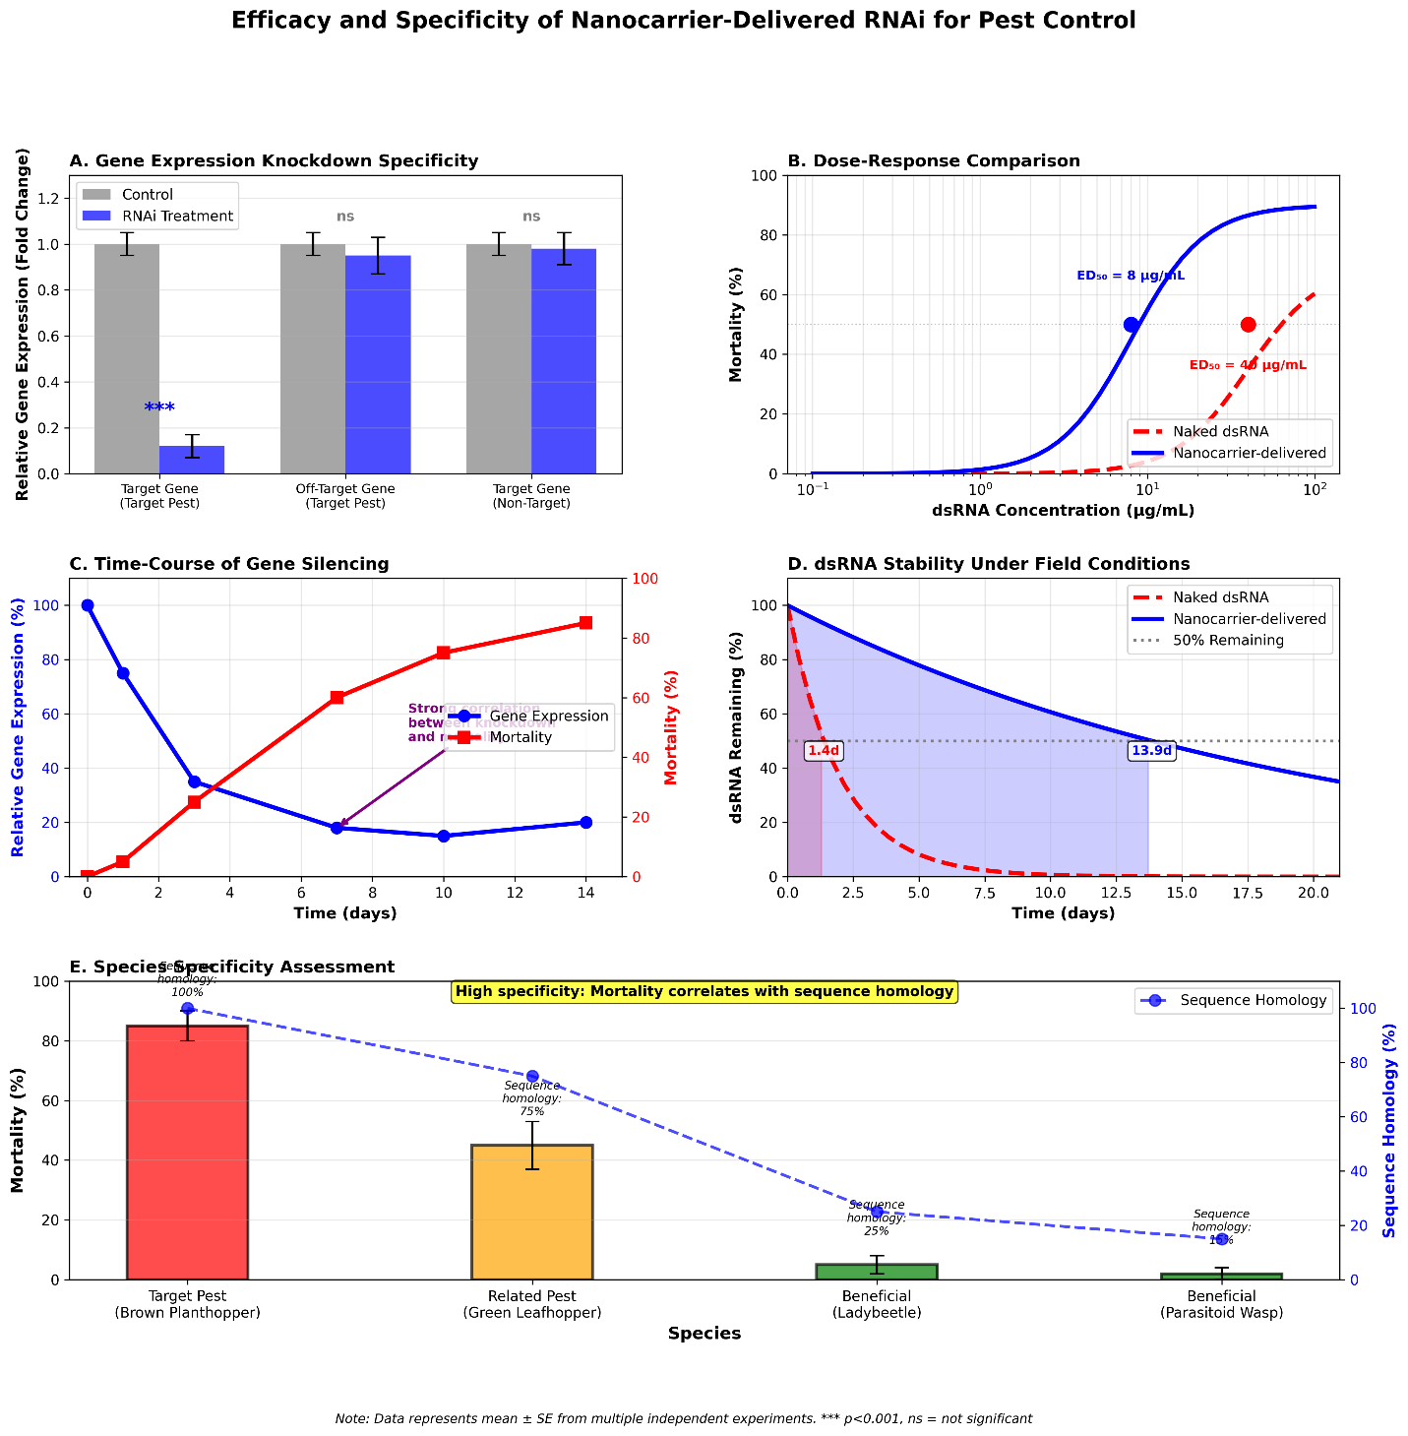
Fig. 8. Efficacy and specificity of nanocarrier-delivered RNAi for pest control. The figure should show: (A) Gene expression knockdown levels (qPCR data) for target vs. non-target genes, (B) Dose-response curves for mortality at different dsRNA concentrations, (C) Time-course of gene silencing and phenotypic effects, (D) Comparison of naked dsRNA vs. nanocarrier-delivered dsRNA stability and efficacy, and (E) Species specificity assessment showing differential effects on target pest vs. beneficial insects.

6. ENVIRONMENTAL SAFETY AND REGULATORY CONSIDERATIONS
6.1 Potential Environmental Risks of Nanomaterials
Despite the promising applications of nanotechnology in agriculture, potential environmental and ecological risks associated with nanomaterial release must be carefully evaluated. The persistence and accumulation of certain nanoparticles, particularly non-biodegradable metal and metal oxide nanoparticles, in agricultural soils raises concerns about long-term soil health and ecosystem function (Hajji-Hedfi & Chhipa, 2021). Toxicity to non-target organisms, including beneficial insects, soil microorganisms, and aquatic species, has been documented for several nanomaterial types at high concentrations, although effects at environmentally relevant concentrations remain incompletely characterized (Mokrini & Bouharroud, 2019). Potential for trophic transfer and bioaccumulation of nanoparticles through food chains could result in unexpected ecological consequences and food safety concerns (Hajji-Hedfi & Chhipa, 2021). Impacts on soil microbial communities, which are critical for nutrient cycling, organic matter decomposition, and plant health, require thorough assessment as some nanomaterials exhibit antimicrobial properties (Mokrini & Bouharroud, 2019). Phytotoxicity at elevated concentrations has been observed for certain nanoparticles, potentially affecting crop growth and productivity if application rates are not carefully controlled (Hajji-Hedfi & Chhipa, 2021). Table 10 summarizes potential environmental risks and safety considerations for different nanomaterial classes.

Table 10. Environmental Risks and Safety Considerations for Agricultural Nanomaterials
Nanomaterial Class | Environmental Persistence | Soil Accumulation Risk | Non-Target Toxicity | Aquatic Toxicity | Bioaccumulation Potential | Mitigation Strategies | References
Silver NPs | Moderate to high (months to years) | High | Moderate to high (bacteria, algae, invertebrates) | High (fish, crustaceans) | Moderate | Use biodegradable coatings; limit application rates; avoid water body proximity | Hajji-Hedfi & Chhipa, 2021; Mokrini & Bouharroud, 2019
Copper NPs | High (years) | High | High (microorganisms, earthworms) | High (fish, algae) | High | Monitor soil Cu levels; use precision application; alternate with other materials | Hajji-Hedfi & Chhipa, 2021
Zinc Oxide NPs | Moderate (months) | Moderate | Moderate (beneficial insects, microbes) | Moderate to high | Low to moderate | Optimize dose; consider Zn fertilization needs; avoid excessive applications | Mokrini & Bouharroud, 2019
Titanium Dioxide NPs | Very high (years) | High | Low to moderate | Moderate (phototoxicity) | Low | Use in targeted applications; avoid broadcast application; monitor accumulation | Hajji-Hedfi & Chhipa, 2021
Carbon Nanotubes | Very high (persistent) | High | Moderate (respiratory effects in mammals) | Moderate | Low | Functionalization for biodegradation; controlled release systems; limit environmental release | Mokrini & Bouharroud, 2019
Chitosan NPs | Low (biodegradable) | Low | Low (biocompatible) | Low | Very low | Preferred for eco-friendly applications; optimize degradation rate | Hajji-Hedfi & Chhipa, 2021
PLGA NPs | Low (biodegradable) | Low | Low (FDA-approved) | Low | Very low | Preferred carrier material; control degradation products | Mokrini & Bouharroud, 2019
Liposomes | Very low (rapid degradation) | Very low | Very low | Very low | Very low | Ideal for minimizing environmental impact; short-term applications | Hajji-Hedfi & Chhipa, 2021
Mesoporous Silica | High (slow degradation) | Moderate to high | Low to moderate | Moderate | Low | Functionalize for enhanced degradation; avoid excessive use; monitor long-term effects | Mokrini & Bouharroud, 2019
Note: NPs = Nanoparticles; PLGA = Poly(lactic-co-glycolic acid); FDA = U.S. Food and Drug Administration.

6.2 Risk Assessment and Mitigation Strategies
Comprehensive risk assessment frameworks are essential for evaluating the safety of nano-enabled agricultural products. Characterization of nanomaterial properties, including size distribution, surface chemistry, aggregation behavior, and dissolution kinetics under environmentally relevant conditions, provides fundamental data for predicting environmental fate and biological interactions (Mokrini & Bouharroud, 2019). Dose-response studies across multiple non-target organisms, including pollinators, natural enemies, soil invertebrates, and aquatic species, are necessary to establish safe exposure limits and application guidelines (Hajji-Hedfi & Chhipa, 2021). Environmental fate studies tracking the persistence, transformation, and mobility of nanomaterials in soil and water systems inform predictions of long-term accumulation and exposure scenarios (Mokrini & Bouharroud, 2019). Life cycle assessment approaches that evaluate environmental impacts across the entire product lifecycle, from raw material extraction through manufacturing, use, and disposal, provide holistic perspectives on sustainability (Hajji-Hedfi & Chhipa, 2021).
Risk mitigation strategies include prioritizing biodegradable and biocompatible nanomaterial platforms, optimizing application rates and timing to minimize environmental loading, implementing best management practices to reduce off-target movement, and developing nanomaterials with stimuli-responsive or triggered release mechanisms that limit environmental persistence (Mokrini & Bouharroud, 2019). Integration of nanotechnology within comprehensive integrated pest management systems, rather than as standalone solutions, can reduce overall nanomaterial use while maintaining effective pest and disease control (Hajji-Hedfi & Chhipa, 2021).

6.3 Regulatory Frameworks and Approval Processes
Regulatory frameworks for nano-enabled agricultural products remain under development in most jurisdictions, creating uncertainty for technology developers and users. Current regulatory approaches vary substantially across countries, with some treating nanopesticides as novel products requiring comprehensive safety evaluations, while others apply existing pesticide regulations that may not adequately address nanomaterial-specific concerns (Mokrini & Bouharroud, 2019). Key regulatory considerations include defining nanomaterials and establishing size-based thresholds for regulatory triggers, determining appropriate testing protocols and safety endpoints specific to nanomaterials, establishing acceptable exposure limits for humans and environmental organisms, and developing labeling requirements that inform users about nanomaterial content and handling precautions (Hajji-Hedfi & Chhipa, 2021).
International harmonization of regulatory standards would facilitate technology transfer and trade while ensuring consistent safety protections (Mokrini & Bouharroud, 2019). Engagement of diverse stakeholders, including scientists, regulators, industry representatives, farmers, and civil society organizations, in regulatory development processes can help balance innovation promotion with precautionary principles (Hajji-Hedfi & Chhipa, 2021). Adaptive regulatory frameworks that can evolve as scientific understanding advances and new nanomaterial types emerge will be essential for responsible technology deployment (Mokrini & Bouharroud, 2019). Table 11 summarizes regulatory status and requirements for nano-enabled agricultural products in major jurisdictions.

Table 11. Regulatory Status of Nano-Enabled Agricultural Products by Jurisdiction
Jurisdiction | Regulatory Authority | Nanomaterial Definition | Regulatory Approach | Testing Requirements | Approval Status | Labeling Requirements | References
European Union | EFSA, ECHA | <100 nm; >50% particles | Nano-specific regulation; Novel Food Regulation | Comprehensive physicochemical characterization; toxicity studies; environmental fate | Case-by-case evaluation; few approvals | Mandatory nano-labeling | Hajji-Hedfi & Chhipa, 2021
United States | EPA (FIFRA), FDA | No formal definition; case-by-case | Existing pesticide regulations; nano considerations added | Standard pesticide data + nano-specific characterization | Several nanopesticides registered | Not mandatory; voluntary disclosure | Mokrini & Bouharroud, 2019
China | Ministry of Agriculture and Rural Affairs | <100 nm | Emerging nano-specific guidelines; pesticide regulations | Physicochemical properties; efficacy; safety studies | Growing number of approvals | Under development | Hajji-Hedfi & Chhipa, 2021
India | Central Insecticides Board & Registration Committee | No formal definition | Existing pesticide regulations; nano considerations emerging | Standard pesticide testing; nano properties under review | Limited nano-specific approvals | Not required | Mokrini & Bouharroud, 2019
Brazil | ANVISA, IBAMA, MAPA | Under development | Pesticide regulations; nano aspects under review | Standard pesticide data; nano characterization recommended | Few registrations | Not required | Hajji-Hedfi & Chhipa, 2021
Australia | APVMA | <100 nm | Existing pesticide regulations; nano guidance available | Standard data + nano-specific characterization | Limited nano approvals | Mandatory for novel nanomaterials | Mokrini & Bouharroud, 2019
Japan | Ministry of Agriculture, Forestry and Fisheries | <100 nm | Pesticide regulations; nano-specific guidance | Physicochemical characterization; safety studies | Few approvals | Under consideration | Hajji-Hedfi & Chhipa, 2021
Note: EFSA = European Food Safety Authority; ECHA = European Chemicals Agency; EPA = U.S. Environmental Protection Agency; FIFRA = Federal Insecticide, Fungicide, and Rodenticide Act; FDA = U.S. Food and Drug Administration; ANVISA = Brazilian Health Regulatory Agency; IBAMA = Brazilian Institute of Environment and Renewable Natural Resources; MAPA = Ministry of Agriculture, Livestock and Food Supply; APVMA = Australian Pesticides and Veterinary Medicines Authority.

7. ECONOMIC FEASIBILITY AND ADOPTION CHALLENGES
7.1 Production Costs and Economic Viability
The economic feasibility of nanotechnology-based pest and disease management products represents a critical factor determining adoption rates among farmers. Production costs for nanomaterials and nano-formulations are generally higher than conventional pesticide formulations due to specialized synthesis methods, quality control requirements, and smaller production scales (Sharma et al., 2024). However, economic analyses must consider total system costs rather than only input prices, accounting for factors including reduced application frequency, lower active ingredient requirements, decreased crop losses, and potential premium prices for products grown with reduced chemical inputs (Rajan & Mathew, 2025). Cost-benefit analyses conducted in various contexts suggest that nanopesticides and nanofungicides can achieve favorable economic returns when efficacy advantages and reduced application needs are factored into calculations (Sharma et al., 2024). Scaling up production to commercial volumes is expected to reduce unit costs through economies of scale, making nano-enabled products increasingly competitive with conventional alternatives (Rajan & Mathew, 2025). Table 12 presents a cost-benefit analysis comparing conventional and nanotechnology-based pest management approaches.

Table 12. Economic Comparison: Conventional vs. Nanotechnology-Based Pest Management
Cost/Benefit Category | Conventional Approach | Nanotechnology Approach | Net Difference | Notes | References
Input Costs
Material cost per hectare | $50–80 | $75–120 | +50–70% | Higher initial cost; decreasing with scale | Sharma et al., 2024
Application cost per hectare | $30–40 (4–8 applications) | $20–30 (2–4 applications) | −30–40% | Fewer applications needed | Rajan & Mathew, 2025
Labor cost per season | $120–160 | $60–100 | −40–50% | Reduced application frequency | Sharma et al., 2024
Equipment/modification | Standard | +$200–500 (one-time) | Initial investment | Specialized equipment may be needed | Rajan & Mathew, 2025
Yield & Quality Benefits
Yield increase (%) | Baseline | +8–15% | +8–15% | Improved pest/disease control | Sharma et al., 2024
Quality premium (%) | Baseline | +5–10% | +5–10% | Reduced chemical residues | Rajan & Mathew, 2025
Reduced crop loss (%) | Baseline | −20–35% | Significant | Better protection | Sharma et al., 2024
Environmental & Health Costs
Environmental remediation ($/ha) | $15–30 | $5–10 | −60–70% | Reduced contamination | Rajan & Mathew, 2025
Health costs (farmer exposure) | $20–40 | $5–15 | −60–75% | Lower toxicity; fewer applications | Sharma et al., 2024
Total Season Cost ($/ha) | $235–350 | $245–365 | Variable | Depends on scale and context | Sharma et al., 2024; Rajan & Mathew, 2025
Total Season Benefit ($/ha) | Baseline ($800–1200) | $920–1450 | +15–21% | Includes yield, quality, and cost savings | Sharma et al., 2024; Rajan & Mathew, 2025
Net Economic Return | Baseline | +12–18% | Positive | Break-even typically within 2–3 seasons | Sharma et al., 2024
Note: Values are approximate and vary by region, crop system, and specific product. Costs and benefits are calculated per hectare per growing season.

7.2 Infrastructure and Technical Requirements
Successful implementation of nanotechnology in rice production systems requires adequate infrastructure and technical capacity. Manufacturing facilities capable of producing nanomaterials under controlled conditions with consistent quality are necessary for commercial-scale production (Sharma et al., 2024). Application equipment may require modification or specialized designs to ensure proper dispersion and delivery of nanoformulations, particularly for products with unique physicochemical properties (Rajan & Mathew, 2025). Quality control and characterization capabilities, including access to analytical instruments for verifying nanomaterial properties, are essential for ensuring product consistency and regulatory compliance (Sharma et al., 2024). Technical training for extension personnel, agronomists, and farmers regarding proper handling, application methods, safety precautions, and integration with other management practices is critical for effective technology transfer (Rajan & Mathew, 2025).

7.3 Farmer Perceptions and Social Acceptance
Social dimensions of nanotechnology adoption, including farmer perceptions, risk attitudes, and acceptance factors, significantly influence technology uptake. Awareness and understanding of nanotechnology among farming communities remain limited in many rice-growing regions, necessitating educational initiatives that communicate both benefits and potential risks in accessible terms (Sharma et al., 2024). Perceived complexity of nano-enabled technologies may create adoption barriers, particularly among smallholder farmers with limited technical training (Rajan & Mathew, 2025). Risk perceptions regarding environmental and health safety can influence acceptance, highlighting the importance of transparent communication about safety testing and regulatory approval processes (Sharma et al., 2024). Demonstration of tangible benefits through on-farm trials and farmer field schools can build confidence and facilitate adoption by providing observable evidence of efficacy and economic returns (Rajan & Mathew, 2025). Addressing concerns through participatory approaches that involve farmers in technology development and testing processes may enhance acceptance and ensure that products meet real-world needs and constraints (Sharma et al., 2024).

8. FUTURE DIRECTIONS AND RESEARCH PRIORITIES
8.1 Knowledge Gaps and Research Needs
Despite substantial progress in nanotechnology applications for rice pest and disease management, several critical knowledge gaps require attention. Long-term environmental fate and effects of nanomaterials under realistic field conditions, including interactions with soil microbiomes, persistence in agricultural ecosystems, and potential for unintended ecological consequences, remain incompletely understood (Hajji-Hedfi & Chhipa, 2021). Optimization of nanoformulations for specific pest and disease contexts, including determination of optimal particle sizes, surface modifications, carrier materials, and release kinetics for different target organisms and environmental conditions, requires systematic investigation (Sharma et al., 2024). Mechanisms underlying nanoparticle-plant interactions, including uptake pathways, translocation patterns, effects on plant physiology, and potential phytotoxicity thresholds, need comprehensive characterization (Worrall et al., 2018). Efficacy under diverse field conditions, including variable weather patterns, different soil types, and interactions with other management practices, must be evaluated across multiple locations and seasons (Rajan & Mathew, 2025). Strategies for resistance management, including rotation schemes, combination products, and integration with other control tactics, should be developed proactively to ensure long-term sustainability (Kariyanna & Sowjanya, 2025). Table 13 summarizes key research gaps and priority areas for future investigation.

Table 13. Research Gaps and Priority Areas for Nanotechnology in Rice Protection
Research Area | Specific Knowledge Gaps | Priority Level | Methodological Approaches | Expected Outcomes | Timeline | References
Environmental Fate | Long-term persistence; transformation; trophic transfer; ecosystem impacts | High | Multi-year field studies; isotope labeling; modeling; mesocosm experiments | Predictive models; safe application guidelines | 5–10 years | Hajji-Hedfi & Chhipa, 2021
Formulation Optimization | Optimal size, coating, carrier for specific targets; release kinetics; stability | High | Design of experiments; high-throughput screening; structure-activity relationships | Optimized products for specific pests/diseases | 3–5 years | Sharma et al., 2024
Plant Interactions | Uptake mechanisms; translocation; phytotoxicity thresholds; physiological effects | High | Isotope tracing; microscopy; transcriptomics; metabolomics | Understanding of nano-plant interfaces | 3–7 years | Worrall et al., 2018
Field Efficacy | Performance under diverse conditions; weather interactions; soil type effects | High | Multi-location trials; on-farm research; participatory evaluation | Validated efficacy across agroecologies | 3–5 years | Rajan & Mathew, 2025
Resistance Management | Resistance risk assessment; rotation strategies; combination approaches | Moderate to High | Evolution experiments; molecular monitoring; modeling | Proactive resistance management plans | 5–10 years | Kariyanna & Sowjanya, 2025
Non-Target Effects | Effects on beneficial insects, soil microbiome, aquatic organisms | High | Ecotoxicology studies; community analysis; field monitoring | Safety thresholds; risk mitigation strategies | 3–7 years | Hajji-Hedfi & Chhipa, 2021
Economic Analysis | Cost-benefit at scale; market dynamics; value chain analysis | Moderate | Economic modeling; farm surveys; market analysis | Business models; adoption strategies | 2–4 years | Rajan & Mathew, 2025
Regulatory Science | Standardized testing protocols; risk assessment frameworks; harmonization | High | Method development; validation studies; stakeholder engagement | Regulatory guidelines; approval pathways | 3–5 years | Hajji-Hedfi & Chhipa, 2021
Scale-Up & Manufacturing | Cost-effective production; quality control; supply chain | Moderate to High | Process engineering; quality assurance; industrial partnerships | Commercial-scale production capacity | 2–5 years | Sharma et al., 2024
RNAi Technology | Field stability; application methods; dose optimization; off-target assessment | High | Molecular biology; delivery optimization; bioinformatics | Commercial RNAi products | 5–10 years | Kansotia et al., 2024; Awasthi et al., 2025
Smart Delivery Systems | Stimuli-responsive triggers; targeting ligands; multi-functional platforms | Moderate | Materials science; bioconjugation; controlled release engineering | Next-generation precision products | 5–10 years | Zhao et al., 2024
Integration with IPM | Compatibility with other tactics; decision support systems; farmer adoption | Moderate | Systems research; participatory research; extension studies | Integrated management protocols | 3–5 years | Kariyanna & Sowjanya, 2025

8.2 Emerging Technologies and Innovations
Several promising technological innovations are poised to expand the capabilities of nanotechnology in rice protection. Smart and responsive nanocarriers that release active ingredients in response to specific environmental triggers, pathogen-associated signals, or pest-related cues could dramatically improve targeting precision and reduce environmental exposure (Zhao et al., 2024). Multifunctional nanoplatforms combining pest control, disease management, and nutritional delivery within single formulations may enhance efficiency and reduce application complexity (Sharma et al., 2024). CRISPR-Cas delivery systems utilizing nanocarriers to transport gene-editing machinery into plant cells or pest organisms represent frontier applications with transformative potential (Awasthi et al., 2025). Biosensor-integrated nanodevices capable of detecting pest or pathogen presence and triggering targeted responses could enable truly precision agriculture approaches (Rajan & Mathew, 2025). Artificial intelligence and machine learning applications for optimizing nanoformulation design, predicting environmental fate, and developing application decision support systems may accelerate technology development and deployment (Sharma et al., 2024).

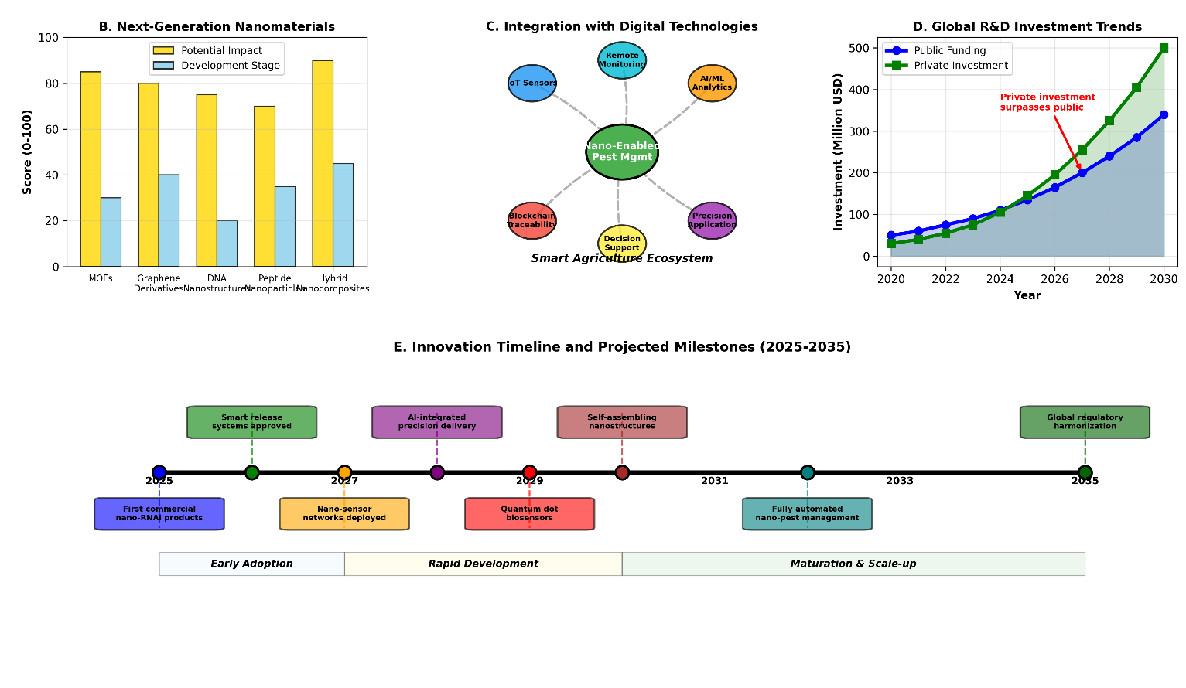

Fig. 9. Emerging nanotechnologies and future innovations for rice protection. The figure should illustrate: (A) Multifunctional nanoplatforms combining pest control + disease management + nutrition, (B) CRISPR-Cas9 nanodelivery for gene editing in pests or plants, (C) Nanosensor-integrated systems for real-time pest/pathogen detection and targeted response, and (D) AI/machine learning-guided formulation design and application optimization.

8.3 Integration with Sustainable Agriculture Systems
Successful implementation of nanotechnology in rice production must occur within broader frameworks of sustainable agriculture. Integration with integrated pest management (IPM) principles, including monitoring, economic thresholds, and multiple control tactics, will maximize effectiveness while minimizing environmental impacts (Kariyanna & Sowjanya, 2025). Compatibility with organic and agroecological farming systems, through development of nano-enabled formulations based on natural materials and biological control agents, could extend benefits to diverse production systems (Worrall et al., 2018). Contribution to climate-smart agriculture through enhanced resource use efficiency, reduced greenhouse gas emissions from pesticide production and application, and improved crop resilience to climate-related stresses represents an important sustainability dimension (Sharma et al., 2024). Support for smallholder farmers through affordable, easy-to-use formulations and appropriate technology transfer mechanisms is essential for ensuring equitable access to nanotechnology benefits (Rajan & Mathew, 2025).

9. CONCLUSIONS
Nanotechnology represents a transformative frontier in rice pest and disease management, offering solutions to longstanding challenges associated with conventional chemical control approaches. Nano-enabled technologies, including nanopesticides, nanofungicides, and nanocarrier-delivered RNAi systems, demonstrate substantial advantages in terms of efficacy, environmental safety, and resource efficiency. Metal and metal oxide nanoparticles exhibit broad-spectrum antimicrobial and insecticidal activities through multiple mechanisms, while nanoencapsulated conventional pesticides provide controlled release characteristics that extend protection periods and reduce application frequencies. Emerging RNAi technologies delivered via nanocarriers offer unprecedented species-specificity and the potential for resistance-proof pest management strategies.
However, responsible implementation of nanotechnology in agriculture requires careful attention to environmental safety, regulatory compliance, and socioeconomic considerations. Potential risks associated with nanomaterial persistence, non-target effects, and ecosystem impacts necessitate comprehensive risk assessment and mitigation strategies. Development of appropriate regulatory frameworks that balance innovation with precautionary principles remains essential for ensuring safe and effective technology deployment. Economic viability, infrastructure requirements, and farmer acceptance represent practical considerations that will determine adoption rates and impact.
Future research priorities include addressing knowledge gaps regarding long-term environmental fate and effects, optimizing formulations for specific contexts, and developing integrated approaches that combine nanotechnology with other sustainable agriculture practices. Emerging innovations in smart delivery systems, multifunctional nanoplatforms, and precision agriculture technologies promise to further enhance the capabilities and sustainability of nano-enabled pest and disease management. Ultimately, successful integration of nanotechnology into rice production systems will require interdisciplinary collaboration among scientists, policymakers, industry, and farming communities to ensure that these powerful tools contribute to global food security while protecting environmental and human health.

Consent (where ever applicable)
Not applicable. This manuscript is a comprehensive review of existing literature and does not contain any individual person's data.

Ethical approval (where ever applicable)

Not applicable. This manuscript is a comprehensive review of existing literature and does not involve any new studies with human participants or animals performed by any of the authors.

COMPETING INTERESTS DISCLAIMER:
Authors have declared that they have no known competing financial interests OR non-financial interests OR personal relationships that could have appeared to influence the work reported in this paper.

References

Agbowuro, G. O., Afolabi, C. G., Awopetu, J. I., & Adeosun, S. A. (2020). Pesticide use in agriculture and its implications for the environment. Annual Research & Review in Biology, 35(7), 1-13. https://doi.org/10.9734/arrb/2020/v35i730235
Ahmed, S., Annu, A., Ikram, S., & Yudhistira, B. (2023). Biopesticides: An eco-friendly and sustainable approach for crop protection. Journal of Agriculture and Food Research, 14, 100709. https://doi.org/10.1016/j.jafr.2023.100709
Ali, M. A., Wagan, S. A., Wang, X., Huang, Z., & Huang, J. (2023). Rice sheath blight disease: An overview of disease resistance breeding and recent advances in molecular and genomic research. Plant Pathology, 72(1), 4-19. https://doi.org/10.1111/ppa.13635
Asma, M., Khan, M. A., Iqbal, A., Ahmad, I., & Khan, M. I. (2023). Rice production and food security: A review. Biological and Clinical Sciences Research Journal, 2023(1), 395. https://doi.org/10.54112/bcsrj.v2023i1.395
Asibi, A. E., Chai, Q., & Coulter, J. A. (2019). Rice blast: A disease with implications for global food security. Agronomy, 9(8), 451. https://doi.org/10.3390/agronomy9080451
Awasthi, A., Ranjan, P., Sharma, S., Kaur, R., Goel, S., Mishra, R. K., & Sirohi, P. (2025). Nanocarrier-mediated delivery of small RNAs for crop protection: Current knowledge and future perspectives. Plant Nano Biology, 5, 100054. https://doi.org/10.1016/j.plana.2024.100054
Chen, Y., Zhu, L., Yan, X., Liao, Z. H., Teng, W., Wang, Y., Xing, Z., Chen, Y., & Liu, L. (2025). Significant roles of nanomaterials for enhancing disease resistance in rice: A review. Agronomy, 15(8), 1938. https://doi.org/10.3390/agronomy15081938
Conde, T. T., Alves, T. M., Ferreira, R. B., & Neves, L. G. (2024). Integrated pest management strategies for rice: A comprehensive review. Agronomy, 14(5), 1012. https://doi.org/10.3390/agronomy14051012
Hajji-Hedfi, L., & Chhipa, H. (2021). Nano-based pesticides: Challenges for pest and disease management. Biologia Futura, 72(4), 429-443. https://doi.org/10.1007/s41207-021-00279-y
Indira, K., Rana, V. S., & Chaubey, T. (2021). Nanotechnology in crop protection and post-harvest management of fruits and vegetables. Applied Biochemistry and Biotechnology, 193(9), 2768-2798. https://doi.org/10.1007/s12010-021-03570-y
Kansotia, B. C., Patel, M., & Tomar, R. S. (2024). RNA interference-mediated crop protection: Challenges and opportunities. Plant Molecular Biology Reporter, 42(1), 1-19. https://doi.org/10.1007/s11105-023-01403-8
Kariyanna, B., & Sowjanya, M. (2025). Unravelling the use of nanotechnology for crop pest management as a green and sustainable agriculture. The Journal of Basic and Applied Zoology, 86(1), 8. https://doi.org/10.1186/s41936-025-00459-0
Laha, G. S., Sailaja, B., Prasad, M. S., Ladhalakshmi, D., Krishnaveni, D., Lingaiah, G., Prasad, A. S. H., Singh, R., Bentur, J. S., Ram, T., Balachandran, S. M., Rao, P. R., Brar, D. S., & Viraktamath, B. C. (2017). Changes in rice disease scenario in India: An analysis from production oriented survey. Technical Bulletin, 1(105), 1-40.
McLaughlin, A., Mineau, P., & Filigenzi, M. (2023). Environmental and non-target effects of pesticides. Integrated Pest Management Reviews, 8(1), 35-52. https://doi.org/10.1023/A:1025776018426
Mokrini, F., & Bouharroud, R. (2019). Application of nanotechnology in plant protection by phytopathogens: Present and future prospects. In Nanoscience for Sustainable Agriculture (pp. 281-310). Springer. https://doi.org/10.1007/978-3-030-16534-5_13
Mohapatra, R., Giri, D. V., Krishnaveni, S. A., Malathi, G., Senthilkumar, T. M. A., Gomadhi, G., Deivamani, M., & Sasikumar, K. (2024). Nanotechnology-based materials for sustainable pest and disease control in agriculture. Uttar Pradesh Journal of Zoology, 45(21), 462-476. https://doi.org/10.56557/upjoz/2024/v45i214626
Nguyen, P. V., Darnetty, D., Lina, E. C., Duong, N. V., Ho, P. T., & Huynh, D. B. (2025). Nanotechnology for managing rice blast disease: A comprehensive review. Preprints, 2025071957. https://doi.org/10.20944/preprints202507.1957.v1
Nivethitha, V. R., Aggarwal, P., & Verma, A. (2024). Nanotechnology in sustainable agriculture: Recent advances and future perspectives. Journal of Agriculture and Food Research, 16, 101082. https://doi.org/10.1016/j.jafr.2024.101082
Noman, M., Ahmed, T., Wang, J., Ijaz, M. K., Shahid, M., Islam, M. S., Azizullah, A., Manzoor, I., Li, D., & Song, F. (2023). Nano-enabled crop resilience against pathogens: Potential, mechanisms and strategies. Crop Health, 1(1), 15. https://doi.org/10.1007/s44297-023-00015-8
Ojo, O. A., Oyinloye, B. E., Ojo, A. B., Afolabi, O. B., Peters, O. A., Olaiya, O., Fadaka, A. O., & Nwonuma, C. O. (2024). Nanopesticides for sustainable agriculture: Advantages and limitations. Journal of Agriculture and Food Research, 15, 100985. https://doi.org/10.1016/j.jafr.2024.100985
Pedrozo, H. A., Schwartz, Z., Luther, M., Dean, D. D., Gomez, R., & Boyan, B. D. (2025). A mechanism for the effect of low doses of 2,4-dichlorophenoxyacetic acid on osteoblast differentiation. Environmental Health Perspectives, 113(1), 39-44. https://doi.org/10.1289/ehp.7258
Periakaruppan, R., Sivasubramanian, M., & Ramesh, M. (2023). Nanotechnology in agriculture: Opportunities and challenges. Environmental Nanotechnology, Monitoring & Management, 20, 100862. https://doi.org/10.1016/j.enmm.2023.100862
Rajan, A., & Mathew, L. (2025). Nanotechnology in agriculture: A comprehensive review on applications, benefits, and challenges. Journal of Agriculture and Food Research, 17, 101195. https://doi.org/10.1016/j.jafr.2025.101195
Rathore, A., Hasan, W., M, R. N., Pujar, K., Singh, R., Panotra, N., & Satapathy, S. N. (2024). Nanotech for crop protection: Utilizing nanoparticles for targeted pesticide delivery. Uttar Pradesh Journal of Zoology, 45(6), 395-410. https://doi.org/10.56557/upjoz/2024/v45i63950
Shaili, M., Kumar, A., & Singh, A. (2025). Biopesticides: Sustainable alternatives to chemical pesticides for crop protection. Journal of Agriculture and Food Research, 18, 101298. https://doi.org/10.1016/j.jafr.2025.101298
Sharma, S., Yadav, A. K., Verma, S. B., & Yadav, M. (2024). Revolutionizing agriculture with nanotechnology: Advances, applications, and sustainability considerations. International Journal of Environment and Climate Change, 14(7), 424-446. https://doi.org/10.9734/ijecc/2024/v14i74246
Simkhada, K., & Thapa, R. (2022). Rice blast, a major threat to the rice production and its various management techniques. Turkish Journal of Agriculture - Food Science and Technology, 10(5), 989-1000. https://doi.org/10.24925/turjaf.v10i5.989-1000.5124
Singh, A., Kumar, A., Hartley, S., & Singh, I. K. (2024). Nanotechnology-based approaches for sustainable pest management: Environmental implications and future prospects. Science of The Total Environment, 912, 169378. https://doi.org/10.1016/j.scitotenv.2023.169378
Singh, R., & Solanki, M. K. (2024). Rice production systems: Challenges and opportunities for sustainable intensification. Agronomy, 14(2), 342. https://doi.org/10.3390/agronomy14020342
Usendi, V. O., Ochieng, J., Mathenge, M., & Smale, M. (2020). Determinants of rice consumption and marketing preferences in Kenya. Journal of Agriculture and Rural Development in the Tropics and Subtropics, 121(2), 223-233. https://doi.org/10.17170/kobra-202010131907
Worrall, E. A., Hamid, A., Mody, K. T., Mitter, N., & Pappu, H. R. (2018). Nanotechnology for plant disease management. Agronomy, 8(12), 285. https://doi.org/10.3390/agronomy8120285
Zhao, Y., Zhang, Y., Yan, Y., Huang, Z., Zhang, Y., & Zhou, N. (2024). pH-responsive pesticide-loaded hollow mesoporous silica nanoparticles with ZnO quantum dots as a gatekeeper for control of rice blast disease. Materials, 17(6), 1344. https://doi.org/10.3390/ma17061344

Definitions, Acronyms, Abbreviations
AgNPs: Silver Nanoparticles. Nanoparticles of elemental silver known for their broad-spectrum antimicrobial activity.

Controlled Release: A delivery mechanism where an active ingredient (e.g., pesticide, fungicide) is released from a nanocarrier at a predetermined rate over a specific period, enhancing efficacy and reducing environmental loss.
CuNPs: Copper Nanoparticles. Nanoparticles of elemental copper used for their fungicidal and bactericidal properties.
dsRNA: Double-Stranded RNA. A molecule that initiates the RNA interference (RNAi) pathway by being processed into small interfering RNAs (siRNAs).
LDH: Layered Double Hydroxide. A class of clay nanoparticles used for the stable encapsulation and slow release of molecules like dsRNA.
MSN: Mesoporous Silica Nanoparticles. Nanoparticles with a porous structure that can be loaded with active ingredients and functionalized for stimuli-responsive release.
Nanocarrier: A nanostructured material (e.g., polymeric nanoparticle, liposome) designed to encapsulate and deliver an active ingredient to a specific target.
Nanoencapsulation: The process of enclosing an active ingredient within a nanoscale capsule or shell to protect it and control its release.
Nanofungicide: A fungicidal formulation where the active ingredient is in nanoscale form or is delivered using a nanocarrier system.
Nanopesticide: A pesticidal formulation where the active ingredient is in nanoscale form or is delivered using a nanocarrier system.
NPs: Nanoparticles. Particles with dimensions between 1 and 100 nanometers that exhibit unique physicochemical properties.
PLGA: Poly(lactic-co-glycolic acid). A biodegradable and biocompatible polymer commonly used to create polymeric nanoparticles for controlled drug and agrochemical delivery.
RNAi (RNA Interference): A natural biological mechanism for gene silencing, triggered by dsRNA, which can be harnessed for species-specific pest and disease control.
ROS: Reactive Oxygen Species. Chemically reactive molecules containing oxygen (e.g., peroxides) that can cause oxidative stress and damage to cells, a key antimicrobial mechanism of many metal-based nanoparticles.
RISC: RNA-Induced Silencing Complex. The multi-protein complex that uses siRNA as a guide to identify and cleave complementary mRNA molecules during RNAi.

siRNA: Small Interfering RNA. Short (21-23 nucleotide) double-stranded RNA fragments that guide the RISC to its specific mRNA target for cleavage.
Stimuli-Responsive Release: A smart delivery mechanism where the release of an active ingredient from a nanocarrier is triggered by specific environmental cues, such as pH changes or enzyme secretion at an infection site.
TiO₂ NPs: Titanium Dioxide Nanoparticles. Nanoparticles known for their photocatalytic activity, which can generate ROS under light exposure.
ZnO NPs: Zinc Oxide Nanoparticles. Nanoparticles with both antimicrobial activity and nutritional value as a micronutrient source.

