Review Article
Dynamics of Ralstonia solanacearum species complex as influenced by soil ecology

Abstract
Bacterial wilt, caused by the Ralstonia solanacearum species complex (RSSC), is one of the most destructive plant diseases worldwide, particularly in vegetable crops. The remarkable variability of RSSC—spanning genetic, ecological, and functional diversity-complicates disease management and sustainable crop production. Among the many determinants of this variability, soil properties play a decisive role by shaping pathogen survival, persistence, and virulence. Soil pH, organic matter content, moisture, and texture directly influence population dynamics, while the indigenous microbiome and antagonistic interactions act as biotic filters that suppress or facilitate infection. Environmental factors such as temperature and moisture further regulate the pathogen’s ability to enter dormant states (e.g., viable but non-culturable) and disperse through water or alternative hosts. Recent evidence shows that acidic, clay-rich soils often enhance long-term survival, whereas alkaline soils can restrict infection. Understanding these soil–pathogen interactions is essential for developing targeted interventions. Soil-based management strategies, including pH adjustment, organic amendments, anaerobic soil disinfestation, microbiome engineering, crop rotation, and host resistance breeding, offer promising avenues for integrated control of bacterial wilt. By focusing on the interplay between soil ecology and pathogen variability, this review highlights new opportunities for sustainable, soil-centred management of bacterial wilt in diverse agroecosystems.
Key words
Ralstonia solanacearum species complex; bacterial wilt; soil properties; pathogen variability; rhizosphere interactions; soil-borne pathogens
Introduction
Agriculture constitutes a fundamental component of the Indian economy. According to the 2011 Census, 54.6% of the total labour force is engaged in agricultural and allied sector activities, which contribute 18.4% of India's Gross Value Added at current prices for the financial year 2022-23 (Ministry of Agriculture and Farmers Welfare, 2024). Vegetables represent an essential element within the Indian culinary framework and are vital to ensure food security, fulfilling the nutritional requirements of the nation’s growing population. On a global scale, India ranks as the second largest producer of vegetables, achieving a significant output of 212.91 million tonnes in the period 2022–23 (APEDA, 2023 & Kumara et al., 2025). Alongside, vegetable production in India faces numerous challenges, including inconsistent weather patterns, soil deterioration, water scarcity, inadequate infrastructure, and pest and disease outbreaks. Among these, losses due to plant diseases are one of the major challenges faced by the production and marketing sectors.
Bacterial wilt caused by Ralstonia solanaceraum is one of the most destructive diseases affecting over 450 plant species from 54 botanical families, with solanaceous crops being particularly vulnerable. R. solanacearum demonstrates variable but significant survival capacity in soil environments (Paret et al., 2010). Notably, potato, tomato, brinjal, and chilli are among those most adversely affected by this disease (Manda et al., 2020). Yield reductions due to bacterial wilt may vary between 10% to an alarming rate of 100% in fields with severe infection levels. Soil is the primary reservoir and transmission medium for the pathogen. It spreads through multiple pathways, including contaminated water sources, infected planting materials, contaminated irrigation water, surface water runoff, and farm equipment carrying infested soil (Heikrujam et al., 2020). The pathogen’s behaviour is not uniform but is highly influenced by the complex and variable nature of its soil habitat. Modern plant disease management strategies face challenges related to climate change, pesticide resistance, pesticide residues, and loss of biodiversity (Senthilraja et al., 2024). The wide host range, ease of dissemination, long-term survival of the pathogen, and lack of effective chemical bactericides serve as bottlenecks for the management of bacterial wilt. Hence, tailoring effective management strategies is essential to combat this devastating disease. This review aims to explain how different soil properties affect a pathogen’s survival, population, and virulence. It also discusses possible management measures based on these factors.
The Pathogen: Ralstonia solanacearum
Ralstonia solanacearum is a soil-inhabiting bacterium that is responsible for bacterial wilt disease. It is ranked as the world’s second most harmful phytopathogen (Mansfield et al., 2012). The pathogen is classified as a "species complex" (Ralstonia solanacearum species complex, RSSC), which reflects its significant genetic and phenotypic diversity, rather than a single, homogeneous entity. This complex contains many strains with different traits, such as different metabolic needs, different origins, different host ranges, and specific conditions for optimal infection (García et al., 2019). Ralstonia spp. are characterized as aerobic, rod-shaped, non-spore-forming bacteria that are motile due to the presence of a polar flagellar tuft (Singh et al., 2021). They are gram-negative in nature and exhibit positive reactions for both oxidase and catalase tests. They are abundant in both terrestrial and aquatic environments (Lampropoulos et al., 2021).
RSSC is conventionally classified into five races based on their host specificity and six biovars based on their ability to utilize sugars (Hayward, 1964). However, this classification was ineffective in grouping genetically homogenous strains. There was also an inconsistency in the allocation of strains. Therefore, a more meaningful classification based on the phylogenetic analysis of sequence data derived from the 16S-23S rRNA internal transcribed spacer (ITS) region, as well as the endoglucanase (egl), hrpB, and mutS genes was put forth by Fegan and Prior (2005). In that way, RSSC strains are classified into four major phylotypes based on their geographical origins, viz Phylotype I (Asia), Phylotype II (the Americas), Phylotype III (Africa and the surrounding islands), and Phylotype IV (Indonesia, Japan, and Australia). These phylotypes are further classified into sequevars, where strains sharing at least 99% similarity in their egl gene sequences are grouped. Later, this classification system was modified by Remenant et al. (2010), suggesting that RSSC is composed of three species. This was further formalised using DNA-DNA hybridisation analyses, leading to the classification of RSSC into R. solanacearum (Phylotype II), R. pseudosolanacearum (Phylotypes I and III), and R. syzygii (Phylotype IV and the Blood Disease Bacterium strains). This classification was supported by Prior et al. (2016) using genomic, proteomic, and phenotypic analyses, resulting in its wide acceptance.
Infection by RSSC significantly reduces the crop quality and yield. The fascinating survival ability of this pathogen is one of the main factors behind the failure of existing management strategies to mitigate its impact (Kelman, 1956). They are prevalent in tropical, subtropical, and other warm temperate regions (Caruso et al., 2003). They possess a wider host range and exhibit a high level of genetic and phenotypic variability. Innate ability for transformation (Champoiseau et al., 2009) and recombination (Muthoni et al., 2014) are the key factors behind their genetic variation. RSSC strains can exist in both terrestrial and aquatic habitats without a host for a prolonged period. According to the European Food Safety Authority [EFSA] (2019) and the EFSA Panel on Plant Health (2019), RSSC can persist for extended periods of time at somewhat high levels within perennial hosts, such as the RSSC-tolerant plant Solanum dulcamara, without producing any symptoms. This taxonomic and functional diversity underscores why soil properties are such critical determinants of disease outcomes. Effective control strategies must take into consideration this inherent variability of strains, which are distinguished by their biovars, races, and phylotypes.
Life cycle of Ralstonia solanacearum species complex (RSSC)
The life cycle of RSSC comprises two principal phases. In one phase, the bacterium infects host plants, synthesizing virulence determinants, evading host defenses, and proliferating within plant tissues. In the other, it survives outside the host, in soil or water, awaiting transmission to new plants. The pathogen alternates between these two ecological niches—host tissues and the external environment—requiring distinct adaptations for each phase. The pathogen typically enters roots through natural openings or wounds and progresses into the xylem (Hayward, 1991). Initial attachment reversibly occurs via pili, followed by irreversible adhesion that facilitates microcolony formation, particularly in the root elongation zone (Kang et al., 2002). Guided by chemotaxis, RSSC locates host plants by sensing chemical cues in root exudates (Yao and Allen, 2007). Selection pressures acting on the pathogen vary with infection stage and host species (Genin, 2010). The xylem provides a nutrient-rich, continuously flowing habitat that supports bacterial proliferation, where RSSC forms biofilm-embedded clusters that obstruct water-conducting vessels, leading to wilting and plant death (Lowe-Power, 2018). Pathogenicity is coordinated by quorum-sensing signals that activate the PhcA regulator and associated virulence genes once bacterial density reaches approximately 10⁹ CFU/ml (Genin and Boucher, 2002; Mansfield et al., 2012; Lowe-Power, 2018). In addition to exopolysaccharide production, virulent strains secrete pectinases that degrade host cell walls, promoting colonization and mortality (Hayward, 1991 & Lowe-Power, 2018). After host death, the pathogen returns to the soil or water, where it persists until it encounters a new susceptible host, thus completing its infection cycle (Genin, 2010 & Farnham, 2022).
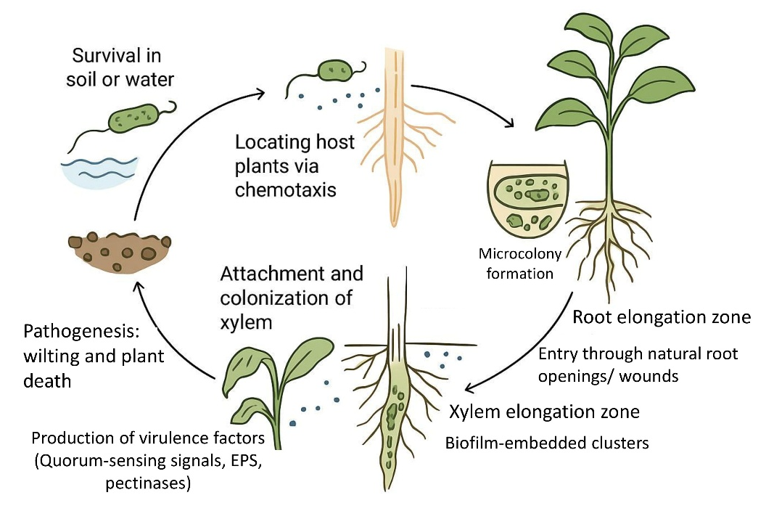

Fig. 1 Life cycle of Ralstonia solanacearum species complex
The soil environment: A critical habitat and modulator of pathogen ecology
Being a soil-inhabiting bacterium, R. solanacearum relies on soil as its main reservoir and natural habitat for survival, persistence, and dissemination. Soil is not just a passive medium, but an active factor that shapes the pathogen’s life cycle and disease potential. Its physical, chemical, and biological characteristics strongly affect the pathogen’s behaviour even before plant invasion. Therefore, a clear understanding of the interactions between the bacterium, native soil microbial communities, and soil properties is vital for designing effective strategies to manage soil-borne diseases.
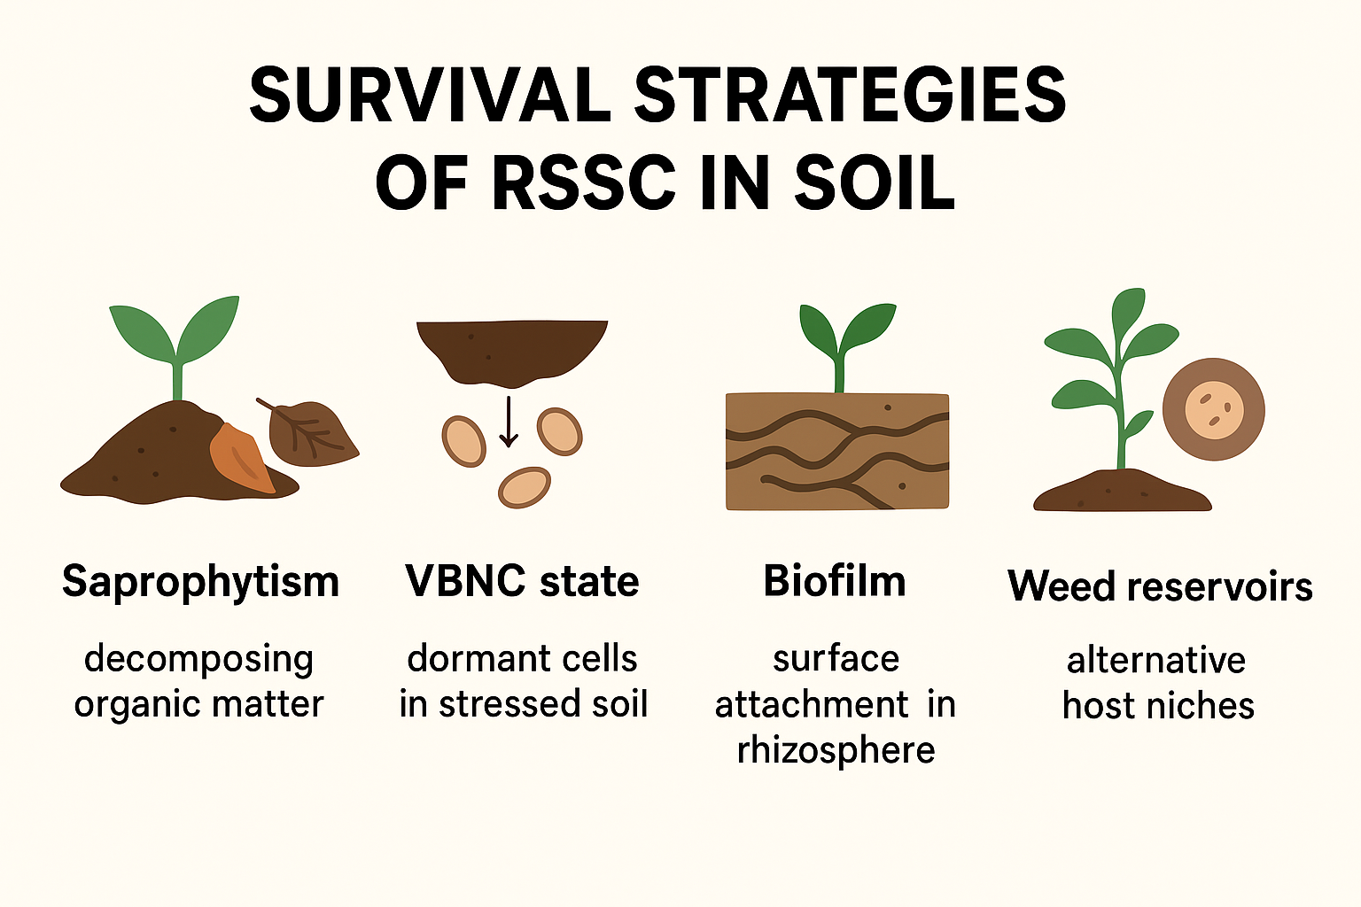

Fig. 2 Survival strategies of RSSC in soil. Abbreviation: VBNC – Viable But Non-Culturable

Selective forces shaping the infection dynamics of RSSC
R. solanacearum is a highly adaptable and difficult pathogen to control, as it constantly adjusts to environmental changes. Its phenotypic plasticity—the ability of a single genotype to exhibit different traits under varying conditions (Farnham, 2022)—enables it to modify virulence, motility, metabolic functions, and stress tolerance. This flexibility enhances the pathogen’s survival and fitness across diverse soil environments. Moreover, RSSC encounters numerous biotic and abiotic pressures during movement through soil and water, which strongly influence its persistence and disease transmission. The following section provides a more detailed examination of these factors.
Abiotic factors influencing the survival and proliferation of RSSC
Abiotic parameters such as temperature, pH, salinity, soil moisture, nutrient availability, and gas concentrations (CO₂ and O₂) strongly influence the survival and virulence of Ralstonia solanacearum. Among these, soil moisture plays a particularly critical role. Elevated moisture, often resulting from rainfall or high-water tables, promotes pathogen survival and is consistently linked to bacterial wilt outbreaks (Hayward, 1991). Soil pH also affects pathogen growth; acidic soils (pH 4.5–5.5) favour its proliferation and are frequently associated with higher wilt incidence (Hayward, 1991). Temperature further determines persistence and epidemiology—although overall survival decreases under cooler conditions, cold-tolerant strains such as race 3 biovar 2 (phylotype IIB sequevar 1) can still cause disease in temperate climates (Janse, 1996 & Elphinstone, 2005). The pathogen’s ability to tolerate nutrient stress is ecologically advantageous, enabling certain strains to persist in oligotrophic environments such as sterile water while remaining infectious to susceptible hosts (Álvarez et al., 2008). Salinity also influences survival: most strains withstand ≈1% NaCl but are inhibited at concentrations ≥2% (Álvarez et al., 2010). Elevated soil moisture remains a consistent driver of disease, as later confirmed by Parkinson et al. (2013). Abiotic conditions collectively determine the pathogen’s ecological range and disease risk (Brennan and Collins, 2015). More recent studies reveal that soil moisture patterns can even predict disease occurrence (Jiang et al., 2021) and that abiotic parameters such as temperature, pH, and salinity modulate the pathogen’s virulence and fitness under different environmental contexts (Zarattini et al., 2021). Collectively, these abiotic factors act as key selective pressures shaping the ecology, epidemiology, and host–pathogen interactions of the RSSC.
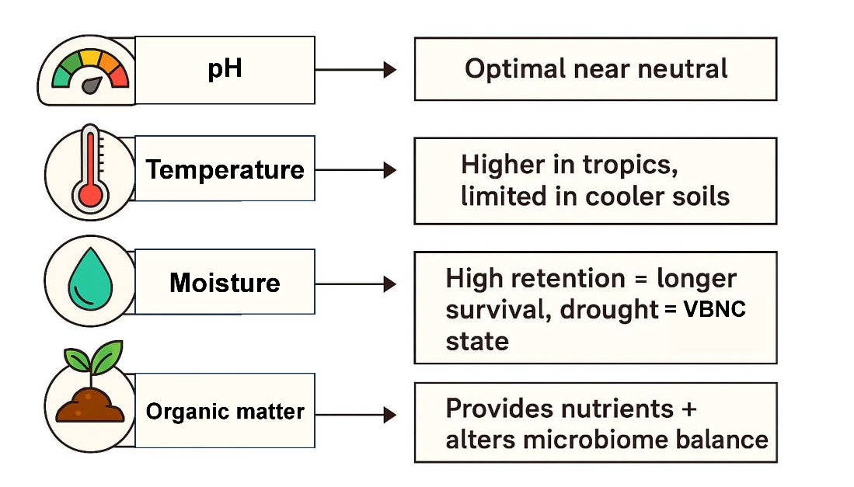

Fig. 3 Environmental factors influencing the persistence of RSSC

Biotic factors influencing the survival and proliferation of RSSC
Establishment in the rhizosphere and invasion
The resource utilization patterns and virulence potential of RSSC vary among strains, reflecting distinct life-history strategies (Hayward, 1991). One important adaptation involves the production of siderophores—iron-chelating compounds that enhance competitiveness and nutrient acquisition in the rhizosphere (Bhatt and Denny, 2004 & Hider and Kong, 2010). For successful infection, RSSC must establish itself in the rhizosphere and attain a threshold population density required to activate virulence genes (Genin and Boucher, 2002 & Mansfield et al., 2012). Strain-specific differences in resource utilisation further influence virulence potential and ecological adaptation (Zuluaga et al., 2013; Peyraud et al., 2016). In highly diverse microbial communities with overlapping ecological niches, invasion efficiency and bacterial wilt incidence are reduced due to negative interactions such as nutrient competition and antibiotic production (Wei et al., 2015 & Li et al., 2019). To overcome these ecological constraints, RSSC manipulates host nutrient availability by deploying effector proteins that convert host-derived molecules into γ-aminobutyric acid (GABA), thereby promoting colonisation and infection (Xian et al., 2019). More recently, siderophore production and other iron-acquisition mechanisms have been recognised as major strategies that enhance survival and competitiveness in the rhizosphere (Gu et al., 2020).
Biotic stress offered by microbial interactions
Within both rhizosphere and aquatic habitats, RSSC encounters diverse biotic stressors in addition to resource competition. The pathogen is subject to strong selective pressures from natural antagonists such as bacteriophages and predatory protists, which influence both its persistence and evolutionary trajectory (Jousset et al., 2006; Yamada et al., 2007; Bhunchoth et al., 2015; Xiong et al., 2019). Resistance to antibiotics also provides a crucial survival advantage, as beneficial microbes like Bacillus and Pseudomonas spp. produce antimicrobial compounds that suppress RSSC populations (Allen et al., 2010; Yuliar et al., 2015; Wei et al., 2018). These biotic interactions collectively impose significant ecological challenges, necessitating continuous adaptation across environments. Modifications in resource utilisation, stress tolerance, and community-level interactions ultimately determine the pathogen’s capacity for survival, virulence, and epidemiological success. Consequently, the physical, chemical, and biological attributes of soil collectively shape RSSC ecology by generating microenvironments that may either favour or inhibit infection, thereby influencing both disease occurrence and severity.
Survival and persistence of RSSC in soil environments
Population dynamics and long-term viability in diverse soils
One of the major reasons for the widespread prevalence of RSSC is its exceptional ability to persist in soils for prolonged periods, even in the absence of host plants. Field-based observations first demonstrated that RSSC can remain viable in agricultural soils for several years after crop removal. In abandoned potato fields, the pathogen persisted for up to four years (van Elsas et al., 2001), while subsequent studies reported survival of 10–12 months under typical cropping conditions (van Elsas et al., 2010). These findings underscore the continued inoculum potential of previously infested land, even following crop rotation or fallow periods. Within infected tissues, pathogen populations can proliferate to extremely high densities, often exceeding 10⁸ colony-forming units (CFU) per gram of tissue (Wang et al., 2022). Once released from decaying or infected plants, these cells enter the soil environment, where initial concentrations typically range between 10³ and 10⁶ CFU per gram of soil. Although populations generally decline gradually due to competition and environmental constraints, RSSC demonstrates an extraordinary capacity for survival. Beyond soils, aquatic ecosystems also serve as long-term reservoirs. Remarkably, the bacterium has been shown to survive in sterile water at 20–25 °C for extended periods, with one study reporting viability for up to 40 years (Wang et al., 2022). Such persistence across both terrestrial and aquatic environments explains why bacterial wilt remains a formidable management challenge—once established, contaminated sites can serve as infection sources for years or even decades. This remarkable longevity highlights the need for management strategies such as prolonged fallow periods, crop exclusion, or soil disinfestation.
The viable but non-culturable (VBNC) state
A crucial survival mechanism is the ability of R. solanacearum to transition into a viable but non-culturable (VBNC) state, particularly under adverse conditions such as low temperatures (e.g., 4 °C). In this physiological state, bacterial cells maintain metabolic activity but cannot be recovered using conventional culture-based methods, resulting in false negatives and a significant underestimation of soil inoculum potential. This complicates disease monitoring and risk assessment, as soils may appear pathogen-free when infectious cells are still present. Although RSSC cells emerging from the VBNC state may sometimes display reduced virulence (van Elsas et al., 2001), environmental conditions such as rising temperatures or the presence of host root exudates can restore both culturability and pathogenicity. This reactivation can trigger sudden and unexpected disease outbreaks after periods of apparent absence. The VBNC state therefore, represents a hidden risk factor for bacterial wilt epidemiology. Addressing this requires the use of advanced molecular diagnostics (e.g., qPCR, LAMP assays, and metagenomics) capable of detecting VBNC cells, alongside a detailed study of the environmental triggers that govern their resuscitation. Moreover, variations in virulence following recovery suggest that pathogenic potential may shift depending on resuscitation conditions, adding further complexity to disease forecasting.
Dispersal mechanisms: water, plant debris, and agricultural practices
RSSC employs multiple dispersal pathways that contribute to its extensive distribution and make containment highly challenging. A well-documented early example comes from northern Europe, where Race 3 Biovar 2 became established in solanaceous weeds growing along slow-flowing rivers. Pathogen populations were later introduced into potato production systems when this contaminated river water was used for irrigation, leading to widespread outbreaks (Janse, 1996). Infected plants, whether symptomatic or asymptomatic, can continuously shed bacteria into the rhizosphere through their root systems, while infected stems, rhizomes, and tubers exude a characteristic milky-white bacterial ooze that seeps into surrounding soil and water, serving as a direct contamination source (García et al., 2019). Insect vectors may also facilitate localised pathogen movement (Montong and Salaki, 2020). Human agricultural activities represent a major driver of long-distance spread: contaminated tools, irrigation equipment, and machinery transfer infested soil particles between fields, while infected propagation materials such as tubers, cuttings, or seeds act as inoculum sources across regions. Water-mediated dissemination, especially through flooding or irrigation with contaminated water, further amplifies pathogen distribution. Similarly, transport of infested soil on seedlings or farm equipment provides another pathway for regional transmission. These findings demonstrate that RSSC does not merely persist passively in the environment—it actively exploits ecological niches and anthropogenic activities to ensure dispersal. The interplay between environmental reservoirs (soil, water, and weeds) and farming practices creates a resilient network of transmission pathways, underscoring the need for integrated biosecurity measures. Preventing spread requires coordinated strategies involving equipment sanitation, water quality monitoring, pathogen-free planting material, and strict crop hygiene practices.
Integrative management approaches based on soil variability
As the survival ability of RSSC is strongly shaped by soil conditions, management efforts must be soil-centred and integrative. Host resistance breeding provides an early line of defence by introducing genetic resistance against bacterial wilt (Huet, 2014). Cultural practices such as crop rotation, intercropping, and cover cropping have long been recognised for their role in suppressing pathogen populations by enriching soil organic matter and stabilising beneficial microbial networks (Álvarez et al., 2010; Butler et al., 2014; Wei et al., 2018). Soil amendments have proven highly effective for improving soil health and disease suppression. Innovative techniques such as anaerobic soil disinfestation—involving incorporation of labile carbon sources followed by soil tarping—reduce pathogen inoculum and restructure microbial communities into more disease-suppressive states (Shinmura et al., 2020). Similarly, biochar has been shown to raise soil pH, increase organic carbon, foster beneficial microbial communities, and induce systemic resistance in host plants (Bonanomi et al., 2020 & Wu et al., 2021). Organic amendments—including composts, crop residues, and bio-organic fertilizers—not only improve soil structure and nutrient status but also stimulate microbial diversity, creating competitive environments that suppress pathogen activity while simultaneously enhancing plant resilience (Zhao et al., 2022).
Adjusting soil pH toward neutrality through liming (e.g., CaCO₃ or CaO) significantly reduces bacterial wilt incidence in acidic soils (pH 4.5–5.5), as R. solanacearum populations persist longer and exhibit higher virulence under acidic conditions (Singh et al., 2023). Liming not only suppresses pathogen survival but also enhances nutrient availability and fosters beneficial microbial communities, thereby promoting overall soil health. In addition, soil disinfection using bleaching powder (calcium hypochlorite) has been reported to directly reduce RSSC inoculum through its bactericidal action, effectively lowering disease incidence when applied at 10–15 kg ha⁻¹ in infested fields (Parker, 2021 & Benti, 2023). Together, these practices—pH correction for long-term suppressiveness and bleaching powder treatment for short-term pathogen reduction—complement cultural, biological, and host-resistance strategies in an integrated soil-centered management framework.
Biocontrol approaches further enhance suppression: antagonistic microbes such as Bacillus and Pseudomonas spp. inhibit RSSC through antibiotic production and simultaneously activate host defence responses, improving plant resistance to infection (Guo et al., 2022 & Chen et al., 2023). Collectively, integrating soil amendments, microbial biocontrol, cultural practices, and host resistance represents the most sustainable strategy for mitigating RSSC across diverse agroecosystems.
Conclusion
The persistence and pathogenic variability of RSSC are strongly modulated by soil properties, which act as both habitat and selective environment. Integrating this ecological understanding into management is crucial for durable disease control. Future research should emphasize (i) engineering soil microbiomes to enhance natural suppression, (ii) developing predictive tools that combine molecular diagnostics (qPCR, metagenomics) with soil health indicators, and (iii) adapting management strategies to climate-driven shifts in soil conditions. Linking soil ecology with resistance breeding and precision agriculture offers the most promising pathway toward sustainable management of bacterial wilt.

References
- Álvarez, B., López, M. M., & Biosca, E. G. (2008). Survival strategies and pathogenicity of Ralstonia solanacearum phylotype II. Microbiology, 154, 3590–3598. https://doi.org/10.1099/mic.0.2008/018550-0
- Álvarez, B., Biosca, E. G., & López, M. M. (2010). On the life of Ralstonia solanacearum, a destructive bacterial plant pathogen. Current Research, Technology, Education Topics in Applied Microbiology and Microbial Biotechnology, 2, 267–279.
- Allen, H. K., Donato, J., Wang, H. H., Cloud-Hansen, K. A., Davies, J., & Handelsman, J. (2010). Call of the wild: antibiotic resistance genes in natural environments. Nature Reviews Microbiology, 8, 251–259. https://doi.org/10.1038/nrmicro2312
- APEDA. (2023). Statistics of horticulture production and export. APEDA, New Delhi. https://apeda.gov.in/apedawebsite/#
- Benti, E. A. (2023). Control of bacterial wilt (Ralstonia solanacearum) and reduction of ginger yield loss through integrated management methods in Southwestern Ethiopia. The Open Agriculture Journal, 17, e187433152212300. https://doi.org/10.2174/18743315-v17-e230404-2022-53
- Bhatt, G., & Denny, T. P. (2004). Ralstonia solanacearum iron scavenging by the siderophore staphyloferrin B is controlled by PhcA, the global virulence regulator. Journal of Bacteriology, 186, 7896–7904. https://doi.org/10.1128/JB.186.23.7896-7904.2004
- Bhunchoth, A., Phironrit, N., Leksomboon, C., Chatchawankanphanich, O., Kotera, S., Narulita, E., Kawasaki, T., Fujie, M., & Yamada, T. (2015). Isolation of Ralstonia solanacearum-infecting bacteriophages from tomato fields in Chiang Mai, Thailand, and their experimental use as biocontrol agents. Journal of Applied Microbiology, 118, 1023–1033. https://doi.org/10.1111/jam.12909
- Bonanomi, G., De Filippis, F., Cesarano, G., La Storia, A., Ercolini, D., & Scala, F. (2020). Organic farming induces changes in soil microbiota. Agronomy for Sustainable Development, 40, 20. https://doi.org/10.1007/s13593-020-0605-2
- Brennan, G., & Collins, S. (2015). Growth responses of a green alga to multiple environmental drivers. Nature Climate Change, 5, 892–897. https://doi.org/10.1038/nclimate2736
- Butler, D. M., Rosskopf, E. N., Kokalis-Burelle, N., Albano, J. P., Muramoto, J., & Shennan, C. (2014). Anaerobic soil disinfestation combined with soil solarization. Plant and Soil, 378, 365–381. https://doi.org/10.1007/s11104-014-2095-y
- Caruso, P., Bertolini, E., Cambra, M., & López, M. M. (2003). A new and sensitive co-operational polymerase chain reaction for rapid detection of Ralstonia solanacearum in water. Journal of Microbiological Methods, 55, 257–272. https://doi.org/10.1016/S0167-7012(03)00039-1
- Champoiseau, P. G., Jones, J. B., & Allen, C. (2009). Ralstonia solanacearum race 3 biovar 2 causes tropical losses and temperate anxieties. Plant Health Progress, 10, 35. https://doi.org/10.1094/PHP-2009-0826-01-RV
- Chen, L., Zhang, J., Liu, Y., Chen, Q., & Liu, X. (2023). Biocontrol potential of Bacillus velezensis. Biological Control, 178, 105124. https://doi.org/10.1016/j.biocontrol.2023.105124
- Elphinstone, J. G. (2005). The current bacterial wilt situation: a global overview. In C. Allen, P. Prior, & A. C. Hayward (Eds.), Bacterial wilt disease and the Ralstonia solanacearum species complex (pp. 9–28). APS Press.
- European Food Safety Authority (EFSA), van der Gaag, D. J., Camilleri, M., Diakaki, M., Schenk, M., & Vos, S. (2019). Pest survey card on potato brown rot, Ralstonia solanacearum. EFSA Supporting Publications, 16, 1567E. https://doi.org/10.2903/sp.efsa.2019.EN-1567
- EFSA Panel on Plant Health (PLH Panel), Bragard, C., Dehnen-Schmutz, K., Di Serio, F., Gonthier, P., Jaques Miret, J. A., Justesen, A. F., MacLeod, A., Magnusson, C. S., Milonas, P., & Navas-Cortes, J. A. (2019). Pest categorisation of the Ralstonia solanacearum species complex. EFSA Journal, 17, e05618. https://doi.org/10.2903/j.efsa.2019.5618
- Fegan, M., & Prior, P. (2005). Recent developments in the phylogeny and classification of Ralstonia solanacearum. Acta Horticulturae, 695, 127–136. https://doi.org/10.17660/ActaHortic.2005.695.11
- Farnham, E. M. (2022). Exploring the phenotypic and genetic diversity of a bacterial plant pathogen, the Ralstonia solanacearum species complex (RSSC). Doctoral dissertation, University of York.
- García, R. O., Kerns, J. P., & Thiessen, L. (2019). Ralstonia solanacearum species complex: a quick diagnostic guide. Plant Health Progress, 20, 7–13. https://doi.org/10.1094/PHP-04-19-0023-RV
- Genin, S. (2010). Molecular traits controlling host range and adaptation to plants in Ralstonia solanacearum. New Phytologist, 187, 920–928. https://doi.org/10.1111/j.1469-8137.2010.03318.x
- Genin, S., & Boucher, C. (2002). Ralstonia solanacearum: secrets of a major pathogen unveiled by analysis of its genome. Molecular Plant Pathology, 3, 111–118. https://doi.org/10.1046/j.1364-3703.2002.00116.x
- Gu, S., Wei, Z., Shao, Z., Friman, V. P., Cao, K., Yang, T., Kramer, J., Wang, X., Li, M., Mei, X., & Xu, Y. (2020). Competition for iron drives phytopathogen control by natural rhizosphere microbiomes. Nature Microbiology, 5, 1002–1010. https://doi.org/10.1038/s41564-020-0706-x
- Guo, J., Li, P., Zhang, C., He, J., Hu, W. (2022). Pseudomonas fluorescens as a biocontrol agent. Frontiers in Plant Science, 13, 829511. https://doi.org/10.3389/fpls.2022.829511
- Hayward, A. C. (1964). Characteristics of Pseudomonas solanacearum. Journal of Applied Bacteriology, 27, 265–277. https://doi.org/10.1111/j.1365-2672.1964.tb04912.x
- Hayward, A. C. (1991). Biology and epidemiology of bacterial wilt caused by Pseudomonas solanacearum. Annual Review of Phytopathology, 29, 65–87. https://doi.org/10.1146/annurev.py.29.090191.000433
- Heikrujam, S. C., Singh, R. I., Laiphrakpam, P. C., & Laishram, S. (2020). Isolation and characterization of Ralstonia solanacearum from infected tomato plants of Bishnupur district of Manipur. Pharma Innov J, 9, 4363. https://doi.org/10.22271/tpi.2020.v9.i2c.4363
- Hider, R. C., & Kong, X. (2010). Chemistry and biology of siderophores. Natural Product Reports, 27, 637–657. https://doi.org/10.1039/b906679a
- Huet, G. (2014). Breeding for resistances to Ralstonia solanacearum. Frontiers in Plant Science, 5, 715. https://doi.org/10.3389/fpls.2014.00715
- Jiang, G., Wei, Z., Xu, J., Chen, H., Zhang, Y., She, X., et al. (2021). Bacterial wilt in China: insights into ecology, epidemiology and management. Phytopathology Research, 3, 11. https://doi.org/10.1186/s42483-021-00092-2
- Jousset, A., Lara, E., Wall, L. G., & Valverde, C. (2006). Secondary metabolites help biocontrol strain Pseudomonas fluorescens CHA0 to escape protozoan grazing. Applied and Environmental Microbiology, 72, 7083–7090. https://doi.org/10.1128/AEM.00617-06
- Janse, J. D. (1996). Potato brown rot in western Europe – history, present occurrence and prospects. EPPO Bulletin, 26, 679–695. https://doi.org/10.1111/j.1365-2338.1996.tb00910.x
- Kang, Y., Liu, H., Genin, S., Schell, M. A., & Denny, T. P. (2002). Ralstonia solanacearum requires type 4 pili to adhere to multiple surfaces and for natural transformation and virulence. Molecular Microbiology, 46, 427–437. https://doi.org/10.1046/j.1365-2958.2002.03150.x
- Kelman, A. (1956). Survival of Pseudomonas solanacearum in water. Phytopathology, 46, 17–26.
- Kumara, T. M. K., Raghavendra, K. J., Kandpal, A., Prakash, P., Ravi, S. C., & Yeligar, S. (2025). Production, trade and future prospects of Indian vegetables: current scenario and way forward. In M. K. Lal, R. K. Tiwari, A. Kumar, R. Kumar, & B. Singh (Eds.), Abiotic stress in underground vegetables (pp. 303–325). Academic Press. https://doi.org/10.1016/B978-0-443-23961-8.00020-6
- Lampropoulos, P., Gkentzi, D., Tzifas, S., Kapnisi, G., Karatza, A., Kolonitsiou, F., et al. (2021). Ralstonia mannitolilytica, an unusual pathogen in the neonatal intensive care unit. Infectious Disorders – Drug Targets, 21, 168–172. https://doi.org/10.2174/1871526519666210617144648
- Li, M., Wei, Z., Wang, J., Jousset, A., Friman, V. P., Xu, Y., Shen, Q., & Pommier, T. (2019). Facilitation promotes invasions in plant-associated microbial communities. Ecology Letters, 22, 149–158. https://doi.org/10.1111/ele.13188
- Lowe-Power, T. M., Khokhani, D., & Allen, C. (2018). How Ralstonia solanacearum exploits and thrives in the flowing plant xylem environment. Trends in Microbiology, 26, 929–942. https://doi.org/10.1016/j.tim.2018.07.002
- Manda, R. R., Addanki, V. A., & Srivastava, S. (2020). Bacterial wilt of solanaceous crops. International Journal of Chemical Studies, 8, 1048–1057.
- Mansfield, J., Genin, S., Magori, S., Citovsky, V., Sriariyanum, M., Ronald, P., et al. (2012). Top 10 plant pathogenic bacteria in molecular plant pathology. Molecular Plant Pathology, 13, 614–629. https://doi.org/10.1111/j.1364-3703.2011.00804.x
- Messiha, N. A. S., van Bruggen, A. H. C., Franz, E., & Janse, J. D., et al. (2007). Potato brown rot incidence and severity under European conditions. European Journal of Plant Pathology, 119, 367–381. https://doi.org/10.1007/s10658-007-9104-9
- Ministry of Agriculture and Farmers Welfare. (2024). Annual Report 2024–25. Government of India, 1–20.
- Montong, V., & Salaki, S. (2020). Insects as carriers of Ralstonia solanacearum phylotype IV on kepOK banana flowers in South Minahasa and Minahasa districts. International Journal of ChemTech Research, 13, 100.
- Muthoni, J., Shimelis, H., Melis, R., & Kinyua, Z. M. (2014). Response of potato genotypes to bacterial wilt caused by Ralstonia solanacearum in the tropical highlands. American Journal of Potato Research, 91, 215–232. https://doi.org/10.1007/s12230-014-9353-1
- Paret, M. L., Kubota, R., Jenkins, D. M., & Alvarez, A. M. (2010). Survival of Ralstonia solanacearum race 4 in drainage water and soil and detection with immunodiagnostic and DNA-based assays. HortTechnology, 20, 539–548. https://doi.org/10.21273/HORTTECH.20.3.539
- Parker, M. (2021). Bacterial wilt: What every potato farmer needs to know about this destructive disease. International Potato Center. https://cgspace.cgiar.org/items/20fc3f1e-2e1b-456f-917b-257a2c264fd2
- Parkinson, N., Bryant, R., Bew, J., Conyers, C., Stones, R., Alcock, M., & Elphinstone, J. (2013). Application of variable-number tandem-repeat typing to discriminate Ralstonia solanacearum strains associated with English watercourses and disease outbreaks. Applied and Environmental Microbiology, 79, 6016–6022. https://doi.org/10.1128/AEM.00948-13
- Peyraud, R., Cottret, L., Marmiesse, L., Gouzy, J., & Genin, S. (2016). A resource allocation trade-off between virulence and proliferation drives metabolic versatility in the plant pathogen Ralstonia solanacearum. PLoS Pathogens, 12, e1005939. https://doi.org/10.1371/journal.ppat.1005939
- Prior, P., Ailloud, F., Dalsing, B. L., Remenant, B., Sánchez, B., & Allen, C. (2016). Genomic and proteomic evidence supporting the division of the plant pathogen Ralstonia solanacearum into three species. BMC Genomics, 17, 90. https://doi.org/10.1186/s12864-016-2413-z
- Remenant, B., Coupat-Goutaland, B., Guidot, A., et al. (2010). Genomes of three tomato pathogens within the Ralstonia solanacearum species complex. BMC Genomics, 11, 379. https://doi.org/10.1186/1471-2164-11-379
- Senthilraja, N., Gangwar, R. K., & Borad, C. K. (2024). Challenges and opportunities in plant disease management: a brief review. International Journal of Phytopathology (in press).
- Shinmura, A., Takeuchi, T., & Sato, T. (2020). Efficacy of anaerobic soil disinfestation. Crop Protection, 137, 105303. https://doi.org/10.1016/j.cropro.2020.105303
- Singh, N. (2021). Ralstonia solanacearum — an emerging threat as a mysterious plant pathogen. Current Science, 120, 20.
- Singh, R., Sharma, S., & Prasad, R. (2023). Soil pH manipulation as a sustainable strategy for managing bacterial wilt of solanaceous crops. Journal of Plant Diseases and Protection, 130, 47–58.
- van Elsas, J. D., et al. (2001). Survival of Ralstonia solanacearum biovar 2 in field and microcosm soils in temperate climates. Phytopathology, 90, 1358–1366. https://doi.org/10.1094/PHYTO.2000.90.12.1358
- van Elsas, J. D., Kastelein, P., de Vries, P. M., & van Overbeek, L. S. (2010). Effects of ecological factors on the survival and physiology of Ralstonia solanacearum bv. 2 in irrigation water. Canadian Journal of Microbiology, 47, 842–854. https://doi.org/10.1139/w10-052
- Wang, R., Wei, Z., Yang, T., Friman, V. P., Xu, Y., Shen, Q., & Jousset, A. (2022). Crop rotation and organic amendments enhance soil suppressiveness against bacterial wilt through microbiome restructuring. Soil Biology and Biochemistry, 165, 108498. https://doi.org/10.1016/j.soilbio.2021.108498
- Wei, Z., Yang, T., Friman, V. P., Xu, Y., Shen, Q., & Jousset, A. (2015). Trophic network architecture of root-associated bacterial communities. Nature Communications, 6, 8413. https://doi.org/10.1038/ncomms9413
- Wei, Z., Gu, Y., Friman, V. P., Kowalchuk, G. A., Xu, Y., Shen, Q., & Jousset, A. (2018). Initial soil microbiome composition and functioning predetermine future plant health. Science Advances, 4(4), eaap7959. https://doi.org/10.1126/sciadv.aap7959
- Wu, S., Sun, J., Liu, X., Sun, W., & Yang, L. (2021). Biochar amendment reduces bacterial wilt by modifying soil properties and microbial communities. Applied Soil Ecology, 167, 104026. https://doi.org/10.1016/j.apsoil.2021.104026
- Xian, L., Yu, G., Wei, Y., Li, Y., Xue, H., Morcillo, R., Rufian, J., & Macho, A. (2019). A bacterial effector protein hijacks plant metabolism to support bacterial nutrition. SSRN. https://ssrn.com/abstract=3479448
- Xiong, W., Li, R., Guo, S., Karlsson, I., Jiao, Z., Xun, W., Kowalchuk, G. A., Shen, Q., & Geisen, S. (2019). Microbial amendments alter protist communities within the soil microbiome. Soil Biology and Biochemistry, 135, 379–382. https://doi.org/10.1016/j.soilbio.2019.05.012
- Yao, J., & Allen, C. (2007). The plant pathogen Ralstonia solanacearum needs aerotaxis for normal biofilm formation and interactions with its tomato host. Journal of Bacteriology, 189, 6415–6424. https://doi.org/10.1128/JB.00130-07
- Yamada, T., Kawasaki, T., Nagata, S., Fujiwara, A., Usami, S., & Fujie, M. (2007). New bacteriophages that infect the phytopathogen Ralstonia solanacearum. Microbiology, 153, 2630–2639.
- Yuliar, N., Nion, Y. A., & Toyota, K. (2015). Recent trends in control methods for bacterial wilt diseases caused by Ralstonia solanacearum. Microbes and Environment, 30, 1–11. https://doi.org/10.1264/jsme2.ME14153
- Zarattini, M., Farjad, M., Launay, A., Cannella, D., Soulié, M. C., Bernacchia, G., & Fagard, M. (2021). Every cloud has a silver lining: how abiotic stresses affect gene expression in plant–pathogen interactions. Journal of Experimental Botany, 72, 1020–1033.
- Zhao, C., Liu, L., Wang, C., Chen, H., & Xu, X. (2022). Bio-organic fertilizer application suppresses bacterial wilt and reshapes rhizosphere microbiota in tomato. Applied Microbiology and Biotechnology, 106, 3017–3030.
- Zuluaga, A. P., Puigvert, M., & Valls, M. (2013). Novel plant inputs influencing Ralstonia solanacearum during infection. Frontiers in Microbiology, 4, 349. https://doi.org/10.3389/fmicb.2013.00349

