Assessing the Nitrogen Leaching Potential of the Njala Soil Series Amended with Biochar

Abstract
Upland gravelly soils of Sierra Leone pose serious challenges to agriculture due to their low ability to retaining nutrients and water. These are highly weathered soils with high accumulation of low activity clays and low organic matter content. Such conditions have led to high leaching of essential nutrients, but little knowledge exist about the magnitude of such loss. This study was therefore established to quantify leaching losses of nitrogen from urea fertilizer in soils treated with and without biochar. In this study, four treatments were used to set up leaching columns: (i)Soil without Biochar (Control), (ii) Soil+Biochar, (iii) Soil+Fertilizer, and (iv) Soil+Biochar+Fertilizer. Each treatment was replicated three times. Leaching experiment was conducted daily for seven days. Leachates were collected daily and analyzed for total Nitrogen. The results showed a high rate of nutrients loss in soils not treated with biochar than soils treated with biochar. Hence, the study has revealed the magnitude of nitrogen loss from applied urea fertilizer is 74.1% while the addition of biochar can reduce the loss significantly to 40% on the gravelly upland soils of Njala. The study showed the vulnerability of nitrogen loss on the Njala uplands and the role of biochar in minimizing such loss.
Keywords: leaching column, acacia biochar, leachates, Njala series, Nutrient Leaching

1. Introduction
Soils of the Njala Area, like most of Sierra Leone soils, have low nutrient retention capacities due to the dominance of highly weathered, acidic and leached soils with low activity clays [1, 2]. Furthermore, the dominant upland soils (Njala Series) have high (60-80%) gravel content leading to high porosity and high infiltration rate [3]. These properties resulted in high nutrient leaching potential of the Njala Soil Series which can impact crop productivity and environmental quality.

Nutrient leaching is a problem of increasing concern especially in the tropics. Nutrient loss through leaching can reduce nutrient use efficiency [4] and thus limit crop production, pollute underground water [5, 6] with economic implications and thus increase the use of fossil fuel-based fertilizers [7, 8]. Furthermore, the leaching of inorganic fertilizers like urea can cause pollution of surface and underground water resources [9].

The common approach to improving nutrient retention and reducing nutrient leaching in highly weathered tropical soils is effective soil organic matter management through the addition of organic manures (e.g. livestock and poultry litter), compost, and green manures. However, soil organic matter has high turnover rates [10] in humid tropical soils like Sierra Leone leading to shorter residence times. This requires frequent addition of soil organic matter to maintain and/or improve soil productivity. In recent years, studies have shown that the application of biochar to agricultural soils have the unique quality of retaining nutrients and water [11, 12, 13, 14] for plant nutrition for longer periods as a result of the more stable carbon it contains [15]. Biochar has positive effects on physical, chemical and biological processes in the soil which appear to enhance nutrient and water retention capacity thereby contributing to reduction in nutrient leaching. For instance, studies suggest that the application of biochar can increase soil fertility and productivity by reducing the leaching of nutrient or even supplying nutrient to the plants [16, 14, 17]. [17] reported that amendment of biochar produced from secondary forest residues significantly reduced the leaching of fertilizer and increase crop growth and nutrition.

Urea fertilizer is the most common nitrogen fertilizer used in Sierra Leone agriculture. Under well drained conditions of upland soils in Sierra Leone, urea can readily be converted to nitrate via ammonium and leached, especially in soil with low nutrient retention capacities like the Njala Series. Very little studies have been conducted to understand the magnitude of nutrient leaching in Sierra Leone soils. It is therefore necessary to conduct a study that will shed light on the potential of nutrient leaching in well-drained, gravelly upland soils of Sierra Leone. Such knowledge will contribute to raising awareness on the relevance of development of effective soil management strategies aimed at reducing nutrient leaching, increase crop production and ensure a healthier environment. Hence, the objectives of this study were to compare nitrogen leaching in soils amended with and without biochar under (i) unfertilized condition and (ii) fertilized condition.

2. Method
2.1 Description of the Study Area
The study was conducted in the Njala University Quality control Laboratory in Njala Campus of the Njala University in Moyamba District, Southern Sierra Leone. The soil used in this study, The Njala Soil Series, belong to Soil Province G: Soils from the Rokel River Series under secondary bush (van Vuure et al. 1976). The Njala Soil Series is the dominant soil in The Njala Area with area of about 5,833ha [18, 3]. The climate is characterized by two distinct seasons, rainy and dry. The rainy season lasts from May to November and the dry season from December to April. The average annual rainfall is about 2500 mm most of which falls in July and August.

2.2 Soil Sampling and Processing
Three composite soil samples of the Njala Soil Series were collected from three different locations at a depth of 30cm. The samples were taken to the Njala University Quality Control Laboratory for preparation and storage. The collected samples were air dried, thoroughly mixed and sieved through a 2mm sieve. The three composite samples from the three different locations on the Njala Soil Series represented three replications.

2.3 Biochar Preparation
The biomass used for biochar production was acacia tree branches. Smaller branches were cut off from trees, and split into smaller sizes and sun dried. The sun-dried biomass was later cut into small chips, placed in a Top-Lit-Up-Draft pyrolysis stove for conversion into biochar. The pyrolyzed biochar was removed from the stove, spread on the floor and quenched with water to prevent it from burning into ashes. The acacia biochar was dried under sun for three days then crushed to pass through a 2mm sieve. The processed biochar was stored in a polythene container.

2.4 Soil Porosity Determination
The soil porosity was determined using a simple lab method: A clean dry 100ml graduated measuring cylinder was weighed and recorded as w₁. The weighed cylinder was filled with 2.0mm sieved air-dry soil and tapped gently to the 100ml mark. The cylinder with soil was weighed and recorded as w₂. The dry soil weight (w₃) was determined by the formula;
w₃ = w₂-w₁
The bulk density was determined using the formula below:

BD = weight of dry soil/volume of cylinder = w₃/100

The process was repeated four times and the average was taken. With an assumed particle density (PD) of 2.65g/cm³, the percentage of soil volume occupied by solids was calculated as:
% Solids = (BD/PD) x 100
The result obtained was used to determine the percent soil porosity as follows
%Porosity = 100 - %Solids
Hence, the soil porosity was given by;
Soil Porosity = %Porosity/100
The pore volume (Vp) of the soil that will fill a 50cm x 5cm leaching column to the 30cm mark was determined by the formula;
Vp = (πr²L) (porosity)
Where;
r = radius of the leaching column and
L = length of the leaching column filled with soil = 30cm.

2.5 Leaching Column Set Up
2.5.1 Column Preparation
A PVC pipe of 50cm length and 5cm diameter was sealed at one end with a piece of cotton cloth to prevent soil particles from running out. The sealed pipe was weighed to obtain the empty weight (w₁). The sealed pipe was filled with dry soil to the 30cm mark. The column was gently tapped and topped to the 30cm mark with soil. The leaching column filled with soil was weighed again (w₂). The weight of soil required to fill the column to the 30cm mark was calculated (w₂-w₁).

2.5.2 Experimental design and layout
The laboratory experiment consisted of four soil treatments with three replications arranged in complete randomized design. The four treatments used are described in table 1 below:

Table 1. Experimental treatments used in the study
Treatment | Description
1 | Control Soil; no biochar, no fertilizer
2 | Soil+Biochar only; No fertilizer
3 | Soil+Fertilizer; no biochar
4 | Soil+Biochar+Fertilizer

Biochar Application: The amount of soil required to fill the leaching column to the 30cm mark (as determined in 2.5.1) was weighed separately into twelve containers arranged in three sets or replications. Biochar was applied at a rate of 20g/kg soil and mixed thoroughly for Treatments 2 and 3 as indicated in Table 1. The columns (total = 12) were filled with the appropriate soil treatment. Each column was clamped and suspended on a wooden platform.

Fertilizer Application: Urea fertilizer granules (applied at a rate of 0.2g/kg soil) were carefully placed on the top of the soil in the suspended columns receiving fertilizer treatments (as indicated in Table 1). The urea granules were carefully mixed with soil to the top 5cm depth using a spatula. The column was tapped gently to allow the particles to settle to the 30cm mark.

2.6 Column Leaching
A filter paper was placed at the surface of the soil in each column to minimize soil particle movement at the top of the column whilst the water is poured. Distilled water (¾ pour volume) was slowly poured onto each column from a tap at a rate of 10ml/min to wet the column without leaching it. The mouth of the column was covered with parafilm to prevent moisture loss through evaporation and left overnight. This was done to initialize the column before running the actual leaching studies. The following day, two pore volumes of distilled water were leached through the column. The leaching process was repeated every 24 hours for seven days with the mouth being covered with parafilm after every leaching period. The volumes of daily leachates collected were measured and the leachates were analyzed for total nitrogen content using the Kjeldahl method.

2.7 Data Analysis
The results obtained from this experiment were subjected to analysis of variance in RStudio. Where significant differences were observed, mean separation was done by Tuckey’s post-hoc test.

3. Results and Discussion
3.1. Effect of biochar on Nitrogen Leaching in Soil without Fertilizer Application
Figure 1 shows the daily leaching losses of nitrogen in the absence of fertilizer application from the control soil without biochar and soil treated with acacia biochar. There was an initial rapid loss of nitrogen in the first three days for both control soil and biochar treated soil. However, the leaching loss of nitrogen was significantly higher (p<0.05; F=202.9, p=0.0) in the control soil without biochar than in the soil treated with biochar. Also, the daily leaching losses of nitrogen for each treatment differed significantly (p<0.05; F=77.26, p=0.0).
Post-hoc analysis of the significant differences in leaching losses between control and biochar treated soils observed for each day reveals that the nitrogen leaching losses were significant at Days 1 and 2 only (Figure 1). At Day 3 and thereafter, there were no significant differences in nitrogen leaching losses between the control and biochar-treated soils. Also, post-hoc analysis of the daily leaching losses of nitrogen showed that, for the biochar treated soil, there were significant differences between Day 1 and all other days; leaching losses at Day 2 did not differ significantly from Days 4 and 5 but differed significantly from Days 5,6 and 7. On the other hand, for the control soil (without biochar), leaching losses differ significantly among Days 1-4. Thereafter, leaching did not differ among the rest of days (Day4-7). Thus, it is clear that leaching losses of nitrogen approached a steady state at Day 3 for biochar treated soil and at Day 4 for the control soil. The lower leaching losses of nitrogen from the biochar treated soil indicated the ability of biochar to minimize leaching losses even under no fertilizer input conditions. Cumulative leaching losses reached a maximum of 29.5mg N/kg soil for the control soil without biochar and 17.1mg N/kg soil for the soil treated with biochar. Thus, the presence of biochar resulted in the significant (p<0.05) reduction of nitrogen losses by 12.4mg N/kg soil.

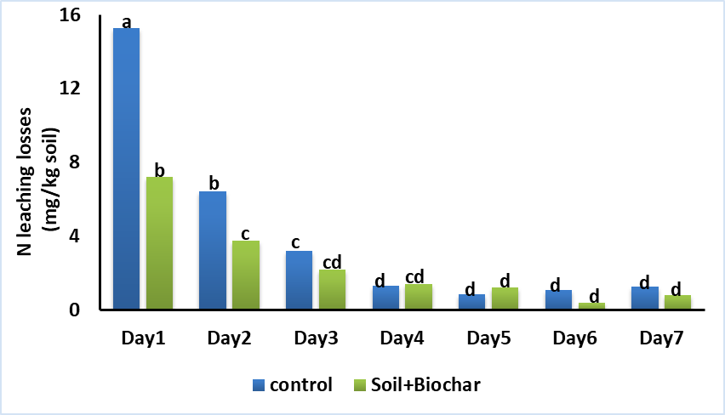
Figure 1. Daily leaching losses of nitrogen in the absence of fertilizer application for control soil without biochar and soil treated with biochar

3.2. Effect of Biochar on Nitrogen Leaching in Soil with Fertilizer Application
Figure 2 shows the daily leaching losses of nitrogen applied as urea on soil without biochar and soil treated with acacia biochar. There was an initial rapid loss of nitrogen in the first four days for soils with and without biochar, but the loss was much rapid for the soil without biochar than soil with biochar. Nitrogen leaching loss was significantly higher (p<0.05; F=2115.4, p=0.0) in the soil without biochar (Soil+Fertilizer) than in the soil treated with biochar (Soil+Fertilizer+Biochar). The daily leaching losses of nitrogen for each treatment differed significantly (p<0.05; F=832.8, p=0.0). At Day 4 and thereafter, leaching losses did not differ significantly between treatments. This showed that biochar can minimize rapid leaching losses of fertilizers in soil thereby improving fertilizer nutrient retention.

In the presence of urea fertilizer, the cumulative nitrogen leaching losses from the soil without biochar (Soil+Fertilizer) reached a maximum of 165.9mg N/kg soil while for the soil treated with biochar (Soil+Fertilizer+Biochar) it reached a maximum of 103.5 mg N/kg soil. Thus, in the presence of biochar, the amount of nitrogen lost from applied urea fertilizer was significantly reduced by 62.4mg N/kg soil. These losses were calculated to represent 74.1% of applied urea fertilizer for soil without biochar and 40% for soil with biochar. Thus, acacia biochar has the potential to reduce leaching losses from urea fertilizer application on Njala soils.

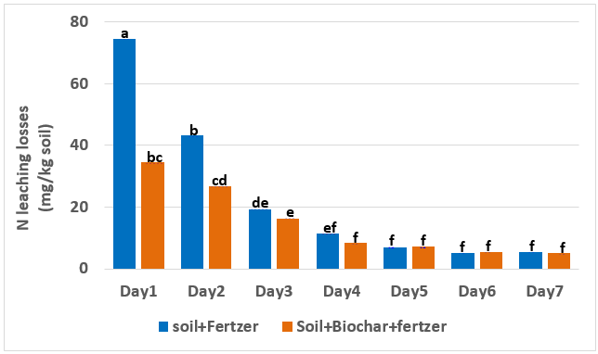
Figure 2. Daily leaching losses of nitrogen in the presence of fertilizer application for control soil without biochar and soil treated with biochar

4. Discussion
The study clearly revealed the vulnerability of upland soils in the Njala area (dominated by the Njala soil series) to nutrient loss by leaching especially after fertilizer application. The reduction in amount of nitrogen loss by leaching in the presence of acacia biochar could be explained by the nutrient retention capacity of acacia biochar. Several studies have shown the ability of biochar to improve nutrient retention and reduce nutrient leaching (Lehmann et al., 2003; Steiner et al., 2007, 2008; Novak et al., 2009). The high gravel content of the Njala upland soils, the dominance of low activity clays, high infiltration capacity, low CEC and acidity make them highly susceptible to leaching losses of nutrients. This can have great impacts on crop productivity and bring loses to famers due to high input cost. Additionally, the leaching of some inorganic fertilizers like urea, can impact water quality. Like many other studies (e.g. Steiner et al., 2008; Novak et al., 2009), this study has shown the potential of biochar in reducing fertilizer nutrient losses thereby improving nutrient retention in soils of the Njala Area.

5. Conclusion
This study has shown that application of urea fertilizer on upland soils of the Njala area (or Njala soil series) without a soil amendment like biochar could lead to significant losses (74.1%) of nitrogen due to leaching. In the presence of biochar leaching losses of urea fertilizer can be reduced from 74.1% to 40%. Thus, acacia biochar is very promising for use as a soil conditioner for minimizing nutrient leaching from soils. Hence, farmers are encouraged to clear and char biomass instead of clear and burn for sustainable crop production and a healthy environment.

COMPETING INTERESTS DISCLAIMER:
Authors have declared that they have no known competing financial interests OR non-financial interests OR personal relationships that could have appeared to influence the work reported in this paper.

REFERENCES

- Bationo, A., Hartemink, A., Lungu, O., Naimi, M., Okoth, P., Smaling, E., and Thiombiano, L. 2006. African Soils: Their Productivity and Profitability for Fertilizer Use. Background paper prepared for the African Fertilizer Submit, June 9-13, 2006, Abuja, Nigeria.
- Dijkerman, J.C. 1969. Soil resources of Sierra Leone, West Africa. African Soils. 14:185-206.
- van Vuure, W., Odell, R.T., and Sutton, P.M. 1976. Soil Survey of the Njala Area Sierra Leone. Bulletin No. 3.
- Novak, M.J., Busscher, W.J., Laird, D.A., Ahmdna, M., Watts, D.W., and Nialtox, M. 2009. Impact of biochar amendment on fertility of southeastern coastal plain soil. Soil Sci. 174:105–112
- Ozacar, M. 2003. Adsorption of phosphate from aqueous solution onto alunite. Chemosphere. 51:321–327.
- Laird, D.A., Fleming, P., Davis, D.D., Wang, B., Horton, R., and Karlen, D.L. 2010. Impact of biochar amendments on the quality of a typical Midwestern agricultural soil. Geoderma. 158:3–4. https://doi.org/10.1016/j.geoderma.2010.05.013
- Kraatz, S., Reinemann, D.J., and Berg, W.E. 2009. Energy Inputs for Corn Production in Wisconsin (Us) and Germany. Applied Engineering in Agriculture. 25(5): 653-662.
- Bruun, E.W., Petersen, C., Strobel, B.W., and Hauggaard-Nielsen, H. 2012. Nitrogen and Carbon Leaching in Repacked Sandy Soil with added Fine Particulate Biochar. Soil Science Society of America Journal. 76(4):1142-1148.
- Fraters, D., Boumans, L.J.M., van Drecht, G., de Haan, T., de Hoop, W.D. 1998. Nitrogen monitoring in groundwater in the sandy regions of the Netherlands. Environmental Pollution, 102:479–485.
- Juo, A.S.R., Manu, A. 1996. Chemical dynamics in slash-and-burn agriculture. Agriculture, Ecosystems & Environment. 58:49–60.
- Lehmann, J., da Silva, Jr. J.P., Steiner, C., Nehls, T., Zech, W., Glaser, B. 2003. Nutrient availability and leaching in an archaeological Anthrosol and a Ferralsol of the Central Amazon basin: fertilizer, manure and charcoal amendments. Plant and Soil. 249:343–357.
- Steiner, C., Teixeira, W.G., Lehmann, J., Nehls, T., de Macêdo, J.L.V., Blum, W.E.H., and Zech, W. 2007. Long term effects of manure, charcoal and mineral fertilization on crop production and fertility on a highly weathered central Amazonian upland soil. Plant and Soil. 291, 275–290.
- Steiner, C., Glaser, B., Teixeira, W.G., Lehmann, J., Blum, W.E.H., and Zech W. 2008. Nitrogen retention and plant uptake on a highly weathered central Amazonian Ferralsol amended with compost and charcoal. Journal of Plant Nutrition and Soil Science. 171, 893–899.
- Novak, J.M., Busscher, W.J., Laird, D.L., Ahmedna, M., Watts, D.W., and Niandou, M.A.S. 2009. Impact of biochar amendment on fertility of a southeastern coastal plain soil. Soil Science. 174, 105–112.
- Granatstein, D., Kruger, C.E., Collins, H., Galinato, S., Garcia-Perez, M., Yoder, J. 2009. Use of biochar from the pyrolysis of waste organic material as a soil amendment. Final project report. Center for Sustaining Agriculture and Natural Resources. Washington State University, Wenatchee, WA. 168pp. http://www.ecy.wa.gov/pubs/0907062.pdf
- Glaser, B., Lehmann, J., and Zech, W. 2002. Ameliorating physical and chemical properties of highly weathered soils in the tropics with charcoal - a review. Biology and Fertility of Soils. 35:219-30.
- Major, J., Rondon, M., Molina, D., Riha, S.J., Lehmann, J. 2010. Maize yield and nutrition during 4 years after biochar application to a Colombian savanna oxisol. Plant Soil. 333:117–128.
- Odell, R.T., and Dijkcrman, J.C.1967. Properties, classification, and use of tropical soils, with special reference to those in Sierra Leone. Njala University College, University of Sierra Leone. 137.

