Original Research Article

IDENTIFICATION OF TRICHOPHYTON SPECIES WITH ARBITRARILY PRIMED POLYMERASE CHAIN REACTION

Abstract
Background and purpose: Dermatophytes represent a clinically significant group of filamentous fungi characterized by their unique ability to metabolize keratin, the primary protein component of skin, hair, and nails. Conventional diagnostic approaches for identifying these fungi primarily rely on phenotypic characterization through microscopic examination and culture-based techniques. The current investigation addresses the inherent limitations of these traditional methods by implementing a molecular diagnostic approach.
Materials and Methods: The current study employed arbitrarily primed polymerase chain reaction (AP-PCR) for the specific detection and differentiation of four prevalent dermatophyte species: Trichophyton rubrum, Trichophyton mentagrophytes, Trichophyton tonsurans, and Trichophyton verrucosum. Genomic DNA from these species was amplified using four distinct arbitrary primers: OPAA11 (5’ ACCCGACCTG 3’), OPU15 (5’ ACGGGCCAGT 3’), OPAA17 (5’ GAGCCCG ACT 3’), and OPD18 (5’ GAGAGCCAAC 3’).
Results: In this study of 272 cutaneous dermatophyte infections, Trichophyton was the predominant genus. T. mentagrophytes was the most frequent species, accounting for 115 (42.2%) of cases, with a near-even gender distribution. It was primarily associated with Tinea corporis and Tinea cruris. T. rubrum was the second most common species (66 cases, 24.2%), showing a male predominance and high association with Tinea cruris. Final species identification utilized AP-PCR and ITS sequencing, which also revealed the presence of T. interdigitale strains.
Conclusion: AP-PCR offers a rapid, reliable, sensitive, and discriminatory molecular approach for accurate dermatophyte identification, overcoming the consistency and specificity limitations of conventional phenotypic methods.
Keywords: AP-PCR, Dermatophyte Identification, Fungal Infections, Molecular Diagnostics, Trichophyton Species
Introduction
Dermatophytes constitute a specialized group of keratinophilic fungi, recognized as the primary etiological agents of superficial mycoses affecting human skin, hair, and nails, commonly referred to as tinea or ringworm infections. These fungi are phylogenetically classified within the class Euascomycetes and are broadly distributed across three distinct genera: Epidermophyton, Microsporum, and Trichophyton.
The genus Epidermophyton comprises two species, one of which is a notable human pathogen causing cutaneous infections, while the other is considered non-pathogenic. The genus Microsporum encompasses 16 recognized species, primarily associated with dermatophytoses of the skin and hair, but typically sparing the nails. In contrast, the genus Trichophyton represents the most speciose and clinically diverse group, with 24 documented species capable of infecting all three keratinized structures: skin, hair, and nails. Prominent human pathogens within the Trichophyton genus includes- Trichophyton mentagrophytes, Trichophyton ajelloi, Trichophyton rubrum, Trichophyton tonsurans, and Trichophyton verrucosum.¹
Colonial morphology of Trichophyton species exhibits considerable diversity, encompassing textures ranging from farinose to velvety or waxy. This macroscopic variability, coupled with characteristic reverse pigmentation, serves as a crucial phenotypic criterion for species-level identification within the genus. Each Trichophyton dermatophyte species manifests distinct colonial architecture and unique pigment production patterns. Microscopic examination reveals the presence of both microconidia and macroconidia across Trichophyton species. Furthermore, certain Trichophyton species demonstrate specific nutritional auxotrophies. For example, Trichophyton tonsurans exhibits a nutritional requirement for the amino acids ornithine, citrulline, and arginine, whereas Trichophyton mentagrophytes necessitates the presence of methionine for optimal growth. These specific nutritional dependencies can be utilized in differential diagnostic media to aid in species identification.²
Laboratory investigations for dermatophytosis traditionally rely on two primary methods: microscopic examination and in vitro culture techniques.
Microscopic Examination: This approach offers a rapid preliminary assessment for the presumptive identification of fungal elements. However, its efficacy is highly dependent on the technical expertise of the observer, as accurate identification of fungal hyphae requires considerable mycological knowledge. Furthermore, microscopic examination inherently lacks the specificity required to differentiate between various fungal species, often providing only a general indication of fungal presence rather than definitive species identification.
In-vitro culture: Culture-based identification is mostly utilized for the definitive diagnosis of dermatophytosis. This technique involves inoculating clinical specimens onto appropriate mycological media, allowing for fungal growth. Subsequent dermatophytes identification is then performed based on the macroscopic and microscopic morphological characteristics unique to different species. While offering higher specificity than direct microscopy, in vitro culture is time-consuming, typically requiring few days to weeks for observable growth and subsequent identification.³
The imperative for accelerated and highly specific diagnostic modalities for dermatophyte species identification remains a critical need in clinical mycology. Recent advancements in DNA-based methodologies, particularly AP-PCR, have significantly enhanced the capacity for accurate detection and precise identification of these fungal pathogens. A particularly effective approach involves the application of PCR technology, which offers a straightforward and rapid means of generating species-specific DNA polymorphisms. These polymorphisms manifest as distinct band patterns following agarose gel electrophoresis, enabling reliable differentiation among various dermatophyte species. This molecular strategy represents a considerable improvement over conventional diagnostic methods, providing a more efficient and specific pathway for diagnosing dermatophytosis.⁴ Molecular techniques present a superior approach for dermatophyte identification due to their enhanced speed and sensitivity compared to conventional methods. These methodologies leverage genetic characteristics, which exhibit greater stability and consistency than phenotypic traits observed through traditional culture-based evaluations. Consequently, molecular diagnostics possess the capability to detect atypical dermatophyte strains that may not exhibit typical growth patterns or morphological features in conventional culture, thereby addressing a significant limitation of traditional diagnostic approaches.⁵
Given the limitations of conventional methods, the current research study reported the identification of Trichophyton species in patients diagnosed with dermatophyte infections using AP-PCR. The present molecular approach was conducted in conjunction with traditional phenotypic and microscopic characterizations to provide comprehensive and accurate identification of the dermatophytes.
Materials and Methods
Ethical Approval: The present research study received approval from the Institutional Ethics Committee (AU/EC/FM/38/2018) and the Institutional Research Committee of Adesh University, Bathinda, Punjab, India.
The research study was conducted at the Centre for Interdisciplinary Biomedical Research, Adesh University, Bathinda. The samples were collected from the patients suffering with skin infection and visited Outpatient Department of Dermatology at Adesh Hospital, Bathinda. All cases were enrolled after written informed consent in their vernacular language.
Patient Recruitment and Sample Collection Methodology
The current investigation encompassed a cohort of 272 cases presenting with cutaneous lesions and 48 cases exhibiting onychomycosis, all demonstrating pertinent clinical symptomatology. A comprehensive medical history was meticulously documented for each participant, including demographic data (gender, age, occupation), and any reported allergies. The clinical history also extended to the duration of the current dermatological condition, prior instances of infection, and the presence of co-morbidities such as diabetes mellitus or other systemic diseases.
Prior to sample acquisition, the affected anatomical region was aseptically prepared with a 70% ethanol solution. Specimens were subsequently collected using either a sterile, blunt-edged surgical blade (for skin lesions) or pre-sterilized nail clippers (for nail samples), and immediately transferred into sterile Eppendorf tubes. Each collected specimen was then aliquoted into three distinct portions: one for direct microscopic examination, a second for mycological culture, and the third for nucleic acid extraction.
Direct microscopic examination: Direct microscopic examination was done on the collected samples utilizing a 20% potassium hydroxide (KOH) solution for clearing. Specimen slides were observed subsequently under ×40 and ×100 (oil immersion) objectives using an Olympus CX31RTSF microscope. Detailed examination focused on the identification of fungal hyphae, spores, and budding cells.
Culturing: Collected samples were inoculated onto Sabouraud Dextrose Agar (SDA) supplemented with gentamicin (20 mg/ml) to inhibit bacterial growth. Cultures were then incubated at 37°C for a period of 7 to 15 days. Following fungal growth, macroscopic identification was performed based on colony morphology, including characteristics such as size, shape, pigmentation (both obverse and reverse sides of the Petri plate), and consistency. Subsequently, microscopic identification was conducted using lactophenol cotton blue tease mounts. Fungal cultures were identified based on the distinct morphological features of their hyphae, fruiting bodies, and spores.
DNA Extraction
Fungal DNA was extracted from the samples following a standardized protocol. Initially, the sample was mechanically disrupted by crushing with a mortar and pestle in the presence of lysis/digestion buffer, proteinase K, and 10% SDS. This mixture was then incubated at 65°C for 2–3 hours in a water bath with intermittent shaking, utilizing 15 mL Falcon tubes.
Following incubation, the samples were vigorously vortexed, after which an equal volume of CTAB/NaCl solution was added. This mixture was then incubated at 56°C in a water bath for approximately 1 hour. Subsequently, an equal volume of chloroform:isoamyl alcohol (24:1) was added, and the mixture was centrifuged at 7000 rpm for 10 minutes at 25°C. The supernatant was carefully transferred to fresh tubes, and an equal volume of phenol:chloroform:isoamyl alcohol (25:24:1) was added.
The samples underwent a second centrifugation at 7000 rpm for 10 minutes. The supernatant was then transferred to new tubes, followed by the addition of an equal volume of chilled isopropanol. This mixture was incubated at −20°C for 30 minutes to precipitate the DNA. The tubes were then centrifuged at 7000 rpm for 10 minutes at 4°C. The supernatant was discarded, and the resulting DNA pellet was washed twice with 70% ethanol. Finally, the DNA pellets were air-dried and resuspended in 50 µL of sterile MilliQ water, then stored at −20°C until further molecular analysis.
Arbitrarily primed polymerase chain reaction (AP-PCR)
AP-PCR was performed individually for all isolates using each primer. The amplification reactions were carried out in a total volume of 20 µl, comprising 3 µl of DNA template, 10 µl of master mix, 2 µL of one of the four random primers [OPAA11 (5’-ACCCGACCTG-3’), OPU15 (5’-ACGGGCCAGT-3’), OPAA17 (5’-GAGCCCGACT-3’), or OPD18 (5’-GAGAGCCAAC-3’)], and 5 µL of sterile MilliQ water.
The thermocycling protocol consisted of 32 cycles, each involving denaturation at 94°C for 30 seconds, primer annealing at 36°C for 45 seconds, and extension at 72∘C for 90 seconds. Following PCR amplification, the products were resolved by electrophoresis on a 1.2% agarose gel in 1X TAE buffer. Gels were stained with ethidium bromide and visualized using a Bio-Rad Gel Doc EZ Imager. The resulting DNA banding patterns were then interpreted by comparison with previously reported data, as described by Zarrin et al.⁶
Sequencing
The purified PCR amplicons were submitted to Central University, Bathinda, for definitive dermatophyte identification through Internal Transcribed Spacer (ITS) region sequencing. The resulting nucleic acid sequences, derived from both forward and reverse cycle sequencing reactions, underwent bioinformatic analysis using DNA Baser software. This analysis involved sequence trimming and subsequent alignment with previously curated sequence data available in the GenBank database via the NCBI Basic Local Alignment Search Tool (BLAST)
Results
In the current study, a cohort of 272 cases with cutaneous dermatophyte infections was investigated. Trichophyton was identified as the predominant fungal genus isolated from skin infections. Trichophyton mentagrophytes was the most frequently isolated species, accounting for 115 (42.2%) of the participants, with a near-even gender distribution (59 males and 56 females). This was followed by Trichophyton rubrum, which was isolated in 66 (24.2%) cases, showing a higher prevalence in males (41 males and 25 females). Trichophyton tonsurans was identified in 15 (5.51%) cases, with a slight female predominance (7 males and 8 females). Lastly, Trichophyton verrucosum was isolated in 7 (2.5%) cases, predominantly affecting males (6 males and 1 female). Overall, Trichophyton mentagrophytes was the most common species isolated from skin infections. While data for nail infections already published⁷, it's notable that Trichophyton rubrum was the most commonly isolated species in nail infections (onychomycosis) within this study.
Five distinct clinical manifestations of dermatophyte infections are recognized: Tinea corporis (affecting glabrous skin), Tinea cruris (involving the groin), Tinea unguium (onychomycosis), Tinea faciei (on the face), and Tinea pedis (on the feet). Understanding the relationship between isolated dermatophyte species and these clinical types is crucial.
In the current study, Trichophyton mentagrophytes was the most prevalent species, accounting for 115 (42.2%) isolates. Of these, 66 were associated with Tinea corporis, 41 with Tinea cruris, 5 with Tinea faciei, and 2 with Tinea pedis. The second most frequently isolated species was Trichophyton rubrum, identified in 66 (24.2%) cases. Its distribution included 29 isolates from Tinea corporis, 37 from Tinea cruris, and only 1 from Tinea pedis. Trichophyton tonsurans was isolated from 15 (5.51%) cases, with 12 originating from Tinea corporis and 3 from Tinea cruris. Lastly, Trichophyton verrucosum was identified in 7 (2.5%) cases, comprising 5 from Tinea corporis and 2 from Tinea faciei.
In the present study, 203 Trichophyton dermatophyte-infected samples underwent potassium hydroxide (KOH) microscopy and subsequent fungal culture. Genomic DNA extracted from these samples was then subjected to AP-PCR for precise species identification. While the genus Trichophyton encompasses 24 recognized species, this investigation specifically identified four species—Trichophyton mentagrophytes, Trichophyton rubrum, Trichophyton tonsurans, and Trichophyton verrucosum—following their isolation on SDA medium. The identification of these species was subsequently confirmed by AP-PCR (Table 1, Figures 1 & 2).
Trichophyton mentagrophytes, a ubiquitous cosmopolitan fungus, typically exhibits visible growth on Sabouraud Dextrose Agar within 6 to 10 days of incubation. Colonies on this medium display a range of textures, from white or creamy and downy to powdery or fluffy, often accompanied by distinct pigmentation on the reverse side. Microscopic examination of Trichophyton mentagrophytes reveals the presence of septate hyphae and characteristic grape-like clusters of microconidia (Figure 3).
Trichophyton rubrum exhibits a slower growth rate compared to other dermatophyte species. On culture media, it typically produces white, downy to cottony colonies, with a characteristic wine-red to brownish pigmentation on the reverse side. Microscopic examination reveals numerous tear-drop-shaped microconidia, while macroconidia are observed rarely (Figure 4).
Trichophyton tonsurans typically forms fast-growing colonies that appear flat, powdery, and off-white in color, often exhibiting central folding. Microscopically, its microconidia are characteristically attached by a broad base and display significant pleomorphism, ranging from tear-drop to cylindrical and even balloon-like shapes, while macroconidia are rarely observed (Figure 5).
In contrast, Trichophyton verrucosum is a very slow-growing species. Macroscopically, its colonies are white, flat, or creamy. Under microscopic examination, it is notable for its string-bean-shaped macroconidia and tear-shaped microconidia (Figure 6).
In the current investigation, four species of the genus Trichophyton—specifically Trichophyton mentagrophytes, Trichophyton rubrum, Trichophyton tonsurans, and Trichophyton verrucosum—were successfully identified. This identification was achieved through the application of AP-PCR utilizing the random primers OPAA11, OPU15, and OPD18 (Figures 1, 2).
In the current investigation, the ITS region of seven dermatophyte strains, isolated from patients diagnosed with Tinea cruris and Tinea corporis, was sequenced. The DNA sequences obtained from the PCR products, amplified using the ITS1 and ITS4 primer pair, were subjected to identification through the NCBI BLASTn algorithm. Based on the sequencing results, the isolates were definitively identified as follows: two strains of Trichophyton interdigitale (GenBank accession numbers MN999938 and MN999939) and five strains of Trichophyton mentagrophytes (GenBank accession numbers MN999935, MN999936, MN999937, MN999940, and MN999941).
Discussion
In the present study, AP-PCR was employed for the identification of dermatophytes in skin and nail samples, and its performance was compared against conventional KOH microscopy and culture methods. AP-PCR proved to be a cost-effective and highly discriminatory procedure, utilizing four distinct arbitrary primers: OPAA11, OPU15, OPAA17, and OPD18, for the accurate identification of dermatophyte species. This approach aligns with previous reports where similar arbitrary primers, including OPAA17 used either alone or in combination with others, have been successfully applied for the detection of dermatophyte infestations by various research groups.^{8,9} Traditional methods for identifying dermatophyte species, though informative, are time-consuming, often requiring several days to yield results. In contrast, AP-PCR amplification offers a more refined and specific approach. These advanced methods can provide high-quality results within a single day, significantly expediting the identification process. While direct microscopic examination of clinical samples is a rapid diagnostic tool, it lacks the specificity needed for definitive identification of dermatophyte species.¹⁰ In this study, seven fungal isolates were identified using both conventional and microscopic methods. These isolates belonged to the Microsporum, Epidermophyton, and Trichophyton genera. Trichophyton species were the predominant isolates found in skin and hair samples. These findings align with studies conducted in Australia¹, which also reported Trichophyton species as the most prevalent dermatophytes associated with dermatophytosis. However, other studies from Iraq indicated that Microsporum species, followed by Trichophyton species, were the most common isolates.¹¹ This observed variability in prevalent fungal species is likely due to the diverse geographical distribution and evolving characteristics of different dermatophyte strains.
The variation in fungal prevalence is likely attributable to the genetically diverse and evolving nature of dermatophyte species. In the current study, the AP-PCR method, utilizing four random primers (OPAA11, OPU15, OPAA17, and OPD18), was successfully employed for the molecular identification of seven dermatophyte isolates, with Trichophyton species being the most frequently isolated.
All primers proved effective in amplifying DNA from the confirmed dermatophytes, yielding band patterns ranging from 250 to 1400 base pairs. This finding is consistent with other studies that have demonstrated the efficacy of these primers in the molecular identification of fungi.¹²
Sequencing of the amplified products from isolates initially identified as Trichophyton mentagrophytes further revealed their identities as Trichophyton mentagrophytes and Trichophyton interdigitale, or Trichophyton mentagrophytes var. interdigitale. The amplification and subsequent sequencing of the ITS1 and/or ITS4 regions have been widely adopted for dermatophyte identification. This approach is validated by multiple sequence alignments, which have demonstrated the presence of specific "barcode" sequences within the ITS1 and/or ITS4 regions of various dermatophyte species, enabling precise molecular differentiation.¹³⁻¹⁴
CONCLUSION
Arbitrarily Primed Polymerase Chain Reaction offers a rapid, reliable, sensitive, and discriminatory molecular approach for the precise identification of dermatophytes. This technique provides a robust solution to the challenges encountered in the phenotypic characterization of dermatophyte species, which often suffer from limitations in consistency and specificity compared to conventional methods.
The current study demonstrates the significant experimental advancement offered by AP-PCR in dermatophytosis diagnosis. Specifically, the primers OPAA11, OPU15, OPAA17, and OPD18 proved to be effective for the molecular diagnosis of dermatophyte species. Given the inherent slowness and lack of specificity associated with traditional identification methods, the urgent need for more accurate and dependable molecular diagnostic platforms for fungal infections remains paramount.
Conflict of interest statement.
None of the authors has any potential or actual conflict of interest to disclose in relation to the present article.
Reference
- Liu, D., Coloe, S., Pedersen, J., & Baird, R. (1996). Use of arbitrarily primed polymerase chain reaction to differentiate Trichophyton dermatophytes. FEMS Microbiology Letters, 136(2), 147-150. https://doi.org/10.1111/j.1574-6968.1996.tb08040.x
- Oyeka, C. A. (2000). Trichophyton mentagrophytes a keratinophilic fungus. In R. K. S. Kushwaha & J. Guarro (Eds.), *Biology of Dermatophytes and other Keratinophilic Fungi* (pp. 60-65). Revista Iberoamericana de Micología. ISBN: 84-607-0711-3
- Moskaluk, A. E., & VandeWoude, S. (2022). Current topics in dermatophyte classification and clinical diagnosis. Pathogens, 11(9), 957. https://doi.org/10.3390/pathogens11090957
- Shehata, A. S., Mukherjee, P. K., Aboulatta, H. N., El Akhras, A. I., Abbadi, S. H., & Ghannoum, M. A. (2008). Single-step PCR using (GACA)4 primer: utility for rapid identification of dermatophyte species and strains. Journal of Clinical Microbiology, 46(8), 2641-2645. https://doi.org/10.1128/JCM.00697-08
- Gräser, Y., El Fari, M., Presber, W., Sterry, W., & Tietz, H. J. (1998). Identification of common dermatophytes (Trichophyton, Microsporum, Epidermophyton) using polymerase chain reactions. British Journal of Dermatology, 138(4), 576-582. https://doi.org/10.1046/j.1365-2133.1998.02165.x
- Zarrin, M., Salehi, Z., & Zarei Mahmoudi, A. (2015). Identification of dermatophytes by arbitrarily primed PCR. Asian Biomedicine, 9(3), 291–298. https://doi.org/10.5372/1905-7415.0903.409
- Kaur, S., Gupta, A., & Gill, P. K. (2020). Arbitrarily Primed Polymerase Chain Reaction-based Identification of Dystrophic Onychomycosis. Archives of Medicine and Health Sciences, 8(1), 47-52. https://doi.org/10.4103/amhs.amhs_31_20
- Fumeaux, J., Mock, M., Ninet, B., Jan, I., Bontems, O., Léchenne, B., Lew, D., Panizzon, R. G., Jousson, O., & Monod, M. (2004). First report of Arthroderma benhamiae in Switzerland. Dermatology, 208(3), 244-250. https://doi.org/10.1159/000077311
- Girgis SA, El-Fakkar NM, Bard H, Shaker OA, Metwally FE, Bassim HH. Genotypic identification and antifungal susceptibility pattern of dermatophytes isolated from clinical specimens of dermatophytosis in Egyptian patients. Egypt J Dermatol Venerol (Online) 2006;2(2):1-23.
- Taha, M., Elfangary, M., Essa, S., & Younes, A. (2017). Species identification of dermatophytes isolated from human superficial fungal infections by conventional and molecular methods. Journal of the Egyptian Women's Dermatologic Society, 14(2), 76-84. https://doi.org/10.1097/01.ewx.0000499598.84966.cb
- Ibrahim, B. M., Hafidh, R. R., & Zainy, S. M. (2022). Molecular Identification of Dermatophytes by Arbitrarily Primed Polymerase Chain Reaction. In AIP Conference Proceedings (Vol. 2398, No. 1, p. 040037). https://doi.org/10.1063/5.0093617
- Kanbe, T. (2008). Molecular approaches in the diagnosis of dermatophytosis. Mycopathologia, 166(5), 307-317. https://doi.org/10.1007/s11046-008-9107-2
- Pryce, T. M., Palladino, S., Kay, I. D., & Coombs, G. W. (2003). Rapid identification of fungi by sequencing the ITS1 and ITS2 regions using an automated capillary electrophoresis system. Medical Mycology, 41(5), 369-381. https://doi.org/10.1080/13693780310001600435
- Romanelli, A. M., Fu, J., Herrera, M. L., & Wickes, B. L. (2014). A universal DNA extraction and PCR amplification method for fungal rDNA sequence-based identification. Mycoses, 57(10), 612-622. https://doi.org/10.1111/myc.12208
Table 1: Trichophyton species and primers with band length.
 | Primers and range of molecular weight in base pair
Dermatophyte species | OPAA11 | OPU15 | OPAA17 | OPD18
Trichophyton mentagrophytes | 350-750 | 250-400-450-600 | 300-450-500-750-900 | 350-400-750-1000
Trichophyton rubrum | 350-450-650 | 250-400-550-750-800 | 300-500-700-800-1200 | 350-400-650-800-900-1300
Trichophyton  Tonsurans | 350-450-600-750-850 | 250-300-400-500-650-800-900 | 300-400-500-700-900-1200 | 350-600-800-1000-1400
Trichophyton  Verrucosum | 350-400-600 | 250-350-750 | 300-500-800 | 350-450-600-700-800-900-1000-1100

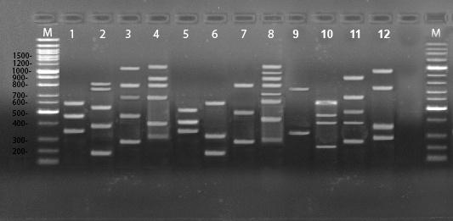
Figure 1: Amplified products of genomic DNA of Trichophyton rubrum, Trichophyton verrucosum and Trichophyton mentagrophytes obtained from primers OPAA11, OPU15, OPAA17 and OPD18.
Lanes 1- 4 show the products of primers OPAA11, OPU15, OPAA17 and OPD18 obtained from Trichophyton rubrum, respectively.
Lanes 5-8 show the products of primers OPAA11, OPU15, OPAA17 and OPD18 from Trichophyton verrucosum, respectively.
Lanes 9-12 show the productsof primers OPAA11, OPU15, OPAA17 and OPD18 from Trichophyton mentagrophytes, respectively.

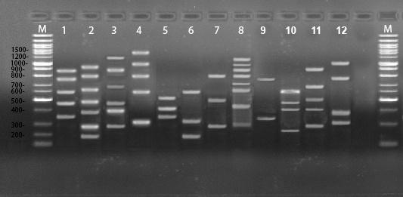
Figure 2: Amplified products of genomic DNA of Trichophyton tonsurans obtained from primers OPAA11, OPU15, OPAA17 and OPD18.
Lanes 1- 4 show the products of primers OPAA11, OPU15, OPAA17 and OPD18 from Trichophyton tonsurans, respectively.

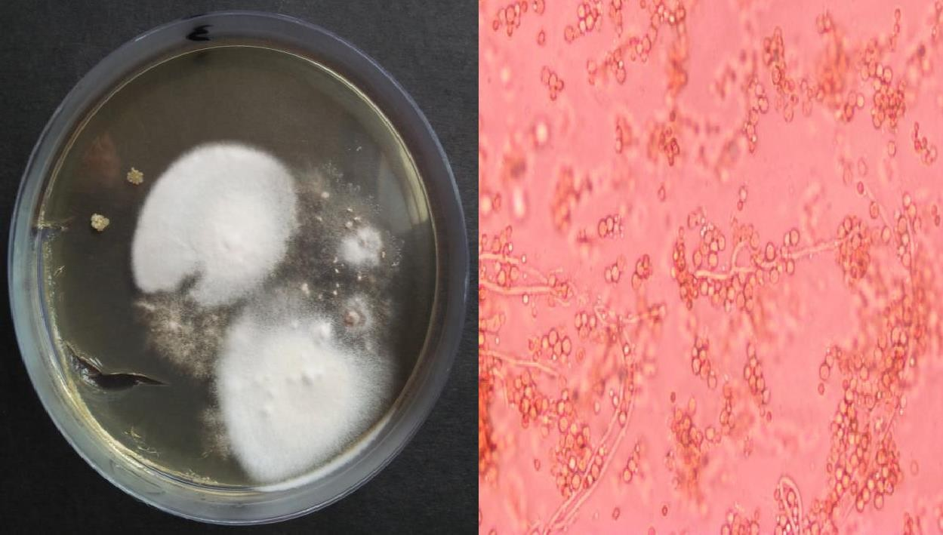
a
b
Figure 3: (a). Colonies of T.mentagrophytes on SDA media at 37 °C up to 7 days growth
(b) Microscopic image of Microconidia (40X).
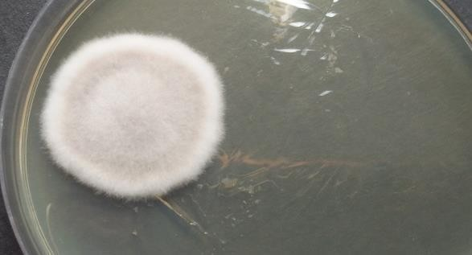
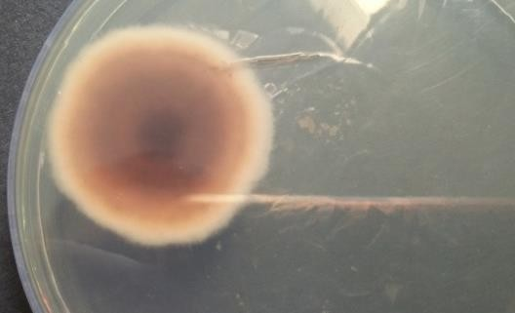
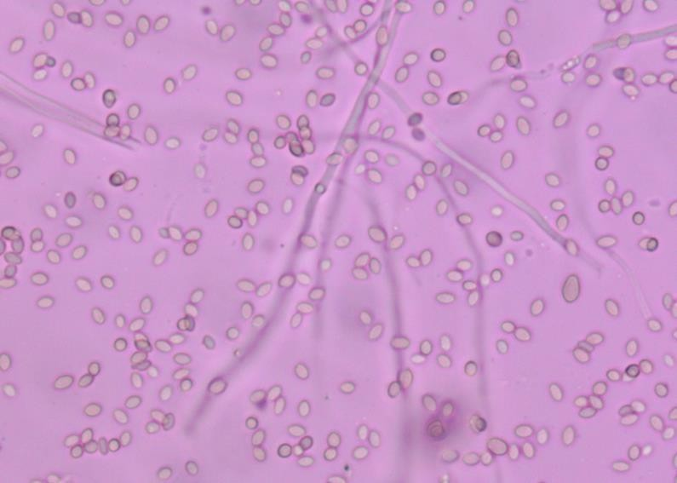

Figure 4: (a) Colonies of T. rubrum on SDA media at 37 °C up to 7 days growth
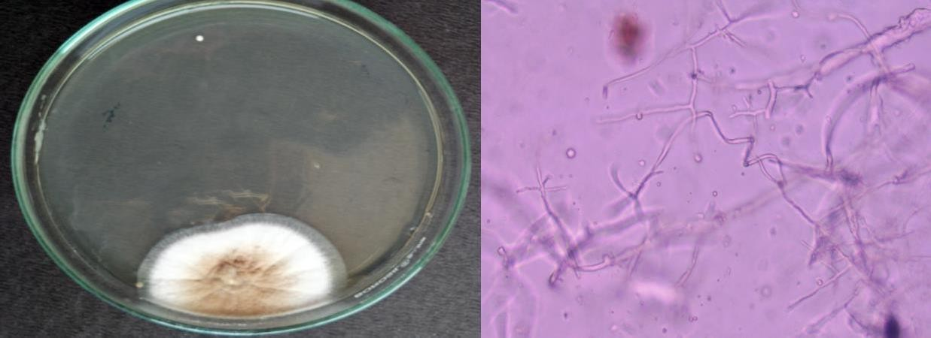
(b)Reverse side of colonies on media plate (c)Microscopic image of Microconidia (40X).
a
b

Figure 5: (a). Colonies of T. tonsurans on SDA media at 37 °C up to 7 days growth
(b) Microscopic image of Microconidia (40X).

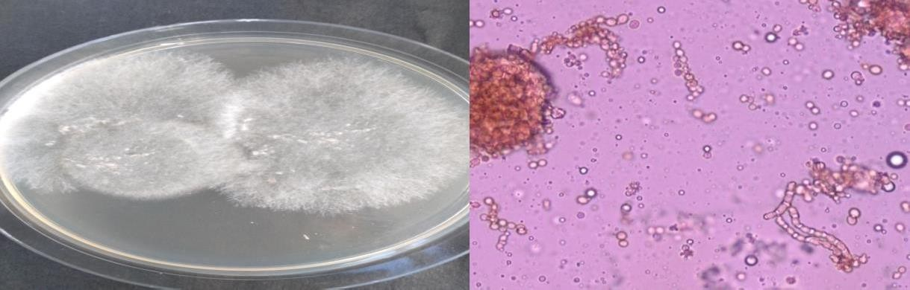
Figure 6: (a). Colonies of T. verrucosum on SDA media at 37 °C up to 7 days growth
a
b
(b) Microscopic image of Microconidia (40X).

