Impact of 'Narva' on Bhoramdeo Wildlife Sanctuary of Chhattisgarh: Ecology and Socio-economic

ABSTRACT
This study evaluates the impact of the 'Narva' initiative on the Bhoramdeo Wildlife Sanctuary and surrounding landscape from ecological and socio-economic perspectives for wildlife conservation. The initiative addresses water and soil conservation issues in the Kawardha hilly region, combating deforestation, habitat loss, and water scarcity. By employing a holistic approach emphasizing ridge-to-valley water management, the project aims to transform the area into multifunctional water harvesting structures, benefiting both wildlife and tribal communities. The study focuses on assessing the ecological impact, particularly on Bijachhap Nala, using Integrated Natural Resource Management techniques, GIS-based planning, and groundwater recharge potential analysis. The methodology involves comprehensive watershed management strategies integrating GIS mapping, ground truthing, and data analysis. Results indicate a significant reduction in soil erosion, increased soil moisture levels, and enhanced water harvesting potential, leading to improved habitat conditions for wildlife and sustainable livelihoods for local communities. The findings underscore the effectiveness of the intervention in mitigating environmental degradation and fostering biodiversity conservation.

INTRODUCTION
Tropical forests are among the most diverse and intricate ecosystems on land, hosting a vast array of life forms and possessing a remarkable capacity for self-regulation (Gardner et al., 2009; Morris, 2010). Yet, many tropical forests are losing their resilience due to intense biotic pressures from human activities. In India's dry tropics, forest resources appear to be significantly depleted, yet accurate data on this issue is scarce. The reduction of tree species, particularly in poorly managed systems with limited species diversity, can compromise the local forest ecosystem's integrity (Sagar and Singh, 2004; Gopalkrishna et al., 2015; Sloan and Sayer, 2015; Sahoo et al., 2020). This can lead to genetic erosion of species, shrinkage of forest area, and degradation of forest quality. Understanding the extent of forest resource depletion in India's dry tropics is crucial for conservation efforts. Without precise data, addressing the impacts of disturbances on tree species and overall ecosystem health becomes challenging (Mehta et al. 2008).
Anthropogenic pressures, overgrazing, forest fires, trampling, litter and debris burning, and other factors impact forest regeneration, jeopardizing the future health and stability of forest stands (Mohanta and Chauhan, 2014; Turco et al., 2023; Lopes et al., 2025). In India, habitat destruction, mining, overexploitation, species introductions, and pollution are identified as primary drivers of biodiversity loss. Various factors influence natural regeneration dynamics and seedling survival in forest ecosystems (Scanes, 2018; Sonter et al., 2018; Gupta and Mishra, 2019). The success of natural regeneration is determined by seed characteristics and regenerative propagules of forest species.
The challenges face in state of Chhattisgarh mainly soil degradation, water scarcity, reliance on chemical fertilizers, food security, sustainable agricultural production, ecological balance, deforestation, encroachment, unscientific natural resource management and unemployment (Gurupanch and Sahu, 2024; Bhardwaj et al., 2024). The Chief Minister of Chhattisgarh has started Suraji Gaon Yojana in October 2, 2019 to make water conservation, animal husbandry, soil health and nutrition management. Under this scheme, a campaign has been started for the Narwa (Rain Drains) Garwa (Livestock) Ghurwa (Compost Manure Manufacturing) Bari (Vegetable and Fruit Garden), aimed at promoting sustainable agricultural practices, enhancing rural livelihoods, and improving the overall ecological balance in Chhattisgarh. Here, 'Narwa' i.e the conservation and rejuvenation of streams and water bodies to ensure sustainable water management. This helps in recharging groundwater and provides water for irrigation.
2.METHODS AND MATERIALS
The study's core objective is to comprehensively address providing drinking water facilities to wildlife, soil conservation, minimizing deforestation, and addressing environmental degradation (Syamsih, 2024; Panda, 2025). It aims to improve vegetation by creating small trenches to boost additional moisture to the forest lands and benefit the regeneration, conserve water, and enhance Rivulet Restoration (Zhu et al., 2019; DoFSC, 2025). For this, we have planned to study the before and after impact of 'Narwa' on the Bhoramdeo Wildlife Sanctuary and surrounding landscape from ecological and socio-economic perspectives for wildlife conservation.
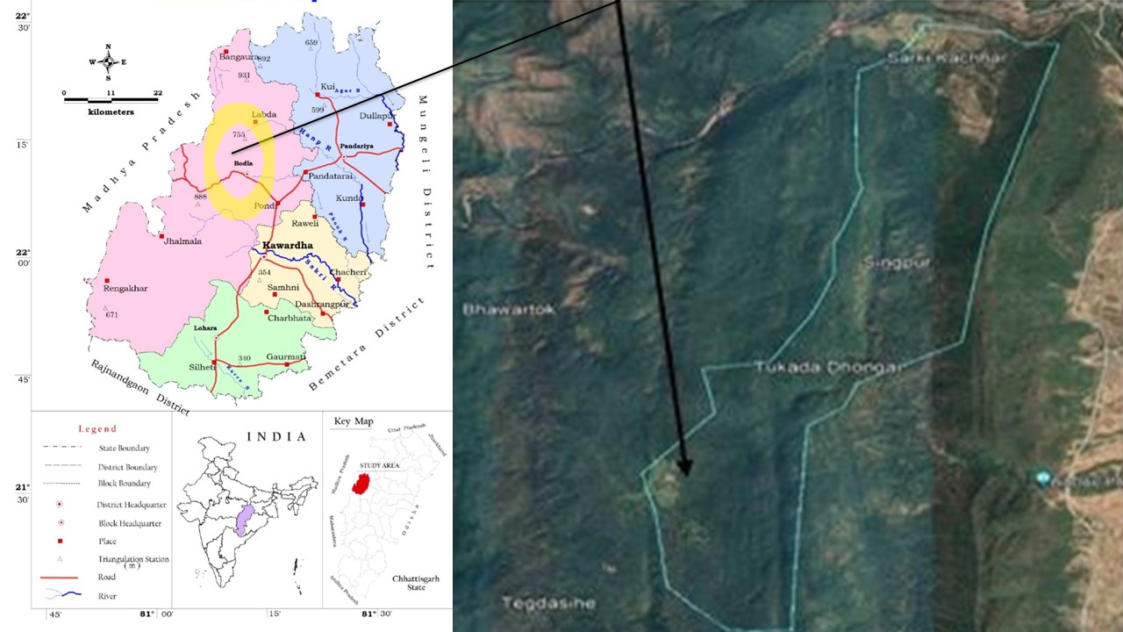
Figure 1: Geospatial Information of Bijachhap Nala, Chhattisgarh

The study also aims to assess the detailed impact on the Bijachhap Nala by analyzing various parameters, including water flow status, soil erosion, open well data, silt monitoring, increased water harvesting potential, and increased recharge potential survey. The study will focus on sampling every kind of activity, and the Impact study will start from June 2022 to January 2024.

Table 1: Basic Information about Intervention area of Bijachhap Nala, Chhattisgarh

1 | Name of the drainage line to be treated | Bijajhap Nala
2 | Division | Kawardha, Bhoremdeo Scantury (Range)
3 | Block | Bodla
4 | District | Kabirdham
5 | Forest Circle | Durg
6 | Milli-watershed Code (MWS) | 4G3C3A3
7 | Stream Order to be treated (First, Second,  Third, Fourth) | First, Second, Third, Fourth order
8 | Name or Number of supporting drainage  lines if any | 2 (Kanaijhori, Chirchoda nala, Nala, Tegda Salhe nala)
9 | - Overall catchment area in Ha | 663
10 | (B) Catchment area falling in Forest in Ha | 663
11 | Name of Gram Panchayats/JFMCs in the catchment area | Choura
12 | Proposed Forest area in ha for treatment | 663
13 | Major issues identified in the catchment area | Catchment is High soil erosion ranking
13 | Major issues identified in the catchment area | Siltation at the bed profile
13 | Major issues identified in the catchment area | Dries just after monsoon
13 | Major issues identified in the catchment area | Low ground water
14 | Name of existing structures along with GPS coordinates in the drainage line (mention functional or non-functional) (in the proposed forest area like tanks, stop dams, check dams, gabion contour trenches, etc.) | NA
15 | Average width of drainage line in mt.  (in the proposed forest area) | At Starting point-2M
15 |  | Middle point - 8.8M & End point-10M
16 | Treatment length of drainage line in Km (in the proposed forest area) | 6.48
17 | Average slope of drainage line in % (in the proposed forest area) | 8.1 %
18 | Benchmark points of drainage line (with location name L. (C. N., Coupe, local name of the plant, etc.) and GPS coordinates) | Compartment No-79,80,82
19 | Average duration of water flow (in months, also write the months name) | 6 (July, August, September, October, November, December)
20 | Maximum depth off low in mt. | At Starting point - 0.60 M  Middle point - 2 M  End point - 2.5M
21 | Availability of boulders in the catchment area (high, medium, low) | Low
22 | Current use of drainage line (Irrigation, livestock drinking, plantation, wildlife, eco-tourism) | Wildlife
23 | Number of Household benefiting from drainage line (SC/ST/OBC/Others)/ (Wildlife and forest growing stock) | 24 House hold, In Wildlife Sloth bear, Leopard, Fox, Hyena, Hanuman, Rabbit, Deer, Langur, Birds

For effective watershed management in the required area, it is not possible to undertakes and alone activities; it must be combined with natural resource management in forest areas. Principles such as prioritizing ecosystem integrity, promoting minimal intervention, and addressing degradation's root causes are followed. Geographic Information Systems (GIS) and satellite mapping are essential tools for spatial data analysis and decision-making in watershed management. The advantages of GIS in forest NRM include enhanced spatial analysis, efficient resource management, and stakeholder engagement. Applications of GIS cover planning, climate resilience, environmental impact assessment, and more. However, GIS has limitations, requiring ground truthing and addressing dynamic geographical conditions. Stream reclamation uses GIS-based analysis and ground confirmation for creek restoration.
Collecting baseline data is crucial for assessing mitigation impacts, including water flow and soil erosion. Forest resource assessment and ground truthing validate GIS data. Calculations like the Rational Method and Dickens formula estimate surface runoff. Insummary, sustainable soil moisture conservation and watershed management rely on data, GIS, ground truthing, and calculations.

Survey Process
To ensure the quality of collected information and facilitate coordination among the entire survey team, as well as to complete the entire process in a timely manner, methods such as obtaining basic area information followed by validation through the Note Cam mobile application have been employed to undertake a significant portion of surveys. This was followed by a GPS - based survey and a series of consultations to validate the collected information and further develop realistic recommendations. Surveyors with prior experience in conducting app-based surveys were identified for two full-day training workshops and field testing. Based on surveyor feedback and our developed understanding, the following information was compiled.
Bijachhap Nala, with Milli-watershed Codes 4G3C3A3, is the focus of a comprehensive project. This area encompasses a catchment of 663 hectares, all of which come under the forest area. The project involves Gram Panchayats and Joint Forest Management Committees. The catchment area covers an observation area within the Choura Village, with three compartments numbered 79, 80, and 82. The drainage line extends for 6.48 kilometers, with varying widths across high, mid, and low-land sections. The average slope of the drainage line is 8.1%. The project involves various bench mark points and benefits both wildlife and 24 Scheduled Tribe households.

GIS and Field Problems findings from the cluster
There are several parameters were consider designing a Mitigation plan of a water shed area but among them the major is the following maps which will help for the Decision making of possible treatment which are as following:
1 - Soil Mapping Data, 2 - Erosion Mapping Data, 3 - Lineament, 4 - Forest Cover Map, 5-CLART Data, and 6 - Grid Data.
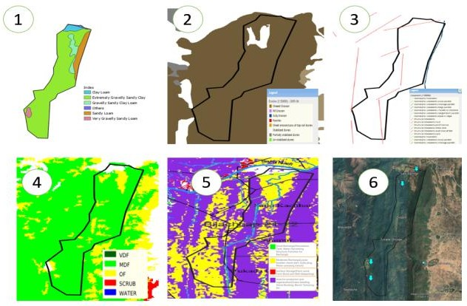

Figure 2: Maps of the catchment provide GIS based analysis of the problem identification of Six locations of Bijachhap Nala, Chhattisgarh

Soil Mapping Data: The soil composition within the catchment consists mainly of Sandy Gravelly soil, with some areas of Sandy Gravelly Loams oil. This indicates that the area is very suitable for soil treatment and facilitates water percolation.
Erosion Mapping Data: Almost the entire catchment is experiencing severe soil loss, as clearly visible on the map. However, in forested areas where the forest density is greater than 0.4, only drainage treatment can be implemented. In open patches, area treatment activities can be conducted.
Lineament Data Analysis: Lineaments represent areas with high recharge potential, where recharge structures can be created.
Forest Cover Data Analysis: Almost all of the catchment is categorized as moderately dense forest.
CLART Data Analysis: Most of the areas within the catchment fall sunder the moderate recharge zone, indicated by the yellow color.
GRID Data: This data was obtained from the FMIS for studying changes in moisture following our intervention.
Mitigation Planning: On the Basis of the above Data and also the consideration of Other GIS Mapping like Drain Map, Contour Map, Slope Map Lithology, Soil Depth map, Geomorphology, Compartment Map, land use and Land Cover waste land Map and on the field survey data. We had planned the following Treatment plan of the Catchment Area.

Table 2: Treatment plan Activity of Bijachhap Nala, Chhattisgarh

Sl. No. | Name of NRM works | Length (M) / Area (Ha) | No. of same Dimension
1 | SCT | 13.02 | 3193
 |  | 9.14 | 2240
 |  | 15.48 | 3796
 |  | 8.64 | 2119
 |  |  | 11348
2 | PT | 40x35x2 | 1
 |  | 60x35x2 | 1
 |  | 30x30x2.5 | 1
 |  |  | 3
3 | CD | 16x1.5 | 1
 |  | 15x1.5 | 1
 |  |  | 2
4 | Pond | 30x40x1.5 | 1
 |  | 50x40x1 | 1
 |  |  | 2
5 | GS | 10 | 3
 |  | 13 | 2
 |  | 14 | 3
 |  |  | 8
6 | BWCD | 7 | 13
 |  | 8 | 44
 |  |  | 57
7 | LBCD | 7 | 50
 |  | 8 | 50
 |  | 9 | 57
 |  |  | 157
 | Total |  | 11577

Table 3: Category of Soil Erosion of Gullies formation of Bijachhap Nala, Chhattisgarh

Category | High - H | Moderate - M | Low -L
Gully formation | More than 10 Gullies | 5–10 Gullies | 0 to 5 Gullies

Impact study after the completion of the proposed works

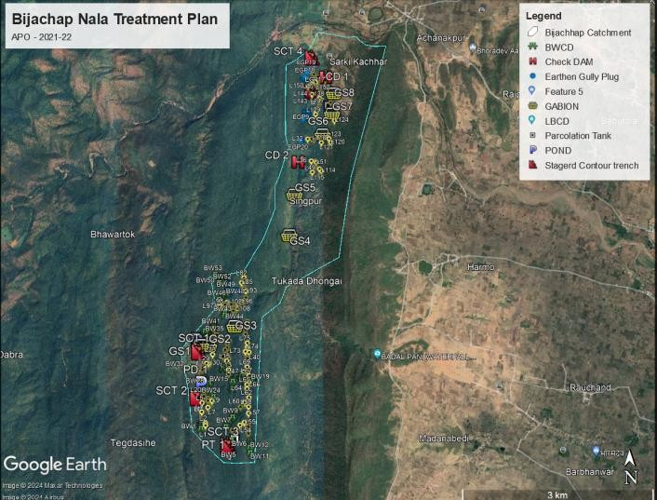
Figure 3: The Satellite image after completed of propose target in Impact of 'Narva' on Bhoramdeo Wildlife Sanctuary of Chhattisgarh

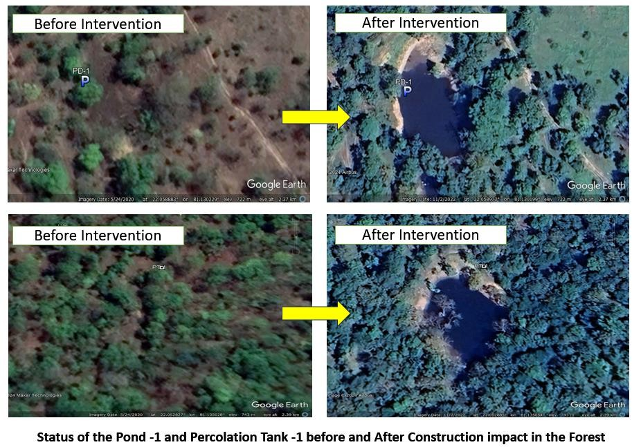

Figure 4: Status of the Pond -1 and Percolation Tank before and After Construction Impact in the Forest
The above ponds and percolation tanks were created under the forest ridge area to ensure water conservation in the top zone of the catchment and provide water to wildlife while simultaneously maintaining moisture in the nearby area.

3. RESULTS AND DISCUSSION
The integrated planning and execution of soil moisture conservation works and water harvesting for wildlife from ridge to valley treatment approach aim to provide water to wildlife and support sustainable tribal income through fish farming. This initiative is both significant and multi-faceted. The results obtained from the project's implementation starting from 2022 and their impacts are outlined in the following steps:

Table 4: Category of the number of the Gullies formation of Bijachhap Nala, Chhattisgarh

Sl.  No. | Zone | Left side of main Nala |  | Right side of main Nala |  | Total | Reading on Jun 2023 | Drains Blocked
Sl.  No. | Zone | No. of  Gully | Category | No. of  Gully | Category | Total | Reading on Jun 2023 | Drains Blocked
1 | Upper  Catchment zone | 24 | H | 5 | L | 29 | 22 | 7
2 | Middle Catchment  zone | 15 | H | 25 | H | 40 | 34 | 6
3 | Lower  Catchment zone | 13 | H | 14 | H | 27 | 21 | 6
 | Total |  |  |  |  | 96 | 77

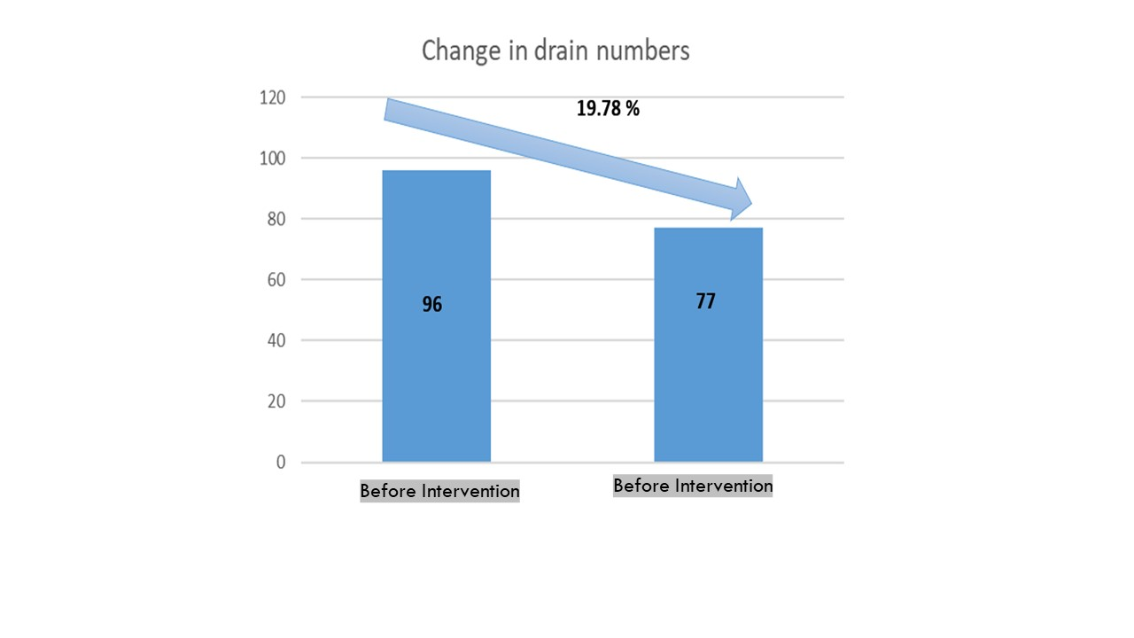
Fig. 5: Graph showing decline of gully due to plugging after the work intervention of Bijachhap Nala, Chhattisgarh

Discussion and findings
Formation of the gullies is the clear indicator of the erosion status of any area but after the intervention the decrease in the numberof thegully isthe clear indicatorof thegully erosionis checked by the SMC works.

Observation and Result analysis of soil moisture changes
The following are the collected grid data:
Table 5: Data showing Average moisture changes of Bijachhap Nala, Chhattisgarh

 | Grid Details |  |  |  | Duration Period
Grid No | ET index | Lat | Long | Wet sample | On June 2022 | Difference | Moisture % | On June 2023 | Difference | Moisture %
1 | 615--128 | 22.05556 | 81.13194 | 200 | 197 | 3 | 1.5 | 191 | 9 | 4.5
2 | 616--128 | 22.0625 | 81.13194 | 200 | 194 | 6 | 3 | 183 | 17 | 8.5
3 | 621--130 | 22.09722 | 81.14583 | 200 | 190 | 10 | 5 | 182 | 18 | 9
4 | 622--131 | 22.10417 | 81.15278 | 200 | 189 | 11 | 5.5 | 187 | 13 | 6.5
 |  |  |  | Average Moisture |  |  | 3.75 |  |  | 7.125

Discussion and findings

The moisture levels at grid points are gradually increasing due to SMC work just after one year of intervention increase up to 3.375 % which gradually increases more in the spell of time.

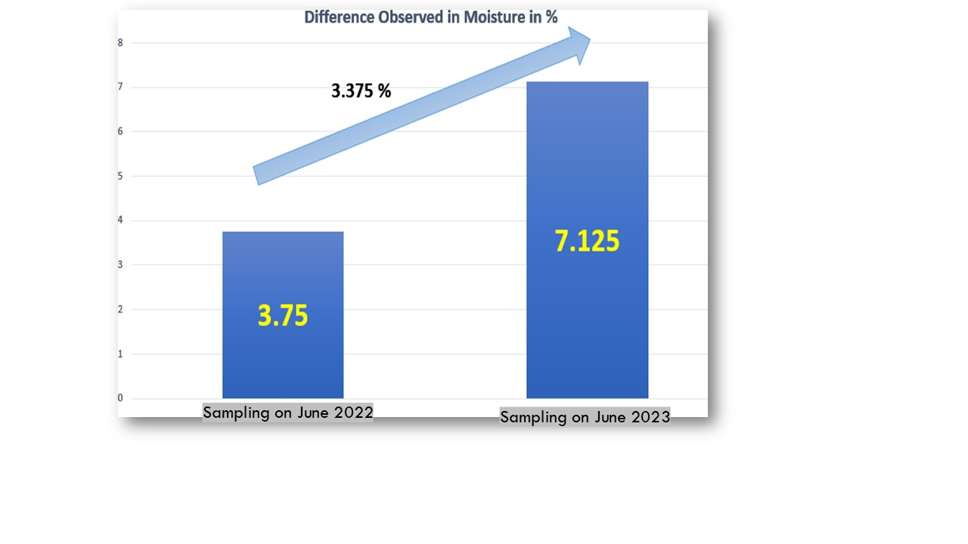

Figure 6. Graph showing the increase in moisture after one Monsoon season of Bijachhap Nala, Chhattisgarh

Results in respect to the Water Harvesting Potential:
Within the catchment area of the Bijachhap Nala, we have only one small pond with a capacity of 510 CUM, which lasts for only 5 months. However, after the intervention of SMC works, we have created 2 ponds, 3 percolation tanks, and 2 check dams, contributing an additional water harvesting capacity of 9975 CUM, which is almost 20 times the existing capacity. The percolation tanks were placed exactly on the planned lineament so that they continuously recharge the groundwater and carry water until the months of October and November. The ponds and check dams store water until the months of April and May, which is very helpful for wildlife. Moreover, they were constructed in the ridge zone where wildlife habitat is abundant, thus preventing animals from needing to venture to the valley for drinking purposes and reducing the risk of hunting.

Table 6: The Increase in the Water Harvesting Potential of Bijachhap Nala, Chhattisgarh

S no | Name of NRM works | Length (M) / Area (Ha) | Water Harvesting Potential in CUM
1 | Percolation Tank | 40 x 35 x 2 | 1400
 |  | 60 x 35 x 2 | 2100
 |  | 30 x 30 x 2.5 | 1350
 |  |  | 4850
2 | Pond | 30 x 40 x 1.5 | 1200
 |  | 50 x 40 x 1 | 1600
 |  |  | 2800
3 | Check Dam | 16 x 1.5 | 1200
 |  | 15 x 1.5 | 1125
 |  |  | 2325
Grand Total |  |  | 9975

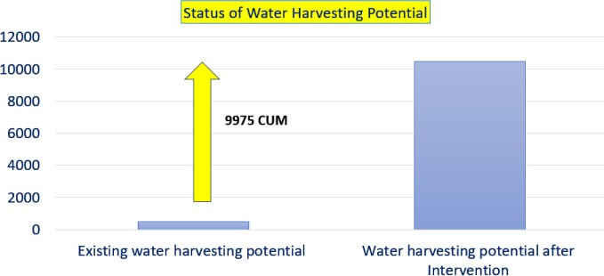

Figure 7. Graph showing the increase in Water harvesting potential in the catchment of Bijachhap Nala, Chhattisgarh

Discussion and findings: Due to Intervention the WHS potential increased to 9975 CUM. which recharge as well as provide the water to the wildlife.

Observation of the silt control and recharge potential of SMC within the Catchment area:
We conducted the impact study to calculate the Recharge factor and checked the silt through the intervention activity, which constituted 10% of each kind of activity completed in the catchment area. The following activities were chosen as samples for the study after the June 2022 rainfall season. In the Kawardha region, which falls under a rain shadow area receiving less rainfall compared to other parts of the state, we may experience 2-3 instances of rainfall in a single day. This implies that the pits may fill up three times. Our calculations for the structure designs are based on the rainfall received within a day and filled our structure. However, in our study, we found only one instance of rainfall per day which filled our structure.
Table 7: The Increase in the Water harvesting potential of Bijachhap Nala, Chhattisgarh
Type | WC | Lat | Long | Size | No. of Same  Dimension | Sample under  Study
SCT | SCT1 | 22.06222 | 81.13121 | 420x310 | 3193 | 1000
PT | PT1 | 22.05259 | 81.1363 | 40x35x2 | 1 | 1
GS | GS3 | 22.06545 | 81.13607 | 10x1.5 | 1 | 1
GS | GS5 | 22.08276 | 81.14418 | 13x1.5 | 1 | 1
LBCD | L30 | 22.06111 | 81.1325 | 7x1 | 1 | 1
LBCD | L34 | 22.09078 | 81.14662 | 7x1 | 1 | 1
LBCD | L43 | 22.06555 | 81.13306 | 7x1 | 1 | 1
LBCD | L44 | 22.06528 | 81.13306 | 7x1 | 1 | 1
LBCD | L70 | 22.06111 | 81.13778 | 8x1 | 1 | 1
LBCD | L91 | 22.07058 | 81.13728 | 8x1 | 1 | 1
LBCD | L101 | 22.06861 | 81.13472 | 9x1 | 1 | 1
LBCD | L111 | 22.06861 | 81.13694 | 9x1 | 1 | 1
LBCD | L126 | 22.09806 | 81.14889 | 9x1 | 1 | 1
LBCD | L127 | 22.09833 | 81.14889 | 9x1 | 1 | 1
LBCD | L140 | 22.09722 | 81.14778 | 9x1 | 1 | 1
LBCD | L145 | 22.09694 | 81.14722 | 9x1 | 1 | 1
LBCD | L151 | 22.09833 | 81.14667 | 9x1 | 1 | 1
LBCD | L152 | 22.09861 | 81.14722 | 9x1 | 1 | 1
LBCD | L153 | 22.09889 | 81.1475 | 9x1 | 1 | 1
EGP | EGP4 | 22.07163 | 81.13562 | 7x1 | 1 | 1
 |  |  |  |  |  | 1019
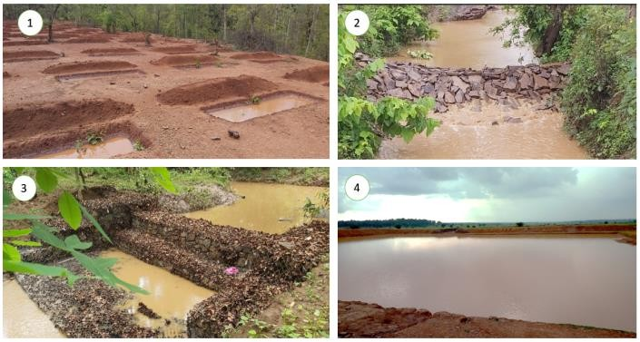
.
Figure 8. 1- SCT, 2- LBCD, 3- Gabion, and 4- Pond of Bijachhap Nala, Chhattisgarh

Calculations for Water Recharge
For SCT– $3x\frac{1.05+0.65}{2}x0.40=1.02$
For 1000 Pits found full filled and percolated in 12 Days. 1000x1.02x12 Days–12240 CUM (Recharge Calculated)
For Percolation Tank –
For PT-1 found full filled and percolated in 8 Days.
40x 35x2=1400CUM
1400CUMx8Days=11200 CUM (Recharge Calculated) For Gabion–
For GS-3&5 found full filled and percolated in 10Days. 10 x 100 x 0.75 = 750 Cum
13x100x 0.75 =975 Cum
For 10Days–1725x10Days=17250 CUM (Recharge Calculated)
For LBCD–
For LBCD- 10 Nos found full filled and percolated in 14 Days 10 x 8.33 (Avg Width) x 7 M x 14 Days = 8163 CUM (Recharge Calculated)
As per the above calculation if we scale up the data up to the full quantity, we will find the following.

Table 8: Calculation of the recharge potential of SMC work of Bijachhap Nala, Chhattisgarh
S No | Work | Nos | Recharge
1 | SCT | 11348 | 138899
2 | PT | 3 | 33600
3 | Gabion | 8 | 69000
4 | LBCD | 157 | 128159
 |  |  | 369658 CUM
Which is in compare of a tanker size of10 Cum – X 36965 Trip of water tanker

In the Same Study we find the Silt check by our Intervention structure after 1 rainfall season’s
Table 9: Silt Survey report of the sample sites of Bijachhap Nala, Chhattisgarh

Type | WC | Lat | Long | Size | No. of Same Dimension | Sample under Study | Silt Check under the sample Pits and Structure
SCT | SCT1 | 22.06222 | 81.13121 | 420x310 | 3193 | 1000 | 204
PT | PT1 | 22.05259 | 81.1363 | 40x35x2 | 1 | 1
GS | GS3 | 22.06545 | 81.13607 | 10x1.5 | 1 | 1 | 37.5
GS | GS5 | 22.08276 | 81.14418 | 13x1.5 | 1 | 1 | 39
LBCD | L30 | 22.06111 | 81.1325 | 7x1 | 1 | 1 | 6.1
LBCD | L34 | 22.09078 | 81.14662 | 7x1 | 1 | 1 | 6.2
LBCD | L43 | 22.06555 | 81.13306 | 7x1 | 1 | 1 | 5.5
LBCD | L44 | 22.06528 | 81.13306 | 7x1 | 1 | 1 | 6.3
LBCD | L70 | 22.06111 | 81.13778 | 8x1 | 1 | 1 | 7.2
LBCD | L91 | 22.07058 | 81.13728 | 8x1 | 1 | 1 | 6.4
LBCD | L101 | 22.06861 | 81.13472 | 9x1 | 1 | 1 | 7.4
LBCD | L111 | 22.06861 | 81.13694 | 9x1 | 1 | 1 | 5.8
LBCD | L126 | 22.09806 | 81.14889 | 9x1 | 1 | 1 | 6.5
LBCD | L127 | 22.09833 | 81.14889 | 9x1 | 1 | 1 | 5.8
LBCD | L140 | 22.09722 | 81.14778 | 9x1 | 1 | 1 | 4.8
LBCD | L145 | 22.09694 | 81.14722 | 9x1 | 1 | 1 | 6.1
LBCD | L151 | 22.09833 | 81.14667 | 9x1 | 1 | 1 | 6.5
LBCD | L152 | 22.09861 | 81.14722 | 9x1 | 1 | 1 | 5.9
LBCD | L153 | 22.09889 | 81.1475 | 9x1 | 1 | 1 | 6.2
 |  |  |  |  |  | 1018 | 373.2

Discussion and findings: Just on the 10 % of the study sampling we find 343 CUM of the soil is conserved which we can easily scale the its total silt control magnitude upto 2612 CUM in only one rainy season and in duration of time is will continue to trap the silt equal to its total capacity.

4. CONCLUSION
The comprehensive study and implementation of the Narva initiative in the Bhoramdeo Wildlife Sanctuary hilly region have demonstrated significant success in combating deforestation and addressing environmental degradation. By focusing on watershed conservation and integrating various natural resource management techniques, the project has effectively mitigated soil erosion, increased soil moisture levels, and enhanced water harvesting potential within the Bijachhap Nala catchment area. The creation of ponds, percolation tanks, and check dams has substantially improved water availability for wildlife while also benefiting local communities. Furthermore, the project's success in controlling soil erosion and silt accumulation underscores its effectiveness in promoting sustainable ecosystem management. Moving forward continued monitoring and evaluation of the project's impact will be essential to ensure the long-term sustainability of conservation efforts in the region. Overall, this study highlights the importance of holistic approaches to wildlife conservation, emphasizing the need for collaborative efforts between government agencies, local communities, and environmental stakeholders.

5. RECOMMENDATION

The Narva initiative should be expanded through continuous monitoring of watershed structures, strengthened community participation, and enhanced GIS-based planning for adaptive management. Scaling up ridge-to-valley interventions across adjacent landscapes will further boost groundwater recharge, habitat restoration, and climate resilience. Capacity-building programs for tribal communities and integration of livelihood opportunities such as eco-tourism and sustainable agro-practices will ensure long-term ecological and socio-economic benefits while reinforcing conservation outcomes within the Bhoramdeo Wildlife Sanctuary region.

DISCLAIMER (ARTIFICIAL INTELLIGENCE)

The authors state that no generative AI tools such as ChatGPT, Copilot, or any text-to-image software were used to write or edit this manuscript.
REFERENCES
- Gardner, T. A., Barlow, J., Chazdon, R., Ewers, R. M., Harvey, C. A., Peres, C. A., & Sodhi, N. S. (2009). Prospects for tropical forest biodiversity in a human-modified world. Ecology Letters, 12(6), 561-582. https://doi.org/10.1111/j.1461-0248.2009.01294.x .
- Gopalakrishna, S. P., Kaonga, M. L., Somashekar, R. K., Suresh, H. S., & Suresh, R. (2015). Tree diversity in the tropical dry forest of Bannerghatta National Park in Eastern Ghats, Southern India. European Journal of Ecology, 1(2), 12-27. https://doi.org/10.1515/eje-2015-0013 .
- Lopes, V., Santos, L.C.d., & Trillo-Santamaría, J.-M. (2025). The influence of forest fires on ecological, economic, and social trends in landscape dynamics in Portugal. Land. https://doi.org/10.3390/land14061273 .
- Mehta, V. K., Sullivan, P. J., Walter, M. T., Krishnaswamy, J., & DeGloria, S. D. (2008). Impacts of disturbance on soil properties in a dry tropical forest in Southern India. Ecohydrology, 1(2), 161-175. https://doi.org/10.1002/eco.15 .
- Mohanta, R., & Chauhan, N.P.S. (2014). Anthropogenic threats and its conservation on Himalayan brown bear (Ursus arctos) habitat in Kugti wildlife sanctuary, Himachal Pradesh, India. Asian Journal of Conservation Biology, 3(2), 175-180. https://www.ajcb.in/current-issue/volume-3-number-2-december-2014/ .
Morris, R. J. (2010). Anthropogenic impacts on tropical forest biodiversity: a network structure and ecosystem functioning perspective. Philosophical Transactions of the Royal Society B: Biological Sciences, 365(1558), 3709–3718. https://doi.org/10.1098/rstb.2010.0273 .
- Sagar, R., & Singh, J. S. (2004). Local plant species depletion in a tropical dry deciduous forest of northern India. Environmental Conservation, 31, 55-62. https://doi.org/10.1017/S0376892904001031 .
- Sahoo, T., Acharya, L., & Panda, P. C. (2020). Structure and composition of tree species in tropical moist deciduous forests of Eastern Ghats of Odisha, India, in response to human-induced disturbances. Environmental Sustainability https://doi.org/10.1007/s42398-020-00095-0 .
- Sloan, S., & Sayer, J. A. (2015). Forest Resources Assessment of 2015 shows positive global trends but forest loss and degradation persist in poor tropical countries. Forest Ecology and Management, 352, 134-145. https://doi.org/10.1016/j.foreco.2015.06.013 .
- Turco, M., Abatzoglou, J. T., Herrera, S., Zhuang, Y., Jerez, S., Lucas, D. D., AghaKouchak, A., & Cvijanovic, I. (2023). Anthropogenic climate change impacts exacerbate summer forest fires in California. Proc Natl Acad Sci USA. https://doi.org/10.1073/pnas.2213815120 .
- Gupta, B., & Mishra, T.K. (2019). Analysis of tree diversity and factors affecting natural regeneration in fragmented dry deciduous forests of lateritic West Bengal. Tropical Ecology, 60(3), 405-414. https://doi.org/10.1007/s42965-019-00039-8 .
- Scanes, C. G. (2018). Human Activity and Habitat Loss: Destruction, Fragmentation, and Degradation. In *Animals and Human Society* (pp. 451-482). https://doi.org/10.1016/B978-0-12-805247-1.00026-5 .
- Sonter, L. J., Ali, S. H., & Watson, J. E. M. (2018). Mining and biodiversity: Key issues and research needs in conservation science. Proceedings of the Royal Society B. https://doi.org/10.1098/rspb.2018.1926 .
- Bhardwaj, R. K., Bhaskar, G. P., Dhurwey, C. K., & Kaushik, D. K. (2024). Challenges in agriculture in tribal areas of Chhattisgarh. International Journal of Agriculture Extension and Social Development, 7(9), 418-421. https://doi.org/10.33545/26180723.2024.v7.i9f.1081 .
- Gurupanch, K.S., & Sahu, N.P. (2014). Water Scarcity in Chhattisgarh. International Journal of Reviews and Research in Social Sciences, 2(2), 133-137. https://www.ijrrss.com/article_detail.php?id=10 .
- Panda, S. (2025). Soil and Water Conservation for Sustainable Resources and Ecosystem Resilience. In R. Brears (Ed.), The Palgrave Encyclopedia of Sustainable Resources and Ecosystem Resilience. Palgrave Macmillan. https://doi.org/10.1007/978-3-030-67776-3_30-1.
- Syamsih, D. (2024). Impacts of Deforestation on Soil Quality and Water Resources in Tropical Forest Areas of Sumatra. Journal Horizon, 1(1), 16-22. https://doi.org/10.62872/kvmcwq82 .
- Zhu, X.A., Chen, C.F., Wu, J.E., Yang, J.B., Zhang, W.J., Zou, X., Liu, W.J., & Jiang, X.J. (2019). Can intercrops improve soil water infiltrability and preferential flow in rubber-based agroforestry system?. Soil and Tillage Research, 191(1), 327-339. https://doi.org/10.1016/j.still.2019.04.017 .
- Department of Forests and Soil Conservation (DoFSC), 2025. Soil Conservation, Watershed Management and Climate Resilience: Program and Activities (Definition, Objective, Scope, and Working Strategy), 4th Edition.

