Hydro-chemical and Bacteriological Assessment of Groundwater in the City of Djara and Surrounding Areas (Kanem-Chad)

Abstract:
This study aims to assess the hydrochemical processes and the physicochemical and bacteriological quality of groundwater in the city of Djara and its surrounding areas. Hydrochemical analysis, performed using Piper diagrams, revealed that 94.11% of the samples exhibited a sodium sulfate (Na-SO₄) facies and 5.89% a sodium bicarbonate (Na-HCO₃) facies. Additional analytical tools, including Gibbs diagrams, Gaillardet plots, and binary diagrams, indicate that groundwater chemistry is primarily controlled by interactions with aquifer materials, particularly silicate weathering and cation-exchange processes.
The results show that the groundwater has a moderate level of mineralization. Iron concentrations range from 0.1 to 4.55 mg/L, with more than half of the samples exceeding the WHO guideline limit for drinking water (0.50 mg/L). The affected boreholes, distributed throughout the study area, represent 58.22% of the analyzed samples. This elevated iron content is likely linked to drilling equipment, especially metallic pipes, which can release iron into the groundwater and result in concentrations above the WHO limit (< 0.5 mg/L).
Furthermore, bacteriological analyses revealed the presence of total coliforms, Escherichia coli (E. coli), and fecal enterococci in all examined samples. According to drinking-water quality standards, the groundwater is not suitable for human consumption, as the detected bacterial levels exceed WHO requirements, which stipulate that no bacteria should be present in 100 mL of drinking water.
Keywords: Hydrochemistry, Bacteriology, Groundwater, Djara

1. Introduction
In many semi-arid and arid regions around the world, water quality is a key limiting factor-particularly for irrigation and drinking-water supply-more so than the quantity available (Singhal et al., 2020). Water quality is crucial not only for ensuring the availability of this vital resource for human health, but also because it plays an essential role in preventing numerous waterborne diseases. A statistical study conducted in 2008 by the Master Plan for Water and Sanitation (S.D.E.A) revealed that diseases such as malaria and diarrhea are frequently associated with poor access to safe drinking water and inadequate sanitation. In Chad, 44% of deaths among children under the age of five are attributed to waterborne diseases such as bilharzia, meningitis, and cholera (S.D.E.A, 2003), results further confirmed by UNICEF in 2011 in N’Djamena. These figures underscore the importance of access to high-quality water in preventing disease and improving public health conditions.
In regions dominated by sedimentary deposits, aquifers-whether shallow or deep, confined or unconfined-represent the main accessible source of water. These aquifers, characterized by diverse lithology, are increasingly subject to overexploitation (Yu et al., 2020; Belhassan, 2021; Swain et al., 2022; Namratha et al., 2022; Bedoui et al., 2022; Wederni et al., 2023; Haddaji et al., 2024), particularly for drinking-water supply and agricultural irrigation. This overexploitation results in environmental problems such as declining groundwater levels, deterioration of water quality, and contamination from irrigation water and wastewater. In particular, aquifers with high levels of dissolved salts (Zhu et al., 2024; Najiah et al., 2023; Han et al., 2024) and iron-often exceeding regulatory drinking-water thresholds-pose a concern for water-supply managers and highlight the need for continuous monitoring to ensure water security in the region.
Additionally, the study area faces a shortage of potable water and low agricultural productivity, two factors that hinder local economic development. Drinking-water quality is a major determinant of individual health (Zhu et al., 2024; Najiah et al., 2023; Han et al., 2024). The Quaternary aquifer system, with its shallow groundwater table, is the main source of drinking water for local populations. However, despite its critical role in daily life, this aquifer system has been the subject of very few in-depth investigations. Some earlier studies have addressed the issue broadly in the context of Mao or the Kanem region (Jean Claude et al., 2024; Abdallah et al., 2021), while others focused on river discharge measurements (Seeber et al., 2013).
This study aims to improve understanding of aquifer functioning to support sustainable groundwater management. Its main objective is to evaluate the origin of groundwater mineralization and assess water quality-both physicochemical and bacteriological-by comparing the results with drinking-water standards. It thus contributes to a better understanding of groundwater geochemistry and verifies compliance with WHO (2017) guidelines to ensure safe water for human consumption.
2. Study Area Location
Located in northern Chad, the city of Djara and its surrounding areas lie within the Kanem region. This region is bordered to the north by Borkou and Tibesti, to the east by Bahr El Ghazel, to the west by Niger, to the southwest by Lake Chad, and to the south by Hadjer-Lamis. The study area is situated east of the city of Mao, between the 14th and 15th degrees of east longitude and the 13th and 14th degrees of north latitude (Fig. 1).
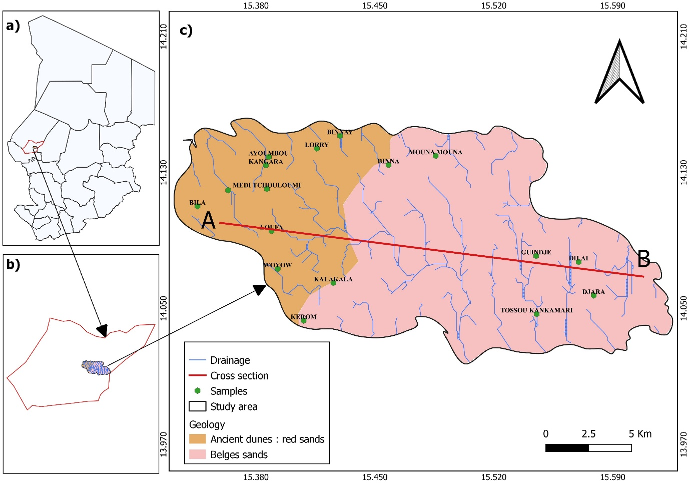
Figure 1: Map showing the location of the study area a) Chad, b) lake region, and c) study area
2.1 Climate
The climate is of the Sahelo-Saharan type, shifting toward a sub-desert climate in the northern part of the region (Olivry et al., 1996). It is characterized by:
- A long dry season extending from October to May;
- A short rainy season occurring from June to September.
The Kanem region lies within the Sahelian belt of Chad, where rainfall is low, ranging between 100 and 400 mm. It marks the transition between the Sahel and the Sahara in its northern part. The area is strongly affected by sand encroachment, and vegetation becomes increasingly sparse from south to north. The presence of several oases, however, offers opportunities for market gardening.
2.2 Geology and Hydrogeology
The geology of the study area is characterized by an ancient erg oriented NNW-SSE, where interdune depressions were flooded during a lacustrine transgression, leading to the deposition of fine and clay-rich sediments (Schuster et al., 2005; Moussa et al., 2016). Moving away from Lake Chad toward the northeast, one reaches the Bir Louri plateau, a vast tabular zone with less pronounced depressions that become deeper in the Mao region. This area contains several NNW-SSE-oriented lakes of modest size (1,000-1,500 m by 500-800 m) (Maglione, 1968; Servant, 1973; Ghienne et al., 2002). Kanem is characterized by an ancient Late Pleistocene erg, with interdune deposits of clays and diatomites dating from the Holocene. The region is dominated by halomorphic soils, sub-desert sands, and clay-rich vertisols, with specific constraints such as localized flooding (Lannoy, 1991).
From a geological perspective, the Chad region rests on Precambrian rocks associated with the Pan-African orogeny (700–520 Ma), overlain by more recent sedimentary formations, including sand dunes and clay deposits linked to lake environments (Kusnir & Moutaye, 1998). The Early Quaternary (Middle to Upper Pleistocene) is marked by significant detrital sedimentation, represented by the Soulias Formation-a wind-shaped, sandy eolian layer containing scattered lenticular clay deposits. These deposits correspond to wetter climatic phases that created lakes and marshes within a dune landscape (Servant, 1973; Schneider & Wolff, 1992), while also reflecting dry periods conducive to alternating aeolian reworking and humid conditions (Roche, 1980).
From a hydrogeological standpoint, the work of Servant-Vildary (1973), Roche (1980), and Olivry et al. (1996) has identified three major aquifer systems in this basin, which includes the study area:
- The Quaternary aquifer, composed of fractured clays (up to 10 m thick) in interdune depressions, and aeolian sands that may contain fossil evaporite deposits;
- The intermediate Pliocene aquifer, also referred to as the “basal aquifer,” which is about 75 m thick and composed of fluviatile sands. In the central part of the basin, this aquifer is artesian;
- The lower aquifer, or deep Continental Terminal aquifer, consisting of poorly sorted fluviatile sands with ferruginous sandstone debris. The thickness of this formation varies greatly, ranging from 200 to 300 m.
The A–B cross-section, which extends 34.310 km from west to east and is characterized by Quaternary sands (Fig. 2), shows a topsoil layer approximately 2 m thick overlying coarse sand deposits that rest unconformably on fine sands, themselves situated above a clay layer. The dominant unit consists of coarse sands, with thickness decreasing from 40 m in the west to 20 m in the east. The fine sands follow, with thicknesses between 20 and 30 m. Finally, the clay layer is less than 10 m thick in the boreholes studied.
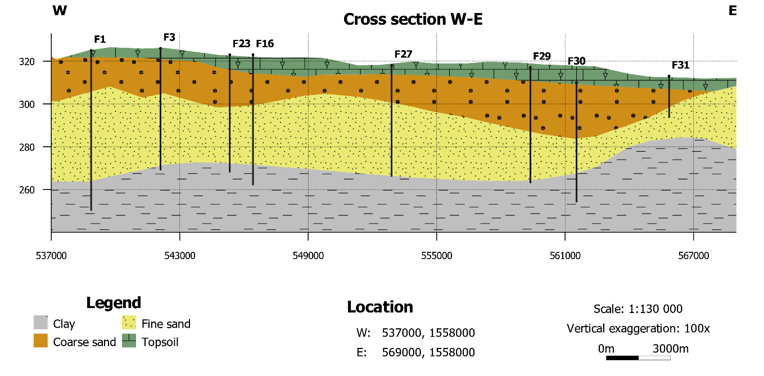
Figure 2: West-East geological cross-section A-B
2. Methodology
The diagram below summarizes the entire sampling and analytical process used in this study. It outlines the successive steps that led to the interpretation of the hydrochemical and bacteriological characteristics of the groundwater (Fig.3).
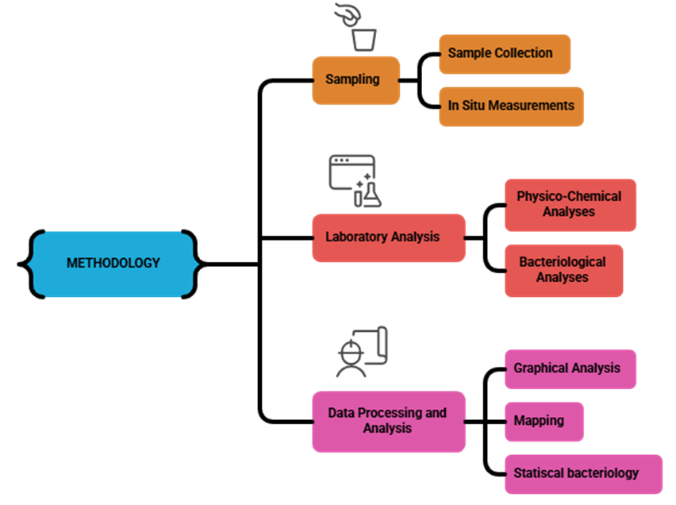
Figure 3: Methodological process diagram
3.1 Sampling
The sampling phase is a crucial step for laboratory analyses, as strict adherence to sampling conditions determines the reliability of the results. A field mission was conducted in August 2025 during which 17 water points were sampled (15 boreholes and two wells), following a consistent and standardized procedure. Water samples for chemical analyses were collected in thoroughly rinsed polypropylene bottles after 15 minutes of pumping. The in-situ parameters measured included pH, electrical conductivity (EC), and total dissolved solids (TDS).
Samples intended for bacteriological analysis were collected in sterile bottles labeled with the neighborhood name, sampling date, and type of water point, with a volume of 75 mL. Sampling was carried out using gloves to avoid any hand contact with the sample. Prior to sampling, boreholes were disinfected using a flame.
3.2 Laboratory Analysis
The samples were analyzed at the National Water Laboratory (LNE), Mao provincial section. Major ions were determined, including cations (Ca²⁺, Mg²⁺, K⁺, and Na⁺) and anions (Cl⁻, NO₃⁻, SO₄²⁻, HCO₃⁻). The analyses were carried out mainly by volumetric titration, with the use of a DR 3900 spectrophotometer and a flame photometer. The reliability of the results was verified using the ionic balance (IB), with deviations remaining within the acceptable limit of ±5% (Domenico & Schwartz, 1997). The ionic balance is calculated according to the following empirical relation (Eq. 1) :
$\% Charge Balance Error \left(CEB\right)=\frac{εcations- εanions}{εcations+εanions}*100$ (1)
The bacteriological analysis of the samples was carried out at the National Water Laboratory (LNE), Mao provincial section, in order to determine total coliforms, Escherichia coli (E. coli), fecal enterococci, and aerobic flora. These analyses followed the general principles and protocols established by the LNE.

4. Results and Discussion
4.1 Characteristics of physico-chemical and chemical parameters
The sampled groundwater exhibits pH values ranging from 6.30 to 7.34, with an average of 6.81, indicating slightly acidic to neutral waters. Electrical conductivity (EC) varies from 149.90 to 1441 μS/cm (average: 356.97 μS/cm), reflecting low mineralization and remaining well below the WHO guideline value of 2500 μS/cm. In direct relation to EC, total dissolved solids (TDS) range from 75.51 to 922.24 ppm (average: 206.09 ppm) (Table 1), also indicating moderate mineralization.
For major cations, the measured concentrations show notable variability (Table1):
- Calcium (Ca²⁺): 0.80 to 4.2 mg/L
- Magnesium (Mg²⁺): 0.49 to 12.64 mg/L (average: 2.95 mg/L)
- Sodium (Na⁺): 7.2 to 92.3 mg/L (average: 27.15 mg/L), reflecting the influence of selective adsorption by clay minerals
- Potassium (K⁺): 0.90 to 56 mg/L (average: 9.75 mg/L), with some values exceeding the WHO limit of 12 mg/L
Regarding anions, the concentrations recorded are generally low to moderate (Table1) :
- Sulfates (SO₄²⁻): 9 to 301 mg/L (average: 52.59 mg/L); only the site of Toussou Kankamari exceeds the WHO/Chad guideline value (200 mg/L)
- Bicarbonates (HCO₃⁻): 4.88 to 103 mg/L (average: 15.53 mg/L)
- Chlorides (Cl⁻): 0.43 to 6 mg/L (average: 2.48 mg/L), well below the WHO guideline of 250 mg/L
- Nitrates (NO₃⁻): 0 to 48.3 mg/L (average: 23.35 mg/L), mainly attributed to anthropogenic activities (fertilizers, domestic effluents), while remaining below the WHO limit of 50 mg/L
Finally, iron (Fe) concentrations range from 0.1 to 4.55 mg/L, with several water points exceeding the WHO limit of 0.3 mg/L, suggesting possible contamination linked to well infrastructure (iron piping) or geochemical conditions favoring iron dissolution.
Table 1: Descriptive statistics of physico-chemical and chemical parameters
Sites | pH | C 25° | TDS | Ca | Mg | K | Na | HCO3 | Cl | SO4 | NO3 | Fe | NH4
Unités |  | (µs/cm) | ppm | mg/L | mg/L | mg/L | mg/L | mg/L | mg/L | mg/L | mg/L | mg/L | mg/L
P1 | 7.17 | 359.2 | 181.03 | 1.6 | 2.916 | 6 | 29 | 7.32 | 2 | 53 | 26.7 | 1.03 | 2.68
P2 | 6.57 | 187.7 | 94.6 | 1.6 | 0.486 | 1.3 | 10.3 | 9.76 | 1.5 | 19 | 0 | 0.2 | 2.81
P3 | 6.6 | 156.1 | 78.7 | 0.8 | 0.972 | 8.9 | 16.3 | 9.76 | 2 | 9 | 41 | 4.55 | 2.69
P4 | 6.67 | 260.6 | 131.34 | 1.6 | 5.832 | 6.6 | 15 | 9.76 | 1.4 | 49 | 10.8 | 2.08 | 1.54
P5 | 6.53 | 268.9 | 135.5 | 0.8 | 1.944 | 9.2 | 18.3 | 12.2 | 6 | 29 | 16.5 | 1.68 | 2.5
P6 | 6.78 | 217.5 | 109.6 | 0.8 | 4.374 | 7.3 | 11 | 7.32 | 1.6 | 32 | 14.5 | 0.17 | 1.05
P7 | 6.3 | 197.3 | 99.43 | 1.6 | 0.486 | 5 | 16 | 4.88 | 2 | 29 | 12.3 | 0.13 | 2.03
P8 | 7.34 | 356.3 | 179.57 | 0.8 | 2.916 | 2.6 | 39.5 | 7.32 | 2.4 | 53 | 48.3 | 0.51 | 0.95
P9 | 7.07 | 163.9 | 82.6 | 1.6 | 3.9 | 0.9 | 7.2 | 4.88 | 2 | 20 | 10.7 | 0.12 | 2.18
P10 | 6.55 | 421.2 | 212.28 | 4.2 | 4.4 | 11.5 | 69 | 103 | 0.43 | 70 | 47.4 | 0.16 | 1.97
P11 | 7.11 | 1079 | 690.56 | 4 | 3.402 | 13.6 | 36 | 34.16 | 6 | 49 | 42.5 | 0.57 | 27
P12 | 7.13 | 1441 | 922.24 | 0.8 | 12.636 | 56 | 92.3 | 24.4 | 2.5 | 301 | 15.9 | 0.37 | 5.38
P13 | 6.79 | 154.1 | 77.66 | 1.6 | 0.972 | 3 | 15 | 7.32 | 1 | 21 | 18.4 | 0.58 | 2.08
P14 | 6.51 | 254.1 | 128.06 | 1.6 | 0.972 | 6.6 | 28 | 4.88 | 1.4 | 60 | 12.6 | 2.08 | 1.7
P15 | 6.61 | 205.9 | 10,3,7 | 2.4 | 0.486 | 7.3 | 29 | 4.88 | 2 | 37 | 44.2 | 0.78 | 1.24
P16 | 6.84 | 149.9 | 75.54 | 2.4 | 1.944 | 12 | 13.6 | 7.32 | 6 | 27 | 21.5 | 3.88 | 1.91
P17 | 7.25 | 195.8 | 98.68 | 1.6 | 1.458 | 8 | 16 | 4.88 | 2 | 36 | 13.7 | 0.09 | 2.64
min | 6.3 | 149.9 | 75.54 | 0.8 | 0.486 | 0.9 | 7.2 | 4.88 | 0.43 | 9 | 0 | 0.09 | 0.95
max | 7.34 | 1441 | 922.24 | 4.2 | 12.636 | 56 | 92.3 | 103 | 6 | 301 | 48.3 | 4.55 | 27
Type deviation | 0.31 | 354.64 | 235.21 | 12.28 | 12.06 | 1.02 | 2.97 | 12.45 | 22.50 | 23.84 | 1.75 | 66.09 | 15.26
Average | 6.8 | 357.0 | 206.1 | 1.8 | 2.9 | 9.8 | 27.1 | 15.5 | 2.5 | 52.6 | 23.4 | 1.1 | 3.7

4.1.1 Correlation Matrix
Table 2 presents the correlation matrix of chemical elements analyzed in the borehole waters. According to Pearson, two variables are considered correlated when their correlation coefficient is greater than or equal to 50%.
Statistical analysis shows that physicochemical elements are strongly correlated with one another. A significant correlation is observed between TDS and magnesium ions (r = 0.76), potassium ions (r = 0.84), sodium ions (r = 0.77), sulfate ions (r = 0.83), and ammonium ions (r = 0.63). A moderate correlation is observed between calcium and bicarbonate (r = 0.70), and ammonium (r = 0.53). Magnesium shows strong correlations with potassium (r = 0.83), sodium (r = 0.72), and sulfate (r = 0.87). Sodium is strongly correlated with sulfate (r = 0.85) and bicarbonate (r = 0.62). A moderate correlation is observed between chloride and ammonium (r = 0.54) (Table 2).
The relationships observed between variables reflect similarities in the processes responsible for the presence of these ions in borehole waters. These correlations illustrate the influence of each parameter on groundwater mineralization processes.
Table 2: Correlation matrix
 | pH | C 25° | TDS | CaCO3 | Ca | Mg | K | Na | HCO3 | Cl | SO4 | NO3 | Fe | NH4
pH | 1
C 25° | 0.40 | 1
TDS | 0.39 | 1.00 | 1
CaCO3 | 0.41 | 0.84 | 0.84 | 1
Ca | -0.07 | 0.19 | 0.18 | -0.12 | 1
Mg | 0.38 | 0.77 | 0.76 | 0.93 | -0.09 | 1
K | 0.23 | 0.84 | 0.85 | 0.86 | -0.07 | 0.83 | 1
Na | 0.23 | 0.79 | 0.77 | 0.64 | 0.24 | 0.72 | 0.79 | 1
HCO3 | -0.12 | 0.33 | 0.30 | 0.09 | 0.70 | 0.29 | 0.23 | 0.62 | 1
Cl | 0.16 | 0.26 | 0.28 | 0.15 | 0.14 | -0.02 | 0.16 | -0.08 | -0.13 | 1
SO4 | 0.29 | 0.84 | 0.83 | 0.87 | -0.12 | 0.87 | 0.95 | 0.85 | 0.23 | -0.03 | 1
NO3 | 0.19 | 0.18 | 0.16 | -0.07 | 0.43 | -0.05 | 0.01 | 0.39 | 0.46 | 0.10 | -0.03 | 1
Fe | -0.24 | -0.24 | -0.22 | -0.11 | -0.15 | -0.19 | -0.03 | -0.23 | -0.20 | 0.32 | -0.20 | 0.14 | 1
NH4 | 0.28 | 0.62 | 0.64 | 0.29 | 0.53 | 0.13 | 0.21 | 0.19 | 0.21 | 0.52 | 0.11 | 0.28 | -0.11 | 1

4.1.2 Chemical Facies of Groundwater
To represent chemical facies, the Piper diagram is commonly used to show the relative concentrations of the main ions present in water and to assess their corresponding hydrochemical characteristics (Piper, 1944).
The Piper diagram is frequently employed to graphically represent the relative concentrations of major ions in water and to evaluate their geochemical correspondences (Merino et al., 2021). This classification system effectively highlights the impact of lithological facies on groundwater composition and helps determine the nature of water chemistry as well as its evolution based on ion proportions (Hem, 1985; Piper, 1953), as illustrated in the ternary Piper diagram (Figure)
In the study area, 94.11% of groundwater samples exhibited a sulfate - sodium (Na-SO₄) facies, characteristic of sulfate - sodium waters, while 5.89% displayed a sodium-bicarbonate (Na-HCO₃) facies.
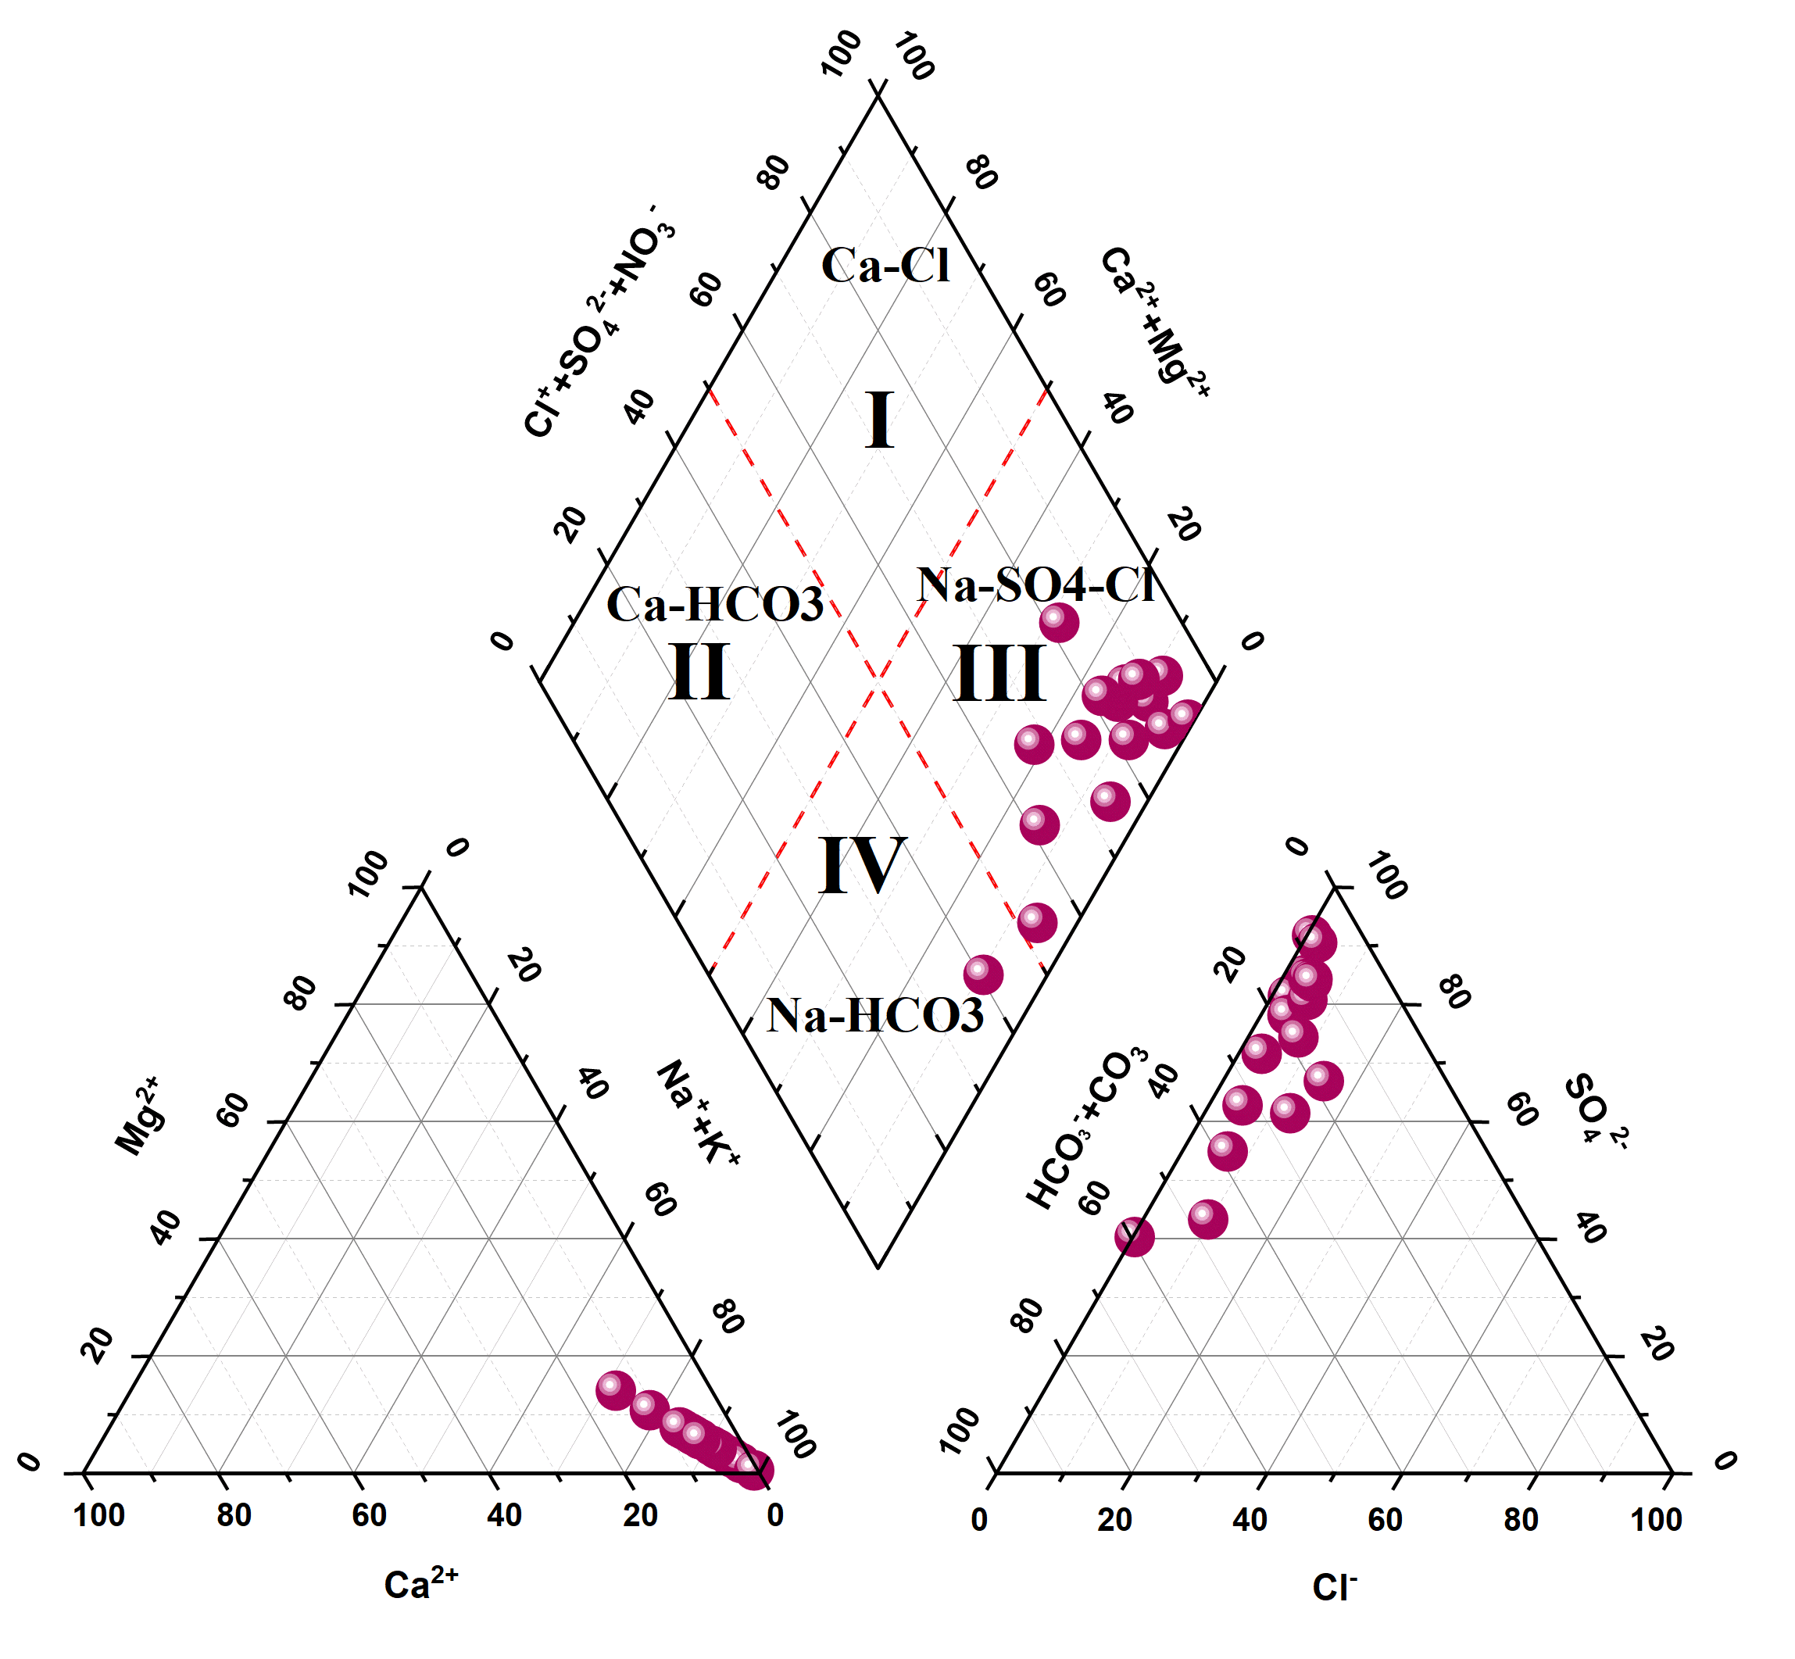
Figure 4: Groundwater Facies Diagram
4.1.3 Gibbs Diagram
The Gibbs diagram (Gibbs, 1970) plots total dissolved solids (TDS) against the mass ratios Na⁺ / (Na⁺ + Ca²⁺) and Cl⁻ / (Cl⁻ + HCO₃⁻) to distinguish the influences of rock–water interaction, evaporation, and precipitation on water chemical composition (Polemio et al., 2005; Petrucci & Polemio, 2007). Figures 5a and 5b illustrate the groundwater chemistry and its changing processes in the study area.
According to the Gibbs diagram, the analyzed waters fall between the zone dominated by water–rock interaction and the zone influenced predominantly by precipitation mechanisms. The impact of rock weathering on groundwater chemistry is attributed to water circulating through the porous aquifer substrate, where water–rock exchanges lead to modifications in the chemical characteristics of groundwater. The predominance of samples with a Na⁺/Cl⁻ ratio greater than 0.8 suggests that silicate weathering, evaporite dissolution, and/or ion-exchange processes are the main factors governing water mineralization.
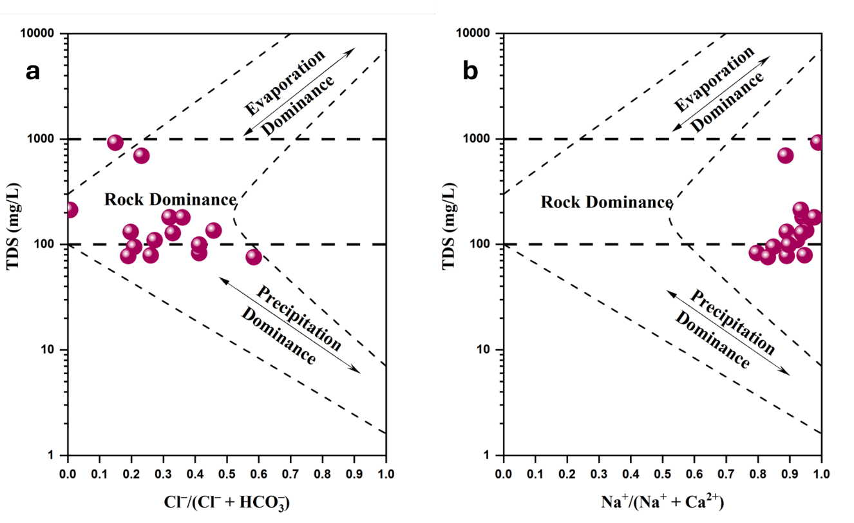
Figure 5: Gibbs Diagrams : Correlation of TDS vs. Cl⁻/(Cl⁻ + HCO₃⁻) (a) and TDS vs. Na⁺/(Na⁺ + Ca²⁺) (b)
4.1.4 Water–Rock Interaction
According to Gaillardet et al. (1999), standardized molar ratio models for sodium (Na) have been proposed to identify the main weathering and dissolution processes influencing groundwater chemistry. Analysis of the covariation of molar ratios Mg²⁺/Na⁺ vs. Ca²⁺/Na⁺ and HCO₃⁻/Na⁺ vs. Ca²⁺/Na⁺ allows the identification of the rock types controlling water chemistry in the study area (Figures 6a and 6b).
The results show that only a few samples fall near the silicate and evaporite mineral zones, while the remaining samples lie between these two zones. Similarly, the HCO₃⁻/Na⁺ vs. Ca²⁺/Na⁺ molar ratios of the samples also appear to approach the evaporite and silicate zones.

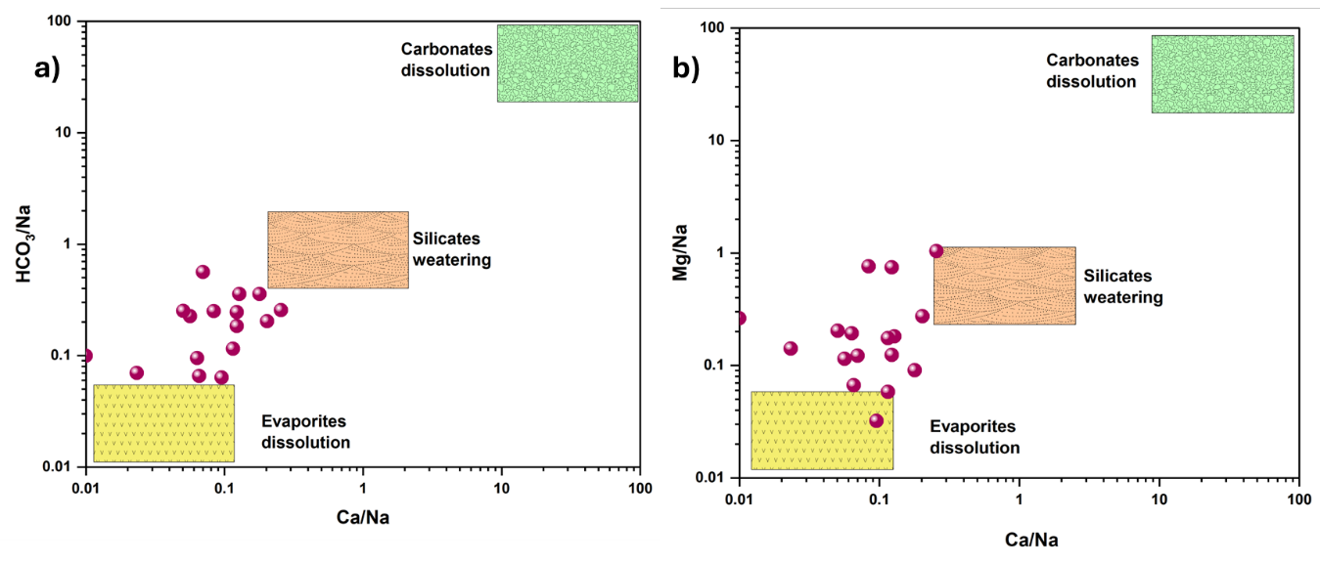
Figure 6: Gaillardet diagram of groundwater (2025) a) HCO₃/Na⁺ vs Ca²⁺/Na⁺ (b) Mg/Na⁺ vs Ca²⁺/Na⁺
4.1.5 Silicate hydrolysis process and Cation Exchange
The total cation vs. Na⁺ + K⁺ diagram (Figure 7a) shows that all samples lie slightly above the 1:1 line, suggesting mineralization caused by direct ion-exchange processes and silicate mineral weathering. To evaluate silicate mineral weathering, the Ca²⁺ + Mg²⁺ vs SO₄²⁻ + HCO₃⁻ diagram was used. This diagram revealed that all groundwater samples exhibited a 100% excess of HCO₃⁻ + SO₄²⁻ (Figure 7b). Samples located below the 1:1 line indicate an excess of SO₄²⁻ + HCO₃⁻ relative to Ca²⁺ + Mg²⁺, pointing to mineralization driven by cation-exchange processes and silicate mineral weathering.
The relationship between (Na⁺ + K⁺ + Cl⁻) and [(Ca²⁺ + Mg²⁺ ) - (HCO₃⁻+ SO₄²)] is used to confirm the occurrence of cation exchange (Zhang et al., 2021; Ouarekh et al., 2021, 2024; Hamad et al., 2023; Bouselsal & Zouari, 2022). When groundwater chemistry is dominated by cation exchange, the correlation parameter between (Na⁺ + K⁺ + Cl⁻) and [(Ca²⁺ + Mg²⁺) - (SO₄²⁻ + HCO₃⁻)] equals 1. In this study, most samples align closely along the 1:1 line, with only a few showing significant deviation (Figure 7c).
Furthermore, the CAI-1 vs. CAI-2 diagram allows identification of cation-exchange processes in groundwater (Eqs. 2 and 3). Negative values of CAI-1 and CAI-2 indicate a cation-exchange process, whereas positive values reflect reverse cation exchange. In this study, all samples had CAI-1 and CAI-2 values below zero (Figure 7d), confirming that cation exchange occurs in all cases.

$CAI.1=\frac{(Cl -(Na+K))/Cl}{Cl}$ Eq (2)
$CAI.2=\frac{(Cl-(Na+K))}{(HCO3+SO4+NO3)}$ Eq (3)
Figure 7 : Box plot / (a) TZ vs Na + K (b) HCO₃ vs SO₄ (c) (Ca + Mg) - (HCO₃ + SO₄) et (d) CAI.1 vs CAI.2
4.1.6 Spatial Distribution of Iron
The groundwater samples containing iron showed concentrations ranging from 0.1 to 4.55 mg/L (Figure 8 and table). The majority of the samples contained iron levels exceeding the World Health Organization (WHO) guideline limit for drinking water quality (0.50 mg/L). These boreholes are distributed across the entire study area and represent 58.22% of all iron-containing samples (Figure 8).
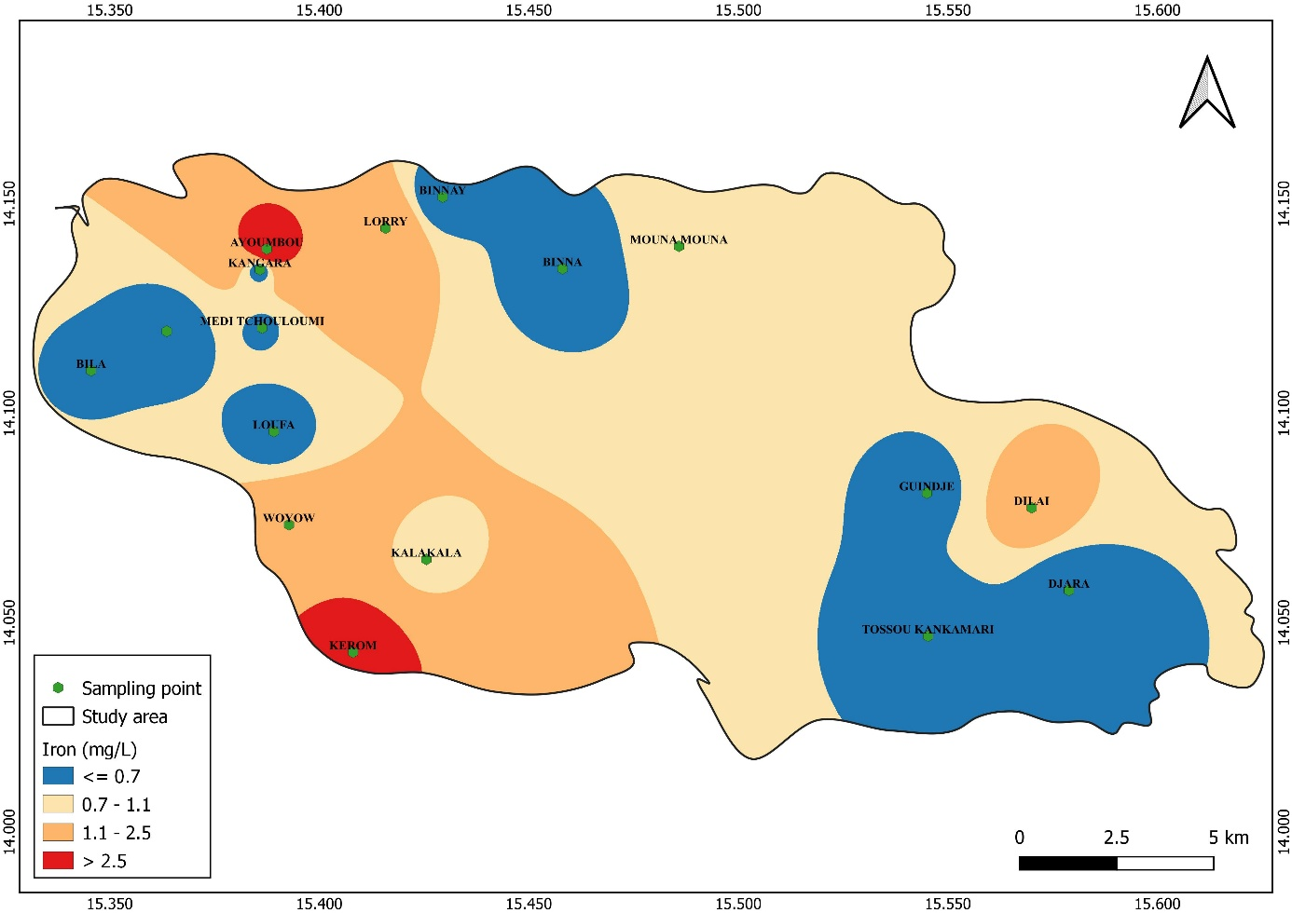
Figure 8 : Spatial distribution of iron
4.1.7 Classification of Water for Irrigation
The Wilcox diagram (Figure 9) was used to analyze the sodium content (%Na) of groundwater in the study area. Among the samples, none exhibited a low %Na (less than 20%), which would indicate excellent quality for irrigation. Three samples showed a moderate level (20-60% Na), and fourteen samples displayed Na concentrations between 75% and 90%. These results place the waters in the categories of “excellent,” “acceptable to doubtful,” and “doubtful” regarding their suitability for irrigation. High sodium concentrations can adversely affect stomatal function, water uptake, and photosynthesis in plants (Sunkari et al., 2023).
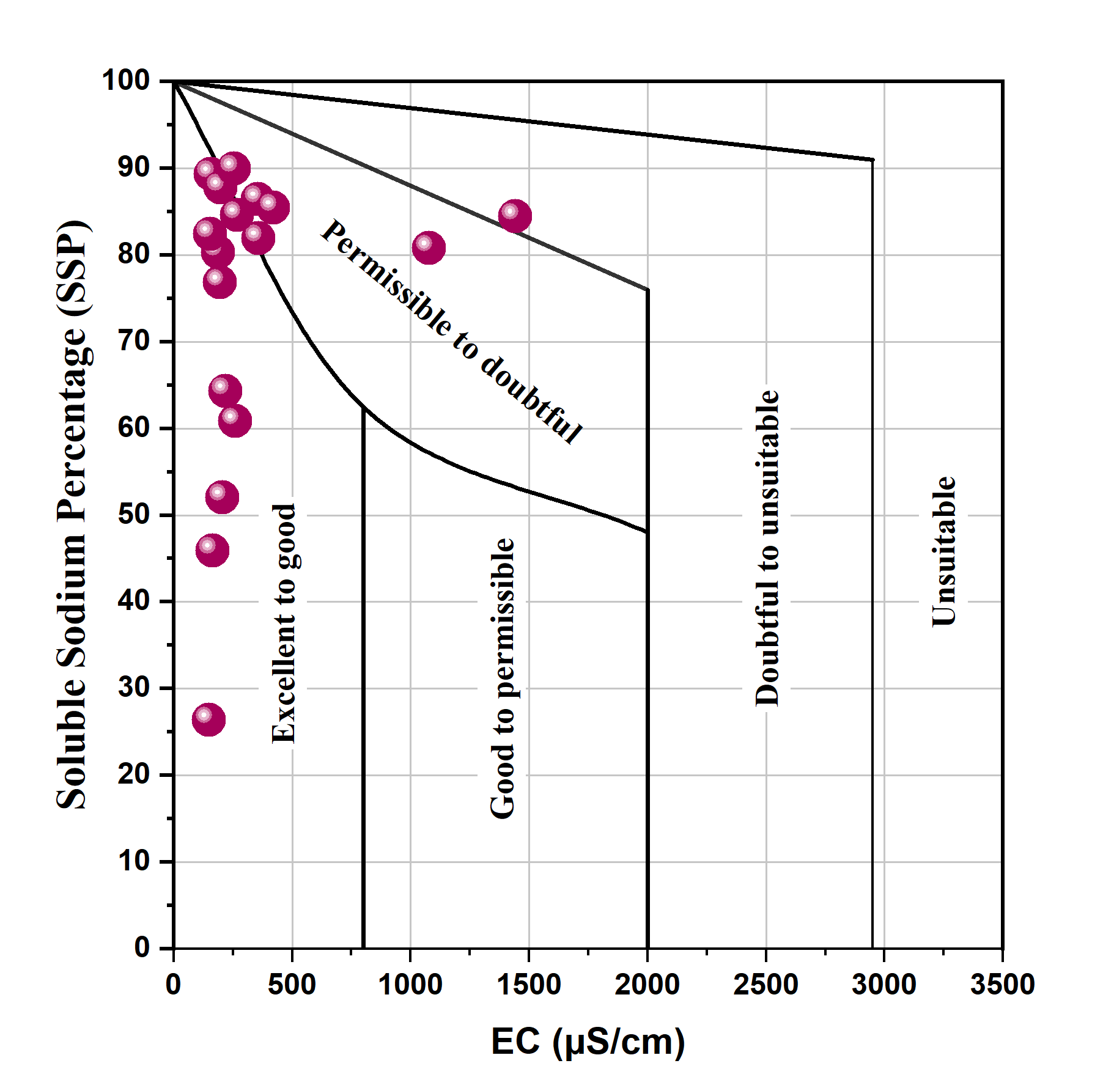
Figure 9 : Wilcox (1955) Diagram Showing the Suitability of Groundwater for Irrigation Purposes.
The USSL (SAR) diagram is an effective tool for evaluating the suitability of groundwater for irrigation, based primarily on the Sodium Adsorption Ratio (SAR) and Electrical Conductivity (EC). This method classifies SAR and EC into four distinct levels: low, medium, high, and very high.
Figure 10 shows that the groundwater samples in the study area fall into the classes C1-S1 (52.94%), C2-S1 (35.29%), C3-S1 (5.88%), and C3-S2 (5.88%). These results indicate a high salinity risk and low, medium, and high alkalinity risks, suggesting that special management practices may be required. Crops with high to very high salt tolerance should be selected to ensure sustainable irrigation.
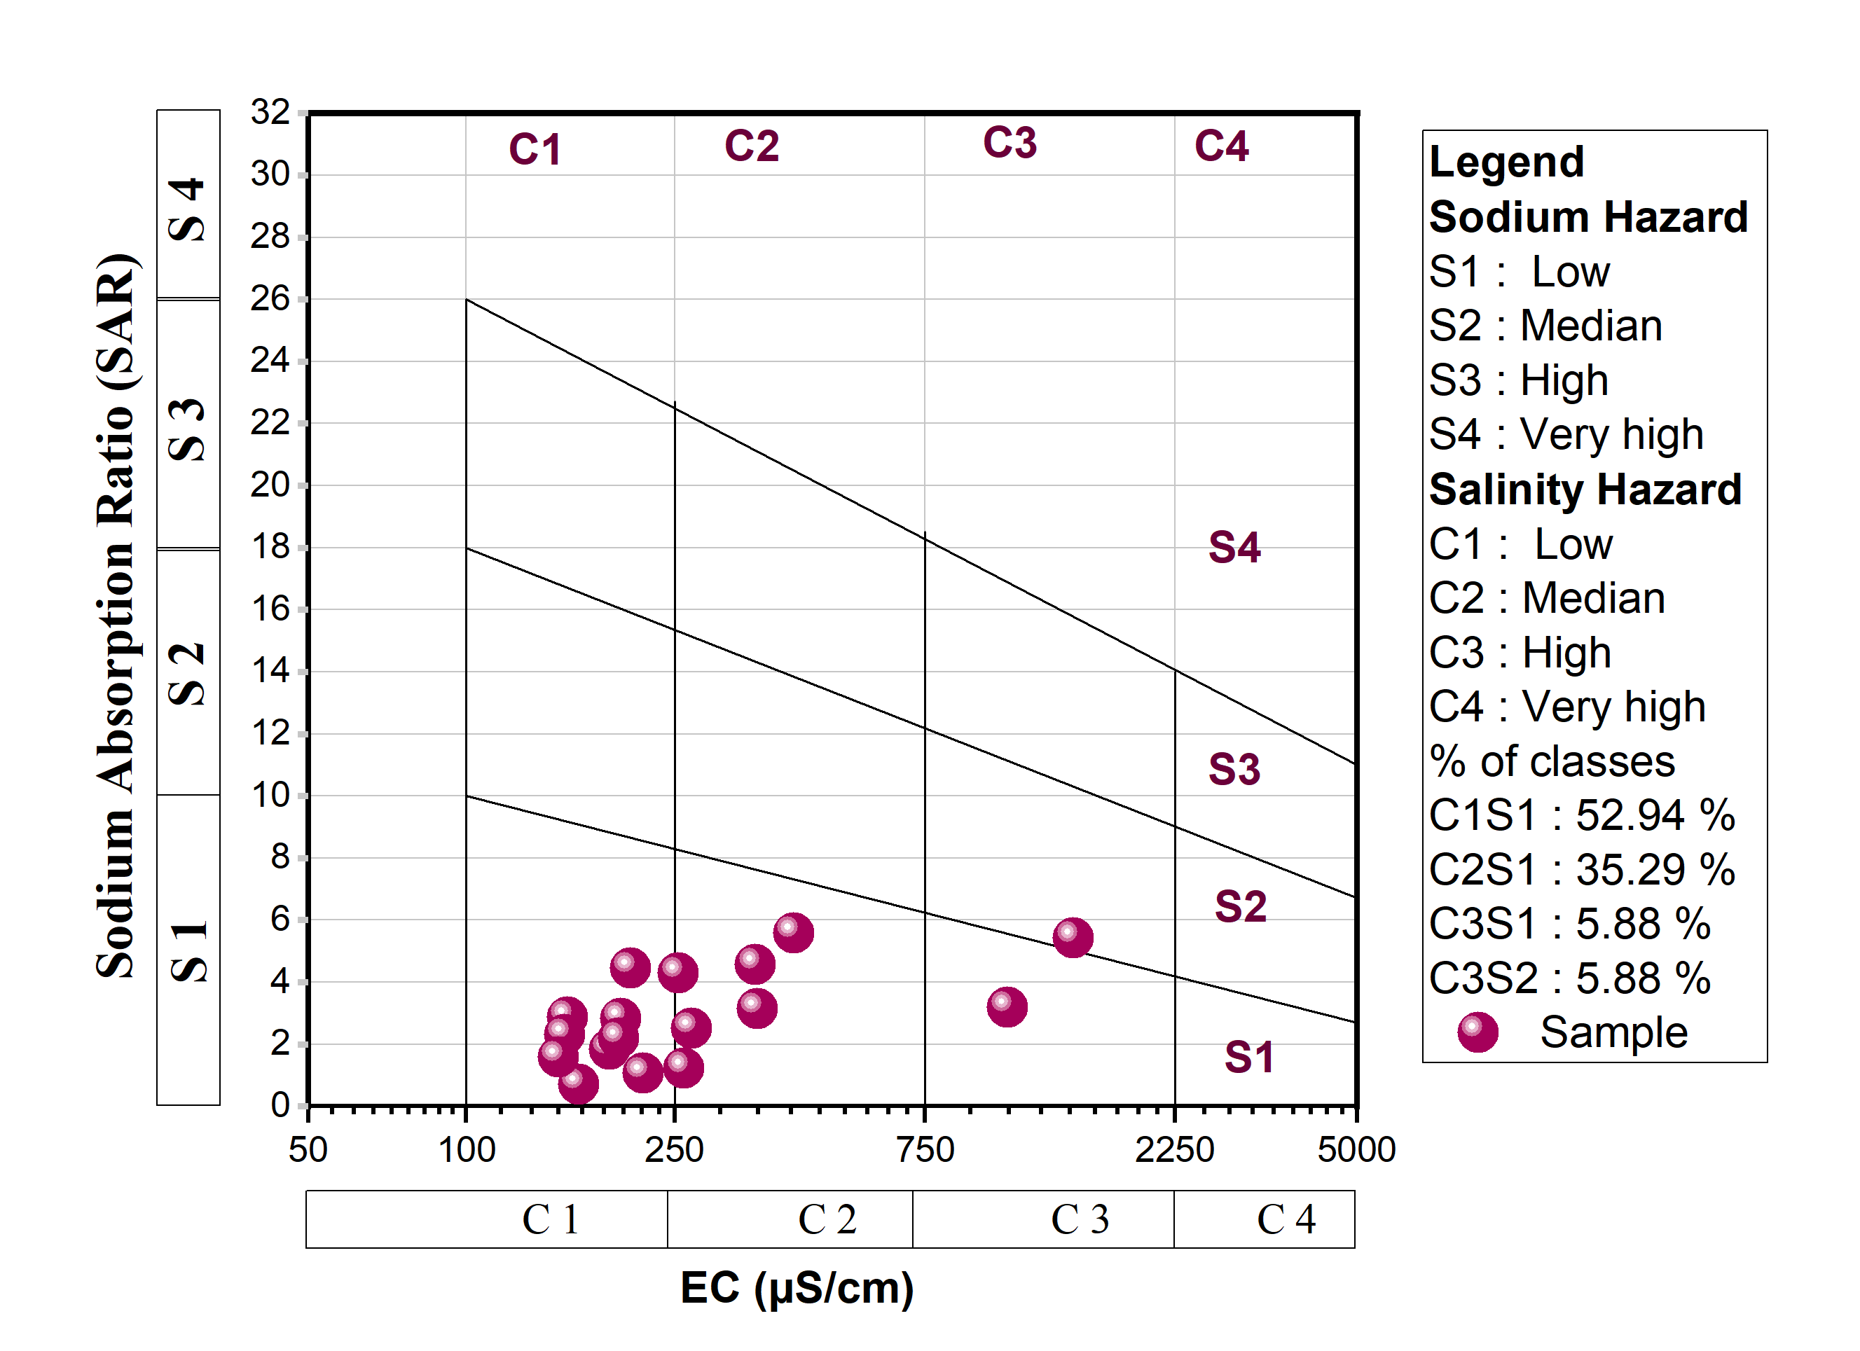
Figure 10 : USSL salinity diagram for classifying water for irrigation.
4.2 Bacteriological Parameters
The bacteriological parameters examined include total coliforms, Escherichia coli (E. coli), and fecal enterococci (Table 3). Analytical results were obtained from 17 domestic water sources, and the interpretations focus on evaluating and mapping the spatial distribution of source water quality.
Table 3 : summarizes the analytical results.
Nomenclature | Escherichia parcels  (24h à 36±1°C) | Total Coliforms  présumés (24h à 36±1°C) | faecal enterococci (48h à 36±1°C) | aerobic flora (24 - 48H à 36±1°C) /PCA
Unit | UFC/100 ml | UFC/100 ml | UFC/100 ml | UFC/100 ml
Mouna mouna | 27 | > 100 | 0 | > 100
Kangara | 3 | > 100 | 0 | > 100
Ayoumbou | 8 | > 100 | 0 | > 100
Lorry | 1 | > 100 | 0 | > 100
Dilai | 0 | 26 | 0 | > 100
Djara | 0 | 4 | 0 | > 100
Medi Djiguida | 0 | 52 | 0 | > 100
Guindjé | 18 | > 100 | 0 | > 100
Binnaye | 5 | > 100 | 0 | > 100
Loufa | 3 | > 100 | 0 | > 100
Medi Tchoulomi (puits) | > 100 | > 100 | 48 | > 100
Tosso Kankamary (puits) | > 100 | > 100 | 56 | > 100
Bila | 10 | > 100 | 0 | > 100
Woyow | 8 | 57 | 0 | > 100
Kalakala | 21 | > 100 | 0 | > 100
Kerom | > 100 | > 100 | 0 | > 100
Binna | 0 | 45 | 0 | > 100
WHO/CHAD guidelines | Must not be found in a 100 ml test sample of the analyzed sample. |  |  | No guidelines for drinking water

4.2.1 Fecal Enterococci
Enterococci are a group of bacteria originating from the fecal matter of living organisms, including humans and animals. Our analyses show that 15 samples were free of enterococci, while two well samples (Medi Tchouloumi and Tosso Kankamary) tested positive for these bacteria. This represents 88.23% negative and 11.77% positive samples. The total coliform counts in the analyzed water ranged between 48 and 56 CFU/100 mL.
4.2.2 Total Coliforms
Total coliforms originate from human and animal waste. Their presence in drinking water does not have a significant direct effect on human health but may indicate potential contamination by harmful microorganisms. They are used as indicators of microbiological water quality, indirectly reflecting fecal pollution and serving as markers for treatment efficiency and bacterial regrowth after treatment (Abdallah et al., 2021). All 17 samples tested positive for total coliforms, meaning 100% of the samples were contaminated. Total coliform counts ranged from 4 to 110 CFU/100 mL.
4.2.3 Escherichia coli
E. coli bacteria originate from the intestines of mammals and can pose health risks if present in drinking water. Their presence indicates fecal contamination and may suggest the presence of pathogenic agents (viruses, bacteria, and parasites) responsible for waterborne diseases (Scott et al., 2002). In this study, 14 samples tested positive while 3 were negative. The prevalence of E. coli in water sources in the study area was 82.35% positive and 17.65% negative (Dilai, Djara, Medi Djiguidanga). E. coli counts in the analyzed water ranged from 1 to over 100 CFU/100 mL. Their presence may also indicate recent contamination events.

4.2.4 Aerobic Flora
Aerobic flora consists of microorganisms that grow in the presence of oxygen at temperatures between 25 and 30 °C. The presence of these bacteria is likely due to infiltration of organic matter-laden water reaching the groundwater table. Aerobic bacteria were detected in all samples, i.e., 100% positive, with counts exceeding 100 CFU/100 mL in all analyzed waters. These results are consistent with findings by Abdallah et al. (2021) in Mao and its surroundings, located west of our study area.
The observed bacteriological pollution appears to result from infiltration of surface water and wastewater into shallow wells (15-35 m), the lack of adequate protection perimeters, and the proximity of pit latrines. In Medi Tchouloumi and Tosso Kankamary, the presence of total coliforms in these wells indicates a deterioration of water quality and the vulnerability of wells to external contamination.
Wells in sedimentary zones are particularly exposed to contamination due to their proximity to pollution sources, shallow depth, insufficient maintenance, and absence of regular water treatment. Field observations also suggest that contamination may result from uncovered wells or poor management of hand-dug wells, which are often left at ground level.

Conclusion
This study assessed the physicochemical and bacteriological quality of groundwater in the study area. The results show that 94.11% of the water samples belong to the sodium sulfate (Na-SO₄) facies, while 5.89% correspond to the sodium bicarbonate (Na-HCO₃) facies. Analyses of groundwater intended for consumption and irrigation generally indicate good overall quality.
Iron concentrations in the groundwater range from 0.1 to 4.55 mg/L, with a significant proportion of samples exceeding the WHO guideline value for drinking water (0.50 mg/L). These exceedances, observed in several boreholes distributed across the study area, represent 58.22% of the sampled points, indicating a notable presence of iron within the aquifer.
Furthermore, the geochemical diagrams used reveal clear water–rock interactions, showing that the chemical composition of the groundwater is strongly influenced by geochemical conditions, silicate hydrolysis processes, and cation exchange mechanisms.
The bacteriological results highlight widespread contamination in many wells and boreholes, with the presence of pathogens such as Escherichia coli, total coliforms, fecal enterococci, and total aerobic flora. These microorganisms originate primarily from the digestive tract of humans or animals and are mainly introduced into the environment through fecal matter, but also via urine.

References
- Mahamat Nour, A., Hamit, A., Abderamane, M., & Batrane, M. (2021). Assessment of the physico-chemical and bacteriological quality of the waters of the quaternary aquifer of the city of Mao in Chad. International Journal of Water Resources and Environmental Engineering, 13(3), 184-195. https://doi.org/10.5897/IJWREE2021.1012
- Bedoui, I., El-Haji, S., Houzi, G., Aghrib, N., Challi, D., Kaioua, S., Alaizari, H., & Fadli, M. (2022). Assessment of groundwater quality for irrigation purposes in Sidi Slimane, Morocco using the irrigation water quality index. Trop J Nat Prod Res, 6(4), 514–519. https://doi.org/10.26538/tjnpr/v6i4.9
- Belhassan, K. (2021). Water scarcity management. In Water Safety, Security and Sustainability: Threat Detection and Mitigation (pp. 443–462). Springer. https://doi.org/10.1007/978-3-030-76008-3_19
- Bouselsal, B., & Zouari, K. (2022). Identification of groundwater quality and hydrogeochemical processes in the shallow aquifer of El-Oued Algerian Sahara. In New Prospects in Environmental Geosciences and Hydrogeosciences: Proceedings of the 2nd Springer Conference of the Arabian Journal of Geosciences CAJG-2, Tunisia 2019 (pp. 579–583). Springer International Publishing. https://doi.org/10.1007/978-3-030-72543-3_130
- Gaillardet, J., Dupré, B., Louvat, P., & Allègre, C. J. (1999). Global silicate weathering and CO2 consumption rates deduced from the chemistry of large rivers. Chemical Geology, 159(1–4), 3–30. https://doi.org/10.1016/S0009-2541(99)00031-5
- Ghienne, J. F., Schuster, M., Bernard, A., Duringer, P., & Brunet, M. (2002). The Holocene giant Lake Chad revealed by digital elevation models. Quaternary International, 87(1), 81-85. https://doi.org/10.1016/S1040-6182(01)00063-5
- Gibbs, R. J. (1970). Mechanisms controlling world water chemistry. Science, 170(3962), 1088–1090. https://doi.org/10.1126/science.170.3962.1088
- Haddaji, B., Atoui, M., Wederni, K., Agoubi, B., & Karroubi, A. (2024). Geothermal water quality index assessment for irrigation purpose with multicomputing modeling coupled with GIS: case of El Hamma, Southeastern Tunisia. Water, Air, & Soil Pollution, 235, 160. https://doi.org/10.1007/s11270-024-06961-5
- Hammad, N., Bouselsal, B., Boussaada, N., Satouh, A., & Lakhdari, A. S. (2023). Application of Water Quality Index to Assess the Potability of the Phreatic Aquifer in Ouargla (Algeria). Ecological Engineering & Environmental Technology, 24(5), 36–45. https://doi.org/10.12912/27197050/163122
- Han, E., DeVeaux, C., Hancock, J.T., Ram, N., Harari, G.M., & Bailenson, J. (2024). The influence of spatial dimensions of virtual environments on attitudes and nonverbal behaviours during social interactions. Journal of Environmental Psychology, 95, 102269. https://doi.org/10.1016/j.jenvp.2024.102269
- Hem, J. D. (1985). Study and interpretation of the chemical characteristics of natural water (3rd ed.). U.S. Geological Survey, Water Supply Paper 2254. http://pubsdata.usgs.gov/pubs/wsp/wsp2254/html/pdf.html .
- Seeber, I., Maier, R., & Weber, B. (2013). Macrocognition in collaboration: Analyzing processes of team knowledge building with CoPrA. Group Decision and Negotiation, 22(5), 915-942. https://doi.org/10.1007/s10726-012-9337-z
- Kusnir, I., & Moutaye, H. A. (1997). Ressources minérales du Tchad: Une revue. Journal of African Earth Sciences, 24(4), 549-562. https://doi.org/10.1016/S0899-5362(97)00080-8
- Maglione, G. (1968). Présence de gaylussite et de trona dans les « natronières » du Kanem (pourtour nord-est du lac Tchad). Bulletin de Minéralogie. https://doi.org/10.3406/bulmi.1968.6245
- Moreno Merino, L., Aguilera, H., González-Jiménez, M., & Díaz-Losada, E. (2021). D-Piper, a modified Piper diagram to represent big sets of hydrochemical analyses. Environmental Modelling & Software. https://doi.org/10.1016/j.envsoft.2021.104979
- Moussa, A., Novello, A., Lebatard, A.-E., Decarreau, A., Fontaine, C., Barboni, D., Sylvestre, F., Bourlès, D. L., Paillès, C., Buchet, G., Duringer, P., Ghienne, J.-F., Maley, J., Mazur, J.-C., Roquin, C., Schuster, M., Vignaud, P., & Brunet, M. (2016). Lake Chad sedimentation and environments during the late Miocene and Pliocene: New evidence from mineralogy and chemistry of the Bol core sediments. Journal of African Earth Sciences, 118, 192-204. https://doi.org/10.1016/j.jafrearsci.2016.02.023
- Najiah, A. (2023). Improving the image quality of grayscale thermal images taken from photovoltaic panels with contrast enhancement methods. International Journal of Innovative Computing, Information & Control, 19(3), 733-747.
- Namratha, K., Nayan, M.B., Byrappa, K., Madesh, P., Basavarajappa, H.T., 2022. Impact of industrial effluents on the ground water contamination around industrial areas of Nanjunagud, Mysore district, India, and an effective strategy to treat using advanced oxidation process. International Journal of Advanced Research in Sciences, Engineering and Technology
- Olivry JC, Chouret A, Vuillaume G, Lemoalle J, Bricquet JP (1996). Hydrologie du lac Tchad, Vol. 12. Orstom.
- Ouarekh, M., Bouselsal, B., Benaabidate, L., Belksier, M. S., Chellat, S., & Satouh, A. (2024). Geochemical evaluation of fluoride enrichment in the complexe terminal aquifer and its implications for human health in Oued Souf Algerian Sahara. Sustain Water Resour Manag, 10, 163. https://doi.org/10.1007/s40899-024-01148-6
- Petrucci, O., & Polemio, M. (2007). Flood risk mitigation and anthropogenic modifications of a coastal plain in southern Italy: Combined effects over the past 150 years. Natural Hazards and Earth System Sciences, 7, 361. https://doi.org/10.5194/nhess-7-361-2007
- Piper, A. M. (1944). A graphic procedure in the geochemical interpretation of water analysis. Eos, Transactions American Geophysical Union, 25, 914-928. https://doi.org/10.1029/TR025I006P00914
- Polemio, M., Limoni, P. P., Mitolo, D., Santaloia, F., & Virga, R. (2005). Nitrate pollution and quality degradation of Ionian coastal groundwater (Southern Italy). In L. Razowska-Jaworek & A. Sadurski (Eds.), Nitrates in Groundwater: IAH Selected Papers on Hydrogeology 5 (pp. 163–176). CRC Press. https://www.routledge.com/Nitrates-in-Groundwater-IAH-Selected-Papers-on-Hydrogeology-5/Razowska-Jaworek-Sadurski/p/book/9789058096647
- Roche, M. A. (1980). Traçage naturel salin et isotopique des eaux du système hydrologique du lac Tchad. ORSTOM. http://www.documentation.ird.fr/hor/fdi:00328
- Schéma Directeur de l’Eau et de l’Assainissement du Tchad, 2001, Le bilan diagnostic des ressources en eau, République du Tchad Partie 1, 112 p.
- Schneider, J. L., & Wolff, J.-P. (1992). Carte géologique et cartes hydrogéologiques à 1/1 500 000 de la République du Tchad: mémoire explicatif. Éditions du BRGM.
- Schuster, M., Roquin, C., Duringer, P., Brunet, M., Caugy, M., Fontugne, M., Mackaye, H. T., Vignaud, P., & Ghienne, J. F. (2005). Holocene Lake Mega-Chad palaeoshorelines from space. Quaternary Science Reviews, 24(16-17), 1821-1827. https://doi.org/10.1016/j.quascirev.2005.02.001
- Servant M (1973). Séquences continentales et variations climatiques. Evolution du bassin du Tchad au Cenozofque sup∼ rieur. Thèse. Sciences, Universit∼ Paris VI.
- Singhal, T. (2020). A review of coronavirus disease-2019 (COVID-19). Indian Journal of Pediatrics, 87(4), 281-286. https://doi.org/10.1007/s12098-020-03263-6
- Sunkari, E. D., Abangba, T., Ewusi, A., Tetteh, S. E. K., & Ofosu, E. (2023). Hydrogeochemical evolution and assessment of groundwater quality for drinking and irrigation purposes in the Gushegu Municipality and some parts of East Mamprusi District, Ghana. Environmental Monitoring and Assessment, 195(1), 165. https://doi.org/10.1007/s10661-022-10731-3
- Swain, S., Sahoo, S., & Taloor, A. K. (2022). Groundwater quality assessment using geospatial and statistical approaches over Faridabad and Gurgaon districts of National Capital Region, India. Applied Water Science, 12(4), 75. https://doi.org/10.1007/s12665-022-01009-2
- Wederni, K., Alaya, M. B., Missaoui, R., & Hamed, Y. (2023). Assessment of groundwater hydrogeochemical characteristics and salinization intrusion in coastal arid area (South Gab`es, South-East Tunisia). Journal of African Earth Sciences, 200, 104875. https://doi.org/10.1016/j.jafrearsci.2023.104875
- Wilcox, L.V., 1955. Classification and use of irrigation water. US Geol. Dept. Agric. Circ. 969, 19.
- World Health Organization. (2017). World health statistics 2017: Monitoring health for the SDGs, sustainable development goals. http://www.who.int/gho/publications/world_health_statistics/2017/en/
- Yu, C., Yin, X., Li, H., & Yang, Z. (2020). A hybrid water-quality-index and grey water footprint assessment approach for comprehensively evaluating water resources utilization considering multiple pollutants. Journal of Cleaner Production, 248, 119225. https://doi.org/10.1016/j.jclepro.2019.119225
- Zhang, Y., He, Z., Tian, H., Xun, H., Zhixiong, Z., Yang, L., Yong, X., & Rui, L. (2021). Hydrochemistry appraisal, quality assessment and health risk evaluation of shallow groundwater in the Mianyang area of Sichuan Basin, southwestern China. Environmental Earth Sciences. https://doi.org/10.1007/s12665-021-09894-y
- Zhu, Y., Vvedenskaya, I. O., Sze, S.-H., Nickels, B. E., & Kaplan, C. D. (2024). Quantitative analysis of transcription start site selection reveals control by DNA sequence, RNA polymerase II activity and NTP levels. Nature Structural & Molecular Biology, 31(1), 190-202. https://doi.org/10.1038/s41594-023-01171-9

