Original Research Article

Climate change and trends in Autlán de Navarro, Jalisco México (1961-2023)

.
ABSTRACT

This study analyzes the changes and trends in temperature and precipitation in Autlán de Navarro, Jalisco, México during the last 62 years, as well as their possible climate impact. Through statistical methods and the Köppen climate classification, adapted by Enriqueta García, recent transformations in the local climate are identified. The results show an increase in temperature and precipitation in recent decades, along with a decrease in winter rainfall. These changes have favored crops with low water requirements and reduced the incidence of pests, but they have also led to the loss of pastures, increased risk of fires and soil degradation. The information obtained contributes to a better understanding of future scenarios and the most vulnerable sectors in the region, thus facilitating the formulation of more effective adaptation and mitigation strategies to the effects of climate change.
Keywords: Climate change; Climate trends; Autlán de Navarro; Adaptation.

1. INTRODUCTION
The increase in greenhouse gases has accelerated global warming and modified atmospheric circulation worldwide (Tiempo, 2021). As a result, significant changes have been recorded in various meteorological variables, such as air and soil humidity, temperature, atmospheric pressure, and precipitation, gradually transforming the planet's climate (Correa-Ortiz et al., 2021; Garizábal et al., 2017; Tapia-Vargas et al., 2011). These transformations, which take place over prolonged periods, are what is known as climate change.
Research has been carried out (e.g., Santana, 1984; Cáceres et al. 1998; Estrela, 2044; Aguirre et al. 2010; Karlin, 2012; Hurtado et al. 2013; Brown-Manrique et al. 2015; González et al. 2015; Blanco, 2021) that focus on studying changes in the climate in recent decades. These modifications are generated by changes in precipitation and temperature and are generating significant environmental, economic and social challenges. Therefore, it is urgent to implement measures to mitigate its effects and adapt to new climate scenarios.
As the impact of this global phenomenon depends on the geographical, social, economic and environmental conditions of each place. It is necessary to carry out regional studies, even at the municipal level, in order to develop and implement strategies adapted to the needs and possibilities of each region (Sánchez-Rodríguez, 2015).
In this work, a climatological analysis of the meteorological variables of temperature and precipitation is carried out in Autlán de Navarro, Jalisco, one of the most representative municipalities of the South Coast region of the state, during the last 62 years. The aim is to examine how these variables have evolved over time, as well as to identify climate transformation trends. In addition, it seeks to understand how social activities in the study area could have negatively impacted ecosystems. The results of this research provide valuable information to make more accurate decisions in the management of natural resources and in the implementation of specific public policies for the region. All this with the purpose of optimizing actions that help mitigate situations appropriate to changes in the local climate.
The municipality of Autlán de Navarro, Jalisco, México, stands out from other municipalities in the South Coast region of the state of Jalisco (Gámez et al., 2017) thanks to its status as the district capital, which favors the flow of visitors from neighboring municipalities. In addition, it is characterized by its rich diversity of vegetation (Robles-Martínez et al., 2021) and for having 4 types of climates (IIEG, 2021).
According to the 2020 population count, Autlán de Navarro has 64,931 inhabitants and experienced a population growth of 12.8% between 2010 and 2020. Approximately 38.95% of the population is engaged in agriculture, growing products such as sugar cane, red fruits, vegetables, corn, and agave, an activity that occupies 26.88% of the territory (Robles-Martínez et al., 2021). However, according to Gámez (2017), this production is threatened by the decrease in rainfall and the loss of nutrients from the soil, factors that, together with climatic conditions, affect the development and growth of crops (Radio Costa, 2023). However, increased rainfall in the coming years could also cause the loss of organic matter and, as a consequence, reduce agricultural production (Sandoval-Legazpi et al., 2017; Arrieta-Aguilar et al., 2023 and Núñez-González, 2023).
The main source of water supply is the Armería-Coahuayana hydrological region and the Ayuquila-Armería river sub-basin. However, the region's media have reported drought problems in Autlán de Navarro, when there is a delay in the storm (Canal 44, 2023).
In addition, they have revealed that deforestation over the years and fires in dry weather generate vulnerability to heavy rains, as ash and deforestation prevent water filtration and increase runoff that carries stones, sticks and ashes, overflowing rivers and streams and affecting homes located within the riverbeds, such as the case of the overflow of the El Cangrejo stream, which according to the scientific team of the Jalisco State Civil Protection and Firefighters Unit (UEPCyBJ) the disaster that occurred on Autlán on September 25 has a high chance of repeating itself. (Labcsa, 2023).
To achieve a more effective response to the strategies implemented by the government and even determine if it is necessary to adjust them, it is essential to know the area of study in detail. Therefore, the results of this research allow us to identify the response of the study region to the specific impacts of climate change and to develop concrete adaptation plans, such as the protection of key crops or the modification of agricultural practices and thus obtain improved management of natural resources and implementation of more effective public policies.
This research presents estimates with a degree of uncertainty due to the limitations of the available data. In the absence of a robust network of weather stations with an extensive historical database, reanalysis data from ERA5-Land were used, which combine measurements with data from global weather numerical models (such as the ECMWF). Although these data comply with the laws of physics, the estimates derived from them have an inherent degree of uncertainty (like any other simulation). However, they provide a reasonably accurate representation of the physical processes that govern the components of the Earth system.
In addition, the data used in this study have a spatial resolution of 9 km and a time range of 62 years, making this dataset highly useful and reliable for a wide range of land-surface-related applications.
2. methodology
To analyze the evolution of temperature and precipitation, as well as the trends of climate transformation in the study area, monthly precipitation and temperature reanalysis data from ERA5 Land, with a horizontal resolution of 9 km, corresponding to the period from 1961 to 2023, were used. To validate these data, nine CONAGUA meteorological stations located in the study area were selected (Figure 1) and the information was compared. Most of the values of ERA5 Land were found within the dispersion range of measurements from local weather stations, allowing it to be used as a database for this research.
However, not all ERA5 Land data met this criterion, so to improve the accuracy of the data, the points in the study area that exceeded the dispersion range of the measurements were replaced with measurements from local weather stations, integrating them into the ERA5 Land database. This combination of information, along with the use of the Python contour library, allowed adjustments to be made that resulted in a more accurate spatial estimate (Figures 2, 3, and 4).
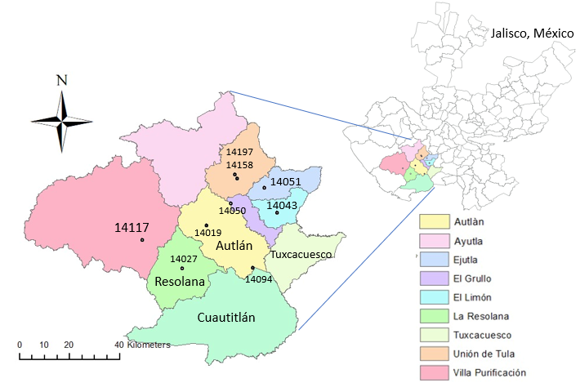

Fig. 1. Study area (municipality of Autlán de Navarro) with its neighboring municipalities and CONAGUA meteorological stations. Own elaboration.

After validating and adjusting the temperature and precipitation data, descriptive statistics were applied, by calculating the mean and standard deviation for every three decades. By contrasting both periods, changes in climatic variables and their respective anomalies were identified.
To obtain the climate transformation trends for each variable, the trendline adjustment method for the periods 1961-1990 and 1991-2023 was used.
Later, Enriqueta García's classification was made (García, 1988; INEGI 2001, IIEG, 2021 and Hernández-Cerda et al., 2018) for each 30-year period and were countered to see changes in climate and finally social activities that could mitigate negative impacts on local ecosystems were investigated.
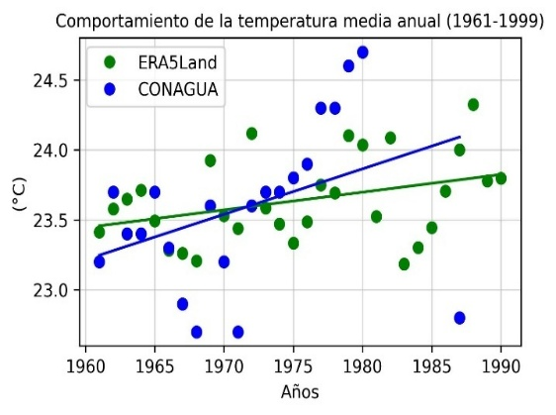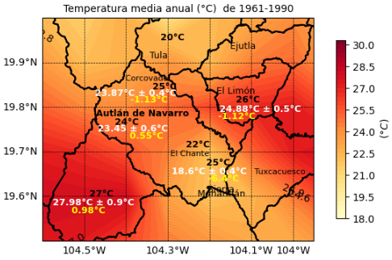
a)
b)
Fig. 2. Map a) shows the comparison of the annual mean temperature data for the period 1961-1990 from the CONAGUA meteorological stations with their standard deviation (in white) and the ERA5 Land data with a resolution of 9 km (in black). The difference between the ERA5 Land data and the station data is indicated in yellow. Graph b) shows the trend lines of the time series corresponding to the municipality of Autlán de Navarro (latitude 19.76, longitude -104.36). The blue line represents the trend calculated from the observational data recorded by the Autlán de Navarro meteorological station, operated by the National Water Commission (CONAGUA), while the green line corresponds to the trend derived from the ERA5-Land data. The blue dots indicate the individual values recorded by the CONAGUA station. Both series refer to the same geographical location, which allows the comparison of trends between the measurements and the estimates of the reanalysis, where the gap in the 1981-1986 data is observed.

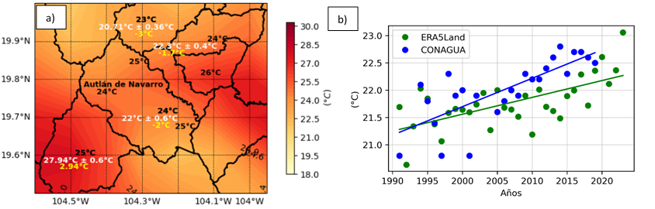
Fig. 3. Map a) shows the comparison of the temperature data for the period 1991-2023 from CONAGUA's meteorological stations with their standard deviation (in white) and the ERA5 Land data with a resolution of 9 km (in black). The difference between the ERA5 Land data and the station data is indicated in yellow. Figure b) shows the trend lines of the time series corresponding to Chante (latitude 19.71, longitude =-104.20). The blue line represents the trend calculated from the observational data recorded by the Autlán de Navarro meteorological station, operated by the National Water Commission (CONAGUA), while the green line corresponds to the trend derived from the data of the ERA5-Land reanalysis. The blue dots indicate the individual values recorded by the CONAGUA station. Both series refer to the same geographic location, allowing for comparison of trends between the measurements and the reanalysis estimates.
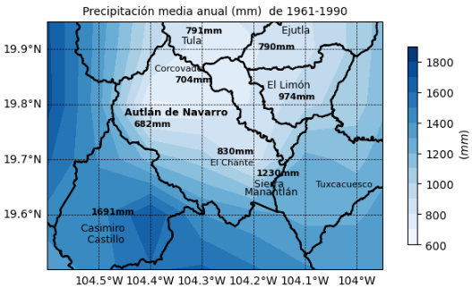
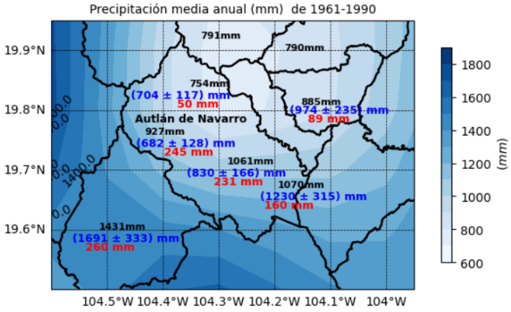
b)
a)

Fig. 4. Mean annual precipitation maps, a) the blue characters are the value of the CONAGUA meteorological stations (includes the standard deviation of the measurements) and the black characters are the ERA5 Land data. While the difference between the ERA5 Land data and the station data is shown in red. Map b) shows the adjusted (or reconstructed) average annual precipitation map. The same is done for the period 1991-2023.

3. results and discussion

Precipitation
The comparison of the average annual rainfall between the periods 1961-1990 and 1991-2023 (Figure 5) shows a similar spatial distribution. In both precipitation maps, it can be seen that it rains less in Autlán than in the surrounding municipalities (Casimiro Castillo and Cuautitlán de García Barragán). Within the municipality, there are higher annual accumulated rainfall in the mountainous region surrounding the municipality (part of the Sierra de Manantlán) than in the urban area of Autlán, which coincides with the climatological map of the National Meteorological Service (SMN) on the Development website, (2024b).
Figure 6 shows the changes in accumulated precipitation over the last 30 years, highlighting a generalized increase in the region. The municipality of El Limón presents the least variation in the average annual rainfall, with an increase of 69 mm, while Casimiro Castillo exhibits the highest increase, reaching 146 mm. This trend is consistent with the results of Méndez-González et al. (2008), who also identify a pattern of increase in different areas of the country.
In relation to the monthly climatology (Figure 7), rainfall is distributed throughout the year, although the highest accumulated rainfall is concentrated between June and September. July is identified as the month with the highest volume of rainfall, which is consistent with the SMN climograms (Desarrollo, 2023c). On the other hand, April registers the lowest level of precipitation. Regarding the changes observed in the last 30 years (Figure 8), the months with the smallest variations in the accumulated are January, March, April, May and November, while June, July, August, September, October and December show the most significant increases.
Finally, the trend line of the precipitation data from 1961-2023 at coordinates 19.76 and -104.36 corresponding to the municipal seat of Autlán de Navarro (figure 9) shows increases in precipitation (3.27 mm/year), reaffirming the increase in precipitation over the years in the study area.

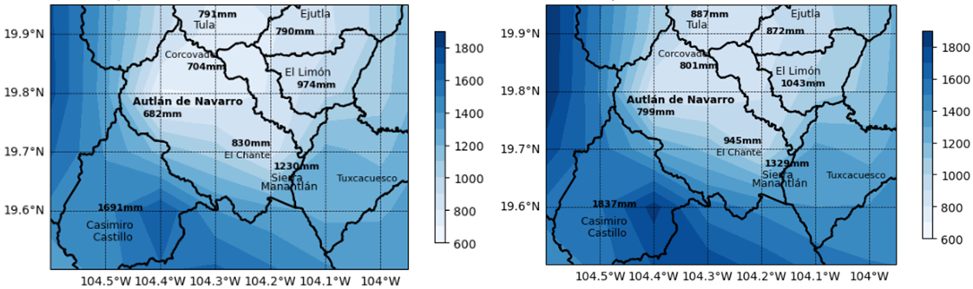
Fig. 5. Reconstructed average annual rainfall for the periods 1961-1990 and 1991-2023.

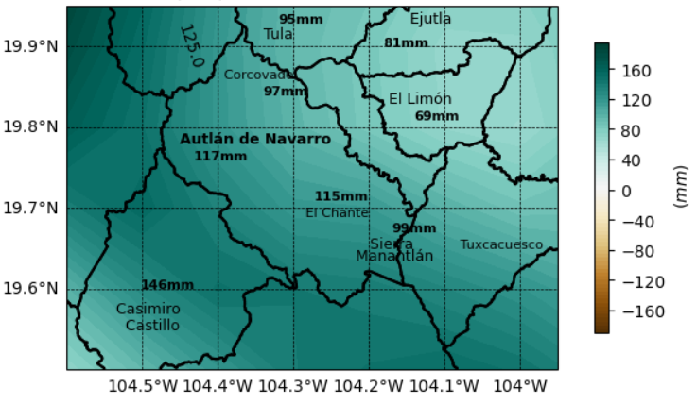
Fig. 6. Precipitation from 1991-2023 minus the period from 1961-1990.
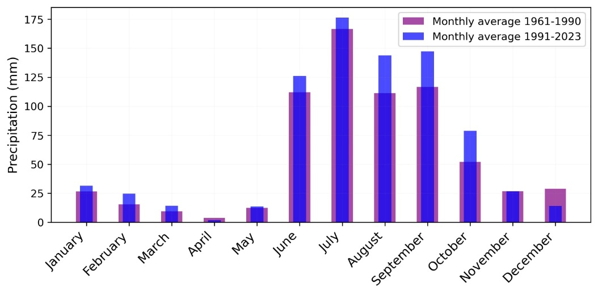
Fig. 7. Monthly precipitation climatology in the periods 1961-1990 and 1991-2022, of the urban area (municipal seat) of Autlán de Navarro.
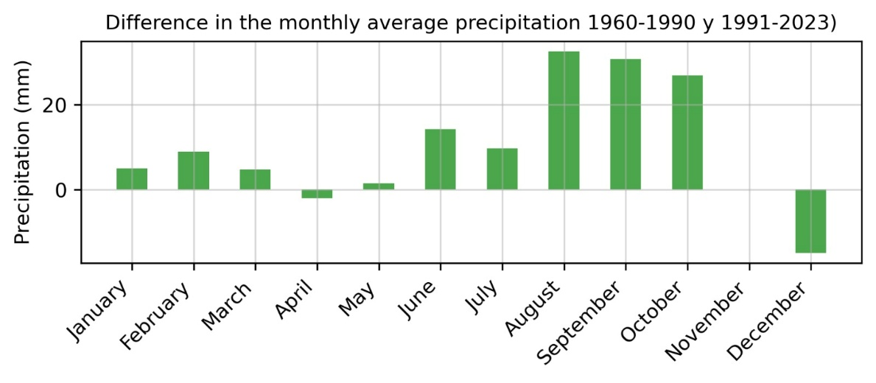
Fig. 8. Changes in the monthly precipitation climatology in the periods 1961-1990 and 1991-2022, of the urban area (municipal seat) of Autlán de Navarro.
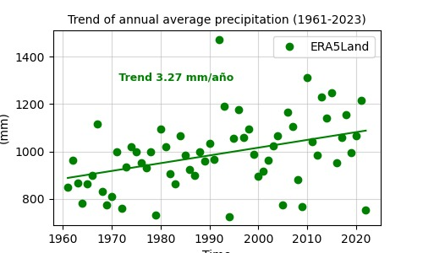
Fig. 9. Trend in the average annual rainfall (1961-2023), of the urban area (municipal seat) of Autlán de Navarro.
Temperature
The spatial distribution pattern of the average annual temperature for the period 1991-2023 shows few differences with respect to that of 1961-1990 (Figure 10), as it continues to show the municipality of Casimiro Castillo as the warmest and the Sierra de Manantlán as the coldest. In addition, no temporary changes greater than one degree Celsius are shown in the last 30 years. However, they allow us to appreciate a spatial difference of approximately 5°C between the urban area (23.5°C and 23.24°C) and the mountainous areas (part of the Sierra de Manantlán with 18.6°C and 18.19°C. These findings are consistent with the NMS's climate map available on its Development website (2024b).
Comparing the average annual temperature between the periods (1961-1990 and 1991-2023), an increase in average annual temperature is observed in Autlán, Manantlán, El Limón and El Corcovado.
In the urban area of Autlán de Navarro, Figure 11 compares the monthly climatology of the average temperature between the periods 1961-1990 and 1991-2023. April, May and June stand out as the warmest months, with values above 25 °C, while December and January are identified as the coldest. During the last 30 years, every month shows an increase in the average annual temperature that does not exceed 1 °C (Figure 12), which is within the range of variation indicated by the bars, where these results coincide with the study by Ramírez-Sánchez et al. (2024), which also reports upward trends in temperature in the state of Jalisco.
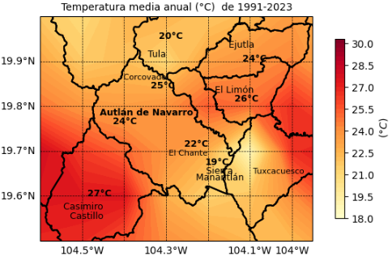
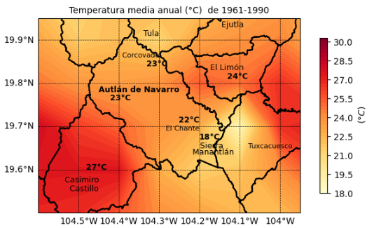
On the other hand, the trend line of the historical data for the 62 years (1961-2023) is shown in Figure 13 indicating temperature increases (0.017 °C/year).

Fig. 10. Reconstructed annual mean temperature for the periods 1961-1990 and 1991-2023. Only the names of the locality and the values of the stations that were used in each date range are displayed.
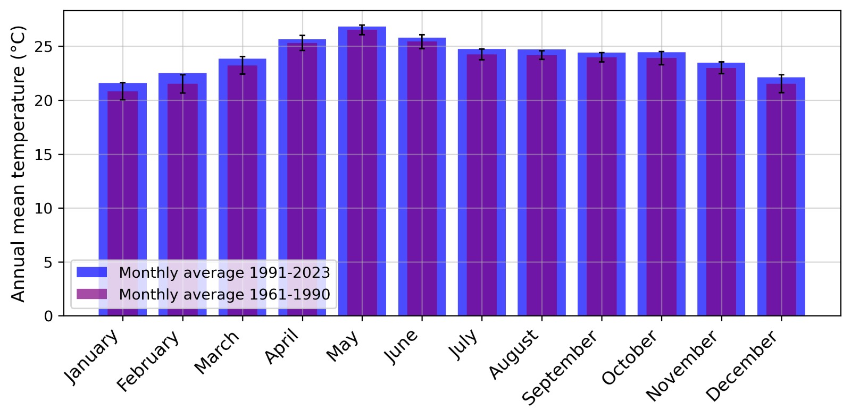
Fig. 11. Monthly temperature climatology in the periods 1961-1990 and 1991-2023, of the urban area (municipal seat) of Autlán de Navarro.
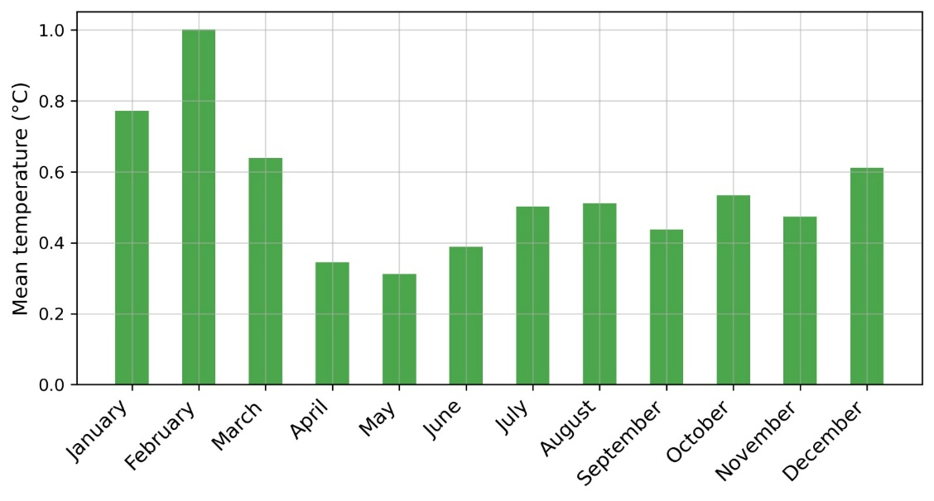
Fig.12. Difference in the average monthly temperature of the periods 1961-1990 and 1991-2023, of the urban area (municipal seat) of Autlán de Navarro.

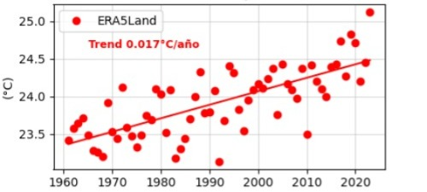
Fig.13. Annual temperature trend (1991-2019), of the urban area (municipal seat) of Autlán de Navarro.
These changes in precipitation and temperature during the time studied have generated some modifications in the local climate of the municipality of Autlán de Navarro that are shown in table 1.
Table 1- Climate Change Trends in Selected Jalisco Weather Stations (1961–2023)

Weather Station Location | Type of climate for the period 1961-1990 | Climate type for the period 1991-2023 | Tendency
Autlán de Navarro (urban area) | Awi’  Average annual temperature greater than 22ºC (23.45°C) and temperature of the coldest month greater than 18ºC (20°C). Precipitation of the driest month less than 60 mm (of 3.7 mm); summer rainfall with a P/T index greater than 22.9 (from 28.8) and a percentage of winter rainfall from 5% to 10.2% of the annual total. | Aw(w)i'  Average annual temperature greater than 22ºC (24°C) and temperature of the coldest month greater than 18ºC (20.8°C). Rainfall in the driest month less than 60 mm (from 0 mm); summer rainfall with a P/T index greater than 22.9 (out of 33.29). In addition, the percentage of winter precipitation represents less than 5% of the annual total (3.8%). | Warmer and sub-humid, with greater accumulated rainfall in summer and drier winters.
El Corcovado | Aw(w)i'  The average annual temperature is above 22°C (from 23.8°C), and the temperature of the coldest month exceeds 18°C (from 19.8°C). Precipitation in the driest month is less than 60 mm (out of 1.8 mm), and rainfall is concentrated in summer, with a P/T ratio above 22.9 (out of 29.48). In addition, the percentage of winter precipitation represents less than 5% of the annual total (4.76%). | Aw(w)i'  Average annual temperature greater than 22ºC (25°C) and temperature of the coldest month greater than 18ºC (21.6°C). Rainfall in the driest month less than 60 mm (of 3.5 mm); summer rainfall with a P/T index greater than 22.9 (out of 33.65). In addition, the percentage of winter precipitation represents less than 5% of the annual total (4.1%). | Warmer and sub-humid, with greater accumulated rainfall in summer and drier winters.
Sierra de Manantlán | (A)C w₂(w)i'  Semi-warm group C, temperate with warm summer.  The average annual temperature is less than 22°C (18.6°C), and the temperature of the coldest month is less than 18°C (14.94°C). Precipitation in the driest month is less than 60 mm (out of 1.5 mm), and rainfall is concentrated in summer, with a P/T index above 55 (out of 66.1). In addition, the percentage of winter precipitation represents less than 5% of the annual total (3.98%). | A(C) w₂(x')i'  Group A semi-warm  The average annual temperature is less than 22°C (19°C), and the temperature of the coldest month is less than 18°C (18.72°C). Precipitation in the driest month is less than 60 mm (out of 27.2 mm), and rainfall is concentrated in summer, with a P/T index above 55.3 (out of 69.9). In addition, the percentage of winter precipitation represents more than 10.2% of the annual total (10.3%). | Warmer, humid and subhumid, with greater accumulated rainfall in summer and winter.
El Chante | Aw(w)i'  The average annual temperature is above 22°C (from 22.7°C), and the temperature of the coldest month exceeds 18°C (from 19.3°C). Precipitation in the driest month is less than 60 mm (out of 1.47 mm), and rainfall is concentrated in summer, with a P/T ratio above 22.9 (out of 36.57). In addition, the percentage of winter precipitation represents less than 5% of the annual total (3.27%) | Aw(w)i'  The average annual temperature is above 22°C (from 22°C), and the temperature of the coldest month exceeds 18°C (from 19.65°C). Precipitation in the driest month is less than 60 mm (out of 0 mm), and rainfall is concentrated in summer, with a P/T ratio above 22.9 (out of 42.3). In addition, the percentage of winter precipitation represents less than 5% of the annual total (4.76%). | Tendency to greater accumulated rainfall in summer and winter.

4. Conclusion
This work analyzed the average temperature and precipitation of the periods 1961-1990 and 1991-2023 using descriptive statistics, identifying the change and trends in temperature and precipitation in the region of Autlán de Navarro over time, as well as the possible impacts on the local climate of the municipality, obtaining:
- The average annual temperature has increased over the last 30 years in the municipality of Autlán de Navarro and shows a slow and increasing trend of 0.017 °C/year.
- The average annual rainfall increased between 69 and 146 millimeters in the last 30 years and considering the 62 years of average annual rainfall in the urban area (municipal seat) of Autlán de Navarro, there is an increasing trend of 3.27 mm per year.
- According to the reconstructed precipitation and temperature series (1961-2023), the percentage of winter precipitation has decreased in the last 30 years in the municipal seat of Autlán de Navarro and Corcovado (going from an Awi' to Aw(w)i' climate); while it has increased both in summer and winter in El Chante and in the Sierra de Manantlán. in the latter passing from (A)Cw2(w)i' to A(C) w₂(x')i'.
- The urban area of Autlán, Corcovado and La Sierra de Manantlán show a trend towards an increase in average annual temperature. While Autlán, Corcovado, El Chante and the Sierra de Manantlán, show a slight increase in temperature in the colder months.
Dry winters can favor agriculture that requires little water, such as agave, vegetable and berry crops. However, the decrease in water levels in water sources could complicate the supply for agricultural irrigation and livestock consumption, increasing production costs. Likewise, this situation could negatively impact the supply of water for domestic use and industrial activities.
On the other hand, drier winters can reduce the occurrence of diseases caused by fungi and bacteria in crops, facilitate forestry activities and improve the transport of timber products. However, it also limits the availability of natural pastures, forcing farmers to invest in supplementary feed, further increasing costs. Although dry winters eliminate mud problems in pastures and improve access to livestock, they also significantly increase the risk of forest fires (Peláez et al., 2004). These fires, in addition to their immediate effects, can leave soils more vulnerable to erosion, especially on steeply sloping terrain.
Some actions that help mitigate the scarcity of natural pastures, the risk of forest fires due to the lack of humidity and deficit of water supply for agricultural irrigation and livestock consumption, are:
- The implementation of good practices for the efficient use of water resources, such as the use of technified irrigation systems, such as drip and sprinkler irrigation, as well as the use of water reserves captured during the rainy season in summer. However, for these practices to be applied effectively, it is essential to train and raise awareness among farmers and ranchers about their importance and benefits. In this sense, this environmental education strategy (carried out in Mexico since the 1990s in marginalized communities vulnerable to climate change) has shown positive results both nationally and in various countries in Latin America and the Caribbean, as indicated by the work of Calixto-Flores (2022) in Cuba, Argentina, and Bolivia.
- Another mitigation strategy in the face of such adverse situations is the use of ancestral techniques, such as introducing drought-resistant species adapted to local conditions (resistant local varieties), cultivating two or more plant species on the same land, at the same time or in rotation, in order to make better use of resources and increase biodiversity (polycultures). Combining trees and shrubs with crops or livestock (agroforestry), thus helping soil conservation and yield (Hernández-Medina et al., 2022).
- In addition to promoting reforestation in the urban area, reinforce fire prevention campaigns and strategies, through the media and social networks.
- Disseminate these sustainable collective skills through the educational sector, the media and social networks.

References

- Aguirre, N., Ojeda, T., & Eguiguren, P. (2010). Climate change and the conservation of biodiversity in Ecuador. Research Articles Aquaculture, 1(1), 17.
- Arrieta-Aguilar, K. F., Sotelo-Nava, H., Peralta-Abarca, J., Villegas-Torres, O. G., Perdomo-Roldán, F., & Millán-Benitez, E. (2023). Analysis of temperature and precipitation in two avocado-growing areas of the state of Morelos: period 1956-2019. Mexican Journal of Agricultural Sciences, 14(4), 543-554. https://doi.org/10.29312/remexca.v14i4.3161
- Blanco, P. S. (2021). Rainfall intensity and climate change: trends and interannual variabilities registered in some localities of the Northeast Argentina (1971-2019 period). Geográfica Digital. https://doi.org/10.30972/geo.17344481
- Brown-Manrique, O., Gallardo-Ballat, Y., Correa-Santana, A., & Barrios-García, S. (2015). Climatic change and its evidence in precipitation. Ingeniería Hidráulica y Ambiental, 36(1), 88-101. https://www.scielo.org.cu/scielo.php?script=sci_arttext&pid=S1680-03382015000100009&lng=en&nrm=iso
- México ante el cambio climático. (2021). Impactos del Cambio Climático en México. https://cambioclimatico.gob.mx/impactos-del-cambio-climatico-en-mexico/
- Canal 44. (2023). Due to the drought, cattle ranchers in Autlán transport water in pipes. https://www.dailymotion.com/video/x8m3lam
- Cáceres, L., Mejía, R., & Ontaneda, G. (1998). Evidencias del cambio climático en Ecuador. Bulletin de l'Institut français d'études andines, 27(3). http://www.redalyc.org/articulo.oa?id=12627319
- Calixto Flores, R. (2022). Environmental popular education and community resilience to climate change. International Journal of Environmental Resilience Research and Science. https://doi.org/10.48075/ijerrs.v4i2.28792
- Correa Ortiz, L. C., Ocampo López, O. L., & Alba Castro, M. F. (2021). Temperature and precipitation trend analysis for the department of Caldas (Colombia), using wavelets. Ciencia e Ingeniería Neogranadina, 31(1), 37-52. https://doi.org/10.18359/rcin.4900
- Gámez Adam, L. C., Joya Arreola, R., & Ortiz Paniagua, M. L. (2017). Micro, Small and Medium Enterprise (Mipymes, According to its Abbreviation in Spanish) Growth in Autlán de Navarro. Cofin Habana, 11(1), 1-11. http://scielo.sld.cu/scielo.php?script=sci_arttext&pid=S2073-60612017000100011&lng=es&tlng=es
- García, E. (1988). Modifications to the Koppen Classification System. 4th Ed. Mexico. P. 219
- García-Garizábal, I., Romero, P., Jiménez, S., & Jordá, L. (2017). Climate change effects on the climate dynamics of coastal Ecuador. DYNA: Journal of the Faculty of Mines. National University of Colombia. Medellín Headquarters, 84(203), 37-44. https://doi.org/10.15446/dyna.v84n203.59600
- Lastra, A., González, P., Russo, B., Xipell, A. R., & Ribalaygua, J. (2015). Efectos del cambio climático sobre las precipitaciones extremas en la comunidad de Madrid. In XXXIII Jornadas Técnicas de AEAS (p. 17). https://dialnet.unirioja.es/servlet/articulo?codigo=5179000
- Development. (2024a). Climatological statistical information. https://smn.conagua.gob.mx/es/climatologia/informacion-climatologica/informacion-estadistica-climatologica
- Servicio Meteorológico Nacional (SMN), CONAGUA. (2024). Mapas de climatología 1981-2010. https://smn.conagua.gob.mx/es/climatologia/informacion-climatologica/mapas-de-climatologia-1981-2010
- Servicio Meteorológico Nacional (SMN). (2024). Climogramas 1981-2010. https://smn.conagua.gob.mx/es/climatologia/informacion-climatologica/climogramas-1981-2010
- Estrela, M. J. (2004). Rainfall from Atlantic fronts in the Valencian Community: changes and trends in recent decades. Acta de las Jornadas Científicas de la Asociación Meteorológica Española, (28).
- Hernández-Cerda, M. E., Ordoñez-Díaz, M., & Giménez de Azcárate, J. (2018). Análisis comparativo de dos sistemas de clasificación bioclimática aplicados en México. Investigaciones geográficas, (95). https://doi.org/10.14350/rig.57451
- Hernández-Medina, C. A., Carrasco Fuentes, M. A., & Báez Hernández, A. (2022). Conceptualización de resiliencia al cambio climático en cadenas agropecuarias de valor. Lámpsakos (revista descontinuada) https://doi.org/10.21501/21454086.4100
- Hurtado, R., Fernández Long, M. E., Serio, L., Portal, M., & Valdiviezo Corte, M. (2013). Estudio de las precipitaciones en la región noroeste de la Argentina. Agraria: Revista Científica de la Facultad de Ciencias Agrarias-UNJu, 7(14), 74-81. https://www.fca.unju.edu.ar/revista-agraria/
- IIEG. (2021). Autlán de Navarro; Diagnosis of the municipality.
- Instituto Nacional de Estadística y Geografía. (2001). *Diccionario de datos climáticos: vectorial: escalas 1 : 250 000 y 1 : 1 000 000*. INEGI. https://en.www.inegi.org.mx/contenidos/productos/prod_serv/contenidos/espanol/bvinegi/productos/historicos/2104/702825223885/70%C2%B72825223885_2.pdf
- Karlin, M. S. (2012). Cambios temporales del clima en la subregión del Chaco Árido. Multequina, 21(1), 3-16. http://www.redalyc.org/articulo.oa?id=42825278001
- Labcsa. (2024). Tragedy in Autlán due to the overflow of El Cangrejo, can be repeated: PC Jalisco. https://labcsa.org/2024/02/16/tragedia-en-autlan-por-desborde-de-el-cangrejo-puede-repetirse-pc-jalisco/
- Méndez González, J., Návar Cháidez, J. J., & González Ontiveros, V. (2008). Análisis de tendencias de precipitación (1920-2004) en México. Investigaciones Geográficas, (65), 38-55. https://www.scielo.org.mx/pdf/igeo/n65/n65a4.pdf
- Núñez-González, G., Velázquez-Pérez, D., Barboza-Jiménez, P., Pelayo-Cortés, F. J., & Aguirre Salas, L. I. (2023). Análisis de las características de los eventos de lluvia de la temporada 2021 en un área urbana, caso de estudio de Autlán de Navarro, Jalisco, México. *Realidad, Datos y Espacio. Revista Internacional de Estadística y Geografía*, *14*(3). https://rde.inegi.org.mx
- Peláez, E. J. J., Navarro, F. C., Villeda, R. R., Mathieu, J. C. C., & Medina, Ó. E. B. (2004). Forest fires in the Sierra de Manantlán biosphere reserve, Jalisco and Colima. Forest fires in Mexico, 143.
- Radio Costa. (2023). Irregularity in rainfall will cause losses to corn producers in Ahuacapán. https://www.radiocosta.com.mx/irregularidad-en-lluvias-provocara-perdidas-a-productores-de-maiz-de-ahuacapan/
- Robles-Martínez, G. S., Luján-Espinoza, M., Santana-González, M. A., Gómez-Macedo, I., Puente-Bernabé, J. E., Galván-García, C. A., Trujillo-Hernández, D., Montes-Zamora, R. A., Nicolas-Ayala del Real, J., Chávez-Aguilar, M. G., Mancilla-Martínez, F., Arreola-López, H., Mata-Madrigal, M. C., & López-Mardueño, N. Y. (2021). *Plan Municipal de Desarrollo y Gobernanza de Autlán de Navarro*. Gobierno de Jalisco. https://plan.jalisco.gob.mx/wp-content/uploads/2022/09/mapa/pdf2021/15.pdf
- Ramírez-Sánchez, H. U., Fajardo-Montiel, A. L., García-Guadalupe, M. E., & Ulloa-Godínez, H. H. (2024). Climate Change Vulnerability Assessment in Jalisco: A Comprehensive Analysis. International Journal of Environment and Climate Change, 14(6), 115-144. https://doi.org/10.9734/ijecc/2024/v14i64215
- Sánchez-Rodríguez, R., & Morales, E. (2015). Development of Climate Change Adaptation Strategies in Vulnerable Municipalities of Northwest Mexico. 4th Activity Report, research project, Colegio de la Frontera Norte.
- Sandoval-Legazpi, J. de J., Figueroa-Rangel, B. L., & Pérez Mares, J. G. (2017). Management of climate and soil scenarios in the production of sugarcane (Saccharum officinarum) 2010-2020: Valle del Grullo-Autlán, Southern Coast of Jalisco. CIBA Ibero-American Journal of Biological and Agricultural Sciences, 6(12), 1-16. https://doi.org/10.23913/ciba.v6i11.66
- Santana, A. (1984). Variación de las precipitaciones de 97 años en Punta Arenas como índice de posibles cambios climáticos. Anales del Instituto de la Patagonia. Serie Ciencias Naturales, 15, 51-60. http://www.bibliotecadigital.umag.cl/bitstream/handle/20.500.11893/1381/Santana_Anales_1984_vol15_pp51-60.pdf?sequence=1&isAllowed=y
- Tapia-Vargas, L. M., Larios-Guzmán, A., Vidales-Fernández, I., Pedraza-Santos, M. E., & Barradas, V. L. (2011). Climate change in the avocado-growing area of Michoacán: long-term precipitation and temperature analysis. Mexican Journal of Agricultural Sciences, 2(SPE2), 325-335. https://www.redalyc.org/articulo.oa?id=60822306027
- Time. (2021). Calentamiento global y circulación atmosférica, un gran efecto dominó. https://www.tiempo.com/noticias/ciencia/calentamiento-global-y-circulacion-atmosferica-un-gran-efecto-domino.html
- United Nations. (n.d.). What is climate change? https://www.un.org/es/climatechange/what-is-climate-change

