Multivariate analyses of climate-resilient traits for in situ conservation of black pepper (Piper nigrum L.) diversity in Kerala

Abstract
Black pepper (Piper nigrum L.), native to the southern Western Ghats of India, represents a globally significant spice crop whose productivity and genetic integrity are increasingly threatened by habitat degradation, land-use shifts and climate-induced drought stress. Kerala, the primary centre of diversity for P. nigrum, harbours extensive landrace variability shaped by farmer selection and heterogeneous agro-ecological conditions. However, widespread replacement by high-yielding cultivars and erosion of wild populations have accelerated genetic loss, underscoring the need for systematic in situ documentation and conservation. This study conducted a comprehensive multivariate assessment of 62 black pepper genotypes collected across Kerala’s agro-ecological units during the peak natural drought period (March–May) to elucidate morpho-physiological diversity and identify drought-resilient genotypes. Significant variation was observed in key adaptive traits, with specific leaf area (SLA) showing the highest variability (CV = 0.55) and relative water content (RWC) the lowest (CV = 0.03). Physiological attributes such as epicuticular wax content and stomatal density displayed strong inter-genotypic differentiation, reflecting varied adaptive strategies to moisture deficit. Hierarchical cluster analysis resolved two major genetic groups, and heatmap clustering further identified 42 drought-tolerant genotypes characterized by reduced SLA, low stomatal density, enhanced leaf thickness and increased epicuticular wax deposition. Principal component analysis (PCA) extracted three components explaining 71.81% of total variance, with PC1 governed primarily by physiological drought-adaptive traits. Nine genotypes (G-44, G-61, G-38, G-50, G-56, G-32, G-54, G-36 and G-48) exhibited high cos² values (>0.75) and clustered with wax-rich, thick-leaf, low-SLA profiles, confirming superior drought resilience. The findings highlight substantial untapped adaptive diversity in Kerala’s black pepper germplasm and provide robust baseline information for targeted on-farm conservation, climate-resilient breeding and long-term genetic resource management.
Keywords: Principal Component Analysis, genetic diversity, drought, hierarchical clustering, Western ghats

Introduction
Plant genetic resources PGRs are the biological foundation of agriculture globally and a prerequisite to achieving long-term food and livelihood security. Species originating from their primary and secondary centres of diversity show significant deviation from their wild relatives through natural selection and ecological adaptation and domestication-driven selection. Global exchange and use of PGRs for desirable traits such as yield improvement, nutritional quality and stress tolerance demonstrate that systematic germplasm collection, characterization and conservation is of utmost importance (Singh et al., 2020). The traditional farming communities have conserved landrace diversity that holds unique adaptive attributes shaped by the local environment and cultural preference (Maxted et al., 2020; Puneeth et al., 2024). In this context, in situ and ex situ conservation approaches must be combined, because on-farm conservation enables the persistence of dynamic evolutionary process, unlike the static gene bank collections (Veteläinen et al., 2009; CGIAR, 2019).
Black pepper (Piper nigrum L.), is one of the most valued spices in international trade and a crop of tremendous economic importance native to the southern Western Ghats of India (Khan et al., 2021; Varghese et al., 2024). Kerala, as the main centre of diversity, harbours a vast array of landraces and farmer-selected cultivars showing variation in morphological, physiological and quality traits that underpin its adaptive resilience against fluctuating environmental conditions (Reshma et al., 2022). However, over the last decades, its genetic erosion accelerated due to the widespread replacement of traditional landraces with high-yielding varieties, habitat loss, degradation of wild populations and change in land-use patterns. On-farm surveys of black pepper across the agro-ecological units (AEUs) of Kerala are warranted to document and conserve the remaining genetic wealth systematically.
Drought stress is the most severe abiotic constraint limiting black pepper production, especially since the crop is mostly rainfed and requires 2000-3000 mm of well-distributed rainfall for its optimum growth and reproduction (Ambrozim et al., 2022; Yudiyanto et al., 2014). Even slight moisture deficiencies reduce vine vigour, spike initiation and berry development and prolonged drought results in vine mortality (Rao, 2016). Given the intensification of early summer droughts and rainfall irregularity due to climate change in Kerala, the identification of drought tolerant genotypes becomes imperative for maintaining productivity as well as conserving adaptive diversity. Morphological and physiological attributes such as specific leaf area, stomatal density, leaf thickness and epicuticular wax play a central role in drought adaptation and are highly variable among black pepper genotypes (Thankamani and Ashokan, 2002; Reshma et al., 2024).
In this regard, multivariate statistical tools, particularly cluster analysis and Principal Component Analysis (PCA), have emerged as potent methods to unravel the complex trait interactions in stress adaptation. Such tools help identify the key discriminatory traits and classify genotypes based on integrated morpho-physiological responses. Diversity is abundant in Kerala, but the comprehensive in situ multivariate assessment of black pepper germplasm for drought resilience has been limited. This study carries out a multivariate evaluation of 62 black pepper genotypes of Kerala to identify climate-resilient genotypes and key adaptive traits. The findings provide essential insights for strengthening on-farm conservation strategies and supporting the development of resilient genetic resources for future breeding programmes.
Materials and methods
This study was conducted across the major black pepper–growing regions of Kerala in the southern Western Ghats of India. Kerala extends from 8°18′ to 12°48′ N latitude and 74°52′ to 77°22′ E longitude, covering a narrow but ecologically diverse tract along the southwestern coast of India. Elevation across the state ranges from mean sea level in the coastal plains to over 2,600 m in the eastern high ranges, creating pronounced gradients in temperature, rainfall and soil properties. The average annual rainfall in Kerala is ~3,000 mm, out of which 85% falls during the southwest (June-September) and northeast (October-December) monsoons, thus leaving a pronounced moisture deficit period during January-May, particularly in the northern districts. The state has a tropical climate of mean ~27.5°C, with temperatures along coasts ranging from 25.5-27.5°C, midlands 27.5-29.5°C, and high ranges 17.5-21.5°C. The peak temperature during March-April ranges from 33-40°C inland. The relative humidity ranges between 70-95% during the monsoons due to low diurnal variation and between 45-60% during December-January with increased fluctuations (CWRDM, 2011). ​These conditions defined a marked summer drought (March-May) of peak evaporative demand when all the field morpho-physiological measurements were taken in order to assess natural drought responses in black pepper under in situ farmer conditions.
Morpho-physiological attributes were assessed employing standardized methodologies. Leaf area was measured by the graph paper method, while leaf thickness was determined using a digital Vernier calliper. Stomatal density was evaluated by microscopic examination of epidermal impressions prepared with thermocol in xylene mixture. Epicuticular wax quantification was performed gravimetrically after chloroform extraction from the leaf surface. Specific leaf area (SLA) was calculated as the ratio of leaf area to dry leaf mass. All measurements were standardized by sampling the fully expanded fourth leaf on the lateral branch. Additional metrics, including lateral branch length, number of nodes, leaf length, leaf width, leaf angle and petiole length were recorded. ​​
Multivariate statistical techniques were employed to elucidate trait variation among the 62 black pepper genotypes. Hierarchical clustering, utilizing Euclidean distance and Ward’s linkage method, was performed to classify genotypes based on morpho-physiological trait similarity. Principal component analysis (PCA) was conducted on standardized data matrices to identify principal sources of variability and to extract key traits contributing to genotype differentiation.
Results and discussion
Variation in morphological and physiological traits
Primary abiotic stresses, particularly heat and drought, exert strong influences on plant growth and productivity, and their impacts are becoming more pronounced under changing climatic conditions. In response, plants typically develop a suite of adaptive morphological and physiological strategies. These include xeromorphic features such as the formation of a thicker, wax-enriched cuticular layer to restrict transpiration, reductions in stomatal size and number, thicker palisade tissues, increased trichome density, smaller and thicker leaves and enhanced vascular development (Ullah et al., 2017a; Iqbal et al., 2013). Additional drought-responsive mechanisms commonly observed in plants include enhanced epicuticular wax deposition, reduced leaf area, leaf rolling, adjustments in leaf angle to minimise transpiration loss and modulation of stomatal behaviour to optimise water use under stress (Bibi et al., 2021).
In the present study, among all evaluated black pepper genotypes, SLA exhibited the highest variability (CV = 0.55), whereas RWC showed the lowest variability (CV = 0.03) (Table 1). Significant genetic variability was observed in growth-related morphological traits such as number of nodes and lateral branch length, while leaf parameters such as leaf length, leaf width, petiole length, leaf area and leaf thickness, displayed only moderate variation. Physiological traits, particularly epicuticular wax content and stomatal density, exhibited relatively higher variability, reflecting the differential adaptive capacities of the genotypes to their respective environmental conditions. In contrast, RWC showed the least variation, suggesting a largely conserved physiological response among genotypes under field conditions. This pattern of variability highlights the underlying genetic diversity and the differing adaptive potential within the black pepper germplasm, offering valuable insights for breeding programmes aimed at developing stress-tolerant and high-yielding varieties.
SLA, the inverse of leaf mass per area (Poorter et al., 2009), is a fundamental ecological trait closely associated with photosynthetic capacity (Xiong et al., 2016). Variation in SLA arises from differences in leaf density and thickness (Witkowski and Lamont, 1991) and responds to environmental factors such as nutrient and moisture availability, light intensity and temperature (Niinemets, 1997; Poorter et al., 2009). Additional factors, including light quality, UV-B radiation, CO₂ concentration, ozone exposure, water stress, salinity and soil conditions further influence the balance between leaf area and dry mass, thereby affecting SLA (Tian et al., 2016). The strong drought-adaptive variation observed in black pepper in our study aligns with findings from Theertha et al. (2023), who similarly reported that black pepper populations maintain substantial physiological diversity. Moreover, variation in the performance of black pepper genotypes across lowland and high-altitude regions reflects inherent genetic differences as well as the influence of local environmental conditions (Sainamole et al., 2002). Consistent with these observations, the variability in quantitative traits recorded in our investigation appears to be shaped by the combined effects of genetic diversity and environmental factors.
Grouping of black pepper genotypes based on cluster analysis
HCA using Ward's D2 linkage and Euclidean distance on 62 black pepper genotypes revealed two major genetic clusters (Figure 1), with Cluster I showing high intracluster similarity and Cluster II displaying greater heterogeneity, consistent with patterns observed in pepper germplasm evaluations. Such clustering reflects underlying genetic divergence shaped by regional adaptation in Kerala's agro-ecological units, where smaller homogeneous groups likely stem from shared ancestry or farmer selection, while larger diverse clusters capture broader variability essential for breeding (Constantino et al., 2020; Wimalarathna et al., 2024). The optimal cluster number was validated using the elbow plot of within cluster sum of squares (Figure 2). Theertha et al. (2023) also reported similar clustering patterns and detected two distinct tolerant and susceptible groups through UPGMA clustering based on morpho-physiological traits..
Heatmap clustering (Figure 3) of morpho-physiological susceptibility indices further refined drought-response groups and identified four highly susceptible genotypes in Cluster I, together with Sub-clusters I (16 intermediate genotypes) and II (42 tolerant genotypes), falling within Cluster II. Genotypes falling within Cluster I demonstrated higher SLA, stomatal density and leaf angle characteristics contributing to high transpiration rates and susceptibility to water deficit, as observed in black pepper and other tropical perennials (Chen et al., 2022). By contrast, genotypes within Sub-cluster II converged on drought-avoidance attributes of reduced SLA, low stomatal density, increased leaf thickness, and greater epicuticular wax, features favouring enhanced water-use efficiency and characteristic of xeromorphic adaptations in stress-prone environments (Ferreira et al., 2024; Ilkay et al., 2024; Fernando et al., 2025). The partial adaptations were reflected in the set of moderate relative water contents and wax levels, suggesting an optimum balance suited to variable moisture regimes typical of farmer fields. Leaf size traits such as length, area and petiole showed variation among groups but did not affect tolerance, emphasizing that in black pepper, dimensional traits have no role in drought tolerance under field conditions. These findings bring Sub-cluster II into focus as an important reservoir for on-farm conservation and breeding, providing donors for climate-resilient varieties against the erratic rainfall in Kerala. The integration of HCA with heatmap validation using elbow plots strengthens genotype prioritization for P. nigrum improvement programs targeting drought tolerance.
Principal component analysis (PCA)
PCA reduced the dimensionality of 12 morpho-physiological traits recorded for 62 black pepper genotypes, retaining three components with eigenvalues >1 (Table 2), which cumulatively explained 71.81% of the total variance, and the individual PCs accounted for 34.75% (PC1), 24.68% (PC2), and 12.39% (PC3) (Figure 4). This capture of variance by the leading PCs is in agreement with the trend observed with the application of PCA in P. nigrum germplasm, where 2-5 PCs explain 70-86% in drought-related morphological, physiological, and yield traits under Kerala conditions (Ravindran et al., 1997; Theertha et al., 2023; Reshma et al., 2024).
PC1 and PC2 together explained 59.43% of the total variation, representing the primary axes of differentiation among black pepper genotypes. PC1 accounted for 34.75% of the variance and was predominantly influenced by physiological and leaf- related traits, with the largest loadings observed for specific leaf area (–0.44), stomatal density (–0.45), leaf thickness (0.43), epicuticular wax (0.43), and relative water content (0.35) (Table 3). Contribution analysis of PC1 revealed that stomatal density (20.41%), SLA (19.57%), epicuticular wax (18.11%) and leaf thickness (18.48%) were the major traits explaining variance in this component (Table 4). The contrasting signs associated with SLA and stomatal density (negative) versus leaf thickness and epicuticular wax (positive) indicate that PC1 effectively distinguishes genotypes that have thin leaves, high specific leaf area and high stomatal density, which are features linked to a more acquisitive and drought-susceptible strategy. In contrast, PC1 differentiates these from genotypes that possess thick leaves, greater wax deposition and higher relative water content, traits indicative of drought adaptation. PC2 accounted for 24.68% of the variation and mainly captured the variation in leaf size and shape. Leaf area (0.49), leaf width (0.48), leaf length (0.42) and petiole length (0.35) had high positive loadings on PC2. Lateral branch length and number of nodes showed negative loadings on PC2 (–0.22 and –0.33, respectively). The percentage contribution analysis confirms that leaf width (23.12%), leaf area (23.95%), and leaf length (17.71%) were the primary contributors to the second principal component. Therefore, PC2 discriminates genotypes characterized by expansive leaf laminae and longer petioles from those with a more compact canopy architecture, indicated by shorter lateral branches and fewer nodes. Jayarathna et al. (2016) also reported a strong and consistent association between leaf area and leaf width. PC3 accounted for 12.39% of the total variation and was mainly associated with morphological traits. Lateral branch length and number of nodes exhibited the highest positive loadings on PC3, contributing approximately 47.30% and 30.52% to the variance explained by this component, respectively. Consequently, PC3 primarily reflects inter-genotypic differences in plant architecture and vegetative vigour, highlighting variation in canopy structure and branching patterns among the evaluated black pepper genotypes. Correlation analyses between variables and PCs supported the loading-based interpretations (Table 5). This pattern is in accordance with Theertha et al. (2023), who similarly reported that leaf structural and stomatal traits are the major contributors to PC1 in distinguishing drought-tolerant from susceptible groups. The negative association between wax content and stomatal density observed in our dataset further supports their findings, reinforcing that increased epicuticular wax deposition coupled with reduced stomatal frequency represents a key physiological mechanism underpinning drought tolerance in black pepper.
The PCA variable plot (Figure 5) clearly resolved genotypes into distinct groups that reflect the underlying physiological and morphological axes. Genotypes positioned on the negative side of PC1 are characterized by greater leaf thickness, higher epicuticular wax content and increased RWC, but lower SLA and stomatal density, which are interpreted as traits associated with drought adaptation. In contrast, genotypes on the positive side of PC1 exhibit higher SLA, increased stomatal density and larger leaf size. These traits are indicative of a vigorous but drought-susceptible phenotype. The second principal component, PC2, further separates genotypes based on leaf size and canopy compactness. Genotypes with high cos² values in the scatter plot (Figure 6), indicating strong representation on these principal axes, included 38 genotypes, among which nine genotypes (G-44, G-61, G-38, G-50, G-56, G-32, G-54, G-36 and G-48) were classified as highly drought-resilient due to cos² values exceeding 0.75.
The PCA biplot (Figure 7) demonstrated that drought‐tolerant genotypes were primarily positioned on the negative side of PC1, where epicuticular wax content, leaf thickness and RWC showed strong negative loadings. Genotypes such as G-44, G-61, G-38, G-50, G-56, G-32, G-54, G-36 and G-48 clustered closest to these trait vectors, confirming that these physiological and anatomical traits are the major contributors to their drought resilience. Malek et al. (2021) noted that analysis of the principal contributing traits represented in the biplot of the first two principal components allows for effective differentiation of genotypes.
Conclusion
This study demonstrates that Kerala’s black pepper germplasm harbours significant morpho-physiological diversity that underpins varied drought-adaptive strategies across genotypes. Traits such as epicuticular wax deposition, leaf thickness, stomatal density and SLA emerged as the most informative indicators of drought resilience, effectively separating tolerant and susceptible groups. Cluster analysis and PCA consistently identified a distinct set of resilient genotypes (G-44, G-61, G-38, G-50, G-56, G-32, G-54, G-36 and G-48) that exhibited strong xeromorphic features and maintained higher relative water status under natural field drought. These genotypes represent valuable candidates for breeding programmes aimed at developing climate-resilient cultivars and for strengthening on-farm conservation of adaptive diversity. The pronounced variability captured across Kerala’s agro-ecological units further underscores the importance of continued, systematic germplasm surveys, especially in regions where landraces are rapidly disappearing. Integrating multivariate analytical frameworks with field-based evaluations provides an efficient approach for prioritizing genetic resources, supporting both conservation and sustainable productivity under changing climatic conditions.

References
- Ambrozim, C. S., Medici, L. O., da Cruz, E. S., Abreu, J. F. G., & de Carvalho, D. F. (2022). Physiological response of black pepper (Piper nigrum L.) to deficit irrigation. Revista Ciência Agronômica, 53, 1–10. https://doi.org/10.5935/1806-6690.20220002
- Bibi, S., Noshad, A., & Khan, A. (2021). Role of epicuticular wax in the regulation of plant growth and health as measured by spectral indices. International Journal of Remote Sensing, 42(9), 3498–3510. https://doi.org/10.1080/01431161.2021.1875509
- CWRDM [Centre for Water Resources Development and Management]. (2011). Documentation and analysis of farmers' practices on water management for plantation crops in Kerala. Kozhikode: CWRDM.
- Chen, Z., Li, S., Wan, X., & Liu, S. (2022). Strategies of tree species to adapt to drought from leaf stomatal regulation and stem embolism resistance to root properties. Frontiers in Plant Science. https://doi.org/10.3389/fpls.2022.926535
- Constantino, L. V., Fukuji, A. Y. S., Zeffa, D. M., Baba, V. Y., Erpen-Dalla Corte, L., Giacomin, R. M., Resende, J. T. V., & Gonçalves, L. S. A. (2020). Genetic variability in pepper accessions based on morphological, biochemical and molecular traits. Bragantia, 79(4), 558–571.
- CGIAR. (2019). Guardians of diversity: The network of genebanks helping to feed the world. https://www.cgiar.org/news-events/news/guardians-of-diversity-the-network-of-genebanks-helping-to-feed-the-world/
- Fernando, Y., Adams, M., Kuhlmann, M., & Jr, V. B. (2025). Stomatal and Non-Stomatal Leaf Traits for Enhanced Water Use Efficiency in Rice. Biology, 14(7), 843. https://doi.org/10.3390/biology14070843
- Ferreira, T. R., Sallin, V. P., Cerri Neto, B., Crasque, J., Pires, A., Rodrigues, P. S., Chisté, H., Lima, A. B. P., Machado Filho, J. A., Arantes, L. O., Lira, J. M. S., Falqueto, A. R., & Dousseau-Arantes, S. (2024). Morphophysiological responses of black pepper to recurrent water deficit. Photosynthetica, 62(3), 292-301. https://doi.org/10.32615/ps.2024.030
- Iqbal, H. M. N., Kyazze, G., & Keshavarz, T. (2013). Advances in the valorization of lignocellulosic materials by biotechnology: An overview. BioResources, 8, 3157–3176. https://doi.org/10.15376/biores.8.2.3157-3176
- Jayarathna, S. P. N. C., Senanayake, S. P., Rajapakse, S., & Jayasekera, L. R. (2016). Phenetic variation and preliminary phytochemical screening of Piper species in Sri Lanka. Journal of Agricultural Sciences, 11(3), 155-160. http://hdl.handle.net/123456789/1700
- Khan, A. U., Talucder, M. S. A., Das, M., Noreen, S., & Pane, Y. S. (2021). Prospect of The Black Pepper (Piper nigrum L.) as Natural Product Used to an Herbal Medicine. Open Access Macedonian Journal of Medical Sciences, 9(F), 563–573. https://doi.org/10.3889/oamjms.2021.7113
- Maxted, N., Hunter, D., & Ríos, R. O. (2020). Plant Genetic Conservation. Cambridge University Press. https://doi.org/10.1017/9781139024297
- Malek, N., Aci, M. M., Khamassi, K., Lupini, A., Rouaissi, M., & Hanifi-Mekliche, L. (2021). Agro-morphological and molecular variability among Algerian faba bean (Vicia faba L.) accessions. Agronomy, 11(8), 1456. https://doi.org/10.3390/agronomy11081456
- Niinemets, Ü. (1997). Distribution patterns of foliar carbon and nitrogen as affected by tree dimensions and relative light conditions in the canopy of Picea abies. Trees, 11, 144–154.
- Poorter, H., Niinemets, Ü., Poorter, L., Wright, I. J., & Villar, R. (2009). Causes and consequences of variation in leaf mass per area (LMA): A meta-analysis. New Phytologist, 182(3), 565–588. https://doi.org/10.1111/j.1469-8137.2009.02830.x
- Prasada Rao, G. S. L. H. V. (2016). Weather extremes and plantation crops in the humid tropics. Mausam, 67(1), 251–258. https://doi.org/10.54302/mausam.v67i1.1189
- Puneeth, G. M., Gowthami, R., Katral, A., Laxmisha, K. M., Vasudeva, R., Singh, G. P., & Archak, S. (2024). On-farm crop diversity, conservation, importance and value: A case study of landraces from Western Ghats of Karnataka, India. Scientific Reports. https://doi.org/10.1038/s41598-024-61428-1
- Ravindran, P. N., Balakrishnan, R., & Nirmal Babu, K. (1997). Morphometrical studies on black pepper (Piper nigrum L.). II. Principal component analysis of black pepper cultivars. Journal of Spices and Aromatic Crops, 6(1), 21–29. https://updatepublishing.com/journal/index.php/josac/issue/view/100
- Reshma, P., Sreekala, G. S., Deepa, S. N., & Stephen, R. (2024). Genetic diversity assessment of black pepper (Piper nigrum L.) cultivars of Western Ghats. Plant Science Today. https://doi.org/10.14719/pst.4816
- Sainamole Kurian, P., Backiyarani, S., Josephrajkumar, A., & Murugan, M. (2002). Varietal evaluation of black pepper (Piper nigrum L.) for yield, quality and anthracnose disease resistance in Idukki District, Kerala. Journal of Spices and Aromatic Crops, 11(2), 122–124. https://updatepublishing.com/journal/index.php/josac/article/view/4727
- Salehi, B., Zakaria, Z. A., Gyawali, R., Ibrahim, S. A., Rajkovic, J., Shinwari, Z. K., & Sharifi-Rad, J. (2019). Role of medicinal plants in the management of diabetes mellitus: a review. 3 Biotech, 9(1), 4. https://doi.org/10.1007/s13205-018-1528-0
- Singh, K., Gupta, K., Tyagi, V., & Rajkumar, S. (2020). Plant genetic resources in India: management and utilization. Vavilovskii Zhurnal Genetiki i Selektsii, 24(3), 306–314. https://doi.org/10.18699/VJ20.622
- Thankamani, C. K., & Ashokan, P. K. (2002). Chlorophyll and leaf epicuticular wax contents of black pepper (Piper nigrum L.) varieties in response to water stress. Journal of Medicinal and Aromatic Plant Sciences, 24, 943–946.
- Theertha, A. P., Shivakumar, M. S., & Krishnamurthy, K. S. (2023). Genetic variability analysis in elite black pepper genotypes using morpho-physiological and yield-attributing traits. Journal of Spices and Aromatic Crops, 32(2), 107–119. https://doi.org/10.25081/josac.2023.v32.i2.8742
- Tian, M., Yu, G., He, N., & Hou, J. (2016). Leaf morphological and anatomical traits from tropical to temperate coniferous forests: Mechanisms and influencing factors. Scientific Reports. https://doi.org/10.1038/srep19703
- Ullah, A., Mushtaq, H., Fahad, S., Shah, A., & Chaudhary, H. J. (2017). Plant growth-promoting potential of bacterial endophytes in novel association with Olea ferruginea and Withania coagulans. Microbiology, 86, 119–127. https://doi.org/10.1134/S0026261717010155
- Varghese, R., & Ray, J.G. (2024). Sustainability of black pepper production: A critical analysis of physicochemical soil parameters concerning variables in pepper fields of South India. Ecological Frontiers, 44(4), 788–801. https://doi.org/10.1016/j.ecofro.2024.01.005
- Veteläinen, M., Negri, V., & Maxted, N. (2009). European Landraces: On-Farm Conservation, Management and Use. Bioversity International. https://hdl.handle.net/10568/106154
- Wimalarathna, N. A., Wickramasuriya, A. M., Metschina, D., Cauz-Santos, L. A., Bandupriya, D., Ariyawansa, K. G. S. U., Gopallawa, B., Chase, M. W., Samuel, R., & Silva, T. D. (2024). Genetic diversity and population structure of Piper nigrum (black pepper) accessions based on next-generation SNP markers. PLOS ONE, 19(6), e0305990. https://doi.org/10.1371/journal.pone.0305990
- Witkowski, E. T. F., & Lamont, B. B. (1991). Leaf specific mass confounds leaf density and thickness. Oecologia, 88(4), 486–493. https://doi.org/10.1007/BF00317710
- Xiong, D., Wang, D., Liu, X., Peng, S., Huang, J., & Li, Y. (2016). Leaf density explains variation in leaf mass per area in rice between cultivars and nitrogen treatments. Annals of Botany, 117, 963–971. https://doi.org/10.1093/aob/mcw022
- Yavas, I., Jamal, M. A., Ul Din, K., Ali, S., Hussain, S., & Farooq, M. (2024). Drought-induced changes in leaf morphology and anatomy: Overview, implications and perspectives. Polish Journal of Environmental Studies, 33(2). https://doi.org/10.15244/pjoes/174476
- Yudiyanto, Y., Rizali, A., Munif, A., Setiadi, D., & Qayim, I. (2014). Environmental factors affecting productivity of two Indonesian varieties of black pepper (Piper nigrum L.). Agrivita Journal of Agricultural Science, 36(3), 278–284. https://doi.org/10.17503/agrivita.v36i3.456

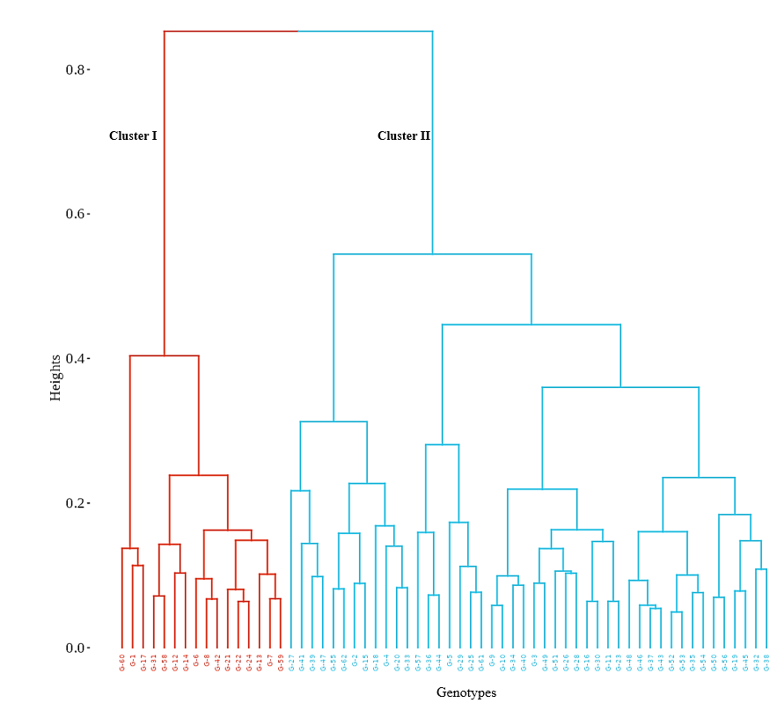
Figure 1. Hierarchical cluster dendrogram of black pepper genotypes grouping based on morpho-physiological variation

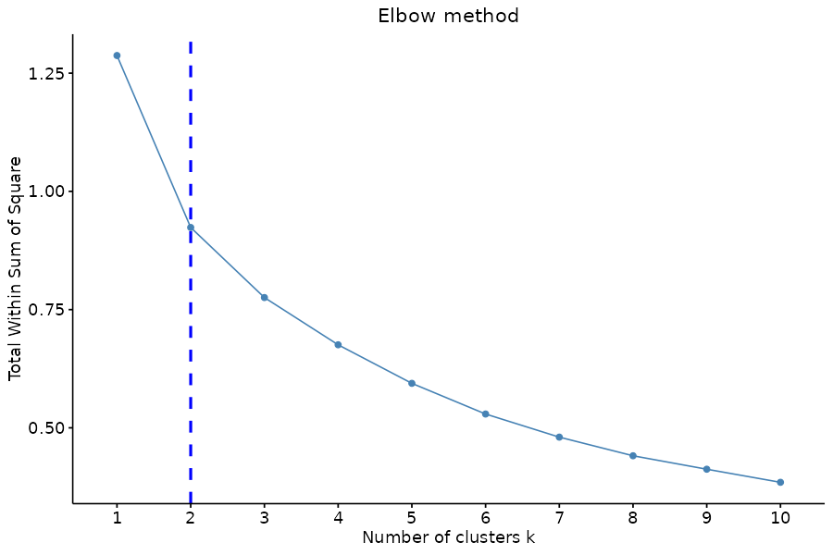
Figure 2. Elbow method showing ideal cluster size

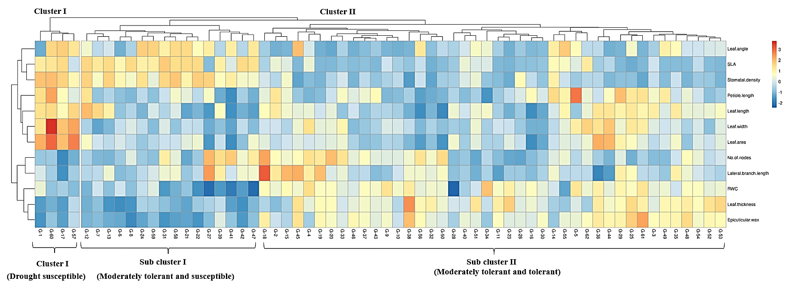

Figure 3. Heatmap and hierarchical clustering of 62 black pepper genotypes evaluated in farmers’ field conditions based on morphological and physiological traits. Colours represent z-score–transformed values of the measured traits

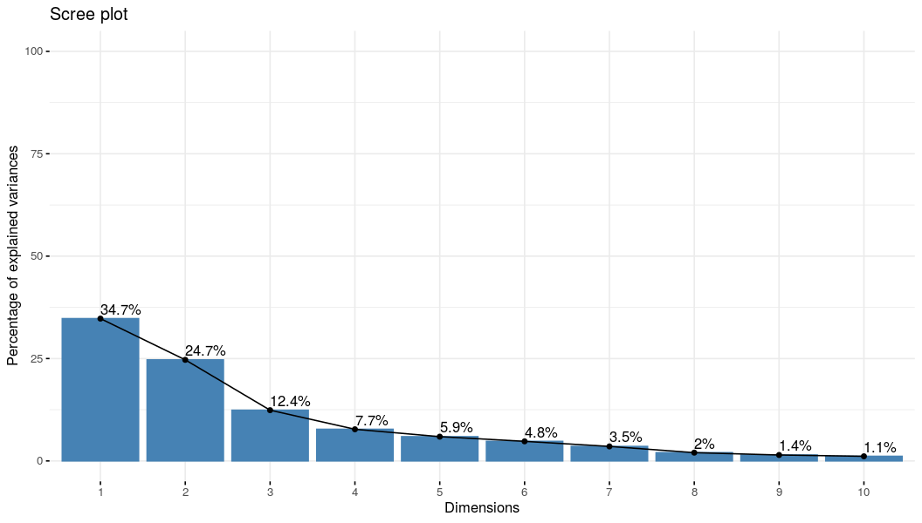
Figure 4. Scree plot showing variance explained by principal components
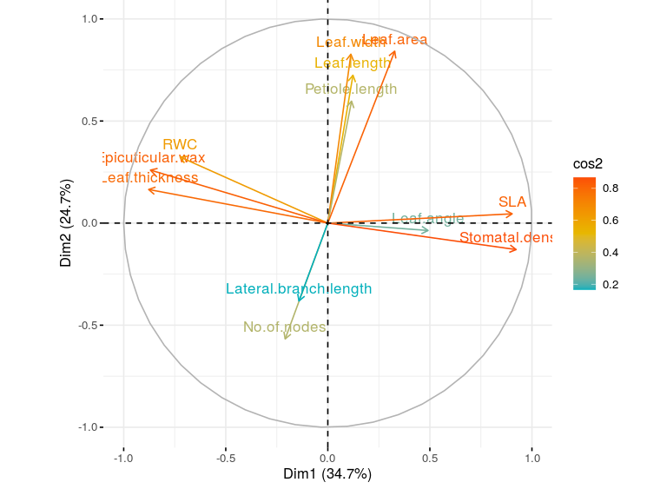
Figure 5. Variable plot of PCA displaying trait associations with drought adaptation
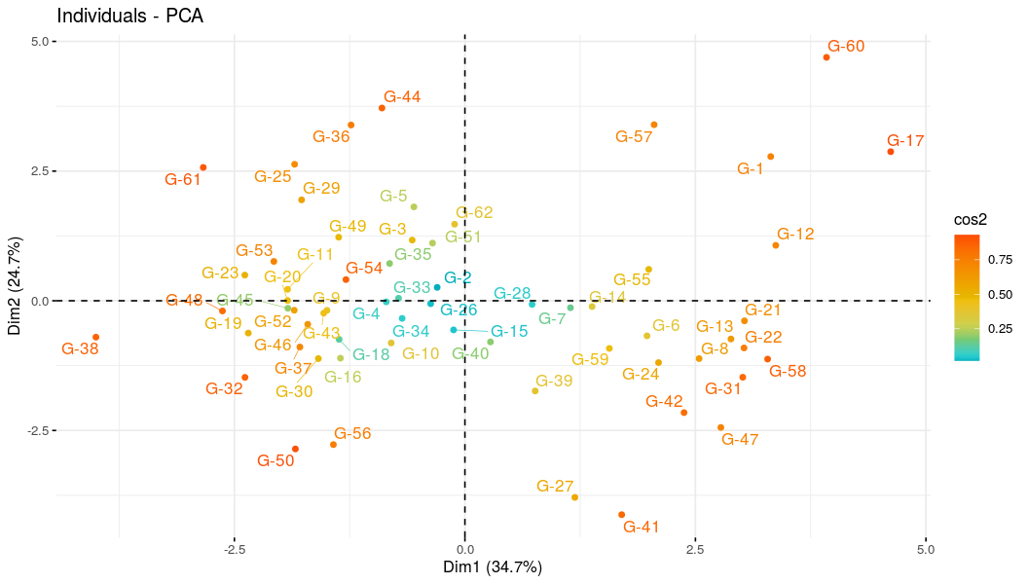
Figure 6. Distribution of black genotypes on PC1 and PC2 based on morphological and physiological traits

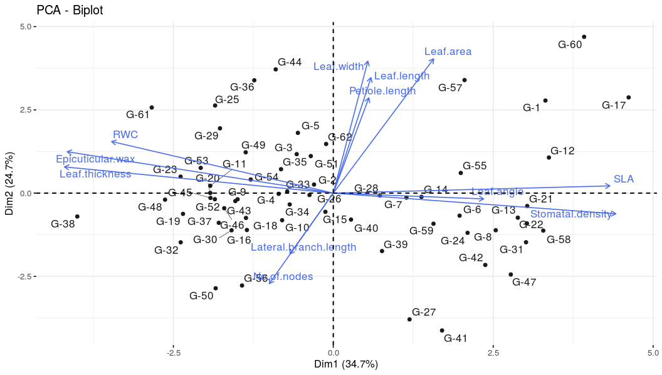
Figure 7. Biplot showing the distribution of black genotypes on PC1 and PC2 based on morphological and physiological traits

Table 1. Summary of minimum, maximum, mean, standard deviation and coefficient of variation for morpho-physiological traits in black pepper
Parameter | Minimum | Maximum | Mean | Standard deviation | Coefficient of variation
Number of nodes | 2.62 | 40.81 | 19.07 | 9.34 | 0.49
Lateral branch length | 15.26 | 73.55 | 36.45 | 11.46 | 0.31
Leaf length | 7.53 | 18.52 | 12.69 | 2.89 | 0.23
Leaf width | 4.67 | 15.43 | 7.48 | 2.09 | 0.28
Petiole length | 0.38 | 3.93 | 1.70 | 0.77 | 0.45
Leaf area | 33.67 | 173.82 | 84.23 | 29.24 | 0.35
Leaf thickness | 0.15 | 0.76 | 0.39 | 0.14 | 0.36
Specific leaf area | 84.93 | 480.33 | 200.46 | 110.20 | 0.55
Relative water content | 83.35 | 94.97 | 89.90 | 2.70 | 0.03
Epicuticular wax | 0.13 | 0.72 | 0.39 | 0.14 | 0.37
Leaf angle | 93.33 | 155.00 | 115.48 | 16.90 | 0.15
Stomatal density | 23.33 | 126.67 | 68.18 | 30.00 | 0.44

Table 2. Eigenvalues and percentage of variance explained by the principal components
Principal component analysis | Eigen value | Percentage of variance | Cumulative percentage of variance
PC1 | 4.17 | 34.75 | 34.749
PC2 | 2.961 | 24.68 | 59.43
PC3 | 1.486 | 12.39 | 71.814
PC4 | 0.927 | 7.726 | 79.54
PC5 | 0.71 | 5.92 | 85.46
PC6 | 0.574 | 4.781 | 90.241
PC7 | 0.425 | 3.54 | 93.781
PC8 | 0.242 | 2.018 | 95.799
PC9 | 0.173 | 1.445 | 97.244
PC10 | 0.135 | 1.128 | 98.372
PC11 | 0.114 | 0.951 | 99.324
PC12 | 0.081 | 0.676 | 100

Table 3. Loadings of morpho-physiological variables on the first three principal components
Variable | PC1 | PC2 | PC3
Number of nodes | 0.10 | –0.33 | 0.55
Lateral branch length | 0.07 | –0.22 | 0.69
Leaf length | –0.06 | 0.42 | 0.24
Leaf width | –0.06 | 0.48 | 0.19
Petiole length | –0.06 | 0.35 | 0.22
Leaf area | –0.16 | 0.49 | 0.14
Leaf thickness | 0.43 | 0.10 | –0.04
Specific leaf area (SLA) | –0.44 | 0.03 | –0.04
Relative water content (RWC) | 0.35 | 0.19 | –0.06
Epicuticular wax | 0.43 | 0.15 | 0.12
Leaf angle | –0.24 | –0.02 | 0.18
Stomatal density | –0.45 | –0.08 | 0.06

Table 4. Percentage contribution of morpho-physiological traits to the first three principal components
Variable | PC1 | PC2 | PC3
Number of nodes | 1.05 | 10.87 | 30.52
Lateral branch length | 0.48 | 4.91 | 47.30
Leaf length | 0.36 | 17.71 | 5.74
Leaf width | 0.31 | 23.11 | 3.72
Petiole length | 0.32 | 12.05 | 5.00
Leaf area | 2.58 | 23.95 | 2.03
Leaf thickness | 18.48 | 0.91 | 0.20
Specific leaf area | 19.57 | 0.07 | 0.13
Relative water content | 12.56 | 3.54 | 0.32
Epicuticular wax | 18.11 | 2.27 | 1.34
Leaf angle | 5.78 | 0.04 | 3.39
Stomatal density | 20.41 | 0.57 | 0.31

Table 5. Correlation coefficients of morpho-physiological traits with the first three principal components
Variables | PC1 | PC2 | PC3
Number of nodes | –0.21 | –0.57 | 0.67
Lateral branch length | –0.14 | –0.38 | 0.84
Leaf length | 0.12 | 0.72 | 0.29
Leaf width | 0.11 | 0.83 | 0.24
Petiole length | 0.12 | 0.60 | 0.27
Leaf area | 0.33 | 0.84 | 0.17
Leaf thickness | –0.88 | 0.17 | –0.05
Specific leaf area | 0.90 | 0.05 | –0.04
Relative water content | –0.72 | 0.32 | –0.07
Epicuticular wax | –0.87 | 0.26 | 0.14
Leaf angle | 0.49 | –0.04 | 0.22
Stomatal density | 0.92 | –0.13 | 0.07

