Original Research Article

Spatio Temporal Assessment of Vegetation Dynamics Using NDVI in the Mann River Watershed, Maharashtra

.
ABSTRACT

Aims: To assess decadal vegetation dynamics in the semi-arid Mann River watershed, Maharashtra, by analysing changes in NDVI-based vegetation density between 2013 and 2022, and to evaluate the effectiveness of NDVI as a long-term vegetation monitoring tool.
Study design: A remote-sensing based comparative temporal analysis using satellite-driven NDVI classification for two time periods (2013 and 2022).
Place and Duration of Study: Mann River watershed, Maharashtra, India. The study utilized Landsat 8 imagery acquired for the years 2013 and 2022.
Methodology: Landsat 8 satellite images for 2013 and 2022 were processed to compute NDVI using the red and near-infrared (NIR) bands. NDVI values were reclassified into five vegetation density categories: water/non-vegetation (<0.00), very low (0.00–0.10), low (0.10–0.25), moderate (0.25–0.40), and dense vegetation (>0.40). Spatial distribution maps for both years were generated, followed by a change detection analysis to quantify transitions between vegetation classes. Class-wise areal extent (km²) and percentage cover were computed to identify temporal shifts in vegetation patterns.
Results: Sparse vegetation increased significantly from 1,723.64 km² (71.34%) in 2013 to 1,922.34 km² (79.57%) in 2022, indicating improved vegetation cover. Moderate vegetation decreased from 538.94 km² (22.31%) to 423.42 km² (17.53%), while dense vegetation showed a notable rise from 0.20 km² to 4.36 km². Bare land reduced from 125.45 km² (5.19%) to 49.93 km² (2.07%), and water bodies slightly declined from 27.78 km² (1.15%) to 15.96 km² (0.66%). Overall trends indicate a positive shift in vegetation vigor over the decade, likely supported by improved agricultural practices, watershed development interventions, and natural regeneration.
Conclusion: NDVI-based assessment proved effective for detecting long-term vegetation changes in semi-arid environments. The observed improvement in vegetation density from 2013 to 2022 highlights successful watershed and land management initiatives in the Mann River watershed. NDVI remains a cost-effective and reliable indicator for guiding sustainable ecological and land-use planning.

Keywords: Vegetation dynamics; Remote sensing; Semi-arid ecosystems; Spatio-temporal analysis;

1. INTRODUCTION

Vegetation plays a vital role in maintaining ecological balance, regulating the hydrological cycle, and sustaining agricultural productivity, particularly in semi-arid regions. Monitoring vegetation condition and its temporal dynamics is essential for understanding ecosystem functioning and evaluating the impacts of both natural and anthropogenic processes. Variations in vegetation cover often reflect changes in climatic conditions, soil moisture availability, and land management practices, making vegetation indices valuable indicators of environmental health and ecosystem resilience (Pettorelli et al., 2005). Among these indices, the Normalized Difference Vegetation Index (NDVI), first proposed by Tucker (1979), has emerged as one of the most widely used tools for assessing vegetation greenness, density, and vigor. NDVI utilizes the spectral reflectance characteristics of vegetation in the red and near-infrared (NIR) bands to quantify photosynthetic activity. Because of its simplicity, computational efficiency, and compatibility with multispectral satellite data, NDVI has become an indispensable method for large scale and long term vegetation monitoring (Justice et al., 1985). Remote sensing based NDVI analysis enables the detection of spatial and temporal variations in vegetation health, providing insights into ecological processes such as drought effects, land degradation, and vegetation regeneration (Anyamba & Tucker, 2005). In the context of India’s semi-arid regions, where vegetation dynamics are highly influenced by erratic rainfall patterns, land-use pressure, and limited water availability, NDVI serves as a robust diagnostic tool for assessing environmental sustainability and identifying early signals of ecosystem stress.
For the region like Vidarbha in Maharashtra State of India, where precipitation is very uncertain and nearly 89% of the cultivated area is under rainfed farming there is need for development in the micro-watershed area. (Dongardive et al., 2018). Water has become a scarce resource here not only due to deficient rainfall but also due to over-exploitation of groundwater. (Ramamohan Reddy et al., 2013). In this region sustainable crop production and water resources development planning is must (Patode et al., 2016).The Mann River watershed, situated in the Akola and Buldhana districts of Maharashtra, exemplifies a semi-arid landscape dominated by seasonal agriculture, scattered scrub vegetation, and expanding built-up areas. Understanding spatial and temporal changes in vegetation patterns across this watershed is crucial for evaluating ecological stability and supporting sustainable land and water resource management efforts. NDVI, calculated from the red and near-infrared spectral bands of satellite imagery, is widely recognized as a proxy for vegetation health and surface condition. It has been effectively applied to evaluate vegetation trends, assess land degradation, and detect zones of ecological transformation such as urbanization or deforestation (Sharma et al., 2021). Several studies have demonstrated NDVI’s utility in watershed scale vegetation monitoring and change detection. The present study focuses on a decadal assessment of vegetation dynamics in the Mann River watershed between 2013 and 2022. By analysing NDVI derived from Landsat satellite imagery for these two timeframes, the research aims to quantify vegetation change, identify spatial variations in greenness, and evaluate recent ecological trends within the watershed. The findings will contribute to understanding how vegetation has responded to climatic and developmental pressures during the past decade and will support better-informed decision-making for sustainable watershed management in semi-arid environments.

2. material and methods

2.1 Study Area

The study was conducted in the Mann river watershed located in the Akola and Buldhana districts of Maharashtra state, India. The watershed covers an approximate area of 2416 km² and is characterized by alluvial deposits and Deccan basalts. The Mann River basin falls within a semi-arid climatic zone, receiving reliable annual rainfall between 750 and 1050 mm, primarily during the monsoon season (June to September). The watershed is characterized by moderately deep, clayey soils. Over 75% of the basin is utilized for dryland farming. The area has witnessed significant land use transitions in recent decades due to urbanization, agricultural expansion, and deforestation, making it a suitable candidate for vegetation trend analysis. The location map of study area is presented in Fig. 1. 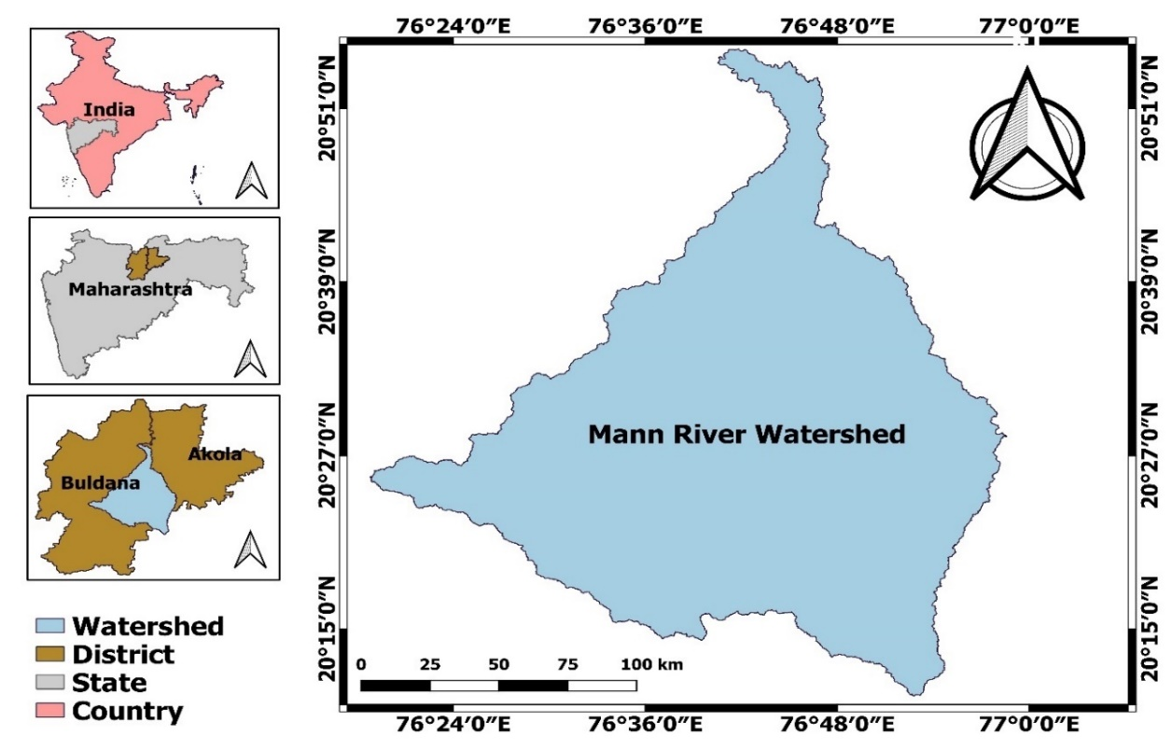 Fig. 1 Location map of Mann river watershed

2.2 Data Acquisition
Multi-temporal satellite data were acquired from the United States Geological Survey (USGS) Earth Explorer portal (https://earthexplorer.usgs.gov/). The details of the datasets used are presented in Table 1.
Table 1 Details of the datasets used
Satellite | Sensor | Resolution | Year | Bands Used (for NDVI)
Landsat 8 | OLI/TIRS | 30 m | 2013 | Band 5 (NIR), Band 4 (Red)
Landsat 8 | OLI/TIRS | 30 m | 2022 | Band 5 (NIR), Band 4 (Red)

2.3 Image Pre-processing and NDVI Derivation
The following image processing steps were carried out in ArcGIS 10.8 using multi-temporal Landsat datasets to ensure radiometric consistency and spatial alignment prior to NDVI computation. Also all the data were projected first, to the UTM coordinate system (Zone 43N, WGS 84 datum)
2.3.1 Layer Stacking
Landsat images downloaded from USGS Earth Explorer are typically provided as separate band files. These were stacked to create a single multi-band image using the Composite Bands tool:
Arc Toolbox → Data Management Tools → Raster → Raster Processing → Composite Bands
Input: Selected bands for NDVI (Red and NIR)
Output: Multi-band raster for NDVI computation
2.3.2 Image Sub setting (Clipping)
The composite image was clipped to the boundary of the watershed using the Extract by Mask tool:
Arc Toolbox → Spatial Analyst Tools → Extraction → Extract by Mask
Input Raster: Composite image
Input Feature Mask: Watershed shapefile
Output: Clipped raster for study area

2.4 NDVI Computation
NDVI was calculated using the Raster Calculator:
ArcToolbox → Spatial Analyst Tools → Map Algebra → Raster Calculator
The NDVI was calculated for each year using the formula:
NDVI = (NIR - Red) / (NIR + Red)
Where:
NIR = Near-infrared reflectance (Band 5 for Landsat 8)
Red = Red reflectance (Band 4 for Landsat 8)
The index values typically range from −1 to +1, where positive values correspond to vegetated areas and negative values represent non-vegetated or water surfaces.
2.5 NDVI Classification
The NDVI raster was classified into vegetation condition categories using Reclassify tool:
Arc Toolbox → Spatial Analyst Tools → Reclass → Reclassify
The derived NDVI rasters were reclassified into five distinct vegetation density categories as shown in Table 2 Pixels with NDVI values below 0.0 were categorized as Water/Non-vegetation, representing rivers, reservoirs, and built-up areas. The range 0.0–0.10 denoted Bare or Very Low Vegetation, typically corresponding to barren surfaces and dry fallow fields. NDVI values between 0.10 and 0.25 were classified as Low Vegetation, indicating sparsely vegetated scrub or degraded lands. The interval 0.25–0.40 represented Moderate Vegetation, primarily associated with agricultural areas and mixed vegetation types. Values exceeding 0.40 were classified as Dense Vegetation, characterizing forested regions or areas under intensive cultivation. These thresholds were adapted from published NDVI classification studies (Dalezios et al., 2001; Thorat et al., 2015; Bisrat & Berhanu, 2018) and adjusted according to the observed NDVI range in the watershed. The reclassification provided a more interpretable representation of vegetation cover and its temporal change across the study period.
Table 2 NDVI Classification Ranges
NDVI Range | Vegetation Status / Land Cover | Description
-1.0 to 0.0 | Non-vegetated / Water bodies | Water, clouds, snow, or built-up areas
0.0 to 0.1 | Barren land / Rock / Sand | Very low or no vegetation
0.1 to 0.25 | Shrubs / Grasslands | Sparse vegetation
0.25 to 0.4 | Open grasslands / Dry vegetation | Moderate vegetation
0.4 to 1.0 | Dense vegetation / Forest | High vegetation cover
2.6 Change Detection
NDVI rasters from different years were subtracted using Raster Calculator to compute the NDVI difference.
NDVI Change = NDVI (2022) – NDVI (2013)
2.7 Final Map Preparation
The NDVI maps for 2013, and 2022 were generated to visualize the spatial distribution of vegetation and to quantify variations in greenness associated with land-use transitions. Symbology was applied to the NDVI raster layers using color ramps to enhance visual interpretation, where shades of green represented areas with high NDVI values (dense vegetation) and shades of red indicated low NDVI values (sparse or no vegetation). The final thematic maps were then prepared using the Layout View feature in ArcGIS 10.8, ensuring a clear presentation of spatial patterns across the study area.

3. results and discussion

3.1 Normalized Difference Vegetation Index (NDVI) Maps
The Normalized Difference Vegetation Index (NDVI) maps of the Mann River watershed are presented in Fig. 2 and Fig. 3. In the present study, NDVI values varied between −0.14 to 0.45 in 2013, and −0.06 to 0.46 in 2022. The gradual shift in the NDVI range toward higher positive values over time indicates a progressive improvement in vegetation condition and an expansion of green cover in certain parts of the watershed. Conversely, localized decreases in NDVI values correspond to built-up expansion and the conversion of agricultural land to non-vegetated surfaces.
For a clearer interpretation of vegetation patterns, the NDVI rasters were reclassified into five distinct vegetation density categories, as discussed earlier. This reclassification provided a consistent framework for evaluating spatial variations in vegetation density and for assessing temporal changes across the study years. This classification provided a meaningful representation of vegetation density and enabled year to year comparison. By analysing the spatial distribution and areal extent of each class, temporal patterns of vegetation gain and loss were identified across the watershed. The results reveal that vegetative cover improved substantially between 1999 and 2013 due to scrub intensification and natural regeneration, while a marginal decline was observed in 2022 in areas affected by urban expansion and land degradation.
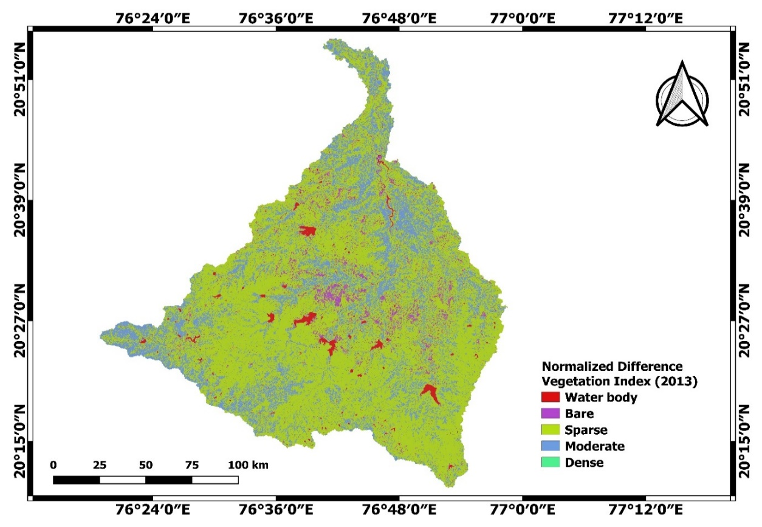Fig. 2 NDVI Map of Mann river watershed (2013)
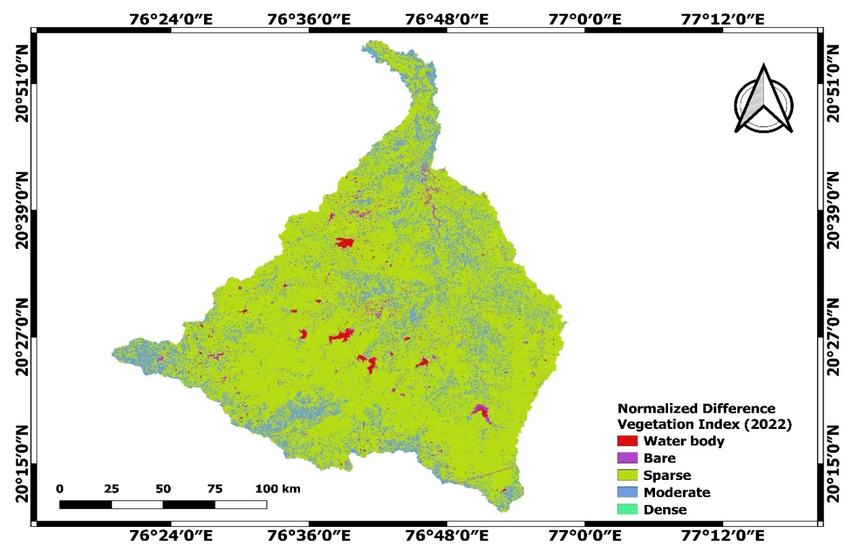Fig. 3 NDVI Map of Mann river watershed (2022)

3.2 NDVI Change Detection and Statistics (2013–2022)
Table 3 presents the NDVI change detection statistics for Mann river watershed for the study period 2013-2022. The NDVI-based change analysis between 2013 and 2022 revealed distinct spatial and temporal variations in vegetation density across the Mann River watershed. The reclassified NDVI maps show notable transitions in vegetation vigor, with areas of sparse and moderate vegetation exhibiting measurable fluctuations.
During this period, the sparse vegetation class expanded from 1,723.64 km² (71.34%) in 2013 to 1,922.34 km² (79.57%) in 2022, registering an overall increase of 8.22%. This indicates a general improvement in vegetation cover across the watershed, likely supported by enhanced agricultural practices and natural regrowth in certain sub-basins. Similar NDVI derived vegetation gains have been reported for semi-arid regions of Madhya Pradesh and Telangana (Singh et al., 2019; Patel & Kumar, 2020
Conversely, the moderate vegetation class decreased from 538.94 km² (22.31%) to 423.42 km² (17.53%), showing a 4.78% reduction, which may be attributed to land conversion or degradation in moderately vegetated zonesm such patterns are consistent with findings from the Godavari basin (Jha et al., 2018).
The dense vegetation category, though limited in spatial extent, showed a positive trend, increasing from 0.20 km² to 4.36 km², suggesting localized afforestation or riparian vegetation recovery, a response commonly observed following small scale watershed management interventions (Tripathi et al., 2017).
Meanwhile, bare areas declined from 125.45 km² (5.19%) to 49.93 km² (2.07%), reflecting an overall reduction in barren land due to expansion of sparse vegetation zones. consistent with similar NDVI based analyses by Rahman et al. (2020).
The water body class slightly reduced from 27.78 km² (1.15%) to 15.96 km² (0.66%), which can be attributed to sedimentation and seasonal drying of reservoirs as observed by Jain et al. (2013).
Overall, NDVI statistics between 2013 and 2022 demonstrate a net positive vegetation response, characterized by expansion of sparse vegetation and limited increase in dense vegetation. These patterns reflect gradual ecological recovery, although certain sub-basins experienced moderate vegetation loss linked to urbanization and land degradation
Table 3 NDVI change detection statistics for Mann river watershed
Class | Area (km²) |  | % cover |  | % change
Class | 2013 | 2022 | 2013 | 2022 | 2013-2022
Water body | 27.78 | 15.96 | 1.15 | 0.66 | -0.49
Bare | 125.45 | 49.93 | 5.19 | 2.07 | -3.13
Sparse | 1723.64 | 1922.34 | 71.34 | 79.57 | 8.22
Moderate | 538.94 | 423.42 | 22.31 | 17.53 | -4.78
Dense | 0.20 | 4.36 | 0.00 | 0.00 | 0.00
Total | 2416.0 | 2416.0 | 100 | 100

3.3 Spatial Interpretation of NDVI Changes (2013–2022)
The spatial comparison of NDVI maps for 2013 and 2022 (Fig. 2 and Fig. 3) reveals noticeable regional variations in vegetation distribution across the Mann River watershed. The central and northern parts of the watershed exhibit a significant expansion of sparse and moderately vegetated zones, reflecting progressive vegetation recovery and improved agricultural vigor. These areas correspond to sub basins where soil water conservation structures and rained cropping practices have become more prominent during the last decade.
In contrast, localized reductions in NDVI are evident in the southern fringes of Akola, primarily due to expansion of built-up areas and land degradation along transportation corridors. Bare and low NDVI zones visible in 2013 have substantially decreased by 2022, suggesting gradual natural regeneration and re-vegetation of degraded surfaces. However, a minor reduction in water spread areas and riparian vegetation indicates the influence of sedimentation, erratic rainfall, and reduced inflows in small reservoirs and tanks.
Overall, the spatial patterns highlight a transition from fragmented low NDVI zones to more cohesive vegetated patches, indicating improved ecosystem connectivity and resilience within the watershed.
3.4 Ecological Implications
The NDVI variations observed between 2013 and 2022 underscore the evolving ecological condition of the Mann River watershed. The expansion of sparse vegetation and localized dense patches indicates positive ecological responses to watershed development initiatives, such as check dam construction, farm ponds, and contour bunding, which have enhanced soil moisture retention and vegetation vigor.
The decline in moderate vegetation suggests localized ecological stress associated with agricultural intensification and urban sprawl. These transitions mirror patterns reported in other semi arid regions of India, where climatic variability, particularly erratic monsoon rainfall, amplifies vegetation fluctuations (Patel & Kumar, 2020).
Despite these challenges, the overall greening trend signifies partial ecosystem recovery and demonstrates the effectiveness of integrated watershed management in semi-arid environments. Sustained NDVI monitoring at finer temporal resolution, coupled with ground-based validation, is recommended to identify emerging degradation zones and to support adaptive management strategies that ensure long term ecological resilience of the Mann River basin.

4. Conclusion
The decadal NDVI assessment of the Mann River watershed (2013–2022) demonstrates that remote sensing based vegetation indices serve as powerful tools for monitoring ecological change in semi-arid environments. The spatial variations in NDVI reflect a dynamic balance between vegetation recovery and localized degradation driven by climatic variability and anthropogenic land use pressures. Overall, the findings indicate a gradual improvement in vegetation condition across the watershed, suggesting a positive ecological response to ongoing agricultural intensification, soil and water conservation initiatives, and natural regeneration processes. Nevertheless, the localized decline in moderate vegetation zones signals emerging stress possibly associated with unsustainable land-use practices, declining water availability, or urban expansion. These results underscore the importance of continuous vegetation monitoring to support adaptive watershed management. Integrating NDVI based analyses with hydro climatic and socioeconomic datasets can provide deeper insights into the drivers of vegetation change and help prioritize areas for conservation, reforestation, and sustainable agricultural planning. Sustained NDVI monitoring will therefore remain essential for guiding evidence-based policy interventions and ensuring the long-term ecological resilience of the Mann River watershed.

References

- Anyamba, A., & Tucker, C. J. (2005). Analysis of Sahelian vegetation dynamics using NOAA-AVHRR NDVI data from 1981–2003. Journal of Arid Environments, 63(3), 596–614. https://doi.org/10.1016/j.jaridenv.2005.03.007

- Bisrat, S. A., & Berhanu, T. (2018). Assessment of land use/land cover dynamics and its impact on vegetation using NDVI in Ethiopian highlands. Journal of Remote Sensing and GIS, 7(2), 1–10.
- Dongardive, M. B., Patode, R. S., Nagdeve, M. B., Gabhane, V. V., & Pande, C. B. (2018). Water resources planning for the micro watersheds using geospatial techniques, International Journal of Chemical Studies, 6(5), 2950-2955.

- Dongardive, M. B., Patode, R. S., Nagdeve, M. B., Gabhane, V. V., & Pande, C. B. (2018). Water resources planning for the micro watersheds using geospatial techniques. International Journal of Chemical Studies, 6(5), 2950-2955. https://www.chemijournal.com/vol6issue5/6-5-10-100.pdf

- Jha, C. S., Goparaju, L., Tripathi, A., & Singh, J. S. (2018). Vegetation dynamics and land-use changes in central Indian watersheds using NDVI and Landsat data. Ecological Indicators, 95, 36–47.

- Justice, C. O., Townshend, J. R. G., Holben, B. N., & Tucker, C. J. (1985). Analysis of the phenology of global vegetation using meteorological satellite data. International Journal of Remote Sensing, 6(8), 1271–1318. https://doi.org/10.1080/01431168508948281

- Jha, C. S., Goparaju, L., Tripathi, A., & Singh, J. S. (2018). Vegetation dynamics and land-use changes in central Indian watersheds using NDVI and Landsat data. Ecological Indicators, 95, 36–47. https://doi.org/10.1016/j.ecolind.2018.07.029

- Patode, R. S., Nagdeve, M. B., & Pande, C. B. (2016). Groundwater level monitoring of Kajaleshwar-Warkhed watershed Tq. Bashitakli Distt. Akola. Advances in Life Sciences, 5(24),11207-11210.
- Justice, C. O., Townshend, J. R. G., Holben, B. N., & Tucker, C. J. (1985). Analysis of the phenology of global vegetation using meteorological satellite data. International Journal of Remote Sensing, 6(8), 1271–1318 https://doi.org/10.1080/01431168508948281

- Rahman, A., Gupta, P. K., & Sinha, S. (2020). Spatio-temporal vegetation change detection using NDVI and LULC correlation in semi-arid environments. Journal of Environmental Management, 270, 110858.
- Reddy, K. R., & Patode, R. S. (2013). Assessment of groundwater quality - A case study of Kondapur mandal, Medak district, Andhra Pradesh. Current World Environment, 8(2), 267-273. https://doi.org/10.12944/CWE.8.2.12

- Saxena, D., Choudhary, M., & Sharma, G. (2023). Land use and land cover change impact on characteristics of surface evapotranspiration in semi-arid environment of Western Rajasthan, India. Water Practice & Technology, 19(1), 154–169. https://doi.org/10.2166/wpt.2023.222

- Pettorelli, N., Vik, J. O., Mysterud, A., Gaillard, J.-M., Tucker, C. J., & Stenseth, N. C. (2005). Using the satellite-derived NDVI to assess ecological responses to environmental change. Trends in Ecology & Evolution, 20(9), 503–510. https://doi.org/10.1016/j.tree.2005.05.011

- Tripathi, S., Shukla, R., & Gupta, M. (2017). Impact of watershed management practices on vegetation greenness using NDVI time-series analysis. Environmental Monitoring and Assessment, 189(6), 269.

- Tucker, C. J. (1979). Red and photographic infrared linear combinations for monitoring vegetation. Remote Sensing of Environment, 8(2), 127–150. https://doi.org/10.1016/0034-4257(79)90013-0

