Review Article
Exploring the Frontiers of Extended Range Weather Forecasting in Indian Agriculture: A Review of the Current Status and Future Development

Abstract
The prediction of weather is crucial to both science and society. Extended range weather forecasting (ERWF) bridges the critical gap between medium-range and long-term seasonal forecasts, offering valuable insights into weather conditions over 10-30 days. Explicitly, the ERWF is crucial for the agriculture, energy, and public health sectors. The objective of this review paper is to highlight the latest research achievements on ERWFs and their advancements. A significant operational milestone for Indian monsoon forecasts and extreme events is the need to improve predictability beyond the medium range at the subdivisional level. As a result, an ERWF can be used in a wide range of fields to meet stakeholder needs based on weather and climate projections. The incorporation of ERWF products into crop models significantly improves crop yield prediction accuracy and helps stakeholders make informed decisions for effective climate risk management. To facilitate tactical adjustments to strategic decisions based on longer-lead seasonal forecasts, it is imperative to forecast the monsoon break at the extended range time scale two to four weeks in advance. This will also aid in the timely review of the current monsoon conditions to provide farmers with outlooks.
Keywords: ERWF; Weather Forecasting; Climate Change; Intraseasonal variations; Indian Monsoon

Introduction
Climate change has caused extensive damage and progressively irreversible losses in terrestrial (Grimm et al., 2013; Bardford and Warren, 2014; Warren et al., 2021; Harrison et al., 2024), freshwater (Woodward et al., 2010; Liu et al., 2015; Singh et al., 2021; Orr et al., 2024), cryosphere (Ding et al., 2021; Wang, 2024), and coastal and ocean ecosystems (Zhang et al., 2024; IPCC, 2023) and affects ecosystems at several levels (Weiskopf et al., 2020). Increasingly compelling research suggests that reinforced forecasts and finer utilization of forecasts (Brunet et al., 2023) are affordable ways to lessen the damage caused by extreme weather and climate change (Tada et al., 2021). Given the close connection between extreme weather and climate change (Stott et al., 2016; Ai et al., 2024), weather forecasting investments are anticipated to play a significant role in climate adaptation (Worldbank.org, 2023). The application of science and technology to forecast the weather for a specific location over a period of time is known as weather forecasting (Didal et al., 2017) and uses different weather parameters (Khajure and Mohod, 2016; Jaseena and Kavoor, 2022), which are likely to occur. There are various temporal and spatial domains for which weather forecasts are provided. Venue, city, district, state, and country are examples of the spatial domain; each has a distinct temporal domain. According to their validity periods, the temporal domains are as follows: (i) Now casting (Banbura et al., 2013, Ravuri et al., 2021), which is a few hours ahead (0–2 hrs); (ii) very short range (3–12 hrs); (iii) short range (Sarma and Kakoti (2024); Mamgain et al., 2024), which is up to three days (12 hrs–3days); (iv) medium range weather forecast (MRWF) (Kumar et al., 2000; Prasad et al., 2024), which is three to ten days; (v) extended range weather forecast (ERWF) (Zhen g et al., 2013; Zhu and Li, 2017; Pattanaik et al., 2017; Pattanaik et al., 2019; Kumar et al., 2022), which is ten days to one month, the large-scale state will be captured by the ERWF before the event occurs for approximately ten days; and (vi) long-range or seasonal, which is months to an entire season (Gouda et al., 2018; Mohanty et al., 2019; Madolli et al., 2022; SOP, IMD), (v) Sub seasonal (2 weeks to 2 months) (Vitart et al., 2012; Robertson et al., 2020; White et al., 2021; 2022; Fu et al., 2024) and Climate forecast (Figure 1).
The numerical weather prediction (NWP) approach (Lorenc, 1987; Kimura, 2002; Brotzge et al., 2023), which depicts atmospheric states as discretized grids and solves partial differential equations computationally to characterize the transition between those states, is currently the most accurate forecast system (Kumar et al., 2006; Mengaldo et al., 2019; Pu and Kalnay, 2019). Nevertheless, the computational cost of this process is high. Although artificial intelligence (AI)-based techniques have recently demonstrated the ability to expedite weather forecasting by orders of magnitude, their forecast accuracy still lags well behind NWP techniques (Pathak et al., 2022). It is the greatest of any field of physical science (Bauer et al., 2015).
The Indian Institute of Tropical Meteorology (IITM) has initiated real-time experimental ERWF and the operational ERF system by the IMD, which forecasts four weeks starting every Wednesday and aids policymakers and farmers by optimizing planting and harvesting practices while enabling timely assessments of monsoon conditions in India. According to the IMD, a significant breakthrough in global weather forecasting will be the development of the ERWF. The present review highlights the development of ERWFs and how this advancement might be helpful to individuals in various industries and sectors in India.
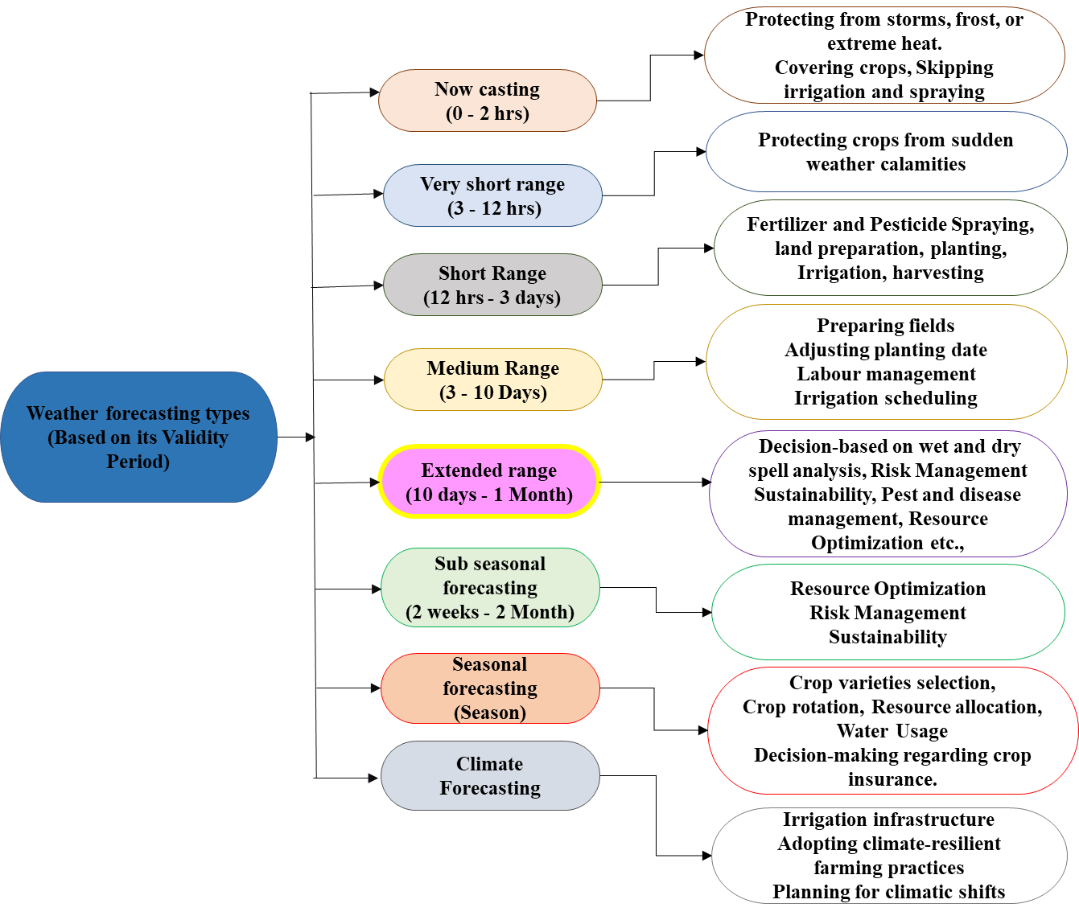
Figure 1: Weather Forecasting Types and their Application in the Agricultural Sector
Weather forecasting and its importance in a changing climate
Weather refers to the state of the atmosphere at a specific location and time (noaa.gov; Amin and Mourshed, 2024), and forecasting uses past data to estimate unknown future conditions. Weather forecasting, a key area of scientific computing, aims to predict changes, particularly extreme events (Lynch, 2008). Despite these advances, it remains a complex, evolving challenge (Bihlo, 2021; Jain and Mallick, 2016). Weather forecasts impact all sectors, including agriculture, tourism, and energy (Jaseena et al., 2022). Climate change, driven by human activity and natural forces, exacerbates extreme events such as heatwaves and floods, posing significant threats, especially to vulnerable regions such as India (Krishnan et al., 2020; IPCC, 2023). Accurate forecasting is crucial for mitigating these impacts and supporting various industries (Chen et al., 2023; Pujahari et al., 2022).
Scope and potential of the ERWF
One of the most difficult challenges in the atmospheric sciences is generating ERWFs for tropical regions. The void left by the MRWF and seasonal forecasting is filled by the ERWF, which produces forecasts for periods of ten to thirty days. The value of MRWFs in Indian agriculture has been demonstrated by numerous studies (Rao et al., 1996; Kumar et al., 2000; Rathore et al., 2001; Chauhan et al., 2008; Sikka, 2009; Rana et al., 2013; Prasad et al., 2014; Chattopadhyay et al., 2016; Neal et al., 2022; Mahopatra et al., 2022). There has been a relatively limited amount of research conducted in the field of ERWFs.
The ERWF time scale is undoubtedly challenging for weather forecasting because it is long enough to erode much of the memory of the initial atmospheric conditions, but it is also too short for the monthly mean time average to be large enough to enable the atmospheric signal related to the ocean anomalies to stand out above the atmospheric noise. Statistical and numerical models have advanced to anticipate weather beyond the medium range, increasing the prediction horizon to 2-3 weeks in the ERWF system (Abhilash et al., 2014; Waliser et al., 2003; Borah et al., 2015; Sahai et al., 2013, 2015). The possibility of ERWFs has been investigated in several studies utilizing various techniques and models. The operational forecasting strategy of the IMD involves predicting synoptic variability and intraseasonal oscillations (ISOs), which are vital for various stakeholder applications. An accurate ERWF benefits not only agriculture but also reservoir management during floods. These forecasts focus on meteorological factors such as rainy days and agricultural risks, such as high winds and extended dry or wet spells. Typically, when reliable for 5 to 7 days with 60% to 70% accuracy, they assist farmers in making critical decisions about sowing times, planting depths, harvesting schedules, and the application of insecticides and nutrients, ultimately maximizing crop yields (Sarma and Kakoti, 2024). Numerous industries, including agriculture, additionally utilize this type of forecast. The primary purpose of this type of prediction is to provide a sense of deviation from the normal (Figure 2).
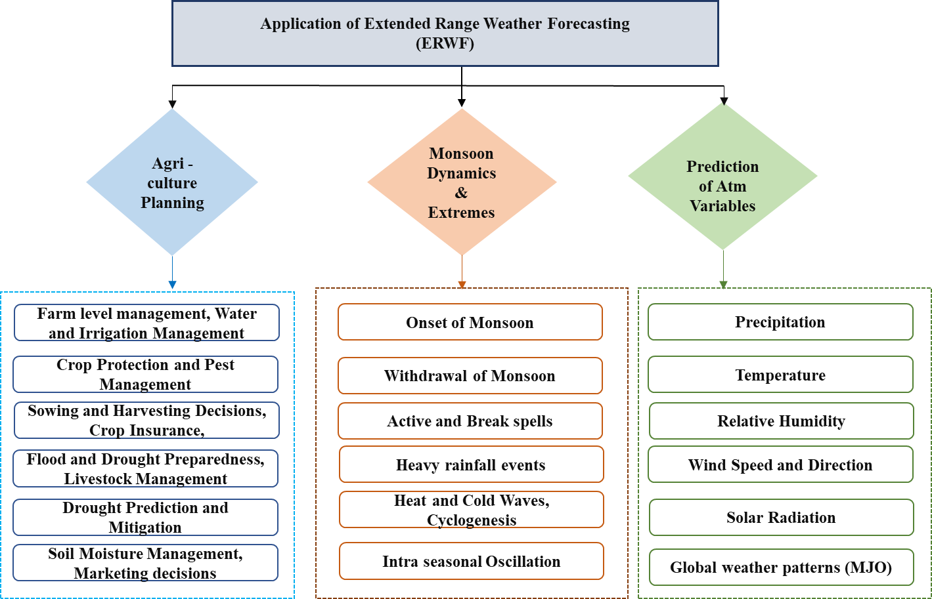
Figure 2: Application of the ERWF
Need and the Imperative for Extended Range Weather Forecasting in a Climate-Responsive World
The production of ERWFs for the tropics, with a timescale ranging from one week to nearly a month, is among the most challenging tasks in the atmospheric sciences. Two-- to three-week forecasts are essential for sectors such as water resources, urban planning, and health management, allowing for effective disaster preparation (Sahai et al., 2016). Feedback from farmers highlights the importance of the ERWF in improving agricultural productivity and managing weather-related uncertainties (Chattopadhyay et al., (2018)). Agro-meteorological advisory services (AASs) are currently offered by the IMD of the Ministry of Earth Sciences in India to help farmers maximize the use of natural resources and increase agricultural productivity. However, it is becoming increasingly important to provide climatological data along with extended range and seasonal weather forecasts before and during the cropping season to adapt the agricultural system to increasing weather variability. The ERWF can predict cyclones a week in advance, aiding administrative readiness. Flood management agencies seek detailed forecasts and require education on probabilistic predictions. Combining rainfall climatology with the ERWF can optimize water storage and release, preventing droughts and floods (Pattanaik and Das, 2015). Therefore, two to four weeks in advance, forecasting monsoon breaks in the extended range time scale is critical for agricultural planning (sowing, harvesting, etc.) and crop stage-specific management (Chattopadhyay et al., 2018). This can facilitate fast assessment of the current monsoon conditions, give farmers outlooks, and allow tactical adjustments to strategic decisions based on longer-lead seasonal projections. The ERWF is gaining significance globally as well. In Finland, a survey indicated a public interest in tailored ERWFs for daily planning and weather risk management (Ervasti et al., 2018). Overall, ERWFs are crucial for agriculture, water management, urban planning, energy, tourism, and health, influencing policymaking (Joseph et al., 2019). The 2017 - 18 ERWF in Cuttack, Odisha, showed notable accuracy between the observed and forecasted temperatures and rainfall, highlighting the growing demand for longer-term monsoon forecasts. Compared with MRWFs, these forecasts benefit agriculture and reservoir management by reducing flood risk and meeting high-quality verification standards (Nayak et al., 2022).
Historical Perspectives and Evolution of Extended Range Weather Forecasting in India
Compared with the short–medium and seasonal prediction systems, the IMD's ERWF system is unique and has a significant history. There were three drought years in the first ten years of the twenty-first century: 2002, 2004, and 2009. The extended dry spell in July 2002 (with a departure of -51%) and the seasonal rainfall departure of -19% across all of India were related to the drought year. This extended dry spell in July exceeded the capabilities of any model, and in the end, the seasonal projection for 2002 was equally erroneous. In a similar vein, the 2004 monsoon drought was linked to a protracted dry spell in July. These two drought years, followed quickly by protracted monsoon dry spells, were crucial in helping the IMD develop its real-time active-break monsoon cycle prediction.
However, it was exceedingly difficult to begin monsoon intraseasonal forecasting operationally because of the lack of appropriate instruments and the extremely low predictive ability. However, starting in 2008, the IMD began to produce operationally in-house temperature and precipitation forecast products on the basis of available model products from various centres in India and outside, taking into account the significance and demand of the ERWF. The available dynamical model outputs were also used for the same purposes once several empirical models were initially employed (Figure 3).

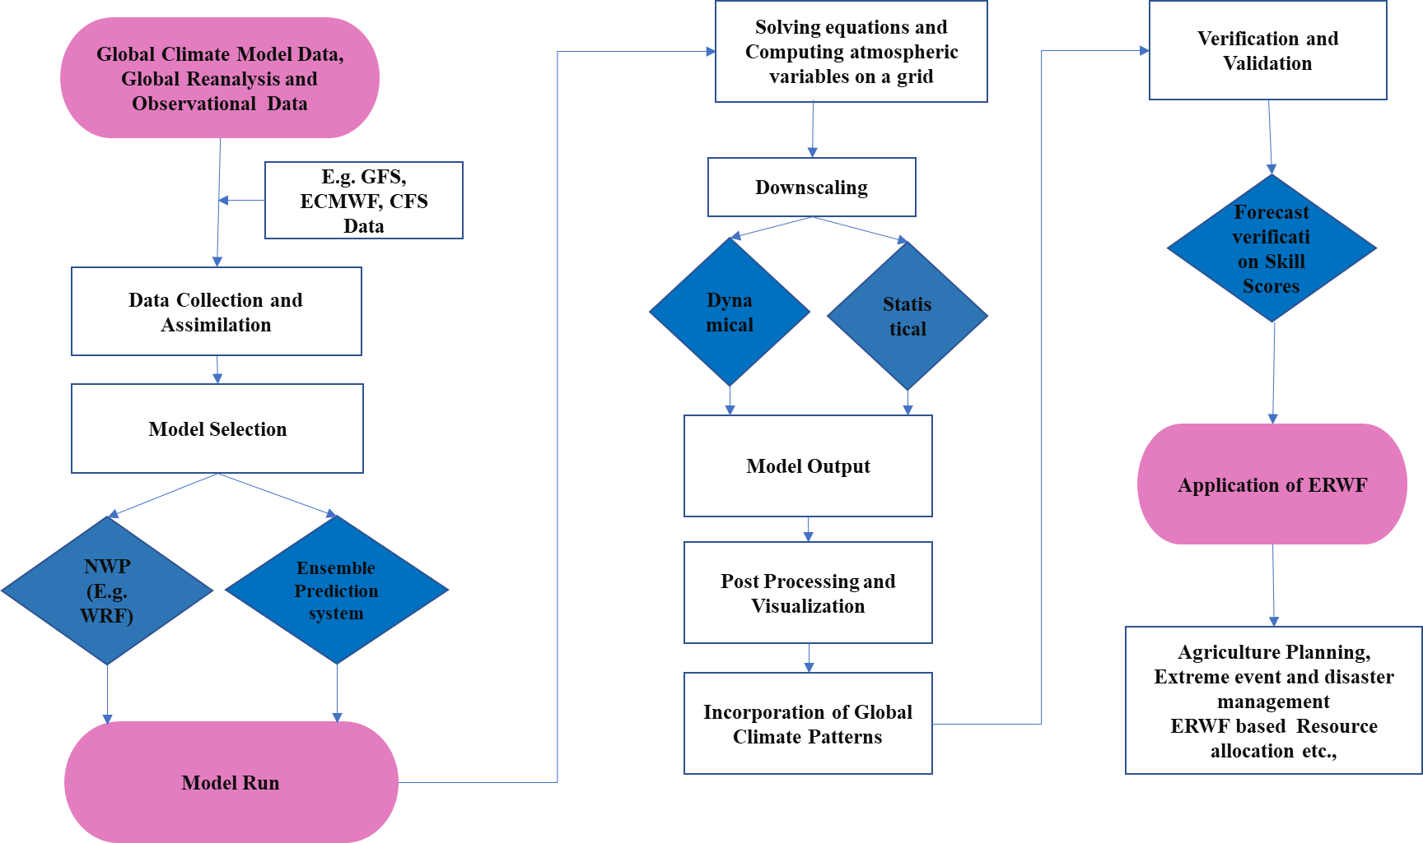
Figure 3: Development of the ERWF
Strategic Importance of the ERWF in India
Historically, monsoons have been viewed as large-scale, regional sea wind circulations caused by the contrast between land and sea temperatures (Loo et al., 2015; Geen et al., 2020, Gadgil et al., 2020; Zuo and Zhang, 2023). The Asian monsoon system (Ummenhofer et al., 2024; Ao et al., 2024; Lu et al., 2024; Chen et al., 2024) is the most vigorous, powerful (Hussain et al., 2024), robust and strongest climatic pattern (Tada et al., 2024) because of the size of the Asian continent and the high terrain of the Tibetan Plateau and the Himalayan Mountains, whose development is closely correlated with climate (Clift et al., 2022). It has three subcomponents: the Indian or South Asian and East Asian subsystems (Wang et al., 2005; Gupta et al., 2022; Li et al., 2024) and the Southeast Asian monsoon. In India, the two prominent monsoon seasons are the northeast monsoon (NEM) season (October–December (OND)) and the southwest monsoon (SWM) season (June–September (JJAS)) (Murty, 2021; Prasad et al., 2024; Ghosh et al., 2024; Williams et al., 2024). Except for the southeastern part of the peninsula, which encompasses the state of Tamil Nadu, the majority of the country experiences its highest rainfall during JJAS (SWM, also called the Indian summer monsoon (ISM)), which is a highly variable, interhemispheric ocean‒atmosphere‒land interaction that has a direct impact on the extremely populous Indian subcontinent (Bolton et al., 2013), followed by maximum rainfall occurring during OND during NEM. The country's northwest, central, and east regions occasionally experience heat waves from April to June (AMJ). From November to February (NDJF), most of these areas occasionally endure cold waves. With an extended window of time (i.e., 15 - 20 days in advance), the severe temperatures during AMJ (NDJF) and the rainfall during SWM, NEM are possibly predicted because of their general association with larger-scale meteorological phenomena, and the coupled general ensemble prediction system (CGEPS) MME has shown noticeable skill (Joseph et al., 2019). For a country such as India, agrometeorological advisories based on operable ERWFs are therefore extremely valuable economically (Pattanaik et al., 2022). The incorporation of ERP and ERFS forecast products into crop models significantly improves rice yield prediction accuracy and helps stakeholders make informed decisions for effective climate risk management.
Exploring intraseasonal variability (ISV) with the ERWF
The timescales over which interseasonal and intraseasonal fluctuations occur, as well as the phenomena they encompass, are the primary differences between them. Interseasonal variations occur between seasons, typically spanning several months to a year. Two well-known temporal oscillations in sea surface temperature (SST) are the El Niño Southern Oscillation (ENSO) and Indian Ocean Dipole (IOD), and it has been suggested that they both affect the interannual variability of the ISM (Pothapakula et al., 2020). These variations often involve large-scale climate patterns, such as ENSO (Chen et al., (2020), which can persist for several seasons and influence weather and climate over broad geographic regions. Other examples include the Arctic Oscillation (He et al., 2019) and the Indian Ocean Dipole (IOD) (Polonsky and Torbinsky, 2021).
The see-saw pattern formed by two out-of-phase convergence systems is known as the ISV. Along with this oscillation, anomalies in circulation features, including northward-propagating rainfall, are linked to the monsoon ISO (MISO). These oscillations result in alternating active and break monsoon conditions, with dry and rainy spells often lasting a week or more. Within a single season, ISO takes place, usually developing from a few weeks to several months. Short-term atmospheric processes and phenomena, such as the Madden‒Julian oscillation (MJO), which is typified by eastward-moving zones of enhanced and repressed tropical rainfall, are frequently involved in these changes (Lumbangaol et al., 2021). There is significant ISV in the ISM. The MJO has been found in previous research to be one of the main determinants of the ISV of monsoon rainfall (Pai et al., 2011). The regionality of the ISV oscillation, however, is another important component that determines the extended range prediction (ERP) skill. The ability of the model to reflect the ISO and related variabilities affects the forecast skill of the ERP (Abhilash et al., 2014) (Figure 4).
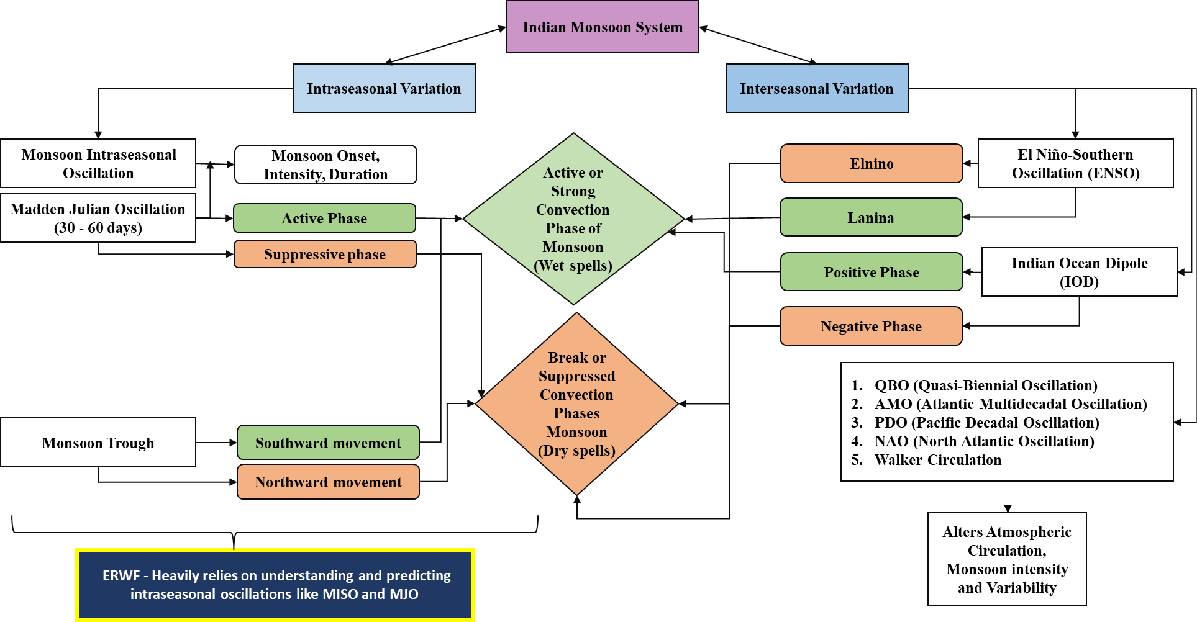
Figure 4: Indian monsoon system and variation in and impact of global weather patterns on the Indian monsoon system
The Indian Summer Monsoon and Its ISV
The ISM is one of the world’s most dynamic monsoon systems, delivering 75–90% of the annual rainfall (Parthasarathy et al., 1991). ISMR variability is driven by large-scale climate factors such as the MJO, IOD, and ENSO, which impact crop production (Ratna et al., 2024). An ERP of the SWM and the active break cycle is crucial for providing accurate advisories in India, where monsoon performance directly impacts agriculture (Pattanaik et al., 2022). The variability of the ISM impacts numerous public interest sectors, especially agriculture and water resources (Mohanty et al., 2019). Changes in ISM trends significantly affect millions of people reliant on agriculture, with a notable increase in the ISM in western India and a decrease in eastern India over the past 40 years (Yadav and Ramesh Kumar, 2024). Monsoon intraseasonal oscillation and its predictability via the ERWF were described by Seo et al. (2005), Klotzbach et al. (2006), Fu and Hsu (2011), Agudelo et al. (2009), Sahai et al. (2013; 2019), and Zhu et al. (2024), who highlighted the importance of the MISO.
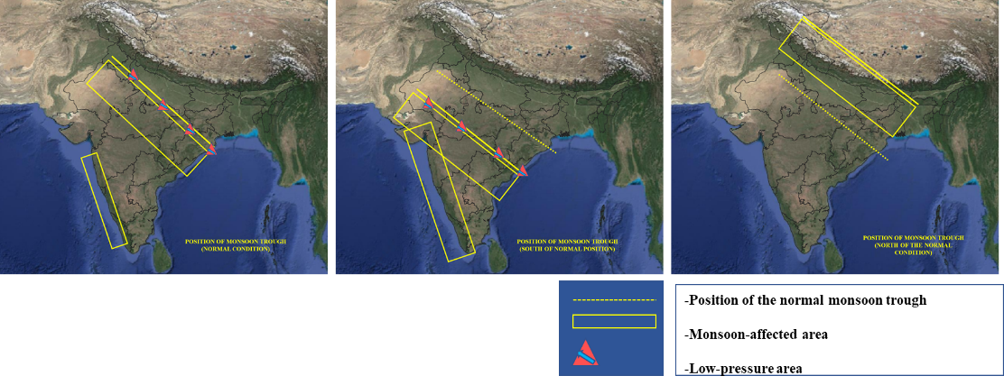
Figure 5: Monsoon Trough
Monsoon onset and its predictability
The onset of the ISM starting across Kerala is a critical and variable annual event (Rajan and Desamsetti, 2021). While state-of-the-art models can predict large-scale processes, their ability to forecast monsoon onset is currently limited to two to three weeks in advance (Pradhan et al., 2017). Monsoon onset impacts agriculture and planning, with early or late onset posing challenges (Aijaz, 2013). Accurate forecasting remains difficult, with current IMD forecasts offering a 21-day lead with ±4 days' accuracy. Predicting abrupt monsoon onset and withdrawal continues to be a challenge, especially because of false onset caused by nonmonsoonal systems (Flatau et al., 2001) (Figure 5).
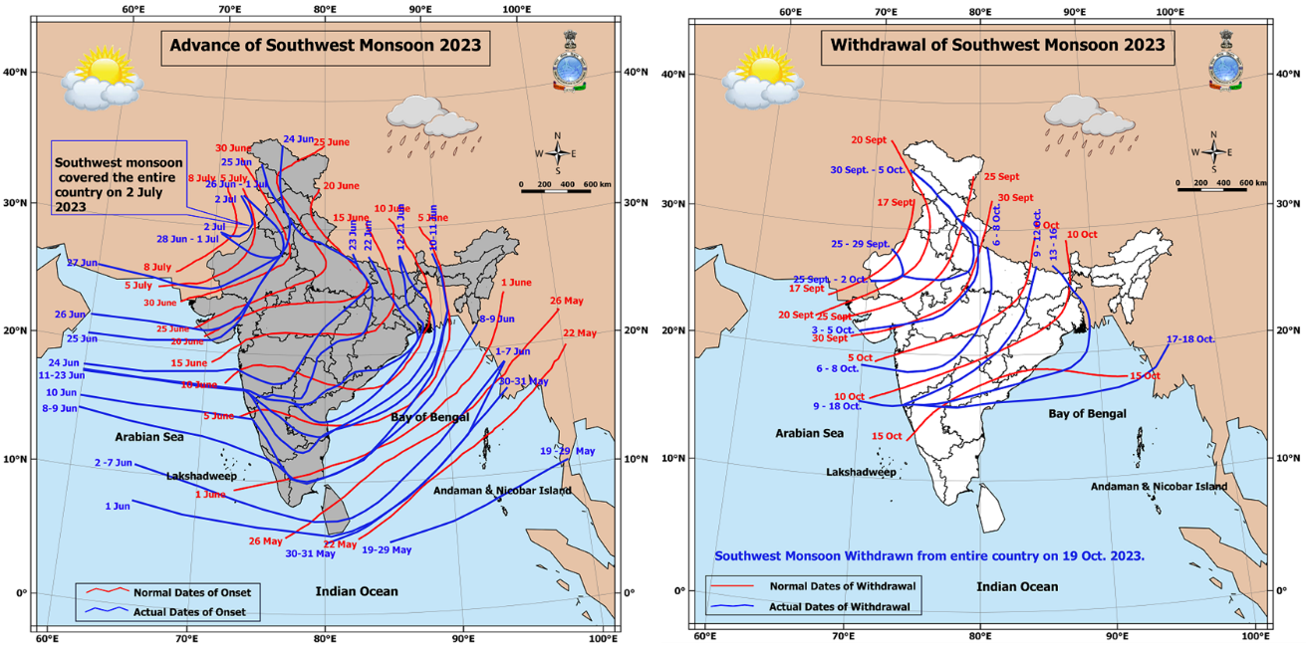
Figure 6: Onset and withdrawal (Picture Credit: imd.gov.in)
Prediction of the Active and Break Phases of the Indian Monsoon via Critical Analysis of the ERWF
The ERWF, which uses dynamic models and ensemble forecasting, can predict large-scale atmospheric patterns such as MISO, which influence active and break spells during the Indian monsoon. Abhilash et al. (2014) reported that the ISMR can reach 3--4 pentads in advance, with a predictability limit of approximately 15 days for precipitation. Probabilistic forecasts revealed a higher skill for active and break conditions than for normal categories, extending beyond the pentad 4 lead time. These forecasts are crucial for agricultural planning. The monsoon trough, a semipermanent feature stretching from Pakistan to the Bay of Bengal, plays a significant role in this dynamic, as its southward migration enhances monsoon strength, whereas northward movement can lead to breaks and heavy rainfall in northern regions (Goel et al., 1990; Feng et al., 2020). Skill analysis indicates that multimodel ensemble (MME) forecasts are effective at predicting these patterns at a broad scale (Sahai et al., 2019). Research has shown that the predictability of the Indian monsoon's active and break phases, associated with ISO variations, is also essential for accurate seasonal forecasting (Kulkarni et al., 2011). Goswami et al. (2003) predicted ISM active and break phases for agricultural planning, revealing that monsoon break predictability (∼20 days) is greater than that under active conditions (∼10 days). An empirical model demonstrates the feasibility of predicting monsoon breaks up to 18 days in advance. Borah et al. (2013) noted deterministic correlation skills of 0.47 and 0.43 for development and hindcast periods, respectively, while addressing stochastic uncertainties and identifying challenges in predicting long active/break spells, providing a benchmark for future dynamical model evaluations.
ERWF of Key Atmospheric Variables and Global Climate Patterns
MJO and Its Influence on Weather Patterns
The MJO is a planetary-scale, equatorial eastward moving pattern of abnormal rainfall with a cycle length of approximately 30--60 days (Prajwal et al., 2022), with active and suppressed phases lasting 15--30 days, also termed a 30--60-day wave or ISO (Waliser, 2005; Tao et al., 2010). Variations in wind, cloud cover, rainfall, and SST are all part of the MJO. The MJO is crucial for the ERWF because of its consistent and predictable eastward movement through the tropics, and it is the primary mode of variability influencing the weather and climate all over the realm (Madden and Julian, 1971; Madden and Julian, 1972). MJO is one of the most significant atmosphere-ocean-linked phenomena in the tropics and has a significant effect on the ISM (Singh et al., 1992; Vernekar et al., 1993; Jones et al., 2016; Mishra et al., 2017; Singh et al., 2019; Dey et al., 2022) and its onset over land (Bhatla, 2017; Taraphdar et al., 2018; Xie et al., 2022; Lenka et al., 2023). The MJO influences the ISM at the subdivision level (Seetharam et al., 2008), causing ISVs in rainfall (Pai et al. (2011) and its extreme events (Anandh et al., 2020), monsoon retreat (Singh Bhatla, 2018) and drought events (Saith et al., 2006) over India. The MJO is the primary mode of tropical ISV (Wang et al., 2019) and has the potential to have a significant variability of 50–80% in monsoon activity in Asian regions (Zhang, 2013). The eight phases of the MJO period (Pai et al., 2011; Hoffmann and Savigny, (2019); Feng et al., 2023) are named after the location of convective activity, and each phase lasts approximately seven to eight days. By tracking the position and strength of the MJO, models such as the WRF model, which uses GEFS and GFS data, can forecast extended-range weather conditions with greater accuracy. By integrating MJO dynamics, forecasters can better anticipate weather patterns weeks in advance, which is invaluable. Therefore, the ability of statistical or numerical models to accurately capture the MJO signal is essential for accurately predicting the monsoon's active/break cycle and for ERWFs (Waliser et al., (1999), Lo and Hendon (2000); Jones et al., (2000); Li et al., (2016); Shuangli et al., (2020). It is a crucial predictability source for sub seasonal to seasonal (S2S) forecasting (Liu et al., 2024). The leading modes of the MJO or boreal summer ISO have been the focus of current assessments of sub seasonal prediction skill and predictability estimations (Neena et al., 2014; Lee et al., 2015; Meehl et al., 2021). In terms of the real-time multivariate MJO (RMM) index, the most advanced model used by the European Centre for Medium-Range Weather Forecast (ECMWF) can forecast the leading modes of the MJO up to 40 days ahead of time.
According to Dey et al., 2022, the primary mechanisms influencing the ISV in the ISMR are the eastward-propagating MJO and the northward-propagating monsoon intraseasonal oscillation (MISO). Break spells mostly occur during MISO phases 6 - 8 (MJO phases 6 - 8 and 1), whereas active spells typically occur during MISO phases 2 - 5 (MJO phases 3 - 6). The MJO is a key factor in subseasonal climate variability, and it can significantly improve the accuracy of the ERWF. By incorporating MJO dynamics, forecasters can predict weather patterns over weeks, making them especially valuable for agriculture, disaster preparedness, and water resource management, particularly in monsoon-dependent regions such as India.
Exploring Organizations at the Front of ERWF Development
Global and National Institutions Driving ERWF Development
Pioneers in Atmospheric Science, IITM has developed an advanced ERP system using the NCEP-CFSv2 ocean‒atmosphere coupled dynamical model, which is capable of producing multiensemble forecasts for up to 28 days. This system is part of India's National Monsoon Mission, and while it performs well, the forecast accuracy decreases during the peak monsoon months due to regional rainfall variability. The IMD also releases a four-week ERWF every Thursday, which is crucial for agricultural decision-making. Globally, organizations such as the ECMWF and IRI contribute to subseasonal and seasonal forecasts, enhancing the understanding of extreme weather events and operational forecasting (Figure 6).
The ECMWF extended-range forecast ensemble, run daily at 00 UTC, produces a 46-day forecast with a 36 km horizontal resolution and 137 vertical levels. It includes land‒atmosphere and ocean-atmosphere coupling. Anomalies, averaged over 7-day periods (Monday to Sunday), help assess whether conditions such as temperature and rainfall will be above or below average and highlight potential extreme deviations. The output mainly focuses on week-to-week weather changes.
IMD implements an intuitive forecasting approach. Every Thursday, ERWFs with a four-week validity period are released in conjunction with long-range forecasts, which cover the entire season. and short to MRWF. The IMD releases a Press note for the ERWF, such as the Current Weather Status and Extended Range Forecast, for the next two weeks (e.g., 22 Feb–06 March, Week 1: 22--28 Feb and Week 2: 29--6 March) as follows:
- Saliently observed features for the week ending 22 February 2024 – The rainfall status and temperature scenario for that week are regularly given by the IMD.
- Large-scale features - MJO index in the phase diagram
- Forecast for the next two weeks - Forecast and forecast anomalies for rainfall and temperature
- Tmin, cold wave, and fog forecasts and warnings for Week 1 (22--28 February 2024) and Week 2 (29 February--06 March 2024).
The operational coupled models at the IMD provide highly helpful guidance on the onset, withdrawal, active and break phases of the monsoon, and active-break transitions. This information is relevant to the skill of monsoon forecasting at this time scale. For all of India's rainfall, quantitative verification typically demonstrates significant competence for up to approximately three weeks.
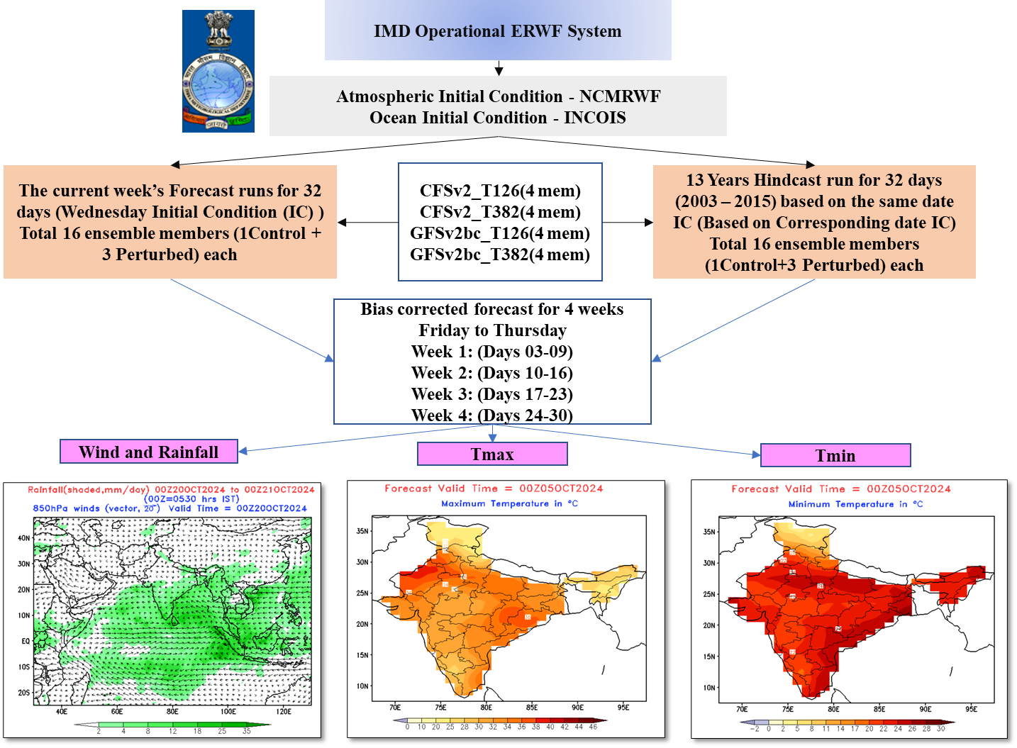
Figure 7: IMD- Leading ERWF for National Resilience (Picture Credit:imd.gov.in)

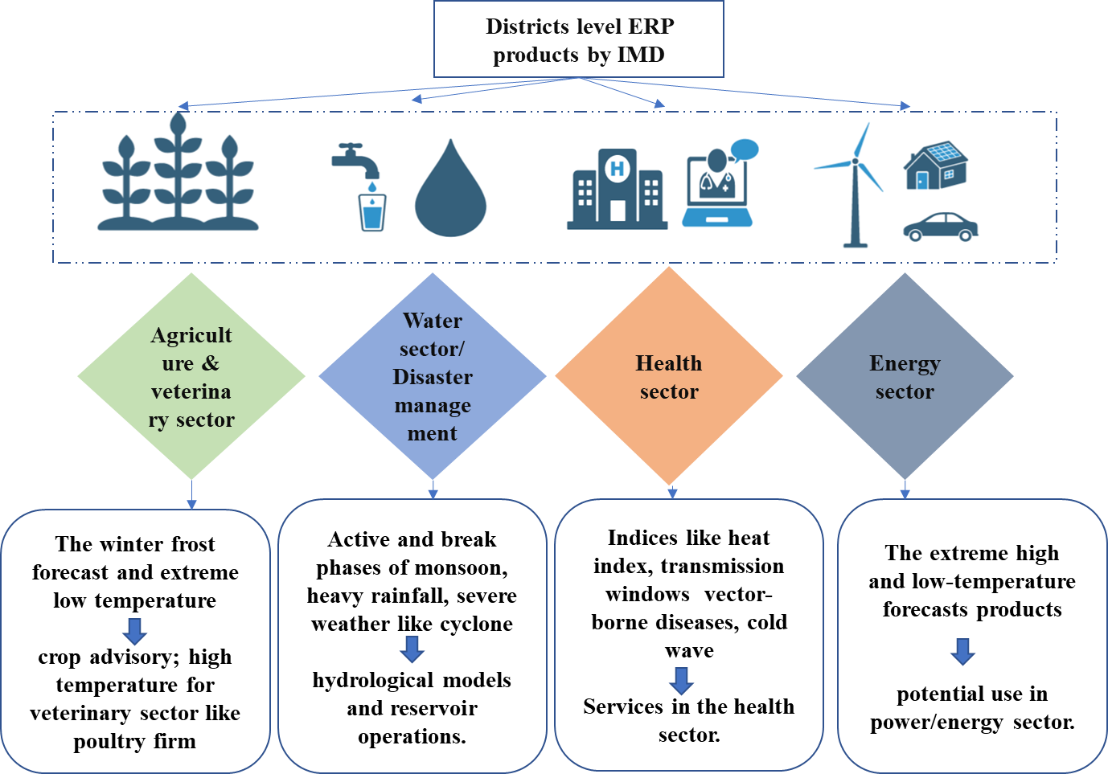
Figure 8: ERP products generated by the IMD
S2S Forecasting: Bridging Short-Term and Long-Term Forecasting
The Indian monsoon system, driven by interactions between the atmosphere, oceans, and continents, is crucial to global weather patterns (Chen et al., 2022). Accurate sub seasonal (2–8 weeks) rainfall predictions are increasingly needed for disaster prevention and agricultural planning (Webster and Hoyos, 2004). The key factors influencing sub seasonal predictability include tropical ISVs and teleconnections (Vitart et al., 2017). While forecasts are typically reliable for two weeks, more research is needed to improve ISV understanding and forecasting capabilities. The Ensemble Prediction System (EPS) must be evaluated for localized forecasts in India (Joseph et al., 2019), and tools such as SubX provide valuable data for enhancing real-time predictions (Pegion et al., 2019). Machine learning models such as UNet also improve sub seasonal forecasts by leveraging historical data (Unal et al., 2023).
Extended Range prediction of Atmospheric variables and its extremes:
Temperature:

The prediction of temperature via the ERWF is critical for managing the impacts of cold waves and heat waves in India. Owing to its location in major tropical and subtropical regions, it is highly vulnerable to heatwaves, with over 24,000 deaths reported between 1992 and 2015. The need for adaptive strategies is critical, as future projections indicate a temperature increase of ±1.2°C to ±3.5°C, with potential reductions expected by 2050 under various emission scenarios (Ravindra et al., 2024). The IMD has set guidelines for identifying heatwaves by analyzing temperature data and deviations from the average temperature for a specific location. Heatwaves in India typically occur between March and July, primarily during the premonsoon season (Nageswararao et al., 2020). In recent years, extreme heat events have caused numerous casualties, with northern, northwestern, central, and northeastern peninsulas being the most affected (Pai et al., 2013; Singh et al., 2021; Mukherjee and Mishra, 2018). Humidity plays a crucial role in assessing heatwaves. Studies have shown that by the end of the century, under high GHG emission scenarios, heatwave intensity, frequency, and duration will increase, potentially impacting regions that are currently unaffected (Murari et al., 2015; Koteswara Rao et al., 2020; Perkins-Kirkpatrick and Lewis 2020; Dubey et al. 2021; Das and Umamahesh 2022). The ERWF can be used to predict temperature (Wang et al., (2013); Qiuming (2018; Joseph et al., 2019; Peng et al., 2020), heatwaves (Kueh and Lin et al., (2020); Hudson et al., (2016) and cold waves. Dai et al. (2024) presented a 25-day ERP model for winter Tmin in southern China via pentad increments derived from ECMWF reanalysis data. By utilizing soil temperature and stratospheric geopotential height as predictors, the model achieves a correlation skill of 0.45 for Tmin and a 57% hit rate for extremely cold days, offering valuable insights for forecasting extreme weather events. Some of the key findings are summarized in a table. The use of the strength of the stratospheric polar vortex to enhance extended-range temperature forecasts in Europe was studied by Korhonen et al. (2020).
Rainfall
Extended-range rainfall predictions (Table) during the monsoon season can guide efficient water conservation, minimize waste, and support more equitable distributions across and within states through integrated water resource management (Borah et al., 2015).

Extreme events

The ERWF can predict extreme events, including cyclones (Gray (1993); Elsner and Schmertmann (1993); Klotzbach et al., (2006; 2012); Elsberry et al., (2014); Baumhefner (2013)). The key findings are summarized in a table.
Application of tools of precision: Numerical weather prediction (NWP) models in the ERWF
High-performance computing systems have substantially accelerated NWP method research in the last ten years (Bauer et al., 2015). The NWP approach (Krishnamurti and Bounoua, 2018; Brotzge et al., 2023), which depicts atmospheric states as discretized grids and numerically solves partial differential equations that explain the transition between those states, is currently the most accurate forecast system (Bauer et al., 2015). In working with the IITM, Pune, and National Center for Medium-range Weather Forecast NCMRWF, Noida, the IMD runs high-resolution mesoscale, global, and coupled models to generate various NWP products. These models are used in weather and climate services that cover the time scale from nowcasting to extended range forecasting. The MoES has made high-power computing systems available to the IMD (NWP-IMD, 2022). Some of the GCM products available for ERWF predictions are NCEP Climate Forecast System Version 2 (CFSv2) - 16--45 days, European Centre for Medium-Range Weather Forecasts (ECMWF) - 15--46 days, Japan Meteorological Agency (JMA) Ensemble Prediction System (EPS) - 1--90 days, UK Met Office Global Seasonal Forecasting System (GloSea) - 10--30 days, Subseasonal to Seasonal Prediction Project (S2S) - 10--60 days (Subseasonal), BoM ACCESS-S1 - 1--30 days, Météo-France Arpege - 1--30 days, Meteorological Service of Canada (MSC) GEM Model Extended Range Forecast (Up to 16 days, Korean Meteorological Administration (KMA) Global Seasonal Forecast System (GloSea5) – 3--4 weeks.
Leveraging Artificial Intelligence and Machine Learning (ML) for Enhanced ERWF
ML and deep learning (DL) techniques excel at identifying patterns and have proven effective in enhancing sub seasonal forecasts by combining dynamical models with modern ML approaches (Cohen et al., 2019). DL and ML models have shown great potential in replicating complex climate dynamics, with AI integration offering significant benefits (Anaka et al., 2023). However, the use of ML in medium- to long-term climate forecasting remains limited due to data constraints and complex variables (Chen et al., 2023). He et al. (2021) reported that models such as XGBoost can capture sub seasonal predictability, sometimes outperforming climatological baselines. CNNs in ensemble forecasts (Weyn et al., 2021) generate six-week global forecasts efficiently, although their performance lags that of ECMWF models at shorter lead times. Wu et al. (2023) demonstrated good prediction accuracy of ERPs for regional persistent extreme cold events with low-frequency oscillations.
Challenges, Opportunities, and Future Directions in ERWFs
A major challenge in atmospheric science is generating ERWFs for the tropics, covering one week to one month. This timeframe bridges seasonal and MRWF but often involves uncertainties in initial atmospheric conditions and model physics (Pattanaik et al., 2019). The ensemble technique is commonly used to address sample errors (Palmer et al., 1993), but evolving atmospheric dynamics limit reliability. Monitoring the ISV of monsoon rainfall in this range is crucial for providing actionable advice, like agrometeorological services (Pattanaik et al., 2022). The ERWF is complex because of the chaotic nature of atmospheric systems, making predictions beyond three to five days nondeterministic (Lorenz, 1965). However, research has shown that error growth saturates over longer timescales, allowing for seasonal predictability (Charney and Shukla, 1981). MJO and MISO offer hope for improving ERWFs (Waliser et al., 2003; Goswami and Xavier, 2003). Recent studies highlight the importance of boundary conditions, such as air‒sea interactions and SSTs, for enhancing ERWF accuracy, especially in an MME framework (Abhilash et al., 2015). Despite advancements, challenges remain in forecasting ERWFs, particularly for complex terrain areas. China's National Meteorological Center developed a 5-km grid ERWF system via techniques such as BP-SM, which significantly improved daily 2-m temperature forecasts (Xiong et al., 2021).
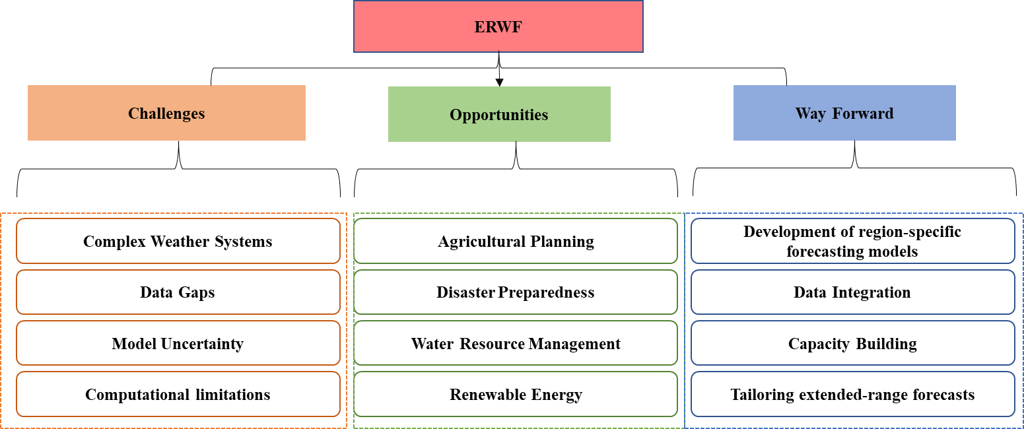
Figure 9: ERP products generated by the IMD
Summary and conclusions:
Forecasting in science involves estimating a variable's value at a future time. IMD predicts variables such as temperature, wind, humidity, and rainfall over specific periods, such as daily rainfall forecasts. Extended range forecasts (ERWFs) bridge the gap between medium- and long-range predictions, typically starting at approximately day 10 and lasting up to one month. The ERWF can predict extreme weather events such as heat waves, droughts, and floods up to four weeks in advance. ERWFs are essential for improving disaster preparedness, optimizing agricultural practices, and managing water resources effectively. They enhance decision-making across various sectors, fostering resilience against climate-related challenges and promoting societal well-being. However, there is a known gap in numerical forecast systems for the ERWF. This gap highlights the need for improved ERWFs, especially under changing climate conditions. This research provides a comprehensive examination of the ERWF, offering a current assessment and a roadmap for future multidisciplinary studies in this emerging field, despite its limitations in scope.

Authors References | Objective of the study | Study period and study area | Technique & Dataset used | Findings
Pattanaik et al., (2013) | Cyclonic storms "Giri" and "Jal" | Postmonsoon season of 2010; Bay of Bengal, Tamil Nadu, and Andhra Pradesh coasts. | - Forecasts using coupled model outputs from ECMWF, NCEP, and a two-model average | The operational forecast indicated cyclonic circulation associated with cyclone "Giri" and successfully captured the genesis of cyclone "Jal."
Lea and Sauders, (2015) | Typhoon activity | Jan 1 to Dec 31, 2021.  Northwest Pacific region. | - Deterministic and probabilistic forecasting methods; statistical methods for ENSO predictions.  - ENSO data. | The precision of early forecasts is low due to uncertainties in ASO ENSO predictions
Pattanaik et al., (2015) | Flood management | August-September 2011, Mahanadi River basin, Odisha, India. | - Bimodel average (BMA) of ECMWF and NCEP CFS models (rainfall data),  - synoptic analysis of low-pressure systems. | The ECMWF model performed better in predicting the heavy rainfall event compared to NCEP CFS, though both underpredicted the actual rainfall.
Zhu and Li., (2017) | Clustering tropical cyclogenesis | 2003–2014, western North Pacific (WNP). | - STPM based on 10–30 and 30–80-day ISV modes.  - Outgoing Longwave Radiation (OLR), atmospheric fields (geopotential height, zonal wind, vorticity, humidity). | 80% of CTC events with a 10-day lead time  69% with a 20-day lead time
Gensini et al., (2019) | Tornado | May 2019, U.S. Great Plains, Midwest, lower Great Lakes | - Extended range tornado activity forecast (ERTAF)  - Tropical convective forcing, Atmospheric angular momentum | Tornadoes predicted 3 - 4 weeks in advance
Gensini et al., (2020) | Tornado | March 2015 onward, U.S. tornado activity | - ERTAF  - Tropical convection, SST, Atmospheric angular momentum | Successful tornado activity prediction 2 - 3 weeks in advance, with better accuracy in week 2 than in week 3.
Wei et al., (2021) | Tropical cyclogenesis | 2009 - 2018,  South China Sea | - Spatial Temporal Projection Model (STPM) based on ISO phases (QBWO/MJO).  - Records, ISO phases, and Daily Genesis Rate sequences. | 80% accuracy - 10-day lead time  74.3%- 20-day lead time,  false alarming rates increased with longer lead times.
Table 1: Key reference article with notified results regarding extended range prediction of cyclones, tornadoes and floods:

Table 2: Key reference article with notified results regarding the extended range prediction of heatwaves and cold waves:
Authors References | Objective of the study | Study period and study area | Technique & Dataset used | Findings
Pattanaik et al., (2017) | Tmax during severe heatwave conditions | 2015, focusing on the severe heatwave period from 22 to 28 May and the subsequent week from 29 May to 4 June. Northwestern, eastern coastal states, and the Indo-Gangetic plain of India. | - (CFSv2).  - Weekly bias-corrected deterministic (ensemble mean) Tmax forecasts for 3 weeks. | The coupled model's ability to provide early warnings for extreme heatwaves
Zhu and Li (2018) | Heatwave | Training data from 1960 to 1999; independent forecast period from 2000 to 2013.  China | - STPM | STPMs perform poorly in reproducing 10–30-day SAT, with a useful skill for the first two modes only within a 15-day lead time.  Over a large part of China, STPMs can forecast more than 30% of heat waves within a 15-day lead time.
Mandal et al., (2019) | Heatwave | Analysis of heat wave spells from 1981 to 2018, focusing on real-time prediction during the heat wave season (March to June).  India | - CFSv2 | Forecast verification for heat wave spells from 2003 to 2018 shows that the system can effectively indicate the onset, duration, and demise of heat wave spells with adequate lead time, though there are some spatiotemporal errors.
Zhang et al., (2021) | Heatwave | July, August, and September (JAS) of 1999–2010  China | - Four single-model ensembles (ECMWF, CMA, UKMO, and NCEP), MME, Bayesian model averaging (BMA)  - Heatwave index for construction and verification.  - S2S database. | BMA improves the reliability of probabilistic forecasts and is effective for extended-range HW forecasting.
Li et al., (2024) | Extreme heat events (EHE) | South China, with case studies including June 4 -6, 1999; August 19 - 29, 2009; and August 3 - 5, 2010. | - Data from ECMWF, NCEP, and China Meteorological Administration (CMA) models. | ECMWF has the best forecasting skill for EHEs, followed by NCEP, with CMA having the poorest skill.
Zhu and Lin (2017) | Forecast winter surface air temperature (SAT) and extremely cold days | Training data from 1960/1961 to 1999/2000; independent forecast period from 2000/2001 to 2012/2013; China. | - Statistical spatial-temporal projection model (STPM). | Over 63% of total forecasts had a significant pattern correlation between forecasted and observed SAT anomalies.  The model can predict local ECDs with over 30% accuracy in most parts of China at least 15 days in advance, except for southeastern China and the Tibetan Plateau.

Table 3: Key reference article of ERP for other events:
Variable | Reference article
Arctic Oscillation | Baldwin et al., (2003)
Runoff & Streamflow | Day (1985); Liu et al., (2019)
Streamflow temperature | Padron et al., (2024)
Arctic sea ice | Liu et al., (2021)
Sudden stratospheric warmings | Karpechko (2018)
PM2.5 | Yu et al., 2023

Table 4 :Application of ERWF products with the integration of crop simulation models:
Reference article | Study area | Application | Techniques | Findings
Ghosh et al., (2014) | Bhubaneswar, India. | Improve rice grain yield prediction skill | IITM-IMD ERP integrated into the CERES-rice model in DSSAT. | Effectively capture year-to-year variability in observed rice yield
Akhtar et al., (2021) | Gangetic West Bengal, India. | Predicting Kharif rice yield | IITM-IMD ERP integrated into the CERES-rice model in DSSAT. | The ERP-driven crop model outperforms the climatology-driven model in capturing the interannual variability of rice yield and better predicting below- and above-normal yield categories.
Dhekale et al., (2021) | Kharagpur, West Bengal, India. | Predicting Kharif rice yield | ERP integrated into the CERES-Rice model in DSSATv4.5. | Efficiently predict year-to-year variability in Kharif rice yield Normal and above-normal yields can be predicted with skill

Table 5: Key reference article with notified results regarding extended range prediction of the monsoon season:
Authors References | Monsoon | Technique Used | Findings
Pattanaik et al., (2014) | SWM - 2012 | - MME approach (ECMWF, NCEP, and JMA models) | MME-based predictions for 2–3 weeks provide skillful results
Pattanaik et al., (2021) | SWM - 2019 | - Verification scores | ERF successfully captured the delayed onset, sluggish progress, and delayed withdrawal of the monsoon with a lead time of 2-3 weeks.
Borah et al., (2015) | ISM, 2013 | - Ensemble forecasting using CFSv2 and GFSv2 models | GFSbc generally outperforms CFSv2.
Raghav et al., (2020) | ISM | - statistical downscaling  - Extreme Gradient Boosting | The statistical downscaling method successfully captures active and break phases of the monsoon, boosting prediction skills for up to 4 weeks.
Pattanaik and Mahopatra (2017) | NEM, 2015 | - Bimodel average JMA Ensemble Prediction System and NCEP's (CFSv.2) coupled model. | Captured the delayed onset of NEM in Tamil Nadu and active phases during November and early December 2015 with 1–2 weeks lead time.

References:
- Grimm, N. B., Chapin III, F. S., Bierwagen, B., Gonzalez, P., Groffman, P. M., Luo, Y., ... & Williamson, C. E. (2013). The impacts of climate change on ecosystem structure and function. Frontiers in Ecology and the Environment, 11(9), 474-482.
- Bradford, M. A., & Warren, R. J. (2014). Terrestrial biodiversity and climate change. In Global environmental change (pp. 355-361). Springer, Dordrecht.
- Warren, R., Price, J., & Jenkins, R. (2021). Climate change and terrestrial biodiversity. In The impacts of climate change (pp. 85-114). Elsevier.
- Harrison, S., Franklin, J., Hernandez, R. R., Ikegami, M., Safford, H. D., & Thorne, J. H. (2024). Climate change and California’s terrestrial biodiversity. Proceedings of the National Academy of Sciences, 121(32), e2310074121.
- Woodward, G., Perkins, D. M., & Brown, L. E. (2010). Climate change and freshwater ecosystems: impacts across multiple levels of organization. Philosophical Transactions of the Royal Society B: Biological Sciences, 365(1549), 2093-2106.
- Liu, J., Kattel, G., Arp, H. P. H., & Yang, H. (2015). Towards threshold-based management of freshwater ecosystems in the context of climate change. Ecological Modelling, 318, 265-274.
- Singh, G., Singh, A., Singh, P., & Mishra, V. K. (2021). Chapter 4—Impact of Climate Change on Freshwater Ecosystem. Water Conservation in the Era of Global Climate Change; Thokchom, B., Qiu, P., Singh, P., Iyer, PK, Eds, 73-98.
- Orr, J. A., Bussi, G., Hughes, J. M., Whitehead, P. G., & Jackson, M. C. (2024). Modelling the potential for local management practices to offset climate change impacts on freshwater macroinvertebrate communities. Freshwater Biology, 69(3), 435-449.
- Ding, Y., Mu, C., Wu, T., Hu, G., Zou, D., Wang, D., ... & Wu, X. (2021). Increasing cryospheric hazards in a warming climate. Earth-Science Reviews, 213, 103500.
- Wang, S. (2024). Opportunities and threats of cryosphere change to the achievement of UN 2030 SDGs. Humanities and Social Sciences Communications, 11(1), 1-13.
- Zhang, T., Liu, H., Lu, Y., Wang, Q., Loh, Y. C., & Li, Z. (2024). Impact of climate change on coastal ecosystem and outdoor activities: a comparative analysis among four largest coastline covering countries. Environmental Research, 250, 118405.
- https://www.ipcc.ch/report/sixth-assessment-report-cycle/
- Weiskopf, S. R., Rubenstein, M. A., Crozier, L. G., Gaichas, S., Griffis, R., Halofsky, J. E., ... & Whyte, K. P. (2020). Climate change effects on biodiversity, ecosystems, ecosystem services, and natural resource management in the United States. Science of the Total Environment, 733, 137782.
- Brunet, G., Parsons, D. B., Ivanov, D., Lee, B., Bauer, P., Bernier, N. B., ... & Yu, R. (2023). Advancing weather and climate forecasting for our changing world. Bulletin of the American Meteorological Society, 104(4), E909-E927.
- Tada, M., Yoshimura, K., & Toride, K. (2021). Improving weather forecasting by assimilation of water vapor isotopes. Scientific Reports, 11(1), 18067.
- Stott, P. (2016). How climate change affects extreme weather events. Science, 352(6293), 1517-1518.
- Ai, X., Han, Z., & Zhang, Q. (2024). Extreme weather experience and climate change risk perceptions: The roles of partisanship and climate change cause attribution. International Journal of Disaster Risk Reduction, 108, 104511.
- https://data.worldbank.org/
- Didal, V. K., Brijbhooshan, A. T., & Choudhary, K. (2017). Weather forecasting in India: A review. Int. J. Curr. Microbiol. App. Sci, 6(11), 577-590.
- Khajure, S., & Mohod, S. W. (2016). Future weather forecasting using soft computing techniques. Procedia Computer Science, 78, 402-407.
- Jaseena, K. U., & Kovoor, B. C. (2022). Deterministic weather forecasting models based on intelligent predictors: A survey. Journal of king saud university-computer and information sciences, 34(6), 3393-3412.
- Bańbura, M., Giannone, D., Modugno, M., & Reichlin, L. (2013). Now-casting and the real-time data flow. In Handbook of economic forecasting (Vol. 2, pp. 195-237). Elsevier.
- Ravuri, S., Lenc, K., Willson, M., Kangin, D., Lam, R., Mirowski, P., ... & Mohamed, S. (2021). Skilful precipitation nowcasting using deep generative models of radar. Nature, 597(7878), 672-677.
- Sarma, H. H., & Kakoti, M. (2024). Significance of weather forecasting in crop production with respect to Indian scenario. Vigyan Varta, 5(7), 95-102.
- Mamgain, A., Prasad, S. K., Sarkar, A., Shanker, G., Dube, A., & Mitra, A. K. (2024). Evaluating short-range forecasts of a 12 km global ensemble prediction system and a 4 km convection-permitting regional ensemble prediction system. Pure and Applied Geophysics, 181(7), 2217-2241.
- Kumar, A., Maini, P., Rathore, L. S., & Singh, S. V. (2000). An operational medium range local weather forecasting system developed in India. International Journal of Climatology: A Journal of the Royal Meteorological Society, 20(1), 73-87.
- Prasad, N., Quamar, M. F., Maneesha, M. E. T., Tiwari, P., Thakur, B., Sharma, A., ... & Javed, M. (2024). Late Holocene vegetation history and monsoonal climate change from the Core Monsoon Zone of India. Catena, 246, 108394.
- Zheng, Z., Huang, J., Feng, G., & Chou, J. (2013). Forecast scheme and strategy for extended-range predictable components. Science China Earth Sciences, 56(5), 878-889.
- Zhu, Z., & Li, T. (2018). Extended-range forecasting of Chinese summer surface air temperature and heat waves. Climate Dynamics, 50(5), 2007-2021.
- Pattanaik, D. R., Mohapatra, M., Srivastava, A. K., & Kumar, A. (2017). Heat wave over India during summer 2015: an assessment of real time extended range forecast. Meteorology and Atmospheric Physics, 129(4), 375-393.
- Pattanaik, D. R., Sahai, A. K., Mandal, R., Muralikrishna, R. P., Dey, A., Chattopadhyay, R., ... & Mishra, V. (2019). Evolution of operational extended range forecast system of IMD: Prospects of its applications in different sectors. Mausam, 70(2), 233-264.
- Kumar, P., Pattanaik, D. R., & Alone, A. (2022). Bias-corrected extended-range forecast over India for hydrological applications during monsoon 2020. Pure and Applied Geophysics, 179(5), 1995-2009.
- Gouda, K. C., Nahak, S., & Goswami, P. (2018). Evaluation of a GCM in seasonal forecasting of extreme rainfall events over continental India. Weather and climate extremes, 21, 10-16.
- Mohanty, U. C., Sinha, P., Mohanty, M. R., Maurya, R. K. S., & Rao, M. N. (2019). A review on the monthly and seasonal forecast of the Indian summer monsoon. Mausam, 70(3), 425-442.
- Madolli, M. J., Himanshu, S. K., Patro, E. R., & De Michele, C. (2022). Past, present and future perspectives of seasonal prediction of Indian summer monsoon rainfall: A review. Asia-Pacific Journal of Atmospheric Sciences, 58(4), 591-615.
- https://mausam.imd.gov.in/imd_latest/contents/pdf/forecasting_sop.pdf
- Vitart, F., Robertson, A. W., & Anderson, D. L. (2012). Subseasonal to seasonal prediction project: Bridging the gap between weather and climate. Bulletin of the World Meteorological Organization, 61(2), 23.
- Robertson AW, Vitart F, Camargo SJ. Subseasonal to seasonal prediction of weather to climate with application to tropical cyclones. Journal of Geophysical Research: Atmospheres. 2020 Mar 27;125(6):e2018JD029375.
- White, C. J., Carlsen, H., Robertson, A. W., Klein, R. J., Lazo, J. K., Kumar, A., ... & Zebiak, S. E. (2017). Potential applications of subseasonal‐to‐seasonal (S2S) predictions. Meteorological applications, 24(3), 315-325.
- White, C. J., Domeisen, D. I., Acharya, N., Adefisan, E. A., Anderson, M. L., Aura, S., ... & Wilson, R. G. (2022). Advances in the application and utility of subseasonal-to-seasonal predictions. Bulletin of the American Meteorological Society, 103(6), E1448-E1472.
- Fu, X., & Hsu, P. C. (2011). Extended‐range ensemble forecasting of tropical cyclogenesis in the northern Indian Ocean: Modulation of Madden‐Julian Oscillation. Geophysical research letters, 38(15).
- Lorenc, A. C. (1986). Analysis methods for numerical weather prediction. Quarterly Journal of the Royal Meteorological Society, 112(474), 1177-1194.
- Kimura, R. (2002). Numerical weather prediction. Journal of Wind Engineering and Industrial Aerodynamics, 90(12-15), 1403-1414.
- Brotzge, J. A., Berchoff, D., Carlis, D. L., Carr, F. H., Carr, R. H., Gerth, J. J., ... & Wang, X. (2023). Challenges and opportunities in numerical weather prediction. Bulletin of the American Meteorological Society, 104(3), E698-E705.
- Kumar, T. V., & Krishnamurti, T. N. (2006). High resolution numerical weather prediction over the Indian subcontinent. Journal of earth system science, 115(5), 529-555.
- Mengaldo, G., Wyszogrodzki, A., Diamantakis, M., Lock, S. J., Giraldo, F. X., & Wedi, N. P. (2019). Current and emerging time-integration strategies in global numerical weather and climate prediction. Archives of Computational Methods in Engineering, 26(3), 663-684.
- Pu, Z., & Kalnay, E. (2018). Numerical weather prediction basics: Models, numerical methods, and data assimilation. In Handbook of hydrometeorological ensemble forecasting (pp. 1-31). Springer, Berlin, Heidelberg.
- Pathak, J., Subramanian, S., Harrington, P., Raja, S., Chattopadhyay, A., Mardani, M., ... & Anandkumar, A. (2022). Fourcastnet: A global data-driven high-resolution weather model using adaptive fourier neural operators. arXiv preprint arXiv:2202.11214.
- Bauer P, Thorpe A, Brunet G. The quiet revolution of numerical weather prediction. Nature. 2015 Sep 3;525(7567):47-55.
- https://www.noaa.gov/
- Amin, A., & Mourshed, M. (2024). Weather and climate data for energy applications. Renewable and Sustainable Energy Reviews, 192, 114247.
- Lynch, P. (2008). The origins of computer weather prediction and climate modeling. Journal of computational physics, 227(7), 3431-3444.
- Bihlo, A. (2021). A generative adversarial network approach to (ensemble) weather prediction. Neural Networks, 139, 1-16.
- Jain, G., & Mallick, B. (2016). A review on weather forecasting techniques. IJARCCE, 5(12), 177-180.
- Jaseena, K. U., & Kovoor, B. C. (2022). Deterministic weather forecasting models based on intelligent predictors: A survey. Journal of king saud university-computer and information sciences, 34(6), 3393-3412.
- Krishnan, R., Sanjay, J., Gnanaseelan, C., Mujumdar, M., Kulkarni, A., & Chakraborty, S. (2020). Assessment of climate change over the Indian region: a report of the ministry of earth sciences (MOES), government of India (p. 226). Springer Nature.
- https://www.ipcc.ch/report/sixth-assessment-report-cycle/
- Chen, L., Han, B., Wang, X., Zhao, J., Yang, W., & Yang, Z. (2023). Machine learning methods in weather and climate applications: A survey. Applied Sciences, 13(21), 12019.
- Pujahari, R. M., Yadav, S. P., & Khan, R. (2022). Intelligent farming system through weather forecast support and crop production. In Application of Machine Learning in Agriculture (pp. 113-130). Academic Press.
- Rao, P. S., Saseendran, S. A., Rathore, L. S., & Bahadur, J. (1996). Medium range weather forecasts in India during Monsoon 1994. Meteorological Applications, 3(4), 317-324.
- Kumar, A., Maini, P., Rathore, L. S., & Singh, S. V. (2000). An operational medium range local weather forecasting system developed in India. International Journal of Climatology: A Journal of the Royal Meteorological Society, 20(1), 73-87.
- Rathore, L. S., Gupta, A., & Singh, K. K. (2001). Medium range weather forecasting and agricultural production. Journal of Agric. Physics, 1(1), 43.
- Chauhan, V. S., Chaudhari, G. B., & Pandey, V. Y. A. S. (2008). Medium range weather forecast verification for middle Gujarat region. J. Agrometeorol, 10, 90-93.
- Sikka, D. R. (2009). Two decades of medium-range weather forecasting in India: National Centre for Medium-Range Weather Forecasting (p. 100). Fairfax, VA, USA: Center of Ocean-Land-Atmosphere Studies.
- Rana, R. S., Sood, R., ADITYA, A., & Shekhar, J. (2013). Validation of medium range weather forecasts in sub-temperate and sub-humid climate of western Himalayas. The Indian Journal of Agricultural Sciences, 83(12).
- Prasad, V. S., Mohandas, S., Dutta, S. K., Gupta, M. D., Iyengar, G. R., Rajagopal, E. N., & Basu, S. (2014). Improvements in medium range weather forecasting system of India. Journal of earth system science, 123(2), 247-258.
- Chattopadhyay, N., Ghosh, K., Malathi, K., BHOWMIK, S. R., & Singh, K. K. (2016). Verification of district level weather forecast. Mausam, 67(4), 829-840.
- Neal, R., Guentchev, G., Arulalan, T., Robbins, J., Crocker, R., Mitra, A., & Jayakumar, A. (2022). The application of predefined weather patterns over India within probabilistic medium‐range forecasting tools for high‐impact weather. Meteorological Applications, 29(3), e2083.
- Mohapatra, M., Kumar, N., Sharma, M., Devi, S. S., Senroy, S., Devi, K. S., & Singh, K. K. (2022). Short to medium range weather forewarning system in India. In Social and Economic Impact of Earth Sciences (pp. 1-29). Singapore: Springer Nature Singapore.
- Abhilash, S., Sahai, A. K., Pattnaik, S., Goswami, B. N., & Kumar, A. (2014). Extended range prediction of active-break spells of Indian summer monsoon rainfall using an ensemble prediction system in NCEP Climate Forecast System. International Journal of Climatology, 34(1).
- Waliser, D. E., Lau, K. M., Stern, W., & Jones, C. (2003). Potential predictability of the Madden–Julian oscillation. Bulletin of the American Meteorological Society, 84(1), 33-50.
- Borah, N., Sahai, A. K., Abhilash, S., Chattopadhyay, R., Joseph, S., Sharmila, S., & Kumar, A. (2015). An assessment of real-time extended range forecast of 2013 Indian summer monsoon. International Journal of Climatology, 35(10).
- Sahai, A. K., Sharmila, S., Abhilash, S., Chattopadhyay, R., Borah, N., Krishna, R. P. M., ... & Pillai, P. A. (2013). Simulation and extended range prediction of monsoon intraseasonal oscillations in NCEP CFS/GFS version 2 framework. Current Science, 1394-1408.
- Sahai, A. K., Chattopadhyay, R., Joseph, S., Mandal, R., Dey, A., Abhilash, S., ... & Borah, N. (2015). Real-time performance of a multi-model ensemble-based extended range forecast system in predicting the 2014 monsoon season based on NCEP-CFSv2. Current Science, 1802-1813.
- Sarma, H. H., & Kakoti, M. (2024). Significance of weather forecasting in crop production with respect to Indian scenario. Vigyan Varta, 5(7), 95-102.
- Sahai, A. K., Chattopadhyay, R., Joseph, S., Phani, R., & Abhilash, S. (2016). Extended range prediction system and its application. Vayu Mandal, 42(2), 75-96.
- Chattopadhyay, N., Rao, K. V., Sahai, A. K., Balasubramanian, R., Pai, D. S., Pattanaik, D. R., ... & Khedikar, S. (2018). Usability of extended range and seasonal weather forecast in Indian agriculture. Mausam, 69(1), 29-44.
- Pattanaik, D. R., & Das, A. K. (2015). Prospect of application of extended range forecast in water resource management: a case study over the Mahanadi River basin. Natural Hazards, 77(2), 575-595.
- Chattopadhyay, N., Rao, K. V., Sahai, A. K., Balasubramanian, R., Pai, D. S., Pattanaik, D. R., ... & Khedikar, S. (2018). Usability of extended range and seasonal weather forecast in Indian agriculture. Mausam, 69(1), 29-44.
- Ervasti, T., Gregow, H., Vajda, A., Laurila, T. K., & Mäkelä, A. (2018). Mapping users' expectations regarding extended-range forecasts. Advances in Science and Research, 15, 99-106.
- Joseph, S., Sahai, A. K., Phani, R., Mandal, R., Dey, A., Chattopadhyay, R., & Abhilash, S. (2019). Skill evaluation of extended-range forecasts of rainfall and temperature over the meteorological subdivisions of India. Weather and Forecasting, 34(1), 81-101.
- Nayak, P., Baliarsingh, A., Swain, C. K., & Rath, B. S. (2022). Validation of extended range forecasts of rainfall and temperature in Cuttack district of Odisha.
- Loo, Y. Y., Billa, L., & Singh, A. (2015). Effect of climate change on seasonal monsoon in Asia and its impact on the variability of monsoon rainfall in Southeast Asia. Geoscience Frontiers, 6(6), 817-823.
- Geen, R., Bordoni, S., Battisti, D. S., & Hui, K. (2020). Monsoons, ITCZs, and the concept of the global monsoon. Reviews of Geophysics, 58(4), e2020RG000700.
- Gadgil, S., Francis, P. A., Rajendran, K., Nanjundiah, R. S., & Rao, S. A. (2020). Role of land-ocean contrast in the Indian summer monsoon rainfall. In The Multiscale Global Monsoon System (pp. 3-12).
- Zuo, Z., & Zhang, K. (2023). Link between the land–sea thermal contrast and the Asian summer monsoon. Journal of Climate, 36(1), 213-225.
- Ummenhofer, C. C., Geen, R., Denniston, R. F., & Rao, M. P. (2024). Past, present, and future of the South Asian monsoon. In The Indian Ocean and its role in the global climate system (pp. 49-78). Elsevier.
- Ao, H., Ruan, J., Martinón-Torres, M., Krapp, M., Liebrand, D., Dekkers, M. J., ... & An, Z. (2024). Concurrent Asian monsoon strengthening and early modern human dispersal to East Asia during the last interglacial. Proceedings of the National Academy of Sciences, 121(3), e2308994121.
- Lu, H., Wu, H., & Meadows, M. (2024). Asian monsoon variations over the past 21 ka: An introduction. Global and Planetary Change, 237, 104452.
- Chen, P. J., Wu, C. H., Chen, Y. G., & Lee, S. Y. (2024). Impact of solar activity and ENSO on the early summer Asian Monsoon during the last millennium. Geophysical Research Letters, 51(3), e2023GL105668.
- Hussain, A., Hussain, I., Rezaei, A., Ullah, W., Lu, M., Zhou, J., & Guan, Y. (2024). Increasing monsoon precipitation extremes in relation to large-scale climatic patterns in Pakistan. Atmospheric Research, 309, 107592.
- Tada, M., Yoshimura, K., & Toride, K. (2021). Improving weather forecasting by assimilation of water vapor isotopes. Scientific Reports, 11(1), 18067.
- Clift, P. D., Betzler, C., Clemens, S. C., Christensen, B., Eberli, G. P., France-Lanord, C., ... & Wan, S. (2022). A synthesis of monsoon exploration in the Asian marginal seas. Scientific Drilling, 31, 1-29.
- Wang, P., Clemens, S., Beaufort, L., Braconnot, P., Ganssen, G., Jian, Z., ... & Sarnthein, M. (2005). Evolution and variability of the Asian monsoon system: state of the art and outstanding issues. Quaternary Science Reviews, 24(5-6), 595-629.
- Gupta, S. K., Sharma, M., & Mukherjee, S. (2022). Buckeye rot of tomato in India: Present status, challenges, and future research perspectives. Plant Disease, 106(4), 1085-1095.
- Li, G., Yu, Z., Li, Y., Yang, C., Gu, H., Zhang, J., & Huang, Y. (2024). Interaction mechanism of global multiple ocean-atmosphere coupled modes and their impacts on South and East Asian Monsoon: A review. Global and Planetary Change, 237, 104438.
- Murty, A. (2021). Monsoons over the Indian subcontinent. Acad Lett, 6, 1-29.
- Prasad, N., Quamar, M. F., Maneesha, M. E. T., Tiwari, P., Thakur, B., Sharma, A., ... & Javed, M. (2024). Late Holocene vegetation history and monsoonal climate change from the Core Monsoon Zone of India. Catena, 246, 108394.
- Ghosh, J., Chakraborty, K., Valsala, V., Bhattacharya, T., & Ghoshal, P. K. (2024). A review of the Indian Ocean carbon dynamics, acidity, and productivity in a changing environment. Progress in Oceanography, 221, 103210.
- Williams, M. A., Hemanth Kumar, A., Jayachandran, V., Thakur, M. K., & Kumar, T. L. (2025). Effect of wet scavenging on black carbon aerosols over a coastal urban site in India. Air Quality, Atmosphere & Health, 18(1), 15-28.
- Bolton, C. T., Chang, L., Clemens, S. C., Kodama, K., Ikehara, M., Medina-Elizalde, M., ... & Zhao, X. (2013). A 500,000 year record of Indian summer monsoon dynamics recorded by eastern equatorial Indian Ocean upper water-column structure. Quaternary Science Reviews, 77, 167-180.
- Joseph, S., Sahai, A. K., Phani, R., Mandal, R., Dey, A., Chattopadhyay, R., & Abhilash, S. (2019). Skill evaluation of extended-range forecasts of rainfall and temperature over the meteorological subdivisions of India. Weather and Forecasting, 34(1), 81-101.
- Pattanaik, D. R., Alone, A., Kumar, P., Phani, R., Mandal, R., & Dey, A. (2022). Extended-range forecast of monsoon at smaller spatial domains over India for application in agriculture. Theoretical and Applied Climatology, 147(1), 451-472.
- Pothapakula, P. K., Primo, C., Sørland, S., & Ahrens, B. (2020). The synergistic impact of ENSO and IOD on the Indian Summer Monsoon Rainfall in observations and climate simulations-an information theory perspective. Earth System Dynamics Discussions, 2020, 1-30.
- Chen, H. C., Tseng, Y. H., Hu, Z. Z., & Ding, R. (2020). Enhancing the ENSO predictability beyond the spring barrier. Scientific Reports, 10(1), 984.
- He, S., Gao, Y., Li, F., Wang, H., & He, Y. (2017). Impact of Arctic Oscillation on the East Asian climate: A review. Earth-Science Reviews, 164, 48-62.
- Polonsky, A., & Torbinsky, A. (2021). The IOD–ENSO interaction: The role of the Indian Ocean current’s system. Atmosphere, 12(12), 1662.
- Lumbangaol, A., Radjawane, I. M., & Furqon, A. (2021, November). Linkages of Active and Weakening MJO events to Seasonal Variations over the Maritime Continent. In IOP Conference Series: Earth and Environmental Science (Vol. 925, No. 1, p. 012004). IOP Publishing.
- Pai, D. S., Bhate, J., Sreejith, O. P., & Hatwar, H. R. (2011). Impact of MJO on the intraseasonal variation of summer monsoon rainfall over India. Climate Dynamics, 36(1), 41-55.
- Abhilash, S., Sahai, A. K., Pattnaik, S., Goswami, B. N., & Kumar, A. (2014). Extended range prediction of active-break spells of Indian summer monsoon rainfall using an ensemble prediction system in NCEP Climate Forecast System. International Journal of Climatology, 34(1).
- Parthasarathy, B., Kumar, K. R., & Munot, A. A. (1991). Evidence of secular variations in Indian monsoon rainfall–circulation relationships. Journal of Climate, 4(9), 927-938.
- Ratna, S. B., Sabeerali, C. T., Sharma, T., Pai, D. S., & Mohapatra, M. (2024). Combined influence of El Niño, IOD and MJO on the Indian Summer Monsoon Rainfall: Case Study for the years 1997 and 2015. Atmospheric Research, 299, 107214.
- Pattanaik, D. R., Alone, A., Kumar, P., Phani, R., Mandal, R., & Dey, A. (2022). Extended-range forecast of monsoon at smaller spatial domains over India for application in agriculture. Theoretical and Applied Climatology, 147(1), 451-472.
- Mohanty, U. C., Sinha, P., Mohanty, M. R., Maurya, R. K. S., & Rao, M. N. (2019). A review on the monthly and seasonal forecast of the Indian summer monsoon. Mausam, 70(3), 425-442.
- Yadav, R. K. (2025). The recent trends in the Indian summer monsoon rainfall. Environment, Development and Sustainability, 27(6), 13565-13579.
- Seo, K. H., Schemm, J. K., Jones, C., & Moorthi, S. (2005). Forecast skill of the tropical intraseasonal oscillation in the NCEP GFS dynamical extended range forecasts. Climate dynamics, 25(2), 265-284.
- Klotzbach, P. J., Gray, W. M., & Thorson, W. (2006). Extended range forecast of Atlantic seasonal hurricane activity and US landfall strike probability for 2007. Keith Elder, Sudha Xirasagar, Nancy Miller, Shelly Ann Bowen, Saundra Glover, and Crystal Piper.“African-Americans’ Decisions Not to Evacuate New Orleans Before Huricane Katrina: A Qualitative Study.” American Journal of Public Health, 97, 1-8.
- Fu, X., & Hsu, P. C. (2011). Extended‐range ensemble forecasting of tropical cyclogenesis in the northern Indian Ocean: Modulation of Madden‐Julian Oscillation. Geophysical research letters, 38(15).
- Agudelo, P. A., Hoyos, C. D., Webster, P. J., & Curry, J. A. (2009). Application of a serial extended forecast experiment using the ECMWF model to interpret the predictive skill of tropical intraseasonal variability. Climate dynamics, 32(6), 855-872.
- Sahai, A. K., Sharmila, S., Abhilash, S., Chattopadhyay, R., Borah, N., Krishna, R. P. M., ... & Pillai, P. A. (2013). Simulation and extended range prediction of monsoon intraseasonal oscillations in NCEP CFS/GFS version 2 framework. Current Science, 1394-1408.
- Sahai, A. K., Chattopadhyay, R., Joseph, S., Krishna, P. M., Pattanaik, D. R., & Abhilash, S. (2019). Seamless prediction of monsoon onset and active/break phases. In Sub-seasonal to seasonal prediction (pp. 421-438). Elsevier.
- Zhu, Z., Wu, J., & Huang, H. (2024). The influence of 10–30-day boreal summer intraseasonal oscillation on the extended-range forecast skill of extreme rainfall over southern China. Climate Dynamics, 62(1), 69-86.
- Rajan, D., & Desamsetti, S. (2021). Prediction of Indian summer monsoon onset with high resolution model: a case study. SN Applied Sciences, 3(6), 645.
- Pradhan, M., Rao, A. S., Srivastava, A., Dakate, A., Salunke, K., & Shameera, K. S. (2017). Prediction of Indian summer-monsoon onset variability: A season in advance. Scientific reports, 7(1), 14229.
- Aijaz, R. (2013). Monsoon variability and agricultural drought management in India.
- Flatau, M. K., Flatau, P. J., & Rudnick, D. (2001). The dynamics of double monsoon onsets. Journal of climate, 14(21), 4130-4146.
- Abhilash, S., Sahai, A. K., Pattnaik, S., Goswami, B. N., & Kumar, A. (2014). Extended range prediction of active-break spells of Indian summer monsoon rainfall using an ensemble prediction system in NCEP Climate Forecast System. International Journal of Climatology, 34(1).
- Goel, M., & Srivastava, H. N. (1990). Monsoon trough boundary layer experiment (MONTBLEX). Bulletin of the American Meteorological Society, 71(11), 1594-1600.
- Feng, T., Yang, X. Q., Sun, X., Yang, D., & Chu, C. (2020). Reexamination of the climatology and variability of the northwest Pacific monsoon trough using a daily index. Journal of Climate, 33(14), 5919-5938.
- Sahai, A. K., Chattopadhyay, R., Joseph, S., Krishna, P. M., Pattanaik, D. R., & Abhilash, S. (2019). Seamless prediction of monsoon onset and active/break phases. In Sub-seasonal to seasonal prediction (pp. 421-438). Elsevier.
- Kulkarni, A., Kripalani, R., Sabade, S., & Rajeevan, M. (2011). Role of intra-seasonal oscillations in modulating Indian summer monsoon rainfall. Climate dynamics, 36(5), 1005-1021.
- Goswami, B. N., & Xavier, P. K. (2003). Potential predictability and extended range prediction of Indian summer monsoon breaks. Geophysical Research Letters, 30(18).
- Borah, N., Sahai, A. K., Chattopadhyay, R., Joseph, S., Abhilash, S., & Goswami, B. N. (2013). A self‐organizing map–based ensemble forecast system for extended range prediction of active/break cycles of Indian summer monsoon. Journal of Geophysical Research: Atmospheres, 118(16), 9022-9034.
- Prajwal, K., Kottayil, A., & Xavier, P. (2022). Impact of Madden Julian Oscillation on the diurnal cycle of precipitation over the west coast of India. Atmospheric Research, 278, 106343.
- Waliser, D. E. (2005). Intraseasonal variability. The Asian Monsoon, 844.
- Tao, L., Song, Y., & Lu, W. S. (2010). 20 TO 30-DAY AND 30 TO 60-DAY OSCILLATIONS IN ASSIMILATED GLOBAL DATASETS USING TRMM RAINFALL OBSERVATIONS. Journal of Tropical Meteorology, 16(3), 210.
- Madden, R. A., & Julian, P. R. (1971). Detection of a 40–50 day oscillation in the zonal wind in the tropical Pacific. Journal of Atmospheric Sciences, 28(5), 702-708.
- Madden, R. A., & Julian, P. R. (1972). Description of global-scale circulation cells in the tropics with a 40–50 day period. Journal of Atmospheric Sciences, 29(6), 1109-1123.
- Singh, S. V., Kripalani, R. H., & Sikka, D. R. (1992). Interannual variability of the Madden–Julian oscillations in Indian summer monsoon rainfall. Journal of Climate, 973-978.
- Vernekar, A. D., Thapliyal, V., Kripalani, R. H., Singh, S. V., & Kirtman, B. (1993). Global structure of the Madden-Julian oscillations during two recent contrasting summer monsoon seasons over India. Meteorology and Atmospheric Physics, 52(1), 37-47.
- Jones, C. (2015). The Madden–Julian oscillation and the monsoons. The monsoons and climate change: observations and modeling, 207-224.
- Mishra, S. K., Sahany, S., & Salunke, P. (2017). Linkages between MJO and summer monsoon rainfall over India and surrounding region. Meteorology and Atmospheric Physics, 129(3), 283-296.
- Singh M, Bhatla R. Modulation of active-break spell of Indian summer monsoon by Madden Julian Oscillation. Journal of Earth System Science. 2019 Apr;128:1-5.
- Dey, A., Chattopadhyay, R., Joseph, S., Kaur, M., Mandal, R., Phani, R., ... & Pattanaik, D. R. (2022). The intraseasonal fluctuation of Indian summer monsoon rainfall and its relation with monsoon intraseasonal oscillation (MISO) and Madden Julian oscillation (MJO). Theoretical and Applied Climatology, 148(1), 819-831.
- Seetharam, K. (2008). Impact of Madden-Julian oscillations on the Indian summer monsoon sub-divisional rainfalls. Mausam, 59(2), 195-210.
- Pai, D. S., Bhate, J., Sreejith, O. P., & Hatwar, H. R. (2011). Impact of MJO on the intraseasonal variation of summer monsoon rainfall over India. Climate Dynamics, 36(1), 41-55.
- Anandh, P. C., & Vissa, N. K. (2020). On the linkage between extreme rainfall and the Madden–Julian Oscillation over the Indian region. Meteorological Applications, 27(2), e1901.
- Singh, M., & Bhatla, R. (2018). Role of Madden–Julian oscillation in modulating monsoon retreat. Pure and Applied Geophysics, 175(6), 2341-2350.
- Saith, N., & Slingo, J. (2006). The role of the Madden–Julian Oscillation in the El Nino and Indian drought of 2002. International Journal of Climatology: A Journal of the Royal Meteorological Society, 26(10), 1361-1378.
- Wang, B., Chen, G., & Liu, F. (2019). Diversity of the Madden-Julian oscillation. Science Advances, 5(7), eaax0220.
- Zhang, C. (2013). Madden–Julian oscillation: Bridging weather and climate. Bulletin of the American Meteorological Society, 94(12), 1849-1870.
- Pai, D. S., Bhate, J., Sreejith, O. P., & Hatwar, H. R. (2011). Impact of MJO on the intraseasonal variation of summer monsoon rainfall over India. Climate Dynamics, 36(1), 41-55.
- Hoffmann, C. G., & von Savigny, C. (2019). Indications for a potential synchronization between the phase evolution of the Madden–Julian oscillation and the solar 27-day cycle. Atmospheric Chemistry and Physics, 19(7), 4235-4256.
- Feng, T., Li, L., Wang, L., & Cai, Z. (2023). Influence of Phase Variations of Madden-Julian Oscillation on Wintertime Large-Scale Cold Events in China. Tellus, 75(1).
- Waliser, D. E., Jones, C., Schemm, J. K. E., & Graham, N. E. (1999). A statistical extended-range tropical forecast model based on the slow evolution of the Madden–Julian oscillation. Journal of climate, 12(7), 1918-1939.
- Lo, F., & Hendon, H. H. (2000). Empirical extended-range prediction of the Madden–Julian oscillation. Monthly Weather Review, 128(7), 2528-2543.
- Jones, C., Waliser, D. E., Schemm, J. K., & Lau, W. K. M. (2000). Prediction skill of the Madden and Julian Oscillation in dynamical extended range forecasts. Climate Dynamics, 16(4), 273-289.
- Li, W., Hsu, P. C., He, J., Zhu, Z., & Zhang, W. (2016). Extended-range forecast of spring rainfall in southern China based on the Madden–Julian Oscillation. Meteorology and Atmospheric Physics, 128(3), 331-345.
- Shuangli, M., Yong, L., & Jie, M. (2020). Review of the Application of MJO in the Extended Range Forecast. Advances in Earth Science, 35(12), 1222.
- Liu, Y., Bao, Q., He, B., Wu, X., Yang, J., Liu, Y., ... & Wu, T. (2024). Dynamical Madden–Julian Oscillation forecasts using an ensemble subseasonal-to-seasonal forecast system of the IAP-CAS model. Geoscientific Model Development, 17(16), 6249-6275.
- Neena, J. M., Lee, J. Y., Waliser, D., Wang, B., & Jiang, X. (2014). Predictability of the Madden–Julian oscillation in the intraseasonal variability hindcast experiment (ISVHE). Journal of Climate, 27(12), 4531-4543.
- Lee, S. S., Wang, B., Waliser, D. E., Neena, J. M., & Lee, J. Y. (2015). Predictability and prediction skill of the boreal summer intraseasonal oscillation in the Intraseasonal Variability Hindcast Experiment. Climate Dynamics, 45(7), 2123-2135.
- Meehl, G. A., Richter, J. H., Teng, H., Capotondi, A., Cobb, K., Doblas-Reyes, F., ... & Xie, S. P. (2021). Initialized Earth System prediction from subseasonal to decadal timescales. Nature Reviews Earth & Environment, 2(5), 340-357.
- Dey, A., Chattopadhyay, R., Joseph, S., Kaur, M., Mandal, R., Phani, R., ... & Pattanaik, D. R. (2022). The intraseasonal fluctuation of Indian summer monsoon rainfall and its relation with monsoon intraseasonal oscillation (MISO) and Madden Julian oscillation (MJO). Theoretical and Applied Climatology, 148(1), 819-831.
- Chen, L., Guan, Y., Zhou, L., Yin, Z., & Jiang, Z. (2022). Variability of Indian monsoon and its forcing mechanisms since late quaternary. Frontiers in Earth Science, 10, 977250.
- Webster, P. J., & Hoyos, C. (2004). Prediction of monsoon rainfall and river discharge on 15–30-day time scales. Bulletin of the American Meteorological Society, 85(11), 1745-1766.
- Vitart, F., Ardilouze, C., Bonet, A., Brookshaw, A., Chen, M., Codorean, C., ... & Zhang, L. (2017). The subseasonal to seasonal (S2S) prediction project database. Bulletin of the American Meteorological Society, 98(1), 163-173.
- Joseph, S., Sahai, A. K., Phani, R., Mandal, R., Dey, A., Chattopadhyay, R., & Abhilash, S. (2019). Skill evaluation of extended-range forecasts of rainfall and temperature over the meteorological subdivisions of India. Weather and Forecasting, 34(1), 81-101.
- Pegion, K., Kirtman, B. P., Becker, E., Collins, D. C., LaJoie, E., Burgman, R., ... & Kim, H. (2019). The Subseasonal Experiment (SubX): A multimodel subseasonal prediction experiment. Bulletin of the American Meteorological Society, 100(10), 2043-2060.
- Ünal, A., Ilıcak, M., Asan, B., & Unal, G. (2023). Seasonal Forecasting using Machine Learning Algorithms for the continental Europe (No. EGU23-16281). Copernicus Meetings.
- Ravindra, K., Bhardwaj, S., Ram, C., Goyal, A., Singh, V., Venkataraman, C., ... & Mor, S. (2024). Temperature projections and heatwave attribution scenarios over India: A systematic review. Heliyon, 10(4).
- Nageswararao, M. M., Sinha, P., Mohanty, U. C., & Mishra, S. (2020). Occurrence of more heat waves over the central east coast of India in the recent warming era. Pure and Applied Geophysics, 177(2), 1143-1155.
- Pai, D. S., Nair, S., & Ramanathan, A. N. (2013). Long term climatology and trends of heat waves over India during the recent 50 years (1961-2010). Mausam, 64(4), 585-604.
- Singh, S., Mall, R. K., Dadich, J., Verma, S., Singh, J. V., & Gupta, A. (2021). Evaluation of CORDEX-South Asia regional climate models for heat wave simulations over India. Atmospheric Research, 248, 105228.
- Mukherjee, S., & Mishra, V. (2018). A sixfold rise in concurrent day and night-time heatwaves in India under 2 C warming. Scientific reports, 8(1), 16922.
- Murari, K. K., Ghosh, S., Patwardhan, A., Daly, E., & Salvi, K. (2015). Intensification of future severe heat waves in India and their effect on heat stress and mortality. Regional Environmental Change, 15(4), 569-579.
- Koteswara Rao, K., Lakshmi Kumar, T. V., Kulkarni, A., Ho, C. H., Mahendranath, B., Desamsetti, S., ... & Sabade, S. (2020). Projections of heat stress and associated work performance over India in response to global warming. Scientific Reports, 10(1), 16675.
- Perkins-Kirkpatrick, S. E., & Lewis, S. C. (2020). Increasing trends in regional heatwaves. Nature communications, 11(1), 3357.
- Dubey, A. K., Lal, P., Kumar, P., Kumar, A., & Dvornikov, A. Y. (2021). Present and future projections of heatwave hazard-risk over India: A regional earth system model assessment. Environmental research, 201, 111573.
- Das, J., & Umamahesh, N. V. (2022). Heat wave magnitude over India under changing climate: Projections from CMIP5 and CMIP6 experiments. International Journal of Climatology, 42(1), 331-351.
- Wang, K., Feng, G. L., Zeng, Y. X., & Wang, X. J. (2013). Analysis of stable components in the extended-range forecast for the coming 10–30 days in winter 2010 and 2011. Chinese Physics B, 22(12), 129202.
- Qiuming, Y. (2018). A study of the extended-range forecast for the low frequency temperature and high temperature weather over the lower reaches of Yangtze River Valley in summer. Advances in Earth Science, 33(4), 385.
- Joseph, S., Sahai, A. K., Phani, R., Mandal, R., Dey, A., Chattopadhyay, R., & Abhilash, S. (2019). Skill evaluation of extended-range forecasts of rainfall and temperature over the meteorological subdivisions of India. Weather and Forecasting, 34(1), 81-101.
- Peng, T., Zhi, X., Ji, Y., Ji, L., & Tian, Y. (2020). Prediction skill of extended range 2-m maximum air temperature probabilistic forecasts using machine learning post-processing methods. Atmosphere, 11(8), 823.
- Kueh, M. T., & Lin, C. Y. (2020). The 2018 summer heatwaves over northwestern Europe and its extended-range prediction. Scientific reports, 10(1), 19283.
- Hudson, D., Marshall, A. G., Alves, O., Young, G., Jones, D., & Watkins, A. (2016). Forewarned is forearmed: Extended-range forecast guidance of recent extreme heat events in Australia. Weather and Forecasting, 31(3), 697-711.
- DAI, J., HUANG, Y., & QIAN, Y. (2024). A possible approach for the extended-range forecast of winter minimum temperature over Southern China. Chinese Journal of Geophysics, 67(6), 2096-2109.
- Korhonen, N., Hyvärinen, O., Kämäräinen, M., Richardson, D. S., Järvinen, H., & Gregow, H. (2020). Adding value to extended-range forecasts in northern Europe by statistical post-processing using stratospheric observations. Atmospheric Chemistry and Physics, 20(14), 8441-8451.
- Borah, N., Sahai, A. K., Abhilash, S., Chattopadhyay, R., Joseph, S., Sharmila, S., & Kumar, A. (2015). An assessment of real-time extended range forecast of 2013 Indian summer monsoon. International Journal of Climatology, 35(10).
- GRAY, W. (1992). Extended range forecast of Atlantic seasonal hurricane activity for 1993.
- Elsner, J. B., & Schmertmann, C. P. (1993). Improving extended-range seasonal predictions of intense Atlantic hurricane activity. Weather and Forecasting, 8(3), 345-351.
- Klotzbach, P. J., Gray, W. M., & Thorson, W. (2006). Extended range forecast of Atlantic seasonal hurricane activity and US landfall strike probability for 2007. Keith Elder, Sudha Xirasagar, Nancy Miller, Shelly Ann Bowen, Saundra Glover, and Crystal Piper.“African-Americans’ Decisions Not to Evacuate New Orleans Before Huricane Katrina: A Qualitative Study.” American Journal of Public Health, 97, 1-8.
- Klotzbach, P. J., Gray, W. M., Wilmsen, E., & Collins, F. (2012). Extended range forecast of Atlantic seasonal hurricane activity and landfall strike probability for 2012. Department of Atmospheric Science. Colorado State University.
- Elsberry, R. L., Tsai, H. C., & Jordan, M. S. (2014). Extended-range forecasts of Atlantic tropical cyclone events during 2012 using the ECMWF 32-day ensemble predictions. Weather and forecasting, 29(2), 271-288.
- Baumhefner DP. Numerical extended-range prediction: Forecast skill using a low-resolution climate model. Monthly weather review. 1996 Sep;124(9):1965-80.
- Bauer, P., Thorpe, A., & Brunet, G. (2015). The quiet revolution of numerical weather prediction. Nature, 525(7567), 47-55.
- Krishnamurti, T. N., & Bounoua, L. (2018). An introduction to numerical weather prediction techniques.
- Brotzge, J. A., Berchoff, D., Carlis, D. L., Carr, F. H., Carr, R. H., Gerth, J. J., ... & Wang, X. (2023). Challenges and opportunities in numerical weather prediction. Bulletin of the American Meteorological Society, 104(3), E698-E705.
- Bauer, P., Thorpe, A., & Brunet, G. (2015). The quiet revolution of numerical weather prediction. Nature, 525(7567), 47-55.

- https://r.search.yahoo.com/_ylt=AwrjW6w4CrRn63AVO05XNyoA;_ylu=Y29sbwNncTEEcG9zAzEEdnRpZAMEc2VjA3Ny/RV=2/RE=1741061944/RO=10/RU=https%3a%2f%2fnwp.imd.gov.in%2f/RK=2/RS=mteWas4rhOd2NiR47xKt6t6NtYA-
- Cohen, J., Coumou, D., Hwang, J., Mackey, L., Orenstein, P., Totz, S., & Tziperman, E. (2019). S2S reboot: An argument for greater inclusion of machine learning in subseasonal to seasonal forecasts. Wiley Interdisciplinary Reviews: Climate Change, 10(2), e00567.
- Anaka, R. E. (2023). Review of AI-enhanced weather forecasting application for communication networks. ResearchGate.
- Chen, L., Han, B., Wang, X., Zhao, J., Yang, W., & Yang, Z. (2023). Machine learning methods in weather and climate applications: A survey. Applied Sciences, 13(21), 12019.
- He, S., Li, X., DelSole, T., Ravikumar, P., & Banerjee, A. (2021, May). Sub-seasonal climate forecasting via machine learning: Challenges, analysis, and advances. In Proceedings of the AAAI conference on artificial intelligence (Vol. 35, No. 1, pp. 169-177).
- Weyn JA, Durran DR, Caruana R, Cresswell‐Clay N. Sub‐seasonal forecasting with a large ensemble of deep‐learning weather prediction models. Journal of Advances in Modeling Earth Systems. 2021 Jul;13(7):e2021MS002502.
- Wu W, Wang Y, Wei F, Liu B, You X. Extended-Range Forecast of Regional Persistent Extreme Cold Events Based on Deep Learning. Atmosphere. 2023 Oct 17;14(10):1572.
- Pattanaik, D. R., Sahai, A. K., Mandal, R., Muralikrishna, R. P., Dey, A., Chattopadhyay, R., ... & Mishra, V. (2019). Evolution of operational extended range forecast system of IMD: Prospects of its applications in different sectors. Mausam, 70(2), 233-264.
- Palmer, T. N., & Anderson, D. L. (1994). The prospects for seasonal forecasting—A review paper. Quarterly Journal of the Royal Meteorological Society, 120(518), 755-793.
- Pattanaik, D. R., Alone, A., Kumar, P., Phani, R., Mandal, R., & Dey, A. (2022). Extended-range forecast of monsoon at smaller spatial domains over India for application in agriculture. Theoretical and Applied Climatology, 147(1), 451-472.
- Lorenz EN. The predictability of a flow which possesses many scales of motion. Tellus. 1969 Jan 1;21(3):289-307.
- Charney JG, Shukla J. Predictability of monsoons. Monsoon dynamics. 1981 Mar 19:99-110.
- Waliser, D. E., Lau, K. M., Stern, W., & Jones, C. (2003). Potential predictability of the Madden–Julian oscillation. Bulletin of the American Meteorological Society, 84(1), 33-50.
- Goswami, B. N., & Xavier, P. K. (2003). Potential predictability and extended range prediction of Indian summer monsoon breaks. Geophysical Research Letters, 30(18).
- Abhilash, S., Sahai, A. K., Borah, N., Joseph, S., Chattopadhyay, R., Sharmila, S., ... & Kumar, A. (2015). Improved spread–error relationship and probabilistic prediction from the CFS-based grand ensemble prediction system. Journal of Applied Meteorology and Climatology, 54(7), 1569-1578.
- Xiong, D., Ling, X., Huang, J., & Peng, S. (2017). Meta-analysis and dose-response analysis of high temperature effects on rice yield and quality. Environmental and Experimental Botany, 141, 1-9.
- Pattanaik, D. R., Mohapatra, M., Mukhopadhyay, B., & Tyagi, A. (2013). A preliminary study about the prospects of extended range forecast of tropical cyclogenesis over the North Indian Ocean during 2010 post-monsoon season. Mausam, 64(1), 171-188.
- Lea, A., & Saunders, M. (2015). Extended range forecast for northwest Pacific typhoon activity in 2015. Tropical Storm Risk, 6.
- Pattanaik, D. R., & Das, A. K. (2015). Prospect of application of extended range forecast in water resource management: a case study over the Mahanadi River basin. Natural Hazards, 77(2), 575-595.
- Zhu, Z., & Li, T. (2017). The statistical extended-range (10–30-day) forecast of summer rainfall anomalies over the entire China. Climate Dynamics, 48(1), 209-224.
- Gensini, V. A., Gold, D., Allen, J. T., & Barrett, B. S. (2019). Extended US tornado outbreak during late May 2019: A forecast of opportunity. Geophysical Research Letters, 46(16), 10150-10158.
- Gensini VA, Barrett BS, Allen JT, Gold D, Sirvatka P. The extended-range tornado activity forecast (ERTAF) project. Bulletin of the American Meteorological Society. 2020 Jun;101(6):E700-9.
- Wei, X., Yang, Y., & Chen, L. (2021). The extended-range forecast of tropical cyclogenesis over the South China Sea based on the intraseasonal oscillation. Meteorology and Atmospheric Physics, 133(5), 1577-1589.
- Pattanaik, D. R., Mohapatra, M., Srivastava, A. K., & Kumar, A. (2017). Heat wave over India during summer 2015: an assessment of real time extended range forecast. Meteorology and Atmospheric Physics, 129(4), 375-393.
- Zhu, Z., & Li, T. (2018). Extended-range forecasting of Chinese summer surface air temperature and heat waves. Climate Dynamics, 50(5), 2007-2021.
- Mandal, R., Joseph, S., Sahai, A. K., Phani, R., Dey, A., Chattopadhyay, R., & Pattanaik, D. R. (2019). Real time extended range prediction of heat waves over India. Scientific reports, 9(1), 9008.
- Zhang, W., Gao, J., Lai, Q., Chi, Y., & Su, T. (2022). Probabilistic Forecast of the Extended Range Heatwave Over Eastern China. Frontiers in Earth Science, 9, 810579.
- Li, X., Chen, R., & Qiao, Y. (2024). Assessing the extended‐range forecast skills of the extreme heat events over South China based on three S2S models. Atmospheric Science Letters, 25(9), e1253.
- Zhu Z, Li T. Statistical extended‐range forecast of winter surface air temperature and extremely cold days over China. Quarterly Journal of the Royal Meteorological Society. 2017 Apr;143(704):1528-38.

- Baldwin MP, Stephenson DB, Thompson DW, Dunkerton TJ, Charlton AJ, O'Neill A. Stratospheric memory and skill of extended-range weather forecasts. Science. 2003 Aug 1;301(5633):636-40.

- Day GN. Extended streamflow forecasting using NWSRFS. Journal of Water Resources Planning and Management. 1985 Apr;111(2):157-70.

- Liu L, Ma Y, Menenti M, Zhang X, Ma W. Evaluation of WRF modeling in relation to different land surface schemes and initial and boundary conditions: A snow event simulation over the Tibetan Plateau. Journal of Geophysical Research: Atmospheres. 2019 Jan 16;124(1):209-26.

- Padrón, R. S., Zappa, M., Bernhard, L., & Bogner, K. (2024). Extended range forecasting of stream water temperature with deep learning models. EGUsphere, 2024, 1-27.
- Liu Y, Bogaardt L, Attema J, Hazeleger W. Extended-range arctic sea ice forecast with convolutional long short-term memory networks. Monthly Weather Review. 2021 Jun;149(6):1673-93.
- Karpechko AY. Predictability of sudden stratospheric warmings in the ECMWF extended-range forecast system. Monthly Weather Review. 2018 Apr;146(4):1063-75.

- Yu, Z., Ma, J., Qu, Y., Pan, L., & Wan, S. (2023). PM2. 5 extended-range forecast based on MJO and S2S using LightGBM. Science of The Total Environment, 880, 163358.
- Ghosh, K., Singh, A., Mohanty, U. C., Acharya, N., Pal, R. K., Singh, K. K., & Pasupalak, S. (2015). Development of a rice yield prediction system over Bhubaneswar, India: combination of extended range forecast and CERES‐rice model. Meteorological Applications, 22(3), 525-533.
- Akhter, J., Mandal, R., Chattopadhyay, R., Joseph, S., Dey, A., Nageswararao, M. M., ... & Sahai, A. K. (2021). Kharif rice yield prediction over Gangetic West Bengal using IITM-IMD extended range forecast products. Theoretical and Applied Climatology, 145(3), 1089-1100.
- Dhekale, B. S., Nageswararao, M. M., Nair, A., Mohanty, U. C., Swain, D. K., Singh, K. K., & Arunbabu, T. (2018). Prediction of kharif rice yield at Kharagpur using disaggregated extended range rainfall forecasts. Theoretical and applied climatology, 133(3), 1075-1091.
- Pattanaik DR. Meteorological subdivisional-level extended range forecast over India during southwest monsoon 2012. Meteorology and Atmospheric Physics. 2014 May;124:167-82.
- Pattanaik, D. R., Mandal, R., Phani, R., Dey, A., Chattopadhyay, R., Joseph, S., ... & Mohapatra, M. (2021). Large-scale features associated with excess monsoon rainfall over India during 2019 and the real-time extended range forecast. Meteorology and Atmospheric Physics, 133(4), 1275-1297.
- Borah, N., Sahai, A. K., Abhilash, S., Chattopadhyay, R., Joseph, S., Sharmila, S., & Kumar, A. (2015). An assessment of real-time extended range forecast of 2013 Indian summer monsoon. International Journal of Climatology, 35(10).
- Raghav P, Borkotoky SS, Joseph J, Chattopadhyay R, Sahai AK, Ghosh S. Revamping extended range forecast of Indian summer monsoon. Climate Dynamics. 2020 Dec;55:3397-411.
- Pattanaik DR, Mohapatra M. Active northeast monsoon over India during 2015–an assessment of real-time extended range forecast. Current Science. 2017 Jun 10:2253-62.

