Original Research Article
Geographical information system-based morphometric analysis of Kupti Watershed, Maharashtra, india

Abstract:
The morphometric analysis of Kupti watershed in parts of Yavatmal and Washim district has been carried out to study the drainage morphometry and its influence on hydrogeology. In this study, a topographic map of the Kupti Watershed was prepared using SRTM (Shuttle Radar Topography Mission) data in ArcGIS software and this data is used for drainage morphometry and to evaluate and compare linear, relief and aerial parameters. The study reveals the elongated shape of the basin due to values of form factor, circularity ratio, and elongation ratio. for Kupti watershed value of the mean bifurcation ratio is 3.39 which indicates that the watershed is less affected by structural disturbances and geological structure has little influence on drainage pattern. The drainage system of watershed exhibits a dendritic to sub-dendritic drainage pattern. The study shows streams varying from one to seven order. drainage density of study area ranges from 1.12 to 3.75 km/km2 indicating that the region is highly permeable and influenced by structural controls.
The methodology and results presented serve as a valuable resource for future studies in river basin management, environmental planning, and water resources management and conservation of water resources.
Keyword: Remote Sensing, GIS, SRTM, Morphometry, Groundwater, watershed,Drainage Density, Bifurcation ratio .

1) INTRODUCTION
Morphometry involves the measurement and mathematical analysis of the configuration of the earth's surface, as well as the shape and dimensions of its landforms. (Horton 1945; Strahler1952,1964; Muller1968; Clarke 1996; Agarwal 1998; ). Analysis of drainage basins is crucial in hydrogeological studies, such as evaluating groundwater potential, managing groundwater, and conducting pedological and environmental assessments (Sreedevi et al,2005;). drainage basin is a well-defined portion of the earth’s surface within a physical boundary defined by topographic slopes that diverts all runoff to the same discharge outlet. It also plays an active role in the hydrogeomorphic performance and hydrologic behavior of a basin. Horton (1932, 1945) was a pioneer in hydromorphometric analysis, focusing on drainage basins. He developed a rational and systematic approach, creating a framework that outlines geomorphological traits and connects them to various hydrological properties of these basins. Morphometric assessment of a watershed offers a quantitative depiction of the drainage network, which is a crucial element in the characterization of watersheds (Strahler 1964). The drainage basin can be thought of as a system that converts rainfall into runoff. It also plays a vital role in the hydrogeomorphic performance and hydrologic behavior of a basin. Remote sensing and GIS methods offer more dependable and precise assessments, making them highly suitable for hydrological studies. (Vijith and Satheesh, 2006; Magesh et al., 2012; Wakode et al., 2011, Shimpi et al.,2018 ). An attempt has been made to utilize the SRTM data and the interpretative techniques of GIS to find out the relationship between the morphometric parameters and hydrological parameter. Many workers have carried out morphometric analysis using these new techniques. The drainage features of a basin reveal the existing climatic conditions, geological structure, topography, surface runoff, rock permeability, and tectonic configuration of the area. Rainfall, lithology, and the slope of the land are the key factors that influence how surface water behaves in a watershed (Mesa 2006, Machiwal and Jha 2014).
2) Study Area
The watershed is located in the Washim and Yavatmal districts of Maharashtra,the Kupti River is a tributary of a Adan river that covers an area of about 314.53 km², where elevation varies from 298.0 meters to 474.0 meters. It is located between latitude 21°41′20.10″N and 21°58′4.10″N and longitude 78°25′42.84″E and 78°46′58.58″E. The study area is covered in survey of India toposheet number 55H/11, 55H/15, 55H/16. The climate of the area is semitropical with alternating dry and wet seasons. The average annual rainfall varies from 729 to 714 mm most of which falls during Southwest monsoon from june to September. The maximum and minimum temperatures vary from 41.8°C to 15.1°C. The main crops are cotton and soybean in the Kharip season and grams ,wheat and pulses in the winter season and groundnut , watermelon in the summer. The extent of surface irrigation is very low, so present irrigation practices mainly depend upon the dug well, bore well, or dug-cum-bore well. The geology of the study area comprises of basaltic flows of Deccan Volcanic Province (DVP) 0f Upper Cretaceous to Lower Paleocene in age.
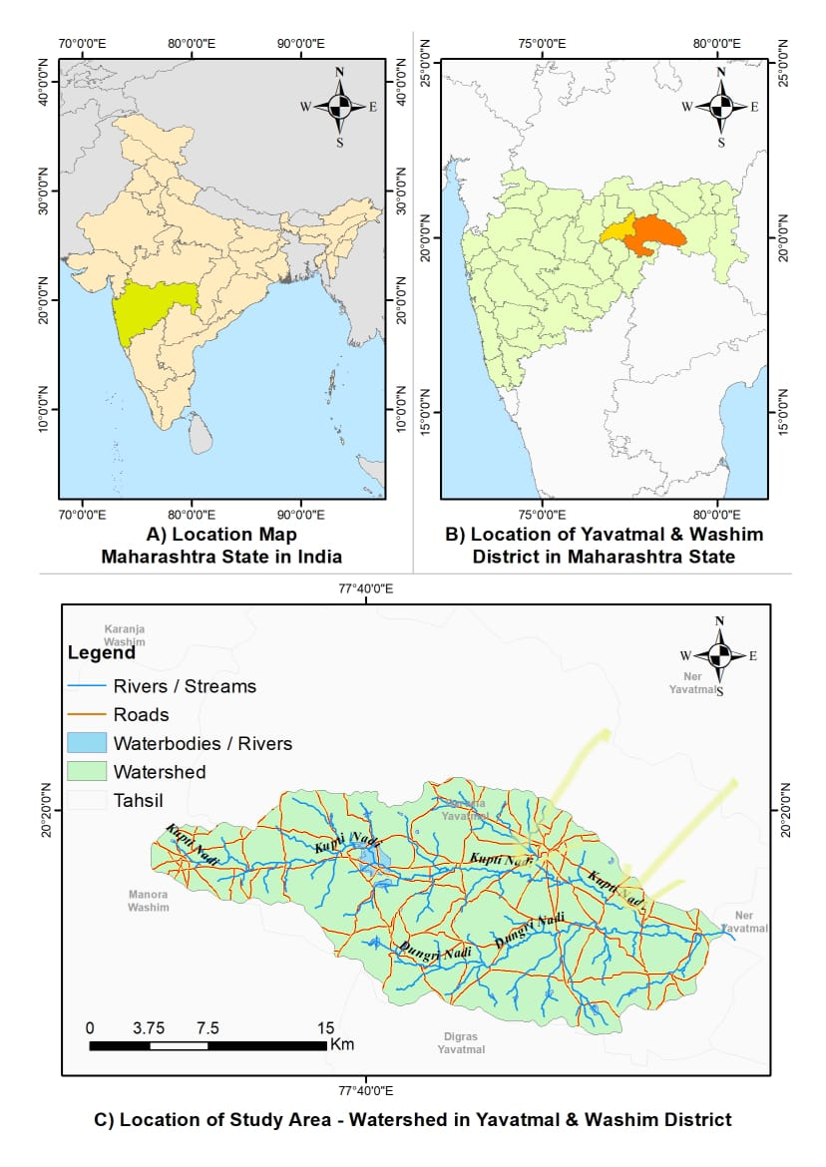

FIG 1. The study location
3) METHODOLOGY
The morphometric analysis of Kupti watershed was carried out using SOI (survey of India) toposheets on scale of 1:50,000 and Shuttle Radar Topography Mission (SRTM) data using Arc GIS software . The SRTM data used was of 30-meter spatial resolution, which is suitable for delineation of the Kupti watershed. The SRTM DEM (Digital Elevation Model) was downloaded from the USGS Earth Explorer portal by selecting the AOI boundary of kupti watershed. Once the data was downloaded, it was imported into ArcGIS. the DEM was reprojected to match the spatial reference system used for the study area, ensuring spatial accuracy during further analysis. After importing the DEM into ArcGIS, the watershed boundary was utilized to clip the DEM with the Extract by Mask tool. This step is essential to focus on watershed and remove unnecessary data. The elevation variation within the Kupti watershed was depicted by the clipped DEM.
To generate the contour lines, the “contour” tool from Arc toolbox was used. These contours represent lines of equal elevation and are helpful in analyzing the slope, gradient and landform features of the watershed. The contour lines were symbolized with appropriate line thickness and color. using this approach, the topographic map of the Kupti watershed was effectively created. The drainage system of the watershed was analyzed according to the laws of Horton (1945) and the stream order was completed using the Strahler method. In this classification, streams with no tributaries are defined as first order; two first-order streams join together to form a second-order stream, and so on. The details on individual stream orders (i.e., one to seven orders) are determined, and subsequently quantitative drainage analysis is worked out in accordance with linear, areal, and relief aspects.
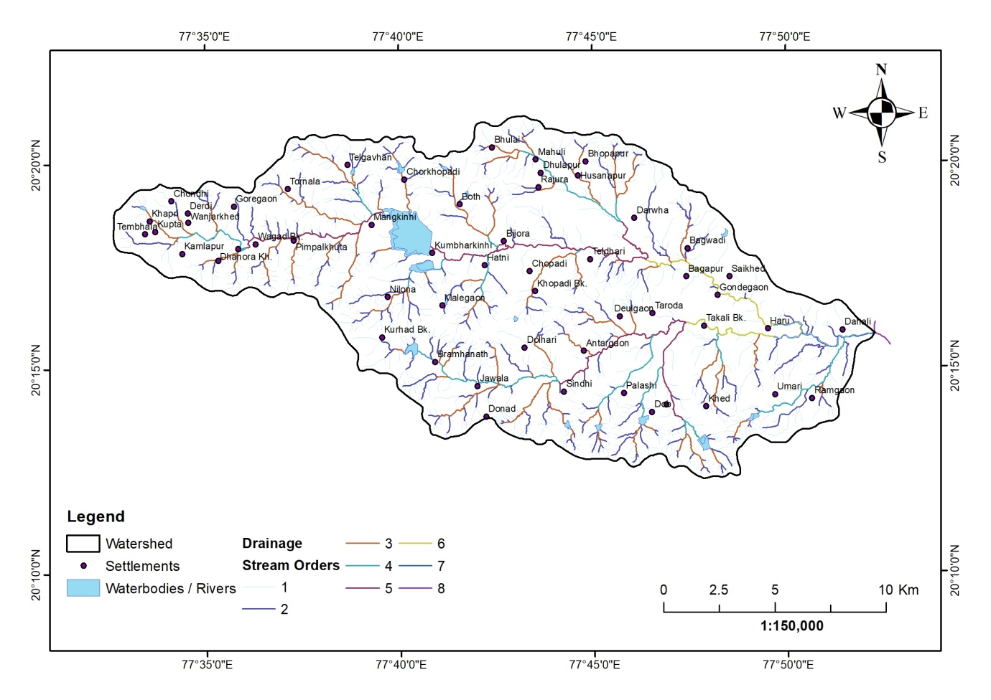 FIG 2. Delineation of the Kupti watershed
- Linear Aspect
Computation of the linear aspects, such as stream order, stream number for various
orders, bifurcation ratio, and stream length for various stream orders, is described below.
- Stream Order (U)
Stream order refers to a system that ranks a stream based on its place within the network of tributaries. (Leopold et al.,1969). The streams of the Kupti watershed have been ranked according to the Strahler's (1964) stream ordering system. The smallest fingertip streams are classified as first-order streams. The trunk stream represents the section of the stream with the highest order. The highest order stream carries discharge and sediment load. The Kupti watershed has been identified as a seventh order stream .
2) Stream Number (Nu)
Stream number the total number of stream segments present in each order is the stream number (Nu). Nu is number strems of order u. Strahler (1964) established a classification system for ordering, which includes the quantity of streams corresponding to each order (Nu), referred to as (U). The overall count of streams consistently decreases as the stream order increases. The differences in order and size of the tributary basin are primarily influenced by the physiographic and structural characteristics of the area. The Nu of the 1 st, 2nd, 3 rd 4 th , 5th, 6th ,7th orders constitute 1124, 271, 71, 17, 4, 2, and 1 streams, respectively.
3) Stream Length (Lu)
Stream length reflects the contributing area of a basin associated with a particular order Horton (1945). The number of streams of various orders in the watershed are counted, their lengths from mouth to drainage divide are measured. Lu has been computed on the basis of Horton's law of stream length.
4) Mean Stream Length (Lsm)
Mean Stream Length (Lsm) is indicative of the characteristic dimensions of components within a drainage network and their associated contributing surfaces (Strahler 1964). It is calculated by dividing the total stream length of a given order, u, by the number of stream segments within that order. It is observed that the Lsm of any specific order is greater than that of the preceding lower order and less than that of the subsequent higher order within the watershed. The LSM value of the Kupti watershed ranges from 0.40 to 9.78 km.
5) Bifurcation Ratio (Rb)
According to Schumn (1956), the bifurcation ratio (Rb) is determined by taking the number of stream segments of a specific order and dividing it by the number of segments in the next higher order. This dimensionless characteristic reflects the level of connectivity among streams of different orders within a drainage basin. The bifurcation ratio (Rb) value for the Kupti watershed lies between 2.0 to 4.11 . As stated by Strahler (1964), the bifurcation ratio typically lies between 3.0 and 5.0 for drainage basins where geological structures do not interfere with the drainage patterns. In the Kupti watershed, a higher Rb value suggests significant structural influence on the drainage pattern, while a lower value implies that the sub-basins are less impacted by structural disturbances (Strahler, 1964).
6) Mean Bifurcation ratio (Rbm)
Mean Bifurcation ratio (Rbm) may be defind as the average of bifurcation ratios of all order and it is 3.92 in case of Kupti watershed.

Table 1: Linear aspects of drainage network of Kupti Watershed
Stream Order(u) | Number of Stream (Nu) | Stream Length(Lu) in m | Mean stream length (Lsm) | Bifurcation Ratio
1 | 1114 | 444.56 | 0.40 | -
2 | 271 | 163.23 | 0.60 | 4.11
3 | 71 | 111.55 | 1.57 | 3.82
4 | 17 | 45.59 | 2.68 | 4.18
5 | 4 | 39.12 | 9.78 | 4.25
6 | 2 | 16.8 | 8.40 | 2.00
7 | 1 | 4.07 | 4.07 | 2.00
Total | 1480 | 824.92 | 27.50 | Avg 3.39

- Areal Aspect
The areal aspect refers to the two-dimensional characteristics of a basin. It is feasible to outline the area of the basin that supplies water to each segment.
1) Drainage Density (Dd)
The total length of the stream channels is determined by dividing it by the basin area, thereby indicating the average stream length per unit area. (Gregory and Walling 1968). Strahler (1956, 1964) indicated that the of drainage is influenced by geological and climatic factors and tends to rise as the size of individual drainage units decreases. The drainage density of the Kupti watershed is measured at 2.62 km/km², suggesting that the basin area is characterized by a coarse texture.
- Drainage Frequency (Fs)
The proportion of all stream segments within a watershed, divided by its total area, is known as the stream frequency (Horton 1932). The stream frequency value for sixth and seventh order streams is low as compared to first order streams. The stream frequency value of the Kupti watershed is 4.71 km/km².
- Texture Ratio (T)
According to Schumm (1956), the texture ratio pertains to the correlation between the first order streams and the basin's boundary. The Kupti watershed has a texture ratio value of 16.26.
4) Circularity Ratio (Rc)
Miller (1958) employed a dimensionless circulatory ratio, Rc which is calculated by dividing the basin area by the area of a circle that has an identical perimeter to the basin. The circularity ratio values range from zero (indicating a line) to one (representing a circle). This ratio is affected by several factors, including stream length, stream frequency (Fs), geological formations, land use, climate, topography, and basin slope (Bali et al.2012). The value of the Kupti watershed is 0.48, which indicates a lack of circularity.
5) Form Factor (Rf)
Horton (1932) The specified form factor is defined as the ratio of the basin's area to the square of its length. The form factor for a perfectly circular basin is always greater than 0.78. A lower value of form factor indicate that basin is more elongated Rf value of Kupti watershed is 0.26 indicative of Slightly elongated and shows flatted peak flow.
6) Elongaton Ratio (Re)
The shape of any basin is conveyed by an elongation ratio , t is the ratio between the diameter of the circle of the same area as the drainage basin and the maximum Schumn (1956).The Re value can vary from 0, signifying a very elongated form, to 1.0, which denotes a circular form. the value for Kupti watershed is 0.58 ,indicative of elongated shape.
7) Length of Overland Flow (Lg)
The length of Overland flow is measured as half the inverse of drainage density (Horton 1945). The distance that water flows across the landscape before it gathers into a distinct stream is referred to as the length of flow. it is quite synonymous to the length of sheet flow over large degree (Rudraiah et al.2008) in kupti watershed value of Lg is 1.31.
8) Constant of Channel Maintenance ( C )
Constant of Channel Maintenance is the inverse of drainage density (Schumm 1956) . the constant of channel maintenance (C) depends on the slope of basin, nature of rock and duration of erosional activity. The Constant of Channel Maintenance value of the Kupti Watershed is 0.38 km/km2 which implies the requirement of an average 0.38 km2 surface area to maintain each kilometer of channel length.
3) Relief Aspects
Linear and areal features have been viewed as the two-dimensional elements that exist on a plane. The introduction of a third dimension brings forth the idea of relief. By assessing the vertical drop from the beginning of each stream segment to the point where it meets the higher order stream, then dividing the total vertical fall by the number of streams of that order, one can calculate the average vertical fall.
- Basin Relief (Bh)
Basin relief refers to the elevation difference between the highest and lowest points within a basin, which influences the basin's shape and the movement of sediments Hadley and Schumm (1961). This is a critical parameter that help in comprehending the erosional traits of the drainage Basin.

- Ruggedness Number (Rn)
Ruggedness number indicates the structural complexity of terrain. Strahler (1968) describe ruggedness number (HD) as the product of basin relief and drainage density it is usually combines slope steepness with its length. For the present watershed ruggedness number obtained is 461.60

- Relief Ratio (Rh)
Schumm (1956) describes the relief ratio as the maximum elevation difference relative to the horizontal distance measured along the longest stretch of the basin that aligns with the primary drainage line. The term total relief of the river basin refers to the variation in elevation between the highest point in the basin and the lowest point on the valley floor.
The relief ratio reflects the general steepness of a drainage basin and serves as measure of the intensity of erosional processes occurring on the basin's slopes (Mangesh et al.,2012) . In case of Kupti watershed it is 5.09

- Infiltration Rate
Infiltration number is the product of drainage density (Dd) and stream frequency (Fs) of the drainage basin, demonstrating the infiltration characteristic of a drainage basin. The infiltration number for the Kupti watershed is observed as 12.34 .

- Elipticity Index. (Ie)
The value of the ellipticity index varies from 1.0 to infinity, and it is inversely proportional to the form factor.

- Channel Gradient (Cg)
Channel gradient is the total drop in elevation from the source to the mouth of trunk channels in each drainage basin. in the Kupti watershed, gradient observed is 0.093 m/km.

- Average Slope of Watershed
Wenthworth (1930) suggests that the erodibility of a watershed can be analyzed and compared by examining its average slope. A higher percentage of slopes indicates greater erosion.

TABLE 2. Linear, relief and areal morphometric parameters used for kupti Watershed

4) Conclusion
The conventional methods of morphometric analysis are time consuming, tiresome and error prone, while employment of present techniques of GIS and Remote Sensing provides more reliable and accurate estimation and serves as an excellent tool for examining similar watershed parameters in hydrological studies. Remote sensing satellite data combined with GIS techniques has proven to be a powerful approach for mapping drainage systems. It is inferred that kupti watershed is dominated by lower order stream .morphometric analysis is carried out by the measurement of linear, areal, relief aspects of watershed. Detail morphometric analysis shows It is a Seventh order river basin and covers an area of about 314.km2, basin perimeter is 91.01 Km and basin length is 34.60 km. The river is trending NW-SE direction. Total Number of 1st, 2nd, 3rd, 4th, 5th, 6th, 7th order streams are 1144, 271, 71, 17, 4, 2 And 1 km respectively. The total numbers of streams are 1480 With total length (824.92) m. The drainage system of the watershed displays a pattern ranging from dendritic to sub-dendritic.
The first-order streams exhibit the greatest frequency of stream order, followed by the second-order streams. This indicates a decrease in stream frequency as the stream order increases, and conversely, an increase in frequency as the stream order decreases. The values of stream frequency demonstrate a positive correlation across watershed, indicating an increase in stream population corresponding to an increase in drainage density. The elongated shape of the basin is evident in the values associated with the form factor, circulatory ratio, and elongation ratio. The average bifurcation ratio of 3.39 suggests that the watershed is minimally influenced by structural disturbances, and the drainage pattern remains largely unaffected by geological structures.

DISCLAIMER (ARTIFICIAL INTELLIGENCE)
Authors hereby declare that no generative AI technologies such as Large Language Models (ChatGPT, COPILOT, etc.) and text-to-image generators have been used during writing or editing of this manuscript.
COMPETING INTERESTS
Author has declared that no competing interests exist.

5)Reference
- 29. Wentworth, C.K (1930), “A Simplified Method of Determining the Average Slope of
- 29. Wentworth, C.K (1930), “A Simplified Method of Determining the Average Slope of
- 29. Wentworth, C.K (1930), “A Simplified Method of Determining the Average Slope of
- 29. Wentworth, C.K (1930), “A Simplified Method of Determining the Average Slope of
- 29. Wentworth, C.K (1930), “A Simplified Method of Determining the Average Slope of

Agarwal, C.S. (1998) Study of Drainage Pattern through Aerial Data in Naugarh Area of Varanasi District, U.P. Journal of the Indian Society of Remote Sensing, 26,169-175.

Bali, R., Agarwal, K. K., Nawaz Ali, S., Rastogi, S. K., & Krishna, K. (2012). Drainage morphometry of Himalayan Glacio-fluvial basin, India: hydrologic and neotectonic implications. Environmental Earth Sciences, 66, 1163-1174.
Clarke JI (1996) Morphometry from maps. Essays in geomorphology. Elsevier Publ. Co., New York, pp 235–274
Gregory KJ, Walling DE (1968) The variation of drainage density within a catchment. Int Assoc Sci Hydrol 13:61–68
Hadley, R. F., and Stanley Alfred Schumm. "Sediment sources and drainage basin characteristics in upper Cheyenne River basin." US geological survey water-supply paper 1531 (1961): 198.
Horton RE (1932) Drainage basin characteristics. Trans Am Geophys Union 13:350–361
Horton, R.E. (1945). Erosional development of streams and their drainage basins. Bull. Geol. Soc.Am., v. 56, pp. 275-370.
Leopold, L. B., Wolman, M. G., Miller, J. P., & Wohl, E. E. (2020). Fluvial processes in geomorphology. Courier Dover Publications.
Machiwal D, Jha MK (2014) Characterizing rainfall–groundwater dynamics in a hard rock aquifer system using time series, geographic information system and geostatistical modelling. Hydrol Process 28(5):2824–2843
Magesh, N. S., Jitheshlal, K. V., Chandrasekar, N., & Jini, K. V. (2012). GIS based morphometric evaluation of Chimmini and Mupily watersheds, parts of Western Ghats, Thrissur District, Kerala, India. Earth Science Informatics, 5, 111-121.
MESA, L.M. (2006) Morphometric analysis of a subtropical Andeanbasin (Tucumam, Argentina). Environmental Geology, v.50(8),pp.1235-1242
Miller, V.C. (1953) A Quantitative Geomorphic Study of Drainage Basin Characteristics in the Clinch Mountain Area, Virginia and Tennessee. Department of Geology Columbia University, New York, 389-402.
Mueller, J.E. (1968) An Introduction to the Hydraulic and Topographic Sinuosity Indexes 1. Annals of the Association of American Geographers, 58, 371-385.
Rai PK, Mohan K, Mishra S, Ahmad A, Mishra VNA. 2014. GIS-based approach in drainage morphometric analysis of Kanhar River Basin, India. Applied Water Science 7(1): 217-232. doi:10.1007/s13201-014-0238-y.
Schumm, S.A. (1956). Evaluation of drainage systems and slopes inbadlands at PerthAmboy, New Jersy. Bull. Geol. Soc.Am., v.67, pp.597-646.
Sheik Mohideen, A. R. (2021). Morphometric assessment of hydrogeomorphic processes and landscape evolution in the Kallar watershed (Western Ghats, India): regionalisation and prioritisation. Arabian Journal of Geosciences, 14, 1-28.
Shimpi, Sujit S., and V. M. Rokade. "GIS based morphometric analysis of Bori-Chikli watershed of Jalgaon District, Maharashtra, India." Int. J. Econ. Environ. Geol. Vol 8.3 (2017): 1-8.
Siddi Raju R, Sudarsana Raju G, Rajasekhar M. 2020. Morphometric analysis of Mandavi River Basin in Rayalaseema region of Andhra Pradesh (South India), using remote sensing and GIS. Jr. Ind. Geophys. Union 24(1): 54-67.
Singh S, Dubey A (1994) Geoenvironmental planning of watershed in India. Chugh Publications, Allahabad, pp 28–69
Sreedevi, P. D., Owais, S. H. H. K., Khan, H. H., & Ahmed, S. (2009). Morphometric analysis of a watershed of South India using SRTM data and GIS. Journal of the geological society of india, 73, 543-552.
Strahler AN (1952) Hypsometric analysis of erosional topography. Bull Geol Soc Am 63:111
Strahler AN (1956) Quantitative slope analysis. Bull Geol Soc Am 67:571–596
Strahler, A.N. (1964). Quantitative geomorphology of drainage basinsand channel networks. : Chow, V.T. ( ) Handbook of AppliedHydrology, McGraw Hill Book Com., NewYork, pp. 4-1
udraiah, M., Govindaiah, S., & Vittala, S. S. (2008). Morphometry using remote sensing and GIS techniques in the sub-basins of Kagna river basin, Gulburga district, Karnataka, India. Journal of the Indian society of remote sensing, 36, 351-360.
Vijith, H., Satheesh, R. (2006). GIS based morphometric analysis of two major upland sub watersheds of Meenachil River in Kerala. Journal of the Indian Society of Remote Sensing, 34 (2), 181-185.
Wakode Hemant Balwant, Dibyendu Dutta, V. R. Desai, Klaus Baier and Rafig Azzam (2011) Morphometric analysis of the upper catchment of Kosi River using GIS techniques. Arabian J. Geosci, 6, 395–408.
Wentworth, C.K (1930), “A Simplified Method of Determining the Average Slope of Land Surfaces”, American Journal of Science, 21, pp 184-194.

Wentworth, C.K (1930), “A Simplified Method of Determining the Average Slope of

