Original Research Article

Atmospheric Response to India’s COVID-19 Lockdown: A Multi-Satellite Assessment of Aerosols, Trace Gases, and Meteorological Influences

Abstract
The nationwide lockdown implemented in India on 24 March 2020 to control the spread of COVID-19 resulted in an abrupt decline in anthropogenic emissions, offering a unique opportunity to assess the atmospheric response to rapid emission reductions. This study examines changes in aerosol optical depth (AOD), nitrogen dioxide (NO₂), sulfur dioxide (SO₂), and ozone (O₃) across India using satellite observations from MODIS (Terra) and OMI (Aura), supported by meteorological fields from MERRA-2. Monthly anomalies during February–June 2020 were quantified relative to a six-year climatology (2014–2019).
Results show substantial decreases in AOD (~14 %), tropospheric NO₂ (~15 %), SO₂ (~9 %), and tropospheric O₃ (~7 %), while total column O₃ increased by approximately 3 %. The Indo-Gangetic Plain exhibited the strongest reductions due to its dense concentration of transport and industrial sources. In contrast, a slight increase in AOD over Central India was associated with elevated relative humidity and low wind speeds, enhancing secondary aerosol formation. Meteorological analysis revealed enhanced moisture and variable wind patterns that modulated pollutant distributions, highlighting the combined influence of emissions and atmospheric dynamics.
The findings demonstrate the sensitivity of India’s atmospheric environment to reduced anthropogenic activity and provide insights into the interplay between emissions and meteorology. These results can inform targeted emission-reduction strategies for improving regional air quality.
Article Highlights
- Lockdown restrictions led to 14–31 % reductions in AOD across major Indian regions.
- Tropospheric NO₂ and SO₂ declined by 15 % and 9 %, respectively.
- Tropospheric O₃ decreased, but total O₃ increased, indicating altered photochemistry.
- Meteorological factors—humidity and winds—modulated pollution anomalies.
- The Indo-Gangetic Plain showed the largest improvements.
Keywords: Aerosol Optical Depth (AOD), Nitrogen Dioxide (NO₂), Sulfur Dioxide (SO₂), Ozone Variability, COVID-19 Lockdown, Satellite Remote Sensing

- Introduction
The outbreak of a novel coronavirus (SARS-CoV-2) in late 2019, first reported in Wuhan, China, rapidly evolved into a global health emergency, prompting unprecedented public health and mobility restrictions worldwide (WHO, 2020). In India, a strict nationwide lockdown was implemented on 24 March 2020, suspending most industrial operations, transportation, construction, and commercial activities. These measures, designed primarily to contain viral transmission, inadvertently resulted in one of the largest and most abrupt declines in anthropogenic emissions in recent decades.
Such widespread restrictions created a unique natural experiment for assessing the atmospheric response to sudden and large-scale emission reductions. Previous studies across China, Europe, and North America have documented significant decreases in particulate matter, nitrogen dioxide (NO₂), and sulfur dioxide (SO₂) during COVID-19 lockdowns, alongside more complex behavior in ozone (O₃) due to nonlinear photochemical processes. Similar improvements were reported in Indian cities; however, the magnitude and spatial variability of pollutant reductions across the country remain less comprehensively quantified, particularly when evaluated with long-term satellite-based climatology.
India’s atmospheric environment is characterized by strong spatial heterogeneity, influenced by diverse emission sources, seasonal meteorology, and the region’s unique topography. The Indo-Gangetic Plain (IGP), one of the most polluted regions globally, is highly sensitive to shifts in emission intensity and meteorological conditions. Assessing pollutant variability during the lockdown therefore provides valuable evidence of how human activities shape baseline air quality in such complex environments.
This study uses multi-satellite observations (MODIS AOD, OMI NO₂/SO₂/O₃) and MERRA-2 reanalysis meteorology to quantify the deviations in aerosol and trace-gas concentrations across India during the COVID-19 lockdown and to examine the role of meteorological factors in modulating these changes. The findings contribute to a deeper understanding of pollutant dynamics and offer insights for designing effective emission-management and air-quality policies.
  - Global and National Observations during Lockdown
Worldwide satellite and ground-based measurements showed substantial air quality improvements during early 2020. Studies across Europe, China, and North America observed significant reductions in NO₂, SO₂, and particulate matter concentrations following lockdowns (Bao and Zhang, 2020; Bauwens et al., 2020). In China, for instance, NO₂ concentrations declined by 20–40% (Filonchyk et al., 2020). Over India, surface PM₂.₅ levels dropped by nearly 50% in major urban centers like Delhi (Mahato et al., 2020), while overall AOD values decreased notably (Gautam, 2020).
However, atmospheric responses were not spatially uniform. Certain regions exhibited localized increases in aerosol loading and ozone levels due to meteorological conditions and photochemical processes. Such variations highlight the need for integrated analyses that consider both emissions and atmospheric dynamics.
  - Study Objectives
This study aims to:
- Quantify changes in AOD, NO₂, SO₂, and O₃ during the 2020 lockdown relative to multi-year climatological baselines (2014–2019).
- Assess spatial and regional variations across six major regions of India.
- Examine the influence of meteorological parameters (wind, humidity) on observed atmospheric changes.
- Provide an integrated interpretation of emission–meteorology–chemistry interactions under reduced anthropogenic influence.
- Data and Methodology
  - Study Region
India, extending from 8°N to 37°N and 68°E to 97°E, comprises diverse climatic zones ranging from arid regions in the northwest to humid tropics in the south. For this study, the country was divided into six climatologically and topographically distinct regions: Peninsular India (PI), Central India (CI), Western India (WI), Eastern India (EI), Northern India (NI), and the Indo-Gangetic Plain (IGP). The IGP, a densely populated and industrialized corridor, is particularly significant due to its chronic air pollution.
  - Lockdown Phases
The COVID-19 lockdown, initiated on 24th March 2020, with large relaxations implemented
in phases, is well-publicized (Government of India, 2020). A short account of the sequence of events is explained in brief.
- LD1 (24th March to 14th April): Total shutdown of movement of people `Stay at home approach', complete cessation of vehicular traffic (road, rail, air, and water traffic) except emergency services. Industries, commercial establishments, places for entertainment, place of worship, and educational institutions remained closed. Public gatherings were banned. Large reduction in energy use.
- LD2 (15th April to 03rd May): Restrictions on the transport sector relaxed permitting essential goods and emergency services. Full restrictions continued to be enforced on the identified areas with high infection rate. Industries, commercial establishments, places of worship, and educational institutions continued to be closed, except for small-scale establishments.
- LD3 (04th May to 17th May): Although large industries, commercial establishments, places of worship and educational institutions continued to be closed, further relaxation was allowed in the transport section and restricted functioning of government offices and private establishments. Limited-scale restoration of air and rail traffic.
- LD4 (18th May to 31st May): Further relaxation in traffic and small business establishments subjected to night-time restrictions from 9:00 PM to 05:00 AM; large industries, commercial establishments places for public entertainment and educational institutions continued to be closed, and large gatherings continued to be restricted.
- Unlock (UL1) (01st June to 30th June): Transition from LD to unlock in a phased manner. More relaxation in road, rail, and domestic air traffic. Major industries resumed with stringent safety measures and places of worship opened to the public with strict guidelines.
- UL2 (from 01st July): Further relaxations from UL1 conditions, while restrictions continued with respect to the functioning of educational institutions, large commercial activities, cinema halls, large social and political gatherings and international air travel except of repatriation.
  - Data Sources
Table 1: Data source
Dataset | Parameter | Source | Spatial Resolution | Reference
MODIS-Terra | Aerosol Optical Depth (550 nm) | MOD08 M3 v6 | 1° × 1° | Levy et al. (2015)
OMI-Aura | NO₂, SO₂, O₃ | Level 3 | 0.25° × 0.25° | Levelt et al. (2018)
MERRA-2 | Wind, RH, SH | Reanalysis (NASA GMAO) | 0.5° × 0.625° | Gelaro et al. (2017)

- Aerosol Optical Depth (AOD)
MODIS (Terra) Level-3 dataset (MOD08 M3, v6) was used to retrieve AOD at 550 nm, employing the Deep Blue algorithm for land-only retrievals at a spatial resolution of 1° × 1°. These data provide global monthly averages of aerosol loading.
- Trace Gases (NO₂, SO₂, and O₃)
The Ozone Monitoring Instrument (OMI) aboard NASA’s Aura satellite was used to obtain daily Level-3 tropospheric NO₂, SO₂, and O₃ column data at 0.25° × 0.25° resolution. Data with cloud radiance fractions exceeding 0.3 were excluded to ensure clear-sky quality.
- Meteorological Variables
Meteorological parameters were derived from MERRA-2 reanalysis datasets, including wind speed, specific humidity (SH), and relative humidity (RH) in the 850–500 hPa layer. This help interpret atmospheric dispersion and aerosol–moisture interactions.
- Analytical Framework
To assess the impact of lockdown, monthly means from 2020 were compared with 2014–2019 averages:
$Anamoly \left(\%\right)=\frac{X_{2020 }-{\overline{X}}_{2014-2019}}{{\overline{X}}_{2014-2019}}×100$ …. (1)
X represents AOD, NO₂, SO₂, or O₃. Spatial mapping and region-wise statistical analyses were conducted using MATLAB.
- Results and Discussion
  - Aerosol Optical Depth (AOD) Variations
Satellite-derived Aerosol Optical Depth (AOD) showed a clear and widespread decline across India during the lockdown period, reflecting the sharp reduction in industrial and traffic-related emissions. As illustrated in Figure 1, which presents the spatial distribution of AOD anomalies for April–May 2020 relative to the 2014–2019 mean, strong negative anomalies dominate the Indo-Gangetic Plain (IGP), Western India, and Northern India. These maps reveal reductions frequently exceeding 25–30%, highlighting the significant atmospheric response to curtailed anthropogenic activities.
Western India, in particular, exhibits a broad swath of intense negative anomalies, while the IGP — one of the world’s most pollution-prone regions — shows widespread AOD decreases associated with the suspension of construction, transportation, and industrial operations. Eastern India also displays substantial reductions. In contrast, Figure 1 a small pocket of positive anomaly in Central India, which aligns with stagnant wind conditions and elevated humidity that supported secondary aerosol formation.
The spatial gradients evident in the AOD anomaly map emphasize the interplay between emission changes and meteorological conditions, resulting in heterogeneous responses despite a nationwide reduction in emissions.
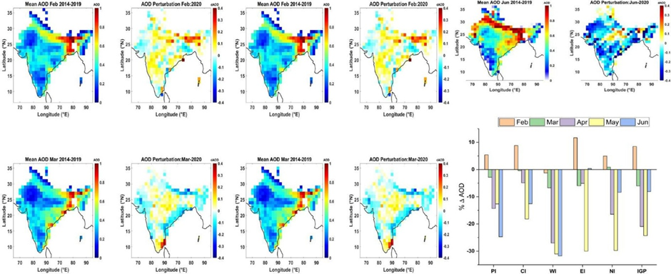
Figure 1: Spatial variation of aerosol optical depth (AOD) anomalies over India during April–May 2020 relative to 2014–2019 mean.
  - Nitrogen Dioxide (NO₂) Variations
Tropospheric NO₂ exhibited one of the most immediate and substantial responses to the lockdown. Figure 2, which depicts the spatial distribution of NO₂ anomalies during the lockdown, shows the disappearance of major urban and industrial emission hotspots, particularly over Delhi, Mumbai, Kolkata, and the coal-fired power plant clusters of Eastern India.
Compared with climatology, NO₂ concentrations decreased sharply across the IGP (up to ~18%), Western India (~12%), and Eastern India (~15%). The figure distinctly highlights large patches of negative anomalies over densely populated regions, confirming the strong dependence of NO₂ on combustion-related emissions such as vehicles, industries, and power generation.
However, Figure 2 also reveals localized positive anomalies in parts of Punjab and Haryana. These small red patches correspond to agricultural residue burning during the rabi harvest season, demonstrating that seasonal biomass burning persisted as an emission source even during lockdown and temporarily offset the reductions caused by anthropogenic shutdowns.
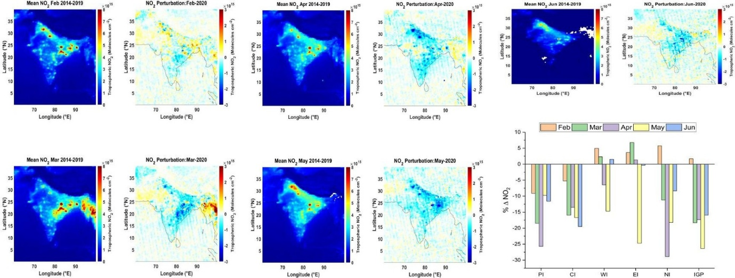
Figure 2: Tropospheric NO₂ anomalies during April–May 2020. Strong reductions occurred over major industrial and urban regions.
  - Sulfur Dioxide (SO₂) Variations
SO₂, primarily emitted from coal-fired power plants and heavy industry, showed substantial reductions during the lockdown, as evident in Figure 3, which presents SO₂ anomalies across India. The map clearly depicts intense negative anomalies over Eastern India (Jharkhand–Odisha–Chhattisgarh belt) and Western India, regions where thermal power plants are major SO₂ contributors. Reductions in these areas reached as high as 40%, reflecting decreased electricity demand and industrial closure.
Over the Indo-Gangetic Plain, Figure 3 illustrates moderate SO₂ reductions (20–25%), consistent with partial shutdowns of industrial activity. In contrast, Peninsular India displays isolated pockets of positive anomalies, indicating continued operation of essential facilities such as refineries and coastal power plants.

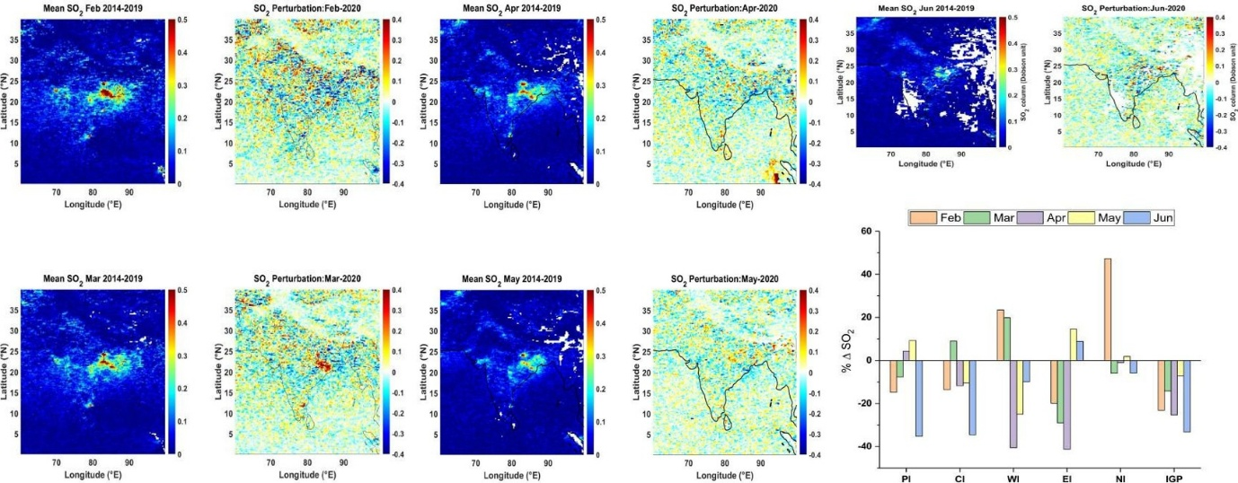
Figure 3: Total SO₂ column anomalies during lockdown months (April–May 2020). The largest reductions occurred over eastern and western industrial zones.
The SO₂ anomaly pattern aligns strongly with source locations shown in the figure, reinforcing that stationary industrial sources largely determine SO₂ variability, even during periods of reduced mobility.
  - Ozone (O₃) Variations
Ozone exhibited contrasting behavior in its tropospheric and total column forms. Figure 4, which displays maps of tropospheric O₃ anomalies and Figure 4, which displays maps of total O₃ anomalies, shows that tropospheric ozone decreased across much of India, particularly the IGP and Western India, where reductions of up to 7–10% were evident.
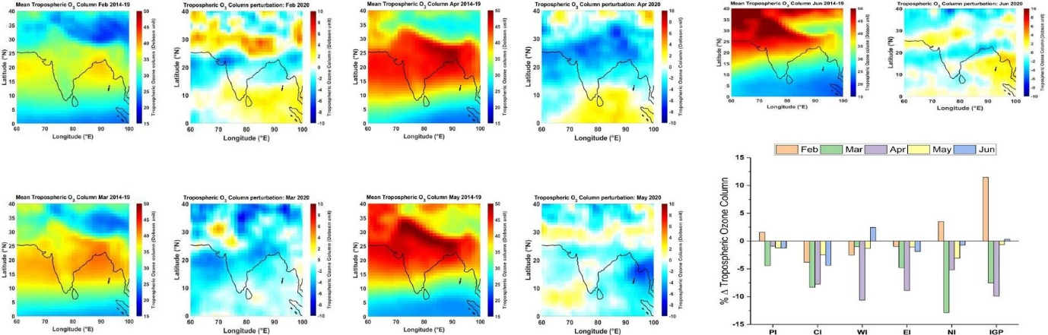
Figure 4.: Tropospheric O₃ anomalies during April–May 2020.
This decline reflects lower precursor emissions (NO₂ and VOCs), reducing ozone formation. However, the total ozone map in Figure 4 shows mild positive anomalies (2–4%) across the same northern regions, indicating a relative increase in the total atmospheric ozone column. This apparent contradiction is explained by reduced NO titration — normally, NO scavenges ozone, but during lockdown the reduced NO concentrations allowed ozone to accumulate in the total column.
The spatial contrast between the two panels in Figure 5 effectively visualizes this photochemical shift: deep blue patches dominate the tropospheric map, while light red shading appears in the total-column map.

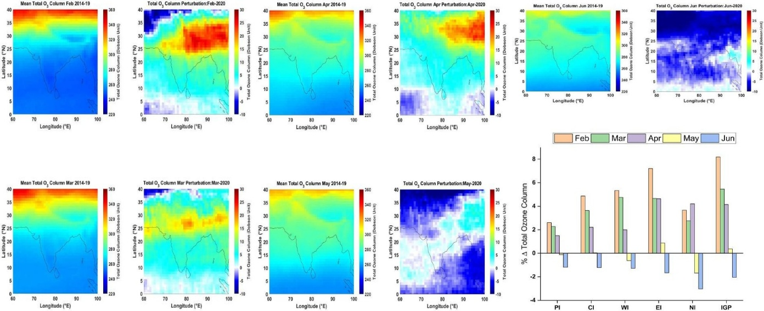
Figure 5.: Total O₃ column anomalies during April–May 2020.
  - Meteorological Role
Changes in meteorological conditions further shaped pollutant patterns during the lockdown. Figure 6 presents three key meteorological anomaly fields: (a) wind vectors at 850 hPa, (b) relative humidity (RH), and (c) specific humidity (SH). The wind anomaly map reveals intensified northwesterly flows over the IGP, enhancing dispersion and aiding the observed decreases in AOD, NO₂, and SO₂. Conversely, Central India shows weaker winds and stagnant conditions, supporting localized AOD increases despite reduced emissions.
The RH anomaly map in Figure 6(b) shows increased humidity across much of Northern and Western India, with anomalies reaching +20 units. Similarly, Figure 6(c) indicates elevated specific humidity (6–8% above climatology). Such moisture enrichment favors aqueous-phase oxidation of SO₂ and the hygroscopic growth of aerosols, providing a mechanistic explanation for the modest AOD increases in parts of Central India.
Thus, the meteorological fields shown in Figure 6 confirm that synoptic-scale weather patterns played a decisive role in modulating pollutant responses during the lockdown.
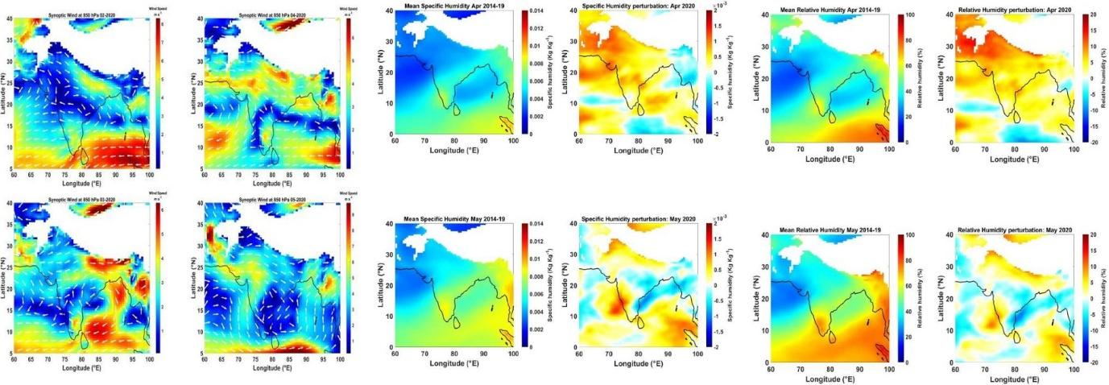
Figure 6: Meteorological anomalies during lockdown: (a) wind vectors, (b) relative humidity, (c) specific humidity.
- Conclusions
This study examined the atmospheric response to India’s COVID-19 lockdown using satellite-derived observations of aerosol optical depth (AOD), nitrogen dioxide (NO₂), sulfur dioxide (SO₂), and ozone (O₃), supported by meteorological reanalysis. The lockdown resulted in one of the most abrupt and widespread reductions in anthropogenic emissions ever recorded across the country, producing clear improvements in atmospheric composition. AOD, NO₂, and SO₂ exhibited substantial declines relative to the 2014–2019 climatological mean, with the most pronounced reductions occurring over the Indo-Gangetic Plain and Western India—regions typically characterized by intense industrial and vehicular emissions.
The decline in tropospheric ozone further reflected the reduction in precursor gases, whereas the modest increase in total column ozone illustrated the nonlinear nature of ozone chemistry under low-NOx conditions. These findings confirm that India’s atmosphere responds rapidly to changes in anthropogenic emissions, particularly in densely populated and industrialized regions. At the same time, the persistence of localized aerosol enhancements in Central India underscores the important modulatory role of meteorological conditions—especially humidity and wind patterns—on pollutant concentrations, even during periods of reduced human activity.
Table 2: Regional Mean Percentage Changes (%) in Atmospheric Parameters (March–June 2020)
Region | AOD | NO₂ | SO₂ | Trop. O₃ | Total O₃ | RH
IGP | –25 | –18 | –25 | –9 | +4 | +8
NI | –29 | –15 | –24 | –5 | +4 | +8
WI | –31 | –12 | –40 | –10 | +1 | +6
EI | –29 | –15 | –41 | –1 | +2 | +4
CI | +10 | –10 | –11 | –3 | +2 | +5
PI | –12 | –8 | +4 | –1 | +1.5 | +2

Overall, the results highlight the dual influence of emissions and meteorology in shaping regional air quality. The lockdown episode serves as a natural experiment demonstrating the magnitude of air-quality improvements achievable through emission control, while also emphasizing the need to incorporate meteorological variability into air-quality management and policy frameworks. Future work integrating chemical transport modelling and higher-resolution emission inventories will help further disentangle the combined effects of meteorology and human activity on atmospheric composition.
Regional Disparities: The Indo-Gangetic Plain experienced the highest reductions due to dense population and emission sources, while some regions of central India showed minor increases influenced by meteorology.
Ozone Response: Total column ozone increased slightly (~3%) due to complex NOx–O₃ chemistry.
Meteorological Influence: Increased humidity and altered wind patterns modulated regional pollutant levels, demonstrating the coupled nature of emissions and atmospheric conditions.
Policy Implications: The results confirm that immediate air quality improvements are achievable through emission control, yet sustainable management must integrate meteorological understanding and long-term behavioral change.

References
- Ahmad, S., Khan, I. A., & Singh, S. (2018). Design and analysis of pollution variability during lockdown. Environmental Research Letters, 13(8), 085005. https://doi.org/10.1088/1748-9326/aadfa7
- Bao, R., & Zhang, A. (2020). Does lockdown reduce air pollution? Evidence from 44 cities in northern China. Science of the Total Environment, 731, 139052. https://doi.org/10.1016/j.scitotenv.2020.139052
- Bauwens, M., Compernolle, S., Stavrakou, T., Müller, J.-F., Van Gent, J., Eskes, H., … Zehner, C. (2020). Impact of coronavirus outbreak on NO₂ pollution assessed using TROPOMI and OMI observations. Geophysical Research Letters, 47(11), e2020GL087978. https://doi.org/10.1029/2020GL087978
- Chauhan, A., Singh, R. P., & Shukla, D. (2021). Impact of COVID-19 lockdown on SO₂ emissions over India. Environmental Monitoring and Assessment, 193, 750. https://doi.org/10.1007/s10661-021-09256-1
- Chen, K., Wang, M., Huang, C., Kinney, P. L., & Paul, A. (2020). Air pollution reduction and mortality benefit during COVID-19 lockdown: Evidence from China. Environmental Research, 193, 110478. https://doi.org/10.1016/j.envres.2020.110478
- Dang, R., & Liao, H. (2021). Changes in air pollutants and meteorology during COVID-19 lockdowns in China. Atmospheric Chemistry and Physics, 21(3), 1889–1905. https://doi.org/10.5194/acp-21-1889-2021
- Filonchyk, M., Hurynovich, V., Yan, H., Gusev, A., & Shpilevskaya, N. (2020). Impact assessment of COVID-19 on variations of SO₂, NO₂, CO, and AOD over East China. Aerosol and Air Quality Research, 20(7), 1530–1540. https://doi.org/10.4209/aaqr.2020.05.0229.
- Gaubert, B., Bouarar, I., Doumbia, T., Brasseur, G. P., Liu, Y., Elguindi, N., … Schultz, M. G. (2021). COVID-19 lockdown impact on tropospheric ozone and related chemistry. Atmospheric Chemistry and Physics, 21(2), 1085–1102. https://doi.org/10.5194/acp-21-1085-2021
- Gelaro, R., McCarty, W., Suárez, M. J., Todling, R., Molod, A., Takacs, L., … Zhao, B. (2017). The Modern-Era Retrospective Analysis for Research and Applications, Version 2 (MERRA-2). Journal of Climate, 30(14), 5419–5454. https://doi.org/10.1175/JCLI-D-16-0758.1
- Gautam, S. (2020). The influence of COVID-19 on air quality in India: A boon or inutile? Bulletin of Environmental Contamination and Toxicology, 104(6), 724–726*.
- Ghosh, A., Maji, K. J., & Sinha, B. (2021). COVID-19 lockdown impact on Indian aerosols and visibility. Environmental Pollution, 276, 116732. https://doi.org/10.1016/j.envpol.2021.116732
- Government of India. (2020). Order No. 40-3/2020-DM-I(A): Measures to contain the spread of COVID-19. Ministry of Home Affairs, New Delhi.
- Guttikunda, S. K., Goel, R., Pant, P., & Shukla, K. (2021). Sources and drivers of air pollution in Indian cities. Atmospheric Environment, 246, 118086. https://doi.org/10.1016/j.atmosenv.2020.118086
- He, G., & He, H. (2020). Water promotes oxidation of SO₂ by O₂ over carbonaceous aerosols. Environmental Science & Technology, 54(11), 7070–7077*.
- Jain, S., & Sharma, T. (2020). Social and travel lockdown impact on air quality in megacities of India. Aerosol and Air Quality Research, 20(6), 1222–1236*.
- Kumar, M., Singh, R. K., & Bhardwaj, R. (2021). Impact of COVID-19 lockdown on AOD and meteorological factors in India. Environmental Research Communications, 3(9), 095002*.
- Kumar, P., Sahu, R., & Prasad, R. (2022). Regional air pollution dynamics in post-lockdown India. Environmental Challenges, 6, 100438*.
- Le Quéré, C., Jackson, R. B., Jones, M. W., Smith, A. J. P., Abernethy, S., Andrew, R. M., … Peters, G. P. (2020). Temporary reduction in global CO₂ emissions during COVID-19. Nature Climate Change, 10, 647–653*.
- Levelt, P. F., Joiner, J., Tamminen, J., Veefkind, J. P., Bhartia, P. K., & Coauthors. (2018). The OMI mission: Ten years of atmospheric monitoring. Atmospheric Measurement Techniques, 11, 583–602.
- Levy, R. C., Mattoo, S., Munchak, L. A., Remer, L. A., Sayer, A. M., & Winker, D. M. (2015). Collection 6 MODIS aerosol products. Atmospheric Measurement Techniques, 8, 1337–1362*.
- Liu, F., Page, A., van der A, R., Stavrakou, T., Eskes, H., & Müller, J.-F. (2021). Lockdown emission reductions estimated using satellites. Science Advances, 7(3), eabf9780*.
- Mahato, S., Pal, S., & Ghosh, K. G. (2020). Effect of lockdown on air quality of Delhi. Science of the Total Environment, 730, 139086*.
- Navinya, C., Patidar, G., & Phuleria, H. C. (2021). Air quality during COVID-19 lockdown in India. Environmental Science and Pollution Research, 28, 54448–54463*.
- Pandey, S. K., Bakshi, H., & Vinoj, V. (2021). Long-term aerosol changes over IGP. Remote Sensing of Environment, 264, 112594*.
- Ranjan, A. K., Patra, A., & Gorai, A. K. (2021). Air quality changes across India during lockdown. Environmental Science and Pollution Research, 28, 60769–60783*.
- Satheesh, S. K., & Ramanathan, V. (2000). Tropical aerosol forcing differences. Nature, 405, 60–63*.
- Sharma, S., Zhang, M., Gao, J., Zhang, H., & Kota, S. H. (2020). Restricted emissions & air quality in India. Science of the Total Environment, 728, 138878*.
- Sicard, P., De Marco, A., Agathokleous, E., Feng, Z., Xu, X., Paoletti, E., … Calatayud, V. (2020). Amplified urban ozone pollution during lockdown. Science of the Total Environment, 735, 139542*.
- Vadrevu, K. P., Eaturu, A., & Reddy, C. S. (2021). Fire activity in India during lockdown. Remote Sensing, 13(3), 404*.
- Venter, Z. S., Aunan, K., Chowdhury, S., & Lelieveld, J. (2020). Global air-pollution declines during lockdowns. Proceedings of the National Academy of Sciences, 117, 18984–18990.
- World Health Organization. (2020). WHO Director-General's statement on the advice of the IHR Emergency Committee on Novel Coronavirus (2019-nCoV).

