Original Research Article

Assessment of Historical and Future Climate Trends in Kapoeta Region of South Sudan

.

ABSTRACT
The future climate situations depend on greenhouse gas emissions in Kapoeta region of South Sudan. The study determined historical (1984-2016) and projected (2021-2050) climate trends in Kapoeta region. Descriptive and non-parametric statistics using Man-Kendall-tau and Sein’s-Slope-estimator in XLSTAT 2016 were employed to project historical (1984-2016) and future (2021-2050) climate trends. The study was conducted in Greater Kapoeta, Eastern Equatoria State of South Sudan in 2016. The rainfall and temperature projection were presented under Representative Concentration Pathways (RCP) 4.5 and 8.5 from 2021-2050 using Norwegian Earth System Model One (NorESM1). Evidently, annual rainfall amount declined (P=0.05) by 0.32 mm from 1984-2016 and its monthly patterns changed from unimodal (1984-1994) to bimodal patterns (1995-2016). Similarly, maximum annual temperature was significantly (P=0.05) increasing by 0.061ºC whereas monthly temperature significantly (P=0.05) increased in March-May, July, and October from 1984-2016. The annual rainfall projection non- significantly (P=0.05) increase by 2.912 mm and decrease by 3.080 mm under RCP8.5 and RCP4.5 from August-December from 2021-2025. The peak monthly rainfall amount of 111 mm and 89 mm will occur in November under RCP8.5 and RCP4.5 from 2021-2050. The study anticipates significantly (P=0.05) increase in annual temperature by 0.016ºC and 0.028ºC and average monthly temperature increase from January-May under RCP4.5 and RCP8.5 from 2021-2050. The peak maximum average monthly temperature will reach 28.4ºC and 28.3ºC in March under RCP4.5 and RCP8.5 from 2021-2050. Ultimately, climate trends increased (1984-2016) with anticipated future increase (2021-2050) that require awareness of the pastoral and agropastoral communities on climate anomalies in Kapoeta region.

Keywords: Climate trends, Greenhouse gases emissions, Representative Concentration Pathways, Rainfall and temperature trends
1. INTRODUCTION

Climate change emanating from greenhouse emissions will affect pastoral and agropastoral livelihoods (Alam and Rukhsana 2023; IPCC 2023; Yuan et al. 2024; Zenda 2024). Intergovernmental Panel on Climate Change (IPCC) Sixth Assessment Report (AR6) (2023) indicated increased global temperature by 1.1ºC from 2011-2020 compared to 0.8ºC of 1850-1900. These temperature increment emanated from greenhouse gas emissions (79%) from energy production, industrial developments, transportation sectors, buildings and 22% from agriculture production and forest exploitations in 2019 (IPCC 2023). Certainly, annual temperature increase of 1ºC will reduce global agricultural and forage production that affect 3.6 billion people from developing countries (Hultgren et al. 2025; Yuan et al., 2024; Zenda, 2024). However, increase adaptation and income will reduce climate effects by 23% while substantial climate mitigation measures at RCP1.0-1.9 will cancel global warming in 2050 (IPCC, 2023). Intermediate (RCP2.6-4.5) and high (RCP7.0-8.5) CO₂ emissions will increase annual temperature rate between 2ºC-3ºC, and 3ºC-4ºC by 2070 that increases droughts, floods and heat to 118 million people from Africa by 2030 (WMO, 2024a). African temperature rate was 0.3ºC from 1991-2024 relative to the global temperature rate of 0.2ºC from 1961-1991 (Chamma, 2024; WMO, 2024a; Wright et al., 2024). North African region recorded rising temperature trends of 0.4ºC from 1991-2024 compared to average temperature of 0.2ºC from 1961-1991 with anticipated drop of 40-60% of precipitation in summer by 2024 (WMO, 2024a; Wright et al., 2024). Tunisia and Morocco recorded maximum temperature of 49ºC and 50.4ºC with short rainy seasons in 2024 (Chamma, 2024) that affected livestock, crops, and forage production (Ayanlade et al., 2022; Serdeczny et al., 2017). The Southern African region had 0.84ºC temperature increment in 2024 relative to the global temperature rate of 0.32ºC and 0.17ºC between 1961-1990 and 1991-2020 respectively.

Further, East African region recorded high temperature rate of 1.37ºC and 0.68ºC in 2024 compared to global temperature rate of 0.02ºC and 0.67ºC between 1961-1990 and 1991-2020 (Serdeczny et al., 2017; WMO, 2024a). Increased droughts and precipitation are associated to negative and positive Indian Ocean Dipole (IOD) from October-December in East Africa (Zheng et al. 2025). The East African temperature trends rise by 0.2ºC and 0.3ºC between 1961-1990 and 1991-2024 (WMO, 2024a).The temperatures and precipitations intensities are projected to increase with CO₂ gas emissions levels in East Africa (Demissie et al., 2025). Consequently, Southern Tanzania will experience increase droughts whereas northern Somalia and South Sudan will have heavy precipitations (FAO, 2024; Omay et al., 2016). South Sudan recorded average annual temperature and rainfall amount of 28ºC and 994.89 mm from 1991-2020 (Tarif et al., 2025) with seasonal temperature rise of 1.15ºC and 1.4ºC from December-February and March-May since 1901 (Tarif et al., 2025). The highest temperature of 45ºC occurred in March 2024 while severe flooding along White Nile occurred in February 2024 (WMO, 2024a).Heavy rain above 400 mm (55%) above-normal was anticipated to occur across Kapoeta region by December 2025 (FAO, 2017; Omay et al., 2016). Certainly, these extreme climates will negatively affect pastoral and agro-pastoral communities (IPCC 2023; Yuan et al. 2024; Zenda 2024) who rely on rain-fed-agriculture and livestock production with limited technological advancement. Therefore, the study determined the historical (1984-2016) and projected (2021-2050) rainfall and temperature trends in Kapoeta region.

2. MATERIAL AND METHODS

2.1 Study Area

The Greater Kapoeta covers 36945.09 Kilometer Square (Km²) located between latitude, 33.133 Degree East to 35.947 Degree East and longitude 4.19 Degree North to 5.974 Degree North comprising of three counties (Kapoeta East, South and North) of Eastern Equatoria State in South Sudan (Fig.1.). Kapoeta has a population of 346551 people (SSCCSE, 2010) who practice pastoral and agropastoral production systems emanating from semi-arid and arid conditions with short rainy seasons that hinder effective crop cultivation. This region is characterized by low average rainfall amount of 200 mm-500 mm annually (CSRF, 2023) and high average temperature of 27-34 degree Celsius. Most of the households (85 percent) depend on livestock production as their main livelihoods (AVSI, 2023). These households practice transhumance and nomadic livestock production systems where ruminants; cattle, goats, sheep and pseudo-ruminants; camels, horses and donkeys are kept. These livestock production systems rely on natural and communal grazing land to access pastureland. Kapoeta landscape is characterize by hills, mountains, grasses, forbs, thickets and shrubs that provide pasture for livestock supported by black cotton clay soil that becomes sticky in raining seasons.

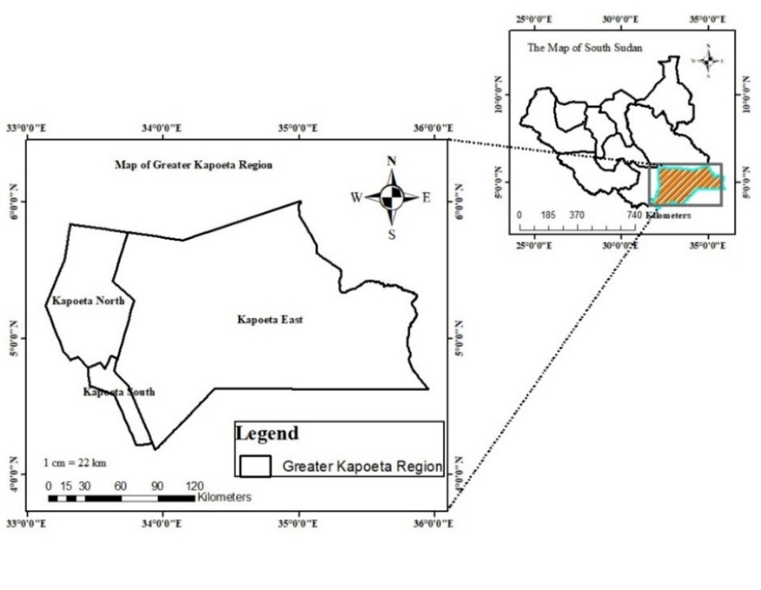
Fig. 1. The Map of Greater Kapoeta of Eastern Equatoria State of South Sudan

2.2 Rainfall and Temperature Data Collection
The rainfall and temperature data was downloaded from the National Aeronautic Space Administration for Prediction of World Energy Resources (NASA POWER) Climatology Resource for Agro-climatology website (https://power.larc.nasa.gov/cgi-bin/cgiwrap/solar/agro.cgi) and the Global Weather Data for Soil Water Assessment Tool (SWAT) (uoguelph.ca/watershed/w3s) data was used to fill the gaps of no data in NASA POWER climatology data set. The climate data set was downloaded from latitude 33.579 degree East and longitude 4.692-degree North at an elevation of 473 meters (m). NASA measured rainfall and temperature amount at 2 meters above the earth surface. In addition, the SWAT climate data was downloaded from Latitude 33.4375 degree East and Longitude 4.52732-degree North at an elevation of 766 meters. The data sets were cleaned and processed by summing the total monthly rainfall amounts for each year from 1984-2016. Accordingly, the average rainfall amounts were obtained by dividing the total monthly rainfall amounts by the number of months from 1984-2016. The average rainfall amount was presented per decade in a graph: 1984-1994, 1995-2005, and 2006-2016. Further, the annual rainfall amounts emanated from summation of the monthly rainfall amounts in each year from 1984-2016. Similarly, rain days were considered when the rainfall amount received was above 0.2 millimeter (mm) in a day (WMO, 2008). As such, the total monthly rain days were calculated by summing all the rainfall amounts received in each day for each month from 1984-2016 while average rain days were obtained by dividing the total rain days in a month by the number of months in a year from 1984-2016. The annual rain days was summation of monthly rain days in a year from 1984-2016. Additionally, annual temperature resulted from summing monthly temperatures and dividing it by 12 months of each year from 1984-2016. To obtain the minimum, mean, and maximum monthly temperatures, the total monthly temperature was divided by the number of days in each month from 984-2016.

2.3 Analysis of Rainfall and Temperature Data
Descriptive statistic was employed to present the trends of rainfall, rain days and temperature amount in graphs and charts from 1984-2016 using Microsoft excel version 2013 and XLSTAT 2016. Non-parametric statistics was used to determine the trends of rainfall, rain days and temperature between 1984 and 2016 and the projected rainfall amount and temperature from 2021-2050 by employing Mann-Kendall test and Theil Sein’s slope estimator at significance of P=0.05. The direction of the trend in annual rainfall, rain days and temperature were determined by Theil Sein’s slope (Yadav et al., 2014).

2.3.1 Mann-Kendall Test
Mann-Kendall Test Statistic (S) is given by:
……………………………………………………………… (1)
X_{i} is the time series rank from i=1, 2………. n-1 and X_{j}=i+1, 2………...n. Every data point X_{i} is a reference point compared with the data point X_{j} so that,
It has been indicated that when n≥8, the statistic S is normally distributed with the mean
E(S) =0 (Mondal et al., 2012).
…………………………………………………………………… (2)
Where δ is the standard deviation and n is the number of data points in the time series.
The Mann Kendall statistic can also be rewritten as:
………………………………………………………………………………… (3)
It can be therefore concluded that a positive value of S denotes an increasing trend while the negative value indicates decreasing trend in rainfall and temperature between 1984 and 2016. The critical statistical test value was 1.97 at 95 percent probability level (Mondal et al., 2012; Yadav et al., 2014).

2.3.2 The Theil-Sen’s estimator
The slope of n pairs of data points estimated by Theil-Sen’s estimator used the following formula
…………………………………………………………………... (4)
Where, β is the Theil Sen Slope and X_{j} and X_{i} are the data values at time j and i. The median of the total points in the data set (N) values of β is the Sen’s estimator of slope. The change in historical and projected annual rainfall, rain days, and temperature were obtained by multiplying annual values of Sen’s Slope by the historical (1984-2016) and projected (2021-2050) number of years.

2.4 Acquisition of Rainfall and Temperature Projection Data
Rainfall and temperature data were downloaded from the Climate Systems Analysis Group (CSAG) of the University of Cape Town (http://www.csag.uct.ac.za/) under the Coordinated Regional Downscaling Experiments (CORDEX) (https://rcmes.jpl.nasa.gov/content/cordex). The rainfall and temperature data were captured by Norwegian Climate Centre’s Earth System Model1 (NorESM1).

2.4.1 Description of the Climate Projection Model
The Norwegian Climate Centre’s Earth System Model 1 (NorESM1-M) is one of the Norwegian Climate Models with intermediate resolution (Bentsen et al., 2013) and one of the Community Climate System Model versions 4 (CCSM4) family. NorESM1-M differs from CCSM4 because it has isopycnic coordinate and advanced chemistry for aerosol-cloud-radiation interactions with a horizontal resolution of two (2) degree for atmosphere and land components, and one (1) degree for ice and ocean components (Bentsen et al., 2013). The sensitivity of the NorESM1 was tested through climate projection simulated from 2006 to 2100 under Representative Concentration Pathways (RCP) 2.6, 4.5, 6.0 and 8.5. The model is capable of projecting climate from 2006 to 2300 under RCP 4.5 (Bentsen et al., 2013). In this study, RCP 8.5 and 4.5 scenarios were used to project rainfall and temperature trends from 2021 to 2050. The RCP 8.5 assumes that greenhouse gas emissions (CO₂) will reach the highest level of 8.5 watts/m² by 2100 without climate mitigation policies (Riahi et al., 2011) that will affect the global rainfall and temperature distributions. As such, RCP 8.5 greenhouse gas (GHG) emission scenario was used to project rainfall and temperature trends at high greenhouse emissions by 2050 in Kapoeta region. Further, RCP 4.5 assumes that GHG emission is moderate at 4.5 watts/m² by 2100 because of technological advancement and some enforcements of climate mitigation policies (Brown et al., 2014; Thomson et al., 2011). The RCP8.5 and RCP4.5 scenarios were used to determined rainfall and temperature trends without and with climate change mitigation measures by 2050 in Kapoeta region of Eastern Equatoria State, South Sudan.

2.5 Rainfall and Temperature Projection
Rainfall and temperature projection employed Norwegian Earth System Model (NorESM1) a General Climate Model (GCM) with a horizontal resolution of 250 Km (Bentsen et al., 2013). This coarse resolution was downscaled to 50 Km grid boxes using Rossby Centre Regional Climate Model (RCA4), a Swedish Meteorological and Hydrological Institute (SMHI) regional climate modelling software (https://www.smhi.se/en/research/research-departments/climate-research-rossby-centre2-552/rossby-centre-regional-atmospheric-model-rca4-1.16562). Thereafter, the average 50 Km grid boxes of Kapoeta region were used to project monthly rainfall and temperature amount under RCP8.5 and RCP4.5 emission scenarios from 2021-2050. The annual rainfall and temperature projection were summations of the monthly rainfall and temperature amount in each year whereas average monthly rainfall and temperature amount were the summations of monthly rainfall and temperature amount divided by the number of months from 2021-2050 under RCP8.5 and RCP4.5. The annual and average monthly rainfall and temperature were presented in graphs and charts using Microsoft excel version 2013.

3 RESULTS

3.1 Trends of Annual Rainfall, Rain Days, Monthly Rainfall and Rain Days from 1984-2016 in Kapoeta region
The result indicates a non-significant (P=0.05) decline in annual rainfall amount with a mean annual rainfall amount of 144.35+/-50.33 mm from 984-2016 (Fig. 2.). The rate of decline in annual rainfall amount was 0.316 mm from 1984-2016 (Fig 2). This decline in annual rainfall amount culminated into the loss of 10.11 mm from 1984-2016. Although, the highest and the lowest annual rainfall amount received were 276.75 mm and 54.5 mm in 1988 and 1998, the mean annual rainfall amount received were: 158.58+/-60.65 mm, 129.67+/-56.16 mm and 144.83+/-24.94 mm between 1984-1994, 1995-2005 and 2006-2016. The finding also indicates a changed in monthly rainfall from unimodal to bimodal rainfall patterns from 1984-2016 (Fig. 2.). The unimodal average monthly rainfall pattern occurred from 1984-1994 whereas bimodal monthly rainfall patterns were observed from 1995-2005, and 2006-2016. The highest and lowest average rainfall amount of 53.40 mm and 0.20 mm were recorded in July and December in the first decade (1984-1994). However, the subsequent decades between 1995-2005 and 2006-2016 recorded increased average monthly rainfall amount from September-December. Similarly, Kendall tau and Sen’s slope indicates significance (P=0.05) increase in monthly rainfall amount from September-December and January-March in Kapoeta region (Table 1.). Conversely, Kendall tau and Sen’s Slope indicate significance decline in average monthly rainfall amount in July from 1984-2016 in Kapoeta region (Table 1.). Conversely, annual rain days significantly (P=0.05) decline by 1.44 day with a mean annual rain days of 64.41+/-28.37 days and a loss of 46 rain days from 1984-2016 (Fig. 2.). The highest and the lowest rain days of 129 days and 22 days were recorded in 1996 and 2000 respectively. The mean annual rainy days between1984-1996, 1995-2005 and 2006-2016 were 90+/-17 days 50+/-30 days and 51+/-8.0 days. (Fig. 2.). There was unimodal monthly rain days pattern with nine average days in July and three rain days from January-March from 1984-2016 (Fig. 2.).

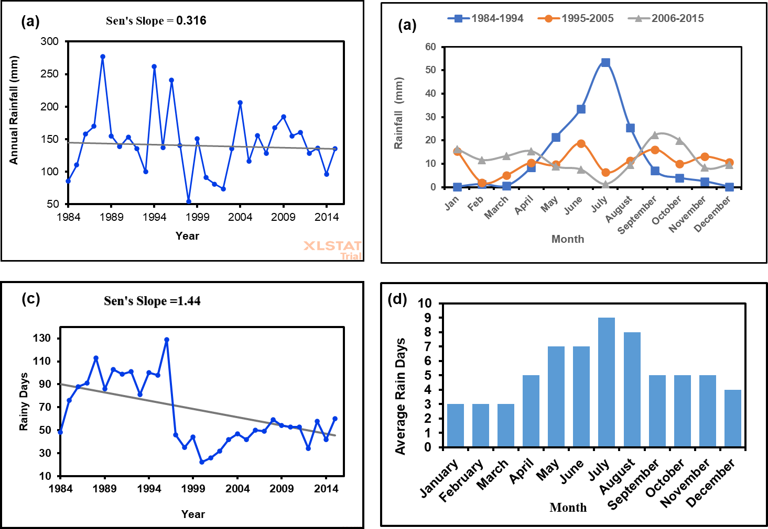
Fig. 2. The trends of rainfall amount and rain days. (a) Shows the trends in annual rainfall amount; (b) Variations in monthly rainfall amount per decade; (c) Trends of annual rain days; (d) Variations in monthly rain days

Table 1. The trend of monthly rainfall between 1984 and 2016 in Kapoeta region
Month | Minimum  (mm) |  | Maximum  (mm) |  | Mean | Std. deviation |  | Kendall's tau | P-value | Sen's slope
January |  | 0.000 | 61.500 | 10.501 |  |  | 15.383 | 0.485 | 0.000 | 0.396
February |  | 0.000 | 31.100 | 4.832 |  |  | 7.133 | 0.470 | 0.000 | 0.219
March |  | 0.000 | 30.300 | 6.168 |  |  | 9.482 | 0.389 | 0.002 | 0.242
April |  | 0.000 | 45.800 | 11.379 |  |  | 14.167 | 0.048 | 0.709 | 0.037
May |  | 0.000 | 89.400 | 13.508 |  |  | 18.141 | -0.054 | 0.673 | -0.069
June |  | 0.000 | 143.440 | 20.354 |  |  | 29.572 | -0.206 | 0.101 | -0.446
July |  | 0.000 | 107.950 | 21.013 |  |  | 32.049 | -0.535 | < 0.0001 | -1.204
August |  | 0.400 | 84.320 | 15.726 |  |  | 19.882 | -0.160 | 0.206 | -0.136
September |  | 0.000 | 43.300 | 15.006 |  |  | 12.544 | 0.331 | 0.008 | 0.583
October |  | 0.070 | 84.200 | 11.091 |  |  | 16.089 | 0.379 | 0.002 | 0.421
November |  | 0.070 | 32.500 | 8.002 |  |  | 8.998 | 0.390 | 0.002 | 0.276
December |  | 0.000 | 22.600 | 6.767 |  |  | 8.356 | 0.491 | < 0.0001 | 0.266

3.2 Annual Temperature trends from 1984-2016 in Grater Kapoeta Region
The maximum temperature significantly (P=0.05) rises by 0.061ºC annually from 1984-2016 (Fig. 3.). The result indicates a non-significant increase (P=0.724) in mean and a decrease (P=0.701) in minimum temperature from 1984-2016. Generally, the maximum and mean temperatures increased by 1.95 ºC and 0.128 ºC whereas the minimum temperature decreased by 0.224 ºC from 1984-2016 respectively.
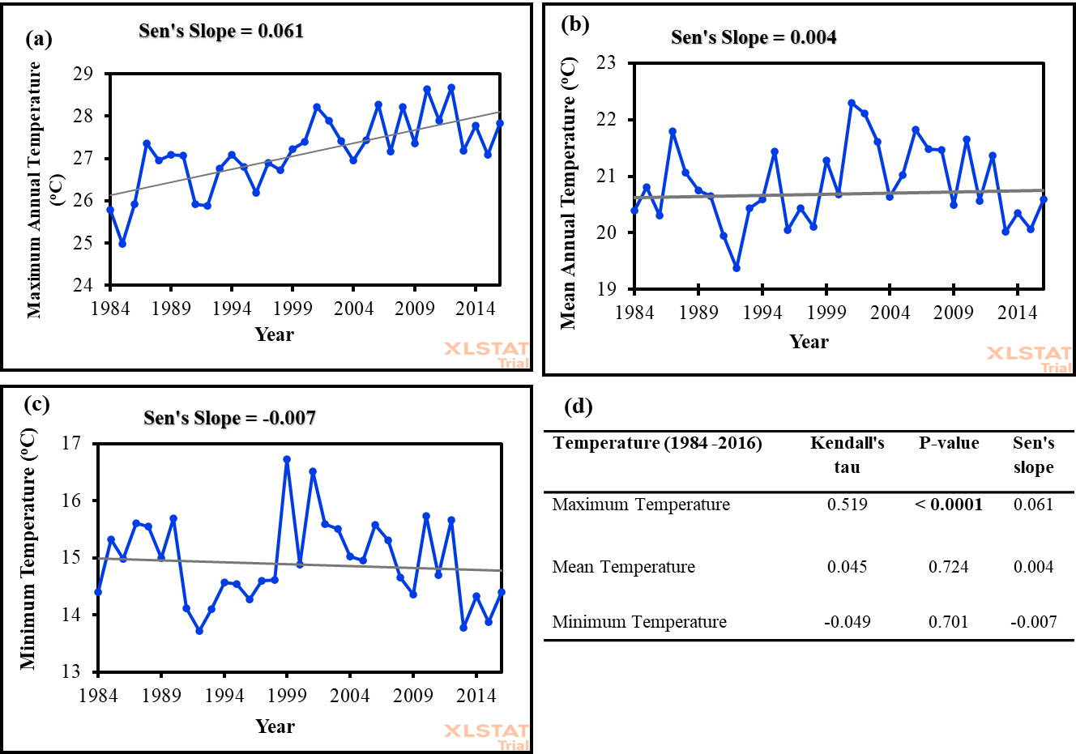
Fig. 3. The trend of annual temperature in Kapoeta region from 1984-2016. (a) Shows maximum annual temperature trend; (b) Mean annual temperature trends; (c) Minimum annual temperature trend; (d) Man Kendall and Sen’s slope temperature trends at P=0.05

3.2.1 Trends of Monthly Temperature between 1984 and 2016 in Kapoeta region
The results showed a significant (P=0.05) increase in maximum monthly temperature trends from March-May, July and October with decreasing trend from December-January from1984 -2016 (Table 2.). The highest maximum monthly temperature increased per decade were 38.9ºC, 39.6ºC, and 40.8ºC from 1984-1994, 1995-2005 and 2006-2016. Essentially, the maximum monthly temperature significantly (P=0.05) increased by 1.9 ºC compared no significant increase in mean and minimum temperatures from 1984-2016 (Table 3 and Table 4), despite significantly (P=0.05) decreased in minimum temperature in February and November in the same period.

Table 2: Maximum Monthly Temperature Trends between 1984 and 2016 in Kapoeta region
Month | Minimum  (ºC) | Maximum  (ºC) | Mean | Std. deviation | Kendall's tau | P-value | Sen's slope
January | 13.335 | 18.642 | 15.697 | 1.424 | 0.220 | 0.075 | 0.045
February | 14.052 | 20.407 | 17.657 | 1.660 | -0.038 | 0.768 | -0.017
March | 18.061 | 26.868 | 21.508 | 1.812 | 0.345 | 0.005 | 0.082
April | 22.993 | 29.480 | 26.130 | 1.871 | 0.356 | 0.004 | 0.110
May | 26.477 | 34.894 | 31.235 | 1.962 | 0.386 | 0.002 | 0.103
June | 17.793 | 41.933 | 35.691 | 3.663 | 0.227 | 0.065 | 0.065
July | 36.439 | 43.265 | 39.746 | 1.677 | 0.282 | 0.022 | 0.061
August | 35.490 | 42.406 | 39.063 | 1.503 | 0.220 | 0.075 | 0.058
September | 31.190 | 37.660 | 33.520 | 1.574 | 0.212 | 0.085 | 0.051
October | 22.165 | 31.745 | 28.107 | 2.212 | 0.292 | 0.018 | 0.096
November | 18.200 | 28.650 | 21.087 | 1.776 | 0.125 | 0.314 | 0.020
December | 13.410 | 19.781 | 16.409 | 1.640 | -0.087 | 0.486 | -0.022

Table 3: Mean Monthly temperature trends between 1984 and 2016 in Kapoeta Region
Month | Minimum  (ºC) | Maximum  (ºC) | Mean | Std. deviation | Kendall's tau | P-value | Sen's slope
January | 6.926 | 12.881 | 9.629 | 1.435 | -0.083 | 0.505 | -0.014
February | 7.062 | 14.375 | 11.166 | 1.669 | -0.186 | 0.133 | -0.055
March | 11.690 | 19.165 | 14.815 | 1.459 | 0.089 | 0.476 | 0.020
April | 15.660 | 28.027 | 19.507 | 2.166 | 0.186 | 0.133 | 0.046
May | 17.732 | 31.187 | 24.649 | 2.431 | 0.140 | 0.258 | 0.040
June | 24.310 | 38.877 | 29.346 | 2.495 | 0.102 | 0.412 | 0.027
July | 27.194 | 42.797 | 32.909 | 2.531 | 0.152 | 0.221 | 0.051
August | 21.003 | 38.406 | 31.682 | 3.390 | 0.154 | 0.215 | 0.041
September | 25.230 | 40.003 | 28.506 | 3.440 | -0.023 | 0.865 | -0.005
October | 17.645 | 32.855 | 22.194 | 2.710 | 0.136 | 0.271 | 0.049
November | 12.020 | 21.490 | 15.188 | 1.631 | -0.125 | 0.314 | -0.026
December | 7.184 | 13.400 | 10.442 | 1.526 | -0.144 | 0.245 | -0.029

Table 4: Minimum monthly temperature trends from 1984 to 016 in Kapoeta region
Month | Minimum  (ºC) | Maximum  (ºC) | Mean | Std. deviation | Kendall's tau | P-value | Sen's slope
January | 1.777 | 6.471 | 4.603 | 1.329 | -0.106 | 0.394 | -0.025
February | 1.276 | 11.271 | 5.554 | 1.893 | -0.254 | 0.039 | -0.067
March | 6.732 | 12.584 | 8.729 | 1.322 | -0.061 | 0.631 | -0.011
April | 9.930 | 21.633 | 12.990 | 1.982 | 0.042 | 0.745 | 0.012
May | 14.974 | 25.006 | 18.422 | 2.306 | 0.008 | 0.963 | 0.001
June | 20.233 | 27.170 | 23.152 | 1.635 | -0.163 | 0.188 | -0.039
July | 19.926 | 34.487 | 26.582 | 2.467 | 0.076 | 0.546 | 0.020
August | 22.090 | 27.971 | 25.689 | 1.192 | 0.095 | 0.448 | 0.020
September | 17.980 | 22.997 | 21.004 | 1.278 | 0.076 | 0.546 | 0.017
October | 13.248 | 18.810 | 16.335 | 1.424 | 0.142 | 0.251 | 0.039
November | 7.127 | 12.307 | 10.118 | 1.100 | -0.264 | 0.032 | -0.046
December | 3.377 | 8.645 | 6.002 | 1.381 | -0.235 | 0.057 | -0.047

3.3 Rainfall and Temperature Projection from 2021 to 2050 in Kapoeta Region

3.3.1 Projection of Annual Rainfall and Temperature Trends between 2021 and 2050
The annual rainfall projection shows a non-significance (P=0.05) increase (Kendall’s tau=0.241 mm; P=0.064; Sen’s slope=2.912 mm) under RCP8.5 and a non-significant decrease (Kendall’s tau=-0.195 mm; P=0.134; Sen’s slope=-3.808 mm) under (RCP4.5) from 2021-2050 in Kapoeta region (Fig. 4). The annual rainfall amount will increase at rate of 2.912 mm and 3.808 mm under RCP8.5 and RCP4.5 from 2021-2050 (Fig. 4). Altogether, the annual rainfall will increase by 84.45 mm and 110.43 mm under RCP8.5 and RCP4.5 from 2021-2050 respectively. Further, annual temperature will significantly (P=0.05) increase under RCP4.5 (Kendall’s tau=0.356ºC; P=0.007; Sen’s slope=0.028ºC) and RCP8.5 (Kendall’s tau=0.301ºC; P=0.020; Sen’s slope=0.016ºC) greenhouse gas emissions from 2021-2050.The finding indicates significantly (P=0.05) annual temperature rate of 0.028ºC and 0.016 ºC under RCP4.5 and RCP8.5 from 2021-2050 (Fig. 4). Ultimately, the annual temperature will increase by 0.81ºC and 0.46ºC under RCP4.5 and RCP8.5 from 2021-2050 (Fig. 4).

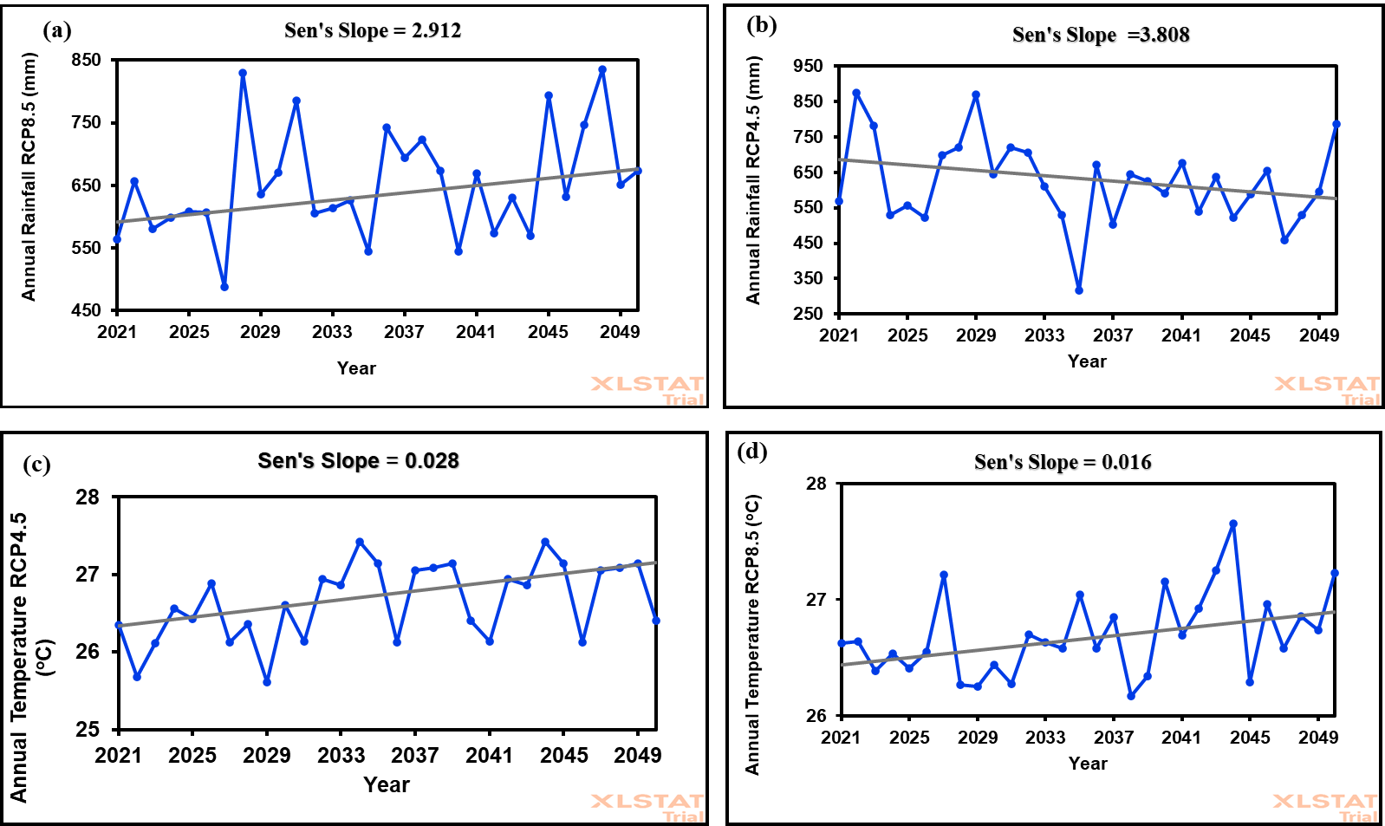
Fig. 4. Projected annual rainfall and temperature trends under RCP8.5 and RCP4.5 from 2021-2050: (a) Shows annual rainfall projection under RCP8.5; (b) Annual rainfall projection under RCP4.5; (c) Annual temperature projection under RCP8.5; (d) Annual temperature projection under RCP4.
3.3.2 Projection of Average Monthly Rainfall and Temperature from 2021 to 2050
The result indicates the highest average monthly rainfall amount will occur from August-December under RCP4.5 and RCP8.5 from 2021-2050 in Kapoeta Region (Fig. 5.). Accordingly, the highest average monthly rainfall amount of 111 mm and 89 mm will occur in November under RCP8.5 and RCP4.5 from 2021-2050. The average monthly rainfall amount of 51.84+/-23.00 mm and 51.80+/-28.60 mm will occur under RCP8.5 and RCP4.5 from 2021-2050. Conversely, the average monthly temperature will increase from January-May under RCP4.5 and RCP8.5 from 2021-2050 (Fig. 5.). The highest average monthly temperature of 28.4ºC and 28.3ºC are anticipated to occur in March whereas the lowest average monthly temperature of 25.6ºC and 25.5ºC will occur in July under RCP4.5 and RCP8.5 from 2021-2050. The results projected the highest average monthly temperature under RCP4.5 and RCP8.5 from January-May and low average monthly temperature from June-December under the two gas emission scenarios from 2021-2050 in Kapoeta region (Fig. 5.).
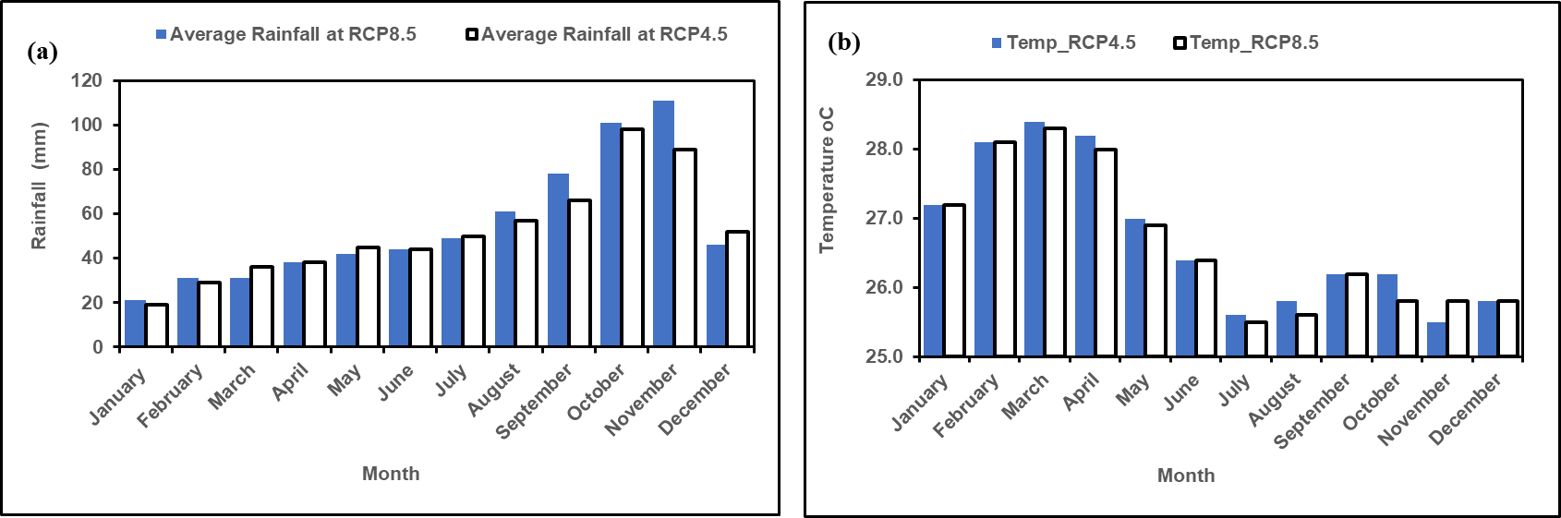
Fig. 5. Projected monthly rainfall and temperature under RCP8.5 and RCP4.5 from 2021-2050. (a) Shows average monthly rainfall amount under RCP8.5 and 4.5; (b) Average monthly temperature under RCP8.5 and 4.5

4.0 DISSCUSSIONS

4.1 Climate Trends and Patterns in Kapoeta Region of South Sudan
There is intensified climate change emanating from changes in rainfall and temperature patterns in Kapoeta region. The evidence demonstrated that the region experienced changes in rainfall, rain days and temperatures trends. This finding agrees with the study of Alhassan et al. (2025) who found significant marginal rainfall increase in Northern Ethiopia. Since 1984, Kapoeta region has lost 10.11mm of its annual rainfall amounts with variations in average annual rainfall amount of 158.58+/-60.65 mm, and 129.67+/-56.16 mm from 1984-2016. Additionally, annual rain days reduced from 90 days to 51 days and monthly rainfall patterns shifted from unimodal to bimodal from 1984-2016. However, the increased monthly rainfall from September-December (2006-2016) in Kapoeta region emanated from positive Indian Ocean Dipole (IOD) that bring rains from October-December in East African region (Zheng, et al., 2025). However, there was marginal increased in monthly rainfall from January-March (1984-2016) that agrees with FAO (2024) prediction of 55% monthly rainfall amount increase from March-May in 2025 in Kapoeta region.

The future annual rainfall amount will not change under RCP8.5 and RCP4.5 by 2050. This can be explained by the insignificant increase in precipitations (Alhassan et al., 2025). Unimodal rainfall pattern is projected to occur from August-November by 2050 that differ from monthly rainfall occurrences from May-September, from 1984-1994 and 1995-2016 which occurred between March-June, and August-December. Remarkably, the model projected higher mean and maximum monthly rainfall amounts under high (RCP8.5) gas emissions (52 mm, and 111 mm) and low (RCP4.5) gas emissions (52 mm, and 98 mm) compared to the period 1984-2016 (12 mm, and 21.01 mm). This projection is similar to that of Lomeling (2020) who anticipated monthly rainfall of 100 mm, 150 mm, and 80 mm between March-June, July-September, and October-December by 2034 in Juba County of South Sudan. However, rainfall patterns shifted in the last three decades (1984-2016) relative to projected rainfall pattern (2021-2050) in Kapoeta region, though WMO (2024b) projected general increase in monthly rainfall in 2024 in the region. The shift in the projected rainy seasons and average monthly rainfall amounts will have significant implications on the pastoral and agropastoral communities in Kapoeta region. Ndebele and Zenda (2023) indicated that climate change and variability caused troubles to pastoral and agropastoral livelihoods causing livestock losses, deforestation, livestock and human water scarcity in Awerial County of South Sudan. Certainly, seasonal rainfall variabilities undermine annual forage availability and distribution in Kapoeta region (Peters et al., 2022). The average rainfall amounts of less than 120 mm is less likely to support grasslands, but will support woody plants which depend on a tap root system to draw ground water. These types of plants will not favor grazers but will support browsers (Kipchirchir, Ngugi, and Wahome, 2011). Further, low soil moisture will encourage the emergence and spread of drought resistant acacia and Prosopis juliflora that are feeds for goats, encourage formation of plant lignin and loss of seeds viability (Kipchirchir et al 2011; Roberts et al., 2023). Low average monthly rainfall amount can reduce the above-ground forage biomass sufficient for grazing (Zhu et al., 2025), nutritional value of grass and legumes forage for livestock, and destroy the seed banks of perennial grass and dwarf shrubs (Rojas-Botero et al., 2023). Ultimately, any changes in forage availability will affect livestock composition, animal production, and livelihoods of the pastoralists. It is unequivocal that rainfall patterns changed between 1984 and 2016, relative to the next three decades (2021-2050). This call for development of drought tolerant forage species with more water use efficiency and a shift to livestock species with high water use efficiency.

Temperature was increasing annually between 1984 and 2016 relative projected to future temperature trends under low and high greenhouse gas emissions from 2021-2050. The highest maximum monthly temperature showed increasing trends of 38.9ºC, 39.6ºC, and 40.8ºC between 1984-1994, 1995-2005 and 2006-2016 consistent with the highest temperature of 45ºC experienced in March 2024 in South Sudan (WMO, 2024a). However, future monthly temperature projection shows lower peak average values of 28.4ºC and 28.3ºC in March under RCP4.5 and RCP8.5 from 2021-2050 compared to temperatures from 1984-2016. The changes in previous and future annual temperature will intensify vaporization of soil moisture, affect nutrient availability for grass species, reduce biomass and caused wilting (Oliveira et al., 2024). This will affect the productivity of domestic ruminants such as cattle and sheep that graze on natural forage and will hinder future pastoral livelihoods in Kapoeta region. Ndebele and Zenda (2023) showed that pastoralists observed an increase in temperature in the last one decade consistent with the reports of several studies in dry areas of South Sudan (Tarif et al. 2025; WMO 2024a; Zheng, et al., 2025).

5.0 CONCLUSION
The historical (1984-2016) and future (2021-2050) rainfall and temperature trends increased and is expected to increase in Kapoeta region, though the future rainfall increase is marginal compared to temperature trends. The monthly rainfall patterns shifted from unimodal to bimodal patterns with more monthly rainfall amount anticipated to occur from October-December between 1984-2016 consistent with anticipated future rainfall amount in November from 2021-2050. Conversely, annual and monthly temperature increased and expected to increase in March by 20250 in Kapoeta region. Therefore, this necessitates early warning system and awareness of the pastoral and agropastoral communities on climate hazards in Kapoeta region of South Sudan.

DISCLAIMER ON THE USE OF ARTIFICIAL INTELLIGENCE (AI)
The authors declare no use of AI during editing and writing the Manuscript and the Manuscript the original work of the authors without publication anywhere.

REFERENCES
Alam, A., & Rukhsana. (2023). Climate Change Impact, Agriculture, and Society: An Overview. In A. Alam & Rukhsana (Eds.), Climate Change, Agriculture and Society: Approaches Toward Sustainability (pp. 3–13). Springer International Publishing. https://doi.org/10.1007/978-3-031-28251-5_1
Alhassan, I., Teklehaimanot, A., Solomon, N., Gufi, Y., Gebre, M. B., Birhane, K., & Eze, E. (2025). Perception and trends of climate change: assessing impacts on smallholder farmers and Agro-Pastoral communities in Northern Ethiopia. Discover Agriculture, 3(1), 1–25. https://doi.org/10.1007/s44279-025-00272-x
AVSI. (2023). Household Multisector Survey. https://www.avsi.org/en/what-we-do/countries/south-sudan
Ayanlade, A., Oluwaranti, A., Ayanlade, O. S., Borderon, M., Sterly, H., Sakdapolrak, P., Jegede, M. O., Weldemariam, L. F., & Ayinde, A. F. O. (2022). Extreme climate events in sub-Saharan Africa: A call for improving agricultural technology transfer to enhance adaptive capacity. Climate Services, 27, 1–11. https://doi.org/10.1016/j.cliser.2022.100311
Bentsen, M., Bethke, I., Debernard, J. B., Iversen, T., Kirkevåg, A., Seland, Ø., Drange, H., Roelandt, C., Seierstad, I. A., Hoose, C., & Kristjánsson, J. E. (2013). The Norwegian Earth System Model, NorESM1-M – Part 1: Description and basic evaluation of the physical climate. Geoscientific Model Development, 6(3), 687–720. https://doi.org/10.5194/gmd-6-687-2013
Brown, D. G., Polsky, C., Bolstad, P., Brody, S. D., Hulse, D., Kroh, R., Loveland, T. R., & Thomson, A. (2014). Chapter 13: Land use and land cover change. Climate Change Impacts in the United States: The Third National Climate Assessment., 318–332. https://doi.org/10.7930/J05Q4T1Q.On
Chamma, D. D. (2024). Climate change and economic growth in sub-Saharan Africa: an empirical analysis of aggregate- and sector-level growth. Journal of Social and Economic Development, 1–13. https://doi.org/10.1007/s40847-024-00377-x
CSRF. (2023). Climate change and conflict in South Sudan: Community perceptions and implications for conflict-sensitive aid. https://csrf-southsudan.org/
Demissie, T., Diro, G. T., Duku, C., Solomon, D., & Jimma, T. B. (2025). Current and projected changes in climate extremes and agro-climatic zones over East Africa. Theoretical and Applied Climatology, 156(3), 1–19. https://doi.org/10.1007/s00704-025-05405-2
FAO. (2015). Climate change and food security: risks and responses. www.fao.org/publications
FAO. (2017). Climate change predictions in sub-Saharan Africa: impacts and adaptations. www.fao.org/publications
FAO. (2024). South Sudan Seasonal Weather Forecast-FAO Key Messages.
Hultgren, A., Carleton, T., Delgado, M., Gergel, D. R., Greenstone, M., Houser, T., Hsiang, S., Jina, A., Kopp, R. E., Malevich, S. B., McCusker, K. E., Mayer, T., Nath, I., Rising, J., Rode, A., & Yuan, J. (2025). Impacts of climate change on global agriculture accounting for adaptation. Nature, 642(8068), 644–652. https://doi.org/10.1038/s41586-025-09085-w
IPCC. (2023). IPCC, 2023: Climate Change 2023: Synthesis Report, Summary for Policymakers. Contribution of Working Groups I, II and III to the Sixth Assessment Report of the Intergovernmental Panel on Climate Change [Core Writing Team, H. Lee and J. Romero (eds.)]. IPCC, Geneva, Switzerland. (P. Arias, M. Bustamante, I. Elgizouli, G. Flato, M. Howden, C. Méndez-Vallejo, J. J. Pereira, R. Pichs-Madruga, S. K. Rose, Y. Saheb, R. Sánchez Rodríguez, D. Ürge-Vorsatz, C. Xiao, N. Yassaa, J. Romero, J. Kim, E. F. Haites, Y. Jung, R. Stavins, … Y. Park, Eds.). https://doi.org/10.59327/IPCC/AR6-9789291691647.001
Kooech O. Kipchirchir, Kinuthia R. Ngugi, & R.G. Wahome. (2011). Use of Dry Land Tree Species (Prosopis juliflora)Seed Pods as Supplementary Feed for Goats in the Arid and Semi-Arid Lands of Kenya. Environmental Research Journal, 2(5), 66–73. https://www.makhillpublications.co › erj.2011.66.73
Lomeling, D. (2020). Predicting Seasonal Rainfall Patterns and Trends in Juba County, South Sudan Using Artificial Neural Networks. European Journal of Agriculture and Food Sciences, 2(2), 1–8. https://doi.org/10.24018/ejfood.2020.2.2.32
Mondal, A., Kundu, S., & Mukhopadhyay, A. (2012). Rainfall Trend Analysis By Mann-Kendall Test: a Case Study of North-Eastern Part of Cuttack District, Orissa. International Journal of Geology, Earth and Environmental Sciences, 2(1), 2277–208170. https://doi.org/10.1017/CBO9781139013895.014
Ndebele, Z., & Zenda, M. (2023). Climate Change Impact and Adaptation of Agro-Pastoral Farmers in Awerial County, Lakes State of South Sudan. South African Journal of Agricultural Extension, 51(3), 135–160. https://doi.org/10.17159/2413-3221/2023/v51n3a14086
Oliveira, B. A., López, I. F., Cranston, L. M., Kemp, P. D., Donaghy, D. J., Dörner, J., López-Villalobos, N., García-Favre, J., Ordóñez, I. P., & Van Hale, R. (2024). 18O isotopic labelling and soil water content fluctuations validate the hydraulic lift phenomena for C3 grass species in drought conditions. Plant Stress, 11. https://doi.org/10.1016/j.stress.2024.100414
Omay, P., Ogallo, L., Oludhe, C., & Gitau, W. (2016). Temporal and Spatial Characteristics of the June-August Seasonal Rainfall and Temperature over South Sudan. Journal of Meteorology and Related Sciences, 9(2), 35–49. https://doi.org/10.20987/jmrs.5.08.2016
Peters, T., Kluß, C., Vogeler, I., Loges, R., Fenger, F., & Taube, F. (2022). GrasProg: Pasture Model for Predicting Daily Pasture Growth in Intensive Grassland Production Systems in Northwest Europe. Agronomy, 12(7), 1–12. https://doi.org/10.3390/agronomy12071667
Riahi, K., Rao, S., Krey, V., Cho, C., Chirkov, V., Fischer, G., Kindermann, G., Nakicenovic, N., & Rafaj, P. (2011). RCP 8.5-A scenario of comparatively high greenhouse gas emissions. Climatic Change, 109(1), 33–57. https://doi.org/10.1007/s10584-011-0149-y
Roberts, N., Moloney, K., Monie, K., & Florentine, S. (2023). Effect of selected environmental factors on the seed germination of the invasive species Polygala myrtifolia (Polygalaceae) in Australia. Australian Journal of Botany, 71(6), 286–295. https://doi.org/10.1071/BT22094
Rojas-Botero, S., Teixeira, L. H., & Kollmann, J. (2023). Low precipitation due to climate change consistently reduces multifunctionality of urban grasslands in mesocosms. PLoS ONE, 18(2 February). https://doi.org/10.1371/journal.pone.0275044
Serdeczny, O., Adams, S., Baarsch, F., Coumou, D., Robinson, A., Hare, W., Schaeffer, M., Perrette, M., & Reinhardt, J. (2017). Climate change impacts in Sub-Saharan Africa: from physical changes to their social repercussions. Regional Environmental Change, 17(6), 1585–1600. https://doi.org/10.1007/s10113-015-0910-2
SSCCSE. (2010). Statistical Yearbook for Southern Sudan 2010 Southern Sudan Centre for Census, Statistics and Evaluation. www.ssccse.org
Tarif, K., Koefoed, M., Seyuba, K., Bunse, S., Iverson, T. O., De Coning, C. H., & Krampe, F. (2025). Climate, Peace and Security Fact Sheet: South Sudan. https://www.nupi.no/news/climate-peace-and-security-fact-sheet-south-sudan3
Thomson, A. M., Calvin, K. V., Smith, S. J., Kyle, G. P., Volke, A., Patel, P., Delgado-Arias, S., Bond-Lamberty, B., Wise, M. A., Clarke, L. E., & Edmonds, J. A. (2011). RCP4.5: A pathway for stabilization of radiative forcing by 2100. Climatic Change, 109(1), 77–94. https://doi.org/10.1007/s10584-011-0151-4
WMO. (2024a). Africa faces disproportionate burden from climate change and adaptation costs. https://wmo.int/news/media-centre/africa-faces-disproportionate-burden-from-climate-change-and-adaptation-costs
WMO. (2024b). State of the Climate in Africa 2024. https://wmo.int/publication-series/state-of-climate-africa-2024.
Wright, C. Y., Kapwata, T., Naidoo, N., Asante, K. P., Arku, R. E., Cissé, G., Simane, B., Atuyambe, L., & Berhane, K. (2024). Climate Change and Human Health in Africa in Relation to Opportunities to Strengthen Mitigating Potential and Adaptive Capacity: Strategies to Inform an African “Brains Trust.” Annals of Global Health, 90(1), 1–21. https://doi.org/10.5334/aogh.4260
Yadav, R., Tripathi, S. K., Pranuthi, G., & Dubey, S. K. (2014). Trend analysis by Mann-Kendall test for precipitation and temperature for thirteen districts of Uttarakhand. Journal of Agrometeorology, 16(2), 164–171.
Yuan, X., Li, S., Chen, J., Yu, H., Yang, T., Wang, C., Huang, S., Chen, H., & Ao, X. (2024). Impacts of Global Climate Change on Agricultural Production: A Comprehensive Review. Agronomy, 14(7), 1–19. https://doi.org/10.3390/agronomy14071360
Zenda, M. (2024). A systematic literature review on the impact of climate change on the livelihoods of smallholder farmers in South Africa. Heliyon, 10(18), 1–13. https://doi.org/10.1016/j.heliyon.2024.e38162
Zheng, Y., Tam, C. Y., & Collins, M. (2025). Indian Ocean Dipole Impacts on Eastern African Short Rains Across Observations, Historical Simulations and Future Projections. Earth’s Future, 13(6), 1–14. https://doi.org/10.1029/2024EF005219
Zhu, A., Wu, Q., Han, G., Wang, R., Wang, B., Yang, Y., Wang, R., & Wu, L. (2025). Aboveground Biomass and Importance Value of Constructive Species in Desert Steppe Are Co‐Regulated by Grazing Intensity and Climate. Ecology and Evolution, 15(10). https://doi.org/10.1002/ece3.72243

