Original Research Article
Changes in Chlorophyll Content of Selected Leafy Vegetables During Hydrothermal Processing

.
ABSTRACT

Aims: Chlorophyll, a naturally occurring green pigment present in plants, often undergoes degradative changes during processing. This work aimed at studying the changes that occur in chlorophyll content of four selected leafy vegetables – Jatropha tanjorensis (tree spinach), Telfiaria occidentalis (fluted pumpkin leaf), Vernonia amygdalina (bitter leaf) and Celosia argentea (Lagos spinach) during hydrothermal processing.
Method: Freshly harvested leaves were subjected to different hydrothermal treatments- 60, 65, 70, 75 and 80 °C. for varying lengths of time --- 0, 5, 10, 15 and 20 minutes. Chlorophyll content was determined by spectrophotometric method. Degradation of chlorophyll during hydrothermal processing was dependent on temperature and time. Increase in temperature and time caused high percentage decrease in the chlorophyll content of each of the vegetables during processing.
Results: The highest percentage decrease of 40.38% was recorded for Telfiaria occidentalis after 20 minutes at 80 °C. Percentage loss of 2.37% was observed for Jatropha tanjorensis after blanching at 60°C for 5 minutes. Blanching temperature and time have significant effects (P=.05) on the degradation of chlorophyll content of the selected leafy vegetables.
Conclusion: As economic value and overall degree of acceptability of these vegetables are dependent on the greenness of the leaves, appropriate attention during processing should be paid to minimise loss of chlorophyll, a naturally occurring green pigment that has been reported to have a wide range of therapeutic properties.

Keywords: Chlorophyll degradation, hydrothermal processing, leafy vegetables [

1. INTRODUCTION

Chlorophyll is a pigment present in all green plants and it is required for photosynthesis which is a process by which light energy converts to chemical energy. It is a unique pigment with green colour and found in diverse plants [1,2]. Chlorophyll is found in almost every green part of plants i.e. leaves and stems, within the chloroplast, the main organelle which contains the highest amount. Chloroplasts are in the mesophyll layer of plant leaves. Chloroplasts possess thykaloid membranes which contain chlorophyll, the pigment that gives plants their green colour. Chlorophyll in plants enables plants to manufacture their own food through the process of photosynthesis during which plants release oxygen into the environment. Proponents of chlorophyll believe the green pigment has antioxidant properties, strengthen immune system, aid treatment of iron deficiency anaemia, enhance skin care and detox the body although there is dearth of research to support these claims and reports are atimes conflicting [1,2]. Moreover, chlorophyll is believed to reduce inflammation and aid weight loss [3,4]. Also, chlorophyll has been reported to be useful in the control of diabetes [5]. More researches are needed to know more on the therapeutic effectiveness of chlorophyll.

Degradation of chlorophyll occurs during leaf senescence and fruit ripening. This gives room for recycling of nitrogen and other nutrients and for protection from buildup of phototoxic chlorophyll intermediates [6]. During chlorophyll degradation, it has been reported that dephytylation- removal of phytol tail, occurs first, catalyzed by enzymes chlorophyllase, which converts chlorophyll to phytol and chlorophyllide. Kinetics of chlorophyll degradation have been conducted on a number of variety of vegetable leaves including morisa xak (Amaranthus caudatus), ivy gourd leaf (Coccinia grandis Voigt), yacon (Smallanthus sonchifolius), turnip green, Malabar spinach (Basella alba) and waterleaf (Talinum triangulare) [7,8,9,10]. Knowledge of chlorophyll degradation is important so as to predict the loss of quality during processing and storage [11]. Stability of chlorophyll is affected by a number of factors including temperature and pH [12,10].

Vegetables are good sources of nutritionally important nutrients [13,14]. Green leafy vegetables such as Jatropha tanjorensis (tree spinach), Telfairia occidentalis (fluted pumpkin leaf), Vernonia amygdalina (bitter leaf) and Celosia argentea (Lagos spinach) are widely cultivated in the tropics particularly in West African sub-region. Tree spinach (Iyana ipaja) is a native of central America and has become naturalised in some tropical and sub-tropical countries like Ghana, India, and Nigeria [15]. It is commonly called Catholic vegetable, lapalapa, iyana ipaja or “hospital too far”. In addition to it’s use as a source of edible leafy vegetable, it is also use as a medicinal herb in treatment and management of diseases because it is relatively more affordable [16,17]. Fluted pumpkin leaves (Telfairia occidentalis), a member of Cucurbitaceae is indigenous to south eastern Nigeria where it is in use primarily in soups and herbal medicine. The plant is drought resistant, ohoccious perennial that is usually grown trellised. The leaves are a good source of calcium and iron [18,19]. Bitter leaf (ewuro) is a shrub that grows well in tropical Africa. It belongs to the Asteraceae family. The leaves are used as a soup constituent [20]. Other popular use of bitter leaf in Africa includes traditional treatment of diseases such as malaria, infertility, gastrointestinal disorder, diabetes, and sexually transmitted diseases [21,22,20].

Chlorophyll in leaf vegetables are highly susceptible to degradation during processing. This process occurs naturally with time but can also be caused by enzymatic and non-enzymatic reactions influenced by a number of factors such as heat, pH, light, exposure to oxygen and processing procedures [12,23,24]. In our continuous study of postharvest changes in vegetables, efforts have been made in this work to study the changes that occur in the concentration of chlorophyll during hydrothermal processing of selected leafy vegetables. It is hoped that information provided will help develop and maintain strategies for preserving quality attributes which can enhance degree of acceptability.

2. material and methods

2.1 Materials
Freshly harvested Jatropha tanjorensis (tree spinach), Telfairia occidentalis (fluted pumpkin leaf), Vernonia amygdalina (bitter leaf) and Celosia argentea (Lagos spinach) were obtained from local farms in Ogbomoso (8˚08’N, 4˚15’E), South-West, Nigeria. The vegetables are shown in Figures 1, 2, 3 and 4, respectively. Analytical grade reagents and other materials were obtained from Food Chemistry laboratory of the Department of Food Science, Ladoke Akintola University of Technology, Ogbomoso, Nigeria.

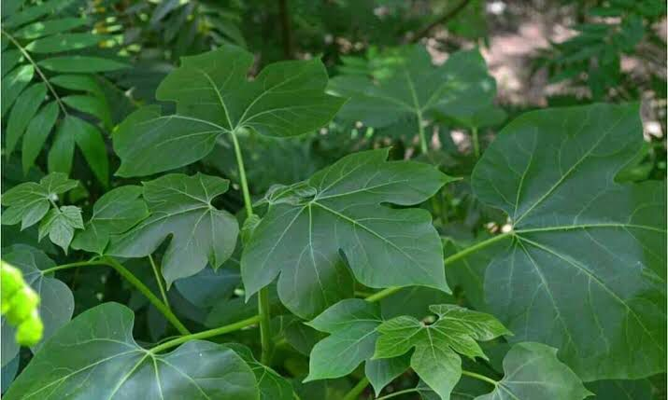

Figure 1: Jatropha tanjorensis (Tree spinach)

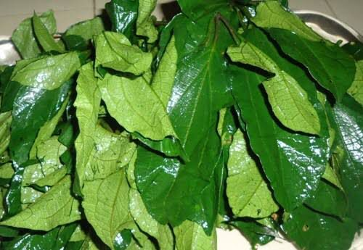

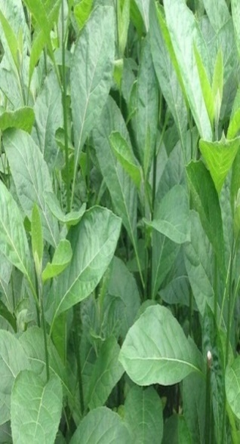
Figure 2: Telfairia occidentalis (Fluted pumpkin leaf)

Figure 3: Vernonia amygdalina (Bitter leaf)

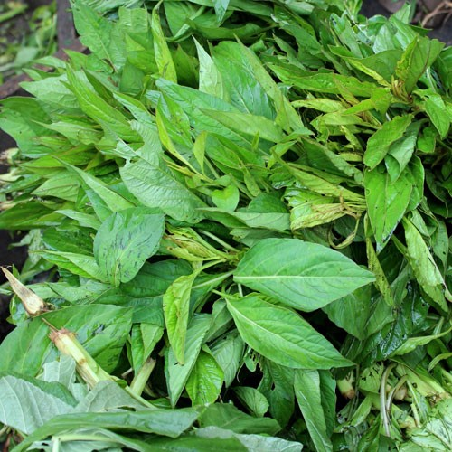

Figure 4: Celosia argentea (Lagos spinach)

2.2 Sample preparation
The leaves of each of the vegetables were plucked briskly, rinsed with clean cold water at ambient temperature (ca 24.5 °C), and were then placed on labeled perforated trays.

2.3 Determination of pH

Ten grams (10 g) of each of the vegetable leaves were weighed, grinded briskly in a mortar with a pestle and placed in a 250 ml beaker containing 100 ml of distilled water. The pH meter (Model 3510, Barloworld Scientific, Dunmow, UK)) was calibrated using the buffer solution of 4, 7 and 9. The electrode was immersed in each of the samples and the pH readings were recorded.

2.4 Heat treatment
Each of the vegetables was blanched in a thermo regulated water bath (Model HH-W21-Cr4211, Techmel and Techmel, Texas, USA) at temperature of 60, 65, 70, 75 and 80 °C. The blanching time was 0, 5 10, 15 and 20 minutes for each temperature. Each of the blanched leaves was analyzed for its chlorophyll content [10,25].

2.5 Determination of chlorophyll content
For each of the blanched samples, the chlorophyll content was determined immediately by weighing 0.2 g of the crushed leaf and placed in a test tube. 10 cm³ of 80% acetone was added to the leaf inside the test tube and left for 30 min. Three (3) cm³ of the resulting green extract was poured into a 4 ml cuvette and then placed in a spectrometer - UVV-NIR V-600, JASCO spectrophotometer. The absorbance of the extract was measured at 645 nm for chlorophyll a and at 663 nm for chlorophyll b. The concentration of chlorophyll pigment was calculated using Lichtenthaler’s equation [25] as reported by Ojo et al., 2024 [10].

$Chla= \frac{1395 х A665-6_{,}88 х A649}{d х W х 1000} х V х D \left(\frac{mg}{g}\right) (1)$
$$Chlb= \frac{24_{,}96 х A649-7_{,}32 х A665}{d х W х 1000} х V х D \left(\frac{mg}{g}\right) (2)$$
Total..$Chl= \frac{6263 х A665+18208 х A649}{d х W х 1000} х V х D \left(\frac{mg}{g}\right) (3)$

where: A= absorbance at specified wavelength, V = volume of total extract (ml), W = fresh weight (g), D = coefficient of dilution, d = thickness of cuvette (mm), 1000 = conversion factor μg – mg

2.6 Statistical analysis

Data obtained were subjected to one-way analysis of variance and the means separated using Duncan multiple range test to detect the significant differences (P=.05) among the samples [26].

3. results and discussion
3.1 pH of freshly harvested leafy vegetables
Table 1 shows the pH of freshly harvested selected leafy vegetables. The pH was 5.87 for bitter leaf and 6.55 for fluted pumpkin leaf. Tree spinach and Lagos spinach had pH of 5.95 and 6.17, respectively. The pH values of the vegetables showed that they were not highly acidic. Vegetables with high pH have been reported to exhibit stronger antioxidant properties than acidic vegetables. Green leafy vegetables are generally classified as alkaline foods because of the low Potential Renal Acid Load (PRAL) [27,28,29]. Moreover, diet rich in alkaline foods, including green leafy vegetables, are associated with reduced markers of inflammation. Increased consumption of alkaline forming foods maintained high oxygen saturation in the blood could reduce incidence of non-communicable diseases although further research testing various dietary modifications is required [29]. Therefore, inclusion of alkaline forming foods vegetables into the diet can enhance overall health.

Table 1. pH of selected leafy vegetables
Botanical name | Common name/ local name | pH values
Jatropha tanjorensis  Telfairia occidentalis  Vernonia amygdalina  Celosia argentea | Tree spinach/ Iyana ipaja  Fluted pumpkin leaf/ Ugwu  Bitter leaf/ Ewuro  Lagos spinach/ Soko | 5.95  6.55  5.87  6.17

3.2 Effect of hydrothermal treatments on chlorophyll content of selected leafy vegetables
The chlorophyll content of J. tanjorensis ranged from 4.64 mg/L for the raw sample to 3.40 mg/L for the sample processed at 80 °C for 20 minutes (Table 2). Freshly harvested samples of T. occidentalis had chlorophyll content of 5.72 mg/L (Table 5). Hydrothermal treatment at varying temperature caused significant difference (P=.05) in the chlorophyll content with time. At 60 °C, the chlorophyll content for 10, 15 and 20 minutes was 5.69, 5.40 and 5.19 mg/L, respectively while at 80 °C the chlorophyll content for 10, 15 and 20 minutes was 3.56, 3.42 and 3.41 mg/L, respectively.

The raw leaf of V. amygdalina contained 5.54 mg/L of chlorophyll (Table 4). Hydrothermal treatment caused significant reduction (P=.05) in the chlorophyll content of V. amygdalina. At 60 °C for 5 minutes the chlorophyll content was 5.36 mg/L while it was 4.50/L for 20 minutes. There was further reduction to .81mg/L at 75 °C for 20 minutes. As presented in Table 5, the raw sample of C. argentea contained 4.97 mg/L of chlorophyll. Processing by blanching at 60 °C for 5 minutes decreased the chlorophyll content to 4.78 mg/L while blanching for 15 and 20 minutes decreased the chlorophyll content to 4.43 and 4.11 mg/L, respectively. The lowest decrease in chlorophyll content of 3.63 mg/L was reported at 80 °C for 20 minutes.
In general, hydrothermal processing of the selected leafy vegetables caused decrease in the chlorophyll content. The decrease in the concentration of chlorophyll was a function of temperature and time. The percentage decrease in chlorophyll of 26.72% was observed for J. tanjorensis at both 75 and 80 °C for 20 minutes (Table 2) while the highest percentage decrease in chlorophyll of 40.38% was observed for Telfairia occidentalis at 80 °C for 20 minutes (Table 3).
For each of the vegetables studied, temperature and time had significant effects (P=.05) on the concentration of chlorophyll. This implies that there was better retention of chlorophyll by processing at relatively a lower temperature. Degradation of chlorophyll is an important complex catabolic process which occurs in green plants at all times of their lifecycle particularly during senescence and fruit ripening. Green colour in plant tissues is associated with the presence of chlorophyll which is an important index for the freshness and quality of plant products. A number of factors can be responsible for chlorophyll degradation in plants. Maturity, fruit ripening, senescence and processing treatments caused loss of chlorophyll [25,10]. As reported in this study, processing such as hydrothermal treatments can cause significant reduction or degradation in the chlorophyll content of leafy vegetables. Chlorophyll degradation has been reported to be caused by dephytylation- removal of phytol tail and the central magnesium atom of the chlorophyll. The first step of dephytylation is catalysed by chlorophyllase which converts chlorophyll to phytol and chlorophyllide. Subsequently, removal of central magnesium converts chlorophyllide to pheophorbibe [12].

In an earlier study of kinetics of chlorophyll degradation of Malabar spinach (Basellae alba) and waterleaf (Talinum triangulare), it has been reported that hydrothermal treatments had significant effect on chlorophyll degradation [10]. Similarly, the present study observed degradation in the concentration of chlorophyll of selected leafy vegetables as influenced by hydrothermal processing operations. Conservation of chlorophyll is important during processing as the greenness of leafy vegetables is an important consumer index for freshness and quality.

Table 2: Chlorophyll content (mg/l) of Jatropha tanjorensis (tree spinanch) during thermal treatment at different temperature and time

Time (min) 60ºC 65ºC 70ºC 75ºC 80ºC
0 4.64^{b}±0.08 4.64^{c}±0.08 4.64^{d}±0.08 4.64e±0.08 4.64e±0.08
{0.00} {0.00} {0.00} {0.00} {0.00}

5 4.53^{ab}±0.05 4.50^{b}±0.01 4.49^{c}±0.01 4.00^{d}±0.00 4.01^{d}±0.01
{2.37} {3.02} {3.23} {13.79} {13.58}

10 4.48ª±0.02 4.42ª±0.03 4.34^{b}±0.06 3.63^{c}±0.09 3.61^{c}±0.05
{3.45} {4.74} {6.47} {21.77} {22.20}

15 4.47ª±0.00 4.40ª±0.01 4.00ª±0.00 3.52^{b}±0.02 3.50^{b}±0.00
{3.66} {5.17} {13.79} {24.14} {24.57}

20 4.46ª±0.01 4.38ª±0.01 3.94ª±0.07 3.40ª±0.03 3.40ª±0.00
{3.88} {5.60} {15.09} {26.72} {26.72}

Values above are means of three replicates $±$ the standard deviation
Means with different letters along the same column are significantly different at P=.05
Values in parenthesis represent percentage decrease in chlorophyll content during processing

4. Conclusion

In this study, it was observed that hydrothermal processing at varying temperature and time causes significant loss in the chlorophyll content of selected leafy vegetables. Although the loss is inevitable during processing, processing at relatively low temperature could result in low percentage loss of chlorophyll content. It is expedient that processing operation that can enhance conservation of chlorophyll should be given adequate attention as the green pigment is considered to have therapeutic properties. Moreover, the degree of consumer acceptability of these leafy vegetables depends on the greenness.

References

Zhong, S., Bird, A. and Kopec, R. E. (2021). The metabolism and potential bioactivity of chlorophyll and metallo-chlorophyll derivatives in the gastrointestinal tract. Mol Nutr. Food Res., 65(57):E2000761. DOI:10.1002/MNFR.202000761

- Martins, T., Barros, A. N., Rosa, E.and Antunes, L. (2023). Enhancing health benefits through chlorophylls and chlorophyll-rich agro-food: a comprehensive review. Molecules, 28(14):5344. doi:10.3390/molecules28145344

- Orgeron, II R., Pope, J., Green, V. and Erickson, D. (2019). Phytonutrient intake and body composition: considering colors. Functional Foods in Health and Diseases, 9(2):108. doi:10.31989/ffhd.v9i2.583

- Carvalho, A. M. S., Heimfart, L., Pereira, E. W. M. (2020). Phytol, a chlorophyll component, produces antihyperalgesic, anti-inflamatory and antiarthritic effects: possible NFkB pathway involvement and reduced levels of the proinflammatory cytokines TNF-α and IL-6. J. Nat. Prod., 83(4):1107-1117. doi:10,1021/acs.jnatprod.9b01116

- Sartore, G. Zagotto, G. and Ragazzi, E. (2025). Beyond Green: The Therapeutic Potential of Chlorophyll and Its Derivatives in Diabetes Control. Nutrients, 17(16): 2653. https://doi.org/10.3390/nu17162653

- Hörtensteiner, S. (2006). Chlorophyll degradation during senescence. Annu. Rev. Plant Biol. 57:55–77.

- Canjura, F. L., Schwartz, S. J. and Nunes, R. V. (1991). Degradation kinetics of chlorophylls and chlorophyllides. J Food Sci., 56(6):1639-1643.

- Potisate, Y., Phoungchandang, S. (2010). Chlorophyll retention and drying characteristics of ivy gourd leaf (Coccinia grandis Voigt) using tray and heat pump–assisted dehumidified air drying. Drying Technology, 28(6):786-797.

- Rudra, S. G., Singh, H., Basu, S., and Shivhare, U. S. (2008). Enthalpy entropy compensation during thermal degradation of chlorophyll in mint and coriander puree. Journal of Food Engineering, 86(3):379-387.

- Ojo, M. A., Olajire, A., Adeoye, A. O., Adejuyitan, J. A., and Odedeji, I. F. (2024). Kinetics of chlorophyll degradation in malabar spinach (Basellae alba) and waterleaf (Talinum triangulare) during hydrothermal processing. International Journal of Biochemistry Research and Review, 33(6):281-289.

- Nayak, P. K., Chandrasekar, C. M., Haque, A., Kesavan, R. K. (2021). Influence of pretreatments on the degradation kinetics of chlorophylls in morisa xak (Amaranthus caudatus) leaves after microwave drying. Journal of Food Process Engineering 44(9):e13790.

- Comunian, T. A., Monterrey-Quintero, E. S., Thomazini, M. (2011). Assessment of production efficiency,Physicochemical properties and storage stabilityof spray-dried chlorophyllide, a natural food colourant, using gum Arabic, maltodextrin and soy proein isolate-based carrier systems. International Journal of Food Science and Technology, 46(6):1259-1265. doi:10.1111/j.1365-2621.2011.02617.x

- Vincente, A. R., Manganaris, G. A., Ortiz, C. M., Sozzi, G. O. and Crisosto, C. H. (2014). Nutritional quality of fruits and vegetables. In Postharvest handling, 69-122. Academic Press.

- Chaudhari, V. M., Oinam, B. S., Gouthami, N. S., Nikhil, T., Rashmi, S., Shweta, S., Umesh, T. and Badri, L. N. (2024). Unlocking the nutritional power of vegetables: a guide to vibrant health. European Journal of Nutrition and Food Safety, 16(8):247-61. https://doi.org/10.9734/ejnfs/2024/v16i81512.

- Anwar, F., Latif, S., Ashraf, M. and Hassan, A. (2007). Moringa oleifera: a food plant with multiple medicinal uses. Phytother. Res., 659:651-659.

- Igbinaduwa, P. O., Usifoh, C. O. and Ugwu, C. C. (2011). Phytochemical analysis and toxicological evaluation of the methanolic extract of Jatropha tanjorensis leaf. Journal of Pharmacy and Bioresources, 8(2):86-91.

- Imohiosen, O. (2023). Phytochemical and biological screening of Catholic vegetable (Jatropha tanjorensis) aqueous extract in Bali, Taraba State, Nigeria. American Journal of Chemistry and Pharmacy, 2(2):37-40.

- Badifu, G. O. (1993). Food potentials of some unconventional oilseeds grown in Nigeria- a brief review. Plant Foods for Human Nutrition, 43:3.

- Ejimofor, C. F., Nwakoby, N. E., Oledibe, O. J., Afam-Ezeaku, C. E. and Mbaukwu O. A. (2022). Biochemical screening of fluted pumpkin leaf. International Journal of Pathogen Research, 11(3-4):32-43. DOI: 10.9734/IJPR/2022/v11i2210.

- Hamzah, R. U., Jigam, A. A., Makun, H. A., Egwin, E. C..(2013). Antioxidant properties of selected African vegetables, fruits and mushrooms: a review. Intech 9:203- 250.

- Huffman, M. A. (2003). Animal self-medication and ethno-medicine exploration and exploitation of the medicinal properties of plant. Proc. Nut. Soc., 62:371–381.

- Ho, W. Y., Liang, W. S., Yeap, S. K., Beh, B. K. and Yousr, A. H. N. (2012). In vitro and in vivo antioxidant activity of Vernonia amygdalina water extracts. Afric J Biotech., 11(17):4090–4094.

- Benlloch-Tinoco M, Kaulmann A, Cortel-Real J, Rodrigo D, Martinez-Navarrete N, Bonn T. (2015). Chlorophyll and carotenoids of kiwifruit puree are affected similarly or less by by microwave than byconventional heat processing and storage. Food Chemistry, 187:254-262. doi:10.1016/j.foodchem.2015.04.052

- Indrasti, D., Andarwulan, N., Purmomo, E. H. and Wulandari, N. (2018). Stability of chlorophyll as natural colourant: a review for suji ( Dracaema angustifolia roxb) leaves’ case. Current Research in Nutrition and Food Science, 6(3):40-56.

- Lichtenthaler, H. K. (1987). Chlorophylls and carotenoids: pigments of photosynthetic biomembranes. Methods in Enzymology, (148):350-382.

- SPSS (2005). Statistical Package for Social Sciences. (version 23), North Carolina, USA: SAS Institute Inc.

- Remer, T. F. (1995). Potential renal acid load of food and its influence on urine pH. Journal of the American Dietetic Association, 95(7):791-797.

- Yari, Z. and Mirmiran, P. (2018). Alkaline diet: a novel nutritional strategy in chronic kidney diseases. Iranian Journal of kidney diseases, 12(4):204.

- Bahrami, H. and Greiner, T. (2021). The alkaline diet and the Warburg effect. World Nutrition, 12(1):20-39.

