Original Research Article
Sunflower De-Oiled Cake as a Protein Source: Extraction and Evaluation of Functional and Colour Properties

.
ABSTRACT
Proteins from sunflower de-oiled cake are considered a valuable alternative as food ingredients, since they are low in anti-nutritional compounds and devoid of toxic substances containing around 30- 40% of protein that can be extracted and used in the development of value -added food products. An attempt was made to extract the protein from cold pressed de-oiled cake using common salt solution. Three levels of pH (8-10) and NaCl% (8-10) at a sunflower meal to solvent ratio of 1:10 were selected and evaluated. Extraction was carried out at 30°C for 60mins. The extracts were centrifuged at 5000 x g for 30mins and then the extracted protein was precipitated at pH 3.5 with 1.0N HCl, further collected by centrifugation. The extracted sunflower protein isolate was washed and adjusted to pH 7.0 with 1.0N NaOH prior to being dried. Protein isolate yield was recorded and the protein content of the isolates was determined by Micro-Kjeldahl method. The resulting sunflower protein isolate exhibited favourable functional characteristics, including water-holding capacity (2.38 g/g), oil-holding capacity (1.49 g/g), emulsion capacity (45.27%), emulsion stability (44.46%), foaming capacity (104%), and foaming stability (53.83%). Particle size analysis indicated that the majority of particles ranged between 250 and 499 μm, and the isolate showed a bulk density of 1.003 g/cm³. Among the treated samples, lightness (L*) increased with higher pH, especially at pH 10 with 8 and 9% salt. The result indicated that the colour attributes improved with increasing pH, with the highest lightness (L*) value at pH 10 and 9% salt. These findings demonstrate the potential of sunflower protein isolate as a functional ingredient for incorporation into food systems.

Keywords: Chlorogenic acid, functional properties, particle size, protein extraction, sodium chloride, sunflower de-oiled cake

Abbreviations:
Sunflower de-oiled cake (SDC)
Sunflower Protein Isolate (SPI)
Chlorogenic acid (CGA)
Photodiode array (PDA)
Ultraviolet (UV)
Water holding capacity (WHC)
Oil holding capacity (OHC)
Emulsion capacity (EC)
Emulsion stability (ES)
Foaming capacity (FC)
Foaming stability (FS)

1. INTRODUCTION
With the growing population and consumer preferences shifting, there is a high demand for plant-based proteins. These proteins are increasingly recognized for their health and nutritional benefits (Amagliani et al., 2016; Egerton et al., 2018). Despite soy and dairy are still the main protein sources in the food industry, there are also commercial options available from wheat, rice, corn, pea, canola, and potato. Importantly, food processing by-products can contain substantial protein levels, offering valuable nutritional, functional, and technological benefits to the food industry (Pickardt et al., 2015). For example, after sunflower seeds are processed for oil, the leftover material cake or meal, is a rich source of protein (Ivanova et al., 2012). According to Gonzalez-Perez & Vireijken, 2007, these raw materials are considered promising protein sources for food because they contain minimal antinutritive compounds and are free from toxic substances.
Although sunflower seed by-products are meant for animal feed or as fertilizer in the soil (Teh & Bekhit, 2015), the high production of sunflower oil and the resulting by-products have sparked researchers' interest in finding alternatives for using these raw materials in food production for human consumption (Salgado et al., 2012). In sunflower seeds, 11S globulin is the dominant protein fraction, representing 40% to 90% of the total protein, and its functional properties are similar to those of soy and other legumes (Gonzalez-Perez & Vireijken, 2007). One major issue in the sunflower seed is the presence of high level of phenolic compounds that range from 1 to 4% in sunflower seeds. These compounds can easily oxidize during traditional alkaline protein extraction lead to change in colour, resulting in an undesirable green to brown hue and reduced nutritional and functional properties. Thus, removing phenolic substances from protein extracts of de-oiled sunflower press cakes could yield a high-quality protein ingredient intended for improving the functional properties of food products. For its application in food system, it is essential to assess the functional properties of sunflower proteins, like emulsifying capacity, solubility, and oil binding ability. This will help us understand their potential uses in food products (Romero et al., 2012).
Thus, this study aimed to examine the possibility of producing protein isolate from de-oiled sunflower seed cake. The protein isolated by isoelectric precipitation was evaluated for physico-chemical properties, particle size distribution and functional properties for assessing its suitability for utilizing in food products as functional ingredient.

2. material and methods

2.1 MATERIAL

2.1.1 Raw material and Chemicals

Sunflower de-oiled cake (SDC) was sourced from a local oil mill in Bengaluru. The samples collected are cold-pressed oil cakes from Ghaana. This oil cake was sun-dried for 24 h. The dried oil cake was ground into powder, packed in an air tight seal container and stored at 4°C until further use. The chemicals utilized in the study are of laboratory reagent (LR) and Analytical reagent (AR) grade.

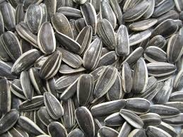 | 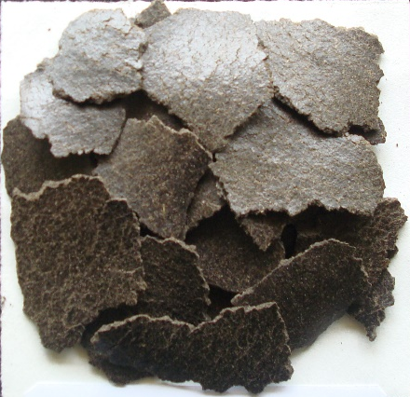
Fig. 1. Sunflower seed and Sunflower de-oiled cake
2.2 METHODS

2.2.1 Extraction of Sunflower protein isolate

Sunflower protein isolate (SPI) was obtained from SDC using a standard method of Shchekoldina and Aider (2012) with minor adjustments. An initial experiment on protein extraction was conducted at three different levels of NaCl ranging from 8-10% and pH levels of 8, 9, 10 (adjusted using 1.0 N NaOH) at a solvent ratio of 1:10. The extraction process was performed at 30°C for 60 minutes. Subsequently, the extracts were centrifuged at 5000 x g for 30 minutes. The extracted protein was precipitated at pH 3.5 by adding 1.0 N HCl and then collected through centrifugation at 5000 x g for 30 minutes. The sunflower protein isolate (SPI) was rinsed with distilled water and the pH was adjusted to 7.0 using 1.0 N NaOH before drying (Fig.2). The yield was recorded, and the protein content of the isolate was determined using the Micro-Kjeldahl method (AOAC, 2000). The formula used for calculating protein yield is as follows:

$Protein Yield \left(\%\right)=\frac{ isolate protein content \left(\%\right) x isolate wt (g)}{flour protein content \left(\%\right) x flour wt (g)}x 100 (1)$

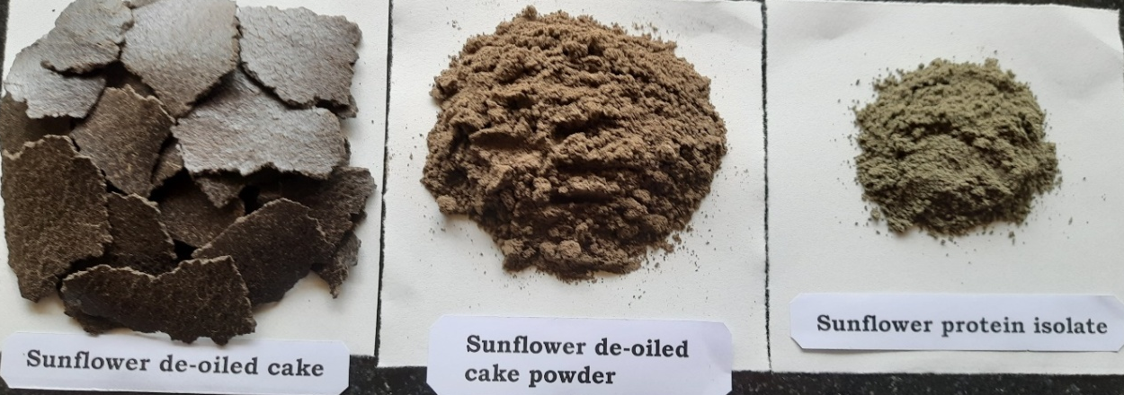

Fig. 2. Sunflower de-oiled cake, Sunflower de-oiled powder, Sunflower protein isolate

2.3 Sieve Analysis
The particle size distribution of the sample (50 g) was evaluated by means of the analytical/vibratory sieve shaker Digital (Retsch, AS 200 control., Germany), equipped with eight certified sieves (openings: 45 μm, 63 μm, 125 μm, 250 μm, 500 μm, 1mm, 2mm, 4mm). The powder was sifted at 2 ± 0.01 mm vibration amplitude for 10 min (Cappa et al., 2013). Eight granulometric fractions were collected, weighed, packed in air tight containers and stored at 4 °C until required for further use. The measurements were done in triplicate, and reported as g/100 g.
2.4 Bulk density

For the determination of bulk density, 10 g of sample was quantitatively transferred to a 100 mL measuring cylinder and tapped to a constant volume. The bulk density was obtained from the weight-to-volume ratio and expressed as g/cm³. The measurement was carried out in triplicate (Girotto et al., 2024).

2.5 Determination of chlorogenic acid using HPLC

Chlorogenic acid (CGA) present in defatted sunflower oil cake was determined using HPLC by following method of Vinson et al. (2019).

Aliquots of 30-50 mg were weighed on an analytical balance and extracted with 100 mL of methanol on a wrist shaker for 5min and then centrifuged for 10 min. Aliquots of the solutions were then stored at -80⁰C until assayed.

The HPLC system utilized a Shimadzu LC-20AD with photodiode array (PDA) detection (Shimadzu SPD-M20A) at 325 nm for CGA. Chromatographic separation was achieved with an Agilent Zorbax RX C-18 column (4.6mm· 250 mm) with a pore size of 5µm. The 5-CGA standard was analyzed with a 12.5-min gradient using the following conditions: (A) 0.1% formic acid in water; (B) 0.1% formic acid in acetonitrile; gradient elution, time 0 at 5% B to 12.5 min at 10% B then hold for 10 min at a flow rate of 1 mL/min. The retention time of the 5-CGa standard was 12.29 min. All CGA had a similar ultraviolet (UV)-visible spectrum by PDA detection. For the HPLC/UV studies, the samples were analyzed using a batch analysis program at a flow rate of 1mL/min using 0.1% formic acid in water (A) and 0.1% formic acid in acetonitrile (B) with gradient elution as follows: 0min (5% B), 12.5min (10% B), 22.5min (10% B), and 60min (30% B).

2.6 Colour measurements

The L*, a*, b* colour values of the sunflower meal and extracted protein isolate were measured using Konica Minolta (Model CM-5) spectrophotometer. The instrument was calibrated with black and white reference tiles. The colour values were expressed as L* (whiteness or brightness/darkness), a* value indicates greenness (-) or redness (+) of the sample and b* value indicates blueness (-) or yellowness (+) of the sample. The ΔE expressed the total colour difference. Three readings were taken for each sample and the mean value was recorded.

2.7 Functional properties

2.7.1 Water/Oil Holding Capacity (WHC / OHC)

The water/oil holding capacity of sunflower protein isolate was assessed following the method outlined by Shchekoldina and Aider (2012) with minor modifications. One gram of protein isolate was mixed with 10 ml of distilled water and stirred for five minutes. After allowing the mixture to sit for 30 minutes, it was centrifuged at 4500 x g for 30 minutes. The supernatant was removed, and the tubes were tilted at a 45° angle for 25 minutes to drain any remaining liquid from the protein sediment.
The water/oil holding capacity was calculated as:
$$WHC/OHC \left(g/gof protein\right)= \frac{M_{2}-M_{1}}{M} (2)$$

Where
a is the mass of the tube with the protein isolate and absorbed water or oil
b is the mass of the tube and protein isolate
c is the mass of the protein isolate

2.7.2 Emulsifying capacity & Stability

The emulsifying capacity (EC) and emulsion stability (ES) of sunflower protein isolates were assessed using the procedure outlined by Lawal et al, (2012). Two percent protein solution, measuring five millilitres, was mixed with an equal volume of soybean oil. The resulting emulsion underwent centrifugation at 3500 x g for five minutes. The heights of both the emulsified layer and the total contents in the tube were subsequently measured.
The emulsifying capacity (EC) was calculated as:

$$EC \left(\%\right)=\frac{Height of emulsified layer }{ Height of total content in tube} x 100 (3)$$

Emulsion stability was determined by heating the emulsion at 80 °C for 30 min before centrifuging at 3500 x g for 5 min and was calculated as:

$$ES \left(\%\right)=\frac{Height of emulsified layer }{ Height of total content in tube} x 100 (4)$$
2.7.3 Foaming capacity & Stability
The foaming capacity (FC) and foam stability (FS) of sunflower protein isolates were assessed following the procedure outlined by Fekria et al. (2012). A protein solution with a concentration of 3% w/v was vigorously whipped in a mixer blender for 5 minutes. The entire mixture was then poured into a measuring cylinder, and the foam volume was recorded immediately. The foam volume was subsequently measured at intervals of 15, 30, 45, and 60 minutes, with each measurement providing an indication of the foam's stability at that specific time.
$$FC \left(\%\right)= \frac{V_{2}-V_{1}}{ V_{1}} x 100 (5)$$

Foam stability was calculated after allowing the foam to stand for 10min and up to 90min. Their volumes were measured that is total volume minus the volume of the solution.

$$FS \left(\%\right)=\frac{V_{60}}{ V_{1}} x 100 (6)$$
2.8 Statistical analysis
The data are presented as the average of three repeated analyses, along with their standard deviation. Statistical analysis was conducted using OPSTAT software, employing a one-way analysis of variance (ANOVA) and Duncan's multiple range test, with the significance level set at P < 0.05.
3. results and discussion

  - Extraction of Sunflower protein isolate from Sunflower de-oiled cake (SDC)

3.1.1 Effect of pH and salt concentration on yield (% weight) of protein isolate from SDC

The effect of different concentrations of salt (8, 9, 10 %) and pH (8, 9, 10) on the yield of the protein isolate was evaluated and the results are depicted in Fig 3. When the salt concentration increased from 8 to 9 %, there was a significant (P<0.05) increase in the protein yield was observed as pH increased from 8 to 9, while further increase in salt percentage (10%) showed a significant decrease in the yield. Also increase in the pH from 9 to 10, there was a significant decrease in the protein yield was observed. However, there was no significant (P<0.05) difference between yield at pH 8 and 9 with 10 % salt concentration. It is evident from the results that higher yield of 24.40±0.300 % was obtained at pH 9 with 9 % salt concentration. Lowest yield of 15.46±0.225% was obtained at pH 10 with both 8 and 10 % salt concentration. The results obtained from the study revealed that both pH and concentration of addition of salt affected the yield of the protein concentration during isolation. The lower yield of precipitated proteins from SDC extracts could be due to a reduction in protein solubility from denaturation that occurs during the oil extraction process (Ivanova et al., 2012). According to Pickardt et al. (2015), the washing of precipitated proteins with water can result in losses of up to 17% of those proteins. Ermis & Karasu (2020) reported similar results for spray dried de-oiled sunflower protein extracts.

Fig. 3. Effect of pH and salt concentration on yield (% weight) of protein isolate from SDC
The data were analysed using one
way ANOVA, and the treatment means were
compared by Duncan multiple range test
The data were analysed using one
way ANOVA, and the treatment means were
compared by Duncan multiple range tes

3.1.2 Effect of pH and salt concentration on protein content (%) of protein isolate from SDC
The effect of different concentration of salt (8, 9, 10%) and pH (8, 9, 10) on the protein content (%) of the isolate was evaluated and the results are depicted in Fig 4. When the salt concentration increased from 8 to 10%, significant (P<0.05) increase in the protein per cent was observed at all the pH levels. Higher protein content of 89.41±0.300 % was obtained at pH 10 and 9% salt concentration. Lowest yield of 74.43±0.252 % was obtained at pH 8 and 10% salt concentration. However, increase in the pH from 8 to 9 and salt concentration at 10%, did not affect the protein content in the isolate as statistical analysis revealed no significant difference in the protein per cent. It was evident from the results that both pH and concentration of addition of salt affected the protein content of the sunflower protein isolate during extraction. Even with the reduction of proteins during the processes of precipitation and purification, the proportion of protein in the precipitated protein fraction remained notably high (approximately 89% on a dry basis) and aligned with the results from earlier studies conducted by researchers (Pickardt et al., 2015; Shchekoldina and aider, 2012; Martinez et al., 2005). Also, the studies reported similar findings in which protein extraction of flax and hemp seed cakes prepared by isoelectric precipitation or salt extraction resulted in enrichment of protein and removal of moisture, ash, lipid and carbohydrate contents (Teh & Bekhit et al., 2015).

Fig. 4. Effect of pH and salt concentration on protein content (%) of protein isolate from SDC

3.2 Sieve Analysis

Flour particle size distribution greatly impacts functionality and performance in different food applications, especially in beverages. It influences mixing characteristics, water adsorption, retention, and the moisture content of the final products (Giratto et al., 2024). In the sunflower protein isolate examined (Fig. 6), most particles (70.30 g/100 g) measured between 250 μm and 499 μm. Specifically, 62% and 20% of the sample were retained by 249 μm and 125 μm sieves, while the remaining 17% was held by 999 μm and 499 μm sieves, respectively. Particle size is the main determinant of flour bulk density, with an inverse relationship. The bulk density of sunflower cake flour was 0.555 g/cm3, and for sunflower protein isolate, it was 1.003 g/cm3 (Table 1), aligning with literature values for defatted sunflower seed flour of similar particle size (Bhise & Kaur, 2015; Petraru et al., 2021). Furthermore, bulk density is affected by moisture and lipid content, where higher amounts lead to increased density (Joshi et al., 2015). The bulk density of flour influences handling requirements and packaging design; higher density reduces packaging costs, while lower density facilitates transportation. Additionally, bulk density is crucial for determining flour applications in the food industry. Flours with low bulk density are often used in infant and weaning foods, whereas those with high bulk density serve as thickeners and stabilizers in processed foods (David et al., 2015). Given the bulk density of 1.003 g/cm3, the micronized SPI seems appropriate for complementary food preparations (Eke-Ejiofor et al., 2021).

Fig. 5. Particle size fractions (%) of Sunflower protein isolate (SPI)
The particle size distribution of SPI exhibits a distinctly unimodal pattern, with most particles concentrated within a single size range (Fig 5). Dominant particle size with sieve e (250-499µm). This category contains the largest portion (~70%) of particles, indicating that the sunflower protein isolate mainly consists of medium-sized particles. Secondary fraction with sieve size f (125-249µm). Approximately, 20% of the particles are in this slightly smaller range, suggesting a notable presence of small particles, yet still close to the dominant size class. About 17% of the material is found in this coarser size range, sieve size d (500-999µm) showing that the sample includes some larger particles, though significantly fewer than the main fraction. Negligible very fine or very coarse particles sieve sizes >3999 µm, 2000-3999 µm, 1000–1999 µm, 63–124 µm, 45–62 µm, and <45 µm show 0%, indicating no extremely large particles no dust-like or ultra-fine particle. Overall, the sample demonstrated a predominantly uniform and medium-sized particle profile, reflecting consistent size-reduction during processing.
Table 1. Bulk density and pH of Sunflower meal and Sunflower protein isolate
 | Bulk Density (g/cm³⁾ | pH
Sunflower de-oiled cake | 0.553± 0.015 | 5.43
Sunflower protein isolate | 1.007± 0.025 | 9.00

3.3 Detection of presence of chlorogenic acid in defatted Sunflower oil cake

The commercial 5-CGA standards obtained from Sigma product were similar in purity as evaluated by HPLC. A typical HPLC chromatogram of sunflower oil cake and sunflower protein isolate samples are shown in Fig 6 & 7. The retention time of the major CGA 5-CGA was 12.29 min using the gradient HPLC system. Sunflower oil cake extract showed CGA content of 2.778mg/L while SPI extract showed 1.277mg/L. From the chromatogram it is evident that CGA content in SPI is reduced by 50% compared to oil cake extract. The isolate had CGA content lower than 0.127% and does not have the intense green colour. On the other hand antioxidant activity of CGA are considered to protect membranes against oxidative damage. The observed values are well within the readings obtained by other researchers (Pedrosa et al., 2000; Wildermuth et al., 2016).

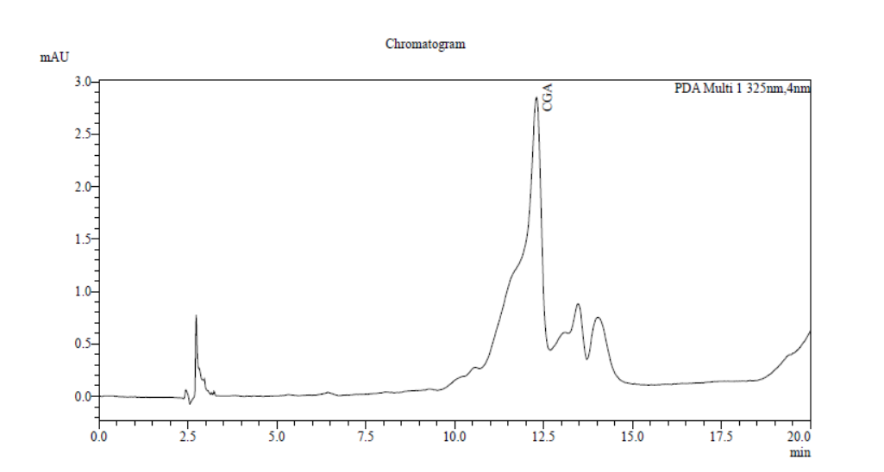

Peak# | Ret. Time | Area | Height | Conc. | Unit | Name
1 | 2.732 | 4489 | 789 | 0.000
2 | 12.298 | 89221 | 2433 | 2.778 | mg/L | CGA
3 | 13.467 | 5817 | 400 | 0.000
4 | 14.028 | 12602 | 465 | 0.000
Total |  | 112129 | 4088

Fig. 6. HPLC Chromatogram of CGA from SDC extract at 325nm

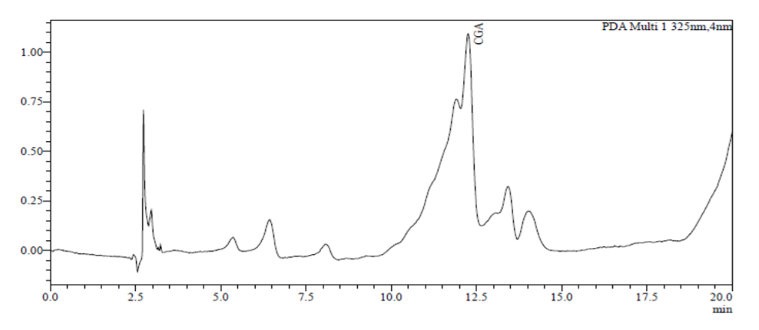

Peak# | Ret. Time | Area | Height | Conc. | Unit | Name
1 | 2.733 | 3557 | 753 | 0.000
2 | 2.963 | 1699 | 220 | 0.000
3 | 11.872 | 5757 | 298 | 0.000
4 | 12.254 | 13406 | 812 | 1.277 | mg/L | CGA
5 | 13.420 | 2259 | 169 | 0.000
Total |  | 26678 | 2252

Fig. 7. HPLC Chromatogram of CGA of SPI extract at 325nm

3.4 Tristimulus Colour measurements
The tristimulus colour of Sunflower meal and sunflower protein isolates obtained with varying salt concentration and pH in terms of L* a* b* & ΔE* values are presented in Table 2.

Table 2. Tristimulus colour of sunflower protein isolate at various treatments

Treatments |  | Tri-stimulus colour
Salt (% NaCl)) | pH | L* | a* | b* | ΔE*
Sunflower de-oiled cake | - | 36.00±0.032^{g} | 2.44±0.006ª | 8.56±0.042^{h} | 0
8 | 8 | 45.53±0.036^{d} | 1.87±0.010^{b} | 13.99±0.021ª | 10.986±0.041^{d}
8 | 9 | 46.72±0.031^{c} | -0.70±0.010^{h} | 12.52±0.026^{c} | 11.854±0.032^{c}
8 | 10 | 51.68±0.025^{b} | -1.71±0.002^{c} | 11.16±0.015e | 16.432±0.025^{b}
9 | 8 | 41.42±0.031e | 1.62±0.002^{d} | 13.13±0.021^{b} | 7.181±0.014e
9 | 9 | 42.38±0.227^{f} | -0.67±0.005^{h} | 12.28±0.015^{d} | 5.458±0.003^{g}
9 | 10 | 53.34±0.020ª | -1.28±0.010^{f} | 11.15±0.015e | 17.923±0.017ª
10 | 8 | 35.35±0.017^{h} | 1.55±0.012e | 10.91±0.035^{f} | 2.595±0.036^{i}
10 | 9 | 34.08±0.040^{i} | -0.86±0.005^{g} | 10.47±0.023^{g} | 4.271±0.011^{h}
10 | 10 | 29.74±0.032^{j} | -0.54±0.005^{i} | 7.23±0.006^{i} | 7.05±0.027^{f}
L* indicates lightness
a* positive value indicates colour redness and negative value indicates greenness
b* value indicates yellowness
Values expressed are mean ± standard deviation
Means in the rows with different superscripts are significantly different at P≤0.05
The tristimulus colour values (L*, a*, b*) of sunflower de-oiled cake and sunflower protein isolate samples varied significantly with changes in salt concentration and pH. The untreated sunflower de-oiled cake exhibited a relatively low lightness (L* = 36.00), moderate redness (a* = 2.44), and noticeable yellowness (b* = 8.56), reflecting its inherently darker and slightly reddish-brown appearance. Across the treated samples, lightness (L) increased with rising pH*, particularly at pH 10 with respect to 8 and 9% salt, indicating a progressive lightening of colour while for 10% salt there is decrease in lightness as pH increased. The highest L* values were recorded at 9% salt and pH 10 (L* = 53.34), suggesting that alkaline conditions coupled with moderate salinity enhanced protein solubilization and reduced pigment intensity. As pH increased, especially at pH 9 and 10, the a values shifted from positive to negative, indicating a transition from slight redness to a greener hue. Similarly, b values decreased with increasing pH, moving from strong yellowness (≈14 at low pH) to lower b* values (≈11 at pH 10), demonstrating diminished yellowness at higher alkalinity. The lowest b* (7.23) was observed at 10% salt and pH 10, reflecting substantial removal or modification of colour-contributing components. Overall, the results indicate that higher pH levels consistently enhanced lightness and reduced both redness and yellowness showing on the green side irrespective of salt concentration. These trends suggest that alkaline extraction improves the visual quality and colour uniformity of sunflower protein ingredients by lightening the matrix and minimizing residual pigments (Girotto et al., 2024).
3.5 Functional properties

3.5.1 Water holding capacity
Water-holding capacity (WHC) refers to a protein's ability to retain water against gravitational forces (Kinsella, 1979). As shown in Table 3, SPI exhibited WHC of 2.38±0.02 g/g of protein, which is lower than that of Soy protein Isolate (3.5g/g) (Nazareth et al., 2009) and dehulled walnut protein (5.6g/g) (Jin et al., 2020). The decline in WHC as compared to soy protein isolate could be linked to a reduction in hydrophilic groups on the surface of sunflower protein isolate, potentially due to the increased presence of hydrophobic groups (Wouters et al., 2016) or due to less availability of polar amino acids. Withana-Gamage et al. (2011) reported a comparable water-holding capacity (WHC) of 2.34 g/g protein for chickpea protein isolate. Similarly, Li et al., 2010) found a WHC of 2.78 g/g protein for mung bean protein isolate.

3.5.2 Oil holding capacity
The oil-holding capacity (OHC) of proteins is also a crucial functional attribute as it enhances mouthfeel and preserves flavor in food (Kinsella, 1976). The OHC of SPI was found to be 1.493±0.009 g/g of protein (Table 3). This value is lower than that of lupin protein isolate (2.7g/g) (EI-Adawy et al., 2000) and higher than that of mung bean protein isolate (1.38g/g) (Li et al., 2010). The lower capacity for holding oil might be attributed to a higher concentration of hydrophilic groups and polar amino acids on the surfaces of protein molecules. The OHC of proteins plays a significant role in determining the functional characteristics and taste of food products, especially in meat and confectionery items (Pickardt et al., 2015). Moreover, OHC is strongly related to the texture of food products and is affected by the bulk density of the protein powder (Tanuja et al., 2012).

3.5.3 Emulsifying properties (EC & ES)
Due to the variety of methods employed and pre-treatment techniques utilized in existing literature, it was challenging to quantitatively compare emulsifying properties with other studies. Previous research has indicated that proteins from sunflower can create stable emulsions (Gonzalez-Perez et al., 2005). Furthermore, sunflower proteins have demonstrated comparable or superior emulsifying capabilities when compared to soy proteins, skim milk powder, and egg powder (Shchekoldina and Aider, 2012; Sila et al., 2014). The emulsifying properties of SPI were recorded at 74% and 43.3% respectively (Ren et al., 2012). In this investigation, those values (EC & ES) were found to be approximately 45.27±2.056 % and 44.46±1.904 % (Table 3). Although the emulsifying capacity of SPI was lower than that of soy protein isolate, the findings from this study suggest that SPI could be effectively utilized in food formulations.

3.5.4 Foaming properties (FC & FS)
The foaming capacity of SPI (104±2.00) was lesser compared to soy protein isolate (110%) (Ren et al., 2012) and mungbean protein isolate (110%), while its stability was greater (53.3± 0.885 %) in comparison to soy protein isolate (43.3%) (Table 3). According to Dalgalarrondo et al. (1984), sunflower 11S globulins are thought to be hexamers formed from pairs of subunits, consisting of a α-polypeptide and a smaller β-polypeptide linked by disulfide bonds. Lower foaming capacity might result from insufficient electrostatic repulsions, reduced solubility and excessive protein-protein interactions (Masood Sadiq Butt and Rizwana Batool, 2010). This information suggests that the foaming ability of sunflower protein isolates is attributed to sunflower globulins. Sunflower protein isolates contain a higher quantity of globulins than soybean protein isolates, which explains why they exhibit greater foaming capacity and stability.

Table 3. Functional property of Sunflower protein isolate (SPI)

Functional property | Sunflower protein isolate*
Water Holding Capacity (g/g of protein) | 2.38 ± 0.02
Oil Holding Capacity (g/g of protein) | 1.493 ± 0.009
Emulsion Capacity (%) | 45.27 ± 2.056
Emulsion Stability (%) | 44.46 ± 1.904
Foaming Capacity (%) | 104 ± 2.00
Foaming Stability (%) | 53.83 ± 0.885
*Data represent the Mean± SD of three independent determinations (n=3)

4. Conclusion

Sunflower oil cake, a by-product of the oil industry, has a relatively high protein content. This makes it an appealing option for producing protein-rich products with high value. The procedures developed in this work successfully produced sunflower protein isolates with high water holding capacity. They also featured moderate oil absorption, good emulsifying properties, and various physico-chemical properties. However, complete removal of phenolic compounds was not possible due to their association with proteins. The remaining phenolic compounds gave the protein products antioxidant properties while not impacting water solubility. Additionally, the protein showed excellent foaming ability along with moderate foam stability, which underscored its capacity to create and partially maintain aerated structures. Overall, these functional qualities support the potential use of sunflower protein isolate in various food formulations. In addition, the protein demonstrated excellent foaming capacity with moderate foam stability, highlighting its ability to form and partially maintain aerated structures. Overall, these functional attributes support the potential use of sunflower protein isolate in a range of food formulations.

Consent (where ever applicable)

Ethics approval and consent to participate: It is declared that the data and facts provided in the manuscript belong solely to the authors only, and authors are liable for originality, authenticity, and validity. The authors also declare that results are presented clearly, honestly, and without fabrication, falsification, or inappropriate data manipulation.

References

Amagliani, L., O'Regan, J.O., Kelly, A.L., & O'Mahony, J.A. (2016). Physical and flow properties of rice protein powders. Journal of Food Engineering, 190, 1–9. https://doi.org/10.1016/j.jfoodeng.2016.05.022
AOAC International. (2000). Official Methods of Analysis of AOAC International. https://books.google.com/books?id=2200AAAAMAAJ&q=Official+Methods+of+Analysis+of+AOAC+International+2000
Bhise, S., & Kaur, A. (2015). The effect of extrusion conditions on the functional properties of defatted cake of sunflower-maize based expanded snacks. International Journal of Food and Fermentation Technology, 5(2), 247-252. https://doi.org/10.5958/2277-9396.2016.00014.3
Cappa, C., Lucisano, M., & Mariotti, M. (2013). Rheological properties of gels obtained from gluten-free raw materials during a short-term aging. LWT-Food Science and Technology, 53, 464-472. https://doi.org/10.1016/j.lwt.2013.02.027
Dalgalarrondo, M., Raymond, J., & Azanza, J. L. (1984). Sunflower seed proteins: Characterization and subunit composition of the globulin fraction. Journal of Experimental Botany, 35(11), 1618-1628. https://doi.org/10.1093/jxb/35.11.1618
David, O., Arthur, E., Kwadwo, S.O., Badu, E., & Sakyi, P. (2015). Proximate composition and some functional properties of soft wheat flour. International Journal of Innovative Research in Science, Engineering and Technology, 4, 753-758.
Egerton, S., Culloty, S., Whooley, J., Stanton, C., & Ross, R. P. (2018). Characterization of protein hydrolysates from blue whiting (Micromesistius poutassou) and their application in beverage fortification. Food Chemistry, 245, 698-706. https://doi.org/10.1016/j.foodchem.2017.10.107
El-Adawy, T. A., Rahma, E. H., El-Bedawy, A. A., & Sobihah, T. Y. (2000). Effect of soaking process on nutritional quality and protein solubility of some legume seeds. Nahrung, 44(5), 339-343. https://doi.org/10.1002/1521-3803(20001001)44:5<339::AID-FOOD339>3.0.CO;2-T
Eke-Ejiofor, J. N., Ojimadu, A. E., Wordu, G. O., & Ofoedu, C. E. (2021). Functional properties of complementary food from millet (Pennisetum glaucum), African yam bean (Sphenostylis stenocarpa), and jackfruit (Artocarpus heterophyllus) flour blends: A comparative study. Asian Food Science Journal, 20, 45-62. https://doi.org/10.9734/afsj/2021/v20i930342
Ermis, E., & Karasu, E. N. (2020). Spray drying of de-oiled sunflower protein extracts: Functional properties and characterization of the powder. GIDA The Journal of Food, 45(1), 39-49. https://doi.org/10.15237/gida.GD19096
Fekria, A. M., Isam, A. M. A., Suha, O. A., & Elfadil, E. B. (2012). Nutritional and functional characterization of defatted seed cake flour of two Sudanese groundnut (Arachis hypogaea) cultivars. *International Food Research Journal*, *19*(2), 629-637. http://www.ifrj.upm.edu.my/list-of-issues
Jin, F., Wang, Y., Tang, H., Regenstein, J. M., & Wang, F. (2020). Limited hydrolysis of dehulled walnut (Juglans regia L.) proteins using trypsin: Functional properties and structural characteristics. LWT-Food Science and Technology, 133, 110035. https://doi.org/10.1016/j.lwt.2020.110035
Girotto, F., Merlino, M., Giovanelli, G., Condurso, C., & Piazza, L. (2024). Unveiling the potential of micronized dehulled sunflower press-cake: a breakthrough in sustainable plant-based protein-rich sport beverages. International Journal of Food Science and Technology, 59(7), 4784-4796. https://doi.org/10.1111/ijfs.17208
González-Pérez, S., van Koningsveld, G. A., Vereijken, J. M., Merck, K. B., Gruppen, H., & Voragen, A. G. J. (2005). Emulsion properties of sunflower (Helianthus annuus) proteins. Journal of Agricultural and Food Chemistry, 53(6), 2261-2267. https://doi.org/10.1021/jf0486388
González-Pérez, S., & Vereijken, J. M. (2007). Sunflower proteins: Overview of their physicochemical, structural and functional properties. Journal of the Science of Food and Agriculture, 87(12), 2173-2191. https://doi.org/10.1002/jsfa.2971
Ivanova, P., Chalova, V., Koleva, L., Pishtiyski, I., & Perifanova-Nemska, M. (2012). Optimization of protein extraction from sunflower meal produced in Bulgaria. Bulg. J. Agric. Sci., 18, 153-160. https://agrojournal.org/18/02-12.pdf
Joshi, A. U., Liu, C., & Sathe, S. K. (2015). Functional properties of select seed flours. LWT - Food Science and Technology, 60, 325-331. https://doi.org/10.1016/j.lwt.2014.09.001
Kinsella, J. E. (1979). Functional properties of soy proteins. Journal of the American Oil Chemists' Society, 56, 242-258. https://doi.org/10.1007/BF02671468
Lawal, O. S., Adebowale, K. O., & Adebowale, Y. A. (2007). Functional properties of native and chemically modified protein concentrates from bambarra groundnut. Food Research International, 40, 1003–1011. https://doi.org/10.1016/j.foodres.2007.05.011
Li, W., Shu, C., Yan, S., & Shen, Q. (2010). Characteristics of sixteen mung bean cultivars and their protein isolates. International Journal of Food Science & Technology, 45(6), 1205-1211. https://doi.org/10.1111/j.1365-2621.2010.02259.x
Martinez, K. D., Baeza, R. I., Millán, F., & Pilosof, A. M. R. (2005). Effect of limited hydrolysis of sunflower protein on the interactions with polysaccharides in foams. Food Hydrocolloids, 19(3), 361-369. https://doi.org/10.1016/j.foodhyd.2004.10.002
Butt, M. S., & Batool, R. (2010). Nutritional and functional properties of some promising legumes protein isolates. Pakistan Journal of Nutrition, 9(4), 373-379. https://doi.org/10.3923/pjn.2010.373.379
Nazareth, Z. M., Desk, N. A., & Johnson, L. A. (2009). Functional properties of soy protein isolates prepared from gas-supported screw-pressed soybean meal. Journal of the American Oil Chemists’ Society, 86(4), 315-321. https://doi.org/10.1007/s11746-009-1360-0
Pedrosa, M. M., Múzquiz, M., García-Vallejo, C., Burbano, C., Cuadrado, C., Ayet, G., & Robredo, L. M. (2000). Determination of caffeic and chlorogenic acids and their derivatives in different sunflower seeds. Journal of the Science of Food and Agriculture, 80(4), 459-464. https://doi.org/10.1002/(SICI)1097-0010(200003)80:4<459::AID-JSFA549>3.0.CO;2-O
Petraru, A., Ursachi, F., & Amariei, S. (2021). Nutritional characteristics assessment of sunflower seeds, oil and cake. Perspective of using sunflower oilcakes as a functional ingredient. Plants. https://doi.org/10.3390/plants10112487
Pickardt, C., Eisner, P., Kammerer, D. R., & Carle, R. (2015). Pilot plant preparation of light-coloured protein isolates from de-oiled sunflower (Helianthus annuus L.) press cake by mild-acidic protein extraction and polyphenol adsorption. Food Hydrocolloids, 44, 208-219. https://doi.org/10.1016/j.foodhyd.2014.09.020
Ren, J., Sun, X. H., Lin, G. P., Zheng, X. Q., & Liu, X. L. (2012). Isolation and characterization of sunflower protein isolates and sunflower globulins. In Information Technology and Agricultural Engineering (Vol. 134, pp. 441–449). Springer. https://doi.org/10.1007/978-3-642-27537-1_54
Romero, A., Beaumal, V., David-Briand, E., Cordobes, F., Guerrero, A., & Anton, M. (2012). Interfacial and emulsifying behaviour of rice protein concentrate. Food Hydrocolloids, 29(1), 1-8. https://doi.org/10.1016/j.foodhyd.2012.01.013
Salgado, P. R., Drago, S. R., Molina Ortiz, S. E., Petruccelli, S., Andrich, O., González, R. J., & Mauri, A. N. (2012). Production and characterization of sunflower (Helianthus annuus L.) protein-enriched products obtained at pilot plant scale. LWT - Food Science and Technology, 45(1), 65-72. https://doi.org/10.1016/j.lwt.2011.09.009
Shchekoldina, T., & Aider, M. (2014). Production of low chlorogenic and caffeic acid containing sunflower meal protein isolate and its use in functional wheat bread making. Journal of Food Science and Technology, 51(10), 2331–2343. https://doi.org/10.1007/s13197-012-0780-2
Sila, A., Sayari, N., Balti, R., Martinez-Alvarez, O., Nedjar-Arroume, N., Moncef, N., & Bougatef, A. (2014). Biochemical and antioxidant properties of peptidic fraction of carotenoproteins generated from shrimp by-products by enzymatic hydrolysis. Food Chemistry, 148, 445-452. https://doi.org/10.1016/j.foodchem.2013.05.146
Tanuja, S., Viji, P., Zynudheen, A., & Joshy, C. (2012). Composition, functional properties and antioxidative activity of hydrolysates prepared from the frame meat of striped catfish (Pangasianodon hypophthalmus). *Egypt. J. Biol.*, *14*, 28-36. https://www.ajol.info/index.php/ejb/article/view/80000
Teh, S. S., & Bekhit, A. E. (2015). Utilization of oilseed cakes for human nutrition and health benefits. In K. R. Hakeem, M. Jawaid, & O. Y. Alothman (Eds.), Agricultural biomass based potential materials (pp. 191-229). Springer International Publishing. https://doi.org/10.1007/978-3-319-13847-3_10
Vinson, J. A., Chen, X., & Garver, D. D. (2019). Determination of Total Chlorogenic Acids in Commercial Green Coffee Extracts. Journal of Medicinal Food, 22(3), 314-320. https://doi.org/10.1089/jmf.2018.0039
Wildermuth, S. R., Young, E. E., & Were, L. M. (2016). Chlorogenic acid oxidation and its reaction with sunflower proteins to form green-colored complexes. Comprehensive Reviews in Food Science and Food Safety, 15(5), 829-843. https://doi.org/10.1111/1541-4337.12213
Withana-Gamage, T. S., Wanasundara, J. P. D., Pietrasik, Z., & Shand, P. J. (2011). Physicochemical, thermal and functional characterisation of protein isolates from Kabuli and Desi chickpea (Cicer arietinum L.): a comparative study with soy (Glycine max) and pea (Pisum sativum L.). Journal of the Science of Food and Agriculture, 91(6), 1022-1031. https://doi.org/10.1002/jsfa.4277
Wouters, A. G. B., Rombouts, I., Fierens, E., Brijs, K., & Delcour, J. A. (2016). Relevance of the functional properties of enzymatic plant protein hydrolysates in food systems. Comprehensive Reviews in Food Science and Food Safety, 15(4), 786–800. https://doi.org/10.1111/1541-4337.12209

