Integrated Anemia Prevention : Current Knowledge and Suggestions for Digital Tools from Staff

.
ABSTRACT

Aims: Assessing the knowledge, attitudes, and practices of staff at the National Institute of Public Hygiene of Côte d'Ivoire regarding nutritional anemias and the link between hygiene and iron status

Study design: A cross-sectional analytical study .

Place and Duration of Study: National Institut of Public Hygien of Cote d’Ivoire, from headquarters, municipal, departmental, and regional offices, and border health control posts from October 30, 2023, to November 10, 2023.

Methodology: study was conducted within the institutional WhatsApp group comprising staff from headquarters, municipal, departmental, and regional offices, and border health control posts. The survey targeted all staff members present in this group, with exhaustive sampling by invitation to all and analysis of voluntary respondents. Data were collected using a digital questionnaire administered via Google Forms and automatically consolidated in an Excel spreadsheet linked to the form. Statistical analysis was performed using Pearson's chi-squared test with a significance level of 5%.

Results: The sample, predominantly healthcare personnel (76.7%), had a mean age of 40.6 years and a male-to-female ratio of 2.4. The results show good general knowledge: 80–85% identified nutritional anemia and iron deficiency anemia as the most frequent, 77.3% knew that iron deficiency precedes anemia, and 81.3% recognized the impact of an uncorrected iron deficiency before age 2 on cognitive development. Nevertheless, significant gaps remain: only 45.3% know the recommended treatment duration (3 months), 34.7% distinguish between heme and non-heme iron, 41.3% are unaware of the beneficial role of vitamin C in iron absorption, and local food resources such as baobab leaves are underestimated by 86.7% of participants. In terms of practices, 69.3% consult a doctor if anemia is suspected, but 36% also resort to traditional therapies. The analyses did not reveal any significant associations between knowledge and sociodemographic variables, suggesting widespread gaps in knowledge. Targeted skills development through modules on functional nutrition and hygiene-nutrition interactions, the systematic integration of the Wash’Nutrition approach into field activities, and increased use of media and technology for awareness-raising are recommended to improve the impact of prevention programs.

Keywords: Iron-deficiency ,Wash'Nutrition, KAP, Hygiene

1. INTRODUCTION

Nutritional anemia, particularly iron deficiency anemia, remains a major public health problem in low- and middle-income countries, with significant consequences for economic and social development. It disproportionately affects young children and women of reproductive age. According to the World Health Organization, nearly 40% of children aged 6 to 59 months and 30% of women aged 15 to 49 years worldwide suffer from anemia, which has detrimental effects on cognitive development, economic productivity, and overall health. Rural populations in low- and middle-income countries are the most affected. In 2019, it was estimated that 50 million healthy life years were lost due to disability caused by anemia. [1] A meta-analysis conducted in 11 French-speaking African countries on the situation of children aged 6 months to 5 years revealed an anemia prevalence ranging from 60.2% to 87.8%. Nearly 50% of women of reproductive age are anemic. Less than half of children regularly consume iron-rich foods, and only 12.6% receive iron supplements. This has justified large-scale iron fortification programs for flour implemented in almost the entire study area. However, only moderate improvement has been observed, highlighting the need for further action. [2]

In Côte d’Ivoire, data from the Demographic and Health Survey (DHS 2021) reveal a particularly high prevalence: 68% of children under five and 66% of pregnant women suffer from anemia, despite multisectoral efforts by health authorities [3].
An analysis of demographic and health surveys revealed that, in 40% of the countries studied, the risk of childhood anemia was higher in households practicing open defecation or with inadequate sanitation facilities, demonstrating the link between anemia and poor access to water, sanitation, and hygiene (WASH) [4]. In Côte d’Ivoire, despite recent progress, approximately 21% of the population still practiced open defecation, with significant disparities between urban (3%) and rural (40%) areas [5]. This practice contributes to the spread of intestinal and parasitic infections, which hinder iron absorption and promote anemia.
The UNICEF conceptual framework (1990) formalized the understanding of the immediate, underlying, and structural determinants of malnutrition by explicitly integrating diet, care practices, access to health services, and water, sanitation, and hygiene conditions [6]. By highlighting the role of hygiene in preventing infections and nutritional losses, this framework legitimized multisectoral responses combining health interventions, WASH actions, food security, and education, thus justifying the assessment of health personnel's knowledge and practices to identify operational levers for prevention.
In this context, healthcare personnel play a fundamental role in raising awareness, preventing, and treating this condition. The National Institute of Public Health (INHP) is a key player in the implementation of health policies. Its mission is to apply health policy regarding general hygiene, prophylaxis, and the control of communicable bacterial, viral, and parasitic diseases. The INHP ​​regularly mobilizes to conduct community and educational initiatives. It is therefore essential that staff have up-to-date knowledge on the nutritional and infectious causes of anemia, iron-rich foods, and the interactions between hygiene, parasitic infections, and malabsorption.

This study aims to assess the knowledge, attitudes, and practices of INHP ​​staff regarding nutritional anemias, with a particular focus on the relationship between hygiene and iron status. It is part of a continuous improvement approach to the skills of healthcare personnel, with the goal of strengthening the effectiveness of public health interventions and contributing to the sustainable reduction of anemia prevalence in Côte d'Ivoire.

2. methodology

This was a cross-sectional analytical study conducted from October 30, 2023, to November 10, 2023, within the institutional WhatsApp group comprising staff from headquarters, municipal, departmental, and regional offices, and border health control posts. The survey targeted all staff members present in this group, with exhaustive sampling by invitation to all and analysis of voluntary respondents (self-selected sample subject to non-response bias). Only consenting staff members who completed the form during the survey period were included. Data were collected using a digital questionnaire administered via Google Forms and automatically consolidated in an Excel spreadsheet linked to the form. The variables studied included sociodemographic characteristics, knowledge levels, attitudes, and practices related to nutrition and anemia. Statistical analysis was performed using Pearson's chi-squared test (with Yates' correction where necessary) with a significance level of 5%. Beyond the technical aspects, this methodology pursues a specific objective: to amplify, through a simple and accessible tool, the voices of field workers, who often possess valuable but poorly documented empirical knowledge. It also reflects an ethical approach, respectful of staff constraints and schedules, and committed to recognizing their dedication to the fight against malnutrition.

3. results and discussion

The study conducted with INHP ​​staff provides valuable information on their knowledge, attitudes, and practices regarding nutritional anemia, in a context where healthcare professionals are called upon to play a fundamental role in prevention and community awareness.

  - Participation rate, sociodemographic characteristics, and background.

The response rate, although modest (9.22%), demonstrates a genuine interest in the topic, within a professional context often characterized by multiple demands. The male-to-female ratio was 2.4. The age range was from 28 to 62 years, with a mean age of 40.59 years. Medical and paramedical staff constituted 76.7% of the sample, and 24% were senior managers (≥ Master's degree + 6 years of higher education). In 17.3% of cases, employees reported a tendency to be anemic, while 16% were unaware of this. More than half of the employees (57.3%) reported having known cases of death due to anemia among their acquaintances.

3.2. Knowledge of Anemia, Iron Status and nutrition

Nutritional anemia was known to 80% of respondents as the most common type of anemia, and 85% knew that iron deficiency anemia was the most frequent type of nutritional anemia. Vitamin B12 was mentioned in 10.7% of cases, and folic acid (vitamin B9) in 4%.
Other causes of anemia known to the respondents were malaria (82.7%), sickle cell disease (73.3%), intestinal worms (48%), and, in 18.7% of cases, pernicious anemia (Figure 1).

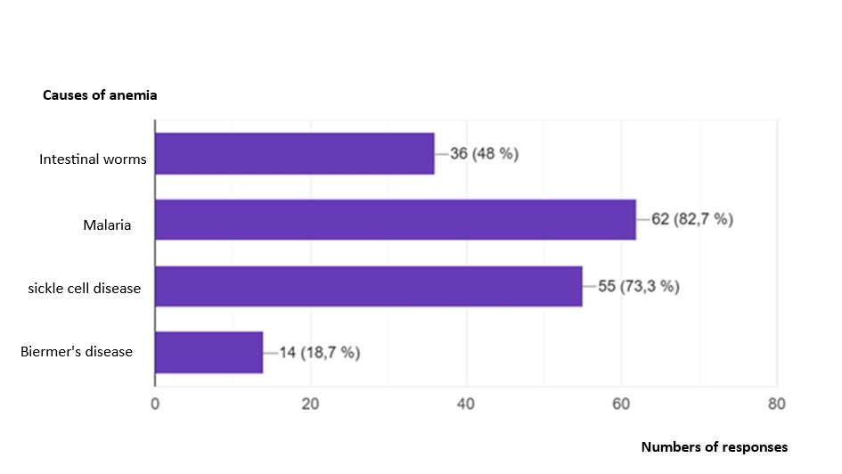
Figure 1 : Answer to the question : "What other causes of anemia do you know besides dietary deficiency?"

Overall, our results are consistent with those observed in other West African contexts. A KAP study of mothers of children under 5 years of age on anemia, conducted at the National Institute of Public Health (INSP) of Abidjan, revealed that only 1% mentioned worms as a cause of anemia, while 61% mentioned malaria and 26% malnutrition [7]. At the Angré University Hospital in Abidjan, Azagoh-Kouadio et al. (2023) demonstrated that, while mothers of children under five years of age easily identify the symptoms of anemia, they have more difficulty understanding its nutritional and parasitic causes [8]. Similarly, in 2016, at the Sylvanus Olympio University Hospital in Lomé, researchers observed that 60% of mothers were unaware of the role of intestinal parasites in iron malabsorption [9]. These observations suggest that these gaps are not specific to the facility in question, but rather stem from a lack of regional training regarding the interactions between nutrition, hygiene, and infection.

More than 77.3% of respondents knew that iron deficiency precedes anemia, and 81.3% were aware that uncorrected iron deficiency before the age of 2 compromises a child's IQ.
The ideal treatment duration of 3 months is known to 45.3% of respondents, while 33.3% stated that anemia treatment takes 2 weeks.
More than half (57.3%) of respondents knew that heme iron is the form of iron best absorbed by the body. The distinction between heme and non-heme iron remains unclear for most respondents: only 34.7% are able to differentiate between them.

The majority of respondents (78.7%) correctly identified the definition of a balanced diet, and 80% correctly identified the definition of nutritional variety.
Slightly more than half (65.3%) considered a dish of yam fufu with a fish-based sauce to be a balanced meal, thus recognizing nutritional balance in a local dish.
Local food sources are underestimated: baobab leaves, despite being rich in iron, were mentioned by only 13.3% of respondents, compared to 61.3% for spinach. (Figure 2A)
Liver is recognized as an animal source of iron by only 32% of respondents, ahead of red meat (28%) and fish (25.3%) (Figure 2B).

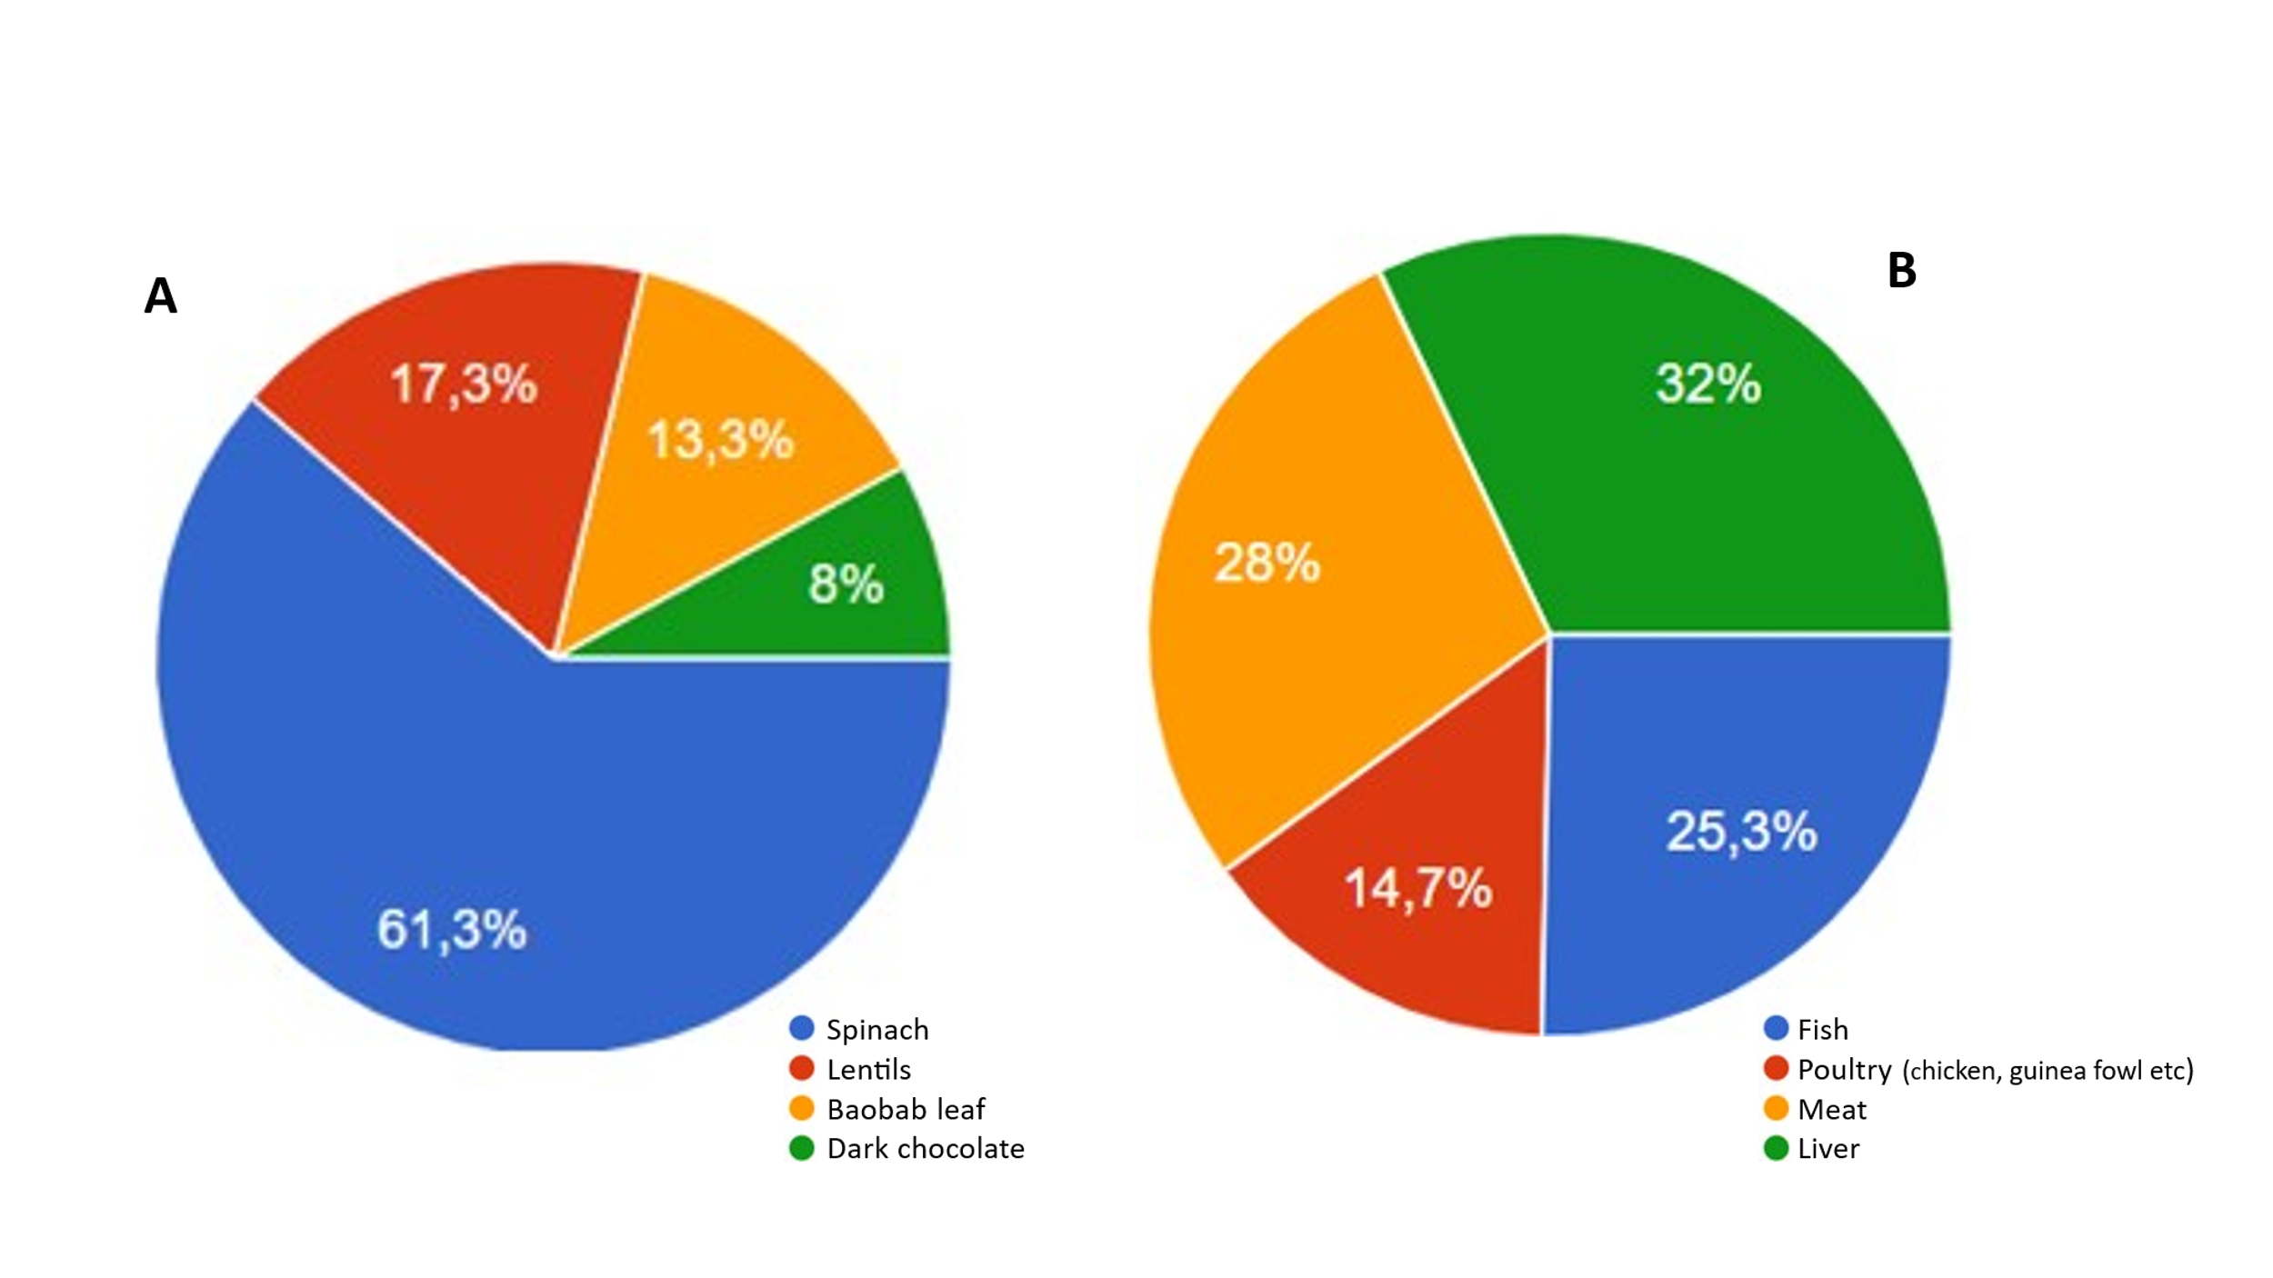

Figure 2 : Answers to the question, which food is richest in iron? (Plant origin: A; Animal origin: B)

Hibiscus tea (Bissap) is recognized as a good source of iron by 90.7% of respondents, while only 38.7% know that tea consumed with meals compromises iron absorption and promotes iron deficiency anemia (Figure 3). However, 41.3% believe that lemon juice inhibits iron absorption, thus being unaware of the role of vitamin C in promoting the absorption of non-heme iron in the body (Figure 3).

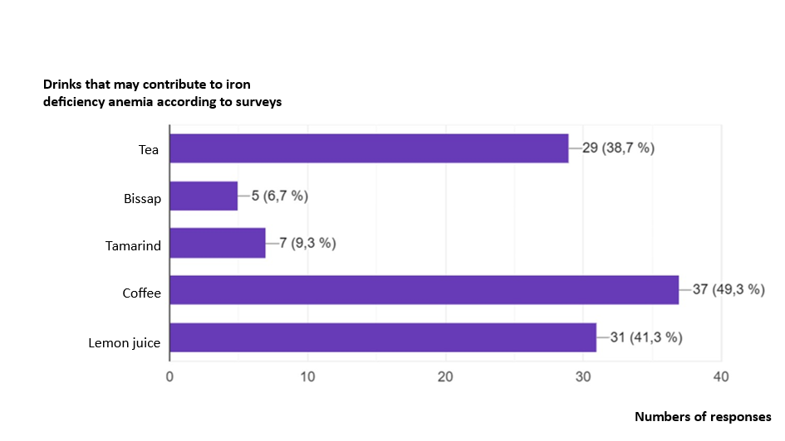
Figure 3: Answer to the question, Which drinks consumed during or after meals can promote iron deficiency anemia
The results reveal a generally satisfactory understanding of the most common forms of anemia, particularly iron deficiency anemia, but also highlight persistent gaps in understanding the mechanisms of iron absorption, local food sources, and the link between hygiene and nutritional status—a link that is essen The fact that 85% of respondents identified iron deficiency anemia as the most common form of nutritional anemia demonstrates a good grasp of basic concepts.
Similarly, the 81.3% of staff who demonstrated knowledge of the role of iron in children's cognitive development reveals a greater awareness of childhood health issues. However, this progress is offset by some confusion regarding the duration of treatment (only 45.3% cited the recommended three months) and the factors that promote or inhibit iron absorption. The fact that 41.3% of respondents believe that vitamin C hinders iron absorption highlights a lack of understanding of nutritional synergies, which are nevertheless well-documented in the scientific literature.

Another important finding of the study concerns the underutilization of local nutritional resources. Baobab leaves, although rich in iron, calcium, and B vitamins [10], were identified as a plant-based source of iron by only 13.3% of staff, compared to 61.3% for spinach.
This preference for Western foods, often highlighted in nutrition textbooks, reflects an underutilization of local knowledge and a missed opportunity to promote accessible and culturally acceptable local solutions.

3.3. Attitudes and Practices

In cases of suspected anemia, 69.3% of survey respondents consult a doctor, 48% have a blood test, 6.7% deworm themselves, 4% go to the pharmacy, and 1.3% drink a mixture of tomato paste and coca-cola.
Traditional therapies are used to treat anemia by 36% of respondents. Analyzing the open-ended responses regarding traditional therapies, we found that hibiscus tea (bissap) is used by 35% of respondents, 25% use the tomato paste and cola mixture (compared to the 1.3% rate obtained with the closed-ended responses), 10% use teak leaves, and 5% use cocoa leaves.

The practices reported in cases of suspected anemia reveal a coexistence between conventional medicine and the use of traditional therapies. While 69.3% of healthcare workers consult a doctor and 48% have blood tests done, 36% report using traditional remedies, such as a mixture of tomato paste and Coca-Cola, mentioned by 25% of respondents to open-ended questions. This discrepancy between responses to closed-ended questions (1.3%) and responses to open-ended questions underscores the persistence of informal, sometimes clandestine, practices that escape biomedical validation. This phenomenon, also observed by Akindès et al., highlights the importance of an intercultural approach in the training of healthcare personnel in order to better understand and guide traditional practices [11]. According to the Tanoh-Kamelan study, mothers' attitudes are such that when another woman's child suffers from anemia, 87% would convince the parents to go to the hospital, 7% would ask them to go to the pharmacy, and 3% would give a traditional remedy [7].

3.4. Analysis of factors associated with knowledge of the link between hygiene and anemia

The interactions between nutrition and hygiene are poorly understood: 48% of respondents identified intestinal parasites as a cause of anemia, and 82.7% mentioned malaria.

The recognition of intestinal worms as a cause of anemia is not significantly associated with socioeconomic status (OR = 1.33; 95% CI = [0.31–5.81]; p = 0.58) or sex (OR = 0.41; 95% CI = [0.15–1.11]; p = 0.08). However, a non-significant trend is observed in favor of women (Table 1) Knowledge of this parasitic cause remains poorly integrated, even among medical professionals, suggesting a lack of training or targeted awareness. Despite their training, medical personnel do not demonstrate significantly better knowledge than non-medical personnel. This may reflect a lack of specific training on the parasitic causes of anemia, or an underestimation of their importance in daily practice. Women appear to be better informed, which could be linked to their more frequent involvement in basic care, nutrition, or community health. This trend warrants further exploration in a larger study, as it could inform gender-differentiated training strategies.

Table 1: Factors associated with knowledge of the link between anemia and intestinal worms

Variables | Intestinal worms cause anemia |  | Odds ratio  [ 95% CI] | Ⲭ² | P-value
 | Yes | No
Socio-professional category
Medical Staff | 27 | 27 | 1 .33 | 0.31 | 0.58
Non-medical staff | 9 | 12 | [0.48 – 3.68]
Sex
Male | 22 | 31 | 0.41 | 3.05 | 0.08
Female | 14 | 8 | [0.15 – 1.13]

We notice a similar situation for malaria, with no significant association according to occupational category (OR = 1.18; 95% CI = [0.32–4.33]; p = 0.81) and sex (OR = 0.68; 95% CI = [0.17–2.75]; p = 0.59). Although malaria is a well-known cause of anemia, its formal recognition as an etiological factor appears to be underutilized in professional practices, particularly among men (Table 2).

Table 2: Factors associated with knowledge of the causes of non-nutritional anemias (malaria only)

Variables | Malaria: cause of anemia |  | Odds ratio  [95% CI] | Ⲭ² | P-value
 | Yes | No
Socio-professional category
Medical Staff | 45 | 9 | 1.18 | 0.06 | 0.81
Non-medical staff | 17 | 4 | [0.32 – 4.33]
Sex
Male | 43 | 10 | 0.68 | 0.30 | 0.59
Female | 19 | 3 | [0.17 – 2.75]

The examination of combined knowledge of the two causes (intestinal worms and malaria) confirms the absence of a significant association with occupational category (OR = 1.21; 95% CI = [0.60–2.43]; p = 0.72) and with sex (OR = 0.47; 95% CI = [0.17–1.28]; p = 0.13). However, a significant trend is observed in favor of women (Table 3)

This combined approach refines the analysis by revealing that some healthcare workers may recognize one of the causes without necessarily identifying the other. It thus highlights a fragmentation of knowledge, which could limit the effectiveness of anemia prevention and management strategies. The combined approach allows for a better understanding of gaps in integrated knowledge. It reveals that some agents know one of the causes, but not necessarily both, which limits their ability to make a comprehensive diagnosis or to carry out effective preventive actions.
These results suggest that healthcare worker training on the non-nutritional causes of anemia remains incomplete and compartmentalized. The failure to simultaneously recognize intestinal worms and malaria as causes of anemia underscores the need for an integrated educational approach that emphasizes the interactions between infectious diseases and nutritional status. Furthermore, the observed trend favoring women, while not statistically significant, warrants further investigation in larger-scale studies, particularly in relation to their role in primary care and community health.

Table 3 : Factors associated with knowledge of the causes of anemias related to hygiene and sanitation: intestinal worms and malaria.

Variables | Intestinal Worms and Malaria: Causes of Anemia |  | Odds ratio  [95% CI] | Ⲭ² | P-value
 | Yes | No
Socio-professional category
Medical Staff | 23 | 31 | 1 .21 | 0.13 | 0.72
Non-medical staff | 8 | 13 | [0.43 – 3.39]
Sex
Male | 19 | 34 | 0.47 | 2.24 | 0.13
Female | 12 | 10 | [0.17 – 1.28]

The lack of a statistically significant difference between healthcare workers and administrative staff suggests a significant gap in our understanding of these broadly comparable issues between the two groups. The small sample size and low response rate (n = 75; 9.2%) are methodological limitations that reduce statistical power and may mask true differences. Self-selection bias, as the volunteers may be those already familiar with the topic, could homogenize the responses.

Finally, the understanding of the link between hygiene and anemia remains incomplete. While 82.7% of healthcare workers identified malaria as a cause of anemia, only 48% mentioned intestinal worms. The lack of statistical correlation between this knowledge and sociodemographic variables confirms the extent of this gap. In a country where 21% of the population still practices open defecation [5], the risks of parasitic infections are high, and their impact on iron malabsorption is well documented. The Wash’Nutrition approach, which combines nutritional interventions with improved living conditions, offers a promising solution.

3.5. Nutrition Promotion Proposal

When asked to suggest the best way to educate the population to reduce the prevalence of anemia, 93% proposed awareness campaigns and/or education, with 10% specifying the use of media and social networks. In 4% of cases, the agents suggested medical consultations, and in 1%, reducing the cost of living.
The suggestion, of using digital media. although a minority, constitutes an exploratory avenue to be pursued further through dedicated studies.

The KAP study conducted at the National Institut of Public Health (INSP) Abidjan revealed that 92% of mothers reported having heard of anemia, primarily from medical personnel (70%), relatives (22%), and to a lesser extent the media (8%) [7]. A study carried out in Lomé noted that medical personnel rarely communicate about anemia [12], and for 58.33% of mothers, there were no known causes of anemia. However, when it comes to specific messages on anemia prevention, the INSP study reveals that 90% of women have never heard about it in the media, and that among the 10% exposed to such messages, national television is the main source. This finding highlights a low level of media investment in prevention, despite a clear recognition of the importance of raising awareness.

The study by Azagoh-Kouadio et al. (2024), conducted at the Angré University Hospital of Abidjan, reinforces this analysis by highlighting that, although the majority of mothers report knowledge of anemia, preventive behaviors remain insufficient, partly due to a lack of consistent and tailored communication. It specifically recommends diversifying communication channels and adapting messages to the sociocultural context of the target populations [8].
These elements, taken together, reveal a gap between the channels perceived as effective and those actually used. There is untapped potential for information and communication technologies in prevention strategies, particularly among young mothers and connected urban populations.

Furthermore, the central role of healthcare personnel in knowledge dissemination underscores the importance of strengthening their communication skills, while developing complementary approaches using digital media to broaden the reach of prevention messages.

4. Conclusion

In conclusion, this study reveals that INHP ​​staff possess fundamental knowledge about nutritional anemias, including the identification of iron deficiency anemia as the most frequent form. However, gaps persist in their understanding of iron absorption mechanisms, knowledge of local foods rich in micronutrients, and the link between hygiene, parasitic infections, and iron status. These gaps, observed across all staff regardless of gender or professional category, do not call into question their competence but rather highlight the need for targeted capacity building within a multisectoral approach to combating malnutrition.

Furthermore, the Wash’Nutrition approach, combining nutritional interventions with improved hygiene conditions, should be systematically integrated into field activities and awareness campaigns. This approach would break the vicious cycle of infections, malabsorption, and anemia, and sustainably strengthen the capacity of healthcare professionals to promote the nutritional health of the population. The use of ICTs proves to be a possible avenue for intervention or improvement of awareness-raising strategies.

Consent

Participation in the study was based on implied consent. Completing and submitting the online questionnaire (Google Form) constituted voluntary acceptance of taking part in the research. Participants were informed that their participation was voluntary, that they could stop completing the form at any time without consequence, and that the data collected would be treated confidentially and used exclusively for scientific purposes. No personally identifiable information was collected or published.

Definitions, Acronyms, Abbreviations

DHS : Demographic and Health Survey
ICTs: Information and Communication Technologies
INHP : National Institute of Public Hygiene (Abidjan, Côte d’Ivoire)
INSP : National Institute of Public Health (Abidjan, Côte d’Ivoire)
KAP : Knowledge, attitude and practice
WASH : Water, Sanitation, and Hygiene

References

1. WHO. (2025) Anaemia, Key Facts [Anaemia]. Feb 10 [cited 2025 Nov 15]. https://www.who.int/news-room/fact-sheets/detail/anaemia

2. Diouf S, Folquet M, Mbofung K, Ndiaye O, Brou K, Dupont C, N’dri D, Vuillerod M, Azaïs Braesco V, Tetanye E. (2015) Prevalence and determinants of anemia in young children in Francophone Africa – Implication of iron deficiency. Arch Pediatr;22(11):1188–1197. doi:. https://doi.org/10.1016/j.arcped.2015.08.015

3. National Institute of Statistics (INS); Ministry of Health, Public Hygiene and Universal Health Coverage (2022) 2021 Demographic and Health Survey of Côte d’Ivoire. INS & ICF; https://dhsprogram.com/publications/publication-SR280-Summary-Reports.cfm
4. Baldi AJ, Clucas D, Pasricha SR. Anemia and water, sanitation, and hygiene (WASH) — is there really a link? (2020) Am J Clin Nutr. ;112(5):1145 1146. doi: https://doi.org/10.1093/ajcn/nqaa213
5. UNICEF/WHO. (2023) Joint Monitoring Program (JMP) for Water Supply, Sanitation and Hygiene: Côte d’Ivoire country file. Geneva. Available from: https://www.washdata.org/data/sdg631-country-files
6. UNICEF (1990). The UNICEF conceptual framework on the determinants of maternal and child nutrition.
7. Tano-Kamelan A, Doukoure D, Kourouma K R, Koumi-Meledje Md, Agbre-Yace Ml5, Adjobi Mc, Coulibaly-Kone S, Ake-Tano O, Kouassi D. (2018) KAP study of mothers of children under 5 years of age on anemia at the INSP, Abidjan, Côte d’Ivoire. Cah. Santé Publique, 17(1): 26-35. https://educi.ci/nos-revues/sciences-de-la-sante/cahier-de-sante-publique/

8. Azagoh-Kouadio R, Andjou-Degré AMA, Tué Bi CG, Koné Toutou I, Assé KV, Amon-Tanoh-DF. (2023) Knowledge, Attitudes and Practices of mothers on anemia at the Angré University Hospital. J Afr Pediatr Genet Med, 21: 36-41 https://www.sobeped.org/le-numero-21
9. Guédénon KM, Atakouma YD, Macamanzi E, Dos Sou FC, Gbadoé AD. (2016) Knowledge, attitudes, and practices of mothers of children under 5 years of age regarding anemia in the pediatric department of the Sylvanus Olympio University Hospital in Lomé. La Tunisie Médicale, 94(1): 46-53. https://www.latunisiemedicale.com/archives

10. Hyacinthe T, Charles P, Adama K, Diarra CS, Dicko MH, Svejgaard JJ, Diawara B. (2015) Variability of vitamins B1, B2, and mineral content in baobab (Adansonia digitata) leaves in East and West Africa. Food Sci Nutr, 3(1): 17-24. doi:10.1002/fsn3.184. https://doi.org/10.1002/fsn3.184

11. Akindès F, Sedia G, Kouakou G, Bricas N. (2016) Anemia in Côte d’Ivoire: the value of a social approach. So What? 1:14. https://www.chaireunesco-adm.com/L-anemie-en-Cote-d-Ivoire-l-interet-d-une-approche-sociale

12. Segbedji K, Takassi O, Azoumah K, Tchagbele O, Agbeko F, ​​Bessi Kama L, Djadou K, Kpegouni M, Atakouma Y, Agbere A. (2017) Anemia in children under 5 years of age and its prevention: knowledge, attitudes and practices of mothers in Lomé. J Rech Sci Univ Lomé, 19(2):291–296. https://doi.org/10.4314/jrsul.v19i2

