Ethnobotanical knowledge and importance of Balanites aegyptiaca (L) Delile in the Ouadi-Rimé Ouadi-Achim Wildlife Reserve and its surroundings in north-central Chad

ABSTRACT
In Chad, Balanites aegyptiaca is a highly useful species that is conserved by farmers in agroforestry parks, but its long-term survival is under threat. The aim of this study is to understand endogenous knowledge about B. aegyptiaca. Surveys were conducted among local populations. Ethnobotanical surveys were carried out from July to August 2024 among 220 people of two sexes living in the Ouadi-Rimé Ouadi-Achim Wildlife Reserve. The results of these ethnobotanical surveys reveal several methods of exploitation and a good knowledge of the species among the local population. The plant is used in a number of areas, including health and food. The park reserve located in the Sahelian sector is the priority site in terms of repopulating B. aegyptiaca. The soap plant must be the subject of assisted regeneration and protection against over-exploitation throughout its distribution area in Chad.
Key words: Ethnobotanical knowledge, Balanites aegyptiaca, exploitation, Ouadi Rimé-Ouadi Achim, Chad
INTRODUCTION
The decline of ligneous resources is a reality in the Sahelian zone. It is characterised by the rarefaction or even disappearance of certain species (Ganaba, 2008). In the Sahelian zone, one of the main activities of human populations has long been the harvesting of plant products and hunting to satisfy their primary needs. Several types of product are sought by farmers on a daily basis (Mpondo et al., 2017 ; Rabiou et al., 2020). The products sought by farmers include edible nuts, mushrooms, fruit, herbs, spices, gums, aromatic plants, game, wood, fodder and plant or animal products for medicinal, cosmetic, food and/or cultural uses (Sinsin et al., 2004, Oumar et al., 2023). Human activity is the main factor responsible for the degradation of ecosystems and therefore biodiversity (Hama et al., 2019). Harvesting often exceeds the production capacity of many species and is the primary cause of their destruction (Douma et al., 2010). The uncontrolled exploitation of plant formations leads to the rapid decline or even total disappearance of certain species that are very important to the population (Yossi et al., 2006). Balanites aegyptiaca is an important species that is much exploited by the population of Chad. All parts of the plant are used in traditional pharmacopoeia. The fruits are a highly prized food resource for the local population and can be used for medicinal purposes; the insect-resistant wood is a high-calorific fuel, used for construction, tool handles, toothpicks, firewood and charcoal, fences, mortars, pestles and Koranic tablets; the seeds are used to make oils and soaps ; and the young leaf twigs are harvested for human consumption (Arbonnier, 2019); Abdou, 2016 ; Ganaba et al., 2004). The fruit pulp has a bittersweet taste and is sweetened as a candy. The drupes are sold by women and are also macerated in water, replacing sugar in the porridge. Oil is extracted from the kernels for cooking and soap-making. In Sahelian countries, the species plays a key role in the food and nutritional security of farmers and in timber production (Abdou et al., 2019).
The general objective of this work is to contribute to the sustainable management of B. aegyptiaca in Chad by filling the knowledge gap on local knowledge of the species in the Ouadi Rimé-Ouadi Ochim wildlife reserve.
Monograph of Balanites aegyptiaca (L) Del.
B. aegyptiaca is a very thorny, deciduous tree or shrub with extensive, complex branching and a spherical, flattened or irregular crown, reaching 8 to 9 m in height (Normand, 1955; Arbonier, 2019). The trunk is well-defined, straight or slightly twisted, with greyish-brown bark and longitudinal cracks. The growth habit is remarkable, with flexible, drooping branches armed with long, straight, alternate or more or less spiral thorns, inserted above the leaf axils. Its bark is grey and smooth when young, becoming cracked and fissured in older trees (Parkan, 1993 ; Arbonier, 2019). The young secondary branches are green, pubescent and also bear thorns. The short-stalked leaves are compound, bifoliolate, reaching 1 to 7 cm in length, inserted below the base of the spines (Arbonier, 2019). In terms of phyllotaxy, the leaves are arranged alternately. They are compound leaves with two elliptical, obovate rhomboid leaflets, with pointed, obtuse or emarginate apexes, 1 to 5 cm long by 0.7 to 3.5 cm wide, subsessile, leathery, green on both sides and slightly pubescent. The inflorescences are small racemes arranged in the leaf axils, composed of fascicles up to 3 cm wide. The greenish-yellow flower has 5 petals and 5 sepals and is borne on a pedicel about 1 cm long. The olive-shaped fruits, 2 to 3 cm long, are drupes ; first green, then yellow when ripe. The pulp of the edible fruit surrounds a hard, ovoid, pointed, ripe stone (Figure 1). Like most plants in semi-arid environments, the desert date palm has different morphological adaptations to drought. These adaptations are particularly varied: pubescence, sclerification, leathery leaves, assimilative chlorophyll branches reduced to spines. This tree has a dual root system : central taproots to access deep-seated moisture and a series of radiating but deep lateral roots that can capture surface moisture while ensuring stability. This tree produces greenish-brown to yellow fruit when ripe (after 5 to 8 years).
Systematics of B. aegyptiaca :
Kingdom: Plantae
Subkingdom: Tracheobionta
Division : Magnoliophyta
Class : Magnoliopsida
Subclass: Rosidae
Order : Sapindales
Family : Zygophyllaceae
Genus: Balanites
Species : aegyptiaca
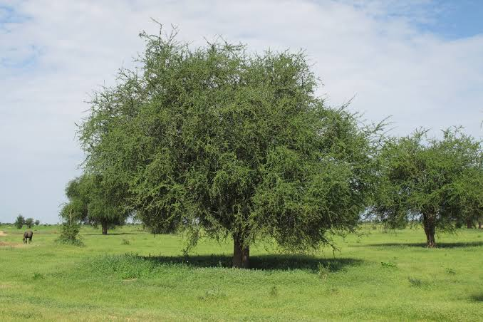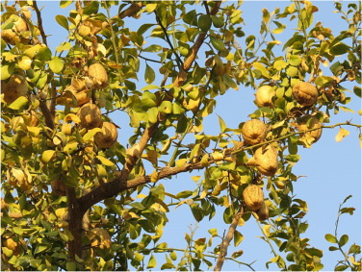
B
A
Figure 1. Mature tree of B. aegyptiaca (A), fruit-bearing branch of B. aegyptiaca (B).
MATERIALS AND METHODS
Presentation of the study area
The study was conducted in the Ouadi-Rimé Ouadi-Achim Faunal Reserve (RFOROA) and its surroundings (Figure 2) located in north-central Chad between latitudes 14° and 17.5°N and longitudes 17.2°-216.5°E (Wacher et al., 2011). It is shared between the provinces of Ba6tha, Borkou, Bahr el Ghazal, Wadi Fira and Ennedi Ouest (Duhem and Cornu, 2019). This reserve is one of the largest in Africa, covering an area of 7795.00 ha (77950 km²). Overall, RFOROA has an arid to semi-arid desert bioclimate (Hiernaux and Le Houérou, 2006). Rainfall varies in duration and abundance according to latitude, and the gradient is such that average annual rainfall decreases by 1 mm/km as latitude increases. Over the course of the year, relative humidity is extremely low (Hiernaux and Le Houérou, 2006) and average monthly temperatures range from 14 to 42°C (Climate-Data, 2012) depending on the season and latitude, reflecting the harshness of the climate. The vegetation of the Ouadi Rimé-Ouadi Achim reserve is represented by the steppe characteristic of the vegetation of Sahelian zones. The grassy stratum is represented by the following genera: Aristida, Panicum, Cenchrus, Chrozophora, etc. and a few creepers and climbers such as Citrullus colcynthis and Leptadania hastata. Woody plants are represented by: B. aegyptiaca, Vachellia radiana, Vachellia seyal, Boscia senegalensis, Maerua crassifolia, Capparis decidua, Cordia sinensis, Leptadania pyrotecnica, etc.
The reserve is also home to a huge diversity of desert animal species, including: the white-tailed mongoose, common genet, sand cat, fox, fennec, golden jackal, pale fox, ratel, striped hyena, desert antelopes such as the dorcas gazelle, the dama gazelle, which is an emblematic species, the Arab bustard, etc.

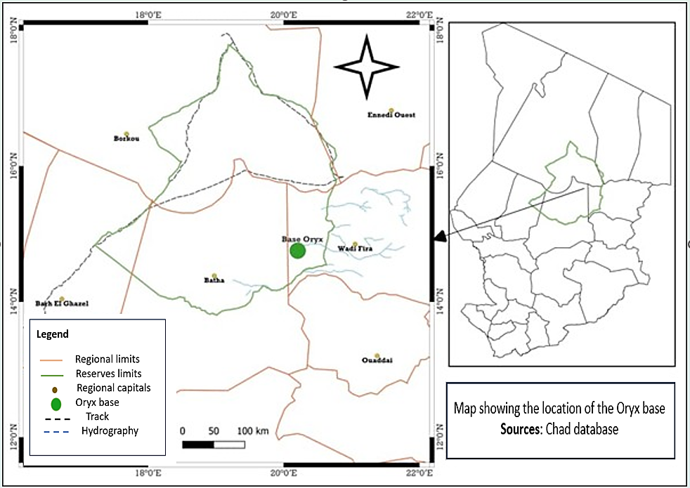
Figure 2. Map showing the location of the study area (Source : Chad database)
Ethnobotanical surveys of farmers
The investigations were conducted among 220 people, comprising 110 women and 110 men living near the park. The respondents were selected using the method described by Diouf et al. (1999), which combines systematic sampling with simple random sampling (Diarassouba et al., 2008). This method has the advantage of being quick, practical and reliable in the field and allows for a regular distribution of the people sampled. The data were collected through ethnobotanical surveys using semi-structured interviews based on a questionnaire. The information sought concerned the vernacular name of B. aegyptiaca, perceptions of its availability, the main threats to it and its various uses. The interviews were conducted with the help of translators. The ethnotypes cited were confirmed through field observations (Albuquerque et al., 2006).
Data analysis and processing
The people surveyed were divided by age category and sex, i.e. young people (age ≤ 30 years), adults (30 < age < 60) and old people (age ≥ 60 years) (Assogbadjo et al., 2008). The analyses focused on the calculation of ethnobotanical indices, namely use value (UV) and frequency of quotation (FC). The following formulae were adopted:
- Relative frequency of citation (FC) (Friedman et al., 1986) :
FC = (n/N) x 100 ;
where n is the number of people who cited different varieties of Balanites aegyptiaca and N is the total number of respondents. We use a threshold of 20% to distinguish between the least and most cited ethnotypes (Tiétiambou et al., 2016). High CF values for a group generally reflect a consensus among informants for that group. According to Kouakou et al. (2020), a species is said to be well known if the level of knowledge is between 50% and 100% ; a species is said to be moderately known if the level of knowledge is between 25% and 50% ; a species is said to be little known if the level of knowledge is between 00% and 25%.

RESULTS
Socio-demographic characteristics of respondents
A total of 220 peoples were surveyed, 110 of them men and 110 women. The majority of respondents were aged over 30 (54.16%) and farmers were the best represented (Table 1). The majority of respondents were aged over 30 (54.16%) and farmers were the best represented.
Table 1. Breakdown by socio-demographic characteristics.
Sexes | Age groups | Single | Monogamous | Polygamous | Widow
Women | Adults | 8 | 46 | 0 | 6
Women | Young | 16 | 18 | 0 | 0
Women | Old | 0 | 6 | 0 | 10
Man | Adults | 2 | 28 | 20 | 0
Man | Young | 12 | 16 | 0 | 0
Man | Old | 0 | 20 | 12 | 0

Relative frequency of citation (FC)
An analysis of the frequency of quotation in relation to the most commonly used plant organs reveals that the level of use varies according to gender and the part of the plant used (Figure 3). However, we note that the level of wood consumption remains the same for both men and women. Fruits and branches are the organs most used by both sexes. These different parts are used for four different purposes: food, energy, medicine and crafts.

Figure 3. Frequency of plant organ use by gender.
Factors responsible for the reduction in B. aegyptiaca stands
Analysis of the results of the respondents' answers reveals that several factors are involved in the reduction of the B. aegyptiaca in its distribution area. These include carbonisation, felling, debarking, bush fires, land clearing and urbanisation. Among these factors, felling and debarking are the main factors in the reduction in the distribution area of B. aegyptiaca, according to the respondents (Figure 4).

Figure 4. Types of pressure on forest stands.

Different phytotherapeutic uses of B. aegyptiaca
An analysis of the results of respondents’ answers on the use of the plant in traditional pharmacopoeia shows that it is used to treat a number of illnesses. These include typhoid, jaundice, dermatitis, malaria, snake bites, scorpion stings, constipation, stomach aches, etc. (Figure 5). This study shows that most parts of the plant are used in the various medical compounds.

Figure 5. Some diseases and the parts of B. aegyptiaca used to treat them.
Strategies for the conservation of B. aegyptiaca by local people
Several strategies for the sustainable management of B. aegyptiaca were reported by local people in different communities. The main measures and strategies proposed by the respondents in this study include assisted natural regeneration (ANR), planting, nurseries and awareness-raising. Analysis of the results of the respondents' answers reveals that assisted natural regeneration and planting are the measures most frequently adopted. These measures are supplemented by awareness-raising, particularly with regard to their socio-economic importance. These existing practices need to be perpetuated and extended throughout the study area. Among the people interviewed, 8.2% stated that they had no conservation strategy for the species. For them, B. aegyptiaca is a forest species and conservation is a natural task, independent of human intervention.
DISCUSSION
The results of this study show that B. aegyptiaca is well known by the local population and that all parts of the plant are appreciated. This result could be explained on the one hand by the cohabitation and transmission of endogenous knowledge between these groups who have been living in the same area for years.
With regard to the frequency with which the different organs reported by the respondents are cited, use varies according to gender. Fruits and branches are the organs most used by both sexes. Similar work was carried out by Abdoulaye et al. (2017) in the Ouaddaï region of Chad. These different parts are used in four different ways: food, energy, medicinal and craft. Similar work was carried out by Abdel Aziz et al. (2019) in Benin. These results are also consistent with those of Abdoulaye et al. (2020) in northern Cote d'Ivoire. The same results were obtained by Abdoulaye et al. (2017) in the Ouaddaï region of Chad and N'Guessan (2019) in Côte d'Ivoire. Work by Chaachouay (2020) in northern Morocco has shown that leaves are the most commonly used organs. Fruits are used more frequently and branches are the most commonly cited parts, followed by wood. The other parts are consumed less frequently. This could be explained by the population's appreciation of fruits and the abundance of these organs during periods of famine. These results are similar to those of Douma (2016), who showed that these same organs were the most commonly consumed.
Anthropogenic pressure seems to play an important role in the destruction of plant cover in the study area. According to the respondents, human pressure on B. aegyptiaca is contributing to the reduction in its habitat area. According to Traoré et al. (2011), farmers in Burkina Faso cut down large areas each year in search of arable land. These results corroborate those of Bindaoudou et al. (2022) in the Amou Prefecture in south-west Togo. Because of the plant's many uses, B. aegyptiaca wood is an important source of energy for the local population. The species is therefore subject to very strong anthropogenic pressure, reducing the plant's distribution area. These results are similar to those obtained by Abdoulaye et al. (2017) in the Ouaddaï region of Chad.
CONCLUSION
The study provided an overview of a wild food plants exploited in north-central Chad, with particular emphasis on characterising its uses. B. aegyptiaca plays an important role for rural populations living in the vicinity of the Ouadi-Rimé Ouadi-Achim Wildlife Reserve. In Chad, the species is present in the floristic procession of the vegetation of the sahel. It is a species of socio-economic interest, most of its parts are used by farmers. The forestry code, which prohibits the cutting of species in agrosystems, must be respected throughout the species' range in Chad. he results of this study constitute a scientific database that will be used by decision-makers to inform their decisions. For example, in the context of restoring degraded land, emphasis could be placed on planting fruit species and ensuring sustainable use of resources. Further research is therefore needed to clarify the ecological conditions required to reconcile the exploitation and conservation of food species in order to ensure the sustainability of their exploitation. However, it is essential to improve the recognition of these plants in the markets and to support their cultivation and marketing in the high-production areas where they originate.

REFERENCES
Abd El-Aziz, ME, Morsi, SMM, Salama DM, Abdel-Aziz MS, Abd Elwahed MS, Shaaban, EA, Youssef AM, (2019). Preparation and characterization of chitosan/polyacrylic acid/copper nanocomposites and their impact on onion production. International Journal of Biological Macromolecules, 123, 856-865. https://doi.org/10.1016/j.ijbiomac.2018.11.155
Abdou HMK., (2016). Characterization of the vegetation in the PLECO intervention zone in Gouré. Master's thesis, Dan Dicko Dankoulodo University of Maradi, 59p.
Abdoulaye B, Bechir AB, Mapongmetsem PM, (2017). Socioeconomic and cultural uses of Balanites aegyptiaca (L) Del. (Family Zygophyllaceae) among local populations in the Ouaddaï Region of Chad. Journal of Applied Biosciences 111: 10854-10866. ISSN 1997-5902.

https://doi.org/10.4314/jab.v111i1.2
Abdoulaye C, Ouattara M, N’Guessan EA, Abrou JEN, (2020). Plant diversity and plant uses in a Sudanese savanna zone: The case of the locality of Ferkessédougou (North, Côte d’Ivoire). International Journal of Biological and Chemical Sciences, 14 (8): 2807-2825. https://doi.org/10.4314/ijbcs.v14i8.13
Albuquerque UP, Lucena RFP, Monteiro JM, Florentino ATN, (2006). Evaluating two quantitative ethnobotanical techniques. Ethnobotany Research and Applications, 4:51-60.

https://ethnobotanyjournal.org/index.php/era/article/view/101
Arbonnier M, (2019). Trees, Shrubs and Vines of the Dry Zones of West Africa. Quae, 775p
Assogba, S, Akpinfa É, Gouwakinnou G, Stiem L, Amadji F, Allabi PM, (2017). Sustainable Land Management: Analysis of experiences from agricultural development projects in Benin. Institute for Advanced Sustainability Studies (IASS).

Assogbadjo AE, Glèlè Kakaï R, Chadare FJ, Thomson L, Kyndt T, Sinsin B, Van Damme P, (2008). Folk classification, perception and preferences of baobab products in West Africa: consequences for species conservation and improvement. Economic Botany, 62 (1): 74-84.

https://doi.org/10.1007/s12231-007-9003-6
Bindaoudou IAK, Koné IZ, Salihou Djari MM, (2022). Explanatory factors of deforestation and forest degradation in the Amou Prefecture in Southwest Togo. International Journal of Engineering Science Invention (IJSI). ISSN (Online): 2319-6734, ISSN (Print): 2319-6726.

https://doi.org/10.35629/6734-1104011933
Chaachouay Noureddine, 2020. Floristic and ethnomedicinal study of aromatic and medicinal plants in the Rif (Northern Morocco). Faculty of Sciences of Kenitra CED Sciences and Techniques, 216p.

Climate-Data, 2012. Climate: Chad. https://fr.climate-data.org/afrique/tchad-59/, (04/07/2020).
Diarassouba N, Kouablan EK, Kanga AN, Van Damme P, Sangaré A, (2008). Local knowledge and its use in the management of shea parks in Côte d’Ivoire. Afrika focus, 21(1): 77-96.

https://doi.org/10.21825/af.v21i1.5050
Douma S, 2016. Ethnobotanical and ecological study of woody food plants in the transition zone of agroforestry systems in southwestern Niger: diversity, structure, and level of threat. Doctoral thesis, Abdou Moumouni University of Niamey, (2016) 110 p.

Douma S, Chaibou R, Mahamane A, N’da D. H, Saadou M, (2010). Current state of population degradation of four fruit-bearing woody species in the Sudanian zone of Niger: Tamou Total Wildlife Reserve. Ivorian Journal of Science and Technology, 16: 191-210. DOI: http://revist.net/REVIST16/REVIST1610.pdf
Duhem B, Cornu F, (2019). Diagnostic study of the socio-economic and cultural context of the Ouadi Rimé - Ouadi Achim Wildlife Reserve. Republic of Chad, 98p.

Friedman M, Thoresen CE, Gill JJ, Ulmer D, Powell LH, Price VA, Dixon T, (1986). Alteration of type A behavior and its effect on cardiac recurrences in post myocardial infarction patients: summary results of the recurrent coronary prevention project. American Heart Journal, 112(4), 653-665.

https://doi.org/10.1016/0002-8703(86)90458-8
Ganaba S, Ouadba JM, Bognounou O, (2004). Plants used for building dwellings in the Sahel region. Bois des Tropiques, 282(4):11-17. DOI: http://doi.org/10.19182/bft2004.282.a20215.
Ganaba S, (2008). Characterization, uses, restoration tests and management of woody vegetation in the Sahel, Burkina Faso. Doctoral thesis, Cheikh Anta Diop University of Dakar, 287p.
Guigma Y, Zerbo P, Millogo-Rasolodimby J, (2012). Use of spontaneous species in three contiguous villages in southern Burkina Faso. Tropicultura 30 (4).
Hama SM, Mahmoud AS, Yassen MM, (2019). Flexural behavior of reinforced concrete beam incorporating waste glass powder. In Structures (Vol. 20, pp. 510-518). Elsevier.
Hiernaux P, Le Houerou HN, (2006). Rangelands of the Sahel. In *Sécurité*, vol. 17 (1-2), pp. 51-57.

https://www.researchgate.net/publication/266369810
Kouakou YB, Kougbo MD, Konan AS, Malan DF, Bakayoko A, (2020). Traditional uses and availability of plants used in crafts among the Koulango and Lobi populations of the eastern periphery of Comoe National Park, Côte d’Ivoire. European Scientific Journal, 16(9), 1857-7881.

http://doi.org/10.19044/esj.2020.v16n9p295
Mpondo ME, Ngene JP, Mpounze SL, Etame LG, Boumsong GCP, Yinyang J, Dibong SD, (2017). Traditional knowledge and uses of medicinal plants in the Haut Nyong department. Journal of Applied Biosciences 113: 11229-11245. https://doi.org/10.4314/jab.v113i1.12
N’Guessan AL, (2019). Flora and vegetation of northern Côte d’Ivoire, availability of useful plants and use values. Master's thesis, Félix Houphouët-Boigny University, 45 pp.

Normand D, Chatelet R, (1955). On the wood of four African species (Caesalpiniaceae, Ochnaceae, and Huaceae). Journal of Traditional Agriculture and Applied Botany, 2(1), 19-27.

Oumar D, Djekota CN, Sabo P, Mbaide Y, (2023). Farming of white gum tree: Senegalia senegal (l.) willd. in the Chari Baguirmi Region of Chad. International Journal of Engineering Sciences & Research Technology. http://doi.org/110.5281/zenodo.10209615
Parkan J, (1993). The Balanites. In: Special Tree of the Month, Journal, E FLAMBOYANT, No. 27, 39 pp.

Rabiou H, Moussa M, Tougiani A, Mahamane A, Mahamane L, Patrick VD, (2020). Structure and regeneration of natural stands of Balanites aegyptiaca (L) Del. and Ziziphus mauritiana Lam. along an ecological gradient in the Maradi region of Niger. Africa Focus, v(33):1, p83-104.

Sinsin B, Eyog Matig O, Assogbadjo AE, Gaoué OG, Sinadouwirou T, (2004). Dendrometric characteristics as indicators of pressure of Afzelia africana Sm. Dynamic change in trees found in different climatic zones of Benin. Biodiversity and Conservation, 13: 1555-1570.

https://doi.org/10.1023/B:BIOC.0000021328.56517.46
Tiétiambou FRST, Lykke AM, Korbéogo G, Thiombiano A, Ouédraogo A, (2016). Perceptions and local knowledge about local oilseed species in Kénédougou, Burkina Faso. Bois & Forets des Tropiques, 327, 39-50.

https://doi.org/10.19182/bft2016.327.a31295
Traoré L, Ouédraogo I, Ouédraogo A, Thiombiano A, (2011). Perceptions, uses and vulnerability of woody plant resources in southwestern Burkina Faso. International Journal of Biological and Chemical Sciences. 5(1): 258-278. https://doi.org/10.4314/ijbcs.v5i1.68103
Wacher T, Wronski T, Hammond RL, Winney B, Blacket MJ, Hundertmark KJ, Bleidorn C, (2011). Phylogenetic analysis of mitochondrial DNA sequences reveals polyphyly in the goitred gazelle (Gazella subgutturosa). Conservation Genetics, 12, 827-831.

https://doi.org/10.1007/s10592-010-0169-6
Yossi H, Kaya B, Traoré CO, Niang A, Butare I, Levasseur V, Sanogo D, (2006). Live hedges in the Sahel: state of knowledge and recommendations for research and development. World Agro

