Ethnomedicinal Potential of Two Underexplored Parasitic Plant Genera, Macrosolen (Blume) Rchb. and Scurrula L. (Loranthaceae): Traditional Knowledge and Research Priorities

Abstract
Parasitic plants remain among the least explored groups in ethnomedicinal research despite their diverse bioactive potential and traditional significance. The present review focuses on two hemiparasitic genera, Macrosolen and Scurrula, to consolidate scattered ethnomedicinal knowledge and highlight their therapeutic importance to the scientific community. A systematic compilation from published literature and field-based observations revealed limited yet diverse traditional applications, ranging from the treatment of hypertension, jaundice, and cough to reproductive, dermatological, and neurological disorders. The analysis indicates that Scurrula species are more frequently cited for cardiovascular and neurological ailments, while Macrosolen species are predominantly used in reproductive and respiratory treatments. Leaves and whole-plant parts were the most utilised, reflecting their pharmacological versatility. Despite their widespread distribution in tropical Asia, both genera remain poorly documented and underrepresented in pharmacological and phytochemical studies. The present review highlights the urgent need for detailed biochemical, pharmacognostic, and molecular investigations to validate and conserve these ethnomedicinally valuable yet neglected parasitic taxa.
Keywords: Ethnobotanical review, Medicinal plants, Odisha, Pharmacological potential
- INTRODUCTION
Parasitic plants represent a unique yet poorly studied group within angiosperms, characterised by their ability to partially or completely depend on host plants for water and nutrients (Jaiswal et al. 2021). Despite their ecological importance and occurrence in diverse tropical and subtropical ecosystems, their ethnomedicinal potential remains underexplored (Bouwmeester et al., 2021). Traditional healers in many Asian regions, particularly India and Southeast Asia, have long utilised parasitic taxa for treating various ailments (Kwanda et al., 2013). Among them, the genera Macrosolen and Scurrula from the family Loranthaceae occupy a remarkable place due to their wide distribution and association with multiple host species (Mishra et al. 2025). However, compared to other medicinal groups, ethnobotanical and pharmacological studies on these genera are sparse, scattered, and often anecdotal. This knowledge gap has limited their recognition within modern phytochemical and pharmacognostic research. The present review compiles and analyses available ethnomedicinal information on Macrosolen and Scurrula through a structured literature survey and supplementary field documentation. Published sources, including ethnobotanical surveys, pharmacological reports, and regional floras, were systematically reviewed to extract species-wise data on plant parts used, preparation methods, and therapeutic applications. The compiled information was further categorised into major ailment groups, and comparative analyses were performed to highlight differences and similarities in ethnomedicinal use patterns between the two genera. Additionally, emphasis was placed on identifying unexplored or underrepresented uses that could guide future pharmacological investigations. Present study represents one of the first comparative ethnomedicinal assessments of Macrosolen and Scurrula, two hemiparasitic genera often overlooked in traditional medicine documentation. The study aims to bridge the gap between traditional ethnomedicine and modern scientific research, promoting the inclusion of Macrosolen and Scurrula in future pharmacognostic and conservation programs.
- METHODOLOGY
A systematic review was conducted to compile and analyse ethnomedicinal information on the parasitic genera Macrosolen and Scurrula. Relevant data were collected from databases (Google Scholar, PubMed, ScienceDirect, and ResearchGate) and literature on regional floras. Only verified records citing plant parts, preparation methods, and therapeutic uses were included. Data were categorised by ailment type and plant part used, followed by comparative analysis between genera. A field survey was conducted in Odisha to take original photos of plants belonging to the genera Macrosolen and Scurrula during 2022-2024 (Kumar, 2025).
- RESULTS AND DISCUSSION
The compiled review documented a total of 14 ethnomedicinal use reports across six species of Macrosolen and Scurrula, representing two genera of hemiparasitic plants belonging to the family Loranthaceae (Table 1; Fig. 2). It was noticed that Macrosolen cochinchinensis is the most cited species (Fig. 2), and the whole plant and leaves are the dominant parts used in ethnomedicinal practices (Fig. 3). It is observed that cardiovascular, neurological, and reproductive uses are most frequently treated by enumerated species (Fig. 4). Genus Macrosolen is more associated with reproductive and respiratory uses, while Scurrula species are dominant in cardiovascular, neurological, and general health applications (Fig. 5). Patterns of ethnomedicinal use also revealed that Scurrula species are comparatively better represented in the literature than Macrosolen. Scurrula ferruginea, S. atropurpurea, and S. parasitica are frequently cited for the treatment of cardiovascular, neurological, and general health disorders, while Macrosolen cochinchinensis is primarily used for reproductive and hepatic ailments (Table 1; Fig 2). Quantitative analysis revealed that Scurrula is associated with a greater number of distinct medicinal uses, indicating broader ethnopharmacological recognition among traditional communities. Plant part utilisation indicated that the leaves and whole plants are the most commonly used, followed by fruits and stems (Fig 3). Such patterns suggest that easily harvestable aerial parts are preferred due to their accessibility and high phytochemical content, a trend consistent with observations in other medicinal taxa. The dominance of leaf-based remedies also highlights their potential as sustainable sources for pharmacological testing without threatening plant survival. Categorisation by ailment type identified cardiovascular (26%), neurological (19%), and reproductive (14%) disorders as the major therapeutic domains, followed by hepatic, respiratory, and dermatological applications (Fig 4). These results align with reports indicating that parasitic plants often possess strong antioxidant and vasorelaxant properties, which may justify their traditional use in hypertension and circulatory disorders. The comparative analysis between genera further emphasises that Macrosolen exhibits a narrower spectrum of recorded uses, possibly due to limited ethnobotanical documentation rather than true medicinal scarcity. Conversely, Scurrula species are more widely studied, particularly in Southeast Asia, for their anti-cancer and anti-hypertensive potentials. However, both genera remain underrepresented in phytochemical and pharmacological validation studies. Overall, the findings underscore the ethnomedicinal relevance and research potential of these neglected parasitic taxa. Their diverse traditional uses warrant further scientific exploration through bioassay-guided screening, phytochemical profiling, and pharmacognostic characterisation. Strengthening such research will not only enhance the pharmacological understanding of Macrosolen and Scurrula but also aid in the documentation and conservation of indigenous knowledge related to parasitic medicinal plants.
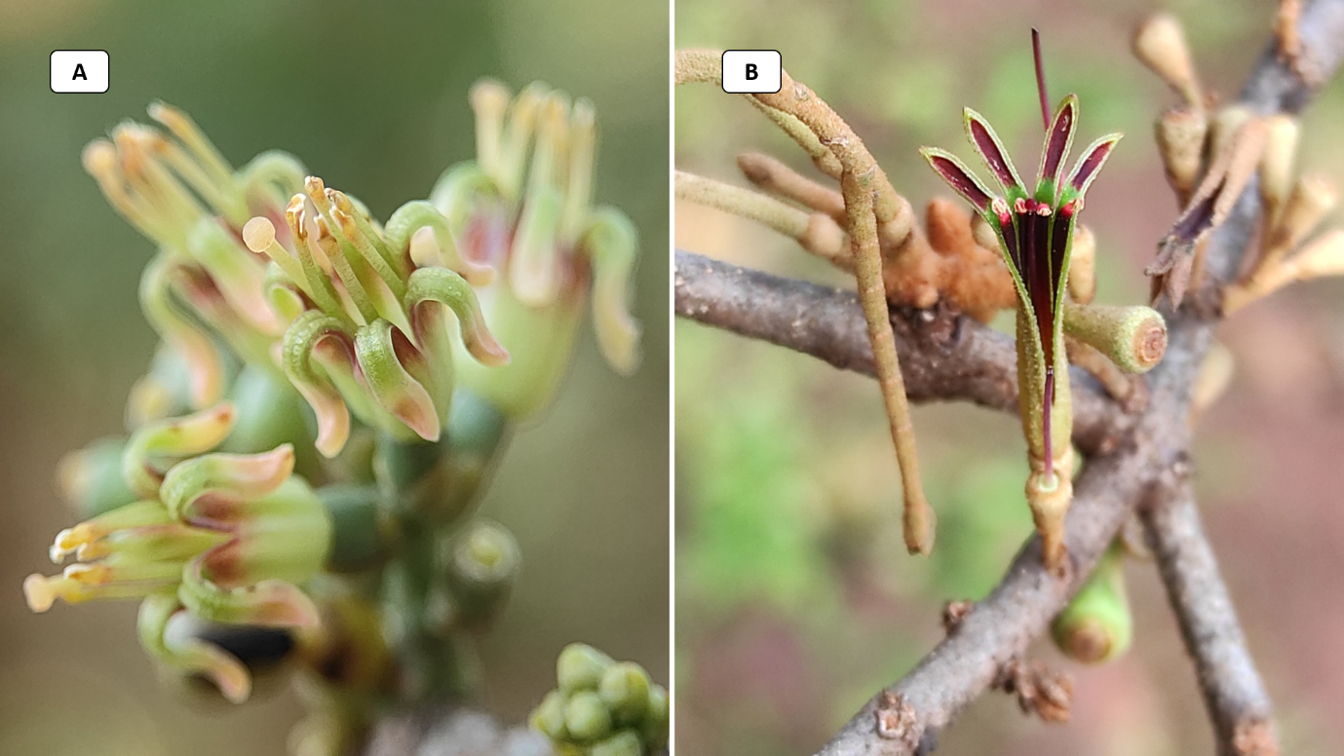
Fig. 1. Parasitic plants of the genus Macrosolen and Scurrula; A) Macrosolen cochinchinensis, B) Scurrula parasitica

Fig. 2. Number of ethnomedicinal uses per parasitic plant species
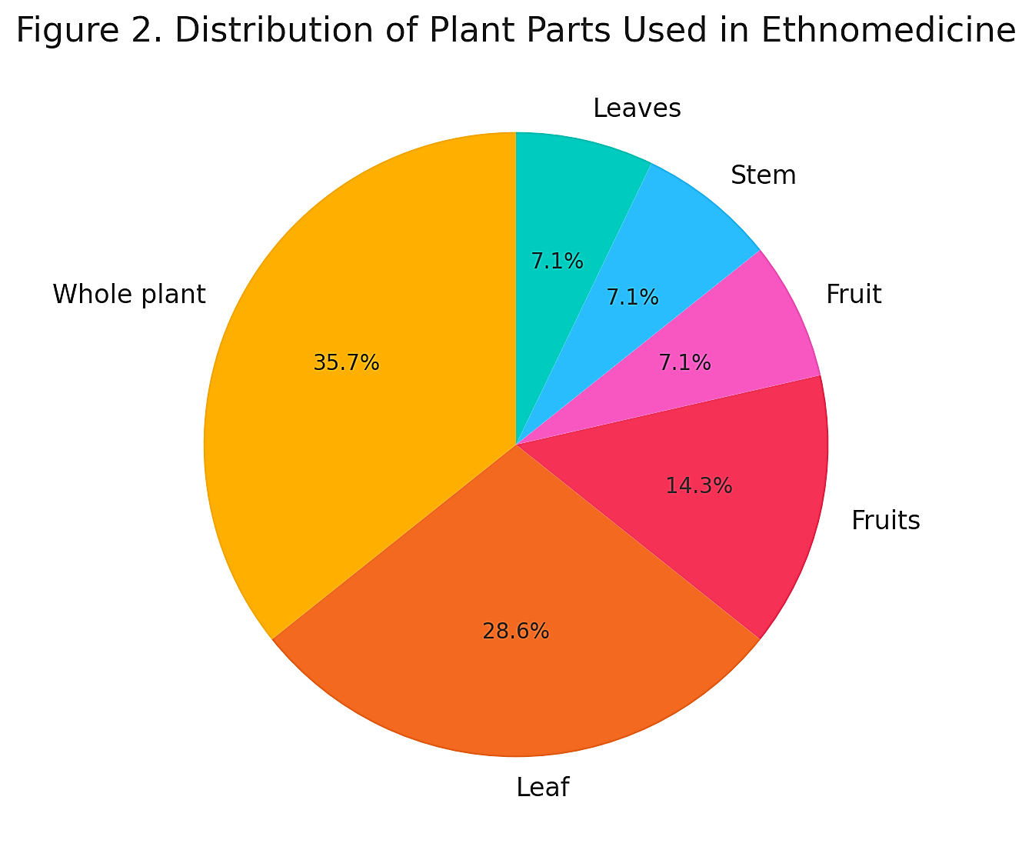
Fig. 3. Distribution of plant parts used

Fig. 4. Ailment category distribution
Table 1: Ethno-medicinal uses of parasitic plants
Plant | Plant parts | Use | Source
Macrosolen cochinchinensis | Leaf | Headache. | Rahman et al., (2012)
Macrosolen cochinchinensis | Leaf | Tighten the uterus after childbirth. | Rahman et al., (2012)
Macrosolen cochinchinensis | Leaf | Jaundice. | Konwar et al., (2025)
Macrosolen cochinchinensis | Leaf | Relaxation effect on vascular smooth muscle. | Nugraha et al., (2020)
Macrosolen cochinchinensis | Fruit | Cough. | Ameer et al., (2009)
Macrosolen cochinchinensis | Stem | Placental expulsion. | Rahman et al., (2012)
Macrosolen globosus | Whole plant | Skin infection. | Present study
Scurrula atropurpurea | Whole plant | Decoction is used for hypertension. | Muhammad et al., (2019)
Scurrula atropurpurea | Whole plant | Infusion is used to cure fatigue. | Muhammad et al., (2019)
Scurrula ferruginea | Leaves | Decoction is used for hypertension. | Ameer et al., (2015)
Scurrula ferruginea | Fruits | Infusion is used in GI complaints and ulcers. | Lim et al., (2016)
Scurrula ferruginea | Fruits | Memory enhancer. | Lim et al., (2016)
Scurrula oortiana | Whole plant | Infusion is used for cancer and fatigue. | Lim et al., (2016)
Scurrula parasitica | Whole plant | Diuretic, tranquillising, and hypotensive activity. | Azyu et al., (2025)

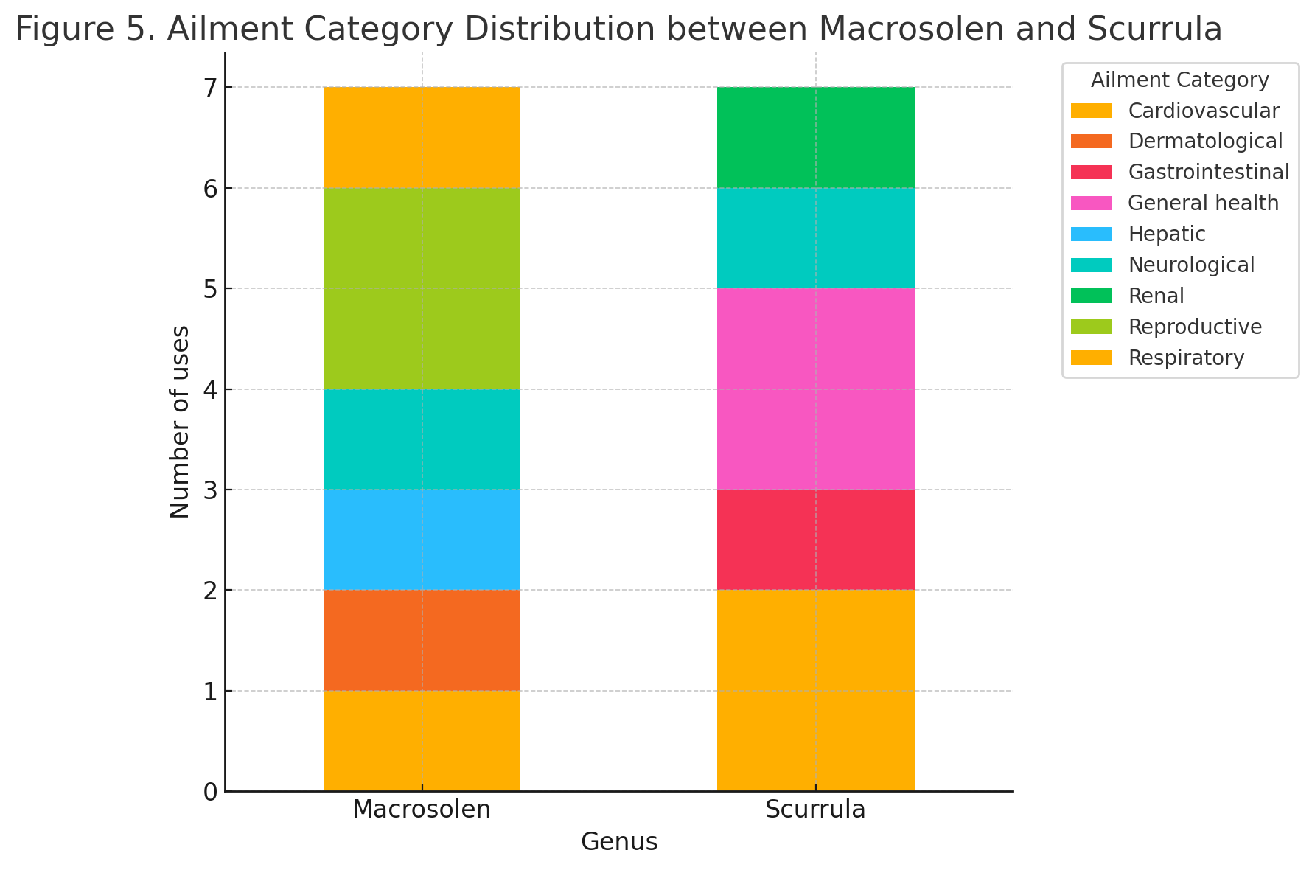
Fig. 5. Stacked bar chart displays ailment-wise comparison

- DISCUSSION
Parasitic plants have long played a notable role in traditional healing systems, yet their ethnomedicinal importance remains largely underappreciated compared to other medicinal taxa. Studies across different geographical regions have documented the therapeutic potential of parasitic species belonging to families such as Loranthaceae, Convolvulaceae, and Santalaceae, which are employed to treat a wide spectrum of human ailments. For instance, Viscum album and V. articulatum are traditionally prescribed for epilepsy, joint pain, hypertension, and rheumatism (Patel and Singh, 2017; Ahmad et al., 2018), while Cuscuta reflexa and Cassytha filiformis are known for treating jaundice, urinary disorders, and promoting hair growth (Saini et al., 2015; Mishra and Rath, 2025). These reports establish parasitic plants as a distinct yet pharmacologically significant group of medicinal flora, valued for their potent bioactive metabolites and therapeutic diversity. Within this broader ethnomedicinal context, the present study provides the first comparative review of two underexplored hemiparasitic genera Macrosolen and Scurrula from the family Loranthaceae. The documentation of 14 ethnomedicinal use reports across six species revealed their applications in treating cardiovascular, neurological, reproductive, hepatic, and dermatological ailments. Among these, Macrosolen cochinchinensis emerged as the most cited species, primarily used in reproductive and hepatic disorders, whereas Scurrula ferruginea, S. atropurpurea, and S. parasitica were predominantly used for cardiovascular and neurological complaints. The predominance of leaf and whole-plant use observed in the present compilation reflects their accessibility and pharmacological richness, an observation consistent with global ethnobotanical patterns noted among other parasitic taxa (Bussmann et al., 2018; Nugraha et al., 2020). The traditional uses of Macrosolen and Scurrula recorded in this study exhibit considerable overlap with other Loranthaceae members documented worldwide. For example, Dendrophthoe falcata and D. pentandra are used to treat menstrual disorders, ulcers, asthma, and skin infections (Patil et al., 2011; Kong et al., 2023), which closely parallels the reproductive and dermatological applications of Macrosolen. Similarly, the reported hypotensive and neurological uses of Scurrula ferruginea and S. atropurpurea correspond with the ethnomedical applications of Viscum album and D. pentandra for hypertension and fatigue (Ahmad et al., 2018; Muhammad et al., 2019). Such similarities indicate that members of Loranthaceae, regardless of genus, possess a shared therapeutic focus on cardiovascular, reproductive, and nervous system disorders, possibly reflecting their comparable phytochemical composition rich in flavonoids, phenolics, and alkaloids. When compared to other parasitic lineages, Macrosolen and Scurrula demonstrate both convergence and specialization in their ethnomedicinal roles. Root parasites such as Cynomorium coccineum and Hydnora abyssinica are valued for their aphrodisiac, astringent, and antidiarrhoeal properties (Patocka and Navratilova, 2020; Mkala et al., 2021), while stem parasites like Cuscuta reflexa and Cassytha filiformis are traditionally used to manage jaundice, rheumatism, and kidney disorders (Saini et al., 2015; Lyngdoh et al., 2023). The uses recorded for Macrosolen and Scurrula similarly encompass reproductive, hepatic, and circulatory systems, suggesting that parasitism itself may contribute to a shared adaptive chemistry that enhances their medicinal value. This cross-taxonomic correspondence underscores that parasitic plants, though diverse in habit and host association, often converge in their ethnomedicinal functions through biochemical mimicry and host-derived metabolite accumulation. Despite their traditional prominence, the scientific investigation of Macrosolen and Scurrula remains in its infancy compared to other medicinal parasites. While Southeast Asian studies have highlighted the anti-hypertensive and anticancer potential of Scurrula ferruginea and S. oortiana (Ameer et al., 2015; Lim et al., 2016), pharmacological and phytochemical validation of Macrosolen species is still limited. The relative scarcity of biochemical studies may stem from their ecological specificity and the limited number of ethnobotanical surveys documenting their uses. The present review, therefore, fills an important gap by consolidating scattered information and emphasizing that Macrosolen and Scurrula are not ethnobotanical anomalies but integral representatives of a pharmacologically potent parasitic lineage. Taken together, the findings of the present and previous works demonstrate that parasitic plants particularly Macrosolen and Scurrula constitute an untapped reservoir of ethnopharmacological potential. Their widespread yet underreported uses for cardiovascular, reproductive, and neurological disorders call for systematic bioassay-guided phytochemical exploration, pharmacognostic standardization, and conservation-driven research. As these taxa are ecologically dependent on specific host species, future efforts must also integrate host–parasite ecological studies to ensure sustainable resource utilization. Bridging traditional knowledge with modern biochemical validation will not only reaffirm the cultural wisdom embedded in indigenous medical systems but also advance the discovery of novel therapeutic compounds from these overlooked parasitic genera.
- CONCLUSION
This review highlights the ethnomedicinal importance of two underexplored parasitic genera, Macrosolen and Scurrula, which possess diverse traditional uses but remain poorly studied scientifically. The findings reveal their application in treating cardiovascular, reproductive, and neurological disorders, with leaves and whole-plant parts being most utilised. Despite their therapeutic promise, both genera suffer from limited pharmacological and phytochemical validation. Future research, focusing on the isolation of bioactive compounds, pharmacological testing, and conservation strategies, is essential to validate traditional claims and promote the sustainable use of these valuable parasitic plants.

DISCLAIMER (ARTIFICIAL INTELLIGENCE)
Author(s) hereby declares that NO generative AI technologies such as ChatGPT, COPILOT, etc, and text-to-image generators have been used during the writing or editing of this manuscript. AI (Grammarly) is used only for checking grammar.
CONSENT
It is not applicable.
ETHICAL APPROVAL
It is not applicable.

COMPETING INTERESTS DISCLAIMER:
Authors have declared that they have no known competing financial interests OR non-financial interests OR personal relationships that could have appeared to influence the work reported in this paper.

REFERENCES
Ahmad S., Mir N.H. & Sultan S.M. (2018). White-berry mistletoe (Viscum album L.): A hemiparasitic plant—Occurrence and ethnobotanical use in Kashmir. Journal of Pharmacognosy and Phytochemistry, 7(1), 1831–1833.
Ameer, O. Z., Salman, I. M., Quek, K. J., & Asmawi, M. Z. (2015). Loranthus ferrugineus: A mistletoe from traditional uses to laboratory bench. Journal of Pharmacology, 18(1), 7–18. https://doi.org/10.3831/KPI.2015.18.001
Azyu, Z. R., Ali Ayub, M., Gali Mohanarao, J., Behera, P., Das, H., Mayengbam, P., & Devi, I. L. (2025). Effect of ethanolic extract of Scurrula parasitica L. on in vivo antioxidant status of diabetic rats. Indian Journal of Animal Research, https://doi.org/10.18805/IJAR.B-5462
Bouwmeester, H., Sinha, N., & Scholes, J. (2021). Parasitic plants: Physiology, development, signaling, and ecosystem interactions. Plant Physiology, 185(4), 1267–1269. https://doi.org/10.1093/plphys/kiab055
Hasan M., Ali M., Khan R., Palit P., Islam A., Seidel V., Akter R. & Nahar L. (2018). Hepatoprotective, antihyperglycemic and antidiabetic effects of Dendrophthoe pentandra leaf extract in rats. Clinical Phytoscience, 4(16). https://doi.org/10.1186/s40816-018-0076-9
Jaiswal, A., Panda, A., Kumar, S. & Mishra, S. (2021). Medicinal parasitic plants of Odisha, In: Medico-Biowealth of India, Volume 3. Ambika Prasad Research Foundation, Odisha, India.
Kong D., Wang L., Niu Y., Cheng L., Sang B., Wang D., Tian J., Zhao W., Liu X., Chen Y., Wang F., Zhou H. & Jia R. (2023). Dendrophthoe falcata (L.f.) Ettingsh. and Dendrophthoe pentandra (L.) Miq.: A review of traditional medical uses, phytochemistry, pharmacology, toxicity, and applications. Frontiers in Pharmacology, 14, 1096379.
Konwar, S., Doimari, R., Gogoi, M., & Gogoi, P. (2025). Ethnomedicinal plants use by the Ahom and Bodo community in human health management in Charaideo district of Upper Assam, North East India. Open Journal of Bioresources. https://doi.org/10.5281/zenodo.14601335
Kumar, S. (2025). Data collection from literature for biological sciences, medicinal plants research, ethnobotany, and pharmacology: a methodological overview. Journal of Biodiversity and Conservation, 9(2), 167-169.
Kwanda, N., Noikotr, K., Sudmoon, R., Tanee, T., & Chaveerach, A. (2013). Medicinal parasitic plants on diverse hosts with their usages and barcodes. Journal of Natural Medicines, 67(3), 438–445. https://doi.org/10.1007/s11418-012-0713-2
Lim, Y. C., Rajabalaya, R., Lee, S. H., Tennakoon, K. U., Le, Q. V., Idris, A., Zulkipli, I. N., Keasberry, N., & David, S. R. (2016). Parasitic mistletoes of the genera Scurrula and Viscum: From bench to bedside. Molecules, 21(8), 1048. https://doi.org/10.3390/molecules21081048
Lyngdoh A., Lyngdoh D., Rakhunde D., Garcha R.B., Prabhavathi K., Mishra S., Rath S.K. & Kumar S. (2023). Parasitic plants of Odisha, India: A source of curative agents against novel viral and microbial diseases. Advances in Zoology and Botany, 11(6), 409–415.
Mishra S, Kumar S & Rath, S.K. (2025). Host plants of Forest Parasitic Angiosperms of Odisha, India: Boon and Bane. Indian Forester, 151 (8), 810‐813.
Mishra S. & Rath S.K. (2025). Analysis of bioactive compounds of selected parasitic plants of Odisha state and validation of their tribal claims. Journal of Biodiversity and Conservation, 9(1), 116–123.
Mishra S., Rath S.K. & Kumar, S. (2023). Parasopubia delphiniifolia: A root parasitic unexplored plant. Journal of Biodiversity and Conservation, 7(3), 1–1.
Mishra S., Kumar S. & Rath S.K. (2025). Host plants of forest parasitic angiosperms of Odisha, India: Boon and bane. Indian Forester, 151(8), 810–813.
Mkala E.M., Mutungi M.M., Mutinda E.S., Oulo M.A., Wanga V.O., Mwachala G. & Hu G.W. (2021). Understanding the ethnobotany, chemistry, pharmacology, and distribution of genus Hydnora (Aristolochiaceae). Plants, 10(3), 494.
Muhammad, K. J., Jamil, S., & Basar, N. (2019). Phytochemical study and biological activities of Scurrula parasitica L. (Loranthaceae) leaves. Journal of Pharmacy Research, 23(3), 522–531.
Nigam Y.P. (2022). The Bornean mistletoes as versatile parasites: A systematic review. Systematic Reviews in Pharmacy, 13(1), 42–47.
Nugraha, A. S., Triatmoko, B., Wangchuk, P., & Keller, P. A. (2020). Vascular epiphytic medicinal plants as sources of therapeutic agents: Their ethnopharmacological uses, chemical composition, and biological activities. Biomolecules, 10(2), 181. https://doi.org/10.3390/biom10020181
Patel B.P. & Singh P.K. (2017). Viscum articulatum Burm. f.: A review on its phytochemistry, pharmacology and traditional uses. Journal of Pharmacy and Pharmacology, 70, 159–177.
Patil S., Anarthe S., Jadhav R. & Surana S. (2011). Evaluation of anti-inflammatory activity and in-vitro antioxidant activity of Indian mistletoe, the hemiparasite Dendrophthoe falcata L. f. (Loranthaceae). Iranian Journal of Pharmaceutical Research, 10(2), 253–259.
Patocka J. & Navratilova Z. (2020). Cynomorium plants: Bioactive compounds and pharmacologic actions. Military Medical Science Letters, 89(2), 90–98.
Pochhi V.U. (2017). Efficacy of phytochemical evaluation of Viscum articulatum Burm. used for animal health care. International Journal of Applied Research, 3(1), 220–221.
Rahman, M. M., Chowdhury, M. A. U., Uddin, M. E., Islam, A. M. T., & Hossain, M. A. (2012). Macrosolen cochinchinensis (Lour.): Anti-nociceptive and antioxidant activity. Asian Pacific Journal of Tropical Biomedicine, 2(1), S203–S207.
Ramezan D., Farrokhzad Y., Zargar M., Stybayev G., Kipshakbayeva G. & Baitelenova A. (2023). An insight into Cuscuta campestris as a medicinal plant: Phytochemical variation of Cuscuta campestris with various host plants. Agriculture, 13(4), 770.
Reza M.S., Jashimuddin M., Ahmed J., Abeer M., Naznin N.E., Jafrin S., Haque M.E., Barek M.A. & Ud Daula A.F.M.S. (2021). Pharmacological investigation of analgesic and antipyretic activities of methanol extract of the whole part of Aeginetia indica. Journal of Ethnopharmacology, 271, 113915.
Saini P., Mithal R. & Menghani E. (2015). A parasitic medicinal plant Cuscuta reflexa: An overview. International Journal of Scientific and Engineering Research, 6(12), 951–959.
Saleh I, Maigandi S.A., Hudu M.I., Abubakar M.I. & Shehu A.U. (2015). Uses and chemical composition of mistletoe obtained from different species of trees. Dutse Journal of Agriculture and Food Security, 2(1), 8–12.
Tripathi S. & Mondal A.K. (2019). Rare ethnomedicinal hemiparasitic plants: Conservation and sustainable use in South West Bengal, India. Global Journal for Research Analysis, 8(3), 41–43.

