Original Research Article

Molecular Authentication and Traceability of Artisanal Palm Oil from Côte d’Ivoire through a Multispectroscopic Approach

Abstract
Aims: To authenticate artisanal palm oil from Yamoussoukro (Côte d’Ivoire) through a quantitative molecular fingerprint generated using a multispectroscopic approach, and to assess its nutritional and technological value.
Study design: Experimental analytical study combining compositional profiling and structural assessment using three complementary spectroscopic techniques.
Place and Duration of Study: Sampling was conducted in rural Yamoussoukro, Côte d’Ivoire, and laboratory analyses were carried out between February and June 2024.
Methodology: Three representative batches of fresh palm bunches (~15 kg each; total 45 kg) were collected, processed and Soxhlet-extracted (50 g dried pulp per run, 12 h extraction, 250 mL hexane). The recovered oil was analyzed by electrospray ionization mass spectrometry (ESI-MS), proton and carbon nuclear magnetic resonance (¹H/¹³C NMR), and Fourier transform infrared spectroscopy (FTIR-ATR). TAG composition, fatty acid distribution, iodine value and functional integrity were quantified.
Results: ESI-MS identified 18 distinct TAG species between m/z 853–939, dominated by PPO (26.62%), POO (22.41%), POS (10.71%) and PPP (7.45%), together representing 67.19% of total TAG signal intensity. ¹H NMR quantified oleic acid at 38.39%, linoleic acid at 8.26%, linolenic acid at 0.51%, and total saturated fatty acids at 52.84% (palmitic/stearic predominance). Unsaturated fatty acids accounted for 47.16%, and the calculated iodine value reached 47.63 g I₂/100 g, indicating intermediate fluidity and good oxidative stability. FTIR spectra showed intense ester C=O absorption at 1745 cm⁻¹, CH₂ elongation at 2922–2853 cm⁻¹, olefinic =C–H band at 3006 cm⁻¹, and minimal trans-signal at 942 cm⁻¹, confirming intact triglyceride structures and low degradation.
Conclusion: The multispectroscopic workflow produced a reproducible molecular fingerprint for Yamoussoukro palm oil, confirming its authenticity and balanced lipid profile. The oil combines high monounsaturated content (>38%), low polyunsaturates (<1%), moderate iodine value (~48), and dominant TAG populations (>67%), supporting its nutritional relevance and technological suitability. This integrated analytical strategy offers a rapid, non-destructive tool for traceability, fraud detection, labeling and premium valorization of artisanal oils.
Keywords: Artisanal palm oil; Côte d’Ivoire; ESI-MS; NMR; FTIR; triacylglycerides; fatty acids; authentication; traceability; valorization.

1. Introduction
Among the most widely consumed vegetable oils in the world, palm oil (Elaeis guineensis) occupies a central position, both for its nutritional qualities and for its technological and industrial applications. It is particularly valued in West Africa, and particularly in Côte d'Ivoire, where small-scale production is still dominant in many rural areas. Red palm oil from the Yamoussoukro region is a perfect illustration of this trend, appreciated for its organoleptic properties, natural oxidative stability and affordability. However, this artisanal production is often confronted with a lack of standardization, making the oils vulnerable to adulteration such as the addition of prohibited colorants (Sudan IV, orange RN) or blending with other oils of inferior quality, thus compromising product safety, traceability and integrity¹⁻².
In this context, precise molecular characterization becomes essential to assess the quality, authenticity and industrial valorization potential of these oils. While conventional chromatographic techniques (GC-MS, HPLC) remain the reference methods for fatty acid and contaminant analysis, they have several limitations: they are costly, require sophisticated equipment and involve complex extraction protocols ill-suited to resource-poor environments³. Conversely, modern spectroscopic techniques such as Fourier transform infrared spectroscopy (FTIR), nuclear magnetic resonance (NMR) and electrospray ionization mass spectrometry (ESI-MS) offer non-destructive, rapid, reliable and more accessible alternatives for the advanced characterization of vegetable oils⁴⁻⁵. FTIR-ATR can identify the characteristic functional groups of triglycerides (C=O, CH₂, C=C) and assess the degree of unsaturation or oxidative alterations. It has established itself as the tool of choice for fraud detection and geographical differentiation of edible oils, particularly when coupled with chemometric models such as principal component analysis (PCA) or partial least squares discriminant analysis (PLS-DA)⁶. NMR, through its 1H and 13C spectra, offers a detailed view of the chemical environment of fatty acids, enabling the relative quantification of oleic, linoleic and linolenic acids, and the distribution of chains within the glycerol skeleton⁴⁻⁷. As for ESI-MS, it enables fine lipidomic profiling, precisely identifying [TAG+Na]⁺ and differentiating species such as PPO, POO, POP or PPP, thus offering a molecular signature specific to the oil's origin and processing method⁸⁻⁹. Recent studies have shown that the lipid composition of palm oils is strongly influenced by geographical, varietal, agroclimatic and technological factors¹⁰. This variability affects not only the relative proportions of saturated and unsaturated fatty acids, but also the triacylglyceride profile, thus influencing the nutritional quality and stability of the oil. However, to date, no study has proposed a cross-characterization FTIR-NMR-ESI-MS of artisanal oils from the Yamoussoukro region, despite the fact that this multispectroscopic approach is an integrated strategy increasingly used for the authentication of high value-added vegetable oils¹⁻⁹.
The present study thus aims to fill this gap by combining FTIR-ATR, NMR and ESI-MS techniques to establish a comprehensive molecular profile of Ivorian artisanal palm oil produced in Yamoussoukro in a robust and innovative way. The aim is twofold: firstly, to assess its physico-chemical and structural characteristics on a molecular scale, and secondly, to propose a robust, reproducible authentication method applicable to the Ivorian artisanal context, with a view to its traceability and sustainable valuation on local and international markets.

2. Materials and methods
2.1. Plant material and sampling site
The plant material used consisted of ripe oil palm (Elaeis guineensis Jacq.) fruit of the tenera variety, a hybrid known for its high oil yields and widely cultivated in southern and central Côte d'Ivoire. Fruits were collected in the village of Djahakro, located in the Yamoussoukro region (central Côte d’Ivoire), within an agroecological ecosystem favorable to oil palm cultivation. The site is of scientific interest because it is poorly documented in previous studies on the chemical quality of ivorian palm oils, even though it represents an active production basin, centered on village systems with low levels of mechanization.
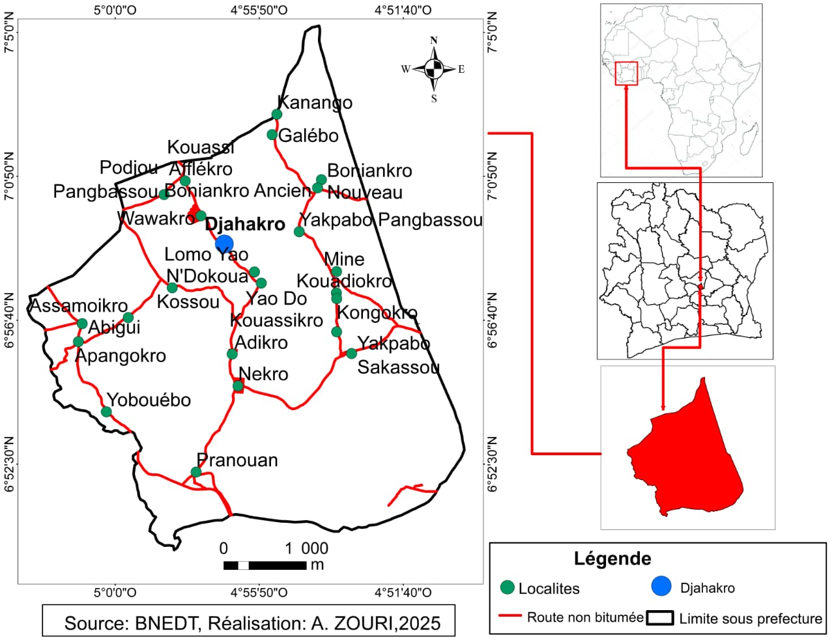
Figure 1: Study area for palm seed harvesting

2.2. Sampling
Sampling was carried out in February 2024, during the dry season, the optimum time for oil palm harvesting, associated with high lipid accumulation in the mesocarp and low humidity, which limits post-harvest microbiological degradation¹¹. Fruits were harvested at physiological maturity, corresponding to phenophase BBCH 805¹², characterized by uniform red-orange coloration of the mesocarp and spontaneous drop of some fruits. The bunches came from palms aged 8 to 12 years, considered to be at their peak lipid yield¹³.
A total of three representative batches of bunches were collected from local growers, amounting to around 45 kg of fresh fruit (15 kg per batch), representing around 10 bunches. After sorting the healthy fruits, they were packed in opaque isothermal bags and transported within less than 24 hours to the Laboratory of Industrial Processes, Synthesis, Environment and New Energies, a process-environmental engineering unit at the Institut National Félix Houphouët BOIGNY in Yamoussoukro. Photographic documentation of the site and cultivation practices ensured traceability of sampling.

2.3 Oil extraction (Soxhlet method)
Oil extraction was carried out in the laboratory on sorted fruit pulp, washed with distilled water and then separated from the pits by hand. The pulp was dried in a ventilated oven at 100°C for 2 hours, then lightly ground using a porcelain mortar.
The oil was extracted using the Soxhlet extraction method, the reference technique for accurate quantification of total lipids. Approximately 50 g of dry matter was placed in a cellulose cartridge, inserted into a Soxhlet extractor connected to a 1 L round flask containing 250 mL hexane (non-polar solvent). The set-up also included a water cooler to ensure cooling and condensation of the solvent.
Extraction lasted 12 hours, with automatic percolation cycles ensuring exhaustive lipid extraction. The vaporized hexane was condensed, dropped onto the sample, loaded with lipids, then siphoned back into the flask. This cycle was repeated until saturation was reached. The extracted oil was recovered by gentle evaporation of the solvent, weighed and then subjected to physico-chemical and chromatographic analysis.
This method was chosen for its ability to maximize oil yields, its analytical reproducibility and its suitability under laboratory conditions for inter-study comparison¹⁴⁻¹⁵. Although it does not reflect traditional village processes, it does enable experimental conditions to be standardized for better scientific comparison.

2.4. Determination of triacylglyceride (TAG) composition by electrospray ionization mass spectrometry (ESI-MS)
The triacylglyceride (TAG) composition of palm oil was analyzed using electrospray ionization mass spectrometry (ESI-MS), a technique recognized for its high sensitivity and ability to profile lipid species in complex matrices. A volume of 20 μL of oil was solubilized in 1 mL toluene, then vortexed vigorously for one minute. Next, a 40 μL aliquot was diluted in 4 mL of a 1% formic acid acidified methanol solution. To promote the formation of sodium adducts [M+Na]⁺ , a second 40 μL portion of a saturated NaCl solution was added, improving the clarity of the spectra.
Injection was carried out directly into the ESI source of an LC-Q-Tof mass spectrometer (Waters Synapt-G2 HDMS), operating in positive ionization mode. Three successive injections per sample were carried out to ensure reproducibility. Operating conditions were as follows: capillary voltage: 2 kV; source temperature: 80°C; cone voltage: 30 V; infusion flow rate: 10 μL/min. Spectra were acquired in the m/z range 100-2000. Data processing was carried out using Waters MassLynx 4.1 software, focusing on the m/z 800-1000 region corresponding to TAGs. Eighteen distinct TAG species were identified. Due to the use of methanol as solvent, both protonated [M+H]⁺ and sodated [M+Na]⁺ adducts were observed. However, their coexistence can affect the reproducibility and accuracy of measurements. One of the major advantages of this technique is its repeatability. Standard deviations of ionic intensities from triplicates remained low, confirming the robustness of the method. In addition, precise mass measurements enabled TAG ions to be effectively discriminated from their isotopes, reducing the risk of misidentification. Fast, sensitive and requiring little preparation, ESI-MS is a reference method for palm oil authentication and quality control.

2.5. Determination of certain chemical compounds in palm oil by NMR
Nuclear magnetic resonance (NMR) is a powerful spectroscopic technique for structural analysis of vegetable oils, characterizing the chemical environments of hydrogen (¹H) and carbon (¹³C) atoms. Fast, non-destructive and requiring no derivatization, NMR is a powerful tool for lipidomic analysis and fine characterization of palm oils. It provides essential information on the lipid composition and nutritional quality of oils. In this study, NMR was used to quantify saturated and unsaturated fatty acids (oleic, linoleic, linolenic), assess the distribution of fatty acid chains in triacylglycerides (TAGs) and estimate the iodine value of samples. Analyses were carried out by dissolving the oil in deuterated chloroform (CDCl₃) at a concentration of between 10 and 15 mg/mL. ¹H and ¹³C NMR spectra were recorded at 400 MHz and 100 MHz respectively on a Bruker AVANCE 300 spectrometer, equipped with a ¹H/BB ATMA probe, a 5 mm holder and a B-ACS 60 automatic changer. Signals were calibrated against residual CDCl₃ peaks (7.26 ppm for ¹H and 77.16 ppm for ¹³C).

2.6. Determination of chemical structure by FT-IR
Fourier transform infrared spectroscopy in ATR mode (FTIR-ATR) was used to identify the functional groups present in the oils analyzed. This rapid, solvent-free method enables a qualitative assessment of the lipid composition, degree of unsaturation and oxidation of the samples. A 2 µL volume of crude oil was deposited directly onto the diamond crystal of the ATR plate. The background spectrum was first recorded dry, followed by the recording of the sample spectrum. Acquisition was performed on a Bruker Tensor 27 spectrophotometer, equipped with a 28,440-point interferogram and a DigiTect™ detector. Each sample was analyzed on 32 scans in the 4000-400 cm-¹ range, with a resolution of 2 cm-¹. Data processing was carried out with OPUS 7.5 software (Bruker Optics).
FTIR analysis revealed the characteristic bands of ester functions, unsaturated fatty acids and methylene groups, confirming the lipid nature of the samples and their state of preservation.

3. Results and discussion
3.1 Characterization by electrospray ionization mass spectrometry (ESI-MS)
Palm oil is a complex lipid mixture, consisting mainly of triacylglycerides (TAGs) formed by esterification of a glycerol backbone with three saturated, unsaturated or mixed fatty acids. Detailed analysis of the TAG profile is essential for assessing the quality, authenticity and traceability of edible oils.

3.1.1. TAG profile of Yamoussoukro palm oil
Positive-mode ESI-MS analysis (ESI⁺) revealed the lipid complexity of artisanal oil produced in Yamoussoukro. The mass spectrum shows that the ions detected correspond mainly to sodium TAGs [TAG+Na]⁺, forming a continuous series of peaks between m/z 853 and 939. This range is characteristic of vegetable oils rich in C16:0 (palmitic acid), C18:1 (oleic acid) and C18:0 (stearic acid)¹⁻⁸.
Analysis of the mass spectrum obtained by ESI-MS in positive mode enabled the identification of eighteen distinct triacylglyceride (TAG) species in artisanal palm oil from Yamoussoukro. Among these compounds, four major TAGs stand out for their relative abundance, reflecting high representativeness in the lipid matrix: PPO (palmitoyl-palmitoyl-oleoyl) at 26.62%, POO (palmitoyl-oleoyl-oleoyl) at 22.41%, POS (palmitoyl-oleoyl-stearoyl) at 10.71%, and PPP (tripalmitin) at 7.45%. This profile is typical of unrefined palm oils, as described in the literature, where oleic (C18:1) and palmitic (C16:0) fatty acids predominate. The lipid signature obtained here therefore reflects a quality profile, rich in monounsaturated fatty acids, which is confirmed by the equivalent carbon number (ECN) distribution, concentrated between 53 and 57 - a range typical of fluid oils with optimal nutritional and technological properties.
Spectrometrically, the dominant ions m/z 853.7255, 855.7407, 857.7483, 877.7255, 879.7416, 881.7567, 883.7695 and 885.7787 appear with marked intensities. These major peaks correspond to molecular formulas compatible with natural TAGs made up of long-chain fatty acids (C16-C18). They were accurately assigned by cross-referencing exact mass, parts per million (ppm) deviation, isotopic goodness of fit (i-FIT), and confidence level (Conf%).
The results of this molecular assignment are summarized in Table 1, which presents the analytical characteristics of the selected ions. This table clearly illustrates the reliability of the identifications thanks to the low mass error and high match values, particularly for the ion at m/z 855.7407, assigned to C₅₃H₁₀₀O₆Na with 96.18% confidence, testifying to the robustness of the analysis.
Table 1. Allocation of peaks of interest in the palm oil mass spectrum
Mass | Calc. Mass | mDa | PPM | DBE | i-FIT | Norm | Conf (%) | Formula
853,7255 | 853,7285 | -3,0 | -3,5 | 7,5 | 46,9 | 1,045 | 35,17 | C₅₅ H₉₇ O₆
 | 853,7261 | -0,6 | -0,7 | 4,5 | 47,0 | 1,097 | 33,39 | C₅₃ H₉₈ O₆ Na
 | 853,7226 | 2,9 | 3,4 | 16,5 | 47,0 | 1,157 | 31,44 | C₆₂ H₉₃ O
855,7407 | 855,7418 | -1,1 | -1,3 | 3,5 | 27,1 | 0,039 | 96,18 | C₅₃ H₁₀₀ O₆ Na
 | 855,7442 | -3,5 | -4,1 | 6,5 | 30,4 | 3,336 | 3,56 | C₅₅ H₉₉ O₆
 | 855,7383 | 2,4 | 2,8 | 15,5 | 33,3 | 6,214 | 0,20 | C₆₂ H₉₅ O
 | 855,7359 | 4,8 | 5,6 | 12,5 | 34,5 | 7,387 | 0,06 | C₆₀ H₉₆ O Na
857,7483 | 857,7515 | -3,2 | -3,7 | 11,5 | 40,6 | 0,617 | 53,96 | C₆₀ H₉₈ O Na
 | 857,7446 | 3,7 | 4,3 | 1,5 | 40,8 | 0,776 | 46,04 | C₅₁ H₁₀₁ O₉
877,7255 | 877,7285 | -3,0 | -3,4 | 9,5 | 50,8 | 0,978 | 37,61 | C₅₇ H₉₇ O₆
 | 877,7261 | -0,6 | -0,7 | 6,5 | 50,8 | 1,046 | 35,14 | C₅₅ H₉₈ O₆ Na
 | 877,7226 | 2,9 | 3,3 | 18,5 | 51,1 | 1,300 | 27,25 | C₆₄ H₉₃ O
879,7416 | 879,7442 | -2,6 | -3,0 | 8,5 | 49,4 | 0,998 | 36,87 | C₅₇ H₉₉ O₆
 | 879,7418 | -0,2 | -0,2 | 5,5 | 49,5 | 1,103 | 33,19 | C₅₅ H₁₀₀ O₆ Na
 | 879,7383 | 3,3 | 3,8 | 17,5 | 49,6 | 1,206 | 29,95 | C₆₄ H₉₅ O
881,7567 | 881,7598 | -3,1 | -3,5 | 7,5 | 44,0 | 1,036 | 35,50 | C₅₇ H₁₀₁ O₆
 | 881,7539 | 2,8 | 3,2 | 16,5 | 44,1 | 1,121 | 32,59 | C₆₄ H₉₇ O
 | 881,7574 | -0,7 | -0,8 | 4,5 | 44,1 | 1,142 | 31,91 | C₅₅ H₁₀₂ O₆ Na
883,7695 | 883,7731 | -3,6 | -4,1 | 3,5 | 35,9 | 0,405 | 66,71 | C₅₅ H₁₀₄ O₆ Na
 | 883,7696 | -0,1 | -0,1 | 15,5 | 37,0 | 1,506 | 22,19 | C₆₄ H₉₉ O
 | 883,7672 | 2,3 | 2,6 | 12,5 | 37,7 | 2,198 | 11,10 | C₆₂ H₁₀₀ O Na
885,7787 | 885,7759 | 2,8 | 3,2 | 1,5 | 39,6 | 0,391 | 67,66 | C₅₃ H₁₀₅ O₉
 | 885,7828 | -4,1 | -4,6 | 11,5 | 40,3 | 1,129 | 32,34 | C₆₂ H₁₀₂ O Na
903,7413 | 903,7442 | -2,9 | -3,2 | 10,5 | 49,7 | 0,954 | 38,53 | C₅₉ H₉₉ O₆
 | 903,7418 | -0,5 | -0,6 | 7,5 | 49,8 | 1,053 | 34,90 | C₅₇ H₁₀₀ O₆ Na
 | 903,7383 | 3,0 | 3,3 | 19,5 | 50,1 | 1,325 | 26,58 | C₆₆ H₉₅ O
905,7570 | 905,7598 | -2,8 | -3,1 | 9,5 | 47,9 | 1,031 | 35,65 | C₅₉ H₁₀₁ O6
 | 905,7574 | -0,4 | -0,4 | 6,5 | 47,9 | 1,082 | 33,88 | C₅₇ H₁₀₂ O₆ Na
 | 905,7539 | 3,1 | 3,4 | 18,5 | 48,0 | 1,189 | 30,47 | C₆₆ H₉₇ O
909,7861 | 909,7887 | -2,6 | -2,9 | 4,5 | 40,7 | 0,820 | 44,03 | C₅₇ H₁₀₆ O₆ Na
 | 909,7852 | 0,9 | 1,0 | 16,5 | 41,0 | 1,145 | 31,83 | C₆₆ H₁₀₁ O
 | 909,7828 | 3,3 | 3,6 | 13,5 | 41,3 | 1,421 | 24,14 | C₆₄ H₁₀₂ O Na
911,8000 | 911,8009 | -0,9 | -1,0 | 15,5 | 42,3 | 0,633 | 53,10 | C₆₆ H₁₀₃ O
 | 911,7985 | 1,5 | 1,6 | 12,5 | 42,9 | 1,237 | 29,03 | C₆₄ H₁₀₄ O Na
 | 911,8044 | -4,4 | -4,8 | 3,5 | 43,4 | 1,722 | 17,87 | C₅₇ H₁₀₈ O₆ Na
913,8102 | 913,8072 | 3,0 | 3,3 | 1,5 | 42,9 | 0,454 | 63,53 | C₅₅ H1₀₉ O₉
 | 913,8141 | -3,9 | -4,3 | 11,5 | 43,4 | 1,009 | 36,47 | C₆₄ H₁₀₆ O Na
939,7137 | 939,7137 | 0,0 | 0,0 | 5,5 | 39,3 | 0,419 | 65,76 | C₅₄ H₉₉ O₁₂
 | 939,7112 | 2,5 | 2,7 | 2,5 | 40,0 | 1,072 | 34,24 | C₅₂ H₁₀₀ O₁₂ Na

The molecular formulas deduced from the mass spectra are characteristic of triacylglycerides (TAGs) formed from various combinations of saturated and unsaturated fatty acids. Among the structures identified are POP (palmitoyl-oleoyl-palmitoyl), PPO (palmitoyl-palmitoyl-oleoyl), POO (palmitoyl-oleoyl-oleoyl) and SPO (stearoyl-palmitoyl-oleoyl). These associations reflect a structural diversity typical of artisanal palm oils produced in West Africa, resulting from variations in fruit maturity, manual extraction conditions and the agroecological characteristics of the terroirs. This observation corroborates the results published by Kouadio¹⁶ and Yusoff⁹, who describe similar TAG profiles in non-industrial oils derived from local processes. Figure 2 below shows the relative percentage distribution of the main TAGs identified in the sample analyzed, based on ion intensity obtained by mass spectrometry. This distribution highlights the dominance of PPO and POO species, confirming the predominantly monounsaturated nature of the lipid matrix of this oil, while at the same time reflecting a strong territorial specificity that can be valorized in a logic of authentication or protected geographical indication.
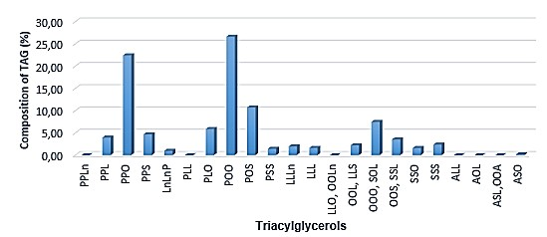
Figure 2. Composition of the TAG profile of extracted palm oil
Data from ESI-MS analysis reveal a predominance of mixed unsaturated triacylglycerides (TAGs), containing at least one unsaturated fatty acid, mainly oleic acid (C18:1). This observation is consistent with previous results obtained by nuclear magnetic resonance (NMR) and gas chromatography coupled with mass spectrometry (GC-MS), which generally report contents of between 35-45% oleic, 35-45% palmitic (C16:0), and lower concentrations of stearic (C18:0) and polyunsaturated fatty acids⁴⁻⁵. This composition gives the oil good oxidative stability, while preserving favorable nutritional properties, notably thanks to the presence of monounsaturates (C18:1). The saturated/unsaturated TAG ratio obtained corroborates the profiles described in other studies on artisanal Ivorian palm oils, which are often rich in PPO, POP and POO¹⁰. The marked abundance of sodium ions [M+Na]⁺, combined with a low isotopic error (i-FIT < 1), guarantees the accuracy of molecular identifications. Many ions have a match rate (Conf%) of over 90%, reinforcing the reliability of assignments and underlining the method's performance in quality control and molecular authentication contexts. This precision is particularly valuable for the traceability of artisanal oils, with a view to combating fraud or promoting local products. Furthermore, the diversity of masses detected, reaching up to m/z 939, testifies to significant structural heterogeneity within TAGs. This variability probably reflects the influence of multiple factors: genetic variety of the oil palm, fruit maturity, fermentation conditions, cooking times and extraction methods¹⁷. Far from being an artifact, this complexity represents on the contrary a potential marker of geographical origin or production method, exploitable in the context of differentiated labeling such as Protected Geographical Indications (PGI), organic farming, or other quality certifications. Finally, the low DBE (double bond equivalent) values found for several ions suggest a low proportion of polyunsaturated fatty acids, which is a typical signature of palm oil compared to other vegetable oils such as sunflower or soybean, as demonstrated in the work of Rahman⁶ and Yusoff⁹.

3.1.2. Regional variability and the influence of local conditions
The lipid composition of palm oils is strongly influenced by agroecological and technological factors, giving artisanal products a regional signature that can potentially be exploited for authentication or commercial differentiation. Major determinants include the genetic variety of the oil palm (notably dura, tenera or pisifera types), the nature of the soil (pH, organic matter richness), climatic conditions (water regime, annual temperature), as well as artisanal processing methods (heat intensity, heating duration, decantation, filtration). Studies carried out in Côte d'Ivoire and Malaysia have highlighted the significant impact of these parameters on the relative proportion of saturated and unsaturated fatty acids, as well as on the distribution of triacylglycerides (TAGs) in the oil obtained. In the specific case of the Yamoussoukro region, limestone-poor ferralitic soils, combined with moderate rainfall and non-standardized manual extraction techniques, often favor partial hydrolysis of TAGs, which may explain the observed prevalence of certain compounds such as PPO (palmitoyl-palmitoyl-oleoyl) in the profiles analyzed. These specific conditions influence the nutritional quality, oxidative stability and technological properties of the oil. While this geographical variability represents a challenge for industrial standardization, it also represents a strategic opportunity in terms of regional value-adding. Indeed, distinctive TAG profiles can serve as markers of origin, paving the way for differentiated labeling such as Protected Geographical Indications (PGI), or for specific industrial applications, for example in the formulation of PPO-rich biolubricants or other high value-added products, adapted to the requirements of sustainable development and the circular economy.

3.1.3. The contribution of ESI-MS to molecular authentication
Electrospray ionization mass spectrometry (ESI-MS) analysis revealed a lipidomic signature characteristic of the artisanal palm oil sample from the Yamoussoukro region. This signature is essentially made up of triacylglycerides (TAGs) incorporating palmitic (C16:0), stearic (C18:0) and oleic (C18:1) fatty acids.
This approach is part of a contemporary drive to enhance the value of local production, where advanced analytical techniques are used to scientifically document regional specificities. ESIMS thus appears as a strategic tool to support labeling processes (such as Protected Geographical Indication - PGI) and quality certifications¹⁻⁷, contributing to the recognition and competitiveness of artisanal oils on national and international markets.
In the case of the sample analyzed, the method enabled rapid and accurate characterization of the TAG profile, revealing a composition that was globally close to that of industrial oils, while highlighting regional specificities. The most abundant TAGs were PPO (26.62%), POO (22.41%), POS (10.71%) and PPP (7.45%), reflecting a predominance of C18:1 and C16:0 fatty acids. This distribution is perfectly consistent with the typical profile of natural palm oils, and constitutes a robust marker of authenticity, useful for distinguishing quality artisanal oils. Compound assignment is based on a combined analysis of exact mass, degree of unsaturation (DBE), theoretical molecular formula, and isotopic adjustment quality. The precision of the measurements obtained, as well as the repeatability of the injections (confirmed by low standard deviations), guarantee excellent analytical reliability, while minimizing spectral interference. Ultimately, the ESI-MS approach proved particularly effective in establishing the TAG profile of this artisanal palm oil from Côte d'Ivoire. It provides a molecular fingerprint that can be used for quality control, traceability, fraud prevention and targeted industrial valorization (formulation, export, territorial valorization, etc.).

3.2 Nuclear magnetic resonance (NMR) characterization
Nuclear magnetic resonance (NMR), and in particular proton NMR spectroscopy (¹H), is a powerful analytical tool for the molecular characterization of vegetable oils, due to its ability to provide precise information on the nature, proportion and structure of the fatty acids present in the lipid matrix⁴⁻⁷. In the case of artisanal palm oil from the Yamoussoukro region, the ¹H NMR spectrum obtained was analyzed to quantify the different types of fatty acids based on the integration of signals representative of their chemical environment. NMR analysis is used to determine fatty acid composition and iodine value. Fatty acid composition is one of the first criteria to be considered when assessing the purity of an oil. The ¹H NMR spectrum of palm oil from the Yamoussoukro area was divided into ten regions, and the relative area of each proton type (%Ai) was calculated according to the equation:
%Ai = (Ai / AT) × 100 where Ai represents the area of the analyzed signal, and AT the total area of protons recorded in the 0 to 10 ppm range of the spectrum.

3.2.1. ¹H NMR profile of fatty acid protons from Yamoussoukro palm oil
The ¹H NMR spectrum of the palm oil analyzed (Figure 3) was divided into ten characteristic zones, corresponding to specific chemical shifts of the protons carried by the -CH₃-, -CH₂-, CH=CH-, -COOH functions or by protons of the glycerol backbone. Chemical shifts (δ ppm) were assigned to terminal methyl, methylene, olefinic, allylic groups, and to protons of glycerol groups (Tables 2 and 3), in agreement with literature data. These signals make it possible to identify the major fatty acids (oleic, linoleic, linolenic, palmitic and stearic) by comparison with reference profiles¹⁸.
Analysis of the relative areas of the signals made it possible to calculate the content of oleic acid (38.39%), linoleic acid (8.26%), linolenic acid (0.51%), and total saturated fatty acids (52.84%). The high prevalence of olefinic protons at δ ≈ 5.35 ppm reflects a good degree of unsaturation, favorable to oil fluidity and oxidative stability.
These values are in perfect agreement with Codex Alimentarius¹⁹ standards for crude palm oil, and concur with observations made in other studies on West African artisanal oils¹⁰⁻¹⁷.
The high level of oleic acid and the measurable presence of linoleic acid reflect a balanced fatty acid profile, combining oxidative stability and nutritional value. The low linolenic acid content (<1%) is also typical of palm oils, unlike other vegetable oils (e.g. linseed, rapeseed), and gives the oil good resistance to thermal oxidation, advantageous for culinary uses¹.
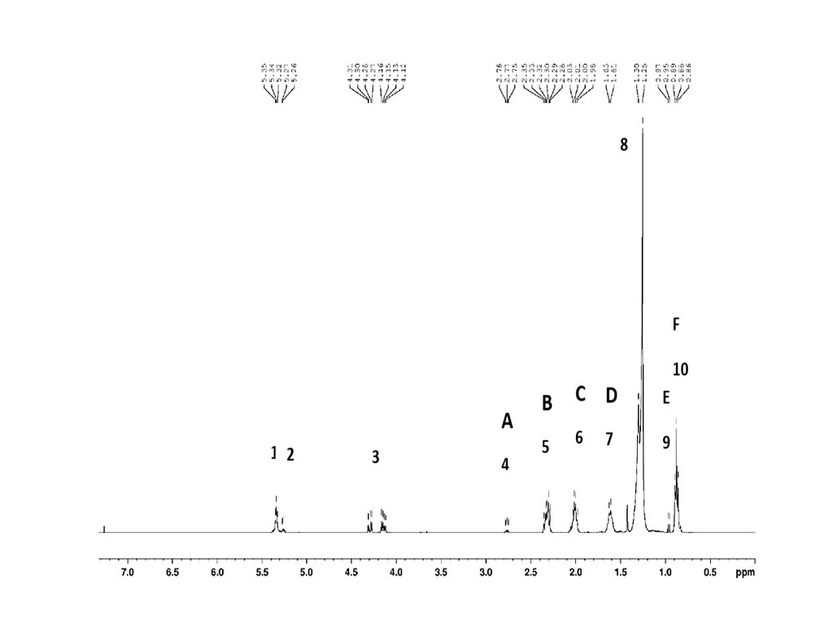
Figure 3. ¹H NMR spectrum of palm oil.

Table 2. ¹H NMR of palm oil.
Signal | δ(ppm) | Protons | Allocations
1 | 5,34 | CH=CH | All unsaturated fatty acids
2 | 5,27 | CH-OCOR | Glycerol (triacylglycerols)
3 | 4,31-4,12 | CH₂-OCOR | Triglycerides
4 (A) | 2,77 | CH=CH-CH₂-CH=CH | Linoleic and linolenic chains
5 (B) | 2,32 | CH₂-COOH | All acyl chains
6 (C) | 2,01 | CH₂-CH=CH | All unsaturated acyl chains
7 (D) | 1,63 | CH₂-CH₂COOH | All acyl chains
8 | 1,3 | (CH₂)_{n} | All acyl chains
9 (E) | 0,97 | CH=CH-CH₂-CH₃ | Linolenic chain
10 (F) | 0,88 | CH₂CH₂CH₂-CH₃ | All acyl chains except linolenic

The chemical shifts corresponding to the protons of the main fatty acids present in palm oil are summarized in Table 3. While this information provides a useful basis for qualitative analysis, it is important to note that signal overlap, particularly in critical spectral regions such as those of glycerols and olefins, often limits the ability to fully resolve individual fatty acid components²⁰⁻²¹.
Table 3: ¹H NMR δ (ppm) of the main acyl chains present in palm oil.
Protons | Chemical shift of acyl chains, δ(ppm)
Protons | Oleic | Linoleic | Linolenic | Palmityl | Stearyl
CH₃ | 0,88 | 0,88 | 0,97 | 0,88 | 0,88
(CH₂)_{n} | 1,3 | 1,3 | 1,3 | 1,3 | 1,3
CH₂CH=CH | 2,01 | 2,01 | 2,01 | …… | ……
CH=CHCH₂CH=CH | …… | 2,77 | 2,77 | …… | ……
CH=CH | 5,34 | 5,34 | 5,34 | …… | ……
CH₂CH₂COOH | 1,63 | 1,63 | 1,63 | 1,63 | 1,63
CH₂COOH | 2,32 | 2,32 | 2,32 | 2,32 | 2,32

3.2.2 Calculation of iodine number and degree of unsaturation
Most of the signals observed in the ¹H NMR spectrum correspond to non-equivalent proton groups, commonly encountered in fatty acid chains²². Consequently, signal intensity analysis can be used to determine the fatty acid composition of oils. Proton NMR spectroscopy is particularly useful for assessing the degree of unsaturation of oils, mainly from the integration of signals from olefinic protons appearing around δ 5.35 ppm.
The signal at δ 0.97 ppm (designated E) is attributed to linolenic acid methyl protons. According to some studies, linolenic acid content can be calculated using the following equation²⁰: [Linolenic] = E / (E + F) (1) where F represents the signal intensity of the methyl protons of all other fatty acids, excluding linolenic acid.
Similarly, the signal at δ 2.77 ppm (denoted by A) corresponds to diallyl protons. From the intensities of signals A, C and F, the contents of linoleic acid, oleic acid and total saturated fatty acids (TSSFA), mainly palmitic acid and stearic acid, can be determined according to the following equations:
[Linoleic] = (3A - 4E) / 2(E + F) (2)
[Oleic] = (3C / 4(E + F)) - ([Linoleic] + [Linolenic]) (3)
[AGST] = F / (E + F) - ([Linoleic] + [Linolenic] + [Oleic]) (4)
The signal from methylene protons (CH₂) denoted B, representing all acyl chains, is related to E and F by the following expression: (E + F) / 3 = B / 2 (5)
Substituting equation (5) into equations (2) and (3), we obtain alternative expressions for calculating linoleic and oleic acid contents:
[Linoleic] = (3A - 4E) / 3B (6)
[Oleic] = C / 2B - ([Linoleic] + [Linolenic]) (7)
The validity of these equations can be verified by evaluating the integral of the olefinic protons signal at δ 5.35 ppm, which reflects the total degree of unsaturation in the oil. This signal is directly related to the fatty acid composition and to the methylene protons of the triglycerides (TG) appearing between δ 4.31-4.12 ppm, according to the following relationship:
[-CH=CH-] = (2[Oleic] + 4[Linoleic] + 6[Linolenic]) / (0.5 × ((E + F)/3 + B/2)) + [TG]/2 (8) It is important to note that equation (2) in this study differs slightly from previous work, in particular from equation (5) in the reference²⁰. In particular, the normalization factor (E + F) is not applied directly to signal A (diallyl protons), and a corrective factor of twothirds is introduced to ensure consistency with linolenic acid methyl protons (E).
Finally, the iodine value (Iv), an indicator of the oil's degree of unsaturation, is calculated using the following equation:
Iv = {([-CH=CH-]/2 - [TG]/2) / ((E + F)/3)} × 86 (9) where [-CH=CH-] and [TG] are deduced from the integrals of the signals at δ 5.35 ppm and δ 4.31 ppm respectively. Constant 86 corresponds to the iodine value of oleic acid.
The calculated fatty acid composition and iodine value of palm oil samples harvested in the Yamoussoukro region are summarized in Table 4.
Table 4. Analytical approach to the fatty acid content of palm oil
Palm oil | Oleic acid | Linoleic acid | Linolenic acid | Saturated free acid | Diode value
Extracted | 38.39 | 8.26 | 0.51 | 52.84 | 47.63
Standards* | 36-44 | 9-12 | < 0.2 | ---- | 30-55
*Codex Alimentarius standards: CODEX CXS -210. Rev 2019
The iodine value (Iv), determined here at 47.63 g I₂/100g oil, reflects a moderate degree of unsaturation, indicating good fluidity at room temperature and chemical stability favorable to preservation. This value is in line with the ranges established for crude palm oil (30-55), and supports the position of this oil in food formulations requiring a compromise between plasticity and stability⁹.
The signal at δ 5.34 ppm, associated with olefinic protons, is a good indicator of the overall degree of unsaturation. The method of integrating the A, B, C, E and F signals, combined with the fatty acid quantification equations (formulae 1 to 9), enabled the relative contents of the different chains to be deduced robustly. These results are in close agreement with previous studies on the composition of Elaeis guineensis oils, confirming the typical fatty acid profile associated with traditional and industrial palm oils.
The presence of appreciable quantities of essential fatty acids, notably linoleic acid and linolenic acid, suggests that this palm oil can make a significant contribution to meeting nutritional requirements, and thus prevent essential fatty acid deficiencies in populations whose diets are predominantly based on lipids of plant origin. The balanced content of saturated and unsaturated fatty acids also gives this oil a favorable lipid profile for culinary and nutritional uses.
Although ¹H NMR spectroscopy provides valuable qualitative and quantitative information on the degree of unsaturation, chain length distribution and general fatty acid profile, the use of ¹³C NMR allows a deeper understanding of lipid structure on a molecular scale. The wider range of chemical shifts and the ability to distinguish positional isomers of fatty acids esterified at the sn-1, sn-2 and sn-3 positions of the glycerol backbone reinforce the analytical power of ¹³C NMR.

3.2.3 Contribution of ¹³C NMR: in-depth molecular structure
To complement the proton analysis, ¹³C NMR spectroscopy was performed (Figure 4), providing a detailed view of the chemical environment of carbon atoms within the oil. Esterified carbons, observed between δ 172-174 ppm, confirm the presence of triacylglycerides (TAGs), while olefinic carbons, located between δ 126-132 ppm, are associated with the double bonds characteristic of unsaturated fatty acids. Aliphatic carbons, detected in the δ 14-35 ppm range, correspond to long chains and terminal methyl groups. ¹³C NMR also highlights the positional distribution of fatty acids on the glycerol backbone, with specific signals at δ 62.1 ppm (sn-1,3 positions) and δ 68.9-65.0 ppm (sn-2 position). This information is particularly useful for differentiating natural oils from modified or partially hydrolysed ones, and is a relevant indicator in the detection of fraud or the evaluation of possible excessive heat treatments⁴⁻⁸.
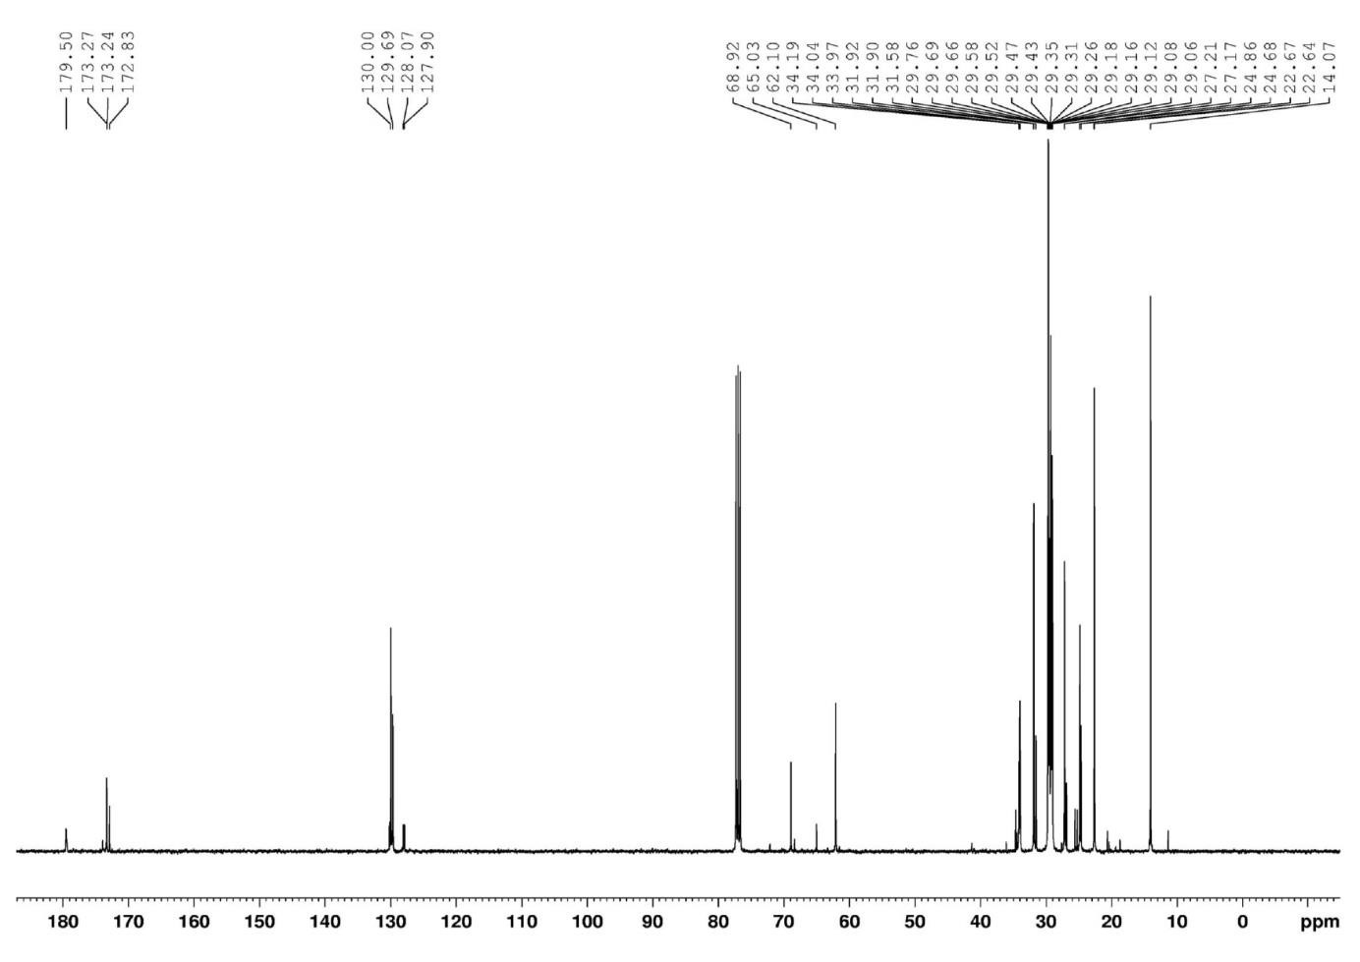
Figure 4. ¹³C NMR spectrum of palm oil.
The chemical shifts observed in the ¹³C NMR spectra of palm oil, free fatty acids and glycerol esters are summarized in Table 5. The interpretation of these spectra is based on fundamental work, as well as more recent research into the structural characterization of lipids²³⁻²⁴.
The main components identified correspond to fatty acids and their glycerol esters, confirming the richness of palm oil in triacylglycerides. Signals characteristic of esterified carbonyl groups (δ 172-174 ppm), olefinic carbons (δ 126-132 ppm) and aliphatic carbons from long hydrocarbon chains were observed, in agreement with profiles reported for natural vegetable oils. Thanks to its ability to discriminate between the different chemical environments of carbon atoms, ¹³C NMR spectroscopy is proving to be a powerful tool for the detailed characterization of lipid compositions, and for distinguishing free fatty acids from glycerol esters. This spectroscopic approach effectively complements conventional chromatographic techniques in the study of edible oils.
Table 5. ¹³C NMR of palm oil
Signal | δ(ppm) | Carbons | Allocations
1 | 179,5 | C1 | Free fatty acids
2 | 173,27-173,24 | C1, sn-1,3 | Triacylglycerols
3 | 172,83 | C1, sn-2 | Triacylglycerols
4 | 130 | C10 | Oleic acid
5 | 129,69 | C9 | Oleic acid
6 | 128,07 | C10 | Linoleic acid
7 | 127,9 | C12 | Linoleic acid
8 | 68,92-65,03 | CHO-,sn-2 | Triacylglycerols
9 | 62,1 | CHO-,sn-1,3 | Triacylglycerols
10 | 34,19 | C2, sn-2 | All acyl chains
11 34,04-33,97 |  | C2, sn-1,3 | All acyl chains
12 31,92-31,58 |  | ω3 | Unsaturated n-6 and n-9 acids
13 29,76-29,06 |  | (CH2) n | All acyl chains
14 27,21 |  | Allylic : C8, C11 | Oleic acid
15 27,17 |  | Allylic: C8, C14 | Linoleic acid
16 24,86-24,68 |  | C3 | All acyl chains
17 22.67-22.64 |  | ω2 | All acyl chains
18 14.07 |  | ω1 (-CH₃) | All acyl chains

3.2.4. Critical discussion and analytical scope
The NMR results obtained in this study confirm the lipid profile typical of Ivorian palm oil: high content of saturated fatty acids (C16:0), marked presence of oleic (C18:1), and low proportion of polyunsaturates. This profile is consistent with those described in international databases, but also shows interesting regional variations, which can be exploited for geographical authentication or labeling⁶⁻¹⁰.
Furthermore, ¹H NMR is proving to be a rapid and reproducible method for oil quality control, even in artisanal contexts, provided that suitable equipment is available. It allows direct evaluation, without prior extraction, thus reducing the risk of compositional modification by organic solvents. The more demanding but more informative ¹³C NMR is the ideal complement to this analytical system.
Finally, the ability to calculate an iodine value directly from NMR spectra, without chemical titration, offers a modern alternative to conventional methods, with both routine and research applications⁷⁻¹⁶.
NMR analysis (¹H and ¹³C) of Yamoussoukro artisanal palm oil has enabled us to accurately characterize its fatty acid composition, degree of unsaturation and triacylglyceride structure. These results confirm that this oil meets international quality standards, while revealing a molecular signature that can be exploited for authentication, traceability and nutritional applications. Complementing the FT-IR and ESI-MS approaches, NMR thus constitutes a fundamental analytical pillar in the multispectroscopic profiling of vegetable oils.

3.3 Characterization by Fourier transform infrared spectroscopy (FT-IR)
Fourier transform infrared spectroscopy (FT-IR) is widely recognized as a rapid, nondestructive and sensitive technique for characterizing vegetable oils, due to its ability to identify specific functional groups associated with the main lipid constituents. In the case of palm oil, this technique can be used to validate the presence of triacylglycerides (TAGs), estimate the degree of unsaturation, and detect any signs of oxidation or hydrolysis⁶⁻⁷.

3.3.1. Spectral analysis of Yamoussoukro palm oil functional groups
This FT-IR spectrum shows the characteristic absorption bands typical of common triglycerides, in excellent agreement with numerous studies²⁵⁻²⁶. Analysis of palm oil from the FT-IR spectrum (Figure 5) is summarized in Table 6, which identifies eight major spectral regions corresponding to key functional groups: =C-H, O-H, -C-H (CH₃), -C-O, -CH₂-, -HC=CH-, as well as other hydroxyl groups (O-H). These results are consistent with literature data, confirming the presence of these functional groups in the palm oil sample²⁷⁻²⁸.
The bands observed correspond to the vibrations expected of typical triglycerides, including the elongation vibrations of -CH₂- and -C-H groups, as well as ester bonds (-C-O-) and unsaturated double bonds (-HC=CH-), as described in recent work²⁵⁻²⁹. These results reinforce the reliability of FT-IR as a tool for characterizing edible oils, particularly palm oil, and confirm previous work in lipid analysis³⁰.
FT-IR is thus a rapid, non-destructive technique for confirming the presence of triglycerides and for preliminary characterization of the fatty acid composition of palm oil and other vegetable oils.

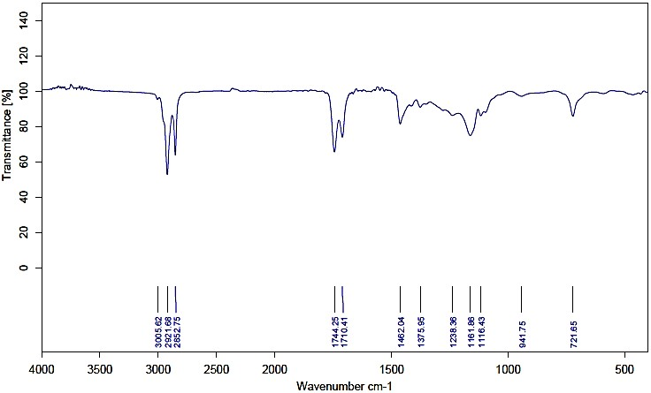

Figure 5. IR-FT spectrum of palm oil extracted from the "Yamoussoukro zone".

Table 6. Allocation of peaks of interest in the IR-FT spectrum of palm oil.
Frequency (cm⁻¹) | Assignment of functional group | Mode of vibration
3006 | =C-H (Cis) | Elongation
2922 | -C-H (CH₂) | Asymmetric elongation
2853 | -C-H (CH₂) | Symmetrical elongation
1745 | -C=O (ester) | Elongation
1711 | -C=O (acid) | Elongation
1462 | -C-H (CH₂) | Deformation (shear)
1450 | -C-H (CH₃) | Asymmetric deformation
1376 | -C-H (CH₃) | Symmetrical deformation
1359 | O-H | Deformation (in plane)
1239 and 1162 | C-O | Elongation
1117 and 1098 | C-O (ester) | Elongation
942 | -HC=CH- (trans) trans-olefin | deformation (Out-of-plane)
722 | Overlap of methylene -(CH₂)_{n}- and -HC=CH- (cis) olefins | deformation (Out-of-plane)
The FT-IR spectrum of the oil extracted at Yamoussoukro (Figure 5) highlights the characteristic bands typical of virgin edible oils, in line with those described for crude palm oil. Analysis of the absorption peaks (Table 6) reveals several key spectral zones: at 3006 cm-¹, the elongation vibration of the =C-H bond in cis configuration signals the presence of unsaturated fatty acids, notably oleic acid (C18:1); at 2922 and 2853 cm-¹, asymmetrical and symmetrical vibrations of the -CH₂- groups of long aliphatic chains indicate the presence of saturated fatty acids such as palmitic and stearic ; at 1745 cm-¹, an intense band associated with the ester bond (C=O) testifies to non-hydrolyzed triglycerides; at 1462 and 1450 cm-¹, deformations of the CH₂- and -CH₃-groups confirm the presence of alkyl chains; at 1239, 1162, 1117 and 1098 cm¹, elongation vibrations of ester C-O bonds reinforce the signature of intact TAGs; finally, at 722 cm-¹, an absorption band due to out-of-plane folding of methylenes -(CH₂)ₙ- and cis double bonds also reflects the presence of unsaturated fatty acids. These results are fully consistent with data reported for unrefined palm oils⁵⁻⁸, confirming the classic lipid structure of the sample. The high intensity of the band at 1745 cm¹ reflects a low level of hydrolysis, a sign of good preservation and controlled artisanal processing, while the moderate presence of a band at 1711 cm-¹, attributed to free carboxylic acids, suggests a certain degree of hydrolysis possibly linked to storage or production conditions. Nevertheless, this profile remains typical of artisanal palm oils, which often have higher levels of free fatty acids (FFA) than refined oils¹⁰⁻¹⁸. The simultaneous identification of olefinic, ester, methylene and hydroxyl groups confirms the presence of long-chain saturated fatty acids (C16:0, C18:0), mono- and polyunsaturated fatty acids (C18:1, C18:2) and undegraded esterified compounds. Furthermore, the low intensity of the band at 942 cm-¹, associated with the trans-out-of-plane deformations of -HC=CH-, is consistent with a predominance of cis configurations in naturally occurring unsaturated fatty acids, differentiating virgin oils from partially hydrogenated oils, which are generally richer in trans configurations⁶⁻¹⁸.

3.3.2 Influence of production conditions on the FTIR spectrum
Recent studies have shown that temperature, extraction mode (mechanical or thermal) and fruit quality influence the spectral bands of palm oils⁵⁻⁹. Excessive heating can lead to broadening or shifting of the C=O band, reflecting the formation of secondary oxidation products (aldehydes, ketones), as well as attenuation of the =C-H band (~3007 cm-¹), indicative of loss of unsaturation. In this study, the spectra obtained show intense, well-resolved unsaturation bands, indicating moderate heat treatment and preservation of essential fatty acids. All the signatures observed confirm the dominant triacylglyceride nature of the sample and the balanced presence of saturated and unsaturated fatty acids⁷, reinforcing the authenticity and lipid profile expected for unrefined crude palm oil from Yamoussoukro. FT-IR is thus a robust tool for characterization, rapid authentication and analytical enhancement of local oils.
FT-IR spectroscopy confirmed the presence of functional groups characteristic of triglycerides in the Yamoussoukro palm oil sample, as well as the structural quality of its fatty acids. These data validate the expected composition of a crude artisanal oil, and provide a solid basis for molecular authentication complementary to ESI-MS and NMR data. By integrating these results with a multi-technique approach, it becomes possible to build a robust, reproducible and exploitable spectral fingerprint for the sustainable valorization of the Ivorian artisanal sector.

3.4. Cross-cutting assessment and originality of the multispectroscopic approach
The cross-sectional approach combining electrospray ionization mass spectrometry (ESI-MS), Fourier transform infrared spectroscopy (FTIR-ATR) and nuclear magnetic resonance (¹H and ¹³C NMR) applied to artisanal palm oil from the Yamoussoukro region represents an original methodological and scientific advance in the African context. Few previous studies have so comprehensively documented the molecular composition of oils derived from traditional processes, particularly in Côte d'Ivoire, where artisanal production represents an essential part of the local market¹⁻². Each analytical technique brings a specific dimension to the understanding of the lipid profile. FTIR-ATR provides a functional fingerprint of the oil, revealing the presence of characteristic groups such as esters (C=O), alkenes (C=C), methylenes and hydroxyls. The spectral bands observed, in particular around 1745, 2922 and 2853 cm-¹, are in agreement with the classical triacylglyceride profiles described in the literature⁵⁻⁶. This rapid, non-destructive and inexpensive method is particularly relevant for preliminary quality analysis or adulteration detection.
Positive-mode ESI-MS mass spectrometry accurately identified the main triacylglycerides (TAGs) in the oil, including PPO, POO, POP and PPP species, dominated by palmitic acid and oleic acid. The mass distribution observed (m/z 853 to 913) reflects the lipid diversity typical of Elaeis guineensis oil palm oils, but also reveals structural variations attributable to agroecological factors specific to the sampling region. This molecular granularity provides a reliable basis for authentication of origin and detection of fraudulent blends, as suggested by Aladedunye⁸ and Yusoff⁹.
¹H NMR, meanwhile, provided robust quantitative data on fatty acid composition. The spectrum reveals a high content of oleic acid (38.39%), followed by linoleic acid (8.26%) and linolenic acid (0.51%), for a total of 47.16% unsaturated. The iodine index, calculated at 47.63 mg I₂/g oil, corroborates this relatively unsaturated profile, consistent with good nutritional and technological potential. These results fall within the range of Codex Alimentarius¹⁹ standards (CODEX CXS 210-2019) and confirm recent observations made by Almeida¹⁸ on crude equatorial oils. ¹³C NMR reinforced these results by highlighting the resonances of esterified carbonyls and alkenes, while offering a fine view of the positional distribution of acyl chains on the glycerol backbone⁴⁻⁷. What sets this study apart from the current literature is the integrated and complementary application of these three techniques to an oil sample derived from a strictly artisanal process, in a region little explored scientifically. Unlike work focused on industrial or refined oils, which are often analyzed solely by chromatography or IR, this multi-instrument approach provides a complete molecular signature, which can be used for traceability, quality certification and protection of local production. It lays the foundations for a standardizable analytical approach for terroir oils, comparable to the efforts made on olive oil in the Mediterranean region³¹. In short, this study proposes an original approach at the crossroads of lipidomics, analytical chemistry and agri-food valorization. It contributes to filling a gap in our knowledge of West African artisanal oils, while offering a practical tool for quality, food safety and marketing policies in a context increasingly focused on sustainable and traceable supply chains. By crossreferencing ESI-MS results with those obtained by NMR and FT-IR, it becomes possible to build an integrated spectral fingerprint enabling molecular authentication, fraud detection (e.g. blending with other oils) and geographical or technological traceability.

4. Conclusion
This study provided an in-depth characterization of artisanal palm oil extracted in the Yamoussoukro region (Côte d'Ivoire), using a crossover approach based on three complementary spectroscopic techniques: electrospray ionization mass spectrometry (ESI-MS), nuclear magnetic resonance (¹H and ¹³C NMR), and Fourier transform infrared spectroscopy (FTIR-ATR). ESI-MS analysis revealed the presence of characteristic triacylglycerides such as PPO (26.62%), POO (22.41%), POS (10.71%) and PPP (7.45%), indicating a balanced lipid composition dominated by oleic acid (C18:1) and palmitic acid (C16:0). The preservation of olefinic and esterified functions indicates a stable, non-oxidized profile, suitable for use in food, cosmetics and energy. These results were confirmed by ¹H NMR, which revealed an oleic acid content of 38.39%, linoleic acid of 8.26%, and linolenic acid of 0.51%, with a total fraction of saturated fatty acids reaching 52.84%. The iodine value, calculated at 47.63 g I₂/100 g oil, indicates intermediate fluidity and a good degree of unsaturation, in line with Codex Alimentarius standards (CXS 210-2019). FTIR-ATR spectroscopy confirmed the presence of functional groups typical of triglycerides (C=O, CH₂, CH=CH), reinforcing the reliability of the results obtained.
The combination of these three approaches made it possible to obtain a complete and reproducible molecular signature of artisanal palm oil, demonstrating the value of this integrated methodology for the authentication, traceability and valorization of oils from local channels. The application of multivariate spectroscopic tools made it possible to clearly differentiate this oil from standard profiles, highlighting the effect of terroir and artisanal process on lipid composition. This methodological synergy represents an original advance in the African context, and particularly in Côte d'Ivoire, where few studies have combined these three techniques to establish reliable molecular fingerprints of edible oils.
The originality of this work lies in the adaptation of cutting-edge methods to a non-standardized artisanal product, helping to fill a scientific and technical gap in the characterization of palm oils produced in a rural context. It opens up concrete prospects for the establishment of regional spectral databases, the development of quality labels (PGI, fair trade) and the integration of local producers into formal value chains. In addition, the favorable composition in essential fatty acids (8.77% PUFA) and oleic acid (>38%) suggests a high nutritional potential, which could contribute to improving lipid security in areas with low dietary diversity.
In conclusion, this study demonstrates that the combination of ESI-MS, NMR and FTIR techniques constitutes a powerful, rapid, non-destructive and accessible analytical strategy for the fine characterization of artisanal oils. It provides a robust scientific basis for the recognition, protection and sustainable development of Ivorian oil production, in line with the objectives of food sovereignty, health safety and local economic development.

References
- Tang, K. H. D., Le, Q. B., & Nguyen, T. T. (2023). Emerging food fraud risks in palm oil supply chains. Trends in Food Science & Technology, 138, 678-688. https://doi.org/10.1016/j.tifs.2023.05.010
- Kpaka, S., Sesay, F., & Tucker, C. (2022). Food fraud in palm oil markets: Implications for public health in West Africa. Journal of Food Quality and Safety, 6(1), 78-88. https://doi.org/10.1093/jfqsafe/fyab066
- Abdulraheem, M. O., Bello, A. A., & Lawal, A. I. (2022). Advances in analytical techniques for edible oil quality assessment. Food Chemistry Advances, 1, 100010. https://doi.org/10.1016/j.focha.2022.100010
- Ares, A. M., Nozal, M. J., & Bernal, J. (2022). NMR spectroscopy in food analysis: Recent advances and future perspectives. TrAC Trends in Analytical Chemistry, 149, 116551. https://doi.org/10.1016/j.trac.2022.116551
- Rahman, M. M., Islam, M. A., Taufiq, M. A., & Karim, R. (2024). Chemometric-assisted FTIR and UV-Vis spectroscopic analysis for rapid detection of adulteration in edible oils. Talanta Open, 9, 100174. https://doi.org/10.1016/j.talo.2024.100174
- Rahman, M. M., Islam, M. A., Taufiq, M. A., & Karim, R. (2024). Chemometric-assisted FTIR and UV-Vis spectroscopic analysis for rapid detection of adulteration in edible oils. Talanta Open, 9, 100174. https://doi.org/10.1016/j.talo.2024.100174
- Haffar, I., Touati, H., & Doukani, K. (2024). Comparative use of FTIR and NMR spectroscopy to assess oxidative degradation in edible oils. Spectrochimica Acta Part A: Molecular and Biomolecular Spectroscopy, 302, 122876. https://doi.org/10.1016/j.saa.2023.122876
- Aladedunye, F., Przybylski, R., & Rudzinska, M. (2023). Electrospray ionization mass spectrometry for in-depth triacylglycerol profiling of palm oils. Journal of the American Oil Chemists' Society, 100(4), 543-556. https://doi.org/10.1002/aocs.12635
- Yusoff, N. A. M., Karim, R., & Rahman, R. A. (2025). Untargeted lipidomics approach to distinguish palm oil origin using ESI-MS fingerprinting. Analytica Chimica Acta, 1273, 341562. https://doi.org/10.1016/j.aca.2024.341562
- Touré, M. F., Kouadio, J. A., Djakpo, A., Koffi, K., & N'Guessan, D. (2022). Physicochemical profile of Ivorian artisanal palm oil according to agroecological zones. Afrique Science, 18(2), 124-136.
- Nanou, E., Bekogianni, M., Stamatoukos, T., & Couris, S. (2025). Detection of adulteration of extra virgin olive oil via Laser-Induced Breakdown Spectroscopy and Ultraviolet-Visible-Near-Infrared Absorption Spectroscopy: A Comparative Study. Foods, 14(2), 321. https://doi.org/10.3390/foods14020321
- Yang, L.-H., Maeng, I., Lee, S., Kim, K., Ji, Y. B., Bark, H. S., Shin, H. J., & Oh, S. J. (2025). Qualitative analysis of edible oil mixture for omega-3 content using terahertz time-domain spectroscopy. npj Science of Food, 9, Article 140. https://doi.org/10.1038/s41538-025-00500-0
- Ozen, B., Cavdaroglu, C., & Tokatli, F. (2024). Trends in authentication of edible oils using vibrational spectroscopic techniques. Analytical Methods, 16, 4216-4233. https://doi.org/10.1039/D4AY00562G
- Tang, F., Banker, T., Green, H. S., Wang, S. C., & Hatzakis, E. (2024). Analysis and authentication of avocado oil by low‐field benchtop NMR spectroscopy and chemometrics. Journal of Food Science, 89(7), 4276-4285. https://doi.org/10.1111/1750-3841.17142
- dos Santos, V. R., Goncalves, V., Deng, P., Ribeiro, A. C., Teigão, M. M., Dias, B., Pinto, I. M., Gallo, J., & Peng, W. K. (2022). Novel time-domain NMR-based traits for rapid, label-free Olive oils profiling. npj Science of Food, 6, Article 59. https://doi.org/10.1038/s41538-022-00173-z
- Kouadio, J. A., Aka, A. E., Djakpo, A., Koffi, K., & N'Guessan, D. (2022). Composition and stability of artisanal palm oils from central Côte d'Ivoire. African Journal of Food Science, 16(4), 101-110. https://doi.org/10.5897/AJFS2022.2190
- Kouassi, A. K., Yao, S. M., Koffi, K., & N'Guessan, D. (2023). Effect of traditional processing on the fatty acid composition of palm oil. Journal of Food Research, 12(3), 1-9. https://doi.org/10.5539/jfr.v12n3p1
- Almeida, S. R., Costa, A. M., & Ferreira, M. J. (2023). 1H and 13C NMR spectral analysis for rapid fatty acid profiling in vegetable oils. Foods, 12(1), 121. https://doi.org/10.3390/foods12010121
- Codex Alimentarius Commission. (2019). Norme sur les huiles végétales portant un nom spécifique – CXS 210-1999 (Révisée en 2019). https://www.fao.org/fao-who-codexalimentarius/sh-proxy/fr/?lnk=1&url=https%253A%252F%252Fworkspace.fao.org%252Fsites%252Fcodex%252FStandards%252FCXS%2520210-1999%252FCXS_210f.pdf
- Knothe, G. (2001). Analytical methods used in the production and fuel quality assessment of biodiesel. Transactions of the ASABE, 44(2), 193-200. https://doi.org/10.13031/2013.4740
- Shi, Hong; Chen, Guo; Zhang, Xia; Zhao, Li. (2019). Recent advances in NMR-based metabolomics for food authenticity detection. Food Chemistry, 277, 676-687. https://doi.org/10.1016/j.foodchem.2018.11.001
- Adriana, Mihaela; Paula, Maria Ana; Ana, Iuliana (2022). NMR Techniques in the Characterization of Edible Oils. Journal of Food Composition and Analysis, 111, 104616. https://doi.org/10.1016/j.jfca.2022.104616
- Mannina, L., Dugo, G., & Segre, A. (2010). NMR as a Powerful Tool for the Characterization of Edible Oils. Analytical and Bioanalytical Chemistry. https://doi.org/10.1007/s00216-009-3251-8
- Gunstone, Frank D. (1993). Structures and Properties of Fatty Acids and Glycerides. Journal of the American Oil Chemists' Society, 70(11), 1067-1075. https://doi.org/10.1007/BF02542737
- Tan, C. P., Chin, Y. A. B., Selamat, J., & Yusoff, M. S. A. (2021). Fourier Transform Infrared Spectroscopy in the detection of edible oil adulteration: a review. Food Analytical Methods, 14(6), 1068-1081. https://doi.org/10.1007/s12161-020-01881-2
- Che Man Yus An Bee, Rohman Abdul (2012). Application of FTIR Spectroscopy Coupled with Chemometrics for Authentication of Fats and Oils. Food Research International, 45(1), 386-394. https://doi.org/10.1016/j.foodres.2011.06.026
- Chaparro, Mariana (2023). Modern Approaches in the Analysis of Triglyceride and Fatty Acid Composition of Edible Oils Using FT-IR Spectroscopy. Food Analytical Methods, 16(6), 12631275. https://doi.org/10.1007/s12161-023-02499-2
- Rohman Abdul (2021). Recent Developments in FT-IR Spectroscopy for the Quality Control of Palm Oil. Journal of Food Quality, Article ID 6635467. https://doi.org/10.1155/2021/6635467
- Sharma, K., Mahato, N., Cho, M. H., & Lee, Y. R. (2022). Application of infrared spectroscopy for food quality analysis. Food Science and Biotechnology, 31(6), 705-720. https://doi.org/10.1007/s10068-022-01054-0
- Bendini, A., Cerretani, L., Carrasco-Pancorbo, A., Gómez-Caravaca, A. M., Segura-Carretero, A., Fernández-Gutiérrez, A., & Lercker, G. (2007). Phenolic molecules in virgin olive oils: a survey of their sensory properties, health effects, antioxidant activity and analytical methods. Molecules, 12(8), 1679-1719. https://doi.org/10.3390/12081679
- Ozen, B., Cavdaroglu, C., & Tokatli, F. (2024). Trends in authentication of edible oils using vibrational spectroscopic techniques. Analytical Methods, 16, 4216-4233. https://doi.org/10.1039/D4AY00562G

