Thermodynamics parameters of Green Corrosion Inhibitor Capacity of African Cherry (Chrysophyllum albidum) seed Extract on Mild steel in Acidic medium

Abstract
Thermodynamics parameters of green corrosion inhibitor capacity of African cherry (Chrysophyllum albidum) seed extraction (ACSE) on mild steel in 2M HCl on varying working temperature using standard analytical procedure and thermodynamics equations were investigated. African cherry seed extract (ACSE) was found to be an effective corrosion inhibition and the efficiency of ACSE increases with rise in temperature. Thermodynamics parameters; ΔH, ΔG, ΔS and the energy of activation (Ea) showed that the free energy of the inhibitor was endothermic and non-spontaneous thereby, protecting the metal steel surface from the environmental heat by minimizing the effect of the mild acid corrosion and the inhibitor was found to be chemisorbed on the metal surface.
Keywords: Thermodynamics, parameters, green, corrosion, inhibitor, African, cherry, extract, mild, steel, acidic, medium
Introduction
The extracts from plant resources contain abundant phytochemicals that possess considerable potential as inexpensive, non-toxic and renewable wide range of green organic chemicals of industrial uses. The yield of these natural products as well as the corrosion inhibition abilities of the plant extracts vary widely depending on the part of the plant and its location (1). The term green inhibitor or eco-friendly inhibitor refers to the substances that have biocompatibility in nature; the inhibitors like plant extracts presumably possess biocompatibility due to their biological origin (2) and green inhibitors pose no detrimental effect on both humans an the nvironment. Apart from being eco-friendly, they are biodegradable, low cost and simple methodologies (3). Most of the metals found in nature are in the form of their compounds except the noble metals such as gold and platinum. This is due to the fact that the metals in their compound state are thermodynamically more stable than their elemental state (4). Most metals exist in the form of oxides and during their extraction into uncoordinated state, a lot of energy is required. The available energy enables them to be reconverted back to their coordinated state when they are exposed to environmental factors such as moisture, oxygen etc. For instance, when iron is exposed to the atmosphere, corrosion takes place and it turns a brown hydrated ferrous oxide (Fe₂O_{3.} x H₂O) which is opposite to metal extraction.
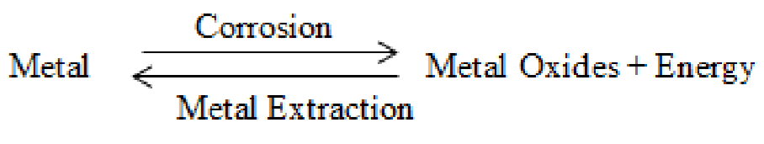
Equation 1. Reversible association between metal extraction and corrosion

Sometimes, corrosion also takes place in essentially clean and unpolluted waters at a temperature of about 130ºC on the product side. This type of corrosion is classical hot spot corrosion (5). Corrosion is a function of temperature, relative humidity and p^{H}. The rate of corrosion increases with the rise in temperature. The rate of corrosion is expected to be almost double for every 10º rise in temperature, provided other biological conditions are kept constant. This increase is usually represented by an exponential curve and any change in temperature also modifies the influence of other factors (6). The rate of corrosion increases sharply above a certain level of relative humidity called critical humidity. The increase in corrosion with relative humidity is as result of the oxide film absorbing moisture thereby creating electrochemical-corrosion reaction on the surface. In addition, the atmospheric moisture may furnish electrolyte and hence, electrochemical reaction is set up. Also, the lower the p^{H} the higher the corrosion. This implies that acidic medium having p^{H} range of 1 to 4 is more aggressive and corrosive than alkaline or neutral medium.
Thermodynamics deals with relationship between various kinds of energy and their diverse manifestations. Levine (7) defined thermodynamics as a macroscopic science that studies the interrelationships of the various equilibrium properties of a system and the changes in equilibrium properties in processes. One of the most fundamental manifestations in nature is the energy changes or inter-conversion associated with all physical and chemical transformations (8). Generally, thermodynamics is also the study of energy transformations accompanying chemical reactions. Thermodynamics parameters include: enthalpy, entropy, work and energy.
The African cherry ((Chrysophyllum albidum)) is from the family Sapotaceae and of the order Ericales, commonly known as African star apple and widely consumed because of its fleshy pulp but the seeds are often discarded (9). In Nigeria, the fruits mature in the month of July as dark green balls and turn yellow or orange as it ripens. The pulp is usually very sweet if the colour of the fruit is yellow and fairly sweet, if the colour is a mixture of green and yellow. Those that have orange colour are most preferred by the rural dwellers. The ripe fruit can be found in the market between December and March. Yearly, a huge amount of the fruit is lost due to deterioration during gathering, transportation and storage (10). There is need to look for more acceptable environmental friendly, ecological and renewable naturally occurring substances as inhibitors (11).
This research work was aimed to evaluate the thermodynamics parameters of Green corrosion capacity of African cherry (Chrysophyllum albidum) seed extract on mild steel in acidic medium.
Materials and Methods
Materials
The materials used for this study include: Mild steel, African cherry (Chrysophyllum albidum) seeds, hydrochloric acid, distilled water, ethanol, talcum powder, thermostat water-bath, vernier-caliper, emery paper, thermometer, 4-digit analytical balance (OPD-E104 model), Whatman filter paper and glassware for classical analysis. All chemical used were of analytical grade.
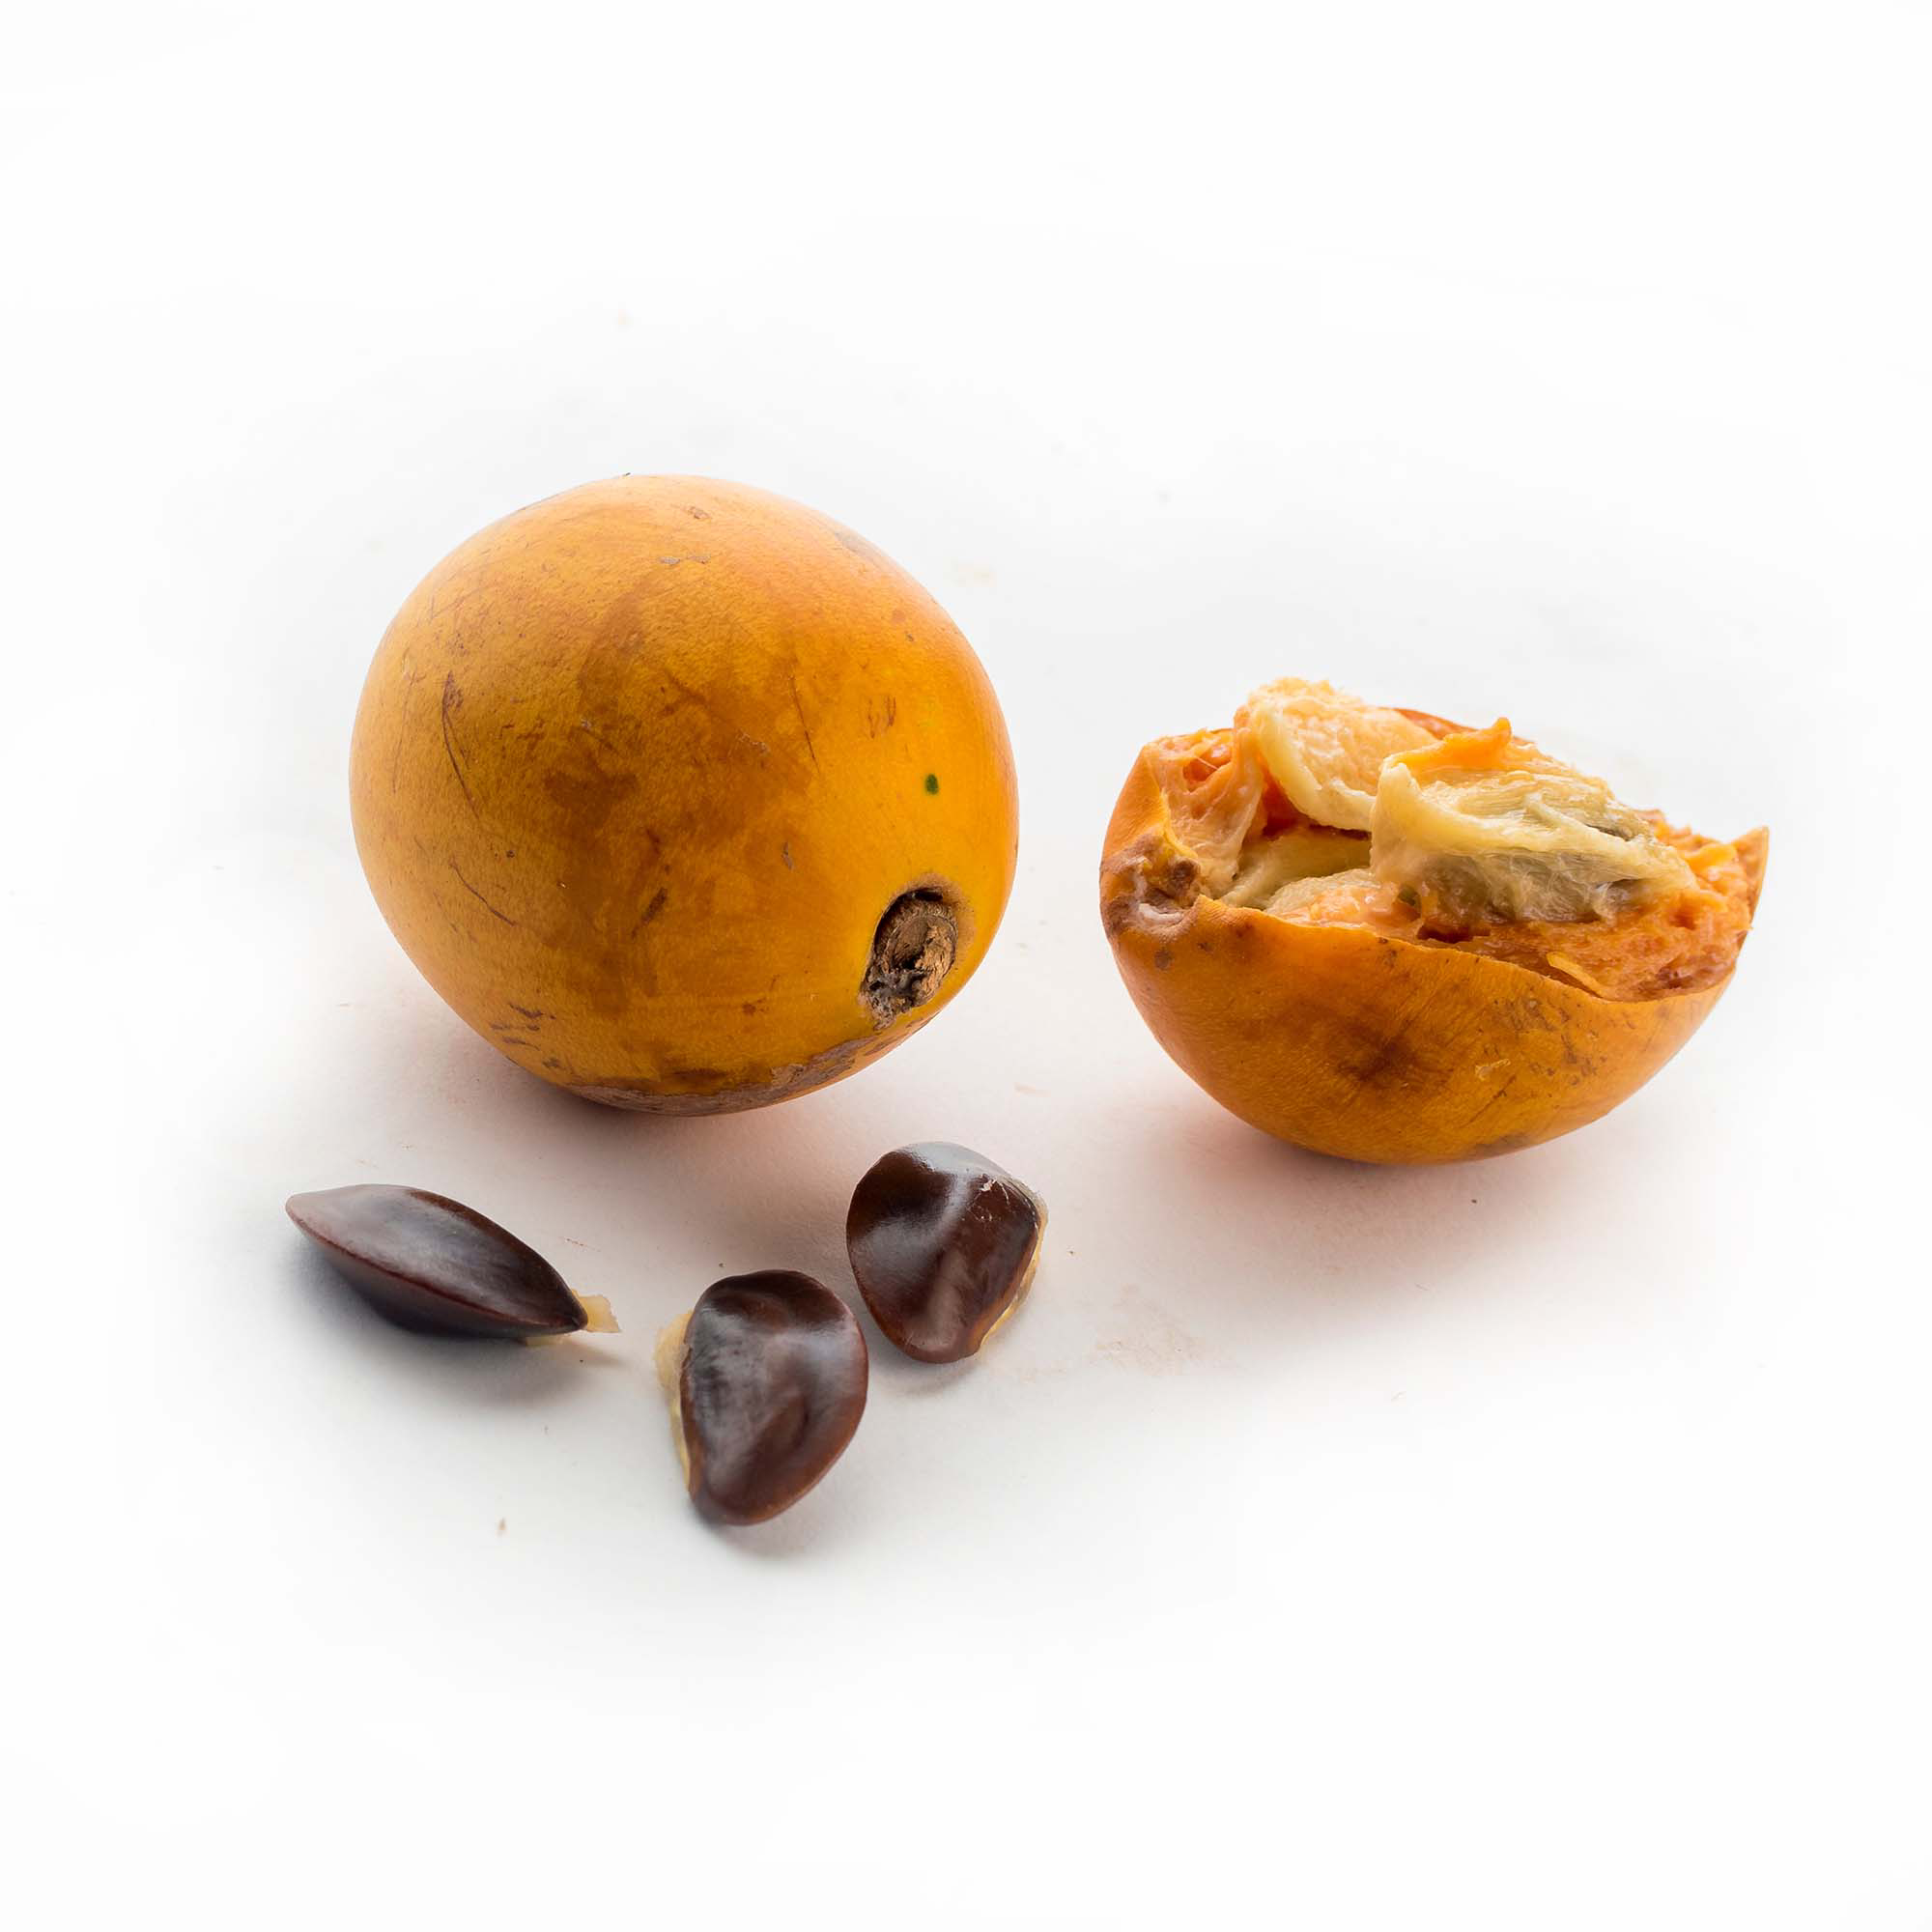
Plate 1: African cherry (Chrysophyllum albidum) fruit and seed
Collection and Preparation of the Specimen
The mild steel specimen used for the experimental work was obtained and pressed cut into coupons of dimensions 18 x 15 x 5 mm at the Department of Material and Metallurgical Engineering, School of Engineering and Engineering Technology, Federal University of Technology Akure, Nigeria. Coupons were abraded with very fine emery paper, rinsed with tap water, dried with handkerchief, further air-dried and temporarily stored in talcum powder to prevent oxidation of the polished surface prior to studies. At the time of the use of the metals for corrosion studies, each one was washed thoroughly with distilled water, degreased with ethanol and air-dried. The weight of each metal sample before (W₁) and after immersion into the acid medium (W₂) was taken using 4-digit OPD-E104 analytical balance. Also, the length, breadth and height of each coupon were measured using digital Vanier caliper (0-150mm).
The weight of the metal sheet after experimental period is given as:
ΔW=W₁-W₂ Equation 2
Where W₁ and W₂ are the weights of the metal sample before and after exposure to the corrosive solution in the absence and presence of the plant extract.
Collection and Preparation of the Seed Extract
The African cherry seeds (Chrysophyllum albidum) used for this research were purchased from the Oba Adesida Central market in Akure, Nigeria.
The African cherry seeds were cracked and the fleshy inner part of the seed pulp air-dried to constant weight. After the complete drying, the seeds were ground into fine powder by an electrical blender in order to facilitate maximum effective contact of the solvent. The pulverized sample was sieved with a sieve 1 mm of moderate mesh size and later stored in a clean, dry and sealed container for the chemical analyses. Ethanol extracts of the powdered sample was obtained by soaking 500 g of the sample in 2.5 litres of 98% ethanol in an air tight, clean flat bottomed container for 6 days at room temperature with occasional stirring and shaking (12). The extract was then filtered first through a mesh (850 micron meter sieve) and finally with Whatman no. 4 filter paper. The filtrate was further subjected to evaporation over a water-bath set at 78°C to remove the ethanol. The crude extract obtained was used to prepare different concentrations ranging from 0.1 to 0.5 g/mL for the experiment.
Temperature variation studies
The effect of temperature on the corrosion rate of the steel coupons in a 100 mL 2 M HCI solution at 308, 318, 328 and 338 K was also studied with the same concentration of the extract for immersion periods of 3 hours in a thermostated water bath (13). The pre-weighed coupons were immersed in blank solution and varied concentrations of the inhibitor and after 3 hours, the steel coupons were retrieved, washed with distilled water and ethanol, dried at room temperature and re-weighed. The results obtained were used to estimate thermodynamics parameters from the following equations (7):
Arrhenius equation expressed as reported by Levine (7)
Log C_{R} = $\frac{-Ea}{2.303RT }$ + Log A Equation 3
Where C_{R} is the corrosion rate, Ea is the activation energy, R is the molar gas constant, T is the absolute temperature (in Kelvin) and A is the Arrhenius constant/pre-exponential factor/frequency factor.
The logarithm of corrosion rate obtained by weight loss measurement was plot against 1/T to obtain a straight line graph, where A, Ea and C_{R} were deduced as described by Sharma and Sharma (7).
The other thermodynamics parameters were obtained using an expanded modified generalized Arrhenius equation:
Log $\frac{CR}{T}$ = Log $\frac{R}{Nh}$ + $\frac{∆S}{2.303R}$ - $\frac{∆H}{N2.303R}$ x $\frac{1}{T}$ Equation 4
Where h is the plank's constant, N is the Avogadro's number, T is the absolute temperature, R is the universal gas constant (8.314 J/Mol/K), ΔS is the entropy of activation and ΔH is the enthalpy of activation. The logarithm of CR/T was plotted against the reciprocal of T (1/T) to give a straight line graph with slope of (-ΔH/2.303R) and an intercept ((Log (R/Nh) + ΔSº/2.303R)), when extrapolated to y-axis.
The Gibb’s Free Energy (ΔG) which is a state function also determined using equation 5 expressed as:
ΔG = ΔH – TΔS Equation 5
Where ΔG is the Free energy, ΔS is the entropy of activation and ΔH is the enthalpy of activation. The value of Free energy (ΔG) was calculated at the room temperature.
The electrode potential was obtained using equations 6 and 7 as follows:
ΔG = -nFE Equation 6
E = -ΔG/nF Equation 7
Where, ΔG is the free energy, n is the number of moles of electron transferred, F is the Faraday’s constant (1 F = 96500 Coulombs) and E is the electrode potential of the surface.

Results and Discussion
Thermodynamics Studies
Thermodynamics parameters are important to further elucidate the adsorption process of inhibitor on metal/solution interface (14). The adsorption of organic compounds can be described by two main types of interactions: physisorption and chemisorption. They are influenced by the nature of the charge on the metal, the chemical structure of the inhibitor, pH, the type of the electrolyte and temperature. Therefore, in order to asses the inhibitive properties of the inhibitor (African cherry seed extract) and the temperature dependence on the corrosion rate, the apparent activation energy (Ea) for the corrosion process in the absence and presence of the inhibitor was evaluated from Arrhenius equation (15).
Estimation of Activation Energy (Ea)
Based on the Arrhenius equation, the natural logarithm of the corrosion rate (log C_{R}) is a linear function with the reciprocal of temperature (1/T) for the acid corrosion of steel. A plot of logarithm of corrosion rate obtained by weight loss measurement versus 1/T gave a straight line graph as shown in Figure 1 with a slope of -Ea/2.303R. Thermodynamics parameter such as the apparent activation energy (Ea) was calculated using the equation 3; Log C_{R} = $\frac{-Ea}{2.303RT }$ + Log A. Where C_{R} is the corrosion rate, Ea is the apparent activation energy, R is the molar gas constant, T is the absolute temperature (in Kelvin) and A is the Arrhenius/pre-exponential/frequency factor. The values of activation energy were obtained from the slope of the linear plots and are reported in Table 1. It is observed that Ea values in the presence of different concentrations of the extracts are lower than that obtained in their absence. It has been reported that decrease in activation energy value in the presence of inhibitor as observed in this study is an indication of chemical adsorption (chemisorption) mechanism while the increase in the Ea in the presence of inhibitor indicates physical adsorption (physisorption) mechanism (16). In addition, Dehri and Ozean (17) reported that, inhibitors whose percentage inhibition efficiency increases with increase in temperature, the activation energy values of the inhibited solution is usually found to be lesser than that of the uninhibited solution and this is associated with chemisorption. Ea is the estimation of the energy that must be surmounted before products are formed. The decrease in enthalpy when the inhibitor was added suggested that the inhibitor had lowered the activated complex of the corrosion reaction pathway thereby, resulting in inhibition. In general, there was a shift in equilibrium towards the right (product) side, thereby, favoring forward reaction, the formation of Metal-Inhibitor complex on the metal surface (Equation 8) as follows:
Metal + Inhibitor $↔$ (Metal-Inhibitor)_{Ads} Complex 8
Metals have been found to form complex with inhibitors (18). The percentage inhibition efficiency decrease with increase in temperature, and the value of activation energy is found to be higher in the presence of an inhibitor than its value in an uninhibited solution, it is associated with physisorption. Chemical adsorption is specific and involves forces much stronger than physical adsorption. So the activation energy for chemical adsorption is of the same magnitude as the heat of the chemical reactions which indicates that the corrosion rate varies with temperature according to the activation energy (Ea) (100 - 150 kJ/mol) in the Arrhenius equation (19), while equilibrium is usually rapidly attained and easily reversible in physical adsorption, because the energy requirement is small (usually not more than 20 kJ/mol) because the Vander Waal forces involved are weak. In this study, a chemical adsorption mechanism is proposed due to the Ea values that ranged between 100 and 150 kJ/Mol or < 200KJ/Mol. The present result corroborates the report of increase in inhibition efficiency with increase in temperature as the inhibitor was applied on the metal surface (20).

Figure 1: Arrhenius plots of log C_{R} versus 1/T in the absence and presence of different concentrations of African cherry seed extract in 2 M HCI
Table 1: Values of thermodynamic parameters (entropy, enthalpy and activation energy) for mild steel dissolution process in 2 M HCI in the absence and presence of African cherry seed extract.
Conc. (g/L) | ∆H (kJ/Mol) | ∆S (kJ/Mol) | ΔG (KJ/Mol) | Ea (kJ/Mol)
Blank | 0.4666 | -77.1580 | 22945 | 130.1776
0.2 | 0.4785 | -77.1849 | 23000 | 127.5142
0.4 | 0.4579 | -77.2500 | 23020 | 120.6270
0.6 | 0.4687 | -77.2270 | 23013 | 123.1238
0.8 | 0.4579 | -77.2634 | 23024 | 119.4437
1.0 | 0.4699 | -77.2289 | 23014 | 122.9400

Estimation of Enthalpy (ΔH) and Entropy (ΔS)
Other thermodynamic parameters such as change in enthalpy (ΔH) and entropy (ΔS) of the activation process were evaluated from the effect of temperature on the corrosion rate of mild steel in 2 M HCl using the equation 4; Log $\frac{CR}{T}$ = Log $\frac{R}{Nh}$ + $\frac{∆S}{2.303R}$ - $\frac{∆H}{N2.303R}$ x $\frac{1}{T}$
Where h is the planck's constant, N is the Avogadro's number, T is the absolute temperature, R is the universal gas constant, ΔS is the entropy of activation and ΔH is the enthalpy of activation. A plot of log C_{R}/T versus 1/T (Figure 2) gave a straight line with slope of (-ΔH/2.303R) and an intercept ((Log (R/Nh) + ΔSº/2.303R)). The result presented in Table 1 shows that the enthalpy of activation are all positive. These positive signs of enthalpy ΔH reflected the endothermic nature of the steel dissolution process. Also, entropy values are negative indicating that the activation complex in the rate-determining step represents an association rather than dissociation step. This finding was in congruent with some reports (21, 22). However, enthalpy change is an energy interaction with the environment where the reaction takes Place. An exothermic reaction emits heat; therefore, the final energy state is lower than initial Energy State to give a negative enthalpy change. On the other hand, an endothermic reaction absorbs heat and its final energy state becomes greater than the initial energy state to give a positive enthalpy. A positive value of ΔH obtained in this study is an indication that the adsorption of African cherry seed on mild steel is endothermic. An input of energy is required to bring about the bond formation because the bonding is short and as a result, energy is needed to overcome the repulsive force of attraction as this inhibitor bind to the metal surface. An external source of heat energy is needed for the endothermic reaction to occur. High temperature favors an endothermic reaction and it is deduced that chemisorption occurs due to the formation of stronger bonds which remain bonded at high temperature (23).

Figure 2: Eyring transition state plot for mild steel in 2 M HCI in the absence (Blank) and presence of ethanol extract of African cherry seed.
The values of ΔS in the absence and presence of the tested inhibitor which were negative implies that, a decrease in disordering has taken place on going from reactants to the activated complex (24). Moreover, the negativity of the entropy means that the process of adsorption is accompanied by a decrease in entropy, which might be that before the adsorption of inhibitor onto the steel surface, the chaotic degree was high but when inhibitor molecules were orderly adsorbed onto the steel surface, as a result, a decrease in entropy (25). Also, a positive ΔS value confirms the increased randomness. In this study, inhibition in acidic medium takes place as a result of increase in extract's orderliness which allowed proper adsorption of the inhibitor. However, entropy is an indication of the system degree of freedom and the reversibility of the system. For a system communicating to an external heat sources, entropy must increase or remain the same. As the entropy increases, the uniformity of the system is improved and therefore the process occurs spontaneously
The Free Energy which is a state function also estimated using Gibb’s equation 5; ΔG = ΔH – TΔS. Free energy is a state functions that is very central to thermodynamics, it has been observed that absolute free energy can be estimated from three different experimental methods, they are: through calorimetric calculation of ΔH and ΔS for the reactants and products using equation 4 and then via the electromotive cell as well as through equilibrium constant (26). In the present work, we used equation 5. The thermodynamics functionality of the free energy can not be overemphasized because it signaling the state of corrosion reaction whether exothermicity, endothermicity and equilibrium. It is also a pointer to whether a reaction will proceed or feasible or not. It is worth noting that if the value of the free energy ΔG of a corrosion reaction is negative , the reaction would be feasible and spontaneous, likewise positive ΔG indicates non feasible and non spontaneous hence, endothermic process but if ΔG is equal to zero, then it is a case of equilibrium process. The inhibitor caused scarcity or deficiency of electron population on the surface thereby, reducing corrosion on the metal surface. The present results reveal that the value of ΔG for the corrosion reaction was generally positive and non spontaneous. The positive value of ΔG obtained indicated that the adsorption of the African cherry seed extract was endothermic in nature. This observation corroborates that reported for the enthalpy. Endothermicity nature of African cherry seed extract suggests that it may have the capacity to retard heat from the environment thereby, protecting the metal steel surface from the environmental heat by annihilating and minimizing the effect of the mild acidic corrosion on the steel.
The electrode potential was estimated using equations 6 and 7 (E = -ΔG/nF). Where, ΔG is the free energy, n is the number of moles of electron transferred, F is the Faraday’s constant and E is the electrode potential of the surface. The positive value of the electrode potential was calculated using equation 7. Electrode potential is the ability of the metal surface to knock out electrons. The higher (positive) value obtained in the current research, precludes that the African cherry seed extract has tendency not to inhibit the metal surface to form metal ions and hence, inhibit corrosion on the surface. It has been discovered that the more negative the electrode potential, the greater the tendency to form metal ions and then corrode.

Conclusion:
It can be concluded that African cherry (Chrysophyllum albidum) seed extract contained viable thermodynamic parameters that have good capacity to mitigate the corrosion on the surface of a metal steel. Both the change in enthalpy and free energy were positive which indicated endothermic adsorption process. With this quality, it could retard maximally the environmental heat thereby, preventing heat from percolating the metal surface. Also, African cherry seed extract has high activation energy and thus capable of lowering the activation complex of the corrosion reaction profile on the metal surface. The equilibrium shift to the right (M-Inhibitor) complex corroborates it potential for efficient inhibition.

References
(1) Awe, F. E., Idris, S. O., Adulwahab, M. and Oguzie, E. E. (2015). Inhibitive and adsorptive effect of Parinari polyyandra on mild steel corrosion in sulphuric acid. Afri. J. Pure Appl. Chem., 9(6) 125-134. https://doi.org/10.5897/AJPAC2015.0630
(2) Gonzalez-Rodriguez J. G., Gutierrez-Granda D. G., Larios-galvez A. K. & Lopez-sesenes R. (2022). Use of Thymus vulgaris extract as green corrosion inhibitor for bronze in acid rain. Journal of Bio- and Tribo-Corrosion. 8:77. https://link.springer.com/article/10.1007/s40735-022-00676-y
(3) Nkuzinna, O. O., Menkiti, M. O. and Onukwuli, O. D. (2011). Inhibition of copper corrosion by Gnetum africana and Musa acuminate peel in acidic media. Int. J. Multidisciplinary Sci. and Eng. 2(5) 125-134. https://www.scirp.org/reference/referencespapers?referenceid=1191656
(4) Vedavyasan, c. v. (2013). Corrosion In: Drioli E., Giorno, L. (eds). Encylopedia of membranes. Springer, Berlin, Heldelberg. https://link.springer.com/rwe/10.1007/978-3-642-40872-4_785-3

(5) Nwogbu, C.C., Udeh, U.O. and Nwogbu, P. I. (2025). Comparative study of corrosion of low carbon steel of environmental effect using TAFEL extrapolation and electrochemical mechanisms. Global Sci. J. 13(1), 1-44. https://www.globalscientificjournal.com/researchpaper/COMPARATIVE_STUDY_OF_ENIRONMENTAL_EFFECT_OF_CORROSION_OF_LOW_CARBON_STEEL_USING_TAFEL_EXTRAPOLATION_AND_ELECTROCHEMICAL_MECHANISMS.pdf
(6) Decarie, E.L and Geider, R. J. (2017). Predictions of response to temperature are contigent on model choice and data quality. Ecol. Evol. 7(23), 10467-10481. https://doi.org/10.1002/ece3.3576
(7) Levine, Iran N. (2009). Physical chemistry, 6th Int. edition, Lond, Pp 1-989. https://www.scirp.org/reference/referencespapers?referenceid=1387951
(8) Sharma, K.K. and Sharma, L.K (2009). A textbook of physical chemistry 4th edition, Vikas pub. Ltd.New Delhi, India, 856
(9). Adisa, S. S., Garba, SA., Iyagbo, O. A. and Iyamo, A. O. (2000). Vitamin C, protein and mineral contents of Africcan star apple, 18th Aannual conference of Nig. Inst. Lab. Tech., Ibadan, PpP 141-146. https://www.scirp.org/reference/referencespapers?referenceid=2269779
(10) Adekambi, D. G. and Olowofoyeku, A. E. (2020). African star apple: potential and application of indigenous spices in Nigeria, J Appl. Sci. Environ. Manage. 24(8) 1307-1314. https://doi.org/10.4314/jasem.v24i8.1
(11) Adeyemi, O. O. and Ukwu, Q. U. (2016). Investigation of Allium cepa extract as corrosion inhibitor for commercial copper in acid medium. Afri. J. Sci. Nature, vol , 17-26. https://doi.org/10.46881/ajsn.v3i0.47
(12) Abdul-Muhit M., Syed M. T., Apurba S. A., Debasish B. and Mohammed S. I. (2010): Isolation and identification of compounds from the leaf extract of Dillenia india Linn. Bang. Pharma. J. 13 (1):0301-4606. https://www.researchgate.net/publication/283986300_Isolation_and_Identification_of_compounds_from_the_leaf_extract_of_Dillenia_Indica_Linn/link/5652d8ac08aeafc2aabac73c/download?_tp=eyJjb250ZXh0Ijp7ImZpcnN0UGFnZSI6InB1YmxpY2F0aW9uIiwicGFnZSI6InB1YmxpY2F0aW9uIn19
(13) Da'Rocha,J.C., Ponciano Gomes, J.A.C., D'Elia, Gil Cruz, A.P., Cabral, L.M.C. Torres, A.G. and Monteiro, M.V.C. (2012): Grape pomace etxracts as green corrosion inhibitors for Carbon steel in Hydrochloric Acid Solutions. Int. J. Electrochemical Sci., 7:11941-11956. https://doi.org/10.1016/S1452-3981(23)16516-3
(14) Xiang-Hong, L., Shu-Duan, and Hui, F. (2010). Inhibition by Jasminium nudiflorum lindi leaves extract of the corrosion of cold rolled steel in hydrochloric acid solution. J. Appl. Electrochemistry, 40, 1641-1649. https://link.springer.com/article/10.1007/s10800-010-0151-5
(15) Rani,P.D and Selvaraj, S. (2010): Inhibitive and adsorption properties of Punica granatum extract on brass in acidic media. Journal Phyto. 2:58-64. https://www.cabidigitallibrary.org/doi/full/10.5555/20113064351
(16) Oguzie, E.E. (2008b): Evaluation of the inhibitive effect of some plant extracts on the acid corrosion of mild steel, Corrosion Sci., 50:2993-2998. https://doi.org/10.5006/C2010-10149
(17) Dehri,I. and Ozean, M. (2006): The effect of temperature on the corrosion of mild steel in acidic media in the presence of some sulphur containing organic compounds. Material Chem. Phys. 98 (2-3):316-323. https://doi.org/10.1016/j.matchemphys.2005.09.020
(18) Maitra, A. N. and Sigh, G. O. (1980) Effect of organic heterocyclics on acid corrosion of pure iron. Ind. J. Chem., 19, A.953.
(19) Kumar, U. (2011): Thermodynamics of adsorption of Cd (II) from aqueous solution NCRH. Int. J. Environ. Sci. Develop. 2 (5): 334-336. https://doi.org/10.7763/IJESD.2011.V2.147
(20) Adeyemi, O. O. (2005). Effects of temperature and concentration on the protective action of 5-membered heterocyclics in the acid corrosion of α- brass. Bull. Electrochemistry, 21(8) 363-366. https://www.scirp.org/reference/referencespapers?referenceid=502056
(21) Fouda, A.S. and Ellithy, A.S. (2009): Inhibition effect of 4-phenylthiazole derivatives on corrosion of 304L stainless steel in HCI solution. Corrosion Sci., 51 (4):868-875. https://doi.org/10.1016/j.corsci.2009.01.011
(22) Olasehinde, E.F., Ogunjobi, J.K., Akinlosotu, O.M. and Omogbehin, S.A. (2015): Investigation of inhibitive properties of Alchornea laxiflora leaves on the corrosion of mild steel in HCI: Thermodynamic and Kinetic study. Journal of American Science.11(1):17-19. https://repository.elizadeuniversity.edu.ng/server/api/core/bitstreams/457994d3-88f6-4962-84ac-2f78dcf604f4/content
(23) Sethu, V., Kua, Y.L., Quek, W.S., Lim, K.V. and Andregen, J.M. (2011): Adsorption thermodynamic of Cu (II) ions from waste using neem - leaf based absorbents. Journal of Environ. Res. Develop. 6:26-33.
(24) Behpour, M., Ghreihi, S. M., Khyatkashani, M. and Soltani, M. (2011): The effect of two oleo-gum rein exudates from Ferula assa-foetida and Dorema ammoniacum on mild steel corrosion in acidic media. Corrosion Sci., 53:2489-2501. https://doi.org/10.1016/j.corsci.2011.04.005
(25) Li Xiangang, Dawei Zhang, Zhiyong Liu, Zhong Li, Cuiwei Du and Chaofang Dong (2015): Materials Science: Share corrosion data. Nature News. 527 (7579):441. https://www.nature.com/articles/527441a
(26) Nicholas, C. Price and Raymond, A. Dwek (1979). Principle and problems in physical chemistry for biochemists 2nd edition, Oxford Univ. press, Lond. Pp 251

