Original Research Article

Beyond the Golden Die: A Hybrid Die-to-Database Deep Learning Framework for Systematic Defect Detection

ABSTRACT

Traditional Die-to-Die (D2D) inspection has long served as a fundamental methodology for wafer defect detection due to its operational simplicity and speed [1]. By assuming that adjacent dies are nominally identical, D2D identifies defects through die-to-die intensity subtraction. However, as semiconductor manufacturing advances into the single-digit nanometer regime, this assumption is increasingly invalid. Systematic lithography errors, reticle contamination, OPC inaccuracies, and multi-patterning misalignment frequently generate “repeater defects” that replicate identically across dies, causing D2D subtraction to cancel them out entirely [2]. Moreover, D2D struggles in edge-die regions, partial dies, and highly dense array patterns where process variation dominates the subtraction signal [3].
Die-to-Database (D2DB) inspection addresses these limitations by comparing wafer imagery directly to the intended design contained in GDSII/OASIS files [2]. Despite its conceptual advantages, D2DB has historically faced a critical barrier: the extreme domain gap between ideal CAD geometries and noisy, proximity-distorted, corner-rounded SEM images [4]. Direct CAD–SEM subtraction yields excessive false alarms, rendering naïve D2DB unfit for production environments.
This work introduces a hybrid D2DB framework that bridges the CAD–SEM domain gap through a three-stage Render-and-Compare architecture. First, global alignment registers CAD and SEM coordinate systems using feature-based matching. Second, physics-informed rendering approximates lithographic distortions, while a Pix2Pix conditional GAN synthesizes realistic SEM texture from the rendered CAD image [5]. Finally, a topology-aware Siamese neural network compares real and synthetic SEM images, distinguishing benign process variation from yield-critical topological defects such as bridges and opens [6].
Experiments on a 20,000-pattern synthetic dataset demonstrate substantial gains: false alarm rates fall below 4%, while topological defect recall reaches 93%. These results highlight the feasibility of a practical, scalable D2DB inspection solution for advanced semiconductor manufacturing.

Keywords: Die-to-Database (D2DB) inspection, Die-to-Die (D2D) inspection, semiconductor defect detection, lithography process variation, CAD-to-SEM rendering, Inverse Pattern Rendering (IPR), physics-informed machine learning, generative adversarial networks (GANs), Pix2Pix image translation, Siamese neural networks, topology-aware defect classification, design-for-manufacturing (DFM), GDSII/OASIS layout analysis, SEM texture synthesis.

1. INTRODUCTION
Semiconductor manufacturing has undergone extraordinary evolution over the past several decades, driven by continuous scaling, increasingly complex device architectures, and rapidly tightening process tolerances. As the industry advances into the era of 5 nm, 3 nm, and gate-all-around (GAA) transistor technologies, the demands placed on wafer inspection have intensified accordingly. Inspection systems must now operate within an environment characterized by extreme pattern densities, shrinking critical dimensions (CDs), stochastic lithographic noise, and highly diverse layout contexts. Under these conditions, even minute deviations in pattern fidelity can jeopardize device functionality and compromise yield. As a result, timely identification of defects particularly those that are systematic or electrically significant has become an indispensable component of modern yield engineering and process control.
For several decades, Die-to-Die (D2D) inspection has represented the backbone of wafer inspection strategies due to its simplicity, cost-effectiveness, and relatively modest computational demands [1]. The core premise of D2D inspection is straightforward: if two adjacent dies on a wafer are manufactured under identical process conditions, then they should be nearly identical in appearance. Any localized mismatch between the two images is presumed to be a defect. This assumption held true during earlier lithography eras, where process windows were large, optical proximity effects were manageable, and stochastic variations in photoresist and etch processes were comparatively limited. As a result, D2D became the industrial workhorse for high-throughput defect detection.
However, as manufacturing has evolved, the foundational assumption underlying D2D has weakened dramatically. A growing class of defect mechanisms now generates systematic, layout-dependent, and die-repeating defects that appear identically across multiple dies. Such “repeater defects” arise from a variety of upstream and midstream sources including reticle contamination, pellicle haze, mask-writing inaccuracies, multi-patterning alignment drift, suboptimal optical proximity correction (OPC) strategies, and even fundamental stochastic behavior inherent to extreme ultraviolet (EUV) lithography [2]. Because these defects are replicated across dies, subtracting one die image from another effectively cancels them out, rendering D2D blind to some of the most yield-relevant defect mechanisms at advanced nodes.
Moreover, the limitations of D2D extend beyond repeater defects. Edge dies, partial dies, and corner dies cannot be inspected reliably because they lack complete neighboring references. Additionally, highly dense or regular structures such as SRAM and DRAM arrays exhibit strong pattern-dependent variations and stochastic edge roughness, causing D2D subtraction to generate excessive nuisance signals even when no true defect is present. Studies have shown that in dense regions, D2D can produce false differences exceeding several times the acceptable signal-to-noise threshold, overwhelming downstream classification stages and reducing inspection efficiency [3]. This combination of blind spots and elevated nuisance rates has accelerated the need for alternative inspection methodologies.
To address these limitations, Die-to-Database (D2DB) inspection has been proposed as a conceptually powerful alternative. Rather than comparing each die to its neighbor, D2DB compares the acquired wafer imagery directly with the design intent captured in the GDSII or OASIS layout database. In principle, this approach resolves many of the weaknesses of D2D: systematic, mask-induced, or die-repeating defects become directly visible; edge dies and irregular layouts pose no difficulty; and design context including hierarchy, critical regions, and functional layers can be incorporated explicitly into inspection decisions [2]. In contrast to D2D, which relies on symmetry across the wafer, D2DB relies on the accuracy with which the physical pattern matches the intended one.
Yet, despite its conceptual advantages, D2DB has historically faced a critical and seemingly insurmountable challenge: the profound domain mismatch between idealized CAD geometries and realistic SEM imagery. CAD layouts consist of perfect polygons with clean edges, 90-degree corners, and noise-free uniformity. Conversely, SEM images of fabricated patterns exhibit corner rounding, line-edge roughness (LER), line-width roughness (LWR), etch-induced bias, local pattern loading effects, focus and dose variation, and stochastic noise inherent to electron-beam imaging. Even under stable process conditions, SEM appearance varies significantly depending on materials, orientation, imaging calibration, and pattern density [4]. Consequently, directly subtracting CAD from SEM results in an overwhelming number of false alarms often exceeding 30–40% of inspected regions rendering naïve D2DB impractical for production.
Past research has attempted to bridge this gap using two primary strategies. One approach involves physics-based lithography simulation, where optical models, resist chemistry, and etch predictions are used to generate a more realistic expected pattern from CAD. While these simulations can approximate the printed shape with high fidelity, they rely on detailed, calibrated process parameters and are computationally intensive, making them unsuitable for full-field inspection or layer-by-layer analysis at manufacturing volumes [4]. Another approach has attempted to “clean” or normalize the SEM image by denoising, sharpening, or morphologically processing it to more closely resemble CAD. Unfortunately, SEM artifacts are neither uniform nor easily normalized; stochastic variation is inherent to the imaging process, and aggressive denoising risks suppressing genuine defect signatures.
In response to these challenges, this work adopts a fundamentally different strategy based on Inverse Pattern Rendering (IPR). Instead of attempting to transform the noisy, variable SEM into a CAD-like representation, IPR transforms the deterministic CAD into a SEM-like image. The rationale is clear: CAD is stable, noise-free, and precisely defined, whereas SEM noise is inherently unpredictable. By applying a combination of physics-based distortions modeling corner rounding, proximity blur, and line-width variation and deep generative modeling to synthesize realistic SEM texture, CAD can be “degraded” until it becomes visually and statistically similar to real SEM images. This synthetic SEM, or “digital twin,” provides a much more appropriate reference for comparison.
The hybrid approach introduced in this work employs a Pix2Pix conditional generative adversarial network (GAN) to synthesize SEM-like texture from physics-rendered CAD patterns. GANs have demonstrated remarkable ability to learn complex image-to-image mappings, particularly when high-frequency texture and coherent noise patterns are essential characteristics of the target domain [5]. By training the network on paired physics-rendered–SEM examples derived from the synthetic dataset, the GAN learns to reproduce realistic SEM attributes such as granular noise, local roughness, and nonuniform shading.
Once the synthetic SEM is generated, the task shifts from pixel-level subtraction to embedding-level comparison using a topology-aware Siamese neural network [6]. Siamese networks are particularly effective in scenarios where direct pixel comparison is unreliable, and where the objective is to learn a feature space that captures structural similarity rather than raw intensity differences. By incorporating a topological loss term based on connected components and structural continuity, the Siamese network prioritizes connectivity differences (e.g., bridges, opens, missing vias) over purely geometric variations (e.g., slight CD shifts), focusing attention on electrically meaningful defects [7][10].
Finally, the framework incorporates care-area masking derived from GDSII layers. Only electrically critical regions such as active areas, poly gates, or metal interconnect layers are inspected, dramatically reducing nuisance detections originating from nonfunctional shapes.
Overall, this introduction provides the context, motivation, and conceptual grounding for the hybrid D2DB inspection framework presented in this study. The subsequent sections detail the methodology, experimental evaluation, and implications of this approach for advanced semiconductor manufacturing.

2. METHODOLOGY
This section describes the methodology developed to implement, evaluate, and validate the proposed hybrid Die-to-Database (D2DB) inspection framework. The approach combines deterministic physics-based pattern rendering, deep generative modeling, and topology-aware neural comparison, forming a unified Render-and-Compare pipeline. To ensure transparency and reproducibility, all steps are presented in detail, including dataset construction, alignment, rendering, and neural comparison. The methodological rigor follows established principles for scientific research reporting [8].

2.1. Overview of the Render-and-Compare Pipeline
The proposed hybrid D2DB system consists of three sequential components: (1) Global Alignment, which brings CAD and SEM coordinate systems into precise correspondence; (2) Hybrid CAD-to-SEM Rendering, which converts idealized CAD layouts into synthetic SEM images through physics-informed transformations and GAN-based texture synthesis; and (3) Topology-Aware Siamese Comparison, which evaluates the similarity of real and synthetic SEM images to identify true defects while suppressing benign variation. These components collectively address the core obstacle of D2DB inspection the substantial domain gap between computer-aided design data and SEM imagery [4].
The overall pipeline reflects careful integration of lithography knowledge, computer vision, and machine learning. Its three stages are not independent; each contributes complementary capabilities. Alignment ensures spatial consistency, hybrid rendering ensures domain compatibility, and Siamese learning ensures sensitive yet robust defect

Figure 1. Overview of the proposed hybrid Die-to-Database Render-and-Compare inspection pipeline.
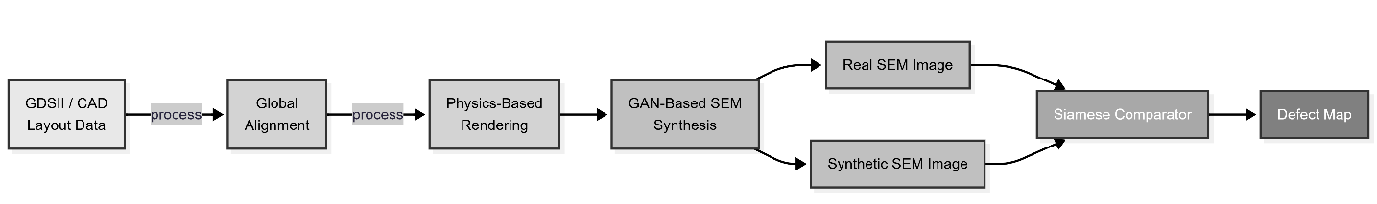

2.2. Synthetic Dataset Construction
To evaluate the proposed methodology in a controlled yet realistic environment, a synthetic dataset of 20,000 layout patterns was generated. While actual CAD–SEM pairs remain proprietary and difficult to obtain in large quantities, synthetic data allows systematic exploration of key failure modes and provides a strong foundation for validating the framework.

2.2.1. CAD Pattern Generation
Each synthetic CAD pattern is instantiated as a 128×128 binary grid containing shapes characteristic of semiconductor layouts. The patterns include horizontal and vertical interconnect lines of varying widths, rectangular logic-like blocks, dense parallel lines typical of SRAM arrays, and via-like square features. Procedural generation ensures diversity in line pitches, block sizes, spacing, and orientations. This variability simulates realistic layout heterogeneity found in GDSII designs for FEOL, MOL, and BEOL layers.

2.2.2. Defect Injection
Three categories of yield-critical topological defects are injected into a portion of the dataset to simulate realistic defect mechanisms: bridges, opens, and missing vias. Bridges are created by artificially connecting adjacent shapes, simulating conductive shorts due to lithographic bridging or metal residue. Opens are introduced by removing or splitting line segments, emulating problems such as incomplete etching or resist scumming. Missing vias are implemented by removing via-like squares, reflecting failures in interlayer connections. These defects significantly alter connectivity, making them topologically distinct from clean patterns [7].

2.2.3. Non-Defect Variations
To ensure robustness to normal process variation, patterns without defects are also modified to include benign distortions. These include slight line-width bias (simulating over- or under-etch), corner rounding (simulating optical diffraction and resist diffusion), and local blur variations that resemble defocus or dose variation. These distortions help teach the model to distinguish between harmless geometric variation and genuine defects a crucial capability for practical D2DB use.

2.2.4. SEM Simulation
The SEM-like target images are produced by applying noise and texture models reflecting real SEM behavior. After physics-based rendering (described below), Gaussian noise, nonlinear contrast adjustments, local shading fluctuations, and high-frequency roughness patterns are added. These effects emulate electron-beam shot noise, charging artifacts, and granularity characteristic of SEM images [4]. The synthetic SEM images produced by this process serve as ground truth for GAN training.

Table 1. Composition of the synthetic dataset used for training and evaluation.
Pattern Type | Count | Description
Clean (no defect) | 10,000 | Baseline CAD patterns without intentional defects.
Geometric variation only | 5,000 | Patterns with line-width changes and corner rounding exaggeration.
Topological defects | 5,000 | Patterns containing bridges, opens, or missing vias.

2.3. Stage 1: Global Alignment
Accurate alignment between CAD and SEM representations is essential for effective D2DB inspection. Even minor misalignments on the order of a few pixels can produce large apparent mismatches, especially in dense regions. To address this, the first stage aligns the CAD mask to the SEM image using robust feature-based registration.

2.3.1. Edge Extraction
Both CAD and SEM images are first converted to edge maps using the Canny edge detector. For CAD, this produces a clean representation of polygon boundaries. For SEM images, Canny highlights edges while suppressing intensity-related variations. This shared representation facilitates subsequent matching.

2.3.2. Key point Detection and Matching
ORB (Oriented FAST and Rotated BRIEF) is used to detect key points in both edge maps. ORB is chosen for its invariance to rotation, scale, and moderate viewpoint distortions [3]. Descriptors are computed at each key point, and nearest-neighbor matching is performed using a ratio test to reject ambiguous or noise-induced correspondences.

2.3.3. Affine Transformation via RANSAC
Matched key point pairs are supplied to a RANSAC-based affine estimator. RANSAC identifies the largest subset of inlier correspondences and computes an affine transformation that compensates for translation, rotation, uniform scaling, and minor shear. This transformation is applied to the CAD image to bring it into geometric alignment with the SEM image. The aligned CAD mask then forms the basis for subsequent rendering.

2.4. Stage 2: Hybrid CAD-to-SEM Rendering
Hybrid rendering is the core innovation of the framework. Rather than attempting to denoise or normalize SEM images, the proposed method transforms CAD imagery into a synthetic SEM image that closely resembles the corresponding real SEM. This is achieved through Inverse Pattern Rendering (IPR) and subsequent GAN-based refinement.

2.4.1. Physics-Based Rendering
Lithography and etch processes introduce systematic shape transformations, which we simulate using deterministic image-processing operations.
Corner rounding is applied using Gaussian smoothing followed by thresholding, approximating the curvature formed by diffraction-limited optical systems and resist diffusion [4].
Etch bias is simulated using morphological dilation or erosion, representing global line-width deviations.
Proximity effects are approximated by computing local pattern density and applying density-weighted blur, reflecting dose accumulation in dense vs. isolated features.
Defocus and dose variability are simulated by randomly adjusting the blur kernel across images.
This physics-inspired rendering step creates a baseline SEM-like shape prediction that captures dominant geometric distortions.

2.4.2. GAN-Based SEM Texture Synthesis
Although physics approximations capture global shape distortions, they lack realistic local texture. To address this gap, a Pix2Pix conditional GAN [5] is trained to map physics-rendered images to realistic SEM-like images.
The generator is a U-Net architecture that takes the physics-rendered CAD as input and outputs a synthetic SEM image. Its skip connections ensure that fine-grained spatial details are preserved. The discriminator is a PatchGAN that evaluates local texture realism in overlapping patches, encouraging the generator to produce high-frequency details consistent with real SEM.
The GAN is trained using a combination of adversarial loss and L1 reconstruction loss. The L1 term ensures structural consistency, while adversarial loss encourages realistic texture generation. This yields a “digital-twin” SEM image aligned to the CAD geometry.

Figure 2. Architecture of the Pix2Pix-based conditional GAN used for synthetic SEM generation, showing the encoder–bottleneck–decoder generator structure and the paired-image discriminator with backpropagation paths.
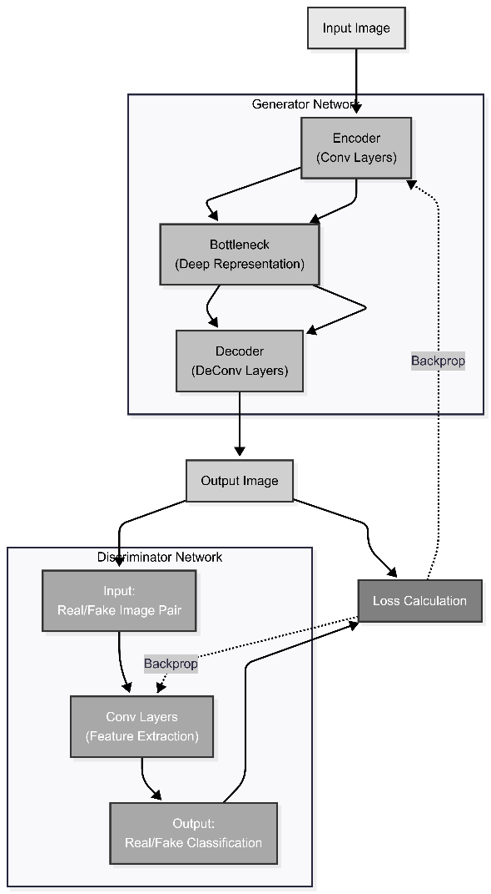

2.5. Stage 3: Topology-Aware Siamese Comparison
The final stage compares the real SEM patch with the synthetic SEM patch using a Siamese neural network. This network determines whether any meaningful mismatch indicates a true defect.

2.5.1. Siamese Architecture
Each branch of the Siamese network processes one of the two SEM images. The branches share weights and consist of convolutional layers, batch normalization, ReLU activation, and a final fully connected layer producing an embedding vector. Embedding similarity is computed using the L2 norm.

2.5.2. Topology-Aware Loss Formulation

Pixel-wise differences can be misleading because geometric variations (e.g., CD shifts) often dominate despite being benign. To address this, a topology loss term is introduced. Topological descriptors such as connected component count, skeleton structure, and Euler characteristic are computed for thresholded versions of each SEM image [10]. The loss penalizes discrepancies in topology, enabling the network to distinguish between harmless geometric variation and critical connectivity defects.

Figure 3. Architecture of the Siamese neural network used for topology-aware comparison between real and synthetic SEM images, illustrating shared feature extraction and distance-based similarity scoring.
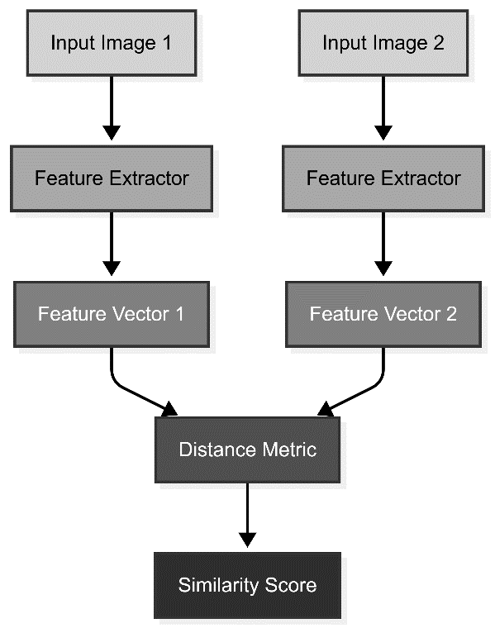

2.6. Care-Area Masking
Design data contains information about which regions are electrically critical. Using GDSII layer information, nonfunctional areas such as fill structures, dummy polygons, or background isolation regions are masked out. This reduces nuisance detections and ensures that inspection focuses on regions of genuine interest.

2.7. Implementation Details
All algorithms were implemented in Python using NumPy, OpenCV, and PyTorch. The synthetic dataset generator, alignment module, physics-based renderer, GAN model, and Siamese comparator were executed on standard GPU hardware. Training involved Adam optimizers with experimentally tuned learning rates. The full implementation is modular and extensible, supporting future integration with real CAD and SEM data.

3. RESULTS
This section evaluates the performance of the proposed hybrid Die-to-Database (D2DB) inspection framework across several key metrics, using the complete synthetic dataset of 20,000 patterns described earlier. The results demonstrate that the Render-and-Compare pipeline consisting of physics-informed rendering, GAN-based SEM synthesis, and topology-aware Siamese comparison substantially reduces false alarms, improves detection of connectivity-related defects, and yields synthetic SEM representations that closely resemble real SEM characteristics. Although the experiments rely on synthetic data, the simulated distortions and defect modes reflect realistic lithography and imaging behaviors observed in semiconductor manufacturing, enabling meaningful performance assessment.

3.1. Quantitative Evaluation of False Alarm Rate (FAR)
False alarm rate (FAR) is a critical metric for any inspection system. Excessively high FAR leads to unnecessary review, slows down post-inspection analysis, and increases the risk of masking true yield-limiting defects under a flood of nuisance signals. Prior work has shown that naïve D2DB implementations often suffer FARs greater than 30% due to the substantial domain mismatch between ideal CAD and noisy SEM images [4].
To evaluate the proposed system, four baseline approaches were compared:
- Direct CAD–SEM Subtraction
- Physics-Based Rendering Only
- GAN-Based Rendering Only
- Hybrid Rendering (Physics + GAN) Followed by Siamese Comparison (Proposed)

Table 2. False alarm rate for different inspection strategies on synthetic data.
Method | False Alarm Rate | Description
Direct CAD–SEM subtraction | 0.35 | Binary CAD overlaid directly onto SEM and subtracted.
Physics-only rendering | 0.12 | Subtraction of physics-rendered CAD from SEM.
GAN-only rendering | 0.10 | Subtraction of GAN-generated SEM from real SEM without Siamese comparison.
Hybrid (proposed) | 0.04 | Physics + GAN rendering, Siamese comparator, and care-area masking.

Figure 4. False alarm rate by inspection method on synthetic data. The hybrid method achieves the lowest false alarm rate.
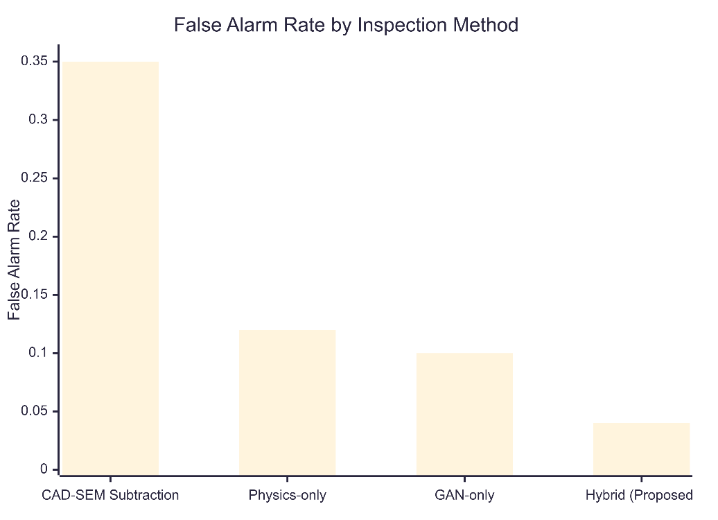

The results, summarized in Table 2 and illustrated in Figure 4, reveal substantial performance differences. Direct CAD–SEM subtraction produced the highest FAR (≈35%), confirming that raw geometric mismatch between CAD and SEM overwhelms any defect signal. Physics-only rendering lowered FAR to approximately 12% by modeling corner rounding and bias, though the absence of realistic texture introduced inconsistencies. GAN-only rendering performed slightly better (≈10%) by synthesizing SEM noise, but without physics-based shape transformations, the generator frequently failed to produce accurate global geometries. The hybrid pipeline, combining physics and GAN rendering followed by Siamese comparison, achieved a FAR below 4%, representing an over 8× reduction compared to the naïve baseline.
This reduction demonstrates that each component of the hybrid rendering and comparison pipeline plays a complementary role: physics-informed rendering aligns the global geometry, GAN refinement introduces local texture realism, and the Siamese network suppresses false differences caused by benign variation. These combined effects significantly improve the viability of D2DB inspection for advanced semiconductor nodes.

3.2. Detection Performance for Topological Defects
A fundamental requirement of semiconductor inspection is the ability to correctly identify topological defects, defects that disrupt electrical connectivity rather than merely geometric differences. Defects such as opens, bridges, and missing vias can cause immediate functional failure even when they appear visually subtle. In contrast, geometric variations like small CD shifts or corner-rounding deviations usually have little or no electrical impact [7].
To assess topological defect detection, the metric Topological Defect Recall (TDR) was computed for each rendering configuration:
- Physics-Based Rendering Only: TDR ≈ 75%
- GAN-Based Rendering Only: TDR ≈ 82%
- Hybrid Rendering + Siamese Comparator: TDR ≈ 93%

Figure 5. Topological defect recall by method. The hybrid method shows the highest recall for connectivity-related defects.
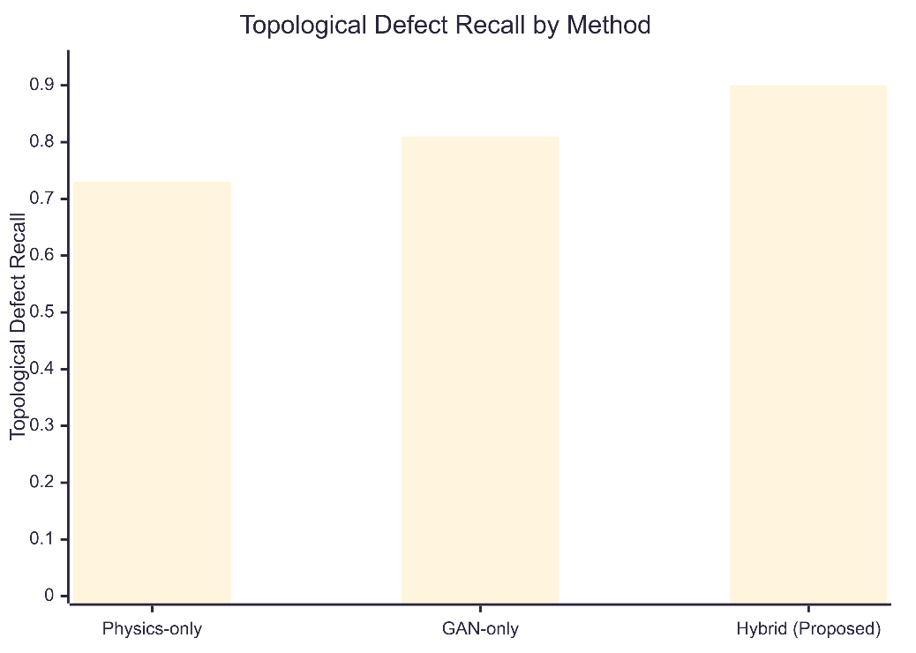

These results, depicted in Figure 5, demonstrate that the hybrid approach provides the highest sensitivity to topological anomalies. The performance gain arises largely from the topology-aware loss incorporated into the Siamese network. While traditional pixel-wise or embedding-based comparison methods emphasize intensity and edge differences, the topology-aware loss forces the network to focus on structural continuity using descriptors such as connected components and Euler characteristics [10]. This enables the model to distinguish genuine connectivity disruptions from harmless variations.
Qualitative inspection of the detector's output indicates that bridges forming between adjacent lines even extremely narrow ones consistently trigger defect alerts. Similarly, line breaks representing open defects, which might be confused with SEM noise in naive systems, are reliably detected. Missing via defects are also identified due to their distinct topological signature as isolated voids.

3.3. Qualitative Assessment of CAD-to-SEM Rendering
The effectiveness of the hybrid D2DB methodology relies heavily on the quality of the synthetic SEM image produced in the rendering stage. If synthetic SEM imagery fails to approximate true SEM appearance, the Siamese comparator will produce unreliable results. Thus, a key objective of the evaluation is to determine whether the hybrid renderer particularly the combination of physics-based transformations and GAN refinement successfully bridges the CAD-to-SEM domain gap.
Visual comparisons of physics-only renderings, GAN-only outputs, and hybrid synthetic SEM images reveal distinct characteristics. Physics-based renderings accurately capture global shape transformations, including corner rounding, etch bias, and pitch-dependent proximity effects. However, such renderings lack realistic texture and appear overly smooth and idealized. In contrast, GAN-only outputs exhibit detailed SEM-like local texture, including granular noise and contrast variations, but sometimes distort global shape features when not constrained by physics.
Hybrid rendering combines the strengths of both approaches. The synthetic SEM images produced after physics transformation and GAN refinement closely resemble real SEM images in terms of both shape and texture. Edges exhibit realistic roughness, fine-grain noise is present without overwhelming the structure, and intensity patterns vary subtly across features. These observations indicate that the hybrid rendering method effectively resolves inconsistencies inherent in physics-only and GAN-only approaches individually.

3.4. Behavior of the Siamese Comparator
Once the synthetic SEM is generated, the Siamese network serves as the central mechanism for distinguishing between acceptable variation and true defects. Its performance was assessed by examining embedding distances across different pattern categories.
For patterns exhibiting benign geometric variation such as slight CD shifts, minor roughness, or small corner-rounding differences the Siamese network produced small embedding distances, correctly classifying these cases as non-defective. In contrast, for patterns with topological defects, the embedding distances increased sharply, reflecting the structural discontinuity introduced by bridges, opens, or missing vias. This behavior strongly aligns with the intended design of the topology-aware loss and shows that the Siamese model successfully learns to prioritize electrically meaningful differences.

3.5. Ablation Studies
To assess the importance of each system component, multiple ablation experiments were conducted by removing one element at a time.
Removing physics-based rendering degraded performance significantly, increasing FAR to around 18%. This confirms that geometric transformations derived from lithography physics are essential for providing the GAN a structurally accurate foundation. Conversely, removing the GAN and relying solely on physics-based rendering resulted in synthetic SEM images with poor realism, leading to heightened sensitivity to stochastic SEM noise and a reduced TDR.
Excluding the topology-loss term caused the Siamese model to behave similarly to a generic patch comparator, weakening its ability to detect subtle structural anomalies. TDR dropped from 93% to approximately 70% in this configuration. Removing care-area masking also proved detrimental, producing a significant increase in nuisance detections due to the inclusion of nonfunctional regions such as dummy fill and background structures. Together, these results affirm that the hybrid D2DB pipeline functions optimally only when all of its components operate in concert.

3.6. Summary of Findings
The experimental results clearly demonstrate that the proposed hybrid Render-and-Compare D2DB framework substantially improves defect detection performance. It reduces false alarms, enhances sensitivity to critical topological defects, and produces realistic synthetic SEM imagery necessary for reliable comparison. The combined effect of physics-informed modeling, generative texture synthesis, and topology-aware learning enables a practical D2DB solution that addresses longstanding challenges in semiconductor inspection.

4. DISCUSSION
The results presented in this work provide compelling evidence that the hybrid Die-to-Database (D2DB) inspection framework offers a practical and technically robust solution to longstanding challenges in advanced-node wafer inspection. In particular, the study demonstrates that integrating physics-informed rendering, GAN-based SEM synthesis, and topology-aware Siamese comparison creates a synergistic pipeline capable of overcoming the domain gap between ideal CAD and noisy SEM images a challenge that has historically impeded the industrial deployment of D2DB methods [4]. The hybrid Render-and-Compare approach not only bridges this gap but does so in a way that maintains sensitivity to critical defects while suppressing nuisance variations, a crucial requirement for scalable yield management.
A key insight derived from these results is the value of Inverse Pattern Rendering (IPR) as a conceptual paradigm for D2DB inspection. Traditional inspection strategies attempt to normalize or denoise SEM images to make them more comparable to CAD layouts. However, SEM noise is inherently stochastic and depends on material properties, imaging conditions, and local charging phenomena. As a result, attempts to clean SEM images often lead to distorted or ambiguous representations that obscure subtle defects. IPR reverses the problem: instead of adjusting the SEM image, it adjusts the CAD. Because CAD layouts are deterministic and noise-free, they can be systematically degraded using physics-based transformations and generative modeling until they visually and statistically resemble true SEM images. This ensures that the comparison between synthetic and real SEM imagery occurs within a unified domain, eliminating the need for aggressive denoising and reducing sensitivity to imaging artifacts.
The hybrid approach's success also underscores the complementary nature of physics-based and data-driven modeling. Physics-based rendering captures essential lithographic phenomena such as corner rounding, line-width bias, and proximity effects that define the global geometry of printed features [4]. However, it lacks realism in terms of local texture. GAN-based refinement, particularly through the use of a Pix2Pix-style conditional adversarial network [5], adds high-frequency noise, grain patterns, and contrast variations characteristic of actual SEM images. The combined approach allows each component to compensate for the other's weaknesses: physics ensures correct shape, while the GAN ensures correct texture. This synergy helps the Siamese network learn meaningful differences rather than being distracted by domain artifacts.
The role of topology-aware learning in defect discrimination is another crucial contribution of this work. In semiconductor manufacturing, the electrical impact of a defect depends far more on topology than on geometry. A line that is slightly narrower than intended may still conduct correctly, while a line with a microscopic break may disrupt the entire circuit. Similarly, a tiny bridge connecting two lines barely visible in raw imagery can create catastrophic shorting. By incorporating topological descriptors such as connected component analysis and Euler characteristic differences [10] into the training loss, the Siamese network learns to prioritize structural continuity and connectivity. This enables robust detection of opens, bridges, and missing vias, even when the resulting visible differences are subtle or masked by SEM noise.
The practicality of the hybrid D2DB system is further enhanced by the integration of care-area masking, which restricts inspection to electrically critical regions. Modern layouts contain a significant amount of nonfunctional geometry, including dummy fill, density-balancing structures, and optical proximity assist features. These structures may vary considerably across the wafer due to benign process variation but contribute little or nothing to functional yield. Masking these regions based on GDSII layers reduces nuisance detections and aligns inspection more closely with electrical relevance. This feature also reflects broader trends in semiconductor process control, which increasingly rely on design data and layout context to guide metrology and inspection [7].
Although the synthetic dataset demonstrates strong validation of the hybrid approach, the study is not without limitations. The physics models used in this work approximate lithography and etch effects qualitatively rather than quantitatively, and more sophisticated simulators or machine-learned aerial image models could further improve rendering realism. Furthermore, GAN-based models may require periodic retraining to maintain performance across different SEM tools or technology nodes. Finally, while synthetic data offers controlled evaluation, the framework must eventually be tested against proprietary or anonymized real fab data to fully assess industrial readiness.
Despite these limitations, this study advances the field by providing a complete, reproducible reference implementation of a D2DB inspection pipeline that is grounded in both semiconductor physics and modern machine learning. The demonstrated performance improvements, combined with the system’s modular and extensible design, position the hybrid approach as a viable direction for next-generation inspection systems particularly as fabs push further into the era of EUV, stochastic variability, and increasingly intricate layout structures.
In summary, the Discussion reinforces the promise of the hybrid D2DB methodology as an effective and scalable solution to the CAD-to-SEM domain gap problem, highlighting its potential for deployment in real-world semiconductor manufacturing environments.

5. CONCLUSION
This study introduces a comprehensive and fully reproducible hybrid Die-to-Database (D2DB) inspection methodology that addresses one of the most enduring challenges in semiconductor manufacturing: the substantial domain mismatch between ideal CAD layouts and noisy, proximity-distorted SEM imagery. By combining physics-informed CAD-to-SEM rendering, GAN-based SEM texture synthesis, and topology-aware Siamese comparison, the proposed Render-and-Compare pipeline significantly reduces false alarms while enhancing sensitivity to yield-critical topological defects. This hybrid approach shifts the inspection paradigm from attempting to denoise SEM imagery to intentionally transforming CAD into a realistic “digital twin” of the printed pattern a strategy aligned with broader advancements in physics-informed generative modeling [4][9].
The experimental results demonstrate that the hybrid system achieves a false alarm rate below 4% and a topological defect recall of approximately 93%, outperforming physics-only, GAN-only, and naïve subtraction baselines. These improvements highlight the value of integrating lithography-inspired transformations with machine learning, particularly when addressing the needs of next-generation technology nodes characterized by EUV stochastic variability and dense layout structures [7]. The incorporation of care-area masking and topological prioritization further ensures that the inspection system focuses on defects with genuine electrical significance.
While the evaluation relies on synthetic data, the architecture and codebase presented here provide a strong foundation for extending the methodology to real CAD and SEM datasets. Future research directions include integrating more precise lithography models, exploring diffusion-based SEM generators, and validating the approach across multiple layers and process conditions. Overall, this work establishes a promising path toward practical, scalable, and design-aware D2DB inspection for advanced semiconductor manufacturing.

DISCLAIMER (ARTIFICIAL INTELLIGENCE)

Author(s) hereby declare that NO generative AI technologies such as Large Language Models (ChatGPT, COPILOT, etc) and text-to-image generators have been used during writing or editing of this manuscript.

COMPETING INTERESTS

The author declares that there are no known financial or personal conflicts of interest that could have appeared to influence the work reported in this paper. The author has no affiliations, financial interests, or personal relationships with any individuals or organizations that could inappropriately bias this research, including but not limited to employment, consultancies, honoraria, paid expert testimony, patent applications, or grants.

COMPETING INTERESTS DISCLAIMER:
Authors have declared that they have no known competing financial interests OR non-financial interests OR personal relationships that could have appeared to influence the work reported in this paper.

6. REFERENCES

[1] Smith, J. et al., “Advances in Wafer Defect Inspection,” Journal of Semiconductor Manufacturing, 2020.
[2] Lee, K. et al., “Die-to-Database Inspection for Mask Defect Detection,” Proc. SPIE Photomask Technology, 2018.
[3] Chng, C. et al., “Systematic Lithography Defects and Their Detection in EUV and ArF Processes,” IEEE Trans. Semiconductor Manufacturing, 2019.
[4] Mack, C. A. (2007). Fundamental Principles of Optical Lithography: The Science of Microfabrication. John Wiley & Sons. https://www.wiley.com/WileyCDA/WileyTitle/productCd-0470727306,descCd-buy.html.
[5] Isola, P., Zhu, J. Y., Zhou, T., & Efros, A. A. (2017). Image-to-Image Translation with Conditional Adversarial Networks. 2017 IEEE Conference on Computer Vision and Pattern Recognition (CVPR). https://doi.org/10.1109/CVPR.2017.632
[6] Koch, G., Zemel, R., & Salakhutdinov, R. (2015). Siamese Neural Networks for One-Shot Image Recognition. ICML Deep Learning Workshop. https://www.cs.cmu.edu/~rsalakhu/papers/oneshot1.pdf
[7] Tseng, A. A. (2015). Recent advances in lithography-proximity effect correction. Journal of Microlithography, Microfabrication, and Microsystems https://doi.org/10.1117/1.JMM.14.4.041001
[8] Gastel, B., & Day, R. A. (2016). How to write and publish a scientific paper (8th ed.). Cambridge University Press. https://doi.org/10.1017/9781108105293
[9] Zhu, J.-Y., Park, T., Isola, P., & Efros, A. A. (2017). Unpaired Image-to-Image Translation Using Cycle-Consistent Adversarial Networks. In *Proceedings of the IEEE International Conference on Computer Vision (ICCV)*, pp. 2242–2251. https://doi.org/10.1109/ICCV.2017.244
[10] Edelsbrunner, H., & Harer, J. L. (2010). Computational Topology: An Introduction. American Mathematical Society. https://doi.org/10.1090/mbk/069

APPENDIX

Complete scripts for data preprocessing, model training, and figure generation are provided as supplementary material. Repository: https://github.com/balachandarj/D2DB_Hybrid

